Understanding Our World

An Open-Source Literacy-Focused Social Studies Curriculum

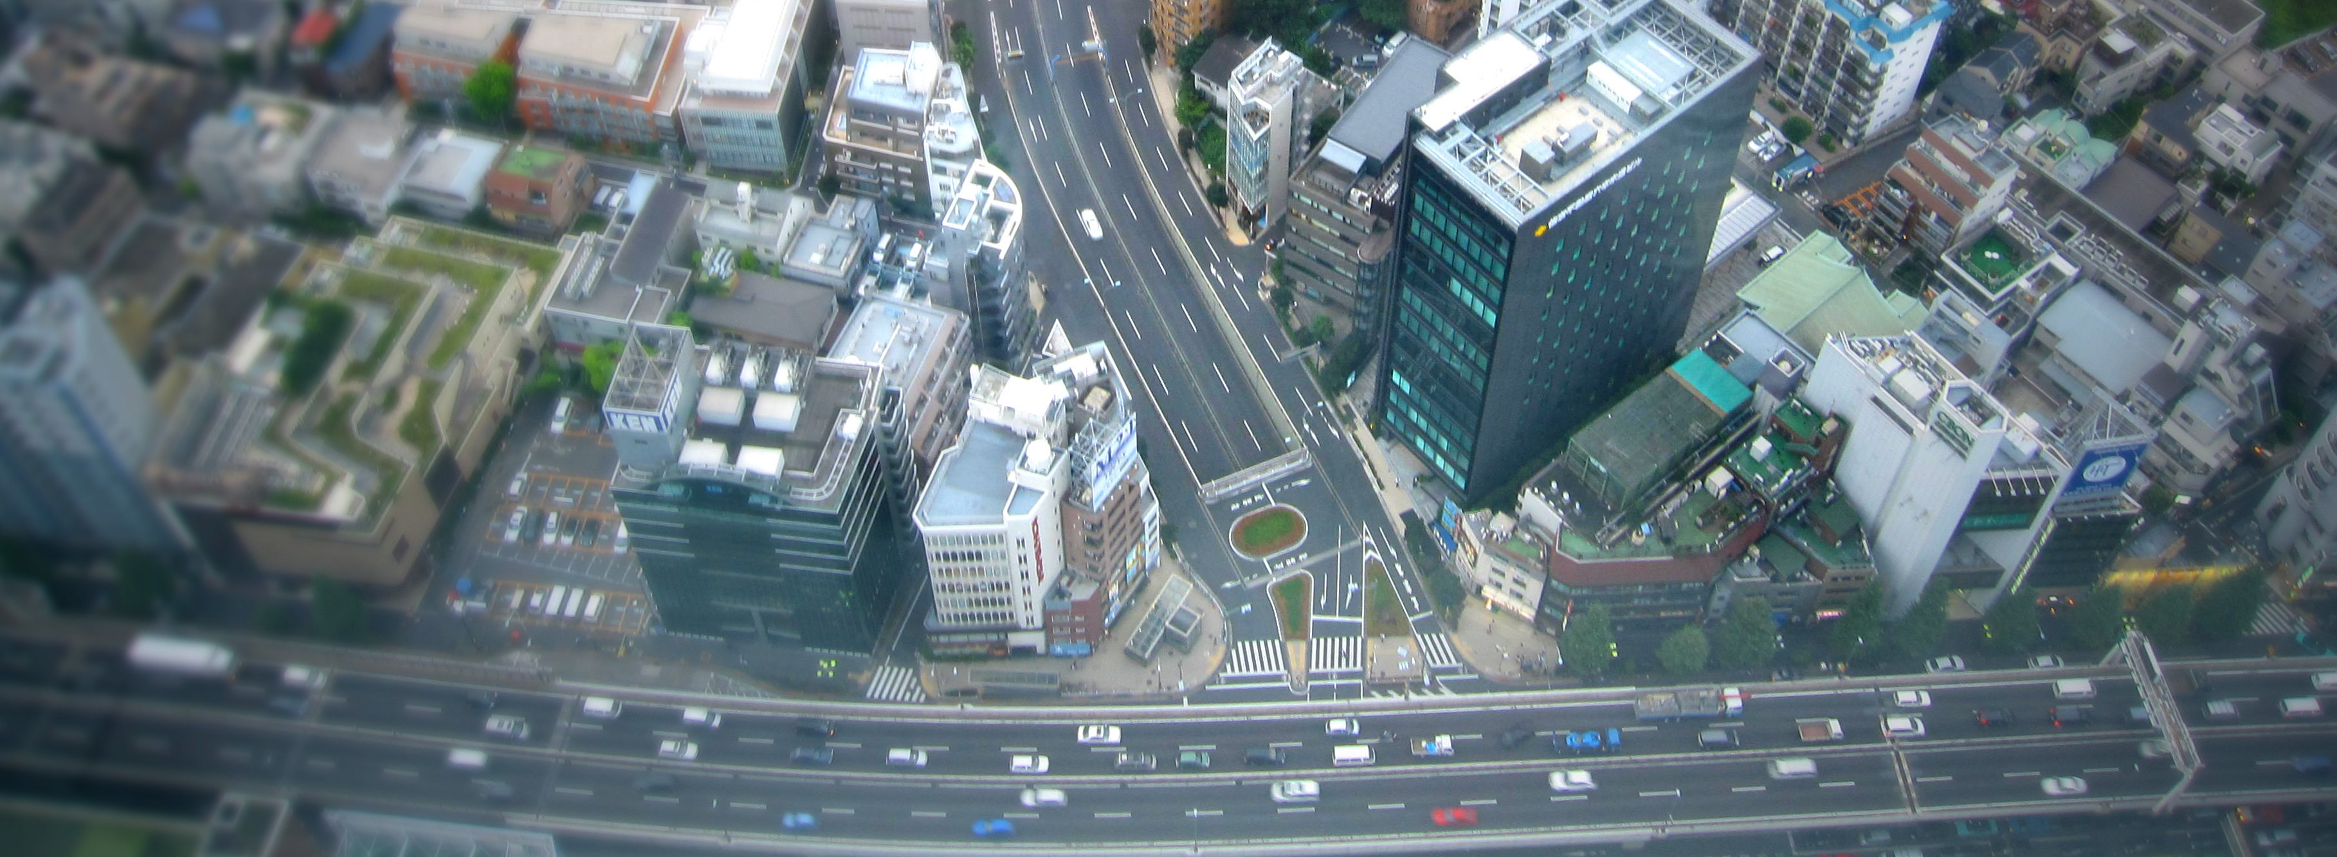

Curric

Level: Grade 4

Exploring the World

Developed By

Christopher C. Martell and Jennifer R. Bryson

Boston University School of Education



INTRODUCTION
Starting in the early elementary grades, all children should receive regular instruction in the social studies, which includes history, civics, geography, and economics. However, there are real pressures on schools and teachers to increase the amount of instruction in other subject areas, which often comes at the expense of their social studies time.

This curriculum was built to help elementary teachers regularly enact powerful and authentic social studies in their classrooms that will also meet essential literacy goals (linking every lesson to the Common Core State Standards). In other words, it leverages the richness of social studies content to help students learn to read, write, speak, and think critically while exploring the past and present world around them. It aims to make every single lesson culturally relevant, connecting to the racial, ethnic, gender, class, language, and immigration experience of the increasingly diverse United States.

ORGANIZATION
These lessons are meant to supplement the school or district social studies curriculum. They are free and open source. Teachers are encouraged to modify and adapt these lesson plans for the individual needs and diverse cultural backgrounds of their students. They are only a guide, or perhaps better a “starter kit” to implementing lessons with important disciplinary questions and social studies content. Moreover, these social studies lessons should be supported with rich English language arts (ELA) texts on related topics.

This curriculum is organized by grade level, with an organizing theme, and each grade is color coated for quick reference. Within each grade level, it is organized by lesson. At the beginning of each grade level, there is a roadmap for that shows the individual lesson topics. Additionally, each lesson plan follows the same lesson plan template (adapted from the Boston University Elementary Education Program) and always includes a thought-provoking inquiry question for the students to answer and primary/secondary sources to use as evidence. All lessons for the primary grades (1-2) are expected to be 30 minutes in length and the intermediate grades (3-5) are expected to be 45 minutes in length. However, depending on the pace of your students, lessons may need to span two or more 30- or 45-minute periods.

This curriculum was designed for students in the Boston Public Schools and each lesson cites the Massachusetts Curriculum Framework for History and the Social Sciences (aligned with the national College, Career, and Civic Life Framework for Social Studies State Standards) and Common Core State Standards. However, this curriculum can be easily adapted for other communities, including districts using other state curriculum frameworks. Some lessons are specifically about history and current events in Dorchester, Boston, and Massachusetts. Teachers from other cities/towns and states are encouraged to adapt these lessons for their particular communities.

GRADE 4
Exploring the World

GRADE 4 CONTENT OVERVIEW

We live in a globalized society. Students today can speak instantaneously through the Internet with their peers in China, Brazil, or Nigeria. In a rapidly changing world, it is crucial that we are preparing global citizens who, from an early age, have a strong understanding of the world’s history and recognize the role of the United States within a much larger global community. These lessons are designed to help students develop a spatial, cultural, and historical understanding of the world. Grade 3’s lessons help students learn that the rich history of each continent and the people who live there, but it also highlights difficult events in our world’s past and present. By the end of Grade 4, students should understand the many overlapping world stories and realize that the world’s history is actually composed of conflicting histories.

GRADE 4 LEARNING GOALS

1. Students Should Be Able to Construct Arguments
Before grade 4, students have begun forming basic arguments. While opinions are claims that are not necessarily based in evidence, arguments include both claims and evidence. In grade 4, students should be able to use evidence to support their claims. While these argumentation skills may still be developing, students should be able to construct relatively logical arguments.
2. Students Should Recognize Inequities and Their Causes
Before grade 4, most students have developed a strong understanding of fairness. Students are also able to recognize racial, gender, and other social differences (there is evidence that most children can detect racial and gender differences by about age 2). In grade 4, students should be able to recognize inequities and the larger social forces that cause inequities. They should be able to suggest ways to improve our communities to make them more fair and just.

3. Students Should Understand Differences Between Present and Past Perspectives
Before grade 4, students are beginning to understand that different people may experience the same situations differently. The have begun to examine how people may think differently in the past compared to today. In grade 4, students should examine examples of people thinking differently about the same events in the past and present. They should be able to recognize that people in the past lived in a world very different to today and that impacted the way they understood the world.
CONCEPTS

Synopsis | Content | Thinking Skills
1. Earth | - While most people will say there are 7 continents, geographers debate that the number is between 4 and 7.  - While most people will say there are 4 oceans, geographers and scientists debate that the number is between 1 and 5.  - Maps are tools to help us understand the world around us. There are many different maps that show the earth from different perspectives and present different information.  - The United Nations is an international organization where nations make worldwide decisions. | - Recognize that maps portray the land and water masses of the earth differently based on purpose.  - Identify the names of continents and oceans.  - Compare different arguments for the number of continents and oceans on earth.  - Evaluate the ability of nations to make worldwide decisions.
2. Africa | - Humans began in Africa.  - Africa has a long history, including several great empires.  - Europeans invaded Africa, which caused many problems for the African people.  - Africa has 54 independent countries with different languages and cultures. | - Identify Africa as the beginning place of humankind.  - Compare different African empires’ histories.  - Recognize Africa’s contributions to the world.  - Identify and compare several modern African nation’s cultures and governments.
3. Asia | - The majority (60%) of the world’s people live in Asia.  - Asia has a long history, including several great empires.  - Europeans invaded Asia, which caused many problems for the African people.  - Africa has 48 independent countries with different languages and cultures. | - Compare different Asian empires’ histories.  - Recognize Asia’s contributions to the world.  - Identify and compare several modern Asian nation’s cultures and governments.
4. Americas | - North and South America has a long history, including several great empires.  - Europeans invaded the Americas, which caused many problems for the Indigenous people.  - South America has 12 and North America has 23 independent countries with different languages and cultures. | - Compare different American empires’ histories.  - Recognize the America’s contributions to the world.  - Identify and compare several modern American nation’s cultures and governments.
5. Europe | - Europe has a long history, including several great empires.  - Europe has 44 independent countries with different languages and cultures. | - Compare different European empires’ histories.  - Recognize Europe’s contributions to the world.  - Identify and compare several modern European nation’s cultures and governments.

GRADE 4 FIELD EXPERIENCES

It is strongly recommended that students engage regularly in social studies field experiences to connect their learning inside school to the world outside school. The Grade 4 curriculum covers the world and its history, civics, geography, and economics. There are several field trip locations in the Boston area that would provide an excellent real world connection to this curriculum. We recommend the following:

Mapparium
www.marybakereddylibrary.org/project/mapparium/

Museum of Science IMAX (Greece Secrets of the Past)
www.mos.org/imax/

Museum of Fine Arts (Asia, Africa, the Americas, and Europe Collections)
www.mfa.org

Boston Children’s Museum (Exhibit: Japanese House, Program: Cultures)
www.bostonchildrensmuseum.org

GRADE 4 PROJECT-BASED LEARNING

These lessons are meant to supplement the school or district social studies curriculum. In addition, teachers are strongly encouraged to have students engage in project-based learning related to the content of these lessons. The Grade 4 curriculum covers the world and its history, civics, geography, and economics. Below are several suggested long-term projects that we recommend teachers use in conjunction with these lessons. These projects may include producing a report and/or brief presentations in the form of poster boards, digital slideshows, performances that highlight the positive and negative aspect to each historical event or person.

Project 1: Africa
To extend on lessons 4-1 to 4-8, students will research the nations of Africa.

Project 2: Asia
To extend on lessons 4-9 to 4-14, students will research the nations of Asia.

Project 3: The Americas
To extend on lessons 4-15 to 4-21, students will research the nations of North and South America.

Project 4: Europe
To extend on lessons 4-22 to 4-28, students will research the nations of Europe.

Project 5: Global Issues
To extend on lessons 4-29 to 4-30, students will research important current-day global issues of their choosing (the environment, access to water, health care, hunger, etc.) and present possible United Nation resolutions to help solve these problems.

GRADE 4 ROAD MAP

LESSON 4-1

Lesson Title: How Many Continents and Oceans Are There?

Inquiry Question: How many continents and oceans are there?

LESSON 4-2

Lesson Title: Which Way Is Up? Seeing the World Through Different Maps

Inquiry Question: Which map is best?

LESSON 4-3

Lesson Title: Africa: Where Humans Began

Inquiry Question: What was the most important event of early human in Africa?

LESSON 4-4

Lesson Title: Ancient Egypt

Inquiry Question: If you could be in any ancient Egyptian social class, which would you choose and why?

LESSON 4-5

Lesson Title: The Great African Empires: Ghana, Kongo, Ethiopia, and Zimbabwe

Inquiry Question: If you could live in any ancient African empire, which one would it be and why?

LESSON 4-6

Lesson Title: Timbuktu: How Trade Shaped a City

Inquiry Question: Why was Timbuktu so important?

LESSON 4-7

Lesson Title: Apartheid in South Africa: A Movement for Freedom

Inquiry Question: What can we learn from the Anti-Apartheid Movement in South Africa?

LESSON 4-8

Lesson Title: Africa Today: Diverse Nations, Diverse People

Inquiry Question: If you were to visit Africa today, what country would you choose and why?

LESSON 4-9

Lesson Title: The Great Asian Empires: China, Japan, India, and Persia

Inquiry Question: If you could live in any ancient Asian empire, which one would it be and why?

LESSON 4-10

Lesson Title: The Silk Road: Connecting the Continents

Inquiry Question: What was life like on the Silk Road?

LESSON 4-11

Lesson Title: Việt Nam: A Country of Waterways

Inquiry Question: Are the human changes to the Mekong River more positive or negative?

LESSON 4-12

Lesson Title: Asian Megacities: Would You Want to Live There?

Inquiry Question: Would you like to live in an Asian megacity?

LESSON 4-13

Lesson Title: World Religions: Hinduism, Confucianism, Buddhism, and Islam

Inquiry Question: What is each religion’s greatest contributions to the world?

LESSON 4-14

Lesson Title: Asia Today: Diverse Nations, Diverse People

Inquiry Question: If you were to visit Asia today, what country would you choose and why?

LESSON 4-15

Lesson Title: The Great American Empires: Aztec, Maya, Inca, and Mississippi

Inquiry Question: If you could live in any ancient American empire, which one would it be and why?

LESSON 4-16

Lesson Title: Columbus: Hero or Villain?

Inquiry Question: Did Columbus’s voyages have more of a positive or negative impact on the world?

LESSON 4-17

Lesson Title: Haiti: What Type of Revolution?

Inquiry Question: What type of revolution did Toussaint Louverture lead in Haiti?

LESSON 4-18

Lesson Title: The History of Mexico

Inquiry Question: What was the most important event in Mexican history?

LESSON 4-19

Lesson Title: Road Trip: Mexico

Inquiry Question: If you were to visit Mexico, what part would you travel to?

LESSON 4-20

Lesson Title: The History of Canada

Inquiry Question: What was the most important event in Canadian history?

LESSON 4-21

Lesson Title: Road Trip: Canada

Inquiry Question: If you were to visit Canada, what part would you travel to?

LESSON 4-22

Northeast (U.S. Regions Mini-Unit)

Inquiry Question: If you were to take a road trip across the United States, which cities and states would you visit?

LESSON 4-23

Southeast (U.S. Regions Mini-Unit)

Inquiry Question: If you were to take a road trip across the United States, which cities and states would you visit?

LESSON 4-24

Midwest (U.S. Regions Mini-Unit)

Inquiry Question: If you were to take a road trip across the United States, which cities and states would you visit?

LESSON 4-25

Southwest (U.S. Regions Mini-Unit)

Inquiry Question: If you were to take a road trip across the United States, which cities and states would you visit?

LESSON 4-26

West (U.S. Regions Mini-Unit)

Inquiry Question: If you were to take a road trip across the United States, which cities and states would you visit?

LESSON 4-27

South America Today: Diverse Nations, Diverse People

Inquiry Question: If you were to visit South America today, what country would you choose and why?

LESSON 4-28

Lesson Title: The Great European Empires: Greece, Rome, Spain, France, and Britain

Inquiry Question: Which European empire had the best ideas?

LESSON 4-29

Lesson Title: Irish Independence: A New Country from an Ancient People

Inquiry Question: Why was Irish independence from England so important to its people?

LESSON 4-30

Lesson Title: Backpacking Across Europe: Diverse Nations, Diverse People

Inquiry Question: If you were to backpack across Europe today, what country would you visit and why?

NOTE: This curriculum is still under development. This version includes 20 lessons. The full version will include 30 lessons and will be released in early spring 2018.

LESSON PLAN 4-1: How Many Continents and Oceans Are There?

MATERIALS

Seven Continents Song Video (Lesson4-1Video1) [Located in the UOW Video Library: www.christophercmartell.com/understandingourworld]
Five Oceans Song Video (Lesson4-1Video2) [Located in the UOW Video Library: www.christophercmartell.com/understandingourworld]
Clipboards (not supplied)
Continents and Oceans Notes (WORKSHEET 4-1.A)
Source 1: 8 Continents Argument (WORKSHEET 4-1.B)
Source 2: 7 Continents Argument (WORKSHEET 4-1.C)
Source 3: 5 Continents Argument (WORKSHEET 4-1.D)
Source 4: 3 Continents Argument (WORKSHEET 4-1.E)
Source 5: 5 Oceans Argument (WORKSHEET 4-1.F)
Source 6: 4 Oceans Argument (WORKSHEET 4-1.G)
Source 7: 3 Oceans Argument (WORKSHEET 4-1.H)
Source 8: 1 Ocean Argument (WORKSHEET 4-1.I)
Continents and Oceans: Exit Ticket (ASSESSMENT 4-1.J)

STANDARDS

Massachusetts History and Social Science Framework

MA-HSS.4.CS.1: Use map and globe skills to determine absolute locations (latitude and longitude) of places studied. (G)

MA-HSS.4.8: On a map of the world, locate … Atlantic and Pacific Oceans.

MA-HSS.2.1: On a map of the world, locate all of the continents: North America, South America, Europe, Asia, Africa, Australia, and Antarctica. (G)

MA-HSS.2.3: Locate the oceans of the world: the Arctic, Atlantic, Indian, Pacific, and Southern Oceans. (G)

Common Core: Literacy

CCSS.ELA-Literacy.RI.4.9: Integrate information from two texts on the same topic in order to write or speak about the subject knowledgeably.

CCSS.ELA-Literacy.RI.4.10: By the end of year, read and comprehend informational texts, including history/social studies, science, and technical texts, in the grades 4–5 text complexity band proficiently, with scaffolding as needed at the high end of the range.
CCSS.ELA-Literacy.W.4.8: Recall relevant information from experiences or gather relevant information from print and digital sources; take notes and categorize information, and provide a list of sources.

CCSS.ELA-Literacy.W.4.9: Draw evidence from literary or informational texts to support analysis, reflection, and research.

PROCEDURES

Inquiry Question: How many continents and oceans are there?

PREPARATION

1. Set Up Carousel Activity
Around the room, post the eight sources:
Source 1: 8 Continents Argument (WORKSHEET 4-1.B)
Source 2: 7 Continents Argument (WORKSHEET 4-1.C)
Source 3: 5 Continents Argument (WORKSHEET 4-1.D)
Source 4: 3 Continents Argument (WORKSHEET 4-1.E)
Source 5: 5 Oceans Argument (WORKSHEET 4-1.F)
Source 6: 4 Oceans Argument (WORKSHEET 4-1.G)
Source 7: 3 Oceans Argument (WORKSHEET 4-1.H)
Source 8: 1 Ocean Argument (WORKSHEET 4-1.I)

Sources 1-4 (Continents) should be posted on top of Sources 5-8 (Oceans), so that you can pull of the second set of sources to reveal them in the second part of the lesson.

2. Post Definitions of Continent and Ocean
Post the definitions of continent and ocean on the board or chart paper hidden from view. Continent: Large land masses separated from others by water. Ocean: A large body of water.

A. OPENER (10 minutes)

3. Watch the Seven Continents Song Video
Show the students a short video involving a nursery rhyme to remember the seven continents (Lesson4-1Video1). After watching the video, ask the students, “How many of you have learned that there are seven continents, like they say in this song?” Count how many students raise their hands. Then tell students that we don’t know how many continents there are, because it is debatable. Most people in English speaking countries say there are seven: North America, South America, Europe, Africa, Asia, Australia, and Antarctica, but that is debatable. In fact, the idea of continents was invented by humans. In some cultures, people say there are anywhere between 3 and 6, while geographers, people who study the Earth including how we map it, think there may be 3 and 9. We will debate this today.

4. Watch the Five Oceans Song Video
Show the students a short video involving a nursery rhyme to remember the five oceans (Lesson4-1Video2). After watching the video, ask the students, “How many of you have learned that there are five oceans, like they say in this song?” Count how many students raise their hands. Then tell students that just like continents we do not know how many oceans there are, because it is debatable. Most people in English speaking countries say there are five: Atlantic, Pacific, Indian, Artic, Southern, but that is debatable. In fact, the idea of oceans was invented by humans. In some cultures, people say there are anywhere between 3 and 5, while scientists and some geographers, argue that there is only one connected ocean. We will debate this today.

B. DEVELOPMENT (20 minutes)

5. Engage in a Carousel Activity on the Number of Continents
Give each student pencil and clipboard with the Continents and Oceans Notes (WORKSHEET 4-1.A) on it. Ask students to go to each of the four stations (4-1.B, 4-1.C, 4-1.D, 4-1.E). At each station, the students should take notes on the arguments about how many continents there are.

Once students have gone to each of the four stations, they should return to their seats. Put students in small groups. Have them look at their note sheets and debate which argument was most compelling or agreeable.

6. Engage in a Carousel Activity on the Number of Oceans
Remove all of the Continent Sources to reveal the Ocean Sources. Use tape or a magnet to put the Continent Sources up on the board or a section of the wall for future reference.

Students should continue to use their pencil and clipboard with the Continents and Oceans Notes (WORKSHEET 4-1.A) on it. Ask students to go to each of the four stations (4-1.F, 4-1.G, 4-1.H, 4-1.I). At each station, the students should take notes on the arguments about how many continents there are.

Once students have gone to each of the four stations, they should return to their seats. Students should again meet in small groups. Have them look at their note sheets and debate which argument was most compelling or agreeable.

C. CLOSING (15 minutes)

7. Write Up Argument on the Continents and Oceans
For the evaluation task, have the students complete the exit ticket (ASSESSMENT 4-1.J), where they write their own personal response to the lesson’s Inquiry Question: “How many continents and oceans are there?” Tell students to cite at least three pieces of evidence from the sheets on the walls. Tell students that the evidence they use can be something that they wrote on the sheets. Encourage students to get up and look at the sheets on the wall, when they need evidence to write on their sheet.

Before using the exit ticket, consider using a graphic organizer or two column notes to prepare students for the writing task. Consider using sentence starters and modeling to help the students with their answer to the inquiry question.

EVALUATION

ASSESSMENT 4-1.J

What to look for?

The students should take a stance on the number of continents and oceans. All arguments should cite at least 3 pieces of evidence from the sources.

Some information that students may include in their answer to the question:

Continents: 8
- Most scientific
- Uses the plate tectonics of the Earth
- Has the most continents

Continents: 7
- Most widely used
- Most historical
- They had two houses, near the ocean (the first “beach side condo”) and the woods
- They could house many families; this allowed families to be close
- Will be recognized by the most people around the world

Continents: 5
- Closest to the dictionary definition
- Shows Eurasia and the Americas as single continent (clearly no oceans divide them)
- Commonly used in many parts of Europe and South America.

Continents: 3
- Groups the major land masses and counts islands with the contents nearby
- Has the least continents

Oceans: 5
- Has the most number of oceans
- Helpful for ocean navigation
- Used by many people today (although not most common)
- Includes the new Southern Ocean (2000)

Oceans: 4
- Most widely used
- The Antarctic Ocean should not be counted, because it is really just the southern part of the Atlantic, Pacific, and Indian Oceans.

Oceans: 3
- Most historical
- Should not count Artic or Antarctic Oceans

Oceans: 1
- Most scientific definition
- All of the oceans are connected
- Has the least number of oceans

WORKSHEET: 4-1.A

Continents and Oceans Notes

Source 1: 8 Continents Argument

Source 2: 7 Continents Argument

Source 3: 5 Continents Argument

Source 4: 3 Continents Argument

Source 5: 5 Oceans Argument

Source 6: 4 Oceans Argument

Source 7: 3 Oceans Argument

Source 8: 1 Ocean Argument

WORKSHEET: 4-1.B

Source 1: 8 Continents Argument

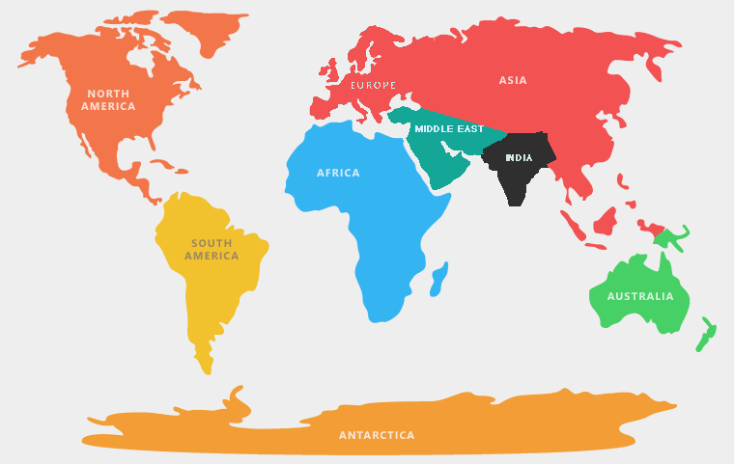

Some geographers count continents by the Earth’s tectonic plates. There are 8 major plates holding land (some have only water) that divide the earth: North American Plate, Eurasian Plate, African Plate, Antarctic Plate, Australian Plate, Indian Plate, Arabian Plate (Middle East), South American Plate. This may be the most scientific way of saying how many continents there are.

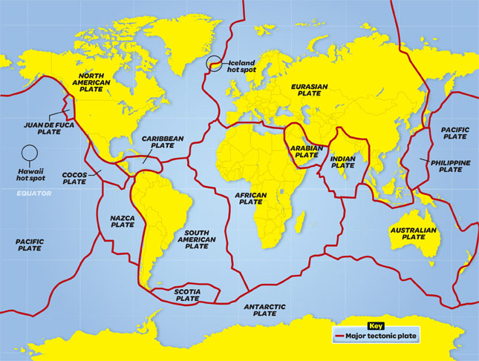

WORKSHEET: 4-1.C

Source 2: 7 Continents Argument

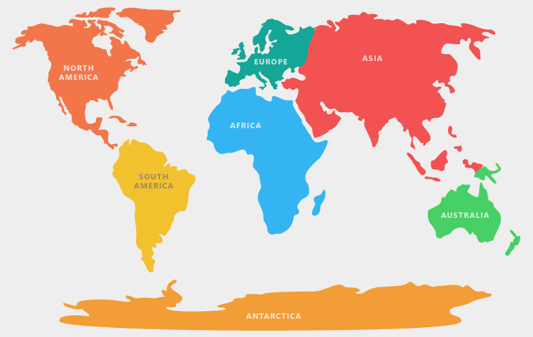

Some geographers count continents through the way that Europe labeled the land masses that they discovered. Europeans went to the different continents in this order: Europe, Africa, Asia, North America, South America, Australia, Antarctica. Europeans observed differences in human culture (language, traditions, government forms) and appearance (skin color and eye type) between Europe, Asia, and Africa and decided these were different groups of people. This may be the most historical way of saying how many continents there are.

WORKSHEET: 4-1.D

Source 3: 5 Continents Argument

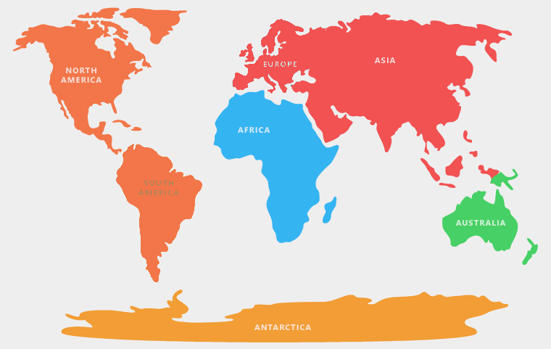

Some geographers count continents by their appearance as separate land masses. For instance, they suggest that North and South America are really one connected continent (the Americas) and Europe and Asia are really one connected continent (Eurasia). This model is taught to students in parts of Europe, South America, and Asia. This way of saying how many continents there are may be the truest to the dictionary definition of continent.

WORKSHEET: 4-1.E

Source 4: 3 Continents Argument

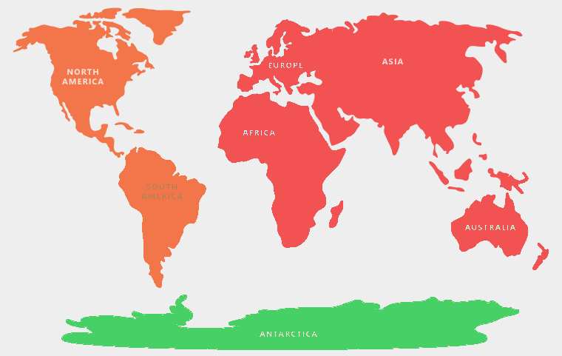

Some geographers count continents based on how the oceans divide them. For instance, they suggest that North and South America are really one connected continent (the Americas) and Europe, Asia, and Africa are really one connected continent (Afroeurasia) divided by the Atlantic and Pacific Oceans). This model also does not count Australia as a continent, instead putting it as a large island off of the cost of Asia (If Greenland is about 2 million square miles and considered North America, then we should not count Australia as a continent if it is only 3 million square miles). This may be the most useful way of saying how many continents if you want to make as few continents as possible.

WORKSHEET: 4-1.F

Source 5: 5 Oceans Argument

Some geographers count oceans by the continents that surround them. This would make five oceans: Pacific, Atlantic, Indian, Artic, and Southern. This may be the most helpful way of saying how many oceans there are for people who need to travel the different oceans on ships.
WORKSHEET: 4-1.G

Source 6: 4 Oceans Argument

The Southern Ocean (which surrounds Antarctica) was only officially named in the year 2000 and many countries do not consider it a separate ocean, so some geographers count only four oceans: Pacific, Atlantic, Indian, and Arctic. This may be the most helpful way of saying how many oceans there are based on what most people in the world already say.

WORKSHEET: 4-1.H

Source 7: 3 Oceans Argument

Some geographers count continents by what humans used for the past three thousand years: Atlantic, Pacific, and Indian. Humans learned only 100 years ago that there is no land under the North Pole (making it an ocean). This view argues that the Arctic Ocean is really just the northern parts of the other oceans. This may be the most historical way of saying how many continents there are.

WORKSHEET: 4-1.I

Source 8: 1 Ocean Argument

Some geographers and most oceanographers (scientists who study the ocean) count only one ocean, because on Earth, all large bodies of water are connected. They would argue that the divisions are only made by humans and are not scientific. This may be the most scientific way of saying how many oceans there are.
ASSESSMENT: 4-1.J

Continents and Oceans: Exit Ticket

Inquiry Question: How many continents and oceans are there?

Choose one argument for the number of continents and one for the number of oceans and explain why you agree with it the most. Include three pieces of evidence from the sources (at least one piece of evidence for each argument).

I argue that there are ______ continents and ______ oceans.

LESSON PLAN 4-2: Which Way Is Up? Seeing the World Through Different Maps

MATERIALS

Clipboards (not supplied)
Making Maps Video (Lesson4-2Video1) [Located in the UOW Video Library: www.christophercmartell.com/understandingourworld]
Various World Maps (MATERIALS 4-2.A) [This activity supplies standard handout-sized maps. This activity would work better if those maps were printed as large as possible or secure larger sized professionally produced maps using the same projections: Mercator Projection, Robinson Projection, Gall-Peters Projection, Atlantic-Centric, Pacific-Centric, Southern Hemisphere-Centric [South Up Map])
Note Taking Sheet (WORKSHEET 4-2.B)
Map Perspectives: Exit Ticket (ASSESSMENT 4-2.C)

STANDARDS

Massachusetts History and Social Science Framework

MA-HSS.4.CS.1: Use map and globe skills to determine absolute locations (latitude and longitude) of places studied. (G)

MA-HSS.4.8: On a map of the world, locate … Atlantic and Pacific Oceans.

MA-HSS.2.1: On a map of the world, locate all of the continents: North America, South America, Europe, Asia, Africa, Australia, and Antarctica. (G)

MA-HSS.2.3: Locate the oceans of the world: the Arctic, Atlantic, Indian, Pacific, and Southern Oceans. (G)

Common Core: Literacy

CCSS.ELA-Literacy.RI.4.9: Integrate information from two texts on the same topic in order to write or speak about the subject knowledgeably.

CCSS.ELA-Literacy.RI.4.10: By the end of year, read and comprehend informational texts, including history/social studies, science, and technical texts, in the grades 4–5 text complexity band proficiently, with scaffolding as needed at the high end of the range.

CCSS.ELA-Literacy.W.4.8: Recall relevant information from experiences or gather relevant information from print and digital sources; take notes and categorize information, and provide a list of sources.

CCSS.ELA-Literacy.W.4.9: Draw evidence from literary or informational texts to support analysis, reflection, and research.

PROCEDURES

Inquiry Question: Which map is best?

PREPARATION

1. Set Up Carousel Activity
Around the room, post the six maps: Mercator Projection, Robinson Projection, Gall-Peters Projection, Atlantic-Centric, Pacific-Centric, Southern Hemisphere-Centric [South Up Map]) (MATERIALS 4-2.A) or professionally produced versions of the same maps. Be sure to post the map and correct description next to it.

A. OPENER (10 minutes)

2. Watch the Making Maps Video
Show the students a short video explaining the history and problems with map making (Lesson4-2Video1). During the video, stop it and highlight/ask questions about how it is difficult to make a globe flat, and the distortions that happen. Write the definition of distortion on the board or chart paper as “changing something so it is inaccurate or not completely true.” After watching the video, ask the students, did some of the maps the video showed us look weird or unusual to you? Why do you think that is? Anticipated student responses may include: we are used to looking at only one type of map, it is hard to make a globe flat, some maps make Africa and South America look smaller than they actually are.

B. DEVELOPMENT (20 minutes)

3. Examine the Maps Posted Around the Room
Give each student pencil and clipboard with the Note Taking Sheet (WORKSHEET 4-2.B) on it. Ask students to go to each of the six maps. At each map, the students should take notes on what they are seeing and feeling. There is a generic question listed to prompt them: What locations are at the center and top of this map? How does this look the same or different than maps you are using to looking at? Which maps do you think are more or less helpful (and for who)?

Once students have gone to each of the four stations, they should return to their seats. Put students in small groups. Have them look at their note sheets and debate which argument was most compelling or agreeable.

C. CLOSING (15 minutes)

6. Write Up Argument on the Continents and Oceans
For the evaluation task, have the students complete the exit ticket (ASSESSMENT 4-2.C), where they write their own personal response to the lesson’s Inquiry Question: “Which map is best?” Tell students to cite at least three pieces of evidence from the maps and descriptions on the walls. Tell students that the evidence they use can be something that they wrote on their note taking sheets. Encourage students to get up and look at the maps and descriptions on the wall, when they need evidence to write on their sheet.

Before using the exit ticket, consider using a graphic organizer or two column notes to prepare students for the writing task. Consider using sentence starters and modeling to help the students with their answer to the inquiry question.

EVALUATION

ASSESSMENT 4-2.C

What to look for?

The students should take a stance on the best map. All arguments should cite at least 3 pieces of evidence from the sources.

Some information that students may include in their answer to the question:

Mercator Projection
- It is the most helpful for navigation, because it will show you the most direct angle from one point to the other.
- It is commonly used by Global Positioning Systems (GPS) maps, such as Google Maps.
- It is the one that most Americans are used to using.

Robinson Projection
- It projects a globe on a rounded flat surface.
- It attempts to show the actual relative sizes of the land on earth comparing north to south.

Gall-Peters Projection
- It shows the correct ratios of land mass across the Earth.
- This means that it shows the exact size of one continent versus another.
- Shows the true size of each country in land size.

Atlantic-Centric and Physical Map
- It is most commonly used by people in the Americas, Europe, and Africa.
- It shows the areas where they often trade goods over the ocean.
- It can show you the elevation (how high or low) the land and water are, as well as where you can find different terrain types.

Pacific-Centric and Political Map
- It is most commonly used by people in Asia.
- It shows the areas where they often trade goods over the ocean.
- It shows country’s boundaries, so you where they start and end.

Southern Hemisphere-Top
- This map makes you question what is up and what is down on a map.
- Since there is no true up or down in space, this map reminds us of that.

MATERIALS: 4-2.A

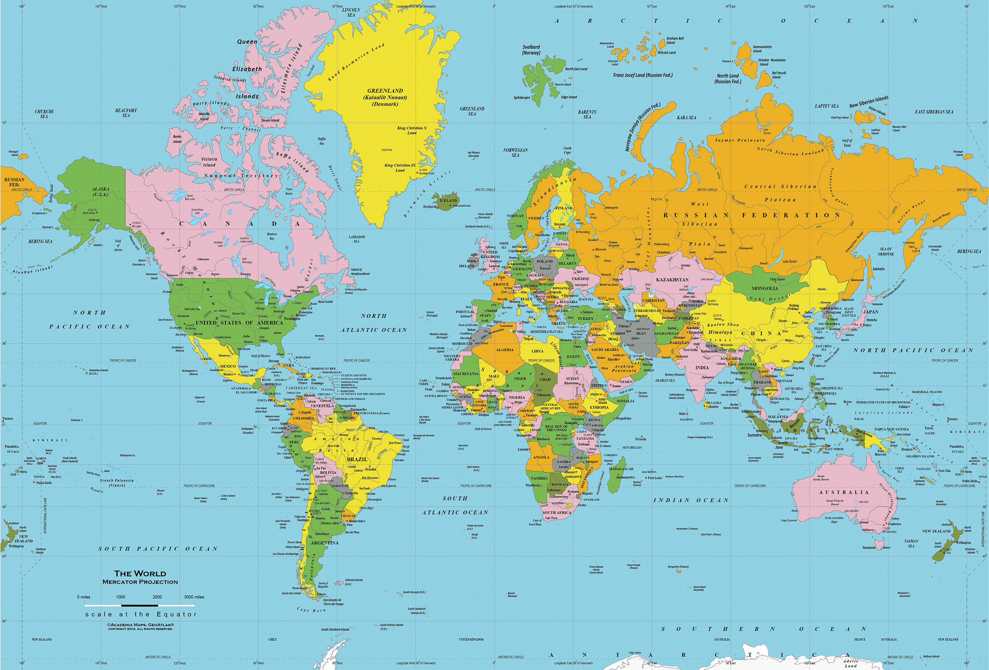
Mercator Projection

Mercator Projection

This type of map was invented by Gerardus Mercator in 1569. He was Flemish (from Belgium in Europe). It projects a globe on a cylinder (see below).

PROS
It is the most helpful for navigation, because it will show you the most direct angle from one point to the other. It is commonly used by Global Positioning Systems (GPS) maps, such as Google Maps.

CONS
It distorts the poles, so that land and water masses at the North and South Poles are stretched, making them look much larger than they actually are.
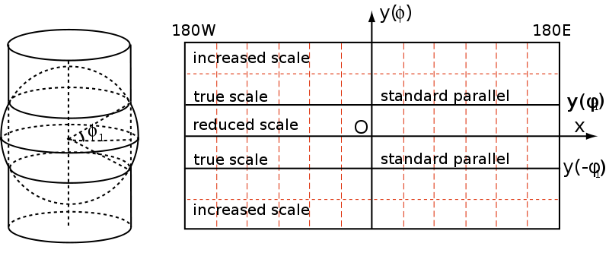

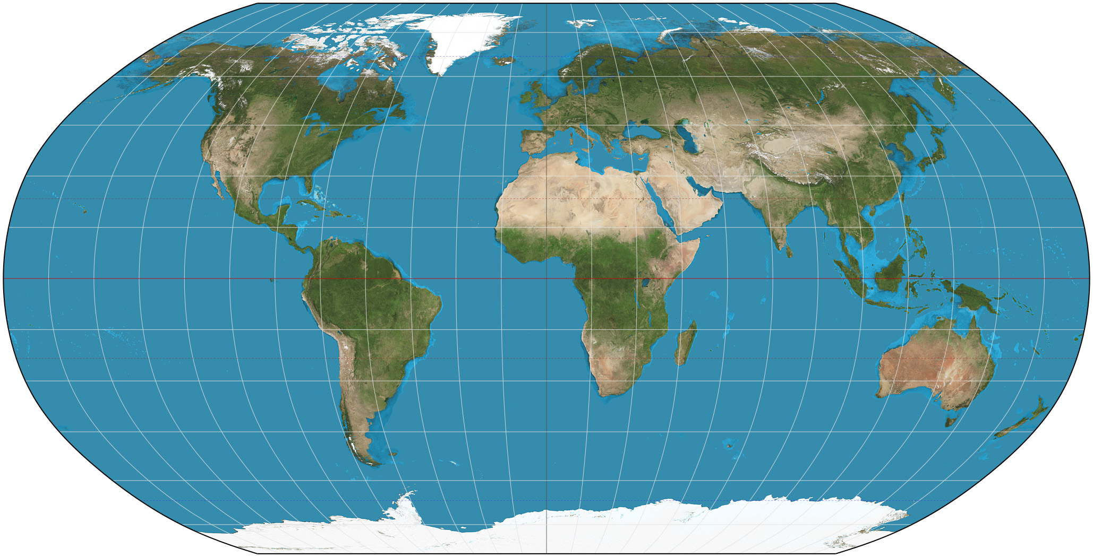
Robinson Projection
Topographical Map
Robinson Projection

This type of map was invented by Arthur H. Robinson in 1963. He was an American (born in Montréal, Québec, lived in Great Britain and later Wisconsin).

PROS
It projects a globe on a rounded flat surface. It attempts to show the actual relative sizes of the land on earth comparing north to south.

CONS
It distorts the corners of the map (northeast, southeast, southwest, northwest), making them look much larger than they actually are.

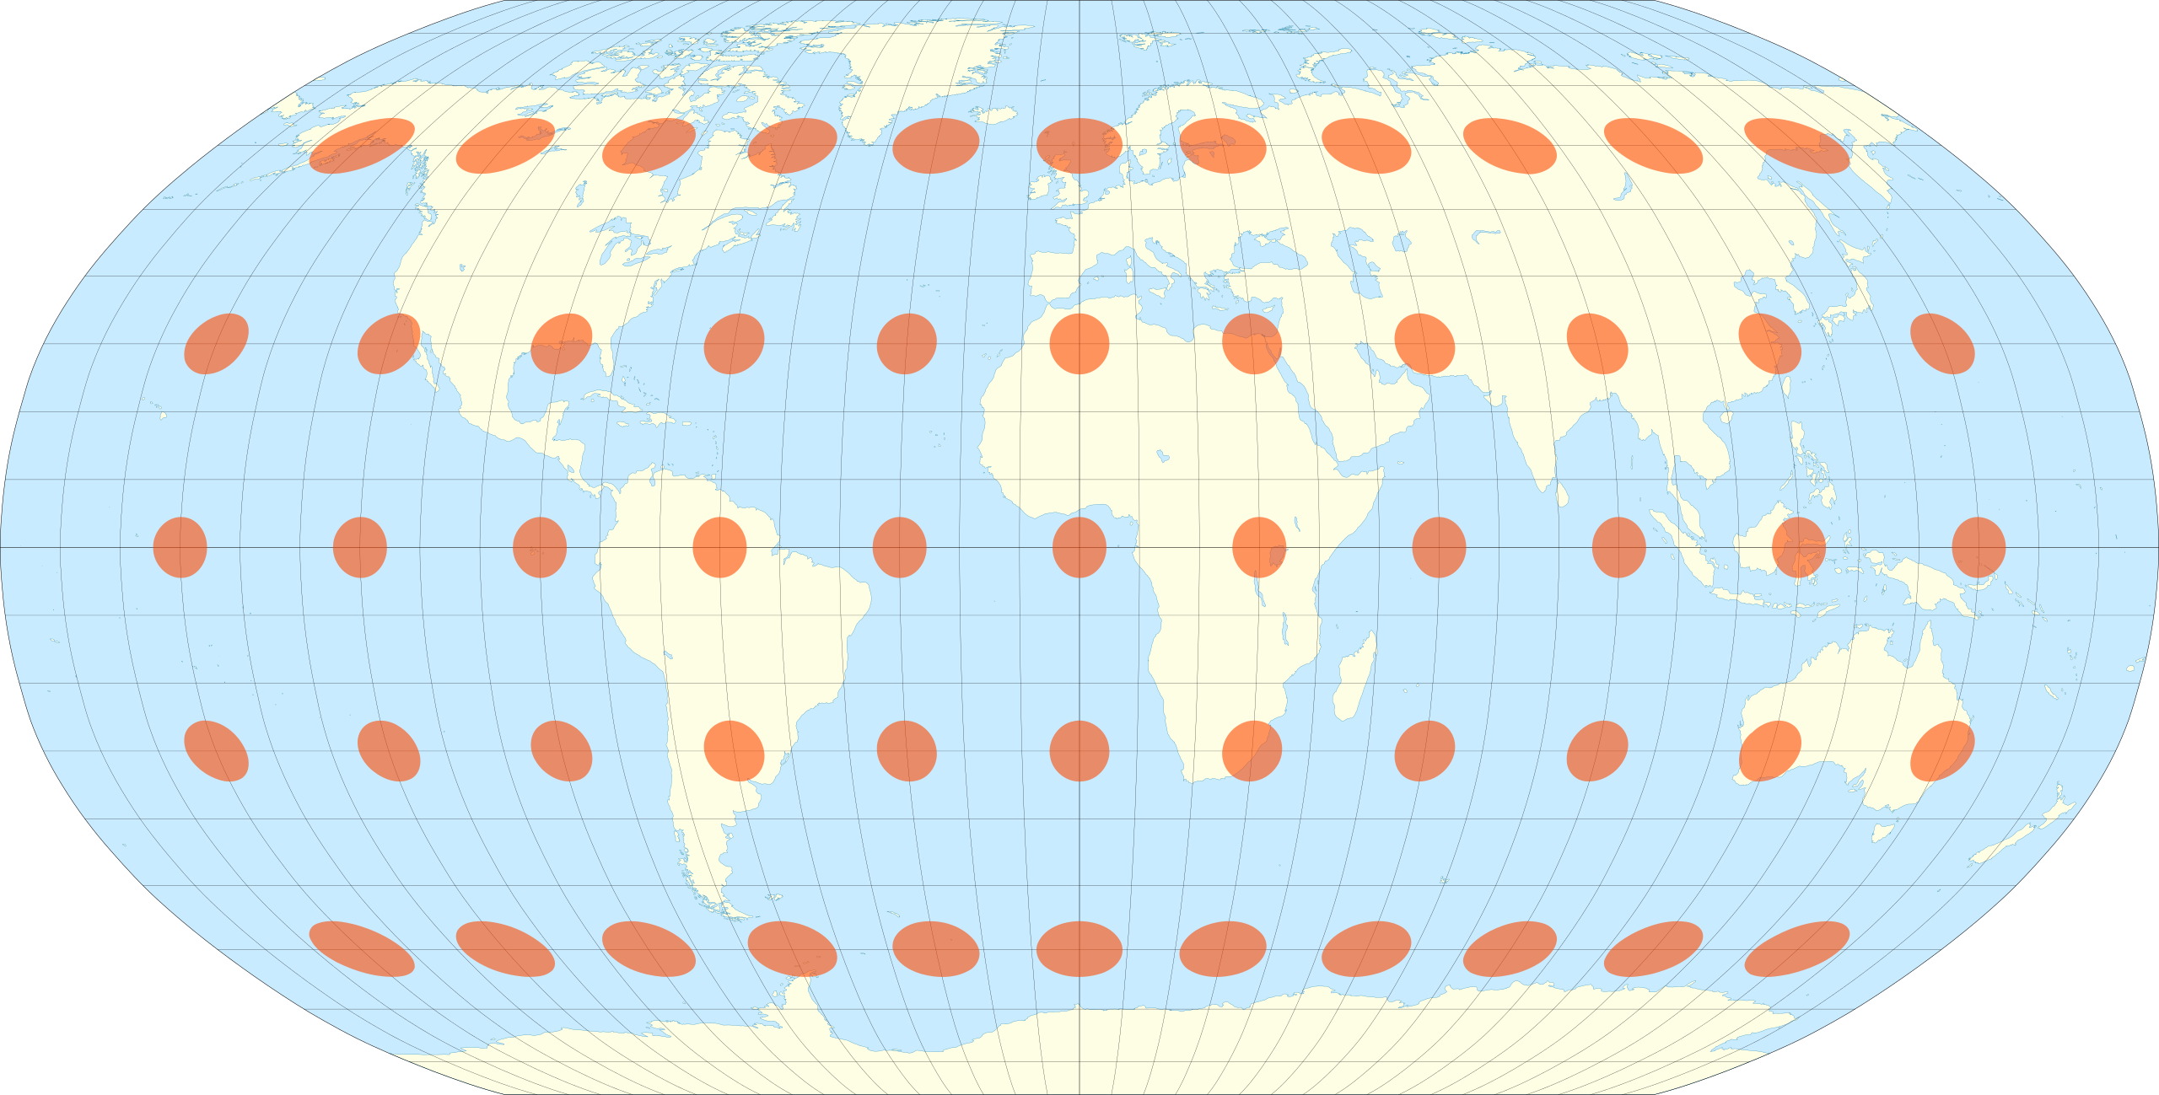

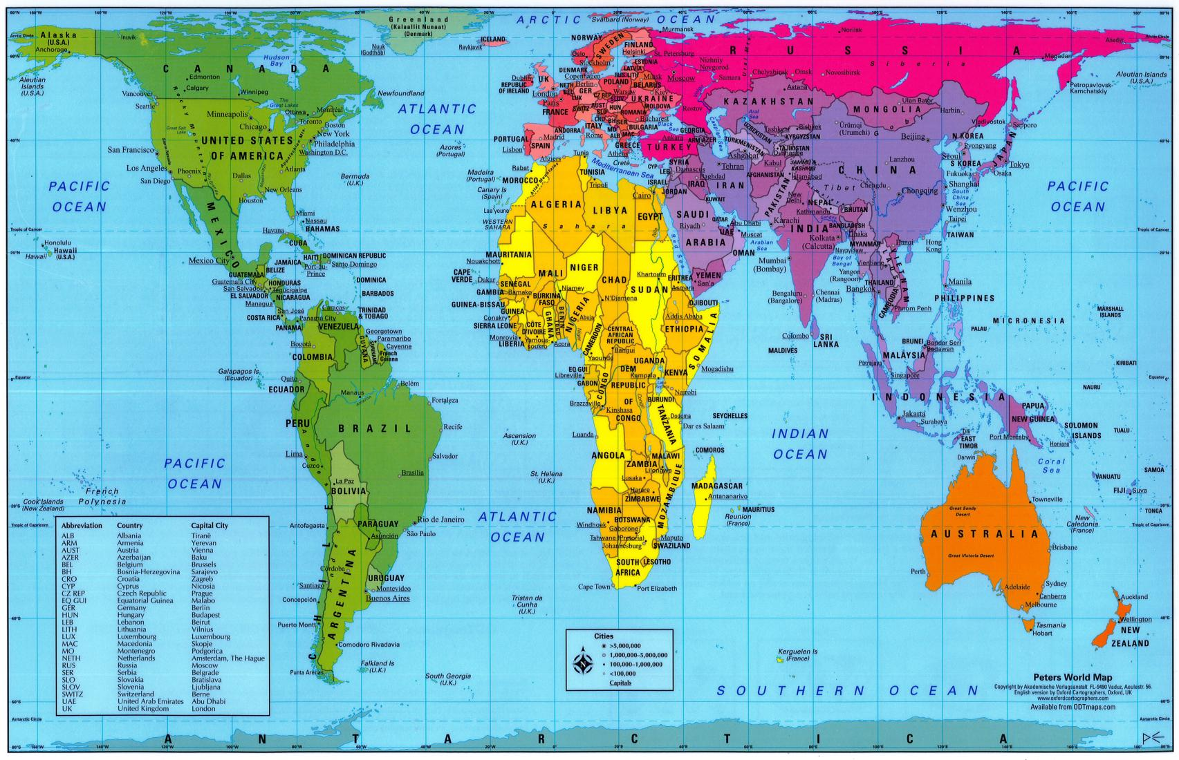
Gall-Peters Projection
Gall-Peters Projection

This type of map was invented by James Gall (from Scotland) in 1851 and later rediscovered by Arno Peters (from Germany) in 1967. In 2017, the Boston Public Schools began became the first school system in the United States to adopt this map in all classrooms.

PROS
It shows the correct ratios of land mass across the Earth. This means that it shows the exact size of one continent versus another.

CONS
It cannot be used for navigation, because it does not show the true shape of every country (as the Mercator Projection would).

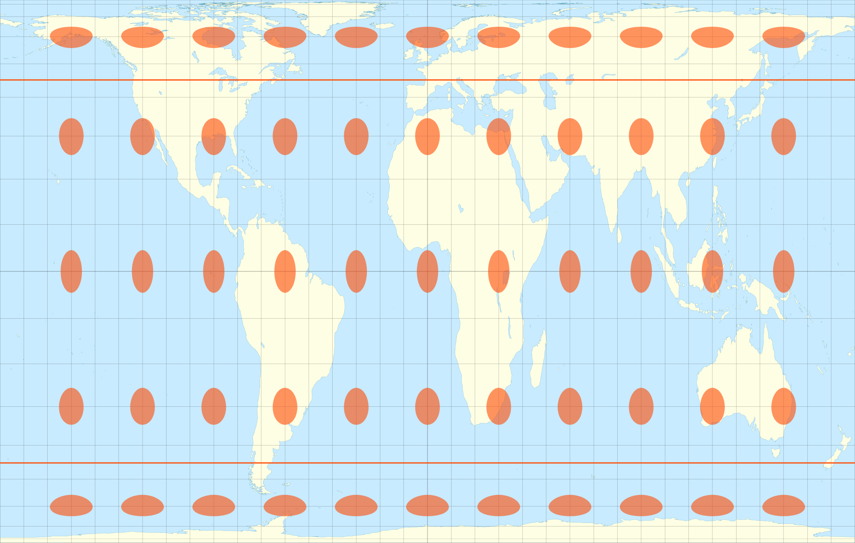
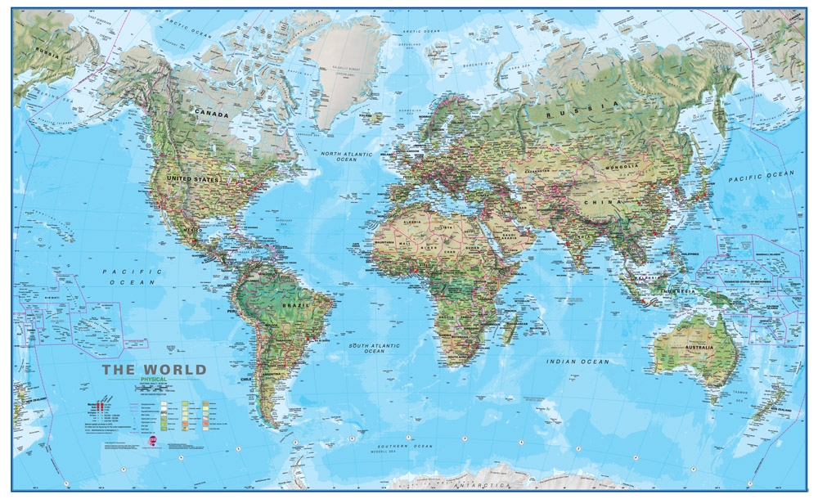
Atlantic-Centric Projection
Physical Map
Atlantic-Centric Projection
Physical Map

This type of map is an Atlantic-Centric physical map. This map places the Atlantic Ocean at the center of the world. It also shows terrain types (i.e. mountains, plains, rives, forests).

PROS
It is most commonly used by people in the Americas, Europe, and Africa. It shows the areas where they often trade goods over the ocean. It can show you the elevation (how high or low) the land and water are, as well as where you can find different terrain types.

CONS
Europe is at the center and top of the Earth, when there is no true center or top of the Earth. It cuts the Pacific Ocean in half.

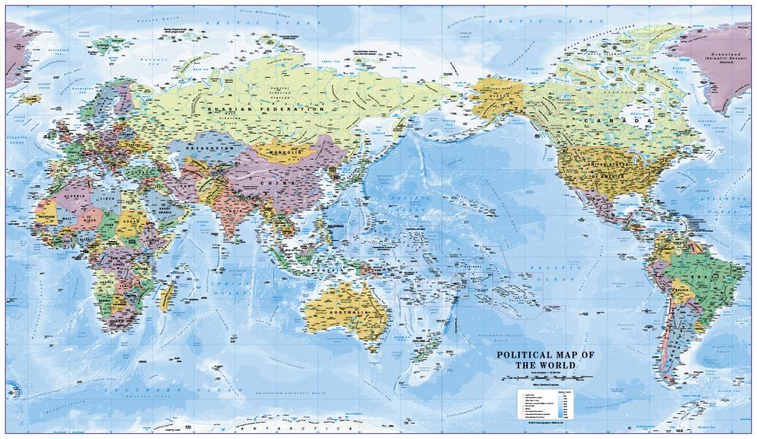
Pacific-Centric Projection
Political Map
Pacific-Centric Projection
Political Map

This type of map is a Pacific-Centric political map. This map places the Pacific Ocean at the center of the world. It also shows the boundaries of each country and makes them a separate color.

PROS
It is most commonly used by people in Asia. It shows the areas where they often trade goods over the ocean. It shows country’s boundaries, so you where they start and end.

CONS
Asia is at the center and top of the Earth, when there is no true center or top of the Earth. It cuts the Atlantic Ocean in half.

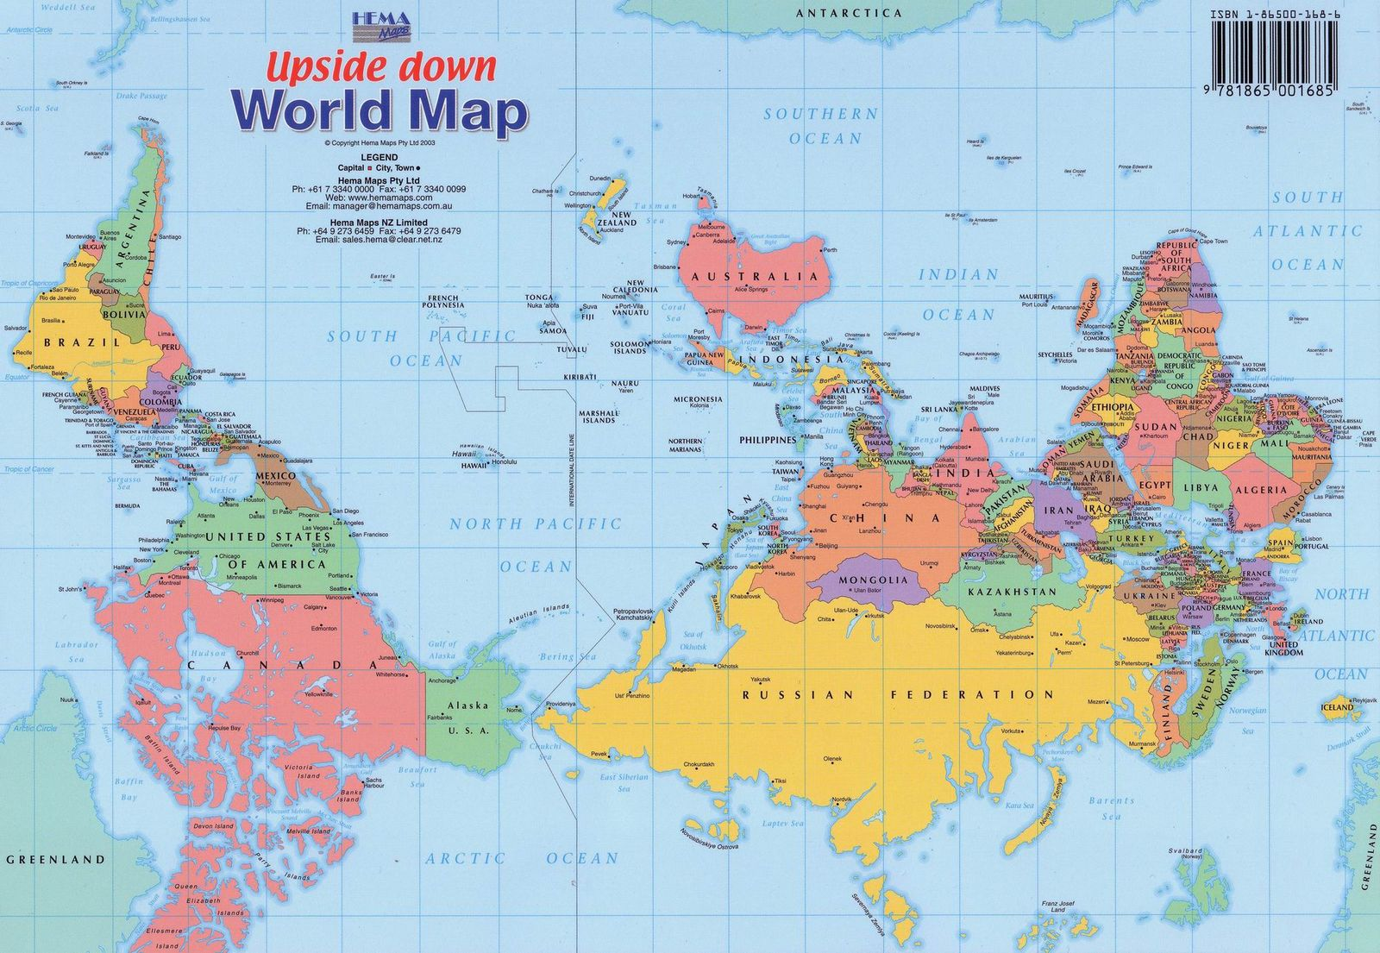
Southern Hemisphere-Top Projection
Southern Hemisphere-Top Projection
[South Up]

This type of map is a Southern Hemisphere-Centric Projection or South Up Map. This map places the Southern Hemisphere at the top of the world. Since most of the world’s land is in the Northern Hemisphere, most map makers have put that at the top.

PROS
This map makes you question what is up and what is down on a map. Since there is no true up or down in space, this map reminds us of that.

CONS
The Southern Hemisphere is at the top of the Earth, when there is no true top of the Earth.

WORKSHEET: 4-2.B

Note Taking Sheet

Map 1: Mercator Projection

What locations are at the center and top of this map? How does this look the same or different than maps you are using to looking at? Which maps do you think are more or less helpful (and for who)?

Map 2: Robinson Projection

What locations are at the center and top of this map? How does this look the same or different than maps you are using to looking at? Which maps do you think are more or less helpful (and for who)?

Map 3: Gall-Peters Projection

What locations are at the center and top of this map? How does this look the same or different than maps you are using to looking at? Which maps do you think are more or less helpful (and for who)?

Map 4: Atlantic-Centric

What locations are at the center and top of this map? How does this look the same or different than maps you are using to looking at? Which maps do you think are more or less helpful (and for who)?

Map 5: Pacific-Centric

What locations are at the center and top of this map? How does this look the same or different than maps you are using to looking at? Which maps do you think are more or less helpful (and for who)?

Map 6: Southern Hemisphere-Centric

What locations are at the center and top of this map? How does this look the same or different than maps you are using to looking at? Which maps do you think are more or less helpful (and for who)?

ASSESSMENT: 4-2.C

Map Perspectives: Exit Ticket

Inquiry Question: Which map is best?

Choose the one map from the carousel that you think best represents the Earth. You may consider qualities like most useful, fairness, accuracy, or other reasons. Include three pieces of evidence from the sources.

LESSON PLAN 4-3: Africa: Where Humans Began

MATERIALS

The First Human Video (Lesson4-3Video1) [Located in the UOW Video Library: www.christophercmartell.com/understandingourworld]
Source 1: Tools (WORKSHEET 4-3.A)
Source 2: Fire! (WORKSHEET 4-3.B)
Source 3: Y Chromosome Adam: Everyone’s Ancestor (WORKSHEET 4-3.C)
Source 4: Agricultural (WORKSHEET 4-3.D)
Africa: Where Man Began: Exit Ticket (ASSESSMENT 4-3.E)

STANDARDS

Massachusetts History and Social Science Framework

MA-HSS.4.CS.1: Use map and globe skills to determine absolute locations (latitude and longitude) of places studied. (G)

MA-HSS.7.1: Describe the great climatic and environmental changes that shaped the earth and eventually permitted the growth of human life. (H)

MA-HSS.7.4: Explain the importance of the invention of metallurgy and agriculture (the growing of crops and the domestication of animals). (H)

Common Core: Literacy

CCSS.ELA-Literacy.RI.4.9: Integrate information from two texts on the same topic in order to write or speak about the subject knowledgeably.

CCSS.ELA-Literacy.RI.4.10: By the end of year, read and comprehend informational texts, including history/social studies, science, and technical texts, in the grades 4–5 text complexity band proficiently, with scaffolding as needed at the high end of the range.

CCSS.ELA-Literacy.W.4.8: Recall relevant information from experiences or gather relevant information from print and digital sources; take notes and categorize information, and provide a list of sources.

CCSS.ELA-Literacy.W.4.9: Draw evidence from literary or informational texts to support analysis, reflection, and research.

PROCEDURES

Inquiry Question: What was the most important event of early humans in Africa?

A. OPENER (10 minutes)

1. Watch First Human Video
Show the students a short video on the first human in Africa 160,000-70,000 years ago (Lesson4-3Video1). Ask the students if they were surprised to learn that all humans came from one person? Are you surprised to learn that all humans were originally from Africa? What did the video tell us help humans spread all over the world? Solicit students’ responses to these questions.

Tell students that today we are going to study the beginning of man in Africa.

B. DEVELOPMENT (20 minutes)

2. Read About the Different Events of Early Humans in Africa
Put students in small groups and assign them one of the sources: Tools (WORKSHEET 4-3.A), Fire! (WORKSHEET 4-3.B), Y Chromosome Adam: Everyone’s Ancestor (WORKSHEET 4-3.C), Agricultural (WORKSHEET 4-3.D). Have one student from each group read their source. As the student reads, tell the other group members to underline or highlight any important information.

3. Engage in a Jig Saw About Early Humans in Africa
Have students participate in a jig saw activity. Make new groups where at least one student from each of the original groups is included. This will create several new groups of three students, one is an expert on 4-3.A, 4-3.B, 4-3.C, 4-3.D. Have each student describe their document to the other members of their group.

Ask students to use the sources to answer the following inquiry question: “What was the most important event of early humans in Africa?” In answering this question, students should debate between the four different worksheets. After students have discussed the question, they should complete the exit ticket in the following step. Circulate the room, helping the students who may have difficulty choosing one asset.

C. CLOSING (15 minutes)

4. Write Up Argument on the Early Humans in Africa
For the evaluation task, have the students complete the exit ticket (ASSESSMENT 4-3.E), where they write their own personal response to the lesson’s Inquiry Question: “What was the most important event of early humans in Africa?” Tell students to cite at least three pieces of evidence from the sources for this lesson.

Before using the exit ticket, consider using a graphic organizer or two column notes to prepare students for the writing task. Consider using sentence starters and modeling to help the students with their answer to the inquiry question.

EVALUATION

ASSESSMENT 4-3.D

What to look for?

The students should take a stance on the most important event of early humans. All arguments should cite at least 3 pieces of evidence from the sources.

Some information that students may include in their answer to the question:

Tools
- By eating meat from animals, the first humans were able to grow stronger due to the proteins and nutrients in meat.
- Unlike many plants, most meat does not include toxins (so it was a safer food), but it does spoil faster than plants.
- Meat is also more quickly digested, so the body can save energy for the brain and other organs.
- Hunting mean can also be dangerous and many humans were killed during hunts.

Fire!
- Fire gave humans warmth during the cold.
- It helped protect them from other animals.
- It helped them stay awake for longer amounts of time.
- It helped them cook their food (which meant food would be safer to eat, as heat killed deadly parasites).
- Fire allowed humans to settle in one place. This had a positive impact on families (moving around all the time could be difficult) and helped create languages (spending time in one place allowed time for humans to speak to one and other).
- Fire may have also lead to the first human art works, as many were cave drawings done with soot from a fire.

Y Chromosome Adam: Everyone’s Ancestor
- All humans are descendant from a male in Africa (Y Chromosome Adam)
- Humans migrated within and outside Africa. This migration made humans a diverse species.
- Over time, the environment influenced skin color and eye shape.

Agricultural
- About 23,000-12,000 years ago, man began to farm (agriculture).
- Before humans farmed, people needed to travel to follow the animals and plants that were their food; humans could now settle in one place and form communities.
- Humans started to grow plants and animals around the same time. They also used those animals for work.
- Farming also allowed humans to move into colder climates. It allowed them to grow food and store it for winter. Also, having more stable food allowed humans to better survive, as they were not always having periods of starvation.

WORKSHEET: 4-3.A

Source 1: Tools

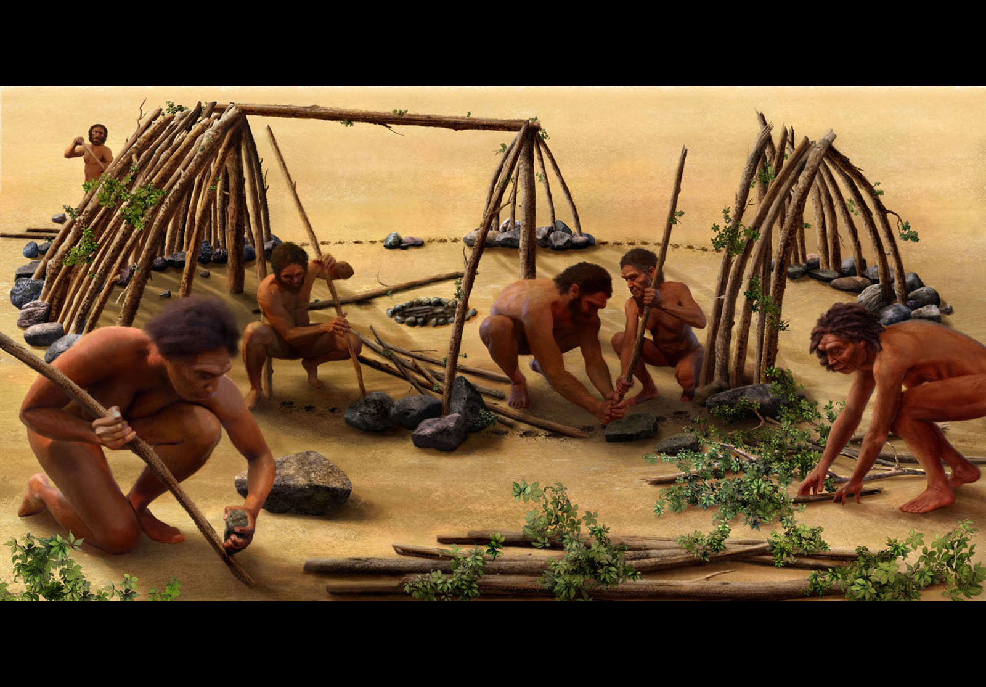

About 2.6 million years ago, the first humans in Africa used stones to strike other stones and produce sharp flakes. These early humans used these tools to cut, pound, crush, and access new foods, including meat from large animals.

By eating meat from animals, the first humans were able to grow stronger due to the proteins and nutrients in meat. Unlike many plants, most meat does not include toxins (so it was a safer food), but it does spoil faster than plants. Meat is also more quickly digested, so the body can save energy for the brain and other organs. Hunting mean can also be dangerous and many humans were killed during hunts.

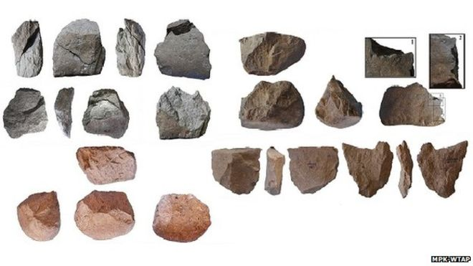

Above are examples of rock flakes that pound and crush. For much or early human history, the tools were primitive. Around 700,000 years ago, humans began to create hand axes, spears, and later bows and arrows.

WORKSHEET: 4-3.B

Source 2: Fire!

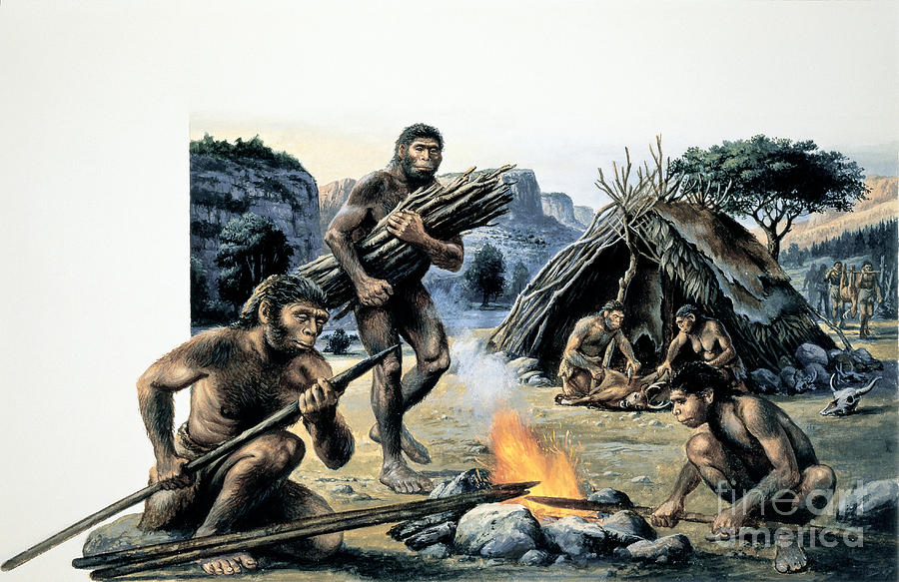

About 600,000 years ago humans were first able to create and control fire. Fire not only gave humans warmth during the cold, but it also helped protect them from other animals, stay awake for longer amounts of time, and cook their food (which meant food would be safer to eat, as heat kills deadly parasites).

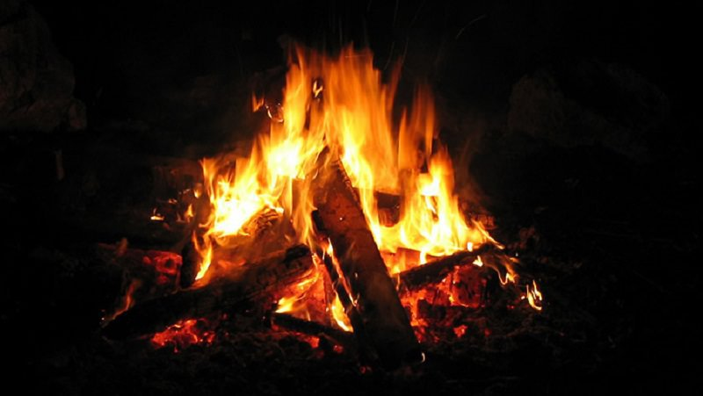

Fire also allowed humans to settle in one place. This had a positive impact on families (moving around all the time could be difficult) and helped create languages (spending time in one place allowed time for humans to speak to one and other). Fire may have also lead to the first human art works, as many were cave drawings done with soot from a fire.

WORKSHEET: 4-3.C

Source 3: Y Chromosome Adam: Everyone’s Ancestor

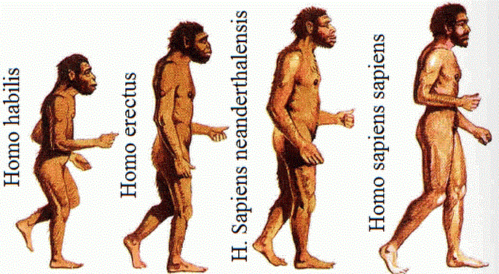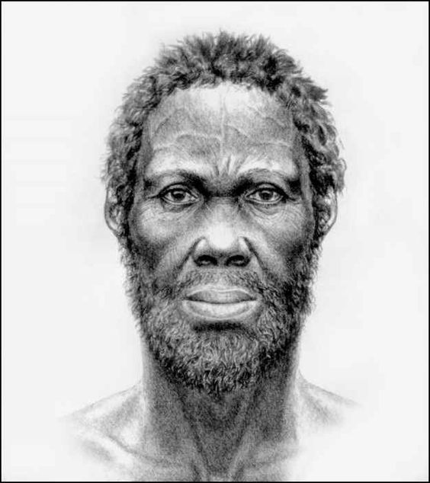

For millions of years there were several different types of hominins (man-like animals), including homo erectus, Neanderthals, and homo sapiens or humans (which is the species that you belong to). With the discovery of DNA, we can now scientifically trace the dates and locations of the first humans to East Africa. About 140,000 years ago, homo erectus went extinct (all died and the species no longer exists) and 40,000 years ago, Neanderthals went extinct. Homo sapiens (humans) were the only hominins left on Earth.

Scientists think that the first male human existed about 200,000 years ago. Scientists have nicknamed him “Y Chromosome Adam,” which is a reference to the Jewish, Christian, and Muslim creation story of Adam and Eve (there is a drawing of what he may have looked like above right). All modern humans are descendants from Y Chromosome Adam.
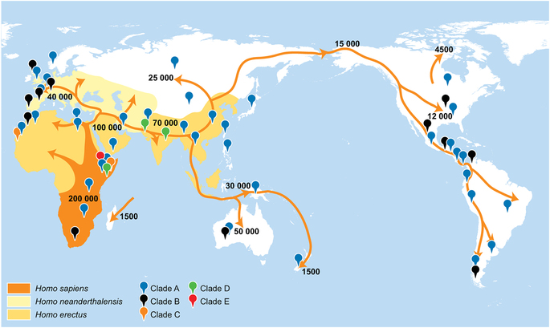

About 60,000 years ago humans first migrated out of Africa. Scientist think this happened just after an event that almost made them go extinct.

The above map shows the locations where those early humans settled, the number of years ago when they settled there, and their common ancestors (Clade A, B, C, D, E). When humans arrived in places like Central Asia and Europe, they encountered other Neanderthals and today most non-Africans have some Neanderthal DNA.

This migration also made humans a diverse species. Over time, the environment influenced skin color and eye shape. Some people developed eyes lids with skin folds or lighter skin, hair, and eye color.
WORKSHEET: 4-3.D

Source 4: Agricultural

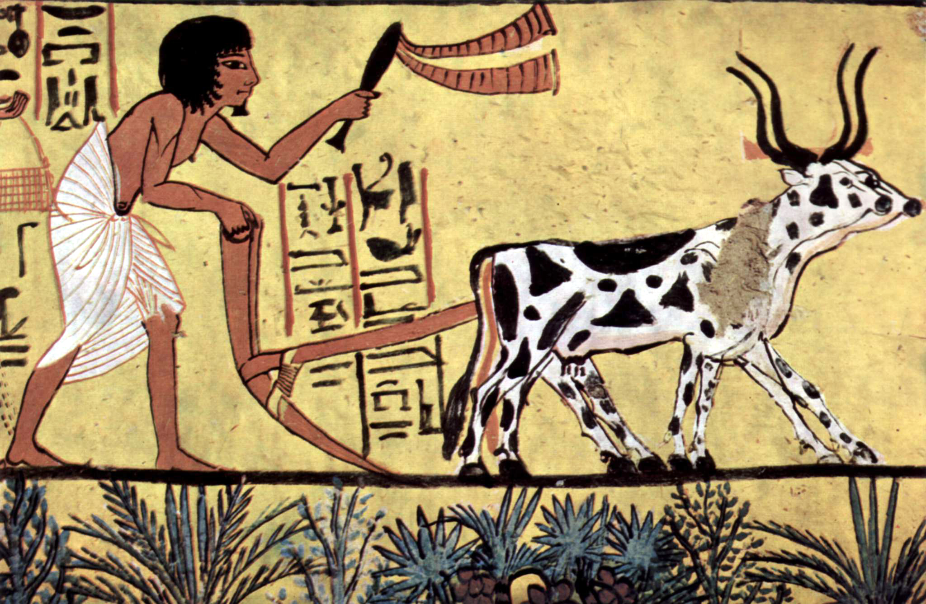

About 23,000-12,000 years ago, man began to farm (agriculture). Before humans farmed, people needed to travel to follow the animals and plants that were their food. This allowed humans to settle in one place and form communities. They began to build walls around their home areas to protect themselves. Humans started to grow plants and animals around the same time. They also used those animals for work.

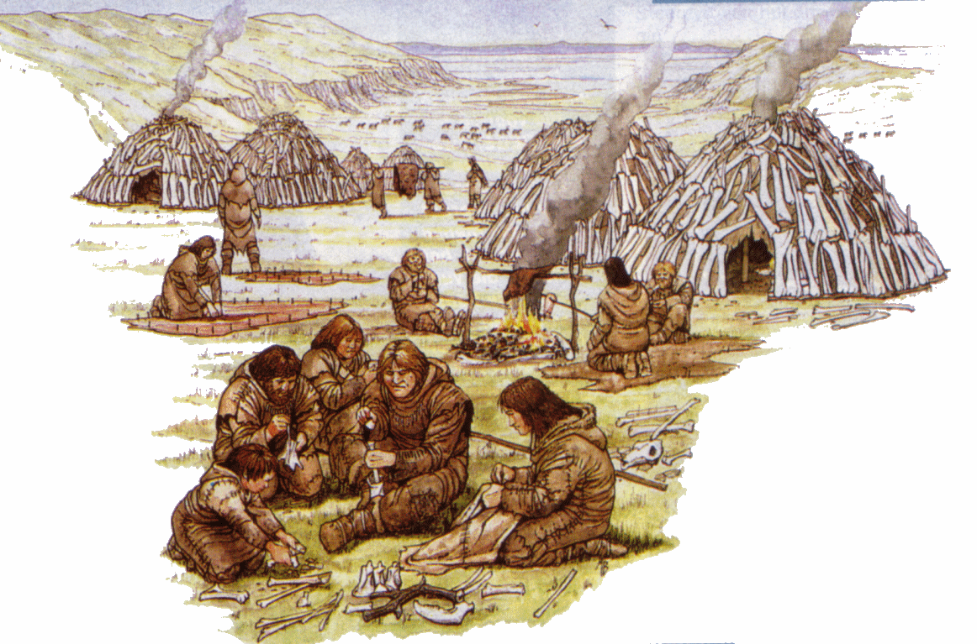

Farming also allowed humans to move into colder climates, like northern Europe, Asia, and America. It allowed them to grow food and store it for the winter. Also, having more stable food sources allowed humans to better survive, as they were not always having periods of starvation.

ASSESSMENT: 4-3.E

Africa: Where Humans Began:
Exit Ticket

Inquiry Question: What was the most important event of early humans in Africa?

Choose one even in early human history and explain why you think it is the most important. Include three pieces of evidence from the sources.

LESSON PLAN 4-4: Ancient Egypt

MATERIALS

Wooden blocks (100 block set is recommended; not supplied)
Blank drawing paper (not supplied)
Ancient Egypt Social Class Cards (WORKSHEET 4-4.A)
Ancient Egypt: Exit Ticket (ASSESSMENT 4-4.B)

STANDARDS

Massachusetts History and Social Science Framework

MA-HSS.4.CS.1: Use map and globe skills to determine absolute locations (latitude and longitude) of places studied. (G)

MA-HSS.7.13: Describe the kinds of evidence that have been used by archaeologists and historians to draw conclusions about the social and economic characteristics of Ancient Nubia (the Kingdom of Kush) and their relationship to the social and economic characteristics of Ancient Egypt. (H, G)

Common Core: Literacy

CCSS.ELA-Literacy.RI.4.9: Integrate information from two texts on the same topic in order to write or speak about the subject knowledgeably.

CCSS.ELA-Literacy.RI.4.10: By the end of year, read and comprehend informational texts, including history/social studies, science, and technical texts, in the grades 4–5 text complexity band proficiently, with scaffolding as needed at the high end of the range.

CCSS.ELA-Literacy.W.4.4: Recall relevant information from experiences or gather relevant information from print and digital sources; take notes and categorize information, and provide a list of sources.

CCSS.ELA-Literacy.W.4.5: Draw evidence from literary or informational texts to support analysis, reflection, and research.

PROCEDURES

Inquiry Question: If you could be in any ancient Egyptian social class, which would you choose and why?

PREPARATION

1. Review the Roles listed on the Ancient Egypt Social Class Card
Carefully review and familiarize yourself with the 5 different roles on the Ancient Egypt Social Class Cards (WORKSHEET 4-4.A) for this lesson.

While the students should receive all of the cards in a packet, you should circle or highlight the card that they have individually been assigned to. The largest number of students should be peasants and workers, with smaller numbers being priests and soldiers, and only one person should be the pharaoh. The gender of the card does not need to be the same as the gender of the student.

A. OPENER (20 minutes)

2. Participate in an Ancient Egypt Social Class Simulation
Tell students that today we are going to pretend we are in Ancient Egypt, which was an Empire in Africa. Each student will represent a specific person who existed in Ancient Egypt: Pharaoh, Priests, Soldiers, Workers, Peasants. Give the students the worksheet titled (with all of the social classes) Ancient Egypt Social Class Cards (WORKSHEET 4-4.A) that describes each social class and their directions. There are five different social class listed on the cards.

Some of the activities students may be asked to do:
- Priests: Pray quietly in a circle. Choose where to build and grow crops.
- Soldiers: Go to war (walk back and forth from two walls of the pharaoh’s choosing).
- Workers: Build pyramid and other building structures.
- Peasants: Grow crops (drawing pictures of wheat).

Tell the students to each read their social class card. Do this one by one until all the students have heard the rules for the five social classes. Next, have them look at their card and underline or highlight their social class and the details of their day-to-day life.

Tell students that they are now in Ancient Egypt and they will need to follow the rules listed under the directions for their social class card.

Have students take part in the social class simulation. They should interact with each other using the directions on their cards.

After the simulation is over, write the names of the five social classes on the board or chart paper. Have students in each social class list what their life was like and take notes about these under each category. After, ask students which people they thought were at the top or had the most power. Ask students which people were at the bottom or had least power (The current order shows most powerful to least powerful: Pharaoh, Priests, Soldiers, Workers, Peasants).

B. DEVELOPMENT (15 minutes)

3. Write Up Argument on the Early Humans in Africa
For the evaluation task, have the students complete the exit ticket (ASSESSMENT 4-4.B), where they write their own personal response to the lesson’s Inquiry Question: “If you could be in any ancient Egyptian social class, which would you choose and why?” Tell students to cite at least three pieces of evidence from the Ancient Egypt Social Class Cards.

Before using the exit ticket, consider using a graphic organizer or two column notes to prepare students for the writing task. Consider using sentence starters and modeling to help the students with their answer to the inquiry question.

C. CLOSING (10 minutes)

4. Share Arguments
Have students share their arguments about social class with the class. Draw comparisons between the different students’ stories and list them on the board or chart paper.

EVALUATION

ASSESSMENT 4-4.B

What to look for?

The students should take a stance on the ancient Egyptian social class that they would want to be a part of. All arguments should cite at least 3 pieces of evidence from the sources.

Some information that students may include in their answer to the question:

Pharaoh (not allowed to write about)

Priests
- They made many choices, where to build buildings or grow food
- Had a lot of power; right under the pharaoh
- Negative: Did not have much freedom over what to eat or wear

Soldiers
- Were respected by many people
- Had more power than workers or peasants
- Negative: Died in war; had to march far distances

Workers
- Did an important and skilled job building things for the empire
- Had more power than peasants
- Did not have to fight in wars
- Could eat and wear whatever they wanted
- Negative: Dies in accidents

Peasants
- Did an important job of growing everyone’s food
- Did not have to fight in wars
- Could eat and wear whatever they wanted
- Negative: Least power

WORKSHEET: 4-4.A

Ancient Egypt Social Class Cards

Pharaoh (only 1 student)

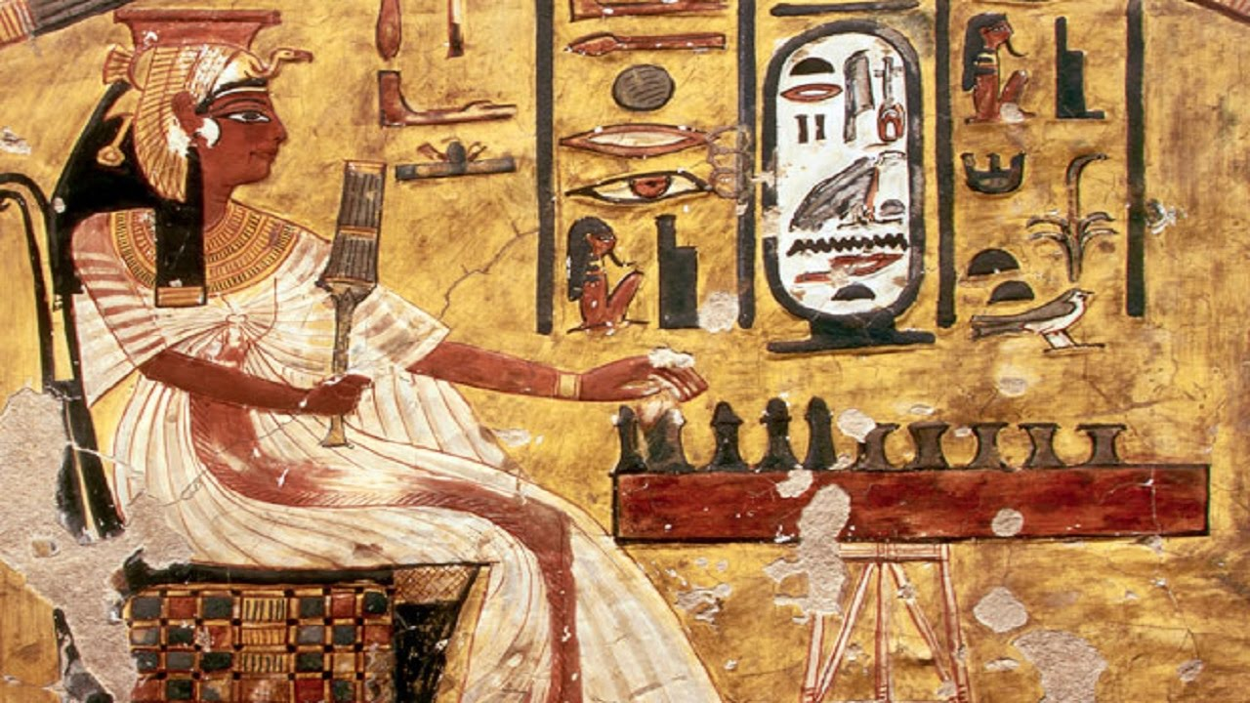

The word pharaoh comes from the Egyptian word for “great house” meaning the royal palace. You are the ruler and control everything in Egypt. You tell everyone what to do.

There were a few women pharaohs, but most were men. In fact, few women actually worked outside the home in Ancient Egypt, as it was something they thought was wrong. Women spent most of their lives taking care of children (although in this activity, to be fair, we will let girls have all the same roles as boys).

At any point, as pharaoh, you may tell the other students to do the following:

Priests: If you want to build a building or grow crops, you must first ask the priest to decide as a group where in the classroom to do this.

Soldiers: Tell the soldiers to invade a nearby empire. When you do this, they will have to walk back and forth from one wall to another wall of the classroom (you choose which two walls).

Workers: Tell all the workers to use the blocks and build you buildings. The best building is a pyramid (see below) and they should build that (priests choose where).

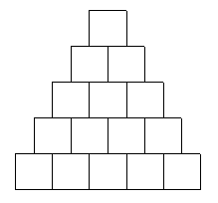

Peasants: Tell all the peasants to grow crops for next year. When they are growing crops (priests choose where they draw), they should take blank drawing paper and draw wheat (see below).
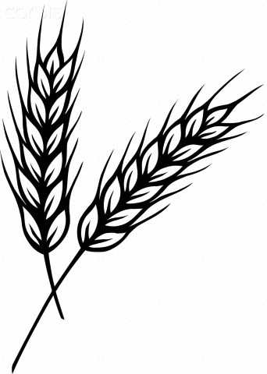
Priests

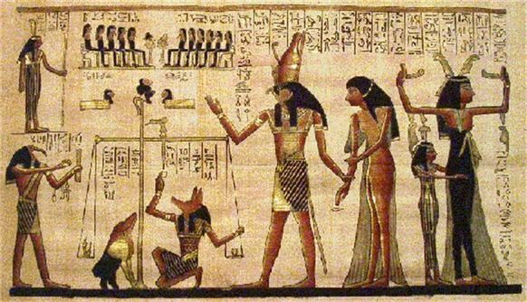

You were very important in Ancient Egyptian society, because you watched the sky, stars, and weather and used it to help the people make decisions. When the Pharaoh asks you, you will choose where to build buildings or plant crops.

The down side is that you cannot eat fish (which was seen as a food only for soldiers, workers, or peasants) or wear any cloth made from animal hair or skin (because animals were unclean). It is only cotton clothes for you (no wool or leather). Also, you must take three or four baths a day to keep yourself clean and pure. Choose one person to keep time and every 2 minutes they tell everyone to take a bath (and pretend to take a bath).

When the Pharaoh is not asking for your advice, you must sit quietly in a circle and pray. You should whisper as a group over and over again the following words (which was a real prayer at the time).
Priests’ Prayer

Nefer em pet!
Pet em hotep
Ta em hotep
Nut jert sat Nut
Sat Geb. Merit Ausar.
Nut jert asha renu!
Anekh herak
Anekh herak
Tu a atu
Tu a atu
Nebet Aset!

Soldiers

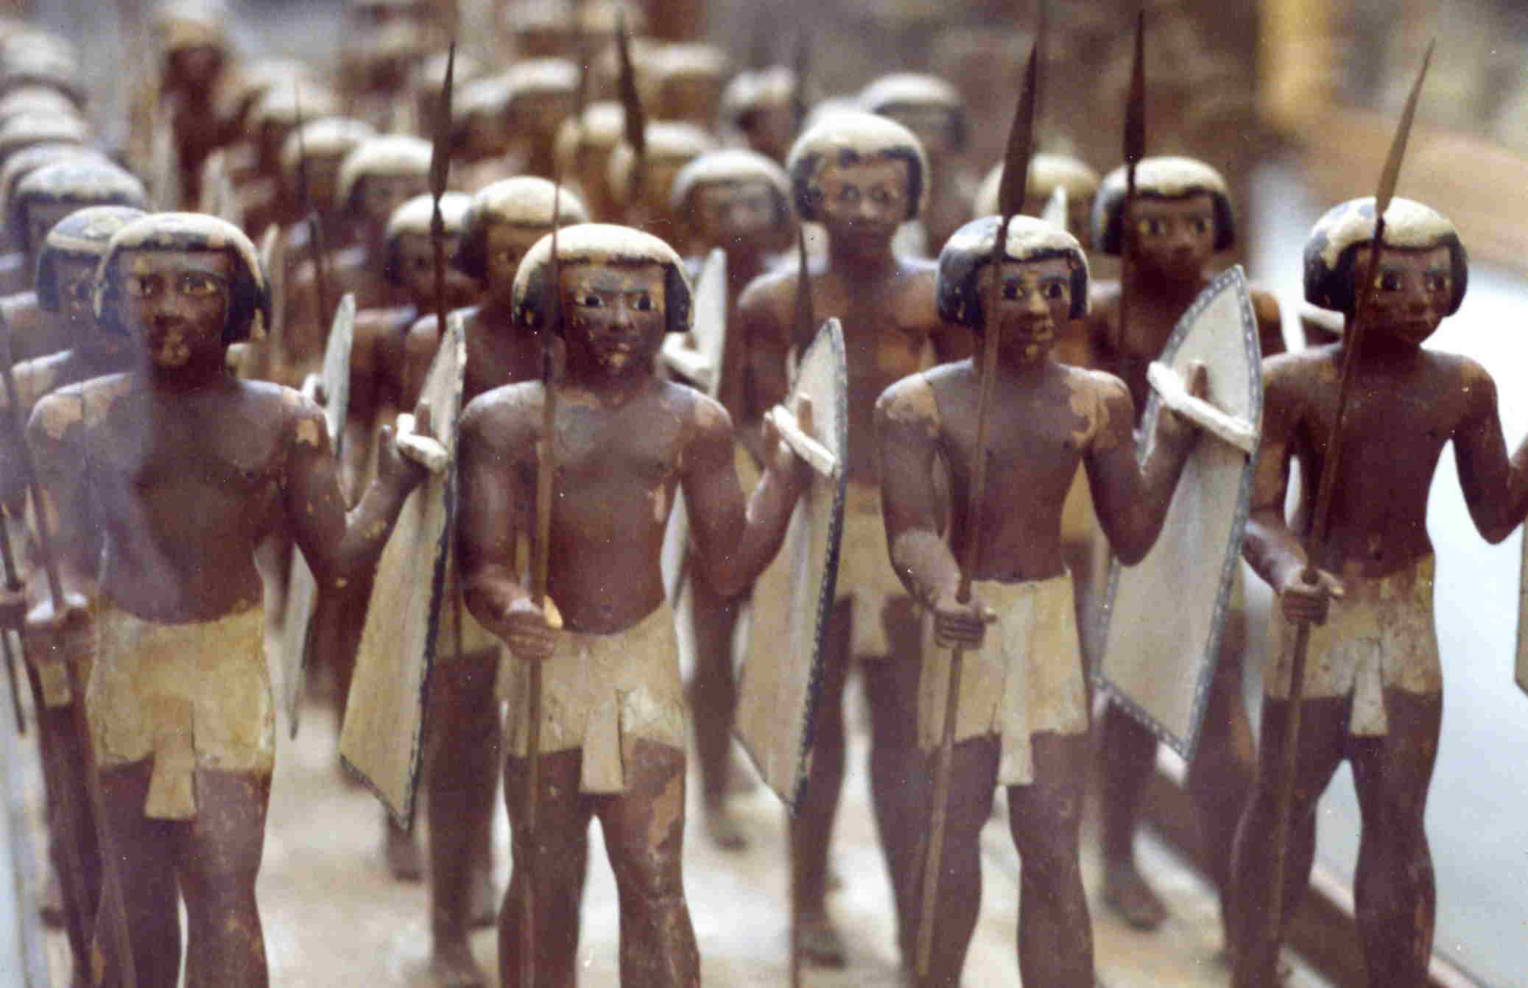

Since you went to war for the empire, soldiers were respected by many people. In the early days, you had few weapons or armor. Over time, they invented helmets, shields, bows and arrows, and spears. Life was difficult during wars and involved marching for many days, weeks, or even months. You were at least feed and paid well.

When the pharaoh orders you to go to war, you will have to walk back and forth between two walls on they tell you to stop.

When you are not at war, you may rest by sitting quietly and watching what the other people in Egypt are doing.

Workers

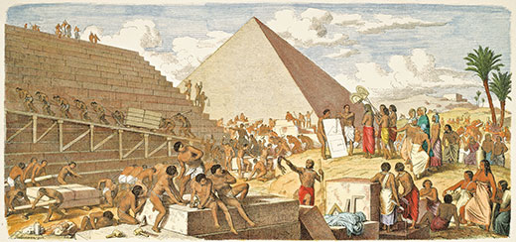

Workers had a more power than peasants, because they had the skills to build things. Your work was tiring and hard. It was also dangerous and workers were often killed in accidents.

When the pharaoh orders you to go to build something, you will have to build whatever they tell you to. You should build the best building, the pyramid (see below).

When you are not building, you may rest by sitting quietly and watching what the other people in Egypt are doing.
Peasants (Farmers)

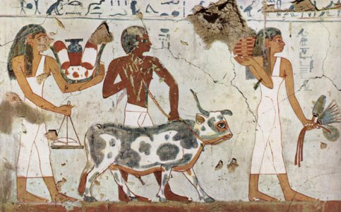

Peasants were very important, because you grew everyone’s food, but you had the least power. Your work was tiring and hard, but not as dangerous as a soldier or worker.

When the pharaoh orders you to grow crops, you will have to draw pictures of wheat (see below).

When you are not growing crops, you may rest by sitting quietly and watching what the other people in Egypt are doing.

ASSESSMENT: 4-4.B

Ancient Egypt:
Exit Ticket

Inquiry Question: If you could be in any ancient Egyptian social class, which would you choose and why?

Choose one social class from Ancient Egypt (but you cannot choose the pharaoh) and explain why you would want to be in that social class. Include three pieces of evidence from the descriptions of each social class.

LESSON PLAN 4-5: The Great African Empires: Ghana, Kongo, Ethiopia, and Zimbabwe

MATERIALS

History of Metal (Lesson4-5Video1) [Located in the UOW Video Library: www.christophercmartell.com/understandingourworld]
Clipboard (not supplied)
Source 1: Ghana (WORKSHEET 4-5.A)
Source 2: Kongo (WORKSHEET 4-5.B)
Source 3: Ethiopia (WORKSHEET 4-5.C)
Source 4: Zimbabwe (WORKSHEET 4-5.D)
Note Taking Sheet (WORKSHEET 4-5.E)
The Great African Empires: Exit Ticket (ASSESSMENT 4-5.F)

STANDARDS

Massachusetts History and Social Science Framework

MA-HSS.4.CS.1: Use map and globe skills to determine absolute locations (latitude and longitude) of places studied. (G)

MA-HSS.WHI.19: Describe important political and economic aspects of the African empires. (H, E)

Common Core: Literacy

CCSS.ELA-Literacy.RI.4.9: Integrate information from two texts on the same topic in order to write or speak about the subject knowledgeably.

CCSS.ELA-Literacy.RI.4.10: By the end of year, read and comprehend informational texts, including history/social studies, science, and technical texts, in the grades 4–5 text complexity band proficiently, with scaffolding as needed at the high end of the range.

CCSS.ELA-Literacy.W.4.8: Recall relevant information from experiences or gather relevant information from print and digital sources; take notes and categorize information, and provide a list of sources.

CCSS.ELA-Literacy.W.4.9: Draw evidence from literary or informational texts to support analysis, reflection, and research.

PROCEDURES

Inquiry Question: If you could live in any ancient African empire, which one would it be and why?

PREPARATION

1. Set Up Carousel Activity
Around the room, post the four sources: Ghana (WORKSHEET 4-5.A), Kongo (WORKSHEET 4-5.B), Ethiopia (WORKSHEET 4-5.C), Zimbabwe (WORKSHEET 4-5.D).

A. OPENER (10 minutes)

2. Watch the History of Metal Video
Show the students a short video describing the invention of metal in Africa (Lesson4-5Video1). After watching the video, ask the students to tell you all the things they can think of that are made of metal. List the items on the board or chart paper. Ask students, why do they think that being able to make metal is important and what would life be like today without metals.

Tell the students that today we are going to study four of the Great African Empires, which were groups of people who were grouped together to form large nations that protected each other and had a single ruler (much like the pharaoh of Ancient Egypt). These empires were able to happen, in part, because of metal. Many of these empires became powerful by trading metals to people in Europe and Asia.

B. DEVELOPMENT (20 minutes)

3. Engage in a Carousel Activity on the Number of Continents
Give each student pencil and clipboard with the Note Taking Sheet (WORKSHEET 4-5.E) on it. Ask students to go to each of the four stations (4-5.A, 4-5.B, 4-5.C, 4-5.D). At each station, the students should take notes on the different Great African Empires.

Once students have gone to each of the four stations, they should return to their seats. Put students in small groups. Have them look at their note sheets and debate which empire they think would be the place where they would want to live.

C. CLOSING (15 minutes)

4. Write Up Argument on the Great African Empires
For the evaluation task, have the students complete the exit ticket (ASSESSMENT 4-5.F), where they write their own personal response to the lesson’s Inquiry Question: “If you could live in any ancient African empire, which one would it be and why?” Tell students to cite at least three pieces of evidence from the sheets on the walls. Tell students that the evidence they use can be something that they wrote on the sheets. Encourage students to get up and look at the sheets on the wall, when they need evidence to write on their sheet.

Before using the exit ticket, consider using a graphic organizer or two column notes to prepare students for the writing task. Consider using sentence starters and modeling to help the students with their answer to the inquiry question.

EVALUATION

ASSESSMENT 4-5.F

What to look for?

The students should take a stance on what ancient African empire they would live in. All arguments should cite at least 3 pieces of evidence from the sources.

Some information that students may include in their answer to the question:

Ghana
- Located in West Africa
- Desert climate with hot and dry year-round with some rain in the winter
- Medium empire (30,000 people)
- Became very rich from mining and trading iron and gold
- Use camels to bring it to other empires across the Sahara Desert
- People lived in large houses with extended family
- Muslims were the largest religious group

Kongo
- Located in Central Africa
- Tropical climate with hot and dry summers, and warm and rainy winters
- Very large empire (500,000 people)
- Empire became very rich from mining and trading iron and copper
- They would sell much of their metals to Europe through ports on the Atlantic
- People lived in small houses with immediate family, but were close to other relatives
- A native religion was the largest religious group

Ethiopia
- Located in East Africa
- Tropical climate with hot and rainy summers, and warm and dry winters
- Small empire (20,000)
- Became very rich from mining and trading iron, gold, and salt (more than just metals)
- They would sell much of their metals to Europe and the Middle East, as they were near the Silk Road (best trade location)
- People lived in small houses with immediate family
- Christianity was the largest religious group

Zimbabwe
- Located in Southern Africa
- Subtropical climate with warm and rainy winters and dry and hot summers
- Small empire (18,000)
- The Zimbabwe Empire became very rich from mining and trading copper, iron, and gold
- Build large granite structures
- People lived in small houses with immediate family
- Shona was the largest religious group

WORKSHEET: 4-5.A

Source 1: Ghana

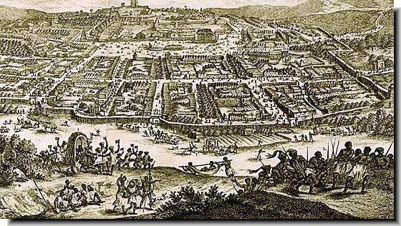

The Ghana Empire was in West Africa (today Mali and Mauritania) and lasted from 400 to 1200 CE. Its capital was a city called ‎Kumbi Saleh (pictured above), which had over 30,000 (about the size of London, England at the time). The climate there is desert with hot and dry year-round with some rain in the winter.

People in the Ghana Empire usually lived with all of their relatives in one big house, including grandparents, uncles, aunts, and cousins. The largest religious group were Muslims. The Ghana Empire had a large army and there were usually well protected. They were known for their art and stories. They may have created the story “Anansi the Spider.”

The Ghana Empire became very rich from mining and trading iron and gold. They would use camels to bring gold and iron across the Sahara Desert to trade with Europe and Asia. One European described the Ghana Empire as, “The King wears necklaces around his neck and bracelets on his forearms and he puts on a high cap decorated with gold. Many people visit him in a domed palace around which stand ten horses covered with gold.”

The below map shows the location of the Ghana Empire in Africa.

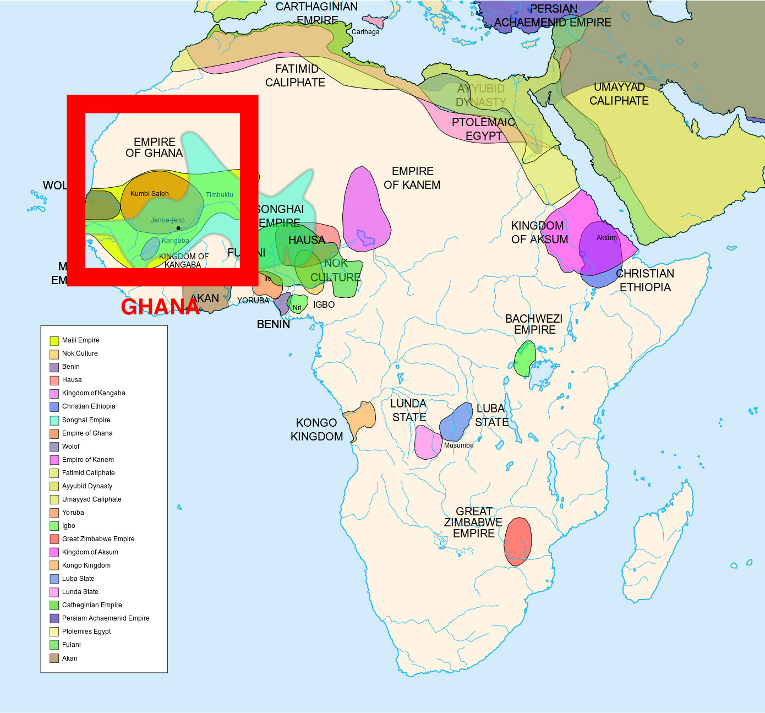
WORKSHEET: 4-5.B

Source 2: Kongo

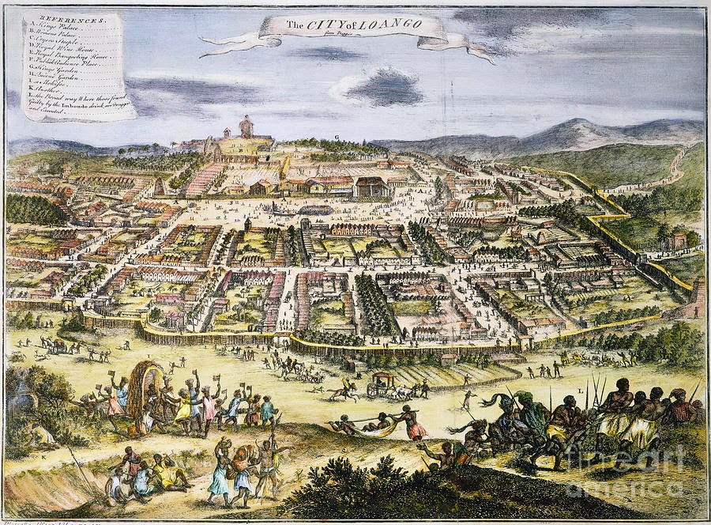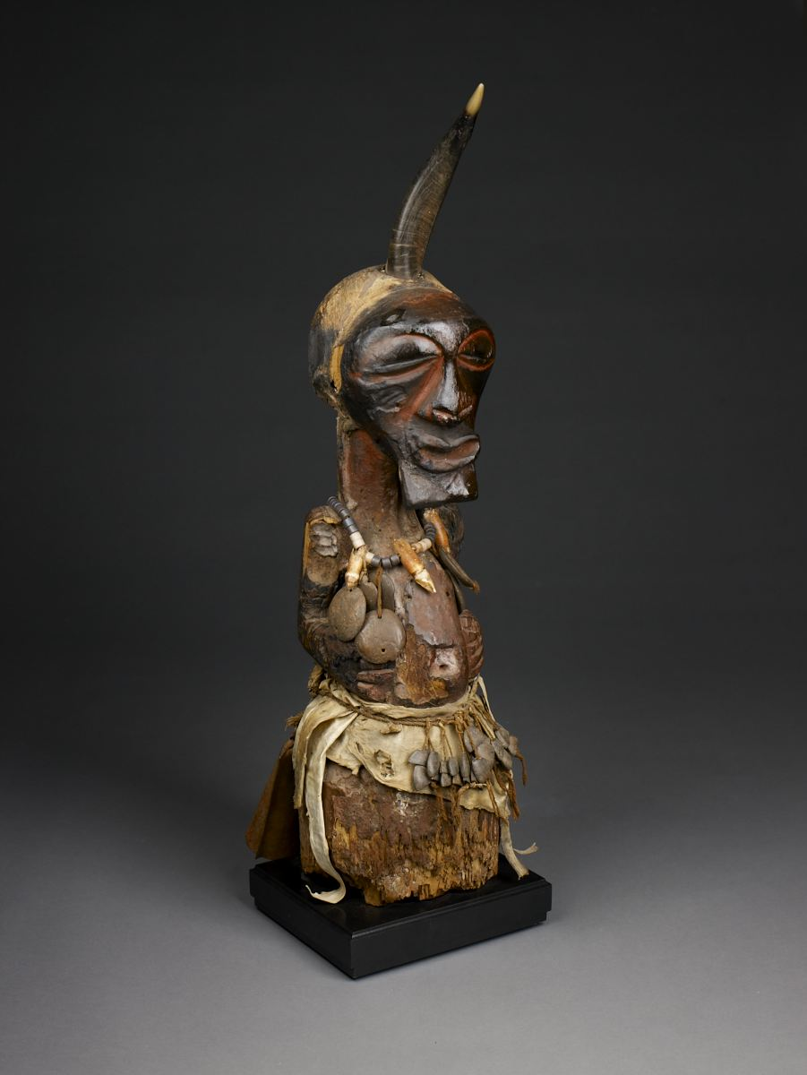

The Kongo Empire was along the Kongo River in Central Africa (today Angola, Republic of the Congo, Democratic Republic of the Congo) and lasted from the 1300s-1800s (the city of Loango is pictured above). The empire had over 500,000 people (about the size of Beijing, China at the time). The climate there is tropical with hot and dry summers, and warm and rainy winters.

People in the Kongo Empire (BaKongo) usually lived in small homes with their families, but they were usually very close to their other family members, like grandparents, uncles, aunts, and cousins. Most people practiced a native religion involving a god or gods. They also used small boats to transport goods up and down the river. They were known for their sculptures called nkisi statues (pictured above).

The Kongo Empire became very rich from mining and trading iron, copper, and ivory. They would sell much of their metals and ivory to Europe who had ports along the Atlantic Ocean. One European described the Ghana Empire as, “There were nine caravans under nine leaders ... The villages we visited were peaceful.”

The below map shows the location of the Kongo Empire in Africa.

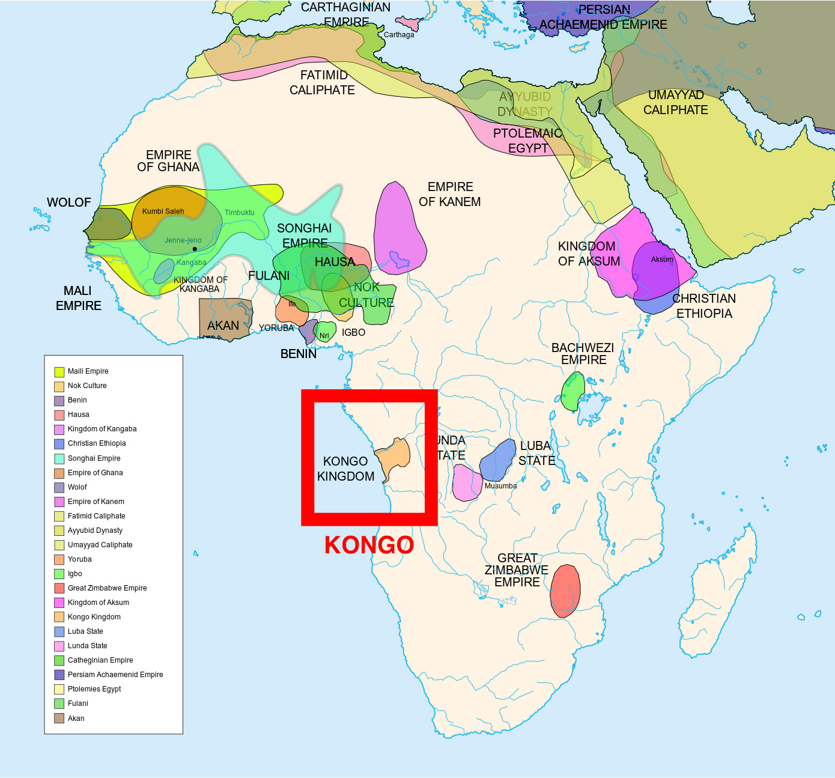
WORKSHEET: 4-5.C

Source 3: Ethiopia

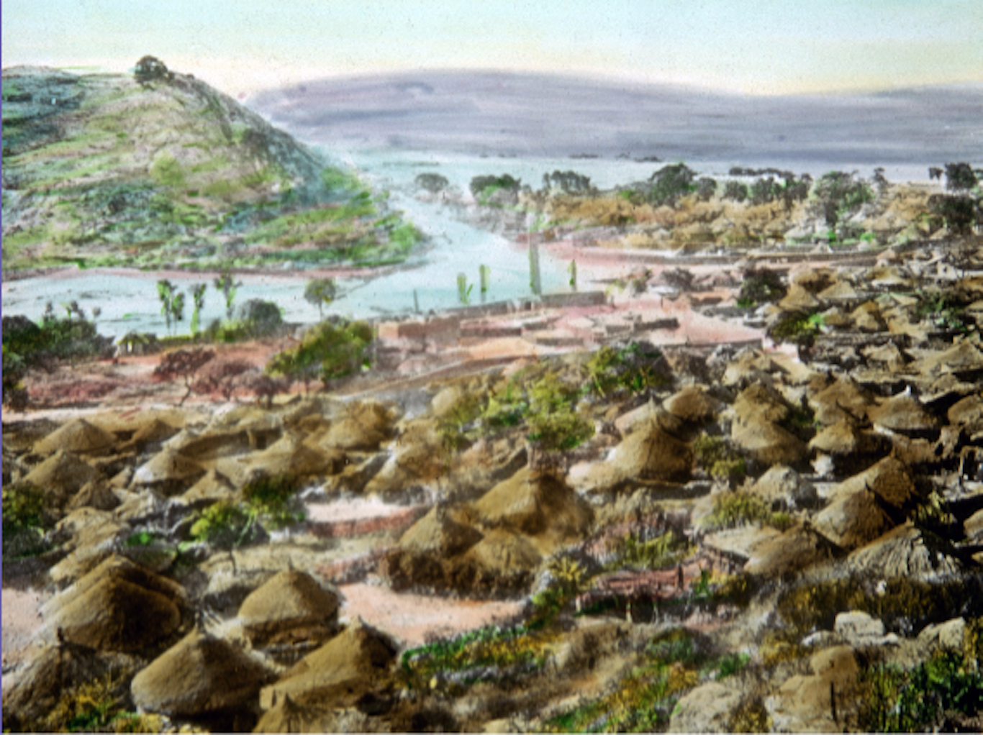

The Ethiopian Empire was in East Africa (today Ethiopia and Eritrea) and lasted from 1100s-1900s. Its capital was a city called ‎Aksum (pictured above), which had 20,000 people (about the size of Rome, Italy at the time). The climate there is tropical with hot and rainy summers, and warm and dry winters.

People in the Ethiopian Empire lived in small homes with their families. Most were farmers or workers. The largest religious group was Christians. They were known for their gold and silver coins, which had pictures of their kings.

The Ethiopian Empire became very rich from mining and trading iron, gold, and salt. They would sell much of their metals to Europe and the Middle East, as they were near the Silk Road. One European described the Ethiopian Empire as, “Among the metals, Ethiopian copper is the most scarce and valuable.”

The below map shows the location of the Ethiopia Empire in Africa.

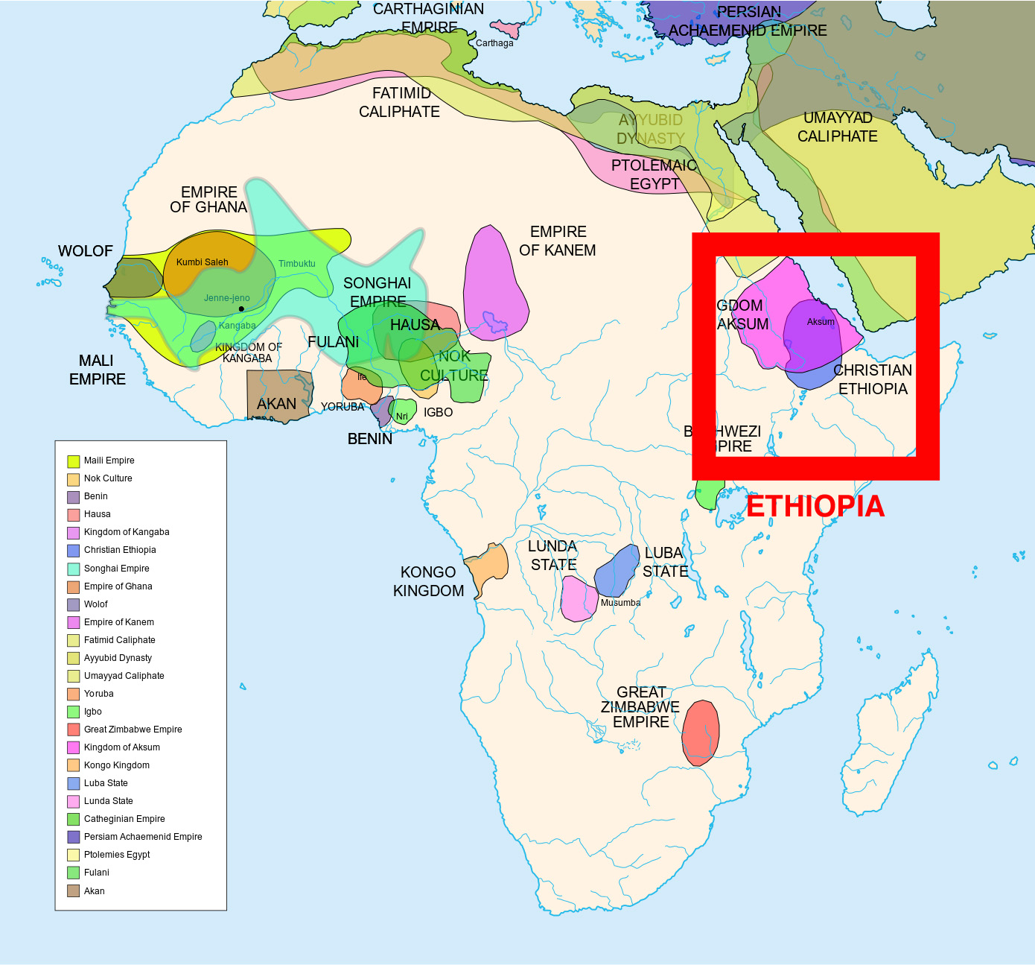
WORKSHEET: 4-5.D

Source 4: Zimbabwe

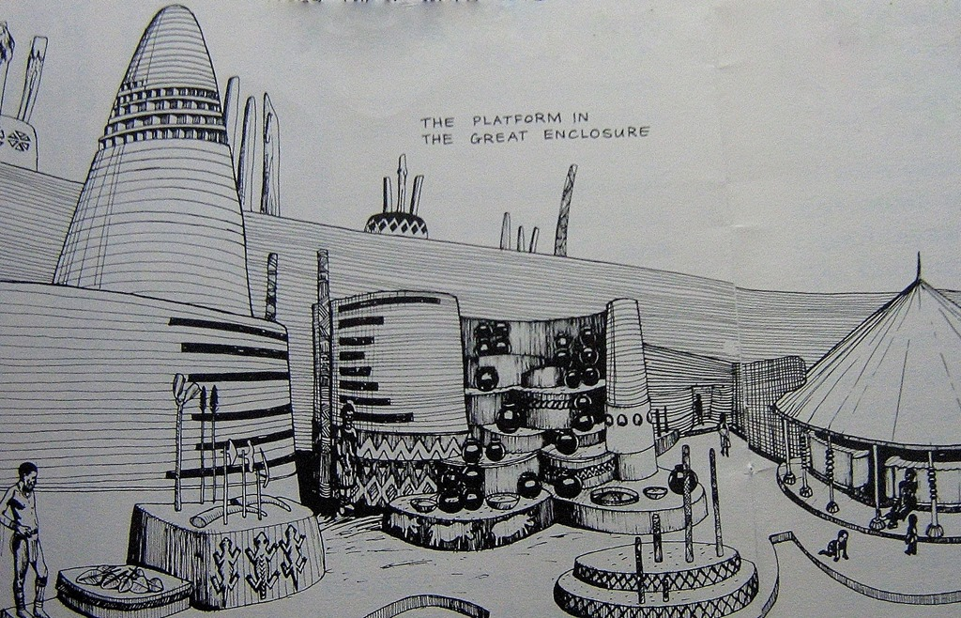

The Zimbabwe Empire was in Southern Africa (today modern-day Zimbabwe) and lasted from 1000s-1500s. Its capital was a city called ‎Great Zimbabwe (pictured above), which had over 18,000 people (about the size of Rome, Italy at the time). The climate there is subtropical with warm and rainy winters and dry and hot summers.

People in the Zimbabwe Empire lived in small homes with their families located around the king’s palace. They probably worshipped Mwari and the Shona religion. They were known for building massive forts from granite stone (which you can still see today and they are some of the oldest buildings in Africa).

The Zimbabwe Empire became very rich from mining and trading copper, iron, and gold. One European described the Zimbabwe Empire as, “Among the gold mines, … there is a fort built of stones of very large size, and there appears to be no mortar cement joining them.”

The below map shows the location of the Zimbabwe Empire in Africa.

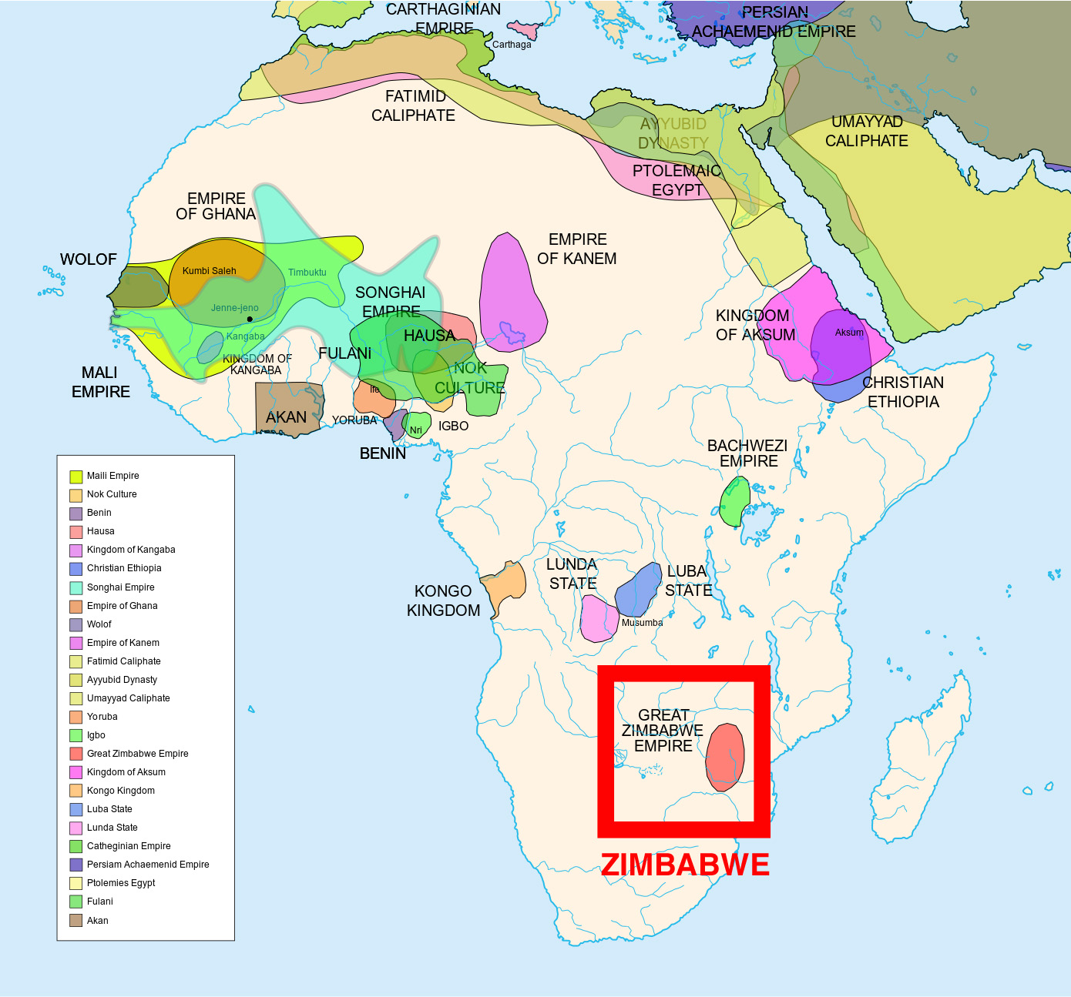

WORKSHEET: 4-5.E

Note Taking Sheet

Source 1: Ghana

What are the most important points about this empire?

Source 2: Kongo

What are the most important points about this empire?

Source 3: Ethiopia

What are the most important points about this empire?

Source 4: Zimbabwe

What are the most important points about this empire?

ASSESSMENT: 4-5.F

The Great African Empires: Exit Ticket

Inquiry Question: If you could live in any ancient African empire, which one would it be and why?

Choose one Great African Empire and explain why you would choose to live there. Include three pieces of evidence from the sources.

LESSON PLAN 4-6: Timbuktu: How Trade Shaped a City

MATERIALS

Images (WORKSHEET 4-6.A)
Source 1: Trade (WORKSHEET 4-6.B)
Source 2: Education (WORKSHEET 4-6.C)
Source 3: Religion (WORKSHEET 4-6.D)
Timbuktu: Exit Ticket (ASSESSMENT 4-6.E)

STANDARDS

Massachusetts History and Social Science Framework

MA-HSS.4.CS.1: Use map and globe skills to determine absolute locations (latitude and longitude) of places studied. (G)

MA-HSS.WHI.19: Describe important political and economic aspects of the African empires. (H, E)

Common Core: Literacy

CCSS.ELA-Literacy.RI.4.9: Integrate information from two texts on the same topic in order to write or speak about the subject knowledgeably.

CCSS.ELA-Literacy.RI.4.10: By the end of year, read and comprehend informational texts, including history/social studies, science, and technical texts, in the grades 4–5 text complexity band proficiently, with scaffolding as needed at the high end of the range.

CCSS.ELA-Literacy.W.4.8: Recall relevant information from experiences or gather relevant information from print and digital sources; take notes and categorize information, and provide a list of sources.

CCSS.ELA-Literacy.W.4.9: Draw evidence from literary or informational texts to support analysis, reflection, and research.

PROCEDURES

Inquiry Question: Why was Timbuktu so important?

PREPARATION

This lesson uses a method called Visual Thinking Strategy (VTS). The key to VTS is that you as a teacher only do two things: (1) Ask the following questions and (2) repeat as precisely as possible exactly what the students say.

Visual Thinking Strategy Questions:
- Open with: “What’s going on in this picture?”
Summarize student responses using conditional language (“Raoul thinks this could be…”). This keeps the conversation open to other interpretations by other students.
- If appropriate: “What do you see that makes you say that?”
This encourages students to back up their statements with things they see in the work of art.
- Ask the group: “What more can we find?”
This continues the conversation.

If this is your first time using VTS, I would recommend reading this description (with a video example from Grade 1) of it from the Milwaukee Art Museum: http://teachers.mam.org/collection/teaching-with-art/visual-thinking-strategies-vts/

A. OPENER (10 minutes)

1. Engage in a Visual Thinking Strategy (VTS) on Timbuktu Images
Give students Images (WORKSHEET 4-6.A). Do not reveal that these are images of Timbuktu or Africa. Project the first image (Lettered “A”) and tell the students to look at the image closely and quietly. Give them about one minute. Next, begin the VTS question about the image. Use the above questions, following VTS instructions. Have students inquire about the question using the above questions for about 2-3 minutes.

Project the second image (Lettered “B”) and tell the students to look at the image closely and quietly. Give them about one minute. Next, begin the VTS question about the image. Use the above questions, following VTS instructions. Have students inquire about the question using the above questions for about 2-3 minutes.

Tell students that today we will be learning about the city of Timbuktu in Africa. It was the heart of trade with many goods being transported through it. Picture A was a picture from today of the Mosque in the center if the city and Picture B was what the city looked like hundreds of years ago. You had many good observations of the pictures. From the pictures, what do you think life was and is like in Timbuktu? Anticipated responses may include: it is in a desert, it was very large, some people there are Muslim (Mosque), it was very important. Tell the students that we will learn today about the many different parts of Timbuktu and it will have to decide what was most important.

B. DEVELOPMENT (20 minutes)

2. Read About the Different Parts of Timbuktu
Put students in small groups and assign them one of the sources: Trade (WORKSHEET 4-6.B), Education (WORKSHEET 4-6.C), Religion (WORKSHEET 4-6.D). Have one student from each group read their source. As the student reads, tell the other group members to underline or highlight any important information.

3. Engage in a Jig Saw About Timbuktu
Have students participate in a jig saw activity. Make new groups where at least one student from each of the original groups is included. This will create several new groups of three students, one is an expert on 4-6.B, 4-6.C, 4-6.D. Have each student describe their document to the other members of their group.

Ask students to use the sources to answer the following inquiry question: “Why was Timbuktu so important?” In answering this question, students should debate between the four different worksheets. After students have discussed the question, they should complete the exit ticket in the following step. Circulate the room, helping the students who may have difficulty choosing one asset.

C. CLOSING (15 minutes)

4. Write Up Argument on the Most Important Part of Timbuktu
For the evaluation task, have the students complete the exit ticket (ASSESSMENT 4-6.E), where they write their own personal response to the lesson’s Inquiry Question: “Why was Timbuktu so important?” and choose the part they think was most important. Tell students to cite at least three pieces of evidence from the sources for this lesson.

Before using the exit ticket, consider using a graphic organizer or two column notes to prepare students for the writing task. Consider using sentence starters and modeling to help the students with their answer to the inquiry question.

EVALUATION

ASSESSMENT 4-6.E

What to look for?

The students should take a stance on why Timbuktu was so important. All arguments should cite at least 3 pieces of evidence from the sources.

Some information that students may include in their answer to the question:

Trade
- It was a center of trade in Africa, selling sugar, nuts, salt, cloth, books, and glass.
- It became one of the wealthiest cities in the world.
- It had goods from all over the world.

Education
- Important place for schools and learning.
- Libraries had over 700,000 books, about art, medicine, philosophy, science, and religion.
- Many people would travel there from all over Africa and the world to learn.

Religion
- A large mosque or Muslim place of worship was built there by Mansa Musa I.
- People would travel all over the world to learn about religion (Islam) there.
- They would copy religious books there.
WORKSHEET: 4-6.A

Images (A)

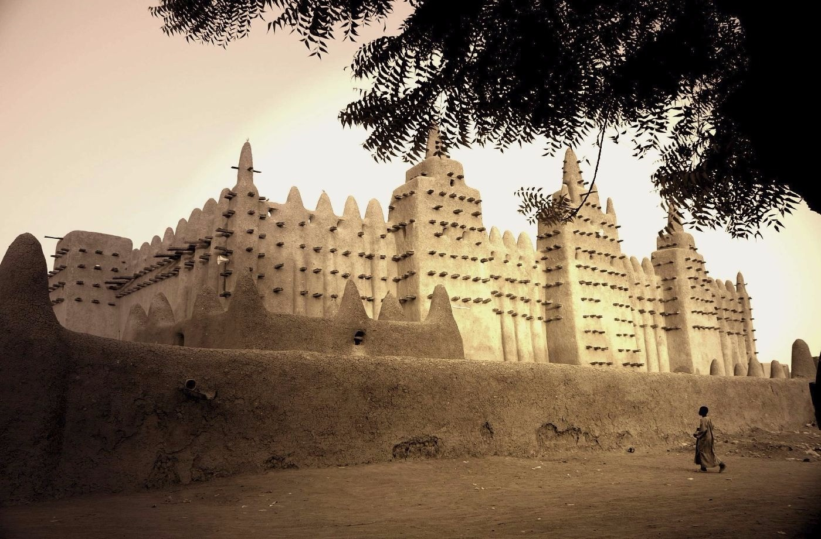
Images (B)

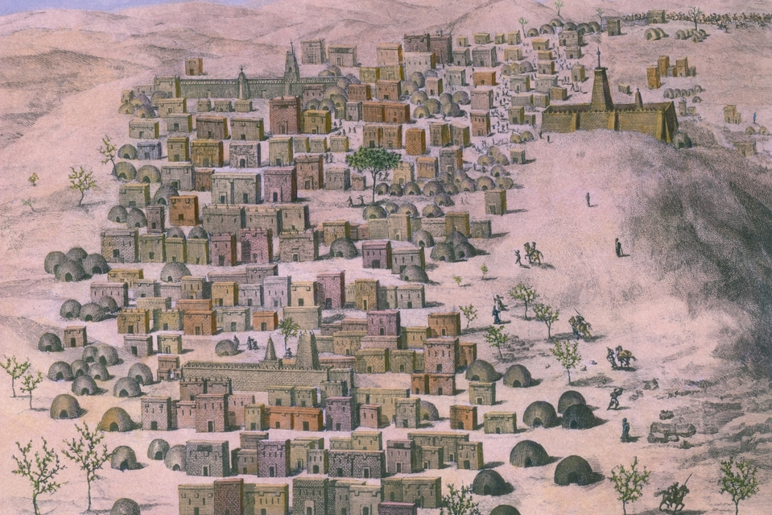
WORKSHEET: 4-6.B

Source 1: Trade

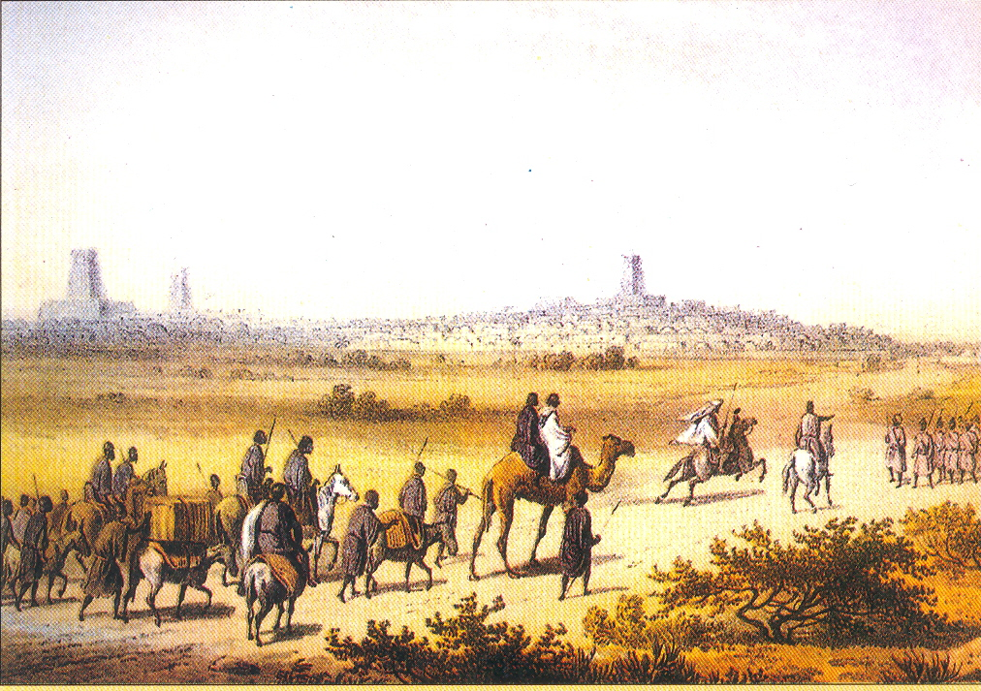

Timbuktu (tim-buck-too) was one of Africa’s most important trading cities. Boats on the Niger (nee-zhur) River and camel caravans across the Sahara Desert would bring goods to trade in Timbuktu. Near Timbuktu there are many salt mines. Through trade, it became one of the wealthiest cities in Africa and the world.

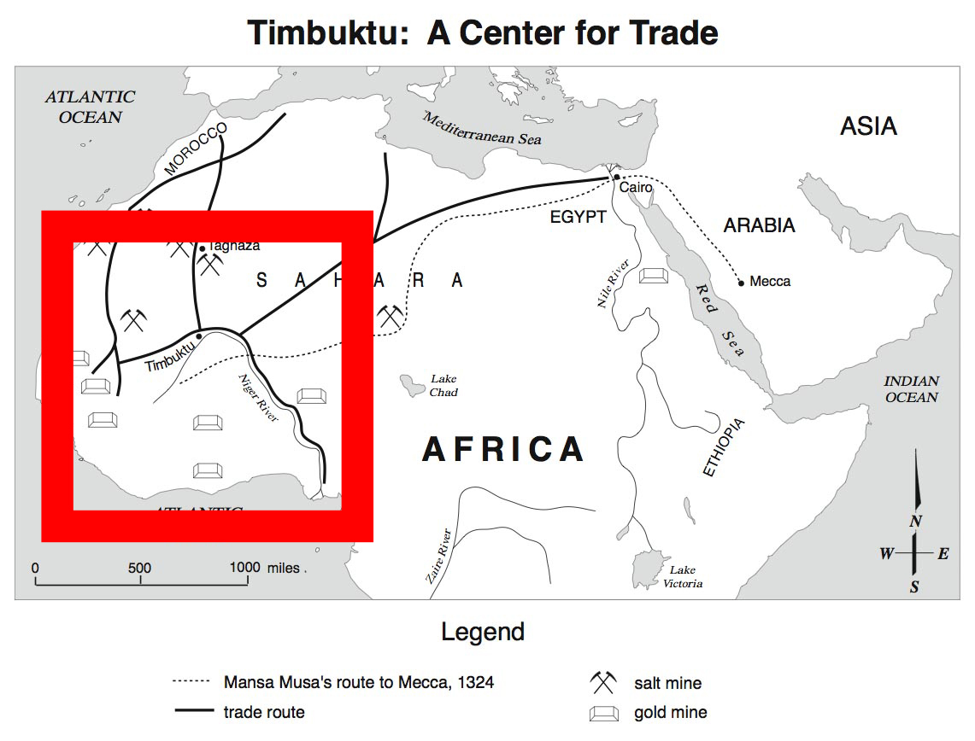

There were crowded markets (see picture below) selling sugar, nuts, salt, cloth, books, and glass. Enslaved people (people forced to work for no pay) were also bought and sold there.

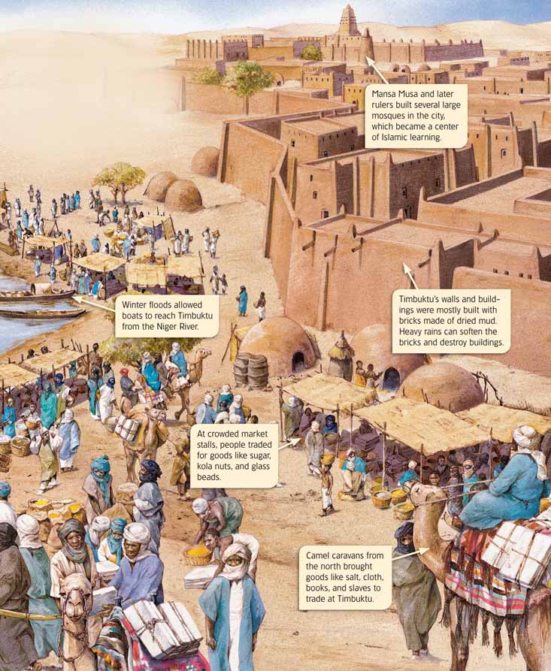
WORKSHEET: 4-6.C

Source 2: Education

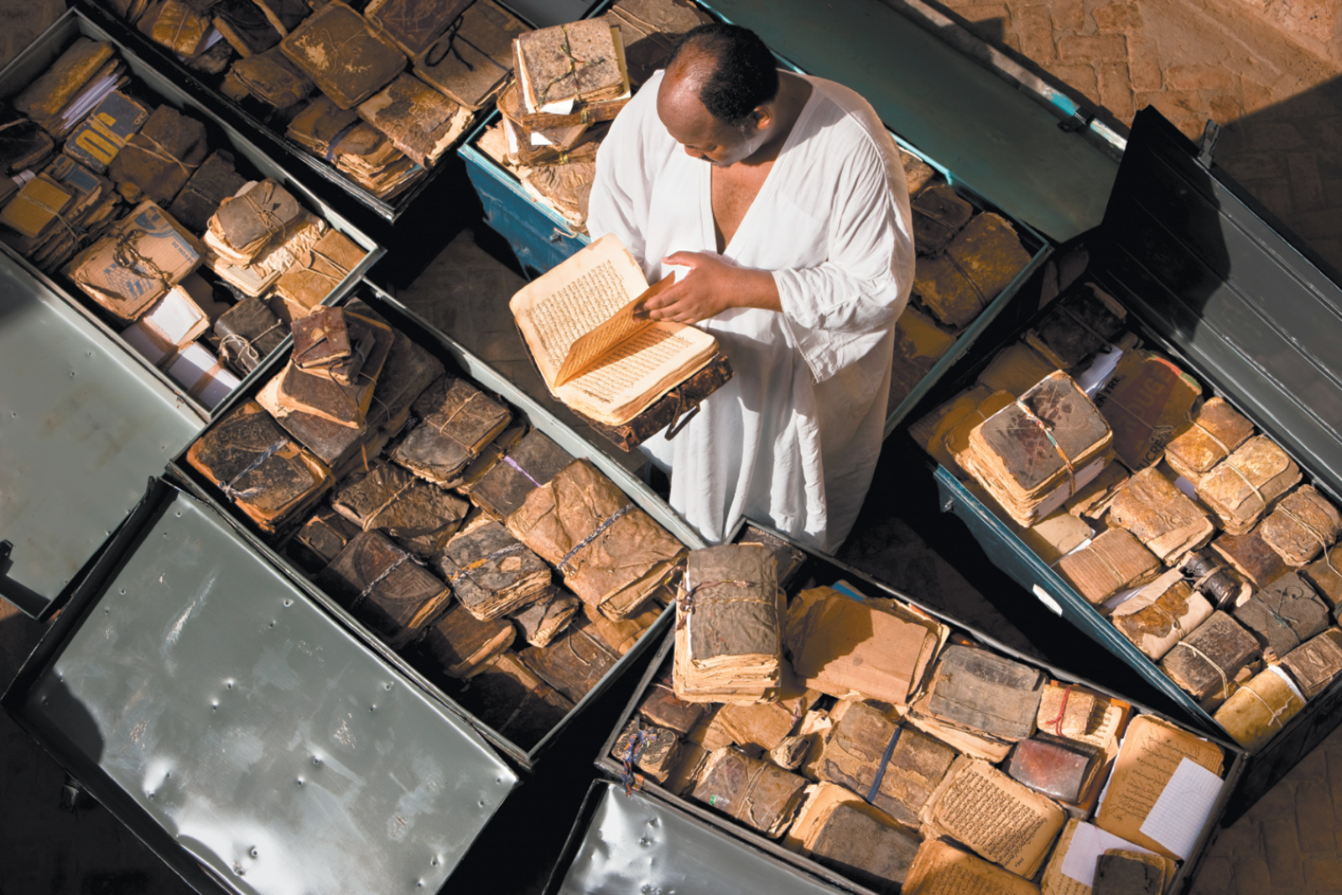

Overtime, Timbuktu became an important place for schools and learning. Many schools were started there and their libraries had books from all over Africa and the world. Eventually, there were over 700,000 books in the schools and libraries of Timbuktu (see a picture of two of the books on the next page). There were books about art, medicine, philosophy, science, and religion, including early copies of the Muslim religious book called the Quran (cu-ron). Many of the books were in the Arabic language, but some were written in other languages. In 2013, war broke out in Timbuktu and many of the books were almost destroyed. One of the librarians helps smuggle 350,000 books to safety.

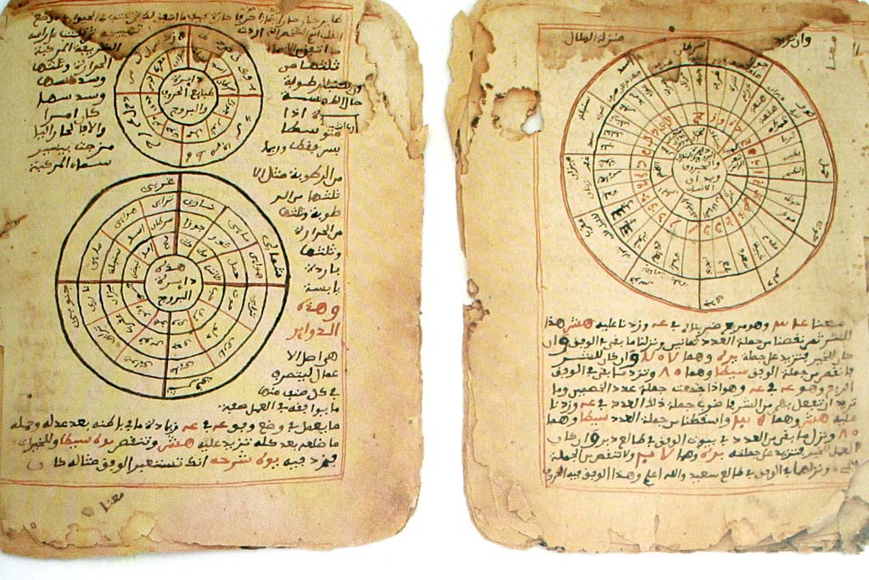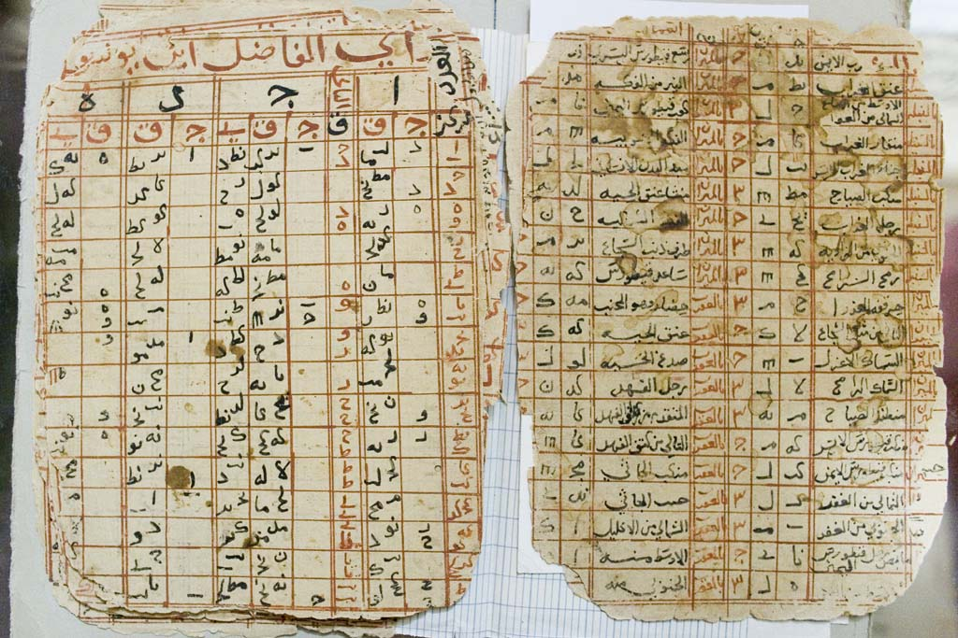
WORKSHEET: 4-6.D

Source 3: Religion

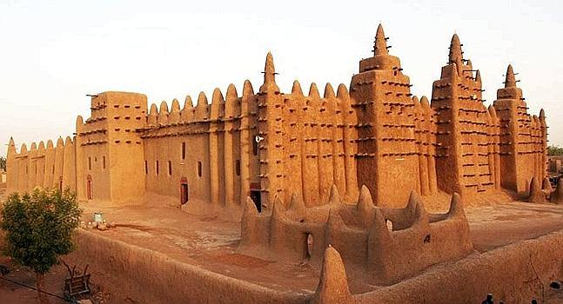

Mansa (King) Musa I (pictured on the next page) was a leader of Timbuktu and one of the wealthiest people in history because of the gold he traded. Like most people in Timbuktu, he was Muslim and practiced Islam. Mansa Musa I paid for the Djinguereber (jing-wer-ber) Mosque to be built, so people could worship there. This is an amazing building as it is very tall and built only from sand, straw, and wood. Although repairs are needed from time-to-time, it still stands today, which is almost 700 years after being built. Due to the mosque and the schools, Timbuktu became an important religious place for Muslims. Students would travel from all over Africa and the world to study Islam there. It also was a place where books were copied by hand (no photocopy machines back then) and then sold around the world.

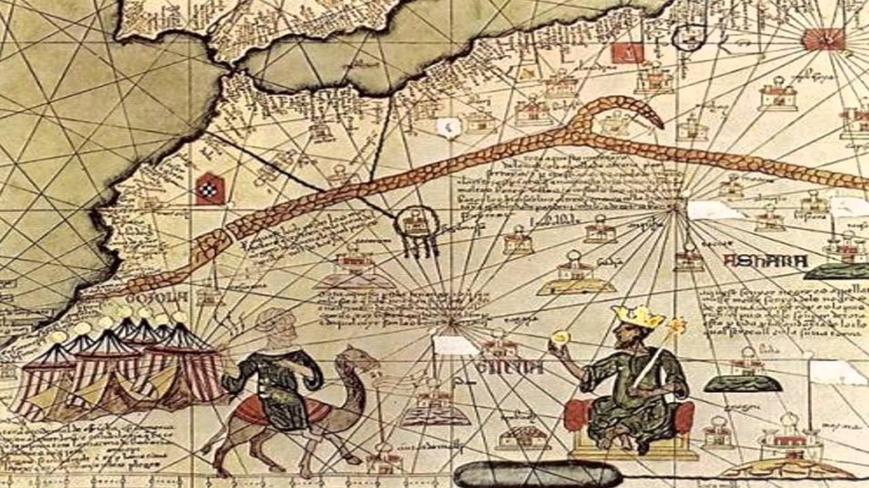
Mansa Musa I pictured with a gold crown and on a throne in this European painting.
ASSESSMENT: 4-6.E

Timbuktu: Exit Ticket

Inquiry Question: Why was Timbuktu so important?

Choose one part of Timbuktu and explain why it is the most important part of the city. Include three pieces of evidence from the sources.

LESSON PLAN 4-7: Apartheid in South Africa: A Movement for Freedom

MATERIALS

“Nelson Mandela” by Kadir Nelson (not supplied)
Source 1: European Imperialism (WORKSHEET 4-7.A)
Source 2: Apartheid Laws (WORKSHEET 4-7.B)
Source 3: Anti-Apartheid Protests (WORKSHEET 4-7.C)
Source 4: Jailed Protesters (WORKSHEET 4-7.D)
Anti-Apartheid: Exit Ticket (ASSESSMENT 4-7.E)

STANDARDS

Massachusetts History and Social Science Framework

MA-HSS.4.CS.1: Use map and globe skills to determine absolute locations (latitude and longitude) of places studied. (G)

MA-HSS.WHII.44 Explain the reasons for the fall of apartheid in South Africa, including the influence and ideas of Nelson Mandela. (H)

Common Core: Literacy

CCSS.ELA-Literacy.RI.4.9: Integrate information from two texts on the same topic in order to write or speak about the subject knowledgeably.

CCSS.ELA-Literacy.RI.4.10: By the end of year, read and comprehend informational texts, including history/social studies, science, and technical texts, in the grades 4–5 text complexity band proficiently, with scaffolding as needed at the high end of the range.

CCSS.ELA-Literacy.W.4.8: Recall relevant information from experiences or gather relevant information from print and digital sources; take notes and categorize information, and provide a list of sources.

CCSS.ELA-Literacy.W.4.9: Draw evidence from literary or informational texts to support analysis, reflection, and research.

PROCEDURES

Inquiry Question: What can we learn from the Anti-Apartheid Movement in South Africa?

PREPARATION

1. Post Definition of Discrimination

Post the definitions of migration on the board or chart paper hidden from view. Discrimination: Unfair treatment, especially because of a person’s race, gender, religion, or age.

A. OPENER (15 minutes)

2. Read “Nelson Mandela” by Kadir Nelson
Before reading the text, tell students that today we are going to read a story about a man who spoke out against discrimination in South Africa. Ask students if they know what discrimination means. Reveal the definition of discrimination as “Unfair treatment, especially because of a person’s race, gender, religion, or age.” Ask students if they can think of any examples from the past or today when people were discriminated against? Anticipated responses may include: laws against African Americans before the civil rights movement, Martin Luther King, personal or family examples.

Read “Nelson Mandela.” This is a picture book that tells the true story of a Nelson Mandela who was a leader to the Anti-Apartheid movement in South Africa. As you read the text, be sure to ask questions to the students about Mandela’s experiences and choices. Connect this story to the work the students have done in previous grades related to slavery, segregation, and civil rights.

Tell students that today, we are going to learn about the Apartheid laws that existed in South Africa and what people did there to try and stop it.

B. DEVELOPMENT (15 minutes)

3. Examine Sources As a Whole Class
Ask the students to read aloud (using choral, partner, or independent reading) the three documents on Apartheid Laws (WORKSHEET 4-7.A), Anti-Apartheid Protests (WORKSHEET 4-7.B), Jailed Protesters (WORKSHEET 4-7.C), Help from Other Countries (WORKSHEET 4-7.D). After reading each document, solicit from students what important facts should be underlined and highlighted about each source. Make sure they highlight examples of how the Apartheid was problematic (i.e. segregation laws), but also acts of resistance to it (i.e. being jailed for protesting, boycotts).

4. Discuss the Struggles that Black and Asian People Faced in South Africa
Put students in small groups (3-4 students). Tell students that after listening to “Nelson Mandela” and reading these sources, I would like you to talk about ways that life was difficult for Black and Asian people in South Africa under Apartheid, but also ways that people did things to stop Apartheid because it was wrong.

After students have had 5-7 minutes to discuss, lead the class in a whole class discussion. On the board or chart paper, take notes on what the students say. Anticipated responses may include: protesting, going to jail for their beliefs, boycotting rules, spreading the word around the world.

C. CLOSING (15 minutes)

5. Answer the Inquiry Question
For the evaluation task, have the students complete the exit ticket (ASSESSMENT 4-7.E), where they write their own personal response to the lesson’s Inquiry Question: “What can we learn from the Anti-Apartheid Movement in South Africa?” Tell students to cite at least three pieces of evidence from the book (Nelson Mandela) and the sources for this lesson.

Before using the exit ticket, consider using a graphic organizer or two column notes to prepare students for the writing task. Consider using sentence starters and modeling to help the students with their answer to the inquiry question.

EVALUATION

ASSESSMENT 4-7.E

What to look for?

The students should take a stance on what we can learn from the Anti-Apartheid Movement. All arguments should cite at least 3 pieces of evidence from the sources.

Some information that students may include in their answer to the question:

Ways that protesters worked to end Apartheid:
- Protesting.
- Going to jail for their beliefs.
- Boycotting rules.
- Spreading the word around the world.
WORKSHEET: 4-7.A

Source 1: European Imperialism

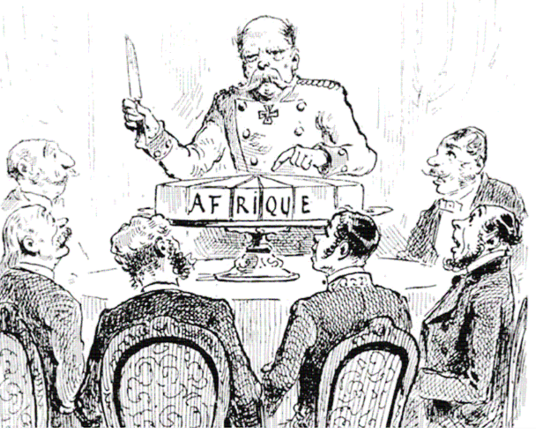

For much of its history, Africans traded with Europe and Asia and some empires became very wealthy. In the 1500s, Europeans from Portugal, Spain, France, England, and other countries went to Africa and bought enslaved people (who were owned by others and forced to work for no pay). They then sold enslaved people around the world with most being sent to the Americas. Slavery, war, and trade weakened many African empires between 1500 and 1900. Europeans took advantage of this and invaded many African nations with their militaries.

South Africa had several different nations, including the Bantu, Xhosa and Zulu people. In the 1700s, the Dutch (who are from the Netherlands in Europe) took over South Africa and renamed it the Cape Colony. In the 1800s, the British took the Cape Colony from the Dutch. For over 200 years, the Bantu, Xhosa, and Zulu tried to stop this and they fought the Dutch and later British.

In 1884, European countries met at the Berlin Conference and divided up Africa among themselves (the below map shows all nations being divided up among Europe, except Ethiopia and Liberia). No Africans were invited and they had no say in this. Historians call this imperialism, which means when one nation takes over another nation.

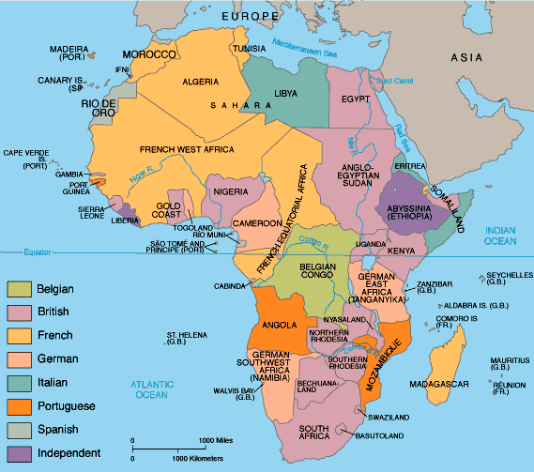
WORKSHEET: 4-7.B

Source 2: Apartheid Laws

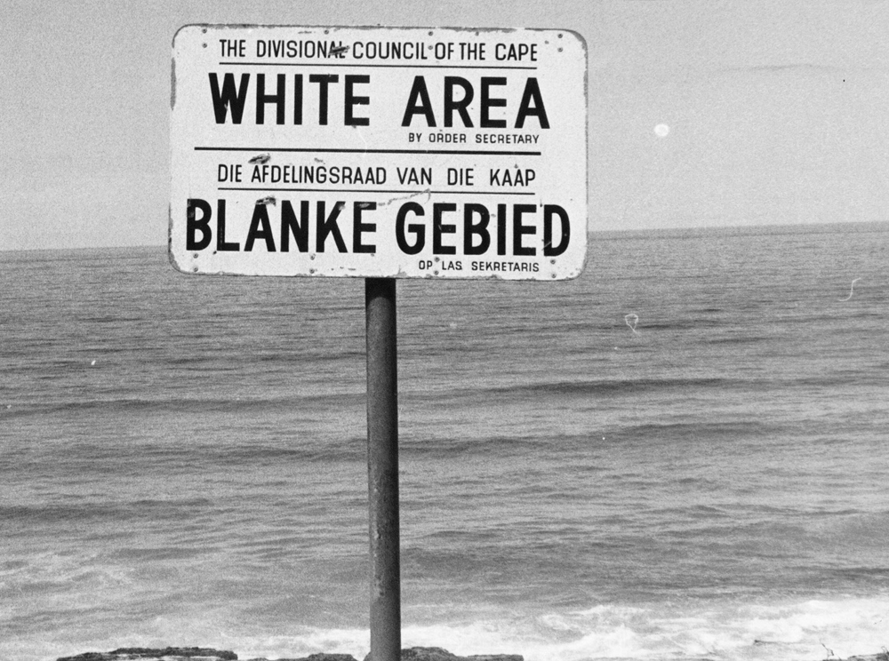

After Europeans took over South Africa (the Cape Colony), they started making laws that discriminated against people with darker skin. At first, this included only indigenous (native) Africans, but as the British brought Asians (Indians, Malaysians, and others) to South Africa, they also had to follow special rules. As you will see in the pictures, the British called some people “Coloured,” a term we no longer use today, which meant people of more than one race.

The British made rules that Black, Asian, and Coloured people needed to use separate restaurants, beaches (see the above sign), restrooms, and bus stops and train stations. People of different races could not marry each other or have children together. Black South Africans were not allowed to leave their hometowns and were required to carry papers on them at all times that said who they were and their race (see bottom picture). Within the place where their ancestors had lived for thousands of years, Black South Africans were also not allowed to be citizens, could not vote, or attend White colleges.

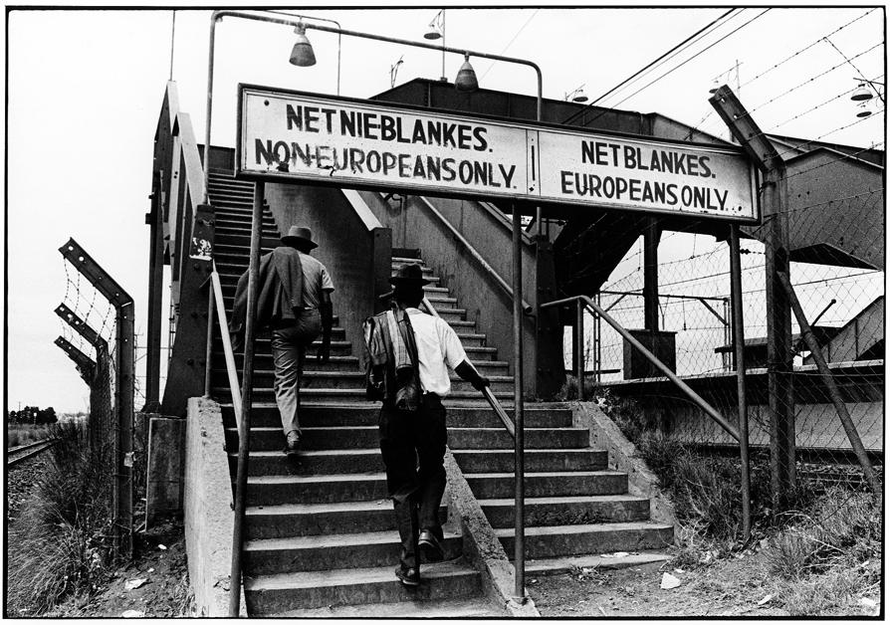

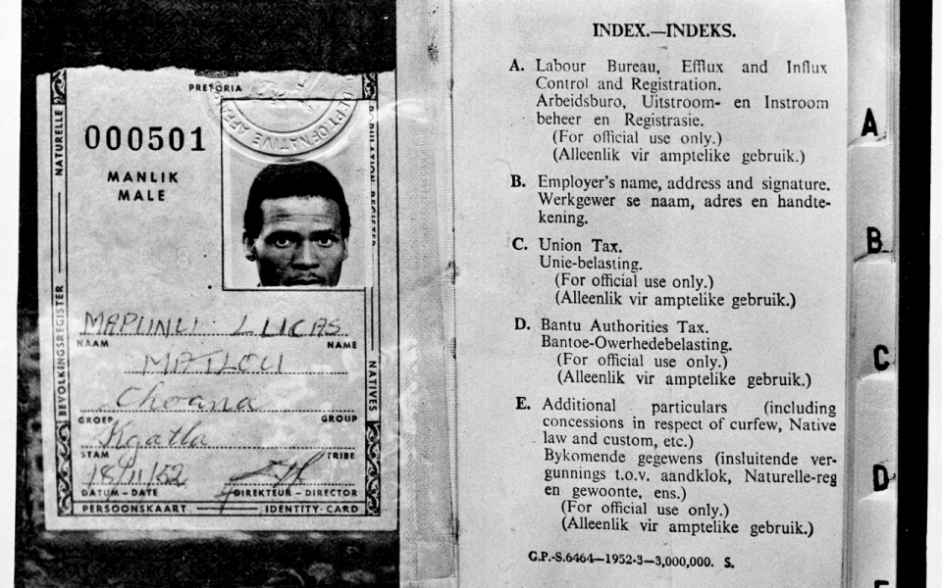
WORKSHEET: 4-7.C

Source 3: Anti-Apartheid Protests

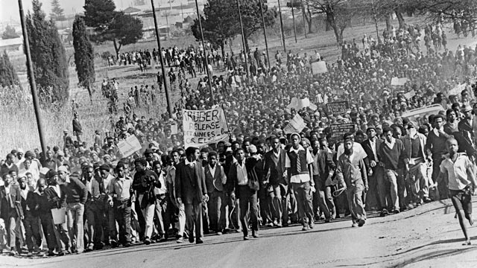

Many Black South Africans protested the Apartheid laws. They formed a group called the African National Congress. They would hold protests and marches demanding the end to discrimination. The White South African government did not like this. After one rally, they arrested over 18,000 people and they put many of the Anti-Apartheid leaders in jail. The White South African police began to use violence on protesters. This did not stop the protest and it convinced many more Black South Africans to join in the Anti-Apartheid Movement.

By the 1980s, people outside South Africa started to protest Apartheid. Many anti-Apartheid people of all races started boycotting (no longer buying) things made in South Africa. Because of Apartheid, South Africa was banned from playing in the Olympics and the World Cup of soccer. Some governments around the world made it illegal to trade with South Africa. This put even more pressure on the White South African government to change the laws.

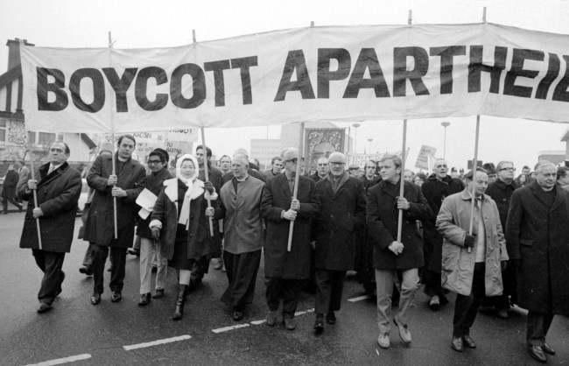

WORKSHEET: 4-7.D

Source 4: Jailed Protesters

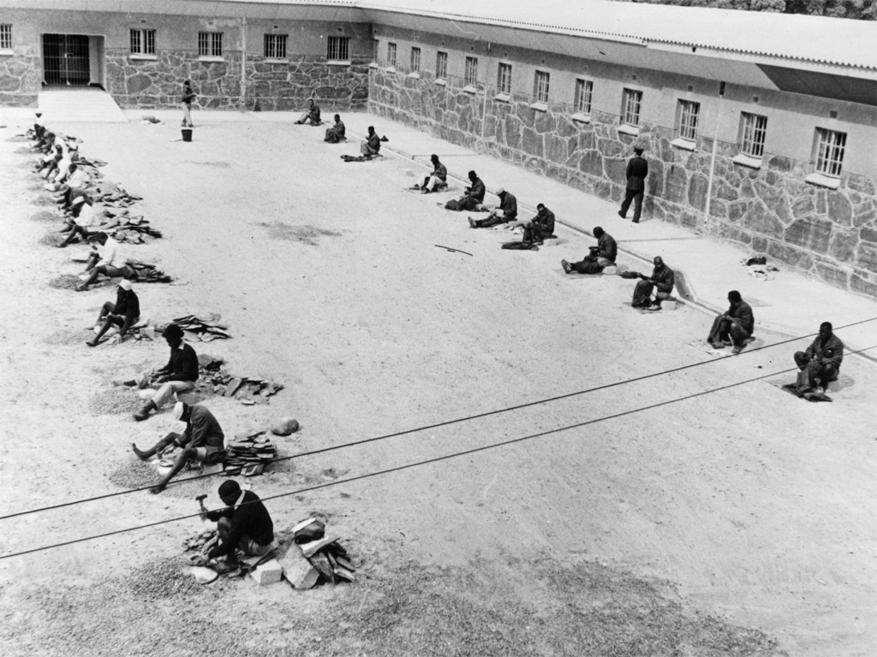

The White South African government jailed many of the leaders of the National African Congress and Anti-Apartheid Movement. The image above shows the leaders being forced to do hard labor during their jail time. One of the more well-known leaders was Nelson Mandel. He would be in prison for over 24 years. On the next page is a picture of him before going to prison and one toward the end of his sentence. It took a long time, but South Africa ended Apartheid in 1993. After that, Mandela would be elected the first Black president of South Africa. As president, in a famous speech, he said, “We understand it still that there is no easy road to freedom. We know that none of us acting alone can achieve success. We must therefore act together as a united people. … Let there be justice for all. Let there be peace for all.”

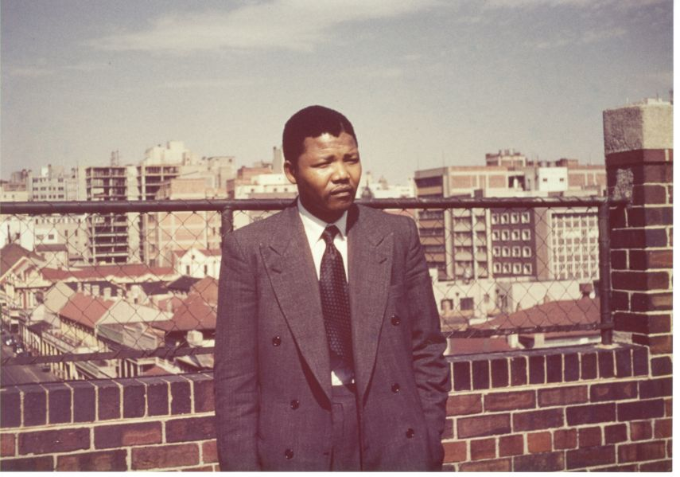
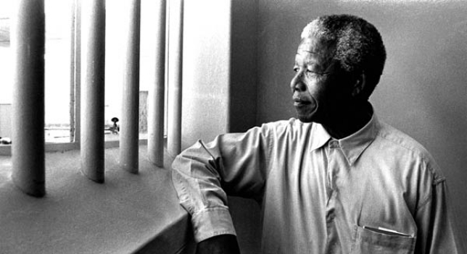
ASSESSMENT: 4-7.E

Anti-Apartheid: Exit Ticket

Inquiry Question: What can we learn from the Anti-Apartheid Movement in South Africa?

Choose one method of protest and explain why it is the most important way that protesters worked to stop Apartheid. Include three pieces of evidence from the book or sources.

LESSON PLAN 4-8: Africa Today: Diverse Nations, Diverse People

MATERIALS

Carmen Sandiego Introduction Video (Lesson4-8Video1) [Located in the UOW Video Library: www.christophercmartell.com/understandingourworld]
Drawing paper (not supplied)
Markers (not supplied)
Lined paper (not supplied)
Clipboards (not supplied)
Carmen Sandiego Questions and Crime Bucks (MATERIALS 4-8.A)
Source 1: Egypt (WORKSHEET 4-8.B)
Source 2: Morocco (WORKSHEET 4-8.C)
Source 3: Nigeria (WORKSHEET 4-8.D)
Source 4: Zimbabwe (WORKSHEET 4-8.E)
Source 5: Kenya (WORKSHEET 4-8.F)
Source 6: South Africa (WORKSHEET 4-8.G)
Source 7: Cape Verde (WORKSHEET 4-8.H)
Source 8: Madagascar (WORKSHEET 4-8.I)
Africa Today: Exit Ticket (ASSESSMENT 4-8.J)

STANDARDS

Massachusetts History and Social Science Framework

MA-HSS.4.CS.1: Use map and globe skills to determine absolute locations (latitude and longitude) of places studied. (G)

MA-HSS.6.A.2: Use a map key to locate countries and major cities in Africa. (G, E)

Common Core: Literacy

CCSS.ELA-Literacy.RI.4.9: Integrate information from two texts on the same topic in order to write or speak about the subject knowledgeably.

CCSS.ELA-Literacy.RI.4.10: By the end of year, read and comprehend informational texts, including history/social studies, science, and technical texts, in the grades 4–5 text complexity band proficiently, with scaffolding as needed at the high end of the range.

CCSS.ELA-Literacy.W.4.8: Recall relevant information from experiences or gather relevant information from print and digital sources; take notes and categorize information, and provide a list of sources.

CCSS.ELA-Literacy.W.4.9: Draw evidence from literary or informational texts to support analysis, reflection, and research.

PROCEDURES

Inquiry Question: If you were to visit Africa today, what country would you choose and why?

PREPARATION

1. Cut Out Carmen Sandiego Bucks
Make 15 copies of the Crime Bucks (MATERIALS 4-8.A) sheet and cut them out.

2. Set Up Carousel Activity
Around the room, post the eight sources:
Source 1: Egypt (WORKSHEET 4-8.B)
Source 2: Morocco (WORKSHEET 4-8.C)
Source 3: Nigeria (WORKSHEET 4-8.D)
Source 4: Zimbabwe (WORKSHEET 4-8.E)
Source 5: Kenya (WORKSHEET 4-8.F)
Source 6: South Africa (WORKSHEET 4-8.G)
Source 7: Cape Verde (WORKSHEET 4-8.H)
Source 8: Madagascar (WORKSHEET 4-8.I)

A. OPENER (15 minutes)

3. Play the “Where in the World Is Carmen Sandiego” Game
Divide the class into three groups: Team Izzat, Team Ajay, and Team Jamal (the contestants in the video that they are about to watch).

Show the students a short video that is the opening to the PBS show “Where in the World Is Carmen Sandiego” (Lesson4-8Video1). After watching the video, tell the students that today we are going to start class by being contestants on “Where in the World Is Carmen Sandiego” and the episode “Diamonds Are a Crook’s Best Friend.” As you saw in the video, The Contessa has stolen diamonds from South Africa. Tell the students that they will each start with $50 Carmen Sandiego Bucks. For each question about Africa that they get right, they will earn $10 Carmen Sandiego Bucks. At the end of the game, the team with the most Carmen Sandiego Bucks catches The Contessa and her diamonds and wins the game. Are you ready to play gumshoes?

You will then read the questions about Africa found on the Carmen Sandiego Questions (MATERIALS 4-8.A). Each group will talk among themselves and write their answer to the question using a marker on a sheet of drawing paper. After each team holds up their answer, give students $10 Carmen Sandiego Bucks if they get it correct. Tabulate the total for each team (starting with all teams getting $50). At the end of the game count up the totals and declare a team(s) the winner. Tell the students that they successful caught The Contessa.

Tell the students that their next challenge is to find Carmen Sandiego. She is hiding somewhere in Africa. You will get a chance to look at eight different African countries and what life is like there today. You will choose which country you would most like to visit. At the end of the lesson, I will reveal where Carmen Sandiego is hiding and we can see if she decided to go to the same country as you.

B. DEVELOPMENT (15 minutes)

4. Engage in a Carousel Activity on African Countries
Handout lined paper and clipboards. Ask students to go to each of the eight stations (4-8.B, 4-8.C, 4-8.D, 4-8.E, 4-8.F, 4-8.G, 4-8.H, 4-8.I). At each station, the students should write the country’s name and take notes on each.

Once students have gone to each of the eight stations, they should return to their seats. Put students in small groups. Have them look at their notes and discuss with their classmates which country they would like to travel to.

C. CLOSING (15 minutes)

5. Write Up Argument on African Countries
For the evaluation task, have the students complete the exit ticket (ASSESSMENT 4-8.J), where they write their own personal response to the lesson’s Inquiry Question: “If you were to visit Africa today, what country would you choose and why?” Tell students to cite at least three pieces of evidence from the sheets on the walls. Tell students that the evidence they use can be something that they wrote on their notes. Encourage students to get up and look at the sheets on the wall, when they need evidence to write on their sheet.

Before using the exit ticket, consider using a graphic organizer or two column notes to prepare students for the writing task. Consider using sentence starters and modeling to help the students with their answer to the inquiry question.

6. Reveal the Location of Carmen Sandiego
At the end of the lesson, reveal that Carmen Sandiego is hiding in South Africa. Just like The Contessa, she also wanted to steal the jewels. Have students give a round of applause for the students who chose the same country as Carmen Sandiego.

EVALUATION

ASSESSMENT 4-8.J

What to look for?

The students should take a stance on what country in Africa would they like to visit. All arguments should cite at least 3 pieces of evidence from the sources.

Some information that students may include in their answer to the question:

Egypt
- Visiting the famous pyramids and the Sphinx.
- Seeing the Nile River.
- Visiting Cairo.
- It is a large country (89 million people).
- Visiting a country run by the military.
- Being in a place where they speak Arabic.
- Visiting a place where Muslims and Christians live.
- Visiting a desert.
- Like the climate/weather (hot and dry in the summer and cool and humid with occasional rain in the winter).

Morocco
- Visiting amazing markets (Fes).
- Visiting a place where Arab, Berber, and French culture comes together.
- Visiting a country with a king.
- Visiting a medium sized country (32 million people).
- Being in a place where they speak Arabic, Berber, and French.
- Visiting a place where Muslims live.
- Visiting a desert.
- Like the climate/weather (hot and dry in the summer and cool and humid with occasional rain in the winter).

Nigeria
- Visiting large cities.
- Visiting Lagos (the New York City of Africa).
- Visiting a country with over 500 ethnic groups and languages.
- Visit a country with an elected president.
- Visit a large country (167 million people).
- Visit a place where Muslims, Christians, and people with indigenous faiths live. Like the tropical climate/weather (cool and dry in the summer and warm and rainy in the winter).

Zimbabwe
- See the nature and/or Victoria Falls.
- Visit a place with 16 different languages (including English, Shona, and Ndebele).
- Visit a place that has only had one leader (recently).
- Visit a small country (13 million people).
- Visit a place where Christians live.
- Like the subtropical climate/weather (warm and rainy winters and dry and hot summers).

Kenya
- See its animals or go on a safari.
- Visit a country with an elected president.
- Visit a medium sized country (42 million people).
- Visit a country where they speak English and Swahili.
- Visit a place where Muslims, Christians, and people with indigenous faiths live.
- Like the tropical climate/weather (warm and dry for most of the year).

South Africa
- Visit its large cities, like Cape Town and Johannesburg.
- Visit its beautiful coastlines.
- See were the 2010 World Cup of Soccer was played.
- Visit a country with an elected president.
- Visit a medium sized country (50 million people).
- Visit a country with 11 languages, including English, Afrikaans, and Zulu.
- Visit a place where Muslims, Christians, and people with indigenous faiths live.
- Like the temperate climate/weather (warm and dry for most of the year).

Cape Verde
- Visit an island nation.
- Visit the beautiful beaches/spend time on a boat.
- Visit a country with an elected president.
- Visit a small nation (500,000 people).
- Visit a country where they speak Portuguese/ Cape Verdean Creole.
- Visit a place where Catholics live.
- Like the arid climate/weather (warm and dry for most of the year).

Madagascar
- Visit a large island nation/fourth largest island in the world.
- See the unique wildlife, including lemurs, mongoose, chameleon, flying fox (bat), frogs, and crocodiles.
- Look at nature/Madagascar trees.
- Visit a country with an elected president.
- Visit a medium sized nation (21 million people).
- Visit a country where they speak Malagasy and French.
- Visit a place where Christians and people with indigenous faiths live.
- Like the monsoonal climate/weather (hot and heavy rains in the winter and dry summers).

MATERIALS: 4-8.A

Where in the World Is Carmen Sandiego?
Questions

1. How many countries are there in Africa?: 22, 54, 81
ANSWER: 54

2. What is the largest city in Nigeria?: Abuja, Lagos, Kano
ANSWER: Lagos

3. What is the capital of Egypt?: Cairo, Alexandria, Giza
ANSWER: Cairo

4. How many languages are spoken in Africa?: 100, 500, 3000
ANSWER: 3000

5. What country is at the southern tip of Africa?: South Africa, South Sudan, Zimbabwe
ANSWER: South Africa

6. Which animal lives in Africa?: Penguins, Polar Bears, Koala Bears
ANSWER: Penguins (on the islands off the coast of South Africa)

7. What is the highest mountain in Africa?: Mount Kenya, Mount Kilimanjaro, Mount Meru
ANSWER: Mount Kilimanjaro

8. How many people live on the continent of Africa: 1 million, 1 billion, 1 trillion
ANSWER: 1 billion

9. Which of these African countries is the newest in the world?: Senegal, Mali, South Sudan
ANSWER: South Sudan

10. This is the world’s largest hot desert?: Gobi, Sahara, Namib
ANSWER: Sahara

$10
Carmen Sandiego Bucks
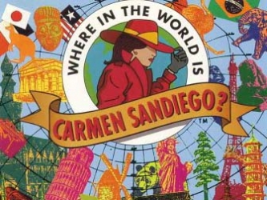
$10

$10
Carmen Sandiego Bucks
$10

WORKSHEET: 4-8.B

Source 1: Egypt

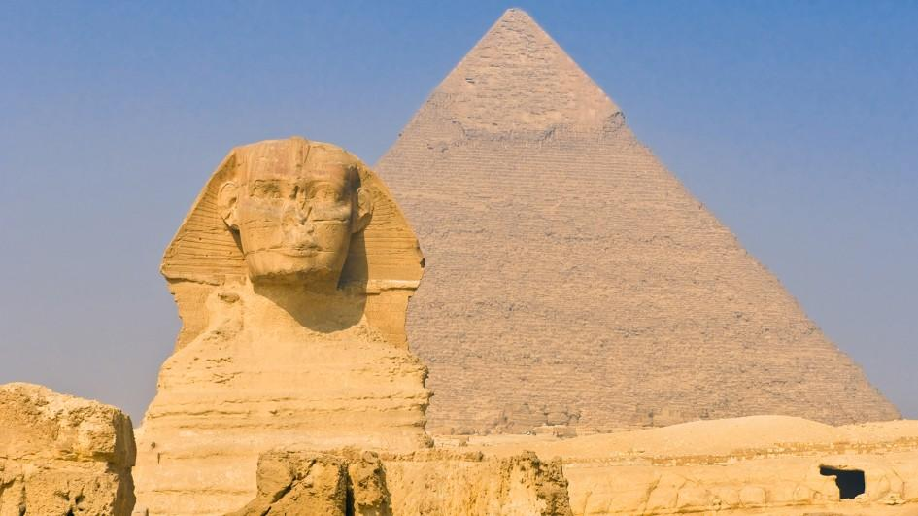

Egypt is known for its famous pyramids and the Sphinx (above). The Nile River ends in Egypt at the Mediterranean Sea. Egypt has a military government and their current president is Abdel Fattah el-Sisi. Egypt has many cities including Cairo. It has 89 million people. Its main language is Arabic and its main religions are Islam and Christianity. It has a desert climate that is hot and dry in the summer and cool and humid with occasional rain in the winter.

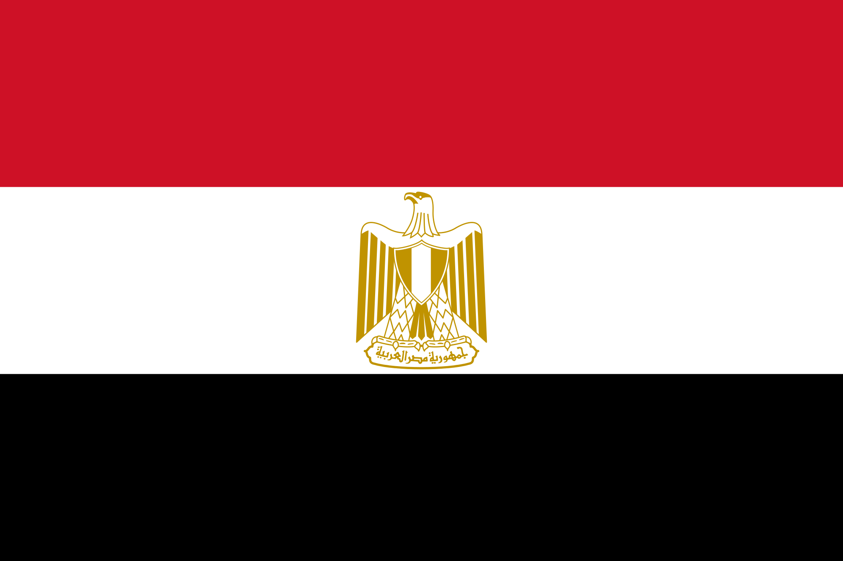
WORKSHEET: 4-8.C

Source 2: Morocco

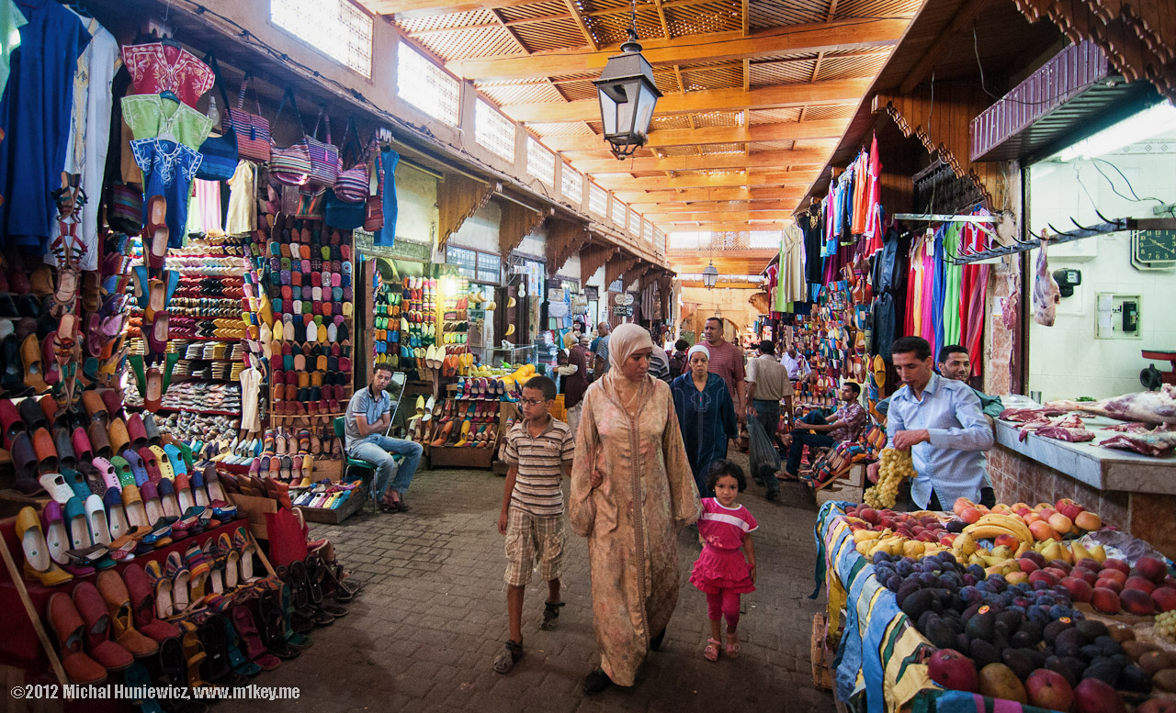

Morocco is known for its amazing markets, including the one in Fès (Fez) (above). It is a country where Arab, Berber, and French culture come together. Morocco has a king, who is currently King Mohammed VI. It has 32 million people. Its main languages are Arabic, Berber, and French and its main religion is Islam. It has a desert climate that is hot and dry in the summer and cool and humid with occasional rain in the winter.

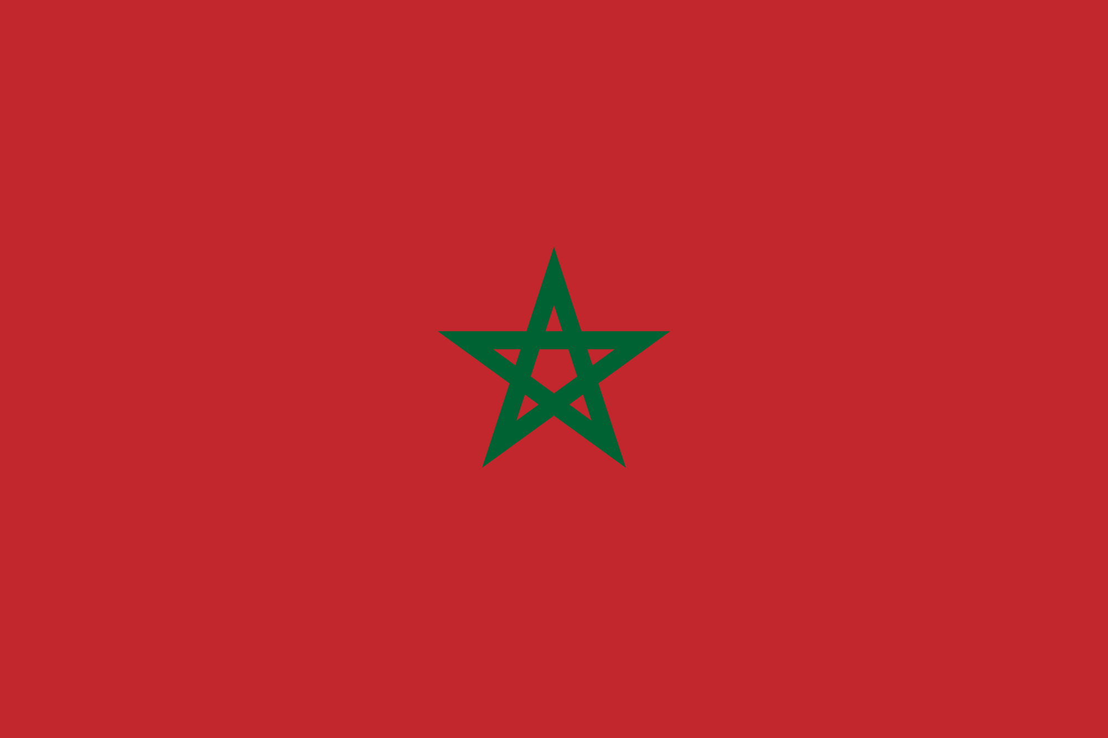
WORKSHEET: 4-8.D

Source 3: Nigeria

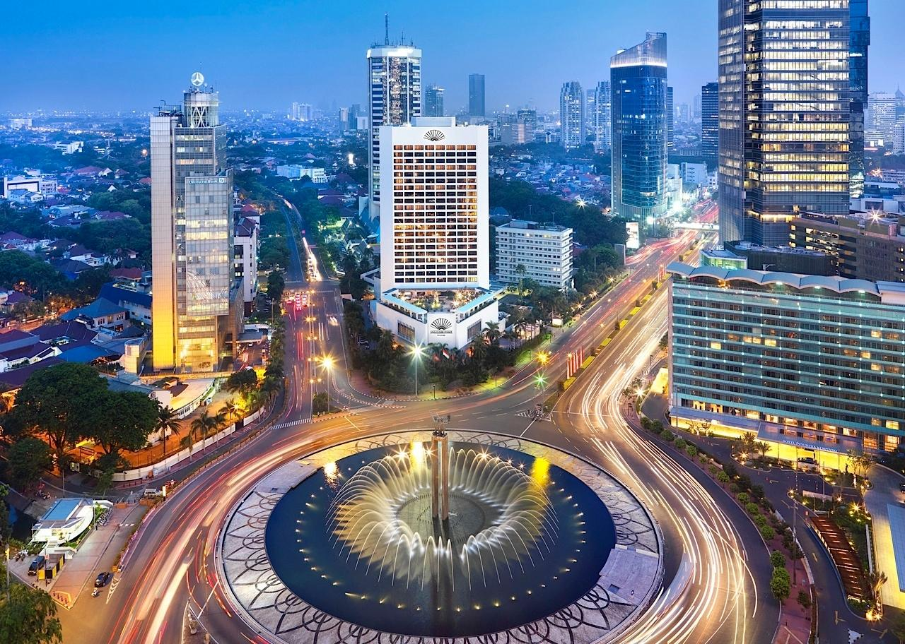

Nigeria is known for its large cities. Some people call Lagos (above) the New York City of Africa. Nigeria has over 500 different ethnic groups and each has a different language. Nigeria has an elected president, who is currently Muhammadu Buhari. It has 167 million people. Its main religions are Islam, Christianity, and indigenous religions. It has a tropical climate that is cool and dry in the summer and warm and rainy in the winter.



WORKSHEET: 4-8.E

Source 4: Zimbabwe

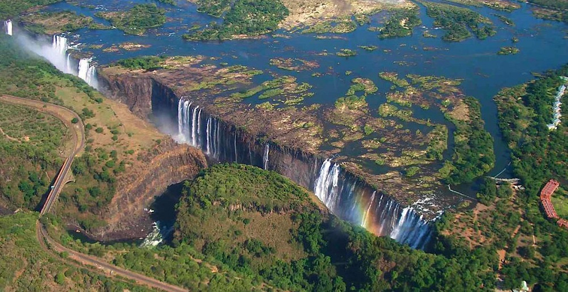

Zimbabwe is known for its amazing nature, including Victoria Falls (above). Zimbabwe has 16 different languages, including English, Shona, and Ndebele. Zimbabwe has only one political party and has had one leader, Robert Mugabe, since it became an independent country. It has 13 million people. Its main religion is Christianity. It has a subtropical with warm and rainy winters and dry and hot summers.

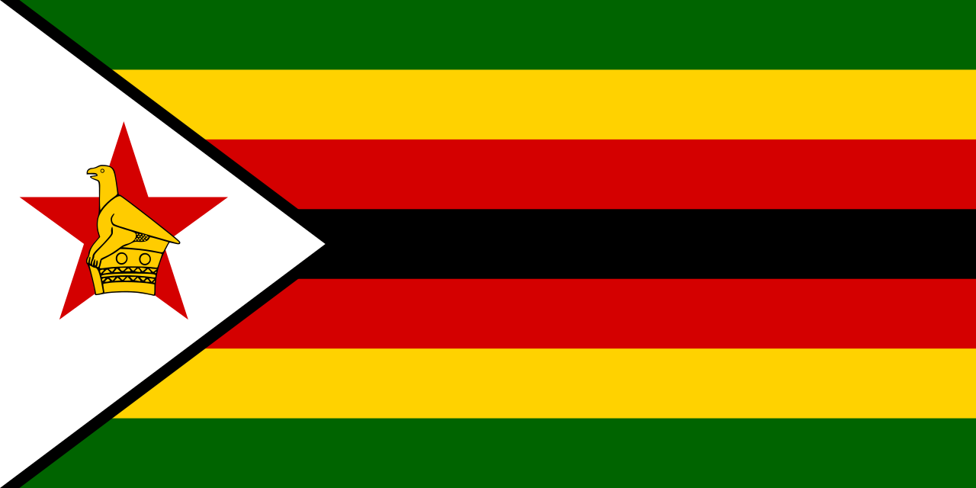
WORKSHEET: 4-8.F

Source 5: Kenya

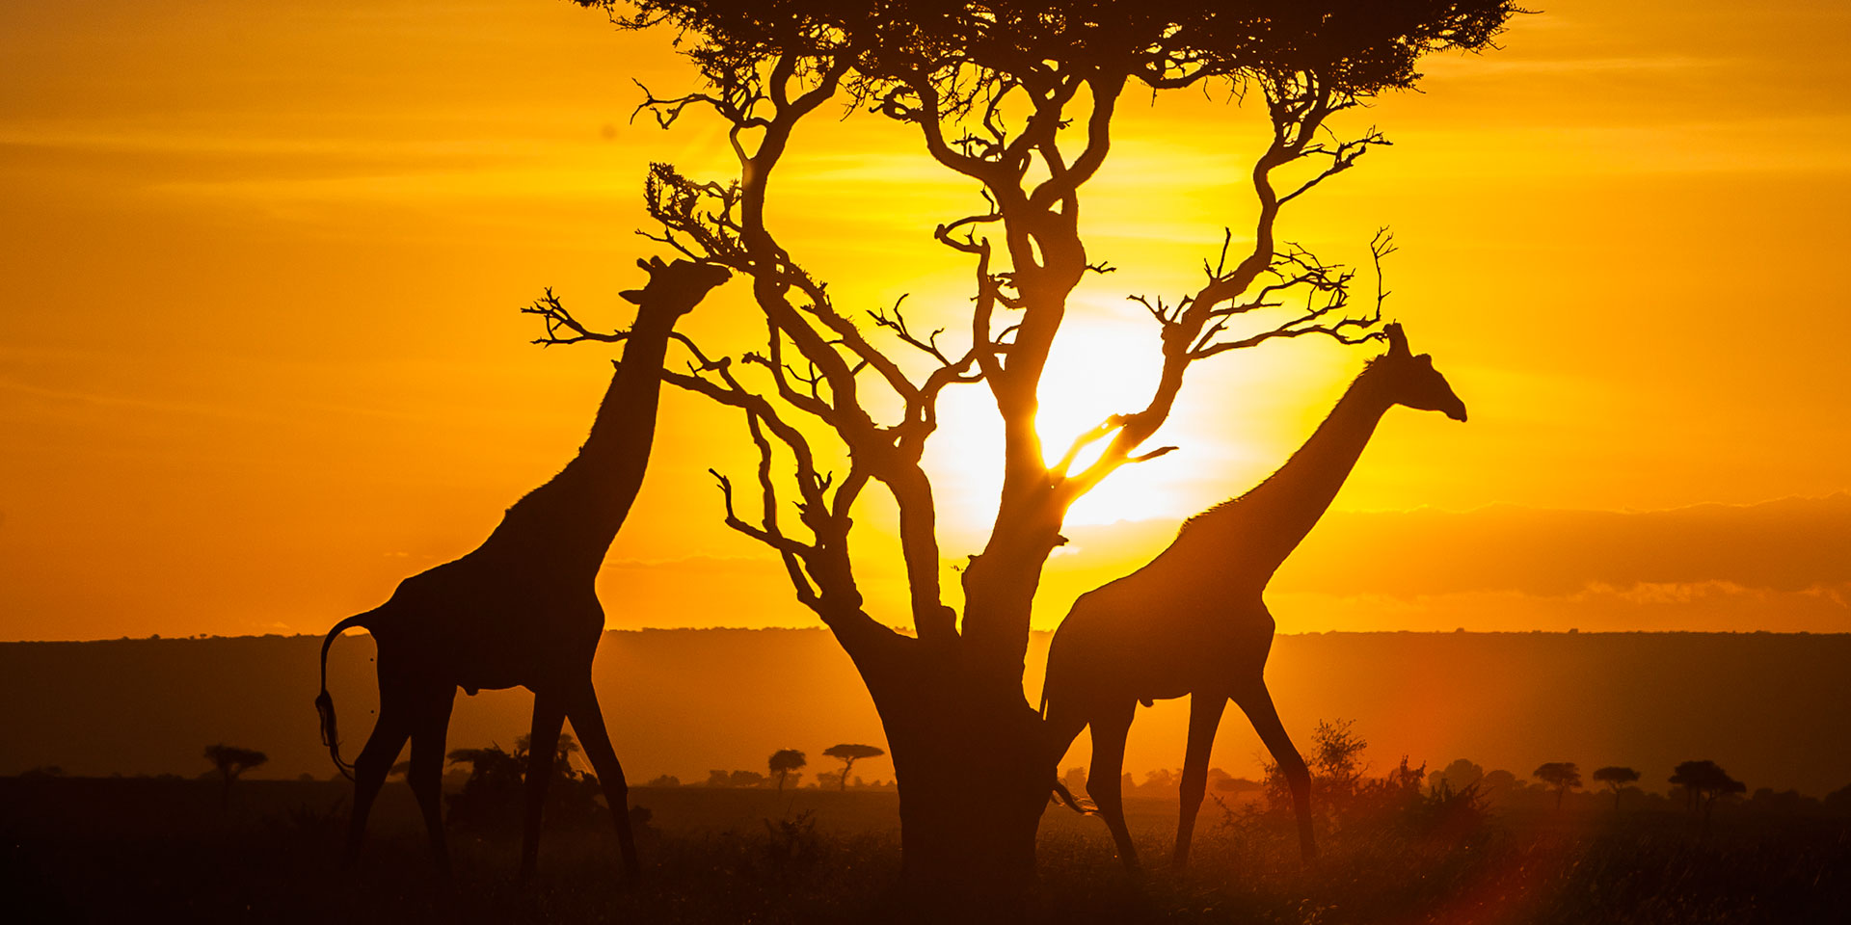

Kenya is known for its animal viewing. Many people travel there from all over the world to go on a safari. Kenya has an elected president, who is currently Uhuru Kenyatta. He is the son of the country’s first president. It has 42 million people. Its main languages are English and Swahili. Its main religions are Christianity, indigenous religions, and Islam. It has a tropical climate that is warm and dry for most of the year.

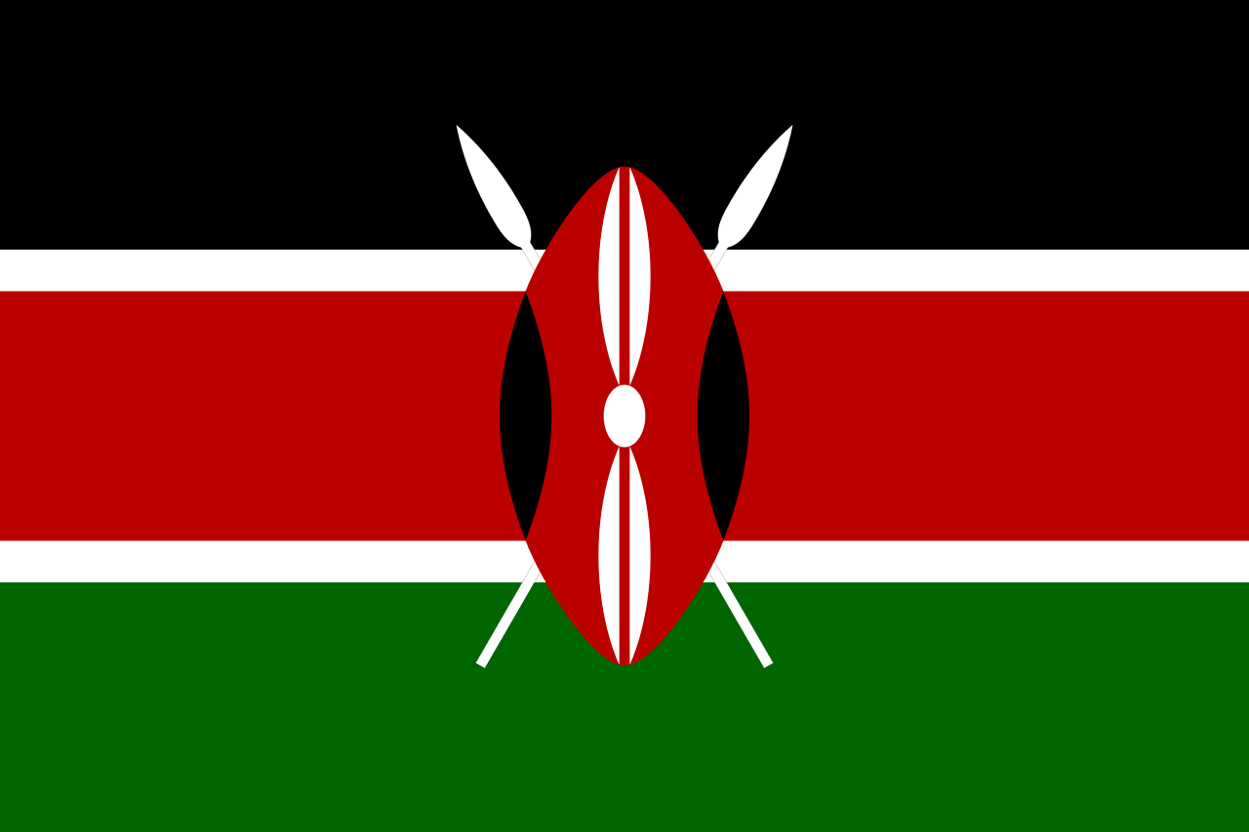

WORKSHEET: 4-8.G

Source 6: South Africa

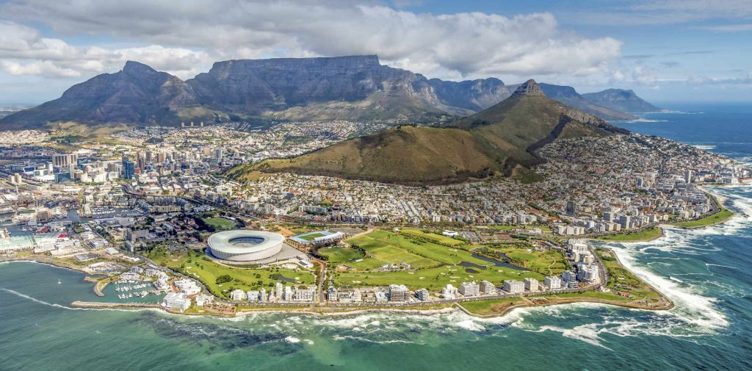

South Africa is known for its large cities, including Cape Town (see above) and Johannesburg, and beautiful coastlines. It also hosted the 2010 World Cup of Soccer. South Africa has an elected president, who is currently Jacob Zuma. It has 50 million people. It has 11 languages, including English, Afrikaans, and Zulu. Its main religions are Christianity, indigenous religions, and Islam. It has a temperate climate that is warm and dry for most of the year.

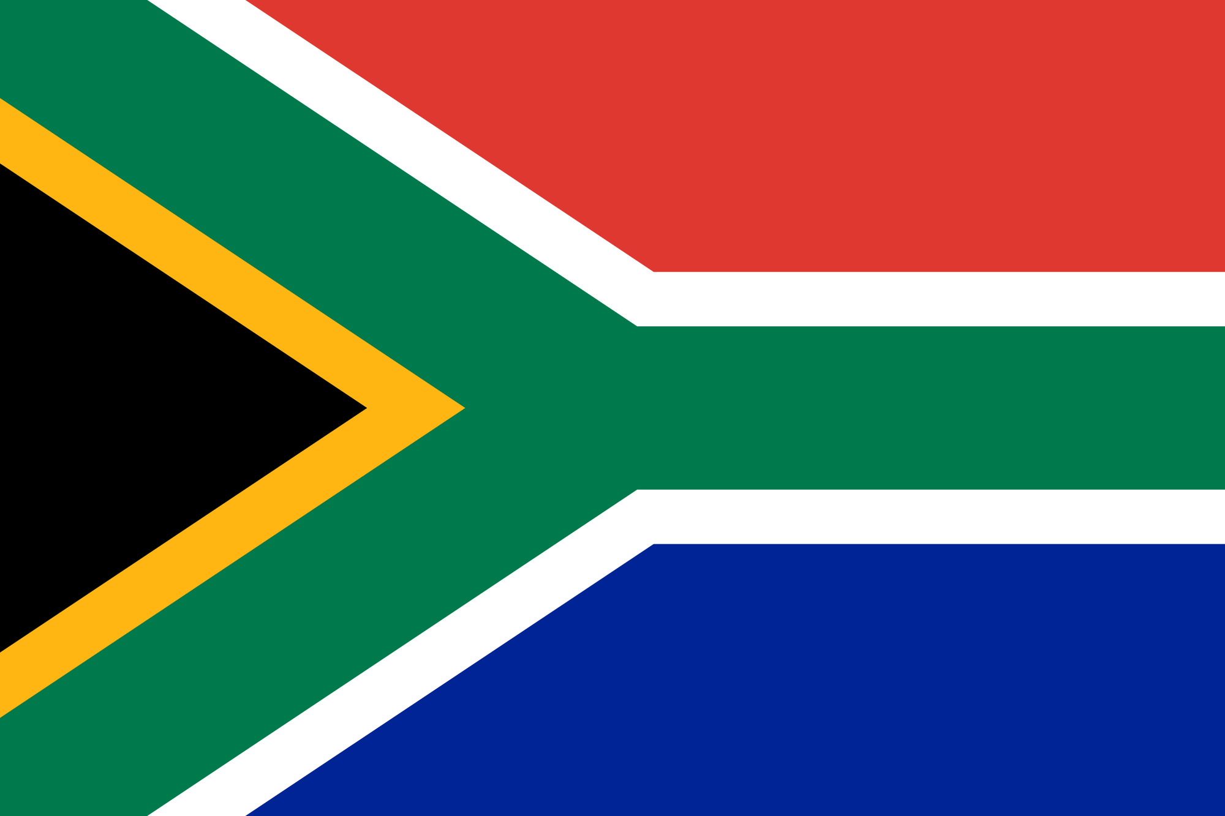
WORKSHEET: 4-8.H

Source 7: Cape Verde

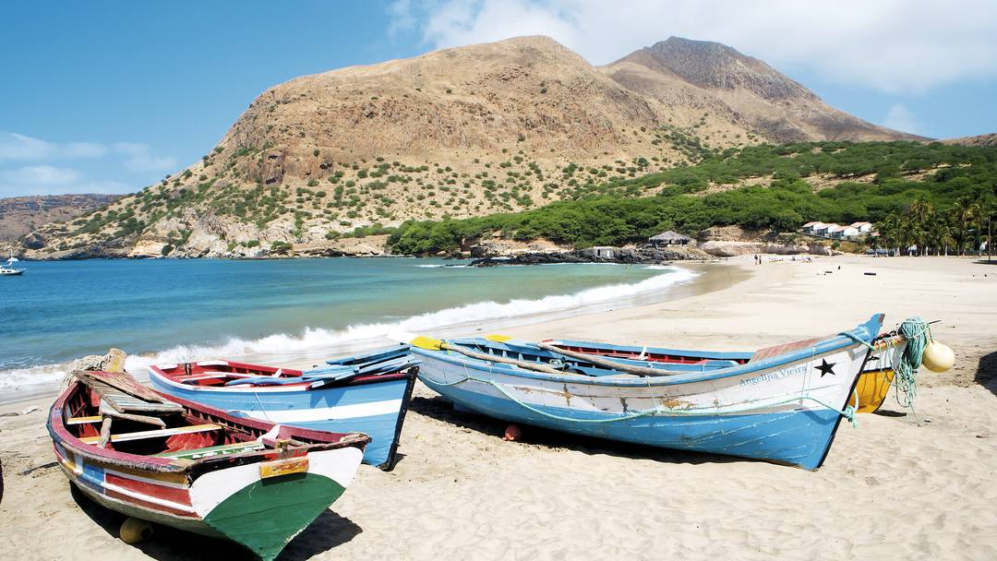

Cape Verde (cape-verd) is an island nation and known for beautiful beaches. It is a great place to spend time on a boat. Cape Verde has an elected president, who is currently Jorge Carlos Fonseca. It has 500,000 people. Its main language is Portuguese/ Cape Verdean Creole. Its main religion is Catholicism. It has an arid climate that is warm and dry for most of the year.

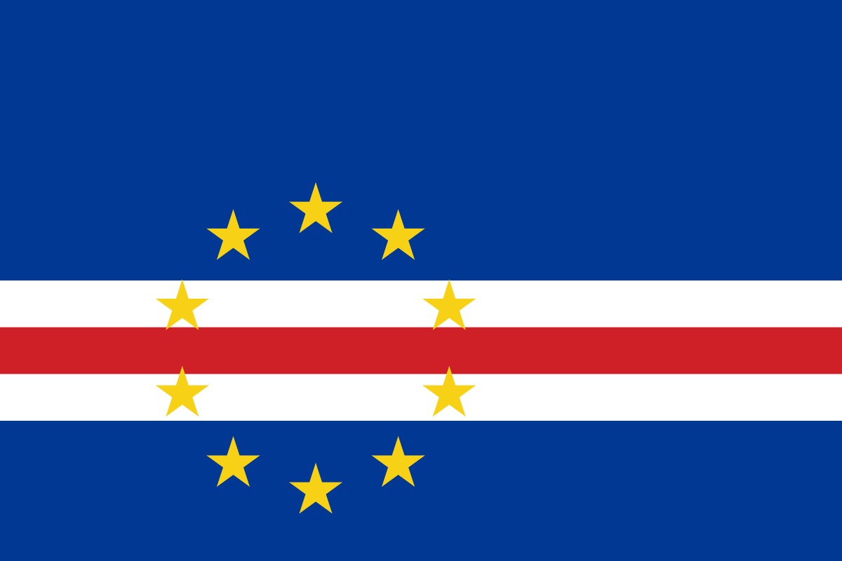
WORKSHEET: 4-8.I

Source 8: Madagascar

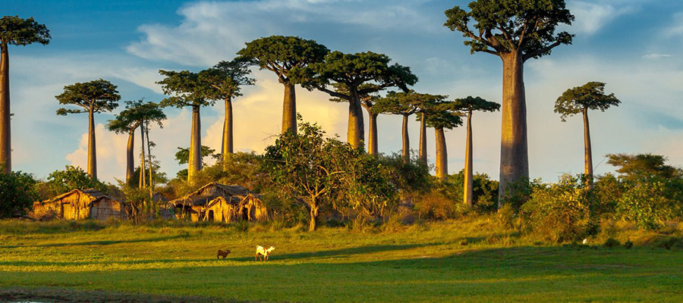

Madagascar is a large island nation (fourth largest island in the world) and known for its unique wildlife, including lemurs, mongoose, chameleon, flying fox (bat), frogs, and crocodiles. It is a great place to look at nature (see the Madagascar trees above). Madagascar has an elected president, who is currently Hery Rajaonarimampianina. It has 21 million people. Its main languages are Malagasy and French. Its main religions are indigenous religion and Christianity. It has a monsoonal climate with hot and heavy rains in the winter and dry summers.

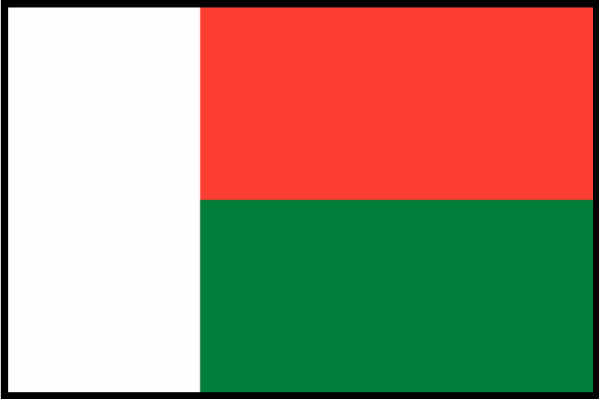
ASSESSMENT: 4-8.J

Africa Today: Exit Ticket

Inquiry Question: If you were to visit Africa today, what country would you choose and why?

Choose one country from those listed around the room and explain why you would like to visit it. Include three pieces of evidence from the sources.

LESSON PLAN 4-9: The Great Asian Empires: China, Japan, India, and Persia

MATERIALS

Zoom In Inquiry Activity (WORKSHEET 4-9.A)
Source 1: Qin China (WORKSHEET 4-9.B)
Source 2: Heian Japan (WORKSHEET 4-9.C)
Source 3: Gupta India (WORKSHEET 4-9.D)
Source 4: Achaemenid Persia (Iran) (WORKSHEET 4-9.E)
The Great Asian Empires: Exit Ticket (ASSESSMENT 4-9.F)

STANDARDS

Massachusetts History and Social Science Framework

MA-HSS.4.CS.1: Use map and globe skills to determine absolute locations (latitude and longitude) of places studied. (G)

MA-HSS.4.6: Describe how the First Emperor unified China by subduing warring factions, seizing land, centralizing government, imposing strict rules, and creating with the use of slave labor large state building projects for irrigation, transportation, and defense (e.g., the Great Wall). (H, C, E)

Common Core: Literacy

CCSS.ELA-Literacy.RI.4.9: Integrate information from two texts on the same topic in order to write or speak about the subject knowledgeably.

CCSS.ELA-Literacy.RI.4.10: By the end of year, read and comprehend informational texts, including history/social studies, science, and technical texts, in the grades 4–5 text complexity band proficiently, with scaffolding as needed at the high end of the range.

CCSS.ELA-Literacy.W.4.8: Recall relevant information from experiences or gather relevant information from print and digital sources; take notes and categorize information, and provide a list of sources.

CCSS.ELA-Literacy.W.4.9: Draw evidence from literary or informational texts to support analysis, reflection, and research.

PROCEDURES

Inquiry Question: If you could live in any ancient Asian empire, which one would it be and why?
PREPARATION

This lesson uses a method called Zoom In Inquiry. The key to Zoom In Inquiry is that you as a teacher allow the students to explore an image in three successive “zoom ins.”

Zoom In Inquiry:
- The teacher has students start by looking at only a specific part of an image (Zoom 1) and not the entire image. The teacher asks, “What do you think this may be?” and “What can you tell from what you see?” or “What clues do you see?”
- The teacher then reveals a slightly larger view of the image (Zoom 2). The teacher asks, “What do you think this may be?” and “What can you tell from what you see?” or “What clues do you see?”
- Finally, the teacher shows the entire image (Zoom 3) to the students. The teacher asks, “What do you think this may be?” and “What can you tell from what you see?” or “What clues do you see?”
- Finally, the teacher explains what the image is of and connects it to the lesson.

If this is your first time using Zoom In Inquiry, we recommend watching this video example from Grade 4 produced by Explorify: https://vimeo.com/205234946

A. OPENER (10 minutes)

1. Zoom In Inquiry Activity
Put students in small groups. Give students the Zoom 1 image (WORKSHEET 4-9.A). Project the Zoom 1 image for the class. Tell the students to look at the image closely. In their groups, they should look at the details or clues and make educated guesses as to what the picture may be of. Ask the following questions: “What do you think this may be?”, “What can you tell from what you see?”, “What clues do you see?” Anticipated responses may include: a door, a castle, a bridge. Have students examine the source for about 2-3 minutes.

Give students the Zoom 2 image (WORKSHEET 4-9.A). Project the Zoom 2 image for the class. Tell the students to look at the image closely. In their groups, they should look at the details or clues and make educated guesses as to what the picture may be of. Ask the following questions: “What do you think this may be?”, “What can you tell from what you see?”, “What clues do you see?” Anticipated responses may include: a door, a castle, a bridge, a fort, a mountain ranger station. Have students examine the source for about 2-3 minutes.

Give students the Zoom 3 image (WORKSHEET 4-9.A). Project the Zoom 3 image for the class. Tell the students to look at the image closely. In their groups, they should look at the details or clues and make educated guesses as to what the picture may be of. Ask the following questions: “What do you think this may be?”, “What can you tell from what you see?”, “What clues do you see?” Anticipated responses may include: a door, a castle, a bridge, a fort, a mountain ranger station, a wall (Great Wall of China). Have students examine the source for about 2-3 minutes.

Tell students that this is an image of the Great Wall of China. Show students the Great Wall of China Map. Tell students that today we will be studying the Great Empires of Asia. One of those empires was Qin (pronounced chin) China (“Qin” is where the word China comes from). To stop invasions from the Mongolians and other people from the north and west, the first Chinese emperor, a man named Qin Shi Huang (pronounced chin-sure-hwong), made this wall. It would eventually be 5,500 miles, which is the distance from Boston to Hawaii.

B. DEVELOPMENT (20 minutes)

2. Read About the Great Asian Empires
Put students in small groups and assign them one of the sources: Qin China (WORKSHEET 4-9.B), Heian Japan (WORKSHEET 4-9.C), Gupta India (WORKSHEET 4-9.D), Achaemenid Persia (Iran) (WORKSHEET 4-9.E). Have one student from each group read their source. As the student reads, tell the other group members to underline or highlight any important information.

3. Engage in a Jig Saw on Great Asian Empires
Have students participate in a jig saw activity. Make new groups where at least one student from each of the original groups is included. This will create several new groups of three students, one is an expert on 4-9.B, 4-9.C, 4-9.D, 4-9.E. Have each student describe their document to the other members of their group.

Ask students to use the sources to answer the following inquiry question: “If you could live in any ancient Asian empire, which one would it be and why?” In answering this question, students should debate between the four different worksheets. After students have discussed the question, they should complete the exit ticket in the following step. Circulate the room, helping the students who may have difficulty choosing one asset.

C. CLOSING (15 minutes)

4. Write Up Argument on Great Asian Empires
For the evaluation task, have the students complete the exit ticket (ASSESSMENT 4-9.F), where they write their own personal response to the lesson’s Inquiry Question: “If you could live in any ancient Asian empire, which one would it be and why?” Tell students to cite at least three pieces of evidence from the sources for this lesson.

Before using the exit ticket, consider using a graphic organizer or two column notes to prepare students for the writing task. Consider using sentence starters and modeling to help the students with their answer to the inquiry question.
EVALUATION

ASSESSMENT 4-9.E

What to look for?

The students should take a stance on what ancient Asian empire they would choose to live in. All arguments should cite at least 3 pieces of evidence from the sources.

Some information that students may include in their answer to the question:

Qin China
- It was a large empire with 20 million people (half the size of Rome).
- The climate is subtropical with hot, humid, and rainy summers and mild winters.
- People lived with their families in small farming villages and rarely left their homes.
- The government made everyone use the same measurements and languages to unite the people.
- They created the Terracotta Army, which includes 8,000 soldiers, 130 chariots, and 670 horses to guard the emperor’s tomb.

Heian Japan
- It was a small empire with 7 million people (quarter the size of Rome).
- The climate is temperate with hot, humid, and rainy summers and cold winters.
- People lived with their families in small farming villages.
- The emperor created a group of elite soldiers called samurai.
- This was also a period of important Japanese art, poems, novels, essays, and music.

Gupta India
- It was a large empire with millions of people (historians are not exactly sure how many people lived there).
- The climate there is tropical monsoonal with hot, humid, and rainy summers and dryer and warm winters.
- People lived with their families in small farming villages.
- The empire was known for its gold coins that were made for trade.
- It was also a period of great buildings, including the Dashavatara Temple.

Achaemenid Persia (Iran)
- It was a large empire with 35 million people (more than half the size of the Roman Empire in Europe).
- The climate there is desert with hot and dry climate year-round.
- People lived with their families in small farming villages.
- It was a time of peace, so most people were not afraid of war.
- Many men were recruited into the Persian army.
- They may have invented the first mail system, which carried letters by horse from city to city.
- Unlike other ancient Asian civilizations, many jobs were done by both men and women.

WORKSHEET: 4-9.A

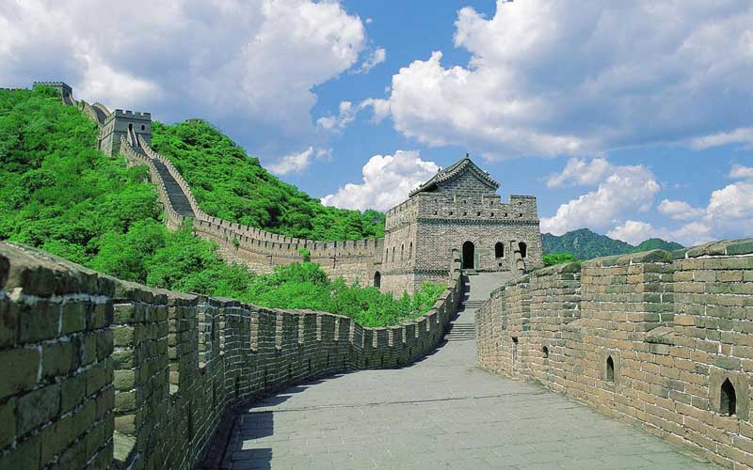
Zoom 1
Zoom 2
Zoom 3
Great Wall of China Map

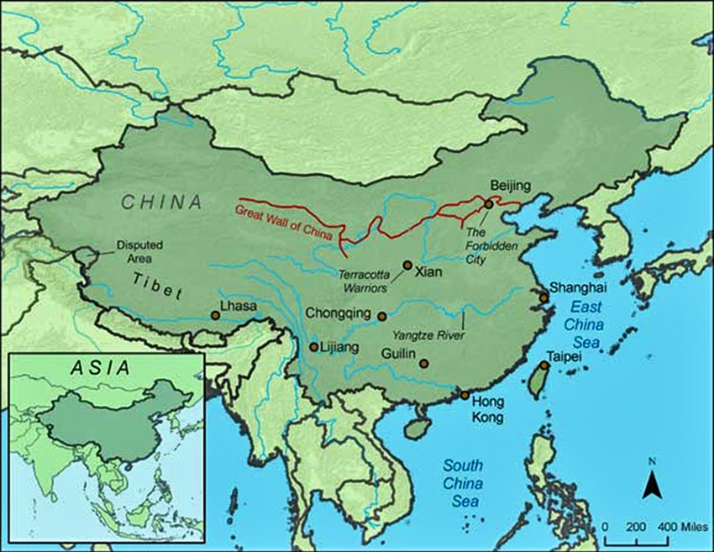

WORKSHEET: 4-9.B

Source 1: Qin China

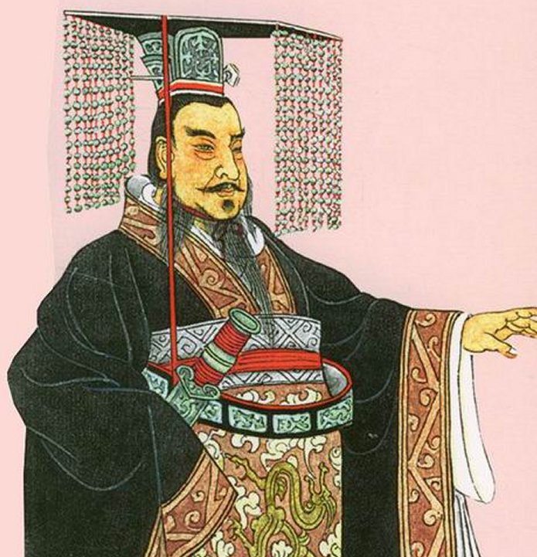

The Qin Empire in China lasted from 221 to 206 BCE. Its first ruler was Qin Shi Huang (chin-sure-hwong). Its capital was a city called ‎ Xianyang (she-en-yang). There were 20 million people in the empire (half the size of the Roman Empire in Europe). The climate there is subtropical with hot, humid, and rainy summers and mild winters.

People in the Qin Empire usually lived with their families in small farming villages and rarely left their homes. It was a time of many wars, so leaving the village could be dangerous. The government made everyone use the same measurements and languages to unite the people. The most famous art of the period was the Terracotta Army. When the first emperor died, he made them create statues of 8,000 soldiers, 130 chariots, and 670 horses to guard his tomb (pictured below).

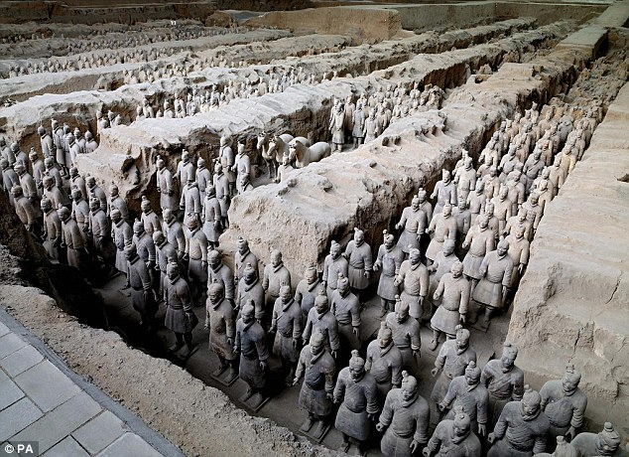

The below map shows the location of the Qin Empire in Asia.

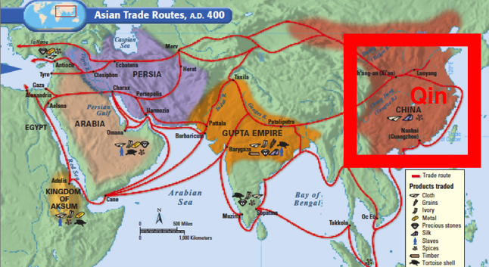

WORKSHEET: 4-9.C

Source 2: Heian Japan

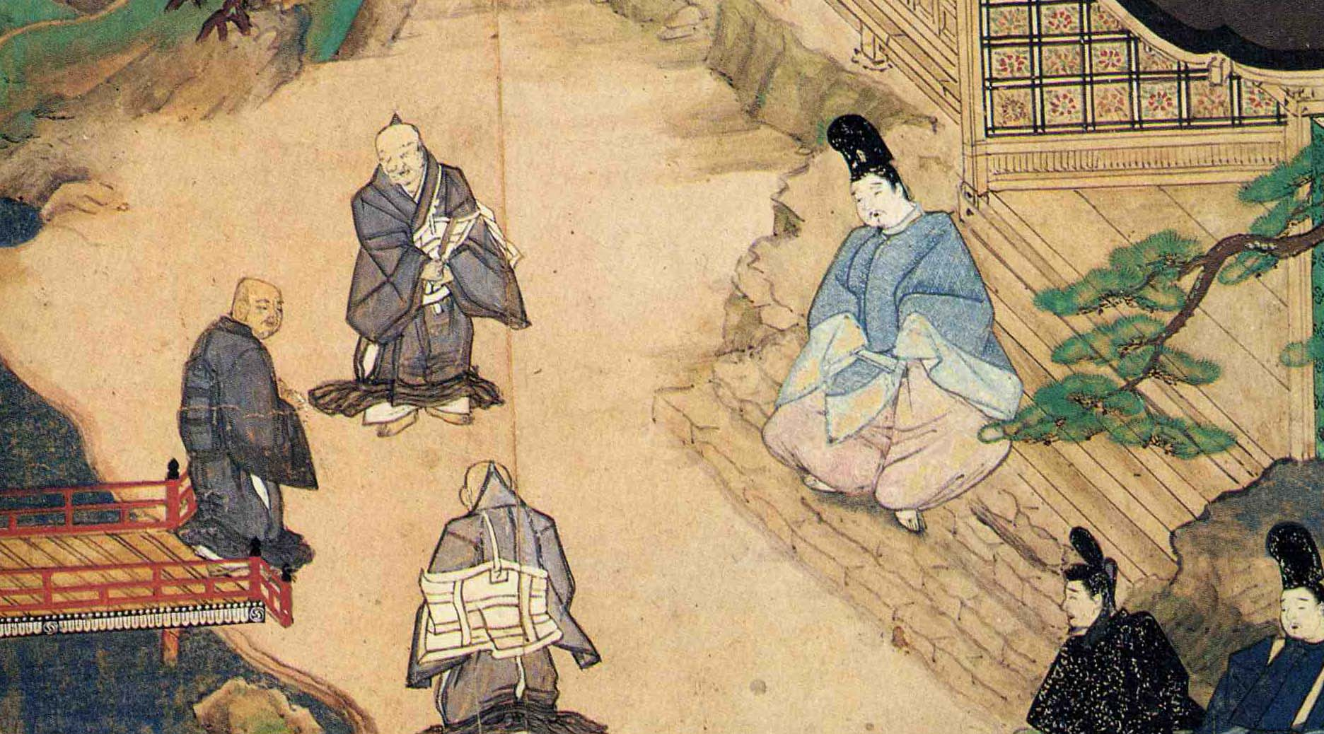

The Heian Empire in Japan lasted from 794 to 1185 CE. During that time, Japan was ruled by the Fujiwara (foo-gee-wha-ra) family. Its capital was a city called ‎ Heian (hay-on), which is today the city of Kyoto (key-oo-toe). There were 7 million people in the empire (quarter of the size of the Roman Empire in Europe). The climate there is temperate with hot, humid, and rainy summers and cold winters.

People in the Heian Empire usually lived with their families in small farming villages. The emperor created a group of elite soldiers called samurai (sam-oo-rye), who are pictured on the next page. The samurai protected their regions and often went to war to defend their clans. This was also a period of important Japanese art, poems, novels, essays, and music.

Samurai pictured in Japanese artwork.

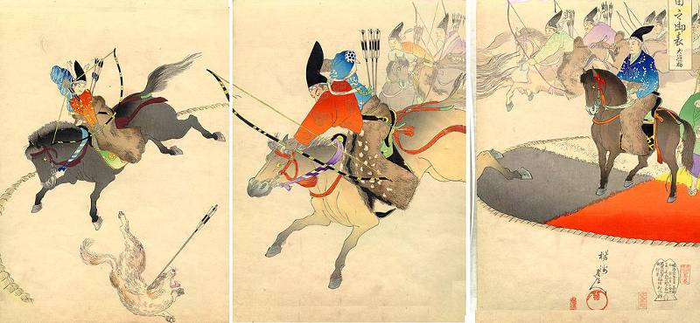

The below map shows the location of the Heian Empire in Asia.

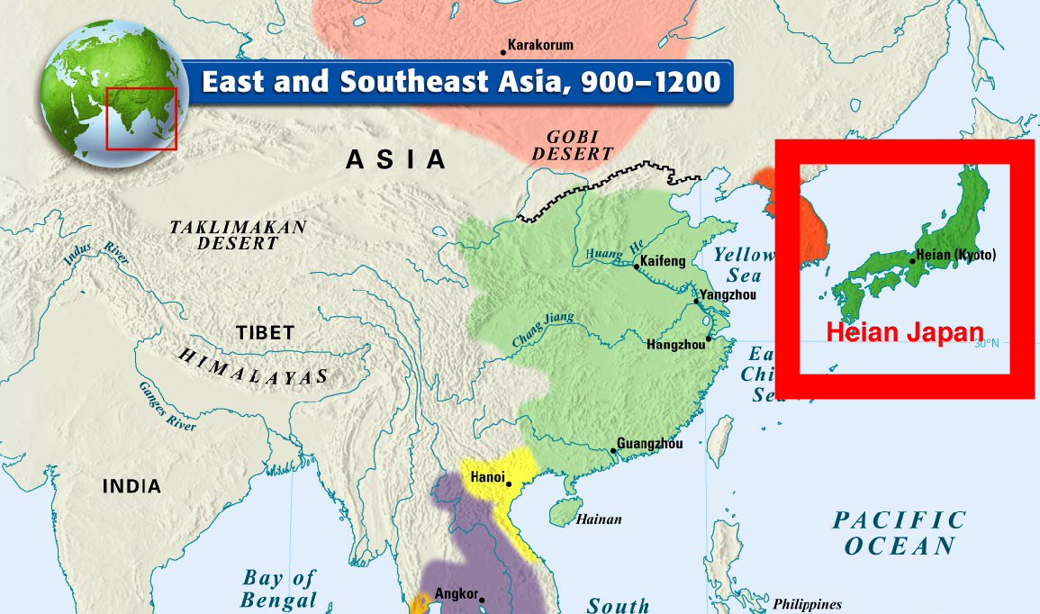

WORKSHEET: 4-9.D

Source 3: Gupta India

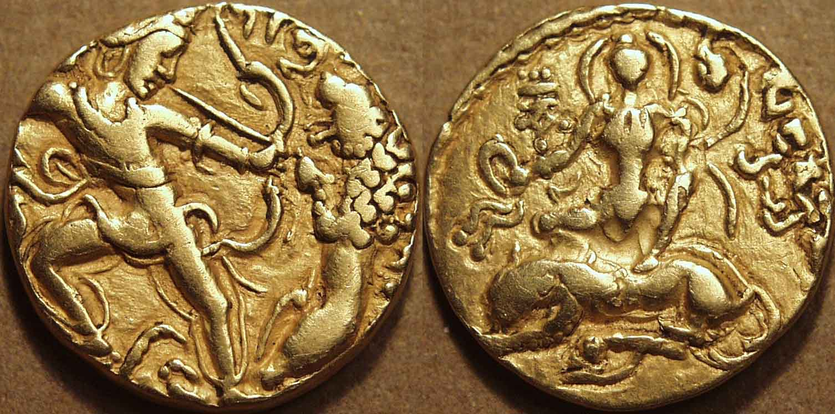

The Gupta Empire in India lasted from 320 to 550 CE. Two of the most important rulers were Chandragupta I and II (shan-dra-goop-ta). Its capital was a city called ‎ Pataliputra (pat-all-lee-poo-tra) near the Ganges (gang-ees) River. There were millions of people in the empire (historians are not exactly sure how many people lived there). The climate there is tropical monsoonal with hot, humid, and rainy summers and dryer and warm winters.

People in the Gupta Empire usually lived with their families in small farming villages. The empire was known for its gold coins that were made for trade (pictured above, showing the ruler Chandragupta II). It was also a period of great buildings, including the Dashavatara Temple (pictured on the next page).

Dashavatara Temple

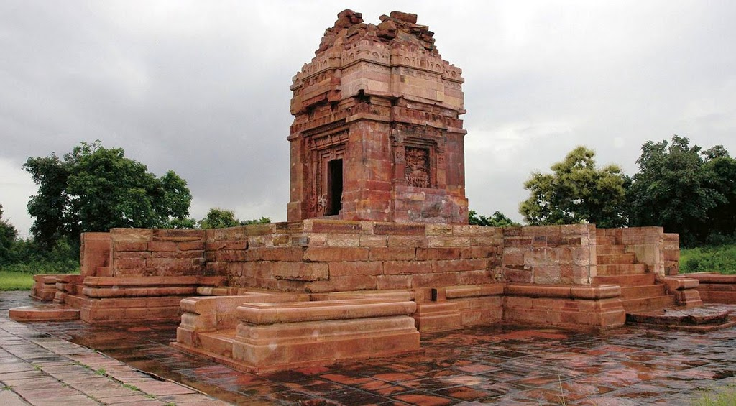

The below map shows the location of the Gupta Empire in Asia.

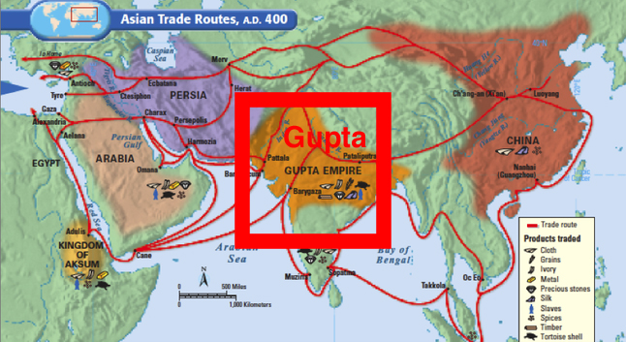

WORKSHEET: 4-9.E

Source 4: Achaemenid Persia (Iran)

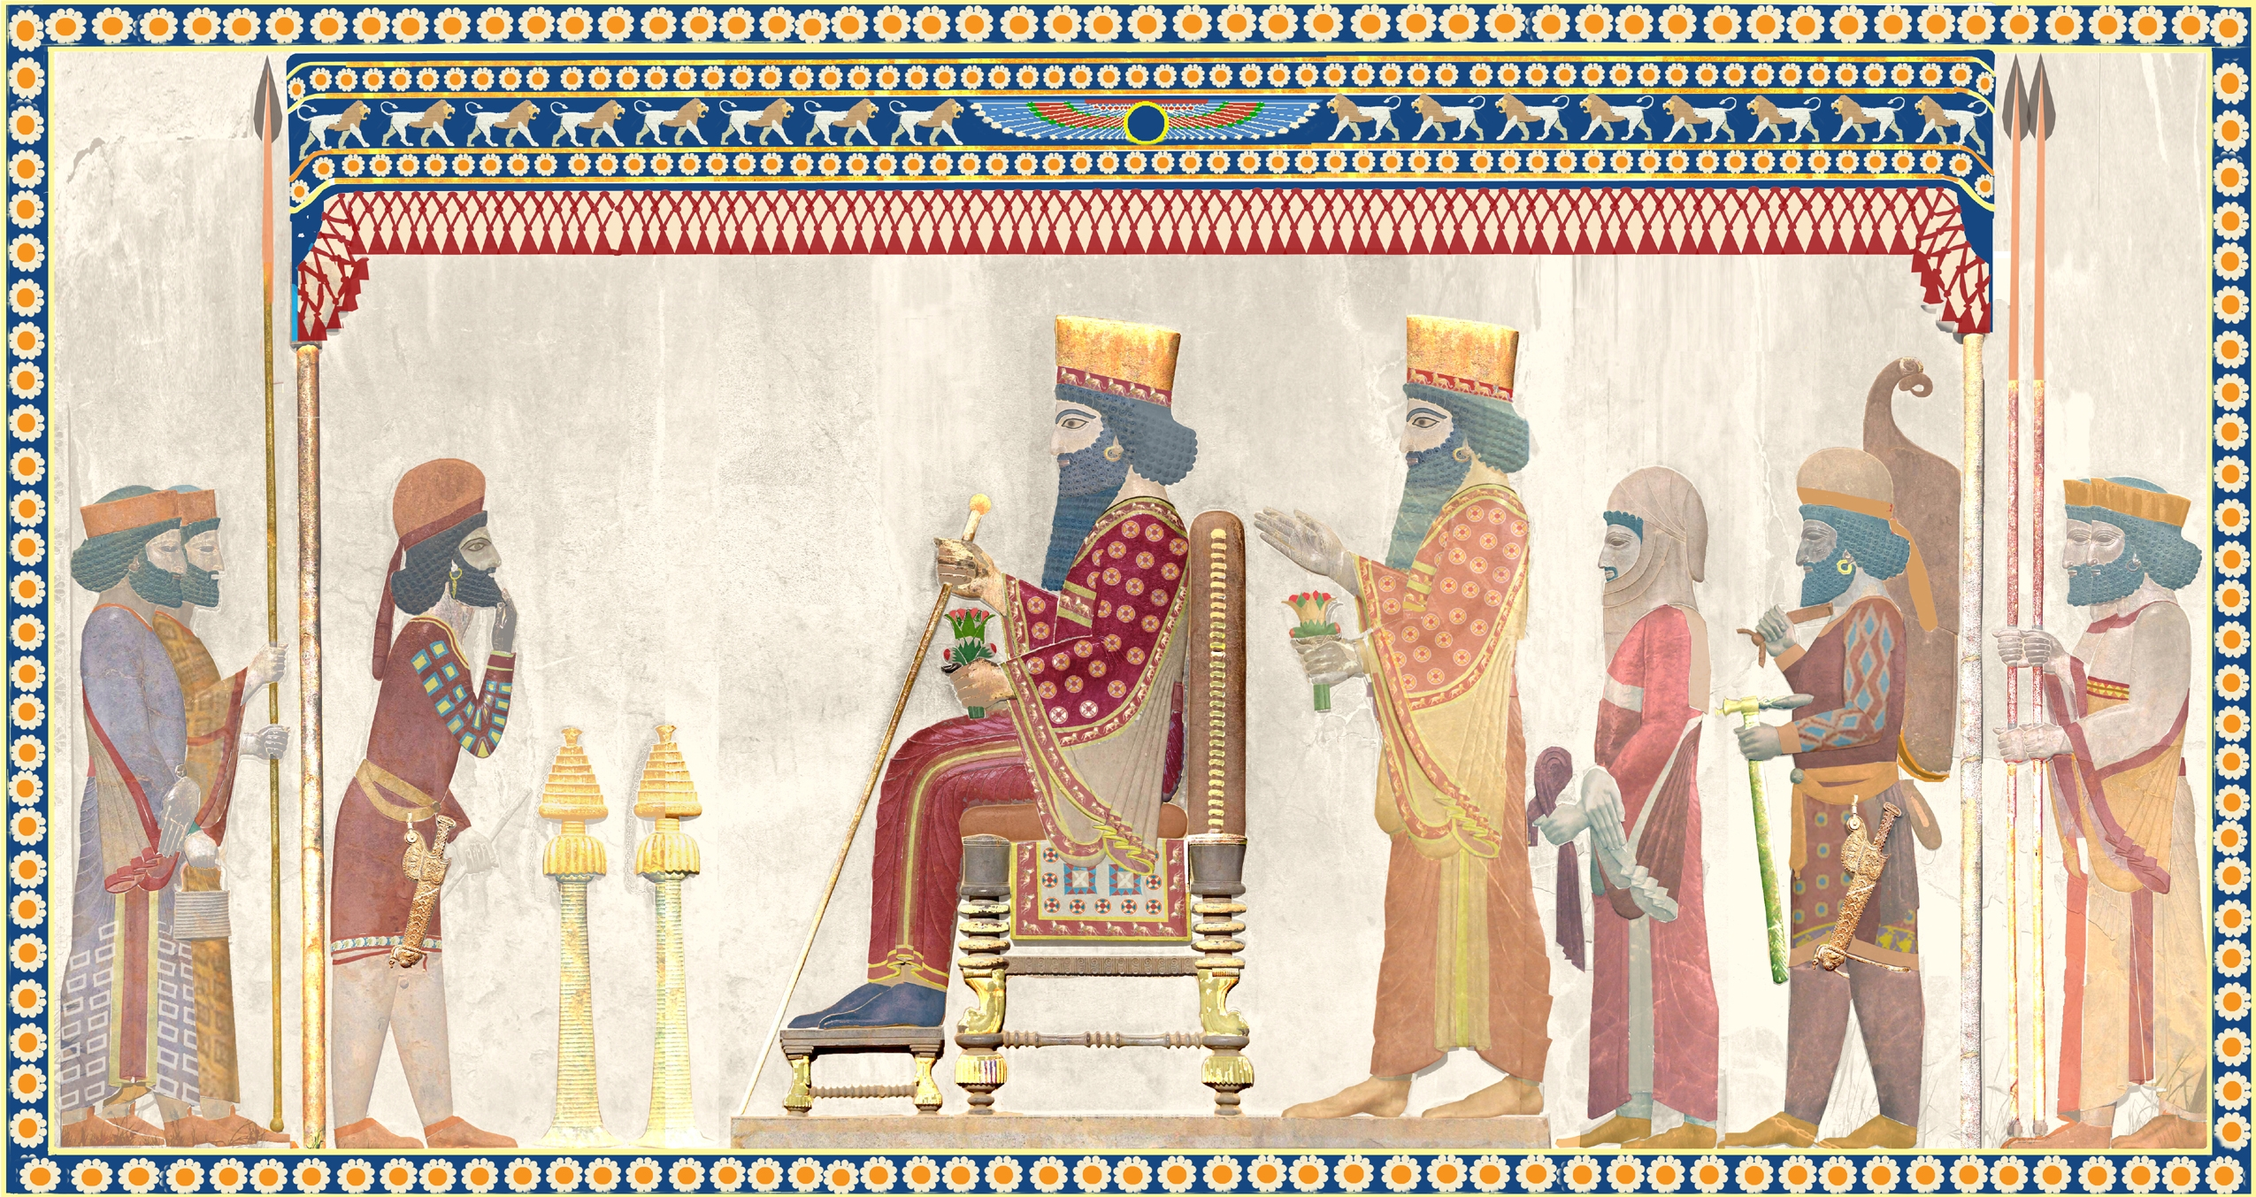

The Achaemenid (ah-key-ma-nid) Empire in Persia lasted from 550 - 330 BCE. Its first ruler was Cyrus (sy-rus) the Great. Its capitals were Pasargadae (pa-sar-ga-day) and Babylon (bab-a-lon). There were 35 million people in the empire (more than half the size of the Roman Empire in Europe). The climate there is desert with hot and dry climate year-round.

People in the Achaemenid Empire usually lived with their families in small farming villages. It was a time of peace, so most people were not afraid of war. Many men were recruited into the Persian army (picture on next page). The Persians may have invented the first mail system, which carried letters by horse from city to city. Unlike other ancient Asian civilizations, many jobs were done by both men and women.
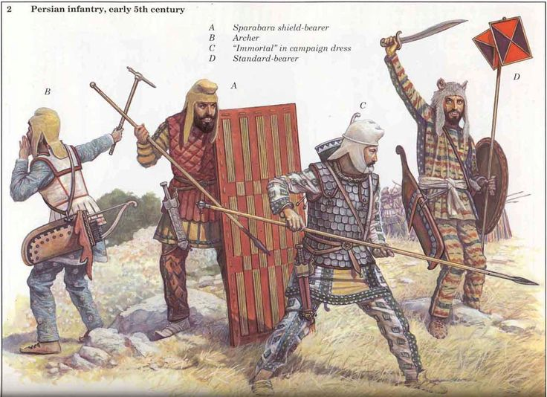

The below map shows the location of the Persian Empire in Asia.

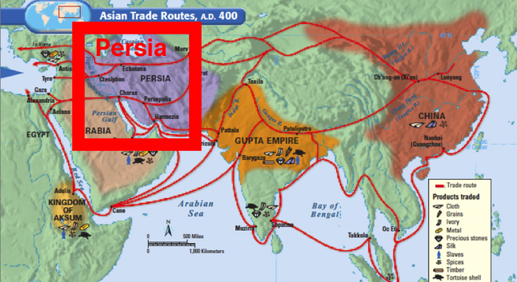
ASSESSMENT: 4-9.F

The Great Asian Empires: Exit Ticket

Inquiry Question: If you could live in any ancient Asian empire, which one would it be and why?

Choose one Great Asian Empire and explain why you would choose to live there. Include three pieces of evidence from the sources.

LESSON PLAN 4-10: The Silk Road: Connecting Continents

MATERIALS

Silk Road Video (Lesson4-10Video1) [Located in the UOW Video Library: www.christophercmartell.com/understandingourworld]
Silk Road Map (WORKSHEET 4-10.A)
Source 1: Stop 1—Guangzhou (WORKSHEET 4-10.B)
Source 2: Stop 2—Chang’an (WORKSHEET 4-10.C)
Source 3: Stop 3—Pataliputra (WORKSHEET 4-10.D)
Source 4: Stop 4—Persepolis (WORKSHEET 4-10.E)
Source 5: Stop 5—Constantinople (WORKSHEET 4-10.F)
The Silk Road: Exit Ticket (ASSESSMENT 4-10.G)

STANDARDS

Massachusetts History and Social Science Framework

MA-HSS.4.CS.1: Use map and globe skills to determine absolute locations (latitude and longitude) of places studied. (G)

MA-HSS.4.4: Describe important technologies of China such as bronze casting, silk manufacture, and gunpowder. (H, E)

Common Core: Literacy

CCSS.ELA-Literacy.RI.4.9: Integrate information from two texts on the same topic in order to write or speak about the subject knowledgeably.

CCSS.ELA-Literacy.RI.4.10: By the end of year, read and comprehend informational texts, including history/social studies, science, and technical texts, in the grades 4–5 text complexity band proficiently, with scaffolding as needed at the high end of the range.

CCSS.ELA-Literacy.W.4.8: Recall relevant information from experiences or gather relevant information from print and digital sources; take notes and categorize information, and provide a list of sources.

CCSS.ELA-Literacy.W.4.9: Draw evidence from literary or informational texts to support analysis, reflection, and research.

PROCEDURES

Inquiry Question: What was life like on the Silk Road?

A. OPENER (10 minutes)

1. Watch the Silk Road Video
Show the students a short video about the Silk Road (Lesson4-10Video1). Stop the video to explain any concepts that may be difficult for students. After watching the video, ask the students, “How was the Silk Road similar and different from how we transport goods today?” Anticipated responses may include: we use planes and ships, it took much longer back then, they did not have factories, they did not have e-mail or telephones. Tell the students that today we are going to pretend that we are traveling on the Silk Road. We will be keeping a diary and you will have to write about each stop along the way. Pass out and have students look at the Silk Road Map (WORKSHEET 4-10.A). Ask them if they recognize any of the cities or empires from our last lesson. Tell the students that the silk road happened because of trade between the main empire of Asia, which included Qin China, Heian Japan, Gupta India, and Achaemenid Persia. Tell students they should use this map to help write their diary entries.

B. DEVELOPMENT (20 minutes)

2. Read About the Silk Road
Pass out the sources: Stop 1—Guangzhou (WORKSHEET 4-10.B), Stop 2—Chang’an (WORKSHEET 4-10.C), Stop 3—Pataliputra (WORKSHEET 4-10.D), Stop 4—Persepolis (WORKSHEET 4-10.E), Stop 5—Constantinople (WORKSHEET 4-10.F)
Have students take turns reading aloud (using choral, partner, or independent reading) each source.

3. Write Diary Entry
Divide the class in half. Explain that a diary is a journal or writing that people do once a day to remember things about their day. They are going to write a diary entry pretending that they are traveling on the Silk Road from Constantinople in Turkey to Guangzhou in China. Tell them to include in their diary entries some of the information in the sources, especially what items they are trading and the people who they are trading with. Before they start writing, make a list of possible items to include on the board or chart paper.

The diary entries (ASSESSMENT 4-10.G) will serve as the evaluation task. Students’ diary entries will address the lesson’s Inquiry Question: “What was life like on the Silk Road?” Tell students to cite at least three pieces of evidence from the sources for this lesson.

C. CLOSING (15 minutes)

4. Share Letters
Have students share their diary entries with the class. Draw comparisons between the different students’ stories and list them on the board or chart paper.
EVALUATION

ASSESSMENT 4-10.G

What to look for?

The students should create diary entries. All entries should cite at least 3 pieces of evidence from the sources.

Some information that students may include in their diary entries:

Guangzhou
- China's greatest international seaport.
- Many of the items traded on the silk road started here.
- Products include tea and ceramics.
- Stock up on items that Europeans and Africans desire.
- It is on the ocean and where items traded on the Silk Road may be put on ships and sent out to places in the Indian and Pacific Oceans.

Chang’an
- Inland Chinese city on the Silk Road.
- Built just south of the Great Wall.
- Became the capital of the Qin Chinese Empire.
- The main starting point on the Silk Road for silk and other clothes.
- Trade tea and ceramics here for silk or other clothes.

Pataliputra
- Near the Ganges River.
- Became the capital of the Indian Empire for a brief period of time.
- Had a wooden wall nine miles long surrounding the city with 470 towers and a moat that was 900 feet wide.
- Stock up on rare oils and chilies.

Persepolis
- On the Silk Road near the Pulvar and Kur Rivers.
- Became the capital of the Achaemenid Persian Empire.
- Known for its Gate of Xerxes, which was a massive gateway that greeted visitors.
- Stock up on rugs, cloth, and dates.

Constantinople
- Was at the end of the Silk Road.
- On the Sea of Marmara, which connects to the Aegean Sea and eventually the Mediterranean Sea.
- Allowed goods to be transported from Constantinople to Europe and Africa.
- Stock up on metal, gold, silver, wool, spices, and other goods brought there from Europe and Africa.

WORKSHEET: 4-10.A

Map of the Silk Road

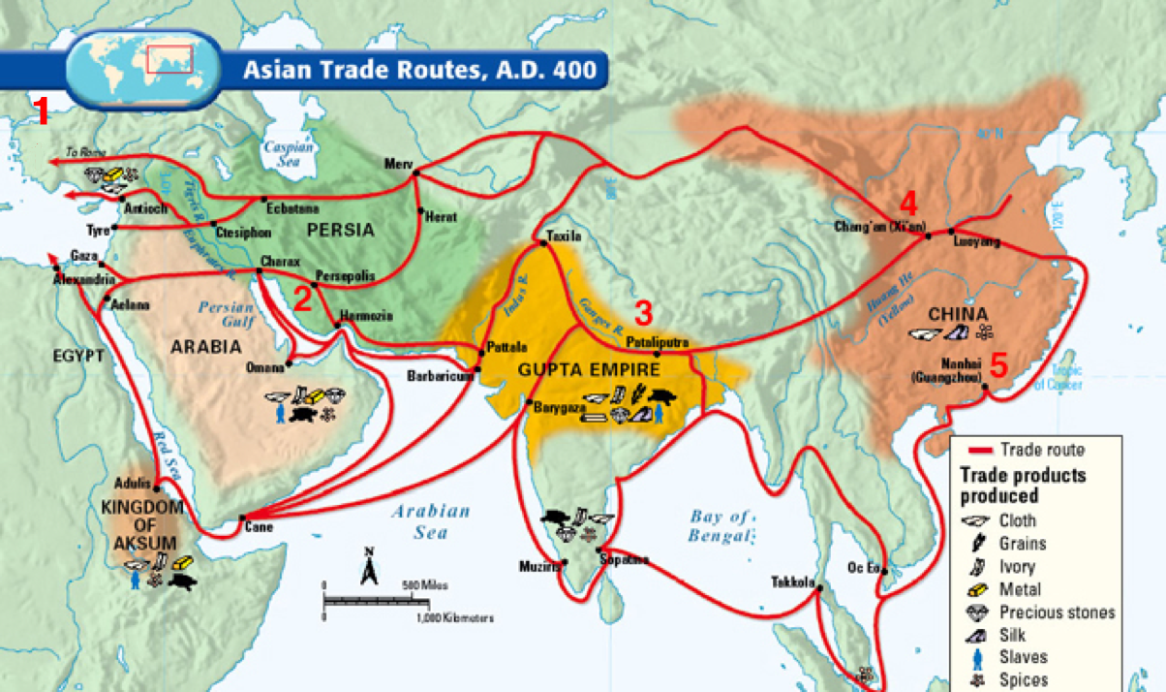

WORKSHEET: 4-10.B

Source 1: Stop 1—Guangzhou

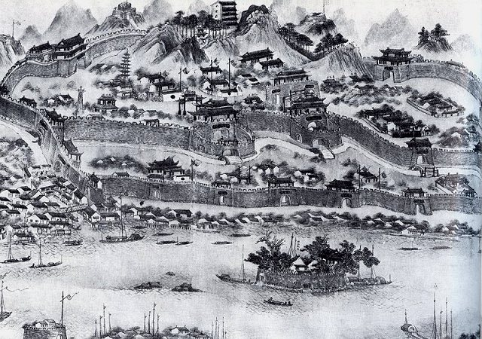

Guangzhou (gwan-zoh), also called Canton (can-tawn), was China's greatest international seaport. Many of the items traded on the silk road started here. This included tea and ceramics. If you were starting on the Silk Road here, you should stock up on items that Europeans and Africans desire. It is also on the ocean and where items traded on the Silk Road may be put on ships and sent out to places in the Indian and Pacific Oceans.

WORKSHEET: 4-10.C

Source 2: Stop 2—Chang’an

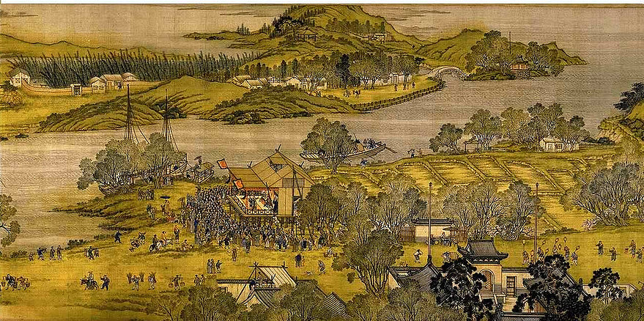

Chang’an (shang-un), also known as Sian or Xi’an, was an inland Chinese city on the Silk Road. It was built just south of the Great Wall. Due to its trade location, it became the capital of the Qin Chinese Empire. It was the main starting point on the Silk Road for silk and other clothes. You may consider trading some of your tea and ceramics here for silk or other clothes.

WORKSHEET: 4-10.D

Source 3: Stop 3—Pataliputra

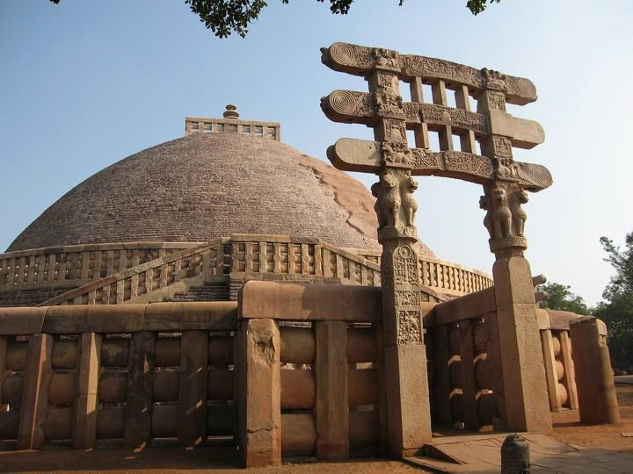

Pataliputra (pa-tal-ee-poo-tra), also known as Patna, was city on the Silk Road near the Ganges River. Due to its trade location, it became the capital of the Indian Empire for a brief period of time. It had a wooden wall that surrounded the city and was nine miles long, with 470 towers, and a moat that was 900 feet wide. It was known as a place to get rare oils and chilies. You may consider trading some of your items for oil or chilies.

WORKSHEET: 4-10.E

Source 4: Stop 4—Persepolis

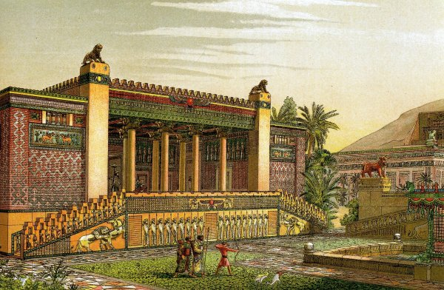

Persepolis (per-sip-o-lis), also known as Takht-e-Jamshid, was city on the Silk Road near the Pulvar and Kur Rivers. Due to its trade location, it became the capital of the Achaemenid Persian Empire. It is known for its Gate of Xerxes, which was a massive gateway that greeted visitors. It was known as a place to get rugs, cloth, and dates. You may consider trading some of your items for these items.

WORKSHEET: 4-10.F

Source 5: Stop 5—Constantinople

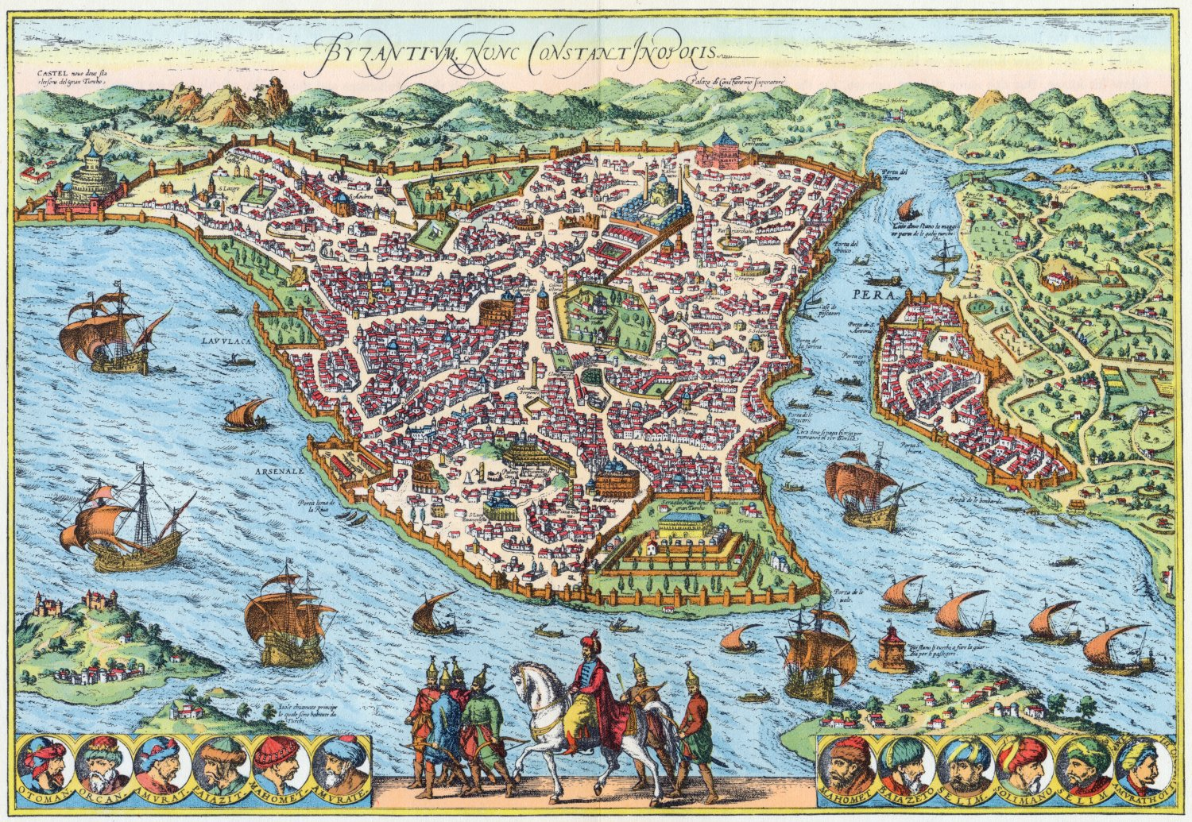

Constantinople, also known as Byzantium (now called Istanbul), was the end of the Silk Road. It is on the Sea of Marmara, which connects to the Aegean Sea and eventually the Mediterranean Sea. This allowed goods to be transported from Constantinople to Europe and Africa. It was known as a place to get metal, gold, silver, wool, spices, and other goods brought there from Europe and Africa. You may consider trading some of your items for these items.

ASSESSMENT: 4-10.G

The Silk Road: Exit Ticket

Inquiry Question: What was life like on the Silk Road?

Imagine you are traveling the Silk Road and write a diary entry about each stop. Include three pieces of evidence from the sources. Use another sheet of paper if you need more space for each diary entry.

Stop 1— Guangzhou

Stop 2— Chang’an

Stop 3—Pataliputra

Stop 4—Persepolis

Stop 5— Constantinople

LESSON PLAN 4-11: Việt Nam: A Country of Waterways

MATERIALS

Mekong Floating Market Video (Lesson4-11Video1) [Located in the UOW Video Library: www.christophercmartell.com/understandingourworld]
Map of the Mekong River (WORKSHEET 4-11.A)
Source 1: Transportation (WORKSHEET 4-11.B)
Source 2: Economy (WORKSHEET 4-11.C)
Source 3: Illegal Wildlife Trade (WORKSHEET 4-11.D)
Source 4: Pollution and Climate Change (WORKSHEET 4-11.E)
Preparation for the Corner Debate (WORKSHEET 4-11.F)
STRONGLY AGREE, AGREE, DISAGREE, STRONGLY DISAGREE signs (MATERIALS 4-11.G)
Việt Nam: A Country of Waterways: Exit Ticket (ASSESSMENT 4-11.H)

STANDARDS

Massachusetts History and Social Science Framework

MA-HSS.4.CS.1: Use map and globe skills to determine absolute locations (latitude and longitude) of places studied. (G)

MA-HSS.4.16: Identify major immigrant groups that live in Massachusetts and where they now live in large numbers (e.g., English, Irish, Italians, French Canadians, Armenians, Greeks, Portuguese, Haitians, and Vietnamese). (H, G)

MA-HSS.6.SEAO.3: Explain how the following five factors have influenced settlement and the economies of major countries of Southeast Asia and Oceania. (G, E)
A. absolute and relative locations
B. climate
C. major physical characteristics
D. major natural resources
E. population size

Common Core: Literacy

CCSS.ELA-Literacy.RI.4.9: Integrate information from two texts on the same topic in order to write or speak about the subject knowledgeably.

CCSS.ELA-Literacy.RI.4.10: By the end of year, read and comprehend informational texts, including history/social studies, science, and technical texts, in the grades 4–5 text complexity band proficiently, with scaffolding as needed at the high end of the range.

CCSS.ELA-Literacy.W.4.8: Recall relevant information from experiences or gather relevant information from print and digital sources; take notes and categorize information, and provide a list of sources.

CCSS.ELA-Literacy.W.4.9: Draw evidence from literary or informational texts to support analysis, reflection, and research.

PROCEDURES

Inquiry Question: Are the human changes to the Mekong River more positive or negative?

A. OPENER (10 minutes)

1. Watch Mekong Floating Market Video
Show the students a short video of the Mekong River’s floating market in Việt Nam (Lesson4-11Video1). Stop the video to ask questions about what the students notice about the market and how it is similar or different to the places where the students shop. At the end of the video, ask students what they know about the country of Việt Nam. Anticipated responses may include: they were born there or have relatives born there, the government is communist, the U.S. fought a war there, there are many rivers, they speak Vietnamese there. Project the Map of the Mekong River (WORKSHEET 4-11.A). Explain that the river starts in the mountains of China, goes through six countries and the last country is Việt Nam. We call that last part the Mekong River Delta of Việt Nam, because it is where the river meets the ocean.

B. DEVELOPMENT (20 minutes)

2. Examine Evidence About the Mekong River
Pass out the sources: Transportation (WORKSHEET 4-11.A), Economy (WORKSHEET 4-11.B), Illegal Wildlife Trade (WORKSHEET 4-11.C), Pollution and Climate Change (WORKSHEET 4-11.D) As a class, have students take turns reading aloud (using choral, partner, or independent reading) each source.

3. Participate in a Corner Debate on the Mekong River Changes
Have students individually think about each Mekong River changes question using Preparation for the Corner Debate (WORKSHEET 4-11.E).

Ask students to bring their preparation sheets with them and stand up in the middle of the room. Post in the four corners of the room the signs that say “STRONGLY AGREE, “AGREE,” “DISAGREE,” “STRONGLY DISAGREE” (MATERIALS 4-11.F).

Read each of the questions. Tell students if they think would be a good choice, they should stand under “STRONGLY AGREE” or “AGREE,” or a bad choice, they should stand under “DISAGREE” or “STRONGLY DISAGREE.” Ask students to explain why they agree or disagree. Repeat this with the other questions. If there are no agrees or disagrees for a question, you should stand there and give a reason why it might be a good or bad choice.

After the students have heard a discussion of each choice, have students return to their seats. They should discuss with their classmates in small groups the inquiry question: “Are the human changes to the Mekong River more positive or negative?” After they have had time to listen and discuss, they should form their own arguments.

C. CLOSING (15 minutes)

4. Write Up Argument on Mekong River Changes
For the evaluation task, have the students complete the exit ticket (ASSESSMENT 4-11.E), where they write their own personal response to the lesson’s Inquiry Question: “Are the human changes to the Mekong River more positive or negative?” Tell students to cite at least three pieces of evidence from the sources or our class debate.

Before using the exit ticket, consider using a graphic organizer or two column notes to prepare students for the writing task. Consider using sentence starters and modeling to help the students with their answer to the inquiry question.

EVALUATION

ASSESSMENT 4-11.E

What to look for?

The students should take a stance on if the human changes to the Mekong River are positive or negative. All arguments should cite at least 3 pieces of evidence from the sources.

Some information that students may include in their answer to the question:

Changes to the Mekong River are more positive:
- The roads are currently very full; using the river for transportation reduces traffic.
- It is an important part of the Vietnamese economy.
- Many people make their living from trading goods on the Mekong River.
- People can use boats to get around.

Changes to the Mekong River are more negative:
- Some people smuggle rare animals from the Mekong River and sell them.
- Boats create pollution in the Mekong.
- Climate change is causing certain animals to go extinct in the Mekong River.
- Climate change is causing flooding along the Mekong River, effecting people’s homes and businesses.

WORKSHEET: 4-11.A

Map of the Mekong River

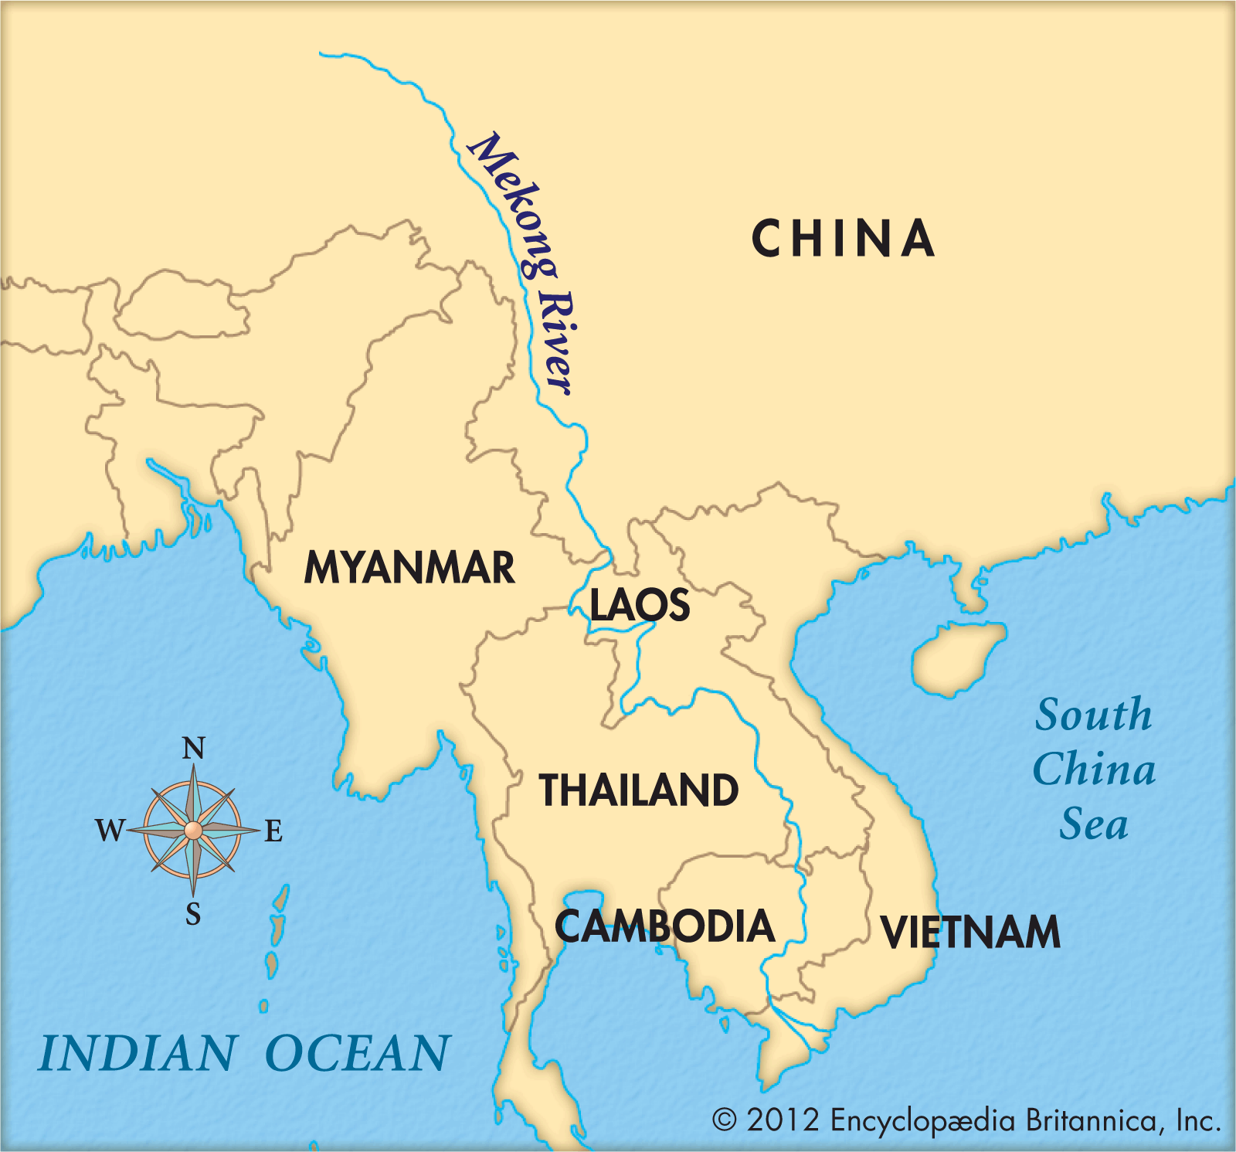

WORKSHEET: 4-11.B

Source 1: Transportation

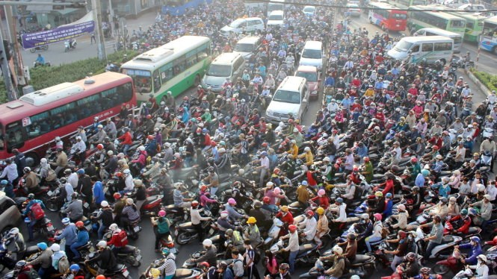

There are many traffic jams in the Vietnamese city of Saigon (see above). On the roads, the motorcycles, cars, and buses compete with trailer trucks that are hauling goods for the market. As fewer people have been transporting goods by boat on the canals and Mekong River, traffic is getting worse. Transporting more goods on the canals and rivers (like they use to) would improve traffic on the roads.

WORKSHEET: 4-11.C

Source 2: Economy

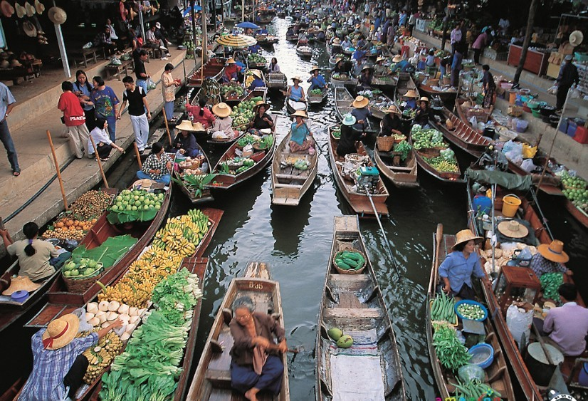

The floating market of the canals and Mekong River in Saigon are an important place to buy and sell goods. You can buy almost anything from a boat vendor, including fresh vegetables, fruits, meats, and fish. Some boats are even floating convenience stores with soda or snacks. The markets have been there for hundreds of years and tourists from all over the world visit them. They are an important part of Việt Nam’s economy and many people make their living from selling items there.

WORKSHEET: 4-11.D

Source 3: Illegal Wildlife Trade

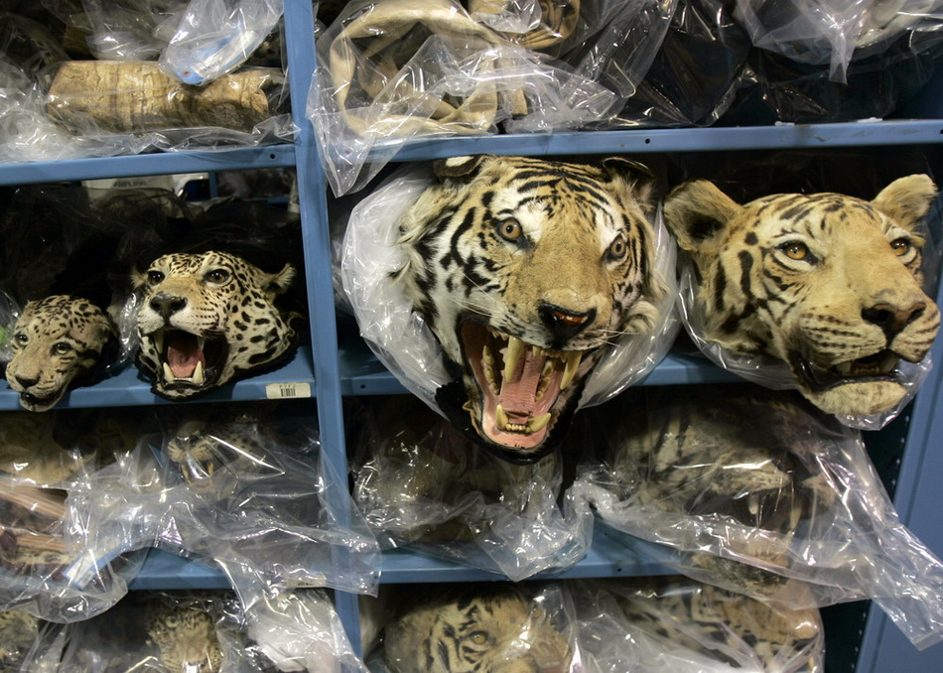

Although it is illegal, some people along the Mekong River catch, kill, and sell rare and endangered animals, such as tigers and sun bears. They often use the river to transport these animals and then people who collect rare animals buy them and display them in their houses. It is believed that there are only 350 tigers left in the Mekong River area, because of these poachers and smugglers. There were more than thousand only a few decades ago.
WORKSHEET: 4-11.E

Source 4: Pollution and Climate Change

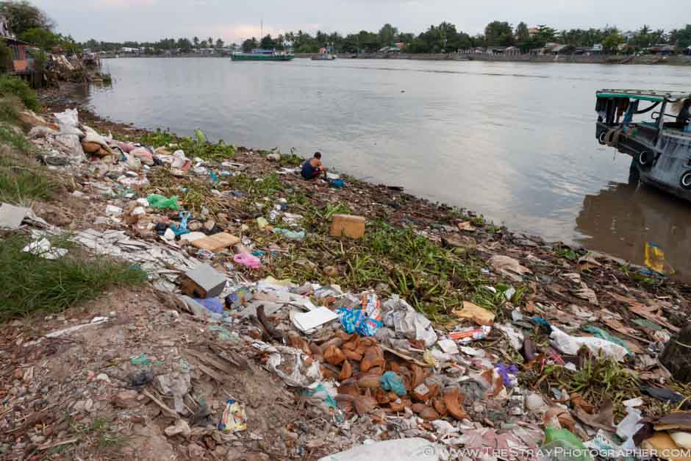

Since there are so many boats on the Mekong River, there is also a lot of pollution. Trash washes up on the shore (see above) and gasoline and oil from boats ends up in the water. The Mekong River is also having problems from climate change. As the Earth’s temperature increases, plants and animals in the Mekong River area are being effected. Climate change also leads to more floods, which affect people’s homes and businesses. In Fall 2011, the Mekong had its worst flood in decades and many people were hurt by it. These floods also hurt the amount of rice that can be grown, which is an important crop in Việt Nam.

WORKSHEET: 4-11.F

Preparation for the Corner Debate

Think about the following sentences and decide if you think “strongly agree,” “agree,” “disagree,” or “strongly disagree.” Then explain why.

More people should transport goods and people using the Mekong River.

Circle:
Strongly Agree Agree Disagree Strongly Disagree

More people should trade goods on the Mekong River.

Circle:
Strongly Agree Agree Disagree Strongly Disagree

People should go to jail for many years if they kill endangered animals near the Mekong River.

Circle:
Strongly Agree Agree Disagree Strongly Disagree

People should stop all pollution in the Mekong River.

Circle:
Strongly Agree Agree Disagree Strongly Disagree

MATERIALS: 4-11.G

STRONGLY AGREE

AGREE

DISAGREE

STRONGLY DISAGREE

ASSESSMENT: 4-11.H

Việt Nam: A Country of Waterways: Exit Ticket

Inquiry Question: Are the human changes to the Mekong River more positive or negative?

Choose that the changes to the Mekong River are positive or negative and explain why you think so. Include three pieces of evidence from the sources.

LESSON PLAN 4-12: Asian Megacities: Would You Want to Live There?

MATERIALS

Japanese Micro-Apartment Video (Lesson4-12Video1) [Located in the UOW Video Library: www.christophercmartell.com/understandingourworld]
Megacities Map (WORKSHEET 4-12.A)
Source 1: Tokyo and Transportation (WORKSHEET 4-12.B)
Source 2: Seoul and Technology (WORKSHEET 4-12.C)
Source 3: Shanghai and Housing (WORKSHEET 4-12.D)
Source 4: Beijing and Pollution (WORKSHEET 4-12.E)
Asian Megacities: Exit Ticket (ASSESSMENT 4-12.F)

STANDARDS

Massachusetts History and Social Science Framework

MA-HSS.4.CS.1: Use map and globe skills to determine absolute locations (latitude and longitude) of places studied. (G)

MA-HSS.6. NEA.2 Use a map key to locate the countries and major cities in the various regions of East Asia. (G, E)

Common Core: Literacy

CCSS.ELA-Literacy.RI.4.9: Integrate information from two texts on the same topic in order to write or speak about the subject knowledgeably.

CCSS.ELA-Literacy.RI.4.10: By the end of year, read and comprehend informational texts, including history/social studies, science, and technical texts, in the grades 4–5 text complexity band proficiently, with scaffolding as needed at the high end of the range.

CCSS.ELA-Literacy.W.4.8: Recall relevant information from experiences or gather relevant information from print and digital sources; take notes and categorize information, and provide a list of sources.

CCSS.ELA-Literacy.W.4.9: Draw evidence from literary or informational texts to support analysis, reflection, and research.

PROCEDURES

Inquiry Question: Would you like to live in an Asian megacity?

A. OPENER (10 minutes)

1. Watch Japanese Micro-Apartment Video
Show the students a short video of Japanese micro-apartments (Lesson4-12Video1). Stop the video to ask questions about what the students notice about these homes are different and similar to their own homes. At the end of the video, ask students if they would want to live in a micro-apartment. Project the Megacities Map (WORKSHEET 4-12.A). Explain that a megacity is any city with over 10 million people (which includes their suburbs). There are only two in the U.S., New York and Los Angeles. Tell students that today we are going to study these megacities in Asia.

B. DEVELOPMENT (20 minutes)

2. Read About the Asian Megacities
Put students in small groups and assign them one of the sources: Tokyo and Transportation (WORKSHEET 4-12.B), Seoul and Technology (WORKSHEET 4-12.C), Shanghai and Housing (WORKSHEET 4-12.D), Beijing and Pollution (WORKSHEET 4-12.E). Have one student from each group read their source. As the student reads, tell the other group members to underline or highlight any important information.

3. Engage in a Jig Saw on Asian Megacities
Have students participate in a jig saw activity. Make new groups where at least one student from each of the original groups is included. This will create several new groups of three students, one is an expert on 4-12.B, 4-12.C, 4-12.D, 4-12.E. Have each student describe their document to the other members of their group.

Ask students to use the sources to answer the following inquiry question: “Would you like to live in an Asian megacity?” In answering this question, students should debate between the four different worksheets. After students have discussed the question, they should complete the exit ticket in the following step. Circulate the room, helping the students who may have difficulty choosing one asset.

C. CLOSING (15 minutes)

4. Write Up Argument on Asian Megacities
For the evaluation task, have the students complete the exit ticket (ASSESSMENT 4-12.F), where they write their own personal response to the lesson’s Inquiry Question: “Would you like to live in an Asian megacity?” Tell students to cite at least three pieces of evidence from the sources.

Before using the exit ticket, consider using a graphic organizer or two column notes to prepare students for the writing task. Consider using sentence starters and modeling to help the students with their answer to the inquiry question.

EVALUATION

ASSESSMENT 4-12.F

What to look for?

The students should take a stance on if they would want to live in an Asia megacity. All arguments should cite at least 3 pieces of evidence from the sources.

Some information that students may include in their answer to the question:

Reasons to live in an Asian megacity:
- Affordable (if you are okay with a small apartment)
- Technologically advanced
- Good public transportation (do not need a car)

Reasons to not live in an Asian megacity:
- Pollution is a major problem
- Too many people in a small area
- Too busy (which can be stressful)

WORKSHEET: 4-12.A

Map of Megacities

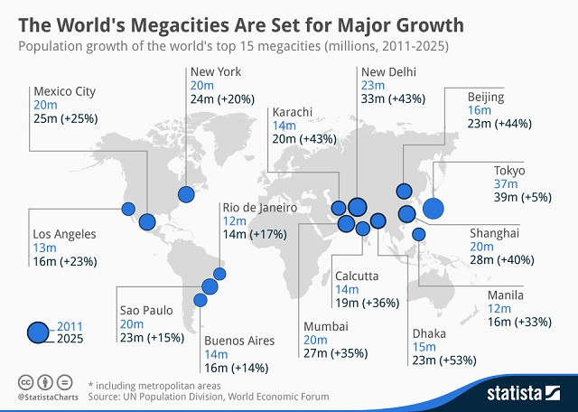
WORKSHEET: 4-12.B

Source 1: Tokyo and Transportation

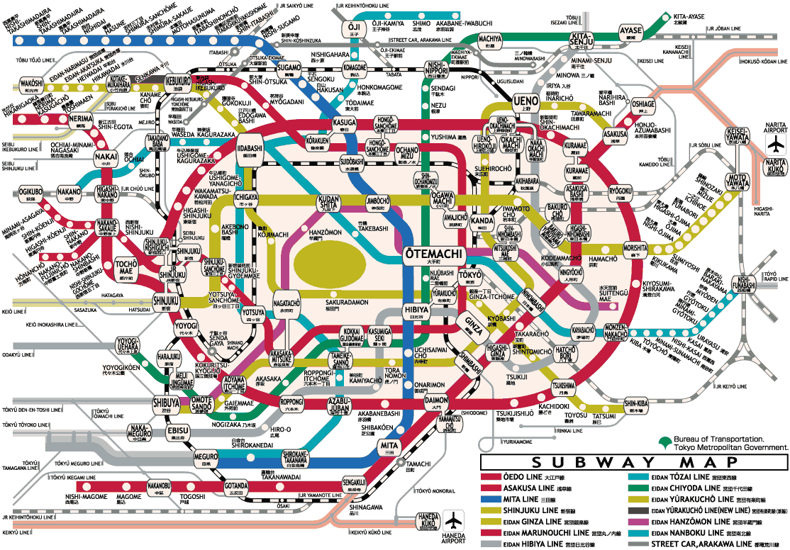

Tokyo, Japan is known for its extensive subway system. Many people in Tokyo do not own a car. The Tokyo subway system has 278 stations and over 189 miles of track (about the distance from Boston to the New York City). Above is the Tokyo subway map. Some stations are so busy that people are hired to push people onto the train, so the trains do not leave late. Almost 9 million people ride the Toyko subway daily. With so many passengers, it is very rare for the Tokyo subway to be late and trains run about every 3 minutes. Historian Kakuei Tanaka said of the Tokyo transit system, “It completely changed the face of Japan. Travel times were shortened … so that everyone uses it.”
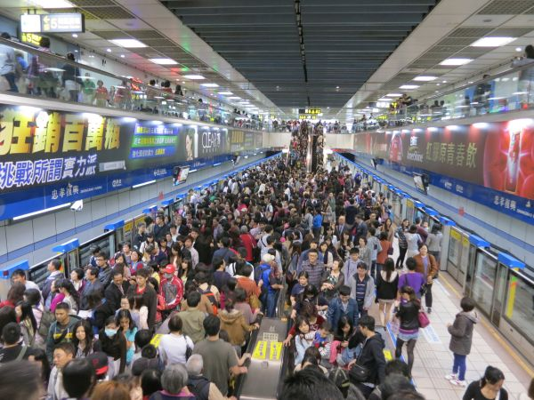
WORKSHEET: 4-12.C

Source 2: Seoul and Technology

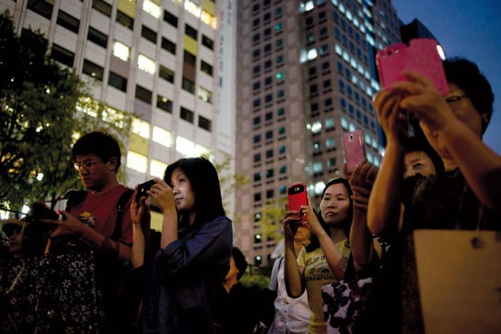

Seoul, South Korea is one of the most technologically advance cities in the world. Wifi Internet is available almost everywhere in the city. 95% of South Korean households have a high-speed Internet connection (compare that to only 70% of Americans). It is also very cheap to get an Internet phone, so almost everyone in Seoul has access to the Internet on their phones. The tech companies Samsung and LG are from Seoul. Mike Kim, who grew up in San Francisco and moved to Seoul, said, “Korea is three or four years ahead of the U.S. … When I go back to the U.S., it feels like the Dark Ages, when it comes to technology.”

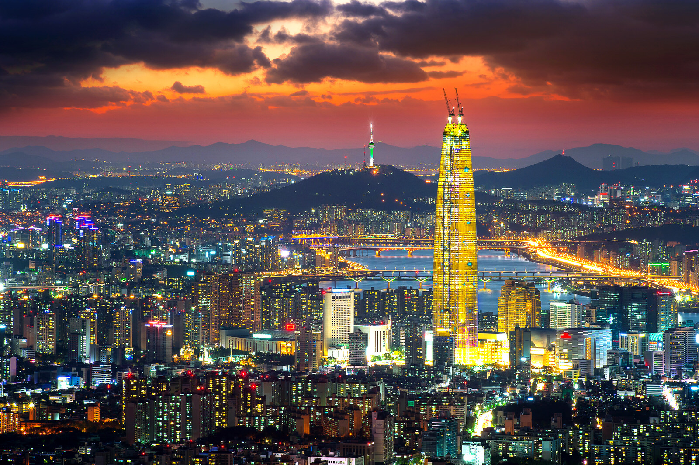
WORKSHEET: 4-12.D

Source 3: Shanghai and Housing

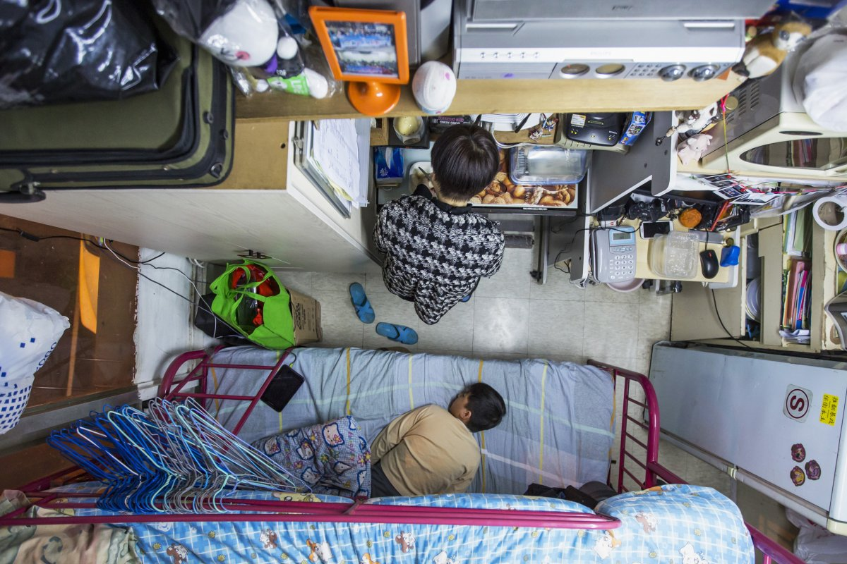

Shanghai, China is one of the world’s largest cities. It is known for its skyscrapers and small apartments. In 1980, there were no skyscrapers; today, Shanghai has twice as many as New York. The Shanghai Tower is the world’s second largest building. Many people in Shanghai live in micro-apartments (one pictured above). Some of these apartments may be as small as 15 feet by 15 feet. While these apartments are very small, they do allow people to live in the areas they want to live in and afford to live there. One mother said, “By living in a 60-square-foot apartment I spend only $487 a month on rent to house myself and my son.”
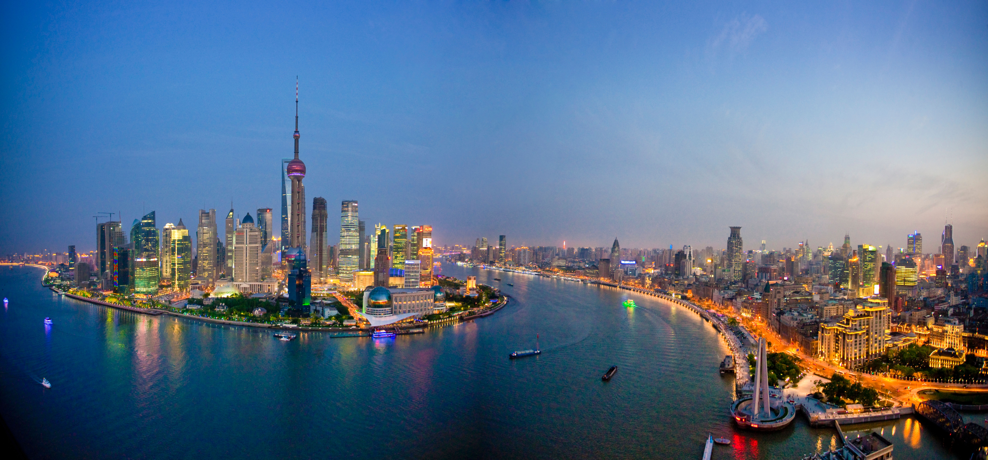
WORKSHEET: 4-12.E

Source 4: Beijing and Pollution

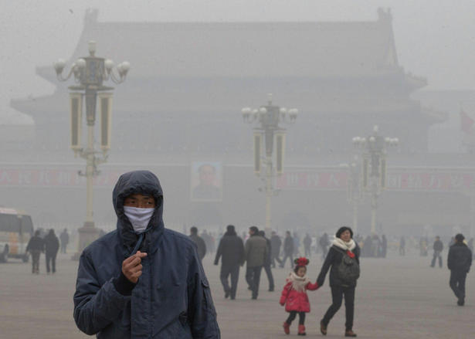

Beijing, China has an increasing population. Since 1990, it has doubled, going from 10 million to 21 million. With the increased cars, trucks, houses, factories, and power plants, Beijing is often under a cloud of pollution smog. Li Shuo, an environmental activist in China, said, “We have had a lucky few years recently. Sandstorms have traditionally been a problem for Beijing … but we have seen quite a significant slowdown in the air quality.” When the air quality is poor many people do not leave their homes and the pollution can make people very sick.

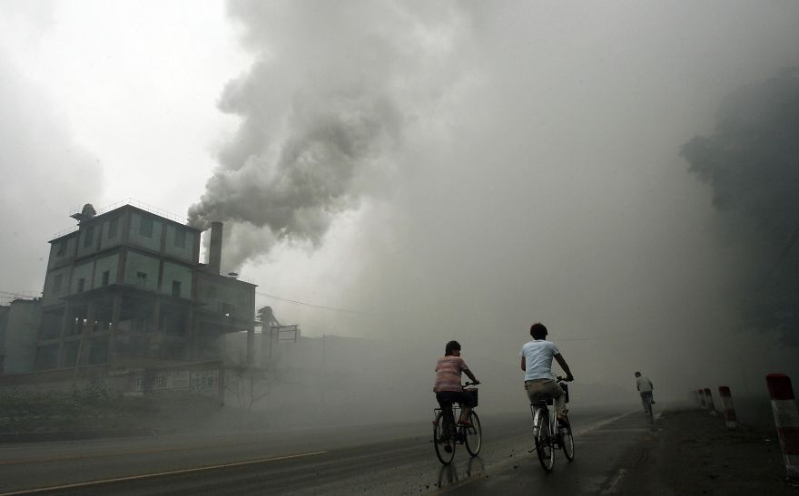
ASSESSMENT: 4-12.F

Asian Megacities: Exit Ticket

Inquiry Question: Would you like to live in an Asian megacity?

Considering the good and bad parts of living in a megacity, would you want to live in an Asian megacity? Why or why not? Include three pieces of evidence from the sources.

LESSON PLAN 4-13: World Religions: Hinduism, Confucianism, Buddhism, and Islam

MATERIALS

World Religions Video (Lesson4-13Video1) [Located in the UOW Video Library: www.christophercmartell.com/understandingourworld]
4 Newspapers (not supplied)
Folders
Source 1: Hinduism (WORKSHEET 4-13.A)
Source 2: Confucianism (WORKSHEET 4-13.B)
Source 3: Buddhism (WORKSHEET 4-13.C)
Source 4: Islam (WORKSHEET 4-13.D)
World Religions Newspaper Checklist (ASSESSMENT 4-13.E)

STANDARDS

Massachusetts History and Social Science Framework

MA-HSS.4.CS.1: Use map and globe skills to determine absolute locations (latitude and longitude) of places studied. (G)

MA-HSS.4.5: Identify who Confucius was and describe his writings on good government, codes of proper conduct, and relationships between parent and child, friend and friend, husband and wife, and subject and ruler. (H, C)

Common Core: Literacy

CCSS.ELA-Literacy.RI.4.9: Integrate information from two texts on the same topic in order to write or speak about the subject knowledgeably.

CCSS.ELA-Literacy.RI.4.10: By the end of year, read and comprehend informational texts, including history/social studies, science, and technical texts, in the grades 4–5 text complexity band proficiently, with scaffolding as needed at the high end of the range.

CCSS.ELA-Literacy.W.4.8: Recall relevant information from experiences or gather relevant information from print and digital sources; take notes and categorize information, and provide a list of sources.

CCSS.ELA-Literacy.W.4.9: Draw evidence from literary or informational texts to support analysis, reflection, and research.

PROCEDURES

Inquiry Question: What is each religion’s greatest contributions to the world?

1. Two Day Lesson
This lesson spans over two days. Day 1 involves learning about major religions that started in Asia and Day 2 includes creating and sharing newspapers on the major religions that started in Asia.

DAY 1

A. OPENER (15 minutes)

2. Watch Spread of World Religions Video
Show the students a short video of world religions video (Lesson4-13Video1). Stop the video to ask questions about what the students notice about the spread of different religions around the world. Highlight the religious that started in Asia that students will be studying today (Hinduism, Buddhism, Islam) and religions students will study later (Judaism, Christianity).

3. Brainstorm About Hinduism, Buddhism, and Islam
On the board or chart paper, make three columns: Hinduism, Buddhism, Islam. Start by asking students if they have heard about Hinduism by doing a “thumbs up, if yes, thumbs down, if no.” Ask students to tell you what they know about each religion, starting with Hinduism. Write what students say on the board or chart paper. Repeat this with Buddhism and then Islam (the order in which these religions began). Anticipated student responses may include: Hinduism: Many of its followers are from India, they cannot eat beef, they worship many gods, they celebrate the holiday of Diwali; Buddhism: Many of its followers are in Asia (Japan, China, Vietnam, Cambodia, Thailand, etc.), their founder was the Buddha (Siddhārtha Gautama), Buddhists want to become enlightened; Islam: Many of its followers are in the Middle East and Africa, it was started by Muhammad (Muslim people may say “peace be upon him” after saying his name out of respect), its book is called the Quran (cu-ron), some people say bad things about Muslims or connect them to the September 11 attacks (NOTE: This is a place for an important teachable moment. If this comes up, remind students that a small group of people claiming to be Muslims do acts of terrorism and most Muslims feel these events go against the teaching of Islam. It would be wrong to blame everyone of one religion for something bad that a small group of people did). Tell students that we will look at your list at the end of class and decide which things we wrong down are true about each religion.

NOTE: Be aware that students may know very little about each religion and that is expected. The purpose of this activity is for you to gauge what the students already know. Also, be aware that students may belong to some of these religions and have a deep understanding of them, while other students may have a negative view of these religions (based on their own religious views or what they have heard from family members or the media). It is important during this activity to emphasize the purpose of is to better understand all religions and how they are the same and different.

B. DEVELOPMENT (20 minutes)

4. Read About the World Religions: Hinduism, Confucianism, Buddhism, and Islam
Put students in small groups and assign them one of the sources: Hinduism (WORKSHEET 4-13.A), Confucianism (WORKSHEET 4-13.B), Buddhism (WORKSHEET 4-13.C), and Islam (WORKSHEET 4-13.D). Have one student from each group read their source. As the student reads, tell the other group members to underline or highlight any important information.

5. Review Brainstorm from the Beginning of Class
After students have read and taken notes on their assigned religion, ask students to help you circle things that are correct about their religion, put a line through things that were incorrect, and put a question mark next to things that we are still unsure about. Tell students that you will look up information about those with question marks and share what you find next time. NOTE: You may also want to put this in a “parking lot” on the classroom board and have students look up the answer on a classroom computer at a later point.

C. CLOSING (10 minutes)

6. Introduce and Plan Newspapers
When all groups are finished reading, explain that they will now design a newspaper about their religion. Ask students if they know what a newspaper is. If they have heard of a newspaper, ask them to describe what a newspaper includes. Anticipated student responses may include: it includes stories about events that happened recently, it has the sport scores, it includes pictures, it is sometimes printed, on a phone/tablet, or a computer. Handout one newspaper to each group. Have students look at the cover page and turn the pages. Explain that newspapers include articles which are stories that report what happened and pictures of the event. Each article has a title and includes the name of the person who wrote it and the location or place where they are. Next, give students white paper. Ask them to begin planning their pictures and stories. Have students use the Religion Newspaper Checklist (ASSESSMENT 4-13.E) to make sure they do not miss anything. Circulate the room, helping the students who may need help. Collect student work in folders at the end of the lesson.

DAY 2

A. OPENER (5 minutes)

7. Review Plan from Last Class
Distribute work folders to groups. Have students review their plans from the previous class.

B. DEVELOPMENT (30 minutes)

8. Create Newspaper on Asian Religions
In their groups, students should take their plans from last class and create their newspaper. As they work, have students use the Religion Newspaper Checklist (ASSESSMENT 4-13.E) to make sure they do not miss anything. If they have time, have students practice reading their newspapers. Circulate the room, helping the students who may need help.

C. CLOSING (10 minutes)

9. Share Newspapers
Have students share their newspapers with the class. They should be allowed to read from their newspapers (no need to memorize, unless they want to).

EVALUATION

ASSESSMENT 4-13.E

What to look for?

The students should create newspapers. All newspapers should cite at least 3 pieces of evidence from the sources.

Some information that students may include in their newspaper articles and pictures (all newspapers should have two articles and three pictures):

Newspapers on Hinduism may include:
- The supreme God is Brahman and Hindus believe in many gods
- It is one of the oldest religions
- Puruṣārthas are four goals: The first is Dharma, which is to be good person. The second is Artha, which is to work hard. The third is Kama, which is to have passion. The last is Moksha, which is to have freedom or to let go.
- Hindus believe in karma, or that after you die, your soul is reborn in another being over and over again.
- Hindus view cows as a sacred animal and they will not hurt or kill them.
- An important holiday for Hindus is Diwali, which is a celebration of light, where people light up diyas (lamps and candles) inside and outside their homes.
- Hindus believe in Ahimsa, which means that you should fight injustice (when something is wrong) and evil without using any physical force.
- The meditation and exercise known as Yoga comes from Hinduism.

Newspapers on Confucianism may include:
- Confucianism involves rules that help a society, including how families should run and what a good ruler or leader should do.
- Its beliefs are found in the Analects.
- Rulers/leaders should be examples for their people and teachers should be examples for their students.
- We should respect our ancestors and our leaders.
- They believe that people can become perfect through their choices, rather than being born perfect.
- Education is very important.
- People should try to live in harmony.
- An important holiday is Confucius’s birthday.
- Confucius has many important sayings still repeated by people today.

Newspapers on Buddhism may include:
- Buddhists live by the Five Moral Precepts, which includes not harming living things, not to take what was not given, not lying or gossiping, not to use drugs or alcohol.
- Buddhists try to live as Buddha did. They will meditate and use prayer beads.
- The main holidays celebrate the Buddha's birth, enlightenment, and death.
- Buddhists believe that after you die, your soul is reborn in another being over and over again (their symbol is the wheel of life that shows this). What you did in your current life will influence your next life. When the rebirths end because a person reaches a perfect state, it is called nirvana.
- A main idea of Buddhism is to have peace across the world.

Newspapers on Islam may include:
- Muslims believe in one God, who is called Allah in Arabic.
- They have a holy book called the Quran (cu-ron).
- Muslims believe in Five Pillars, which include:
  - To declare or say they believe in God (Shahada)
  - To pray five times a day (Salat)
  - To give money to charity and the poor (Zakah)
  - To fast at certain times of the year (Sawm)
  - To go to Mecca at least once in their life (Hajj)
- Muslims cannot eat pork, because it is considered unclean.
- The idea of the library is from Islam.
WORKSHEET: 4-13.A

Source 1: Hinduism
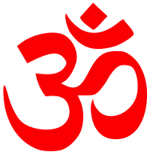
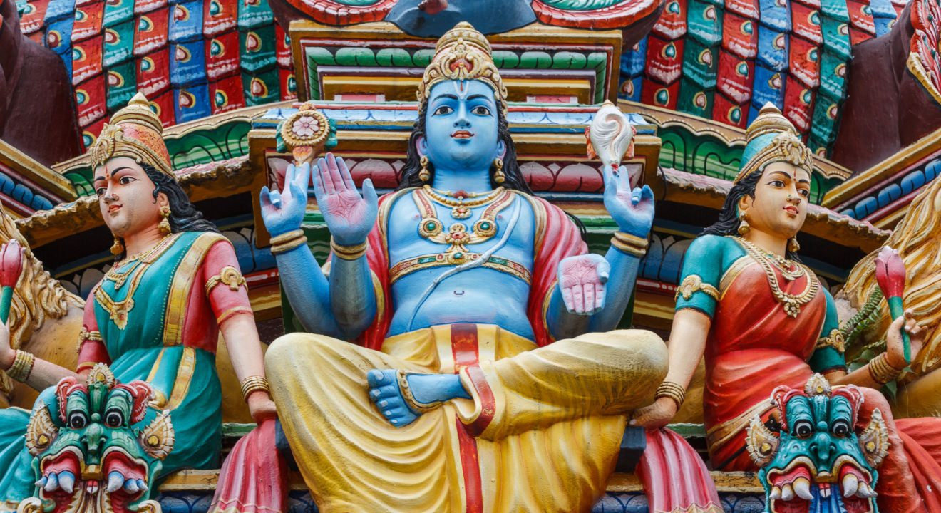

There is no one person who started Hinduism. It is one of the world’s oldest religions and it began over 4,000 years ago in India. The name Hindu comes from the Indus River, which is an important river in India. Today, Hinduism is the world’s third largest religion (after Christianity and Islam) with 900 million followers.

Hindus believe in a supreme God named Brahman, who is found in everything. There are many gods/goddesses (pictured above). Hindus have four goals in life or Puruṣārthas. The first is Dharma, which is to be good person. The second is Artha, which is to work hard. The third is Kama, which is to have passion. The last is Moksha, which is to have freedom or to let go. Hindus believe in karma, or that after you die, your soul is reborn in another being over and over again. Hindus also view cows as a sacred animal and they will not hurt or kill them (most Hindus will not eat beef). An important holiday for Hindus is Diwali, which is a celebration of light, where people light up diyas (lamps and candles) inside and outside their homes.

Hindus believe in Ahimsa, which means that you should fight injustice (when something is wrong) and evil without using any physical force.

Yoga, which is practiced by many Americans, comes from Hinduism. Yoga involves meditating, controlling your breathing, and practicing putting your body in different positions. The ultimate goal of Yoga is moksha (to have freedom or let go).

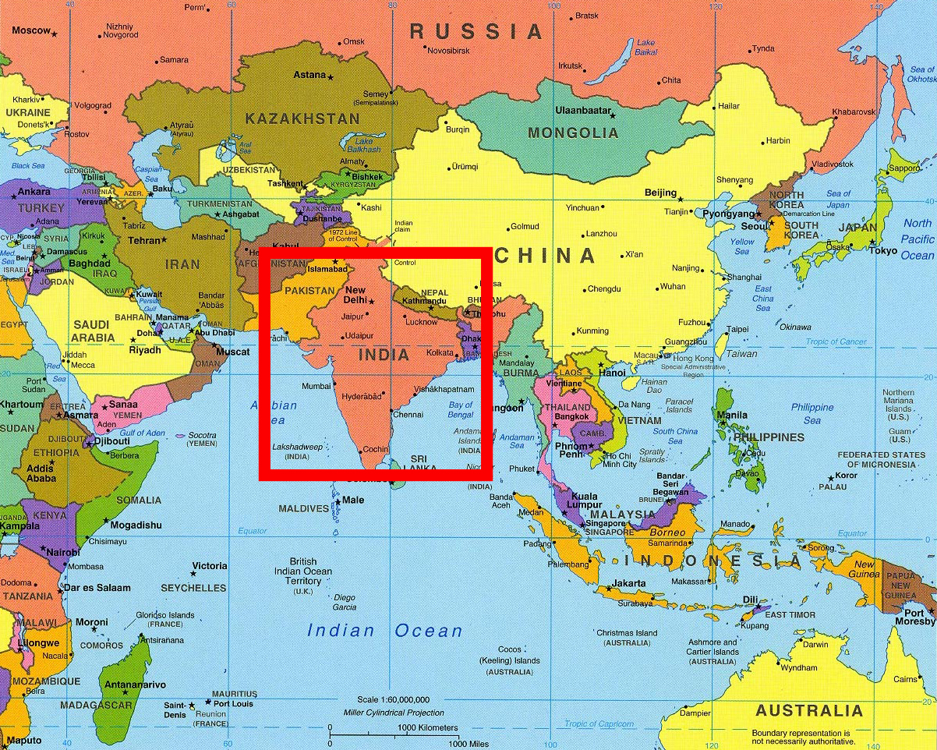
WORKSHEET: 4-13.B

Source 2: Confucianism
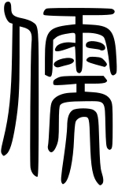
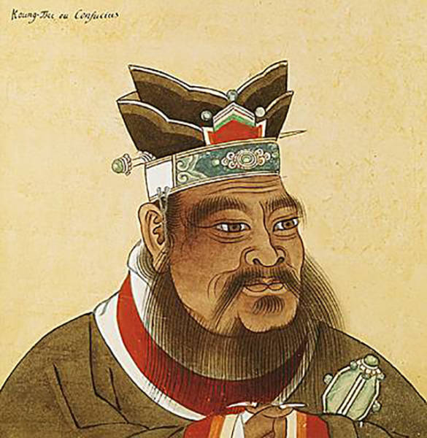

Confucianism was started by a man named Confucius (pictured above). It began over 2,500 years ago in China. Today, Confucianism has 6 million followers.

Confucianism involves rules that help a society, including how families should run and what a good ruler or leader should do. Unlike other religions, it does not say much about death and the afterlife. Its beliefs are found in the Analects and include that rulers/leaders should be examples for their people and teachers should be examples for their students. They believe that we should respect our ancestors (members of our family before us) and our leaders. They believe education and school is very important. They teach that people can become perfect through their choices, rather than being born perfect. People should try to live in harmony (live together in agreement and peace). An important holiday is Confucius’s birthday.

Confucian sayings (which come from the Analects) are used by people around the world today. Below are some of his quotes:
“He who thinks of the good for others, secures his own good.”
“Life is really simple, but men make it complicated.”
“It is not bad to fail, if you rise every time.”
“The superior man seeks what is right, the inferior man seeks what makes him rich.”
“You cannot open a book without learning something.”
“When you get angry, think of what will happen because of it.”
“Choose a job you love, and you will never have to work.”

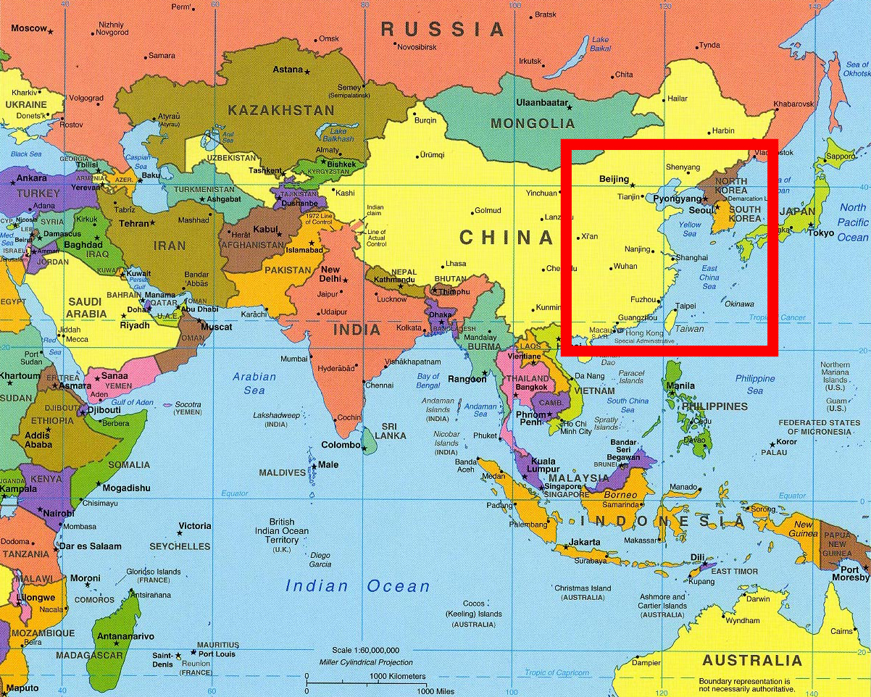
WORKSHEET: 4-13.C

Source 3: Buddhism
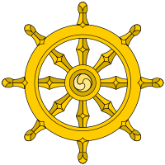
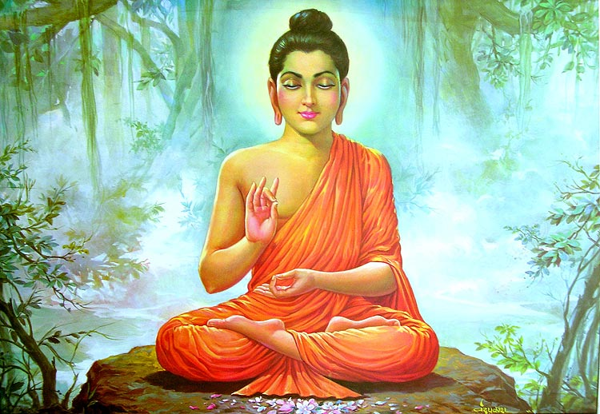

Buddhism was started by Siddhārtha Gautama (pictured above), who was called the Buddha (or the enlighten or knowing one). It began over 2,500 years ago in Nepal. He was a prince from a rich family. When he saw people suffering, he went to nature and meditated to search for truth. He then dedicated his life to teaching. Today, Buddhism has 376 million followers.
Buddhists live by the Five Moral Precepts, which include not harming living things, not taking what was not given, not lying or gossiping, and not using drugs or alcohol. Buddhists try to live as Buddha did. They will meditate and use prayer beads. The main holidays celebrate the Buddha's birth, enlightenment, and death. Buddhists believe that after you die, your soul is reborn in another being over and over again (their symbol is the wheel of life that shows this). What you did in your current life will influence your next life. The rebirths will end when a person reaches a perfect state, which is called nirvana.

A main idea of Buddhism is to have peace across the world. In the past 100 years, many people have quoted Buddhist teachings to explain why the whole world should have peace.

WORKSHEET: 4-13.D

Source 4: Islam
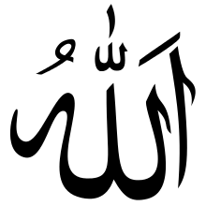
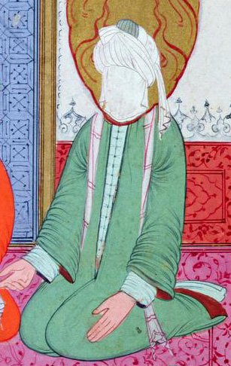

Islam was started by Muhammad (pictured above). It began over 1,500 years ago in Mecca, Saudi Arabia. Muhammad would go into a cave to often pray to God where he saw the angel Gabriel who gave him his religious ideas. The word Islam in Arabic means to follow God. Muslims are people who follow Islam. Today, Islam is the world’s second largest religion (after Christianity) with 1.5 billion followers.

Muslims believe in one God, who is called Allah in Arabic. They believe that Muhammad is the last prophet after Jesus or Isa, Moses or Musa, and Abraham or Ibrahim. They have a holy book called the Quran (cu-ron). Some Muslims believe that you should not show pictures of Muhammed (so they do not draw his face) and that you should say “peace be upon him” after you say his name. Muslims also cannot eat pork, because it is considered unclean.

Muslims believe in Five Pillars, which include:
- To declare or say they believe in God (Shahada)
- To pray five times a day (Salat)
- To give money to charity and the poor (Zakah)
- To fast (not eat) at certain times of the year (Sawm)
- To go to Mecca at least once in their life (Hajj)

The idea of the library was born out of Islam. They were created so the people could read the books of Islam. It was not long until Muslim libraries also housed books on math, science, history, literature, and philosophy for everyone to read.
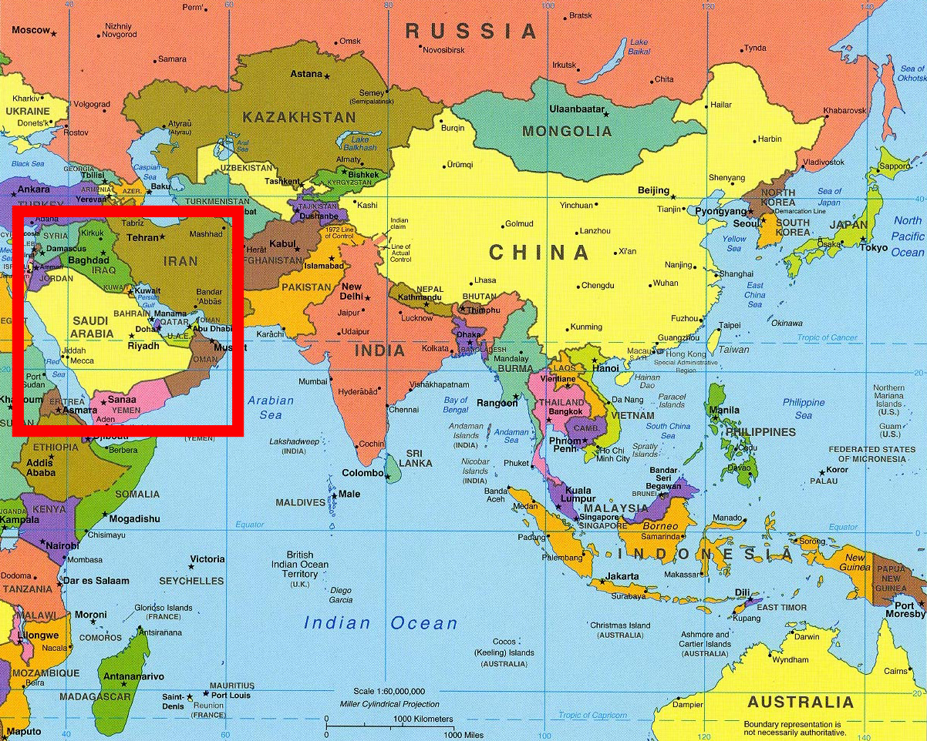
ASSESSMENT: 4-13.E

World Religions Newspaper Checklist

Inquiry Question: What is each religion’s greatest contributions to the world?

Students will answer the above inquiry question by creating a newspaper that highlights their assigned religions contributions to the world. Your group’s newspaper should have the following (check box when complete):

 A title for your newspaper that includes religion’s name.

Article 1 on the basic facts about your assigned religion.

Article 2 on an interesting part of your assigned religion.

Picture 1 on the founder and/or supreme being of your religion

Picture 2 of a map showing where your religion started

Picture 3 on something interesting from your religion
LESSON PLAN 4-14: Asia Today: Diverse Nations, Diverse People

MATERIALS

30 Days-7 Countries in Asia Video (Lesson4-14Video1) [Located in the UOW Video Library: www.christophercmartell.com/understandingourworld]
Clipboard (not supplied)
8 Asian Countries Notes and Asia Map (WORKSHEET 4-14.A)
Source 1: Taiwan (WORKSHEET 4-14.B)
Source 2: Vietnam (WORKSHEET 4-14.C)
Source 3: India (WORKSHEET 4-14.D)
Source 4: Mongolia (WORKSHEET 4-14.E)
Source 5: South Korea (WORKSHEET 4-14.F)
Source 6: United Arab Emirates (WORKSHEET 4-14.G)
Source 7: Japan (WORKSHEET 4-14.H)
Source 8: Nepal (WORKSHEET 4-14.I)
Asia Today: Exit Ticket (ASSESSMENT 4-14.J)

STANDARDS

Massachusetts History and Social Science Framework

MA-HSS.4.CS.1: Use map and globe skills to determine absolute locations (latitude and longitude) of places studied. (G)

MA-HSS.6. NEA.2 Use a map key to locate the countries and major cities in the various regions of East Asia. (G, E)

Common Core: Literacy

CCSS.ELA-Literacy.RI.4.9: Integrate information from two texts on the same topic in order to write or speak about the subject knowledgeably.

CCSS.ELA-Literacy.RI.4.10: By the end of year, read and comprehend informational texts, including history/social studies, science, and technical texts, in the grades 4–5 text complexity band proficiently, with scaffolding as needed at the high end of the range.

CCSS.ELA-Literacy.W.4.8: Recall relevant information from experiences or gather relevant information from print and digital sources; take notes and categorize information, and provide a list of sources.

CCSS.ELA-Literacy.W.4.9: Draw evidence from literary or informational texts to support analysis, reflection, and research.
PROCEDURES

Inquiry Question: If you were to visit Asia today, what country would you choose and why?

PREPARATION

1. Set Up Carousel Activity
Around the room, post the eight sources:
Source 1: Taiwan (WORKSHEET 4-14.B)
Source 2: Vietnam (WORKSHEET 4-14.C)
Source 3: India (WORKSHEET 4-14.D)
Source 4: Mongolia (WORKSHEET 4-14.E)
Source 5: South Korea (WORKSHEET 4-14.F)
Source 6: United Arab Emirates (WORKSHEET 4-14.G)
Source 7: Japan (WORKSHEET 4-14.H)
Source 8: Nepal (WORKSHEET 4-14.I)

A. OPENER (10 minutes)

2. Watch 30 Days-7 Countries in Asia Video
Show the students a short video of Czech citizen Jan Fiala (yawn fe-ah-la) as he travels to 7 Asian countries in one month (Lesson4-14Video1). Stop the video to ask questions about the countries that Jan travels to and how they are different and similar to the United States. At the end of the video, tell students that today, just like Jan, you will look at 8 different countries in Asia and have to decide which one you most want to travel to.

B. DEVELOPMENT (20 minutes)

3. Engage in a Carousel Activity on 8 Asian Nations
Give each student a pencil and clipboard with the 8 Asian Countries Notes (WORKSHEET 4-1.A) on it. Ask students to go to each of the eight stations (4-14.B, 4-14.C, 4-14.D, 4-14.E, 4-14.F, 4-14.G, 4-14.H). At each station, the students should take notes on each country.

Once students have gone to each of the eight stations, they should return to their seats. Put students in small groups. Have them look at their note sheets and discuss the top 3 Asian countries that they would like to visit and explain why they would like to visit those countries.

C. CLOSING (15 minutes)

4. Write Up Argument on 8 Asian Nations
For the evaluation task, have the students complete the exit ticket (ASSESSMENT 4-14.I), where they write their own personal response to the lesson’s Inquiry Question: “If you were to visit Asia today, what country would you choose and why?” Tell students to cite at least three pieces of evidence from the sources.

Before using the exit ticket, consider using a graphic organizer or two column notes to prepare students for the writing task. Consider using sentence starters and modeling to help the students with their answer to the inquiry question.

EVALUATION

ASSESSMENT 4-14.I

What to look for?

The students should take a stance on the Asian country that they would most like to visit and explain why. All arguments should cite at least 3 pieces of evidence from the sources.

Some information that students may include in their answer to the question:

Reasons to choose Taiwan:
- I have family members/friends/ancestors who live there
- I love nature
- I love hiking

Reasons to choose Vietnam:
- I have family members/friends/ancestors who live there
- I want to go to a place with so many cultures come together
- I love eating food

Reasons to choose India:
- I have family members/friends/ancestors who live there
- I want to visit the Taj Mahal or Ganges River
- I love learning about history

Reasons to choose Mongolia:
- I have family members/friends/ancestors who live there
- I want to visit the ger (yurts) and see the sheep, goat, and yak herders
- I like the idea of a house that you can move

Reasons to choose South Korea:
- I have family members/friends/ancestors who live there
- I want to visit Seoul
- I love fashion and/or technology
- I love shopping

Reasons to choose United Arab Emirates:
- I have family members/friends/ancestors who live there
- I want to visit a desert
- I want to see a man-made island
- I like vacationing in warm weather

Reasons to choose Japan:
- I have family members/friends/ancestors who live there
- I want to visit Mt. Fuji
- I want to ride on a bullet train/Shinkansen
- I love looking at pretty scenery/nature

Reasons to choose Nepal:
- I have family members/friends/ancestors who live there
- I want to climb Mt. Everest
- I want to meet the expert Nepalese climbers (Sherpas)
- I love hiking and climbing
- I love the cold

WORKSHEET: 4-14.A

8 Asian Countries Notes

Source 1: Taiwan

Source 2: Vietnam

Source 3: India

Source 4: Mongolia

Source 5: South Korea

Source 6: United Arab Emirates

Source 7: Japan

Source 8: Nepal

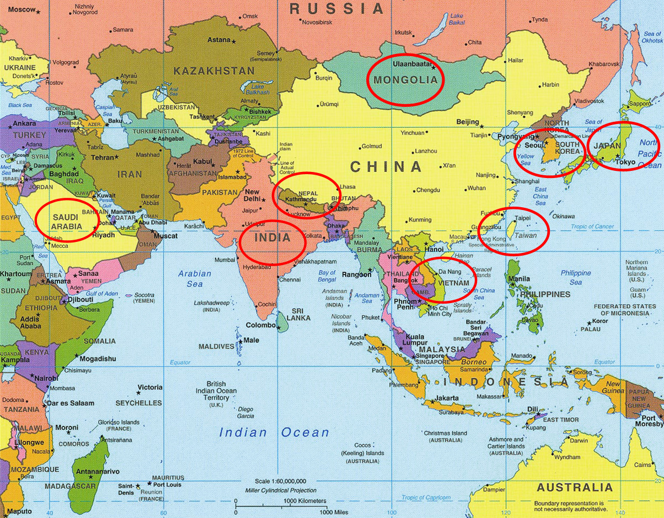
WORKSHEET: 4-14.B

Source 1: Taiwan



Taiwan is an island country off of the coast of China. It is known for its natural beauty. It has many mountains and seashore cliffs. Pictured above is Taroko National Park, which has many gorges (narrow valleys caused by rivers). It gets its name from Truku, who are a group of Indigenous (first) people in Taiwan. If you love nature and hiking, then Taiwan is the place for you.

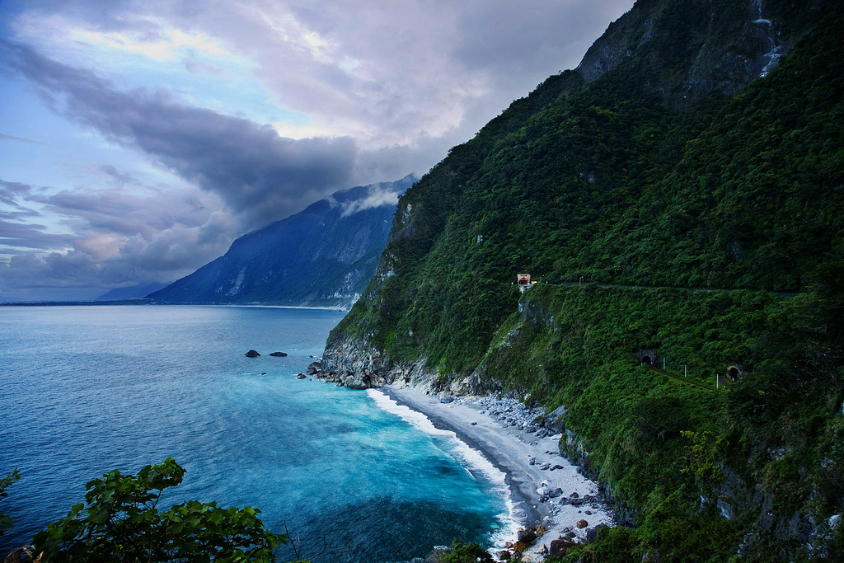
WORKSHEET: 4-14.C

Source 2: Vietnam

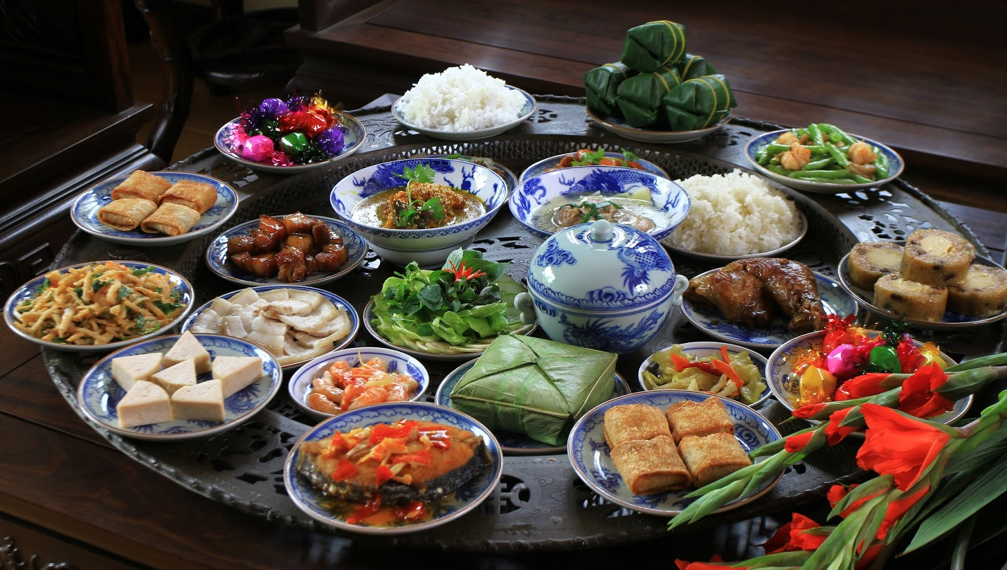

Vietnam is a country in Southeast Asia. It is known for its cuisine (food). Vietnam’s food borrows from its neighbors, such as China and Malaysia, but also the French (who took over Vietnam in the 1800s). Pictured above are some common Vietnamese dishes. Two Vietnamese foods that have become popular in the U.S. are Phở (fa) noodle soup and the Bánh Mì (bun mi) baguette sandwich. If you love food, then Vietnam is the place for you.

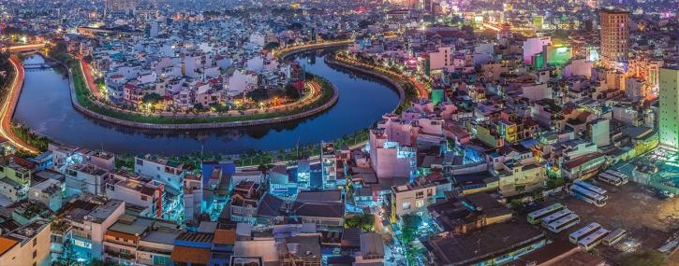
WORKSHEET: 4-14.D

Source 3: India

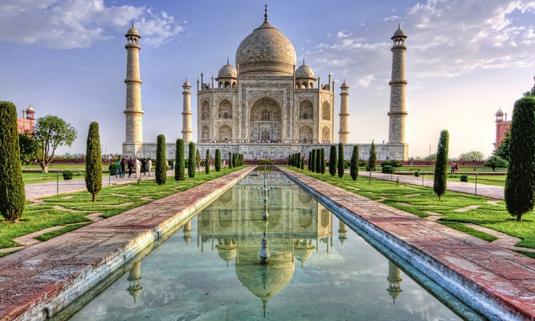

India is a country in South Asia. It is known for its history. One famous historical site is the Taj Mahal (above), which was created to bury the wife of emperor Shah Jahan. Another important site is the Ganges (gain-gees) River (below), where there is a Hindu tradition of bathing to wash sins away. If you love history, then India is the place for you.

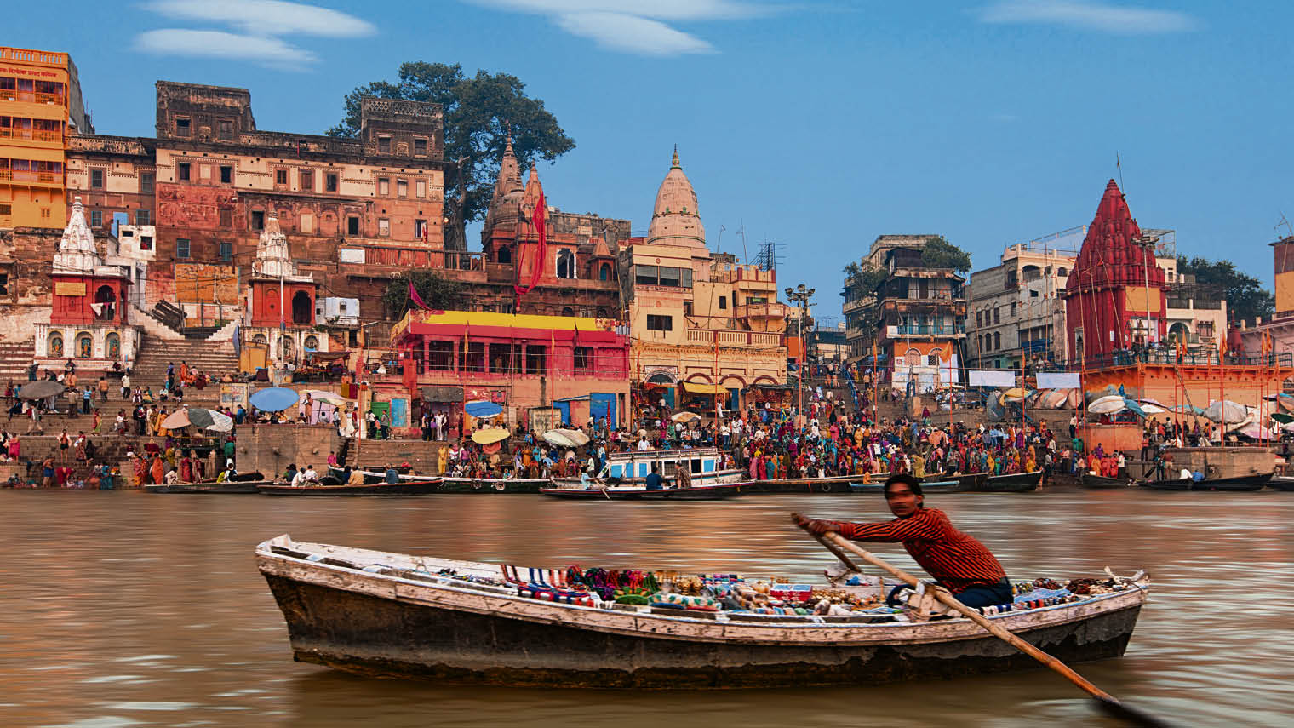
WORKSHEET: 4-14.E

Source 4: Mongolia

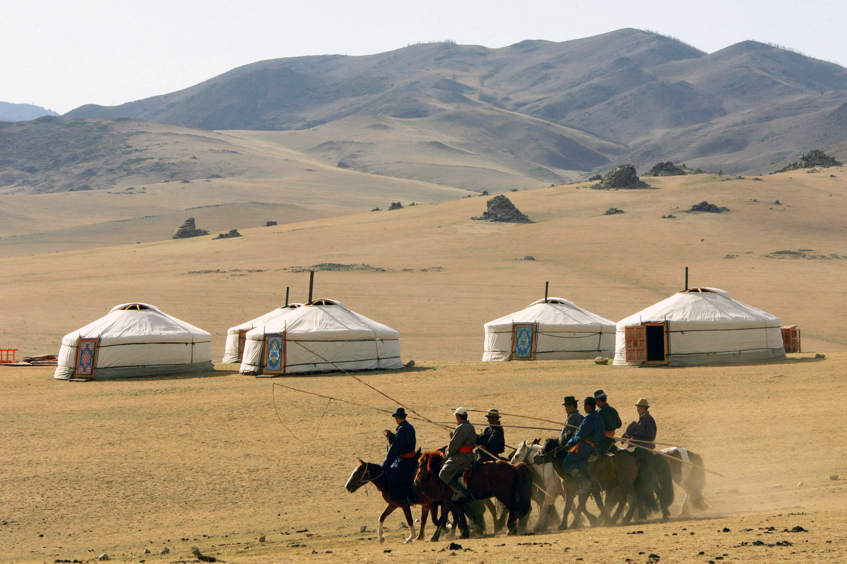

Mongolia is a country in North Asia. It is known for its nomadic families who travel while raising sheep, goats, and yaks. Pictured above is the ger (or yurt in English), which more than half of Mongolians live in. If you think the idea of being able to move your home is interesting, then Mongolia is the place for you.

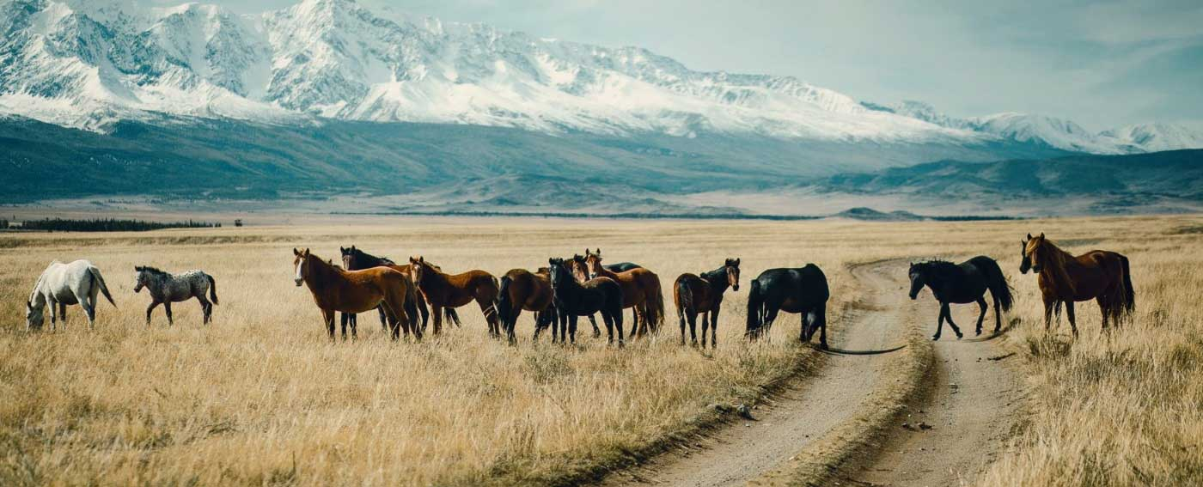
WORKSHEET: 4-14.F

Source 5: South Korea

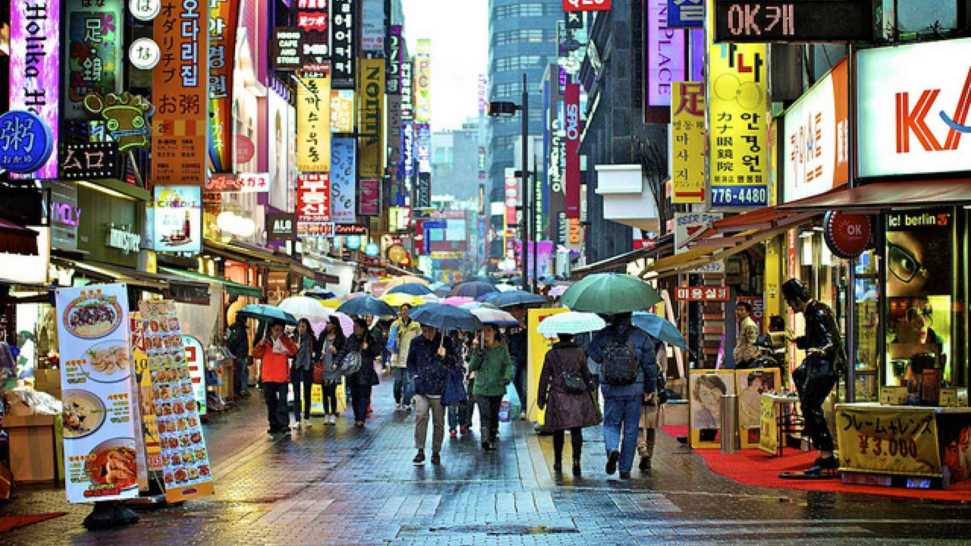

South Korea is a country in East Asia. It is known for its style and technology. Many popular consumer products in the U.S. are from South Korea, like Samsung, LG, or Hyundai. Pictured above is the Myeongdong (myung-toong) shopping street. If you like shopping, then South Korea is the place for you.

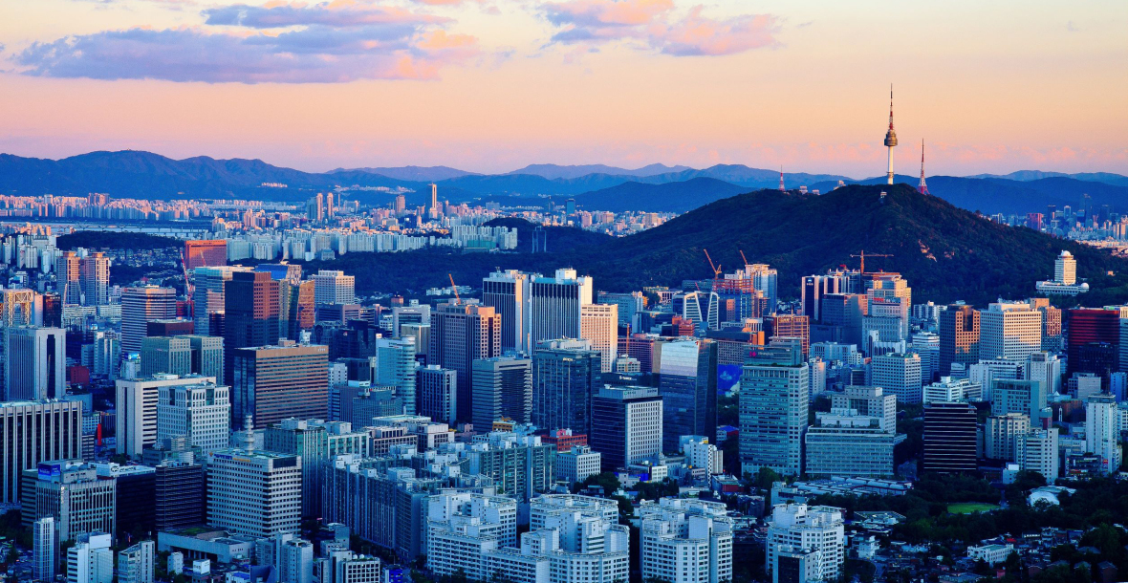
WORKSHEET: 4-14.G

Source 6: United Arab Emirates

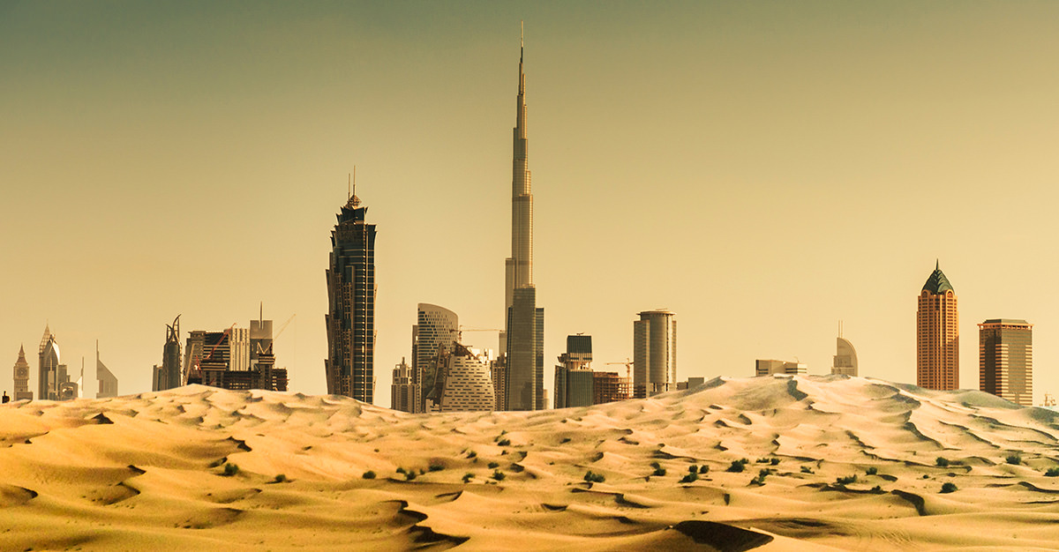

United Arab Emirates (UAE) is a country in the Middle East (West Asia). It is known for its deserts and vacation resorts. Many tourists travel to Dubai (above) and Abu Dhabi. Pictured below are the Palm Islands Atlantis, which is a man-made island shaped like a palm tree that includes beaches and resorts. If you like vacationing in warm weather, then UAE is the place for you.

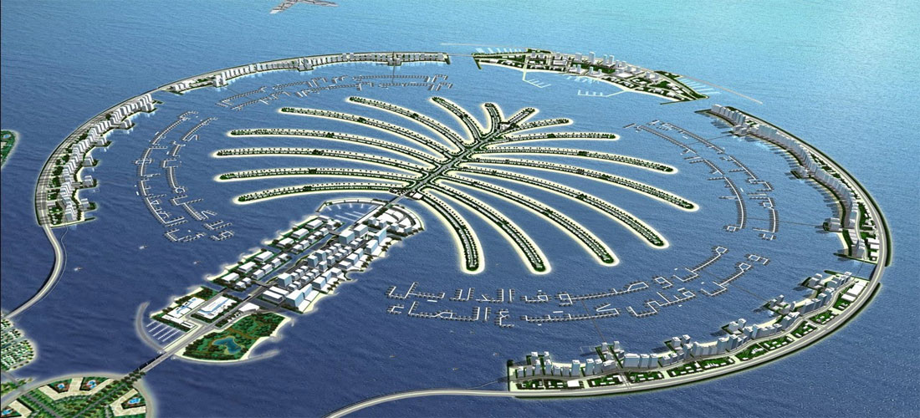
WORKSHEET: 4-14.H

Source 7: Japan

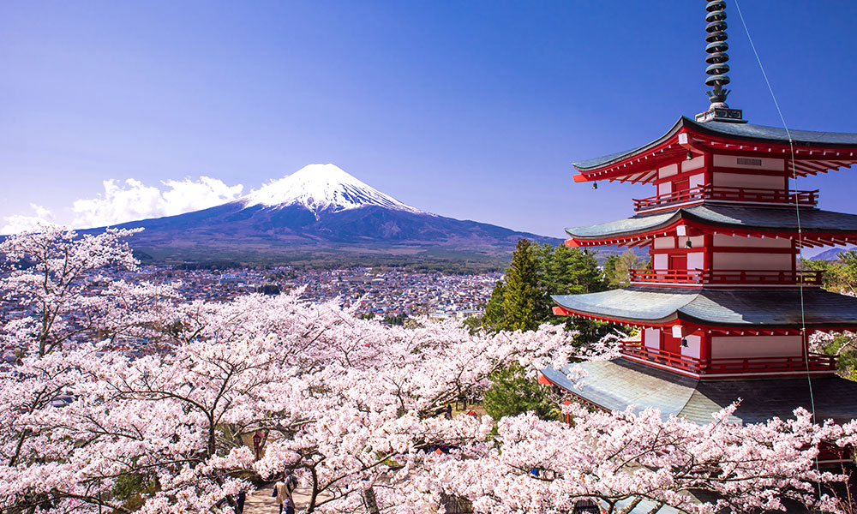

Japan is a country in East Asia. It is known for its scenic views and fast transportation. Pictured above is Mount Fuji (foo-ge), which is the highest mountain in Japan and an active volcano (last erupted in 1708). You can get to all these places by taking the shinkansen (shin-con-sen) or bullet train (below), which goes over 200 miles per hour. If you like pretty scenery and fast trains, then Japan is the place for you.

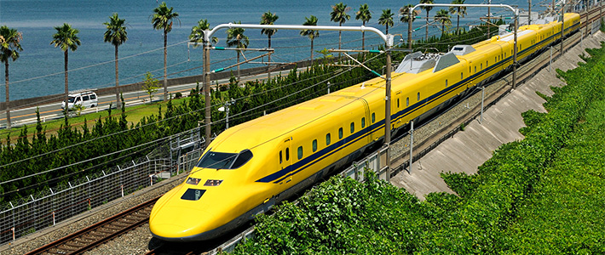
WORKSHEET: 4-14.I

Source 4: Nepal

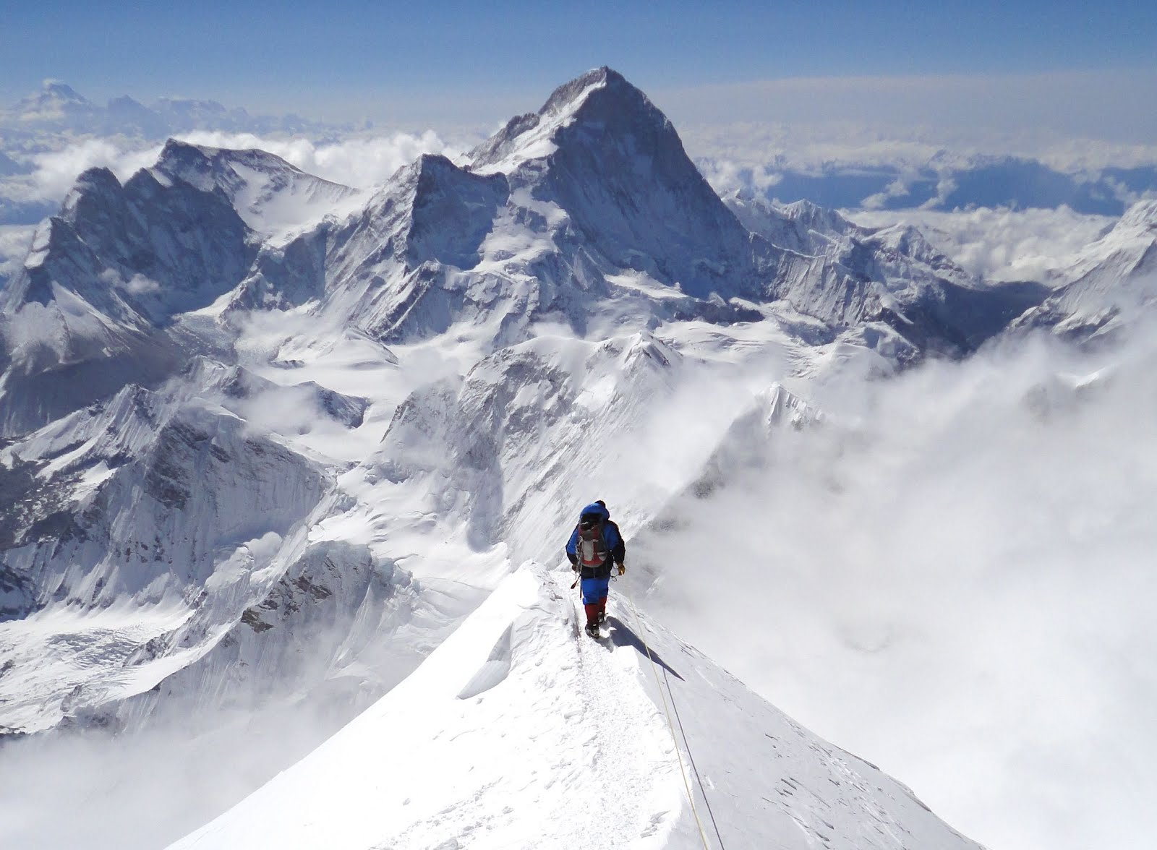

Nepal (nay-paul) is a country in South Asia. It is known for having the tallest mountain in the world, Sagarmāthā (sa-gar-ma-tha) or Mt. Everest (pictured above). People train for years before climbing Everest. To climb the mountain, it takes about 2 months and you must be guided by Sherpas (below), who are highly skilled Nepalese climbers. If you want to climb the tallest mountain in the world, then Nepal is the place for you.

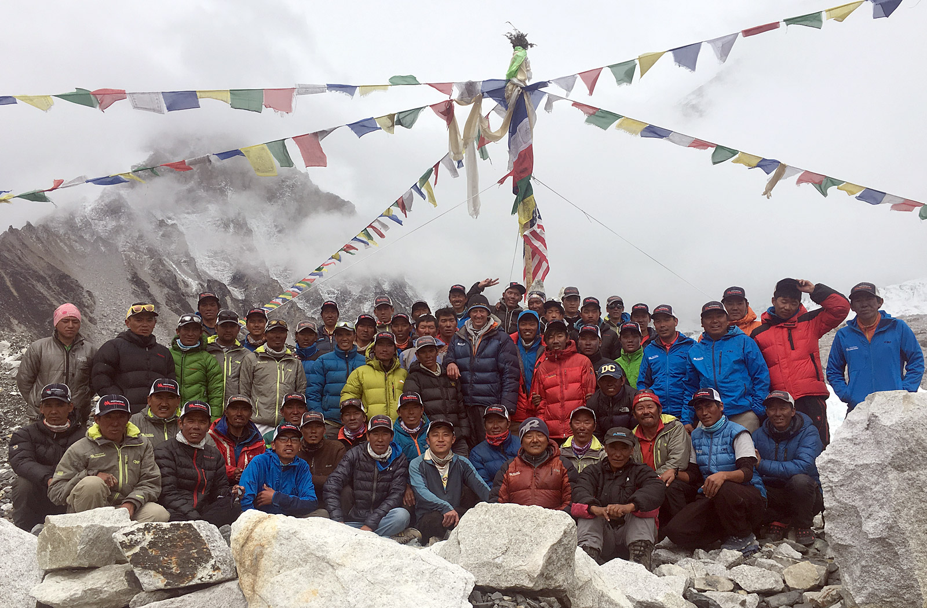
ASSESSMENT: 4-14.J

Asia Today: Exit Ticket

Inquiry Question: If you were to visit Asia today, what country would you choose and why?

Out of the 8 Asian countries presented, which one would you most like to visit and why? Include three pieces of evidence from the sources.

LESSON PLAN 4-15: The Great American Empires: Aztec, Maya, Inca, and Mississippi

MATERIALS

Image (WORKSHEET 4-15.A)
Source 1: Aztec (WORKSHEET 4-15.B)
Source 2: Maya (WORKSHEET 4-15.C)
Source 3: Inca (WORKSHEET 4-15.D)
Source 4: Mississippi (WORKSHEET 4-15.E)
American Empires: Poster Instructions (WORKSHEET 4-15.F)
The Great American Empires: Exit Ticket (ASSESSMENT 4-15.G)

STANDARDS

Massachusetts History and Social Science Framework

MA-HSS.4.CS.1: Use map and globe skills to determine absolute locations (latitude and longitude) of places studied. (G)

MA-HSS.5.2: Identify the three major pre-Columbian civilizations that existed in Central and South America (Maya, Aztec, and Inca) and their locations. (H, G, E)

Common Core: Literacy

CCSS.ELA-Literacy.RI.4.9: Integrate information from two texts on the same topic in order to write or speak about the subject knowledgeably.

CCSS.ELA-Literacy.RI.4.10: By the end of year, read and comprehend informational texts, including history/social studies, science, and technical texts, in the grades 4–5 text complexity band proficiently, with scaffolding as needed at the high end of the range.

CCSS.ELA-Literacy.W.4.8: Recall relevant information from experiences or gather relevant information from print and digital sources; take notes and categorize information, and provide a list of sources.

CCSS.ELA-Literacy.W.4.9: Draw evidence from literary or informational texts to support analysis, reflection, and research.

PROCEDURES

Inquiry Question: If you could live in any ancient American empire, which one would it be and why?

PREPARATION

This lesson uses a method called Visual Thinking Strategy (VTS). The key to VTS is that you as a teacher only do two things: (1) Ask the following questions and (2) repeat as precisely as possible exactly what the students say.

Visual Thinking Strategy Questions:
- Open with: “What’s going on in this picture?”
Summarize student responses using conditional language (“Raoul thinks this could be…”). This keeps the conversation open to other interpretations by other students.
- If appropriate: “What do you see that makes you say that?”
This encourages students to back up their statements with things they see in the work of art.
- Ask the group: “What more can we find?”
This continues the conversation.

If this is your first time using VTS, I would recommend reading this description (with a video example from Grade 1) of it from the Milwaukee Art Museum: http://teachers.mam.org/collection/teaching-with-art/visual-thinking-strategies-vts/

1. Two-Day Lesson
This lesson spans over two days. Day 1 involves learning about the American empires and drafting advertisement posters. Day 2 includes presenting posters.

2. Note About This Topic
All four of these American empires practiced different forms of human sacrifice. Students may come across information on this during any independent research. Human sacrifice may be a difficult topic to explain to elementary students and would require extensive explanation and historical context to be addressed properly (and probably not something able to be covered in only one lesson). It may be best to acknowledge that it was true that these groups practiced human sacrifice and explain that it was something commonly practiced throughout history in the Americas and worldwide, including Europe (examples include ancient European tribes and the witch trials of the 1500s and 1600s). Additionally, it would be good to remind the students that human sacrifice was not something practiced by most of the people in these empires and that it should not be the focus of their advertisements.

DAY 1

A. OPENER (10 minutes)

3. Engage in a Visual Thinking Strategy (VTS) on Aztec Image
Give students Images (WORKSHEET 4-15.A). Do not reveal that this is an image of Tenochtitlan, which was the center of the Aztec civilization in modern day Mexico. Project the image and tell the students to look at the image closely and quietly. Give them about one minute. Next, begin the VTS question about the image. Use the above questions, following VTS instructions. Have students inquire about the question using the above questions for about 2-3 minutes.

Tell students that today we will be learning about four American empires. They were the heart of trade in the Americas and had cities that were larger than most European cities at the time. Tell students that the image that we just looked at was a mural painted by famous Mexican artist Diego Rivera. It is called El Mercado de Tlatelolco (Tlatelolco Market) and shows the Aztec people trading goods. You had many good observations of the pictures. From the pictures, what do you think life was like in the Aztec empire? Anticipated answers may include: they lived in a large city, they had many different items to trade, people look very busy, they lived near mountains and water, it seems like it is warm/hot there.

B. DEVELOPMENT (15 minutes)

4. Examine Sources About the American Empires
Put students into four groups. Assign each group an empire: Aztec, Maya, Inca, and Mississippi. Give them the corresponding source to their group: Aztec (WORKSHEET 4-15.B), Maya (WORKSHEET 4-15.C), Inca (WORKSHEET 4-15.D), and Mississippi (WORKSHEET 4-15.E). Have students take turns reading aloud (using choral, partner, or independent reading) the sources to the whole class.

5. Plan Advertisements for the American Empires
Tell students that this is a two-day lesson. Today, we will be doing research on our assigned colonies and creating a poster to advertise it to others in the class. Next class, we will have a “American Empires Showcase,” where students will pretend that they are traveling in the ancient American empires and they will have to pick a place to settle.

In their small groups, have the students read their specific source again. As the student reads, tell the other group members to underline or highlight any important information. Pass out reference books and/or give students access to computers. Read to students the directions on the sheet called American Empires: Poster Instructions (WORKSHEET 5-15.F).

Students should collect information about their empires based on the questions listed on American Empires: Poster Instructions (WORKSHEET 5-15.F). Students should draft their posters using a piece of drawing paper. Circulate the room answering questions and giving groups guidance.

C. CLOSING (20 minutes)

6. Create Advertisements for the American Empires
Students should create a poster advertising their empires to the class based on the questions listed on American Empires: Poster Instructions (WORKSHEET 5-15.F). It should include three sections on way of life, climate, and trade, as well as three drawings related to the colony.

DAY 2

A. OPENER (10 minutes)

7. Complete Advertisements for the American Empires
Students should finish their posters advertising their colonies to prospective settlers based on the questions listed on American Empires: Poster Instructions (WORKSHEET 5-15.F). It should include three sections on way of life, climate, and trade, as well as three drawings related to the colony.

B. DEVELOPMENT (20 minutes)

8. Share Posters During American Empires Showcase

Students should walk around the room looking at the different posters. One group member should stay behind to help persuade the other students to come to their empire. Halfway through the period, that student should switch with another person in their group, allowing them to look at all the posters.

C. CLOSING (15 minutes)

9. Write Up Argument on the American Empires
For the evaluation task, have the students complete the exit ticket (ASSESSMENT 4-15.G), where they write their own personal response to the lesson’s Inquiry Question: “If you could live in any ancient American empire, which one would it be and why?” Tell students to cite at least three pieces of evidence from the posters or sources.

Before using the exit ticket, consider using a graphic organizer or two column notes to prepare students for the writing task. Consider using sentence starters and modeling to help the students with their answer to the inquiry question.

EVALUATION

ASSESSMENT 4-15.G

What to look for?

The students should take a stance on what ancient American empire they would live in. All arguments should cite at least 3 pieces of evidence from the sources or their independent research.

Some information that students may include in their answer to the question:

Aztec
- It was the largest empire (350,000 people)
- It was on a lake
- Good climate: never too hot or cold with dry winters and rainy summers
- Large pyramids
- Traded many items: rabbits, birds, dogs, fish, turkeys, chili peppers, maize (corn), tomatoes, shoes, clothes, pots, and dishes

Maya
- It was a medium sized empire (50,000 people)
- It was on the Yucatán Peninsula and Caribbean Sea
- Known for their music and art
- Hieroglyphics and calendar
- Good climate: year-round rain and warm winters and hot summers
- Traded many items: food, clothes, and other items

Inca
- It was a larger empire (150,000 people)
- It was on Andes Mountains
- Elaborate road and communication network
- Good climate: cool and dry
- Traded many items: potatoes, weavings, and rugs

Mississippi
- It was a small empire (20,000 people)
- It was in North America along the Mississippi River
- Built large mounds
- Large trade network from Mexico to Canada
- Good climate: warm rainy summers and cool rainy winters
- Traded many items: salt and copper

WORKSHEET: 4-15.A

Image

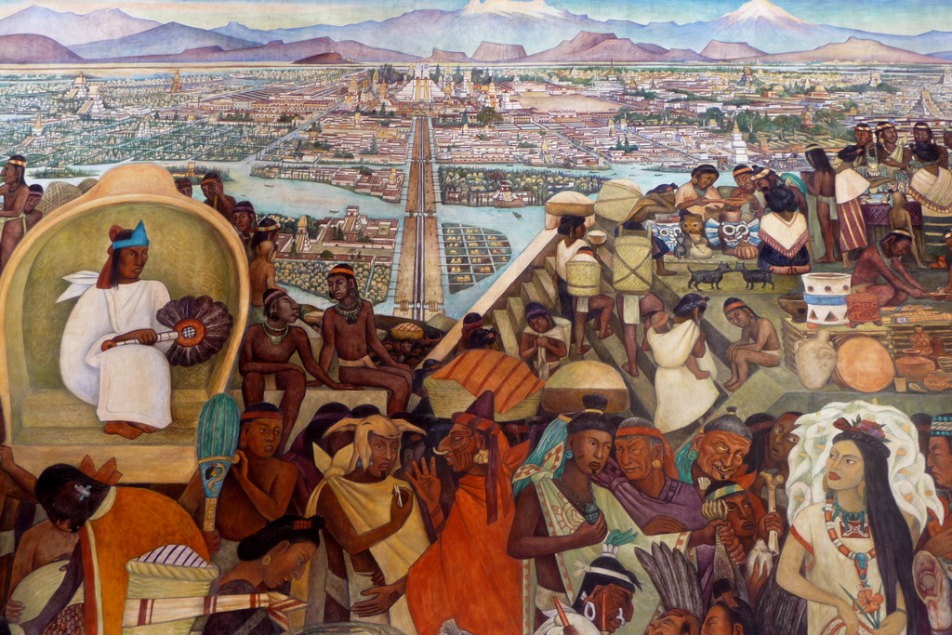
WORKSHEET: 4-15.B

Source 1: Aztec

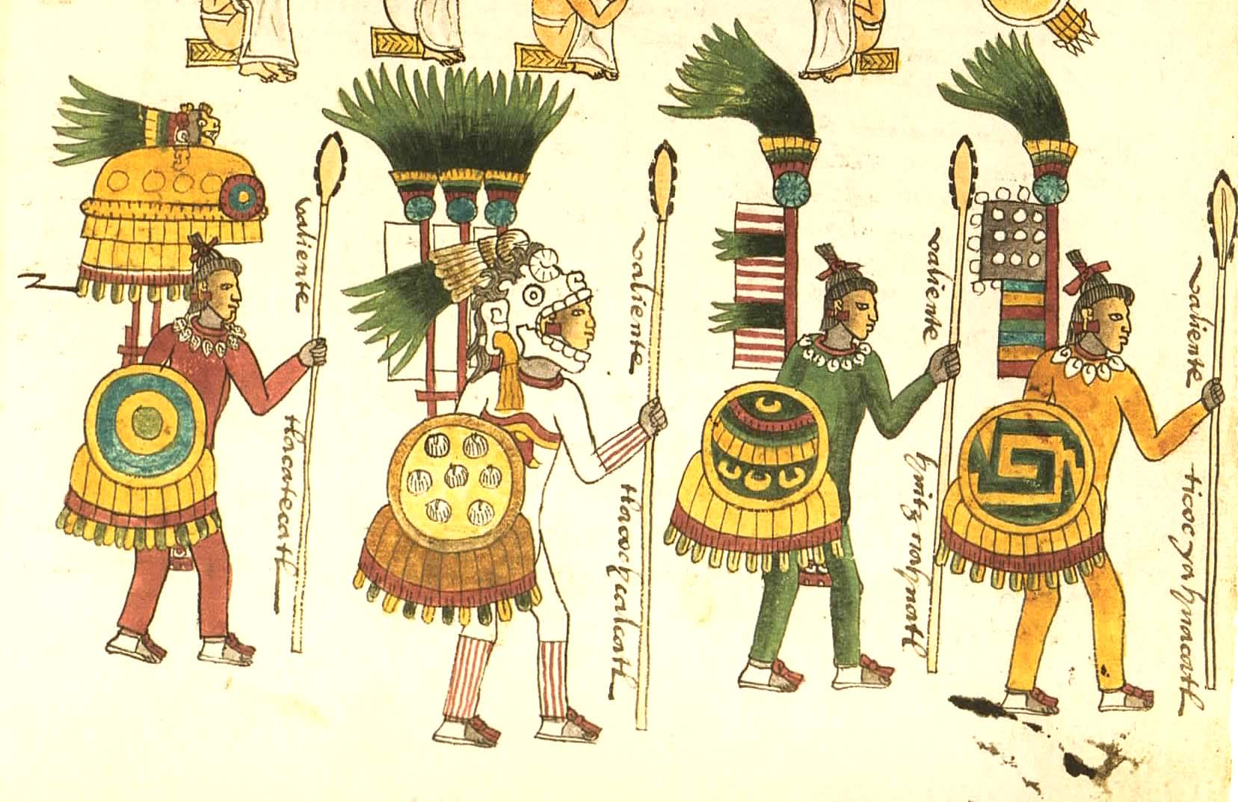

The Aztec Empire was in modern day Mexico and lasted from 900 CE to 1500 CE. Its capital was a city called ‎Tenochtitlan (pictured on the next page), which had over 300,000 people (about the size of London, England at the time) and was built around Lake Texcoco. Due to its elevation (high above sea level), the climate there is never too hot or cold with dry winters and rainy summers.

There were two main classes in Tenochtitlan: nobles (top) and commoners (bottom). You were born into a noble or commoner family, but that could change if you were a great soldier during war. The Aztecs were great builders and they created cities with many plazas, temples, and other large structures. They traded many items, including rabbits, birds, dogs, fish, turkeys, chili peppers, maize (corn), tomatoes, shoes, clothes, pots, and dishes. Today, many Mexican people are descendants of the Aztecs.
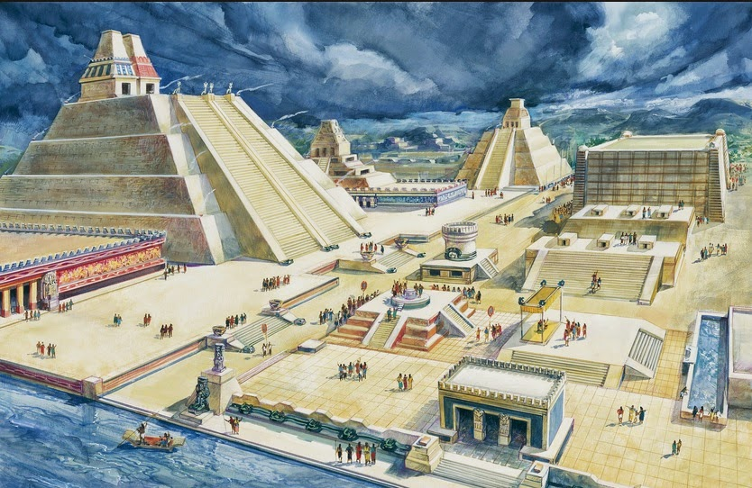

The below map shows the location of the Aztec in the Americas.

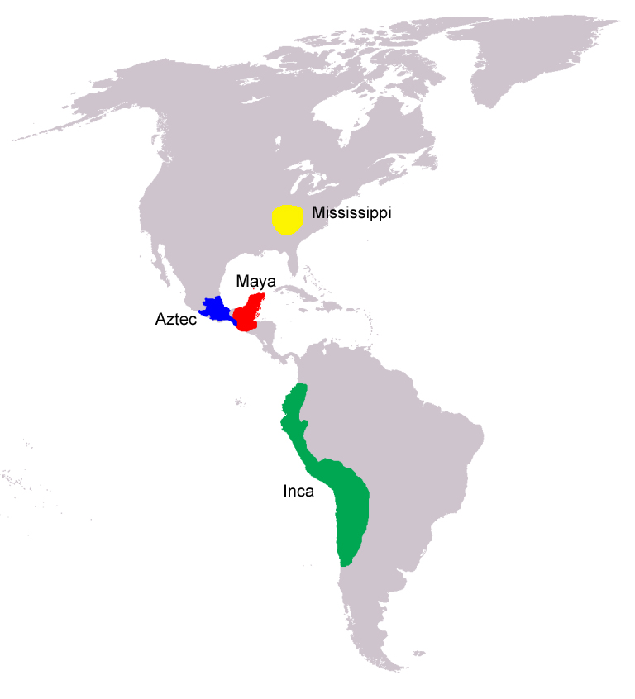
WORKSHEET: 4-15.C

Source 2: Maya

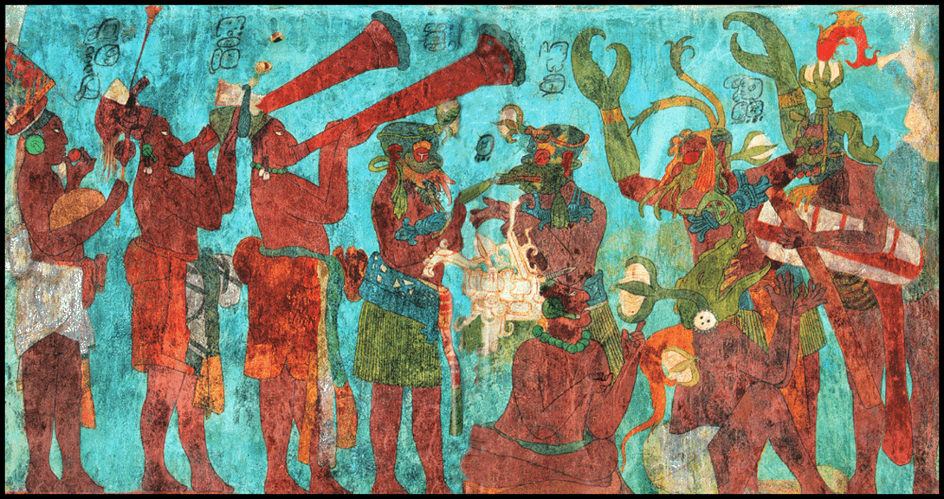

The Maya Empire was in modern day Mexico and lasted from 700 BCE to 1600 CE. It did not have one capital, but instead 40 cities (like the one on the next page) and over 50,000 people (about the size of Seville, Spain at the time) and was built on the Yucatán Peninsula (in the Caribbean Sea and Gulf of Mexico). It has a tropical climate with year-round rain and warm winters and hot summers.

The Maya were one of the few American empires with a written language. They would use hieroglyphics (picture words) and created a very detailed calendar. The Maya also were known for their music and art (see the above painting of musicians). The Maya had many different cities that traded with each other. In these cities, there were many market stalls where people traded food, clothes, and other items. Today, there are 7 million Maya people in Mexico, Guatemala, El Salvador, Honduras, and other Central American countries.
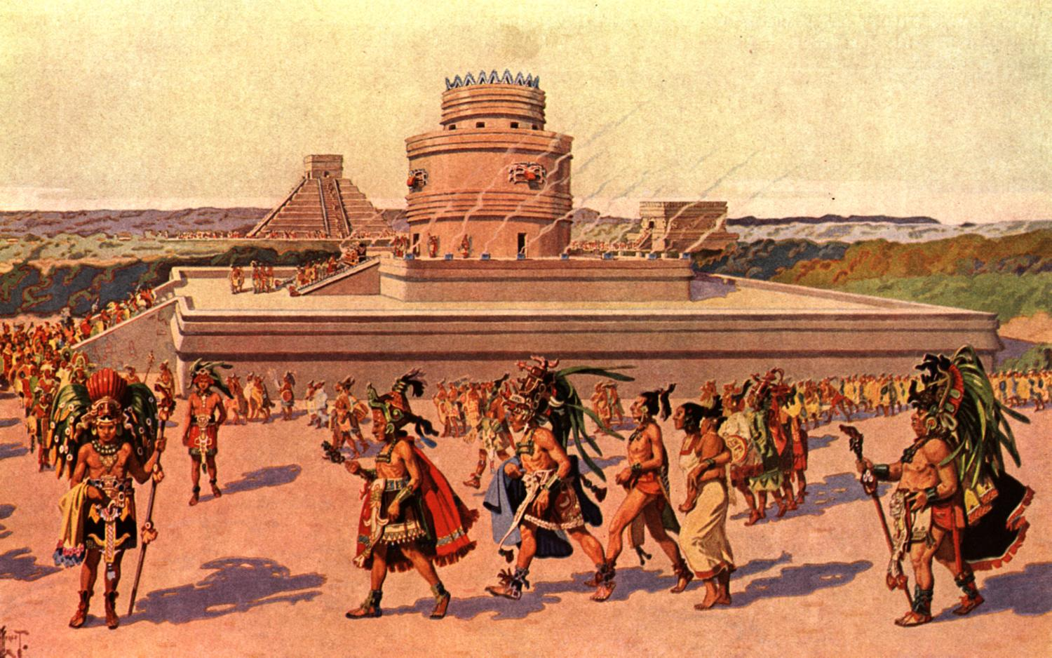

The below map shows the location of the Maya in the Americas.

WORKSHEET: 4-15.D

Source 3: Inca

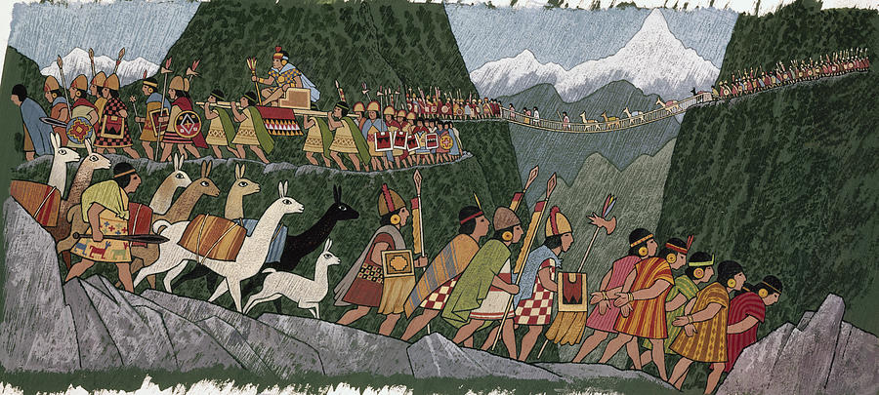

The Inca Empire was in modern day Peru, Ecuador, Colombia, Chile, Argentina, and Bolivia. It lasted from 1200 CE to 1500 CE. Its capital was a city called ‎Cusco (pictured on next page), which had over 150,000 people (about the size of Lisbon, Portugal at the time). Due to its elevation (high above sea level), the climate there is generally cool and dry.

The Incas built an amazing network of roads high in the Andes Mountains. This allowed them to easily travel from one city to the next in their large empire. They also created a messenger system that went hundreds of miles and runners would run messages from one place to the next. Most people in the empire were farmers and one of their main crops were potatoes (which were eventually brought to Europe). They also were known for the amazing weaving skills and they made elaborate rugs. Today, there are 11 million Quechua people in South America who are the ancestors of the Inca Empire.
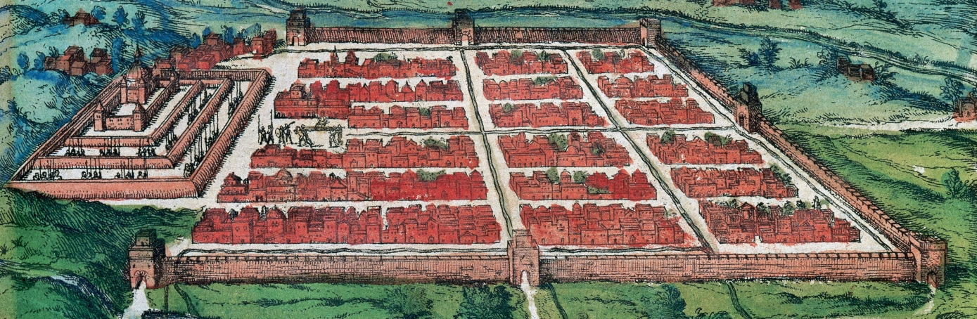

The below map shows the location of the Inca in the Americas.

WORKSHEET: 4-15.E

Source 4: Mississippi

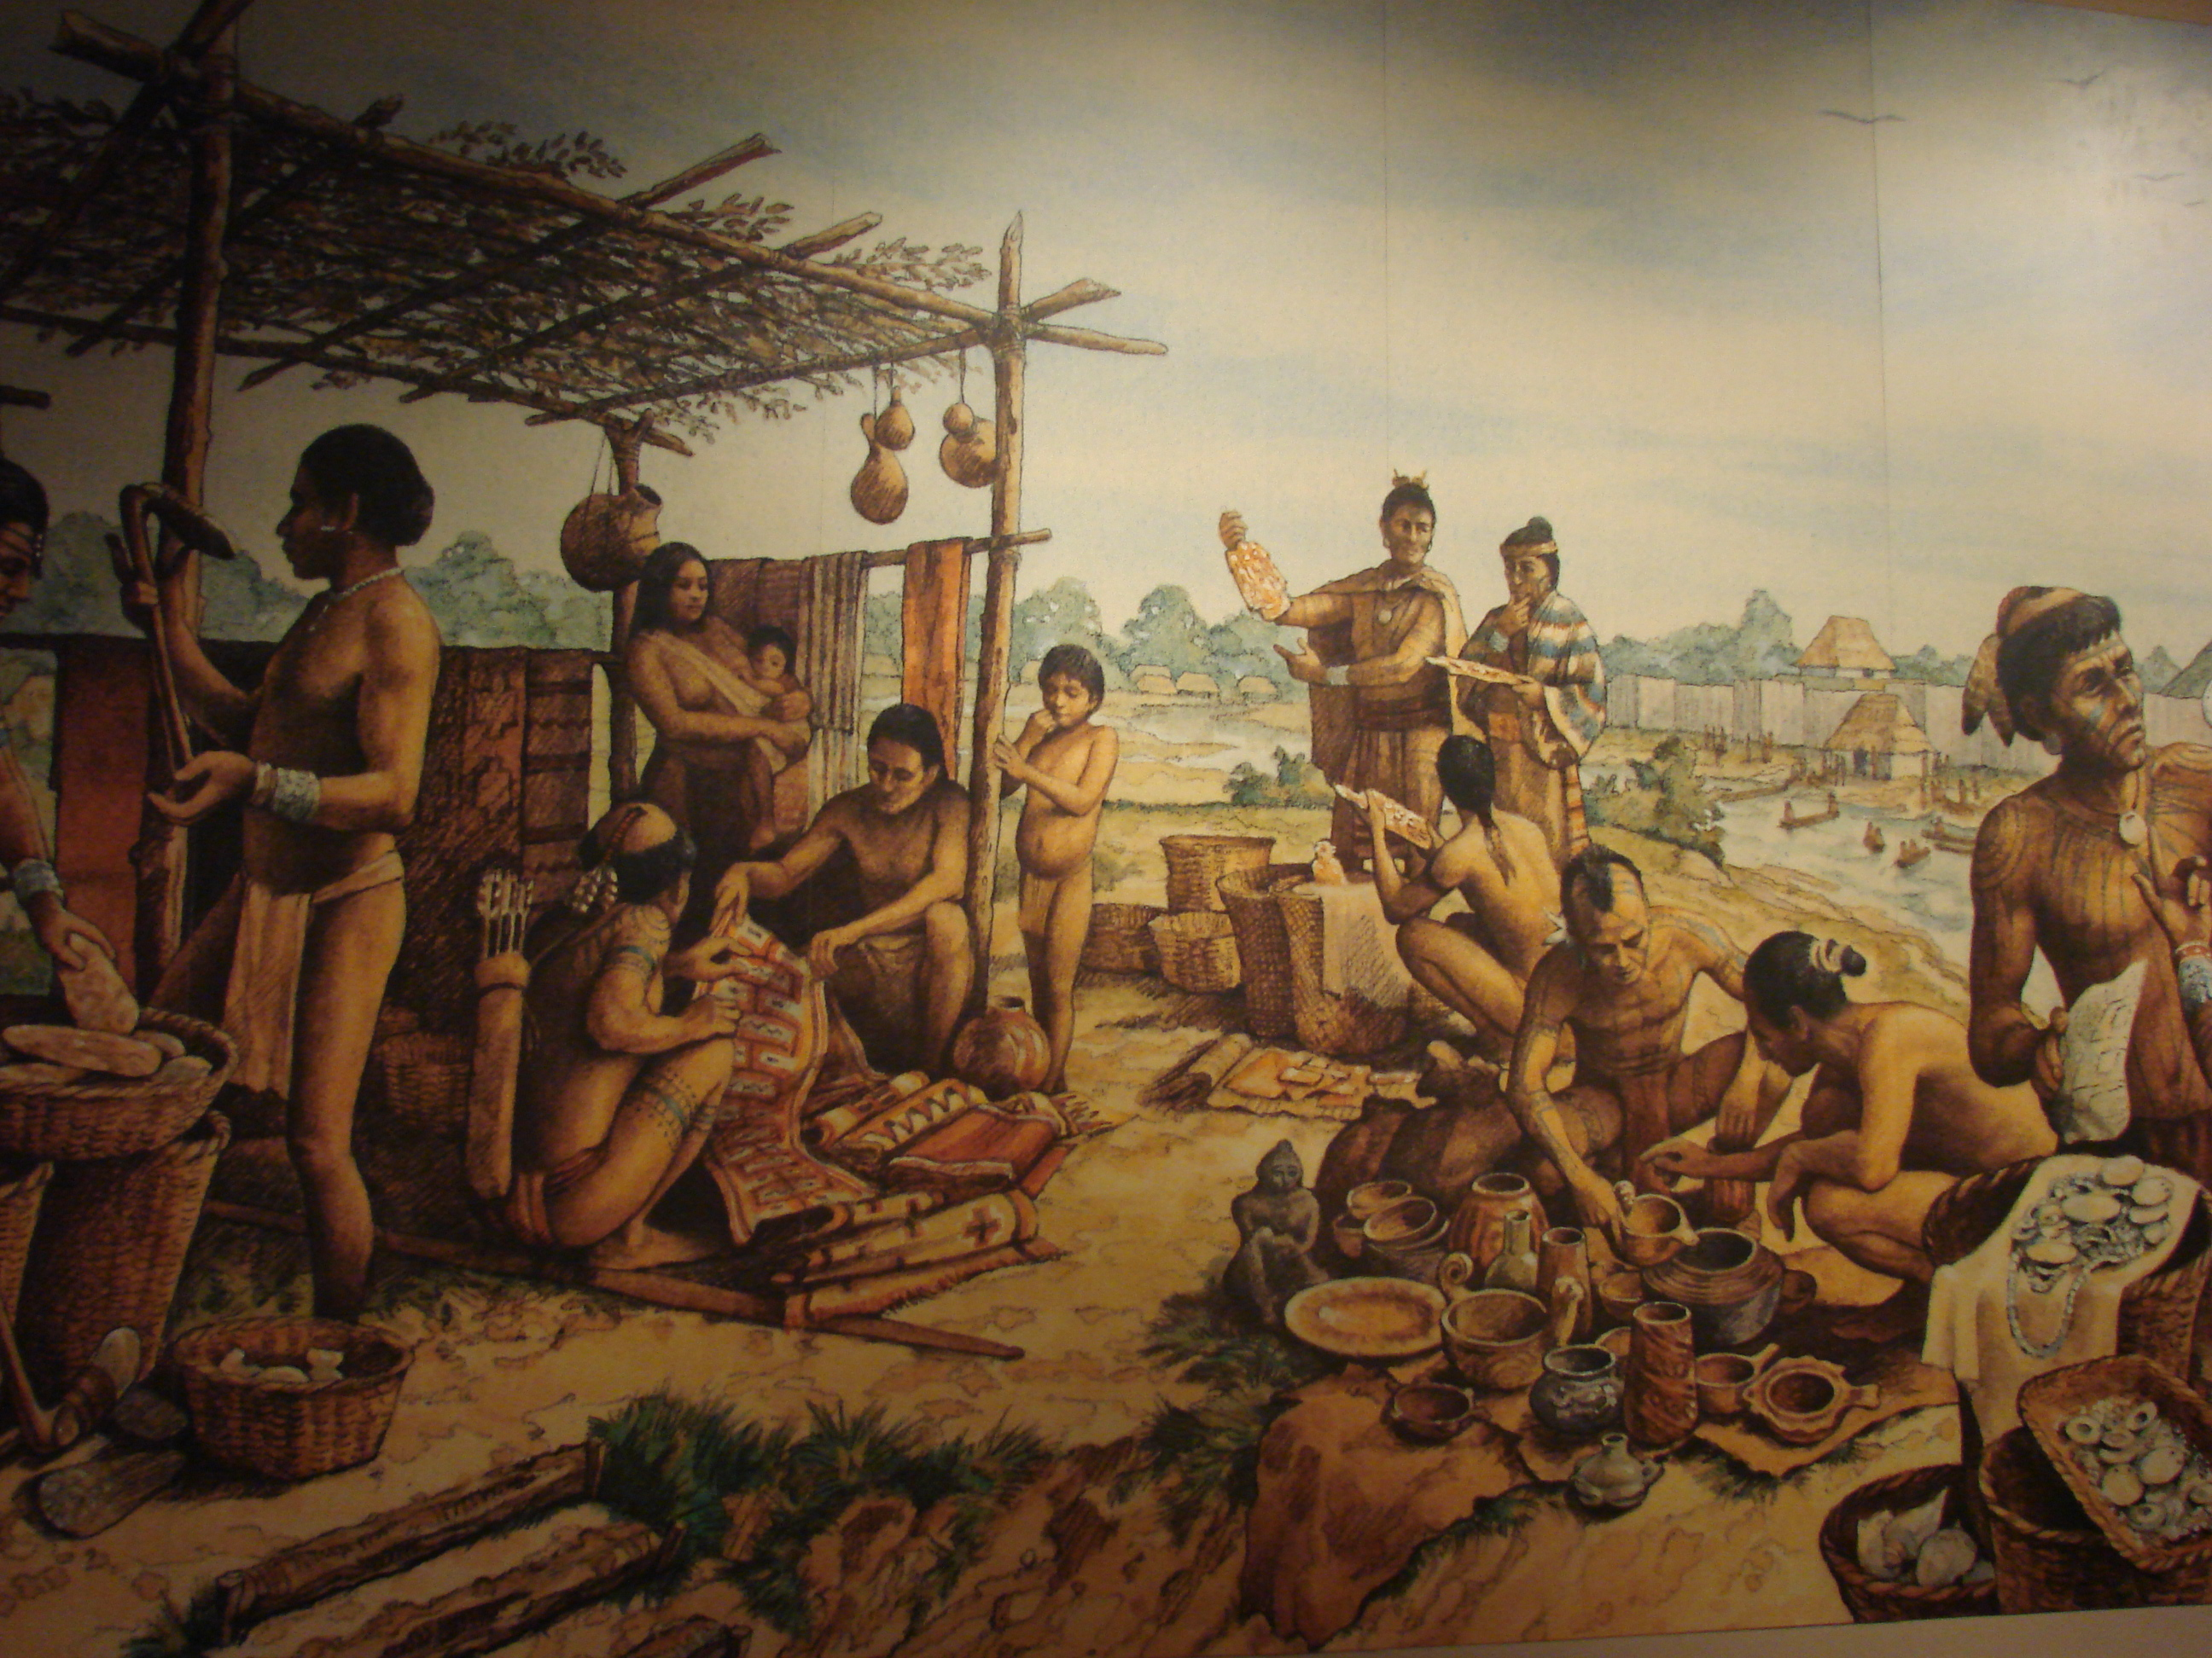

The Mississippi Empire was in the modern day southeastern United States along the Mississippi River. It lasted from 800 CE to 1600 CE. Its largest city was a city called ‎ Cahokia (pictured on next page), which had over 20,000 people (about the size of Berlin, Germany at the time). The climate was warm rainy summers and cool rainy winters.

The Mississippi people were known for their mound building and many of these mounds can still be found all over the United States. They were amazing traders and created a network of sellers from as far north as modern day Canada and as far south as modern day Mexico. They often traded salt and copper. Today, there are 1 million ancestors of the Mississippi in numerous Indigenous nations, including the Cherokee, Creek, and Choctaw people.

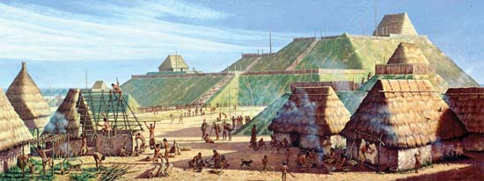

The below map shows the location of the Maya in the Americas.

WORKSHEET: 4-15.F

American Empires: Poster Instructions

Today, we will be making poster advertisements for our assigned empires. You will need to answer the following questions on your poster. Since it is an advertisement, remember to convince others that your empire is the best.

Your poster should include 3 drawings:

These drawings should give us images related to the below sections, maps, or important symbols.

Your poster should include 3 sections:

Section 1: Way of Life

What was life like for people in your empire? Did the people do certain jobs? Were their certain classes (i.e. nobles, priests, peasants, farmers, commoners)? What types of houses did they live in?

Section 2: Climate

What was the climate, including weather, like in your empire? How did the climate effect the empire?

Section 3: Trade

What items did your empire trade? How wealthy did this make the empire?

ASSESSMENT: 4-15.G

The Great American Empires: Exit Ticket

Inquiry Question: If you could live in any ancient American empire, which one would it be and why?

After looking at all of the empire advertisements, choose one Great American Empire and explain why you would choose to live there. Include three pieces of evidence from the sources.

LESSON PLAN 4-16: Columbus: Hero or Villain?

MATERIALS

Columbus Day News Story Video (Lesson4-16Video1) [Located in the UOW Video Library: www.christophercmartell.com/understandingourworld]
Overview: Christopher Columbus (WORKSHEET 4-16.A)
Source 1: Christopher Columbus’s Journal (WORKSHEET 4-16.B)
Source 2: 1917 Elementary School Textbook (WORKSHEET 4-15.C)
Source 3: Bartolomé de las Casas’s Writings (WORKSHEET 4-16.D)
Source 4: Howard Zinn’s Book (WORKSHEET 4-16.E)
Source 5: Columbian Exchange Chart (WORKSHEET 4-16.F)
Positive-Negative Chart (ASSESSMENT 4-16.G)
Columbus: Exit Ticket (ASSESSMENT 4-16.H)

STANDARDS

Massachusetts History and Social Science Framework

MA-HSS.4.CS.1: Use map and globe skills to determine absolute locations (latitude and longitude) of places studied. (G)

MA-HSS.5.3: Explain why trade routes to Asia had been closed in the 15th century and trace the voyages of [Christopher Columbus]. Describe what each explorer sought when he began his journey, what he found, and how his discoveries changed the image of the world, especially the maps used by explorers. (H, G, E)

Common Core: Literacy

CCSS.ELA-Literacy.RI.4.9: Integrate information from two texts on the same topic in order to write or speak about the subject knowledgeably.

CCSS.ELA-Literacy.RI.4.10: By the end of year, read and comprehend informational texts, including history/social studies, science, and technical texts, in the grades 4–5 text complexity band proficiently, with scaffolding as needed at the high end of the range.

CCSS.ELA-Literacy.W.4.8: Recall relevant information from experiences or gather relevant information from print and digital sources; take notes and categorize information, and provide a list of sources.

CCSS.ELA-Literacy.W.4.9: Draw evidence from literary or informational texts to support analysis, reflection, and research.

PROCEDURES

Inquiry Question: Did Columbus’s voyages have more of a positive or negative impact on the world?

PREPARATION

1. Two-Day Option
This lesson can be divided into two days, if time permits. Day 1 would involve preparing for the debate. Day 2 would involve the debate.

A. OPENER (5 minutes)

2. Brainstorm on Columbus
On the board or chart paper, write the name “Christopher Columbus.” Start by asking students if they have heard about Christopher Columbus by doing a “thumbs up, if yes, thumbs down, if no.” Ask students to tell you what they know about Christopher Columbus. Write what students say on the board or chart paper. Anticipated student responses may include: he has a holiday, he discovered America, he didn’t discover America, he was from Europe/Italy/Spain, he wore funny hats or clothes, he sailed in three boats: Niña, Pinta, and Santa María, he was nice/not nice to the Native people.

Tell students that today Christopher Columbus is someone who people debate about. He is liked by some people and disliked by others. Some people claim he discovered America and helped Europeans come here. Other people claim that he hurt and killed the Indigenous or Native people. This has led to many communities changing the name of Columbus Day to Indigenous People’s Day. On Indigenous People’s Day, they celebrate the Native or Indigenous people instead of Columbus.

A Note on the Topic:
This curriculum uses the term Indigenous people to describe the first people of the Americas or uses the specific name of a tribe or nation, which is preferred (i.e. Arawak, Taíno, Algonquian, Mohawk). This term is the most accurate, as it reflects that the native people were the original people to inhabit the area. However, it should be noted that Native, Indian, or American Indian are all appropriate and acceptable terms. While the term Native American is generally used by the United States government, First Nations/People and Aboriginal are generally used by the Canadian government, and Indian or American Indian is the most commonly used term among Indigenous people. Here is a good article on usage: www.learnnc.org/lp/editions/nc-american-indians/5526

3. Watch Columbus Day News Story Video
Show the students a short news clip video on Lincoln, Nebraska changing Columbus Day to Indigenous Peoples’ Day (Lesson4-16Video1). Ask the students if they were surprised to learn that Columbus had done some bad things and some people want to change the name of Columbus Day? Ask students if they think Columbus should have his own holiday by doing a “thumbs up, if yes, thumbs down, if no.” Tell the students that today we will do some research to see if what we think about Columbus will change or stay the same.

B. DEVELOPMENT (25 minutes)

4. Introduce the Possible Arguments About Columbus
Tell students that today we will be debating if Christopher Columbus was more positive (good) or negative (bad). You will learn that Columbus did both good and bad things, but we will need to decide if he did more good or more bad. Ask the students to read aloud as a class (using choral, partner, or independent reading) the Overview: Christopher Columbus (WORKSHEET 4-16.A).

5. Prepare for the Debate on Columbus
Divide the class into two groups, one will represent the “Positive” Perspective and the other will represent the “Negative” Perspective. Tell both groups to look at their documents that are labeled either “Positive” (Christopher Columbus’s Journal [WORKSHEET 4-16.B]; 1917 Elementary School Textbook [WORKSHEET 4-15.C], “Negative” (Bartolomé de las Casas’s Writings [WORKSHEET 4-16.D]; Howard Zinn’s Book [WORKSHEET 4-16.E]), or both (Columbian Exchange Chart [WORKSHEET 4-16.F]). Students should first read the sources that relate to their group: positive or negative (using choral, partner, or independent reading). As the student reads, tell the other group members to underline or highlight any important information. When they are done, they should read the sources that relate to the other side. As the student reads, tell the other group members to underline or highlight any important information.

Ask students to discuss in their groups, based on what they read, their position (Columbus is positive or negative) and the reasons why. Have them make a list of facts that support that Columbus is positive or negative on the Positive-Negative Chart (ASSESSMENT 4-16.G) to help make your argument (students should only complete the notes for their debate side at this point). Have students use a piece of paper to prepare an opening speech. Tell students to choose one student to read their opening speech. Circulate the room helping students complete their opening speech.

6. Participate in the Columbus Debate
Have students put their chairs in a position where the two groups of the debate can see each other. Tell students that we will now have a debate about which idea we think is more likely. Tell students that there will be three rules for our debate:
- We must respect each other. There is no one right answer and everyone’s ideas are important.
- We should only have one person speaking at a time (you may consider using a talking stick or item for this activity-where only the student holding that stick/item has the right to speak)
- We should be listening when others speak.

Have one of the debate sides read their opening speech. Next, have the other debate side read their opening speech [NOTE: It does not matter which side goes first].

After the opening speeches are read, tell the first team that they get to speak for 3 minutes and the other team cannot interrupt them. This is their chance to say why they think their idea is right.

Tell the second team that they get to speak for 3 minutes and the other team cannot interrupt them. This is their chance to say why they think their idea is right.

Have students make points or ask questions to the other side and allow the other side time to respond. This should last 5-7 minutes. Go back and forth having each side ask and the other side answer their question/respond to their statement.

Tell the students that the debate is now over and that they will have a chance to make up their own mind, which may be different than the debate side that they were on. Before they make up their own mind, tell them that we will review the arguments from each side. Ask the class to remind us of the arguments for “Positive.” List these ideas on the board or chart paper. Have students add them to their worksheets, if they are not already recorded from the debate preparation. Ask the class to remind us of the arguments for “Negative.” List these ideas on the board or chart paper. Have students add them to their worksheets, if they are not already recorded from the debate preparation.

Have students complete the evaluation task and then share their answers.

C. CLOSING (10 minutes)

7. Write Up Argument on Columbus
For the evaluation task, have the students complete the exit ticket (ASSESSMENT 4-16.H), where they write their own personal response to the lesson’s Inquiry Question: “Did Columbus’s voyages have more of a positive or negative impact on the world?” Tell students to cite at least three pieces of evidence from the sources for this lesson.

Before using the exit ticket, consider using a graphic organizer or two column notes to prepare students for the writing task. Consider using sentence starters and modeling to help the students with their answer to the inquiry question.

8. Share Arguments
Have students share their arguments with the class. Draw comparisons between the different students’ arguments and list them on the board or chart paper.

EVALUATION

ASSESSMENT 4-16.H

What to look for?

The students should take a stance on if Columbus was more positive or negative. All arguments should cite at least 3 pieces of evidence from the sources.

Some information that students may include in their answer to the question:

Columbus was positive
- He helped Europeans find the “New World” or Americas
- This led to Europeans coming to the Americas
- He was a brave sailor
- This helped new products go to Europe (squash, pumpkin, turkeys, potatoes, tomatoes, maize/corn) and the Americas (onions, citrus fruits like oranges and lemons, grapes, olives, turnips, coffee, peaches, pears, bananas, sugar, honey bees, wheat, livestock like cows, pigs, horses, and sheep)
- It was his sailors, but not him, who killed and hurt Native people

Columbus was negative
- His sailors killed and hurt Native people (possibly as many as 50 million)
- He only wanted gold and slaves (and writes about this in his own diary)
- This led to many diseases coming to the Americas (smallpox, influenza, typhoid, measles, malaria, diphtheria, pertussis)
- He wanted to be rich and famous
- He did not care about the Arawaks/Native people

WORKSHEET: 4-16.A

Overview: Christopher Columbus

Christopher Columbus has been described as a great sailor, a genius, a terrible leader, and a greedy dictator. He helped the Europeans find the Americas (although the Vikings had reached North America centuries earlier). However, it is also important to note that he did not discover that the world was round. Almost all sailors of the time knew the world was round. Columbus' wanted to find a westward route to Asia, because he thought it would be a quicker way to get there. He lived for a time in Portugal, where he tried unsuccessfully to get money for his voyage, before moving to Spain. The Spanish Queen Isabel and King Ferdinand gave him money for his voyage.
On the journey west, Columbus’s sailors almost mutinied (rebelled against their ship’s captain). On October 12, 1492, he reached the Bahamas. Columbus’s voyage made him famous throughout Europe and made him money. He would make three more voyages to the “New World” (map below). Columbus believed until his death that he had reached Asia.

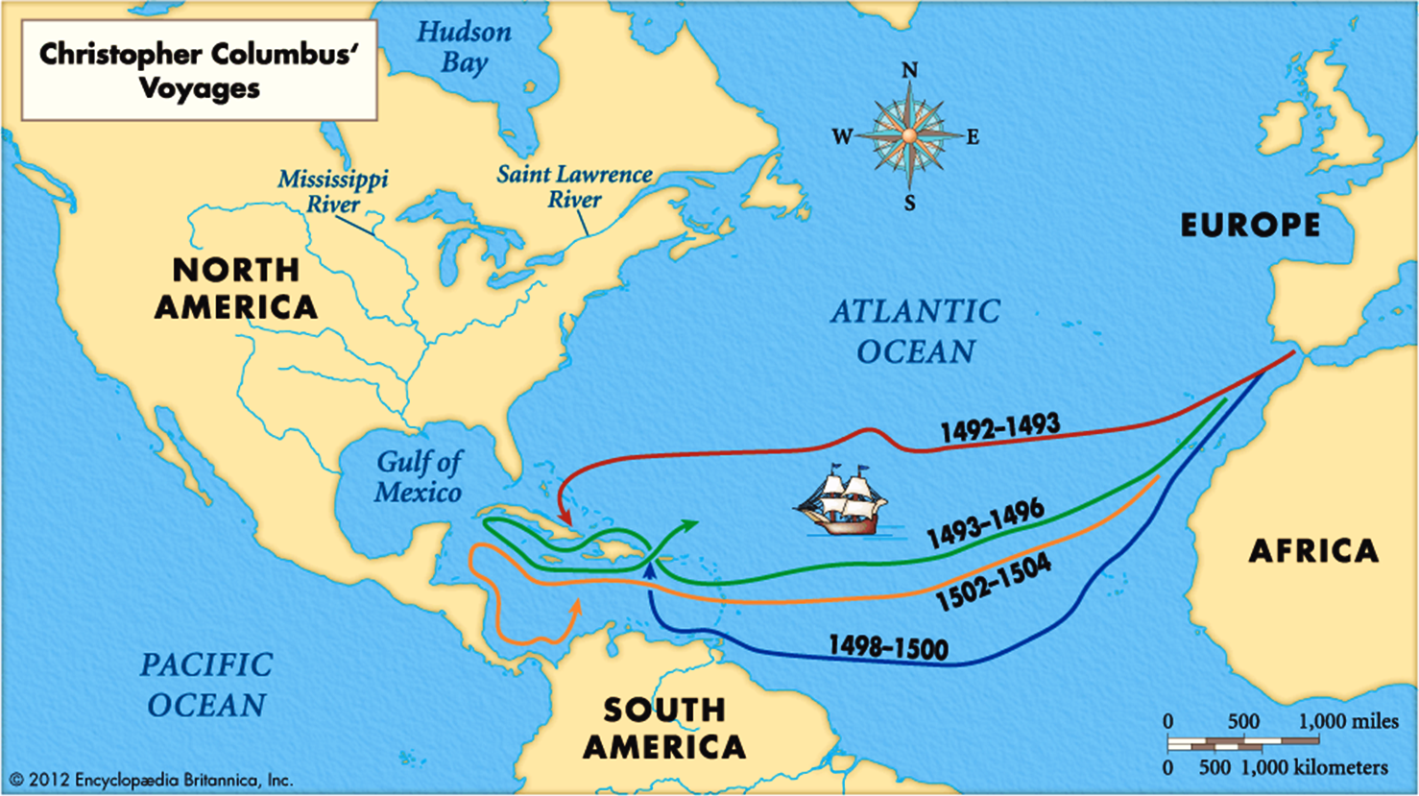

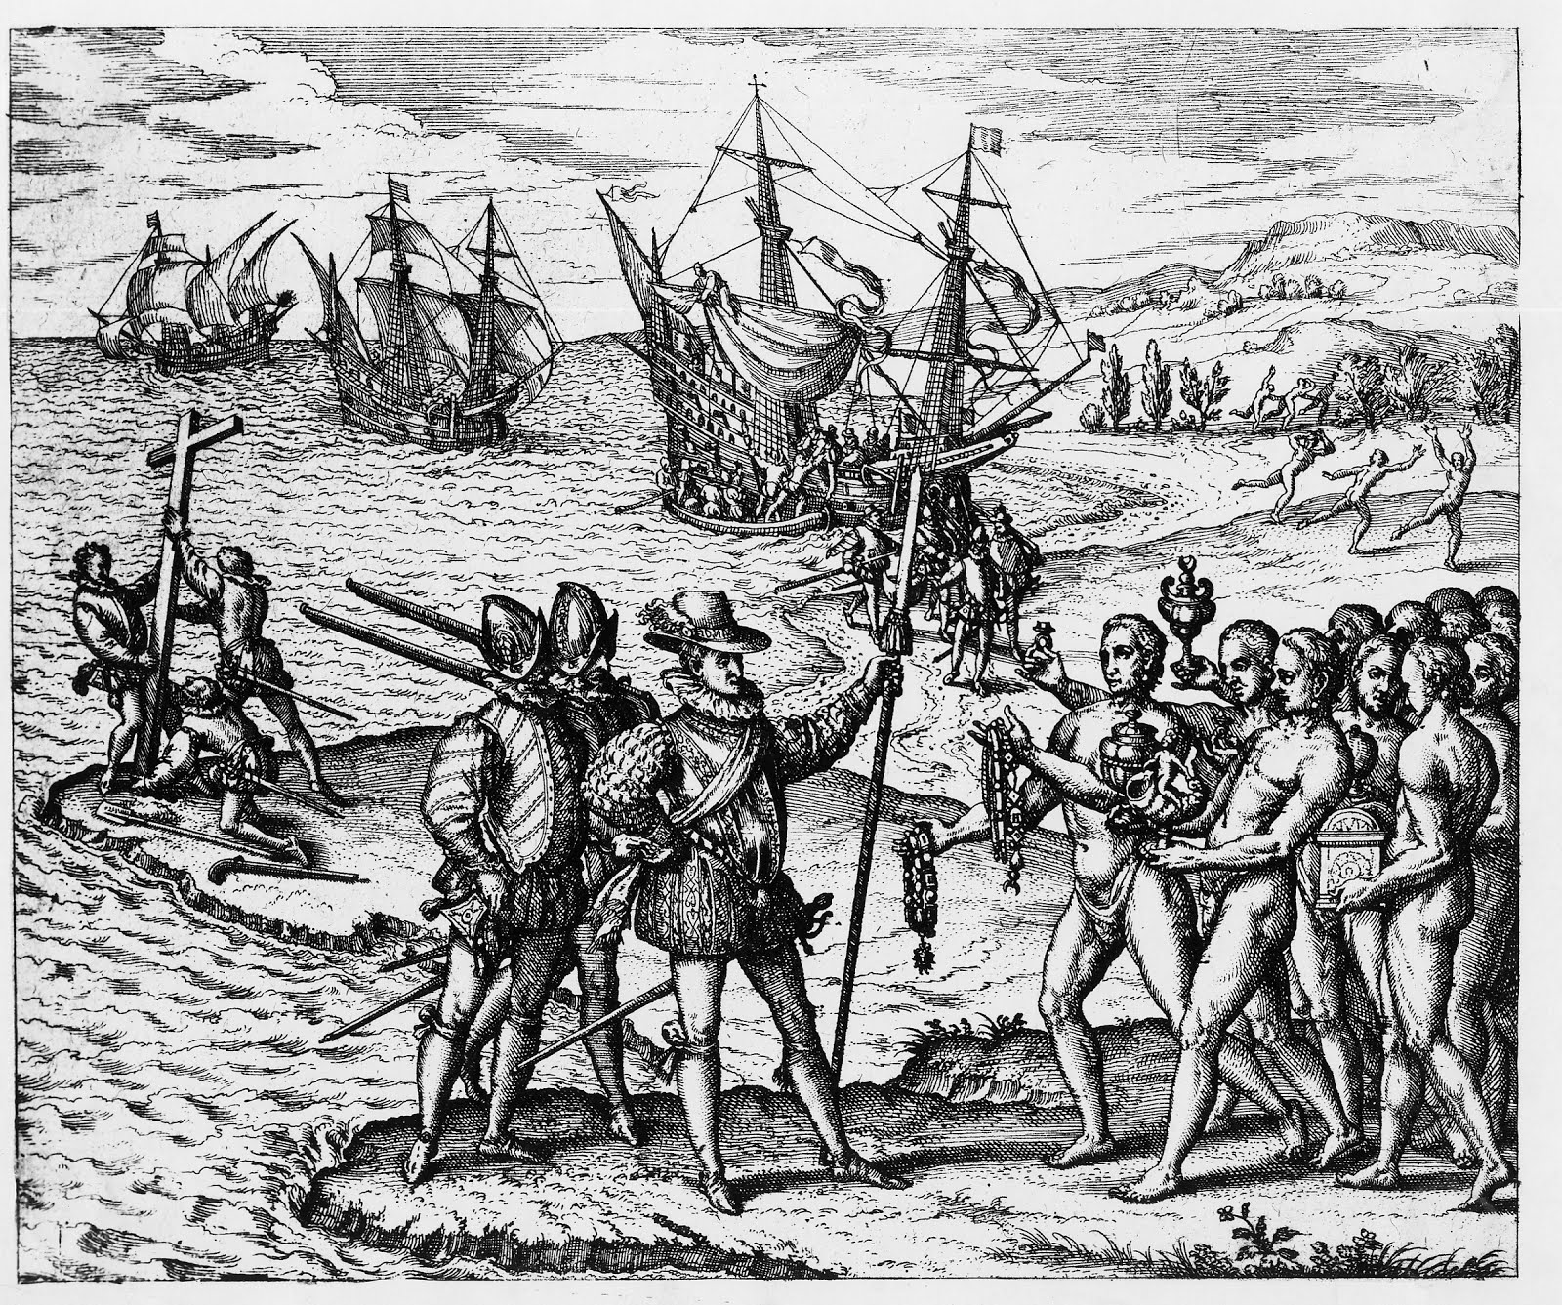
Above: European etching (drawing) of Columbus arriving. The Indigenous (Native) people are shown bringing gifts to Columbus. Spanish sailors put up a cross, which is a sign of Christianity. In the background, Indigenous people run away from sailors arriving on the shore. This shows how the Europeans viewed the Indigenous people.

WORKSHEET: 4-16.B

Source 1: Christopher Columbus’s Journal (Positive)

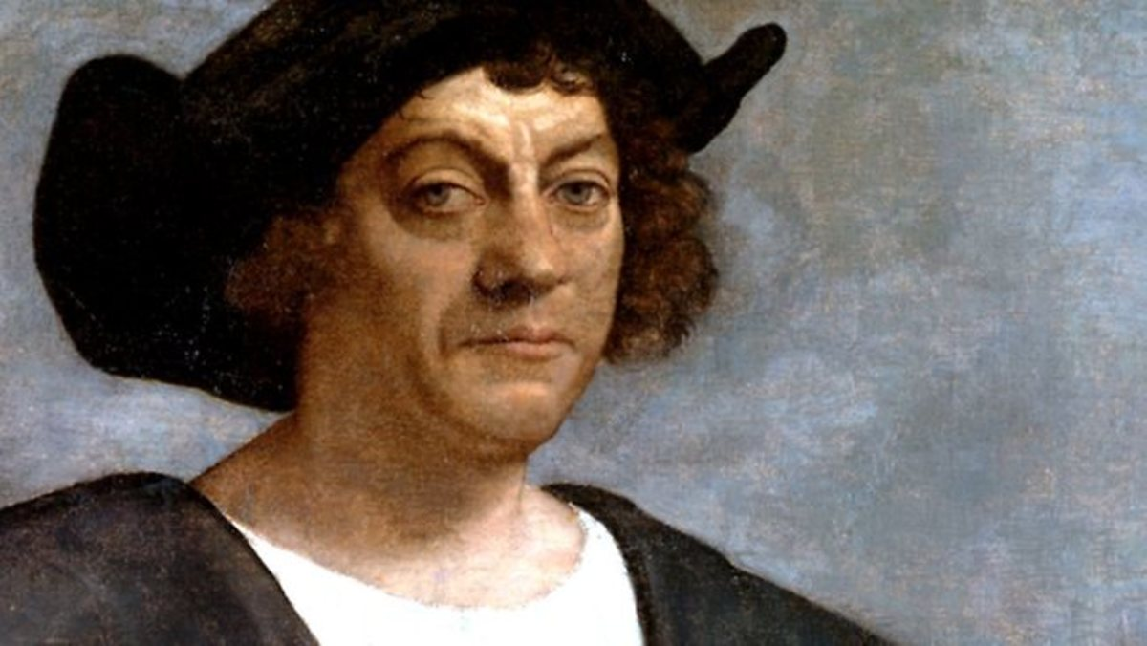
Above: We do not know what Columbus looked like, since no paintings were made during his life. This is what an artist imagined he looked like.

Christopher Columbus wrote this in his diary on October 12, 1492.

Friday, we were near a small island (Bahamas). The Natives were very friendly to us. I presented them with some red caps, and strings of beads to wear upon their necks. They were very happy. After, they came swimming to our boats, bringing parrots, balls of cotton thread, javelins for us. They seemed to be a very poor people. They have no weapons. I showed them a sword and they cut themselves on it. They have no iron, their javelins are only sticks. They are smart and would be good servants. They will easily become Christians. They learn the words that we speak to them very quickly. I will bring home six people for the King and Queen.
WORKSHEET: 4-16.C

Source 2: 1917 Elementary School Textbook (Positive)

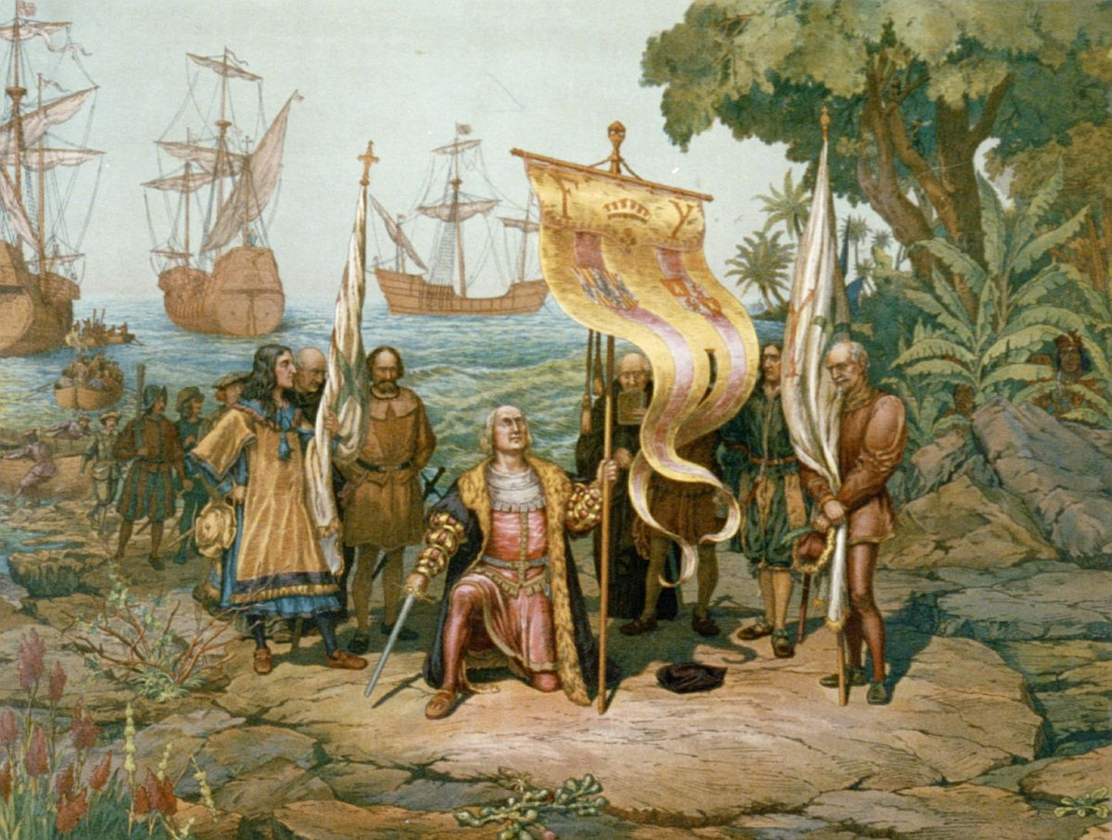

This is a summary of Columbus from an elementary school history textbook written in 1917 (over 100 years ago).

The dawn (sunrise) spread slowly over sky and sea, and a low island appeared, fresh and green with trees. When they arrived on land, Columbus was greeted by the Indians. The Indians had never before seen such amazing people and they thought they were gods that had come down from the sky to visit them.

The day when Columbus first stood upon this land of the western world was Friday, October 12, 1492. Remember this date. It is one of the golden days of history! The people of the world cannot measure what they owe to Columbus for discovering America. He united Europe and the Americas. He is the reason that many Europeans are here today.
WORKSHEET: 4-16.D

Source 3: Bartolomé de las Casas’s Writings (Negative)

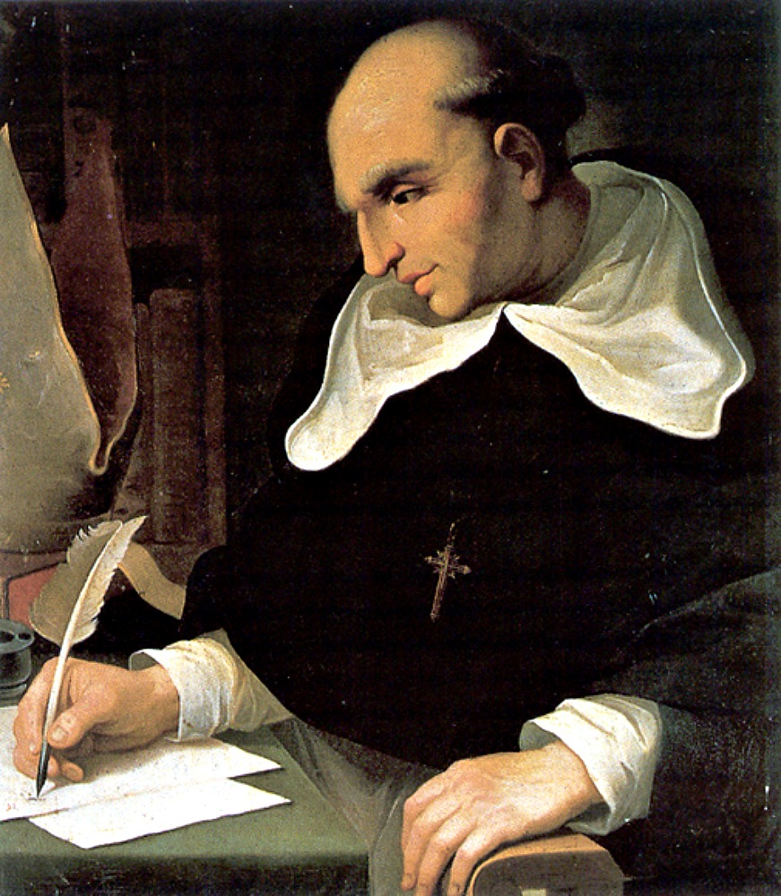

Bartolomé de las Casas was the Spanish Catholic (Christian) bishop put in charge of protecting the Native people. He interviewed people who were on Columbus’s ships and wrote this about the journeys.

Some Spaniards, acting like beasts, were killing, torturing, and destroying the Native peoples. The number of people killed could be as many as fifteen million. Their reasons for killing is that the Christians have an ultimate aim, which is to acquire gold, and to become rich in a very brief time. They do not care for these souls.

And the Christians, with their horses and swords and pikes began to carry out massacres against the Indians. They attacked the towns and hurt children, the old, and pregnant women. They laid bets as to who, with one stroke of the sword, could kill the most people.

WORKSHEET: 4-16.E

Source 4: Howard Zinn’s Book (Negative)

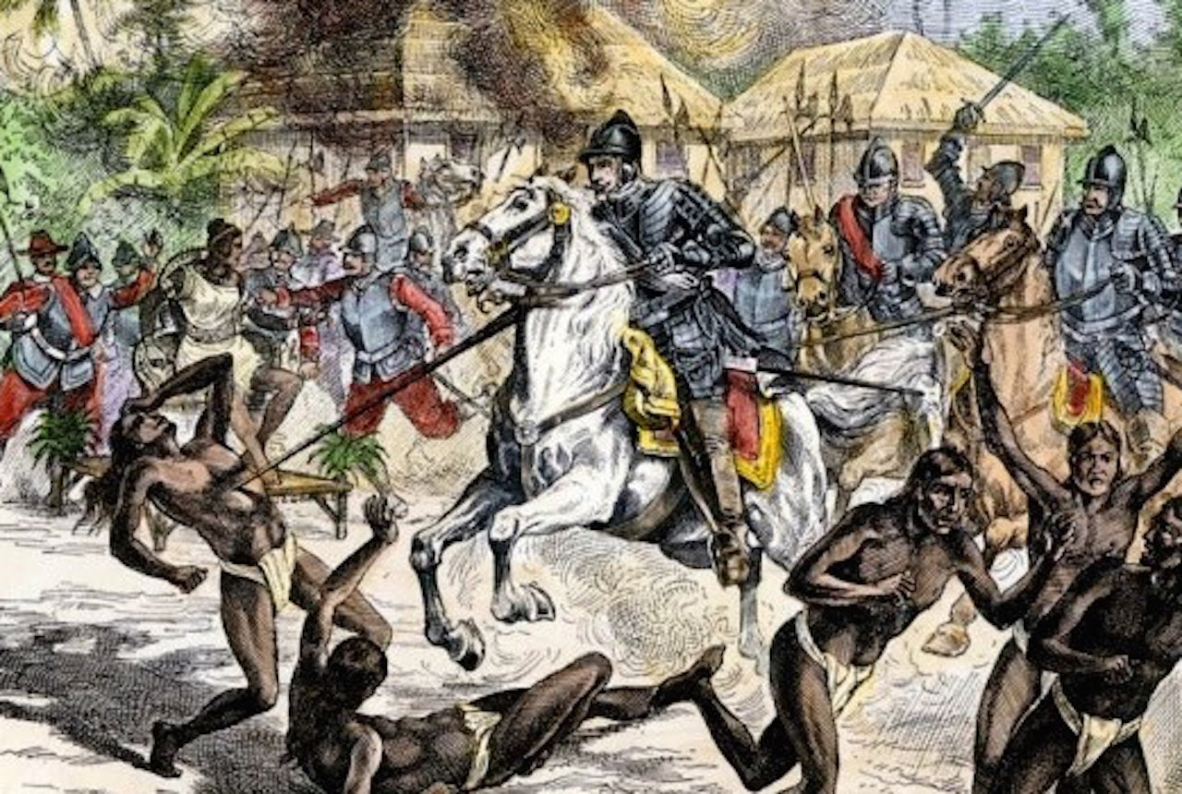

This is a summary of Columbus from a history book written in 1980 (almost 40 years ago).

Arawak (Indigenous/Native) men and women emerged from their villages onto the island's beaches and swam out to get a closer look at the strange big boat. When Columbus and his sailors came ashore, carrying swords, speaking oddly, the Arawaks ran to greet them, brought them food, water, gifts.

He only wanted to take the Native people as slaves and steal their gold. Columbus and his men went from island to island in the Caribbean taking the Indians as captives (without their permission). They found more and more empty villages, as the Native people ran away. This is not the story of people who cared about the Native people, but people who only cared about conquering.
WORKSHEET: 4-16.F

Source 5: Columbian Exchange Chart (Positive and Negative)

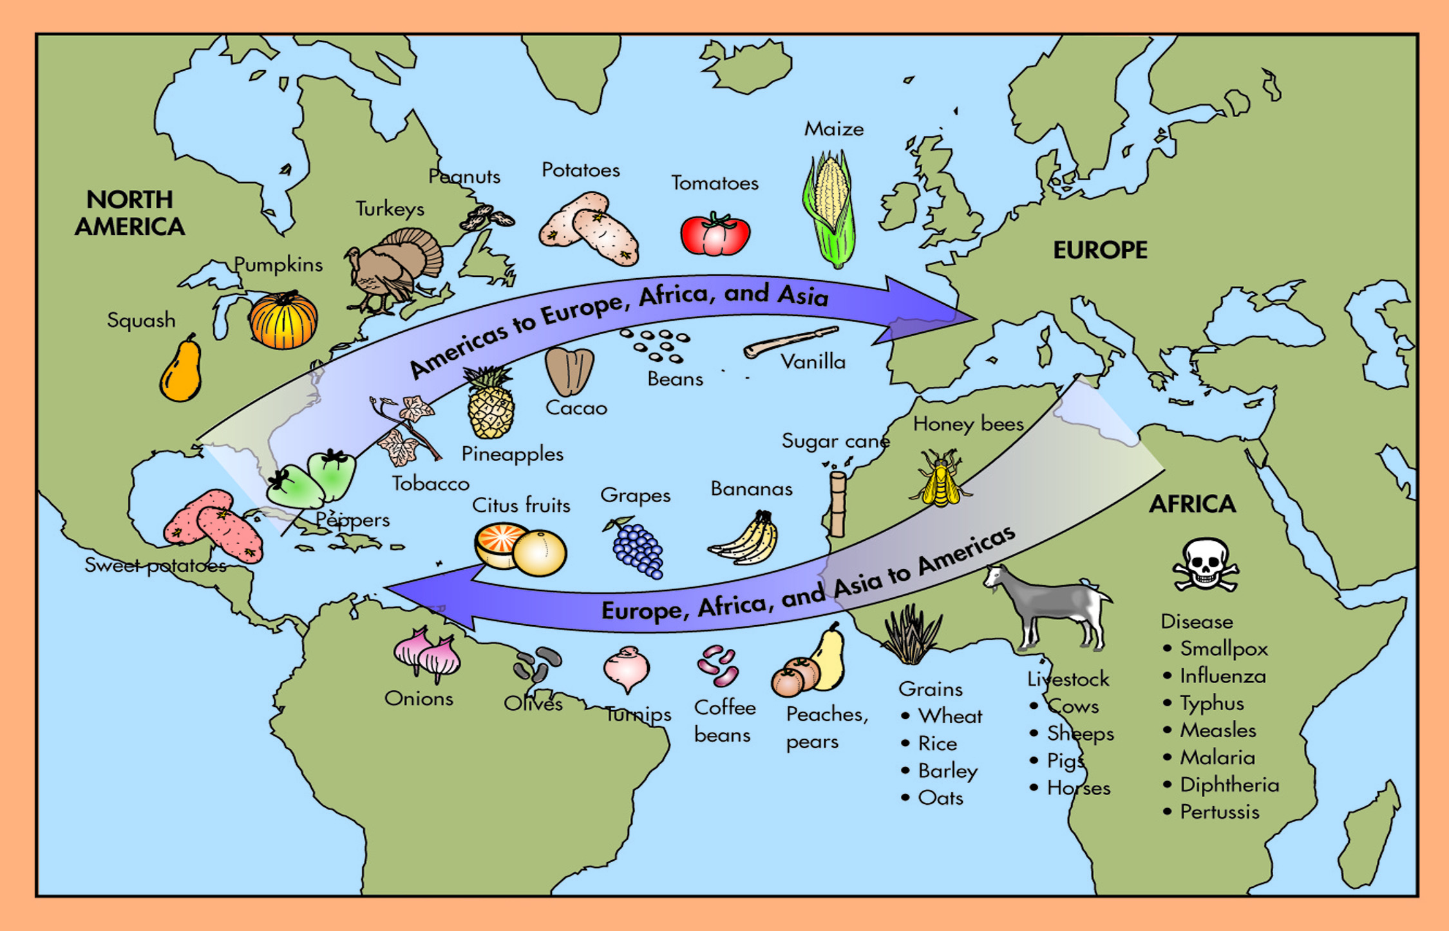
ASSESSMENT: 4-16.G

Positive-Negative Chart

Columbus is Positive

Columbus is Negative

ASSESSMENT: 4-16.H

Columbus: Exit Ticket

Inquiry Question: Did Columbus’s voyages have more of a positive or negative impact on the world?

After looking at the sources and hearing the debate, do you think Columbus did more positive (good) or negative (bad). You do not need to agree with the side that you were on the debate team. Include three pieces of evidence from the sources.

LESSON PLAN 4-17: Haiti: What Type of Revolution?

MATERIALS

“Toussaint L’Ouverture: The Fight for Haiti's Freedom” by Walter Dean Myers and Jacob Lawrence (not supplied)
Source 1: Timeline of the Haitian Revolution (WORKSHEET 4-17.A)
Source 2: Toussaint Louverture’s Constitution (WORKSHEET 4-17.B)
Source 3: Letter from Toussaint Louverture to Napoléon (WORKSHEET 4-17.C)
Source 4: Columbian Centinel American Newspaper on the Haitian Revolution (WORKSHEET 4-17.D)
Haitian Revolution: Exit Ticket (ASSESSMENT 4-17.E)

STANDARDS

Massachusetts History and Social Science Framework

MA-HSS.4.29: Identify the different languages used in different countries in the Caribbean region today (e.g., Spanish in Cuba, French in Haiti, English in Barbados and Jamaica). (H)

MA-HSS.4.30: Identify when the countries in the Caribbean and in Central America became independent nations and explain how independence was achieved. (H, G)

Common Core: Literacy

CCSS.ELA-Literacy.RI.4.9: Integrate information from two texts on the same topic in order to write or speak about the subject knowledgeably.

CCSS.ELA-Literacy.RI.4.10: By the end of year, read and comprehend informational texts, including history/social studies, science, and technical texts, in the grades 4–5 text complexity band proficiently, with scaffolding as needed at the high end of the range.

CCSS.ELA-Literacy.W.4.8: Recall relevant information from experiences or gather relevant information from print and digital sources; take notes and categorize information, and provide a list of sources.

CCSS.ELA-Literacy.W.4.9: Draw evidence from literary or informational texts to support analysis, reflection, and research.

PROCEDURES

Inquiry Question: What type of revolution did Toussaint Louverture lead in Haiti?

PREPARATION

1. Post Definitions of Rebellion and Revolution

Post the definitions of revolution on the board or chart paper hidden from view. Revolution (1): An uprising or revolt against a government. Revolution (2): A major change in ideas.

2. Note About This Book
In the book “Toussaint L‘Ouverture: The Fight for Haiti's Freedom,” the cruelty of slavery and war is depicted in historically accurate ways, but it may be difficult for some students. Be sure to preview the book beforehand and decide if there are any parts that you think should be omitted.

A. OPENER (10 minutes)

3. Read “Toussaint Louverture: The Fight for Haiti's Freedom” by Walter Dean Myers and Jacob Lawrence
Before reading the text, tell students that today we are going to read a story about a man who was born into slavery and would lead a slave army to take over a country. That country was Haiti, which is an island in the Caribbean that was then ruled by France. France had brought many Africans there to be slaves in the sugar plantations. Ask students if they know what revolution means. Reveal the two different definitions of revolution as “Revolution (1): An uprising or revolt against a government” and “Revolution (2): A major change in ideas.”

Read select pages of “Toussaint L’Ouverture: The Fight for Haiti's Freedom.” This is a picture book that tells the true story of Toussaint Louverture who led a revolution against the French government and slavery in Haiti. As you read the text, be sure to ask questions about Toussaint Louverture’s experiences and choices. Connect this story to the work the students have done in previous grades related to slavery, segregation, and civil rights. Start with page 5 (not numbered-“On the twentieth of May…) and read to page 10 (not numbered-“Toussaint’s small force…”). Start again at page 22 (not numbered-“Toussaint L’Ouverture controlled most of…”) and stop at page 24 (not numbered-“But on the other side of the ocean…”). Start again at page 28 (not numbered-“Toussaint understood that if the French sent…”) and end at page 32 (not numbered-“But the struggle that Toussaint L’Ouverture had begun…”).

Tell students that today, we are going to learn about the slavery that existed in Haiti and what people did there to try and stop it, which would lead to Haiti becoming its own country.

B. DEVELOPMENT (25 minutes)

4. Introduce the Possible Arguments
Remind students of the two different definitions of revolution as “Revolution (1): An uprising or revolt against a government” and “Revolution (2): A major change in ideas.”

Tell students that today we will be learning about the Haitian Revolution and you will have to decide if it was revolution 1, a revolt against the government, or revolution 2, a change in ideas. You will have to decide if what the people of Haiti did only changed who their ruler was OR it changed the way people thought about the world.

5. Examine Sources As a Whole Class
Ask the students to read aloud (using choral, partner, or independent reading) the three documents on Timeline of the Haitian Revolution (WORKSHEET 4-17.A), Toussaint Louverture’s Constitution (WORKSHEET 4-17.B), Letter from Toussaint Louverture to Napoléon (WORKSHEET 4-17.C), Columbian Centinel American Newspaper on the Haitian Revolution (WORKSHEET 4-17.D).

After reading each document, solicit from students what important facts should be underlined and highlighted about each source. Make sure they highlight examples of how the slavery was problematic, but also the acts of resistance to it. It is important that the students realize that enslaved people did not just accept their condition.

6. Discuss the Struggles that Black People Faced in Haiti and What They Did in Response
Put students in small groups (3-4 students). Tell students that after listening to “Toussaint L’Ouverture: The Fight for Haiti's Freedom” and reading these sources, I would like you to talk about ways that life was difficult for Black people in Haiti under slavery, but also ways that people did things to stop slavery because it was wrong. You will need to decide if what Toussaint Louverture and other Haitians did was only changing their government or if it changed the way that the world thought about Haitians and Black people.

After students have had 5-7 minutes to discuss, lead the class in a whole class discussion. On the board or chart paper, take notes on what the students say. Anticipated responses may include: it showed that enslaved people will do whatever they can to stop slavery, it showed that people should not be in slavery, it showed that when someone believes something is wrong, they can stop it, it showed it takes a group of people working together to change the world.

C. CLOSING (10 minutes)

7. Answer the Inquiry Question
For the evaluation task, have the students complete the exit ticket (ASSESSMENT 4-17.E), where they write their own personal response to the lesson’s Inquiry Question: “What type of revolution did Toussaint Louverture lead in Haiti?” Tell students to cite at least three pieces of evidence from the book (Toussaint L’Ouverture: The Fight for Haiti's Freedom) and the sources for this lesson.

Before using the exit ticket, consider using a graphic organizer or two column notes to prepare students for the writing task. Consider using sentence starters and modeling to help the students with their answer to the inquiry question.

EVALUATION

ASSESSMENT 4-17.E

What to look for?

The students should take a stance on if Toussaint Louverture was more positive or negative. All arguments should cite at least 3 pieces of evidence from the sources.

Some information that students may include in their answer to the question:

Chooses revolution (1): an uprising or revolt against a government
- It was to end slavery
- It was meant to get rid of the French government

Chooses revolution (2): A major change in ideas
- It was one of the first countries to ban slavery in the world
- It made all men equal in its Constitution
- It showed the world that Black people could lead their own nation

WORKSHEET: 4-17.A

Source 1: Timeline of the Haitian Revolution

1491: Over a million Taíno/Arawak people live on the island.

1492: Columbus lands on the island and names it Hispaniola. Many Taíno/Arawak (Indigenous) people are killed.

1577: Only a small number of Taíno/Arawak people live on the island. Spain brings the first enslaved Africans to the island to start working on sugar plantations. French people come to Haiti to also start plantations.

1685: Le Code Noir (The Black Code) is made by the French King and it says that free Black people had few rights and that slave owners had full control of their enslaved people.

1697: France signs a treaty (agreement) with Spain to take 1/3rd of the island on the west side. This is renamed Haiti, which is based on the word “Ayiti” (ay-tee) that was used by the Taíno/Arawak people (and by Haitians today).

1743: François Dominique Toussaint Bréda is born. He would later go by Toussaint Louverture (tu-sont lo-va-ture).

1758: There is a failed slave revolt in Haiti. The French kill its leader François Mackandal (fran-wa mac-on-dol).

1789: There is a revolution in France where the people get rid of their king and declare that “all men are equal.”

1790: A delegation of métis Haitians (métis means “mixed” or people who are Black and White) go to France and ask to be given equal rights. Two years later, they were given equal rights.

1790: There is a failed slave revolt in Haiti. The French kill its leader Vincent Ogé (vin-cent oh-gay).

August 1791: A revolt led by a slave named Boukman happens on the Chabaud plantation. This spreads to nearby plantations.

October 1791: The revolt is now led by George Biassou (bi-ah-su). The capital Port-au-Prince is burned down. Toussaint Louverture joins the rebellion and becomes the aid of George Biassou.

1794: Toussaint Louverture takes control of the revolt. He controls the entire northern section of Haiti.

1799: Napoléon Bonaparte takes over the government of France and become a dictator (not elected).

1800: Toussaint Louverture’s army controls all of Haiti.

July 1801: Toussaint Louverture releases his Constitution and sends it to Napoléon Bonaparte.

June 1802: Toussaint Louverture is captured and put in prison.

April 7, 1803: Toussaint Louverture dies in prison.

December 1803: Last French soldiers leave Haiti.

January 1, 1804: Haitians declare independence from France.
WORKSHEET: 4-17.B

Source 2: Toussaint Louverture’s Constitution

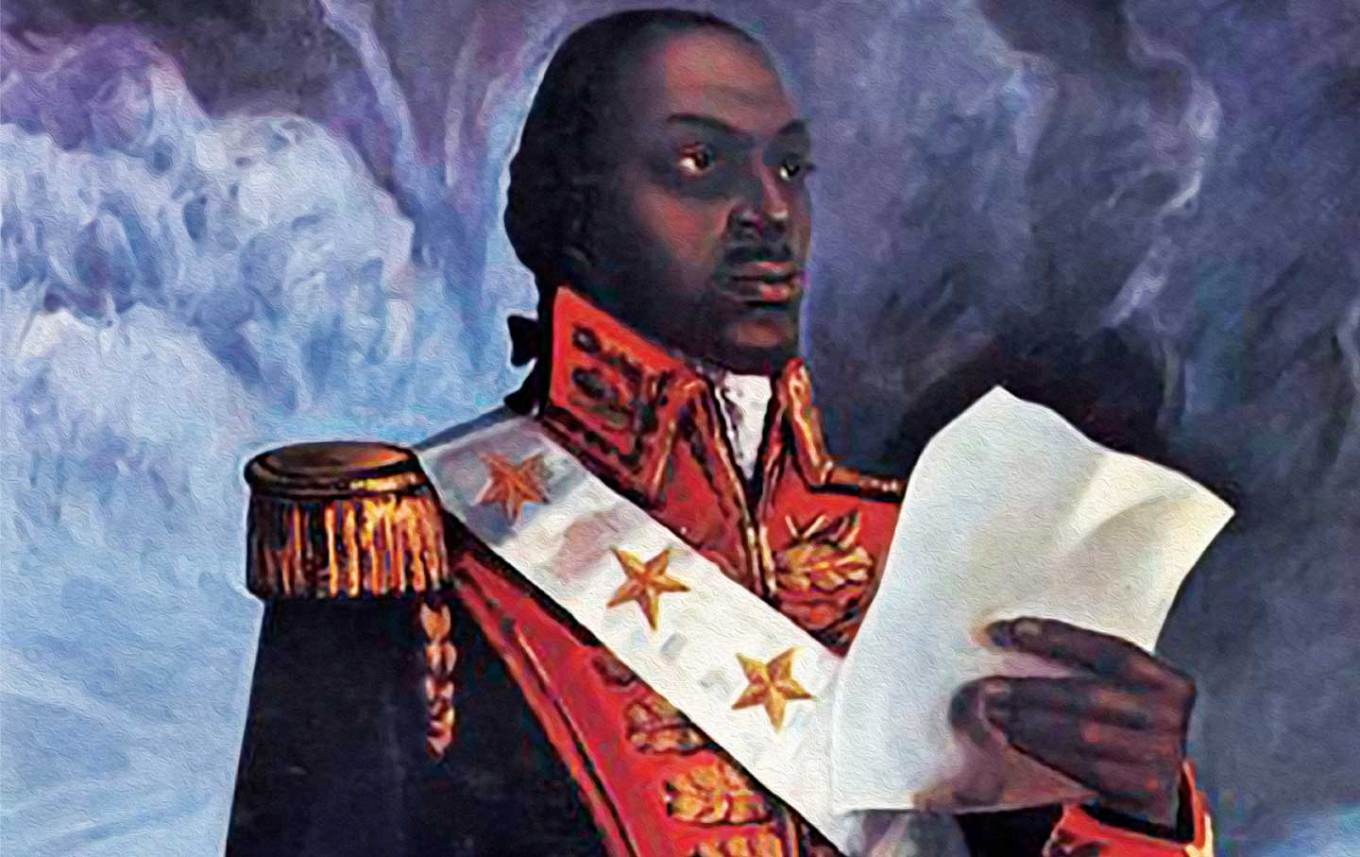
Above: A painting of Toussaint Louverture reading his Constitution.

Title 2, Article 3: There will be no slaves in Haiti. All men are born, live, and die free (making it one of the first countries in the world to ban slavery).

Title 2, Article 4: All men can work.

Title 5, Article 12: All men can have a trial.

Title 5, Article 13: All men can own property. No one can take their property. Anyone who tries to take property will be put on trial.

WORKSHEET: 4-17.C

Source 3: Letter from Toussaint Louverture to Napoléon

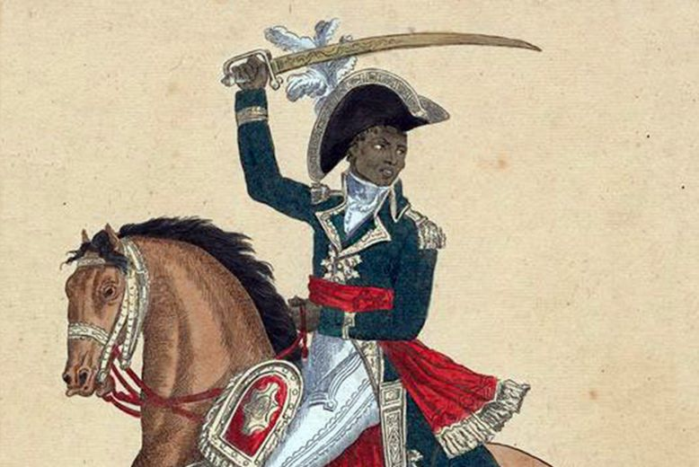
Above: Toussaint Louverture on a horse with a sword.

Dear Citizen Consul (Napoléon):

I have created a Constitution which will be the future of Santo Domingo (Haiti). I have made it to help the people rule themselves. I have sent it to you in order that you will say yes to it and allow Haiti to be its own country.

Greetings of respect,
Toussaint Louverture
WORKSHEET: 4-17.D

Source 4: Columbian Centinel American Newspaper on the Haitian Revolution

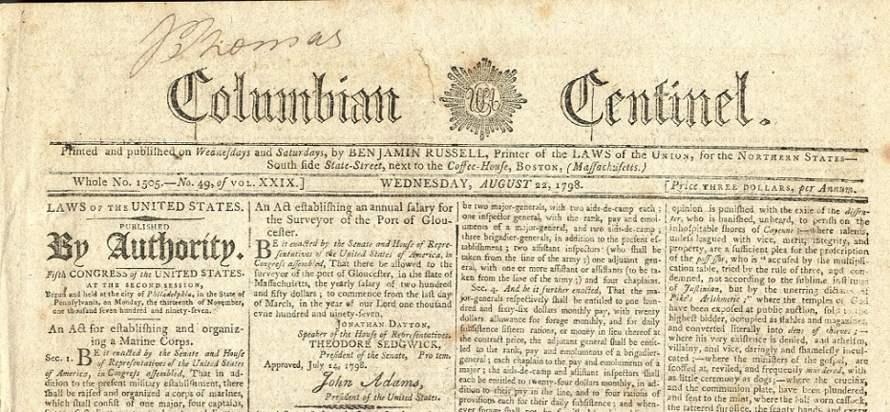

The Columbian Centinel was an American newspaper written by White people in Boston. They were members of the Federalist Party, which was against France. It wrote in support of Toussaint Louverture and the Revolution.

The rebellion in Haiti is similar to our own rebellion here in the United States (American Revolution). Toussaint would not come to the French until a White officer of equal rank would speak with him. He wants to be their equal. Great joy was diffused throughout Haiti when this happened. He is a hero. It would be good to see France defeated and Haiti be its own country.

ASSESSMENT: 4-17.E

Haitian Revolution: Exit Ticket

Inquiry Question: What type of revolution did Toussaint Louverture lead in Haiti?

Revolution (1): An uprising or revolt against a government. Revolution (2): A major change in ideas.

After looking at the above definitions of “revolution,” do you think Toussaint Louverture led an uprising or a major change in ideas. Explain if it was definition 1 or 2, and include three pieces of evidence from the sources.

LESSON PLAN 4-18: The History of Mexico

MATERIALS

Lined paper (not supplied)
Mexican History Dates (MATERIALS 4-18.A)
Mexican History Events (WORKSHEET 4-18.B)
Mexican History: Exit Ticket (ASSESSMENT 4-18.C)

STANDARDS

Massachusetts History and Social Science Framework

MA-HSS.4.23: On a map of North America, locate Mexico and its major cities. (G)

MA-HSS.4.24: Describe the climate, major physical characteristics, and major natural resources of Mexico and explain their relationship to the Mexican economy. (G)

MA-HSS.4.24: Identify when Mexico became an independent nation and describe how independence was achieved. (H, G)

Common Core: Literacy

CCSS.ELA-Literacy.RI.4.9: Integrate information from two texts on the same topic in order to write or speak about the subject knowledgeably.

CCSS.ELA-Literacy.RI.4.10: By the end of year, read and comprehend informational texts, including history/social studies, science, and technical texts, in the grades 4–5 text complexity band proficiently, with scaffolding as needed at the high end of the range.

CCSS.ELA-Literacy.W.4.8: Recall relevant information from experiences or gather relevant information from print and digital sources; take notes and categorize information, and provide a list of sources.

CCSS.ELA-Literacy.W.4.9: Draw evidence from literary or informational texts to support analysis, reflection, and research.

PROCEDURES

Inquiry Question: What was the most important event in Mexican history?

A. OPENER (15 minutes)

1. Event Sorting Activity
Put students into small groups. Students will be given seven different events from Mexican history: Maya Inventions, Aztec Empire Grows, Hernán Cortés Arrives, Father Manuel Hidalgo and the Independence Movement, Mexico Creates a Constitution, Mexican Revolution, and Mexico Hosts the Olympics (WORKSHEET 4-18.B). Be sure to scramble these events, so they are not in chronological order. These events will have descriptions and images, but no dates. Next, students will be given seven dates (years). Tell the students to put those dates in order from longest ago to most recent. Walk around the room and make sure the groups’ dates are in order. Tell students that today we will be looking at the history of Mexico. Your challenge is to try to put the events in order from longest ago to most recent and match the events to the dates. Circulate the room, helping the students who may have difficulty choosing one asset.

After 10 minutes, take another set of dates and post them on the board or wall. Next, reveal the correct events that go with each date. As you reveal each event, have a student volunteer to read the caption. Next, have students write the date on each source. The dates should be: 250-Maya Inventions, 1325-Aztec Empire Grows, 1519-Hernán Cortés Arrives, 1810-Father Manuel Hidalgo and the Independence Movement, 1857-Mexico Creates a Constitution, 1910-Mexican Revolution, and 1968-Mexico Hosts the Olympics. Tell students that today, your goal will be to decide which of these events was most important in the creation of a Mexican nation.

B. DEVELOPMENT (20 minutes)

2. Examine Sources As a Group
In their groups, ask the students to read aloud (using choral, partner, or independent reading) the seven documents: Maya Inventions, Aztec Empire Grows, Hernán Cortés Arrives, Father Manuel Hidalgo and the Independence Movement, Mexico Creates a Constitution, Mexican Revolution, and Mexico Hosts the Olympics (WORKSHEET 4-18.B). Have one student from each group read their source. As the student reads, tell the other group members to underline or highlight any important information.

3. Discuss the Events that Are Most Important
Handout lined paper. Tell students that after reading the sources, I would like you to talk with your group about which events you think are most important. As a group, students should decide what the top 3 most important events are. Students should then discuss which is the most important. Tell students to use the lined paper to write down reasons why that is the most important event.
After students have had 5-7 minutes to discuss, have students report out what their most important event is and why. On the board or chart paper, take notes on what the students say.

C. CLOSING (10 minutes)

4. Answer the Inquiry Question
For the evaluation task, have the students complete the exit ticket (ASSESSMENT 4-18.C), where they write their own personal response to the lesson’s Inquiry Question: “What was the most important event in Mexican history?” Tell students that they can also reference other events as less important. Tell students to cite at least three pieces of evidence from the sources and their group discussion.

Before using the exit ticket, consider using a graphic organizer or two column notes to prepare students for the writing task. Consider using sentence starters and modeling to help the students with their answer to the inquiry question.

EVALUATION

ASSESSMENT 4-18.C

What to look for?

The students should take a stance on which event in Mexican history was most important. All arguments should cite at least 3 pieces of evidence from the sources.

Students answers will vary based on which event they chose.

MATERIALS: 4-17.A
250

1325

1519

1810

1857

1910

1968

WORKSHEET: 4-17.B

Maya Inventions

The Maya people invent a calendar (see below), a writing system, art and music, and mathematics. They build tall pyramids and other buildings.

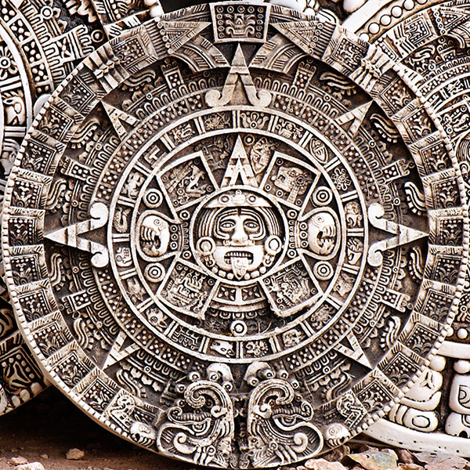

Aztec Empire Grows

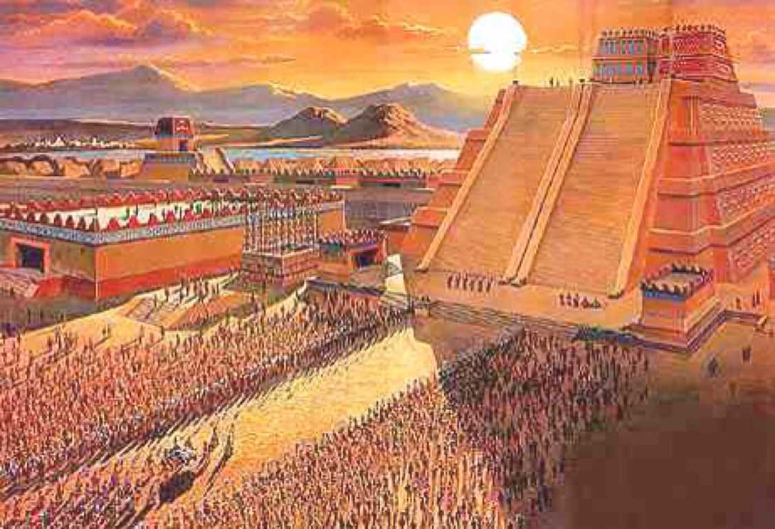

The Aztec Empire grows in size. They take over neighboring groups and create a large kingdom with an emperor. Montezuma II (below) would be their leader when the Spanish arrived.

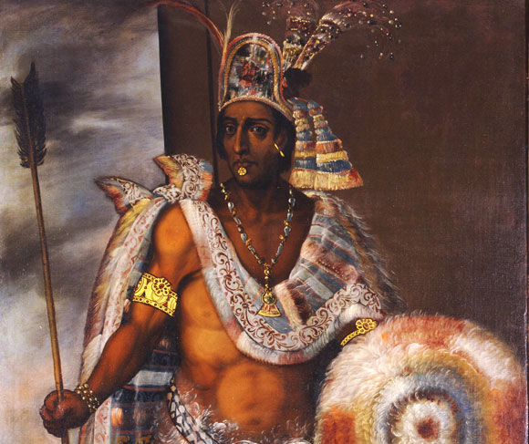

Hernán Cortés Arrives

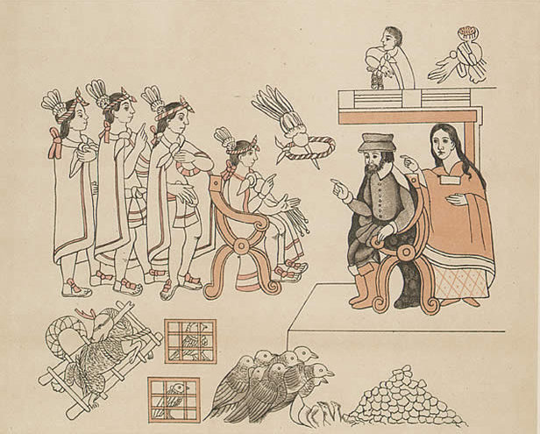

Hernán Cortés and his men are the first Spanish people to meet with the Aztecs (above). They will imprison Emperor Montezuma II and take control of Tenochtitlan (Mexico City) killing over 200,000 people (below). Mexico becomes part of Spain.

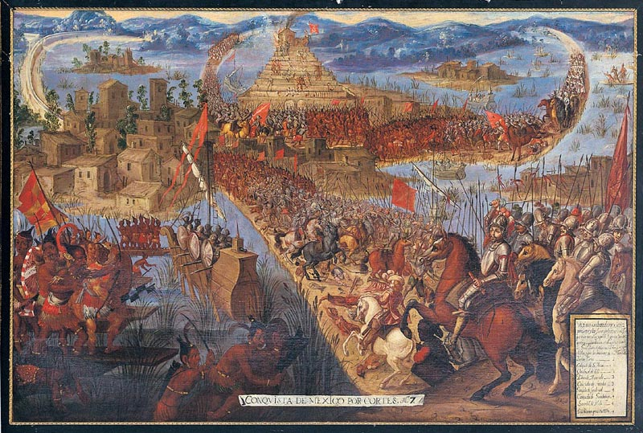
Father Manuel Hidalgo and the Independence Movement

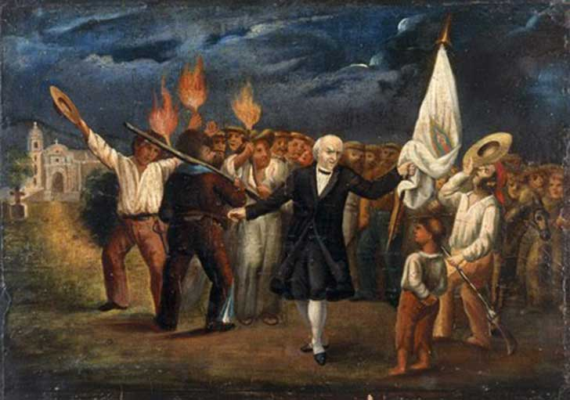

Father Manuel Hidalgo (above) declares Mexican independence from Spain on September 16th. After a decade of fighting, Mexico would be its own country (pictured below).

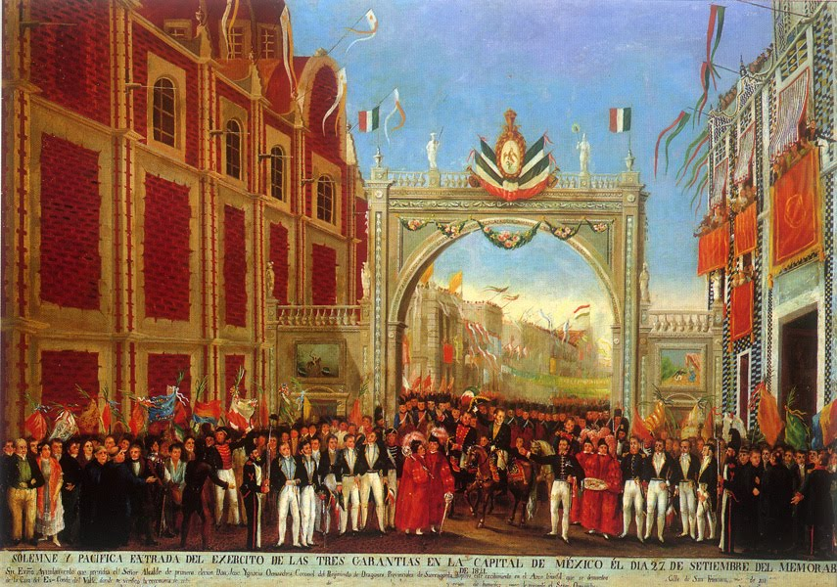
Mexico Creates a Constitution

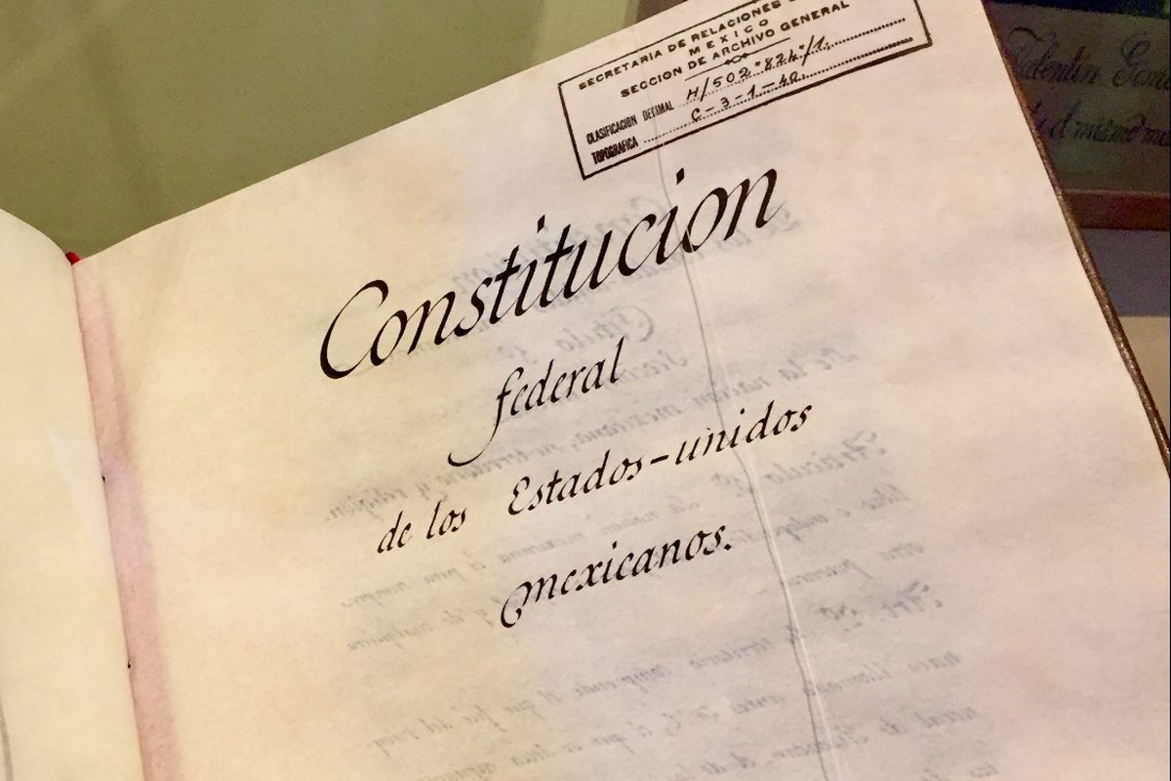

Mexico creates a Constitution (above) that explains how the government works. It also takes power away from the Catholic Church, says everyone has freedom of speech and other rights. Below is a painting about the Constitution.

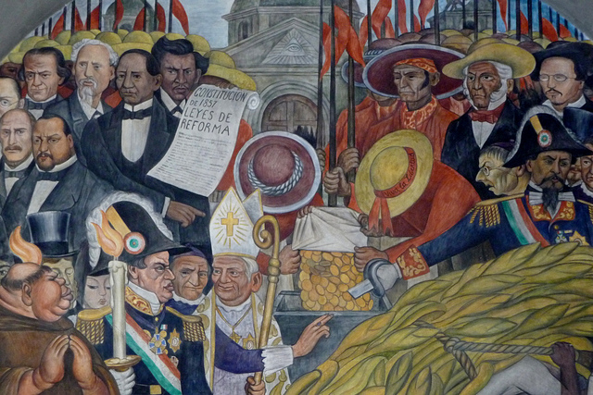
Mexican Revolution

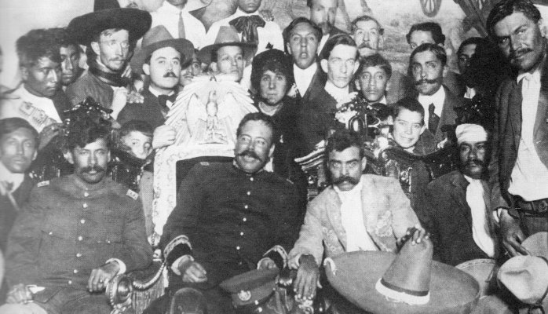

Emiliano Zapata (above front center left) and Pancho Villa (above front center right) lead the Mexican Revolution. It demands that Mexico become a democracy (leaders chosen by the people), get rid of the military dictator have more rights for workers and farmers.

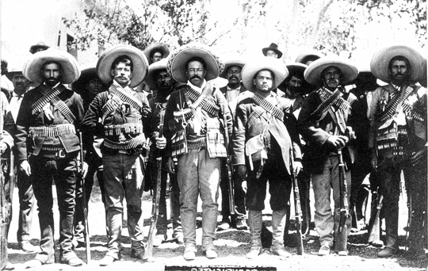
Mexico Hosts Olympics

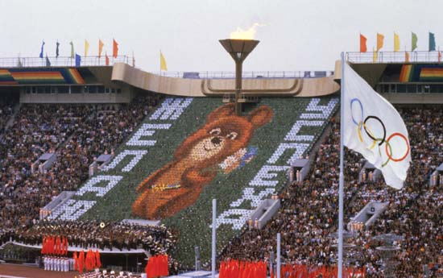

Mexico City hosts the Olympics, where most of the world’s nations compete in sporting events, such as track and field, basketball, soccer, swimming, and marathon.


ASSESSMENT: 4-18.C

Mexican History: Exit Ticket

Inquiry Question: What was the most important event in Mexican history?

After reading the sources, decide what event was most important in creating the nation of Mexico. Include three pieces of evidence from the sources.

LESSON PLAN 4-19: Road Trip: Mexico

MATERIALS

Kids Visit Mexico Video (Lesson4-19Video1) [Located in the UOW Video Library: www.christophercmartell.com/understandingourworld]
Places in Mexico Notes (WORKSHEET 4-19.A)
Source 1: Mexico City (WORKSHEET 4-19.B)
Source 2: Baja California (WORKSHEET 4-19.C)
Source 3: Yucatán Peninsula (WORKSHEET 4-19.D)
Source 4: Chihuahua (WORKSHEET 4-19.E)
Road Trip, Mexico: Exit Ticket (ASSESSMENT 4-19.F)

STANDARDS

Massachusetts History and Social Science Framework

MA-HSS.4.23: On a map of North America, locate Mexico and its major cities. (G)

MA-HSS.4.24: Describe the climate, major physical characteristics, and major natural resources of Mexico and explain their relationship to the Mexican economy. (G)

MA-HSS.4.25: Identify the language, major religion, and peoples of Mexico. (H)

Common Core: Literacy

CCSS.ELA-Literacy.RI.4.9: Integrate information from two texts on the same topic in order to write or speak about the subject knowledgeably.

CCSS.ELA-Literacy.RI.4.10: By the end of year, read and comprehend informational texts, including history/social studies, science, and technical texts, in the grades 4–5 text complexity band proficiently, with scaffolding as needed at the high end of the range.

CCSS.ELA-Literacy.W.4.8: Recall relevant information from experiences or gather relevant information from print and digital sources; take notes and categorize information, and provide a list of sources.

CCSS.ELA-Literacy.W.4.9: Draw evidence from literary or informational texts to support analysis, reflection, and research.

PROCEDURES

Inquiry Question: If you were to visit Mexico, what part would you travel to?

A. OPENER (15 minutes)

1. Watch the Kids Visit Mexico Video
Show the students a short video about two kids who travel to a town in Mexico (Lesson4-19Video1). During the video, stop it and highlight/ask questions about how a town in Mexico is similar and different to a town in the United States. After watching the video, ask the students to list ways that the town in Mexico was similar and different to a town in the United States. List their ideas on the board or chart paper within two columns: “similar” and “different.” Anticipated student responses may include: they have playgrounds, they eat tamales, they use piñatas, they have stores, they have beaches, they have restaurants (the column that these are listed in with vary based on your community).

Tell students that today, we are going to take a road trip around Mexico, just like the kids in the video. You will get to know a little bit about four different places in Mexico and you will have to decide, if you could only go to one place in Mexico, where would it be.

B. DEVELOPMENT (20 minutes)

2. Engage in a Carousel Activity on Places in Mexico
Give each student pencil and clipboard with the Places in Mexico Notes (WORKSHEET 4-19.A) on it. Ask students to go to each of the four stations (4-19.B, 4-19.C, 4-19.D, 4-19.E). At each station, the students should take notes on the arguments about how many continents there are. Everyone time that you have students switch, you should ask them to get back in the car and drive to the next place (to make these seem more like a road trip).

Once students have gone to each of the four stations, they should return to their seats. Put students in small groups. Have them look at their note sheets and discuss which place in Mexico they would most like to visit and why.

C. CLOSING (10 minutes)

3. Answer the Inquiry Question
For the evaluation task, have the students complete the exit ticket (ASSESSMENT 4-19.F), where they write their own personal response to the lesson’s Inquiry Question: “If you were to visit Mexico, what part would you travel to?” Tell students to cite at least three pieces of evidence from the sources. You may want to encourage students to get up and look at the information at a particular station, if it will help them answer the inquiry question.

Before using the exit ticket, consider using a graphic organizer or two column notes to prepare students for the writing task. Consider using sentence starters and modeling to help the students with their answer to the inquiry question.

EVALUATION

ASSESSMENT 4-19.F

What to look for?

The students should take a stance on the place in Mexico that they would most like to visit. All arguments should cite at least 3 pieces of evidence from the sources.

Some information that students may include in their answer to the question:

Mexico City
- Large city with many people
- Many attractions (universities, museums, concert halls, cathedrals)
- Shopping
- Public transportation
- Aztec old city at Teotihuacán

Baja California
- Visit Tijuana (on San Diego border)
- Dancing and music at clubs
- Food and restaurants
- Oceanside resorts and beaches

Yucatán Peninsula
- Natural areas on land and in the water
- Swimming and snorkeling
- Cenote Samulá sinkhole
- Seeing turtles

Chihuahua
- Visit a desert
- See interesting plants and animals: cactus, shrubs, grasses, rattlesnakes, hawks, coyote, gray wolves, roadrunners, rabbits, and lizards
- Go hiking or mountain biking
- See the place with the same name as the small dog

WORKSHEET: 4-19.A

Places in Mexico Notes

Source 1: Mexico City

Source 2: Baja California

Source 3: Yucatán Peninsula

Source 4: Chihuahua

WORKSHEET: 4-19.B

Source 1: Mexico City

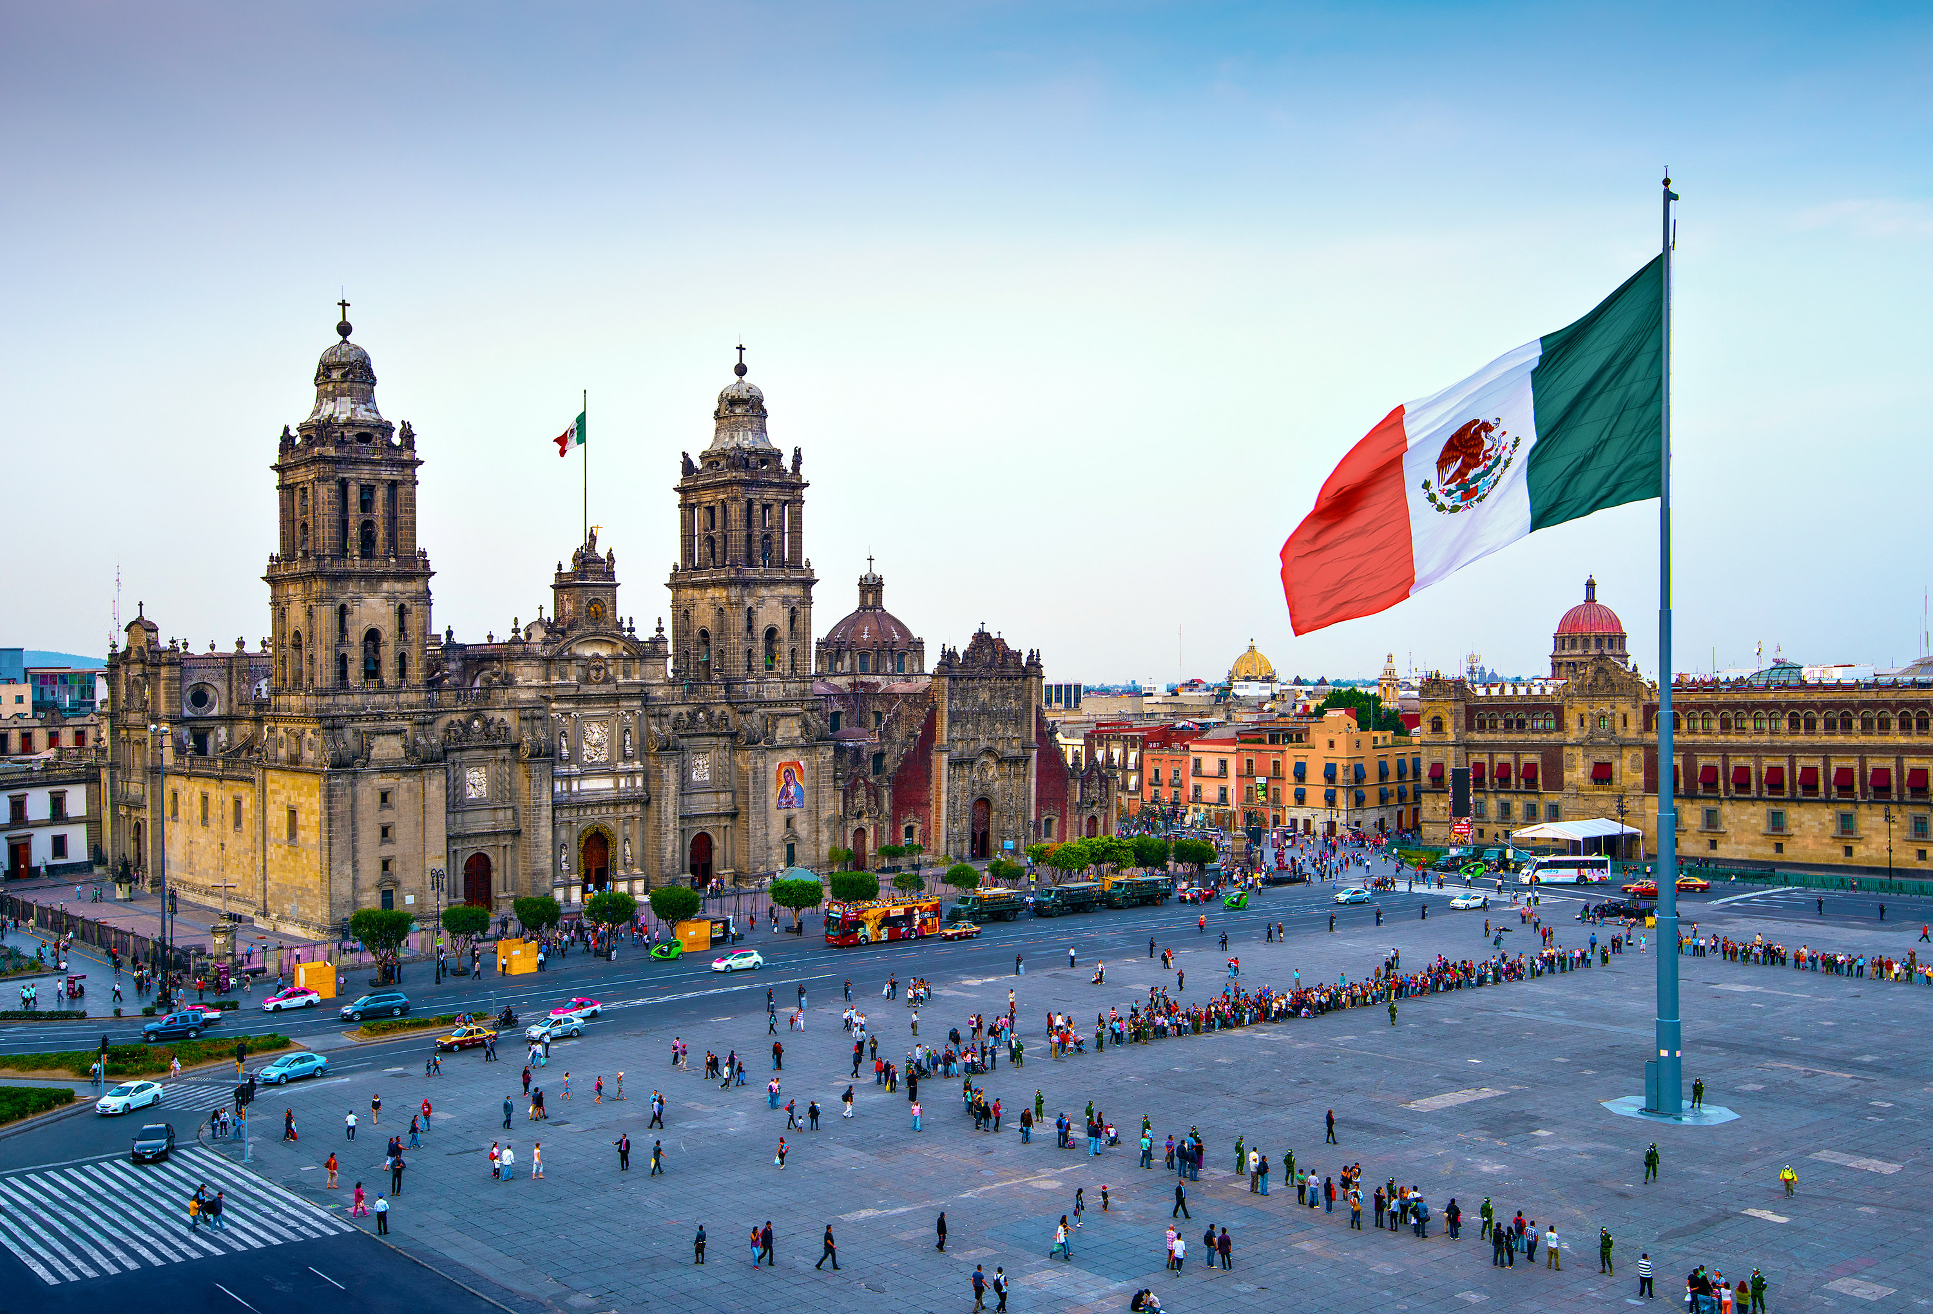
Mexico City is home to 8.5 million people (it has about as many people as New York City). It is the capital city (center of government) and center of business in Mexico. It was founded by the Aztecs and today you can still visit their old city Teotihuacán (other page). It has many universities, museums, and concert halls. Above is the Cathedral of the Assumption, which is the main Catholic Church. There is a lot of shopping in Mexico City, with all of the major companies having stores there. Traffic can be pretty bad during rush hour, but you can take their subway system, which has 195 stations. If you like big cities, art and music, and historic sites, then Mexico City is for you.
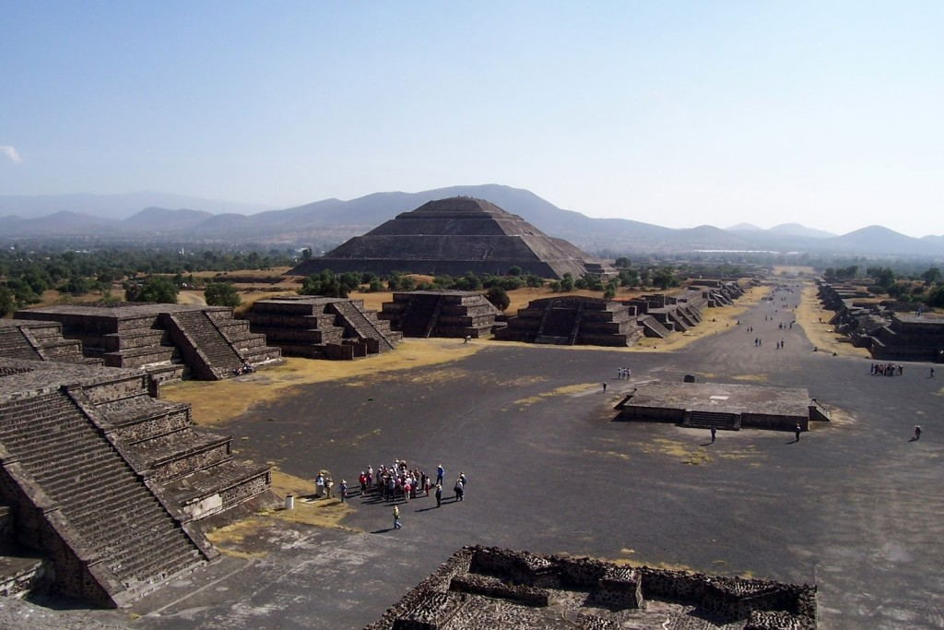

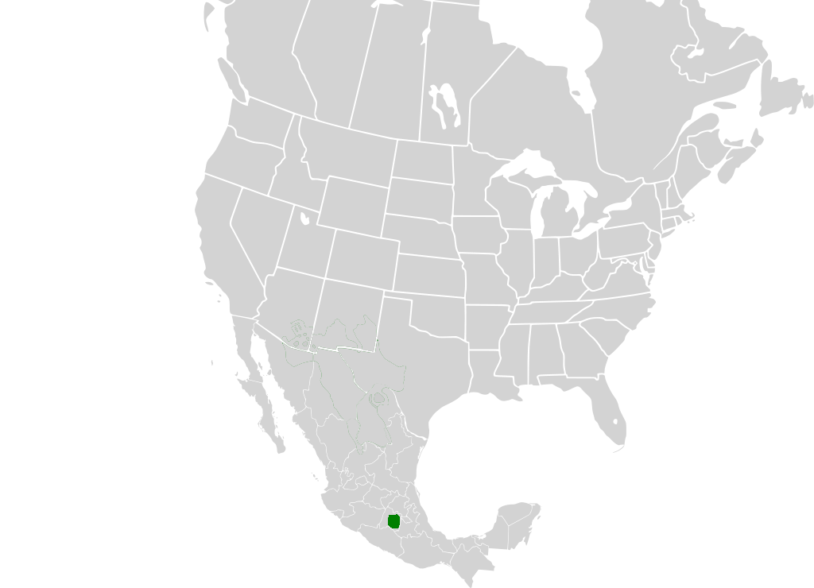
WORKSHEET: 4-19.C

Source 2: Baja California

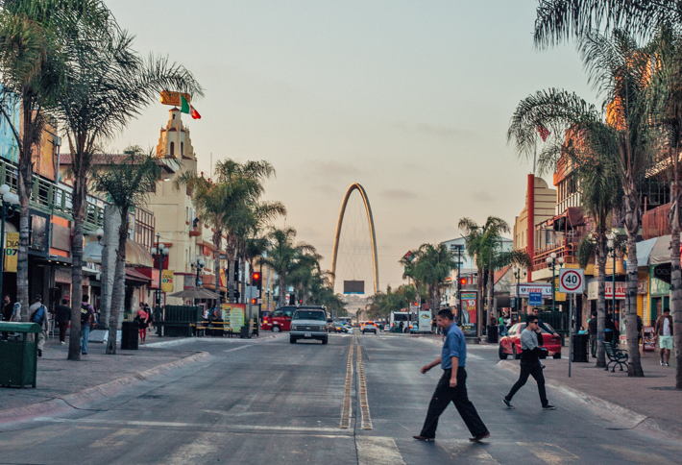
Baja (ba-ha) California is a peninsula in the Pacific Ocean just south of San Diego in the United States. Its largest city is Tijuana (above), which is a popular destination for tourists. You can actually walk across the border of the United States into Tijuana and enjoy Mexican food and dancing at the many restaurants and clubs. South of Tijuana are many oceanside resorts (other page). Baja California is known for its beautiful beaches. It is also a desert, so it is very warm and dry for most of the year. If you like eating, dancing, and going to the beach, then Baja California is for you.
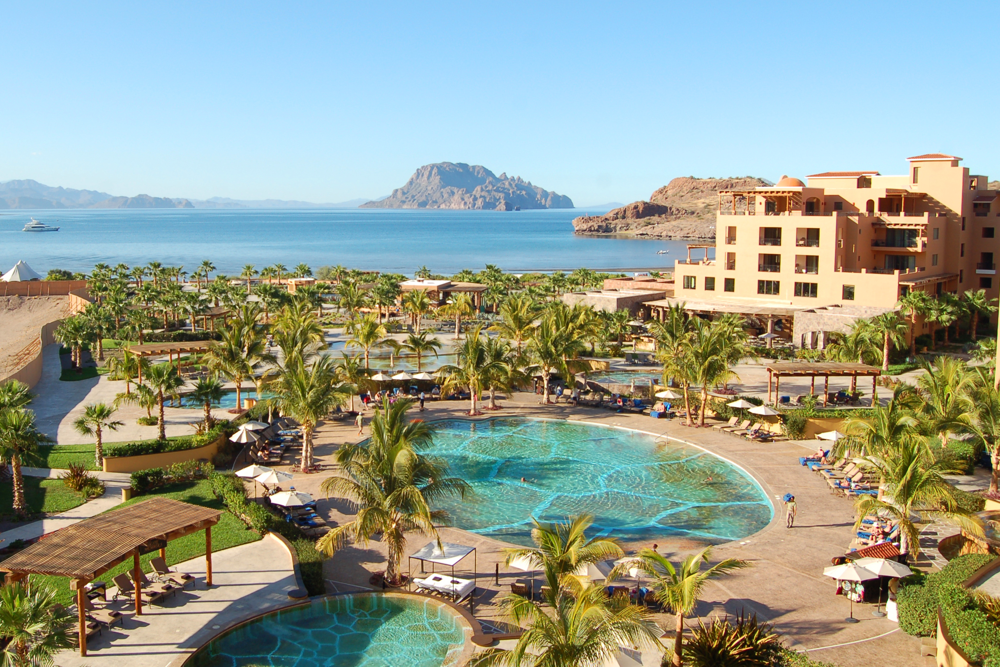

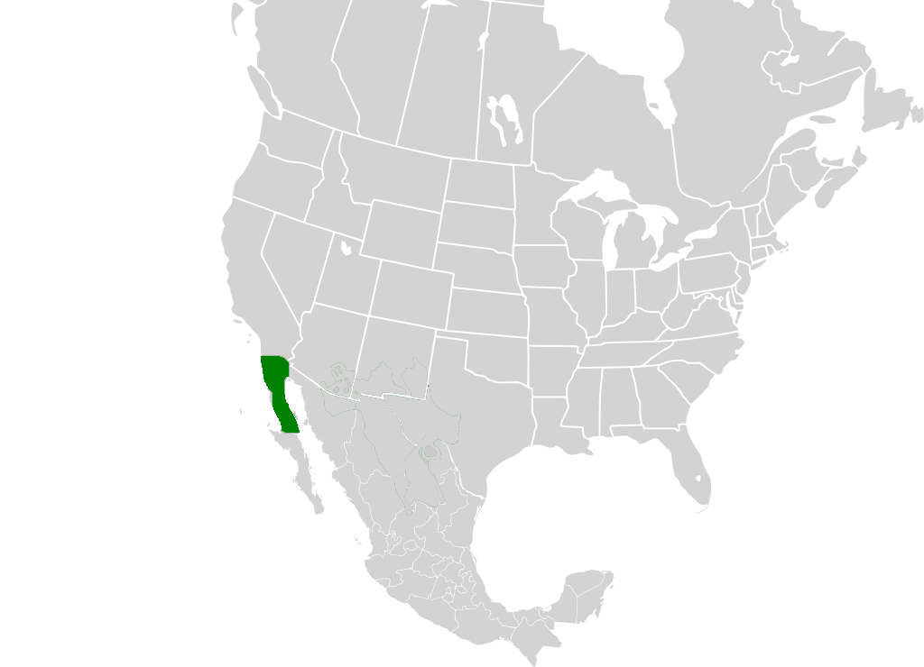
WORKSHEET: 4-19.D

Source 3: Yucatán Peninsula

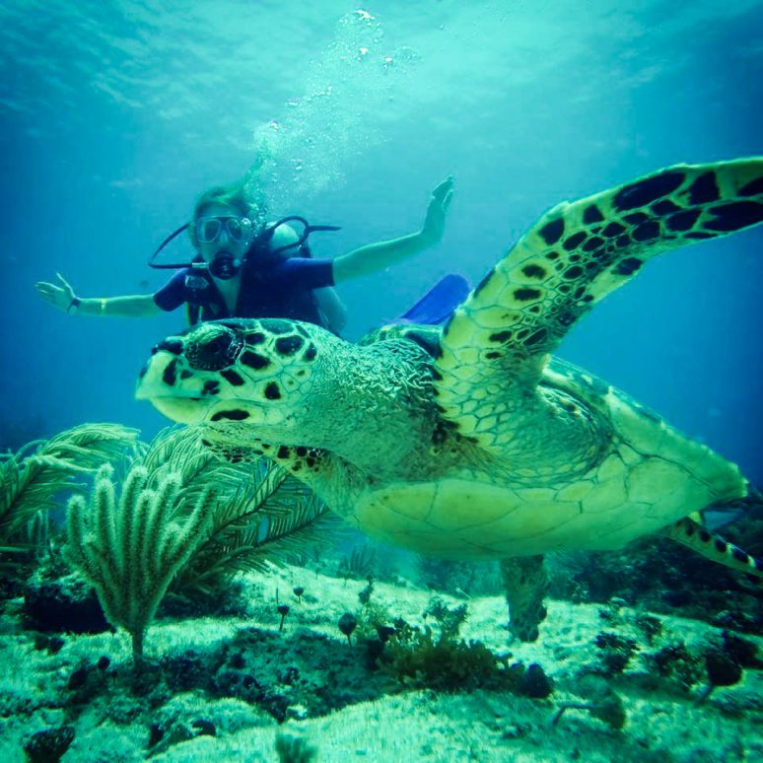
The Yucatán (yu-ca-tawn) Peninsula separated the Caribbean Sea from the Gulf of Mexico. It was at the center of Maya Empire and today there are many Maya temples and buildings still standing. It is known for its amazing natural beauty on land and in the water. It is home to many animals, including the above picture of someone swimming with sea turtles. There is also a famous Yucatán sinkhole called Cenote Samulá (other page), where people can go swimming inside this naturally made cave pool. If you like watching animals, walking in nature, swimming, and snorkeling then the Yucatán Peninsula is for you.

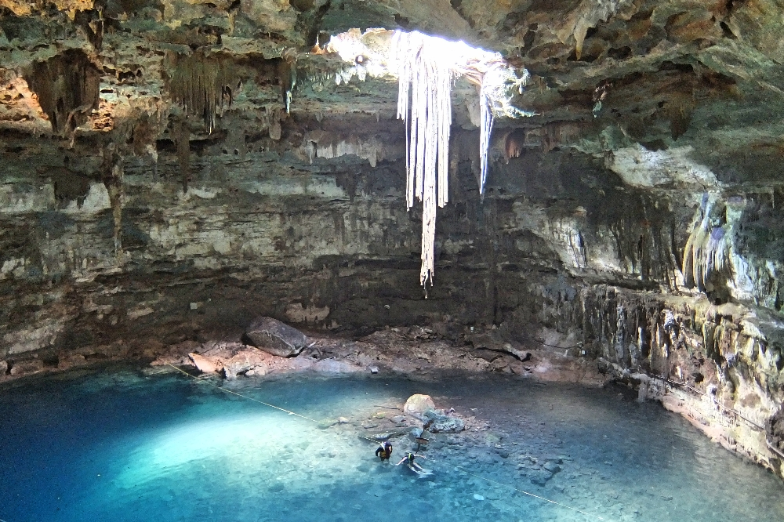

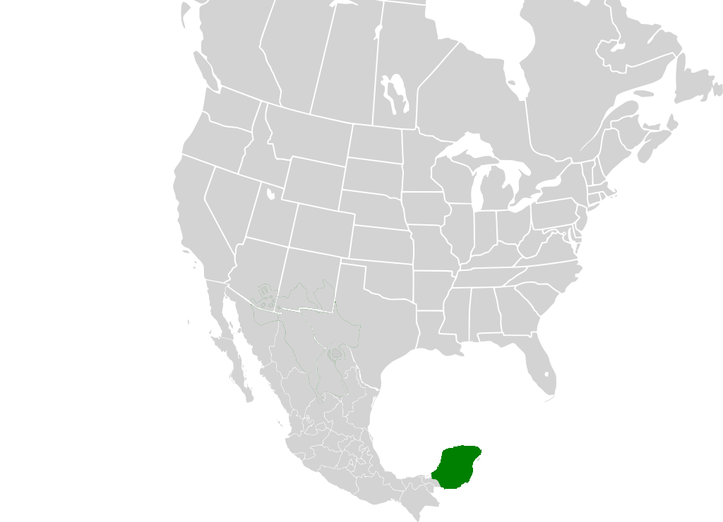
WORKSHEET: 4-19.E

Source 4: Chihuahua

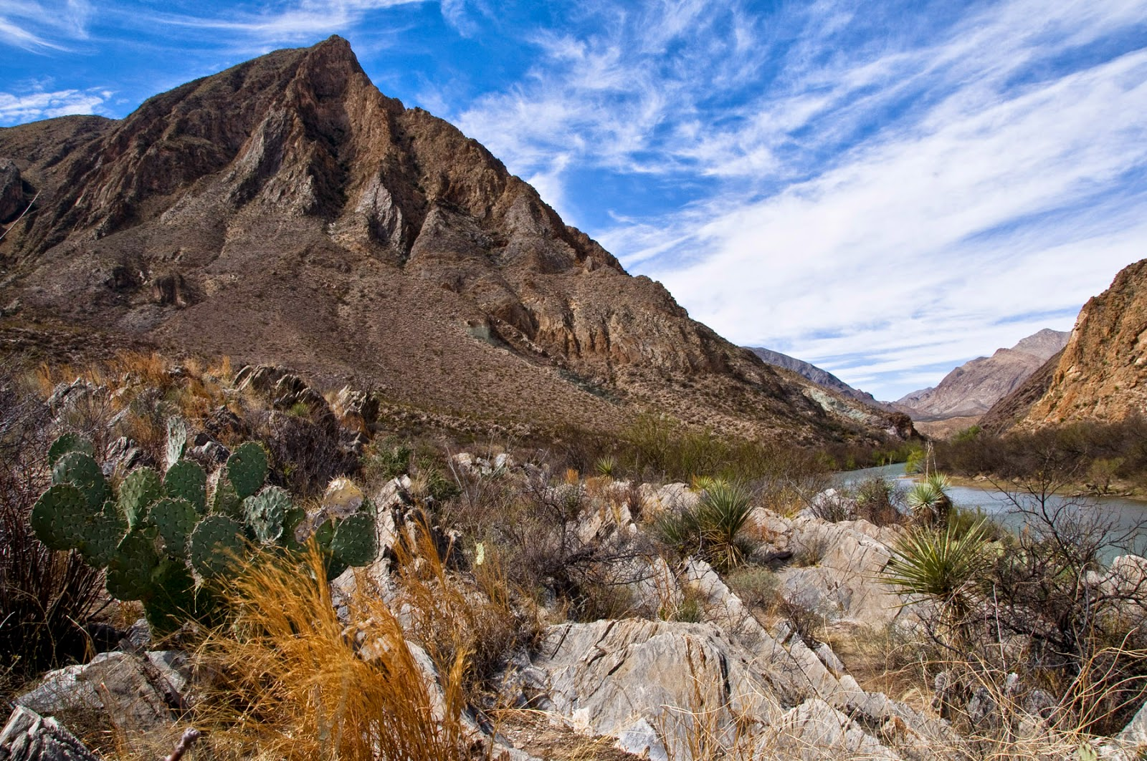
Chihuahua (cha-wa-wa) is home to the Chihuahuan Desert (which actually is in both Mexico and the United States). The Chihuahuan Desert is the largest desert in North America. It is home to many different types of plants and animals, including cactus, shrubs, grasses, as well as rattlesnakes, hawks, coyote, gray wolves, roadrunners, rabbits, and lizards. And yes, the small dog called a Chihuahua is named after here (scientists think it may have originated in Mexico), but it does not live in the desert. Many people like to hike and mountain bike in the Chihuahuan Desert (other page). If you want to visit a desert and see its wildlife, or go mountain biking or hiking, then Chihuahua is for you.
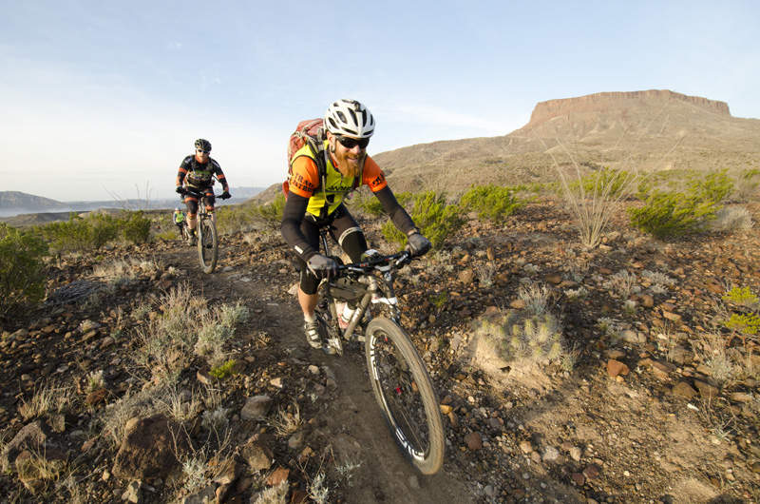

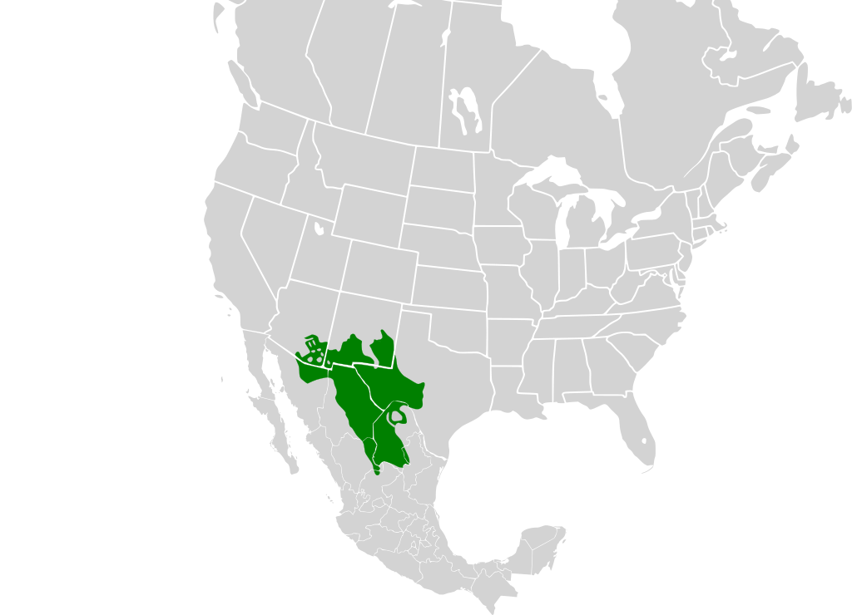

ASSESSMENT: 4-19.F

Mexico, Road Trip: Exit Ticket

Inquiry Question: If you were to visit Mexico, what part would you travel to?

After looking at the places in Mexico that we studied today on our road trip, which place would you most want to visit? Include three pieces of evidence from the sources.

LESSON PLAN 4-20: The History of Canada

MATERIALS

Lined paper (not supplied)
Heritage Minute: Jacques Cartier (Lesson4-20Video1) [Located in the UOW Video Library: www.christophercmartell.com/understandingourworld]
Heritage Minute: Sir John Macdonald and the Confederation (Lesson4-20Video2) [Located in the UOW Video Library: www.christophercmartell.com/understandingourworld]
Heritage Minute: Halifax Explosion (Lesson4-20Video2) [Located in the UOW Video Library: www.christophercmartell.com/understandingourworld]
Canadian History Timeline (WORKSHEET 4-20.A)
Source 1: Indigenous Canadians (WORKSHEET 4-20.B)
Source 2: French Canadians (WORKSHEET 4-20.C)
Source 3: Anglo Canadians (WORKSHEET 4-20.D)
Source 4: Black Canadians (WORKSHEET 4-20.E)
Source 5: Asian Canadians (WORKSHEET 4-20.F)
Canadian History: Exit Ticket (ASSESSMENT 4-20.G)

STANDARDS

Massachusetts History and Social Science Framework

MA-HSS.4.19: Describe the major ethnic and religious groups of modern Canada. (G, H, C, E)

MA-HSS.4.20: Identify when Canada became an independent nation and explain how independence was achieved. (H, G)

Common Core: Literacy

CCSS.ELA-Literacy.RI.4.9: Integrate information from two texts on the same topic in order to write or speak about the subject knowledgeably.

CCSS.ELA-Literacy.RI.4.10: By the end of year, read and comprehend informational texts, including history/social studies, science, and technical texts, in the grades 4–5 text complexity band proficiently, with scaffolding as needed at the high end of the range.

CCSS.ELA-Literacy.W.4.8: Recall relevant information from experiences or gather relevant information from print and digital sources; take notes and categorize information, and provide a list of sources.

CCSS.ELA-Literacy.W.4.9: Draw evidence from literary or informational texts to support analysis, reflection, and research.

PROCEDURES

Inquiry Question: What was the most important event in Canadian history?

A. OPENER (15 minutes)

1. Watch Heritage Minute: Jacques Cartier Video
Tell the students that we are going to watch three short clips about Canadian history. Show the students a short video describing the first group of French people to arrive in Canada (Lesson4-20Video1). You should pause and read to the students the subtitles of the Iroquoian language. After watching the video, ask the students, “What happened in the video?” “What did the Indigenous people say?” “What did the French people say?” “What does this tell you about the relationship between the two groups?” “Who were the first people to live in Canada?” Anticipated responses may include: The French people (Jacques Cartier) came and were the first people to meet the Iroquois (Indigenous/Native), the French people misunderstood the Iroquois word for village (kanata) as their country, the French named the place Canada. Tell the students that the Indigenous people, which Canadians call the First Nations, were the first people to live in Canada. The first Europeans to come to Canada were the Vikings, who briefly lived on the Atlantic Ocean coast, but then left. Next came the French, led by a man named Jacques Cartier (jzahk car-te-ay).

2. Watch Heritage Minute: John Macdonald and Confederation Video
Show the students a short video describing how John Macdonald united all of the British colonies of Canada into one nation on July 1, 1867 (Lesson4-20Video2). John Macdonald is worried the Maritimes (New Brunswick, Nova Scotia, and Prince Edward Island) will not join. After watching the video, ask the students, “What were the concerns of the people who first united Canada?” “How did John Macdonald unite the colonies?” Anticipated responses may include: They felt the colonies were isolated and weak, they were worried about the American Civil War, he bought them champagne, they made one united Canada, John Macdonald became the first prime minister of Canada. Tell the students that unlike the United States, Canada did not become a country because of a war. Instead, it was a peaceful uniting of the colonies into one “Dominion of Canada.” This took a lot of work. He had to convince the French people in Lower Canada (Québec) that they could keep their Catholic religion and speak French if they joined English and Protestant Upper Canada (Ontario). He had to convince the people in the Maritimes that they would be unfairly used for their shipping and fishing resources. In the end, all of the colonies would join together.

3. Watch Heritage Minute: Halifax Explosion Video
Show the students a short video describing the Halifax Explosion of December 6, 1917 (Lesson4-20Video3). A ship was carrying weapons going to Europe for World War I exploded when another ship ran into it. After watching the video, ask the students, “What happened in the video?” “Why did so many die and get hurt?” Anticipated responses may include: The ship was carrying weapons, many people were near the shore, they didn’t get the word fast enough to get away. Tell the students that 2,000 people were killed and 9,000 people were injured in the explosion. Much of the city of Halifax, Nova Scotia was destroyed in the blast. Since Boston is the closest city to Halifax, the people there sent many supplies and workers to help the people there. Since it was around Christmas time, to this day, Nova Scotia sends Boston Christmas trees for Boston Common and elsewhere to say thank you for your help.

B. DEVELOPMENT (20 minutes)

4. Read About the Different Events in Canadian History from Different Perspectives
Put students in small groups and assign them one of five groups: Indigenous Canadians/First Nations (WORKSHEET 4-20.B), French Canadians (WORKSHEET 4-20.C), Anglo Canadians (WORKSHEET 4-20.D), Black Canadians (WORKSHEET 4-20.E), Asian Canadians (WORKSHEET 4-20.F). Have students take turns reading aloud (using choral, partner, or independent reading) the sources to their group. As the student reads, tell the other group members to underline or highlight any important information.

5. Whole Class Discussion About Canadian History
Pass out the Canada History Timeline (WORKSHEET 4-20.A). Project the chart found on the timeline worksheet’s last page. Take notes on what each group says about each event on the projected chart. Tell students to fill in notes on their chart, as each group speaks.

Write the definition for benefit and disadvantage on the board or chart paper. Benefit: To gain from something. Disadvantage: To lose from something.

Start with the first event on the timeline. Read the description of each event. When you get to the first gray highlighted event (1541: Jacques Cartier explores the St. Lawrence River), ask students to say what their position is on that event: do they support it, oppose it, or something else? Next, ask students which groups will benefit and which groups will be disadvantaged from the events.

Repeat the same steps for the other gray highlighted events: 1763: Britain takes over Canada, 1837-38: Patriote movement and rebellion, 1867 Dominion of Canada, December 6, 1917: Halifax Explosion, 1982: Canada Act/Constitution.

Ask students to use the sources and the timeline chart to answer the following inquiry question: “What was the most important event in Canadian history?” In answering this question, students should be thinking about all of the different groups in Canada: Indigenous people, Anglo Canadians, French Canadians, Black Canadians, and Asian Canadians. After students have discussed the question, they should complete the exit ticket in the following step. They do not need to answer the question from their assigned role; instead, they should be encouraged to consider all of the different groups in Canada when choosing the most important event. Circulate the room, helping the students who may need extra help.

C. CLOSING (10 minutes)

6. Answer the Inquiry Question
For the evaluation task, have the students complete the exit ticket (ASSESSMENT 4-20.G), where they write their own personal response to the lesson’s Inquiry Question: “What was the most important event in Canadian history?” Tell students to cite at least three pieces of evidence from the sources and their group discussion.

Before using the exit ticket, consider using a graphic organizer or two column notes to prepare students for the writing task. Consider using sentence starters and modeling to help the students with their answer to the inquiry question.

EVALUATION

ASSESSMENT 4-20.G

What to look for?

The students should take a stance on which event in Canadian history was most important. All arguments should cite at least 3 pieces of evidence from the sources.

Some information that students may include in their answer to the question:

1541: Jacques Cartier explores the St. Lawrence River
- It was the first major interaction between Indigenous people and Europeans
- It is where the name Canada comes from
- It was the beginning of the European’s mistreatment of the Indigenous people
- It marked the beginning of New France

1763: Britain takes over Canada
- It is a change of power between the French and British
- It began Canada as an English-speaking country
- It was the beginning of the Anglo Canadian’s mistreatment of the French Canadians

1837-38: Patriote movement and rebellion
- It almost resulted in a civil war between French and Anglo Canadians, but was prevented
- It led to come reforms that helped unite Canada

1867 Dominion of Canada
- It was the official beginning of Canada as an independent country
- It was not a result of a war
- It united all of Canada
- John Macdonald was elected the first prime minister
- Some groups did not support the confederation

December 6, 1917: Halifax Explosion
- Worst man-made disaster in Canadian history with 2,000 people killed and 9,000 people injured
- Many people came together to help Halifax, including Boston and Québec
- The deaths of Indigenous and Black Canadians are often forgotten

1982: Canada Act/Constitution
- It made Canada completely independent from Britain
- It protected the rights of all Canadians, including democracy, speech, press, protest, and religion
- It protected the rights of Indigenous people

WORKSHEET: 4-20.A

Canadian History Timeline

Below are some of the important events in Canadian history. We will specifically discuss the events that are highlighted in gray.

8000 BCE: Indigenous people first settle in Canada.

1000: Vikings arrive in Newfoundland (500 years before Columbus), briefly settled there and left after a short time to explore other places.

1541: Jacques Cartier explores the St. Lawrence River and makes contact with the St. Lawrence Iroquois people.

1608: Samuel de Champlain founds Québec and French people begin settling along the St. Lawrence River.

1763: France would fight Britain in Canada (1754-1763) during what was called the War of Conquest (by Canadians) or French and Indian War (by Americans). In the end, Britain would take control of Canada.

1775: During the American Revolution, the United States would invade Canada and try to take it over. Britain’s army would stop the invasion.

1812: During the War of 1812, the United States would invade Canada and try to take it over. Britain’s army would stop the invasion.

1837-38: French Canadians would rebel against the British government as part of the Patriote movement, which demanded equal rights to Anglo Canadians.

1867: The Canadian colonies unite under the Confederation of Canada, becoming one nation, and electing John Macdonald prime minister.

December 6, 1917: A ship ran into another ship carrying explosives for the war. 2,000 people died and 9,000 were injured during the Halifax Explosion. It was the largest man-made disaster in Canadian history. It was part of the First World War, where many Canadian soldiers fought and died in Europe.

1930s: During the Depression, 1 in 5 Canadians had no jobs and many people were hungry. The Canadian government would create relief programs to help the people.

1939: Canada sends soldiers to Europe (and later Asia) to fight in the Second World War. One million Canadians would serve.

1982: Canada Act: Canada gained its full independence from Britain by creating its own constitution. This included the Charter of Rights and Freedom, which guarantees all citizens the rights to democracy, speech, press, protest, and religion.

 | 1541 | 1763 | 1837-38 | 1867 | 1917 | 1982
Indigenous People
French Canadians
Anglo Canadians
Black Canadians
Asian Canadians
WORKSHEET: 4-20.B

Indigenous People
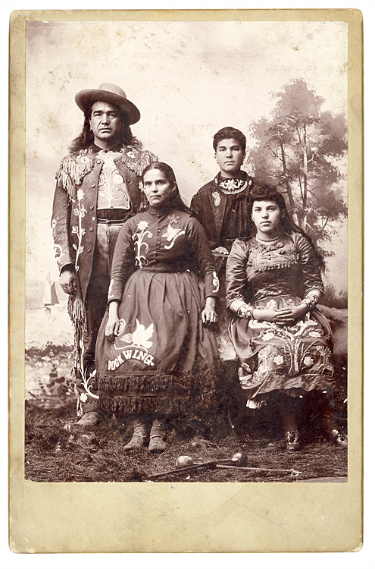
The Indigenous people are the first people of Canada, who settled there over 10,000 years ago. Many call their homeland Turtle Island. Since the arrival of Europeans to Canada, they have been treated unfairly. They often had their land taken by Whites, forced to speak English, convert to Christianity, and dress like Whites.

1541: Jacques Cartier explores the St. Lawrence River.

You oppose this. Jacques Cartier puts up a large wooden cross and declares this land for France and Christianity. He also kidnaps Chief Donnacona’s (do-na-co-na) two sons and brings them back to France. This is wrong and shows that the French do not respect your land or people.

1763: France would fight Britain and take control of Canada.

You oppose the British claiming they own Canada. You support the British government no longer allowing White Canadians to take land from the Indigenous people.

1837-38: French Canadians would rebel against the British government as part of the Patriote movement.

You have no position. No matter if the French or English Canadians are in power, you are not treated as their equals.

1867: The Confederation of Canada is formed and John Macdonald becomes prime minister.

You have no position on the Confederation. The Anglos Canadians are not even mentioning you in their discussions.

December 6, 1917: Halifax Explosion: A ship ran into another ship carrying explosives for the war and many people died.

You want to remind everyone that a Mi'kmaw (mic-ma) village was destroyed by the explosion and at least 30 Indigenous people were killed. They were largely forgotten in news reports.

1982: Canada gained its full independence from Britain by creating its own constitution. This included the Charter of Rights and Freedom, which guarantees all citizens the rights to religion, speech, and religion.

You support the new Constitution, because it specifically states the rights of Indigenous people.
WORKSHEET: 4-20.C

French Canadians
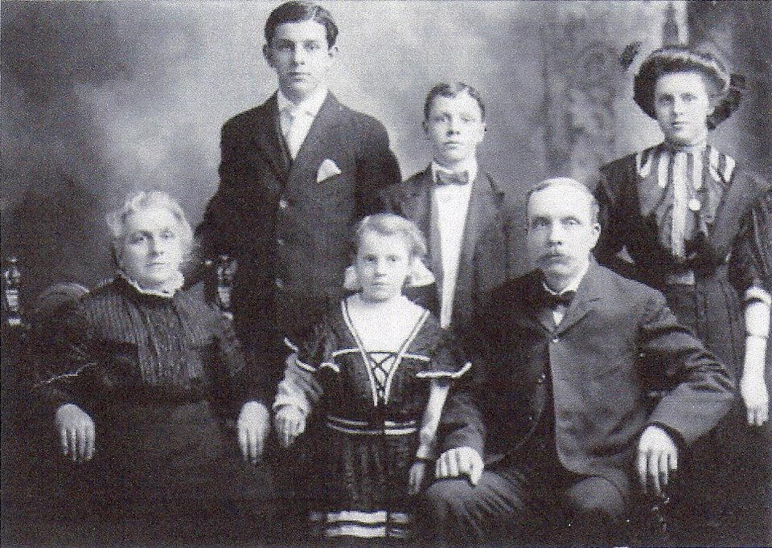
French Canadians first settled in Canada in the 1600s. The first French people to come to Canada were soldiers and farmers. In the 1500s and 1600s, France ruled over Canada. After Britain takes over Canada in 1763, French people were not treated equally.

1541: Jacques Cartier explores the St. Lawrence River.

You support this. Jacques Cartier opens Canada to the settlement of French people. By the 1660s, thousands of French people are settling along the St. Lawrence River, calling it Canada, which is part of a larger territory called New France.

1763: France would fight Britain and take control of Canada.

You oppose the British claiming they own Canada. You worry that the French language and Catholic religion will be banned.

1837-38: French Canadians would rebel against the British government as part of the Patriote movement.

You support the Patriote movement. You want to be treated as equals to Anglo Canadians.

1867: The Confederation of Canada is formed and John Macdonald becomes prime minister.

One group supports it, because you are afraid the U.S. may invade Canada again (the Americans just ended the Civil War and may be looking to expand). Another group opposes it, because they believe the Anglo Canadians will not treat French Canadians as equals.

December 6, 1917: Halifax Explosion: A ship ran into another ship carrying explosives for the war and many people died.

You support the efforts to help the injured people in Halifax.

1982: Canada gained its full independence from Britain by creating its own constitution. This included the Charter of Rights and Freedom, which guarantees all citizens the rights to religion, speech, and religion.

You do not support the new Constitution, because it gives less power to Québec and French speakers.
WORKSHEET: 4-20.D

Anglo Canadians
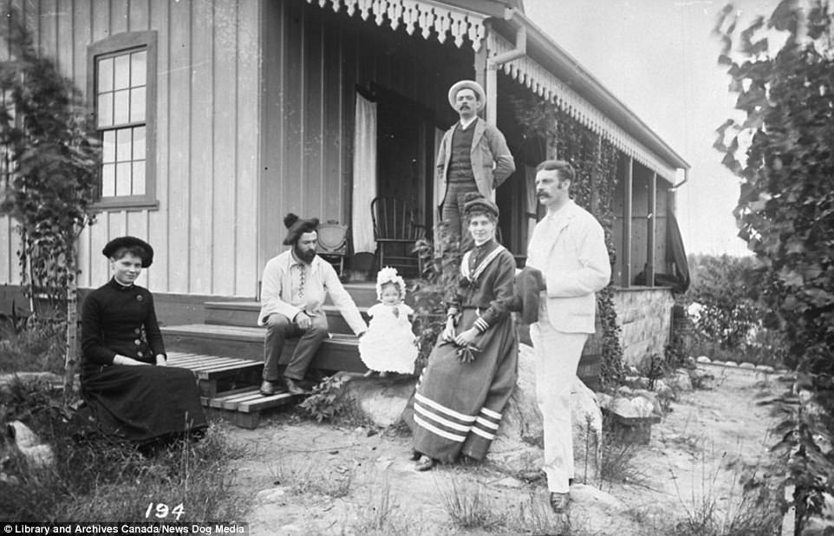
Anglos Canadians first settled in Atlantic fishing villages in Canada in the 1500s. The English, Scottish, and Irish people came in much larger numbers after 1763, when Canada became part of Britain. After that, Anglo Canadians had the most power in government and business.

1541: Jacques Cartier explores the St. Lawrence River.

You have no position. There are very few Anglo Canadians at this point.

1763: France would fight Britain and take control of Canada.

You support the British claiming they own Canada. You want Canada to be part of the British empire.

1837-38: French Canadians would rebel against the British government as part of the Patriote movement.

You oppose the Patriote movement. You worry this could turn into a civil war between Anglo and French Canadians.

1867: The Confederation of Canada is formed and John Macdonald becomes prime minister.

You support it, because you are afraid the U.S. may invade Canada again (the Americans just ended the Civil War and may be looking to expand).

December 6, 1917: Halifax Explosion: A ship ran into another ship carrying explosives for the war and many people died.

You support the efforts to help the injured people in Halifax.

1982: Canada gained its full independence from Britain by creating its own constitution. This included the Charter of Rights and Freedom, which guarantees all citizens the rights to religion, speech, and religion.

You support the new Constitution, because it specifically gives all power over their country to Canadians (instead of Britain) and guarantees certain rights to all Canadians.

WORKSHEET: 4-20.E

Black Canadians
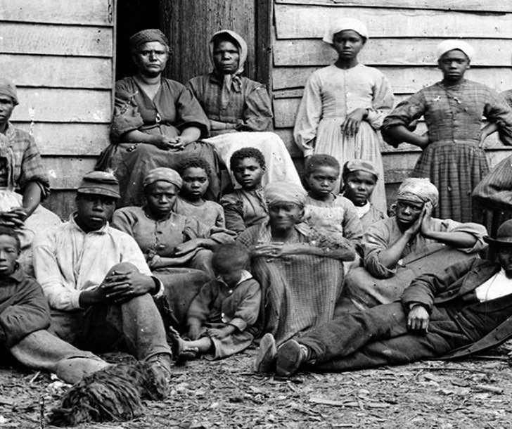
Black Canadians first settled in Canada in large numbers after the American Revolutionary War. Most were soldiers who fought for the British. In the 1800s, many Black Canadians were runaway slaves from the United States and later migrants from the Caribbean. Black people were not treated equally. For example, in Halifax, most Black people were segregated in a neighborhood called Africville and were later forced to move out in the 1960s.

1541: Jacques Cartier explores the St. Lawrence River.

You have no position. There are very few Black Canadians at this point.

1763: France would fight Britain and take control of Canada.

You have no position. Most Black Canadians are runaway slaves and you do not see this change ending slavery.

1837-38: French Canadians would rebel against the British government as part of the Patriote movement.

You have no position. No matter if the French or English Canadians are in power, you are not treated as their equals.

1867: The Confederation of Canada is formed and John Macdonald becomes prime minister.

You have no position on the Confederation. The Anglos Canadians are not even mentioning you in their discussions.

December 6, 1917: Halifax Explosion: A ship ran into another ship carrying explosives for the war and many people died.

You want to remind everyone that at least 30 Black Canadians were killed, many of them were Africville residents. They were largely forgotten in news reports.

1982: Canada gained its full independence from Britain by creating its own constitution. This included the Charter of Rights and Freedom, which guarantees all citizens the rights to religion, speech, and religion.

You support the new Constitution, because it specifically states that all people are equal. You do still worry that Black people will not be treated fairly.

WORKSHEET: 4-20.F

Asian Canadians
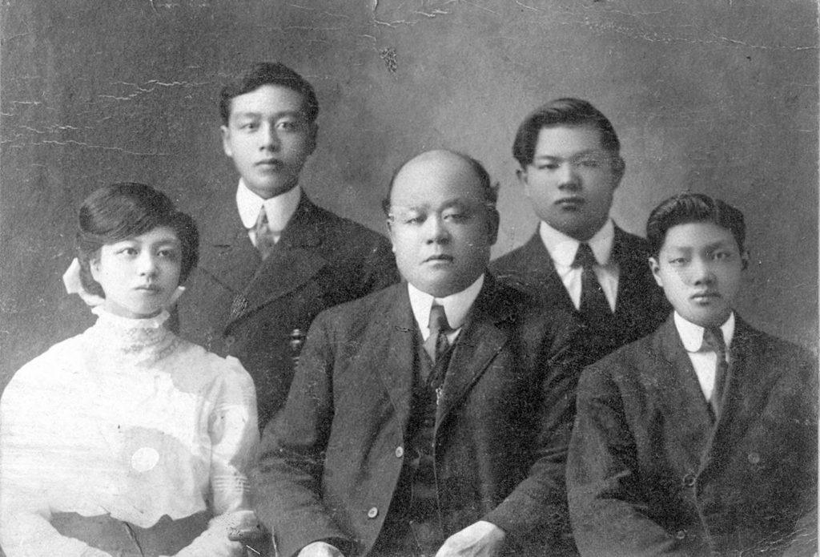
Asian immigrants, mostly from China, Japan, and India, first arrived in Canada in the 1850s to work in the gold mines and building the Trans-Canada Railroad. Asian people were not treated equally. For example, during the Second World War, innocent Japanese Canadians were forced to leave their homes and live in prison camps.

1541: Jacques Cartier explores the St. Lawrence River.

You have no position. There are very few Asian Canadians at this point.

1763: France would fight Britain and take control of Canada.

You have no position. There are very few Asian Canadians at this point.

1837-38: French Canadians would rebel against the British government as part of the Patriote movement.

You have no position. There are very few Asian Canadians at this point.

1867: The Confederation of Canada is formed and John Macdonald becomes prime minister.

You support the Confederation. It means that Canada may be able to build a Trans-Canada Railroad, which may help you get work and support your family.

December 6, 1917: Halifax Explosion: A ship ran into another ship carrying explosives for the war and many people died.

You support the efforts to help the injured people in Halifax.

1982: Canada gained its full independence from Britain by creating its own constitution. This included the Charter of Rights and Freedom, which guarantees all citizens the rights to religion, speech, and religion.

You support the new Constitution, because it specifically states that all people are equal. During World War II, innocent Japanese Canadians were imprisoned and you still worry that could happen again and that Asian people will not be treated fairly.

ASSESSMENT: 4-20.G

Canadian History: Exit Ticket

Inquiry Question: What was the most important event in Canadian history?

After reading the sources, decide what event was most important in creating the nation of Canada. Include three pieces of evidence from the sources.

LESSON PLAN 4-21: Road Trip: Canada

Lesson currently under development.
Expected Spring 2018.

LESSON PLAN 4-22: Northeast (U.S. Regions Mini-Unit)

Lesson currently under development.
Expected Spring 2018.

LESSON PLAN 4-23: Southeast (U.S. Regions Mini-Unit)

Lesson currently under development.
Expected Spring 2018.

LESSON PLAN 4-24: Midwest (U.S. Regions Mini-Unit)

Lesson currently under development.
Expected Spring 2018.

LESSON PLAN 4-25: Southwest (U.S. Regions Mini-Unit)

Lesson currently under development.
Expected Spring 2018.

LESSON PLAN 4-26: West (U.S. Regions Mini-Unit)

Lesson currently under development.
Expected Spring 2018.

LESSON PLAN 4-27: South America Today: Diverse Nations, Diverse People

Lesson currently under development.
Expected Spring 2018.

LESSON PLAN 4-28: The Great European Empires: Greece, Rome, Spain, France, and Britain

Lesson currently under development.
Expected Spring 2018.

LESSON PLAN 4-29: Irish Independence: A New Country from an Ancient People

Lesson currently under development.
Expected Spring 2018.

LESSON PLAN 4-30: Backpacking Across Europe: Diverse Nations, Diverse People

Lesson currently under development.
Expected Spring 2018.

ADDITIONAL RESOURCES

Below is a list of lesson plan and unit resources from other organizations, which in conjunction with Understanding Our World, may help teachers develop a content-rich elementary social studies curriculum.

Boston Public Schools: History and Social Studies Department

K-12 Curriculum Resources
https://sites.google.com/a/bostonpublicschools.org/history/curriculum-documents/

Massachusetts Department of Elementary and Secondary Education
Model Curriculum Units (Elementary-Level; Social Studies)
http://www.doe.mass.edu/candi/model/download_form.aspx

C3 Teachers

Inquiries
http://www.c3teachers.org/

New York State Education Department

New York State K-12 Social Studies Resource Toolkit
https://www.engageny.org/resource/new-york-state-k-12-social-studies-resource-toolkit

Teaching Tolerance

Elementary Resources
http://www.tolerance.org/activities

Facing History and Ourselves

Educator Resources
https://www.facinghistory.org/educator-resources

Primary Source

Online Curriculum
https://www.primarysource.org/for-teachers/online-curriculum

Share My Lesson (American Federation of Teachers)
Educator Resources
https://sharemylesson.com

Better Lesson (National Education Association)
Educator Resources
https://betterlesson.com

ABOUT THE DEVELOPERS



Christopher C. Martell, Ed.D.
Chris Martell is a Clinical Assistant Professor and Program Director of Social Studies Education at the Boston University School of Education. He teaches courses on elementary and secondary social studies methods. He was a social studies teacher for eleven years in urban and suburban contexts. For most of his teaching career, Chris taught in Framingham, Massachusetts, which is a racially and economically diverse urban school outside Boston with large immigrant populations from Brazil, Central America, and the Caribbean. His research and professional interests focus on social studies teachers in urban and multicultural contexts, critical race theory, culturally relevant pedagogy, and historical inquiry.



Jennifer R. Bryson, Ed.M.
Jenn Bryson is a former elementary classroom teacher in the Chelsea Public Schools and specializes in the professional preparation of elementary education teachers at the Boston University School of Education. Her responsibilities include coordination and supervision of student teachers in the elementary education program and the student-teaching abroad programs in London, England, Sydney, Australia, and Quito, Ecuador. She also facilitates the elementary pre-practicum placements for juniors and graduate students. In addition, Jenn teaches a course on urban education, leads field seminars on classroom management, and facilitates a book club entitled “Dads Read” at the William Monroe Trotter School in Dorchester, Massachusetts.

