Understanding Our World

An Open-Source Literacy-Focused Social Studies Curriculum



Curric

**STUDENT WORKBOOK**

**Level: Grade 1**

Our Communities: Local, State, Nation, World

Developed By

Christopher C. Martell and Jennifer R. Bryson

Boston University School of Education



**GRADE 1 ROAD MAP**

**LESSON 1-1**

Lesson Title: Time and Calendars

*Inquiry Question: Which calendar is most useful for its people?*

**LESSON 1-2**

Lesson Title: My Family and Our History (Family Chronology)

*Inquiry Question: What is my family’s story?*

**LESSON 1-3**

Lesson Title: Mapping Our Ancestors

*Inquiry Question: How were our ancestors (or our own) journeys to (or within) the U.S. similar and different?*

*[This lesson uses a timeline for the Boston neighborhood of Dorchester, but it can be altered for other communities where this curriculum may be used]*

**LESSON 1-4**

Lesson Title: An Introduction to Our Communities (Local, State, National, Global)

*Inquiry Question: Which community is most important in your life?*

**LESSON 1-5**

Lesson Title: Our Neighborhood (Dorchester)

*Inquiry Question: What makes our neighborhood a great place to live?*

*[This lesson will be on one neighborhood in the City of Boston (specifically Dorchester), but can be altered for other communities where this curriculum may be used]*

**LESSON 1-6**

Lesson Title: Our Boston

*Inquiry Question: Should Boston be considered a world-class city? Why or why not?*

*[This lesson will be on the City of Boston, but can be altered for other communities where this curriculum may be used]*

**LESSON 1-7**

Lesson Title: Our Nation

*Inquiry Question: Why do you like living in the United States?*

**LESSON 1-8**

Lesson Title: Important Americans (Part 1: Workers for Justice): Harriet Tubman, Alice Paul, Fred Korematsu, César Chávez

*Inquiry Question: Which civil rights leader had the best way to make change?*

**LESSON 1-9**

Lesson Title: Important Americans (Part 2: Breaking Barriers): Amelia Earhart, Jackie Robinson, Lin-Manuel Miranda, Yo-Yo Ma

*Inquiry Question: What are the most important ways that these pioneers have broken barriers?*

**LESSON 1-10**

Lesson Title: Important Americans (Part 3: Inventors): The Wright Brothers,George Washington Carver, Rachel Carson, Eugene Trinh

*Inquiry Question: Which inventor contributed the most to our nation?*

**LESSON 1-11**

Lesson Title: National Symbols: The Many Meanings of the American Flag

*Inquiry Question: Is our flag a good symbol for our nation?*

**LESSON 1-12**

Lesson Title: National Symbols: The Bald Eagle

*Inquiry Question: Is the bald eagle the best choice for a national bird?*

**LESSON 1-13**

Lesson Title: National Symbols: Monuments

*Inquiry Question: Which group of national monuments are most important?*

**LESSON 1-14**

Lesson Title: Our Holidays: Independence Day, Labor Day, Patriots’ Day, and Juneteenth

*Inquiry Question: What national holiday should we create?*

**LESSON 1-15**

Lesson Title: The Pledge of Allegiance

*Inquiry Question: Should everyone say the Pledge of Allegiance?*

**LESSON 1-16**

Lesson Title: Our Customs and Traditions

*Inquiry Question: What customs or traditions are most important to you?*

**LESSON 1-17**

Lesson Title: Our World

*Inquiry Question: If you could move anywhere in the world, where would it be?*

**LESSON 1-18**

Lesson Title: Important Global Citizens: Mahatma Gandhi, Desmond Tutu, Malala Yousafzai, Mary Robinson

*Inquiry Question: Which leader made the most important change to the world?*

**LESSON 1-19**

Lesson Title: Making Our World Better (Part 1)

*Inquiry Question: What are the most important current global problems?*

**LESSON 1-20**

Lesson Title: Making Our World Better (Part 2)

*Inquiry Question: Taking a global issue that you think is very important, what should we do to make it better?*

**ASSESSMENT 1-1.E**

**Calendars: Exit Ticket**

Inquiry Question: *Which calendar is most useful for its people?*

Describe what calendar you think is most useful. Include one piece of evidence from the sources.

**WORKSHEET 1-2.A**

**Pre-Lesson Activity: Learning About My Family**

Dear Students and Families,

We will be learning about the histories of our own families in social studies. To help us know more about your family we ask that parents/guardians and students complete this sheet together. We realize that you may not know certain information about your family members. It is all right to leave anything blank. We also realize that families have different numbers of people and you are welcome to add any relative to this list that should be included (for instance, a student may have 5 grandparents or 3 guardians). As you fill this out, we also hope this is an opportunity for parents/guardians to tell stories to their students about their ancestors.

**Student**

My name is:

I was born (date and place):

Places I have lived:

**Parent/Guardian 1**

My name is:

Children’s names:

I was born (date and place):

Places I have lived:

Jobs that I have had:

Important events in my life:

**Parent/Guardian 2**

My name is:

Children’s names:

I was born (date and place):

Places I have lived:

Jobs that I have had:

Important events in my life:

**Grandparent 1**

My name is:

Children’s names:

I was born (date and place):

Places I have lived:

Jobs that I have had:

Important events in my life:

**Grandparent 2**

My name is:

Children’s names:

I was born (date and place):

Places I have lived:

Jobs that I have had:

Important events in my life:

**Grandparent 3**

My name is:

Children’s names:

I was born (date and place):

Places I have lived:

Jobs that I have had:

Important events in my life:

**Grandparent 4**

My name is:

Children’s names:

I was born (date and place):

Places I have lived:

Jobs that I have had:

Important events in my life:

NOTE: If you can list other ancestors (i.e. great-grandparents, great-great-grandparents, or beyond, please attach an additional sheet with similar information to above). On the next page, we ask for the oldest known relatives (ancestors) of your student.

**Oldest Known Relative 1**

My name is:

Relationship to student:

Children’s names:

I was born (date and place):

Places I have lived:

Jobs that I have had:

Important events in my life:

**Oldest Known Relative 2**

My name is:

Relationship to student:

Children’s names:

I was born (date and place):

Places I have lived:

Jobs that I have had:

Important events in my life:

**Oldest Known Relative 3**

My name is:

Relationship to student:

Children’s names:

I was born (date and place):

Places I have lived:

Jobs that I have had:

Important events in my life:

**Oldest Known Relative 4**

My name is:

Relationship to student:

Children’s names:

I was born (date and place):

Places I have lived:

Jobs that I have had:

Important events in my life:

**WORKSHEET 1-2.B**



**WORKSHEET 1-2.C**

**My Family and Our History: Outline Sheet**

Make a list of everything you know about each family member on your timelines, including the places where they lived and important events and jobs in their lives. If you finish early, you may add more family members. If you need more room, use the back of this sheet.

**Family Member 1 (Oldest) Name:**

**Family Member 2 (2nd Oldest) Name:**

**Family Member 3 (2nd Youngest) Name:**

**Family Member 4 (Youngest) Name:**

**ASSESSMENT 1-2.D**

**My Family and Our History: Exit Ticket**

Inquiry Question: *What is my family’s story?*

Write about each person listed in your timelines from oldest to youngest. Write your answer below citing information from your timeline and outline. Be sure to include their birthdates, placed where they lived, and important events and jobs in their lives. If you need more room, use the back of this sheet.

**WORKSHEET 1-3.A**

**Family Members’ Places**

For each place where your family members have lived. If you need more room for additional places, use the back of this sheet.

Place 1:

Name of Family Members Living There:

Place 2:

Name of Family Members Living There:

Place 3:

Name of Family Members Living There:

Place 4:

Name of Family Members Living There:

Place 5:

Name of Family Members Living There:

**WORKSHEET 1-3.B**

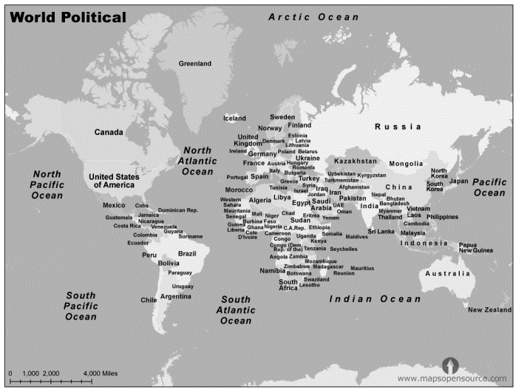

**ASSESSMENT 1-3.C**

**Mapping Our Ancestors: Exit Ticket**

Inquiry Question: *How were our ancestors (or our own) journeys to (or within) the U.S. similar and different?*

Write about where our classmates’ families come from. Include at least one thing that is the same, and one thing that is different about the places where we are from.

**MATERIALS 1-4.A**

**Earth**

**United States**

**Massachusetts**

**Boston**

**Dorchester**

**ASSESSMENT 1-4.B**

**Most Important Community: Exit Ticket**

Inquiry Question: *Which community is most important in your life?*

Choose one community (Earth, United States, Massachusetts, Boston, Dorchester) that you feel is most important to you. Include two pieces of evidence from the sheets on the wall.

**ASSESSMENT 1-5.D**

**Our Neighborhood: Exit Ticket**

Inquiry Question: *What makes our neighborhood a great place to live?*

Write about the asset (i.e. Parks, Businesses, Music and Art, Schools, Libraries, and Hospitals) that you think is the most important asset in our neighborhood. Include two pieces of evidence from the sources.

**ASSESSMENT 1-6.E**

**Our City: Exit Ticket**

Inquiry Question: *Should Boston be considered a world-class city? Why or why not?*

Write about the asset (Places, People, Inventions) that you think is the most important in making Boston a world class city or the reason why it is not. Include two pieces of evidence from the sources.

**WORKSHEET 1-7.E**

**American Stories Thinking Questions**

Source 1: Marisela’s Story

How is Marisela’s reasons similar or different to your reasons for why you like living in the U.S.?

Source 2: Amy’s Story

How is Amy’s reasons similar or different to your reasons for why you like living in the U.S.?

Source 3: Chris’s Story

How is Chris’s reasons similar or different to your reasons for why you like living in the U.S.?

Source 4: Christina’s Story

How is Christina’s reasons similar or different to your reasons for why you like living in the U.S.?

**ASSESSMENT 1-7.F**

**Our Nation: Exit Ticket**

Inquiry Question: *Why do you like living in the United States?*

Write about the reasons why you like living in the United States. Use the stories we read today and President Obama’s speech for examples.

**ASSESSMENT 1-8.E**

**Important Americans (Workers for Justice): Exit Ticket**

Inquiry Question: *Which civil rights leader had the best way to make change?*

Choose one person (Harriet Tubman, Alice, Fred Korematsu, César Chávez) and write about why they had the best way to make change. Include two pieces of evidence from the sources.

**WORKSHEET 1-9.E**

**Breaking Barriers Stories Notes**

List here what your group wants to tell the class about your important American:

Person’s Name:

Important Details:

**ASSESSMENT 1-9.F**

**Important Americans (Breaking Barriers): Exit Ticket**

Inquiry Question: *What are the most important ways that these pioneers have broken barriers?*

Choose one person (Amelia Earhart, Jackie Robinson,

Lin-Manuel Miranda, Yo-Yo Ma) and write about the most important way they broke a barrier. Include two pieces of evidence from the sources.

**WORKSHEET 1-10.E**

**Inventors Thinking Questions**

Source 1: The Wright Brothers

What important things did they invent, discover, or do?

Source 2: George Washington Carver

What important things did he invent, discover, or do?

Source 3: Rachel Carson

What important things did she invent, discover, or do?

Source 4: Eugene Trịnh

What important things did he invent, discover, or do?

**ASSESSMENT 1-10.F**

**Important Americans (Inventors): Exit Ticket**

Inquiry Question: *Which inventor contributed the most to our nation?*

Choose one person (The Wright Brothers, George Washington Carver, Rachel Carson, Eugene Trinh) and write about the most important way they broke a barrier. Include two pieces of evidence from the sources.

**WORKSHEET 1-11.A**

**World Flags**

Using the word bank, guess which country belongs to each flag.



1.

______________

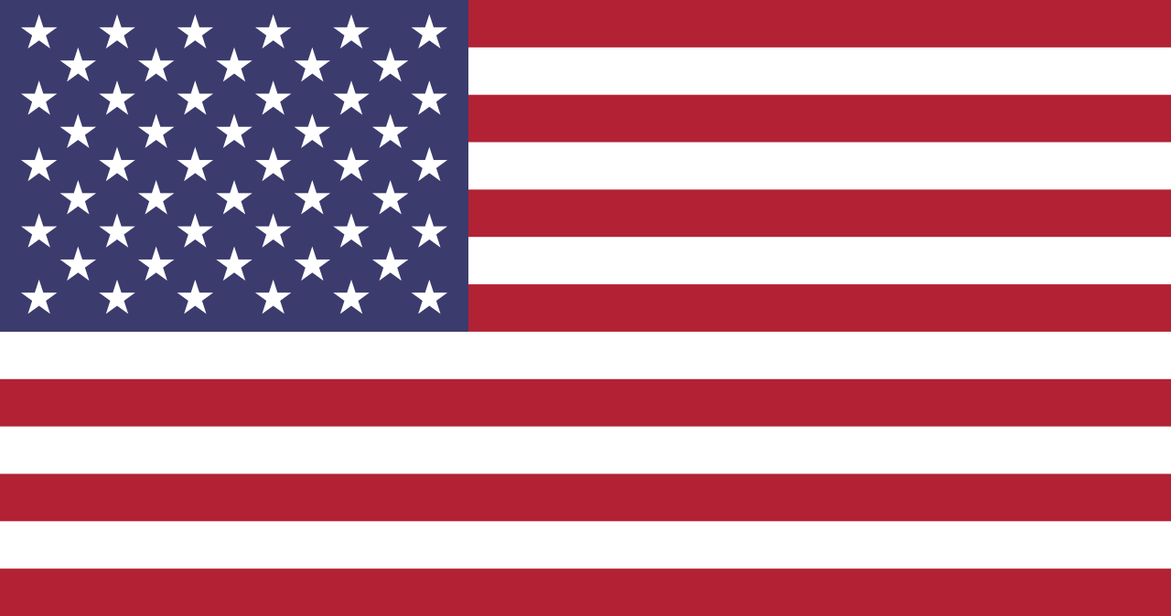

2. ______________

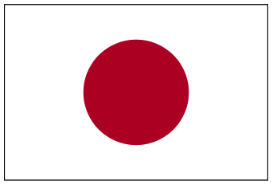

3. _____________

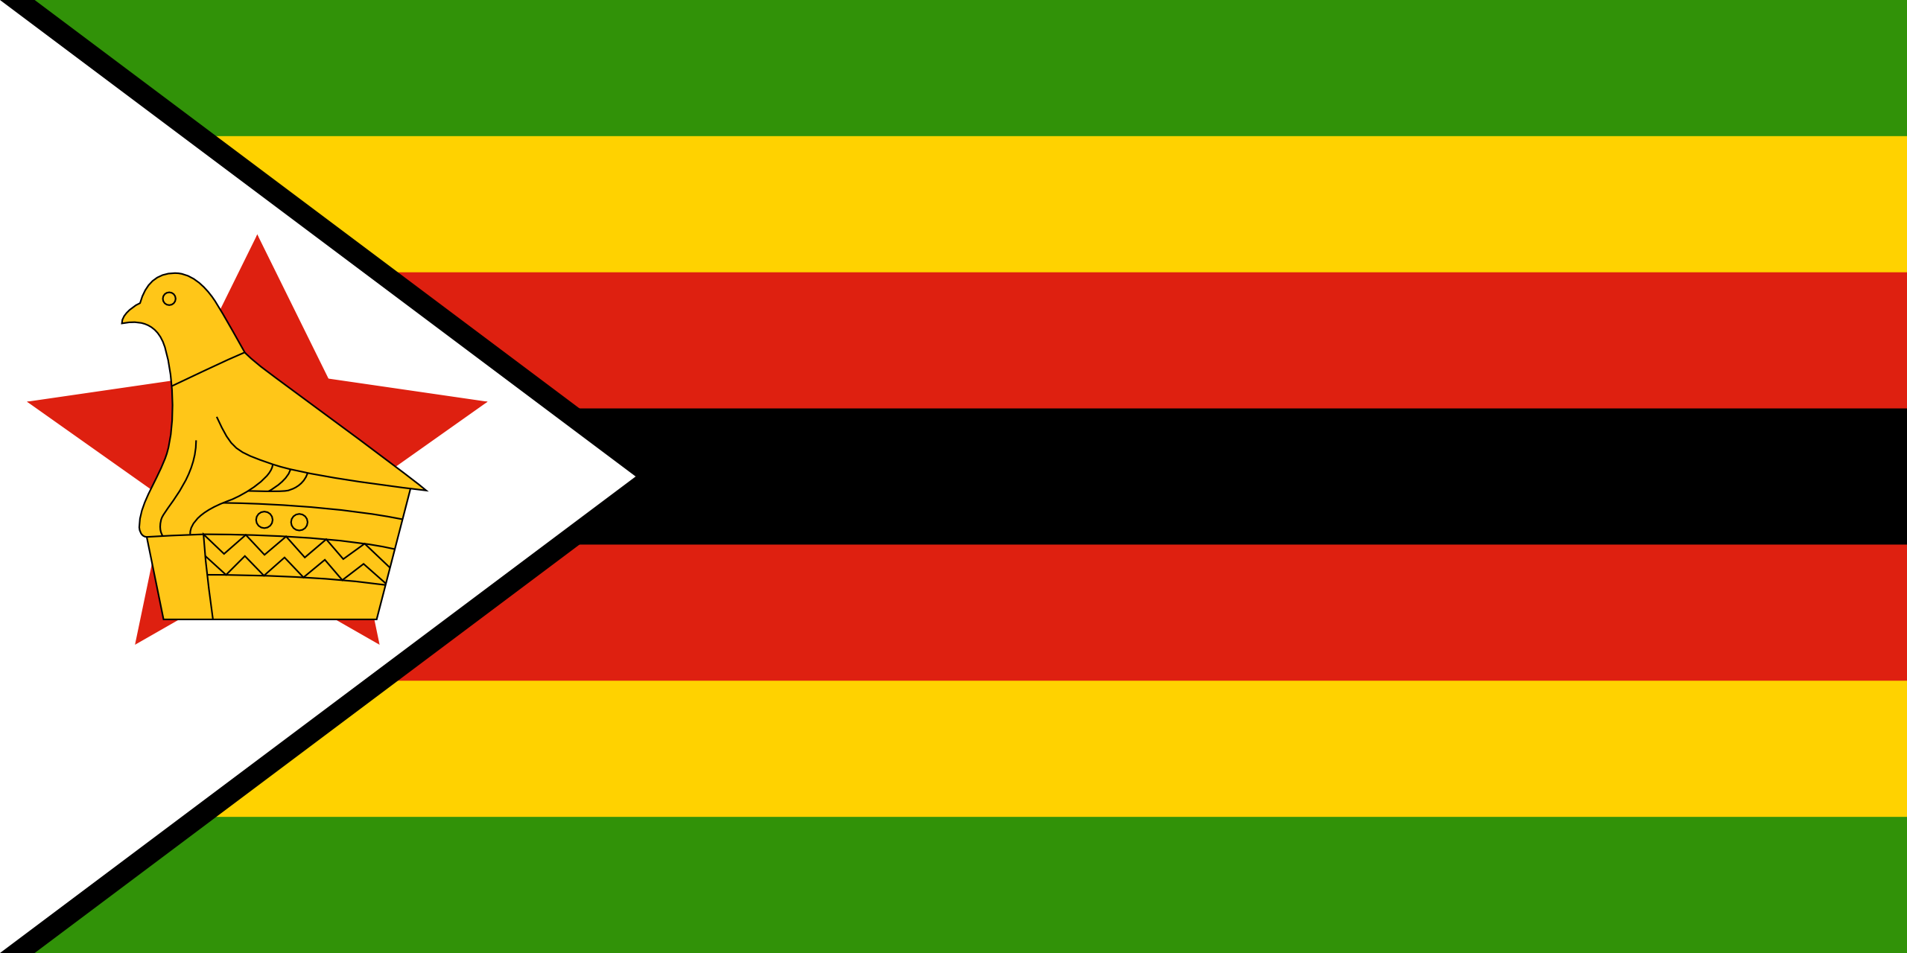

4.

______________

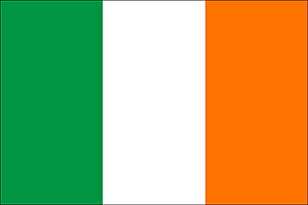

5.

_____________

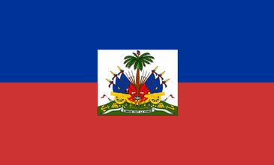

6.

_____________



7.

_____________

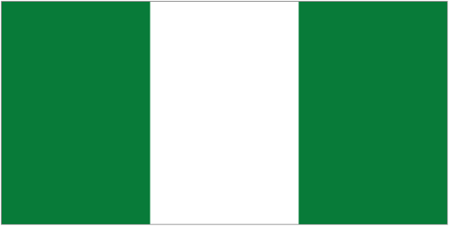

8.

_____________

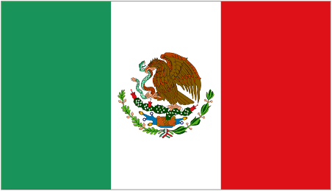

9.

_____________

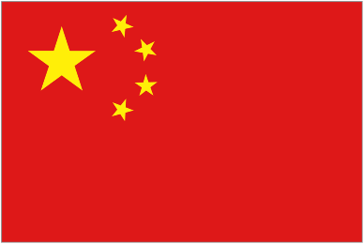

10.

____________

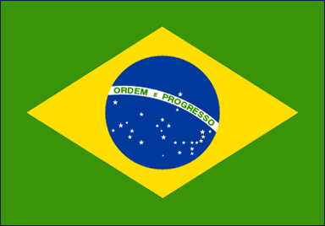

11.

____________

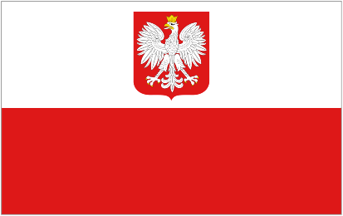

12.

____________

**Word Bank:**

Brazil

Canada

China

Haiti

Ireland

Japan

Mexico

Nigeria

Poland

United States

Vietnam

Zimbabwe

**ANSWER SHEET: 1-11.A**

**World Flags**

Using the word bank, guess which country belongs to each flag.



1. Vietnam (South)



2. United States



3. Japan



4. Zimbabwe



5. Ireland



6. Haiti



7. Canada



8. Nigeria



9. Mexico



10. China



11. Brazil



12. Poland

**ASSESSMENT 1-11.H**

**The Many Meanings of the American Flag: Exit Ticket**

Inquiry Question: *Is our flag a good symbol for our nation?*

Describe why the U.S. flag is a good or not good symbol for our nation. Include two pieces of evidence from the sources. If you have a better idea for the American flag, you may draw it on a separate piece of paper (ask your teacher for drawing paper).

**WORKSHEET 1-12.B**

**Preparation for the Corner Debate**

Think about the following birds and decide if you think “yes” or “no” on them being the national bird of the United States. You may say “yes” to more than one bird. Then explain why that bird would be a good or bad choice.

**Bald Eagle**

Circle: Yes or No

**Black Crow**

Circle: Yes or No

**American Turkey**

Circle: Yes or No

**Hummingbird**

Circle: Yes or No

**MATERIALS 1-12.C**

**YES**

**NO**

**ASSESSMENT 1-12.C**

**National Symbols: The Bald Eagle: Exit Ticket**

Inquiry Question: *Is the bald eagle the best choice for a national bird?*

Write an argument as to why the bald eagle is the best choice for the national bird **or** it should instead be another bird (choose American turkey, black crow, or hummingbird). Include two pieces of evidence from the sources. You may also draw the national bird you think is best on separate piece of paper (ask your teacher for drawing paper).

**ASSESSMENT 1-13.H**

**National Symbols: Exit Ticket**

Inquiry Question: *Which group of national monuments are most important?*

Choose one group of national monuments (Government Monuments, Independence Monuments, Constitution Monuments, Immigration Monuments, Natural Monuments, Man-Made Monuments) and write about why they are the most important. Include two pieces of evidence from the sources.

**WORKSHEET 1-14.E**

**Holiday Carousel Sheet**

Source 1: Independence Day

Why do we celebrate Independence Day?

Source 2: Labor Day

Why do we celebrate Labor Day?

Source 3: Patriots’ Day

Why do we celebrate Patriots’ Day?

Source 4: Juneteenth

Why do we celebrate Juneteenth?

**ASSESSMENT 1-14.F**

**Our Holidays: Exit Ticket**

Inquiry Question: *What national holiday should we create?*

In your groups, you will choose one person, event, idea, or group of people who should have their own holiday in the United States. It should not be one of the following holidays that currently exists: *Labor Day, Columbus Day/Indigenous Peoples Day, Veterans’ Day, Thanksgiving, Martin Luther King, Jr. Day, Presidents’ Day, Patriots’ Day, Memorial Day, Flag Day, and Independence Day.* Include two reasons why this person, event, idea, or group should have a holiday.

**ASSESSMENT 1-15.E**

**Pledge of Allegiance: Exit Ticket**

Inquiry Question: *Should everyone say the Pledge of Allegiance?*

Describe why students should or should not have to say the Pledge of Allegiance (unless for religious or personal reasons). Include two pieces of evidence from the sources.

**WORKSHEET 1-16.A**

**Pre-Lesson Activity: My Family’s Customs and Traditions**

Dear Students and Families,

We will be learning about the customs and traditions of our own families in social studies. To help us know more about your family we ask that parents/guardians and students complete this sheet together. We realize that you may not know certain information about your family’s customs or traditions. It is all right to leave anything blank. We also realize that families have different customs and traditions, so what you list may be very different from what other families list. As you fill this out, we also hope this is an opportunity for parents/guardians to explain why you do certain customs or traditions and when those customs and traditions started.

Customs: Something a family (or group) does regularly. May include both special events or celebrations. For instance, a family may celebrate their member’s birthdays every year with a party. Or, a family may visit family in Haiti every summer.

Traditions: Something a family (or group) has passed from one generation to the next. For instance, a person may inherit a cookbook from their mother or father and use that cookbook to make special recipes. Or, a person may go to Mosque every Friday, because their parents and grandparents did.

**Student Name:**

**Custom or Tradition 1**

My custom/tradition is:

When did it start?

Why do we do this?

**Custom or Tradition 2**

My custom/tradition is:

When did it start?

Why do we do this?

**Custom or Tradition 3**

My custom/tradition is:

When did it start?

Why do we do this?

**Custom or Tradition 4**

My custom/tradition is:

When did it start?

Why do we do this?

**Custom or Tradition 5**

My custom/tradition is:

When did it start?

Why do we do this?

[If more customs/traditions need to be listed, use additional sheets of paper]

**WORKSHEET 1-16.B**

**Customs and Traditions Worksheet**

*Put the number of the picture next to what you think it is…*

*­­­*___ Birthday: A party held on the date that you were born each

year.

___ Quinceañera/o: A party when you turn 15 years old and are

more grown up.

___ First Day of School: Celebrating the beginning of a new

school year.

___ Barbecue/Cookout: An outdoor meal that involves cooking on

a grill or fire.

___ Wedding: When one person decides to live the rest of their

life with another person.

___ Funeral: When a person dies, people celebrate their life with

a ceremony.

**Answers**

**F** Birthday: For some Vietnamese families, Đầy Tháng (day tang) or full month (first month birthday) for babies. It is a very important celebration.

**D** Quinceañera/o: In some Latin American families, girls and boys celebrate their 15th birthdays with a “coming of age” party. This usually involves dancing and eating.

**B** First Day of School: In some German families, parents give their students a Schultüte (shol-tu-ta). It is a cone full of candy, toys, and school supplies.

**E** Barbecue/Cookout: In some African American and Caribbean families, summertime holidays are the time to barbecue. Barbecue means to slow cook meats with sauces over a fire. They also enjoy other cultural foods.

**A** Wedding: In some Indian families, when two people marry they have a ceremony and party. The party lasts for up to three days.

**C** Funeral: In some Japanese families, when someone dies, they have a funeral at a Buddhist Temple/Church or at home. They pray and burn incense.

**ASSESSMENT 1-16.E**

**Our Customs and Traditions: Exit Ticket**

Inquiry Question: *What customs or traditions are most important to you?*

Choose one of the customs or traditions from your own family (or one of the customs or traditions posted on the walls). Include two pieces of evidence from the sources.

**ASSESSMENT 1-16.E**

**Our World: Exit Ticket**

Inquiry Question: *If you could move anywhere in the world, where would it be?*

After hearing about the continents, if you were to move somewhere else, where would it be and why? Include two pieces of evidence from the sources.

**WORKSHEET 1-18.E**

**Books and Computer Research Sheet**

**My global citizen is: ____________________________________**

**Main Event 1:**

**What important things did you learn about this event from the books, websites, or class handouts?**

**Main Event 2:**

**What important things did you learn about this event from the books, websites, or class handouts?**

**Main Event 3:**

**What important things did you learn about this event from the books, websites, or class handouts?**

**Main Event 4 (EXTRA):**

**What important things did you learn about this event from the books, websites, or class handouts?**

**ASSESSMENT 1-18.F**

**Important Global Citizens: Exit Ticket**

Inquiry Question: *Which leader made the most important change to the world?*

After listening to all of the biographies (Mahatma Gandhi, Desmond Tutu, Malala Yousafzai, Mary Robinson), choose the person you think made the most important change. Include two pieces of evidence from the students’ biographies/presentations.

**WORKSHEET 1-19.A**

**Preparation for the Corner Debate**

Think about the following questions. You should choose “yes” or “no” and explain why you think that. We will then have a corner debate about these four questions.

**The Earth getting warmer is a bad thing.**

Circle: Yes or No

**Too many people around the world do not have a place to live, enough food to eat, or clothes to wear.**

Circle: Yes or No

**We should do more to cure diseases.**

Circle: Yes or No

**People in every country should have the right to choose their leaders.**

Circle: Yes or No

**MATERIALS 1-19.B**

**YES**

**NO**

**ASSESSMENT 1-19.G**

**Global Problems: Notes Sheet**

Our global problem is: ________________________________

List below the most important facts about your global problem (that you will share with the class).

**ASSESSMENT 1-19.H**

**Making Our World Better (Part 1): Exit Ticket**

Inquiry Question: *What are the most important current global problems?*

After considering important global problems (Global Warming/Climate Change, Poverty, Disease, Lack of Democracy), write about what you think is the most important challenge. Include two pieces of evidence from the students’ biographies and presentations.

**MATERIALS 1-20.B**

**Global Warming**

**Poverty**

**Disease**

**Lack of Democracy**

**ASSESSMENT 1-20.G**

**Making Our World Better (Part 2): Exit Ticket**

Inquiry Question: *Taking a global issue that you think is very important, what should we do to make it better?*

My global issue is (circle):

Global Warming/Climate Change Poverty

Disease Lack of Democracy

After considering possible solutions to a global problem, explain what we should do. Include two pieces of evidence from the sources.