Understanding Our World

An Open-Source Literacy-Focused Social Studies Curriculum

Curric

STUDENT SOURCEBOOK

Level: Grade 3

Exploring Boston: From Past to Present

Developed By

Christopher C. Martell and Jennifer R. Bryson

Boston University School of Education

GRADE 3 ROAD MAP

LESSON 3-1

Lesson Title: People of the First Light: The Wampanoag

Inquiry Question: What was the most interesting part of the Wampanoag’s traditional way of life?

LESSON 3-2

Lesson Title: Squanto’s Life: A Timeline Activity

Inquiry Question: What was the most important event in Squanto’s Life?

LESSON 3-3

Lesson Title: The Mayflower Voyage and Settlement

Inquiry Question: Did the Pilgrims make the right choice in coming to America?

LESSON 3-4

Lesson Title: The First Thanksgiving?

Inquiry Question: How should we remember the Pilgrim and Wampanoag Thanksgiving?

LESSON 3-5

Lesson Title: Choose Your Own Adventure: The Puritans

Inquiry Question: Did the Puritans make the right decisions?

LESSON 3-6

Lesson Title: Roger Williams: Church and State

Inquiry Question: What was Roger Williams’ most important achievement?

LESSON 3-7

Lesson Title: Anne Hutchinson: Women Should Lead!

Inquiry Question: What should Anne Hutchinson be remembered for?

LESSON 3-8

Lesson Title: King Philip’s War

Inquiry Question: What caused King Philip’s War?

NOTE: In chronological order, Massachusetts and the American Revolution would appear here after Lesson 3-8. These lessons are currently included in the Grade 5 curriculum (i.e. 5-8, 5-9, 5-10, 5-11, 5012), which is United States history. Teachers are encouraged to use modified versions of those lessons again here.

LESSON 3-9

Lesson Title: Revolutionary Leaders: John Adams, Samuel Adams, John Hancock, and Paul Revere

Inquiry Question: Which Boston leader had the best way to spread revolutionary ideas?

LESSON 3-10

Lesson Title: Massachusetts, From Slavery to Anti-Slavery: Frederick Douglass, Sojourner Truth, and William Lloyd Garrison

Inquiry Question: What was the best way that Massachusetts abolitionists convinced people to oppose slavery?

LESSON 3-11

Lesson Title: Women’s Rights: Abigail Adams, Susan B. Anthony, the Grimké sisters, and Lucy Stone

Inquiry Question: Which Massachusetts women’s rights leader had the best strategy for equality?

LESSON 3-12

Lesson Title: New England Factory Life

Inquiry Question: Did Massachusetts factory owners treat their workers well?

LESSON 3-13

Lesson Title: Massachusetts: The Birthplace of Public Education

Inquiry Question: What was Horace Mann’s most important achievement?

LESSON 3-14

Lesson Title: Massachusetts: A State of Firsts

Inquiry Question: Which Massachusetts invention was the most important?

LESSON 3-15

Lesson Title: Massachusetts Town Meeting: How Does It Work?

Inquiry Question: If you were a member of a town meeting, what would you want to pass and why?

LESSON 3-16

Lesson Title: Running for Mayor

Inquiry Question: What issues do you want the Mayor of Boston to address?

LESSON 3-17

Lesson Title: Taxes: You Decide What Should Be Funded!

Inquiry Question: What should our city/town use our tax money for?

LESSON 3-18

Lesson Title: Preserving Boston: The Pierce House, The Strand Theater, The Ladder Blocks, The Little-Collins (Malcolm X) House

Inquiry Question: Which historic building in Boston is the most important to preserve?

LESSON 3-19

Lesson Title: Our Past: Dorchester’s History

Inquiry Question: What was the most important event in our community’s history?

LESSON 3-20

Lesson Title: Our Future: Making Boston Better

Inquiry Question: What is the most important issue for our community to solve in the future?
SOURCEBOOK 3-1.A

Source 1: Wetus

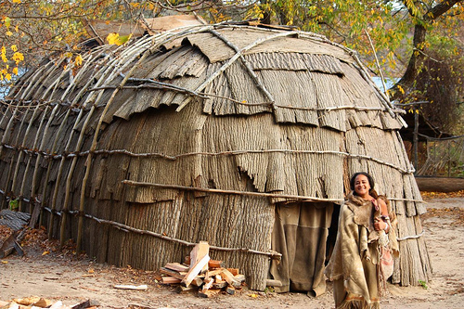

400 years ago, the Wampanoag usually lived in two different houses, one inland in the winter and one near the coast in the summer. They Wampanoag word for house is wetu. Both men and women were involved in building new wetu. To build it, they would create a structure or frame and then attach tree bark (inland) or reeds (near the water) for the walls. They were so strong they could withstand heavy rains and thunderstorms in the spring and summer, hurricanes in fall, and blizzards in the winter. Annawon Weeden, a Wampanoag who builds wetu, said, “They were built near the wooded coast where cool breezes came off the ocean,” and then joked, "They were the ultimate beachfront condos!"

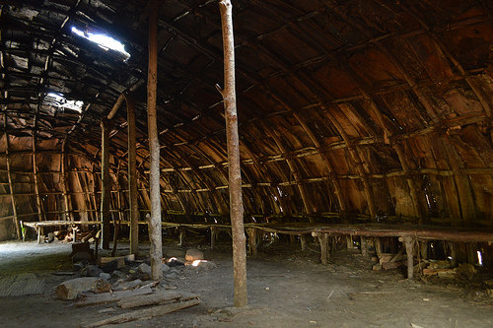

About 40-50 people lived in one house, which was about 3-4 related families. Inside, people would sleep on beds with bear fur blankets and sit on mats made from cattails. Fires were used to heat the house and cook. There were holes at the top of the wetu to let the smoke out. Today Wampanoag people live in modern houses, but some members of the Wampanoag build wetu at Plimoth Plantation to educate others about them.

SOURCEBOOK 3-1.B

Source 2: Mishoon

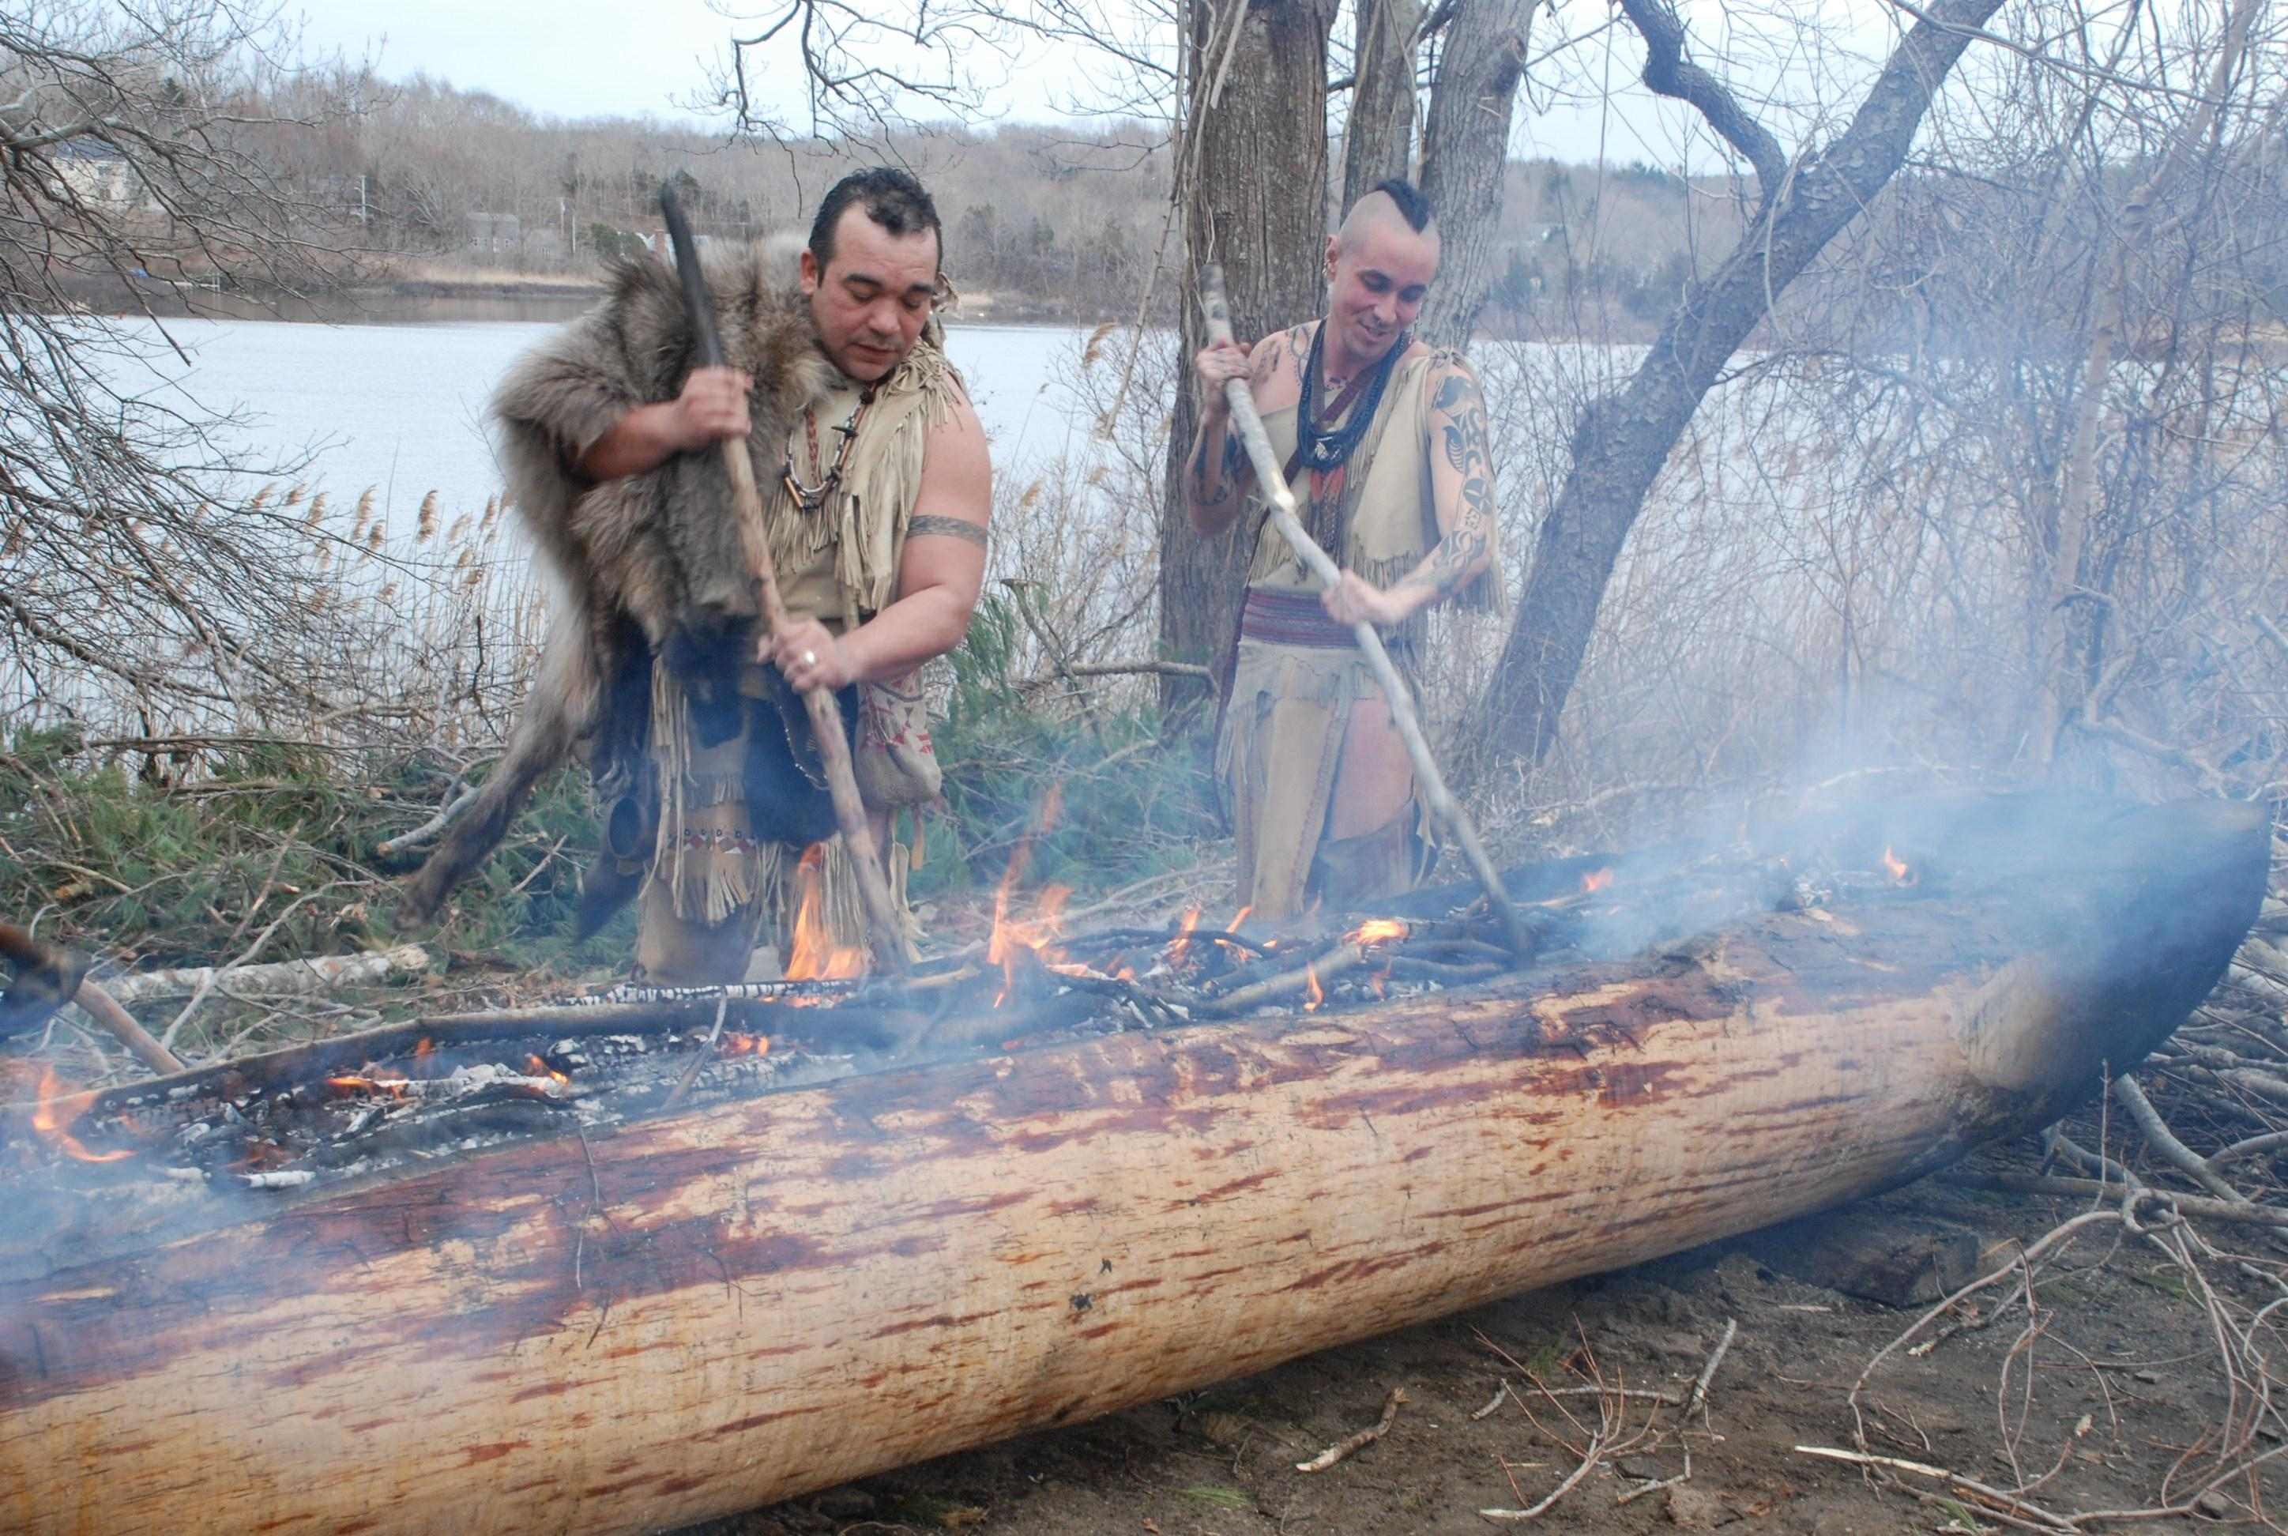

400 years ago, the Wampanoag traveled by walking, running, and using boats. The Wampanoag word for boat is mishoon. Mishoon were made by burning and scraping the inside of a tree to hollow it out. The fire would be 24 hours a day and take about 2 weeks to complete. Darius Coombs, a Wampanoag who makes mishoons today, said, “Fire for us is considered to be the No. 1 wood-working tool … It’s not like we didn’t have the tools to chop and carve, we did. If you know about stone tools, certain types of stone are extremely sharp. Burning is just easier if you know how to burn the fire.”

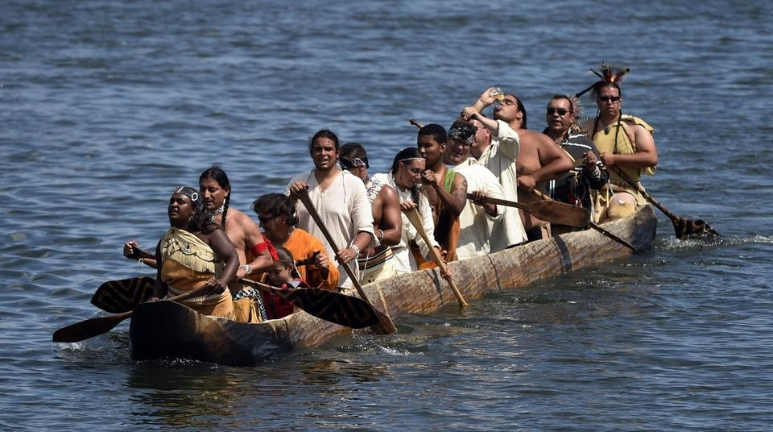

Mishoon could be made as large as 40 feet or more and carry 12 or 15 people. Wampanoag were able to use them to travel farther and faster than walking or running. They would also fish off of them. The Wampanoag have a program today called Mission Mishoon, which teaches their children how to make mishoons.

SOURCEBOOK 3-1.C

Source 3: Wampanoag Food

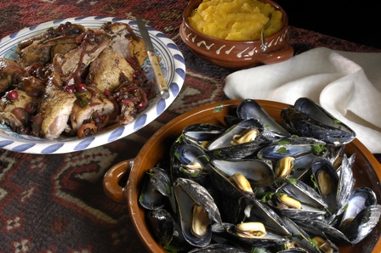

400 years ago, the Wampanoag ate many different foods. They got their food by hunting, fishing, harvesting wild berries and fruits, and planting of crops. The animals they hunted included deer, moose, beaver, rabbit, skunk, raccoon, and quail. They fished for herring, trout, perch, catfish, eels, mussels, and lobster. Some animals and fish were used for food, while others were used for clothes, tools, or other supplies. They planted many crops, including the “three sisters” of corn, beans and squash. In fact, corn and many squashes were introduced to Europeans by the Indigenous people.

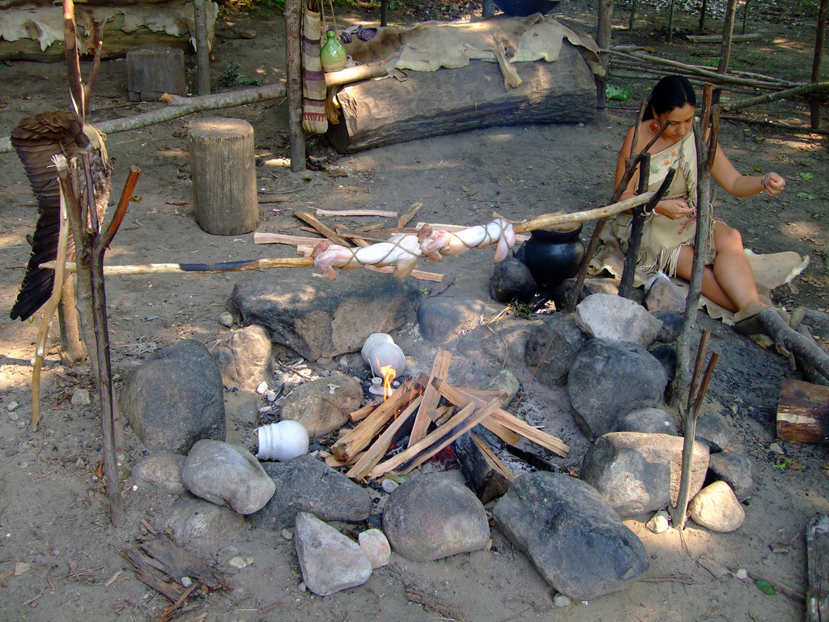

After hours of cooking, the Wampanoag would eat their meals together. They would always give thanks to the Creator for allowing them to catch an animal. They also did not waste and misuse of what was collected from the natural world, who they saw as Mother Earth. Today, you can find traditional Wampanoag foods being cooked in Wampanoag people’s homes and at their cultural celebrations called pow wow, such as the one held every summer on Cape Cod.

SOURCEBOOK 3-1.D

Source 4: Wôpanâak

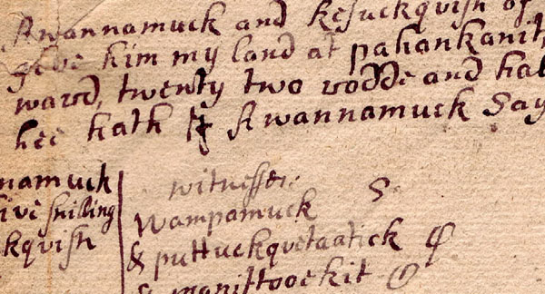

400 years ago, all Wampanoag spoke the language Wôpanâak (see above). It was not a written language, but over time some Wampanoag started writing it down, because they were afraid it would be lost as Whites came to their land and started teaching Wampanoag’s English. Here is what it sounded like and a translation:

Peesh mucheemee nutawâhkônân utah sâhkee pumôtamwak.

We shall always use it as long as we live.

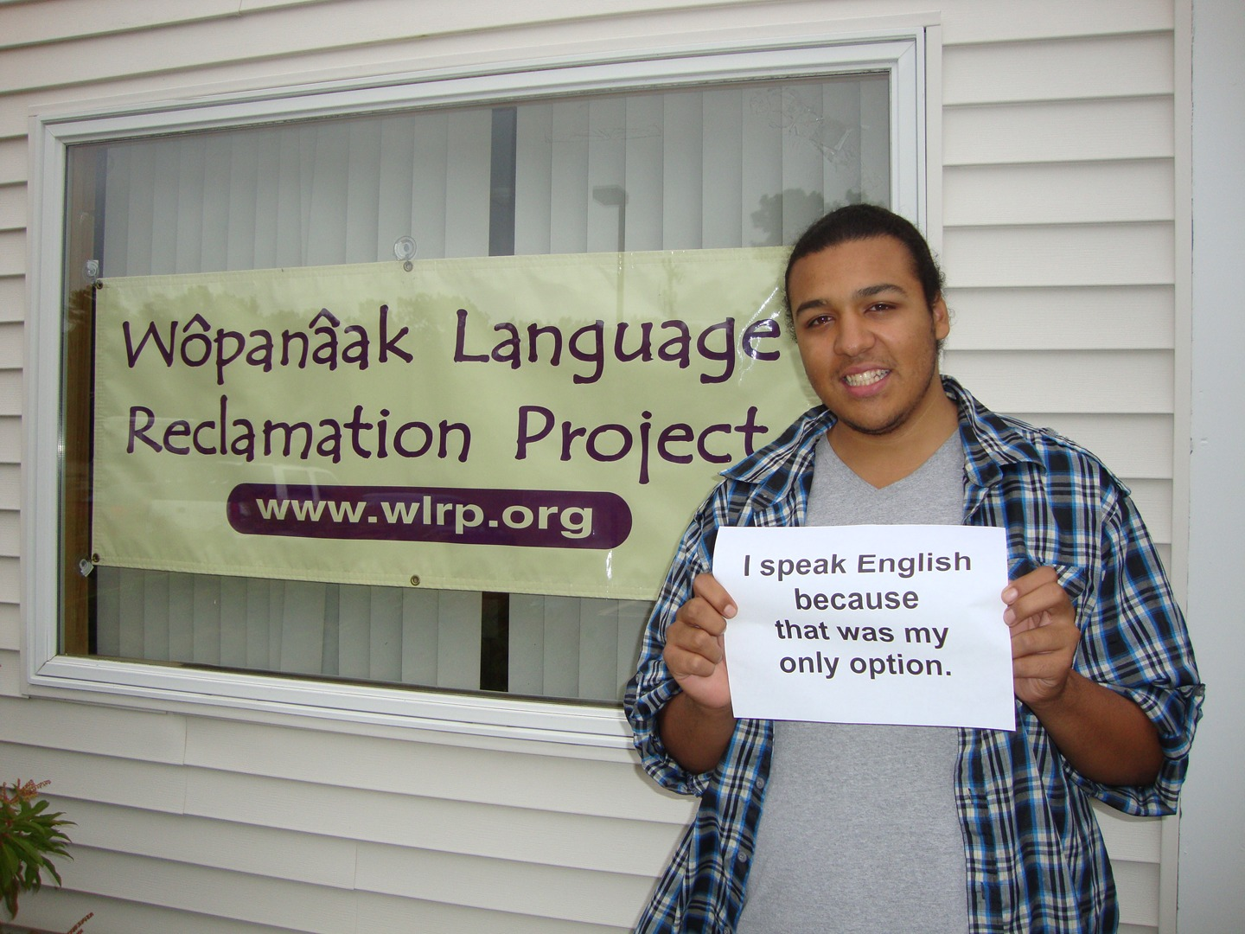

About 100 years ago, Wôpanâak became a lost language, which means no one spoke it anymore. Today, the Wampanoag Nation has started a new school to teach their children and other people the Wôpanâak language, so it will be used again.

SOURCEBOOK 3-4.A

Source 1: Edward Winslow’s First Thanksgiving Description

Many of the Indians coming to us, and … their greatest king Massasoit, with some ninety men, whom for three days we entertained and feasted, and they went out and killed five Deer, which they brought to the Plantation.

SOURCEBOOK 3-4.B

Source 2: William Bradford’s First Thanksgiving Description

They began now to gather in the small harvest they had, and to fit up their houses for winter. They were all well in health and strength. … All the summer there had all they needed and now … as winter approached … this place gave them what they needed.

Harvest: To collect food crops

SOURCEBOOK 3-4.C

Source 3: Thanksgiving Image #1

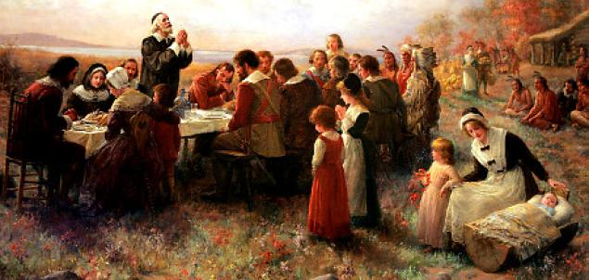

We have no paintings from the time of the Pilgrims and Wampanoag’s thanksgiving. This is a painting done in 1914 (almost 300 years later). Notice that it only shows a few Wampanoag men off in the right corner.

SOURCEBOOK 3-4.D

Source 4: Thanksgiving Image #2

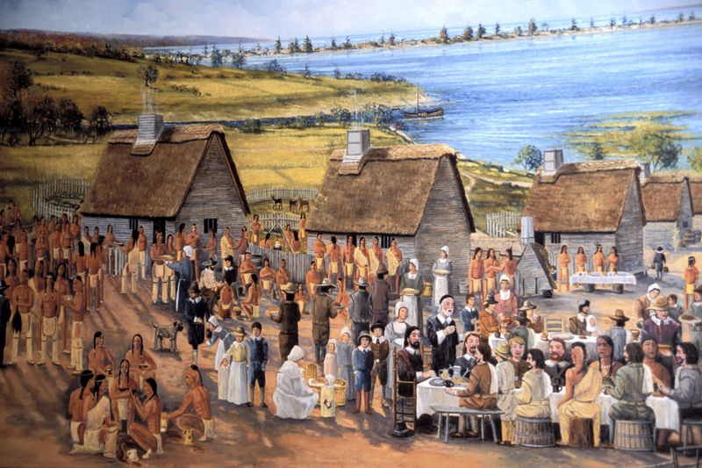

This image was created recently to show a more accurate picture of what the Pilgrim and Wampanoag thanksgiving was like.

SOURCEBOOK 3-5.A

Choose Your Own Adventure: The Puritans
Choice 1: Go On “The Arabella”? (Source 1)
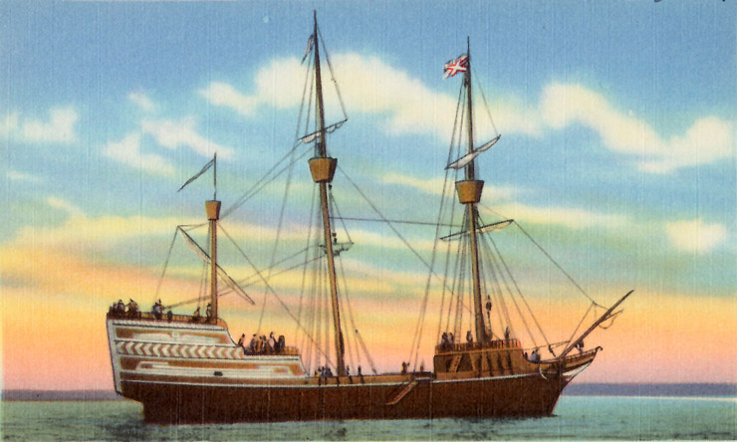

You are English and live in London. You believe that the Church of England is not doing things right. You call yourself a Puritan, because you want to make the Church of England more “pure.” For instance, you want pictures of saints to be removed from the church walls and demand that no one be able to work on the Lord’s Day (Sunday). These changes in religion and church are not popular with most English people. A group of Puritans tell you that they plan on taking a ship, called The Arabella, to New England in America and start a colony where they make all the religious rules.

If you would join them, give a thumbs up. If not, thumbs down.
Choose Your Own Adventure: The Puritans
Outcome: Meet John Winthrop (Source 2)

Those students who chose to stay in England, over time your religious views become so unpopular that people stop calling themselves Puritans.

Those students who decided to journey to America, meet your new leader, John Winthrop (below). He is a minister and very religious. He tells people what to do and believes God wants the English to convert the Indians to their religion (even if the Indians do not want that). In fact, the Massachusetts Bay Colony’s symbol (below) has a picture of an Indian saying “Come Over And Help Us” because of this (many Indigenous people said that’s wrong).
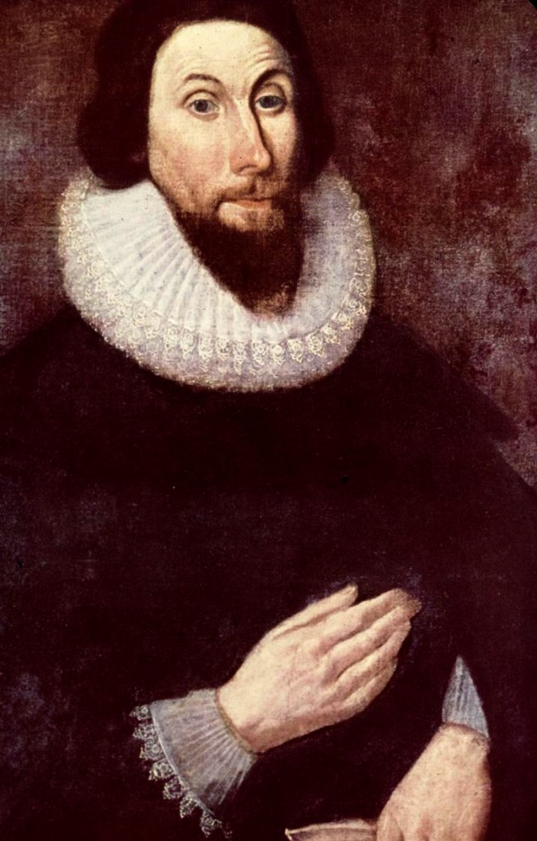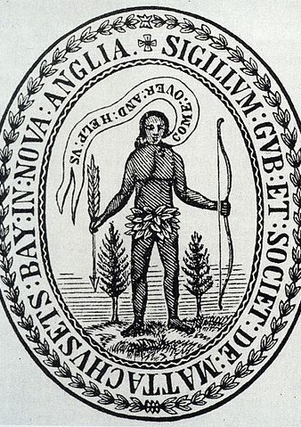
Choose Your Own Adventure: The Puritans
Choice 2: Where to Live? (Source 3)

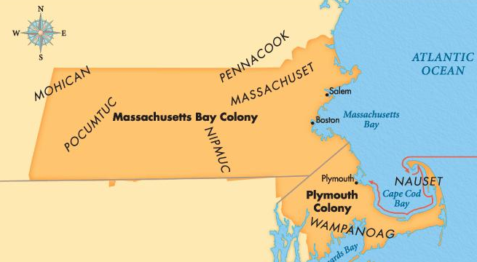

Once the ship The Arabella arrives in New England, the Puritans need to find a place to live. There is another religious group, the Pilgrims, who live in Plymouth. They have different religious views and it might lead to fights. There are some other English fishermen who have settled in Salem. There is also the area of Boston, where no English people currently live and there is good fresh water from a nearby river. The local Indigenous people are listed in all capital letters.

Now vote for one, Plymouth, Salem, and Boston.
Raise your hands if you would like to settle in Plymouth.
Raise your hands if you would like to settle in Salem.
Raise your hands if you would like to settle in Boston.

Choose Your Own Adventure: The Puritans
Outcome: Boston and Indigenous People Displaced (Source 4)

The Puritans would choose to settle in a place they named Boston in a colony they called Massachusetts Bay (named after the local Indigenous people). The result of that decision was to force out the Massachusett Indians, who had been living there for a very long time. The Puritans then began “converting” or making the Massachusett become Christian (some by choice and others by force). Below is a picture of a Puritan reading the Bible to the Massachusett.

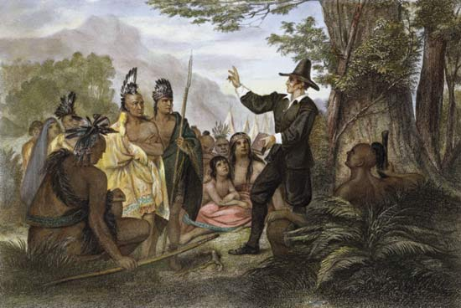
A picture of John Eliot telling the Massachusett (the Indigenous people) about Christianity in Dorchester (near Lower Mills) in 1646.
Choose Your Own Adventure: The Puritans
Choice 3: Choose A Leader (Source 5)

John Winthrop reads a speech called “Citty Upon a Hill” to the Puritans.

God will be among us. Ten of us shall be able to stop a thousand of our enemies. … The Lord make this place like a New England. We should be a city upon a hill. The eyes of all people of the world are on us. … Our prayers to be turned into curses until we do what God wants us to.

The colony is run by men and they only allow men to vote (some women said that’s wrong-we will learn about Anne Hutchinson later). Two men run, John Winthrop, you know what he thinks, and Thomas Dudley, who just started a new church down the road in New Towne. He is even more religious than Winthrop and wants to make more religious rules. Let’s vote.

Raise your hands if you vote for Winthrop.
Raise your hands if you vote for Dudley.

Winthrop Dudley
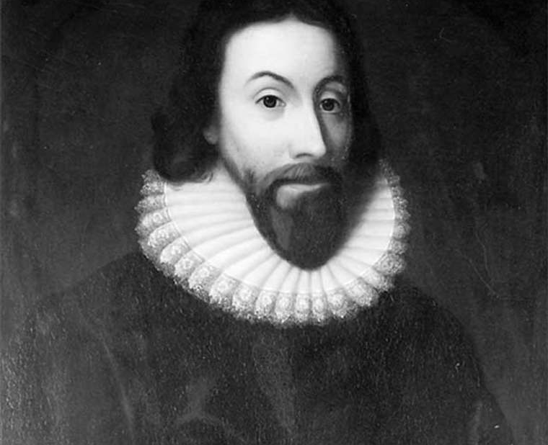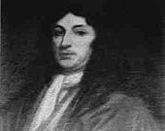
Choose Your Own Adventure: The Puritans
Outcome: Winthrop Wins (Source 6)
Choice 4: Choose Rules

The Puritans in Boston choose Winthrop. Winthrop says that since we are a “city upon a hill,” we should have rules that our God would like. He and the other men start drafting the “Massachusetts Body of Liberties.” Which of these rules would you support? After reading each, give thumbs up for laws you support, and thumbs down for laws you disagree with.

Law 1: Only free men should be leaders (no women or enslaved people allowed).

Law 2: Anyone who is found to be a witch shall be punished with death.

Law 3: All Catholics, Quakers, and non-Christians are banned from the colony.

Law 4: It is illegal to celebrate holidays.

Law 5: There are to be no pictures of Jesus, crosses, or other religious symbols.

Law 6: Anyone who violates these laws will be punished by banishment (kicked out of the colony) or death.

Choose Your Own Adventure: The Puritans
Outcome: All the Rules Were Voted Yes (Source 7)

The Puritan men voted yes on all those rules. The Puritans made a safe place for other Puritans to live (as they were treated poorly in England). They also made a colony that said many people were not allowed to live there and they would kick out (or worse) anyone who disagreed with their rules or practice their religion.

They wanted to make a perfect place based on their religion. They made it a goal to have all Indians believe in their religion (even if they did not want to). This caused many problems for the Indians.

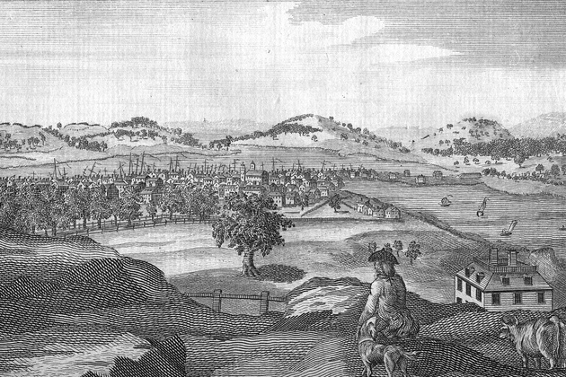
Drawing of Boston (looking toward Dorchester’s hills) from the colonial period.
SOURCEBOOK 3-6.A

Freedom of Religion: The Engel Court Case

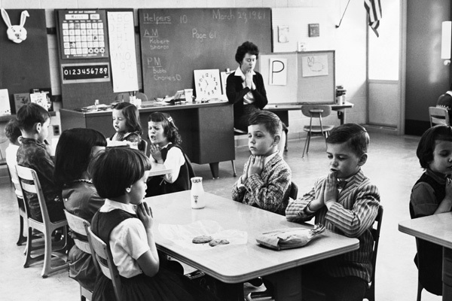

Before 1962, many public schools made all students say a Christian prayer called the Lord’s Prayer (or the “Our Father”). Steven Engel, who was a Jewish parent, thought it was wrong that his children were forced to say this Christian prayer. He sued the school. The case went to the Supreme Court and they said that the country was founded on religious freedom (First Amendment), meaning that no one can make you do something religious or stop you from practicing your religion. This means you can pray on your own, but no one can make you pray.

Why is it important that all people can practice their religion or not be forced to do religious things?

SOURCEBOOK 3-6.B

Source 1: Roger Williams: Founder

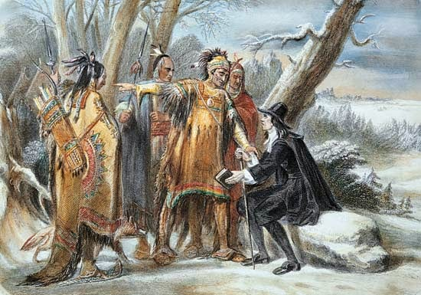

Roger Williams was born in England and sailed to Boston in his late 20s. He was very religious, but did not like how the ministers (religious leaders) in Boston told to him how to worship and pray. He also thought it wrong that the Whites did not buy their land from the Indigenous (Native) people. The ministers did not like these ideas and they banished (kicked out) him from the colony. He was protected by the Wampanoag people. Then he bought land from the Narragansett people and founded (started it) a town called Providence (meaning place where God protects you). He invited all people to live there and practice religion however they wanted. The new colony would not make religious rules.
SOURCEBOOK 3-6.C

Source 2: Roger Williams: Diplomat

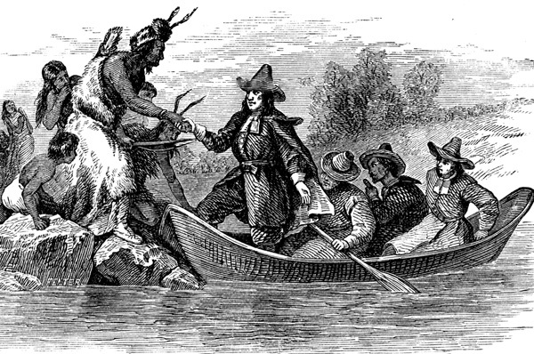

In his new colony of Providence, Roger Williams began a friendship with the Narragansett and Wampanoag people. He was a diplomat, or someone who communicated between two groups. He made rules that respected their way of life. He said Indigenous people to not become Christian, unless they wanted to. The Whites believed that God and the King gave them all of the land in America, but Roger Williams believed the land belonged to the Indigenous people. He made Whites in Providence pay them for it. When he heard that the Whites we planning an attack on the Pequot people (an Indigenous group to the west), he warned the Narragansett and Wampanoag to not get involved, which probably saved hundreds of people’s lives.

SOURCEBOOK 3-6.D

Source 3: Roger Williams: Linguist

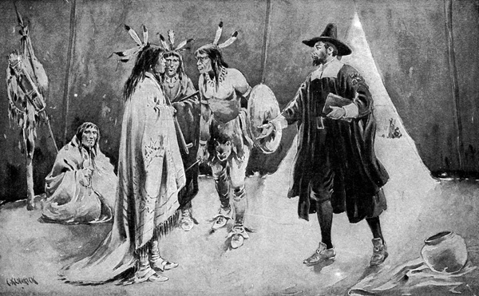

Roger Williams was a linguist or someone who studies languages. He taught himself Indigenous languages and wrote a book called “A Key into the Language of America.” He thought by learning Indigenous languages and treating them as equals, he could make peace. In his book, he wrote, “The brother Indian is by birth good. We are all of one blood. God made him, and me, and all.” He learned about how the Native people viewed religion, their families, their food, and their homes, and then taught other White people.

SOURCEBOOK 3-7.A

Source 1: Anne Hutchinson: Early Life

Anne Hutchinson was born in England. Her father was a minister and teacher, so he gave her a better education than most girls at the time and taught her a lot about the Bible (the Christian religious book). When she was 43 years old, her family, including her husband and children, moved to Boston. She started a home Bible study group, where women would go to her house and discuss religion. She said that it was important that “the older women would teach the younger women.” This group would grow to over 60 people and included men. She started asking questions about Boston’s ministers and their teachings.

SOURCEBOOK 3-7.B

Source 2: Anne Hutchinson: Preaching As a Woman/Trial

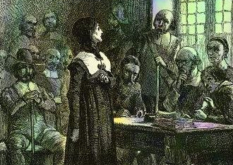

The leader of the colony, John Winthrop, charged (told she was doing something against the law) Anne Hutchinson with preaching (being a minister) as a woman. Only men were allowed to be ministers at this time in Boston. There was a trial. All of the judges were men. They convicted her of breaking the law. Winthrop wrote, “She had bad opinions, she will bring monsters to our colony.” They sentenced her to be banished (had to leave the colony).

SOURCEBOOK 3-7.C

Source 3: Anne Hutchinson: New Colony

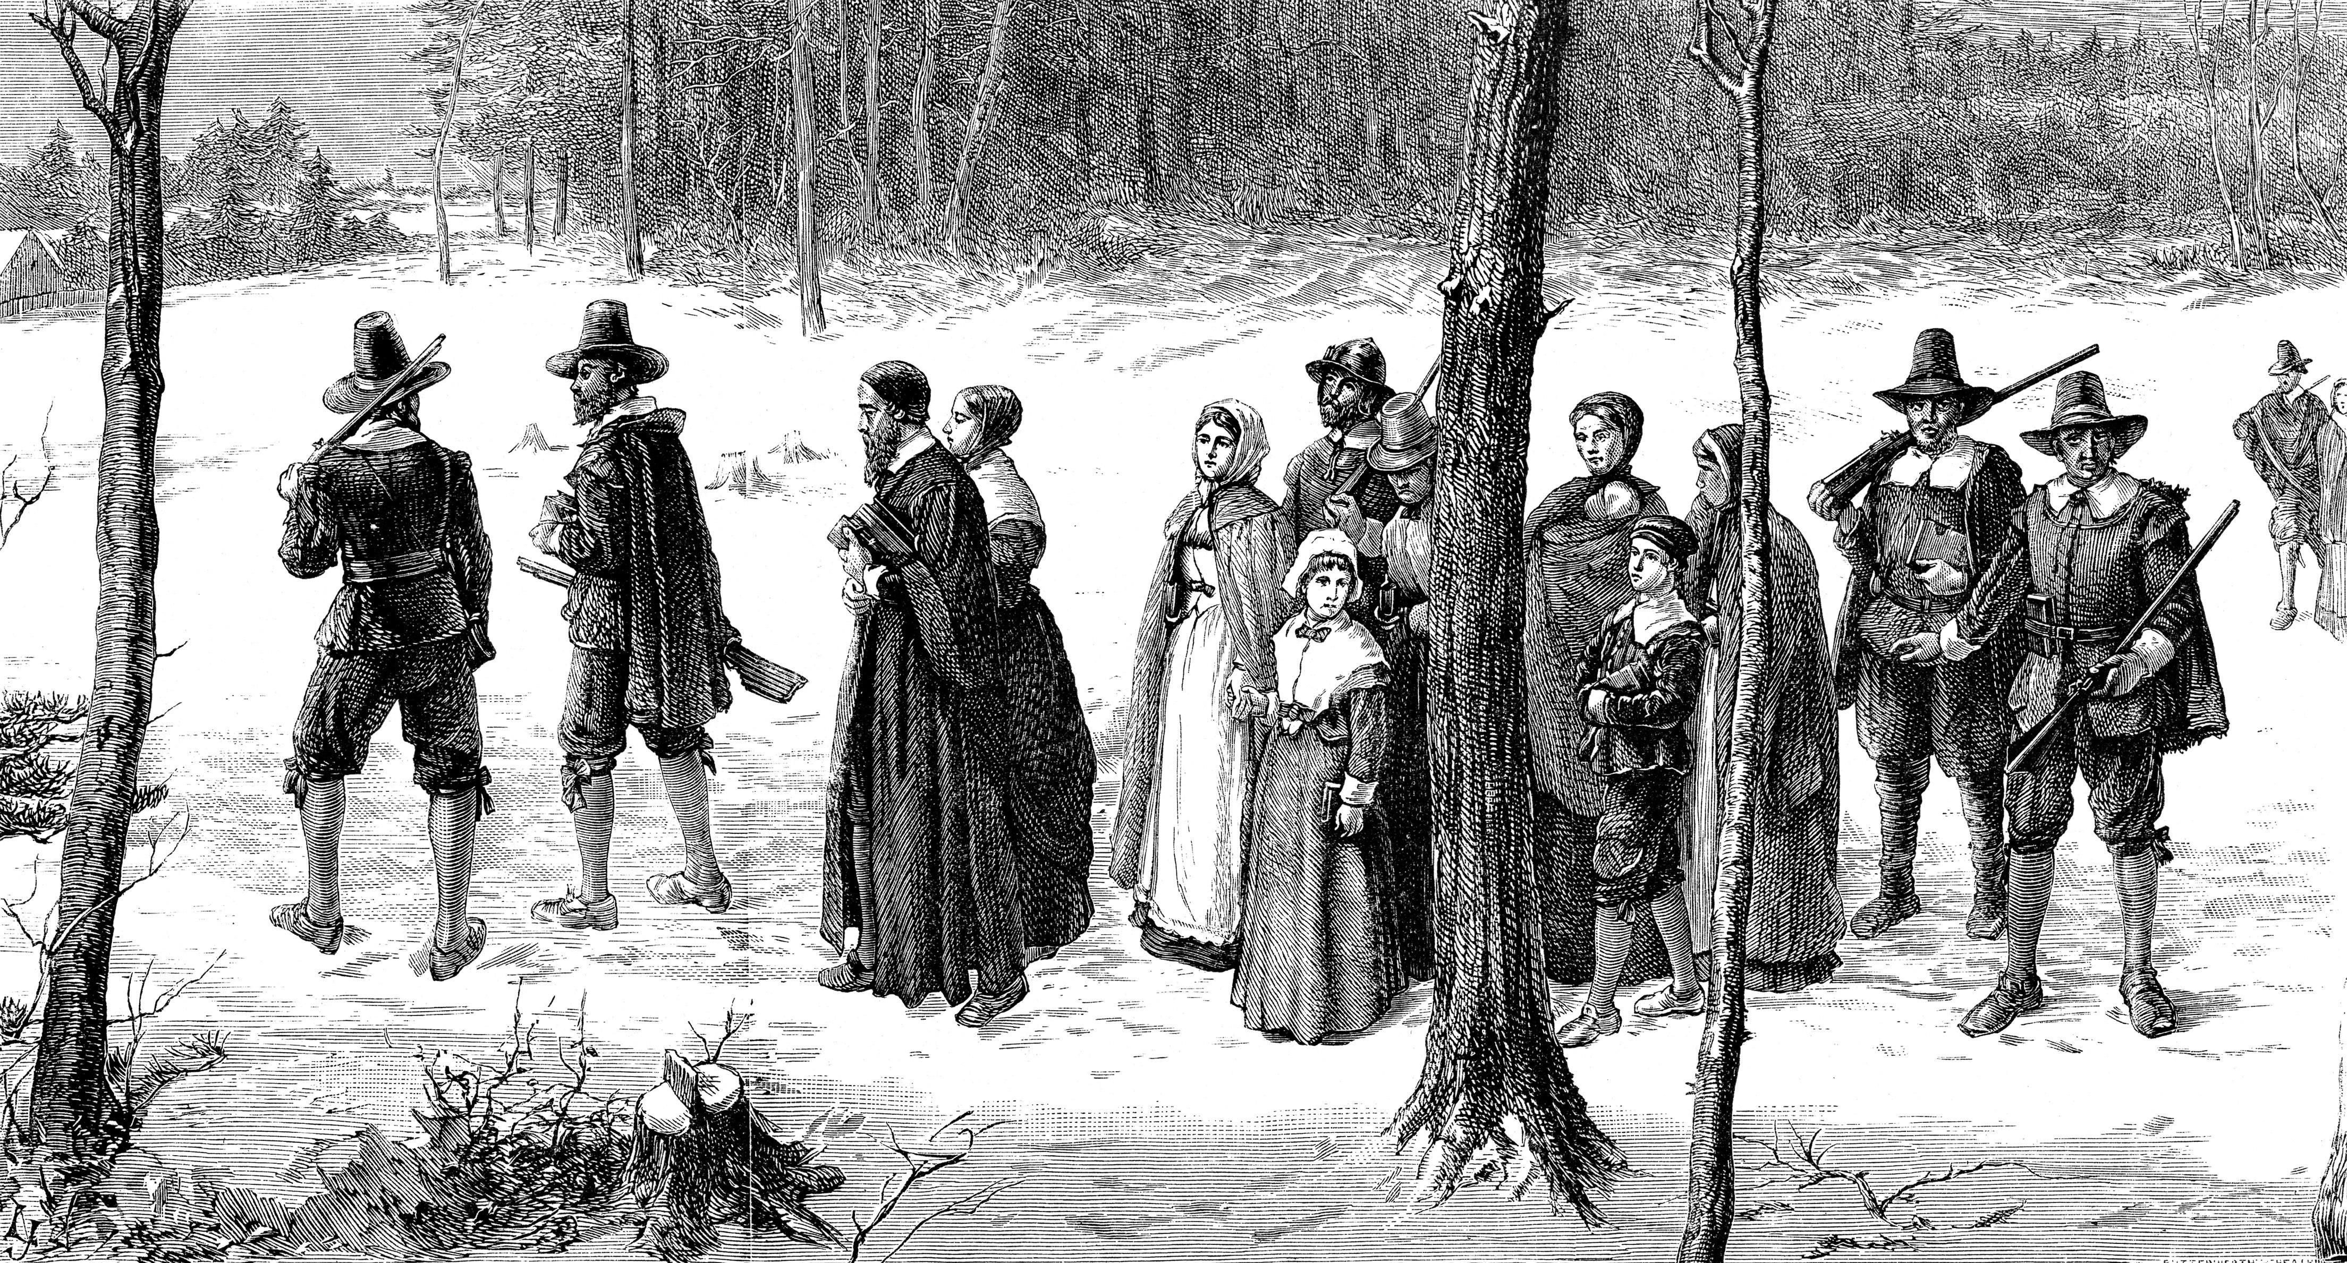

Anne Hutchinson and her family left Boston in 1638. Roger Williams (from the last lesson) let them stay in Providence for a while. They then moved to New Netherland (now the Bronx, New York) and built a house there. They invited other families to come there, if they wanted to change the way they did their religion and let women teach and preach about the Bible. She wrote, “Man cannot stop me. I am called here to do what is right.”

SOURCEBOOK 3-8.A

Images (A)

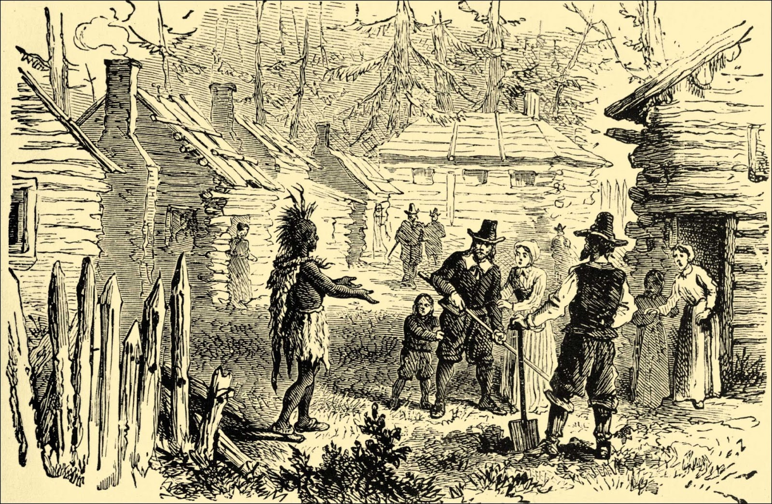
Images (B)

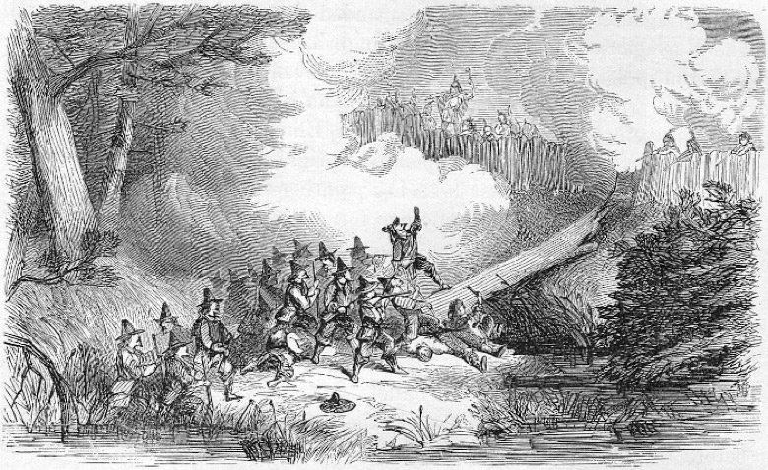
SOURCEBOOK 3-8.B

Source 1: Metacom/King Philip

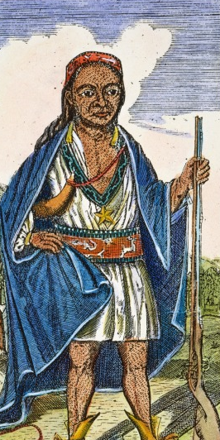
Metacom, who was called King Philip by the Whites, was the second son of sachem (leader) Massasoit of the Wamponoag. Massasoit was the Wampanoag leader who greeted and helped the Pilgrims.

Metacom grew up in a world where the English and Indigenous people lived relatively peacefully together. He would often dress in European clothes and spend time with White people in Boston.

Whites believed that land should be owned by people. The Wampanoag believed that no one could own the land, like no one can own the air or water. This would cause many problems. Whites began building fences and grazing cows. Many of those cows would break lose and run through Wampanoag villages. Metacom raised concerns about this to the Whites, but they ignored him.

To protect themselves, Metacom began forming friendships with other Indigenous people, including the Naragansett, Abenaki, Nipmuc, and Mohawk. Hearing this, the Whites demanded that the Wampanoag give up their guns. Worried that soon his people would be taken over by the Whites, Metacom decided to attack the Whites. The Whites would attack back. It turned into a war that lasted a year. In the end, 3,000 Indigenous people, including Metacom, and 600 Whites were killed. Metacom’s family would be sold into slavery and sent to Bermuda. The Whites would win and force most Indigenous people into Praying Towns, where they had to learn English and become Christian.

SOURCEBOOK 3-8.C

Source 2: “Too Many People” Perspective

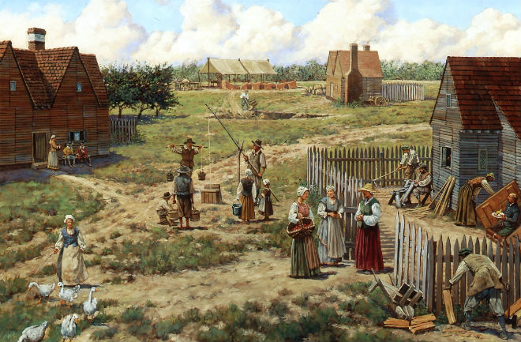

Some people argue that after the Whites settled in New England, there were just too many people living near each other. Whites had a very different way of life (grazing cows, farming) and laws that banned non-Christians. The Whites did not believe the Indigenous people were equal to them. The only way that the two groups could have lived together was if they lived apart.

Edward Randolph, a White person who visited New England on behalf of the British King, wrote, “If the leaders of Boston did not settle here to make the Indians Christian, then this would have never happened.”

SOURCEBOOK 3-8.D

Source 3: “Disrespect” Perspective

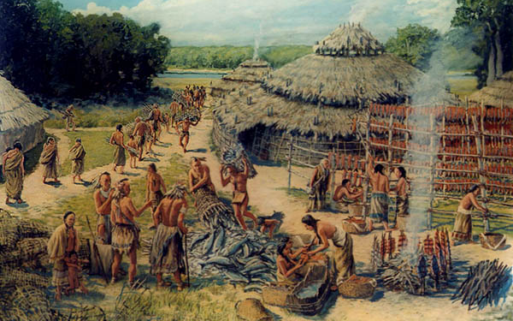

The Indigenous people were the first people to live in the area that became New England. They had their own beliefs, religion, and way of life (farming, hunting, fishing). When the Whites moved there, the Indigenous people helped them from starving. 40 years later, the Whites forgot the kindness and help that the Indigenous people gave them. They disrespected their ways of life, did not share the land, and forced Indigenous people to become Christian.

Metacom told the White person John Easton before the war, “They said that they had done no wrong; the English wronged us. We do not want war. We want the English to stop forcing Indians to be Christian and stop killing our crops with their cows.”
SOURCEBOOK 3-9.A

Source 1: John Adams

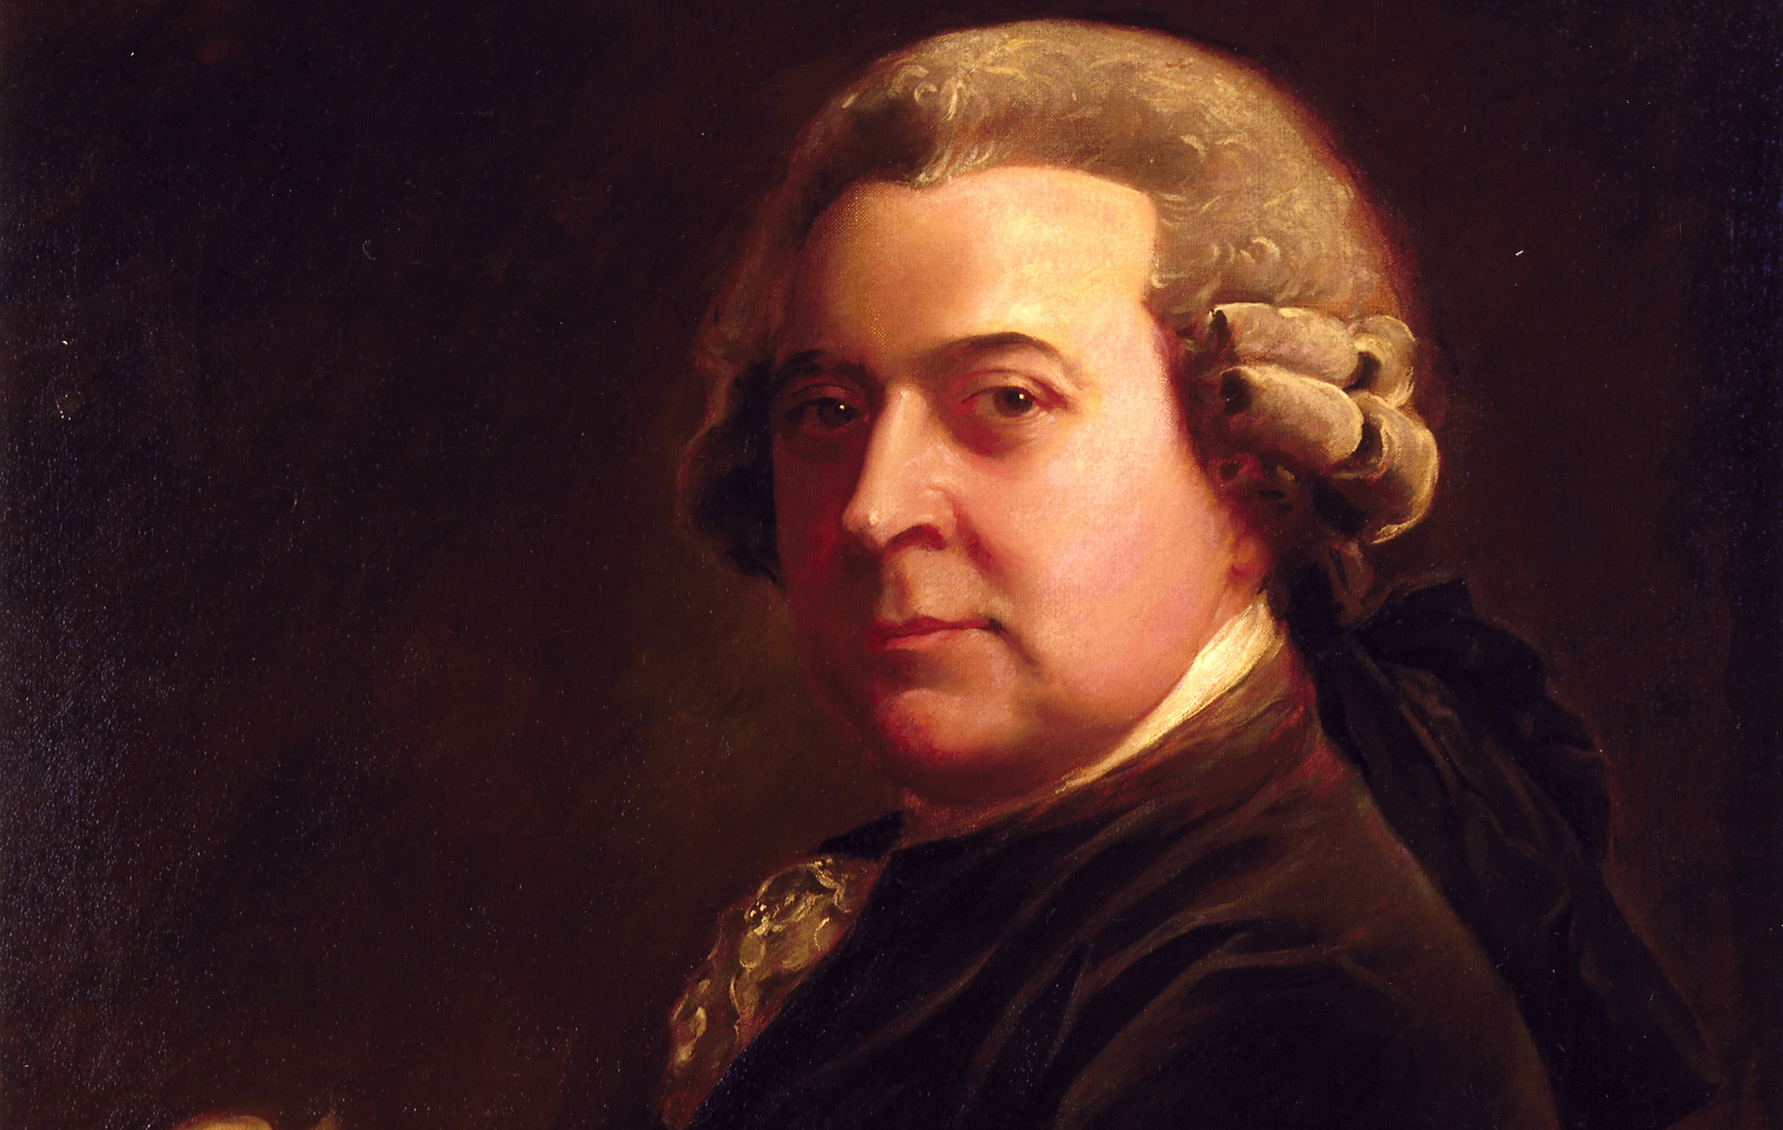

John Adams (who was cousins with Samuel Adams) opposed many of the taxes that were placed on the colonists by the British Parliament (their government), because the colonists did not have any representatives there.

John Adams was upset with the British, but he also wanted everyone to have fairness. He said the courts should be used before violence. For example, when five colonists were killed by British soldiers, he was their lawyer and they were found not guilty. He wrote, “Facts are stubborn things; no matter our passions, they cannot change the facts. … It is important the innocent are protected, and the guilty punished.”

Representative: Someone who speaks for you in the government.

SOURCEBOOK 3-9.B

Source 2: Samuel Adams

Samuel Adams (who was cousins with John Adams) opposed many of the taxes that were placed on the colonists by the British Parliament (their government), because the colonists did not have any representatives there.

Samuel Adams formed a secret organization called the Sons of Liberty. The Sons of Liberty organized protests against the British Parliament, including boycotts (stop buying taxed products) and the Boston Tea Party, where taxed tea was dumped into Boston Harbor. He wrote, “It does not take a many people to make change... but instead a small group of people, who set brushfires of freedom in the minds of men.”

SOURCEBOOK 3-9.C

Source 2: John Hancock

John Hancock opposed many of the taxes that were placed on the colonists by the British Parliament (their government), because the colonists did not have any representatives there.

John Hancock made money off of shipping goods in boats and was one of the wealthiest men in America. He formed smuggled goods (secretly shipped them without anyone noticing) to avoid paying taxes. He wrote, “The greatest thing that being in business can do is get along with others and influence their actions.”

SOURCEBOOK 3-9.D

Source 4: Paul Revere

Paul Revere opposed many of the taxes that were placed on the colonists by the British Parliament (their government), because the colonists did not have any representatives there. He used communication, pictures (see other page) and words, to show the problems of Boston.

Paul Revere also famously rode through the streets yelling “The regulars are coming!” (not “the British are coming”) to warn everyone, that soldiers were marching through the streets.

SOURCEBOOK 3-10.B

History of Slavery in Massachusetts

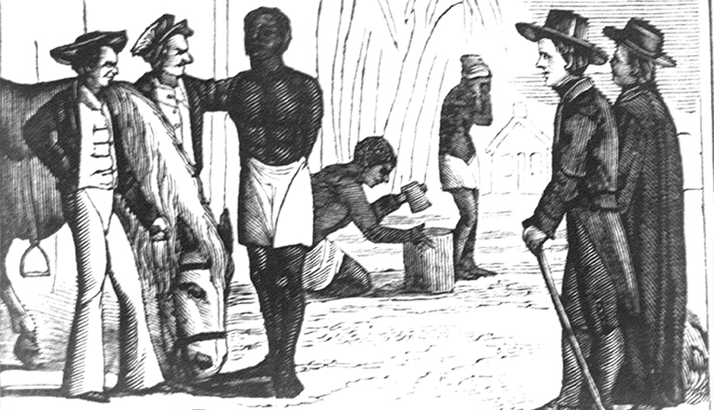

Slavery, which means to own another person and make them work for you without pay, began in Massachusetts when the Europeans arrived. At first, Europeans enslaved some Indigenous (Native) people. In 1636, Europeans brought the first enslaved African people to Massachusetts (shown in the above picture) on the ship “Desire.” Massachusetts then became the first colony to make laws allowing slavery. Many White Boston merchants (business owners) started to ship and trade enslaved Africans, especially to the southern colonies where large farms needed many workers. This made the merchant slave traders very rich. The number of enslaved Black people in Massachusetts grew from 200 in 1676 to 4,500 by 1754. In that year, there were 31 enslaved people in Dorchester, including 18 men and 13 women.
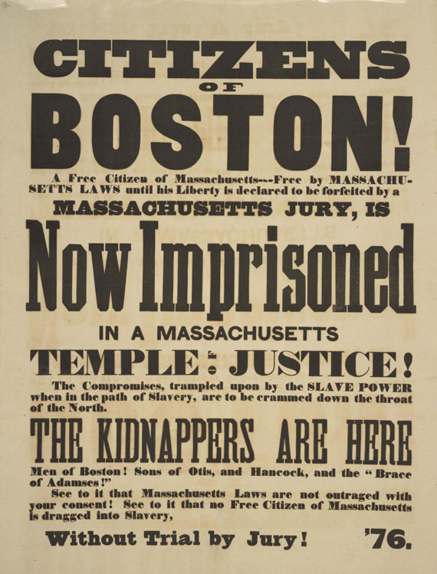

By 1780, abolitionism (people trying to stop slavery) was growing in Massachusetts. The state put in its new Constitution, “All men are born free and equal” and judges ruled that all slavery was illegal. This made Massachusetts an important stop on the Underground Railroad, which were houses used to secretly hide and help enslaved people escape and prevent slave catchers from finding them. Many abolitionists, including Frederick Douglass, started to give speeches about ending slavery. Many White people did not support abolition. At one rally in Boston (pictured above), when Douglass was speaking, a pro-slavery man interrupted yelling hateful words and then pro-slavery men rushed the stage and tried to hurt Douglass. When the Civil War started over slavery, Massachusetts would send the first regiment of Black soldiers to fight. When the last slave was freed on June 19, 1865 (a holiday called Juneteenth), many Massachusetts abolitionists celebrated and then started work to help the former slaves and have racial equality.

SOURCEBOOK 3-10.C

Source 1: Frederick Douglass

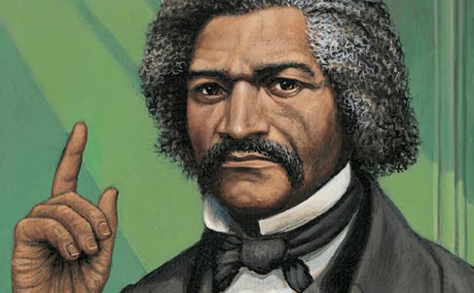

Born a slave in Maryland, Frederick Douglass ran away to freedom when he was 20 by hiding on a north bound train and then ship. He would settle with his wife in New Bedford, Massachusetts. He would write three different versions of his autobiography, which told the word about his life, but also how bad slavery was. His book was widely read and he started giving speeches all around the country and world. In one speech, he said, “This is the Fourth of July. It is the birth day of your National Independence. … But, this Fourth of July is yours, not mine. You may rejoice, I must mourn (cry). … because to me the American slave-trade is a terrible reality.” He disagreed with William Lloyd Garrison, because he believed that Constitution said slavery should not be allowed.
SOURCEBOOK 3-10.D

Source 2: Sojourner Truth

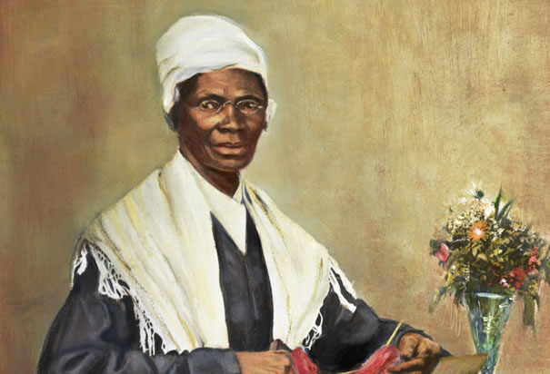

Born a slave in New York, Sojourner Truth ran away with her infant daughter to freedom when she was 29. In 1844, she would start a farm in Northampton, Massachusetts. All of the money they made from the farm would go to buying enslaved people and bringing them to freedom in the North. Like Douglass, she also gave speeches about her life. In one speech, she told everyone that she was treated more poorly than others because she was Black, she said, “Nobody ever helps me into carriages, or over mud-puddles, or gives me any best place! Ain't I a Woman?” She believed that religion, and especially Christianity, showed that slavery was wrong and should be ended.

SOURCEBOOK 3-10.E

Source 3: William Lloyd Garrison

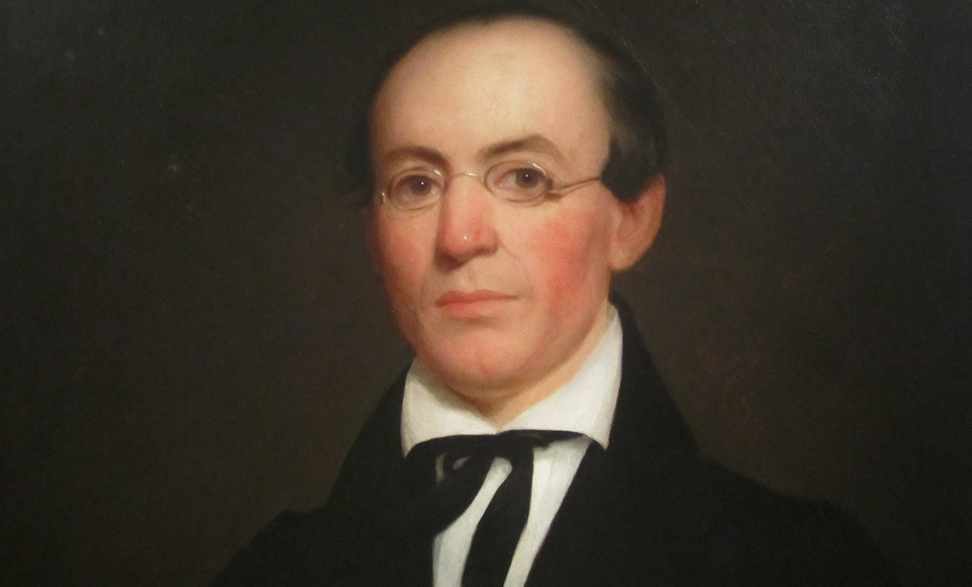

Born free (as were all White people) in Massachusetts. As an adult, he started working for a newspaper. He thought slavery was wrong and starting working with different groups to end it. He would later start his own anti-slavery newspaper called “The Liberator,” where he wrote, “Tell a man whose house is on fire to give a small alarm or a small rescue for his wife … I urge you to not be small in a cause like slavery. I will not move a single inch, and I will be heard.” Although they were friends, he disagreed with Frederick Douglass, because he believed that slavery could not be ended under the Constitution and that a new country of northern states should be made. He was so angry at the Constitution, at one meeting he burned copies of it in protest.

SOURCEBOOK 3-10.A

Images of the 2017 Women’s March in Boston

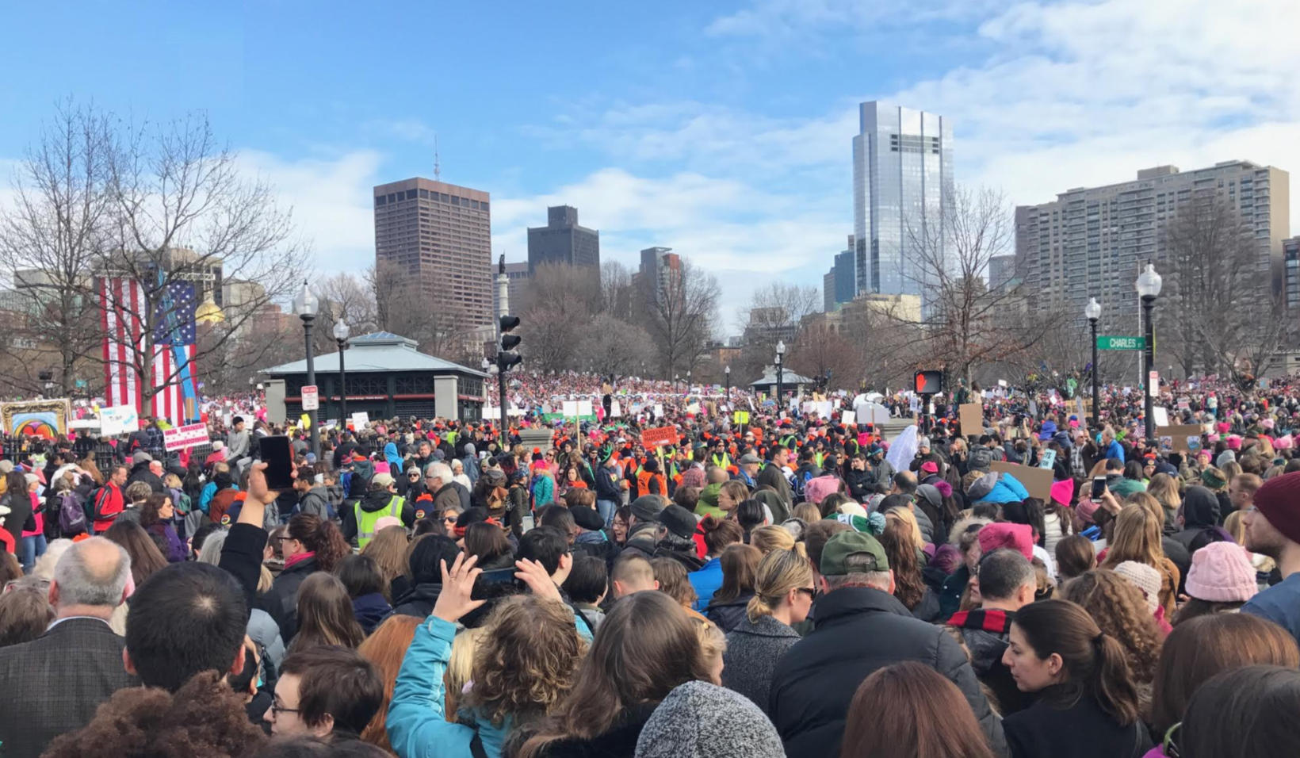

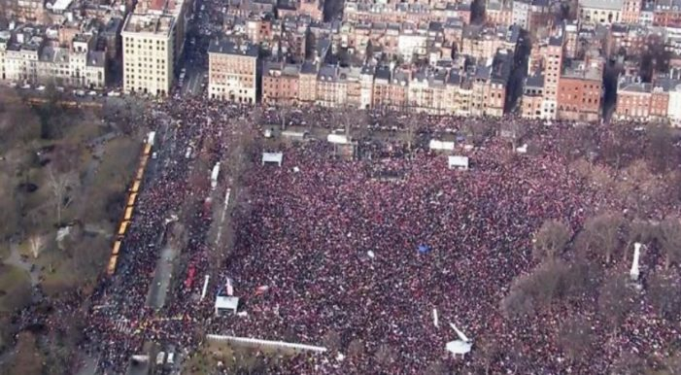

SOURCEBOOK 3-11.D

Corner Debate Information

Men are needed to help women be equal.

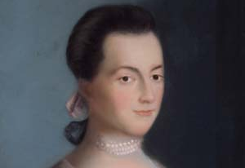

Abagail Adams was the wife of President John Adams and they lived in Braintree (now Quincy), Massachusetts. She believed that women will not be equal to men until men realize that it is wrong to treat women as unequal. In 1776, when her husband was working on the Declaration of Independence, she wrote him to say, men needed to “remember the ladies” and that if they don’t, women may have their own rebellion.

It is okay to break a law, if that law is wrong.

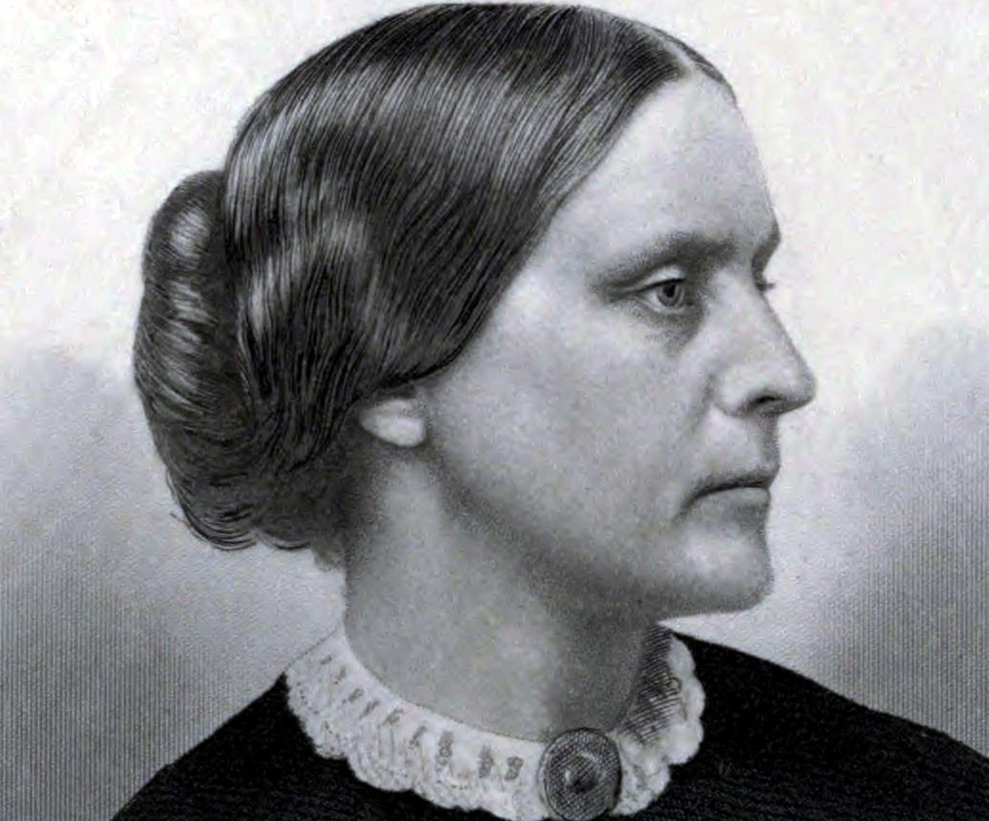

Susan B. Anthony was born in Adams, Massachusetts. As an adult, she started groups to push for equal rights for women. Women were not allowed to vote in 1872 and Anthony decided to vote anyway. She was arrested for voting in her hometown of Rochester, New York and convicted in a trial and ordered to pay a fine (which she refused to pay). She once wrote, “There never will be complete equality until women themselves help to make laws and elect lawmakers.”
The best way to make change it is to make a group and do it together.

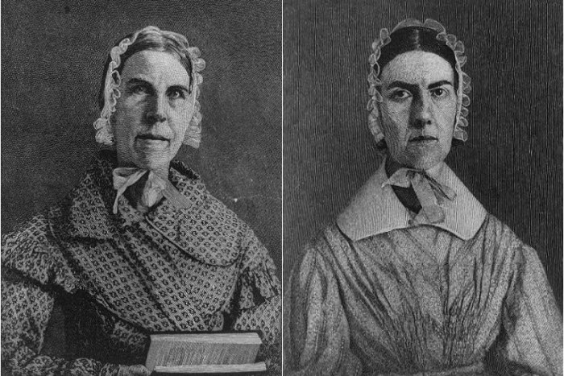

The Grimké Sisters, Sarah and Angelina, were born in South Carolina, where their father owned enslaved people. From a young age, they wanted to stop slavery and they secretly taught enslaved people to read. In their 20s, they moved to Philadelphia where slavery was illegal. In 1837, the sisters traveled to over 67 towns in Massachusetts collecting signatures on a petition that demanded the end to slavery. A year later, Angelina made a speech on the floor of the Massachusetts State House, where she presented a petition with the signature of 20,000 Massachusetts citizens who supported abolition. Angelina Grimké was said, “If a law commands me to sin, I will break it.”
Women do not need men to be successful.

Lucy Stone was born in West Brookfield, Massachusetts and moved to Boston as an adult. Her house was on Boutwell Street in Dorchester, just behind the Kenny Elementary School. Lucy was a teacher. Back then, women teachers were paid less than men and she protested. Stone believed that women did not need men to be successful. When she was married, she kept her last name (instead of taking her husband’s last name), she wore pants as a woman (which was not allowed at the time), and she collected petitions to allow women to vote. She created the “Women’s Journal,” which was a magazine to argue for women’s equality, which may be her most well-known action.

SOURCEBOOK 3-12.B

Mill Town Sources

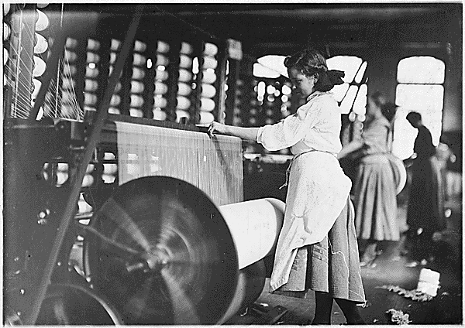

Picture of the Lowell Mills. Children were often used as factory workers, because they were paid less than adult workers.

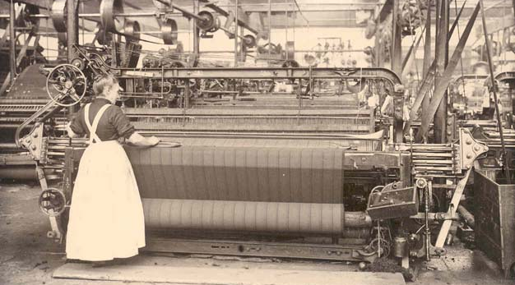

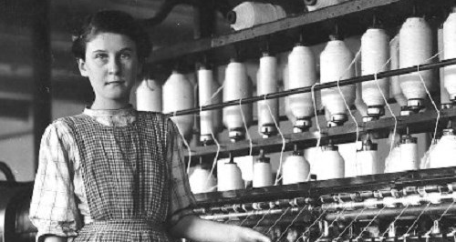
Picture of a power loom, which spun threads into cloth. These were very common in the textile factories across Massachusetts. These machines were very fast and not very safe. Many workers were hurt or even killed by them, when their clothes or hair become caught.

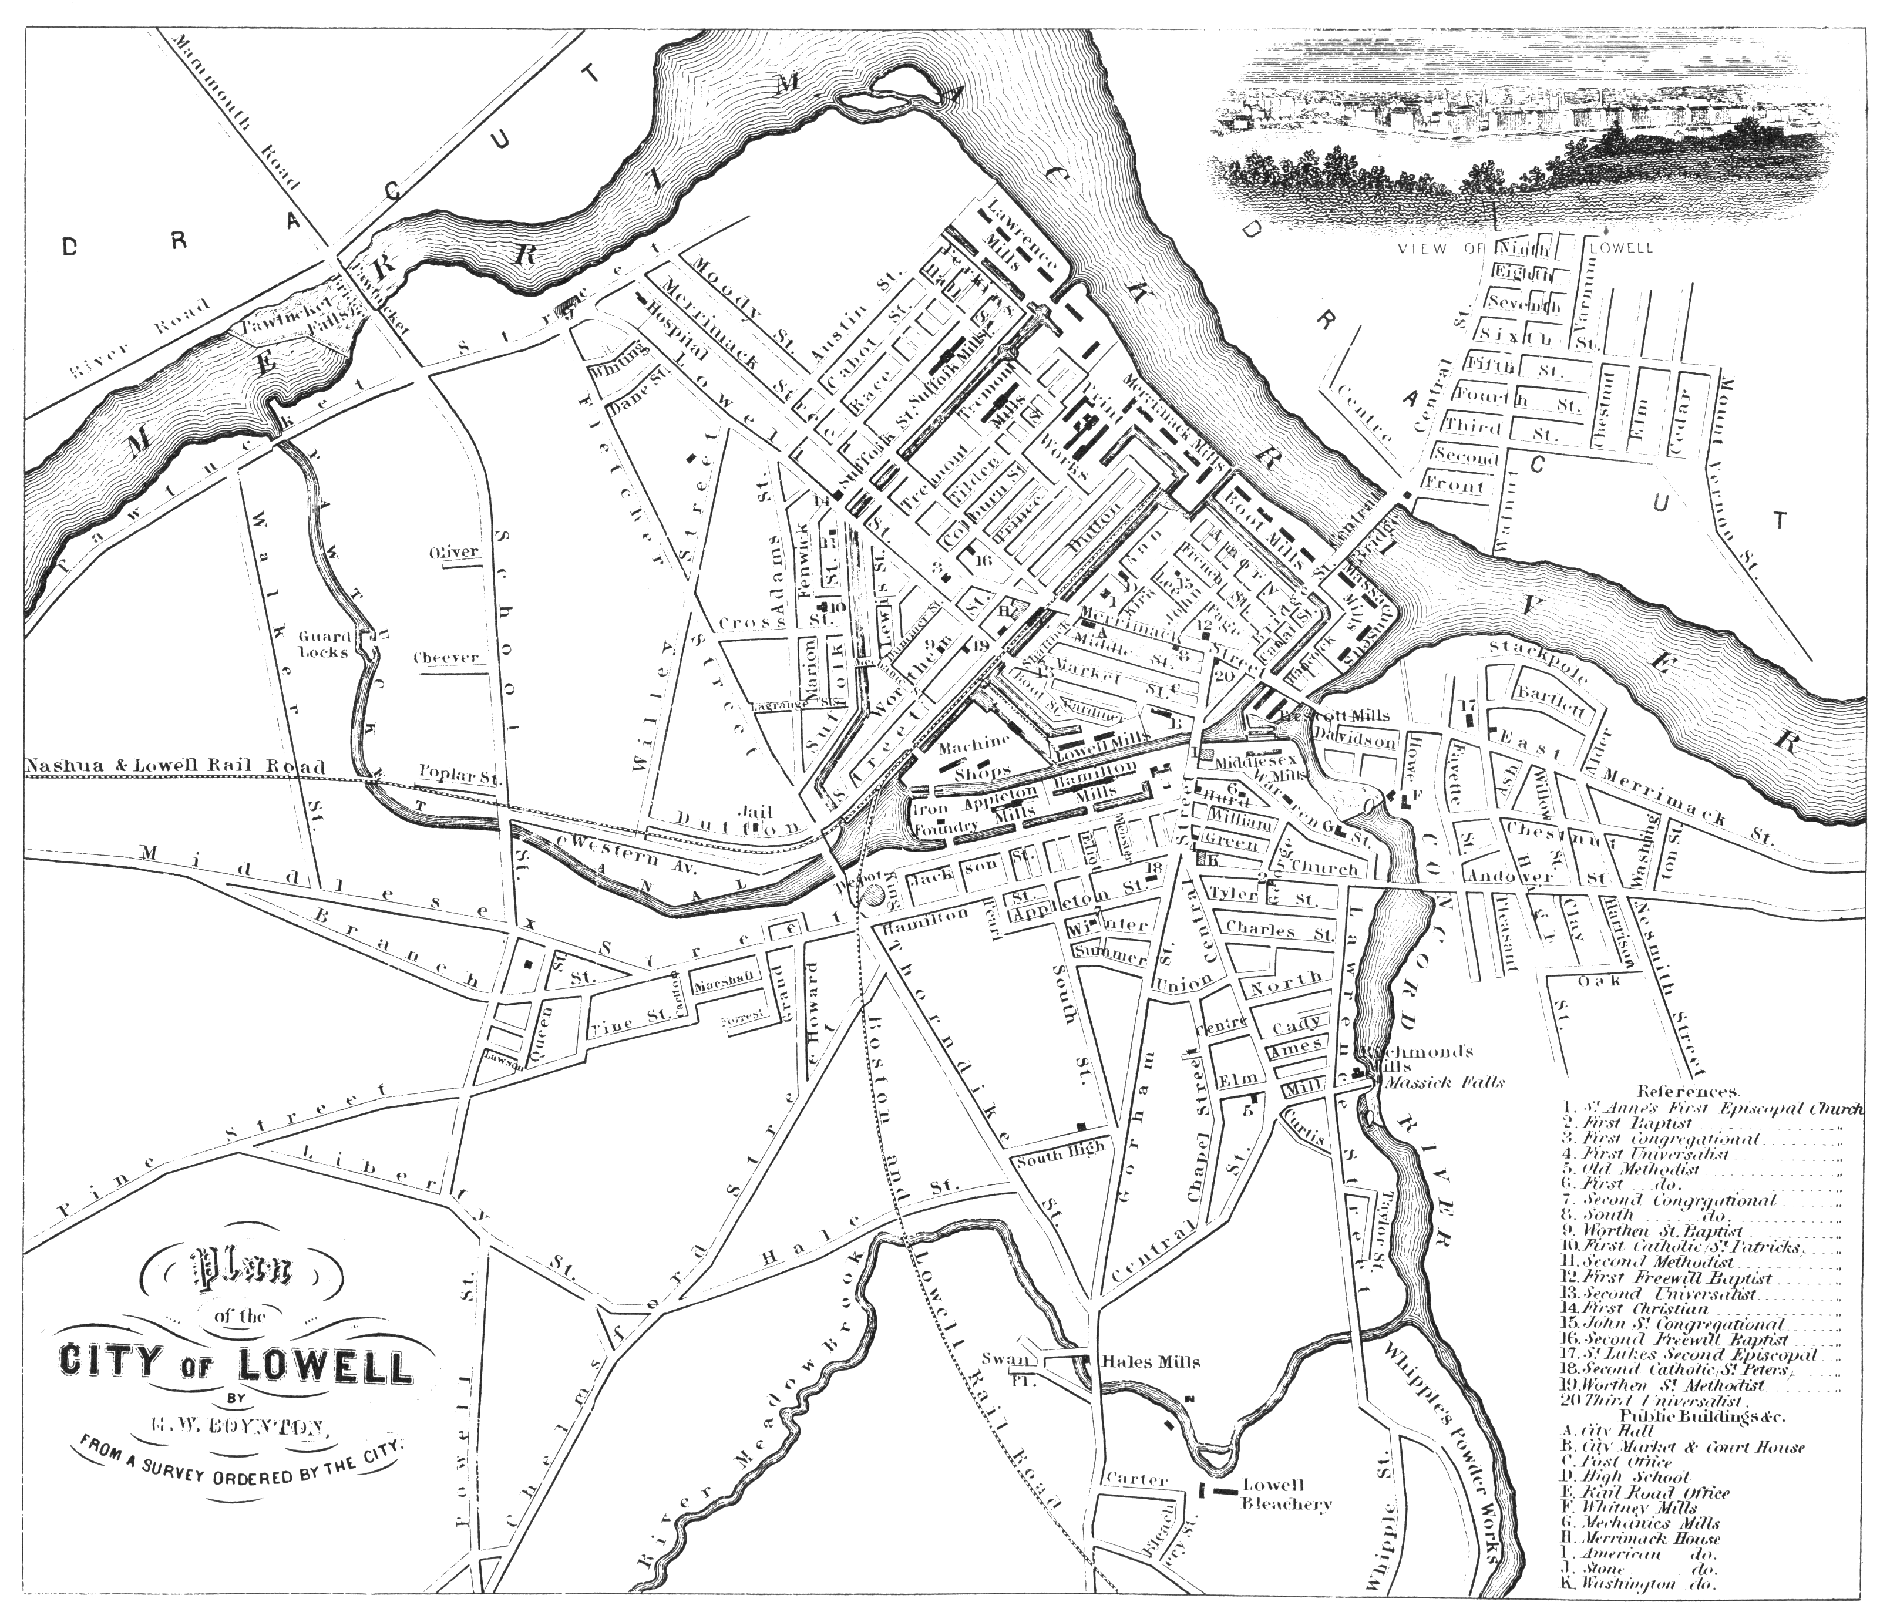
Over 40 years (1820s-1860s), Lowell went from a very small farming community into a city that produced more cloth than almost any other place. This map shows all of the many roads and factories that were in the city by 1845. Factory towns like Lowell allowed many grown children from struggling farming families to make additional money, which they often sent back to help feed their families. It also helped them do a job that was not as dangerous or tiring.

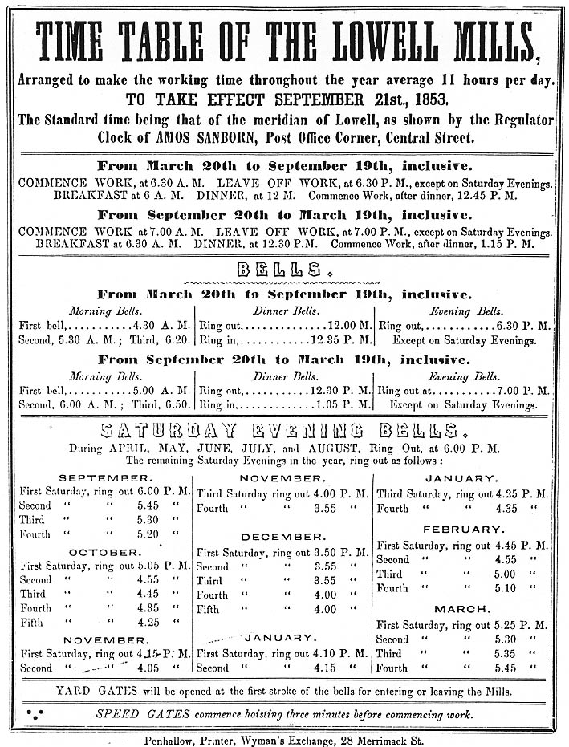

The mills had very strict rules. During certain times of the day, whistles would blow calling all workers to work, telling them it was break time, or that the work day was over. Workers had no control over when they worked and were not allowed to call out sick.
SOURCEBOOK 3-13.A

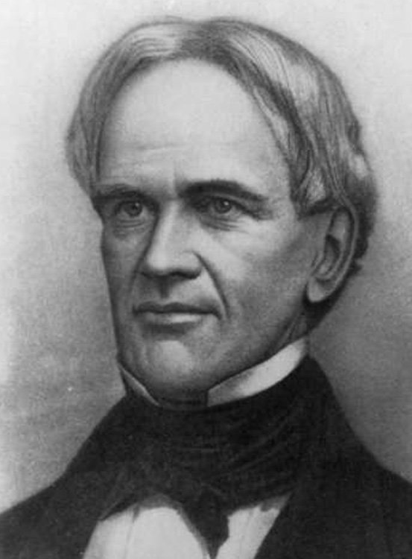

SOURCEBOOK 3-13.B

Six Principles for Public Schools

Horace Man published his six principles in his Common School Journal.

1. All people should not be ignorant (not know anything).

2. All people should have an education (school) paid for by the public (everyone).

3. The common school should teach both the rich and poor, so that they may learn together in harmony.

4. The common school should teach morals (right from wrong), but not teach one specific religion.

5. The common school should teach students to be part of a free society where they are citizens who make decisions.

6. The common school should have educated teachers who went to school to learn to teach.

SOURCEBOOK 3-13.C

Source 1: Education Paid for by Taxes

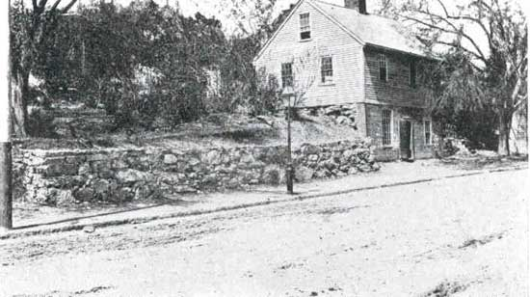

In 1837, Horace Mann made the state use more taxes to a pay for schools. Towns also began to collect taxes on all adults to pay for the school in town. Even if a person did not have children, they had to pay for the school, because it was good for the community.

The above picture is of the original Mather School in Dorchester (today it is on Meeting House Hill). It was the first elementary school in the United States. In the 1800s, it would become a common school, or a school for all children in the town (at one time all of the children in Dorchester went there).

SOURCEBOOK 3-13.D

Source 2: Education for All

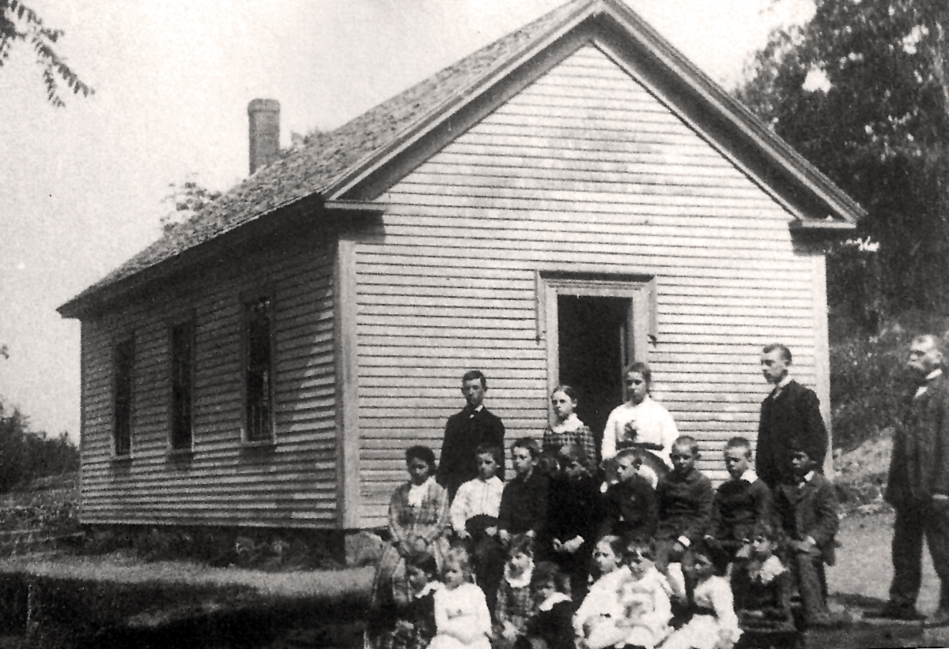

Horace Mann said, “Education, beyond all other things, is the great equalizer of men, the balance-wheel of the social machinery.” When he said this, he meant that education should allow people to be equal. He thought that once everyone was smart from school, they would be treated the same in their communities. Girls and poor children were often not allowed to go to school. Horace Mann argued that every single person in a town should get a free education. Horace Mann said girls and people will less money should get the same education as wealthy boys.
SOURCEBOOK 3-13.E

Source 3: More and Better Schools

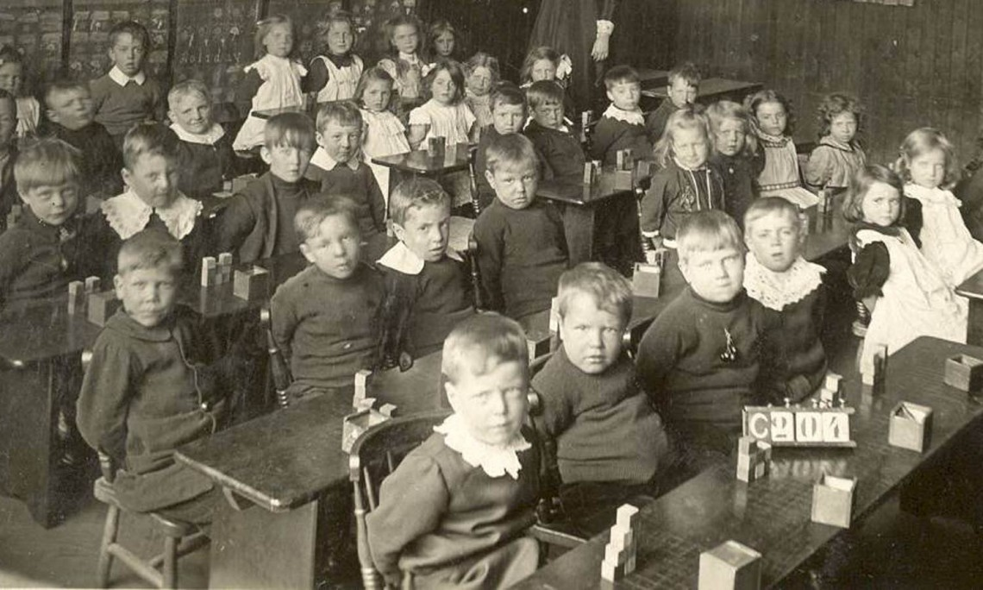

In 1852, Horace Mann helped Massachusetts pass the first law saying that children needed to attend a school for at least 12 weeks. This would later be changed to require all children go to school until they were 16 years old. Horace Mann also told towns that they needed better school houses, longer school years, teach more subjects (like history, geography, science, math, reading, and writing), and needed to pay their teachers more money.

SOURCEBOOK 3-13.F

Source 4: Schools for Teachers

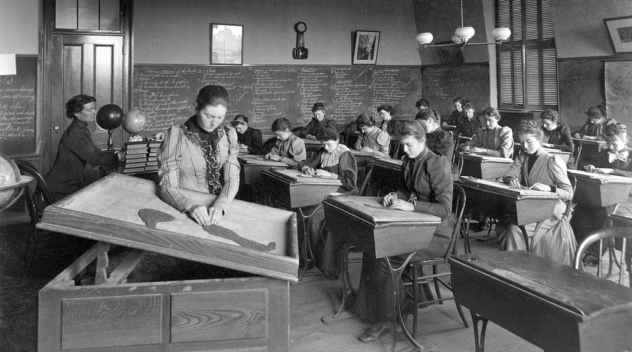

Horace Mann created the first teacher schools in Massachusetts. They were called “normal schools” because it was where teachers learned to teach the same way. The above picture is the normal school at Boston (now Massachusetts College of Art). There teachers learn how to teach students using the best lessons. They also did practice teaching before working with their own students. This made teachers better, because they learned how to teach before teaching students.
SOURCEBOOK 3-14.A

Source 4: Rubber (Goodyear)

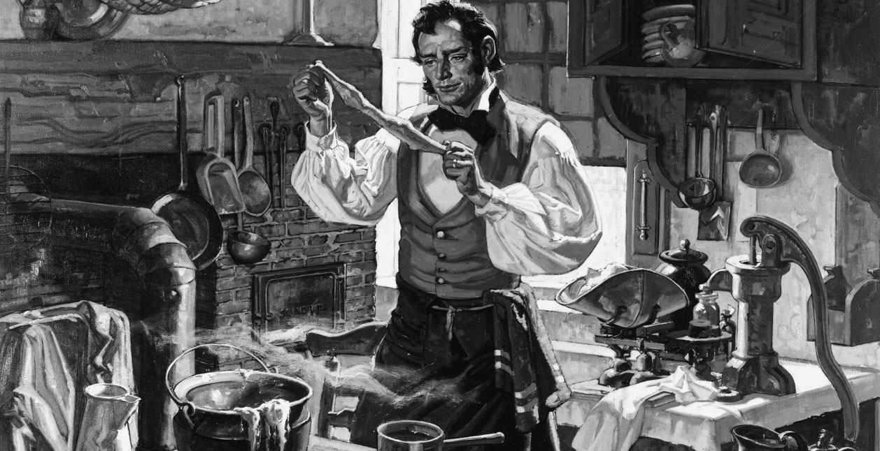

Indigenous people in the Americas had been using rubber to make waterproof clothes, containers, and even sports balls. In 1839 in Springfield, Massachusetts, a scientist Charles Goodyear mistakenly invented a process called “vulcanization,” which made the rubber stronger by adding sulfur. This allowed the rubber to be used in products such as tires (all wheels were wooden or metal before then), flooring, gloves, and numerous other things.
SOURCEBOOK 3-14.B

Source 2: Telephone (Bell)

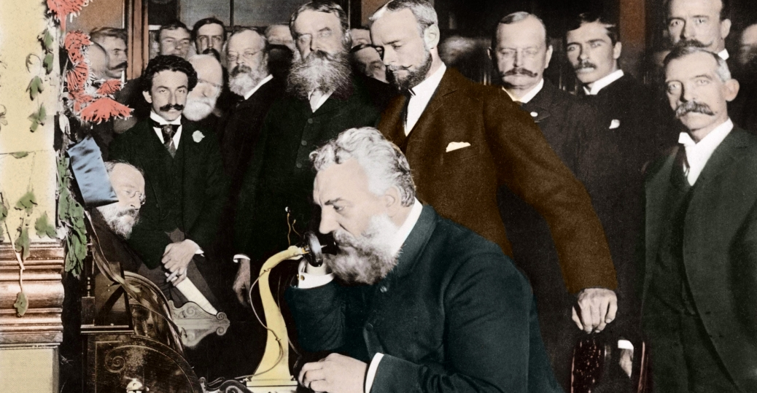

A scientist Alexander Graham Bell wanted to make a machine that would help Deaf people learn to speak. It would send an electrical current over a wire making the air vibrate. In 1876, in Boston, Massachusetts, he made his first call for an audience, famously asking his assistant, “Mr. Watson, come here, I want you.” This device would allow people to talk over far distances. He would later start the Bell Telephone Company (today AT&T).
SOURCEBOOK 3-14.C

Source 3: Rocket (Goddard)

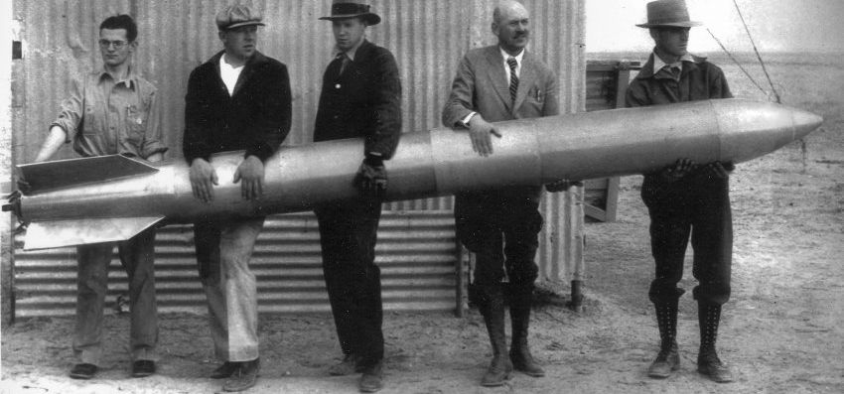

Chinese people had been making rockets since the year 1232, by putting gun powder in a tube. In 1926, in Auburn, Massachusetts, a scientist Robert Goddard discovered a way to put liquid fuel in a rocket. This allowed the rocket to be more accurate and less likely to explode. This would allow the rocket to eventually be able to carry people and objects (like satellites) into space. It also allowed countries to make dangerous rockets like missiles for war.
SOURCEBOOK 3-14.D

Source 2: World Wide Web (Berners-Lee)

In the 1960s, the U.S. military created a network where computers could talk to each other. In 1989, in Cambridge, Massachusetts, a scientist Tim Berners-Lee created the World Wide Web, which would link up files on computers using an address (http://www.name.country). This allowed people to look at files (later video and images) on a connected computer anywhere in the world. Today, the “web” is where many people communicate to each other and get information.
SOURCEBOOK 3-16.A

Image

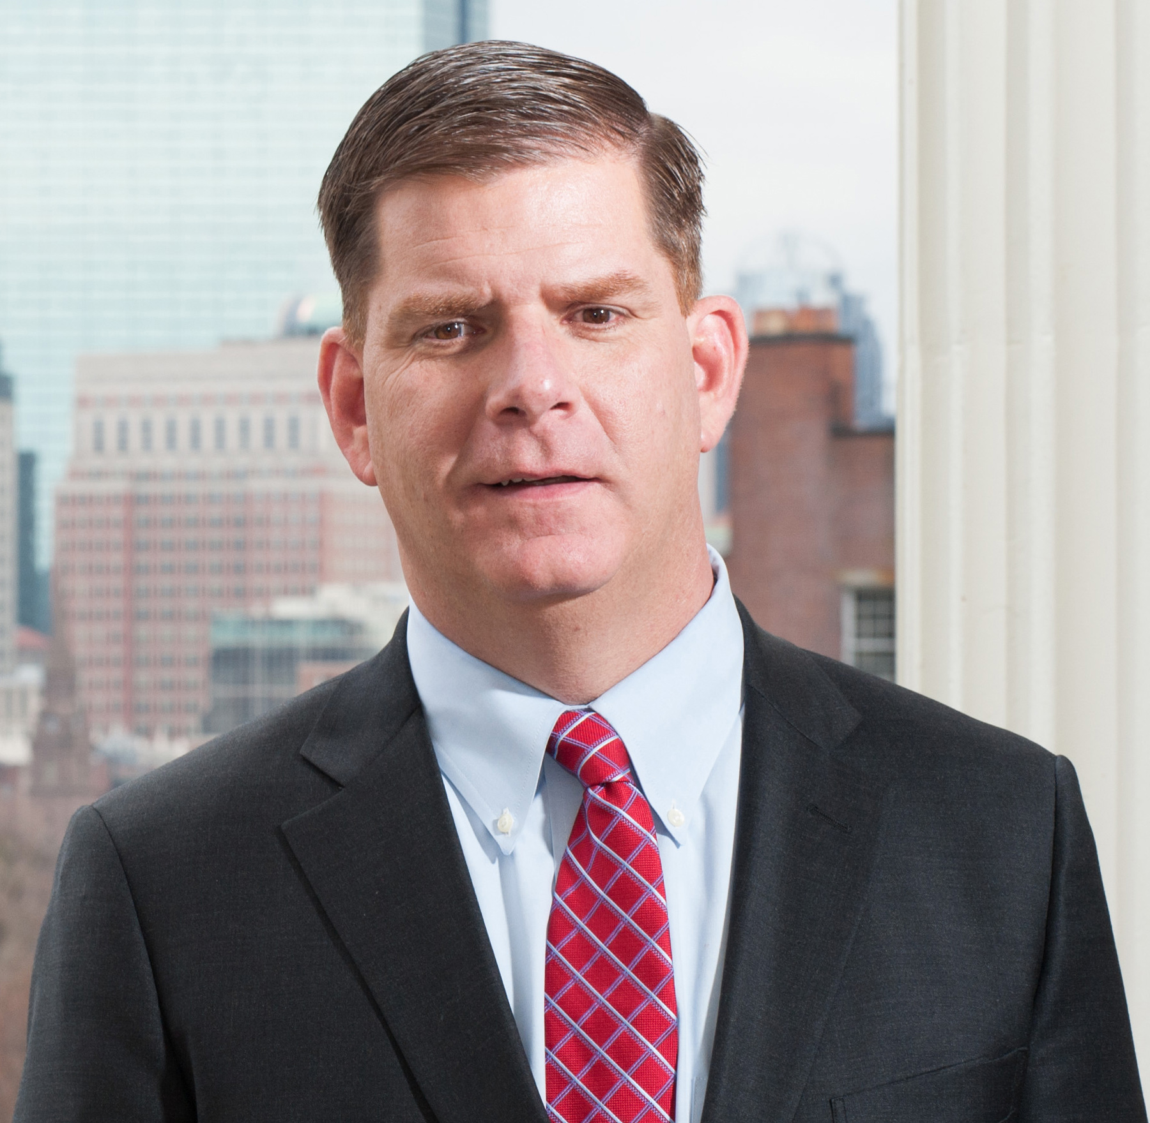
SOURCEBOOK 3-16.B

Mayor’s Responsibilities

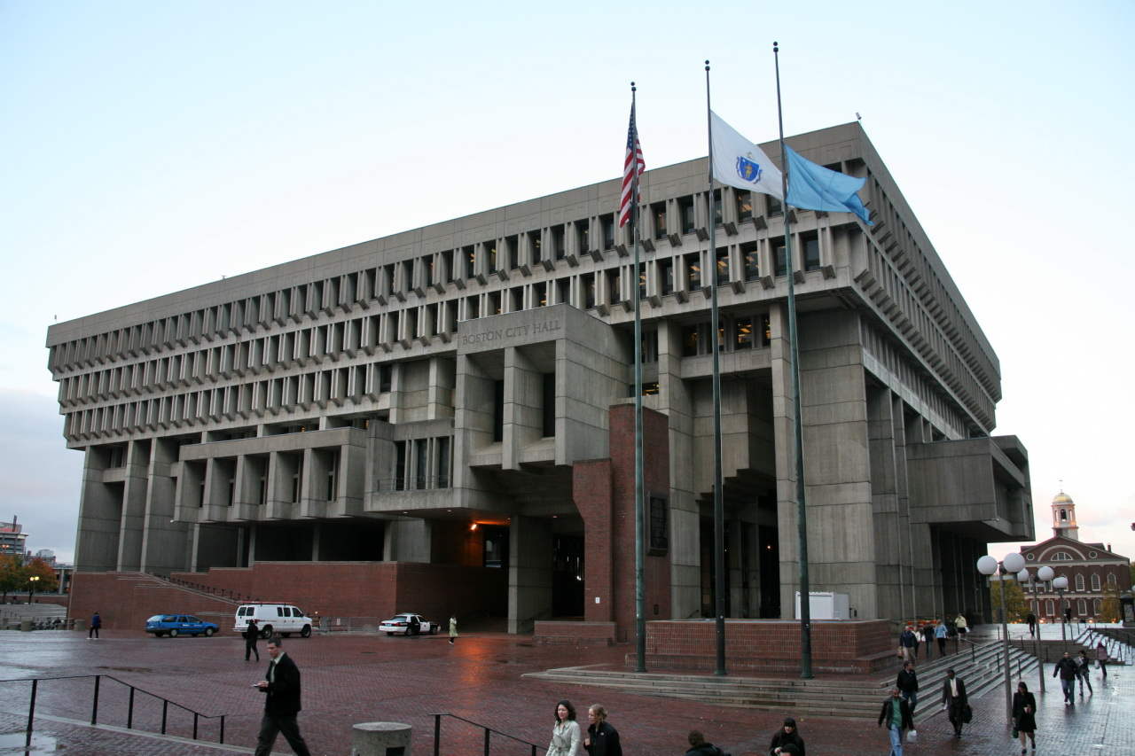

A mayor is in charge of running a city. She or he is elected to make sure that the citizens follow the city ordinances (laws or rules) and that all of the departments are doing their jobs. Boston has many departments, including schools, fire and emergency services (ambulances), police, public works (streets, lights, buildings, garbage), water and sewer, parks and recreation (playgrounds, pools, sports fields, natural areas), and tax collection. Many people work for these departments. The mayor also runs a hotline. You can call 311 or use an application on a cell phone to make a complaint or ask for something to be fixed.

SOURCEBOOK 3-16.C

Campaign Roles
Campaign Director
You are in charge of helping the mayoral candidate get elected. To do this, you will work with your candidate to make a platform, or a list of all the things she or he plans on doing as mayor. Write your platform on a lined piece of paper. Below is a list of the main departments in the city, which may help you think of ideas:
- Schools
- Fire and emergency services
- Police
- Public works (streets, lights, buildings, garbage)
- Water and sewer
- Parks and recreation
- Tax collection

Communications Director
You are in charge of advertising your candidate, so everyone knows to vote for her or him. To do this, you will work with your candidate to make at least one sign (more, if you have time) on poster board/chart paper that includes the phrase “Vote For” and the candidate’s name. You should also include images and reasons why they should be elected.

Field Director
You are in charge of getting ideas from voters and spreading the word about your candidate. To do this, you will first go around the room and ask students to tell you about the issues that they are writing about. You should then let the candidate and campaign manager know what issues are being listed by students. Next, you will go around the room and talk with students about why you think your candidate is a good person to vote for.

SOURCEBOOK 3-17.A

Source 1: Public Safety (Police and Fire)

Cities and towns have public safety workers who make sure everyone in the community is safe. Larger cities, like Boston with almost 700,000 people, need many public safety workers. This includes police officers, fire fighters, and paramedics. Police officers prevent crime and arrest people who break the law. Boston has about 2,100 police officers. Fire fighters put out fires and rescue people from accidents. Boston has about 1,500 fire fighters. Paramedics travel in ambulances and help people who are sick and cannot get to a hospital on their own. Boston has about 350 paramedics.

SOURCEBOOK 3-17.B

Source 2: Education (Schools and Libraries)

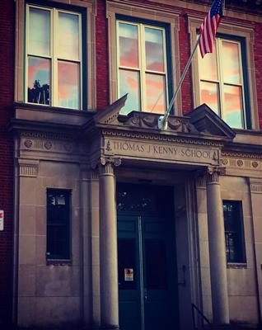

Cities and towns have education systems that help children and adults learn. This includes elementary, middle, and high schools, public colleges and universities, and libraries. Larger cities, like Boston with more than 56,000 students, need many teachers and librarians. Teachers teach students different subjects, like social studies, science, math, English, art, music, and physical education. Boston has about 4,300 teachers and 2,200 professors at its four public colleges: UMass Boston, Massachusetts College of Art, Roxbury Community College, and Bunker Hill Community College. Librarians help people find books and other items to help them learn. Boston has about 300 librarians to help the 3.7 million visitors at the United States’ second largest library.

SOURCEBOOK 3-17.C

Source 3: Parks (Playgrounds, Community Centers, and Natural Areas)

Cities and towns have parks and community centers to give their citizens a place to enjoy the outside and exercise. Larger cities, like Boston with almost 90 square miles, need many parks and community centers for its people. Parks often have playgrounds for children to play on, which include swings, slides, seesaws, and other structures. Parks also keep the land natural, so people can enjoy trees, rocks, ponds, and rivers. Community centers often have pools, meeting rooms, exercise equipment, sports gyms, and play areas. Boston has 167 park workers, who take care of 217 parks, 2 golf courses, 65 squares, 17 fountains, 75 tennis and basketball courts, 16 cemeteries, and approximately 125,000 trees.
SOURCEBOOK 3-17.D

Source 4: Transportation (Roads, Trains, Subways, and Buses)

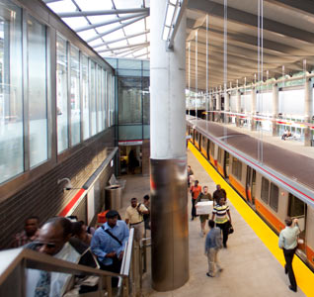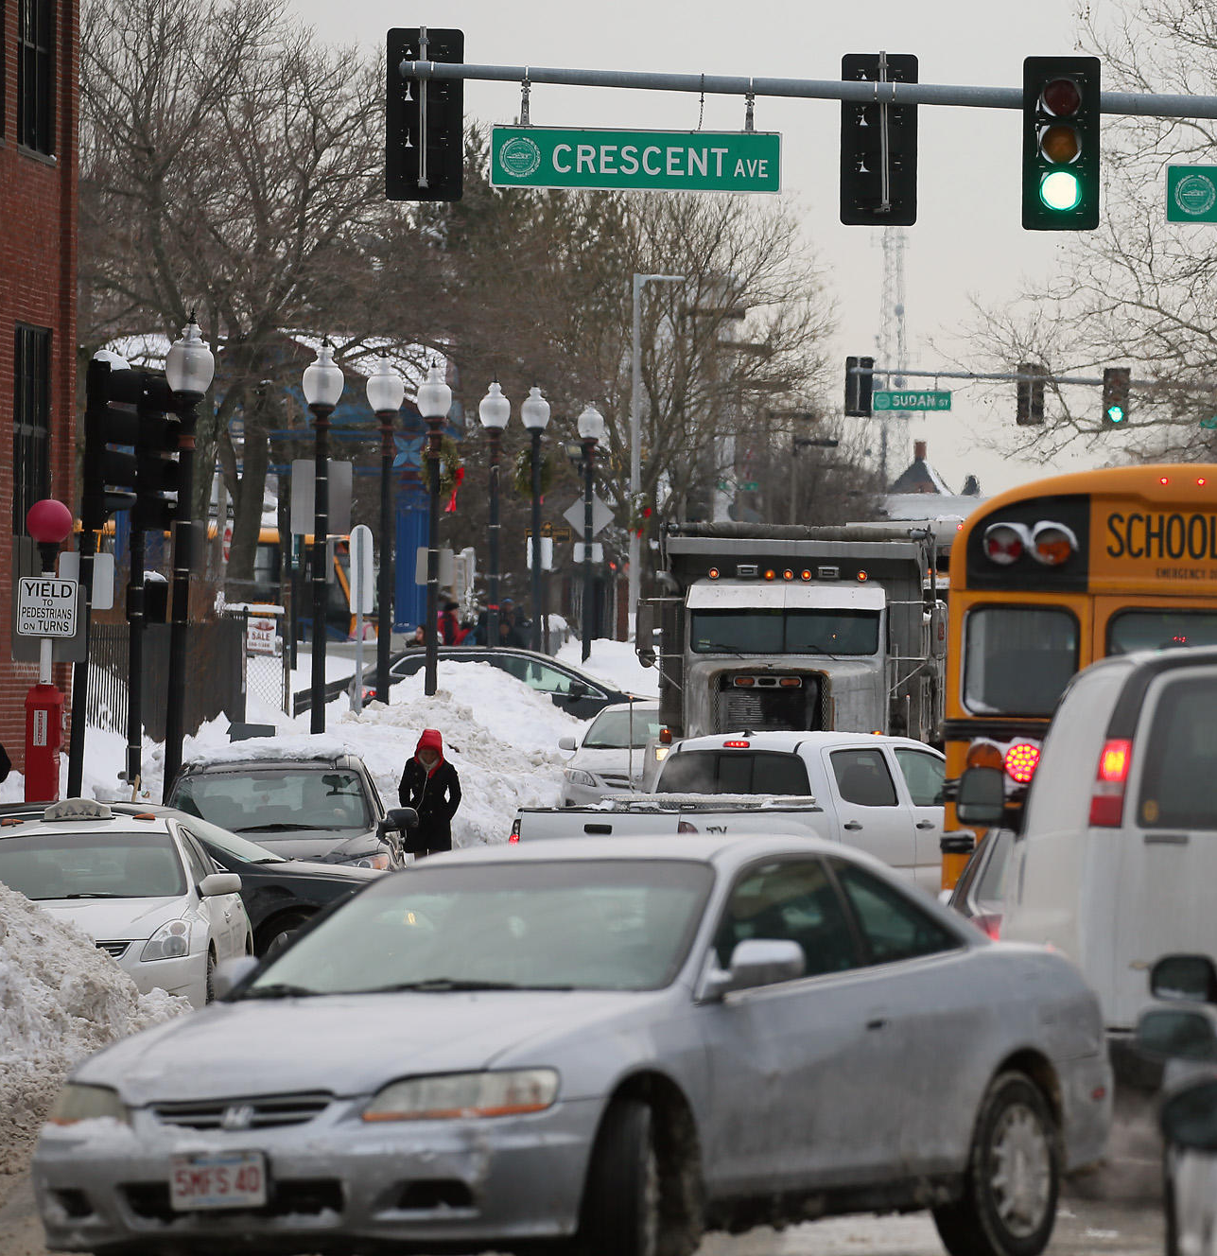

Cities and towns have roads, sidewalks, bike trails, and public transit systems (trains, subways, buses) to help their citizens get around. Larger cities, like Boston with almost 802 miles of roads and hundreds of train, subway, and bus lines, need to often repair their roads and vehicles. In the summer time, cities and towns need to repave roads that get warn out. In the winter time, cities and towns need to plow, salt, and sand the roads. Cities and towns also need to be fixing train and subway tracks and keeping the vehicles in good condition. Boston has one of the oldest roads and transit systems in the country. Since it is so old, it needs extra money to keep it in shape. Many people who live in Boston do not have a car, because the MBTA, also known as the T, goes almost everywhere. People use transportation to get to work, school, stores, and so many other places.

SOURCEBOOK 3-17.A

Source 1: The Pierce House (Dorchester)

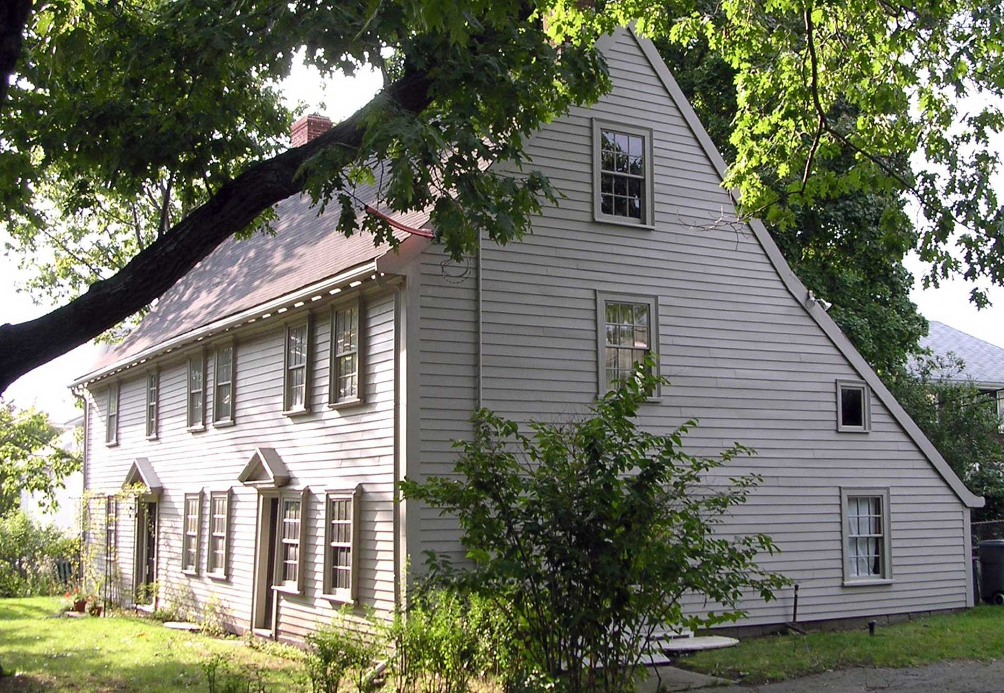

The Pierce House was built around 1683 (top image on next page) by Robert and Ann Pierce. It was built only a few years after English people first immigrated to Dorchester. The house stayed in the Pierce family for many generations until 1968. Over that time, the family added rooms to it and making it almost triple the size of the original. In the 1960s, the house started to fall apart (bottom image on next page) and it was given to Historical New England, so they could repair it. It has since become a historic site and museum that is open to the public several times a year. It is a place where many students from the Kenny School (across the street) have events. It is one of the last houses from the 1600s still standing in the entire city of Boston.
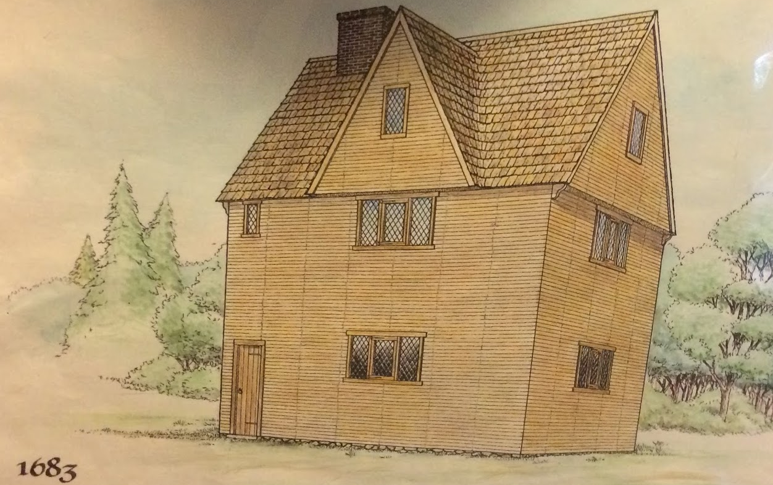

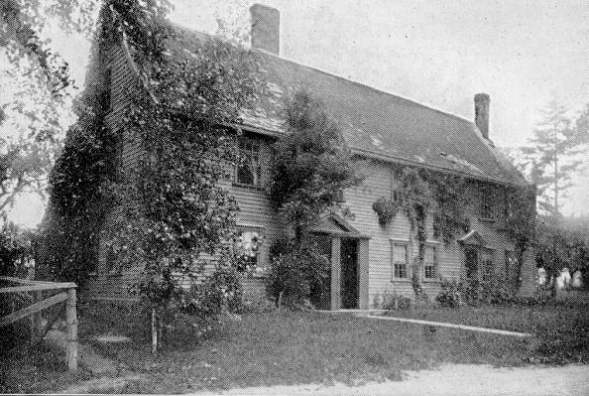
SOURCEBOOK 3-17.B

Source 2: The Strand Theater (Dorchester)

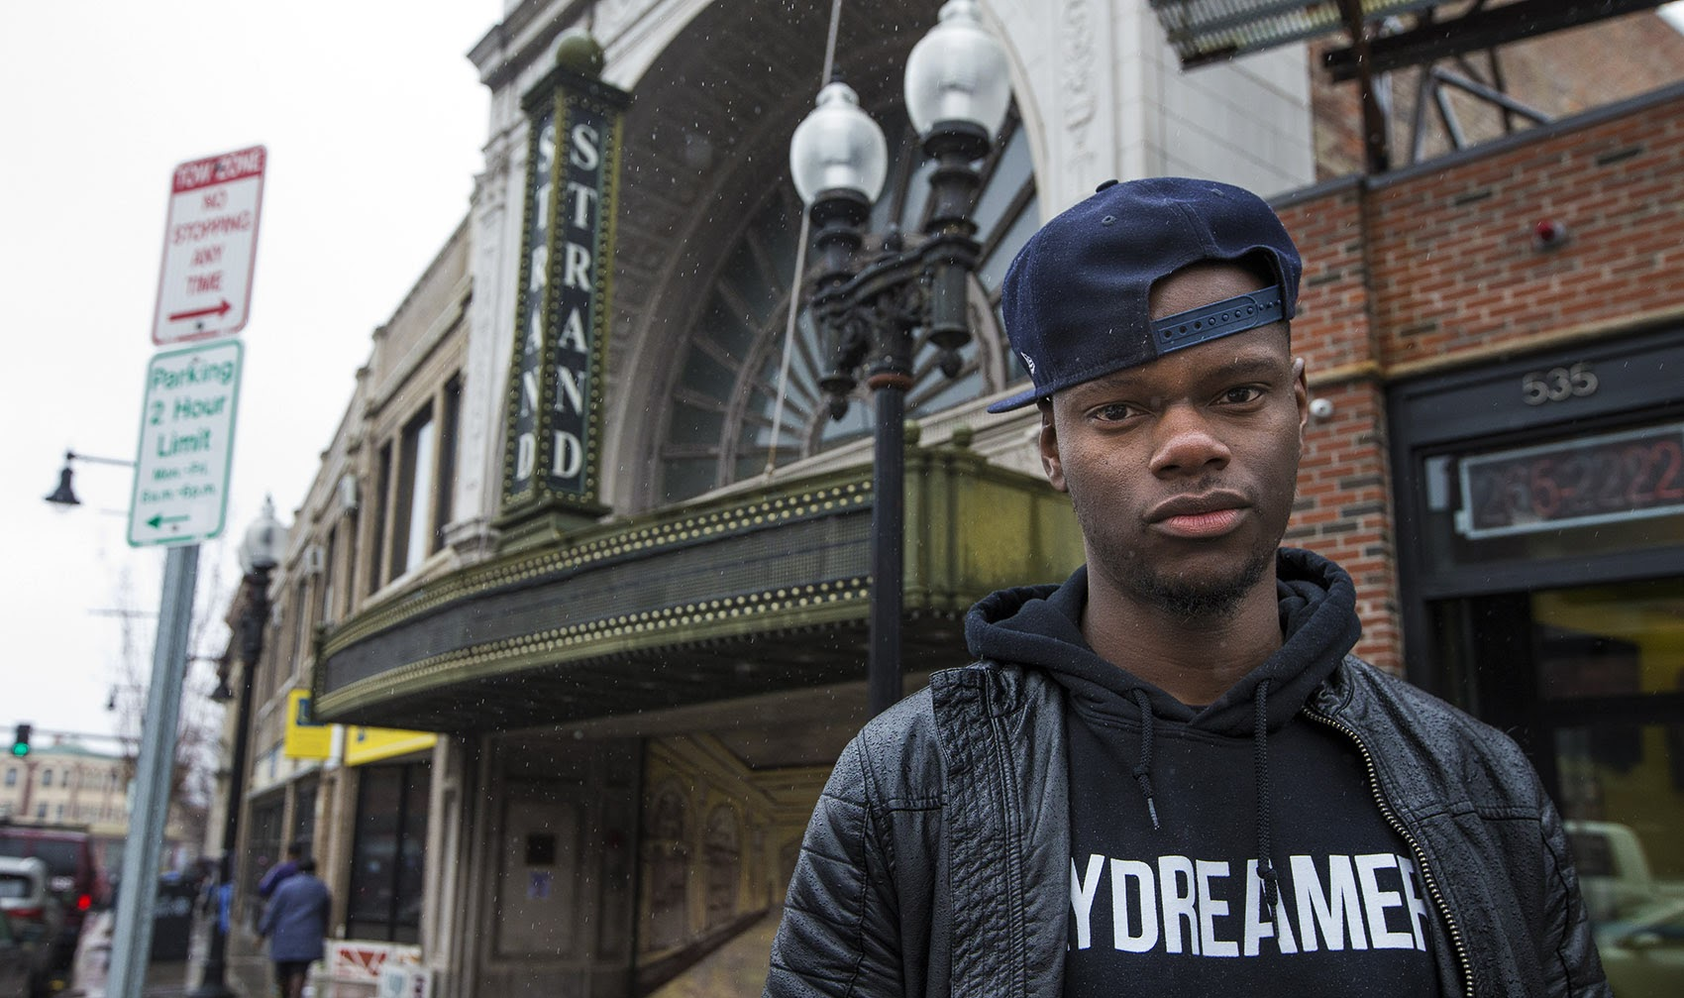
The Strand Theater was built in 1918 (top image on next page-from the 1930s). It was a place for plays, comedians, musicians, dancers, and movies. Back then, movies did not have sound and people had to read the screen. It closed in 1969, as larger theaters with many screens became more popular. In the 1970s, a group of Dorchester residents took over the Strand and made it into an arts and music space. In the 2000s, the theater was renovated for $10 million (bottom image on next page) and today it hosts music groups, plays, and musicals. Many in the community say that the Strand is not being used enough, since it is empty for almost 10 months a year. Tory Bullock (top image), a Boston artist, started an online campaign to have more music and art events at the Strand. He also suggested that the city build a smaller theater inside the Strand that can host smaller plays and music groups, so it would be used more often.
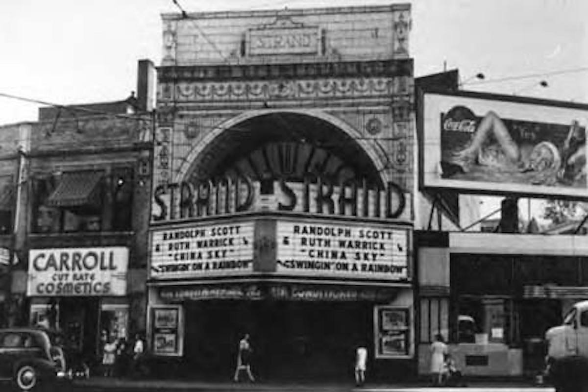

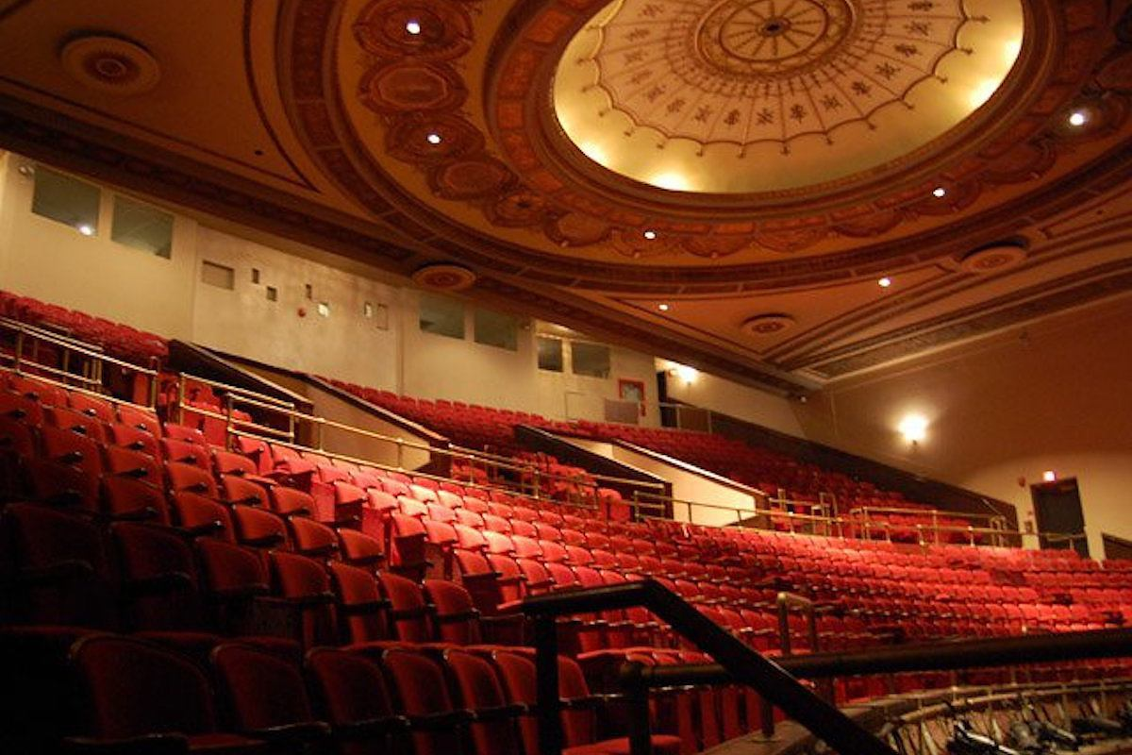
SOURCEBOOK 3-17.C

Source 3: The Ladder Blocks (Downtown)

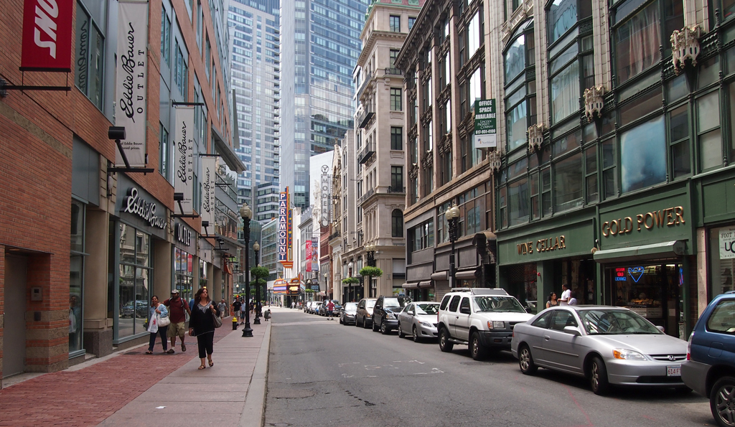

The Ladder Blocks are a part of Downtown Crossing that includes many old buildings (image above). It also has several old theaters where they still show movies, plays, and musicals. Many of the buildings in the area date back to the early 1800s. On the next page, there is a picture of Bromfield street from 1910 and another picture from today (top images on next page). In 1872, the Great Boston Fire burned down over 500 buildings (bottom image on next page). Many of the buildings were rebuilt. They also built fancy new department stores like Filene’s (now Primark) and Jordan Marsh (now Macy’s). Today, many of the old Ladder Blocks’ buildings are falling apart and need repair. Some companies are tearing down the old buildings and building expensive new buildings.
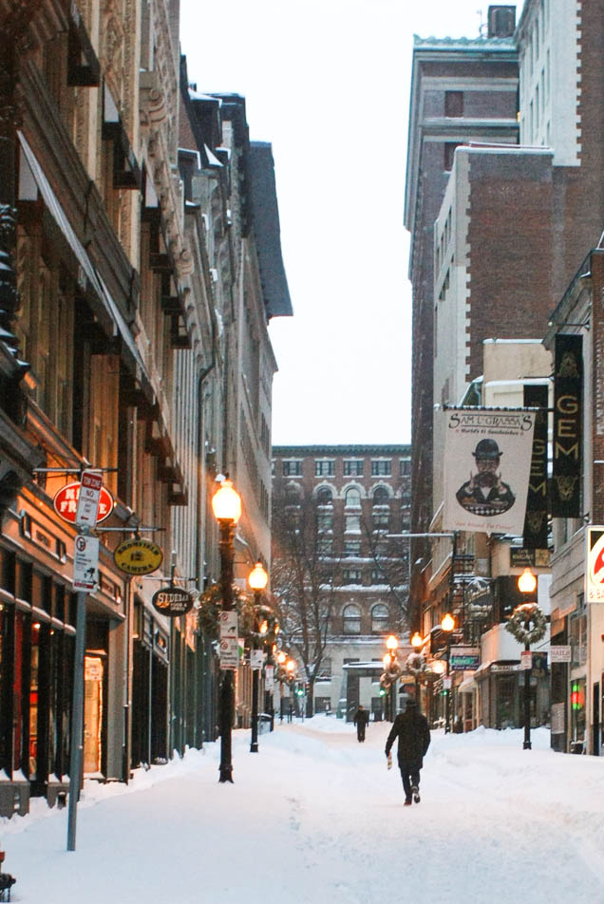

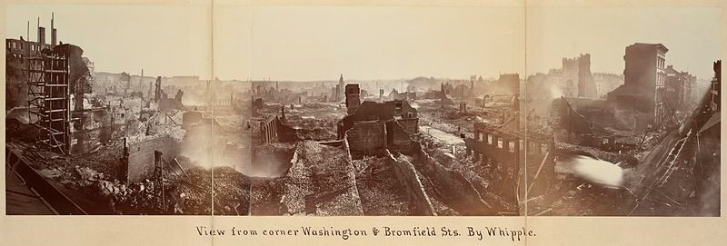
SOURCEBOOK 3-17.D

Source 4: Little-Collins (Malcolm X) House (Roxbury)

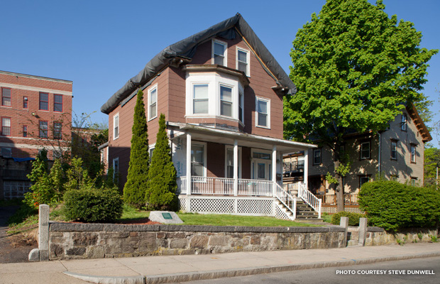

Built in 1874, the Little Collins house (image above) has had four different owners. Ella Little bought it in 1941 (top images on next page). When he was 16-years-old, Malcolm Little came to Boston to stay with his sister Ella Little (bottom images on next page). Malcolm Little would later change his name to Malcolm X and become an important civil rights leader and member of the Nation of Islam. As an adult, he started a nearby mosque with his sister Ella and he would routinely come to Boston to speak about civil rights and against racism. This is the only known childhood home of Malcolm X that is still standing. Malcolm X’s family still lives in the house and they are working hard to repair and protect it. His nephew, Rodnell Collins, hopes it can one day be a house for students who are studying about civil rights and social justice.
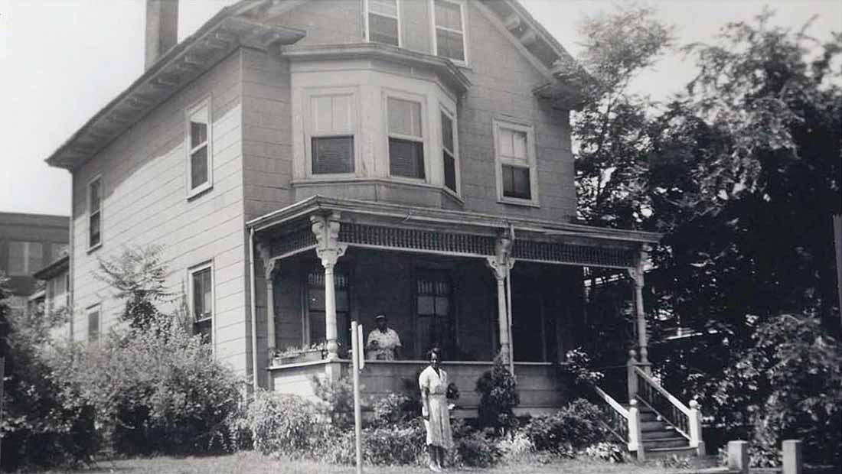

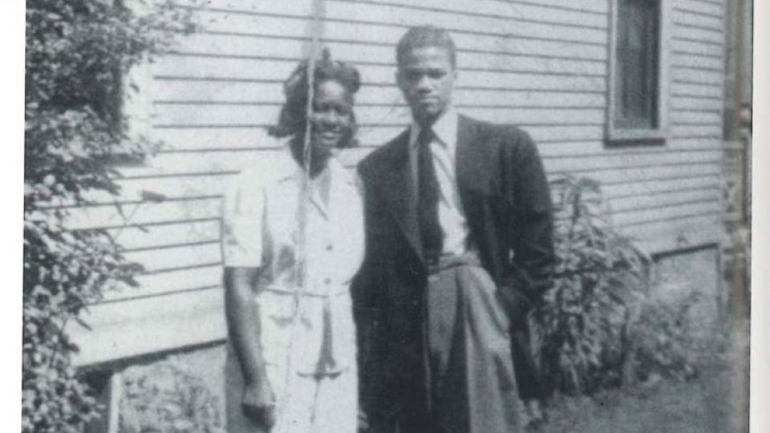

SOURCEBOOK 3-19.A

Images (A)

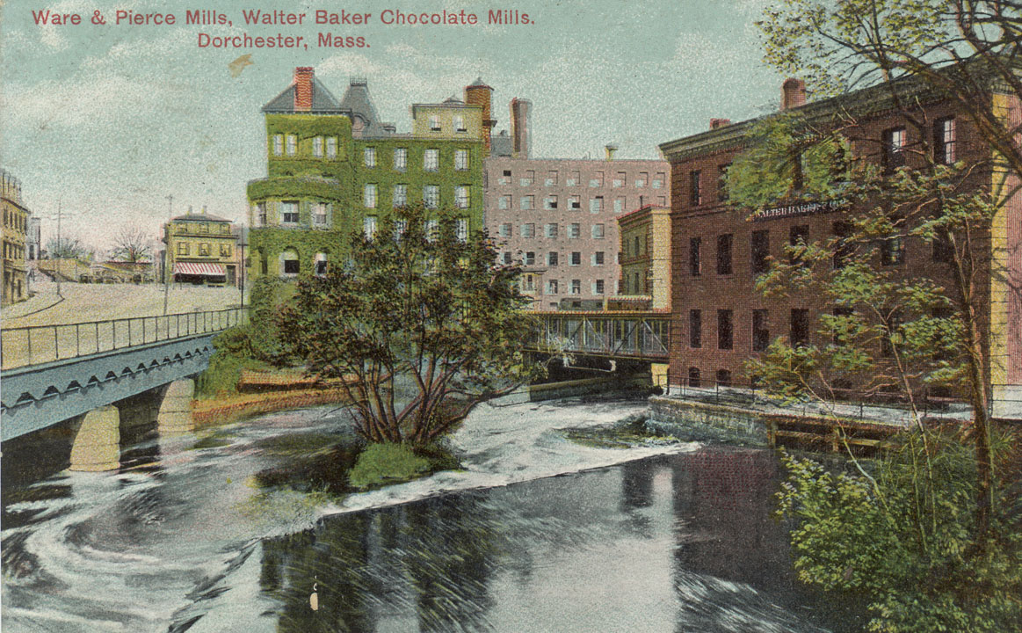
Images (B)

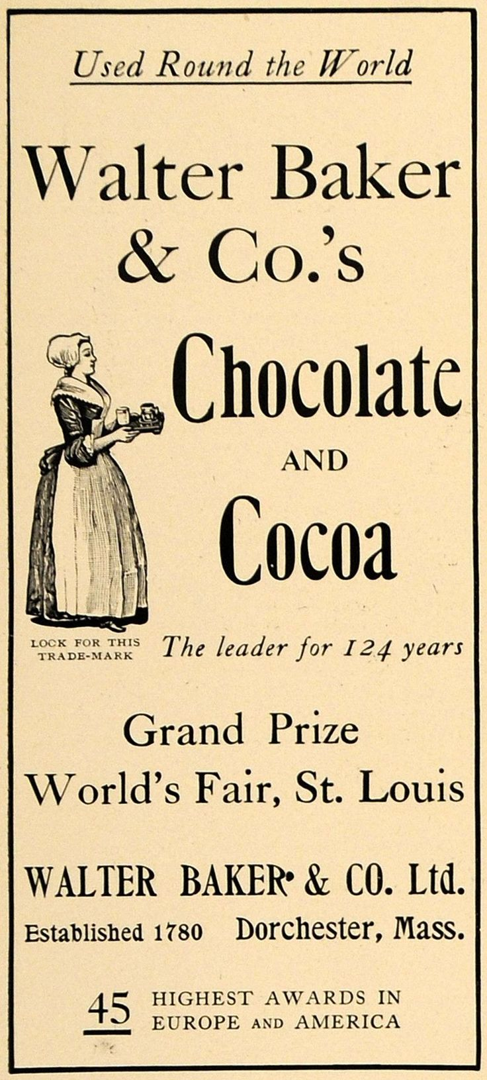
SOURCEBOOK 3-19.B

Source 1: Settlement by the Neponset People

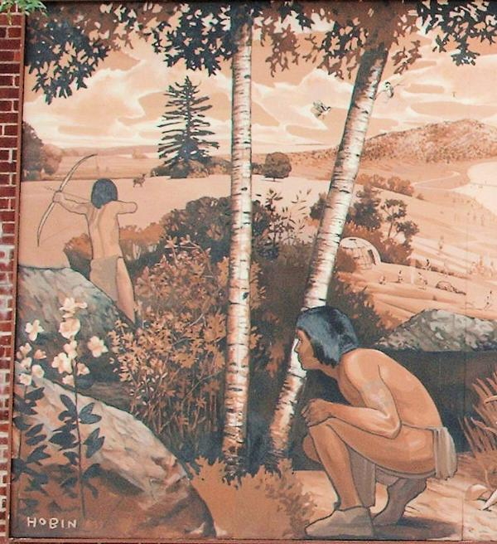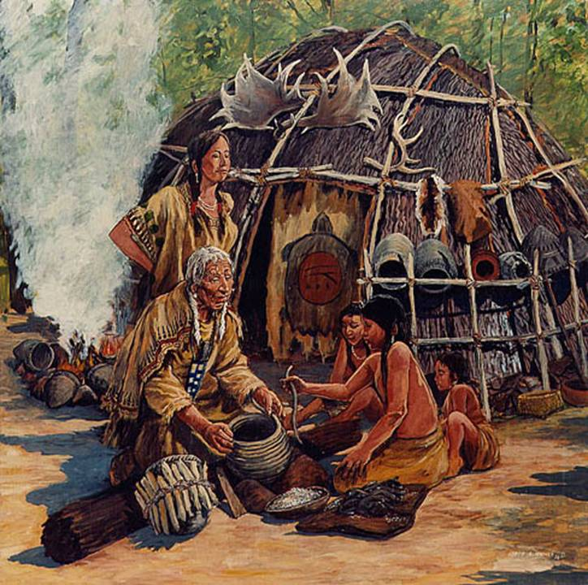

Dorchester was originally inhabited by the Neponset tribe (above) of the Massachusett nation. They settled in the area now known as Dorchester before 2400 BCE or about 4000 years before Europeans came here. The Neponset people made their home along the Neponset River because it had many shellfish (clams and mussels), beaver, and fish (trout, shad, and herring) and was near hills where deer roamed and maize (corn) and squash could be planted. Many of the names in Dorchester are from the Neponset people, like the Neponset River, Mattapan (originally part of Dorchester), and Chickatawbut Street. Today, the Neponset people continue to live in the Boston area and have established a tribal council in Brockton.

SOURCEBOOK 3-19.C

Source 2: Arrival of the “Mary and John” Ship
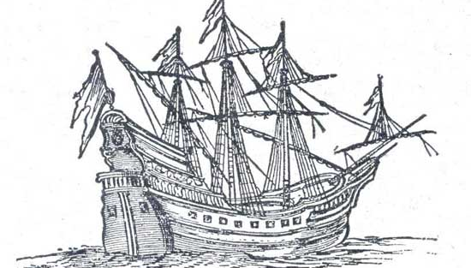

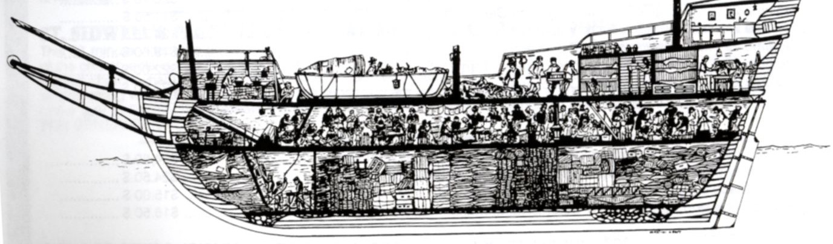

In March 1630, a ship called the Mary and John (above) sailed from Plymouth, England and landed in May at what is today Savin Hill Beach. These were the first 140 English people to settle in what they named Dorchester, after a town back in England. They soon started making houses, a church, and a school. Many of the streets and squares in Dorchester are named after these families, because they built those homes there, including Clapp Street, Pierce Avenue, and Parkman Street.
SOURCEBOOK 3-19.D

Source 3: First Chocolate Factory in American Colonies

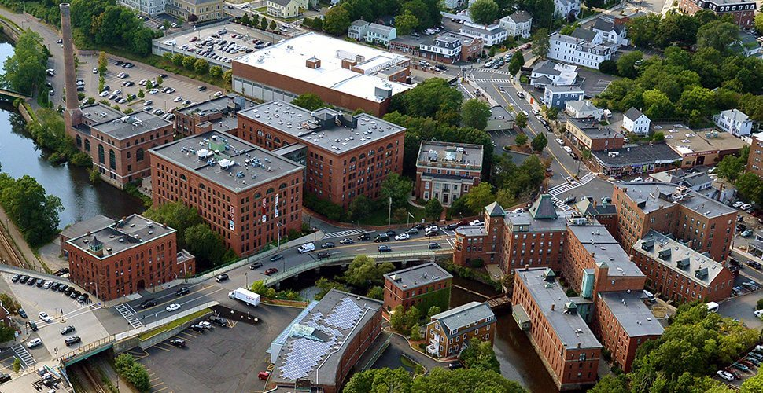

In 1765, Irish chocolate maker John Hannon brought the first cacao beans from the Caribbean to Dorchester and started the first chocolate company in the American colonies with James Baker. Walter Baker, James’ grandson, would build the Walter Baker Chocolate Company into one of the world’s largest chocolate companies. By the 1800s, they were famous for making chocolate for baking, candy, and hot cocoa. The company stayed at its large headquarters in Lower Mills (above) until 1965, when it moved to Delaware. People who grew up in Dorchester in the 1960s say that the air in Lower Mills use to smell like chocolate all the time back then due to the factory.

SOURCEBOOK 3-19.E

Source 4: Creation of the “Triple-Decker”

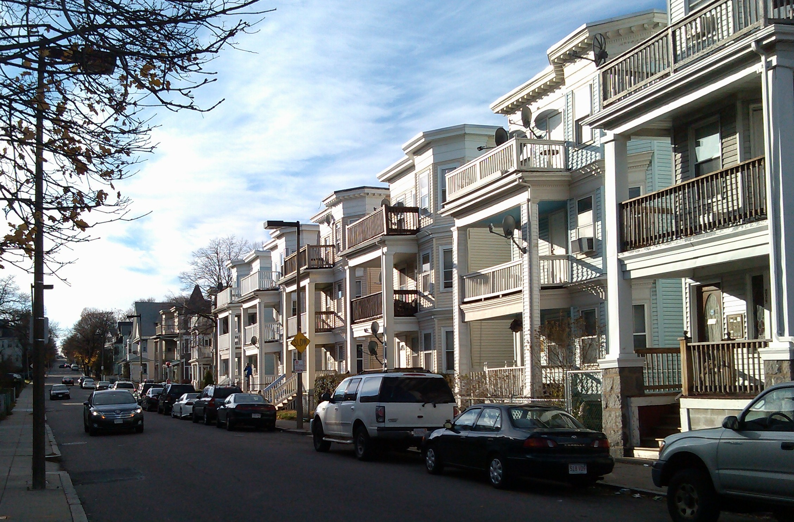

In the late 1800s and early 1900s, many migrants were coming to Dorchester to work on the factories from the U.S. southern states, Ireland, Poland, Russia, Ukraine, French Canada, and the Caribbean. Because of the trolleys that use to run up and down Dorchester Ave. and other streets, people called it a “Streetcar Suburb.” To house all of these new people, local builders created the “Triple-Decker” (above). It is a house with three floors and usually a flat roof that can fit at least one family on each level. It is still the most common type of house in Dorchester today and allows for many families to live in one building.

SOURCEBOOK 3-19.F

Source 5: First Supermarket in the United States

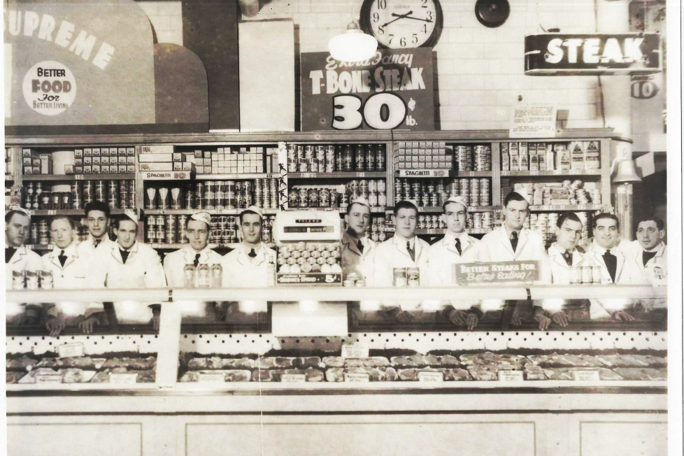

In 1919, John and Paul Cifrino started the Upham’s Corner Market Company in the Upham’s Corner section of Dorchester. Grocery stores (often called general stores) usually had a counter near the doorway and you would walk up and give your list to the grocer, who would go in the back and get your groceries for you. In the 1920s, the Cifrino brothers expanded the size of their store (meat counter-above) and put their groceries out on shelves. They allowed people to shop and pick their own items. They then put cash registers near the door where people would pay. This became the first supermarket in the United States. It is a model used today by most grocery stores. While their supermarket is now closed, the Cifrino family still runs several stores in the area (including Supreme Market in Adams Corner).
SOURCEBOOK 3-20.A

Source 1: Global Warming

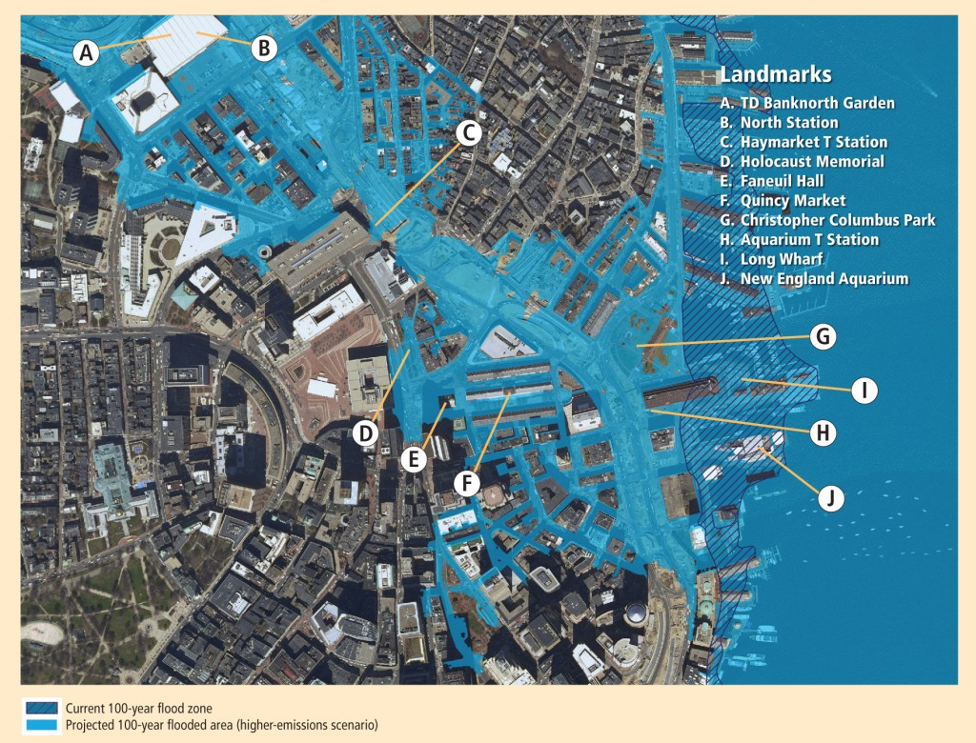

Overview: As the Earth continues to warm due to the burning of fossil fuels (like gas, oil, and coal), the sea level will continue to rise. If Boston does nothing, areas like the Boston Garden, Quincy Market, the New England Aquarium, and Back Bay may be under water by the year 2100 or sooner (see above and next page). We have already seen unusual flooding during recent hurricanes and winter storms in places like the Seaport District.

Solution 1: Reduce the Amount of Fossil Fuels that We Are Burning. Replace fossil fuel (natural gas, oil, coal) power plants with renewable energy sources (wind, solar, water). Have people use more efficient lighting and heat, as well as electric cars. Pro: Would slow down sea rise. Con: Would need most cities and countries in the world to do this for it to work.

Solution 2: Build a Flood Wall in Boston Harbor. Build a giant wall that would protect Boston Harbor and the Charles River from rising sea levels. Pro: It has worked in other cities, like Rotterdam in the Netherlands. Cons: It is very expensive and may not work in Boston.

Solution 3: Move Current Buildings in Flood Areas. Make a government program that would require all buildings in future flood areas to be moved and no longer allow people to build in areas that will flood. Pro: It would be the only way to prevent flooded buildings in the future. Cons: It would be very expensive and would make many people move their homes and business.

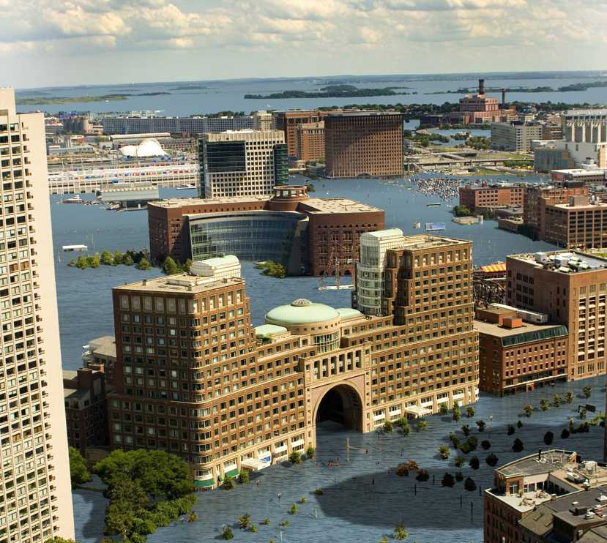
SOURCEBOOK 3-20.B

Source 2: Overcrowding

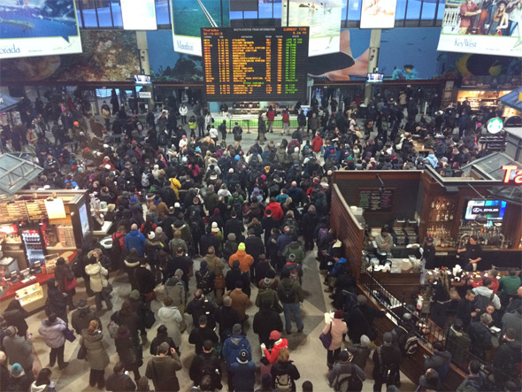

The Boston area’s population of 4 million will increase to almost 8 million by the year 2100. Since there is not much new land in Boston, people will have to build large apartment buildings everywhere to house everyone. If we do not improve our subway and commuter rail systems, then there will be extreme crowding and people will have trouble using them.

Solution 1: Limit the Number of Houses and Apartments Built. The city could limit the number of new houses and apartments being built here. This will reduce the number of people who could move to the area and encourage them to move to other places where there is new room. Pro: Would not cost anything. Con: The prices of houses and apartments would go up and only rich people could live in Boston.

Solution 2: Make Large Apartment Buildings to House Everyone and a New Transportation System. The government could create large apartment buildings with small rooms (micro apartments) to house everyone and rebuilt the MBTA system (subway, buses, trains, boats) to transport a growing number of people. Pro: It would help the growing population have a place to live and a way to move around. Cons: It is very expensive.

Solution 3: Do Nothing. Hope that businesses and individual people find ways to build homes and transport themselves in a growing city. Pro: Would not cost anything. Cons: If people do not find ways, it could cause major problems for everyone including crowding and lack of homes.

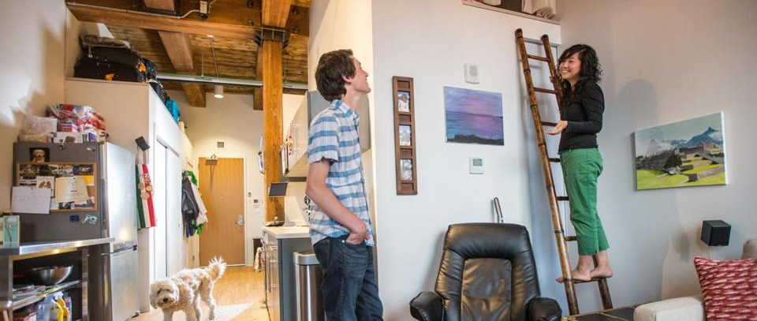
SOURCEBOOK 3-20.C

Source 3: Larger Elderly Population

As doctors continue to find new ways to help keep people healthy and cure diseases, people will live longer. Some people predict that life expectancy (how old most people live) could be as much as 102 years old in 2100. That means most people will live into their 100s! We will need more hospitals and places for elderly people to live and be taken care of. Since most people receive money from the government to live when they are retired and no longer work, we will need to spend more money to take care of everyone. Also, keep in mind that the elderly people that we are talking about will be you. How old will you be in the Year 2100?

Solution 1: Require People to Work Longer. As people are living longer, the government could require people to work longer. This would create more taxes to pay for programs for the elderly. Pro: If not enough elderly people can work, there will not be enough taxes to pay for everything. Con: People would have to work longer and not enjoy retired life as much. Elderly people’s health makes it hard for many to work, so many will still not be able to work.

Solution 2: Make New Hospitals and Elderly Homes. The government could create programs for elderly, including new hospitals and special apartments (below) for them to live in. Pro: It would help elderly people continue to have a good retirement. Cons: It is very expensive.

Solution 3: Do Nothing. Hope that businesses and individual people find ways to take care of their elderly parents and relatives. Pro: Would not cost anything. Cons: If people do not find ways, it could cause major problems for hospitals and individual families.

