Understanding Our World

An Open-Source Literacy-Focused Social Studies Curriculum

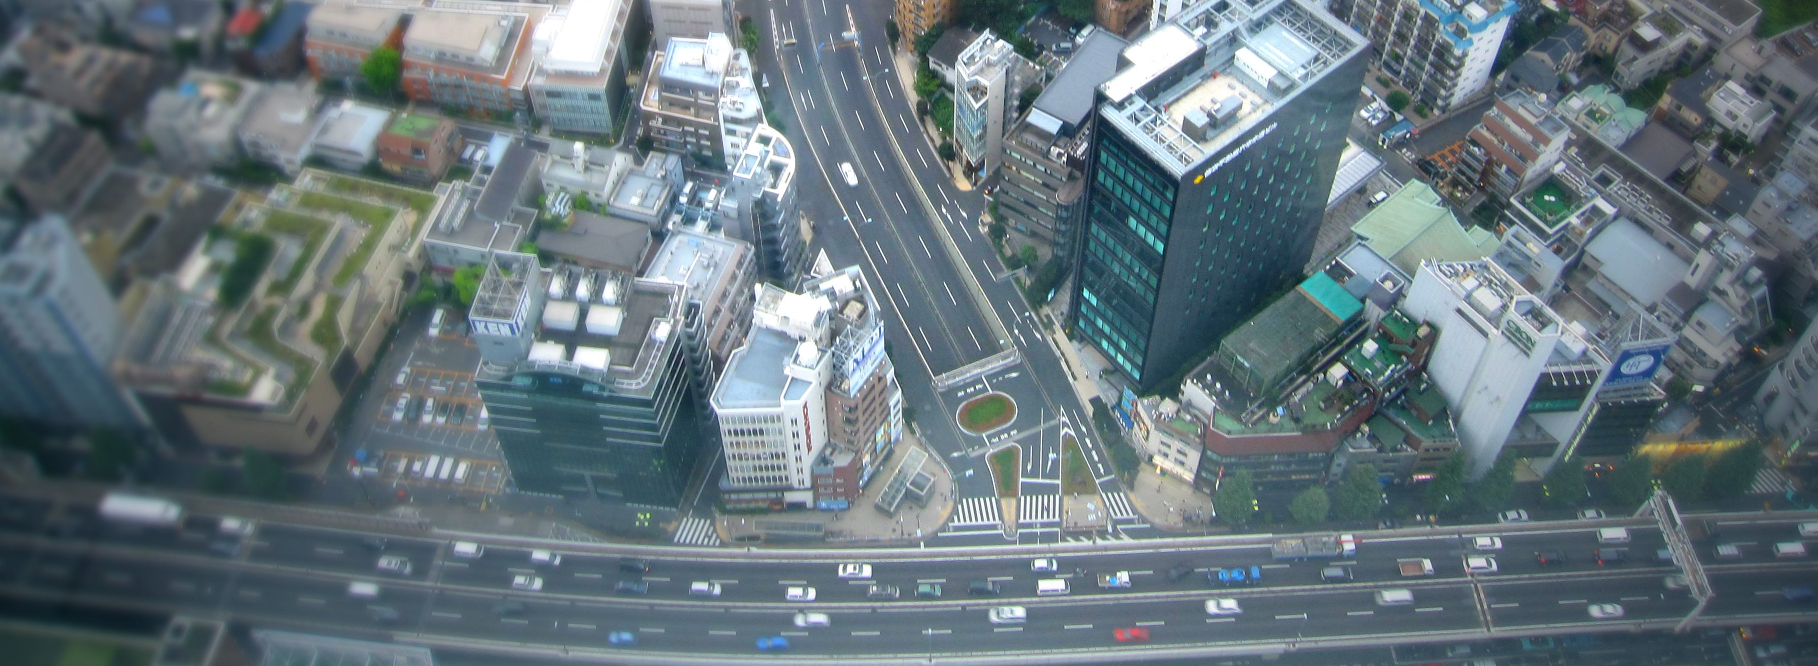

Curric

Level: Grade 4

Exploring the World

Developed By

Christopher C. Martell and Jennifer R. Bryson

Boston University School of Education

INTRODUCTION
Starting in the early elementary grades, all children should receive regular instruction in the social studies, which includes history, civics, geography, and economics. However, there are real pressures on schools and teachers to increase the amount of instruction in other subject areas, which often comes at the expense of their social studies time.

This curriculum was built to help elementary teachers regularly enact powerful and authentic social studies in their classrooms that will also meet essential literacy goals (linking every lesson to the Common Core State Standards). In other words, it leverages the richness of social studies content to help students learn to read, write, and think critically while exploring the past and present world around them. Moreover, it aims to make every single lesson culturally relevant, connecting to the racial, ethnic, gender, class, language, and immigration experience of the increasingly diverse United States.

ORGANIZATION
These lessons are meant to supplement the school or district social studies curriculum. They are free and open source. Teachers are encouraged to modify and adapt these lesson plans for the individual needs and diverse cultural backgrounds of their students. They are only a guide, or perhaps better a “starter kit” to implementing lessons with important disciplinary questions and social studies content. Moreover, these social studies lessons should be supported with rich English language arts (ELA) texts on related topics.

This curriculum is organized by grade level, with an organizing theme, and each grade is color coated for quick reference. Within each grade level, it is organized by lesson. At the beginning of each grade level, there is a roadmap for that shows the individual lesson topics. Additionally, each lesson plan follows the same lesson plan template (adapted from the Boston University Elementary Education Program) and always includes a thought-provoking inquiry question for the students to answer and primary/secondary sources to use as evidence. All lessons for the primary grades (1-2) are expected to be 30 minutes in length and the intermediate grades (3-5) are expected to be 45 minutes in length. However, depending on the pace of your students, lessons may need to span two or more 30- or 45-minute periods.

This curriculum was designed for students in the Boston Public Schools and each lesson cites the Massachusetts Curriculum Framework for History and the Social Sciences (aligned with the national College, Career, and Civic Life Framework for Social Studies State Standards) and Common Core State Standards. However, this curriculum can be easily adapted for other communities, including districts using other state curriculum frameworks. Some lessons are specifically about history and current events in Dorchester, Boston, and Massachusetts. Teachers from other cities/towns and states are encouraged to adapt these lessons for their particular communities.

GRADE 4
Exploring the World

GRADE 4 CONTENT OVERVIEW

We live in a globalized society. Students today can speak instantaneously through the Internet with their peers in China, Brazil, or Nigeria. In a rapidly changing world, it is crucial that we are preparing global citizens who, from an early age, have a strong understanding of the world’s history and recognize the role of the United States within a much larger global community. These lessons are designed to help students develop an spatial, cultural, and historical understanding of the world. Grade 3’s lessons help students learn that the rich history of each continent and the people who live there, but it also highlights difficult events in our world’s past and present. By the end of Grade 4, students should understand the many overlapping world stories and realize that the world’s history is actually composed of conflicting histories.

GRADE 4 LEARNING GOALS

1. Students Should Be Able to Construct Arguments
Before grade 4, students have begun forming basic arguments. While opinions are claims that are not necessarily based in evidence, arguments include both claims and evidence. In grade 4, students should be able to use evidence to support their claims. While these argumentation skills may still be developing, students should be able to construct relatively logical arguments.
2. Students Should Recognize Inequities and Their Causes
Before grade 4, most students have developed a strong understanding of fairness. Students are also able to recognize racial, gender, and other social differences (there is evidence that most children can detect racial and gender differences by about age 2). In grade 4, students should be able to recognize inequities and the larger social forces that cause inequities. They should be able to suggest ways to improve our communities to make them more fair and just.

3. Students Should Understand Differences Between Present and Past Perspectives
Before grade 4, students are beginning to understand that different people may experience the same situations differently. The have begun to examine how people may think differently in the past compared to today. In grade 4, students should examine examples of people thinking differently about the same events in the past and present. They should be able to recognize that people in the past lived in a world very different to today and that impacted the way they understood the world.

CONCEPTS

Synopsis | Content | Thinking Skills
1. Earth | - While most people will say there are 7 continents, geographers debate that the number is between 4 and 7.  - While most people will say there are 4 oceans, geographers and scientists debate that the number is between 1 and 5.  - Maps are tools to help us understand the world around us. There are many different maps that show the earth from different perspectives and present different information.  - The United Nations is an international organization where nations make worldwide decisions. | - Recognize that maps portray the land and water masses of the earth differently based on purpose.  - Identify the names of continents and oceans.  - Compare different arguments for the number of continents and oceans on earth.  - Evaluate the ability of nations to make worldwide decisions.
2. Africa | - Humans began in Africa.  - Africa has a long history, including several great empires.  - Europeans invaded Africa, which caused many problems for the African people.  - Africa has 54 independent countries with different languages and cultures. | - Identify Africa as the beginning place of humankind.  - Compare different African empires’ histories.  - Recognize Africa’s contributions to the world.  - Identify and compare several modern African nation’s cultures and governments.
3. Asia | - The majority (60%) of the world’s people live in Asia.  - Asia has a long history, including several great empires (i.e. .  - Europeans invaded Asia, which caused many problems for the African people.  - Africa has 48 independent countries with different languages and cultures. | - Compare different Asian empires’ histories.  - Recognize Asia’s contributions to the world.  - Identify and compare several modern Asian nation’s cultures and governments.
4. Americas | - North and South America has a long history, including several great empires (i.e. Aztec, Mayans, Incas, and Mississippian).  - Europeans invaded the Americas, which caused many problems for the Indigenous people.  - South America has 12 and North America has 23 independent countries with different languages and cultures. | - Compare different American empires’ histories.  - Recognize the America’s contributions to the world.  - Identify and compare several modern American nation’s cultures and governments.
5. Europe | - Europe has a long history, including several great empires.  - Europe has 44 independent countries with different languages and cultures. | - Compare different European empires’ histories.  - Recognize Europe’s contributions to the world.  - Identify and compare several modern European nation’s cultures and governments.

GRADE 4 FIELD EXPERIENCES

It is strongly recommended that students engage regularly in social studies field experiences to connect their learning inside school to the world outside school. The Grade 4 curriculum covers the world and its history, civics, geography, and economics. There are several field trip locations in the Boston area that would provide an excellent real world connection to this curriculum. We recommend the following:

Mapparium
www.marybakereddylibrary.org/project/mapparium/

Museum of Science IMAX (Greece Secrets of the Past)
www.mos.org/imax/

Museum of Fine Arts (Asia, Africa, the Americas, and Europe Collections)
www.mfa.org

Boston Children’s Museum (Exhibit: Japanese House, Program: Cultures)
www.bostonchildrensmuseum.org

GRADE 4 PROJECT-BASED LEARNING

These lessons are meant to supplement the school or district social studies curriculum. In addition, teachers are strongly encouraged to have students engage in project-based learning related to the content of these lessons. The Grade 4 curriculum covers the world and its history, civics, geography, and economics. Below are several suggested long-term projects that we recommend teachers use in conjunction with these lessons. These projects may include producing a report and/or brief presentations in the form of poster boards, digital slideshows, performances that highlight the positive and negative aspect to each historical event or person.

Project 1: Africa
To extend on lessons 4-1 to 4-8, students will research the nations of Africa.

Project 2: Asia
To extend on lessons 4-9 to 4-14, students will research the nations of Asia.

Project 3: The Americas
To extend on lessons 4-15 to 4-21, students will research the nations of North and South America.

Project 4: Europe
To extend on lessons 4-22 to 4-28, students will research the nations of Europe.

Project 5: Global Issues
To extend on lessons 4-29 to 4-30, students will research important current-day global issues of their choosing (the environment, access to water, health care, hunger, etc.) and present possible United Nation resolutions to help solve these problems.

GRADE 4 ROAD MAP

LESSON 4-1

Lesson Title: How Many Continents and Oceans Are There?

Inquiry Question: How many continents and oceans are there?

LESSON 4-2

Lesson Title: Which Way Is Up? Seeing the World Through Different Maps

Inquiry Question: Which map is best?

LESSON 4-3

Lesson Title: Africa: Where Humans Began

Inquiry Question: What was the most important event of early human in Africa?

LESSON 4-4

Lesson Title: Ancient Egypt

Inquiry Question: If you could be in any ancient Egyptian social class, which would you choose and why?

LESSON 4-5

Lesson Title: The Great African Empires: Ghana, Kongo, Ethiopia, and Zimbabwe

Inquiry Question: If you could live in any ancient African empire, which one would it be and why?

LESSON 4-6

Lesson Title: Timbuktu: How Trade Shaped a City

Inquiry Question: Why was Timbuktu so important?

LESSON 4-7

Lesson Title: Apartheid in South Africa: A Movement for Freedom

Inquiry Question: What can we learn from the Anti-Apartheid Movement in South Africa?

LESSON 4-8

Lesson Title: Africa Today: Diverse Nations, Diverse People

Inquiry Question: If you were to visit Africa today, what country would you choose and why?

LESSON 4-9

Lesson Title: The Great Asian Empires: China, Japan, India, and Persia

Inquiry Question: If you could live in any ancient Asian empire, which one would it be and why?

LESSON 4-10

Lesson Title: The Silk Road: Connecting the Continents

Inquiry Question: What was life like on the Silk Road?

LESSON 4-11

Lesson Title: Việt Nam: A Country of Waterways

Inquiry Question: Are the human changes to the Mekong River more positive or negative?

LESSON 4-12

Lesson Title: Asian Megacities: Would You Want to Live There?

Inquiry Question: Would you like to live in an Asian megacity?

LESSON 4-13

Lesson Title: Confucianism, Buddhism, Hinduism, and Islam

Inquiry Question: What is each religion’s greatest contribution to the world?

LESSON 4-14

Lesson Title: Asia Today: Diverse Nations, Diverse People

Inquiry Question: If you were to visit Asia today, what country would you choose and why?

LESSON 4-15

Lesson Title: The Great American Empires: Aztec, Mayans, Incas, and Mississippian

Inquiry Question: If you could live in any ancient American empire, which one would it be and why?

LESSON 4-16

Lesson Title: Columbus: Hero or Villain?

Inquiry Question: Did Columbus’s voyages have more of a positive or negative impact on the world?

LESSON 4-17

Lesson Title: Haiti: Rebellion or Revolution?

Inquiry Question: Were the events in Haiti led by Toussaint L’Ouverture a rebellion or a revolution?

LESSON 4-18

Lesson Title: Mexico: A Nation of Many People

Inquiry Question: What was the most important event in Mexican history?

LESSON 4-19

Lesson Title: Road Trip: Mexico

Inquiry Question: If you were to visit Mexico, what part would you travel to?

LESSON 4-20

Lesson Title: Canada: One Nation or Many Nations?

Inquiry Question: Is Canada a “nation” or “many nations”?

LESSON 4-21

South America Today: Diverse Nations, Diverse People

Inquiry Question: If you were to visit South America today, what country would you choose and why?

LESSON 4-22

Lesson Title: The Great European Empires: Greece, Rome, Spain, and Russia

Inquiry Question: Which European empire had the best ideas?

LESSON 4-23

Lesson Title: The Kings of France

Inquiry Question: Which French king was the best leader?

LESSON 4-24

Lesson Title: British Monarchy

Inquiry Question: Were the changes over time to the British monarch positive?

LESSON 4-25

Lesson Title: European Imperialism: The Scramble for Africa and Asia

Inquiry Question: What was the best way for African and Asian nations to stop European invasions?

LESSON 4-26

Lesson Title: Where’s Poland?: A Case Study of a Disappearing/Reappearing Country and Its People

Inquiry Question: Do you need a country to be a nation?

LESSON 4-27

Lesson Title: Irish Independence: A New Country from an Ancient People

Inquiry Question: Why was Irish independence from England so important to its people?

LESSON 4-28

Lesson Title: Backpacking Across Europe: Diverse Nations, Diverse People

Inquiry Question: If you were to backpack across Europe today, what country would you visit and why?

LESSON 4-29

The World in 2050: How Will You Be the Leaders of Tomorrow?

Inquiry Question: Presented with several world problems, which do you think is the most important issues for the world to solve?

LESSON 4-30

Model UN: A Global Assembly

Inquiry Question: If you were a UN delegate, what resolution would you want to pass and why?

NOTE: This curriculum is in the pilot stage. The full version will include 35 weeks of lessons per grade-level.

LESSON PLAN 4-1: How Many Continents and Oceans Are There?

MATERIALS

Seven Continents Song Video (Lesson4-1Video1) [Located in the UOW Video Library: www.christophercmartell.com/understandingourworld]
Five Oceans Song Video (Lesson4-1Video2) [Located in the UOW Video Library: www.christophercmartell.com/understandingourworld]
Clipboards (not supplied)
Continents and Oceans Notes (WORKSHEET 4-1.A)
Source 1: 8 Continents Argument (WORKSHEET 4-1.B)
Source 2: 7 Continents Argument (WORKSHEET 4-1.C)
Source 3: 5 Continents Argument (WORKSHEET 4-1.D)
Source 4: 3 Continents Argument (WORKSHEET 4-1.E)
Source 5: 5 Oceans Argument (WORKSHEET 4-1.F)
Source 6: 4 Oceans Argument (WORKSHEET 4-1.G)
Source 7: 3 Oceans Argument (WORKSHEET 4-1.H)
Source 8: 1 Ocean Argument (WORKSHEET 4-1.I)
Continents and Oceans: Exit Ticket (ASSESSMENT 4-1.J)

STANDARDS

Massachusetts History and Social Science Framework

MA-HSS.4.CS.1: Use map and globe skills to determine absolute locations (latitude and longitude) of places studied. (G)

MA-HSS.4.8: On a map of the world, locate … Atlantic and Pacific Oceans.

MA-HSS.2.1: On a map of the world, locate all of the continents: North America, South America, Europe, Asia, Africa, Australia, and Antarctica. (G)

MA-HSS.2.3: Locate the oceans of the world: the Arctic, Atlantic, Indian, Pacific, and Southern Oceans. (G)

Common Core: Literacy

CCSS.ELA-Literacy.RI.4.9: Integrate information from two texts on the same topic in order to write or speak about the subject knowledgeably.

CCSS.ELA-Literacy.RI.4.10: By the end of year, read and comprehend informational texts, including history/social studies, science, and technical texts, in the grades 4–5 text complexity band proficiently, with scaffolding as needed at the high end of the range.
CCSS.ELA-Literacy.W.4.8: Recall relevant information from experiences or gather relevant information from print and digital sources; take notes and categorize information, and provide a list of sources.

CCSS.ELA-Literacy.W.4.9: Draw evidence from literary or informational texts to support analysis, reflection, and research.

PROCEDURES

Inquiry Question: How many continents and oceans are there?

PREPARATION

1. Set Up Carousel Activity
Around the room, post the eight sources:
Source 1: 8 Continents Argument (WORKSHEET 4-1.B)
Source 2: 7 Continents Argument (WORKSHEET 4-1.C)
Source 3: 5 Continents Argument (WORKSHEET 4-1.D)
Source 4: 3 Continents Argument (WORKSHEET 4-1.E)
Source 5: 5 Oceans Argument (WORKSHEET 4-1.F)
Source 6: 4 Oceans Argument (WORKSHEET 4-1.G)
Source 7: 3 Oceans Argument (WORKSHEET 4-1.H)
Source 8: 1 Ocean Argument (WORKSHEET 4-1.I)

Sources 1-4 (Continents) should be posted on top of Sources 5-8 (Oceans), so that you can pull of the second set of sources to reveal them in the second part of the lesson.

2. Post Definitions of Continent and Ocean

Post the definitions of continent and ocean on the board or chart paper hidden from view. Continent: Large land masses separated from others by water. Ocean: A large body of water.

A. OPENER (10 minutes)

3. Watch the Seven Continents Song Video

Show the students a short video involving a nursery rhyme to remember the seven continents (Lesson4-1Video1). After watching the video, ask the students, “How many of you have learned that there are seven continents, like they say in this song?” Count how many students raise their hands. Then tell students that we don’t know how many continents there are, because it is debatable. Most people in English speaking countries say there are seven: North America, South America, Europe, Africa, Asia, Australia, and Antarctica, but that is debatable. In fact, the idea of continents was invented by humans. In some cultures, people say there are anywhere between 3 and 6, while geographers, people who study the Earth including how we map it, think there may be 3 and 9. We will debate this today.

4. Listen to the Five Oceans Song Video

Show the students a short video involving a nursery rhyme to remember the five oceans (Lesson4-1Video2). After watching the video, ask the students, “How many of you have learned that there are five oceans, like they say in this song?” Count how many students raise their hands. Then tell students that just like continents we do not know how many oceans there are, because it is debatable. Most people in English speaking countries say there are five: Atlantic, Pacific, Indian, Artic, Southern, but that is debatable. In fact, the idea of oceans was invented by humans. In some cultures, people say there are anywhere between 3 and 5, while scientists and some geographers, argue that there is only one connected ocean. We will debate this today.

B. DEVELOPMENT (20 minutes)

5. Engage in a Carousel Activity on the Number of Continents
Give each student pencil and clipboard with the Continents and Oceans Notes (WORKSHEET 4-1.A) on it. Ask students to go to each of the four stations (4-1.B, 4-1.C, 4-1.D, 4-1.E). At each station, the students should take notes on the arguments about how many continents there are.

Once students have gone to each of the four stations, they should return to their seats. Put students in small groups. Have them look at their note sheets debate which argument was most compelling or agreeable.

6. Engage in a Carousel Activity on the Number of Oceans
Remove all of the Continent Sources to reveal the Ocean Sources. Use tape or a magnet to put the Continent Sources up on the board or a section of the wall for future reference.

Students should continue to use their pencil and clipboard with the Continents and Oceans Notes (WORKSHEET 4-1.A) on it. Ask students to go to each of the four stations (4-1.F, 4-1.G, 4-1.H, 4-1.I). At each station, the students should take notes on the arguments about how many continents there are.

Once students have gone to each of the four stations, they should return to their seats. Students should again meet in small groups. Have them look at their note sheets debate which argument was most compelling or agreeable.

C. CLOSING (15 minutes)

7. Write Up Argument on the Continents and Oceans
For the evaluation task, have the students complete the exit ticket (ASSESSMENT 4-1.J) where they write their own personal response to the lesson’s Inquiry Question: “How many continents and oceans are there?” Tell students to cite at least three pieces of evidence from the sheets on the walls. Tell students that the evidence they use can be something that they wrote on the sheets. Encourage students to get up and look at the sheets on the wall, when they need evidence to write on their sheet.

Before using the exit ticket, consider using a graphic organizer or two column notes to prepare students for the writing task. Consider using sentence starters and modeling to help the students with their answer to the inquiry question.

EVALUATION

ASSESSMENT 4-1.J

What to look for?

Some information that students may include in their answer to the question:

Continents: 8
- Most scientific
- Uses the plate tectonics of the Earth
- Has the most continents

Continents: 7
- Most widely used
- Most historical
- They had two houses, near the ocean (the first “beach side condo”) and the woods
- They could house many families; this allowed families to be close
- Will be recognized by the most people around the world

Continents: 5
- Closest to the dictionary definition
- Shows Eurasia and the Americas as single continent (clearly no oceans divide them)
- Commonly used in many parts of Europe and South America.

Continents: 3
- Groups the major land masses and counts islands with the contents nearby
- Has the least continents
Oceans: 5
- Has the most number of oceans
- Helpful for ocean navigation
- Used by many people today (although not most common)
- Includes the new Southern Ocean (2000)

Oceans: 4
- Most widely used
- The Antarctic Ocean should not be counted, because it is really just the southern part of the Atlantic, Pacific, and Indian Oceans.

Oceans: 3
- Most historical
- Should not count Artic or Antarctic Oceans

Oceans: 1
- Most scientific definition
- All of the oceans are connected
- Has the least number of oceans

WORKSHEET: 4-1.A

Continents and Oceans Notes

Source 1: 8 Continents Argument

Source 2: 7 Continents Argument

Source 3: 5 Continents Argument

Source 4: 3 Continents Argument

Source 5: 5 Oceans Argument

Source 6: 4 Oceans Argument

Source 7: 3 Oceans Argument

Source 8: 1 Ocean Argument

WORKSHEET: 4-1.B

Source 1: 8 Continents Argument

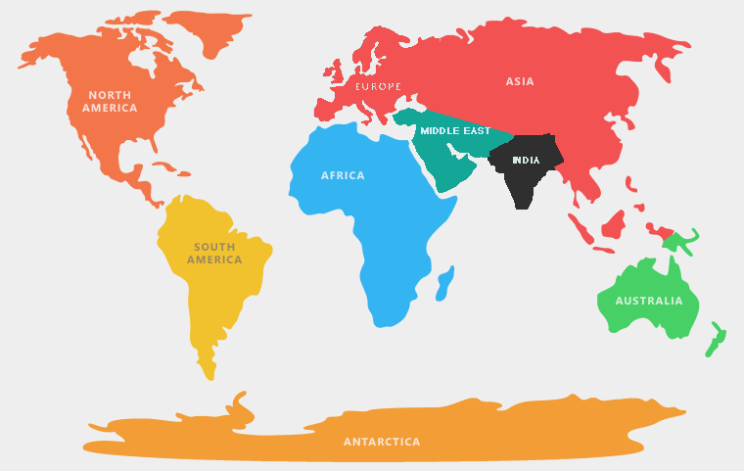

Some geographers count continents by the Earth’s tectonic plates. There are 8 major plates holding land (some have only water) that divide the earth: North American Plate, Eurasian Plate, African Plate, Antarctic Plate, Australian Plate, Indian Plate, Arabian Plate (Middle East), South American Plate. This may be the most scientific way of saying how many continents there are.

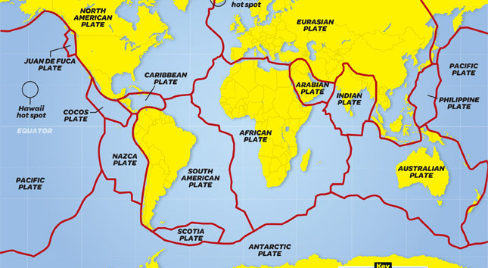

WORKSHEET: 4-1.C

Source 2: 7 Continents Argument

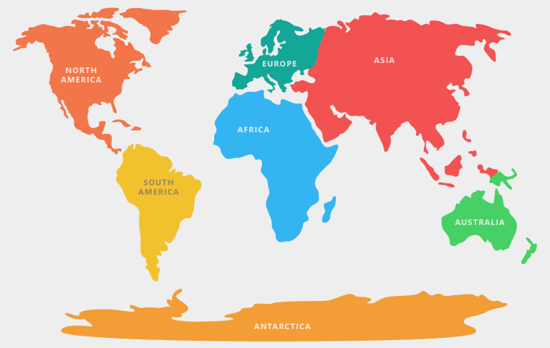

Some geographers count continents through the way that Europe labeled the land masses that they discovered. Europeans went to the different continents in this order: Europe, Africa, Asia, North America, South America, Australia, Antarctica. Europeans observed differences in human culture (language, traditions, government forms) and appearance (skin color and eye type) between Europe, Asia, and Africa and decided these were different groups of people. This may be the most historical way of saying how many continents there are.

WORKSHEET: 4-1.D

Source 3: 5 Continents Argument

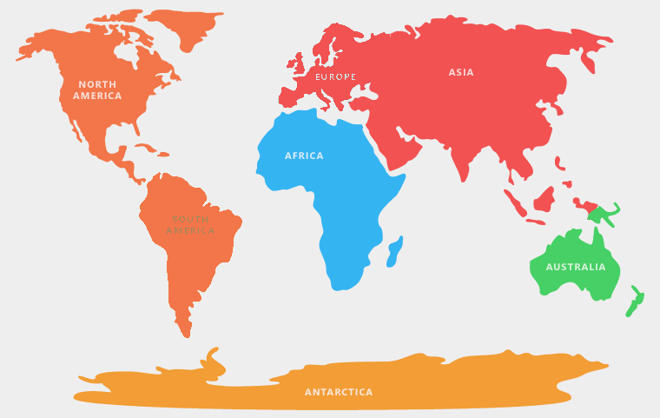

Some geographers count continents by their appearance as separate land masses. For instance, they suggest that North and South America are really one connected continent (the Americas) and Europe and Asia are really one connected continent (Eurasia). This model is taught to students in parts of Europe, South America, and Asia. This way of saying how many continents there are may be the truest to the dictionary definition of continent.

WORKSHEET: 4-1.E

Source 4: 3 Continents Argument

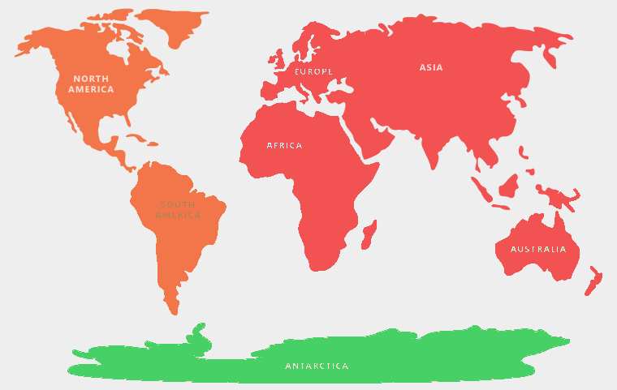

Some geographers count continents based on how the oceans divide them. For instance, they suggest that North and South America are really one connected continent (the Americas) and Europe, Asia, and Africa are really one connected continent (Afroeurasia) divided by the Atlantic and Pacific Oceans). This model also does not count Australia as a continent, instead putting it as a large island off of the cost of Asia (If Greenland is about 2 million square miles and considered North America, then we should not count Australia as a continent if it is only 3 million square miles). This may be the most useful way of saying how many continents if you want to make as few continents as possible.

WORKSHEET: 4-1.F

Source 5: 5 Oceans Argument

Some geographers count oceans by the continents that surround them. This would make five oceans: Pacific, Atlantic, Indian, Artic, and Southern. This may be the most helpful way of saying how many oceans there are for people who need to travel the different oceans on ships.
WORKSHEET: 4-1.G

Source 6: 4 Oceans Argument

The Southern Ocean (which surrounds Antarctica) was only officially named in the year 2000 and many countries do not consider it a separate ocean, so some geographers count only four oceans: Pacific, Atlantic, Indian, and Arctic. This may be the most helpful way of saying how many oceans there are based on what most people in the world already say.

WORKSHEET: 4-1.H

Source 7: 3 Oceans Argument

Some geographers count continents by what humans used for the past three thousand years: Atlantic, Pacific, and Indian. Humans learned only 100 years ago that there is no land under the North Pole (making it an ocean). This view argues that the Arctic Ocean is really just the northern parts of the other oceans. This may be the most historical way of saying how many continents there are.

WORKSHEET: 4-1.I

Source 8: 1 Ocean Argument

Some geographers and most oceanographers (scientists who study the ocean) count only one ocean, because on Earth, all large bodies of water are connected. They would argue that the divisions are only made by humans and are not scientific. This may be the most scientific way of saying how many oceans there are.
ASSESSMENT: 4-1.J

Continents and Oceans: Exit Ticket

Inquiry Question: How many continents and oceans are there?

Choose one argument for the number of continents and one for the number of oceans and explain why you agree with it the most. Include three pieces of evidence from the sources (at least one piece of evidence for each argument).

I argue that there are ______ continents and ______ oceans.

LESSON PLAN 4-2: Which Way Is Up? Seeing the World Through Different Maps

MATERIALS

Clipboards (not supplied)
Making Maps Video (Lesson4-2Video1) [Located in the UOW Video Library: www.christophercmartell.com/understandingourworld]
Various World Maps (MATERIALS 4-2.A) [This activity supplies standard handout-sized maps. This activity would work better if those maps were printed as large as possible or secure larger sized professionally produced maps using the same projections: Mercator Projection, Robinson Projection, Gall-Peters Projection, Atlantic-Centric, Pacific-Centric, Southern Hemisphere-Centric [South Up Map])
Note Taking Sheet (WORKSHEET 4-2.B)
Map Perspectives: Exit Ticket (ASSESSMENT 4-2.C)

STANDARDS

Massachusetts History and Social Science Framework

MA-HSS.4.CS.1: Use map and globe skills to determine absolute locations (latitude and longitude) of places studied. (G)

MA-HSS.4.8: On a map of the world, locate … Atlantic and Pacific Oceans.

MA-HSS.2.1: On a map of the world, locate all of the continents: North America, South America, Europe, Asia, Africa, Australia, and Antarctica. (G)

MA-HSS.2.3: Locate the oceans of the world: the Arctic, Atlantic, Indian, Pacific, and Southern Oceans. (G)

Common Core: Literacy

CCSS.ELA-Literacy.RI.4.9: Integrate information from two texts on the same topic in order to write or speak about the subject knowledgeably.

CCSS.ELA-Literacy.RI.4.10: By the end of year, read and comprehend informational texts, including history/social studies, science, and technical texts, in the grades 4–5 text complexity band proficiently, with scaffolding as needed at the high end of the range.

CCSS.ELA-Literacy.W.4.8: Recall relevant information from experiences or gather relevant information from print and digital sources; take notes and categorize information, and provide a list of sources.

CCSS.ELA-Literacy.W.4.9: Draw evidence from literary or informational texts to support analysis, reflection, and research.

PROCEDURES

Inquiry Question: Which map is best?

PREPARATION

1. Set Up Carousel Activity
Around the room, post the six maps: Mercator Projection, Robinson Projection, Gall-Peters Projection, Atlantic-Centric, Pacific-Centric, Southern Hemisphere-Centric [South Up Map]) (MATERIALS 4-2.A) or professionally produced versions of the same maps. Be sure to post the map and correct description next to it.

A. OPENER (10 minutes)

2. Watch the Making Maps Video

Show the students a short video explaining the history and problems with map making (Lesson4-2Video1). During the video, stop it and highlight/ask questions about how it is difficult to make a globe flat, and the distortions that happen. Write the definition of distortion on the board or chart paper as “changing something so it is inaccurate or not completely true.” After watching the video, ask the students, did some of the maps the video showed us look weird or unusual to you? Why do you think that is? Anticipated student responses may include: we are used to looking at only one type of map, it is hard to make a globe flat, some maps make Africa and South America look smaller than they actually are.

B. DEVELOPMENT (20 minutes)

3. Examine the Maps Posted Around the Room
Give each student pencil and clipboard with the Note Taking Sheet (WORKSHEET 4-2.B) on it. Ask students to go to each of the six maps. At each map, the students should take notes on what they are seeing and feeling. There is a generic question listed to prompt them: What locations are at the center and top of this map? How does this look the same or different than maps you are using to looking at? Which maps do you think are more or less helpful (and for who)?

Once students have gone to each of the four stations, they should return to their seats. Put students in small groups. Have them look at their note sheets debate which argument was most compelling or agreeable.

C. CLOSING (15 minutes)

6. Write Up Argument on the Continents and Oceans
For the evaluation task, have the students complete the exit ticket (ASSESSMENT 4-2.C) where they write their own personal response to the lesson’s Inquiry Question: “Which map is best?” Tell students to cite at least three pieces of evidence from the maps and descriptions on the walls. Tell students that the evidence they use can be something that they wrote on their note taking sheets. Encourage students to get up and look at the maps and descriptions on the wall, when they need evidence to write on their sheet.

Before using the exit ticket, consider using a graphic organizer or two column notes to prepare students for the writing task. Consider using sentence starters and modeling to help the students with their answer to the inquiry question.

EVALUATION

ASSESSMENT 4-2.C

What to look for?

Some information that students may include in their answer to the question:

Mercator Projection
- It is the most helpful for navigation, because it will show you the most direct angle from one point to the other.
- It is commonly used by Global Positioning Systems (GPS) maps, such as Google Maps.
- It is the one that most Americans are used to using.

Robinson Projection
- It projects a globe on a rounded flat surface.
- It attempts to show the actual relative sizes of the land on earth comparing north to south.

Gall-Peters Projection
- It shows the correct ratios of land mass across the Earth.
- This means that it shows the exact size of one continent versus another.
- Shows the true size of each country in land size.

Atlantic-Centric and Physical Map
- It is most commonly used by people in the Americas, Europe, and Africa.
- It shows the areas where they often trade goods over the ocean.
- It can show you the elevation (how high or low) the land and water are, as well as where you can find different terrain types.

Pacific-Centric and Political Map
- It is most commonly used by people in Asia.
- It shows the areas where they often trade goods over the ocean.
- It shows country’s boundaries, so you where they start and end.

Southern Hemisphere-Top
- This map makes you question what is up and what is down on a map.
- Since there is no true up or down in space, this map reminds us of that.

MATERIALS: 4-2.A

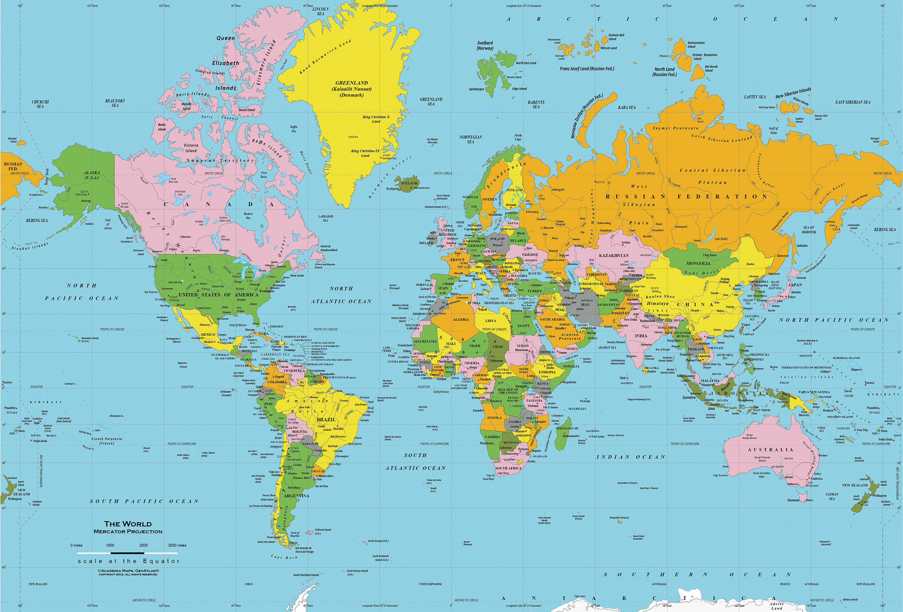
Mercator Projection

Mercator Projection

This type of map was invented by Gerardus Mercator in 1569. He was Flemish (from Belgium in Europe). It projects a globe on a cylinder (see below).

PROS
It is the most helpful for navigation, because it will show you the most direct angle from one point to the other. It is commonly used by Global Positioning Systems (GPS) maps, such as Google Maps.

CONS
It distorts the poles, so that land and water masses at the North and South Poles are stretched, making them look much larger than they actually are.

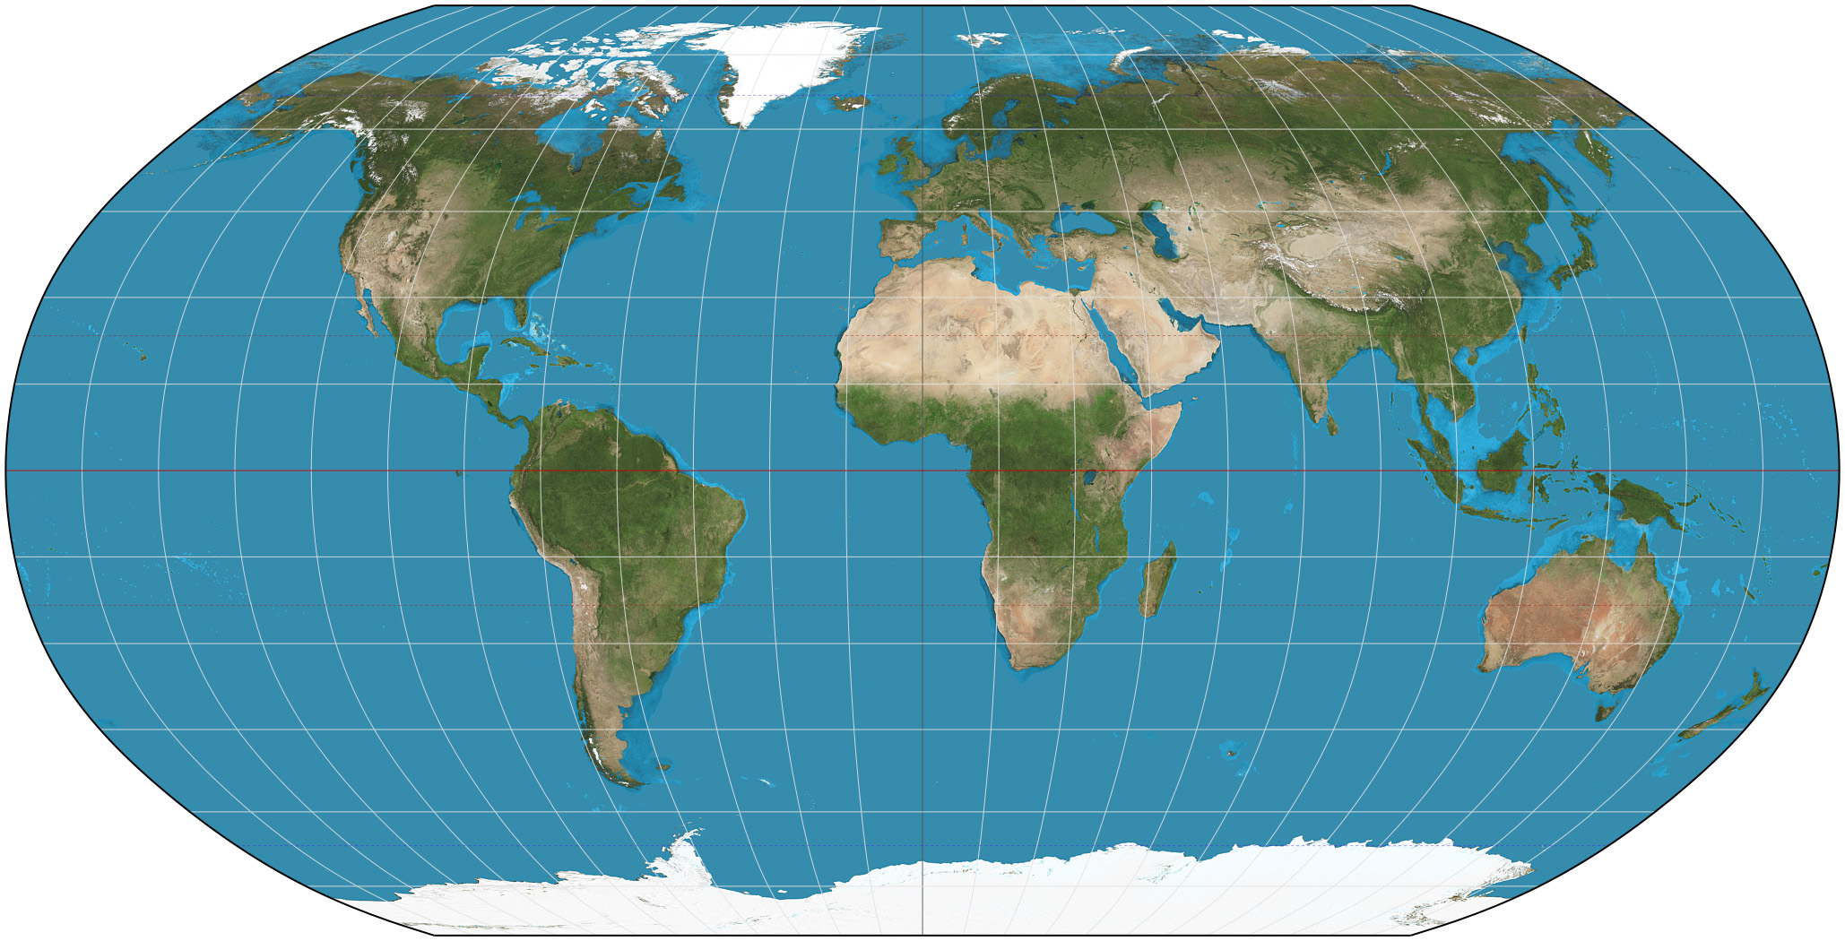
Robinson Projection
Topographical Map
Robinson Projection

This type of map was invented by Arthur H. Robinson in 1963. He was an American (born in Montréal, Québec, lived in Great Britain and later Wisconsin).

PROS
It projects a globe on a rounded flat surface. It attempts to show the actual relative sizes of the land on earth comparing north to south.

CONS
It distorts the corners of the map (northeast, southeast, southwest, northwest), making them look much larger than they actually are.

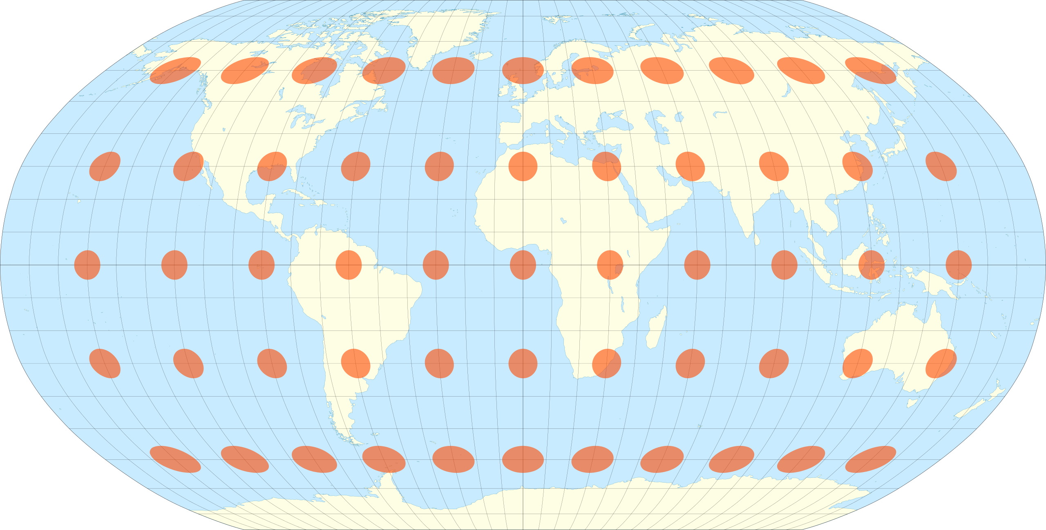

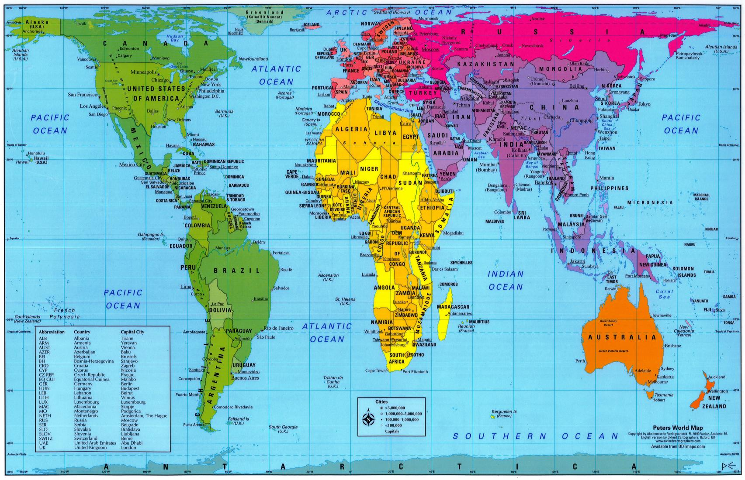
Gall-Peters Projection
Gall-Peters Projection

This type of map was invented by James Gall (from Scotland) in 1851 and later rediscovered by Arno Peters (from Germany) in 1967. In 2017, the Boston Public Schools began became the first school system in the United States to adopt this map in all classrooms.

PROS
It shows the correct ratios of land mass across the Earth. This means that it shows the exact size of one continent versus another.

CONS
It cannot be used for navigation, because it does not show the true shape of every country (as the Mercator Projection would).

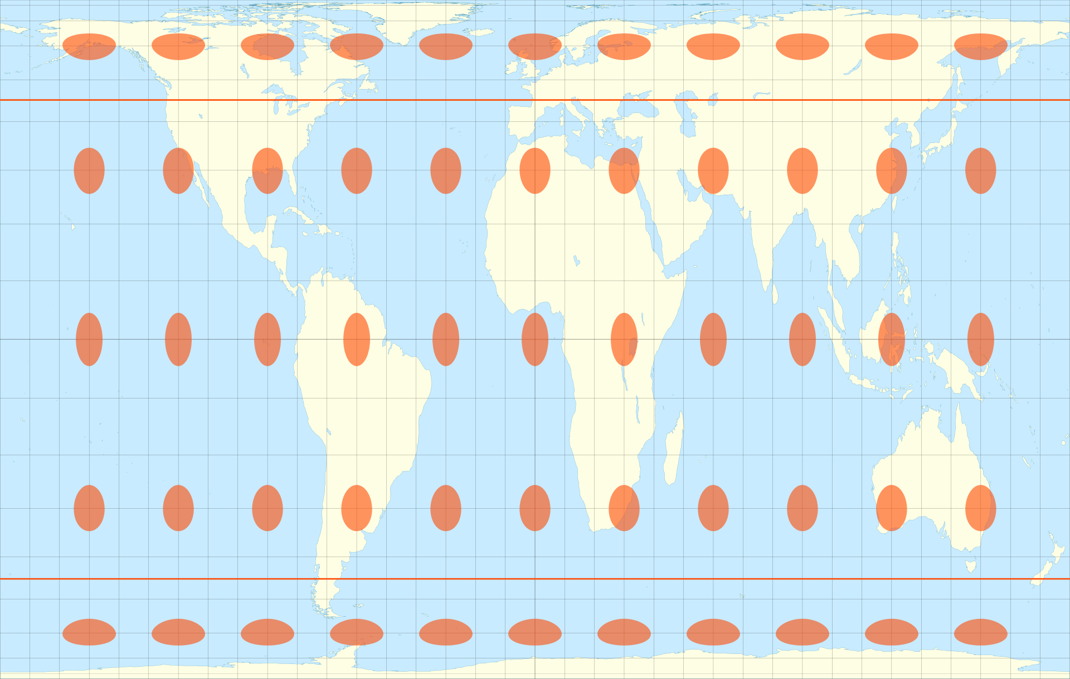
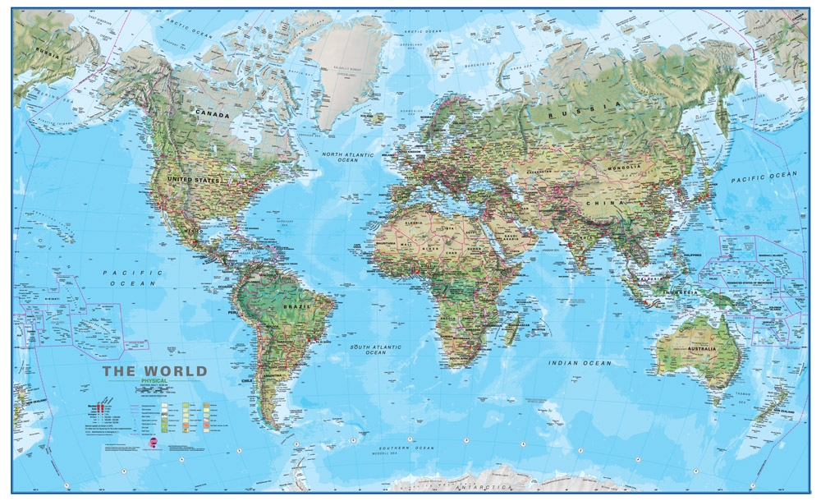
Atlantic-Centric Projection
Physical Map
Atlantic-Centric Projection
Physical Map

This type of map is an Atlantic-Centric physical map. This map places the Atlantic Ocean at the center of the world. It also shows terrain types (i.e. mountains, plains, rives, forests).

PROS
It is most commonly used by people in the Americas, Europe, and Africa. It shows the areas where they often trade goods over the ocean. It can show you the elevation (how high or low) the land and water are, as well as where you can find different terrain types.

CONS
Europe is at the center and top of the Earth, when there is no true center or top of the Earth. It cuts the Pacific Ocean in half.

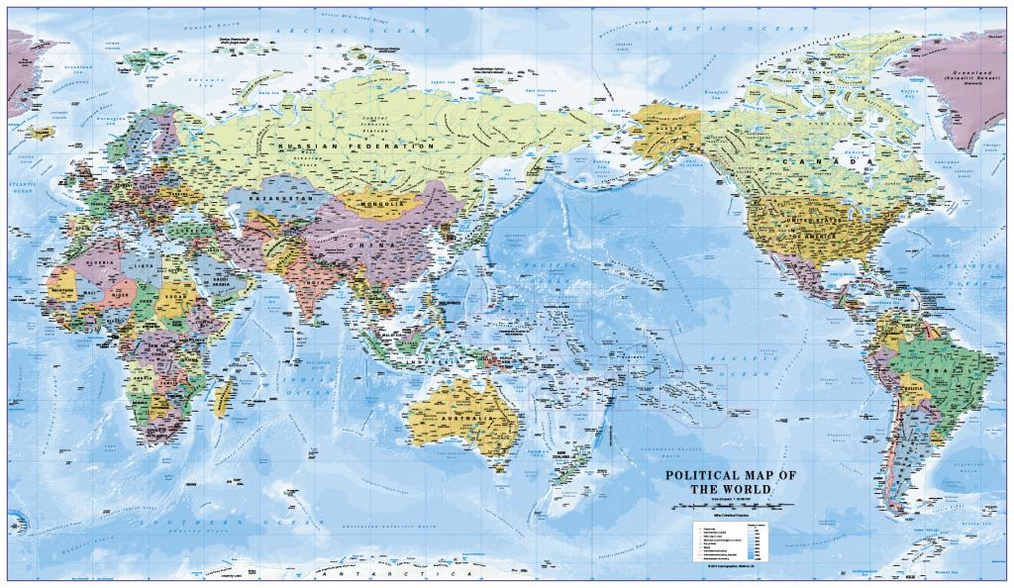
Pacific-Centric Projection
Political Map
Pacific-Centric Projection
Political Map

This type of map is a Pacific-Centric political map. This map places the Pacific Ocean at the center of the world. It also shows the boundaries of each country and makes them a separate color.

PROS
It is most commonly used by people in Asia. It shows the areas where they often trade goods over the ocean. It shows country’s boundaries, so you where they start and end.

CONS
Asia is at the center and top of the Earth, when there is no true center or top of the Earth. It cuts the Atlantic Ocean in half.

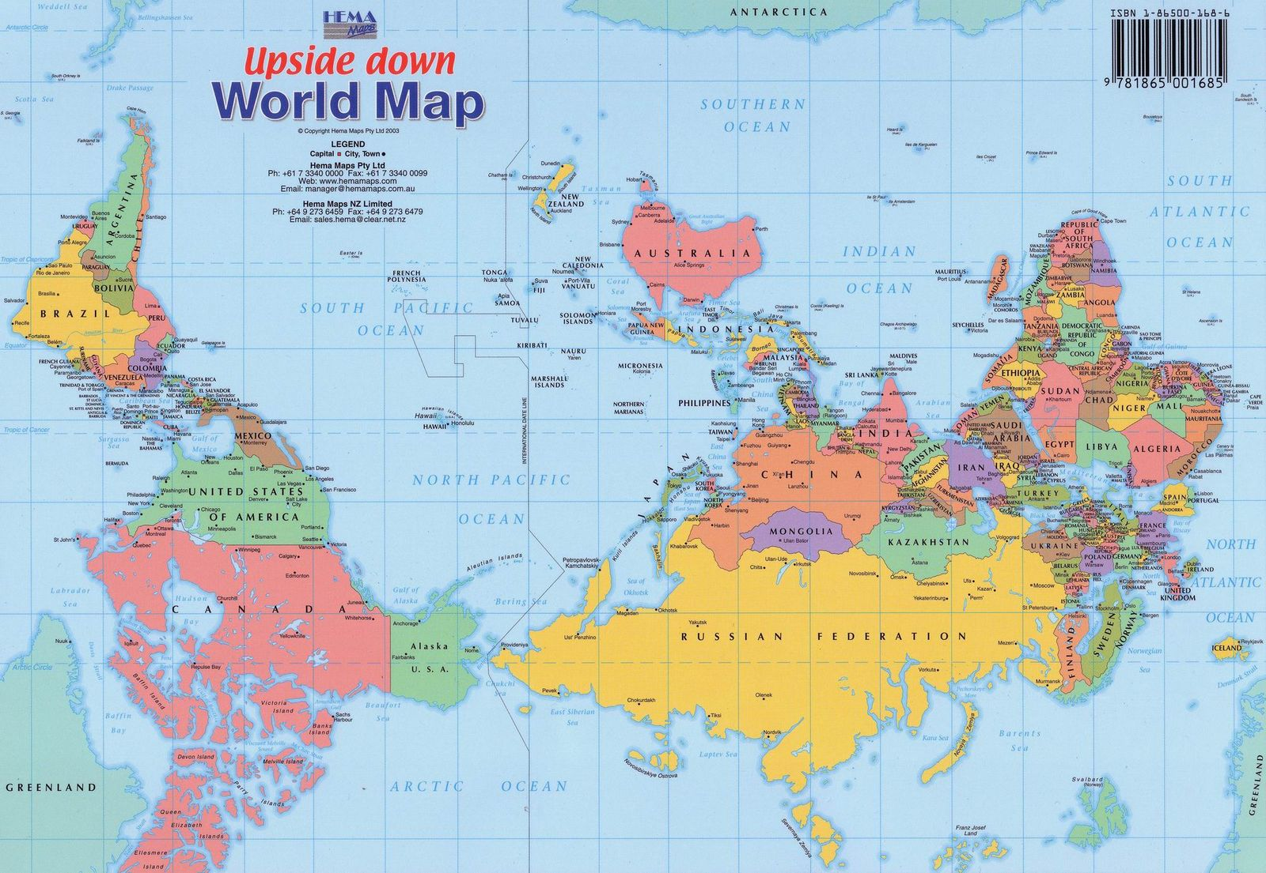
Southern Hemisphere-Top Projection
Southern Hemisphere-Top Projection
[South Up]

This type of map is a Southern Hemisphere-Centric Projection or South Up Map. This map places the Southern Hemisphere at the top of the world. Since most of the world’s land is in the Northern Hemisphere, most map makers have put that at the top.

PROS
This map makes you question what is up and what is down on a map. Since there is no true up or down in space, this map reminds us of that.

CONS
The Southern Hemisphere is at the top of the Earth, when there is no true top of the Earth.

WORKSHEET: 4-2.B

Note Taking Sheet

Map 1: Mercator Projection

What locations are at the center and top of this map? How does this look the same or different than maps you are using to looking at? Which maps do you think are more or less helpful (and for who)?

Map 2: Robinson Projection

What locations are at the center and top of this map? How does this look the same or different than maps you are using to looking at? Which maps do you think are more or less helpful (and for who)?

Map 3: Gall-Peters Projection

What locations are at the center and top of this map? How does this look the same or different than maps you are using to looking at? Which maps do you think are more or less helpful (and for who)?

Map 4: Atlantic-Centric

What locations are at the center and top of this map? How does this look the same or different than maps you are using to looking at? Which maps do you think are more or less helpful (and for who)?

Map 5: Pacific-Centric

What locations are at the center and top of this map? How does this look the same or different than maps you are using to looking at? Which maps do you think are more or less helpful (and for who)?

Map 6: Southern Hemisphere-Centric

What locations are at the center and top of this map? How does this look the same or different than maps you are using to looking at? Which maps do you think are more or less helpful (and for who)?

ASSESSMENT: 4-2.C

Map Perspectives: Exit Ticket

Inquiry Question: Which map is best?

Choose the one map from the carousel that you think best represents the Earth. You may consider qualities like most useful, fairness, accuracy, or other reasons. Include three pieces of evidence from the sources.

LESSON PLAN 4-3: Africa: Where Humans Began

MATERIALS

The First Human Video (Lesson4-3Video1) [Located in the UOW Video Library: www.christophercmartell.com/understandingourworld]
Source 1: Tools (WORKSHEET 4-3.A)
Source 2: Fire! (WORKSHEET 4-3.B)
Source 3: Y Chromosome Adam: Everyone’s Ancestor (WORKSHEET 4-3.C)
Source 4: Agricultural (WORKSHEET 4-3.D)
Africa: Where Man Began: Exit Ticket (ASSESSMENT 4-3.E)

STANDARDS

Massachusetts History and Social Science Framework

MA-HSS.4.CS.1: Use map and globe skills to determine absolute locations (latitude and longitude) of places studied. (G)

MA-HSS.7.1: Describe the great climatic and environmental changes that shaped the earth and eventually permitted the growth of human life. (H)

MA-HSS.7.4: Explain the importance of the invention of metallurgy and agriculture (the growing of crops and the domestication of animals). (H)

Common Core: Literacy

CCSS.ELA-Literacy.RI.4.9: Integrate information from two texts on the same topic in order to write or speak about the subject knowledgeably.

CCSS.ELA-Literacy.RI.4.10: By the end of year, read and comprehend informational texts, including history/social studies, science, and technical texts, in the grades 4–5 text complexity band proficiently, with scaffolding as needed at the high end of the range.

CCSS.ELA-Literacy.W.4.8: Recall relevant information from experiences or gather relevant information from print and digital sources; take notes and categorize information, and provide a list of sources.

CCSS.ELA-Literacy.W.4.9: Draw evidence from literary or informational texts to support analysis, reflection, and research.

PROCEDURES

Inquiry Question: What was the most important event of early humans in Africa?

A. OPENER (10 minutes)

1. Watch First Human Video
Show the students a short video on the first human in Africa 160,000-70,000 years ago (Lesson4-3Video1). Ask the students if they were surprised to learn that all humans came from one person? Are you surprised to learn that all humans were originally from Africa? What did the video tell us help humans spread all over the world? Solicit students’ responses to these questions.

Tell students that today we are going to study the beginning of man in Africa.

B. DEVELOPMENT (20 minutes)

2. Read About the Different Events of Early Humans in Africa
Put students in small groups and assign them one of the sources: Tools (WORKSHEET 4-3.A), Fire! (WORKSHEET 4-3.B), Y Chromosome Adam: Everyone’s Ancestor (WORKSHEET 4-3.C), Agricultural (WORKSHEET 4-3.D). Have one student from each group read their source. As the student reads, tell the other group members to underline or highlight any important information.

3. Engage in a Jig Saw About Early Humans in Africa
Have students participate in a jig saw activity. Make new groups where at least one student from each of the original groups is included. This will create several new groups of three students, one is an expert on 4-3.A, 4-3.B, 4-3.C, 4-3.D. Have each student describe their document to the other members of their group.

Ask students to use the sources to answer the following inquiry question: “What was the most important event of early humans in Africa?” In answering this question, students should debate between the four different worksheets. After students have discussed the question, they should complete the exit ticket in the following step. Circulate the room, helping the students who may have difficulty choosing one asset.

C. CLOSING (15 minutes)

4. Write Up Argument on the Early Humans in Africa
For the evaluation task, have the students complete the exit ticket (ASSESSMENT 4-3.E) where they write their own personal response to the lesson’s Inquiry Question: “What was the most important event of early humans in Africa?” Tell students to cite at least three pieces of evidence from the worksheets for this lesson.

Before using the exit ticket, consider using a graphic organizer or two column notes to prepare students for the writing task. Consider using sentence starters and modeling to help the students with their answer to the inquiry question.

EVALUATION

ASSESSMENT 4-3.D

What to look for?

Some information that students may include in their answer to the question:

Tools
- By eating meat from animals, the first humans were able to grow stronger due to the proteins and nutrients in meat.
- Unlike many plants, most meat does not include toxins (so it was a safer food), but it does spoil faster than plants.
- Meat is also more quickly digested, so the body can save energy for the brain and other organs.
- Hunting mean can also be dangerous and many humans were killed during hunts.

Fire!
- Fire gave humans warmth during the cold.
- It helped protect them from other animals.
- It helped them stay awake for longer amounts of time.
- It helped them cook their food (which meant food would be safer to eat, as heat killed deadly parasites).
- Fire allowed humans to settle in one place. This had a positive impact on families (moving around all the time could be difficult) and helped create languages (spending time in one place allowed time for humans to speak to one and other).
- Fire may have also lead to the first human art works, as many were cave drawings done with soot from a fire.

Y Chromosome Adam: Everyone’s Ancestor
- All humans are descendant from a male in Africa (Y Chromosome Adam)
- Humans migrated within and outside Africa. This migration made humans a diverse species.
- Over time, the environment influenced skin color and eye shape.

Agricultural
- About 23,000-12,000 years ago, man began to farm (agriculture).
- Before humans farmed, people needed to travel to follow the animals and plants that were their food; humans could now settle in one place and form communities.
- Humans started to grow plants and animals around the same time. They also used those animals for work.
- Farming also allowed humans to move into colder climates. It allowed them to grow food and store it for winter. Also, having more stable food allowed humans to better survive, as they were not always having periods of starvation.

WORKSHEET: 4-3.A

Source 1: Tools

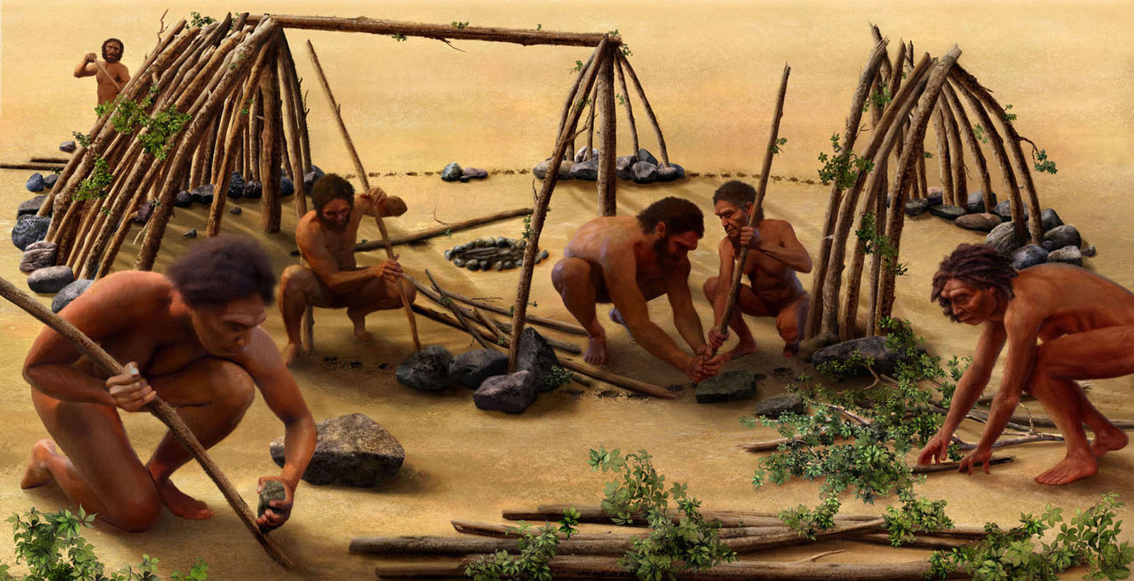

About 2.6 million years ago, the first humans in Africa used stones to strike other stones and produce sharp flakes. These early humans used these tools to cut, pound, crush, and access new foods, including meat from large animals.

By eating meat from animals, the first humans were able to grow stronger due to the proteins and nutrients in meat. Unlike many plants, most meat does not include toxins (so it was a safer food), but it does spoil faster than plants. Meat is also more quickly digested, so the body can save energy for the brain and other organs. Hunting mean can also be dangerous and many humans were killed during hunts.

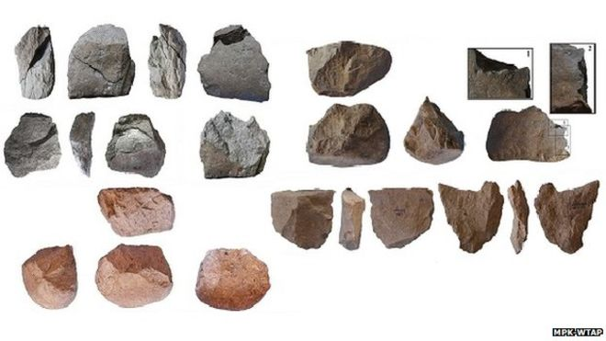

Above are examples of rock flakes that pound and crush. For much or early human history, the tools were primitive. Around 700,000 years ago, humans began to create hand axes, spears, and later bows and arrows.

WORKSHEET: 4-3.A

Source 2: Fire!

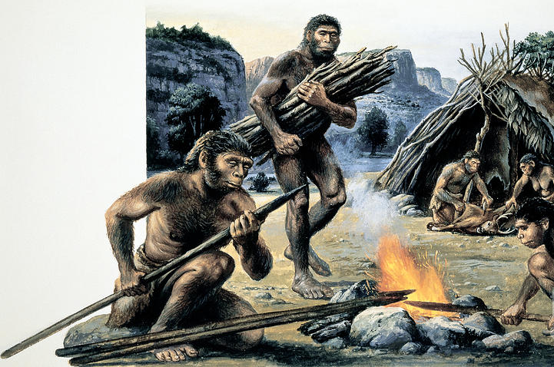

About 600,000 years ago humans were first able to create and control fire. Fire not only gave humans warmth during the cold, but it also helped protect them from other animals, stay awake for longer amounts of time, and cook their food (which meant food would be safer to eat, as heat kills deadly parasites).

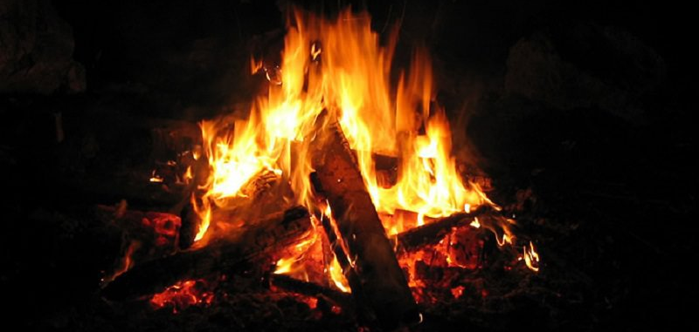

Fire also allowed humans to settle in one place. This had a positive impact on families (moving around all the time could be difficult) and helped create languages (spending time in one place allowed time for humans to speak to one and other). Fire may have also lead to the first human art works, as many were cave drawings done with soot from a fire.

WORKSHEET: 4-3.B

Source 3: Y Chromosome Adam: Everyone’s Ancestor

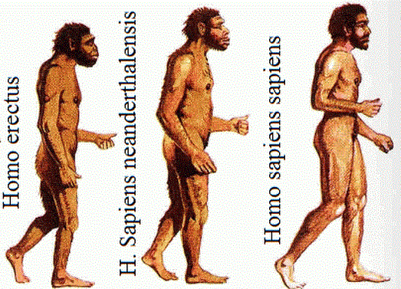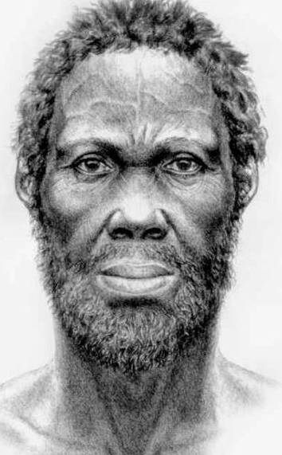

For millions of years there were several different types of hominins (man-like animals), including homo erectus, Neanderthals, and homo sapiens or humans (which is the species that you belong to). With the discovery of DNA, we can now scientifically trace the dates and locations of the first humans to East Africa. About 140,000 years ago, homo erectus went extinct (all died and the species no longer exists) and 40,000 years ago, Neanderthals went extinct. Homo sapiens (humans) were the only hominins left on Earth.

Scientists think that the first male human existed about 200,000 years ago. Scientists have nicknamed him “Y Chromosome Adam,” which is a reference to the Jewish, Christian, and Muslim creation story of Adam and Eve (there is a drawing of what he may have looked like above right). All modern humans are descendants from Y Chromosome Adam.
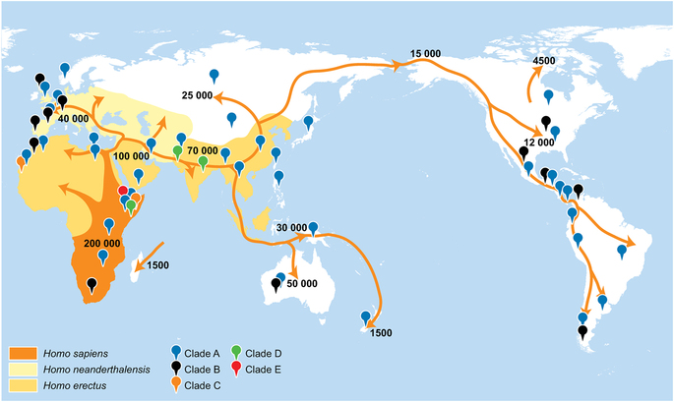

About 60,000 years ago humans first migrated out of Africa. Scientist think this happened just after an event that almost made them go extinct.

The above map shows the locations where those early humans settled, the number of years ago when they settled there, and their common ancestors (Clade A, B, C, D, E). When humans arrived in places like Central Asia and Europe, they encountered other Neanderthals and today most non-Africans have some Neanderthal DNA.

This migration also made humans a diverse species. Over time, the environment influenced skin color and eye shape. Some people developed eyes lids with skin folds or lighter skin, hair, and eye color.
WORKSHEET: 4-3.D

Source 4: Agricultural

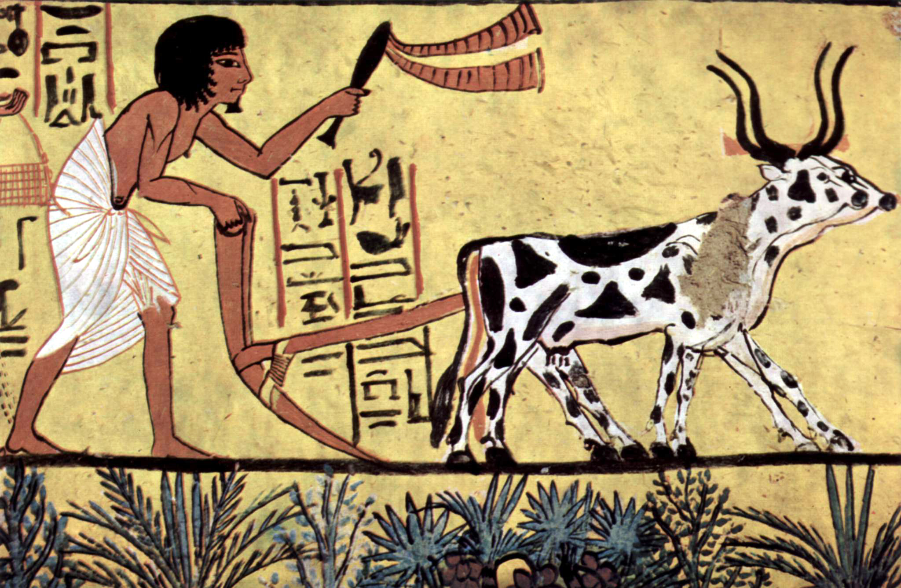

About 23,000-12,000 years ago, man began to farm (agriculture). Before humans farmed, people needed to travel to follow the animals and plants that were their food. This allowed humans to settle in one place and form communities. They began to build walls around their home areas to protect themselves. Humans started to grow plants and animals around the same time. They also used those animals for work.

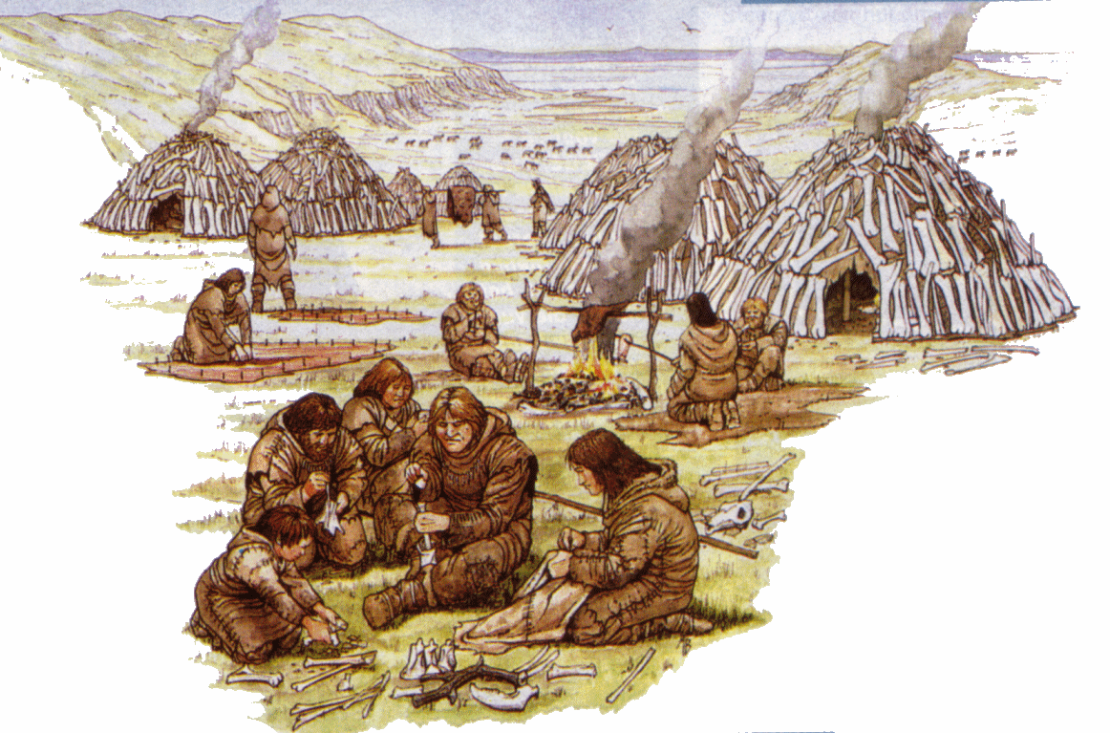

Farming also allowed humans to move into colder climates, like northern Europe, Asia, and America. It allowed them to grow food and store it for the winter. Also, having more stable food sources allowed humans to better survive, as they were not always having periods of starvation.

ASSESSMENT: 4-3.E

Africa: Where Humans Began:
Exit Ticket

Inquiry Question: What was the most important event of early humans in Africa?

Choose one even in early human history and explain why you think it is the most important. Include three pieces of evidence from the sources.

LESSON PLAN 4-4: Ancient Egypt

MATERIALS

Wooden blocks (100 block set is recommended; not supplied)
Blank drawing paper (not supplied)
Ancient Egypt Social Class Cards (WORKSHEET 4-4.A)
Ancient Egypt: Exit Ticket (ASSESSMENT 4-4.B)

STANDARDS

Massachusetts History and Social Science Framework

MA-HSS.4.CS.1: Use map and globe skills to determine absolute locations (latitude and longitude) of places studied. (G)

MA-HSS.7.13: Describe the kinds of evidence that have been used by archaeologists and historians to draw conclusions about the social and economic characteristics of Ancient Nubia (the Kingdom of Kush) and their relationship to the social and economic characteristics of Ancient Egypt. (H, G)

Common Core: Literacy

CCSS.ELA-Literacy.RI.4.9: Integrate information from two texts on the same topic in order to write or speak about the subject knowledgeably.

CCSS.ELA-Literacy.RI.4.10: By the end of year, read and comprehend informational texts, including history/social studies, science, and technical texts, in the grades 4–5 text complexity band proficiently, with scaffolding as needed at the high end of the range.

CCSS.ELA-Literacy.W.4.4: Recall relevant information from experiences or gather relevant information from print and digital sources; take notes and categorize information, and provide a list of sources.

CCSS.ELA-Literacy.W.4.5: Draw evidence from literary or informational texts to support analysis, reflection, and research.

PROCEDURES

Inquiry Question: If you could be in any ancient Egyptian social class, which would you choose and why?

PREPARATION

1. Review the Roles listed on the Ancient Egypt Social Class Card
Carefully review and familiarize yourself with the 5 different roles on the Ancient Egypt Social Class Cards (WORKSHEET 4-4.A) for this lesson.

While the students should receive all of the cards in a packet, you should circle or highlight the card that they have individually been assigned to. The largest number of students should be peasants and workers, with smaller numbers being priests and soldiers, and only one person should be the pharaoh. The gender of the card does not need to be the same as the gender of the student.

A. OPENER (20 minutes)

1. Participate in an Ancient Egypt Social Class Simulation
Tell students that today we are going to pretend we are in Ancient Egypt, which was an Empire in Africa. Each student will represent a specific person who existed in Ancient Egypt: Pharaoh, Priests, Soldiers, Workers, Peasants. Give the students the worksheet titled (with all of the social classes) Ancient Egypt Social Class Cards (WORKSHEET 4-4.A) that describes each social class and their directions. There are five different social class listed on the cards.

Some of the activities students may be asked to do:
- Priests: Pray quietly in a circle. Choose where to build and grow crops.
- Soldiers: Go to war (walk back and forth from two walls of the pharaoh’s choosing).
- Workers: Build pyramid and other building structures.
- Peasants: Grow crops (drawing pictures of wheat).

Tell the students to each read their social class card. Do this one by one until all the students have heard the rules for the five social classes. Next, have them look at their card and underline or highlight their social class and the details of their day-to-day life.

Tell students that they are now in Ancient Egypt and they will need to follow the rules listed under the directions for their social class card.

Have students take part in the social class simulation. They should interact with each other using the directions on their cards.

After the simulation is over, write the names of the five social classes on the board or chart paper. Have students in each social class list what their life was like and take notes about these under each category. After, ask students which people they thought were at the top or had the most power. Ask students which people were at the bottom or had least power (The current order shows most powerful to least powerful: Pharaoh, Priests, Soldiers, Workers, Peasants).

B. DEVELOPMENT (15 minutes)

2. Write Up Argument on the Early Humans in Africa
For the evaluation task, have the students complete the exit ticket (ASSESSMENT 4-4.B) where they write their own personal response to the lesson’s Inquiry Question: “If you could be in any ancient Egyptian social class, which would you choose and why?” Tell students to cite at least three pieces of evidence from the Ancient Egypt Social Class Cards.

Before using the exit ticket, consider using a graphic organizer or two column notes to prepare students for the writing task. Consider using sentence starters and modeling to help the students with their answer to the inquiry question.

C. CLOSING (10 minutes)

3. Share Arguments
Have students share their arguments about social class with the class. Draw comparisons between the different students’ stories and list them on the board or chart paper.

EVALUATION

ASSESSMENT 4-4.B

What to look for?

Some information that students may include in their answer to the question:

Pharaoh (not allowed to write about)

Priests
- They made many choices, where to build buildings or grow food.
- Had a lot of power; right under the pharaoh.
- Negative: Did not have much freedom over what to eat or wear.

Soldiers
- Were respected by many people.
- Had more power than workers or peasants.
- Negative: Died in war; had to march far distances.

Workers
- Did an important and skilled job building things for the empire.
- Had more power than peasants.
- Did not have to fight in wars.
- Could eat and wear whatever they wanted.
- Negative: Dies in accidents.

Peasants
- Did an important job of growing everyone’s food.
- Did not have to fight in wars.
- Could eat and wear whatever they wanted.
- Negative: Least power.

WORKSHEET: 4-4.A

Ancient Egypt Social Class Cards

Pharaoh (only 1 student)

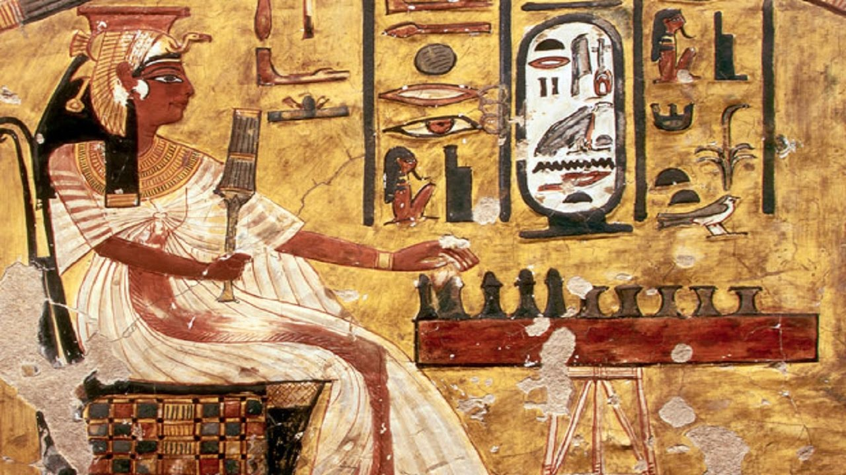

The word pharaoh comes from the Egyptian word for “great house” meaning the royal palace. You are the ruler and control everything in Egypt. You tell everyone what to do.

There were a few women pharaohs, but most were men. In fact, few women actually worked outside the home in Ancient Egypt, as it was something they thought was wrong. Women spent most of their lives taking care of children (although in this activity, to be fair, we will let girls have all the same roles as boys).

At any point, as pharaoh, you may tell the other students to do the following:

Priests: If you want to build a building or grow crops, you must first ask the priest to decide as a group where in the classroom to do this.

Soldiers: Tell the soldiers to invade a nearby empire. When you do this, they will have to walk back and forth from one wall to another wall of the classroom (you choose which two walls).

Workers: Tell all the workers to use the blocks and build you buildings. The best building is a pyramid (see below) and they should build that (priests choose where).

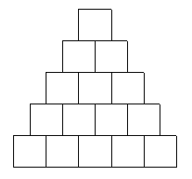

Peasants: Tell all the peasants to grow crops for next year. When they are growing crops (priests choose where they draw), they should take blank drawing paper and draw wheat (see below).
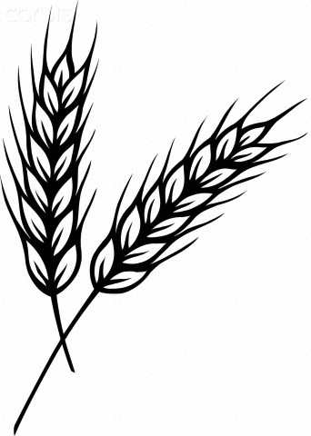
Priests

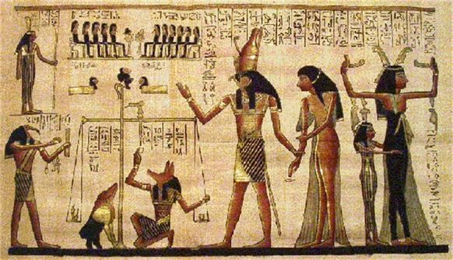

You were very important in Ancient Egyptian society, because you watched the sky, stars, and weather and used it to help the people make decisions. When the Pharaoh asks you, you will choose where to build buildings or plant crops.

The down side is that you cannot eat fish (which was seen as a food only for soldiers, workers, or peasants) or wear any cloth made from animal hair or skin (because animals were unclean). It is only cotton clothes for you (no wool or leather). Also, you must take three or four baths a day to keep yourself clean and pure. Choose one person to keep time and every 2 minutes they tell everyone to take a bath (and pretend to take a bath).

When the Pharaoh is not asking for your advice, you must sit quietly in a circle and pray. You should whisper as a group over and over again the following words (which was a real prayer at the time).
Priests’ Prayer

Nefer em pet!
Pet em hotep
Ta em hotep
Nut jert sat Nut
Sat Geb. Merit Ausar.
Nut jert asha renu!
Anekh herak
Anekh herak
Tu a atu
Tu a atu
Nebet Aset!

Soldiers

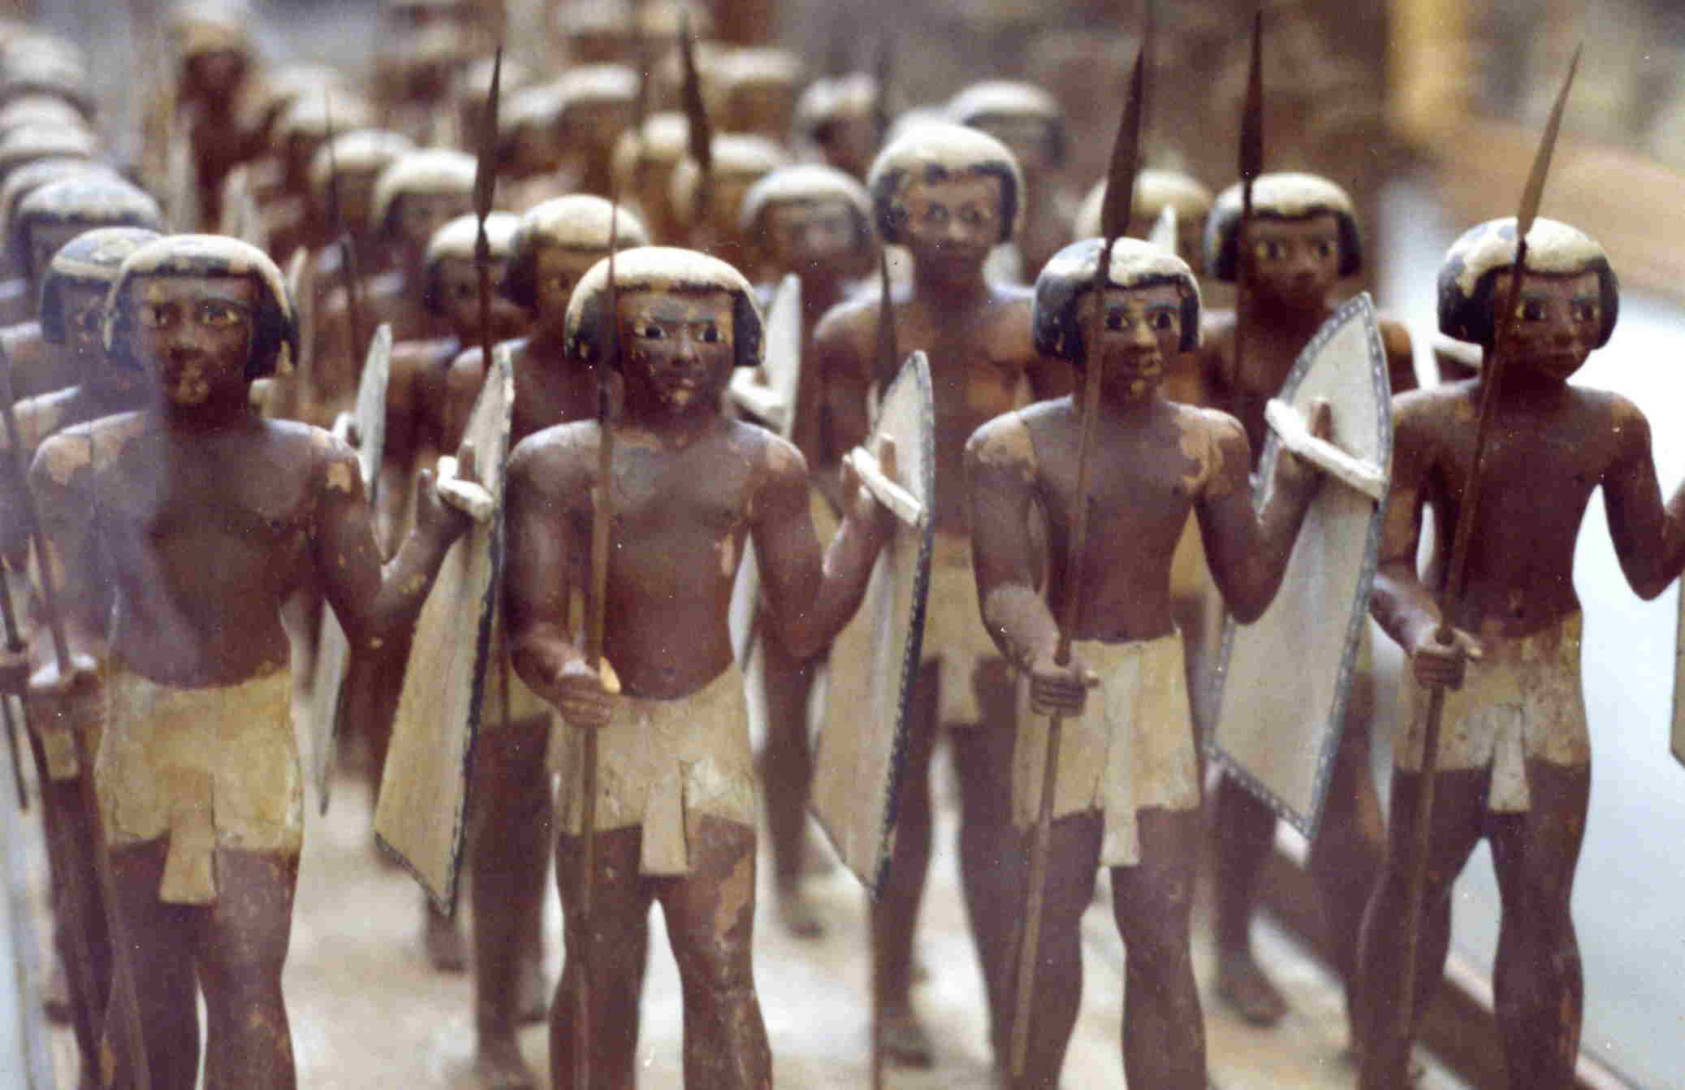

Since you went to war for the empire, soldiers were respected by many people. In the early days, you had few weapons or armor. Over time, they invented helmets, shields, bows and arrows, and spears. Life was difficult during wars and involved marching for many days, weeks, or even months. You were at least feed and paid well.

When the pharaoh orders you to go to war, you will have to walk back and forth between two walls on they tell you to stop.

When you are not at war, you may rest by sitting quietly and watching what the other people in Egypt are doing.

Workers

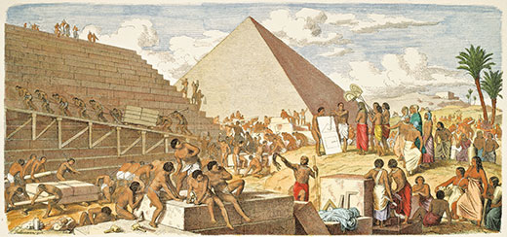

Workers had a more power than peasants, because they had the skills to build things. Your work was tiring and hard. It was also dangerous and workers were often killed in accidents.

When the pharaoh orders you to go to build something, you will have to build whatever they tell you to. You should build the best building, the pyramid (see below).

When you are not building, you may rest by sitting quietly and watching what the other people in Egypt are doing.
Peasants (Farmers)

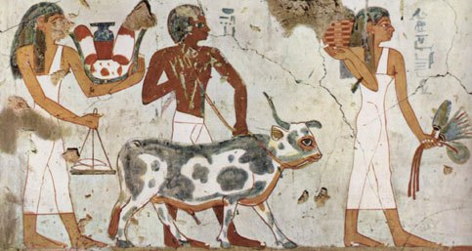

Peasants were very important, because you grew everyone’s food, but you had the least power. Your work was tiring and hard, but not as dangerous as a soldier or worker.

When the pharaoh orders you to grow crops, you will have to draw pictures of wheat (see below).

When you are not growing crops, you may rest by sitting quietly and watching what the other people in Egypt are doing.

ASSESSMENT: 4-4.B

Ancient Egypt:
Exit Ticket

Inquiry Question: If you could be in any ancient Egyptian social class, which would you choose and why?

Choose one social class from Ancient Egypt (but you cannot choose the pharaoh) and explain why you would want to be in that social class. Include three pieces of evidence from the descriptions of each social class.

LESSON PLAN 4-5: The Great African Empires: Ghana, Kongo, Ethiopia, and Zimbabwe

MATERIALS

History of Metal (Lesson4-5Video1) [Located in the UOW Video Library: www.christophercmartell.com/understandingourworld]
Clipboard (not supplied)
Source 1: Ghana (WORKSHEET 4-5.A)
Source 2: Kongo (WORKSHEET 4-5.B)
Source 3: Ethiopia (WORKSHEET 4-5.C)
Source 4: Zimbabwe (WORKSHEET 4-5.D)
Note Taking Sheet (WORKSHEET 4-5.E)
The Great African Empires: Exit Ticket (ASSESSMENT 4-5.F)

STANDARDS

Massachusetts History and Social Science Framework

MA-HSS.4.CS.1: Use map and globe skills to determine absolute locations (latitude and longitude) of places studied. (G)

MA-HSS.WHI.19: Describe important political and economic aspects of the African empires. (H, E)

Common Core: Literacy

CCSS.ELA-Literacy.RI.4.9: Integrate information from two texts on the same topic in order to write or speak about the subject knowledgeably.

CCSS.ELA-Literacy.RI.4.10: By the end of year, read and comprehend informational texts, including history/social studies, science, and technical texts, in the grades 4–5 text complexity band proficiently, with scaffolding as needed at the high end of the range.

CCSS.ELA-Literacy.W.4.8: Recall relevant information from experiences or gather relevant information from print and digital sources; take notes and categorize information, and provide a list of sources.

CCSS.ELA-Literacy.W.4.9: Draw evidence from literary or informational texts to support analysis, reflection, and research.

PROCEDURES

Inquiry Question: If you could live in any ancient African empire, which one would it be and why?

PREPARATION

1. Set Up Carousel Activity
Around the room, post the four sources: Ghana (WORKSHEET 4-5.A), Kongo (WORKSHEET 4-5.B), Ethiopia (WORKSHEET 4-5.C), Zimbabwe (WORKSHEET 4-5.D).

A. OPENER (10 minutes)

2. Watch the History of Metal Video
Show the students a short video describing the invention of metal in Africa (Lesson4-5Video1). After watching the video, ask the students to tell you all the things they can think of that are made of metal. List the items on the board or chart paper. Ask students, why do they think that being able to make metal is important and what would life be like today without metals.

Tell the students that today we are going to study four of the Great African Empires, which were groups of people who were grouped together to form large nations that protected each other and had a single ruler (much like the pharaoh of Ancient Egypt). These empires were able to happen, in part, because of metal. Many of these empires became powerful by trading metals to people in Europe and Asia.

B. DEVELOPMENT (20 minutes)

3. Engage in a Carousel Activity on the Number of Continents
Give each student pencil and clipboard with the Note Taking Sheet (WORKSHEET 4-5.E) on it. Ask students to go to each of the four stations (4-5.A, 4-5.B, 4-5.C, 4-5.D). At each station, the students should take notes on the different Great African Empires.

Once students have gone to each of the four stations, they should return to their seats. Put students in small groups. Have them look at their note sheets debate which empire they think would be the place where they would want to live.

C. CLOSING (15 minutes)

4. Write Up Argument on the Great African Empires
For the evaluation task, have the students complete the exit ticket (ASSESSMENT 4-5.F) where they write their own personal response to the lesson’s Inquiry Question: “If you could live in any ancient African empire, which one would it be and why?” Tell students to cite at least three pieces of evidence from the sheets on the walls. Tell students that the evidence they use can be something that they wrote on the sheets. Encourage students to get up and look at the sheets on the wall, when they need evidence to write on their sheet.

Before using the exit ticket, consider using a graphic organizer or two column notes to prepare students for the writing task. Consider using sentence starters and modeling to help the students with their answer to the inquiry question.

EVALUATION

ASSESSMENT 4-5.F

What to look for?

Some information that students may include in their answer to the question:

Ghana
- Located in West Africa.
- Desert climate with hot and dry year-round with some rain in the winter.
- Medium empire (30,000 people)
- Became very rich from mining and trading iron and gold.
- Use camels to bring it to other empires across the Sahara Desert.
- People lived in large houses with extended family.
- Muslims were the largest religious group.

Kongo
- Located in Central Africa.
- Tropical climate with hot and dry summers, and warm and rainy winters.
- Very large empire (500,000 people)
- Empire became very rich from mining and trading iron and copper.
- They would sell much of their metals to Europe through ports on the Atlantic.
- People lived in small houses with immediate family, but were close to other relatives.
- A native religion was the largest religious group.

Ethiopia
- Located in East Africa.
- Tropical climate with hot and rainy summers, and warm and dry winters.
- Small empire (20,000)
- Became very rich from mining and trading iron, gold, and salt (more than just metals).
- They would sell much of their metals to Europe and the Middle East, as they were near the Silk Road (best trade location).
- People lived in small houses with immediate family.
- Christianity was the largest religious group.

Zimbabwe
- Located in Southern Africa.
- Subtropical climate with warm and rainy winters and dry and hot summers.
- Small empire (18,000)
- The Zimbabwe Empire became very rich from mining and trading copper, iron, and gold.
- Build large granite structures.
- People lived in small houses with immediate family.
- Shona was the largest religious group.

WORKSHEET: 4-5.A

Source 1: Ghana

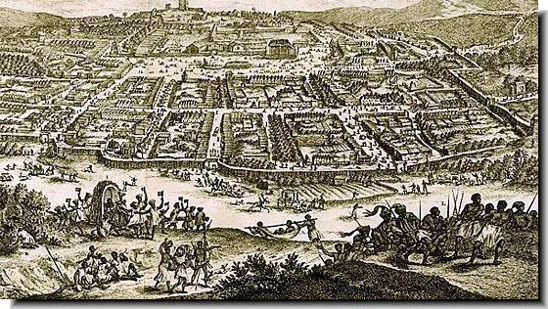

The Ghana Empire was in West Africa (today Mali and Mauritania) and lasted from 400 to 1200 CE. Its capital was a city called ‎Kumbi Saleh (pictured above), which had over 30,000 (about the size of London, England at the time). The climate there is desert with hot and dry year-round with some rain in the winter.

People in the Ghana Empire usually lived with all of their relatives in one big house, including grandparents, uncles, aunts, and cousins. The largest religious group were Muslims. The Ghana Empire had a large army and there were usually well protected. They were known for their art and stories. They may have created the story “Anansi the Spider.”

The Ghana Empire became very rich from mining and trading iron and gold. They would use camels to bring gold and iron across the Sahara Desert to trade with Europe and Asia. One European described the Ghana Empire as, “The King wears necklaces around his neck and bracelets on his forearms and he puts on a high cap decorated with gold. Many people visit him in a domed palace around which stand ten horses covered with gold.”

The below map shows the location of the Ghana Empire in Africa.

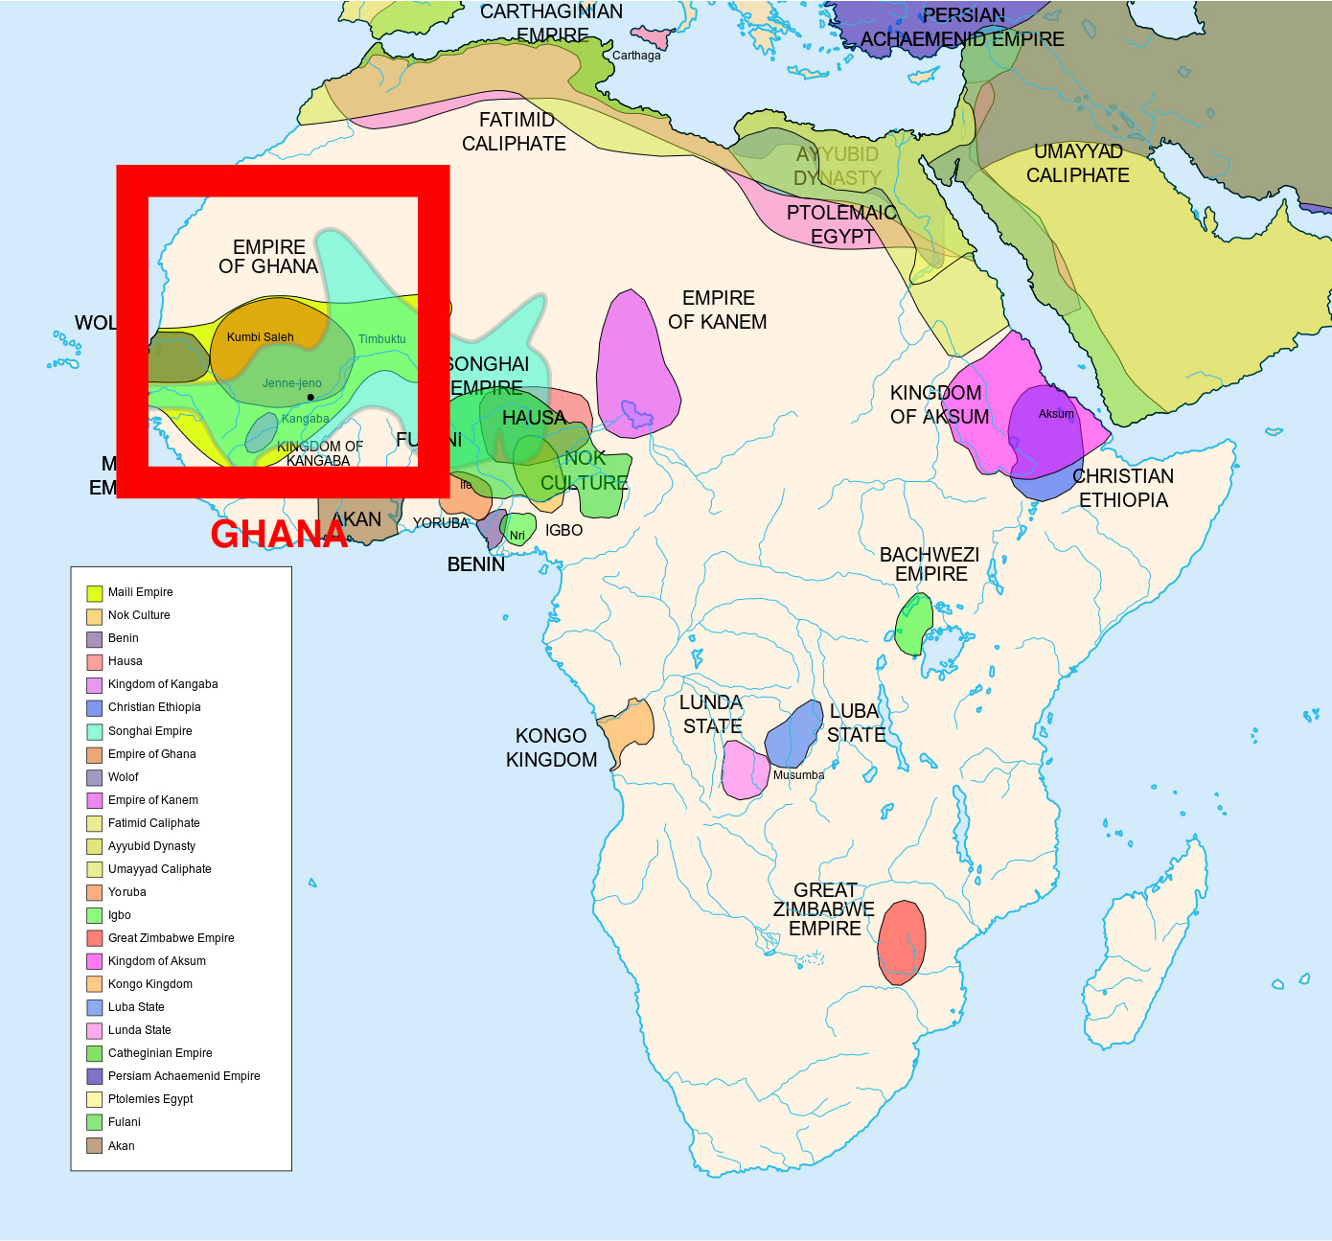
WORKSHEET: 4-5.B

Source 2: Kongo

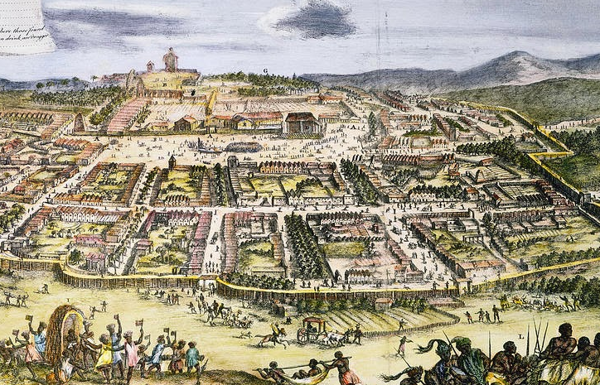

The Kongo Empire was along the Kongo River in Central Africa (today Angola, Republic of the Congo, Democratic Republic of the Congo) and lasted from the 1300s-1800s (the city of Loango is pictured above). The empire had over 500,000 people (about the size of Beijing, China at the time). The climate there is tropical with hot and dry summers, and warm and rainy winters.

People in the Kongo Empire (BaKongo) usually lived in small homes with their families, but they were usually very close to their other family members, like grandparents, uncles, aunts, and cousins. Most people practiced a native religion involving a god or gods. They also used small boats to transport goods up and down the river. They were known for their sculptures called nkisi statues (pictured above).

The Kongo Empire became very rich from mining and trading iron, copper, and ivory. They would sell much of their metals and ivory to Europe who had ports along the Atlantic Ocean. One European described the Ghana Empire as, “There were nine caravans under nine leaders ... The villages we visited were peaceful.”

The below map shows the location of the Kongo Empire in Africa.

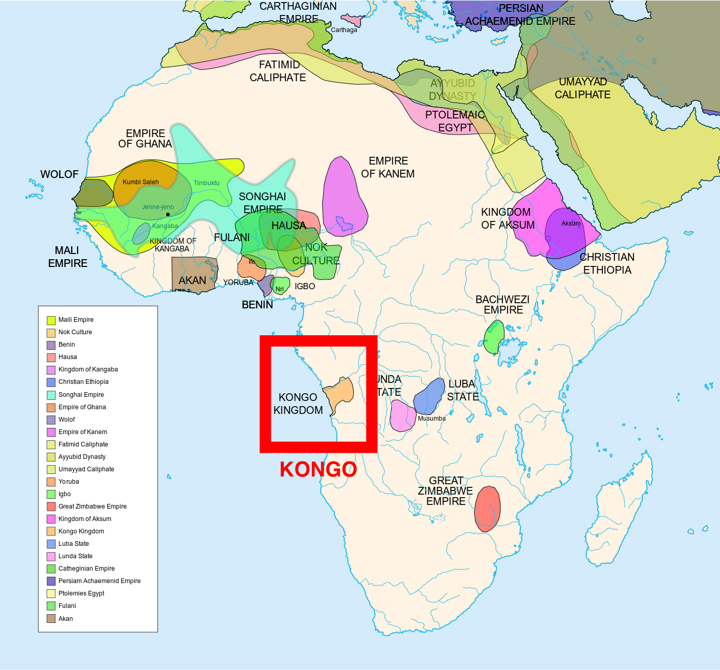
WORKSHEET: 4-5.C

Source 3: Ethiopia

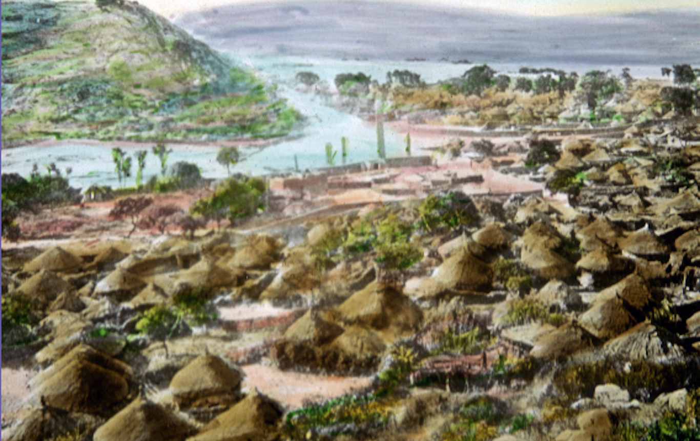

The Ethiopian Empire was in East Africa (today Ethiopia and Eritrea) and lasted from 1100s-1900s. Its capital was a city called ‎Aksum (pictured above), which had 20,000 people (about the size of Rome, Italy at the time). The climate there is tropical with hot and rainy summers, and warm and dry winters.

People in the Ethiopian Empire lived in small homes with their families. Most were farmers or workers. The largest religious group was Christians. They were known for their gold and silver coins, which had pictures of their kings.

The Ethiopian Empire became very rich from mining and trading iron, gold, and salt. They would sell much of their metals to Europe and the Middle East, as they were near the Silk Road. One European described the Ethiopian Empire as, “Among the metals, Ethiopian copper is the most scarce and valuable.”

The below map shows the location of the Ethiopia Empire in Africa.

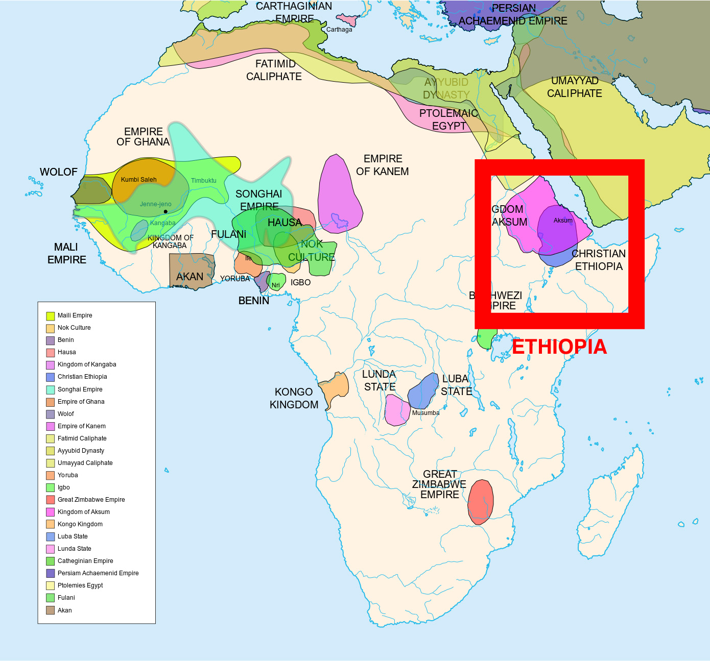
WORKSHEET: 4-5.D

Source 4: Zimbabwe

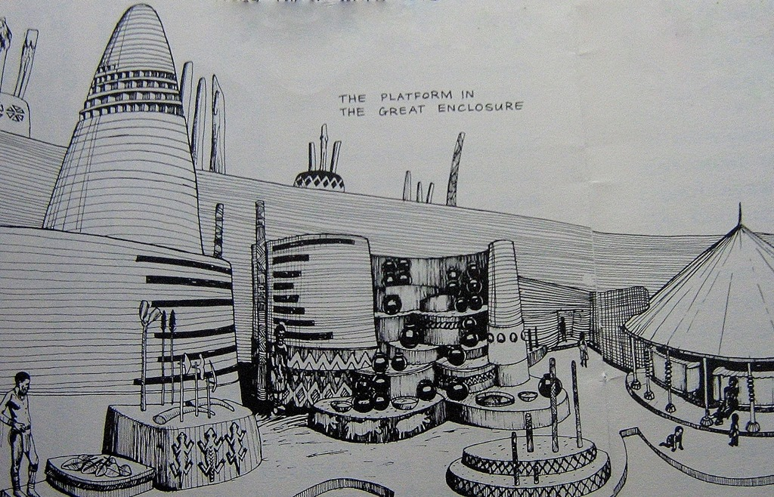

The Zimbabwe Empire was in Southern Africa (today modern-day Zimbabwe) and lasted from 1000s-1500s. Its capital was a city called ‎Great Zimbabwe (pictured above), which had over 18,000 people (about the size of Rome, Italy at the time). The climate there is subtropical with warm and rainy winters and dry and hot summers.

People in the Zimbabwe Empire lived in small homes with their families located around the king’s palace. They probably worshipped Mwari and the Shona religion. They were known for building massive forts from granite stone (which you can still see today and they are some of the oldest buildings in Africa).

The Zimbabwe Empire became very rich from mining and trading copper, iron, and gold. One European described the Zimbabwe Empire as, “Among the gold mines, … there is a fort built of stones of very large size, and there appears to be no mortar cement joining them.”

The below map shows the location of the Zimbabwe Empire in Africa.

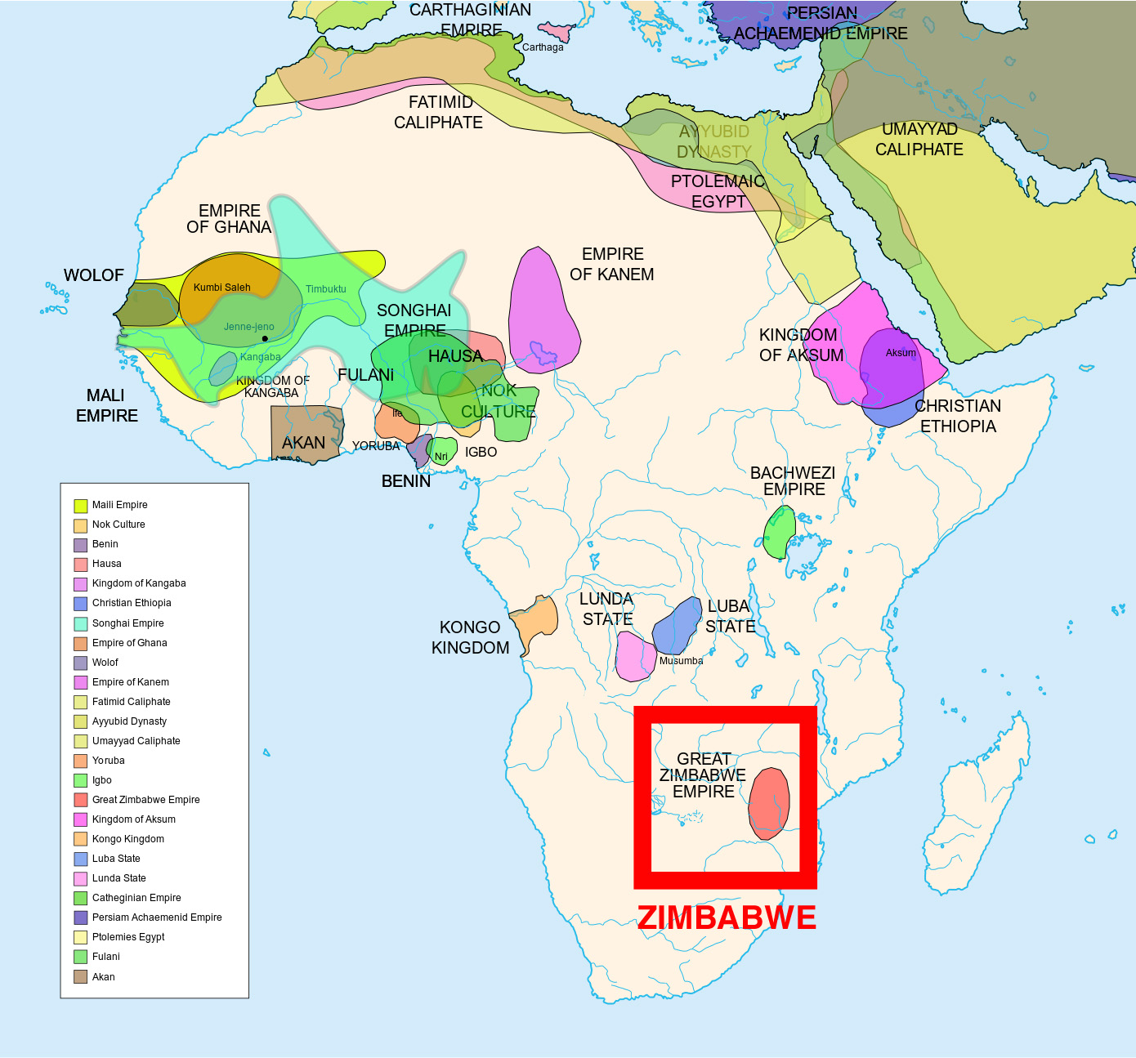

WORKSHEET: 4-5.E

Note Taking Sheet

Source 1: Ghana

What are the most important points about this empire?

Source 2: Kongo

What are the most important points about this empire?

Source 3: Ethiopia

What are the most important points about this empire?

Source 4: Zimbabwe

What are the most important points about this empire?

ASSESSMENT: 4-5.F

The Great African Empires: Exit Ticket

Inquiry Question: If you could live in any ancient African empire, which one would it be and why?

Choose one Great African Empire and explain why you would choose to live there. Include three pieces of evidence from the sources.

LESSON PLAN 4-6: Timbuktu: How Trade Shaped a City

MATERIALS

Images (WORKSHEET 4-6.A)
Source 1: Trade (WORKSHEET 4-6.B)
Source 2: Education (WORKSHEET 4-6.C)
Source 3: Religion (WORKSHEET 4-6.D)
Timbuktu: Exit Ticket (ASSESSMENT 4-6.E)

STANDARDS

Massachusetts History and Social Science Framework

MA-HSS.4.CS.1: Use map and globe skills to determine absolute locations (latitude and longitude) of places studied. (G)

MA-HSS.WHI.19: Describe important political and economic aspects of the African empires. (H, E)

Common Core: Literacy

CCSS.ELA-Literacy.RI.4.9: Integrate information from two texts on the same topic in order to write or speak about the subject knowledgeably.

CCSS.ELA-Literacy.RI.4.10: By the end of year, read and comprehend informational texts, including history/social studies, science, and technical texts, in the grades 4–5 text complexity band proficiently, with scaffolding as needed at the high end of the range.

CCSS.ELA-Literacy.W.4.8: Recall relevant information from experiences or gather relevant information from print and digital sources; take notes and categorize information, and provide a list of sources.

CCSS.ELA-Literacy.W.4.9: Draw evidence from literary or informational texts to support analysis, reflection, and research.

PROCEDURES

Inquiry Question: Why was Timbuktu so important?

PREPARATION

This lesson uses a method called Visual Thinking Strategy (VTS). The key to VTS is that you as a teacher only do two things: (1) Ask the following questions and (2) repeat as precisely as possible exactly what the students say.

Visual Thinking Strategy Questions:
- Open with: “What’s going on in this picture?”
Summarize student responses using conditional language (“Raoul thinks this could be…”). This keeps the conversation open to other interpretations by other students.
- If appropriate: “What do you see that makes you say that?”
This encourages students to back up their statements with things they see in the work of art.
- Ask the group: “What more can we find?”
This continues the conversation.

If this is your first time using VTS, I would recommend reading this description (with a video example from Grade 1) of it from the Milwaukee Art Museum: http://teachers.mam.org/collection/teaching-with-art/visual-thinking-strategies-vts/

A. OPENER (10 minutes)

1. Engage in a Visual Thinking Strategy (VTS) on Timbuktu Images
Give students Images (WORKSHEET 3-6.A). Do not reveal that these are images of Timbuktu or Africa. Project the first image (Lettered “A”) and tell the students to look at the image closely and quietly. Give them about one minute. Next, begin the VTS question about the image. Use the above questions, following VTA instructions. Have students inquire about the question using the above questions for about 2-3 minutes.

Project the second image (Lettered “B”) and tell the students to look at the image closely and quietly. Give them about one minute. Next, begin the VTS question about the image. Use the above questions, following VTA instructions. Have students inquire about the question using the above questions for about 2-3 minutes.

Tell students that today we will be learning about the city of Timbuktu in Africa. It was the heart of trade with many goods being transported through it. Picture A was a picture from today of the Mosque in the center if the city and Picture B was what the city looked like hundreds of years ago. You had many good observations of the pictures. From the pictures, what do you think live was and is like in Timbuktu? Anticipated answers may include: it is in a desert, it was very large, some people there are Muslim (Mosque), it was very important. Tell the students that we will learn today about the many different parts of Timbuktu and it will have to decide what was most important.

B. DEVELOPMENT (20 minutes)

2. Read About the Different Parts of Timbuktu
Put students in small groups and assign them one of the sources: Trade (WORKSHEET 4-6.B), Education (WORKSHEET 4-6.C), Religion (WORKSHEET 4-6.D). Have one student from each group read their source. As the student reads, tell the other group members to underline or highlight any important information.

3. Engage in a Jig Saw About Timbuktu
Have students participate in a jig saw activity. Make new groups where at least one student from each of the original groups is included. This will create several new groups of three students, one is an expert on 4-6.B, 4-6.C, 4-6.D. Have each student describe their document to the other members of their group.

Ask students to use the sources to answer the following inquiry question: “Why was Timbuktu so important?” In answering this question, students should debate between the four different worksheets. After students have discussed the question, they should complete the exit ticket in the following step. Circulate the room, helping the students who may have difficulty choosing one asset.

C. CLOSING (15 minutes)

4. Write Up Argument on the Most Important Part of Timbuktu
For the evaluation task, have the students complete the exit ticket (ASSESSMENT 4-6.E) where they write their own personal response to the lesson’s Inquiry Question: “Why was Timbuktu so important?” and choose the part they think was most important. Tell students to cite at least three pieces of evidence from the worksheets for this lesson.

Before using the exit ticket, consider using a graphic organizer or two column notes to prepare students for the writing task. Consider using sentence starters and modeling to help the students with their answer to the inquiry question.

EVALUATION

ASSESSMENT 4-6.E

What to look for?

Some information that students may include in their answer to the question:

Trade
- It was a center of trade in Africa, selling sugar, nuts, salt, cloth, books, and glass.
- It became one of the wealthiest cities in the world.
- It had goods from all over the world.

Education
- Important place for schools and learning.
- Libraries had over 700,000 books, about art, medicine, philosophy, science, and religion.
- Many people would travel there from all over Africa and the world to learn.

Religion
- A large mosque or Muslim place of worship was built there by Mansa Musa I.
- People would travel all over the world to learn about religion (Islam) there.
- They would copy religious books there.
WORKSHEET: 4-6.A

Images (A)

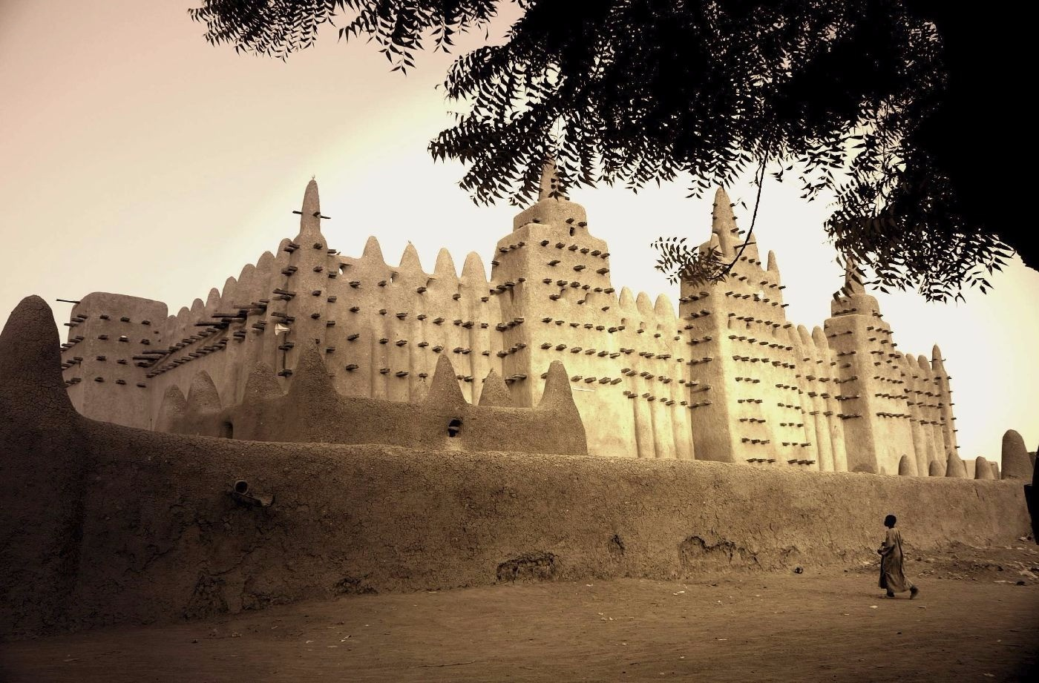
Images (B)

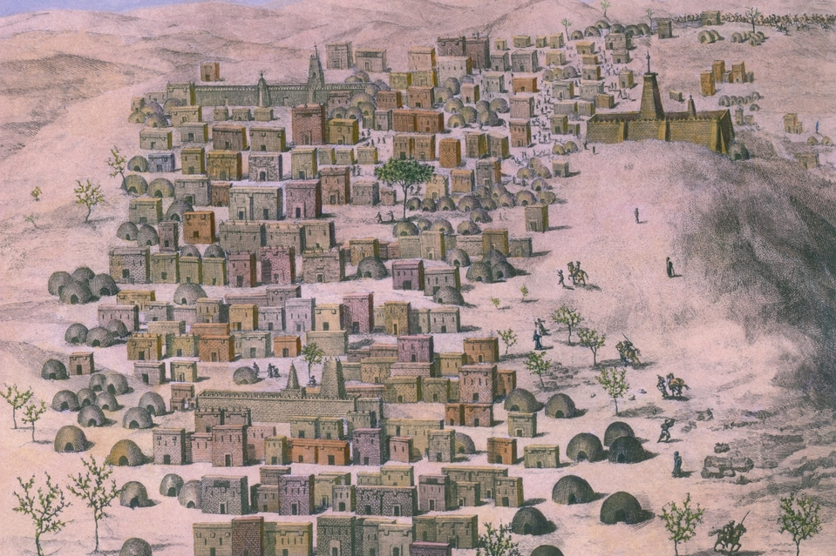
WORKSHEET: 4-6.B

Source 1: Trade

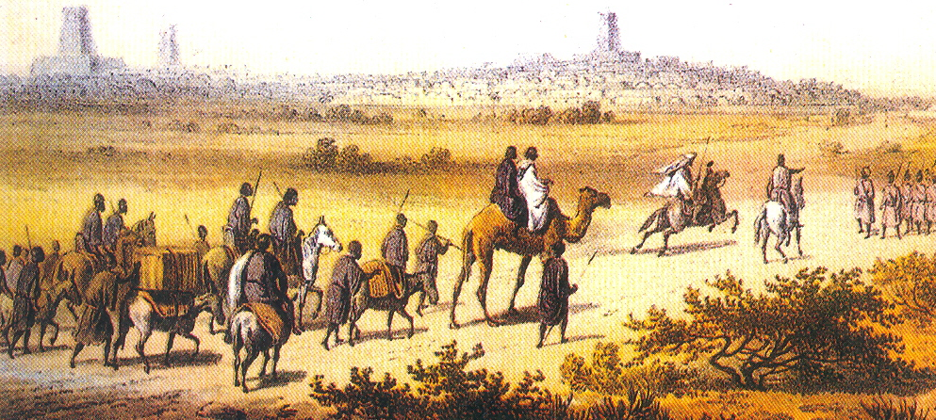

Timbuktu (tim-buck-too) was one of Africa’s most important trading cities. Boats on the Niger (nee-zhur) River and camel caravans across the Sahara Desert would bring goods to trade in Timbuktu. Near Timbuktu there are many salt mines. Through trade, it became one of the wealthiest cities in Africa and the world.

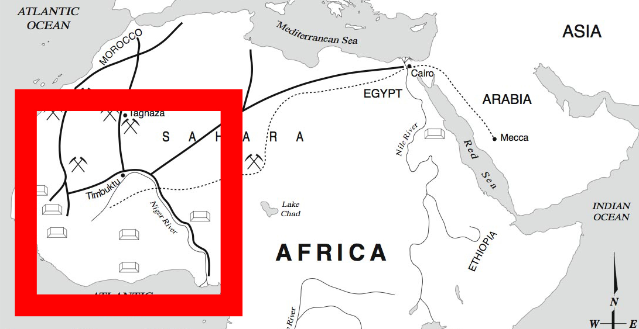

There were crowded markets (see picture below) selling sugar, nuts, salt, cloth, books, and glass. Slaves (people forced to work for no pay) were also bought and sold there.

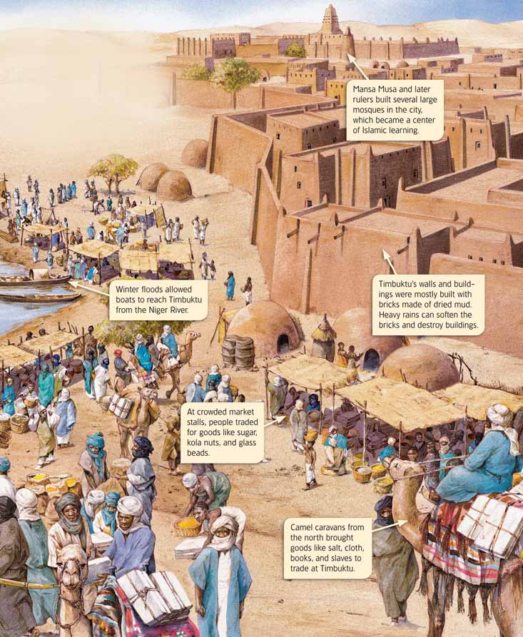
WORKSHEET: 4-6.C

Source 2: Education

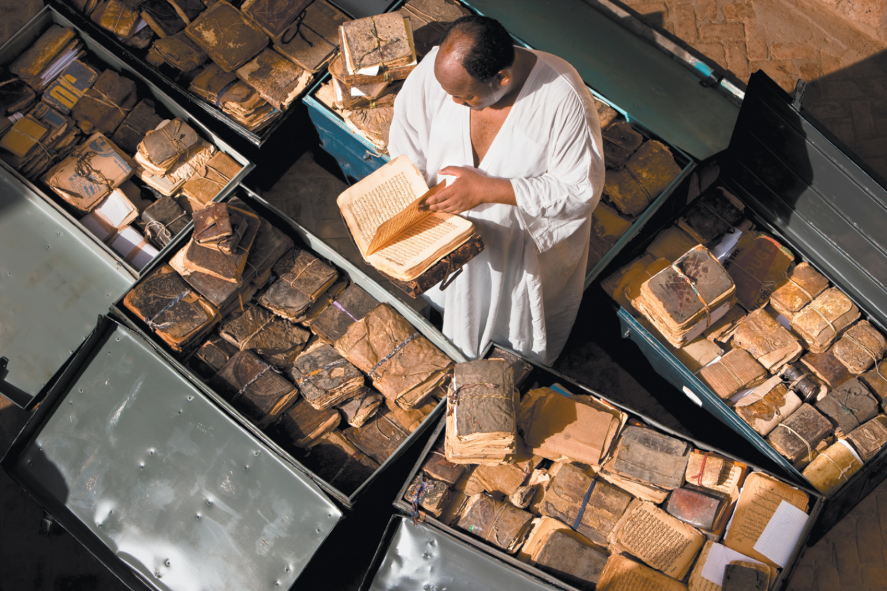

Overtime, Timbuktu became an important place for schools and learning. Many schools were started there and their libraries had books from all over Africa and the world. Eventually, there were over 700,000 books in the schools and libraries of Timbuktu (see a picture of two of the books on the next page). There were books about art, medicine, philosophy, science, and religion, including early copies of the Muslim religious book called the Quran (cu-ron). Many of the books were in the Arabic language, but some were written in other languages. In 2013, war broke out in Timbuktu and many of the books were almost destroyed. One of the librarians helps smuggle 350,000 books to safety.

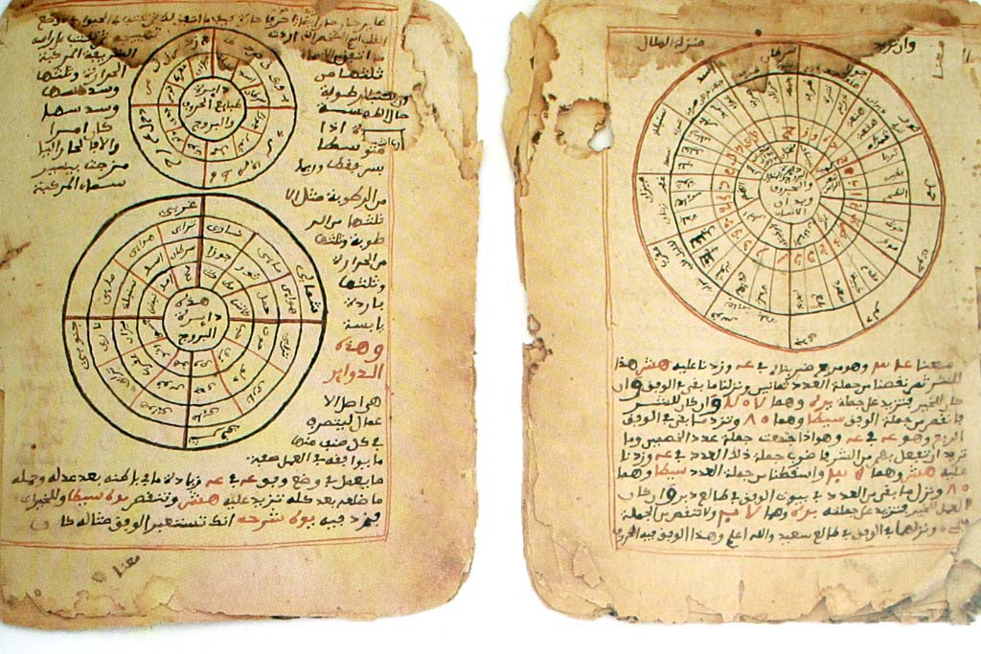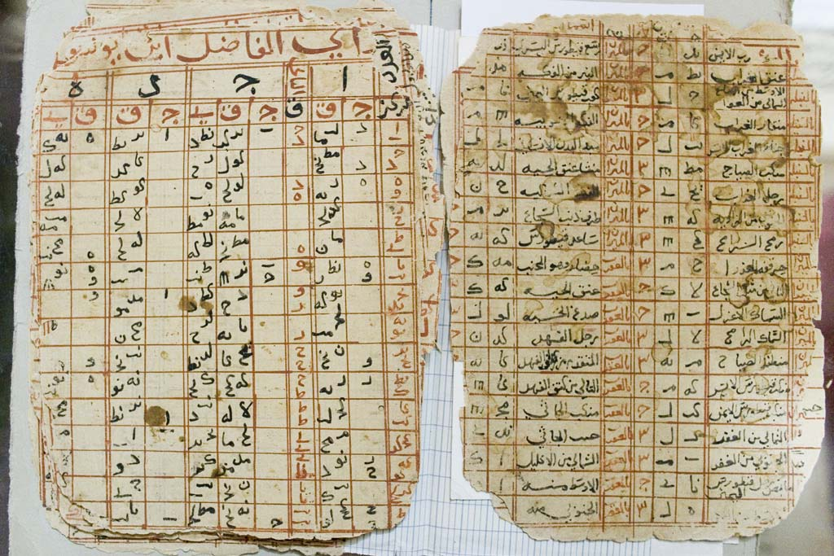
WORKSHEET: 4-6.D

Source 3: Religion

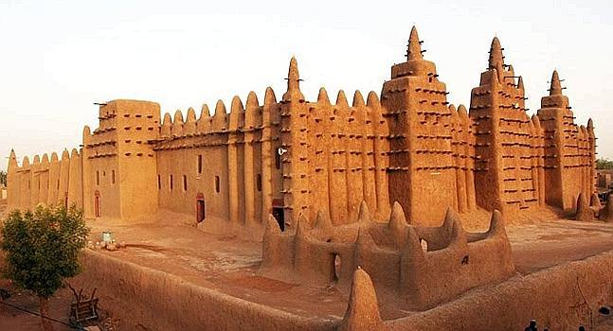

Mansa (King) Musa I (pictured on the next page) was a leader of Timbuktu and one of the wealthiest people in history because of the gold he traded. Like most people in Timbuktu, he was Muslim and practiced Islam. Mansa Musa I paid for the Djinguereber (jing-wer-ber) Mosque to be built, so people could worship there. This is an amazing building as it is very tall and built only from sand, straw, and wood. Although repairs are needed from time-to-time, it still stands today, which is almost 700 years after being built. Due to the mosque and the schools, Timbuktu became an important religious place for Muslims. Students would travel from all over Africa and the world to study Islam there. It also was a place where books were copied by hand (no photocopy machines back then) and then sold around the world.

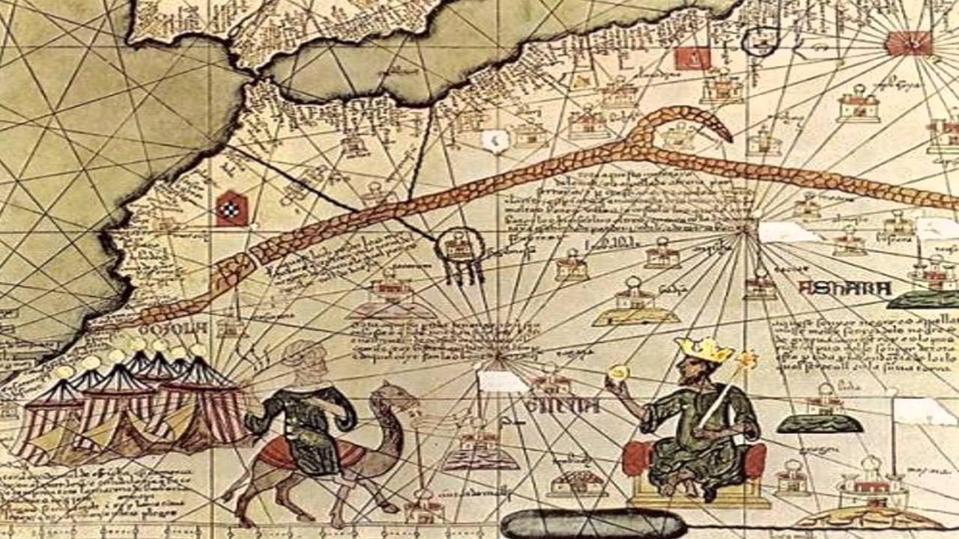
Mansa Musa I pictured with a gold crown and on a throne in this European painting.
ASSESSMENT: 4-6.E

Timbuktu: Exit Ticket

Inquiry Question: Why was Timbuktu so important?

Choose one part of Timbuktu and explain why it is the most important part of the city. Include three pieces of evidence from the sources.

LESSON PLAN 4-7: Apartheid in South Africa: A Movement for Freedom

MATERIALS

“Nelson Mandela” by Kadir Nelson (not supplied)
Source 1: European Imperialism (WORKSHEET 4-7.A)
Source 2: Apartheid Laws (WORKSHEET 4-7.B)
Source 3: Anti-Apartheid Protests (WORKSHEET 4-7.C)
Source 4: Jailed Protesters (WORKSHEET 4-7.D)
Anti-Apartheid: Exit Ticket (ASSESSMENT 4-7.E)

STANDARDS

Massachusetts History and Social Science Framework

MA-HSS.4.CS.1: Use map and globe skills to determine absolute locations (latitude and longitude) of places studied. (G)

MA-HSS.WHII.44 Explain the reasons for the fall of apartheid in South Africa, including the influence and ideas of Nelson Mandela. (H)

Common Core: Literacy

CCSS.ELA-Literacy.RI.4.9: Integrate information from two texts on the same topic in order to write or speak about the subject knowledgeably.

CCSS.ELA-Literacy.RI.4.10: By the end of year, read and comprehend informational texts, including history/social studies, science, and technical texts, in the grades 4–5 text complexity band proficiently, with scaffolding as needed at the high end of the range.

CCSS.ELA-Literacy.W.4.8: Recall relevant information from experiences or gather relevant information from print and digital sources; take notes and categorize information, and provide a list of sources.

CCSS.ELA-Literacy.W.4.9: Draw evidence from literary or informational texts to support analysis, reflection, and research.

PROCEDURES

Inquiry Question: What can we learn from the Anti-Apartheid Movement in South Africa?

PREPARATION

1. Post Definition of Discrimination

Post the definitions of migration on the board or chart paper hidden from view. Discrimination: Unfair treatment, especially because of a person’s race, gender, religion, or age.

A. OPENER (15 minutes)

2. Read “Nelson Mandela” by Kadir Nelson
Before reading the text, tell students that today we are going to read a story about a man who spoke out against discrimination in South Africa. Ask students if they know what discrimination means. Reveal the definition of discrimination as “Unfair treatment, especially because of a person’s race, gender, religion, or age.” Ask students if they can think of any examples from the past or today when people were discriminated against? Anticipated responses may include: laws against African Americans before the civil rights movement, Martin Luther King, personal or family examples.

Read “Nelson Mandela.” This is a picture book that tells the true story of a Nelson Mandela who was a leader to the Anti-Apartheid movement in South Africa. As you read the text, be sure to ask questions to the students about Mandela’s experiences and choices. There is one page where Henry burns his hand to allow his escape plan to happen. Connect this story to the work the students have done in previous grades related to slavery, segregation, and civil rights.

Tell students that today, we are going to learn about the Apartheid laws that existed in South Africa and what people did there to try and stop it.

B. DEVELOPMENT (15 minutes)

3. Examine Sources As a Whole Class
Ask the students to read aloud (using choral, partner, or independent reading) the three documents on Apartheid Laws (WORKSHEET 4-7.A), Anti-Apartheid Protests (WORKSHEET 4-7.B), Jailed Protesters (WORKSHEET 4-7.C), Help from Other Countries (WORKSHEET 4-7.D). After reading each document, solicit from students what important facts should be underlined and highlighted about each source. Make sure they highlight examples of how the Apartheid was problematic (i.e. segregation laws), but also acts of resistance to it (i.e. being jailed for protesting, boycotts).

4. Discuss the Struggles that Black and Asian People Faced in South Africa
Put students in small groups (3-4 students). Tell students that after listening to “Nelson Mandela” and reading these sources, I would like you to talk about ways that life was difficult for Black and Asian people in South Africa under Apartheid, but also ways that people did things to stop Apartheid because it was wrong.

After students have had 5-7 minutes to discuss, lead the class in a whole class discussion. On the board or chart paper, take notes on what the students say. Anticipated responses may include: protesting, going to jail for their beliefs, boycotting rules, spreading the word around the world.

C. CLOSING (15 minutes)

5. Answer the Inquiry Question
For the evaluation task, have the students complete the exit ticket (ASSESSMENT 4-7.E) where they write their own personal response to the lesson’s Inquiry Question: “What can we learn from the Anti-Apartheid Movement in South Africa?” Tell students to cite at least three pieces of evidence from the book (Nelson Mandela) and the worksheets for this lesson.

Before using the exit ticket, consider using a graphic organizer or two column notes to prepare students for the writing task. Consider using sentence starters and modeling to help the students with their answer to the inquiry question.

EVALUATION

ASSESSMENT 4-7.E

What to look for?

Some information that students may include in their answer to the question:

Ways that protesters worked to end Apartheid:
- Protesting.
- Going to jail for their beliefs.
- Boycotting rules.
- Spreading the word around the world.
WORKSHEET: 4-7.A

Source 1: European Imperialism

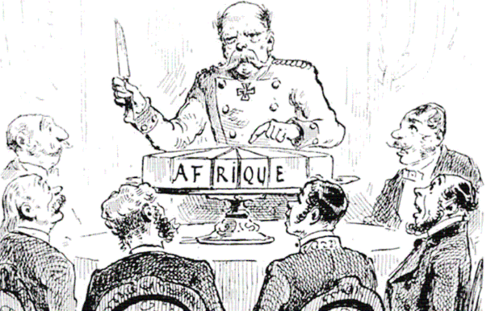

For much of its history, Africans traded with Europe and Asia and some empires became very wealthy. In the 1500s, Europeans from Portugal, Spain, France, England, and other countries went to Africa and bought slaves (people who were owned by others and forced to work for no pay). They then sold these slaves around the world with most being sent to the Americas. Slavery, war, and trade weakened many African empires between 1500 and 1900. Europeans took advantage of this and invaded many African nations with their militaries.

South Africa had several different nations, including the Bantu, Xhosa and Zulu people. In the 1700s, the Dutch (who are from the Netherlands in Europe) took over South Africa and renamed it the Cape Colony. In the 1800s, the British took the Cape Colony from the Dutch. For over 200 years, the Bantu, Xhosa, and Zulu tried to stop this and they fought the Dutch and later British.

In 1884, European countries met at the Berlin Conference and divided up Africa among themselves (the below pictures shows all nations being divided up among Europe, except Ethiopia and Liberia). No Africans were invited and they had no say in this. Historians call this imperialism, which means when one nation takes over another nation.

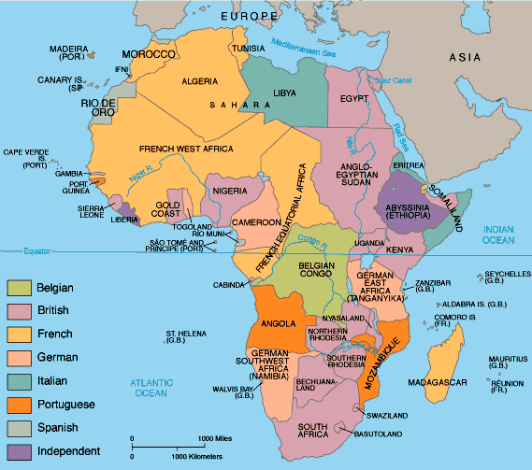
WORKSHEET: 4-7.B

Source 2: Apartheid Laws

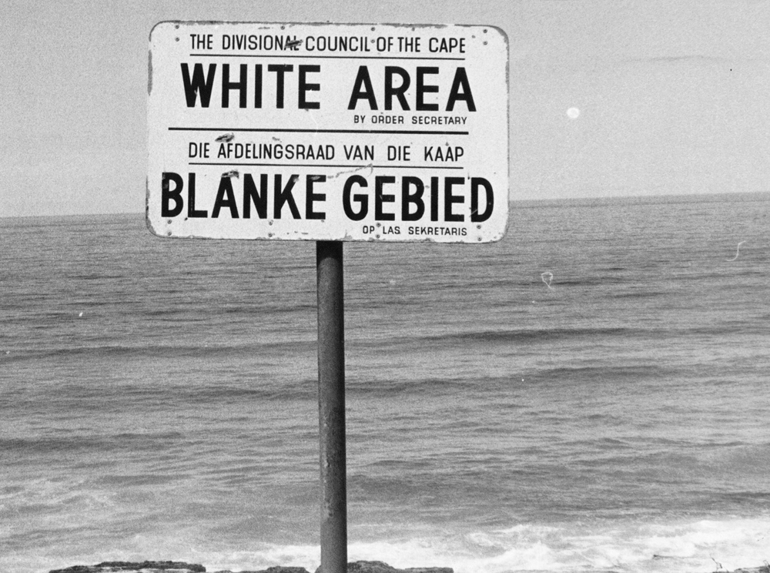

After Europeans took over South Africa (the Cape Colony), they started making laws that discriminated against people with darker skin. At first, this included only indigenous (native) Africans, but as the British brought Asians (Indians, Malaysians, and others) to South Africa, they also had to follow special rules. As you will see in the pictures, the British called some people “Coloured,” a term we no longer use today, which meant people of more than one race.

The British made rules that Black, Asian, and Coloured people needed to use separate restaurants, beaches (see the above sign), restrooms, and bus stops and train stations. People of different races could not marry each other or have children together. Black South Africans were not allowed to leave their hometowns and were required to carry papers on them at all times that said who they were and their race (see bottom picture). Within the place where their ancestors had lived for thousands of years, Black South Africans were also not allowed to be citizens, could not vote, or attend White colleges.

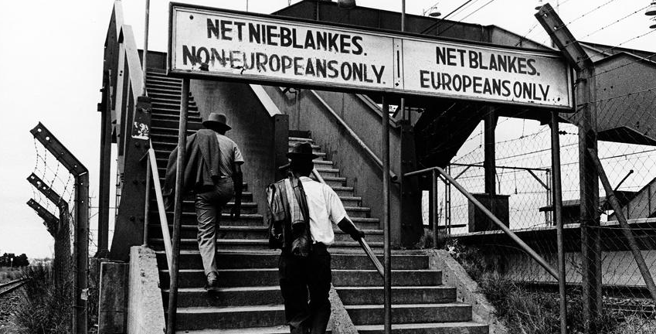

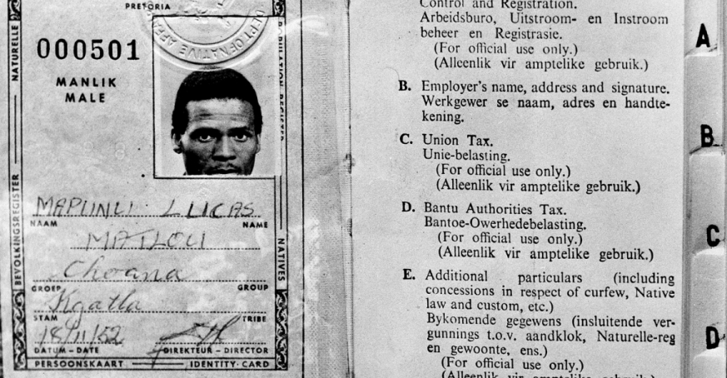
WORKSHEET: 4-7.C

Source 3: Anti-Apartheid Protests

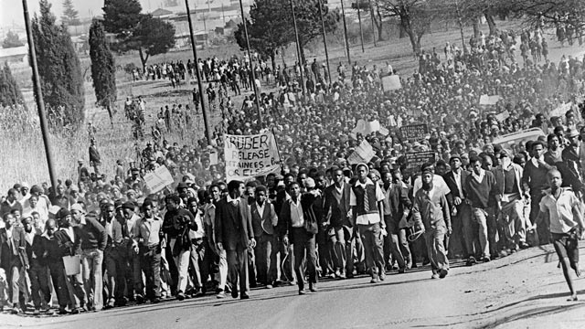

Many Black South Africans protested the Apartheid laws. They formed a group called the African National Congress. They would hold protests and marches demanding the end to discrimination. The White South African government did not like this. After one rally, they arrested over 18,000 people and they put many of the Anti-Apartheid leaders in jail. The White South African police began to use violence on protesters. This did not stop the protest and it convinced many more Black South Africans to join in the Anti-Apartheid Movement.

By the 1980s, people outside South Africa started to protest Apartheid. Many anti-Apartheid people of all races started boycotting (no longer buying) things made in South Africa. Because of Apartheid, South Africa was banned from playing in the Olympics and the World Cup of soccer. Some governments around the world made it illegal to trade with South Africa. This put even more pressure on the White South African government to change the laws.

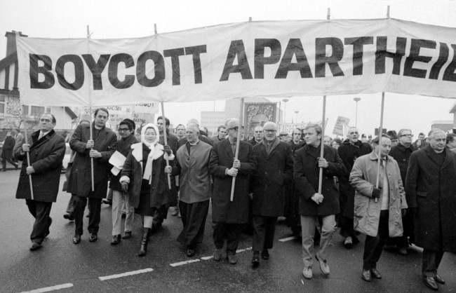

WORKSHEET: 4-7.D

Source 4: Jailed Protesters

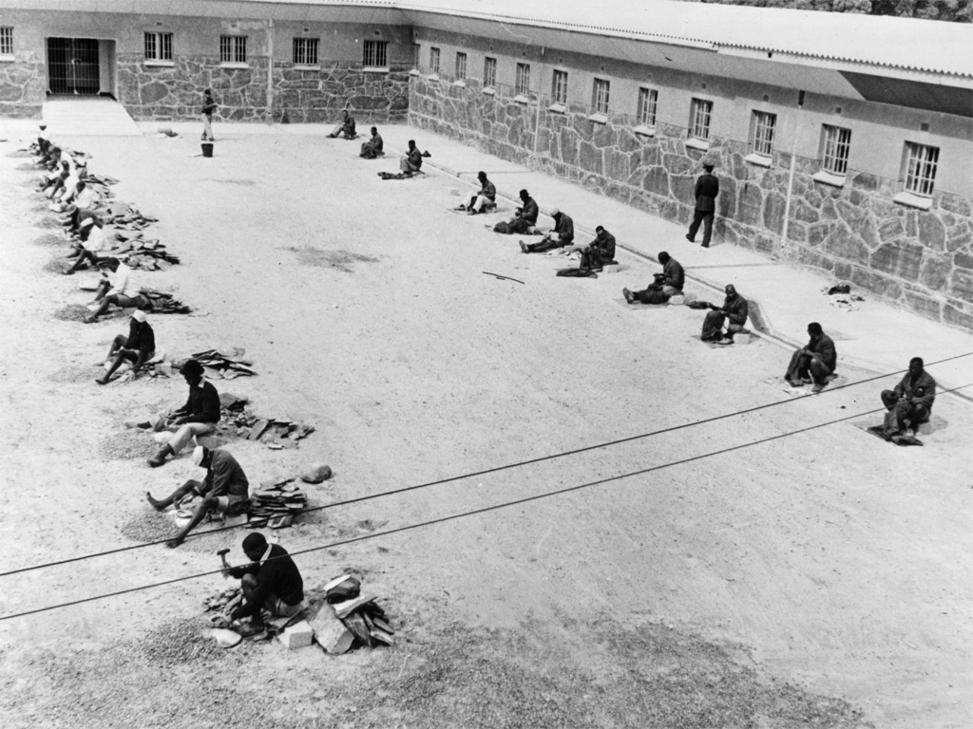

The White South African government jailed many of the leaders of the National African Congress and Anti-Apartheid Movement. The image above shows the leaders being forced to do hard labor during their jail time. One of the more well-known leaders was Nelson Mandel. He would be in prison for over 24 years. On the next page is a picture of him before going to prison and one toward the end of his sentence. It took a long time, but South Africa ended Apartheid in 1993. After that, Mandela would be elected the first Black president of South Africa. As president, in a famous speech, he said, “We understand it still that there is no easy road to freedom. We know that none of us acting alone can achieve success. We must therefore act together as a united people. … Let there be justice for all. Let there be peace for all.”

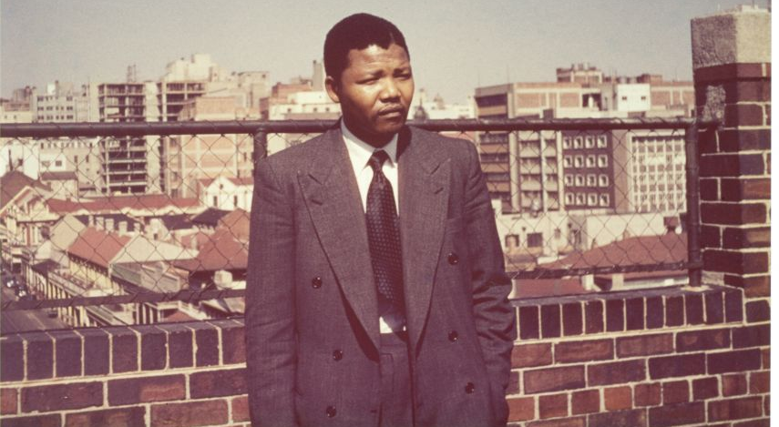
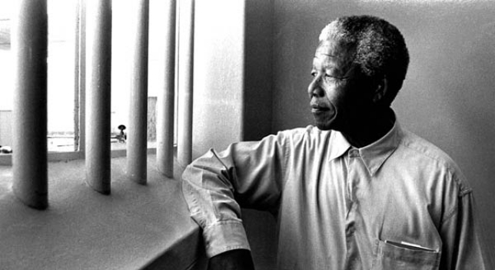
ASSESSMENT: 4-7.E

Anti-Apartheid: Exit Ticket

Inquiry Question: What can we learn from the Anti-Apartheid Movement in South Africa?

Choose one method of protest and explain why it is the most important way that protesters worked to stop Apartheid. Include three pieces of evidence from the book or sources.

LESSON PLAN 4-8: Africa Today: Diverse Nations, Diverse People

MATERIALS

Carmen Sandiego Introduction Video (Lesson4-8Video1) [Located in the UOW Video Library: www.christophercmartell.com/understandingourworld]
Drawing paper (not supplied)
Markers (not supplied)
Lined paper (not supplied)
Clipboards (not supplied)
Carmen Sandiego Questions and Crime Bucks (MATERIALS 4-8.A)
Source 1: Egypt (WORKSHEET 4-8.B)
Source 2: Morocco (WORKSHEET 4-8.C)
Source 3: Nigeria (WORKSHEET 4-8.D)
Source 4: Zimbabwe (WORKSHEET 4-8.E)
Source 5: Kenya (WORKSHEET 4-8.F)
Source 6: South Africa (WORKSHEET 4-8.G)
Source 7: Cape Verde (WORKSHEET 4-8.H)
Source 8: Madagascar (WORKSHEET 4-8.I)
Africa Today: Exit Ticket (ASSESSMENT 4-8.J)

STANDARDS

Massachusetts History and Social Science Framework

MA-HSS.4.CS.1: Use map and globe skills to determine absolute locations (latitude and longitude) of places studied. (G)

MA-HSS.6.A.2: Use a map key to locate countries and major cities in Africa. (G, E)

Common Core: Literacy

CCSS.ELA-Literacy.RI.4.9: Integrate information from two texts on the same topic in order to write or speak about the subject knowledgeably.

CCSS.ELA-Literacy.RI.4.10: By the end of year, read and comprehend informational texts, including history/social studies, science, and technical texts, in the grades 4–5 text complexity band proficiently, with scaffolding as needed at the high end of the range.

CCSS.ELA-Literacy.W.4.8: Recall relevant information from experiences or gather relevant information from print and digital sources; take notes and categorize information, and provide a list of sources.

CCSS.ELA-Literacy.W.4.9: Draw evidence from literary or informational texts to support analysis, reflection, and research.

PROCEDURES

Inquiry Question: If you were to visit Africa today, what country would you choose and why?

PREPARATION

1. Cut Out Carmen Sandiego Bucks
Make 15 copies of the Crime Bucks (MATERIALS 4-8.A) sheet and cut them out.

2. Set Up Carousel Activity
Around the room, post the eight sources:
Source 1: Egypt (WORKSHEET 4-8.B)
Source 2: Morocco (WORKSHEET 4-8.C)
Source 3: Nigeria (WORKSHEET 4-8.D)
Source 4: Zimbabwe (WORKSHEET 4-8.E)
Source 5: Kenya (WORKSHEET 4-8.F)
Source 6: South Africa (WORKSHEET 4-8.G)
Source 7: Cape Verde (WORKSHEET 4-8.H)
Source 8: Madagascar (WORKSHEET 4-8.I)

A. OPENER (15 minutes)

3. Play the “Where in the World Is Carmen Sandiego” Game
Divide the class into three groups: Team Izzat, Team Ajay, and Team Jamal (the contestants in the video that they are about to watch).

Show the students a short video that is the opening to the PBS show “Where in the World Is Carmen Sandiego” (Lesson4-8Video1). After watching the video, tell the students that today we are going to start class by being contestants on “Where in the World Is Carmen Sandiego” and the episode “Diamonds Are a Crook’s Best Friend.” As you saw in the video, The Contessa has stolen diamonds from South Africa. Tell the students that they will each start with $50 Carmen Sandiego Bucks. For each question about Africa that they get right, they will earn $10 Carmen Sandiego Bucks. At the end of the game, the team with the most Carmen Sandiego Bucks catches The Contessa and her diamonds and wins the game. Are you ready to play gumshoes?

You will then read the questions about Africa found on the Carmen Sandiego Questions (MATERIALS 4-8.A). Each group will talk among themselves and write their answer to the question using a marker on a sheet of drawing paper. After each team holds up their answer, give students $10 Carmen Sandiego Bucks if they get it correct. Tabulate the total for each team (starting with all teams getting $50). At the end of the game count up the totals and declare a team(s) the winner. Tell the students that they successful caught The Contessa.

Tell the students that their next challenge is to find Carmen Sandiego. She is hiding somewhere in Africa. You will get a chance to look at eight different African countries and what life is like there today. You will choose which country you would most like to visit. At the end of the lesson, I will reveal where Carmen Sandiego is hiding and we can see if she decided to go to the same country as you.

B. DEVELOPMENT (15 minutes)

4. Engage in a Carousel Activity on African Countries
Handout lined paper and clipboards. Ask students to go to each of the eight stations (4-8.B, 4-8.C, 4-8.D, 4-8.E, 4-8.F, 4-8.G, 4-8.H, 4-8.I). At each station, the students should write the country’s name and take notes on each.

Once students have gone to each of the eight stations, they should return to their seats. Put students in small groups. Have them look at their notes and discuss with their classmates which country they would like to travel to.

C. CLOSING (15 minutes)

5. Write Up Argument on African Countries
For the evaluation task, have the students complete the exit ticket (ASSESSMENT 4-8.J) where they write their own personal response to the lesson’s Inquiry Question: “If you were to visit Africa today, what country would you choose and why?” Tell students to cite at least three pieces of evidence from the sheets on the walls. Tell students that the evidence they use can be something that they wrote on their notes. Encourage students to get up and look at the sheets on the wall, when they need evidence to write on their sheet.

Before using the exit ticket, consider using a graphic organizer or two column notes to prepare students for the writing task. Consider using sentence starters and modeling to help the students with their answer to the inquiry question.

6. Reveal the Location of Carmen Sandiego
At the end of the lesson, reveal that Carmen Sandiego is hiding in South Africa. Just like The Contessa, she also wanted to steal the jewels. Have students give a round of applause for the students who chose the same country as Carmen Sandiego.

EVALUATION

ASSESSMENT 4-8.J

What to look for?

Some information that students may include in their answer to the question:
Egypt
- Visiting the famous pyramids and the Sphinx.
- Seeing the Nile River.
- Visiting Cairo.
- It is a large country (89 million people).
- Visiting a country run by the military.
- Being in a place where they speak Arabic.
- Visiting a place where Muslims and Christians live.
- Visiting a desert.
- Like the climate/weather (hot and dry in the summer and cool and humid with occasional rain in the winter).

Morocco
- Visiting amazing markets (Fes).
- Visiting a place where Arab, Berber, and French culture comes together.
- Visiting a country with a king.
- Visiting a medium sized country (32 million people).
- Being in a place where they speak Arabic, Berber, and French.
- Visiting a place where Muslims live.
- Visiting a desert.
- Like the climate/weather (hot and dry in the summer and cool and humid with occasional rain in the winter).

Nigeria
- Visiting large cities.
- Visiting Lagos (the New York City of Africa).
- Visiting a country with over 500 ethnic groups and languages.
- Visit a country with an elected president.
- Visit a large country (167 million people).
- Visit a place where Muslims, Christians, and people with indigenous faiths live. Like the tropical climate/weather (cool and dry in the summer and warm and rainy in the winter).

Zimbabwe
- See the nature and/or Victoria Falls.
- Visiti a place with 16 different languages (including English, Shona, and Ndebele).
- Visit a place that has only had one leader (recently).
- Visit a small country (13 million people).
- Visit a place where Christians live.
- Like the subtropical climate/weather (warm and rainy winters and dry and hot summers).

Kenya
- See its animals or go on a safari.
- Visit a country with an elected president.
- Visit a medium sized country (42 million people).
- Visit a country where they speak English and Swahili.
- Visit a place where Muslims, Christians, and people with indigenous faiths live.
- Like the tropical climate/weather (warm and dry for most of the year).

South Africa
- Visit its large cities, like Cape Town and Johannesburg.
- Visit its beautiful coastlines.
- See were the 2010 World Cup of Soccer was played.
- Visit a country with an elected president.
- Visit a medium sized country (50 million people).
- Visit a country with 11 languages, including English, Afrikaans, and Zulu.
- Visit a place where Muslims, Christians, and people with indigenous faiths live.
- Like the temperate climate/weather (warm and dry for most of the year).

Cape Verde
- Visit an island nation.
- Visit the beautiful beaches/spend time on a boat.
- Visit a country with an elected president.
- Visit a small nation (500,000 people).
- Visit a country where they speak Portuguese/ Cape Verdean Creole.
- Visit a place where Catholics live.
- Like the arid climate/weather (warm and dry for most of the year).

Madagascar
- Visit a large island nation/fourth largest island in the world.
- See the unique wildlife, including lemurs, mongoose, chameleon, flying fox (bat), frogs, and crocodiles.
- Look at nature/Madagascar trees.
- Visit a country with an elected president.
- Visit a medium sized nation (21 million people).
- Visit a country where they speak Malagasy and French.
- Visit a place where Christians and people with indigenous faiths live.
- Like the monsoonal climate/weather (hot and heavy rains in the winter and dry summers).

MATERIALS: 4-8.A

Where in the World Is Carmen Sandiego?
Questions

1. How many countries are there in Africa?: 22, 54, 81
ANSWER: 54

2. What is the largest city in Nigeria?: Abuja, Lagos, Kano
ANSWER: Lagos

3. What is the capital of Egypt?: Cairo, Alexandria, Giza
ANSWER: Cairo

4. How many languages are spoken in Africa?: 100, 500, 3000
ANSWER: 3000

5. What country is at the southern tip of Africa?: South Africa, South Sudan, Zimbabwe
ANSWER: South Africa

6. Which animal lives in Africa?: Penguins, Polar Bears, Koala Bears
ANSWER: Penguins (on the islands off the coast of South Africa)

7. What is the highest mountain in Africa?: Mount Kenya, Mount Kilimanjaro, Mount Meru
ANSWER: Mount Kilimanjaro

8. How many people live on the continent of Africa: 1 million, 1 billion, 1 trillion
ANSWER: 1 billion

9. Which of these African countries is the newest in the world?: Senegal, Mali, South Sudan
ANSWER: South Sudan

10. This is the world’s largest hot desert?: Gobi, Sahara, Namib
ANSWER: Sahara

$10
Carmen Sandiego Bucks
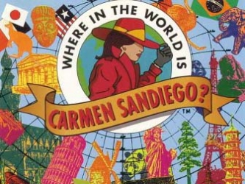
$10

$10
Carmen Sandiego Bucks
$10

WORKSHEET: 4-8.B

Source 1: Egypt

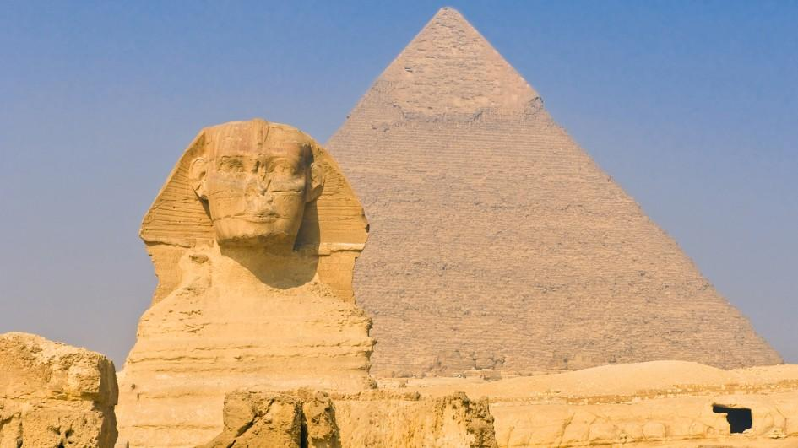

Egypt is known for its famous pyramids and the Sphinx (above). The Nile River ends in Egypt at the Mediterranean Sea. Egypt has a military government and their current president is Abdel Fattah el-Sisi. Egypt has many cities including Cairo. It has 89 million people. Its main language is Arabic and its main religions are Islam and Christianity. It has a desert climate that is hot and dry in the summer and cool and humid with occasional rain in the winter.

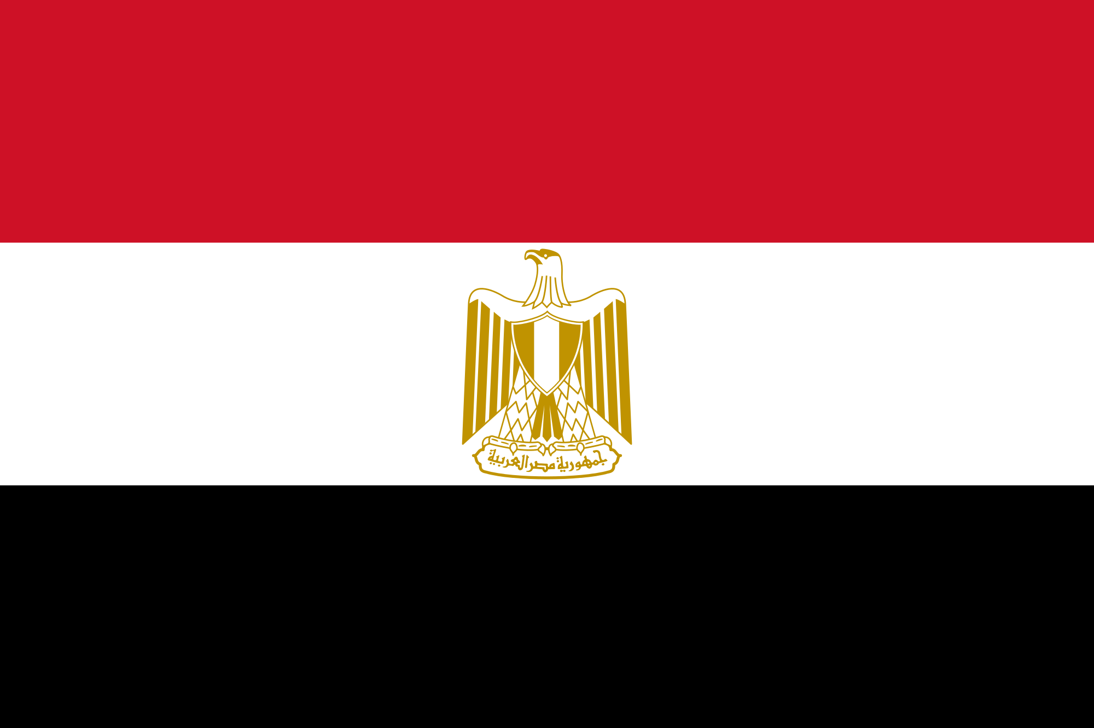
WORKSHEET: 4-8.C

Source 2: Morocco

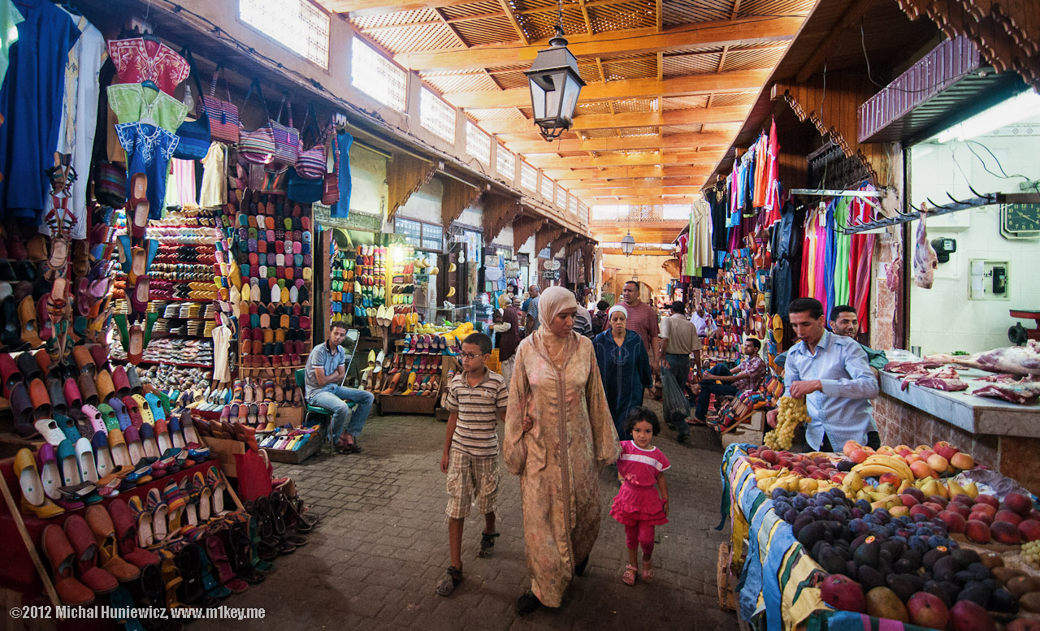

Morocco is known for its amazing markets, including the one in Fès (Fez) (above). It is a country where Arab, Berber, and French culture come together. Morocco has a king, who is currently King Mohammed VI. It has 32 million people. Its main languages are Arabic, Berber, and French and its main religion is Islam. It has a desert climate that is hot and dry in the summer and cool and humid with occasional rain in the winter.

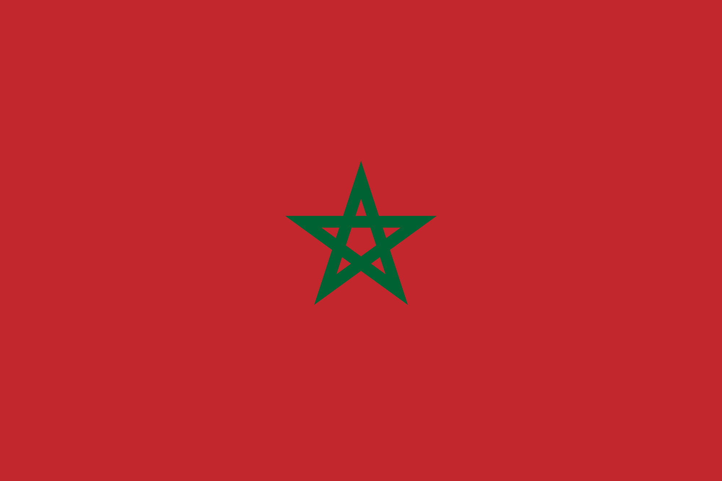
WORKSHEET: 4-8.D

Source 3: Nigeria

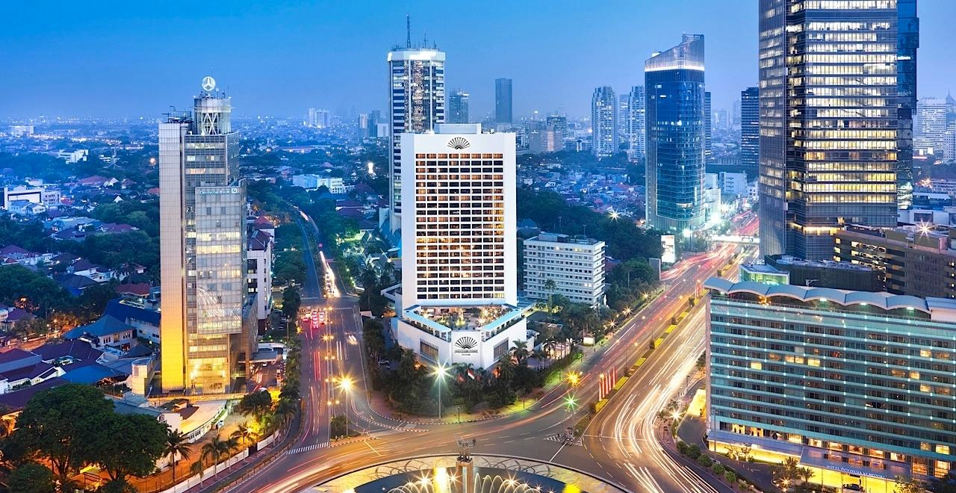

Nigeria is known for its large cities. Some people call Lagos (above) the New York City of Africa. Nigeria has over 500 different ethnic groups and each has a different language. Nigeria has an elected president, who is currently Muhammadu Buhari. It has 167 million people. Its main religions are Islam, Christianity, and indigenous religions. It has a tropical climate that is cool and dry in the summer and warm and rainy in the winter.

WORKSHEET: 4-8.E

Source 4: Zimbabwe

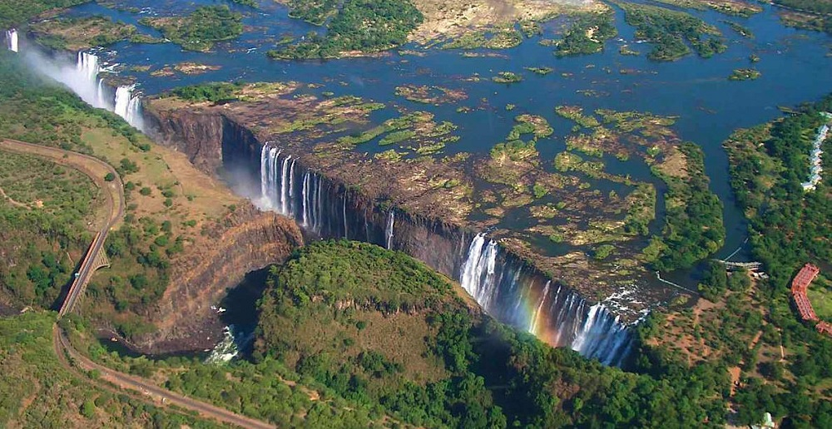

Zimbabwe is known for its amazing nature, including Victoria Falls (above). Zimbabwe has 16 different languages, including English, Shona, and Ndebele. Zimbabwe has only one political party and has had one leader, Robert Mugabe, since it became an independent country. It has 13 million people. Its main religion is Christianity. It has a subtropical with warm and rainy winters and dry and hot summers.

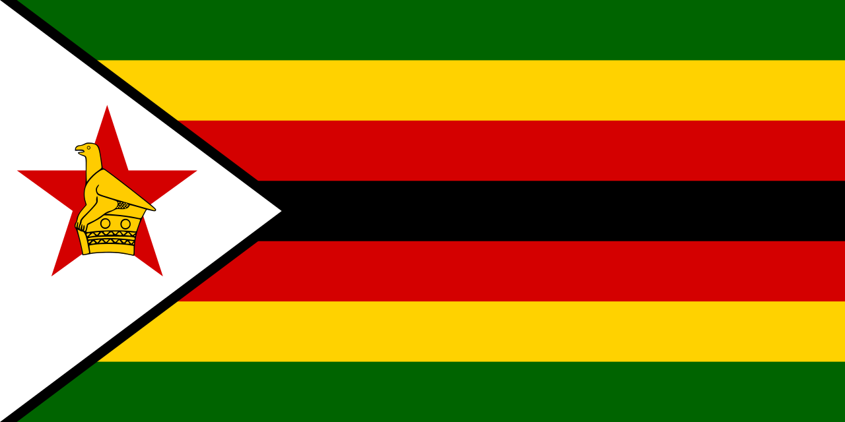
WORKSHEET: 4-8.F

Source 5: Kenya

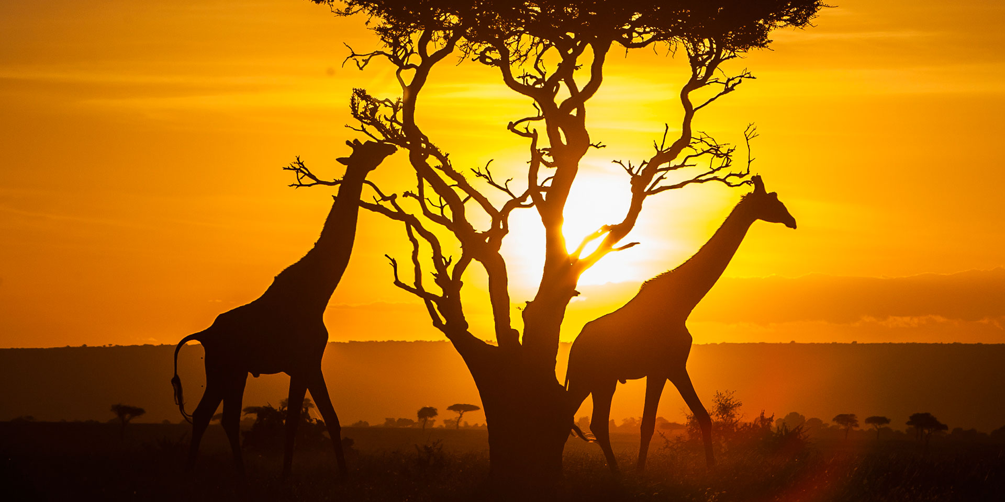

Kenya is known for its animal viewing. Many people travel there from all over the world to go on a safari. Kenya has an elected president, who is currently Uhuru Kenyatta. He is the son of the country’s first president. It has 42 million people. Its main languages are English and Swahili. Its main religions are Christianity, indigenous religions, and Islam. It has a tropical climate that is warm and dry for most of the year.

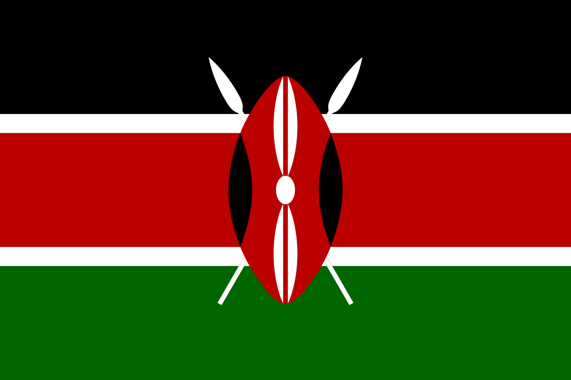

WORKSHEET: 4-8.G

Source 6: South Africa

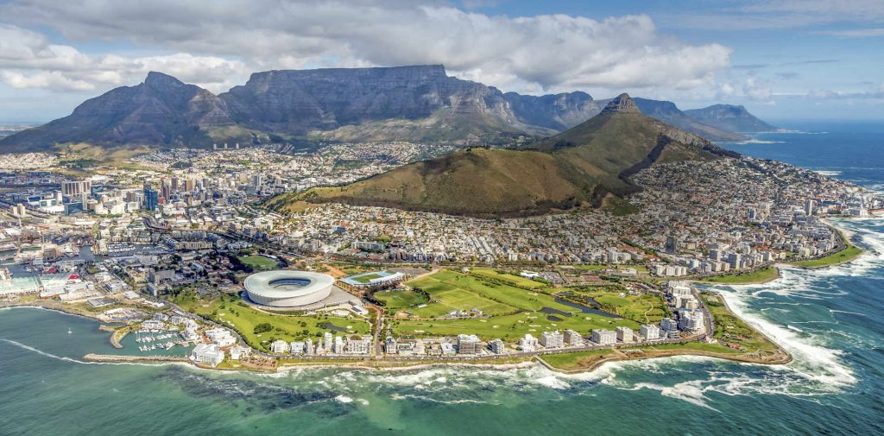

South Africa is known for its large cities, including Cape Town (see above) and Johannesburg, and beautiful coastlines. It also hosted the 2010 World Cup of Soccer. South Africa has an elected president, who is currently Jacob Zuma. It has 50 million people. It has 11 languages, including English, Afrikaans, and Zulu. Its main religions are Christianity, indigenous religions, and Islam. It has a temperate climate that is warm and dry for most of the year.

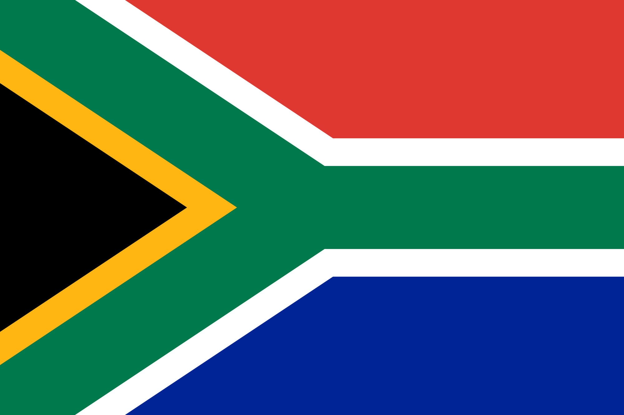
WORKSHEET: 4-8.H

Source 7: Cape Verde

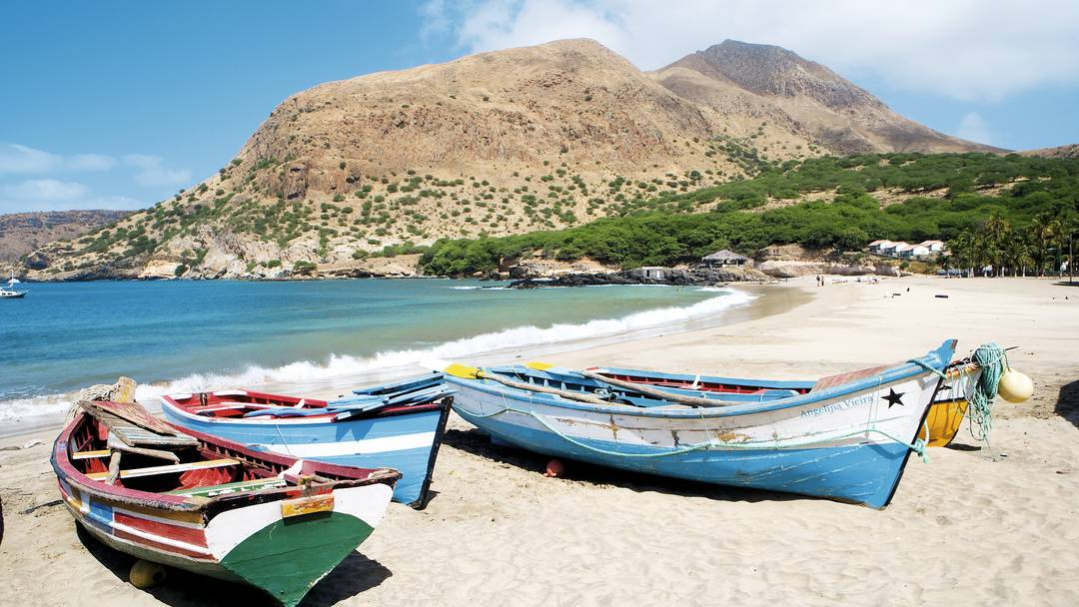

Cape Verde (cape-verd) is an island nation and known for beautiful beaches. It is a great place to spend time on a boat. Cape Verde has an elected president, who is currently Jorge Carlos Fonseca. It has 500,000 people. Its main language is Portuguese/ Cape Verdean Creole. Its main religion is Catholicism. It has an arid climate that is warm and dry for most of the year.

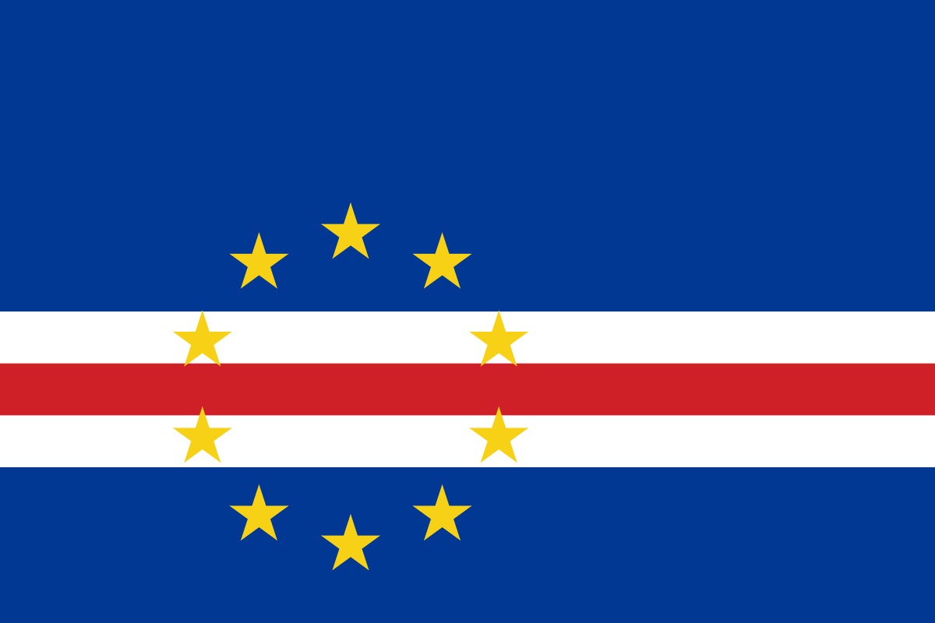
WORKSHEET: 4-8.B

Source 8: Madagascar

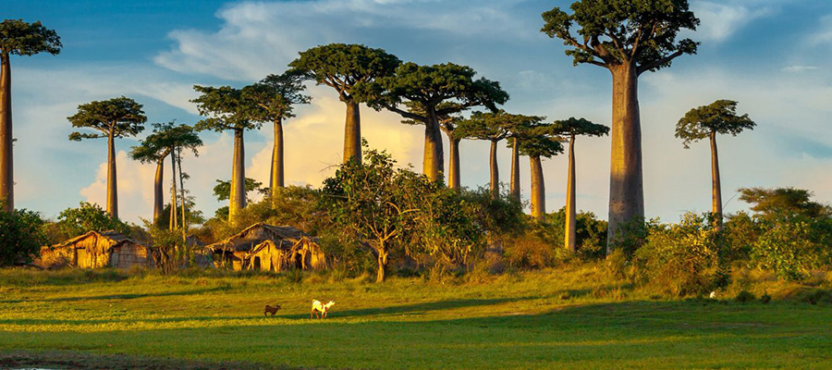

Madagascar is a large island nation (fourth largest island in the world) and known for its unique wildlife, including lemurs, mongoose, chameleon, flying fox (bat), frogs, and crocodiles. It is a great place to look at nature (see the Madagascar trees above). Madagascar has an elected president, who is currently Hery Rajaonarimampianina. It has 21 million people. Its main languages are Malagasy and French. Its main religions are indigenous religion and Christianity. It has a monsoonal climate with hot and heavy rains in the winter and dry summers.

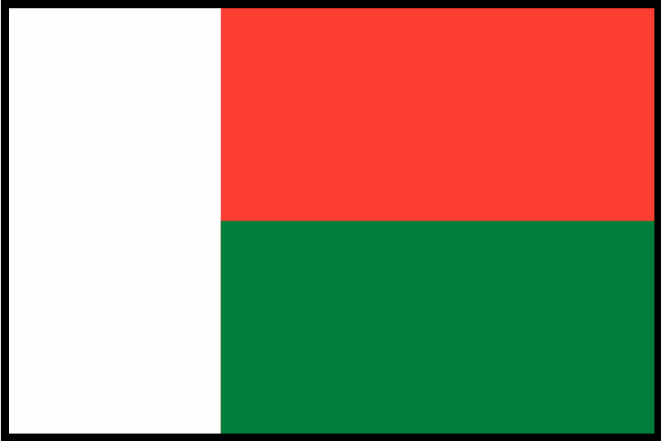
ASSESSMENT: 4-8.J

Africa Today: Exit Ticket

Inquiry Question: If you were to visit Africa today, what country would you choose and why?

Choose one country from those listed around the room and explain why you would like to visit it. Include three pieces of evidence from the book or sources.

LESSON PLAN 4-9: The Great Asian Empires: China, Japan, India, and Persia

MATERIALS

Zoom In Inquiry Activity (WORKSHEET 4-9.A)
Source 1: Qin China (WORKSHEET 4-9.B)
Source 2: Heian Japan (WORKSHEET 4-9.C)
Source 3: Gupta India (WORKSHEET 4-9.D)
Source 4: Achaemenid Persia (Iran) (WORKSHEET 4-9.E)
The Great Asian Empires: Exit Ticket (ASSESSMENT 4-9.F)

STANDARDS

Massachusetts History and Social Science Framework

MA-HSS.4.CS.1: Use map and globe skills to determine absolute locations (latitude and longitude) of places studied. (G)

MA-HSS.4.6: Describe how the First Emperor unified China by subduing warring factions, seizing land, centralizing government, imposing strict rules, and creating with the use of slave labor large state building projects for irrigation, transportation, and defense (e.g., the Great Wall). (H, C, E)

Common Core: Literacy

CCSS.ELA-Literacy.RI.4.9: Integrate information from two texts on the same topic in order to write or speak about the subject knowledgeably.

CCSS.ELA-Literacy.RI.4.10: By the end of year, read and comprehend informational texts, including history/social studies, science, and technical texts, in the grades 4–5 text complexity band proficiently, with scaffolding as needed at the high end of the range.

CCSS.ELA-Literacy.W.4.8: Recall relevant information from experiences or gather relevant information from print and digital sources; take notes and categorize information, and provide a list of sources.

CCSS.ELA-Literacy.W.4.9: Draw evidence from literary or informational texts to support analysis, reflection, and research.

PROCEDURES

Inquiry Question: If you could live in any ancient Asian empire, which one would it be and why?
PREPARATION

This lesson uses a method called Zoom In Inquiry. The key to Zoom In Inquiry is that you as a teacher allow the students to explore an image in three successive “zoom ins.”

Zoom In Inquiry:
- The teacher has students start by looking at only a specific part of an image (Zoom 1) and not the entire image. The teacher asks, “What do you think this may be?” and “What can you tell from what you see?” or “What clues do you see?”
- The teacher then reveals a slightly larger view of the image (Zoom 2). The teacher asks, “What do you think this may be?” and “What can you tell from what you see?” or “What clues do you see?”
- Finally, the teacher shows the entire image (Zoom 3) to the students. The teacher asks, “What do you think this may be?” and “What can you tell from what you see?” or “What clues do you see?”
- Finally, the teacher explains what the image is of and connects it to the lesson.

If this is your first time using Zoom In Inquiry, we recommend watching this video example from Grade 4 produced by Explorify: https://vimeo.com/205234946

A. OPENER (10 minutes)

1. Zoom In Inquiry Activity
Put students in small groups. Give students the Zoom 1 image (WORKSHEET 4-9.A). Project the Zoom 1 image for the class. Tell the students to look at the image closely. In their groups, they should look at the details or clues and make educated guesses as to what the picture may be of. Ask the following questions: “What do you think this may be?”, “What can you tell from what you see?”, “What clues do you see?” Anticipated responses may include: a door, a castle, a bridge. Have students examine the source for about 2-3 minutes.

Give students the Zoom 2 image (WORKSHEET 4-9.A). Project the Zoom 2 image for the class. Tell the students to look at the image closely. In their groups, they should look at the details or clues and make educated guesses as to what the picture may be of. Ask the following questions: “What do you think this may be?”, “What can you tell from what you see?”, “What clues do you see?” Anticipated responses may include: a door, a castle, a bridge, a fort, a mountain ranger station. Have students examine the source for about 2-3 minutes.

Give students the Zoom 3 image (WORKSHEET 4-9.A). Project the Zoom 3 image for the class. Tell the students to look at the image closely. In their groups, they should look at the details or clues and make educated guesses as to what the picture may be of. Ask the following questions: “What do you think this may be?”, “What can you tell from what you see?”, “What clues do you see?” Anticipated responses may include: a door, a castle, a bridge, a fort, a mountain ranger station, a wall (Great Wall of China). Have students examine the source for about 2-3 minutes.

Tell students that this is an image of the Great Wall of China. Show students the Great Wall of China Map. Tell students that today we will be studying the Great Empires of Asia. One of those empires was Qin (pronounced chin) China (“Qin” is where the word China comes from). To stop invasions from the Mongolians and other people from the north and west, the first Chinese emperor, a man named Qin Shi Huang (pronounced chin-sure-hwong), made this wall. It would eventually be 5,500 miles, which is the distance from Boston to Hawaii.

B. DEVELOPMENT (20 minutes)

2. Read About the Great Asian Empires
Put students in small groups and assign them one of the sources: Qin China (WORKSHEET 4-9.B), Heian Japan (WORKSHEET 4-9.C), Gupta India (WORKSHEET 4-9.D), Achaemenid Persia (Iran) (WORKSHEET 4-9.E). Have one student from each group read their source. As the student reads, tell the other group members to underline or highlight any important information.

3. Engage in a Jig Saw on Great Asian Empires
Have students participate in a jig saw activity. Make new groups where at least one student from each of the original groups is included. This will create several new groups of three students, one is an expert on 4-9.B, 4-9.C, 4-9.D, 4-9.E. Have each student describe their document to the other members of their group.

Ask students to use the sources to answer the following inquiry question: “If you could live in any ancient Asian empire, which one would it be and why?” In answering this question, students should debate between the four different worksheets. After students have discussed the question, they should complete the exit ticket in the following step. Circulate the room, helping the students who may have difficulty choosing one asset.

C. CLOSING (15 minutes)

4. Write Up Argument on Great Asian Empires
For the evaluation task, have the students complete the exit ticket (ASSESSMENT 4-9.F) where they write their own personal response to the lesson’s Inquiry Question: “If you could live in any ancient Asian empire, which one would it be and why?” Tell students to cite at least three pieces of evidence from the worksheets for this lesson.

Before using the exit ticket, consider using a graphic organizer or two column notes to prepare students for the writing task. Consider using sentence starters and modeling to help the students with their answer to the inquiry question.
EVALUATION

ASSESSMENT 4-9.E

What to look for?

Some information that students may include in their answer to the question:

Qin China
- It was a large empire with 20 million people (half the size of Rome).
- The climate is subtropical with hot, humid, and rainy summers and mild winters.
- People lived with their families in small farming villages and rarely left their homes.
- The government made everyone use the same measurements and languages to unite the people.
- They created the Terracotta Army, which includes 8,000 soldiers, 130 chariots, and 670 horses to guard the emperor’s tomb.

Heian Japan
- It was a small empire with 7 million people (quarter the size of Rome).
- The climate is temperate with hot, humid, and rainy summers and cold winters.
- People lived with their families in small farming villages.
- The emperor created a group of elite soldiers called samurai.
- This was also a period of important Japanese art, poems, novels, essays, and music.

Gupta India
- It was a large empire with millions of people (historians are not exactly sure how many people lived there).
- The climate there is tropical monsoonal with hot, humid, and rainy summers and dryer and warm winters.
- People lived with their families in small farming villages.
- The empire was known for its gold coins that were made for trade.
- It was also a period of great buildings, including the Dashavatara Temple.

Achaemenid Persia (Iran)
- It was a large empire with 35 million people (more than half the size of the Roman Empire in Europe).
- The climate there is desert with hot and dry climate year-round.
- People lived with their families in small farming villages.
- It was a time of peace, so most people were not afraid of war.
- Many men were recruited into the Persian army.
- They may have invented the first mail system, which carried letters by horse from city to city.
- Unlike other ancient Asian civilizations, many jobs were done by both men and women.

WORKSHEET: 4-9.A

Zoom 1
Zoom 2
Zoom 3
Great Wall of China Map

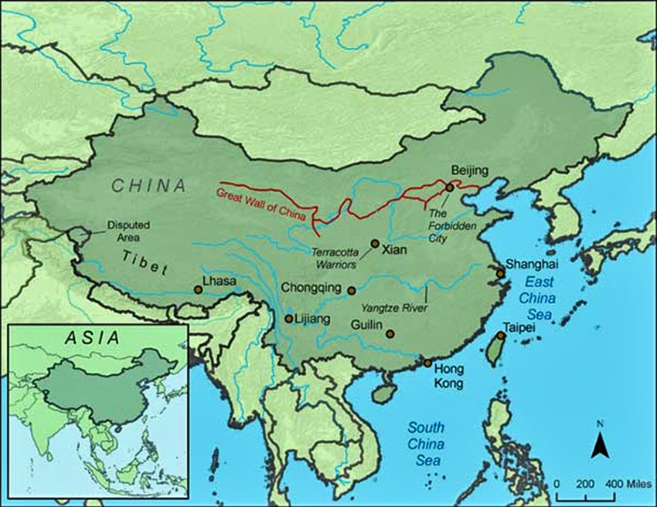

WORKSHEET: 4-9.B

Source 1: Qin China

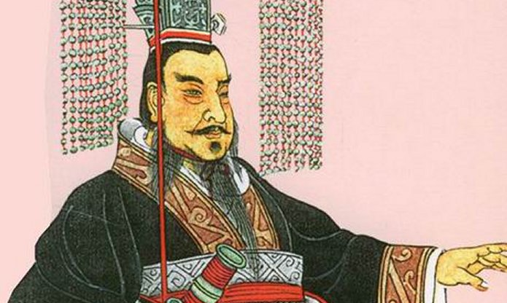

The Qin Empire in China lasted from 221 to 206 BCE. Its first ruler was Qin Shi Huang (chin-sure-hwong). Its capital was a city called ‎ Xianyang (she-en-yang). There were 20 million people in the empire (half the size of the Roman Empire in Europe). The climate there is subtropical with hot, humid, and rainy summers and mild winters.

People in the Qin Empire usually lived with their families in small farming villages and rarely left their homes. It was a time of many wars, so leaving the village could be dangerous. The government made everyone use the same measurements and languages to unite the people. The most famous art of the period was the Terracotta Army. When the first emperor died, he made them create statues of 8,000 soldiers, 130 chariots, and 670 horses to guard his tomb (pictured below).

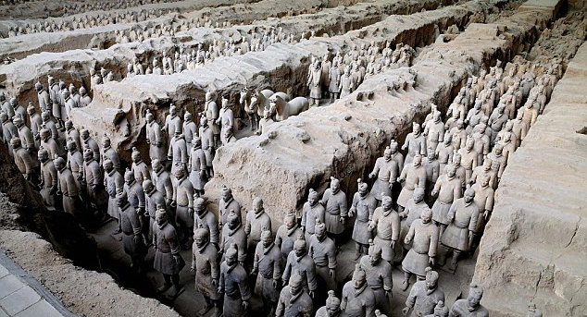

The below map shows the location of the Qin Empire in Asia.

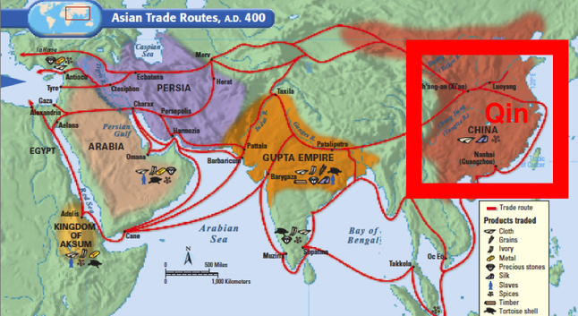

WORKSHEET: 4-9.C

Source 2: Heian Japan

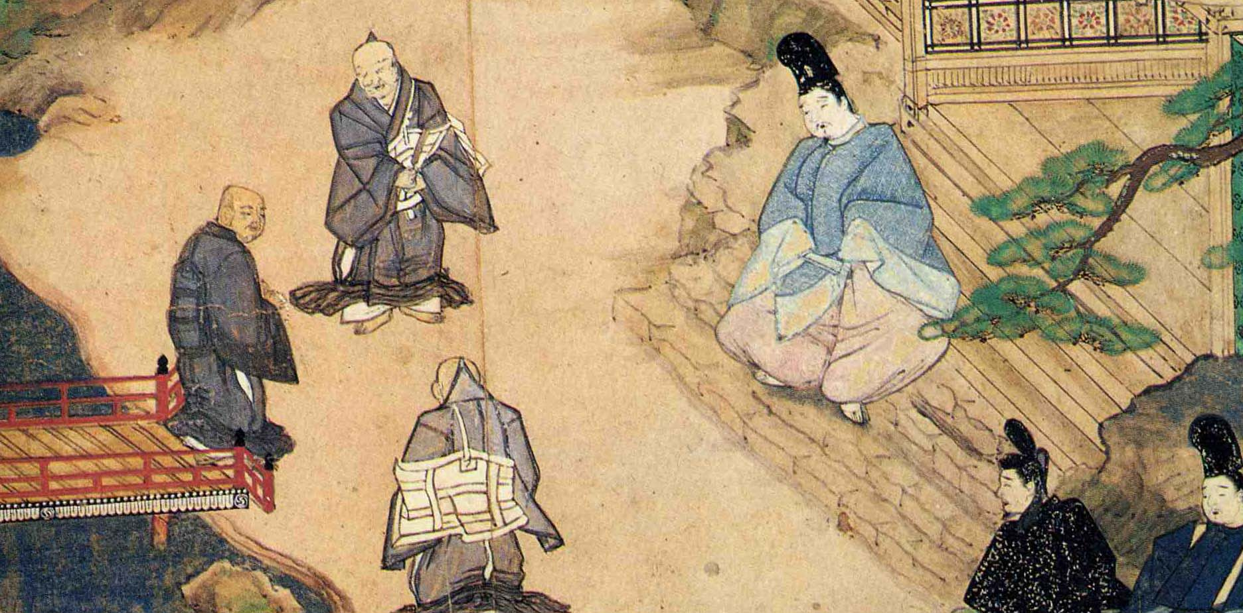

The Heian Empire in Japan lasted from 794 to 1185 CE. During that time, Japan was ruled by the Fujiwara (foo-gee-wha-ra) family. Its capital was a city called ‎ Heian (hay-on), which is today the city of Kyoto (key-oo-toe). There were 7 million people in the empire (quarter of the size of the Roman Empire in Europe). The climate there is temperate with hot, humid, and rainy summers and cold winters.

People in the Heian Empire usually lived with their families in small farming villages. The emperor created a group of elite soldiers called samurai (sam-oo-rye), who are pictured on the next page. The samurai protected their regions and often went to war to defend their clans. This was also a period of important Japanese art, poems, novels, essays, and music.

Samurai pictured in Japanese artwork.

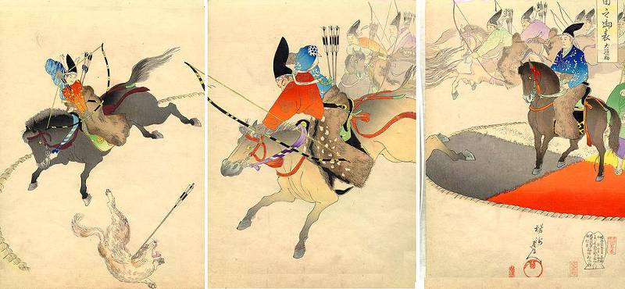

The below map shows the location of the Heian Empire in Asia.

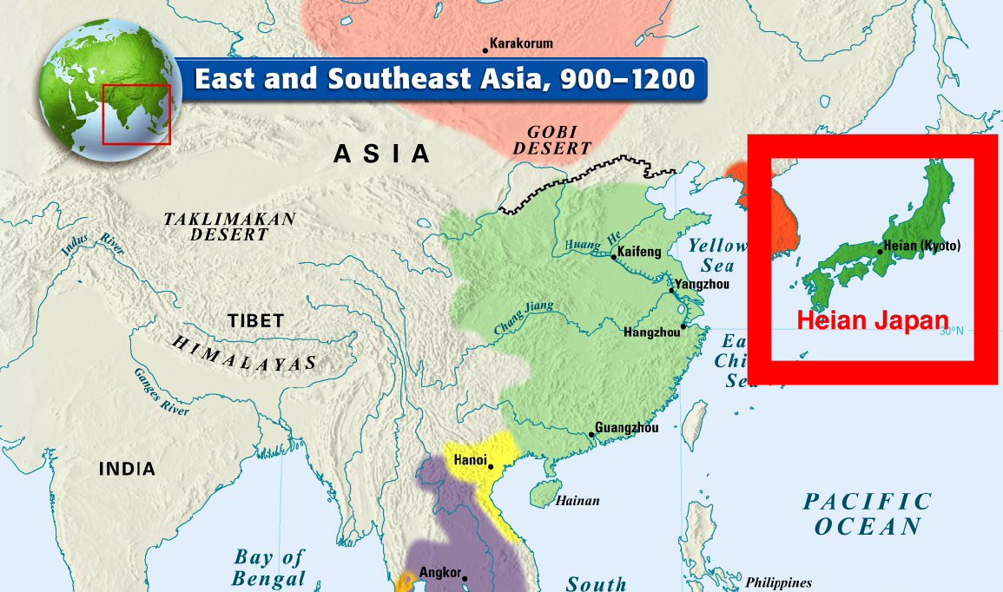

WORKSHEET: 4-9.D

Source 3: Gupta India

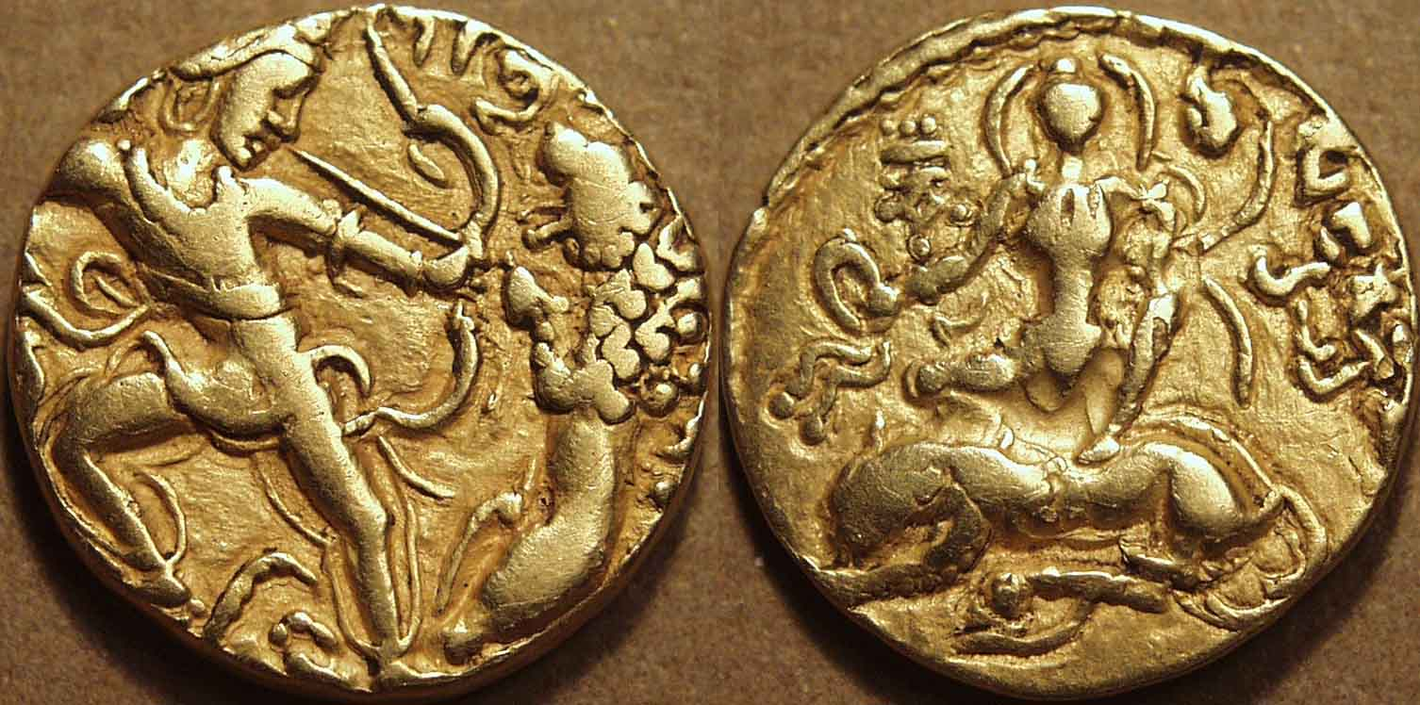

The Gupta Empire in India lasted from 320 to 550 CE. Two of the most important rulers were Chandragupta I and II (shan-dra-goop-ta). Its capital was a city called ‎ Pataliputra (pat-all-lee-poo-tra) near the Ganges (gang-ees) River. There were millions of people in the empire (historians are not exactly sure how many people lived there). The climate there is tropical monsoonal with hot, humid, and rainy summers and dryer and warm winters.

People in the Gupta Empire usually lived with their families in small farming villages. The empire was known for its gold coins that were made for trade (pictured above, showing the ruler Chandragupta II). It was also a period of great buildings, including the Dashavatara Temple (pictured on the next page).

Dashavatara Temple

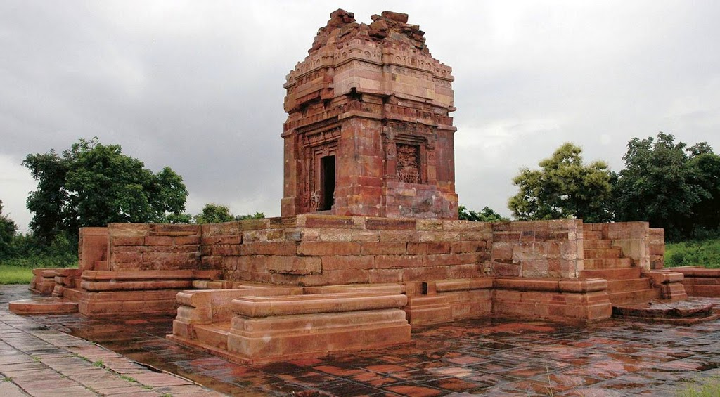

The below map shows the location of the Gupta Empire in Asia.

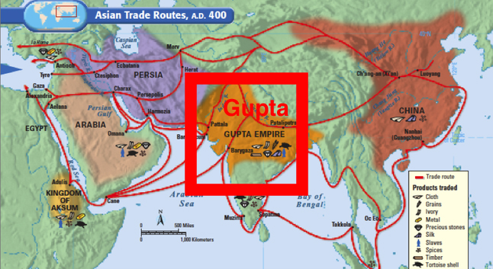

WORKSHEET: 4-9.E

Source 4: Achaemenid Persia (Iran)

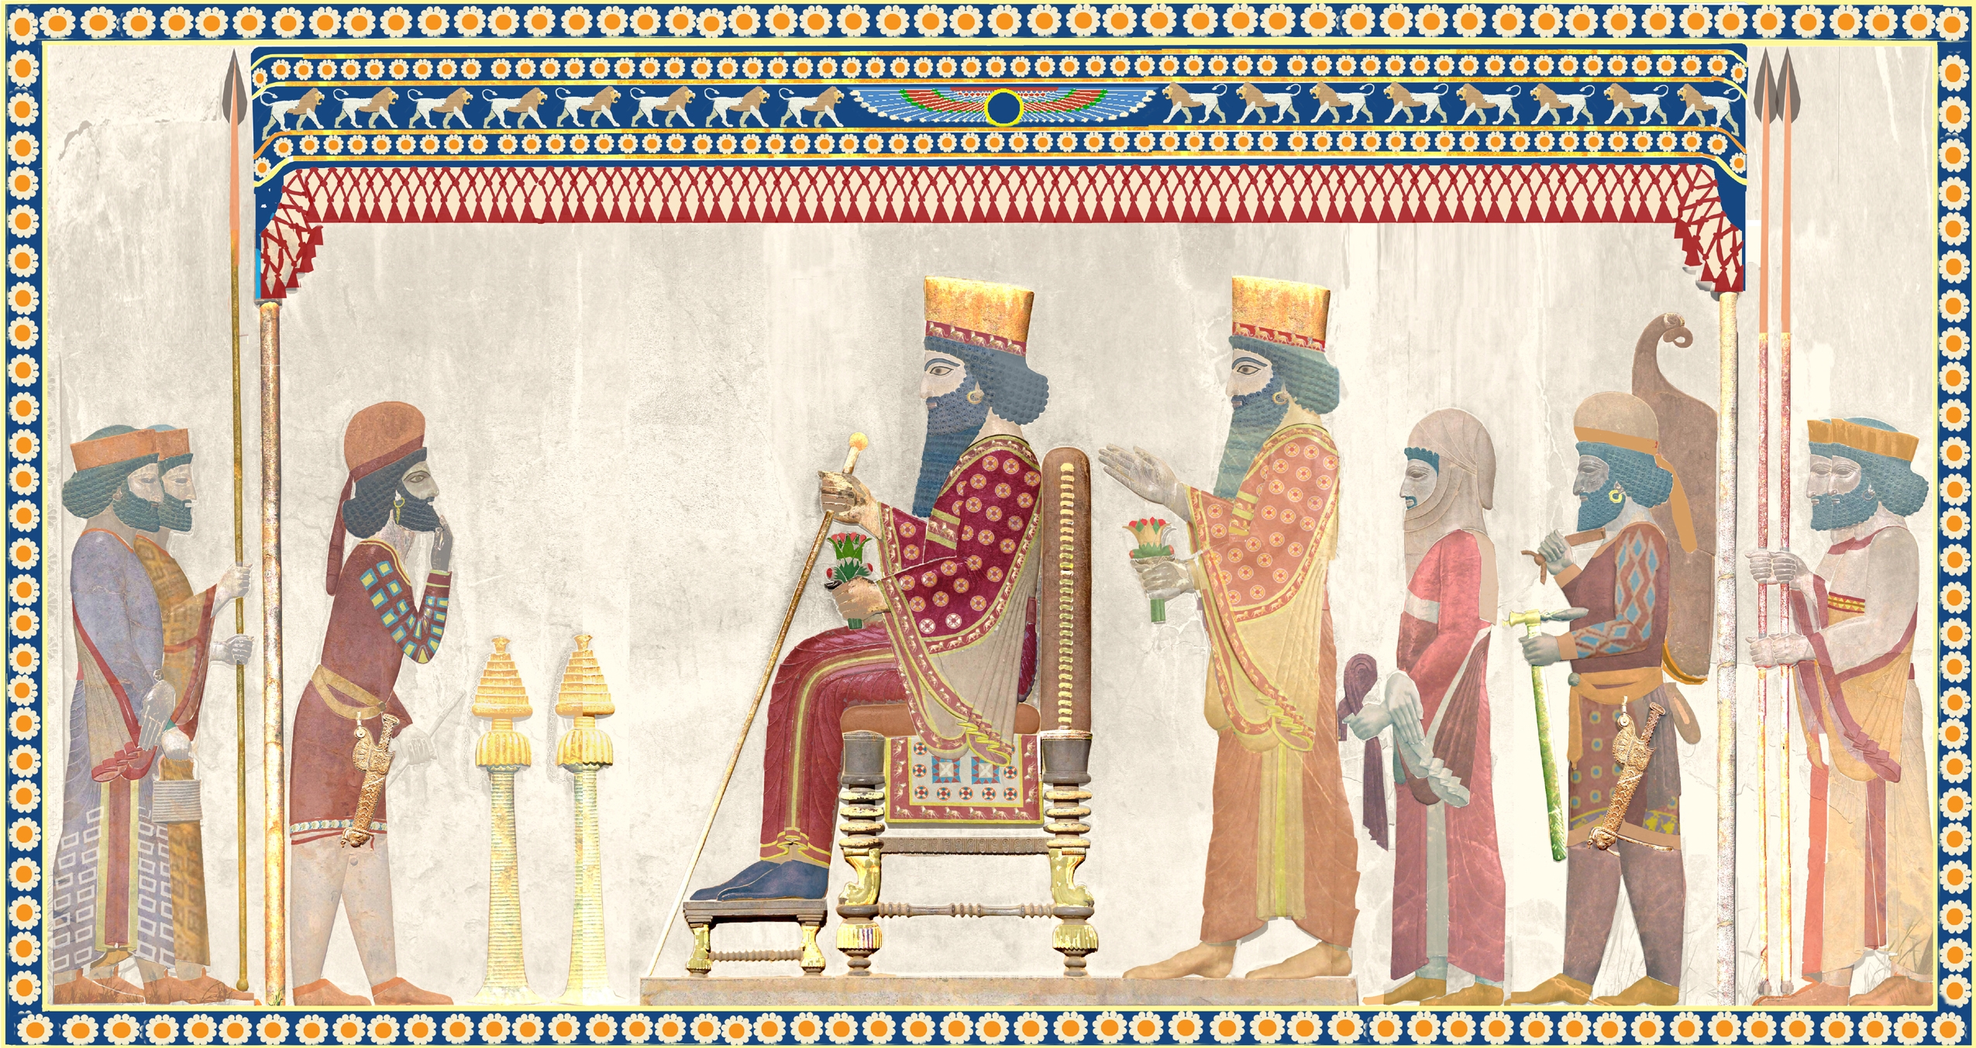

The Achaemenid (ah-key-ma-nid) Empire in Persia lasted from 550 - 330 BCE. Its first ruler was Cyrus (sy-rus) the Great. Its capitals were Pasargadae (pa-sar-ga-day) and Babylon (bab-a-lon). There were 35 million people in the empire (more than half the size of the Roman Empire in Europe). The climate there is desert with hot and dry climate year-round.

People in the Achaemenid Empire usually lived with their families in small farming villages. It was a time of peace, so most people were not afraid of war. Many men were recruited into the Persian army (picture on next page). The Persians may have invented the first mail system, which carried letters by horse from city to city. Unlike other ancient Asian civilizations, many jobs were done by both men and women.
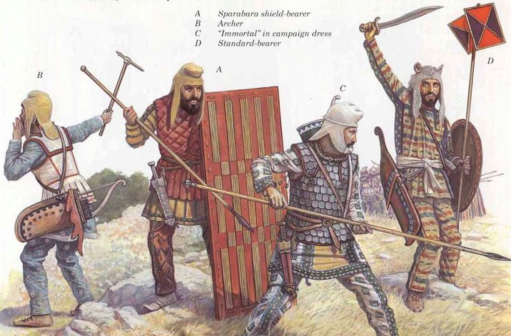

The below map shows the location of the Persian Empire in Asia.

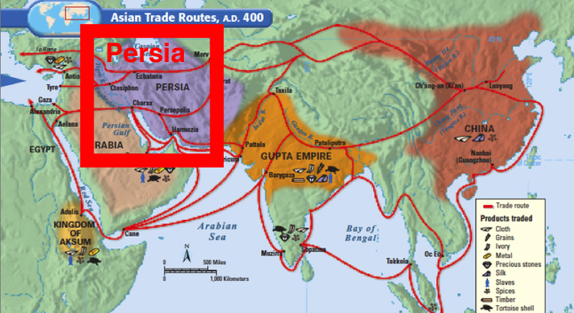
ASSESSMENT: 4-9.F

The Great Asian Empires: Exit Ticket

Inquiry Question: If you could live in any ancient Asian empire, which one would it be and why?

Choose one Great Asian Empire and explain why you would choose to live there. Include three pieces of evidence from the sources.

LESSON PLAN 4-10: The Silk Road: Connecting Continents

MATERIALS

Silk Road Video (Lesson4-10Video1) [Located in the UOW Video Library: www.christophercmartell.com/understandingourworld]
Silk Road Map (WORKSHEET 4-10.A)
Source 1: Stop 1—Guangzhou (WORKSHEET 4-10.B)
Source 2: Stop 2—Chang’an (WORKSHEET 4-10.C)
Source 3: Stop 3—Pataliputra (WORKSHEET 4-10.D)
Source 4: Stop 4—Persepolis (WORKSHEET 4-10.E)
Source 5: Stop 5—Constantinople (WORKSHEET 4-10.F)
The Silk Road: Exit Ticket (ASSESSMENT 4-10.G)

STANDARDS

Massachusetts History and Social Science Framework

MA-HSS.4.CS.1: Use map and globe skills to determine absolute locations (latitude and longitude) of places studied. (G)

MA-HSS.4.4: Describe important technologies of China such as bronze casting, silk manufacture, and gunpowder. (H, E)

Common Core: Literacy

CCSS.ELA-Literacy.RI.4.9: Integrate information from two texts on the same topic in order to write or speak about the subject knowledgeably.

CCSS.ELA-Literacy.RI.4.10: By the end of year, read and comprehend informational texts, including history/social studies, science, and technical texts, in the grades 4–5 text complexity band proficiently, with scaffolding as needed at the high end of the range.

CCSS.ELA-Literacy.W.4.8: Recall relevant information from experiences or gather relevant information from print and digital sources; take notes and categorize information, and provide a list of sources.

CCSS.ELA-Literacy.W.4.9: Draw evidence from literary or informational texts to support analysis, reflection, and research.

PROCEDURES

Inquiry Question: What was life like on the Silk Road?

A. OPENER (10 minutes)

1. Watch the Silk Road Video
Show the students a short video about the Silk Road (Lesson4-10Video1). Stop the video to explain any concepts that may be difficult for students. After watching the video, ask the students, “How was the Silk Road similar and different from how we transport goods today?” Anticipated responses may include: we use planes and ships, it took much longer back then, they did not have factories, they did not have e-mail or telephones. Tell the students that today we are going to pretend that we are traveling on the Silk Road. We will be keeping a diary and you will have to write about each stop along the way. Pass out and have students look at the Silk Road Map (WORKSHEET 4-10.A). Ask them if they recognize any of the cities or empires from our last lesson. Tell the students that the silk road happened because of trade between the main empire of Asia, which included Qin China, Heian Japan, Gupta India, and Achaemenid Persia. Tell students they should use this map to help write their diary entries.

B. DEVELOPMENT (20 minutes)

3. Read About the Silk Road
Pass out the sources: Stop 1—Guangzhou (WORKSHEET 4-10.B), Stop 2—Chang’an (WORKSHEET 4-10.C), Stop 3—Pataliputra (WORKSHEET 4-10.D), Stop 4—Persepolis (WORKSHEET 4-10.E), Stop 5—Constantinople (WORKSHEET 4-10.F)
Have students take turns reading aloud (using choral, partner, or independent reading) each source.

4. Write Diary Entry
Divide the class in half. Explain that a diary is a journal or writing that people do once a day to remember things about their day. They are going to write a diary entry pretending that they are traveling on the Silk Road from Constantinople in Turkey to Guangzhou in China. Tell them to include in their diary entries some of the information in the sources, especially what items they are trading and the people who they are trading with. Before they start writing, make a list of possible items to include on the board or chart paper.

The diary entries (ASSESSMENT 4-10.G) will serve as the evaluation task. Students’ diary entries will address the lesson’s Inquiry Question: “What was life like on the Silk Road?” Tell students to cite at least three pieces of evidence from the sources for this lesson.

C. CLOSING (15 minutes)

5. Share Letters
Have students share their diary entries with the class. Draw comparisons between the different students’ stories and list them on the board or chart paper.
EVALUATION

ASSESSMENT 4-10.G

What to look for?

Some information that students may include in their diary entries:

Guangzhou
- China's greatest international seaport.
- Many of the items traded on the silk road started here.
- Products include tea and ceramics.
- Stock up on items that Europeans and Africans desire.
- It is on the ocean and where items traded on the Silk Road may be put on ships and sent out to places in the Indian and Pacific Oceans.

Chang’an
- Inland Chinese city on the Silk Road.
- Built just south of the Great Wall.
- Became the capital of the Qin Chinese Empire.
- The main starting point on the Silk Road for silk and other clothes.
- Trade tea and ceramics here for silk or other clothes.

Pataliputra
- Near the Ganges River.
- Became the capital of the Indian Empire for a brief period of time.
- Had a wooden wall nine miles long surrounding the city with 470 towers and a moat that was 900 feet wide.
- Stock up on rare oils and chilies.

Persepolis
- On the Silk Road near the Pulvar and Kur Rivers.
- Became the capital of the Achaemenid Persian Empire.
- Known for its Gate of Xerxes, which was a massive gateway that greeted visitors.
- Stock up on rugs, cloth, and dates.

Constantinople
- Was at the end of the Silk Road.
- On the Sea of Marmara, which connects to the Aegean Sea and eventually the Mediterranean Sea.
- Allowed goods to be transported from Constantinople to Europe and Africa.
- Stock up on metal, gold, silver, wool, spices, and other goods brought there from Europe and Africa.

WORKSHEET: 4-10.A

Map of the Silk Road

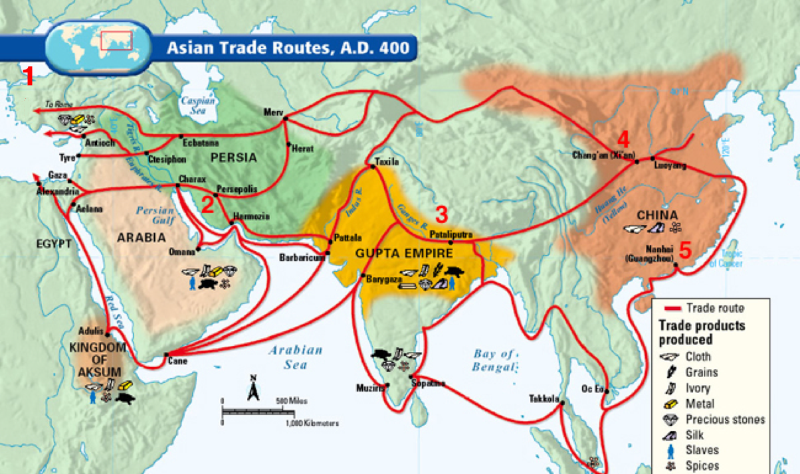

WORKSHEET: 4-10.B

Source 1: Stop 1—Guangzhou

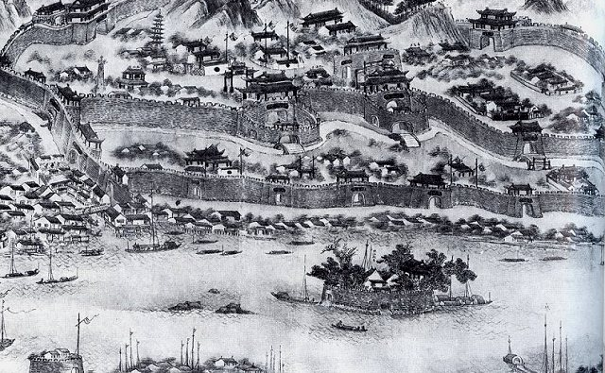

Guangzhou (gwan-zoh), also called Canton (can-tawn), was China's greatest international seaport. Many of the items traded on the silk road started here. This included tea and ceramics. If you were starting on the Silk Road here, you should stock up on items that Europeans and Africans desire. It is also on the ocean and where items traded on the Silk Road may be put on ships and sent out to places in the Indian and Pacific Oceans.

WORKSHEET: 4-10.C

Source 2: Stop 2—Chang’an

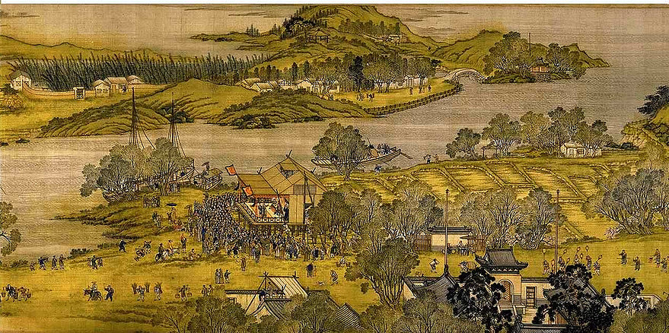

Chang’an (shang-un), also known as Sian or Xi’an, was an inland Chinese city on the Silk Road. It was built just south of the Great Wall. Due to its trade location, it became the capital of the Qin Chinese Empire. It was the main starting point on the Silk Road for silk and other clothes. You may consider trading some of your tea and ceramics here for silk or other clothes.

WORKSHEET: 4-10.D

Source 3: Stop 3—Pataliputra

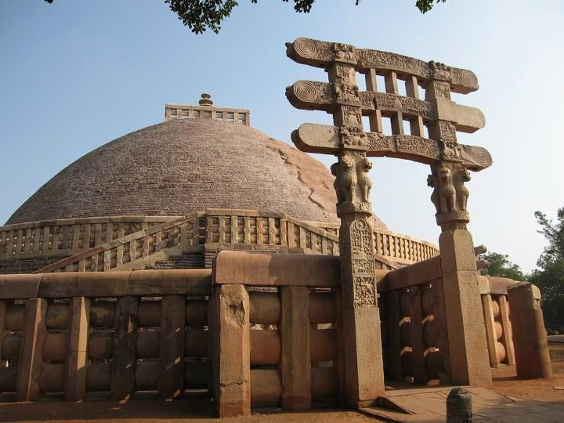

Pataliputra (pa-tal-ee-poo-tra), also known as Patna, was city on the Silk Road near the Ganges River. Due to its trade location, it became the capital of the Indian Empire for a brief period of time. It had a wooden wall nine miles long surrounding the city with 470 towers and a moat that was 900 feet wide. It was known as a place to get rare oils and chilies. You may consider trading some of your items for oil or chilies.

WORKSHEET: 4-10.E

Source 4: Stop 4—Persepolis

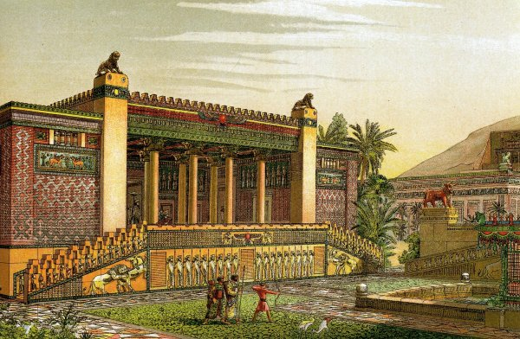

Persepolis (per-sip-o-lis), also known as Takht-e-Jamshid, was city on the Silk Road near the Pulvar and Kur Rivers. Due to its trade location, it became the capital of the Achaemenid Persian Empire. It is known for its Gate of Xerxes, which was a massive gateway that greeted visitors. It was known as a place to get rugs, cloth, and dates. You may consider trading some of your items for these items.

WORKSHEET: 4-10.F

Source 5: Stop 5—Constantinople

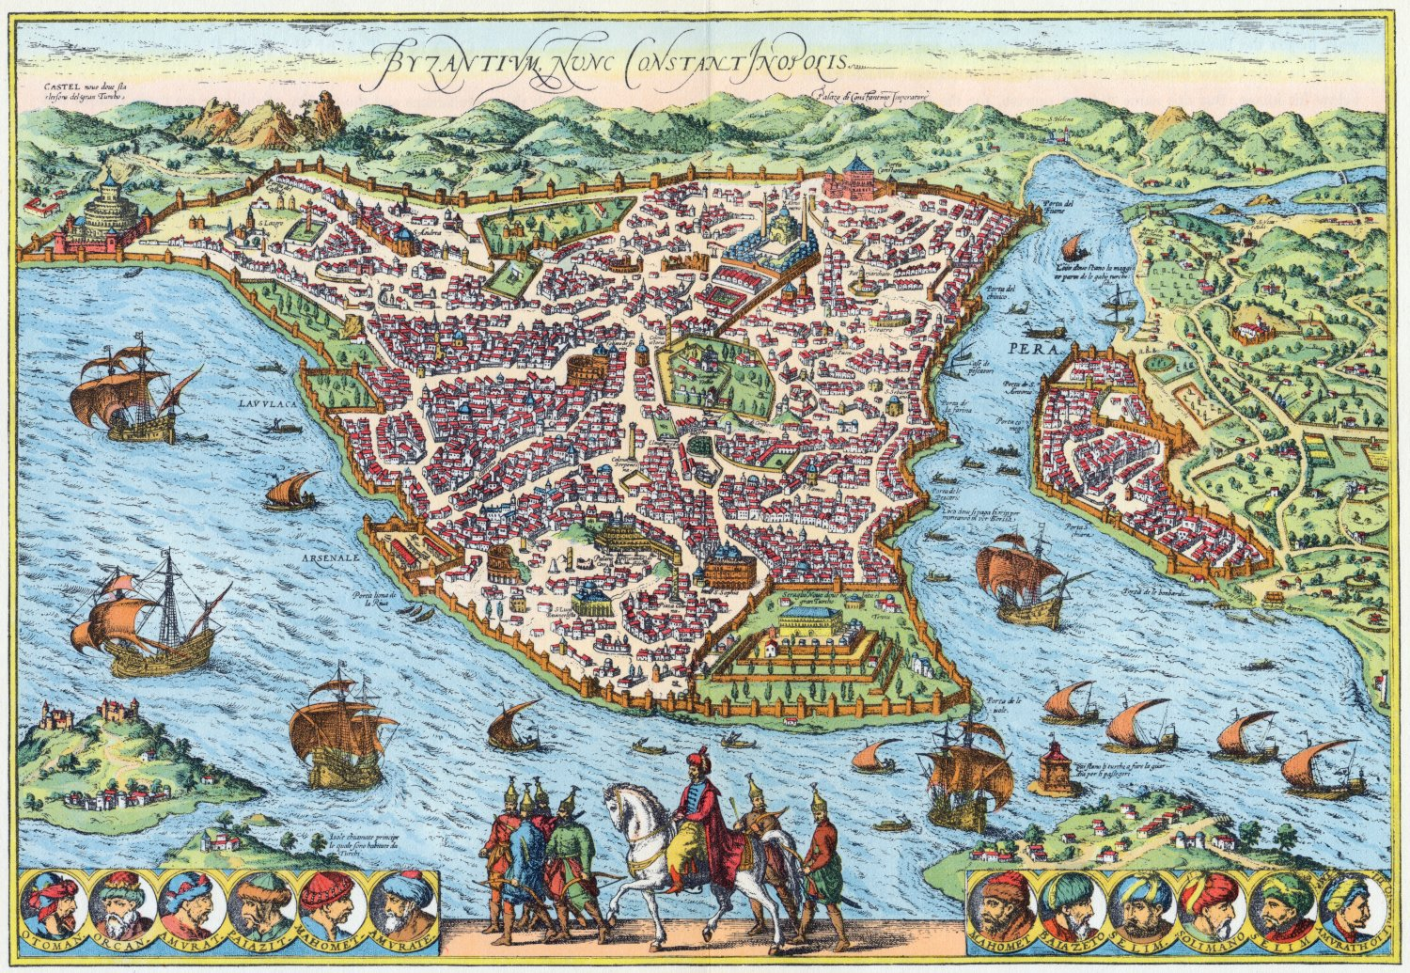

Constantinople, also known as Byzantium (now called Istanbul), was the end of the Silk Road. It is on the Sea of Marmara, which connects to the Aegean Sea and eventually the Mediterranean Sea. This allowed goods to be transported from Constantinople to Europe and Africa. It was known as a place to get metal, gold, silver, wool, spices, and other goods brought there from Europe and Africa. You may consider trading some of your items for these items.

ASSESSMENT: 4-10.G

The Silk Road: Exit Ticket

Inquiry Question: What was life like on the Silk Road?

Imagine you are traveling the Silk Road and write a diary entry about each stop. Include three pieces of evidence from the sources. Use another sheet of paper if you need more space for each diary entry.

Stop 1— Guangzhou

Stop 2— Chang’an

Stop 3—Pataliputra

Stop 4—Persepolis

Stop 5— Constantinople

LESSON PLAN 4-11: Việt Nam: A Country of Waterways

MATERIALS

Mekong Floating Market Video (Lesson4-11Video1) [Located in the UOW Video Library: www.christophercmartell.com/understandingourworld]
Map of the Mekong River (WORKSHEET 4-11.A)
Source 1: Transportation (WORKSHEET 4-11.B)
Source 2: Economy (WORKSHEET 4-11.C)
Source 3: Illegal Wildlife Trade (WORKSHEET 4-11.D)
Source 4: Pollution and Climate Change (WORKSHEET 4-11.E)
Preparation for the Corner Debate (WORKSHEET 4-11.F)
STRONGLY AGREE, AGREE, DISAGREE, STRONGLY DISAGREE signs (MATERIALS 4-11.G)
Việt Nam: A Country of Waterways: Exit Ticket (ASSESSMENT 4-11.H)

STANDARDS

Massachusetts History and Social Science Framework

MA-HSS.4.CS.1: Use map and globe skills to determine absolute locations (latitude and longitude) of places studied. (G)

MA-HSS.4.16: Identify major immigrant groups that live in Massachusetts and where they now live in large numbers (e.g., English, Irish, Italians, French Canadians, Armenians, Greeks, Portuguese, Haitians, and Vietnamese). (H, G)

MA-HSS.6.SEAO.3: Explain how the following five factors have influenced settlement and the economies of major countries of Southeast Asia and Oceania. (G, E)
A. absolute and relative locations
B. climate
C. major physical characteristics
D. major natural resources
E. population size

Common Core: Literacy

CCSS.ELA-Literacy.RI.4.9: Integrate information from two texts on the same topic in order to write or speak about the subject knowledgeably.

CCSS.ELA-Literacy.RI.4.10: By the end of year, read and comprehend informational texts, including history/social studies, science, and technical texts, in the grades 4–5 text complexity band proficiently, with scaffolding as needed at the high end of the range.

CCSS.ELA-Literacy.W.4.8: Recall relevant information from experiences or gather relevant information from print and digital sources; take notes and categorize information, and provide a list of sources.

CCSS.ELA-Literacy.W.4.9: Draw evidence from literary or informational texts to support analysis, reflection, and research.

PROCEDURES

Inquiry Question: Are the human changes to the Mekong River more positive or negative?

A. OPENER (10 minutes)

1. Watch Mekong Floating Market Video
Show the students a short video of the Mekong River’s floating market in Việt Nam (Lesson4-11Video1). Stop the video to ask questions about what the students notice about the market and how it is similar or different to the places where the students shop. At the end of the video, ask students what they know about the country of Việt Nam. Anticipated responses may include: they were born there or have relatives born there, the government is communist, the U.S. fought a war there, there are many rivers, they speak Vietnamese there. Project the Map of the Mekong River (WORKSHEET 4-11.A). Explain that the river starts in the mountains of China, goes through six countries and the last country is Việt Nam. We call that last part the Mekong River Delta of Việt Nam, because it is where the river meets the ocean.

B. DEVELOPMENT (20 minutes)

2. Examine Evidence About the Mekong River
Pass out the sources: Transportation (WORKSHEET 4-11.A), Economy (WORKSHEET 4-11.B), Illegal Wildlife Trade (WORKSHEET 4-11.C), Pollution and Climate Change (WORKSHEET 4-11.D) As a class, have students take turns reading aloud (using choral, partner, or independent reading) each source.

3. Participate in a Corner Debate on the Mekong River Changes
Have students individually think about each Mekong River changes question using Preparation for the Corner Debate (WORKSHEET 4-11.E).

Ask students to bring their preparation sheets with them and stand up in the middle of the room. Post in the four corners of the room the signs that say “STRONGLY AGREE, “AGREE,” “DISAGREE,” “STRONGLY DISAGREE” (MATERIALS 4-11.F).

Read each of the questions. Tell students if they think would be a good choice, they should stand under “STRONGLY AGREE” or “AGREE,” or a bad choice, they should stand under “DISAGREE” or “STRONGLY DISAGREE.” Ask students to explain why they agree or disagree. Repeat this with the other questions. If there are no agrees or disagrees for a question, you should stand there and give a reason why it might be a good or bad choice.

After the students have heard a discussion of each choice, have students return to their seats. They should discuss with their classmates in small groups the inquiry question: “Are the human changes to the Mekong River more positive or negative?” After they have had time to listen and discuss, they should form their own arguments.

C. CLOSING (15 minutes)

4. Write Up Argument on Mekong River Changes
For the evaluation task, have the students complete the exit ticket (ASSESSMENT 4-11.E) where they write their own personal response to the lesson’s Inquiry Question: “Are the human changes to the Mekong River more positive or negative?” Tell students to cite at least three pieces of evidence from the sources or our class debate.

Before using the exit ticket, consider using a graphic organizer or two column notes to prepare students for the writing task. Consider using sentence starters and modeling to help the students with their answer to the inquiry question.

EVALUATION

ASSESSMENT 4-11.E

What to look for?

Some information that students may include in their diary entries:

Changes to the Mekong River are more positive:
- The roads are currently very full; using the river for transportation reduces traffic.
- It is an important part of the Vietnamese economy.
- Many people make their living from trading goods on the Mekong River.
- People can use boats to get around.

Changes to the Mekong River are more negative:
- Some people smuggle rare animals from the Mekong River and sell them.
- Boats create pollution in the Mekong.
- Climate change is causing certain animals to go extinct in the Mekong River.
- Climate change is causing flooding along the Mekong River, effecting people’s homes and businesses.
WORKSHEET: 4-11.A

Map of the Mekong River

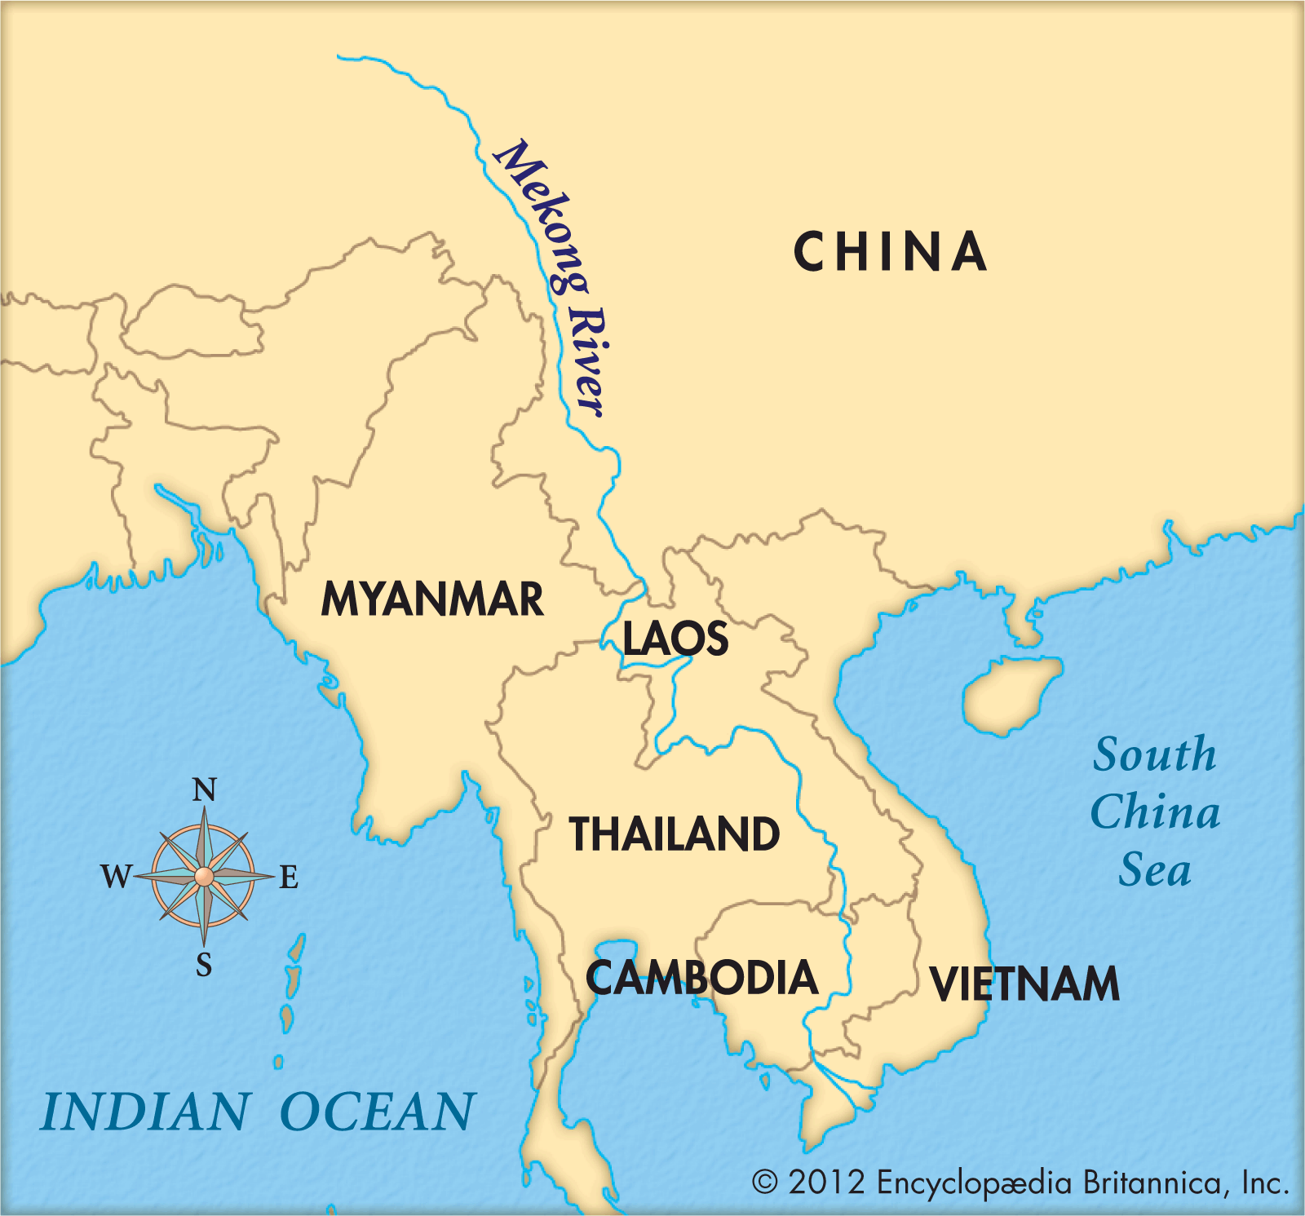

WORKSHEET: 4-11.B

Source 1: Transportation

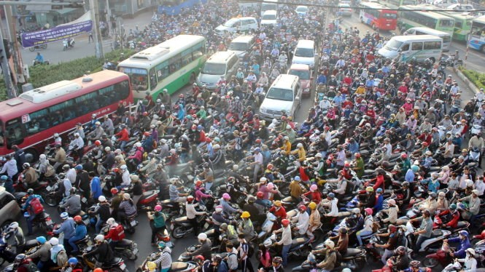

There are many traffic jams in the Vietnamese city of Saigon (see above). On the roads, the motorcycles, cars, and buses compete with trailer trucks that are hauling goods for the market. As fewer people have been transporting goods by boat on the canals and Mekong River, traffic is getting worse. Transporting more goods on the canals and rivers (like they use to) would improve traffic on the roads.

WORKSHEET: 4-11.C

Source 2: Economy

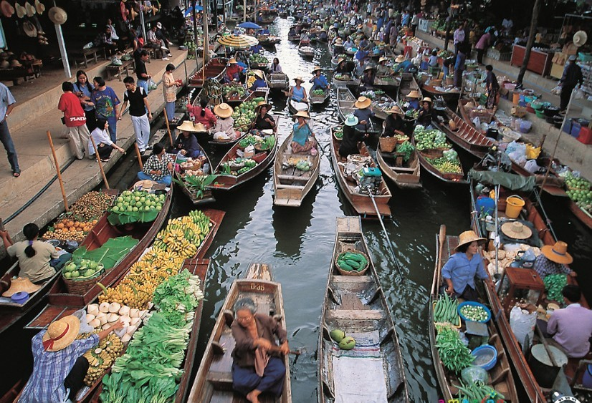

The floating market of the canals and Mekong River in Saigon are an important place to buy and sell goods. You can buy almost anything from a boat vendor, including fresh vegetables, fruits, meats, and fish. Some boats are even floating convenience stores with soda or snacks. The markets have been there for hundreds of years and tourists from all over the world visit them. They are an important part of Việt Nam’s economy and many people make their living from selling items there.

WORKSHEET: 4-11.D

Source 3: Illegal Wildlife Trade

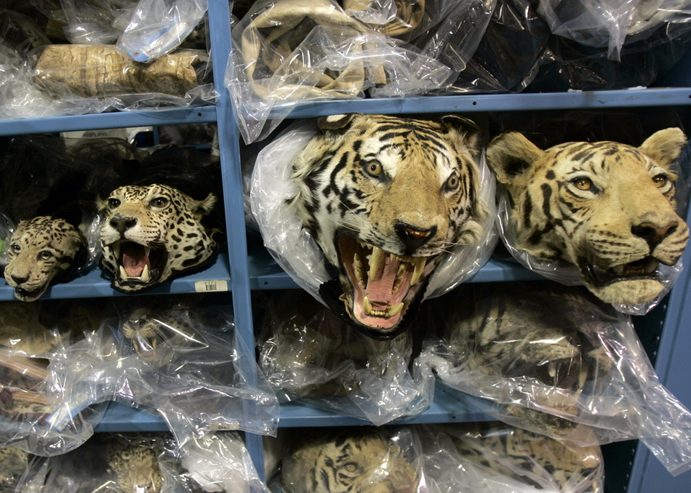

Although it is illegal, some people along the Mekong River catch, kill, and sell rare and endangered animals, such as tigers and sun bears. They often use the river to transport these animals and then people who collect rare animals buy them and display them in their houses. It is believed that there are only 350 tigers left in the Mekong River area, because of these poachers and smugglers. There were more than thousand only a few decades ago.
WORKSHEET: 4-11.E

Source 4: Pollution and Climate Change

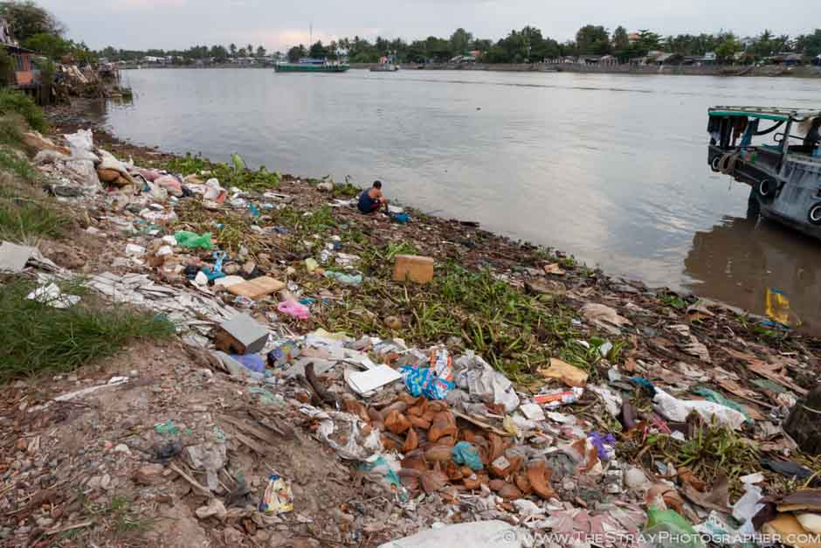

Since there are so many boats on the Mekong River, there is also a lot of pollution. Trash washes up on the shore (see above) and gasoline and oil from boats ends up in the water. The Mekong River is also having problems from climate change. As the Earth’s temperature increases, plants and animals in the Mekong River area are being effected. Climate change also leads to more floods, which affect people’s homes and businesses. In Fall 2011, the Mekong had its worst flood in decades and many people were hurt by it. These floods also hurt the amount of rice that can be grown, which is an important crop in Việt Nam.

WORKSHEET: 4-11.F

Preparation for the Corner Debate

Think about the following sentences and decide if you think “strongly agree,” “agree,” “disagree,” or “strongly disagree.” Then explain why.

More people should transport goods and people using the Mekong River.

Circle:
Strongly Agree Agree Disagree Strongly Disagree

More people should trade goods on the Mekong River.

Circle:
Strongly Agree Agree Disagree Strongly Disagree

People should go to jail for many years if they kill endangered animals near the Mekong River.

Circle:
Strongly Agree Agree Disagree Strongly Disagree

People should stop all pollution in the Mekong River.

Circle:
Strongly Agree Agree Disagree Strongly Disagree

MATERIALS: 4-11.G

STRONGLY AGREE

AGREE

DISAGREE

STRONGLY DISAGREE

ASSESSMENT: 4-11.H

Việt Nam: A Country of Waterways: Exit Ticket

Inquiry Question: Are the human changes to the Mekong River more positive or negative?

Choose that the changes to the Mekong River are positive or negative and explain why you think so. Include three pieces of evidence from the sources.

LESSON PLAN 4-12: Asian Megacities: Would You Want to Live There?

MATERIALS

Japanese Micro-Apartment Video (Lesson4-12Video1) [Located in the UOW Video Library: www.christophercmartell.com/understandingourworld]
Megacities Map (WORKSHEET 4-12.A)
Source 1: Tokyo and Transportation (WORKSHEET 4-12.B)
Source 2: Seoul and Technology (WORKSHEET 4-12.C)
Source 3: Shanghai and Housing (WORKSHEET 4-12.D)
Source 4: Beijing and Pollution (WORKSHEET 4-12.E)
Asian Megacities: Exit Ticket (ASSESSMENT 4-12.F)

STANDARDS

Massachusetts History and Social Science Framework

MA-HSS.4.CS.1: Use map and globe skills to determine absolute locations (latitude and longitude) of places studied. (G)

MA-HSS.6. NEA.2 Use a map key to locate the countries and major cities in the various regions of East Asia. (G, E)

Common Core: Literacy

CCSS.ELA-Literacy.RI.4.9: Integrate information from two texts on the same topic in order to write or speak about the subject knowledgeably.

CCSS.ELA-Literacy.RI.4.10: By the end of year, read and comprehend informational texts, including history/social studies, science, and technical texts, in the grades 4–5 text complexity band proficiently, with scaffolding as needed at the high end of the range.

CCSS.ELA-Literacy.W.4.8: Recall relevant information from experiences or gather relevant information from print and digital sources; take notes and categorize information, and provide a list of sources.

CCSS.ELA-Literacy.W.4.9: Draw evidence from literary or informational texts to support analysis, reflection, and research.

PROCEDURES

Inquiry Question: Would you like to live in an Asian megacity?

A. OPENER (10 minutes)

1. Watch Japanese Micro-Apartment Video
Show the students a short video of Japanese micro-apartments (Lesson4-12Video1). Stop the video to ask questions about what the students notice about the homes are different and similar to this own. At the end of the video, ask students if they would want to live in a micro-apartment. Project the Megacities Map (WORKSHEET 4-12.A). Explain that a megacity is any city with over 10 million people (which includes their suburbs). There are only two in the U.S., New York and Los Angeles. Tell students that today we are going to study these megacities in Asia.

B. DEVELOPMENT (20 minutes)

2. Read About the Asian Megacities
Put students in small groups and assign them one of the sources: Tokyo and Transportation (WORKSHEET 4-12.B), Seoul and Technology (WORKSHEET 4-12.C), Shanghai and Housing (WORKSHEET 4-12.D), Beijing and Pollution (WORKSHEET 4-12.E). Have one student from each group read their source. As the student reads, tell the other group members to underline or highlight any important information.

3. Engage in a Jig Saw on Asian Megacities
Have students participate in a jig saw activity. Make new groups where at least one student from each of the original groups is included. This will create several new groups of three students, one is an expert on 4-12.B, 4-12.C, 4-12.D, 4-12.E. Have each student describe their document to the other members of their group.

Ask students to use the sources to answer the following inquiry question: “Would you like to live in an Asian megacity?” In answering this question, students should debate between the four different worksheets. After students have discussed the question, they should complete the exit ticket in the following step. Circulate the room, helping the students who may have difficulty choosing one asset.

C. CLOSING (15 minutes)

4. Write Up Argument on Asian Megacities
For the evaluation task, have the students complete the exit ticket (ASSESSMENT 4-12.F) where they write their own personal response to the lesson’s Inquiry Question: “Would you like to live in an Asian megacity?” Tell students to cite at least three pieces of evidence from the sources or our class debate.

Before using the exit ticket, consider using a graphic organizer or two column notes to prepare students for the writing task. Consider using sentence starters and modeling to help the students with their answer to the inquiry question.

EVALUATION

ASSESSMENT 4-12.F

What to look for?

Some information that students may include in their diary entries:

Reasons to live in an Asian megacity:
- Affordable (if you are okay with a small apartment)
- Technologically advanced
- Good public transportation (do not need a car)

Reasons to not live in an Asian megacity:
- Pollution is a major problem
- Too many people in a small area
- Too busy (which can be stressful)

WORKSHEET: 4-12.A

Map of Megacities

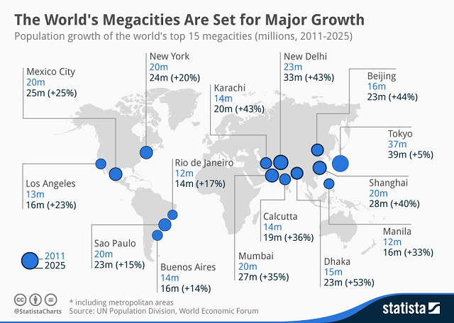
WORKSHEET: 4-12.B

Source 1: Tokyo and Transportation

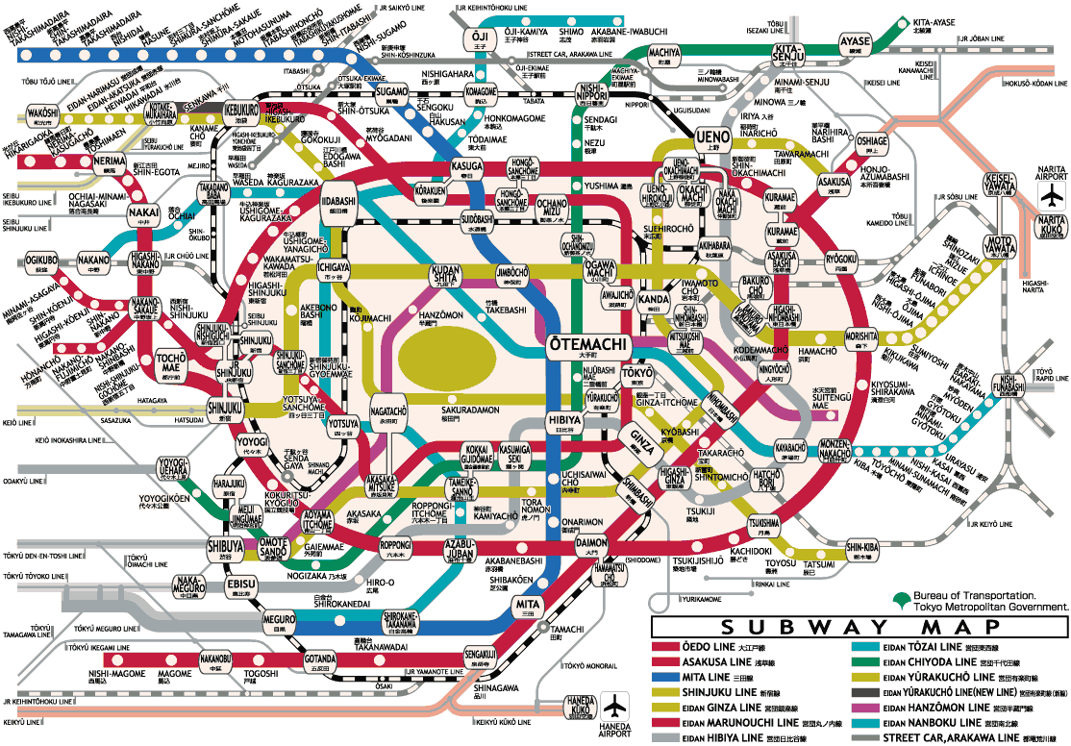

Tokyo, Japan is known for its extensive subway system. Many people in Tokyo do not own a car. The Tokyo subway system has 278 stations and over 189 miles of track (about the distance from Boston to the New York City). Above is the Tokyo subway map. Some stations are so busy that people are hired to push people onto the train, so the trains do not leave late. Almost 9 million people ride the Toyko subway daily. With so many passengers, it is very rare for the Tokyo subway to be late and trains run about every 3 minutes. Historian Kakuei Tanaka said of the Tokyo transit system, “It completely changed the face of Japan. Travel times were shortened … so that everyone uses it.”
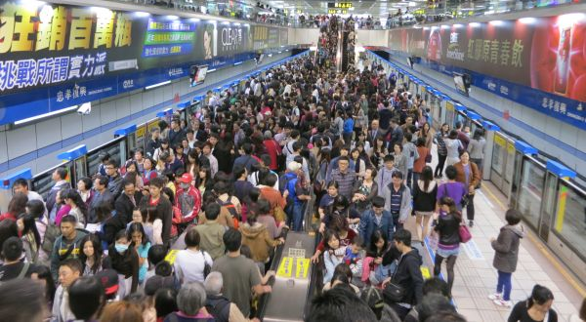
WORKSHEET: 4-12.C

Source 2: Seoul and Technology

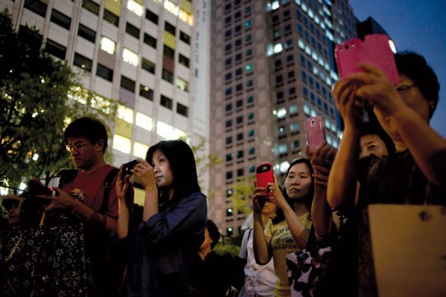

Seoul, South Korea is one of the most technologically advance cities in the world. Wifi Internet is available almost everywhere in the city. 95% of South Korean households have a high-speed Internet connection (compare that to only 70% of Americans). It is also very cheap to get an Internet phone, so almost everyone in Seoul has access to the Internet on their phones. The tech companies Samsung and LG are from Seoul. Mike Kim, who grew up in San Francisco and moved to Seoul, said, “Korea is three or four years ahead of the U.S. … When I go back to the U.S., it feels like the Dark Ages, when it comes to technology.”

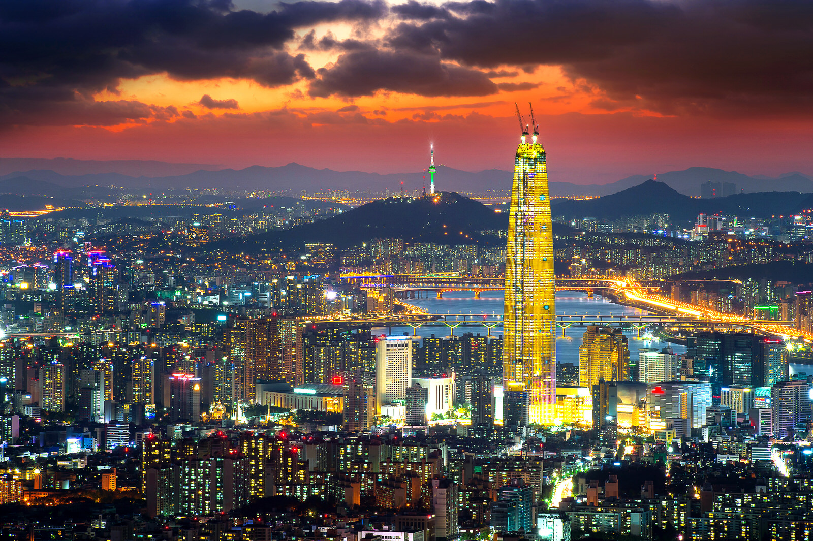
WORKSHEET: 4-12.D

Source 3: Shanghai and Housing

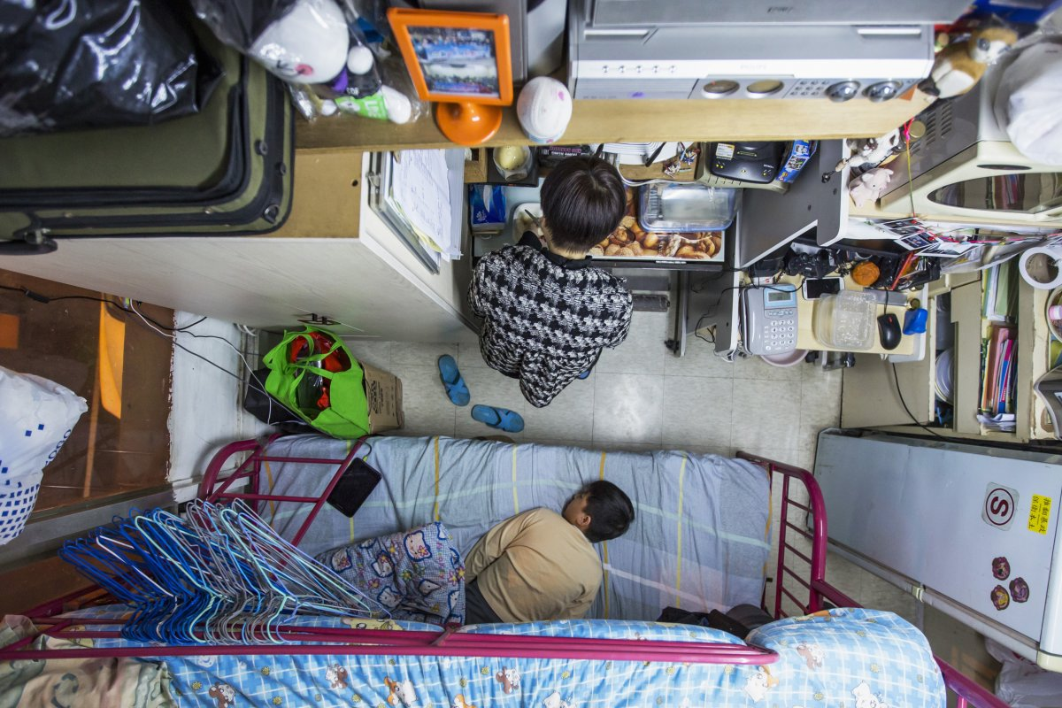

Shanghai, China is one of the world’s largest cities. It is known for its skyscrapers and small apartments. In 1980, there were no skyscrapers; today, Shanghai has twice as many as New York. The Shanghai Tower is the world’s second largest building. Many people in Shanghai live in micro-apartments (one pictured above). Some of these apartments may be as small as 15 feet by 15 feet. While these apartments are very small, they do allow people to live in the areas they want to live in and afford to live there. One mother said, “By living in a 60-square-foot apartment I spend only $487 a month on rent to house myself and my son.”
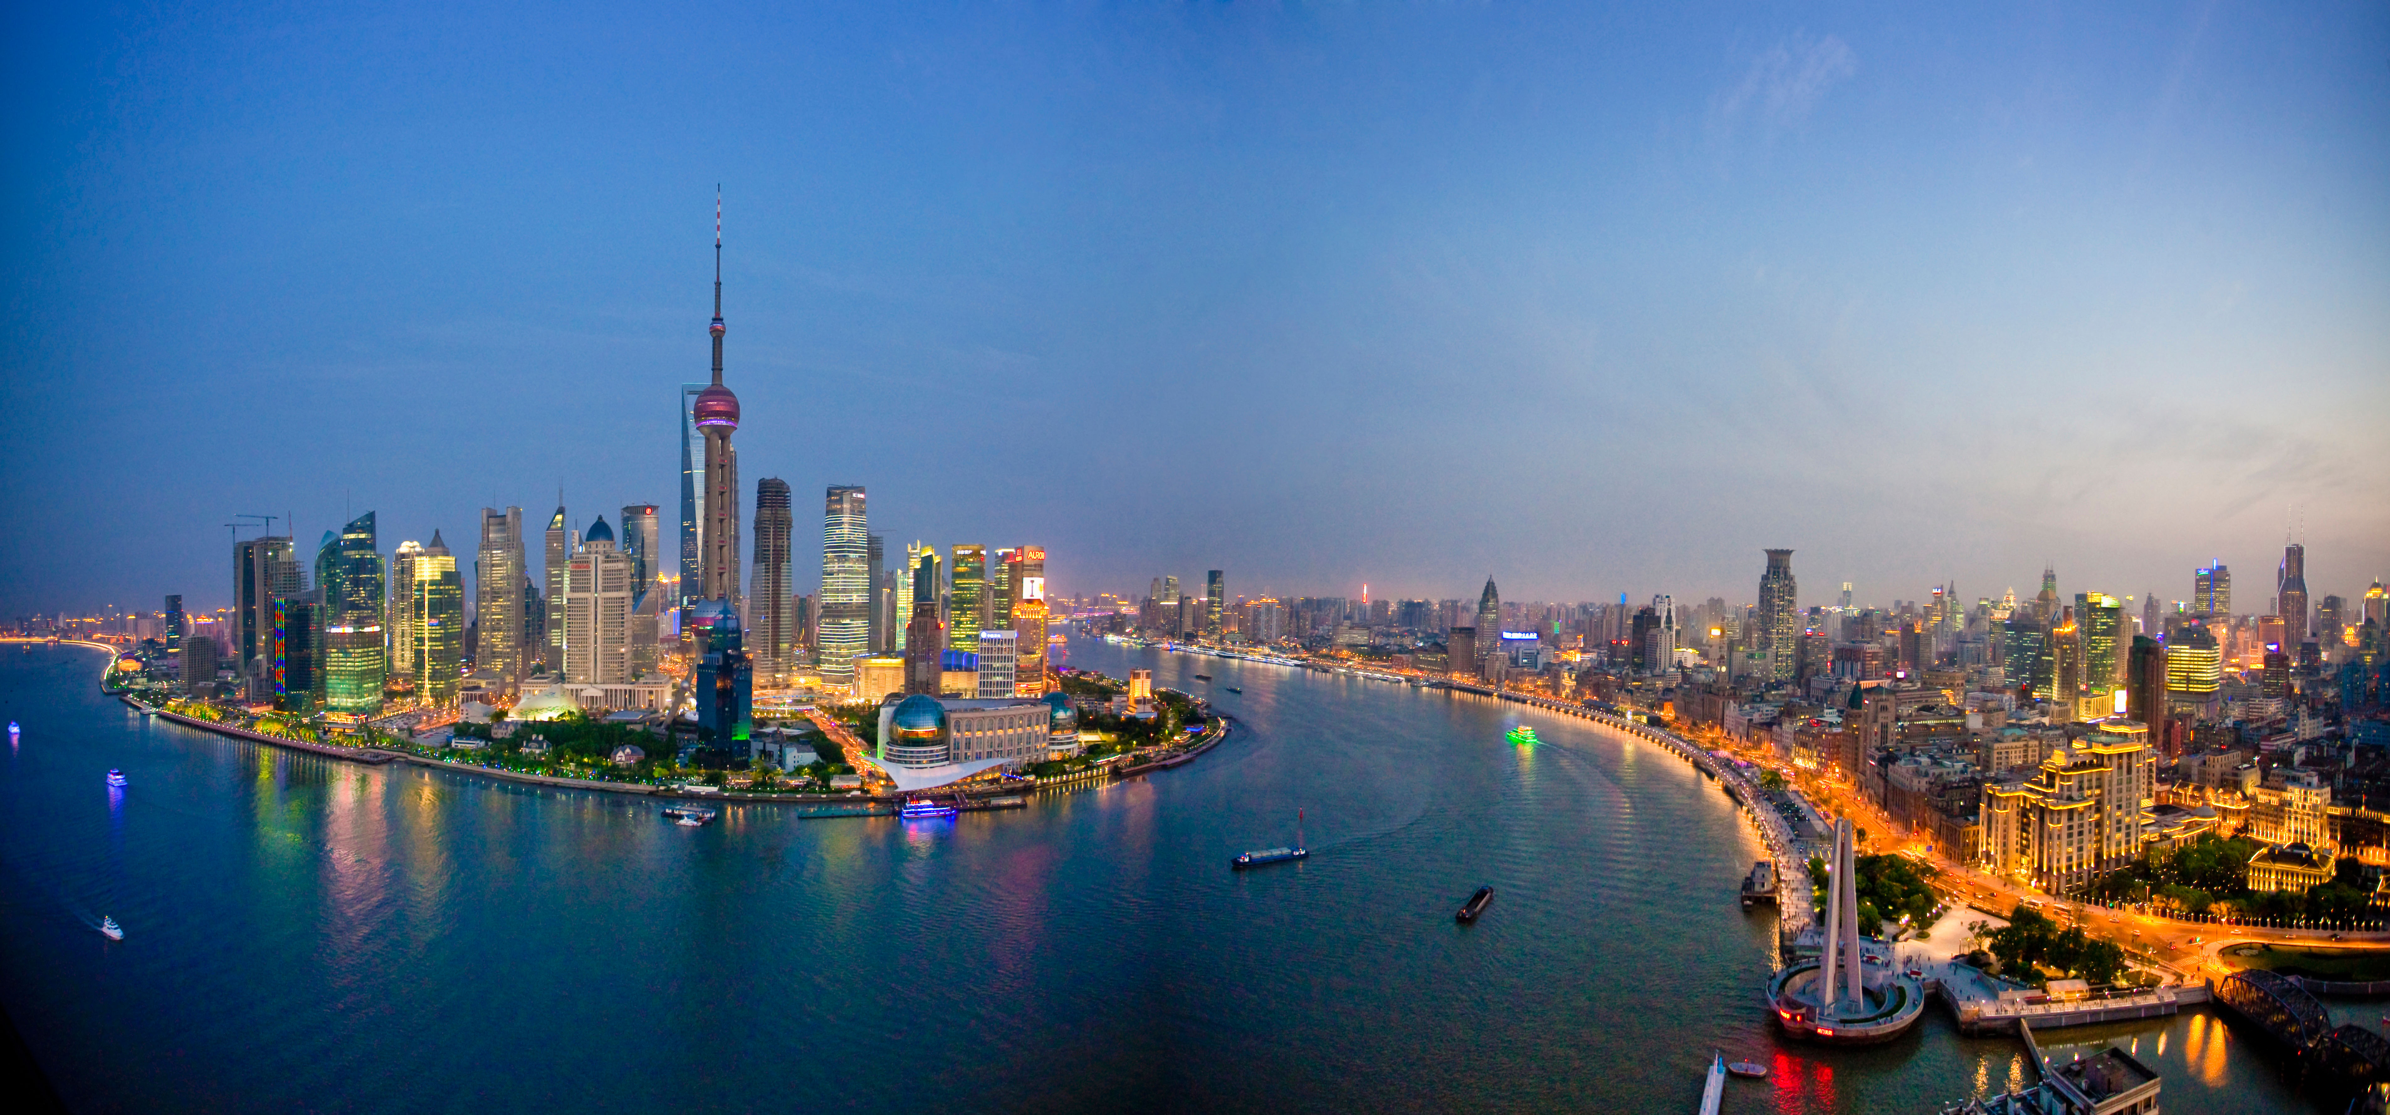
WORKSHEET: 4-12.E

Source 4: Beijing and Pollution

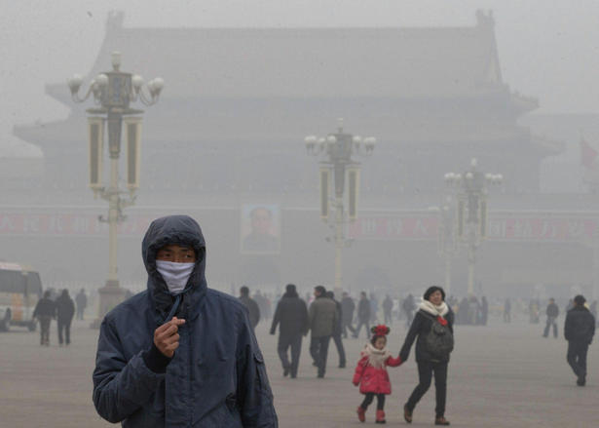

Beijing, China has an increasing population. Since 1990, it has doubled, going from 10 million to 21 million. With the increased cars, trucks, houses, factories, and power plants, Beijing is often under a cloud of pollution smog. Li Shuo, an environmental activist in China, said, “We have had a lucky few years recently. Sandstorms have traditionally been a problem for Beijing … but we have seen quite a significant slowdown in the air quality.” When the air quality is poor many people do not leave their homes and the pollution can make people very sick.

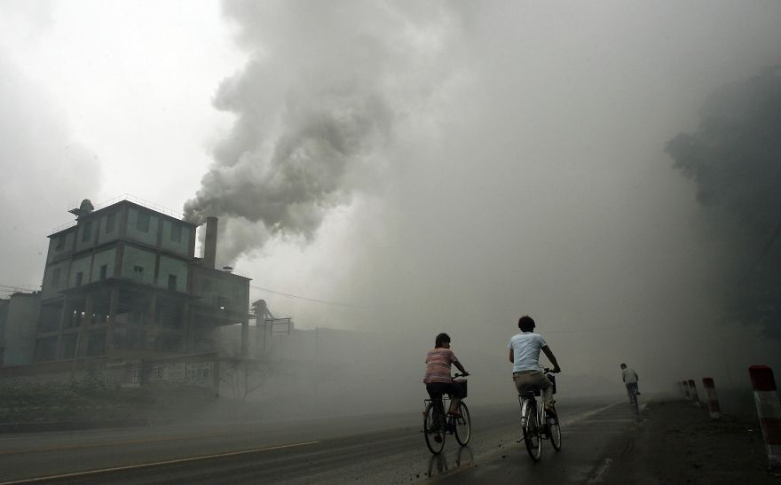
ASSESSMENT: 4-12.D

Asian Megacities: Exit Ticket

Inquiry Question: Would you like to live in an Asian megacity?

Considering the good and bad parts of living in a megacity, would you want to live in an Asian megacity? Why or why not? Include three pieces of evidence from the sources.

LESSON PLAN 4-13: Confucianism, Buddhism, Hinduism, and Islam

Lesson currently under development.
Expected Fall 2017.

LESSON PLAN 4-14: Asia Today: Diverse Nations, Diverse People

Lesson currently under development.
Expected Fall 2017.

LESSON PLAN 4-15: The Great American Empires: Aztec, Mayans, Incas, and Mississippian

Lesson currently under development.
Expected Fall 2017.

LESSON PLAN 4-16: Columbus: Hero or Villain?

Lesson currently under development.
Expected Fall 2017.

LESSON PLAN 4-17: Haiti: Rebellion or Revolution?

Lesson currently under development.
Expected Fall 2017.

LESSON PLAN 4-18: Mexico: A Nation of Many People

Lesson currently under development.
Expected Fall 2017.

LESSON PLAN 4-19: Road Trip: Mexico

Lesson currently under development.
Expected Fall 2017.

LESSON PLAN 4-20: Canada: One Nation or Many Nations?

Lesson currently under development.
Expected Fall 2017.

LESSON PLAN 4-21: South America Today: Diverse Nations, Diverse People

Lesson currently under development.
Expected Fall 2017.

LESSON PLAN 4-22: The Great European Empires: Greece, Rome, Spain, and Russia

Lesson currently under development.
Expected Fall 2017.

LESSON PLAN 4-23: The Kings of France

Lesson currently under development.
Expected Fall 2017.

LESSON PLAN 4-24: British Monarchy

Lesson currently under development.
Expected Fall 2017.

LESSON PLAN 4-25: European Imperialism: The Scramble for Africa and Asia

Lesson currently under development.
Expected Fall 2017.

LESSON PLAN 4-26: Where’s Poland?: A Case Study of a Disappearing/Reappearing Country and Its People

Lesson currently under development.
Expected Fall 2017.

LESSON PLAN 4-27: Irish Independence: A New Country from an Ancient People

Lesson currently under development.
Expected Fall 2017.

LESSON PLAN 4-28: Backpacking Across Europe: Diverse Nations, Diverse People

Lesson currently under development.
Expected Fall 2017.

LESSON PLAN 4-29: The World in 2050: How Will You Be the Leaders of Tomorrow?

Lesson currently under development.
Expected Fall 2017.

LESSON PLAN 4-30: Model UN: A Global Assembly

Lesson currently under development.
Expected Fall 2017.

ADDITIONAL RESOURCES

Below is a list of lesson plan and unit resources from other organizations, which in conjunction with Understanding Our World, may help teachers develop a content-rich elementary social studies curriculum.

Boston Public Schools: History and Social Studies Department

K-12 Curriculum Resources
https://sites.google.com/a/bostonpublicschools.org/history/curriculum-documents/

Massachusetts Department of Elementary and Secondary Education
Model Curriculum Units (Elementary-Level; Social Studies)
http://www.doe.mass.edu/candi/model/download_form.aspx

C3 Teachers

Inquiries
http://www.c3teachers.org/

New York State Education Department

New York State K-12 Social Studies Resource Toolkit
https://www.engageny.org/resource/new-york-state-k-12-social-studies-resource-toolkit

Teaching Tolerance

Elementary Resources
http://www.tolerance.org/activities

Facing History and Ourselves

Educator Resources
https://www.facinghistory.org/educator-resources

Primary Source

Online Curriculum
https://www.primarysource.org/for-teachers/online-curriculum

Share My Lesson (American Federation of Teachers)
Educator Resources
https://sharemylesson.com

Better Lesson (National Education Association)
Educator Resources
https://betterlesson.com

ABOUT THE DEVELOPERS

Christopher C. Martell, Ed.D.
Chris Martell is a Clinical Assistant Professor and Program Director of Social Studies Education at the Boston University School of Education. He teaches courses on elementary and secondary social studies methods. He was a social studies teacher for eleven years in urban and suburban contexts. For most of his teaching career, Chris taught in Framingham, Massachusetts, which is a racially and economically diverse urban school outside Boston with large immigrant populations from Brazil, Central America, and the Caribbean. His research and professional interests focus on social studies teachers in urban and multicultural contexts, critical race theory, culturally relevant pedagogy, and historical inquiry.

Jennifer R. Bryson, Ed.M.
Jenn Bryson is a former elementary classroom teacher in the Chelsea Public Schools and specializes in the professional preparation of elementary education teachers at the Boston University School of Education. Her responsibilities include coordination and supervision of student teachers in the elementary education program and the student-teaching abroad programs in London, England, Sydney, Australia, and Quito, Ecuador. She also facilitates the elementary pre-practicum placements for juniors and graduate students. In addition, Jenn teaches a course on urban education, leads field seminars on classroom management, and facilitates a book club entitled “Dads Read” at the William Monroe Trotter School in Dorchester, Massachusetts.

