Understanding Our World

An Open-Source Literacy-Focused Social Studies Curriculum

Curric

Level: Grade 2

Strangers from Different Shores:

Migration/Immigration

Developed By

Christopher C. Martell and Jennifer R. Bryson

Boston University School of Education

INTRODUCTION
Starting in the early elementary grades, all children should receive regular instruction in the social studies, which includes history, civics, geography, and economics. However, there are real pressures on schools and teachers to increase the amount of instruction in other subject areas, which often comes at the expense of their social studies time.

This curriculum was built to help elementary teachers regularly enact powerful and authentic social studies in their classrooms that will also meet essential literacy goals (linking every lesson to the Common Core State Standards). In other words, it leverages the richness of social studies content to help students learn to read, write, speak, and think critically while exploring the past and present world around them. It aims to make every single lesson culturally relevant, connecting to the racial, ethnic, gender, class, language, and immigration experience of the increasingly diverse United States.

ORGANIZATION
These lessons are meant to supplement the school or district social studies curriculum. They are free and open source. Teachers are encouraged to modify and adapt these lesson plans for the individual needs and diverse cultural backgrounds of their students. They are only a guide, or perhaps better a “starter kit” to implementing lessons with important disciplinary questions and social studies content. Moreover, these social studies lessons should be supported with rich English language arts (ELA) texts on related topics.

This curriculum is organized by grade level, with an organizing theme, and each grade is color coated for quick reference. Within each grade level, it is organized by lesson. At the beginning of each grade level, there is a roadmap for that shows the individual lesson topics. Additionally, each lesson plan follows the same lesson plan template (adapted from the Boston University Elementary Education Program) and always includes a thought-provoking inquiry question for the students to answer and primary/secondary sources to use as evidence. All lessons for the primary grades (1-2) are expected to be 30 minutes in length and the intermediate grades (3-5) are expected to be 45 minutes in length. However, depending on the pace of your students, lessons may need to span two or more 30- or 45-minute periods.

This curriculum was designed for students in the Boston Public Schools and each lesson cites the Massachusetts Curriculum Framework for History and the Social Sciences (aligned with the national College, Career, and Civic Life Framework for Social Studies State Standards) and Common Core State Standards. However, this curriculum can be easily adapted for other communities, including districts using other state curriculum frameworks. Some lessons are specifically about history and current events in Dorchester, Boston, and Massachusetts. Teachers from other cities/towns and states are encouraged to adapt these lessons for their particular communities.
GRADE 2
Strangers from Different Shores:
Migration/Immigration

GRADE 2 CONTENT OVERVIEW

The United States is a nation of migrants and immigrants. From the Indigenous people who were our First Nations to present-day immigrants, we are a people who are on the move, either within this continent or from other continents. This has resulted in our nation being a truly multicultural society. While traditionally the United States has been described as a melting pot, our country may be better described as a “salad bowl.” Like a salad we are made of many different distinct ingredients, but together we make one coherent dish. This perspective acknowledges the many different cultures and traditions that make up our people. Our national motto of “E Pluribus Unum” (“of many, one” in Latin) then represents the important and delicate balance of unity and diversity. Grade 2’s lessons help students learn the diversity of migrant and immigrant experiences and that migrants and immigrants have contributed to the development and cultural growth of the United States. By the end of Grade 2, students should understand that migrants and immigrants move for many reasons, that there is diversity even within their groups, and while many groups came her voluntarily, others were forced.

GRADE 2 LEARNING GOALS

1. Students Should Build on Opinions to Begin Making Arguments
Before grade 2, students have begun to move from making opinions to forming arguments. While opinions are claims that are not necessarily based in evidence, arguments include both claims and evidence. In grade 2, students should continue practice using evidence to support their claims. Yet, it is expected that students will not be able to make arguments with the same level of sophistication as intermediate (grades 3-5) students or adults. Argumentation in grade 2 is about "trying out" arguments by answering a question using sources.
2. Students Should Recognize Differences and Inequities
Before grade 2, most students have developed a strong understanding of fairness. Students are also beginning to recognizing racial, gender, and other social differences (there is evidence that most children can detect racial and gender differences by about age 2). In grade 2, students should be able to recognize differences and inequities. They should start thinking about ways that we can improve our communities to make them more fair and just.

3. Students Should Understand Multiple Perspectives
Before grade 2, students are beginning to understand that different people may experience the same situations differently. While this occurs at school and home, they are also seeing examples of it in their communities and in the media. In grade 2, students should examine examples of people thinking differently about the same events in the past and present. They should also begin to understand how people in the past lived and thought differently than people in the present.

CONCEPTS

Synopsis | Content | Thinking Skills
1. Indigenous People | - The Indigenous people (also referred to as American Indians, Native Americans, or Aboriginal people in Canada) were the first nations of what became North America.  - There are several possible theories for how the Indigenous people migrated to the Americas, including over a land bridge in Siberia or across the ocean.  - Indigenous communities have different languages, cultures, and ways of life today and in the past. | - Identify that Indigenous people are made up of many groups with different languages, traditions, and cultures.  - Compare the cultures of different Indigenous groups in the past to the present.  - Evaluate the different ideas related to the migrations of the Indigenous people.
2. Voluntary Migrants/Immigrants | - Migrants are people who move from one place to another; Immigrants are people who settle in a new country.  - Many migrants and immigrants came/come to the United States voluntarily.  - There are push and pull factors influencing them.  - Migrants and immigrants come from different social and cultural backgrounds (some are wealthy, middle class, or poor; some are from majority or minority groups in the home countries) | - Identify the largest immigrants during various periods of U.S. history.  - Describe immigration push and pull factors.  - Compare the cultures and traditions of different immigrant/migrant groups.
3. Forced Migrants | - Some people are force migrants. They did not have a choice to come to the United States.  - The vast majority of forced migrants were Africans who were sold into slavery by Europeans.  - Not all Black or African Americans migrants to the U.S. were forced migrants. Slavery was ended over 150 years ago and many African people have come to the U.S. since then. | - Distinguish the difference between voluntary migrant/immigrants and forced migrants.  - Describe the challenges of being a forced migrant.
4. Refugees | - Refugees are people are who have to leave their country because of a problem, like natural disasters, war, or their religion in not allowed. | - Describe the challenges of being a refugee.
5. Citizenship | - Who has been allowed to come to the U.S. has changed over time. For much of the nation’s history, there were little to no rules stopping immigrants from entering.  - There is a formal process of becoming a citizen (naturalization). For most people, it involves living here for 5 years, submitting an application, taking a test, and taking an oath. | - Compare the changes in immigration rules over time.  - Evaluate the current process of becoming a citizen.

GRADE 2 FIELD EXPERIENCES

It is strongly recommended that students engage regularly in social studies field experiences to connect their learning inside school to the world outside school. The Grade 2 curriculum covers the immigrant/migrant experience through history, civics, geography, and economics. There are several field trip locations in the Boston area that would provide an excellent real world connection to this curriculum. We recommend the following:

Museum of African American History/Boston’s Black Heritage Trail
www.maah.org

Lowell Mills National Historic Park
www.nps.gov/lowe/index.htm

Prudential Building Skywalk Observatory
[Students would create their own maps of the city from this bird’s eye perspective]
www.skywalkboston.com

Boston Children’s Museum (Exhibits: Native Voices: New England, Boston Black)
www.bostonchildrensmuseum.org

GRADE 2 PROJECT-BASED LEARNING

These lessons are meant to supplement the school or district social studies curriculum. In addition, teachers are strongly encouraged to have students engage in project-based learning related to the content of these lessons. The Grade 2 curriculum covers the immigrant/migrant experience through history, civics, geography, and economics. Below are several suggested long-term projects that we recommend teachers use in conjunction with these lessons. These projects may include producing a report and/or brief presentations in the form of poster boards, digital slideshows, performances that highlight the positive and negative aspect to each historical event or person.

Project 1: Indigenous People of the Americas
To extend on lessons 2-1 to 2-2, students will research the Indigenous people or first nations of the Americas.

Project 2: Early Immigrant/Migrant Groups
To extend on lessons 2-3 to 2-7 students immigrant groups to the United States during the 17th and 18th centuries.

Project 3: Recent Immigrant/Migrant Groups
To extend on lessons 2-8 to 2-13 students immigrant groups to the United States during the 19th and 20th centuries.

Project 4: Immigrant Oral Histories
To extend on lessons 2-1 to 20, students will interview immigrants from different countries and tell the stories of recent immigrants.

Project 5: Push/Pull Factors
To extend on lessons 2-1 to 2-20, students will research issues related to immigrants today (education, economics, religion, political freedom, refugees, etc.) and present possible plans to help solve problems at home and abroad.

GRADE 2 ROAD MAP

LESSON 2-1

Lesson Title: The Indigenous People: The First Migrants?

Inquiry Question: Which idea of how the Indigenous (Native) people first came to the Americas is the strongest?

LESSON 2-2

Lesson Title: The Indigenous People: Communities

Inquiry Question: What quality of Indigenous life do you think we should adopt today in our society?

LESSON 2-3

Lesson Title: Push/Pull: Why Do People Immigrate?

Inquiry Question: If you were an immigrant to the U.S. in the 1890s, what would be the biggest challenge you would face?

LESSON 2-4

Lesson Title: Forced Migration: Slavery and Confronting a Difficult Past

Inquiry Question: How did African Americans stand up to slavery?

LESSON 2-5

Lesson Title: Mapping Where Our Families Immigrated/Migrated From

Inquiry Question: What is the most important similarity between how our ancestors came to the United States?

LESSON 2-6

Lesson Title: The Early European Immigrants: English, Germans, and Irish

Inquiry Question: What is the most important impact that English, German, and Irish immigrants made to the United States?

LESSON 2-7

Lesson Title: The Early Asian Immigrants: Chinese

Inquiry Question: How have Chinese immigrants made the United States better?

LESSON 2-8

Lesson Title: Welcome to Ellis Island: Eastern and Southern Europe and the Caribbean

Inquiry Question: How would you describe the experiences of immigrants entering the United States through Ellis Island?

LESSON 2-9

Lesson Title: Life After Angel Island: China, Japan, and India

Inquiry Question: Imagine that you were an immigrant from China, Japan, or India to the United States, how would you describe your new country to the people back home?

LESSON 2-10

Lesson Title: Life in the Tenements

Inquiry Question: If you were to redesign the tenement to improve immigrant conditions, what would they include?

LESSON 2-11

Lesson Title: Immigration from Canada and Mexico: A History

Inquiry Question: What was the Canadian and Mexican immigrant experience like?

LESSON 2-12

Lesson Title: The Immigration Act of 1924

Inquiry Question: Should we limit the number of people who can move to the United States?

LESSON 2-13

Lesson Title: Immigration in the 20th Century

Inquiry Question: In the 20th century, why did newer immigrants start coming from different countries?

LESSON 2-14

Lesson Title: What is a Refugee? A Case Study of Vietnam

Inquiry Question: If you were a refugee who came to the U.S. from Vietnam in the 1970s or 80s, what would have been the most difficult part of the journey?

LESSON 2-15

Lesson Title: The Contributions of American Immigrants
[Albert Einstein, David Ortiz, I.M. Pei, Maria Hinojosa]

Inquiry Question: Which of the featured American immigrants do you think made the largest contribution to the United States?

LESSON 2-16

Lesson Title: Immigration Today: How Do People Come to the U.S.?

Inquiry Question: What is the most difficult challenge immigrants face today?

LESSON 2-17

Lesson Title: Boston: A City of Immigrants

Inquiry Question: How does being a city of immigrants make Boston better?

LESSON 2-18

Lesson Title: Immigration Today: Naturalization

Inquiry Question: Is it fair how we choose who can become a citizen?

LESSON 2-19

Lesson Title: Examples of Good Citizens

Inquiry Question: Which group of people is the best example of good citizenship?

LESSON 2-20

Lesson Title: How Will I Be a Good Citizen?

Inquiry Question: What actions can I take to make my community and country a better place?

LESSON PLAN 2-1: The Indigenous People: The First Migrants?

MATERIALS

Human Migration Video (Lesson2-1Video1) [Located in the UOW Video Library: www.christophercmartell.com/understandingourworld]
Possible Routes Map (WORKSHEET 2-1.A)
Land Bridge Idea (WORKSHEET 2-1.B)
Over Water Idea (WORKSHEET 2-1.C)
Two Column Note Sheet (WORKSHEET 2-1.D)
The Indigenous People: The First Migrants? Exit Ticket (ASSESSMENT 2-1.E)

STANDARDS

Massachusetts History and Social Science Framework

MA-HSS.2.CS.5: Read globes and maps and follow narrative accounts using them. (G, H)

MA-HSS.2.7: On a map of the world, locate the continent, regions, or countries from which students, their parents, guardians, grandparents, or other relatives or ancestors came.

Common Core: Literacy

CCSS.ELA-Literacy.RI.2.9: Compare and contrast the most important points presented by two texts on the same topic.

CCSS.ELA-Literacy.RI.2.10: By the end of year, read and comprehend informational texts, including history/social studies, science, and technical texts, in the grades 2–3 text complexity band proficiently, with scaffolding as needed at the high end of the range.

CCSS.ELA-Literacy.W.2.8: Recall information from experiences or gather information from provided sources to answer a question.

PROCEDURES

Inquiry Question: Which idea of how the Indigenous (Native) people first came to the Americas is the strongest?

PREPARATION

1. Post Definition of Migration

Post the definition of migration on the board or chart paper hidden from view. Migration: To move from one place to another.

A. OPENER (8 minutes)

2. Engage in a Brainstorm on Migration
Tell students that today we will be studying migration. Reveal the definition of migration as “To move from one place to another.” Ask the class if they can think of the different ways that people migrate or move around from one place to another. Write their ideas on the board or chart paper. Anticipated responses may include: walking, riding animals (like horses), cars, trains, subways, planes, boats/ships, bicycles.

Tell students that scientists have found out that humans have been around for at least 200,000 years. That is a very long time ago. Even in the early days of humans, we were a group that migrated or moved around. But humans have not always had machines, like cars and planes, to help us move around or migrate. Any guesses which of these ways of moving on the board were used by early humans thousands and thousands of years ago? Anticipated responses may include: walking, riding animals (like horses), and boats.

A Note on the Topic:
This curriculum uses the term Indigenous people to describe the first people of the Americas or uses the specific name of a tribe or nation, which is preferred (i.e. Wampanoag, Mohawk, Pomo). This term is the most accurate, as it reflects that the native people were the original people to inhabit the area. However, it should be noted that Native, Indian, or American Indian are all appropriate and acceptable terms. While the term Native American is generally used by the United States government, First Nations/People and Aboriginal are generally used by the Canadian government, and Indian or American Indian is the most commonly used term among Indigenous people. Here is a good article on usage: www.learnnc.org/lp/editions/nc-american-indians/5526

3. Watch Video on Human Migration
Tell students that they are going to watch a video that shows how humans moved from Africa, where they began, to the other parts of the world. Have students watch a brief film Human Migration Video (Lesson2-1Video1) showing human migration that begins with Africa and ends with the Americas. Ask students about their reaction to this and questions like “Did humans travel long distances over time?” Do you think it would have been difficult to travel over mountains and oceans?”

B. DEVELOPMENT (16 minutes)

4. Introduce the Two Theories of Indigenous Migration to the Americas
Tell students that while humans have moved around the Earth for a very long time, today we will be looking at just one group of migrants, the Indigenous (Native) people of the Americas. We are not exactly sure how the Indigenous people came to the Americas, but we will learn about two different ideas. Ask the students to read aloud (using choral, partner, or independent reading) the two documents on the Land Bridge Idea and Over Water Idea. After read each, we should write down reasons why that idea might be right, using the two column note sheet (WORKSHEET 2-1.D).

5. Prepare for the Debate
Divide the class into two groups, one will represent the Land Bridge Idea and the other will represent the Over Water Idea. Tell both groups to look at the map of different possible routes (WORKSHEET 2-1.A). Ask students to discuss in their groups, based on what they read, the reasons why their idea (land bridge or over water) is better. Have students use the two column note sheet (WORKSHEET 2-1.D) to help make your argument. Have students use a piece of paper to prepare an opening speech. Tell students to choose one student to read their opening speech. Circulate the room helping students complete their opening speech.

6. Participate in the Debate
Have students put their chairs in a position where the two sides of the debate can see each other. Tell students that we will have a debate about which idea we think is more likely. Tell students that there will be three rules for our debate:
- We must respect each other. There is no one right answer and everyone’s ideas are important.
- We should only have one person speaking at a time (you may consider using a talking stick or item for this activity-where only the student holding that stick/item has the right to speak)
- We should be listening when others speak.

Have one of the debate sides read their opening speech. Next, have the other debate side read their opening speech [NOTE: It does not matter which side goes first].

After the opening speeches are read, tell the first team that they get to speak for 3 minutes and the other team cannot interrupt them. This is their chance to say why they think their idea is right.

Next, tell the second team that they get to speak for 3 minutes and the other team cannot interrupt them. This is their chance to say why they think their idea is right.

Tell the students that the debate is now over and that they will now have a chance to make up their own mind, which may be different than the debate side that they were on. Have students complete the evaluation task and then share their answers.

C. CLOSING (6 minutes)

7. Write Up Argument on Indigenous Migration
For the evaluation task, have the students complete the exit ticket (ASSESSMENT 2-1.E), where they write their own personal response to the lesson’s Inquiry Question: “Which idea of how the Indigenous (Native) people first came to the Americas is the strongest?” Tell students to cite at least two pieces of evidence from the sources for this lesson.

Before using the exit ticket, consider using a graphic organizer or two column notes to prepare students for the writing task. Consider using sentence starters and modeling to help the students with their answer to the inquiry question.

8. Share Arguments
Have students share their arguments with the class. Draw comparisons between the different students’ arguments and list them on the board or chart paper.

EVALUATION

ASSESSMENT 2-1.E

What to look for?

The student should take a stance on if the land bridge or over water migration is the stronger idea.

Some reasons it should be the land bridge may include:
- At the time Indigenous people migrated, there was a land bridge.
- Taking boats would be far more dangerous than walking.
- It would have been difficult to take such small boats for such long distances.

Some reasons it should be over water may include:
- People were probably here before 20,000 years ago, when there would not have been a “land bridge.”
- It makes sense that people took small boats along the coast. Boats would have been much faster than walking.
- It would also be hard to live walking across the very cold ice.

WORKSHEET: 2-1.A

Possible Routes Map

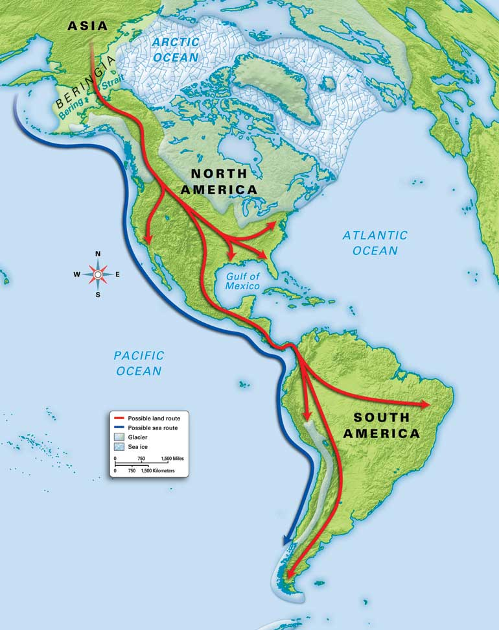

WORKSHEET: 2-1.B

Source 1: Land Bridge Idea

Some scientists argue that the Indigenous people came to the Americas by walking across a land bridge. About 20,000 years ago, the world was in an ice age, where much of the land was covered in ice. They argue this would have lowered the sea and created “bridge” of land for people to walk from Asia to the Americas. They also argue that taking boats would be far more dangerous than walking.

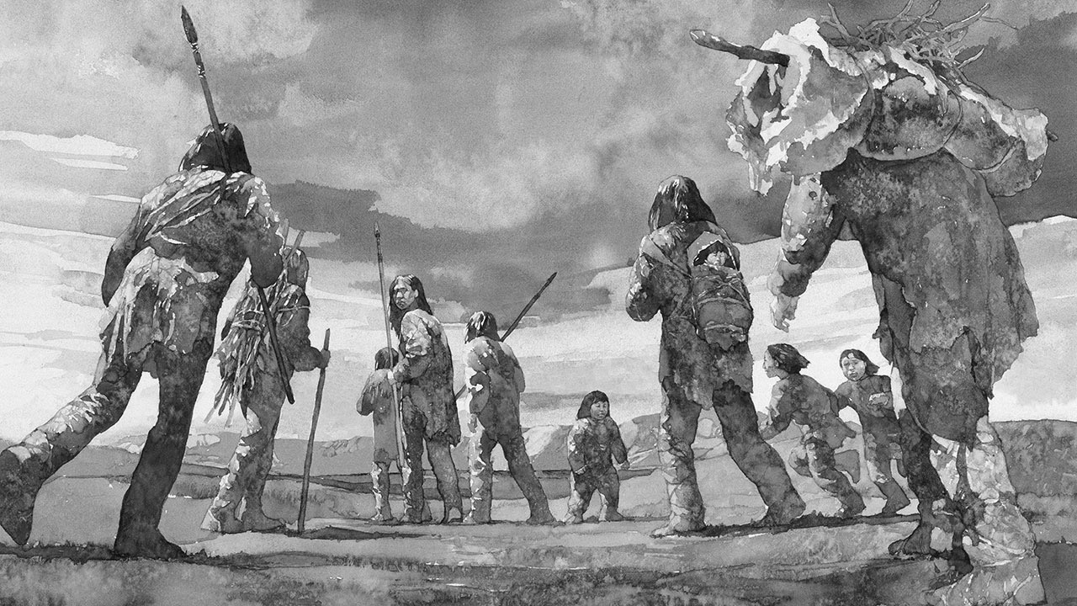

WORKSHEET: 2-1.C

Source 2: Over Water Idea

Some scientists argue that the Indigenous people came to the Americas in boats over the water. They say there is evidence that people were here before 20,000 years ago, when there would not have been a “land bridge.” They argue that the people took small boats along the coast. Boats would have been much faster than walking. It would also be hard to live walking across the very cold ice.

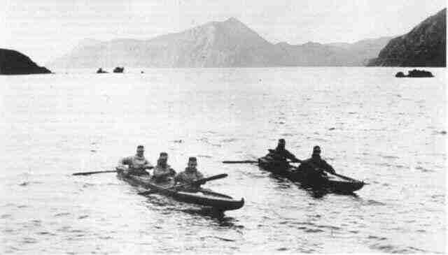

ASSESSMENT: 2-1.D

Two Column Note Sheet

Land Bridge Idea

Over Water Idea

ASSESSMENT: 2-1.E

The Indigenous People: First Migrants? Exit Ticket

Inquiry Question: Which idea of how the Indigenous (Native) people first came to the Americas is the strongest?

Explain why you think either the land bridge idea or the over water idea is strongest. Include two pieces of evidence from the sources.

LESSON PLAN 2-2: The Indigenous People: Communities

MATERIALS

Quick Quiz (WORKSHEET 2-2.A)
Source 1: Iroquois Confederacy and Government (WORKSHEET 2-2.B)
Source 2: Lakota and the Buffalo (WORKSHEET 2-2.C)
Source 3: Mississippian and Buildings (WORKSHEET 2-2.D)
The Indigenous People: Communities: Exit Ticket (ASSESSMENT 2-2.E)

STANDARDS

Massachusetts History and Social Science Framework

MA-HSS.2.7: On a map of the world, locate the continent, regions, or countries from which students, their parents, guardians, grandparents, or other relatives or ancestors came.

MA-HSS.2.10: After reading or listening to a variety of true stories about individuals recognized for their achievements, describe and compare different ways people have achieved great distinction (e.g. scientific, professional, political, religious, commercial, military, athletic, or artistic). (H)

Common Core: Literacy

CCSS.ELA-Literacy.RI.2.9: Compare and contrast the most important points presented by two texts on the same topic.

CCSS.ELA-Literacy.RI.2.10: By the end of year, read and comprehend informational texts, including history/social studies, science, and technical texts, in the grades 2–3 text complexity band proficiently, with scaffolding as needed at the high end of the range.

CCSS.ELA-Literacy.W.2.8: Recall information from experiences or gather information from provided sources to answer a question.

PROCEDURES

Inquiry Question: What quality of Indigenous life do you think we should adopt today in our society?

A. OPENER (8 minutes)

1. Take Quiz on Indigenous Way of Life
Tell students that we will have a quiz. This quiz will not be graded, but it is a chance for you to take guesses about what we will be studying today. Pass out the quiz (WORKSHEET 2-2.A) and give students time to take it.

Reveal that all of the answers to the quiz are true. Tell students that we will learn today about some of the communities that Indigenous (Native) people made their communities and that we can learn a lot from the way they lived their lives.

B. DEVELOPMENT (16 minutes)

2. Read About the Different Indigenous Communities
Put students in small groups and assign them one of the three sources: Iroquois Confederacy and Government (WORKSHEET 2-2.B), Lakota and Buffalo (WORKSHEET 2-2.C), Mississippian and Buildings (WORKSHEET 2-2.D). Have one student from each group read their source. As the student reads, tell the other group members to underline or highlight any important information. Note: If your students have difficulty with jig saw activities, this lesson plan can be spread out over three days having all students focus on only one document per lesson. Assign different students to be a leader for one of the three documents, responsible for explaining that document to their peers on the final day of the lessons when they use the exit ticket.

3. Engage in a Jig Saw About the Different Indigenous Communities
Have students participate in a jig saw activity. Make new groups where at least one student from each of the original groups is included. This will create several new groups of three students, one is an expert on 2-2.B, 2-2.C, 2-2.D. Have each student describe their document to the other members of their group.

Ask students to use the sources to answer the following inquiry question: “What quality of Indigenous life do you think we should adopt today in our society?” In answering this question, students should debate between the three different worksheets. After students have discussed the question, they should complete the exit ticket in the following step. Circulate the room, helping the students who may have difficulty choosing one asset.

C. CLOSING (6 minutes)

4. Write Up Argument Related to the Indigenous Communities
For the evaluation task, have the students complete the exit ticket (ASSESSMENT 2-2.E), where they write their own personal response to the lesson’s Inquiry Question: “What quality of Indigenous life do you think we should adopt today in our society?” Tell students to cite at least two pieces of evidence from the sources for this lesson.

Before using the exit ticket, consider using a graphic organizer or two column notes to prepare students for the writing task. Consider using sentence starters and modeling to help the students with their answer to the inquiry question.

EVALUATION

ASSESSMENT 2-2.E

What to look for?

The student should take a stance on which Indigenous group has an idea that we should use today.

If student argues it was Iroquois, possible answers may include (and cites Source1):
- They had a government that stopped them from fighting.
- They kept peace for many years.
- The U.S. government is based on their government.
- It is still the government they use today.

If student argues it was Lakota, possible answers may include (and cites Source 2):
- They could live solely on the buffalo.
- They respected nature.
- The did not waste anything.
- They were able to move their homes from place to place.

If student argues it was Mississippian, possible answers may include (and cites Source 3):
- They had a city larger than any in Europe.
- They created amazing buildings.
- They made over 120 mounds.

WORKSHEET: 2-2.A

Quick Quiz

Take a guess on each of these questions. Choose either true or false.

1. The United States government copied some things from the Indigenous peoples’ governments.

True or False

2. Indigenous people were able to live completely from nature. They did not need to make anything in factories.

True or False

3. Before Europeans came to the Americas, Indigenous people had a city larger than any city in Europe.

True or False

Quick Quiz
ANSWERS

Take a guess on each of these questions. Choose either true or false.

1. The United States government copied some things from the Indigenous peoples’ governments.

True or False

2. Indigenous people were able to live completely from nature. They did not need to make anything in factories.

True or False

3. Before Europeans came to the Americas, Indigenous people had a city larger than any city in Europe.

True or False

WORKSHEET: 2-2.B

Source 1: Iroquois Confederacy and Government

The Iroquois Confederacy was five different groups (Seneca, Cayuga, Onondaga, Oneida, and Mohawk) who agreed to not fight each other. Together they created a meeting where all the groups could talk through their problems and worked together. This civic group stopped the groups from fighting and the current U.S. government used some of their ideas.

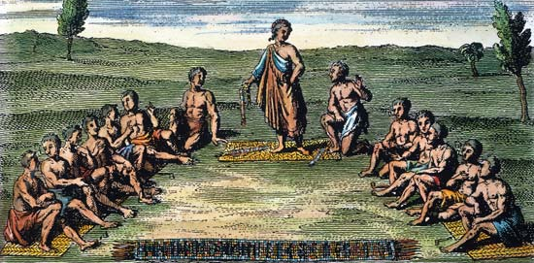

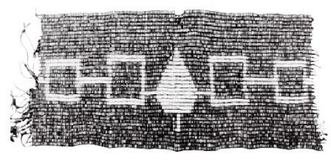
WORKSHEET: 2-2.C

Source 2: Lakota and Buffalo

The buffalo was incredibly important to the Lakota people. Almost everything the Lakota people needed came from the buffalo, including their homes called tipis (tee-pees), their clothes, and their food. Their life was spent following the buffalo and killing them only when they needed to. The Lakota would not waste any part of the buffalo

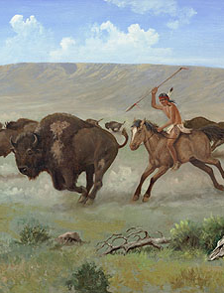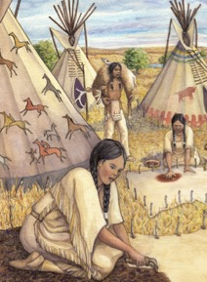

ASSESSMENT: 2-2.D

Source 3: Mississippian and Buildings

Before any European ever came to the Americas, the Mississippian people made one of the largest cities in the world. It was called Cahokia. It was made of over 120 mounds with thousands of buildings. The Mississippian had an amazing ability to make buildings, which allowed over 15,000 people make their home there.

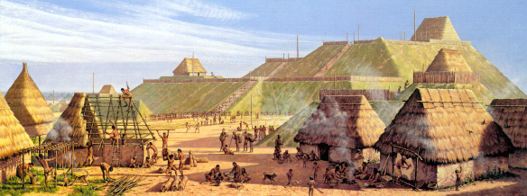

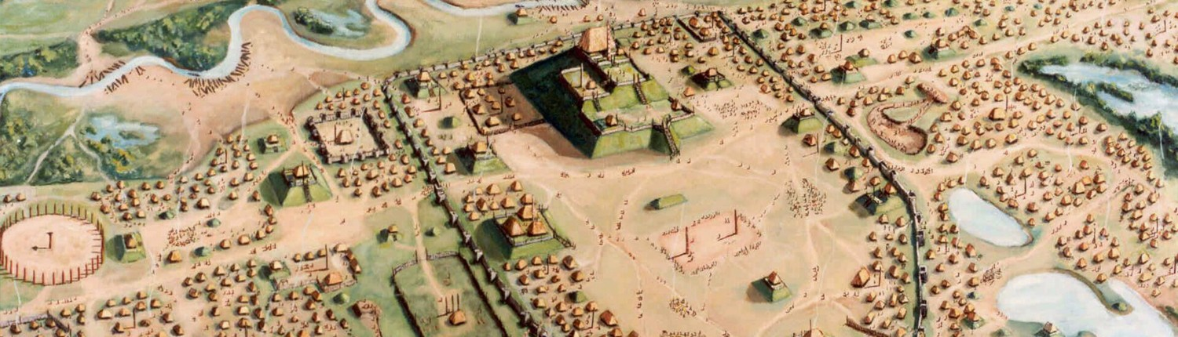

ASSESSMENT: 2-2.E

The Indigenous People: Communities: Exit Ticket

Inquiry Question: What quality of Indigenous life do you think we should adopt today in our society?

Describe which Indigenous group (Iroquois, Lakota, Mississippian) you think we should adopt today in our society. Include two pieces of evidence from the sources.

LESSON PLAN 2-3: Push/Pull: Why Do People Migrate/Immigrate?

MATERIALS

Immigration Cards (MATERIALS 2-3.A)
Push-Pull Factors (WORKSHEET 2-3.B)
Source1: Dagoberto Olvera’s Immigration Story (WORKSHEET 2-3.C)
Push/Pull: Why Do People Migrate/Immigrate?: Exit Ticket (ASSESSMENT 2-3.F)

STANDARDS

Massachusetts History and Social Science Framework

MA-HSS.2.7: On a map of the world, locate the continent, regions, or countries from which students, their parents, guardians, grandparents, or other relatives or ancestors came.

MA-HSS.2.10: After reading or listening to a variety of true stories about individuals recognized for their achievements, describe and compare different ways people have achieved great distinction (e.g. scientific, professional, political, religious, commercial, military, athletic, or artistic). (H)

Common Core: Literacy

CCSS.ELA-Literacy.RI.2.9: Compare and contrast the most important points presented by two texts on the same topic.

CCSS.ELA-Literacy.RI.2.10: By the end of year, read and comprehend informational texts, including history/social studies, science, and technical texts, in the grades 2–3 text complexity band proficiently, with scaffolding as needed at the high end of the range.

CCSS.ELA-Literacy.W.2.8: Recall information from experiences or gather information from provided sources to answer a question.

PROCEDURES

Inquiry Question: If you were an immigrant to the U.S. in the 1890s, what would be the biggest challenge you would face?

A. OPENER (12 minutes)

1. Participate in an Immigration Simulation
Tell students that today we are going to pretend it is 1890. Most students will be immigrants from different countries coming to the United States. Give each student an Immigration Card (WORKSHEET 2-3.A) that describes who there are and where they are coming from. There are 12 immigrant cards. If you have more than 12 students, you should use the same immigrant cards for multiple students. The gender of the card does not need to be the same as the gender of the student. 1 student will be the immigration doctor. 1 student will be an immigration agent.

Tell the students to read their immigration card. They should underline or highlight their name, where they are from, why they are coming from the United States, and if they are healthy.

Have students go out into the hallway and line up against a wall. Have the immigration agent be sitting at a desk/chair near the door. Have the immigration doctor sit at a desk off to the side of the classroom.

Tell students that they have just arrived in the United States after more than two weeks sailing on a ship or, if they are from Mexico or Canada, taking a train. Tell them that when they arrive they will first have to speak with the immigration agent. They should use their cards to answer her or his questions. After the immigration agent asks questions, they will then meet with an immigration doctor.

Have the first student go through the immigration agent and immigration doctor stations. Make sure all of the students are watching and listening. After the student go through, ask the class if they were allowed to enter the U.S., why or why not?

Once a student enters the U.S., they can go to their seat, which you will call their “tenement apartment” (which we will learn about in a future lesson).

Some students will not be allowed to enter because they are sick. They will be asked to sit to the side and wait. At the end of the simulation, explain that those students will need to return to their home country, because immigrants with illnesses were not allowed to enter then. Tell students that at this time, unless you had an illness or committed a crime, anyone could enter the United States.

B. DEVELOPMENT (12 minutes)

2. Complete Push-Pull Factors Worksheet
Give students the Push-Pull Factors (WORKSHEET 2-3.B). Ask students if they can tell you what push means. Tell them that we think about immigrants as having something “push” them out of their home countries. Looking at your cards, what pushed you out of your home country? List those items on the board or chart paper and have students enter them in the worksheet under push.

Then ask students if they can tell you what pull means. Tell them that we think about immigrants as having something “pull” them to the United States, or a reason to come here. Looking at your cards, what pulled you to the United States? List those items on the board or chart paper and have students enter them in the worksheet under push.

3. Read an Immigrant from Today’s Story
Tell the students that there are still push and pull factors today. Now we will read the story of a recent immigrant from Mexico. While we listen, you should underline or highlight the push and pull factors that he has. Using the first worksheet, model looking for facts and taking notes for the students.

Ask the students to read aloud (using choral, partner, or independent reading) Dagoberto Olvera’s Immigration Story (WORKSHEET 2-3.C). At the end of the reading, ask students about what pushed him out of Mexico and what pulled him to the United States. Asked them to tell you what he said made it hard being an immigrant.

C. CLOSING (6 minutes)

4. Make an Argument About the Challenges of Being an Immigrant
For the evaluation task, have the students complete the exit ticket (ASSESSMENT 2-3.D), where they write their own personal response to the lesson’s Inquiry Question: “If you were an immigrant to the U.S. in the 1890s, what would be the biggest challenge you would face?” Tell students to cite at least two pieces of evidence from the sources for this lesson.

Before using the exit ticket, consider using a graphic organizer or two column notes to prepare students for the writing task. Consider using sentence starters and modeling to help the students with their answer to the inquiry question.

EVALUATION

ASSESSMENT 2-3.D

What to look for?

The students should take a stance on the largest challenge immigrants faced. All arguments should cite at least 2 pieces of evidence from the sources.

Some challenges that immigrants face that students may choose include:
- It is difficult being far away from family.
- The journey may be difficult or take a long time.
- You might get sick from the journey.
- You might not be accepted or welcomed in the United States.
- You might not know English language.

MATERIALS: 2-3.A

Immigration Cards

Caitlin O’Sullivan: You are Catholic and from Ireland. You have eight children. Your husband died of illness a few years ago. You have no job skills. You are healthy. There was a famine in Ireland and your family was going hungry. You came here for a job.

Elisha Robinowitz: You are Jewish and from Poland. You have no children. You want to find a husband in the United States. and has no particular job skills. You have no job skills. You are healthy. You are treated poorly back home because of your religion and came here because there is freedom of religion.

Belinda Esposito: You are Catholic and from Italy. You have a husband and two children. You can mend clothes as a seamstress. You have a high fever. You were having a hard time finding working in your home country. You came here for a job.

Tan Ji: You are Buddhist and from China. You have a wife and two children. You are a farmer. You are healthy. There was a problem with the crops (plants) on your farm and you were no longer able to grow them there. You came here for a job.

Jakob Tenerowicz: You are Catholic and from Poland. You have five children. Your wife died of illness a few years ago. You were a farmer. You are healthy. There was a famine in your country and your family was going hungry. You came here for a job.

Eusebé Martell: You are Catholic and from French Canada (Québec). You have no children. You are a trained carpenter. You are healthy. You have been out of work for several months and cannot afford food. You came here for a job.

José Gonzalez: You are a Mexican immigrant. You have no children. You were a farmer. You are healthy. There was a problem with the crops (plants) on your farm and you were no longer able to grow them there. You came here for a job.

Vasya Mikolovich: You are Eastern Orthodox and from Russia. You have no children. You have no job skills. You have a high fever. You were having a hard time finding working in your home country. You came here for a job.

Asim Abboud: You are and from Egypt. You have no children. You were a farmer. You are healthy. There was a war in your country and you were told that you need to fight, so you left your home country. There is no war here.

Ryuzo Hashimoto: You are Buddhist and from Japan. You have a wife and four children. You were a farmer. There was a problem with the crops (plants) on your farm and you were no longer able to grow them there. You came here for a job.

Elizabeth Smith: You are Protestant and from England. You have no children. You worked in a factory. You are healthy. You lost your job when the factory closed. You came here for a job.

Dalip Singh Samra: You are Sikh and from India. You have a wife and four children. You were a farmer. You are healthy. You are treated poorly back home because of your religion and came here because there is freedom of religion.

Immigration Agent: Your job is to ask questions to immigrants and decide if they can enter the U.S. Ask the following questions:

1. What is your name? What country are you from? Why are you entering the United States?

If they answer these questions truthfully, let them into the U.S.

2. Have you ever committed a crime?

If they answer no to this question, then let them into the U.S.

Immigration Doctor:

1. You should ask each person if they are sick.

If they say they are sick, tell them they must wait to enter the U.S. At the end of this, they will be sent back home (because they are still sick).

If they say they are healthy, let them into the U.S.

ASSESSMENT: 2-3.B

Push-Pull Factors

PUSH

PULL

WORKSHEET: 2-3.B

Source 1: Dagoberto Olvera’s Immigration Story

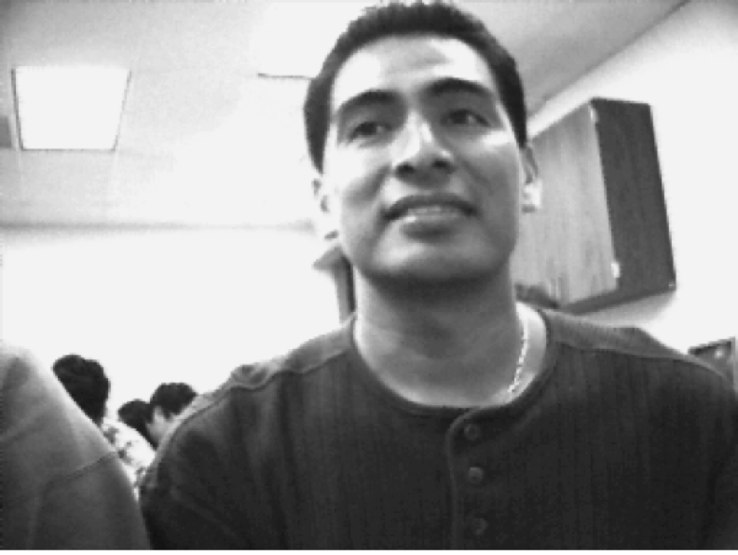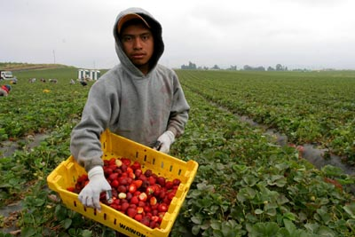

I am Dagoberto Olvera. I was born in Mexico City, one of the biggest cities on the world. I did not finish high school and it was hard to find a job. I heard that they needed farm workers in the United States and I applied to work for a company. They helped me come to California. I only spoke Spanish, so it was very difficult. I worked long hours on that farm in the hot sun.

I started to slowly learn English. It was hard. I saved enough money to attend college. I then went to school for computers. I learned all about how to make the computers work and today I work for Apple Computers. I love my job and living in California, but I miss my family. It is hard being an immigrant, because you cannot sometimes see your family, because they are so far away.

ASSESSMENT: 2-3.E

Push/Pull: Why Do People Migrate/Immigrate?: Exit Ticket

Inquiry Question: If you were an immigrant to the U.S. in the 1890s, what would be the biggest challenge you would face?

Thinking about all of the immigrant stories we heard today, describe what you think is hardest for immigrants who come to the United States. Include two pieces of evidence from the sources.

LESSON PLAN 2-4: Forced Migration: Slavery and Confronting a Difficult Past

MATERIALS

“Henry’s Freedom Box” by Ellen Levine and Kadir Nelson (not supplied)
Letter Home to Parents (LETTER 2-4.A)
Source 1: Life in Africa (WORKSHEET 2-4.B)
Source 2: The Slave Trade (WORKSHEET 2-4.C)
Source 3: Plantations (WORKSHEET 2-4.D)
Source 4: Abolition (WORKSHEET 2-4.E)
Forced Migration: Confronting a Difficult Past: Exit Ticket (ASSESSMENT 2-1.F)

STANDARDS

Massachusetts History and Social Science Framework

MA-HSS.2.10: After reading or listening to a variety of true stories about individuals recognized for their achievements, describe and compare different ways people have achieved great distinction (e.g. scientific, professional, political, religious, commercial, military, athletic, or artistic). (H)

MA-HSS.2.7: On a map of the world, locate the continent, regions, or countries from which students, their parents, guardians, grandparents, or other relatives or ancestors came.

Common Core: Literacy

CCSS.ELA-Literacy.RI.2.9: Compare and contrast the most important points presented by two texts on the same topic.

CCSS.ELA-Literacy.RI.2.10: By the end of year, read and comprehend informational texts, including history/social studies, science, and technical texts, in the grades 2–3 text complexity band proficiently, with scaffolding as needed at the high end of the range.

CCSS.ELA-Literacy.W.2.8: Recall information from experiences or gather information from provided sources to answer a question.

PROCEDURES

Inquiry Question: How did African Americans stand up to slavery?

PREPARATION

1. Note About This Topic and Parent Letter to Send Home
It is important that young children learn about difficult histories from the caring and supportive adults in their lives, including parents/guardians and teachers. For an explanation of how slavery will be addressed in this lesson, we ask that you read the attached letter (LETTER 2-4.A) and we encourage you to send it home to parents a week before you teach this lesson.

In addition to this lesson, we suggest that you include other lessons on the experience of enslaved people to help students understand the wider historical contents. Pictures books may be one of the best devices for introducing young children to difficult topics such as slavery. Here is a list of other recommended elementary-level texts on slavery: http://www.chicagotribune.com/lifestyles/books/ct-prj-slavery-in-childrens-books-20160227-story.html

A. OPENER (8 minutes)

2. Read “Henry’s Freedom Box” by Ellen Levine and Kadir Nelson
Before reading the text, tell students that today we are going to read a story about a boy who was a slave. Ask students if they know what it means to be a slave or live in slavery. Anticipated responses may include: you are owned by someone, you have to work for free, you can’t leave, people are mean to you.

Read “Henry’s Freedom Box.” This is a picture book that tells the true story of a man who escaped slavery by hiding in a box. As you read the text, be sure to ask questions to the students about Henry’s experiences. There is one page where Henry burns his hand to allow his escape plan to happen. If you think that would be difficult for your students, you may consider skipping that page. Be sure to emphasize how he was able to stop something that was being done to him that was wrong. Tell students at the end of the book that slavery has been against the law for many years (over 150). Ask them if they have any questions about slavery and do your best to answer them. If a student asks a question that you do not know the answer to, write it on the board or chart paper in a “parking lot” and promise to get the answer to them later (and follow up on this).

Remind the students that over the past couple weeks we have learned about the Indigenous (Native) people, who migrated to the Americas thousands of years ago. Then we learned about immigrants from places like Europe, Asia, Mexico, and Canada. Today, we are going to learn about another group of people. They did not come here on their own, but instead people forced them to come here as enslaved people, just like Henry. In fact, Henry’s ancestors probably came from West Africa. Tell students that today, we are going to learn about their story of coming here and discuss why it was wrong and what people did to try and stop it.

B. DEVELOPMENT (16 minutes)

3. Examine Sources As a Whole Class
Ask the students to read aloud (using choral, partner, or independent reading) the three documents on life in Africa, the Slave Trade, and Abolition (WORKSHEET 2-4.B). After reading each document, solicit from students what important facts should be underlined and highlighted about each source. Make sure they highlight examples of how the slave trade was problematic (i.e. being taken from their homes, having to cross the ocean on a boat, being owned by someone, not being able to leave, having to work for no pay), but also acts of resistance to it (i.e. running away, abolitionist newspapers and speeches, trying to convince others to help end slavery). Using the first worksheet, model looking for facts and taking notes for the students.

4. Discuss the Struggles that Enslaved People Faced Through Forced Migration and Their Day-to-Day Lives
Tell students that after listening to Henry’s Freedom Box and reading these sources, we will talk about ways that life was difficult for enslaved people, but also ways that African Americans did things to stop slavery because it was wrong. On the board or chart paper, take notes on what the students say. Anticipated responses may include: problems enslaved people faced: being taken from their homes, having to cross the ocean on a boat, being owned by someone, not being able to leave, having to work for no pay) and ways they stood up against slavery: running away, abolitionist newspapers and speeches, trying to convince others to help end slavery.

C. CLOSING (6 minutes)

5. Answer the Inquiry Question
For the evaluation task, have the students complete the exit ticket (ASSESSMENT 2-4.E), where they write their own personal response to the lesson’s Inquiry Question: “How did African Americans stand up to slavery?” Tell students to cite at least two pieces of evidence from the book (Henry’s Freedom Box) and the worksheets for this lesson.

Before using the exit ticket, consider using a graphic organizer or two column notes to prepare students for the writing task. Consider using sentence starters and modeling to help the students with their answer to the inquiry question.

EVALUATION

ASSESSMENT 2-4.E

What to look for?

The students should take a stance on how did African Americans stand up to slavery. All arguments should cite at least 2 pieces of evidence from the sources.

Some ways that African Americans stood up to slavery:
- Running away/underground railroad
- Starting abolitionist newspapers
- Protesting and giving speeches
- Trying to convince others to help end slavery
LETTER: 2-4.A

Dear parents and guardians,

We are sending this letter home to let you know that next week the students will be learning about slavery during our social studies time. It is essential that students learn about difficult historical topics like these from the caring and supportive adults in their lives, including their teachers and parents/guardians.

In covering this topic, we will be guided by three important principles. First, we will approach this topic with respect for those who lived in slavery. You may have heard stories on the news of teachers around the country using lessons that have students participate in mock slave auctions or pretend to be slaves and masters. Those lessons are not only troubling, but harmful. Nothing like that will occur in our classrooms.

Second, we will carefully monitor students’ emotions during our lesson on slavery. Our lesson will not include graphic depictions of slavery’s violence. Despite this, we realize the topic could still be upsetting to some children. Our classroom will be a safe place to grapple with this difficult topic.

Third, we are aware of the developmental level of the students and will only approach the topic in a way that is appropriate for 2nd graders. One helpful way to approach difficult topics in the classroom is through the use of picture books. In our classroom, we will be using the picture book “Henry’s Freedom Box” by Ellen Levine and Kadir Nelson. You are also welcome to read this book at home and use it as a way to discuss slavery with your child before we learn about it in our class.

As a parent or guardian, you may have additional questions about the lesson and are welcome to contact me through e-mail, the phone, or in person. I would also be happy to send you the lesson plan in advance, if you would like to see how we will teach about slavery.

Sincerely,
TEACHER NAME
E-MAIL ADDRESS
PHONE NUMBER

WORKSHEET: 2-4.B

Source 1: Life in Africa

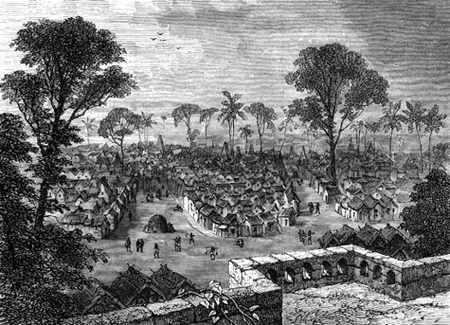

West Africa had many wealthy empires from their mining of gold, salt, and metals. Some West African people lived in large cities, such as Asante (above), while others lived in small villages (below). Many West African people were farmers or miners. There were also many different groups of West African people, who spoke different languages and had different religions. These West African groups also had their own music, art, and stories. Much of our American music, art, and stories traces its roots to West Africa.

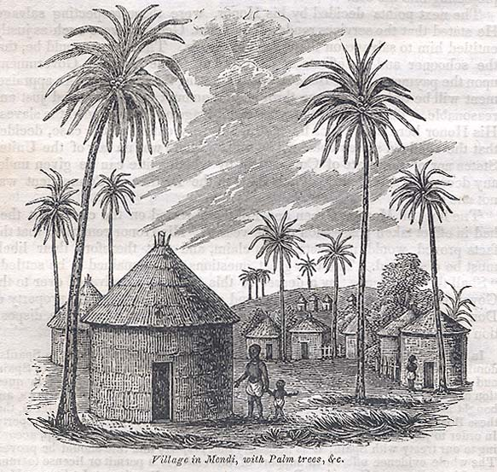
WORKSHEET: 2-4.C

Source 2: The Slave Trade

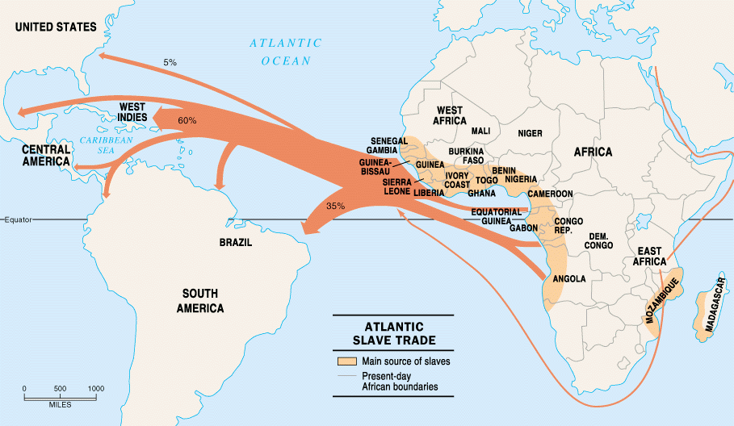

Slavery is the owning of a person and making them work for you without pay. In the 1600s, Europeans started taking Africans on ships to be sold as enslaved people in the Americas. Unlike immigrants, they were forced migrants and did not chose to come here. Most enslaved people were sent to the Caribbean and Brazil, but about 400,000 enslaved people were sent to the U.S.

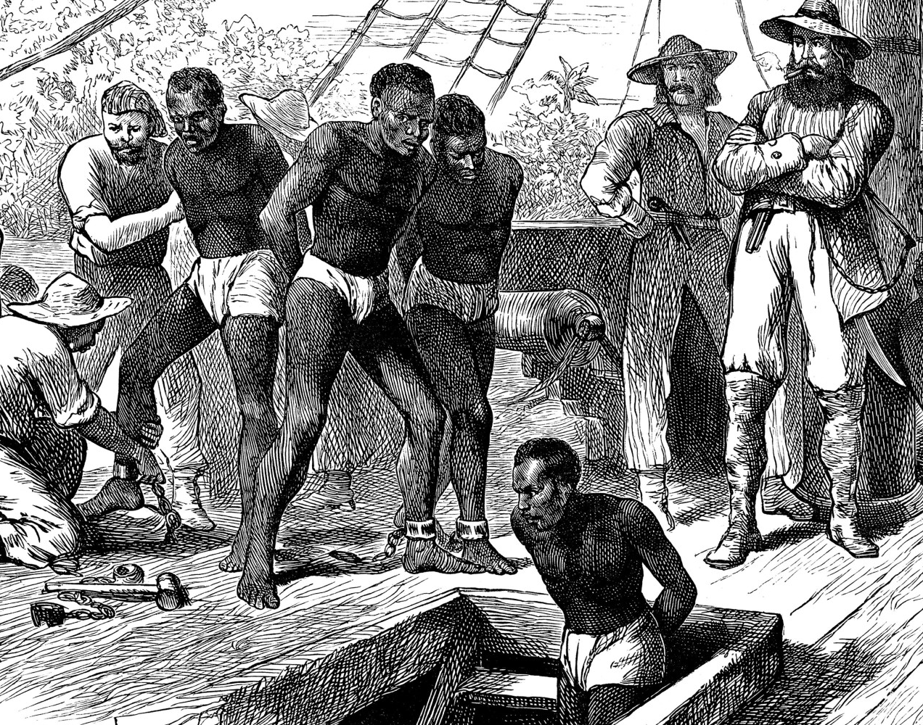

WORKSHEET: 2-4.D

Source 3: Plantations

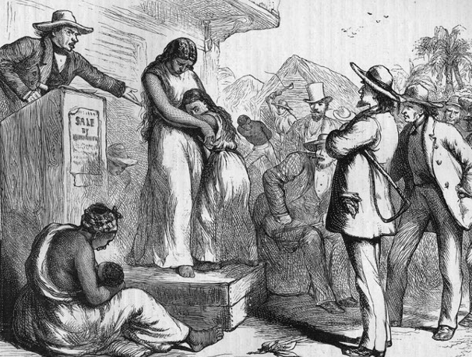

In the United States, Africans were sold to European American slave owners, often called masters, who then made the Africans work on their plantations (large farms) for no pay. This happened in both the North and South. The Africans were often treated badly. Sometimes people (like Henry in the book) were sold and had to move away from their families. Enslaved people could not leave, so many tried to ran away. Slave masters hired slave catchers to find runaway slaves.

WORKSHEET: 2-4.E

Source 3: Abolition

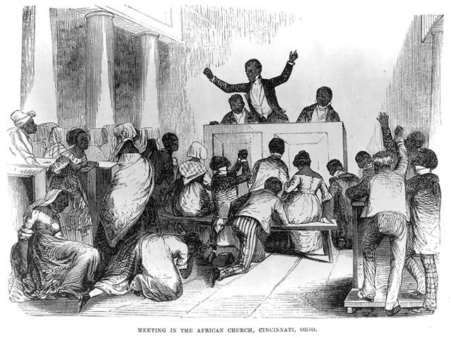

Many African Americans tried to stop slavery, especially free Black people in the North. Someone who wanted to end slavery is called an abolitionist. They would help enslaved people run away from their plantations (like Henry). They gave speeches and made newspapers. In some places, they were able to pass laws against slavery. After the Civil War, slavery was banned in the United States. While many African Americans have ancestors who were enslaved, others have ancestors were born free or came to the U.S. after slavery.

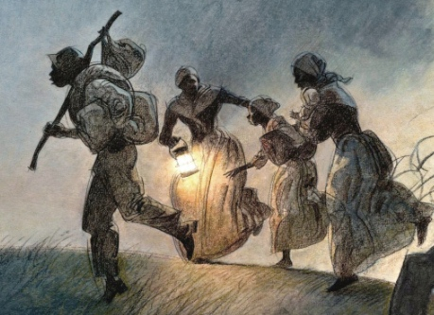

ASSESSMENT: 2-4.F

Forced Migration: Slavery and Confronting a Difficult Past: Exit Ticket

Inquiry Question: How did African Americans stand up to slavery?

Thinking about all of information we learned about slavery, including the book “Henry’s Freedom Box,” and explain what you think is the most important way that African Americans stood up to slavery. Include two pieces of evidence from the sources or the book.

LESSON PLAN 2-5: Lesson Title: Mapping Where Our Families Immigrated/Migrated From

MATERIALS

Immigrant Guest Letter (LETTER 2-5.A)
Classroom world map (recommended size is as large as possible) (not supplied)
Round stickers (not supplied)
Pre-Lesson Activity: Where Did My Family Come From? (WORKSHEET 2-5.B)
World Map (Worksheet 2-5.C)
Mapping Where Our Families Immigrated/Migrated From: Exit Ticket (ASSESSMENT 2-5.D)
Interview Questions (ASSESSMENT 2-5.E) (for optional lesson)
Guest Speakers: Exit Ticket (ASSESSMENT 2-5.F) (for optional lesson)

STANDARDS

Massachusetts History and Social Science Framework

MA-HSS.2.7: On a map of the world, locate the continent, regions, or countries from which students, their parents, guardians, grandparents, or other relatives or ancestors came.

Common Core: Literacy

CCSS.ELA-Literacy.RI.2.9: Compare and contrast the most important points presented by two texts on the same topic.

CCSS.ELA-Literacy.RI.2.10: By the end of year, read and comprehend informational texts, including history/social studies, science, and technical texts, in the grades 2–3 text complexity band proficiently, with scaffolding as needed at the high end of the range.

CCSS.ELA-Literacy.W.2.8: Recall information from experiences or gather information from provided sources to answer a question.

PROCEDURES

Inquiry Question: What is the most important similarity between how our family members came to the United States?

PREPARATION

1. Arrange Guest Speaker/Speakers
This lesson has an optional day 2 that includes guest speakers who are relatives of your students (or community members) who have immigrated to the United States. You should arrange these guests in advance. There is a solicitation letter included (LETTER 2-5.A)

2. Complete Worksheet with Family Members
Before this class, students should work with their parents or guardians to complete the Pre-Lesson Activity: Where Did My Family Come From? (WORKSHEET 2-5.B) in preparation for the activities in Lesson 2-5. Be mindful that some students may know very little about their immigrant or migrant histories due to family circumstances. It will be all right if students can only fill out a little or none of the worksheet in advance.

DAY 1

A. OPENER (8 minutes)

3. Introduce the Topic
Tell the students that today we will be mapping where our families and relatives come from. Tell students to take out the worksheet they completed with their parents or guardians about this. Give students a copy of the World Map (Worksheet 2-5.C). Have the students highlight or circle any countries on the World Map that are listed on the Pre-Lesson Activity: Where Did My Family Come From? (WORKSHEET 2-5.B). Circulate the room and help students locate on the map any countries on their sheet. If a student has domestic locations (for migrants), help them find the approximate location on the map for this (as no words will not be listed for those locations).

Once students have located these locations on their World Maps, have them come to the large classroom world map (which is positioned in a place that can be reached by students). Have the students take the stickers and place them on the locations of their immigrant/migrant family members. After all of the students have placed their stickers, have them return to their seats.

B. DEVELOPMENT (16 minutes)

2. Debrief from the Map Activity
Ask students to look at their maps. Ask a series of questions and take notes for the students on the board or chart paper: Can they see any areas that many of our family members immigrated from? Make a distinction between country (a nation with its own government, i.e. United States, Nigeria) and continent (a large mass of land, i.e. South America, Asia). Does it seem like our family members came from similar distances or were some from nearer and farer? Explain that climates tend to be warmer near the equator (show them where the equator is) and cooler near the poles of the Earth. Looking at our stickers, do our family members mostly come from cooler or warmer places, or a mix of both? Do you think it would be difficult to move from a warmer climate to Boston? Why or why not? Ask students if any of their immigrant relatives speak a language other than English? What languages do they speak? Do you think it would be difficult to move to a country where you do not speak the language?

C. CLOSING (6 minutes)

3. Make an Argument About the Challenges of Being an Immigrant
For the evaluation task, have the students complete the exit ticket (ASSESSMENT 2-5.D), where they write their own personal response to the lesson’s Inquiry Question: “What is the most important similarity between how our family members came to the United States?” Tell students to cite at least two pieces of evidence from the notes on the board or chart paper for this lesson.

Before using the exit ticket, consider using a graphic organizer or two column notes to prepare students for the writing task. Consider using sentence starters and modeling to help the students with their answer to the inquiry question.

DAY 2 (OPTIONAL)

A. OPENER (8 minutes)

1. Prepare Questions

Tell students that today we have special guests visiting our class who are immigrants or migrants from different places. Pass out the Interview Questions (ASSESSMENT 2-5.E). Tell students that I have created four questions that we might ask our guests. Read the questions to them. Tell students that they should write down a few more questions that they might like to ask. If they are having a hard time thinking of questions, remind them to think about the previous lesson where we mapped where our family members came from or we learned about immigrants coming from different countries.

B. DEVELOPMENT (16 minutes)

2. Guest Speaker(s)
Introduce each guest speaker by saying their name and where they came from. If there is more than one guest speaker, you can have them speak separately or on a panel. Allow each guest speaker some time to tell their immigration/migration story. Have students ask their questions. Make sure that the four included questions are asked (if the students do not ask them) by the end of the guest speakers time with the class.

C. CLOSING (6 minutes)

3. Reflect on the Guest Speaker(s) Story
For the evaluation task, have the students complete the exit ticket (ASSESSMENT 2-5.F), where they write what they learned from the guest speakers.

EVALUATION

ASSESSMENT 2-5.D

What to look for?

The students should take a stance on the most important similarity between how our families came to the U.S. All arguments should cite at least 2 pieces of evidence from the sources.

Some ways that family members may have similar immigrant/migrant experiences:
- Immigrant/migrants came from similar countries or continents.
- Immigrant/migrants traveled long distances.
- Immigrant/migrants came from different climates or weather.
- Immigrant/migrants had to learn a new language.
- Immigrant/migrants had to learn about their new place.

ASSESSMENT 2-5.F

What to look for?

Answers will vary based on guest speakers and students’ choice.

LETTER: 2-5.A

Dear parents and guardians,

In our social studies time, we are studying immigration/migration. As part of a lesson, we are looking for family members who are immigrants or migrants to come tell their immigration/migration stories to our class.

If you or a relative would be interested in visiting our class and telling your immigrant/migrant story, please return this sheet with your name and contact information.

Name:
E-mail:
Phone Number:
Place Where I Am Originally From:

Thank you in advance for volunteering.

Sincerely,
TEACHER NAME
E-MAIL ADDRESS
PHONE NUMBER

WORKSHEET: 2-5.B

Pre-Lesson Activity: Where Did My Family Come From?

Dear Students and Families,

We will be learning about the immigration/migration histories of our own families in social studies. To help us know more about your family we ask that parents/guardians and students complete this sheet together. We realize that you may not know certain information about your family members. It is all right to leave anything blank. As you fill this out, we also hope this is an opportunity for parents/guardians to tell family stories to their students about immigration and migration.

Below, please list any family members/relatives who lived in other countries and moved to the U.S. (immigrants) or lived in another part of the U.S. and moved to Boston (migrants). These family members can be alive today or ancestors from past generations. If your child is an immigrant or migrant, please include them in the list. If you do not have any relatives, you may also list family friends or community members whom you know. Use the back of the sheet to list additional family members or relatives.

Name:
Relation to Student:
Place They Moved From:
Place They Moved To:

Name:
Relation to Student:
Place They Moved From:
Place They Moved To:

Name:
Relation to Student:
Place They Moved From:
Place They Moved To:
WORKSHEET: 2-5.C

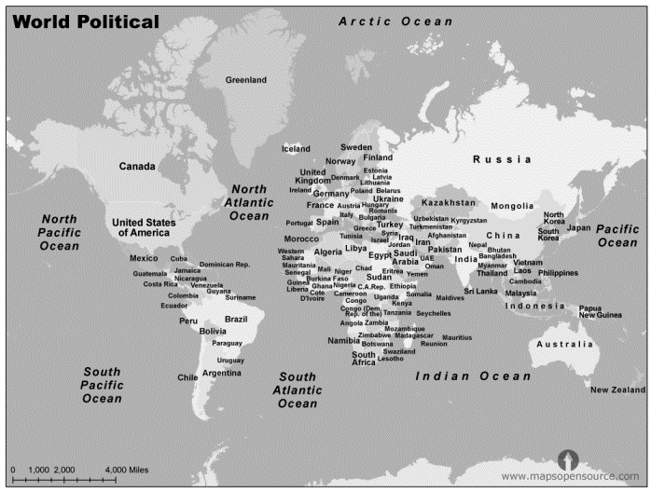
ASSESSMENT: 2-5.D

Mapping Where Our Families Immigrated/Migrated From:
Exit Ticket

Inquiry Question: What is the most important similarity between how our family members came to the United States?

Thinking about the ways that our family members came to the United States (or moved from one part of it to another), explain what you think is the most important similarity between how our family members came here. Include two pieces of evidence from then notes we took.

WORKSHEET: 2-5.E

Interview Questions

Below are some interview questions to start with. You should add more questions for our guest speakers.

1. When and where did you immigrate or migrate from?

2. How did you travel to the United States? What was that journey like?

3. What do you miss about your old home?

4. What do you like about living in the United States?

5.

6.

7.

8.

9.

10.

ASSESSMENT: 2-5.F

Guest Speakers: Exit Ticket

Thinking about our guest speakers, list the most important things you learned about immigrants who live in our community.

LESSON PLAN 2-6: The Early European Immigrants: English, German, and Irish

MATERIALS

Pop Quiz: English, German, or Irish? (WORKSHEET 2-1.A)
Source 1: English Immigrants (WORKSHEET 2-6.B)
Source 2: German Immigrants (WORKSHEET 2-6.C)
Source 3: Irish Immigrants (WORKSHEET 2-6.D)
English, German, and Irish Immigrants: Exit Ticket (ASSESSMENT 2-6.E)

STANDARDS

Massachusetts History and Social Science Framework

MA-HSS.2.7: On a map of the world, locate the continent, regions, or countries from which students, their parents, guardians, grandparents, or other relatives or ancestors came.

Common Core: Literacy

CCSS.ELA-Literacy.RI.2.9: Compare and contrast the most important points presented by two texts on the same topic.

CCSS.ELA-Literacy.RI.2.10: By the end of year, read and comprehend informational texts, including history/social studies, science, and technical texts, in the grades 2–3 text complexity band proficiently, with scaffolding as needed at the high end of the range.

CCSS.ELA-Literacy.W.2.8: Recall information from experiences or gather information from provided sources to answer a question.

PROCEDURES

Inquiry Question: What is the most important impact that English, German, and Irish immigrants made to the United States?

A. OPENER (8 minutes)

1. Engage Students in the “Pop Quiz”
Tell students that today we will be learning about three groups of early immigrants to the United States: English, German, and Irish immigrants. These were the first Europeans that interacted with the Indigenous (Native) people and today are the largest group of people living in the United States. Today, German Americans are the largest group in the United States, followed by Irish Americans. English Americans are the fourth largest group behind African Americans. Because of their size as a group, many of the things that we think of as American are actually originally from the English, Germans, and Irish.

To show you this, we are going to take a little quiz. Give students Pop Quiz: English, German, or Irish? (WORKSHEET 2-6.A). Tell students to use the worksheets to take guesses as to what is English, German, and Irish. After all students are finished guessing, reveal the answers and read their short descriptions on the answer page.

B. DEVELOPMENT (16 minutes)

4. Compare the Different Immigrant Groups
Put students into small groups. Assign each group one of three worksheets on English Immigrants (WORKSHEET 2-6.B), German Immigrants (WORKSHEET 2-6.C), and Irish Immigrants (WORKSHEET 2-6.D). Have each group read its worksheet. They should underline or highlight important information. Tell the students that they should then discuss the document and write down a list of facts. Note: If your students have difficulty with jig saw activities, this lesson plan can be spread out over three days having all students focus on only one document per lesson. Assign different students to be a leader for one of the three documents, responsible for explaining that document to their peers on the final day of the lessons when they use the exit ticket.

5. Engage in a Jig Saw About the Different Immigrant Groups
Have students participate in a jig saw activity. Make new groups where at least one student from each of the original groups is included. This will create several new groups of three students, one is an expert on 2-6.B, 2-6.C, and 2-6.D. Have each student describe their document to the other members of their group.

Ask students to use the sources to answer the following inquiry question: “What is the most important impact that English, German, and Irish immigrants made to the United States?” In answering this question, students should look across the three different worksheets, looking for common contributions (i.e. language, government, food, music and art). After students have discussed the question, they should complete the exit ticket in the following step. Circulate the room, helping the students who may have difficulty choosing one asset.

C. CLOSING (6 minutes)

6. Write Up Argument About the Impact of the English, German, and Irish
For the evaluation task, have the students complete the exit ticket (ASSESSMENT 2-6.E), where they write their own personal response to the lesson’s Inquiry Question: “What is the most important impact that English, German, and Irish immigrants made to the United States?” Write on the board or chart paper: language, government, food, music and art. Tell students the can choose from this list or something else they read in the sources. Tell students to cite at least two pieces of evidence from the sources for this lesson.

Before using the exit ticket, consider using a graphic organizer or two column notes to prepare students for the writing task. Consider using sentence starters and modeling to help the students with their answer to the inquiry question.

EVALUATION

ASSESSMENT 2-6.D

What to look for?

The students should take a stance on the most important impact the English, German, and Irish had on the United States. All arguments should cite at least 2 pieces of evidence from the sources.

Some ways that the English, Germans, and Irish influenced the United States:
- Language: The United States speaks English, which is from England and spoken in Ireland (and a similar language to German).
- Government: The Parliament of England was one of the inspiration for the U.S. Congress.
- Food: All three cultures have contributed foods to American culture.
- Music and art: All three cultures have brought with them their music and art.

WORKSHEET: 2-6.A

Pop Quiz: English, German, or Irish?

Many things in American culture come from English, German, and Irish immigrants. Take a look at these items. If you think it came from England put an “E” above to it, Germany put a “G” above it, Ireland put an “I” above it.

1. Hot Dog: _____________

2. Hot Chocolate: ________

3. Soccer (Football): ______

4. Leprechaun: ___________
5. Holiday Tree: _________

6. Apple Pie: ____________

7. Kindergarten: _________

8. Hamburger: ___________

Answers

1. Hot Dog: Germany
Originally called the Frankfurter. It was a type of sausage first created in Frankfurt, Germany.

2. Hot Chocolate: Ireland
While the Mayans and Aztecs in Mexico gave us chocolate, it was someone from Ireland who created the first modern hot chocolate by heating chocolate with milk.

3. Soccer (Football): England
Kicking a ball for sport probably started in China, but the first country to have organized rules for soccer (or called football in most countries) was England.

4. Leprechaun: Ireland
The leprechaun comes from an Irish folk tale. The original story involved an Irish king being granted three wishes from this little imaginary man.

5. Holiday Tree: Germany
Germans were the first people to bring trees into their house and decorate them during Christmas.

6. Apple Pie: England
While many cultures have versions of the pie, it was the English who first decided to put apples in them.

7. Kindergarten: Germany
Germans invented the idea of preschool for young children, which they called Kindergarten or “children’s garden.”

8. Hamburger: Germany
The beef meat patty was invented in Hamburg, Germany. Although the idea of putting it on bread may actually be from the United States.

WORKSHEET: 2-6.B

Source 1: English Immigrants

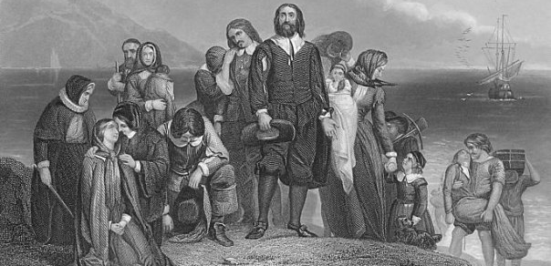

The first Europeans to immigrate to what is now the United States were the English. This is why the most common language in the United States is English. The Colonial Assemblies and later the U.S. Congress were created by mostly English Americans and based on their English Parliament. They also brought with them their food and many American recipes are actually from England, including some stews, pies, meats, breads, and cheeses.

WORKSHEET: 2-6.C

Source 2: German Immigrants

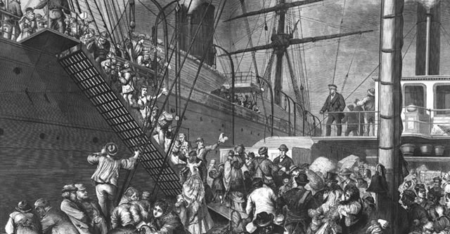

The second major wave of European immigrants to the United States was the Germans. While they spoke German, it is a language that is similar to English, so many learned English. Many Germans came to the United States to seek religious freedom or leave wars. Many Germans were Protestants and brought their Christian holiday traditions (such as Christmas trees and Easter eggs) that many Americans celebrate today. They also brought many foods here, such as hamburgers and frankfurters. Germans also brought with them their music. It often used clarinets, fiddles, accordions, and drums.

WORKSHEET: 2-6.B

Source 3: Irish Immigrants

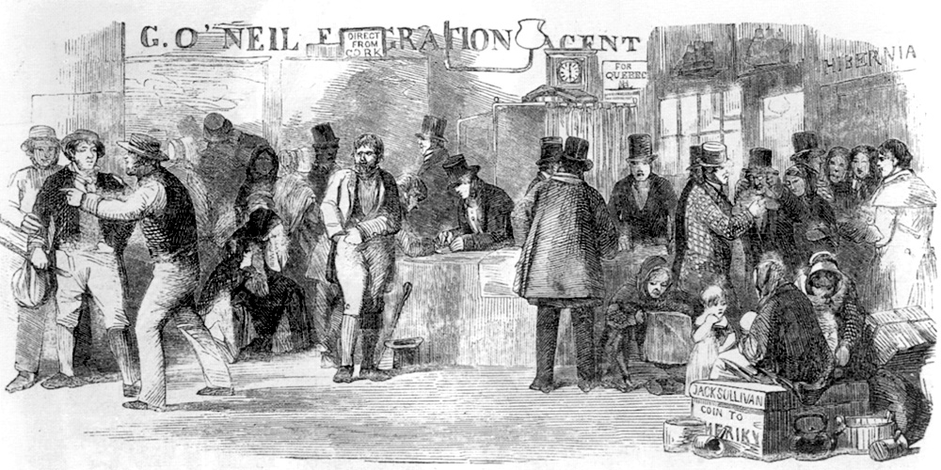

The third major wave of European immigrants to the United States was the Irish. While they spoke the Irish language (also sometimes called Gaelic), since their country was ruled by the English, many Irish people also spoke English. Many Irish people came to the United States because of something called the Potato Famine. A disease (called a blight) killed most of the potatoes in Ireland. Potatoes were the main part of their meals, because they needed to sell wheat and other crops to the English. While corn beef and cabbage is rarely eaten in Ireland, Irish Americans made it a popular dish in the U.S. Irish music often uses fiddles, flutes, harps, and bagpipes. American folk music borrowed a lot from it.

ASSESSMENT: 2-5.F

English, German, and Irish Immigrants: Exit Ticket

Inquiry Question: What is the most important impact that English, German, and Irish immigrants made to the United States?

Describe what you think is the most important thing that the English, Germans, and Irish brought with them to the United States. Some ideas to consider: language, government, food, music. Include two pieces of evidence from the sources.

LESSON PLAN 2-7: The Early Asian Immigrants: Chinese

MATERIALS

Clipboard (not supplied)
“Landed” by Milly Lee (not supplied)
Source 1: The Gold Rush (WORKSHEET 2-7.A)
Source 2: The Railroad (WORKSHEET 2-7.B)
Source 3: Feeding the United States (WORKSHEET 2-7.C)
Source 4: Making Chinatowns (WORKSHEET 2-7.D)
Chinese Immigrants Thinking Questions (WORKSHEET 2-7.E)
The Early Asian Immigrants: Chinese: Exit Ticket (ASSESSMENT 2-7.F)

STANDARDS

Massachusetts History and Social Science Framework

MA-HSS.2.7: On a map of the world, locate the continent, regions, or countries from which students, their parents, guardians, grandparents, or other relatives or ancestors came.

Common Core: Literacy

CCSS.ELA-Literacy.RI.2.9: Compare and contrast the most important points presented by two texts on the same topic.

CCSS.ELA-Literacy.RI.2.10: By the end of year, read and comprehend informational texts, including history/social studies, science, and technical texts, in the grades 2–3 text complexity band proficiently, with scaffolding as needed at the high end of the range.

CCSS.ELA-Literacy.W.2.8: Recall information from experiences or gather information from provided sources to answer a question.

PROCEDURES

Inquiry Question: How have Chinese immigrants made the United States better?

PREPARATION

1. Set Up Carousel Activity
Around the room, post the three sources: The Gold Rush (WORKSHEET 2-7.A), The Railroad (WORKSHEET 2-7.B), and Development of Chinatowns (WORKSHEET 2-7.C).

A. OPENER (8 minutes)

1. Read Landed
Start the lesson by reading part of the picture book “Landed” by Milly Lee to the students (since this book is intended for Grades 3-5, it is recommended that you read only pages 10-19; NOTE: the pages are not numbered and page 10 starts, “In Hong Kong, Father arranged…” Page 19 starts, “Sun and his father were up early the next morning”). This story explains the travels of 12-year old from China to San Francisco in the late 1800s. As you read the text, ask probing questions, such as “Do you think it would be difficult to travel for so long on a ship?” “Would you be scared when if you Sun and had to answer questions?”

2. Ask Questions About the Text
Ask probing questions about the text, such as, “What were the biggest challenges that Sun faced on his journey to the United States?” Anticipated responses may include: the long voyage, not speaking English, being afraid, being away from his family. “Knowing that things were not good for Sun in China, would you have made the same decision as him to leave? Anticipated responses may include: no-I would miss my family too much, yes-it was difficult but the only thing he could do.

B. DEVELOPMENT (16 minutes)

5. Engage in a Carousel Activity on Community Connections
Give each student pencil and clipboard with the Chinese Immigrants Thinking Questions (WORKSHEET 2-7.E) on it. Ask students to go to each of the four stations (2-7.A, 2-7.B, 2-7.C, 2-7.D). At each station, the students should take notes on the descriptions of each contribution that Chinese immigrants made to the United States.

Once students have gone to each of the four stations, they should return to their seats.

C. CLOSING (6 minutes)

6. Write Up Argument on Most Important Community
For the evaluation task, have the students complete the exit ticket (ASSESSMENT 2-7.F), where they write their own personal response to the lesson’s Inquiry Question: “How have Chinese immigrants made the United States better?” Tell students to cite at least two pieces of evidence from the sheets on the walls. Tell students that the evidence they use can be something that they wrote on the sheets. Encourage students to get up and look at the sheets on the wall, when they need evidence to write on their sheet.

Before using the exit ticket, consider using a graphic organizer or two column notes to prepare students for the writing task. Consider using sentence starters and modeling to help the students with their answer to the inquiry question.

EVALUATION

ASSESSMENT 2-7.F

What to look for?

The students should explain at least two ways Chinese immigrants have made the United States better. All arguments should cite at least 2 pieces of evidence from the sources.

Some ways that the Chinese made the United States better:
- Making the United States wealthy by helping mine gold
- Helping the U.S. transportation system by creating the railroad
- Farming much of the food for the people in the U.S.
- Sharing their culture and supporting their communities by making Chinatowns

WORKSHEET: 2-7.A

Source 1: The Gold Rush

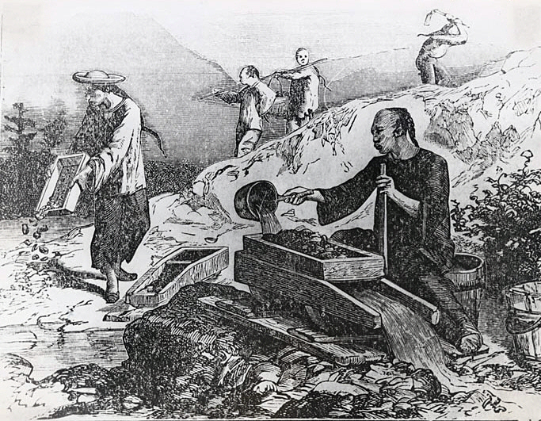

The first Chinese immigrants came in small numbers to the U.S. in 1810s. When gold was discovered in California in 1848, thousands of Chinese men decided to go to San Francisco in hopes of making money for their families. In the gold fields and mines, the Chinese were paid and treated very poorly. Despite this, they were responsible for mining much of the gold found at this time.
WORKSHEET: 2-7.B

Source 2: The Railroad

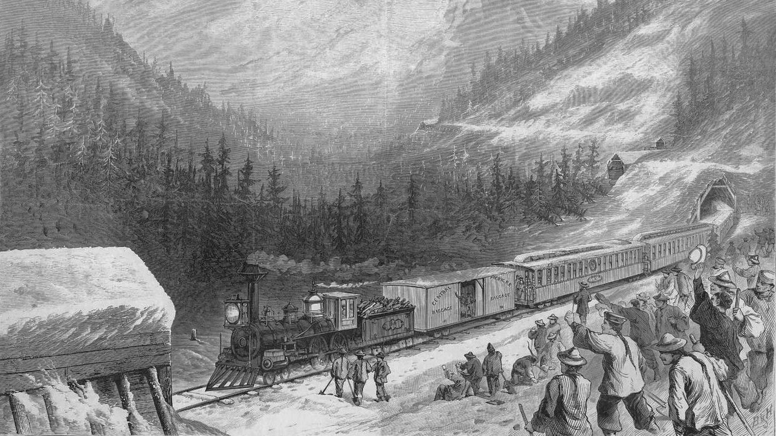

After the Gold Rush, the U.S. started building its first railroad across the country, called the Transcontinental Railroad. Since there was a lack of White workers on the West Coast, the railroad companies recruited Chinese immigrants to do these difficult and dangerous jobs. During this time, the Chinese were paid and treated very poorly. Despite this, without the Chinese workers, the railroad may have not been made.

WORKSHEET: 2-7.C

Source 3: Feeding the United States

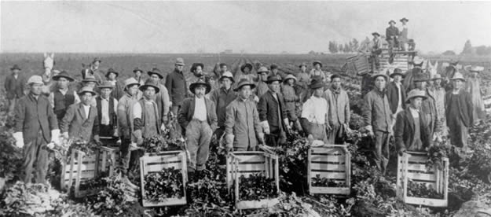

In the late 1800s, California began producing much of the food for the United States. With the railroad connecting California to the East Coast, it allowed food to be transported in days rather than weeks. Many Chinese immigrants started to work in their fields (alongside Japanese and Indian immigrants). During this time, the Chinese and other Asians were not allowed to buy land. Despite this, they would be responsible for helping grow much of the United States’ food.

WORKSHEET: 2-7.D

Source 4: Making Chinatowns

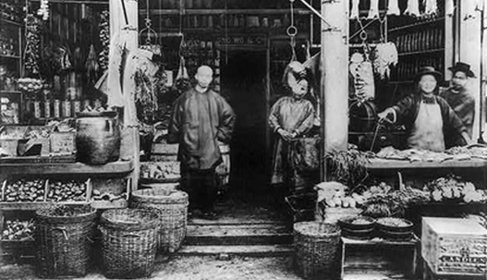

During the Gold Rush, Chinese immigrants started creating homes and businesses in the same area of San Francisco, which became known as Chinatown (not long after other Chinese immigrants would also make a Chinatown in Boston). In Chinatowns, Chinese people could sell all of the products that they needed, such as tea, rice, herbs, and Chinese style clothing. Chinatowns also became places for other Americans to learn about Chinese culture.

WORKSHEET: 2-7.E

Chinese Immigrants Thinking Questions

Source 1: The Gold Rush
How did Chinese immigrants play an important part in this event?

Source 2: The Railroad
How did Chinese immigrants play an important part in this event?

Source 3: Feeding the United States
How did Chinese immigrants play an important part in this event?

Source 4: Making Chinatowns
How did Chinese immigrants play an important part in this event?

ASSESSMENT: 2-7.F

Chinese Immigrants: Exit Ticket

Inquiry Question: How have Chinese immigrants made the United States better?

Describe what you think is the most important thing that the Chinese did to help make the United States better. Include two pieces of evidence from then notes we took. You may also stand up and look at the information posted on the classroom walls.

LESSON PLAN 2-8: Welcome to Ellis Island: Eastern and Southern Europe and the Caribbean

MATERIALS

Ellis Island Video (Lesson2-8Video1) [Located in the UOW Video Library: www.christophercmartell.com/understandingourworld]
Images of Ellis Island (MATERIALS 2-8.A)
Source 1: The Voyage (WORKSHEET 2-8.B)
Source 2: Arriving at Ellis Island (WORKSHEET 2-8.C)
Source 3: The Inspection (WORKSHEET 2-8.D)
Ellis Island: Exit Ticket (ASSESSMENT 2-8.E)

STANDARDS

Massachusetts History and Social Science Framework

MA-HSS.2.7: On a map of the world, locate the continent, regions, or countries from which students, their parents, guardians, grandparents, or other relatives or ancestors came.

Common Core: Literacy

CCSS.ELA-Literacy.RI.2.9: Compare and contrast the most important points presented by two texts on the same topic.

CCSS.ELA-Literacy.RI.2.10: By the end of year, read and comprehend informational texts, including history/social studies, science, and technical texts, in the grades 2–3 text complexity band proficiently, with scaffolding as needed at the high end of the range.

CCSS.ELA-Literacy.W.2.8: Recall information from experiences or gather information from provided sources to answer a question.

PROCEDURES

Inquiry Question: How would you describe the experiences of immigrants entering the United States through Ellis Island?

A. OPENER (8 minutes)

1. Watch Ellis Island Video
To help students understand the struggles immigrants to Ellis Island faced, show them a clip from the film Island of Hope, Island of Tears (1979) (Lesson2-8Video1). Stop the film and explain any events depicted that may be confusing for students.

2. Engage in a Brainstorm on Ellis Island
Post the question on the board or chart paper, “What do you know about Ellis Island?” Project the Images of Ellis Island (MATERIALS 2-8.A) to help foster student ideas. Tell students they can use things they know from the video we just watched or that they have learned in other places. Emphasize what facts are correct. Anticipated responses may include: it is in New York, people took long ship rides, it was crowed, people were scared, people didn’t know English, people saw the Statue of Liberty.

B. DEVELOPMENT (16 minutes)

3. Read About Ellis Island
Pass out the sources: The Voyage (WORKSHEET 2-8.B); Arriving at Ellis Island (WORKSHEET 2-8.C); The Inspection (WORKSHEET 2-8.D). Have students take turns reading aloud (using choral, partner, or independent reading) each source.

4. Write About Arriving at Ellis Island
Tell the students to imagine they are an immigrant from Europe or the Caribbean (have them choose a country-see Source 1: The Voyage) and they have just arrived in New York at Ellis Island. Tell them to include in their letters some of the information in the sources and the things we listed on the board or chart paper.

The letters (ASSESSMENT 2-8.E) will serve as the evaluation task. Students’ letters will address the lesson’s Inquiry Question: “How would you describe the experiences of immigrants entering the United States through Ellis Island?” Tell students to cite at least two pieces of evidence from the sources for this lesson.

C. CLOSING (6 minutes)

5. Share Letters
Have students share letters home with the class. Draw comparisons between the different students’ stories and list them on the board or chart paper.

EVALUATION

ASSESSMENT 2-8.E

What to look for?

The students should write a letter home from the perspective of an immigrant going through Ellis Island. All arguments should cite at least 2 pieces of evidence from the sources.

Some information that students may include in their letters home:
- A voyage that would take 7-10 days
- Poor food on the ship
- Seeing the Statue of Liberty
- Getting seasick or diseases
- Not knowing English
- Being afraid of the inspectors
- Children and mothers being separated from fathers
- Having to answer many questions
- Having a medical inspection
- Being happy when they saw their family members again
- Going to the mainland (New York)

MATERIALS: 2-8.A

Images of Ellis Island

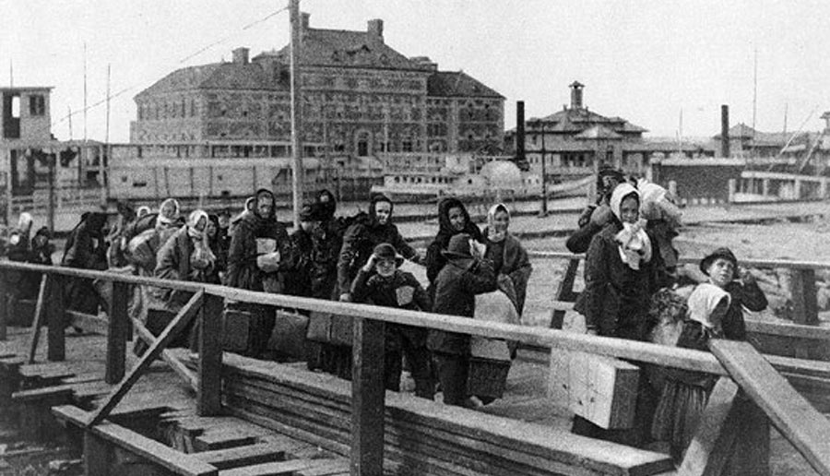

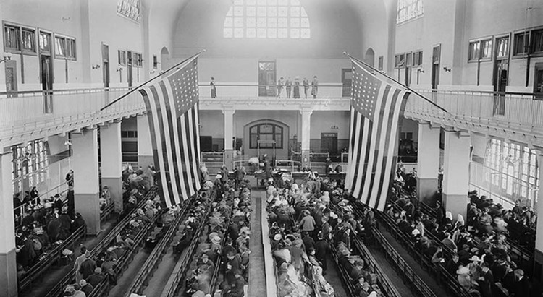

WORKSHEET: 2-8.B

Source 1: The Voyage

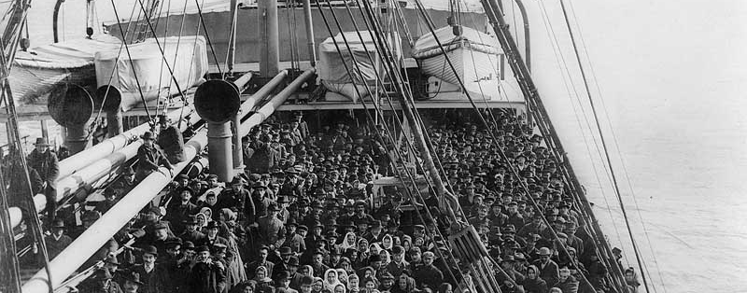

Immigrants to Ellis Island came from many countries, mostly in Eastern Europe (Poland, Russia), Southern Europe (Italy, Greece), and the Caribbean (Jamaica, Cuba, Puerto Rico). They were forced to travel in steerage, or the bottom of the boat. Many people had to fit in a small area. They slept on bunk beds and the food did not taste good. Many were seasick and some people got diseases. The voyage took about seven to ten days. Once they arrived in the United States, they saw the Statue of Liberty.

WORKSHEET: 2-8.C

Source 2: Arriving at Ellis Island

Once the immigrants arrived at Ellis Island, they walked off the boat and waited in line. They were only allowed to bring with them a few things that they could carry. Each immigrant was given a label with their name and home country. Men were separated from women and children. Millions of immigrants would enter the United States through Ellis Island.

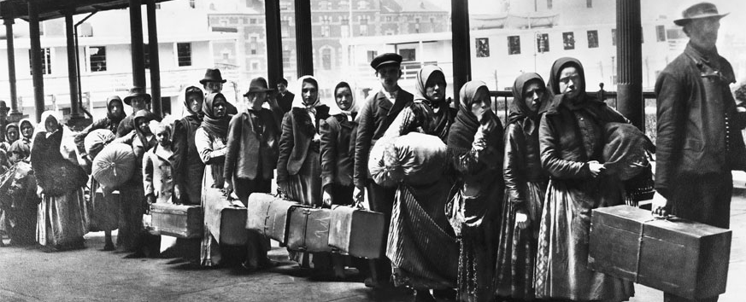
WORKSHEET: 2-8.D

Source 3: The Inspection

Immigrants would then enter the Great Hall (above). Before entering, they would get a health inspection. If they were sick, the would have to go to special rooms. If they did not get better, they would be sent back home. The immigrants would wait for hours in line. Then they would be asked 32 questions and their answers were written down. After the questions, they would find their bags and relatives at something called the Kissing Post. From there, they took a ferry to the land.

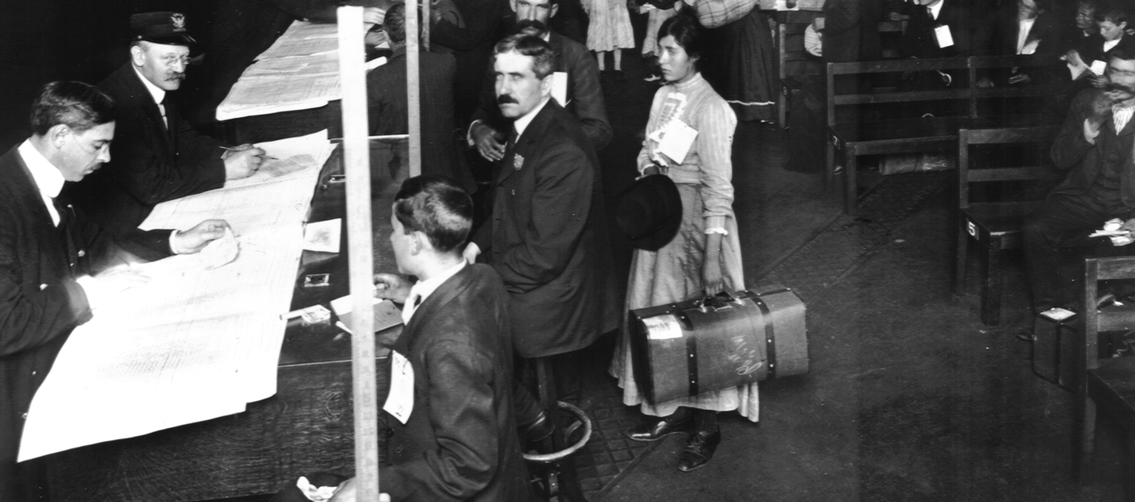

ASSESSMENT: 2-8.E

Ellis Island: Exit Ticket

Inquiry Question: How would you describe the experiences of immigrants entering the United States through Ellis Island?

Pretend that you are an immigrant from Europe or the Caribbean and write back home to your family telling them what Ellis Island was like. You can say both good and bad things about Ellis Island. Include two pieces of evidence from the sources.

LESSON PLAN 2-9: Life After Angel Island: China, Japan, and India

MATERIALS

Images of Angel Island (WORKSHEET 2-9.A)
Source 1: Arriving in San Francisco (WORKSHEET 2-9.B)
Source 2: Finding a Home (WORKSHEET 2-9.B)
Source 3: Finding Work (WORKSHEET 2-9.C)
Life After Angel Islands: Exit Ticket (ASSESSMENT 2-9.D)

STANDARDS

Massachusetts History and Social Science Framework

MA-HSS.2.7: On a map of the world, locate the continent, regions, or countries from which students, their parents, guardians, grandparents, or other relatives or ancestors came.

Common Core: Literacy

CCSS.ELA-Literacy.RI.2.9: Compare and contrast the most important points presented by two texts on the same topic.

CCSS.ELA-Literacy.RI.2.10: By the end of year, read and comprehend informational texts, including history/social studies, science, and technical texts, in the grades 2–3 text complexity band proficiently, with scaffolding as needed at the high end of the range.

CCSS.ELA-Literacy.W.2.8: Recall information from experiences or gather information from provided sources to answer a question.

PROCEDURES

Inquiry Question: Imagine that you were an immigrant from China, Japan, or India to the United States, how would you describe your new country to the people back home?

A. OPENER (12 minutes)

1. Engage in a Brainstorm on Angel Island
Tell the students that last class they studied Ellis Island in New York. Ask students to tell us what they remember about Ellis Island. Give students Images of Angel Island (WORKSHEET 2-8.A). Tell the students that they will look at pictures another island, Angel Island in San Francisco. Write on the board or chart paper: “How is Angel Island the same as Ellis Island? How is Angel Island different than Ellis Island? Read the questions. Tell students to look over the images by themselves. They can circle or highlight any important parts of the pictures. Next, tell students to turn and talk with a partner. Together you should answer the two questions written here. Have partners share what they think are the same and different about the two places. Anticipated responses may include: Different: The people look different, they are Asian at Angel Island instead of White, Black, or Latino at Ellis Island, the immigrants’ clothes look a little different. Same: They have to wait in line, they took ships, they went through inspections, it was an island.

B. DEVELOPMENT (12 minutes)

2. Examine Sources from After Angel Island
Tell the students that, as they can see, the experience of Angel Island was very similar to Ellis Island. So, today we are going to focus on life after Angel Island. What was life like for Asian immigrants in California after they came here?

Put students into small groups. Assign each group one of three worksheets: Arriving in San Francisco (WORKSHEET 2-9.B); Finding a Home (WORKSHEET 2-9.B); Finding Work (WORKSHEET 2-9.C). Have each group read its worksheet. They should underline or highlight important information. Tell the students that they should then discuss the document and write down a list of facts. Note: If your students have difficulty with jig saw activities, this lesson plan can be spread out over three days having all students focus on only one document per lesson. Assign different students to be a leader for one of the three documents, responsible for explaining that document to their peers on the final day of the lessons when they use the exit ticket.

3. Engage in a Jig Saw About Life After Angel Island
Have students participate in a jig saw activity. Make new groups where at least one student from each of the original groups is included. This will create several new groups of three students, one is an expert on 2-9.B, 2-9.C, and 2-9.D. Have each student describe their document to the other members of their group.

Ask students to use the sources to answer the following questions: “What struggles did the immigrants face? What good things happened for the immigrants?” Circulate the room, helping the students.
4. Write About Arriving at Angel Island
For the evaluation task, have the students complete the exit ticket (ASSESSMENT 2-9.D), where they write letter home describing their experience after Angel Island, which is a response to the lesson’s Inquiry Question: “Imagine that you were an immigrant from China, Japan, or India to the United States, how would you describe your new country to the people back home?” Tell students to cite at least two pieces of evidence from the sources for this lesson.

Before using the exit ticket, consider using a graphic organizer or two column notes to prepare students for the writing task. Consider using sentence starters and modeling to help the students with their answer to the inquiry question.

C. CLOSING (6 minutes)

5. Share Letters
Have students share letters home with the class. Draw comparisons between the different students’ stories and list them on the board or chart paper.

EVALUATION

ASSESSMENT 2-9.D

What to look for?

The students should write a letter home from the perspective of an immigrant from China, Japan, or India. All arguments should cite at least 2 pieces of evidence from the sources.

Some information that students may include in their letters home:
- Leaving the ship or inspection at Angel Island
- Arriving in Chinatown, Japantown, or Cow Hollow
- Meeting up with long lost relatives
- Struggling with the fact that they could not speak English
- Finding a place to live: apartments
- Finding a place to work: dockyards, factories, or farms

WORKSHEET: 2-9.A

Images of Angel Island

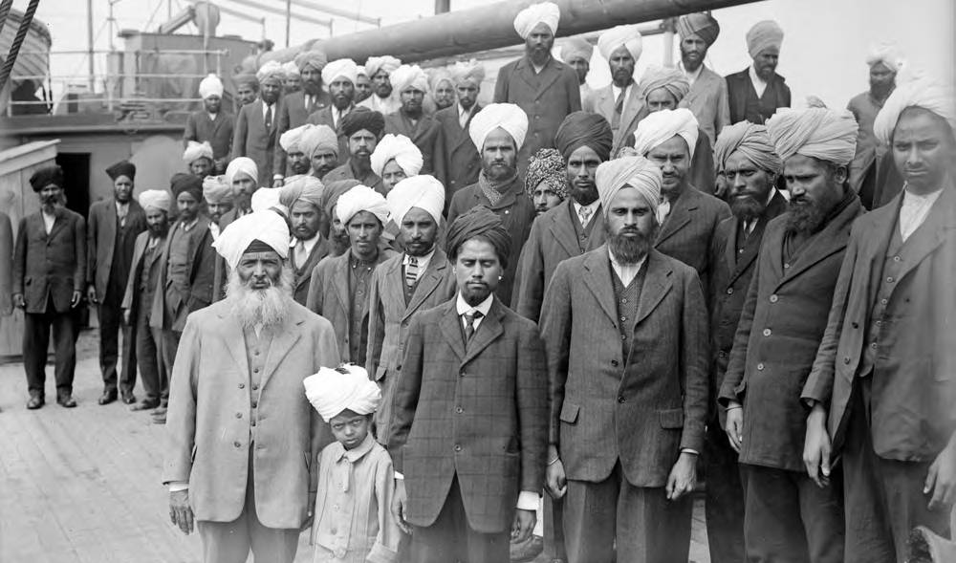

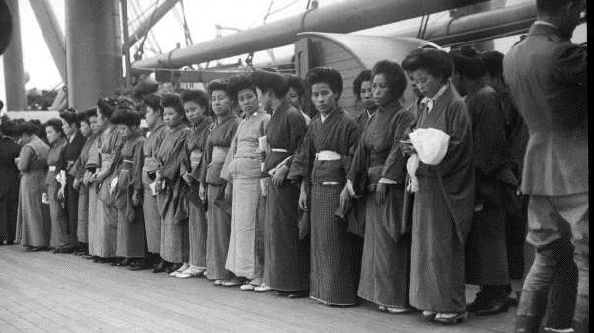

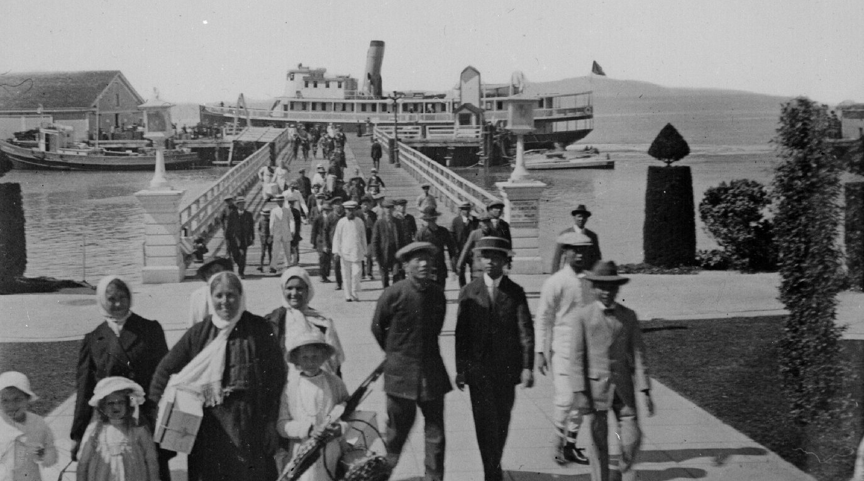

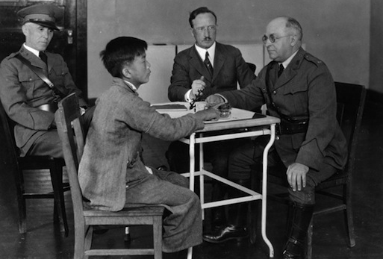
WORKSHEET: 2-9.B

Source 1: Arriving in San Francisco

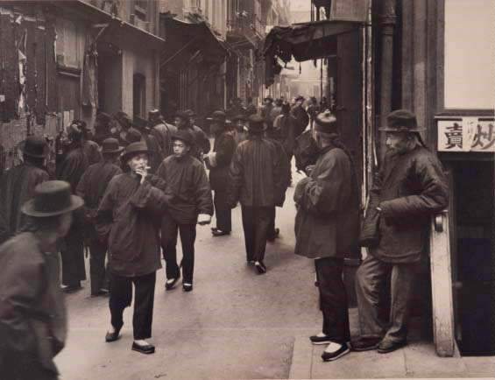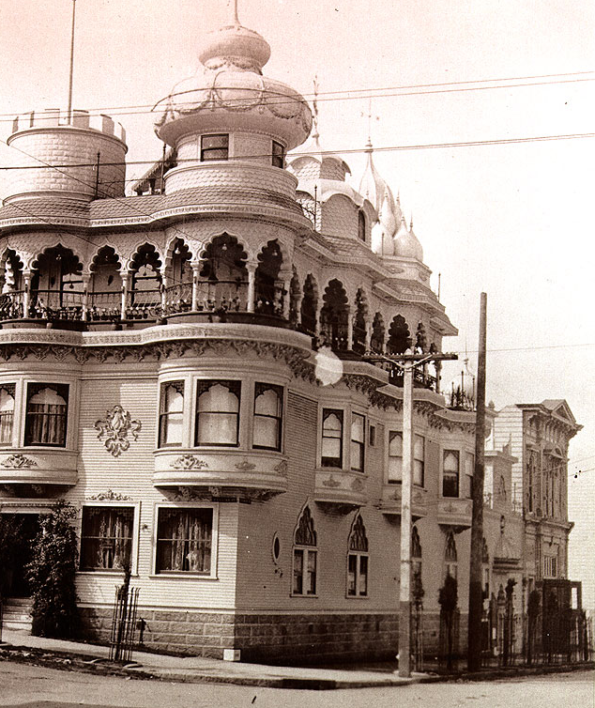

After taking a ferry to San Francisco from Angel Island, Chinese people would usually go to Chinatown. Japanese people would go to Japantown. Indian people would go to a place called Cow Hollow. These were places to find other people would speak their languages and could help them find a place to stay and work. If you had relatives in San Francisco, they may be waiting here for you. Sometimes family members had not seen each other in years. There were also laws in California that said Asians could not be citizens, so they could not vote or own land. This made life very hard.

WORKSHEET: 2-9.C

Source 2: Finding a Home

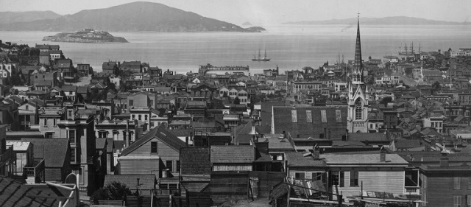

In the early 1900s, San Francisco was a very crowded city. New immigrants from China, Japan, and India usually lived in small apartments. Since immigrants were new to the city, they may stay with a relative first. Apartments were expensive, so people would often share their apartments with other people.

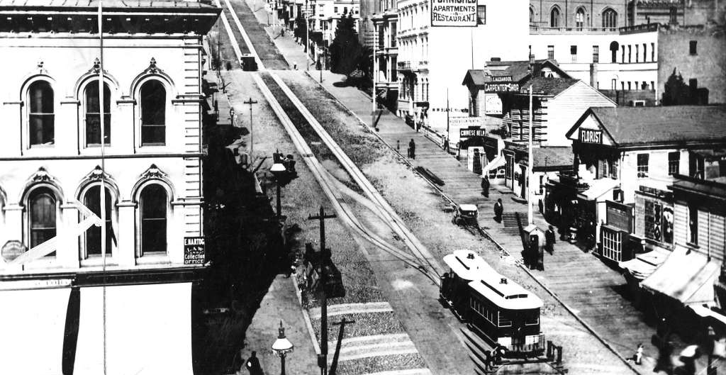

WORKSHEET: 2-9.D

Source 3: Finding Work

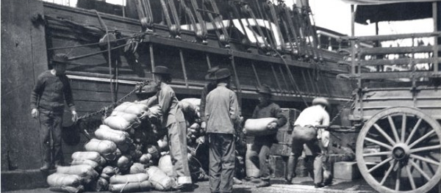

Since so many people were looking for work, companies often paid poorly and made people work for long hours. Many Chinese, Japanese, and Indian immigrants worked in the dockyards (above) and factories (below). Others moved out of San Francisco and worked on farms. Most bosses did not speak their language.

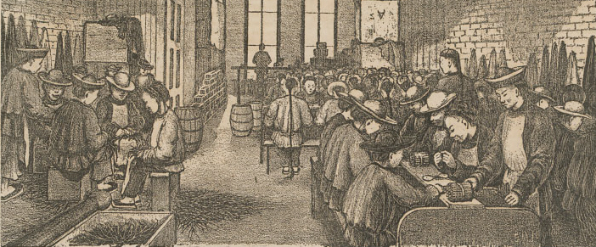

ASSESSMENT: 2-9.E

Life After Angel Island: Exit Ticket

Inquiry Question: Imagine that you were an immigrant from China, Japan, or India to the United States, how would you describe your new country to the people back home?

Imagine that you were an immigrant from China, Japan, or India. Write a letter back home describing life in your new country. Include two pieces of evidence from the sources.

LESSON PLAN 2-10: Life in the Tenements

MATERIALS

Drawing paper (not included)
Images (WORKSHEET 2-10.A)
Original Tenement Description and Floor Plan (WORKSHEET 2-10.B)
Tenement Redesign Description: Exit Ticket (ASSESSMENT 2-10.C)
Dumbbell Tenement (WORKSHEET 2-10.D)

STANDARDS

Massachusetts History and Social Science Framework

MA-HSS.2.7: On a map of the world, locate the continent, regions, or countries from which students, their parents, guardians, grandparents, or other relatives or ancestors came.

Common Core: Literacy

CCSS.ELA-Literacy.RI.2.9: Compare and contrast the most important points presented by two texts on the same topic.

CCSS.ELA-Literacy.RI.2.10: By the end of year, read and comprehend informational texts, including history/social studies, science, and technical texts, in the grades 2–3 text complexity band proficiently, with scaffolding as needed at the high end of the range.

CCSS.ELA-Literacy.W.2.8: Recall information from experiences or gather information from provided sources to answer a question.

PROCEDURES

Inquiry Question: If you were to redesign the tenement and pass laws to improve immigrant conditions, what would they include?

PREPARATION

This lesson uses a method called Visual Thinking Strategy (VTS). The key to VTS is that you as a teacher only do two things: (1) Ask the following questions and (2) repeat as precisely as possible exactly what the students say.

Visual Thinking Strategy Questions:
- Open with: “What’s going on in this picture?”
Summarize student responses using conditional language (“Raoul thinks this could be…”). This keeps the conversation open to other interpretations by other students.
- If appropriate: “What do you see that makes you say that?”
This encourages students to back up their statements with things they see in the work of art.
- Ask the group: “What more can we find?”
This continues the conversation.

If this is your first time using VTS, we recommend reading this description with a video example from Grade 1 produced by the Milwaukee Art Museum: http://teachers.mam.org/collection/teaching-with-art/visual-thinking-strategies-vts/

A. OPENER (8 minutes)

1. Engage in a Visual Thinking Strategy (VTS) on Tenement Images
Give students Images (WORKSHEET 2-10.A). Do not reveal that these are images of tenements. Project the first image (Lettered “A”) and tell the students to look at the image closely and quietly. Give them about one minute. Next, begin the VTS question about the image. Use the above questions, following VTS instructions. Have students inquire about the question using the above questions for about 2-3 minutes.

Project the second image (Lettered “B”) and tell the students to look at the image closely and quietly. Give them about one minute. Next, begin the VTS question about the image. Use the above questions, following VTS instructions. Have students inquire about the question using the above questions for about 2-3 minutes.

Tell students that today we will be learning about tenement apartments. We were just looking at a picture outside and inside tenements. You had many good observations of the tenement pictures.

B. DEVELOPMENT (16 minutes)

2. Examine the Tenement Floor Plan
Tell the students that you have a historical problem for them. Pass out Original Tenement Description and Floor Plan (WORKSHEET 2-10.B). Ask the students to look at the image. Ask the students if they know what a floor plan is. Tell the students that this is a picture of a building. Pretend that we cut off the roof and we are looking down at it. It shows us the floors, walls, doors, and windows. Ask if any students are confused and then individually help them see the floor plan is a birds-eye view of a building.
Once all the students understand the floor plan, explain that this is a floor plan for a tenement, just like the pictures we were just looking at. Next, have students take turns reading the description on the back while the other students look at the floor plan.

3. Engage in Problem Solving Around the Tenement
Have students get in partners. One partner should be the architect, who will draw, and the other should be the scribe, who will take notes. Working together, each partner team should make a new floor plan that they think will address the following problem:
- The tenements do not get much fresh air. Since there are only windows in the front and back, the breeze cannot flow through the building well. You cannot put windows on the sides, because there is a building there. Emphasize: How can you change the shape to make more windows?
- It is now possible to add indoor plumbing for sinks, and toilets. It is also very expensive. Emphasize: Will you pay the money to move the toilets and water inside?
- Children have no safe place to play. Emphasize: What will you do to help children have a safe place to play?

Tell the students: Architect, your job is to draw a new floor plan to do these three things: make more windows and a place for children to play. Scribe, your job is to make a list of the changes that you made in your new drawing using the exit ticket sheet (ASSESSMENT 2-10.C). You will also have to describe on that sheet if you will put toilets and sinks in the tenement.

C. CLOSING (6 minutes)

5. Share Tenement Drawings
If you have access to a document camera, project each tenement for all the students to see while a partner group explains. Draw comparisons between the different students’ tenement floor plans.

6. Reveal the Dumbbell Tenement Plan
Pass out or project the Dumbbell Tenement (WORKSHEET 2-10.D). Ask students if any groups came up with similar ideas. Tell the students that this tenement, which is called a dumbbell tenement (like the things people exercise with), had something called a court yard, which allowed more windows by putting them on the inside. Check to see that students understand that. It also made the front and back a different shape, to allow more air to flow in. Check to see that students understand that. Ask the students if they think this is a good improvement or not?

EVALUATION

ASSESSMENT 2-10.C

What to look for?

The students should redesign the tenement and write up the changes that they made.

Some design features that the students describe may include:
- A courtyard.
- Changing the shape of the building to allow more windows.
- Adding plumbing (sinks, toilets), because it is worth the money.
- Not adding plumbing, because the money could be spent in other ways (lowering rent, fixing the building).
- A playground can be made for children in the back lot or nearby.

WORKSHEET: 2-10.A

Images (A)

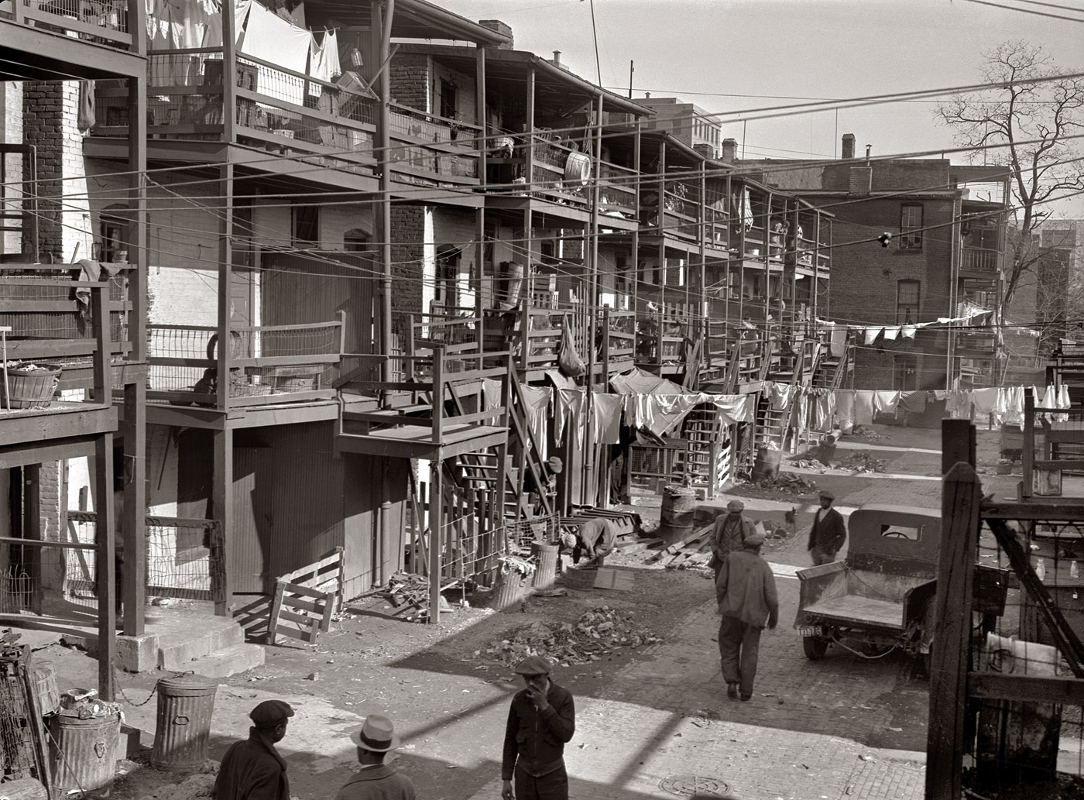
Images (B)

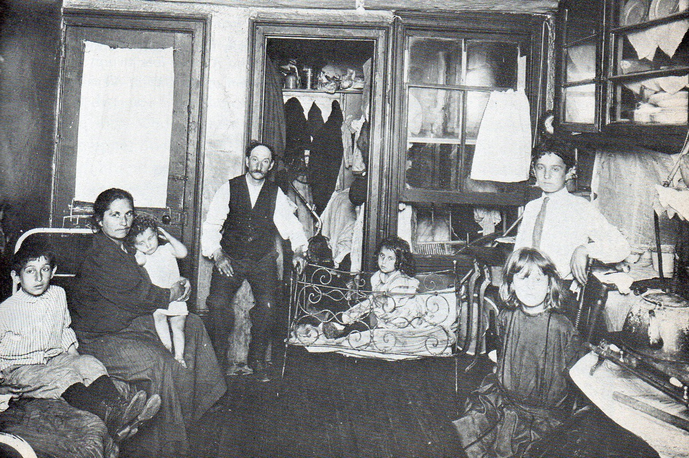
WORKSHEET: 2-10.B

Original Tenement Description and Floor Plan
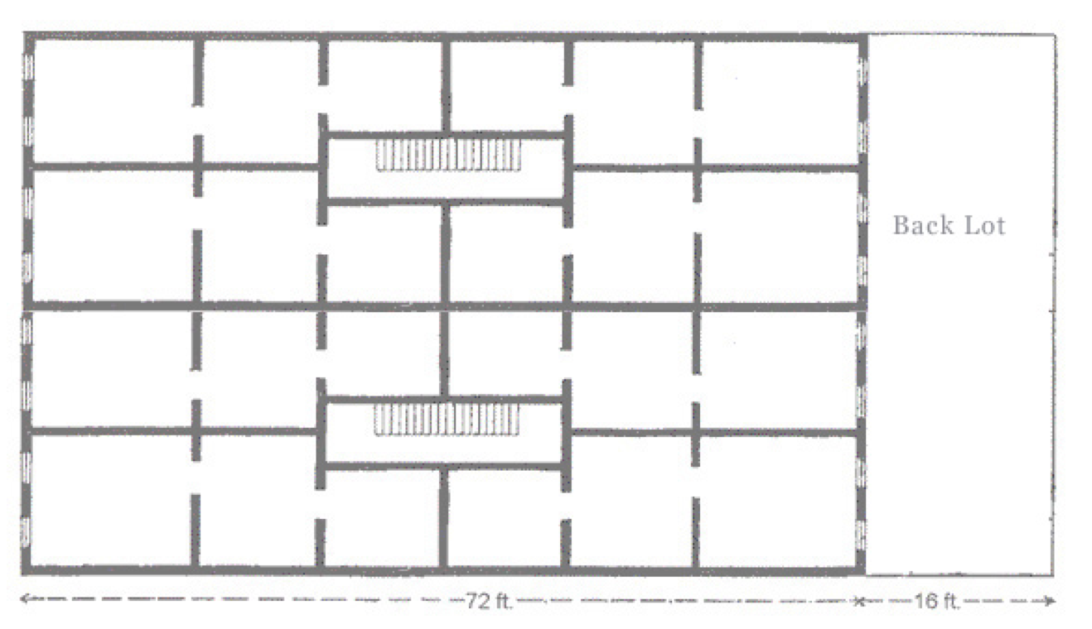
Tenement Description

- This is a tenement in the Little Poland section of New Britain, Connecticut. It has no indoor toilets or running water. People needed to go use outhouses and get water outside.

- If you are looking at the floor plan, each apartment has three rooms. They start at the stairs with the smallest, next is a larger room, and the largest room is on the end with windows. The windows went from almost the floor to almost the ceiling, just like most school classrooms.

- Sometimes more than one family lived in each apartment. It was very expensive and usually the whole family worked jobs, including the children. They may work in factories, selling things on the streets (like newspapers), or doing repair work (like sewing).

- Since there were few parks at this time, children had nowhere safe to play. They would often play on roofs or in back dirt lots (sometimes near the outhouses).

ASSESSMENT: 2-10.C

Explanation of Tenement Redesign: Exit Ticket

Inquiry Question: If you were to redesign the tenement to improve immigrant conditions, what would they include?

Scribe: List here all of the changes that were made to make the tenement better for the immigrants who live there.

WORKSHEET: 2-10.D

Dumbbell Tenement
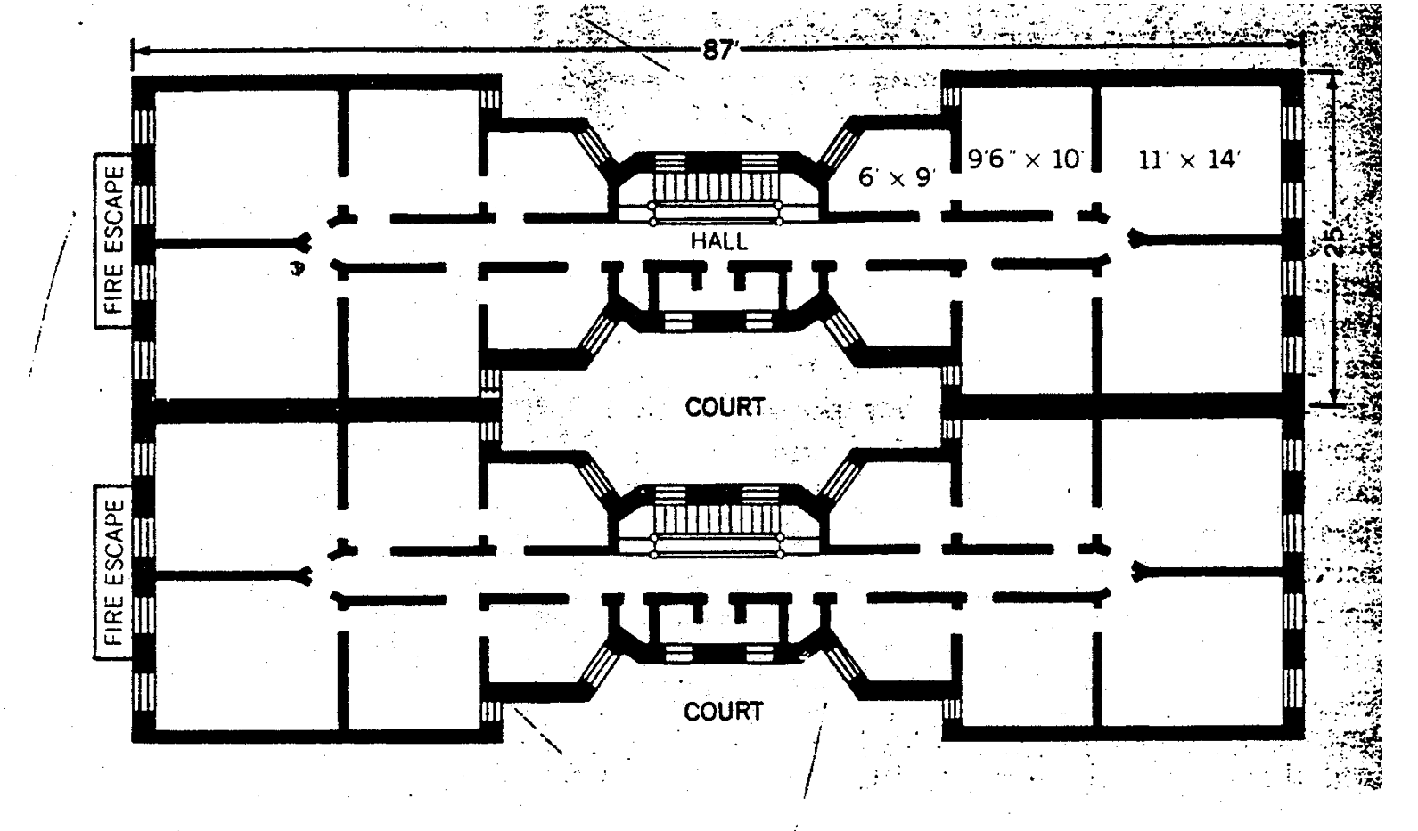
LESSON PLAN 2-11: Immigration from Canada and Mexico: A History

MATERIALS

1897 Train Video (Lesson2-11Video1) [Located in the UOW Video Library: www.christophercmartell.com/understandingourworld]
Picture of Mexican Family and French Canadian Family (WORKSHEET 2-11.A)
Source 1: Mexican Immigrants (WORKSHEET 2-11.B)
Source 2: French Canadian Immigrants (WORKSHEET 2-11.C)
Immigration from Canada and Mexico: Exit Ticket (ASSESSMENT 2-11.D)

STANDARDS

Massachusetts History and Social Science Framework

MA-HSS.2.7: On a map of the world, locate the continent, regions, or countries from which students, their parents, guardians, grandparents, or other relatives or ancestors came.

Common Core: Literacy

CCSS.ELA-Literacy.RI.2.9: Compare and contrast the most important points presented by two texts on the same topic.

CCSS.ELA-Literacy.RI.2.10: By the end of year, read and comprehend informational texts, including history/social studies, science, and technical texts, in the grades 2–3 text complexity band proficiently, with scaffolding as needed at the high end of the range.

CCSS.ELA-Literacy.W.2.8: Recall information from experiences or gather information from provided sources to answer a question.

PROCEDURES

Inquiry Question: What was the Canadian and Mexican immigrant experience like?

A. OPENER (8 minutes)

1. Watch 1897 Train Video
Tell students that we have been studying immigrants for the last few social studies lessons and I have a question for you: “How did most immigrants travel to the United States?” Anticipated answers may include: ships, boats, over the ocean.
Not all immigrants came over the ocean in ships. Today, we will learn about two groups who came by train or even by foot. First, let’s look at a short video of a train back in 1897. Show the 1897 Train Video (Lesson2-11Video1). Ask the students to describe what trains were like back then. Anticipated responses may include: noisy/loud, lots of soot/pollution, fast, carried many people, people were hanging out of them, there were workers in the film, it looks like Thomas the Train from the show.

2. View Mexican and French Canadian Family Photos
Show the students the images of Mexican immigrant family. Tell them that this is a family from Mexico who emigrated to Kansas City, Missouri in the early 1900s. Ask the students, “How might this family be the same or different than yours?” Anticipated answers may include: their family is larger, they live in Missouri, they speak Spanish, they are wearing different types of clothes.

Show the students images of French Canadian immigrants. Tell them that this is a family from French Canada, also called Québec, who emigrated to Holyoke, Massachusetts in the early 1900s. Ask the students, “How might this family be the same or different than yours?” Anticipated answers may include: their family is larger, they live in Massachusetts, they speak French, they are wearing different types of clothes.

B. DEVELOPMENT (16 minutes)

3. Read About Ellis Island
Pass out the sources: Mexican Immigrants (WORKSHEET 2-11.B); French Canadian Immigrants (WORKSHEET 2-11.C). Have students take turns reading aloud (using choral, partner, or independent reading) each source.

4. Write Diary Entry
Divide the class in half. Explain that a diary is a journal or writing that people do once a day to remember things about their day. They are going to write a diary entry pretending that they are a child who has recently emigrated with their family from either Québec to Massachusetts or Mexico to California. Tell them to include in their diary entries some of the information in the sources. Before they start writing, make a list of possible items to include on the board or chart paper.

The diary entries (ASSESSMENT 2-11.D) will serve as the evaluation task. Students’ diary entries will address the lesson’s Inquiry Question: “What was the Canadian and Mexican immigrant experience like?” Tell students to cite at least two pieces of evidence from the sources for this lesson.

C. CLOSING (6 minutes)

5. Share Letters
Have students share their diary entries with the class. Draw comparisons between the different students’ stories and list them on the board or chart paper.

EVALUATION

ASSESSMENT 2-11.D

What to look for?

The students should write diary entries from the perspective of a Mexican or Canadian immigrant. All arguments should cite at least 2 pieces of evidence from the sources.

Some information that students may include in their journal entries:
- Riding on a train to get here
- Eating new foods in the United States
- Being happy to be with their families
- Meeting up with long lost relatives
- Struggling with the fact that they could not speak English
- Celebrating their holidays
- Keeping their culture through food, holidays, and music

WORKSHEET: 2-11.A

Mexican Family

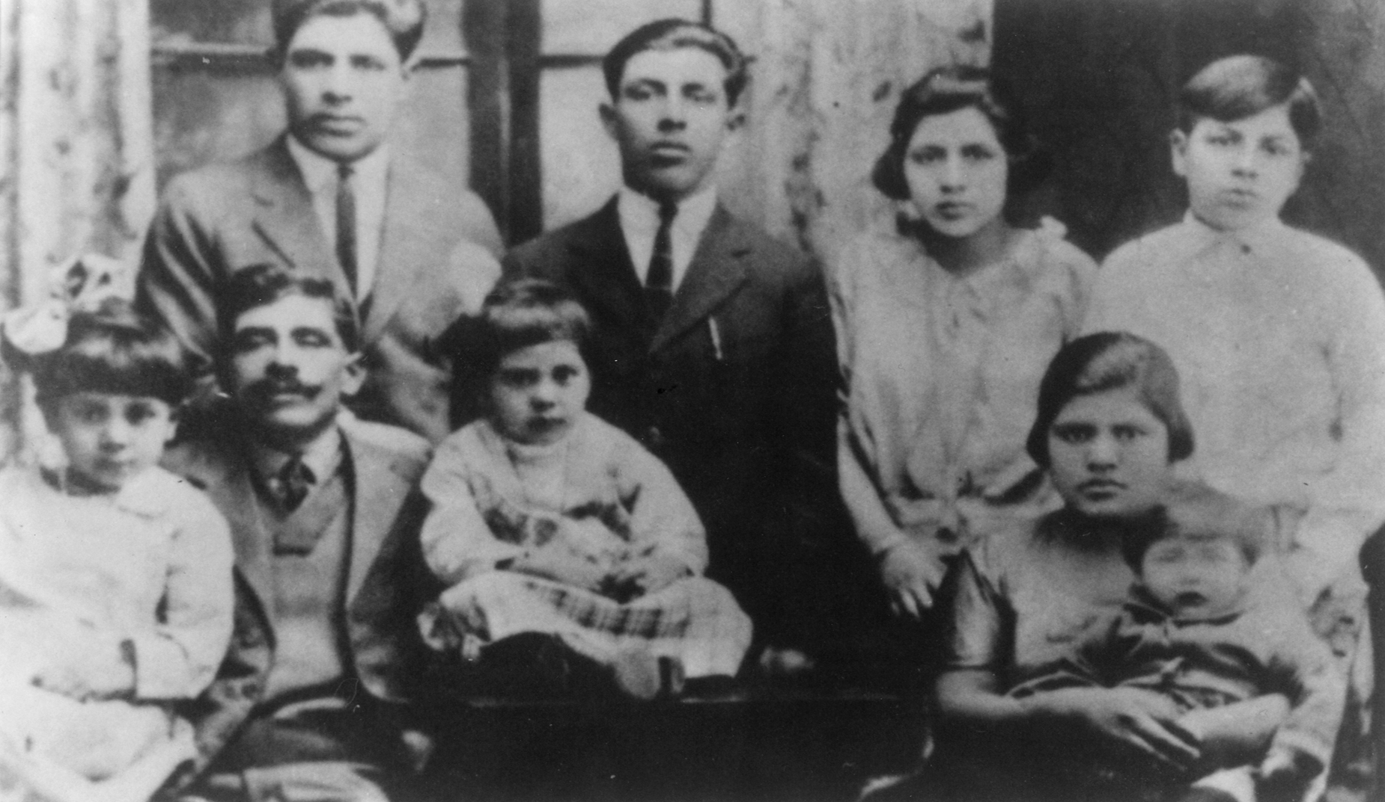
French Canadian Family

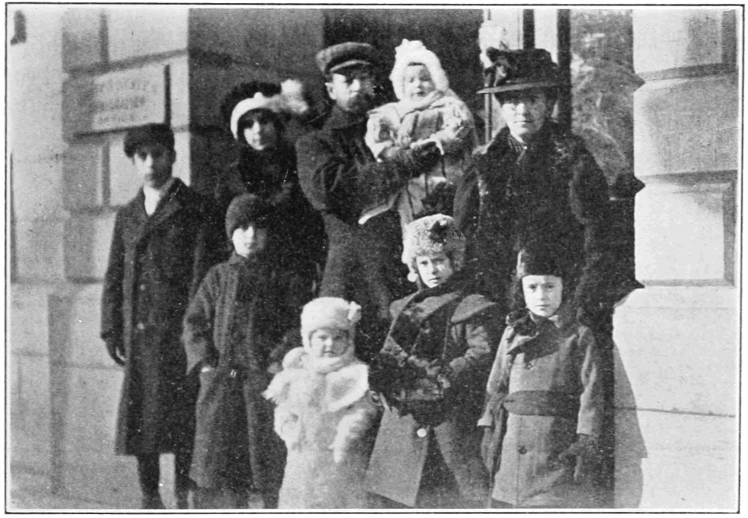
WORKSHEET: 2-11.C

Source 1: Mexican Immigrants

This is the Montoya family. They emigrated from Zacatecas,
Mexico and came to Kansas City in 1907. The father was named Juan and he brought his family to Kansas City because he got a job working for the railroad. The family only spoke Spanish when they first arrived. They experienced all sorts of new American food, but cooked Mexican food like tamales (below). They liked to listen to traditional Mexican music, which was played at family parties. They help start the first Spanish speaking Catholic church in Kansas City, called Our Lady of Guadalupe.

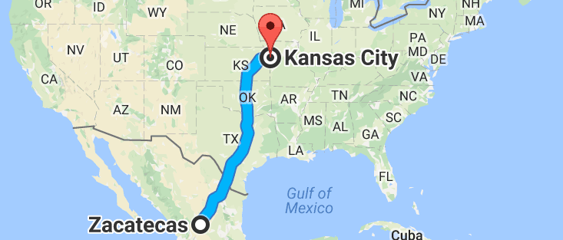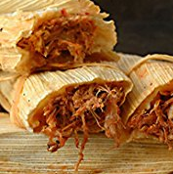
WORKSHEET: 2-11.D

Source 2: French Canadian Immigrants

This is the Lapointe family. They emigrated from Montréal, Québec (French Canada) and came to Holyoke, Massachusetts in 1907. The father was named Theophile and he brought his family to Holyoke because he got a job working in a paper factory. The family only spoke French when they first arrived. They experienced all sorts of new American food, but cooked French food like tourtière (below). They liked to listen to traditional Québec music, which was played at family parties. They went to the French-speaking Precious Blood Catholic Church.

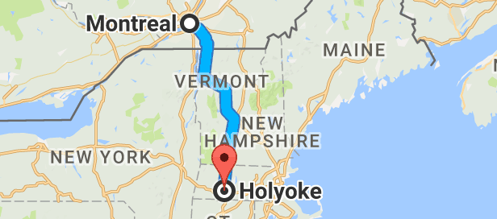
ASSESSMENT: 2-11.D

Immigration from Canada and Mexico: Exit Ticket

Inquiry Question: What was the Canadian and Mexican immigrant experience like?

Imagine that you were a child who emigrated from Mexico or Québec (French Canada). Write a diary entry about your time living in the United States. You can discuss the journey here and your new community. Include two pieces of evidence from the sources.

LESSON PLAN 2-12: The Immigration Act of 1924

MATERIALS

1924 Immigration Law (WORKSHEET 1-12.A)
Preparation for the Corner Debate (WORKSHEET 1-12.B)
YES and NO signs (MATERIALS 1-12.C)
The Immigration Act of 1924: Exit Ticket (ASSESSMENT 1-12.D)

STANDARDS

Massachusetts History and Social Science Framework

MA-HSS.2.10: After reading or listening to a variety of true stories about individuals recognized for their achievements, describe and compare different ways people have achieved great distinction (e.g. scientific, professional, political, religious, commercial, military, athletic, or artistic). (H)

Common Core: Literacy

CCSS.ELA-Literacy.RI.2.9: Compare and contrast the most important points presented by two texts on the same topic.

CCSS.ELA-Literacy.RI.2.10: By the end of year, read and comprehend informational texts, including history/social studies, science, and technical texts, in the grades 2–3 text complexity band proficiently, with scaffolding as needed at the high end of the range.

CCSS.ELA-Literacy.W.2.8: Recall information from experiences or gather information from provided sources to answer a question.

PROCEDURES

Inquiry Question: Should we limit the number of people who can move to the United States?

A. OPENER (12 minutes)

1. Introduce the 1924 Immigration Act
Ask students if they can tell you what a law is. After listening to students, write the definition on the board or chart paper as “a rule for all people in a place.” Ask students if they can give some examples of laws. Anticipated responses may include: no speeding in your car, you have to wear a seatbelt, you have to go to school. Tell students another name for a law is an “act.”

Tell the students that we have been studying the many different immigrant groups who came to the United States over its history. Ask students, “Who was allowed to come to the United States as immigrants.” Anticipated answers may include: anyone, you couldn’t have diseases, you couldn’t have committed crimes.

Tell the students that in 1924, the United States Congress decided that it wanted fewer immigrants, so it passed a law saying fewer people could come here. Until 1924, most immigrants to the United States could just come here. Many people said that the U.S. could just build more factories for jobs, homes, and schools, if more immigrants came. Ask the students “Why might a country want to have fewer immigrants?” Anticipated responses from students may include: they may not have enough jobs for everyone, they may not have enough houses for everyone, they may not have enough food for everyone, they may not have enough schools for everyone.

Project for the students the text of the 1924 Immigration Law (WORKSHEET 1-12.A). Ask the students to do a choral reading of it together. Stop the students at the word “quota” and explain that that means no more than that number of people could enter the United States in that year. In this case, quota means “no more than.” So, if I had a quota that only 3 students could go to recess, if you were the fourth student, could you go to recess? What about the fifth?” After the choral reading, ask the posted question: After 1890, there was a change in where immigrants came from. There were many more immigrants from Asia, Eastern Europe (like Poland and Russia), and Southern Europe (like Italy and Greece). Why do you think they chose that year instead of 1920? Anticipated answers may include: they didn’t want more immigrants from Asia, Southern, or Eastern Europe (many historians agree with this), they wanted the country to be smaller, they needed to choose a number and that one was from a long time ago. If students do not connect the choice of 1890, explain that the government wanted fewer immigrants from certain countries, so they passed this law.

B. DEVELOPMENT (12 minutes)

2. Participate in a Corner Debate on the 1924 Immigration Act
Have students individually think about each immigration question using Preparation for the Corner Debate (WORKSHEET 2-12.B).

Ask students to bring their preparation sheets with them and stand up in the middle of the room. Post on one side of the room the sign that says “YES” and on the other side of the room the sign that says “NO” (MATERIALS 2-12.C).

Read each of the questions. Tell students if they think would be a good choice, they should stand under “YES” or a bad choice, they should stand under “NO.” Ask students to explain why they think yes and no. Repeat this with the other two choices. If any choices have no supporters, you (teacher) should stand there and give a reason why it might be a good choice.

A Note on the Topic:
Be mindful that some students are immigrants or children of immigrants and that other children may have parents at home that say negative things about immigrants. While this topic may raise emotions, this is exactly why this lesson is so important-it gives students a chance to hear the other side in a respectful way and models good citizenship around a controversial issue. If this debate does become emotional, you should have the students take a pause and tell them that our country is a country of immigrants, unless we are Indigenous (Native) people, our family came from somewhere else over the last 300 years. At the same time, we live in a democracy, where we have to listen and respect people who disagree with us. This is how we all can make this a better country.

After the students have heard a discussion of each choice, have students return to their seats. Show the text of the 1924 Immigration Act of 1924 (WORKSHEET 2-12.A). Tell students that after respectfully listening to the different opinions of this law and if all immigrants should come to the United States, they will now have a chance to make you own mind up.

C. CLOSING (6 minutes)

4. Write Up Argument on the 1924 Immigration Act
For the evaluation task, have the students complete the exit ticket (ASSESSMENT 2-12.D), where they write their own personal response to the lesson’s Inquiry Question: “Should we limit the number of people who can move to the United States?” Tell students to cite at least two pieces of evidence from the 1924 Immigration Act or our class debate.

Before using the exit ticket, consider using a graphic organizer or two column notes to prepare students for the writing task. Consider using sentence starters and modeling to help the students with their answer to the inquiry question.

EVALUATION

ASSESSMENT 2-12.D

What to look for?

The students should take a stance on if we should limit the number of immigrants who can come to the U.S. All arguments should cite at least 2 pieces of evidence from the sources.

Arguments for limiting the number of immigrants
- There is a limited number of jobs
- There is a limited number of houses/apartments
- There is a limited number of schools
- Relatives of Americans should be allowed first

Arguments for not limiting the number of immigrants
- It is not fair who is allowed to immigrate (some groups are not allowed)
- It may stop family members from being together
- Many workers are needed
- There are plenty of homes/apartments for people or we can build more
- There are plenty of schools for people or we can build more
- Almost all of us are immigrants or our ancestors were, so how could we tell others they cannot come here

WORKSHEET: 2-12.A

1924 Immigration Law

Section 1A: If you have family members in the United States or marry an American, you can become a citizen.

Section 1B: There is a quota for the current immigrants. No more than a certain number of people can come to the United States from any country in a year.

…

Section 11: For the number of immigrants allowed to come to the U.S., we will base it on the number of immigrants from each country in 1890.

Question:
After 1890, there was a change in where immigrants came from. There were many more immigrants from Eastern Europe (like Poland and Russia), Southern Europe (like Italy and Greece), and Asia (like China and Japan).

Why do you think they chose that year instead of 1920?

WORKSHEET: 2-12.B

Preparation for the Corner Debate

Think about the following sentences and decide if you think “yes” or “no.” Then explain why.

The United States should allow most immigrants to come here.

Circle: Yes or No

Immigrants who have families should be allowed to come to the United States before people who do not have families.

Circle: Yes or No

WORKSHEET: 2-12.C

YES

NO

ASSESSMENT: 2-12.D

1924 Immigration Act: Exit Ticket

Inquiry Question: Should we limit the number of people who can move to the United States?

Describe if you think that we should limit the number of immigrants (like they started doing in 1924) or that we should allow most immigrants to come here. Include two pieces of evidence from the sources.

LESSON PLAN 2-13: Immigration in the 20th Century

MATERIALS

Zoom In Inquiry Activity (WORKSHEET 2-13.A)
Source 1: 1965 Immigration Act (WORKSHEET 2-13.B)
Source 2: Transportation Changes (WORKSHEET 2-13.C)
Source 3: Work Changes (WORKSHEET 2-13.D)
Source 4: Government Changes (WORKSHEET 2-13.E).
Immigration in the 20th Century: Exit Ticket (ASSESSMENT 2-13.F)

STANDARDS

Massachusetts History and Social Science Framework

MA-HSS.2.7: On a map of the world, locate the continent, regions, or countries from which students, their parents, guardians, grandparents, or other relatives or ancestors came.

Common Core: Literacy

CCSS.ELA-Literacy.RI.2.9: Compare and contrast the most important points presented by two texts on the same topic.

CCSS.ELA-Literacy.RI.2.10: By the end of year, read and comprehend informational texts, including history/social studies, science, and technical texts, in the grades 2–3 text complexity band proficiently, with scaffolding as needed at the high end of the range.

CCSS.ELA-Literacy.W.2.8: Recall information from experiences or gather information from provided sources to answer a question.

PROCEDURES

Inquiry Question: In the 20th century, why did newer immigrants start coming from different countries?

PREPARATION

This lesson uses a method called Zoom In Inquiry. The key to Zoom In Inquiry is that you as a teacher allow the students to explore an image in three successive “zoom ins.”

Zoom In Inquiry:
- The teacher has students start by looking at only a specific part of an image (Zoom 1) and not the entire image. The teacher asks, “What do you think this may be?” and “What can you tell from what you see?” or “What clues do you see?”
- The teacher then reveals a slightly larger view of the image (Zoom 2). The teacher asks, “What do you think this may be?” and “What can you tell from what you see?” or “What clues do you see?”
- Finally, the teacher shows the entire image (Zoom 3) to the students. The teacher asks, “What do you think this may be?” and “What can you tell from what you see?” or “What clues do you see?”
- Finally, the teacher explains what the image is of and connects it to the lesson.

If this is your first time using Zoom In Inquiry, we recommend watching this video example from Grade 4 produced by Explorify: https://vimeo.com/205234946

A. OPENER (10 minutes)

1. Zoom In Inquiry Activity
Put students in small groups. Give students the Zoom 1 image (WORKSHEET 2-13.A). Project the Zoom 1 image for the class. Tell the students to look at the image closely. In their groups, they should look at the details or clues and make educated guesses as to what the picture may be of. Ask the following questions: “What do you think this may be?”, “What can you tell from what you see?”, “What clues do you see?” Anticipated responses may include: doors, cabinets in a classroom, lockers, numbered seats. Have students examine the source for about 2-3 minutes.

Give students the Zoom 2 image (WORKSHEET 2-13.A). Project the Zoom 2 image for the class. Tell the students to look at the image closely. In their groups, they should look at the details or clues and make educated guesses as to what the picture may be of. Ask the following questions: “What do you think this may be?”, “What can you tell from what you see?”, “What clues do you see?” Anticipated responses may include: a room, a theater, van, bus, plane. Have students examine the source for about 2-3 minutes.

Give students the Zoom 3 image (WORKSHEET 2-13.A). Project the Zoom 3 image for the class. Tell the students to look at the image closely. In their groups, they should look at the details or clues and make educated guesses as to what the picture may be of. Ask the following questions: “What do you think this may be?”, “What can you tell from what you see?”, “What clues do you see?” Anticipated responses may include: a bus, a plane. Have students examine the source for about 2-3 minutes.

Ask the students “We have spent several lessons studying how immigrants came to the United States in the past. What types of transportation did they mostly use?” Anticipated responses may include ships (emphasize this is how most immigrants came to the U.S. 100 years ago), trains, by foot.

Show students the image of the TACA Airplane at the Airport Terminal. Tell students that this is an image of an airplane waiting to take off. Tell students that today we will be studying recent immigrants to the United States. We started with this picture of a plane, because today most immigrants come to the U.S. on airplanes, with a smaller number from Mexico, Central America, and Canada coming by foot, bus, or ship. Ask students why they think immigrants today take airplanes instead of ships? Anticipated responses may include: it is faster, it is cheaper, there weren’t planes back then. Tell students that changes in how immigrants get here is one reason for why the places immigrants are coming from are different than they were 100 years ago. Project for the class and show the students this website, that shows the different countries immigrants came over time from 1960 to today (highlight that more immigrants now come from Central and South America, Asia, and Africa): http://www.migrationpolicy.org/programs/data-hub/charts/largest-immigrant-groups-over-time

B. DEVELOPMENT (14 minutes)

2. Read About the Reasons for Immigration Changes
Put students in small groups and assign them one of the sources: 1965 Immigration Act (WORKSHEET 2-13.B), Transportation Changes (WORKSHEET 2-13.C), Work Changes (WORKSHEET 2-13.D), Government Changes (WORKSHEET 2-13.E). Have one student from each group read their source. As the student reads, tell the other group members to underline or highlight any important information.

3. Engage in a Jig Saw on Immigration Changes
Have students participate in a jig saw activity. Make new groups where at least one student from each of the original groups is included. This will create several new groups of three students, one is an expert on 2-13.B, 2-13.C, 2-13.D, 2-13.E. Have each student describe their document to the other members of their group.

Ask students to use the sources to answer the following inquiry question: “In the 20th century, why did newer immigrants start coming from different countries (than before)?” In answering this question, students should debate between the four different worksheets and consider which factor had the biggest effect/cause. After students have discussed the question, they should complete the exit ticket in the following step. Circulate the room, helping the students who may have difficulty choosing one factor.

C. CLOSING (6 minutes)

4. Write Up Argument on Immigration Changes
For the evaluation task, have the students complete the exit ticket (ASSESSMENT 2-13.F), where they write their own personal response to the lesson’s Inquiry Question: “In the 20th century, why did newer immigrants start coming from different countries (than before)?” Tell students to cite at least two pieces of evidence from the sources for this lesson.

Before using the exit ticket, consider using a graphic organizer or two column notes to prepare students for the writing task. Consider using sentence starters and modeling to help the students with their answer to the inquiry question.

EVALUATION

ASSESSMENT 2-13.F

What to look for?

The students should take a stance on why different immigrant groups came to the U.S. in the 20th century. All arguments should cite at least 2 pieces of evidence from the sources.

Arguments for the 1965 Immigration Act being the most important:
- This changed the rules and allowed more immigrants from places in South America, Caribbean, Asia, and Africa.
- This removed quotas (or limits) that said more Europeans could come here than people from other places.
- This law allowed more people to come here from new countries.

Arguments for the Transportation Changes being the most important:
- Planes became cheaper and flew to more places.
- Trains became faster.
- Planes and trains were better than boats.
- Faster and cheaper transportation allowed more people from far away to come to the U.S.

Arguments for the Work Changes being the most important:
- NAFTA had a bad effect on Mexican farmers (and U.S. factory workers).
- This forced many Mexican farmers and their families to look for work in the United States.
- This has led to an increase in Mexican immigrants, making them one of the largest immigrant group in the U.S.

Arguments for the Government Changes being the most important:
- The end of communism in some countries led to more immigrants for those places.
- Other communist countries allowed their citizens to immigrant to the United States (they didn’t before). This resulted in more people coming from these countries.

WORKSHEET: 2-13.A

Zoom 1

Zoom 2
Zoom 3
WORKSHEET: 2-13.B

Source 1: 1965 Immigration Act

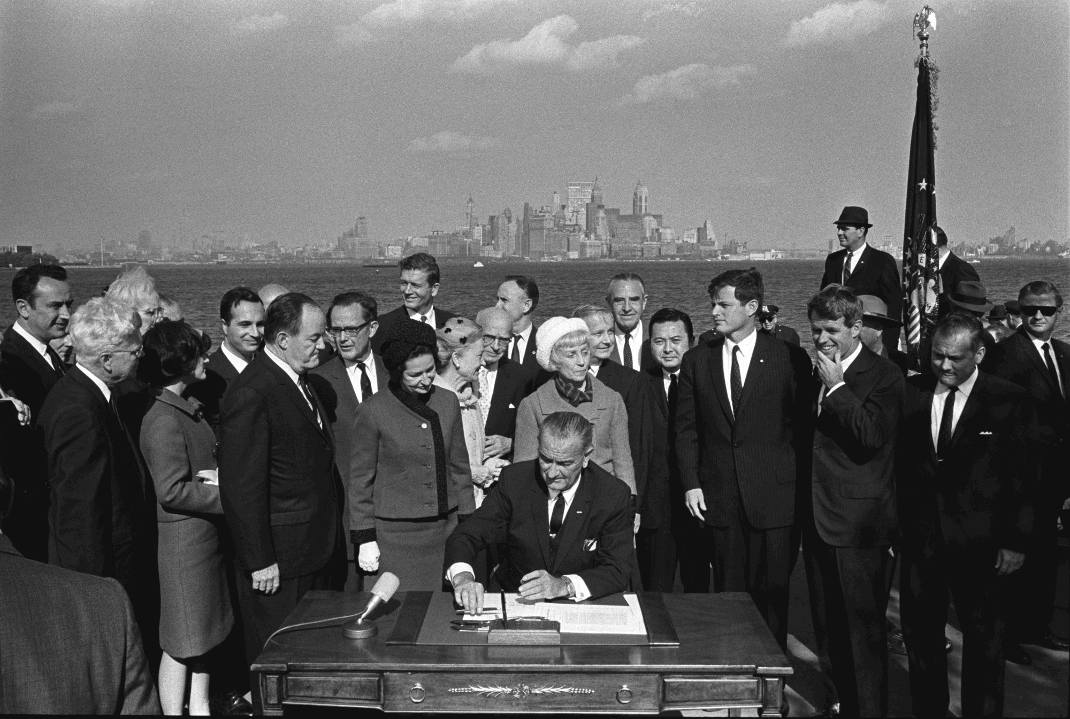

In 1965, President Lyndon Johnson signed a new immigration law while sitting in front of the Statue of Liberty (see New York City in the background). This new law ended quotas or limits (meaning only a certain number of people could enter from any one country). These quotas allowed many more immigrants from Europe compared to other continents. This law allowed more immigrants from countries in Asia (like China, Vietnam, and India) and South America and the Caribbean (like Colombia, Dominican Republic, Haiti, Brazil).

WORKSHEET: 2-13.C

Source 2: Transportation Changes

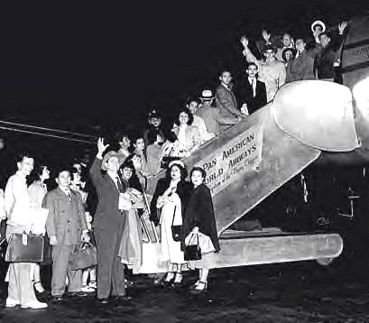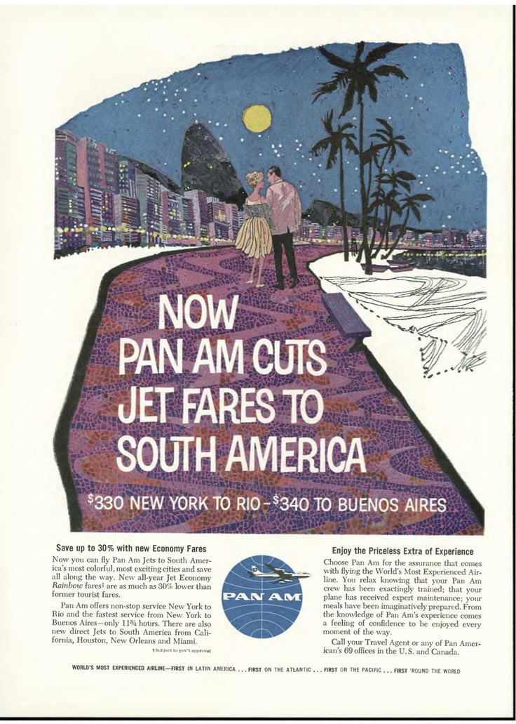

In the 1930s, trains became faster and transported many immigrants from Mexico and Canada. These trains from Mexico and Canada carried people until the 1970s when they ended due to lack of passengers. In 1960s, with the new jet airplane, flights became much faster and cheaper. Different American airlines began flying to further away places, like South America, the Caribbean, Asia, and Africa. This allowed more immigrants to take airplanes, instead of ships to the United States. It would only take a few hours by plane, instead of several days by ship. These two new transportation types, ships and planes, allowed more people from faraway places to immigrate to the United States.

WORKSHEET: 2-13.D

Source 3: Work Changes

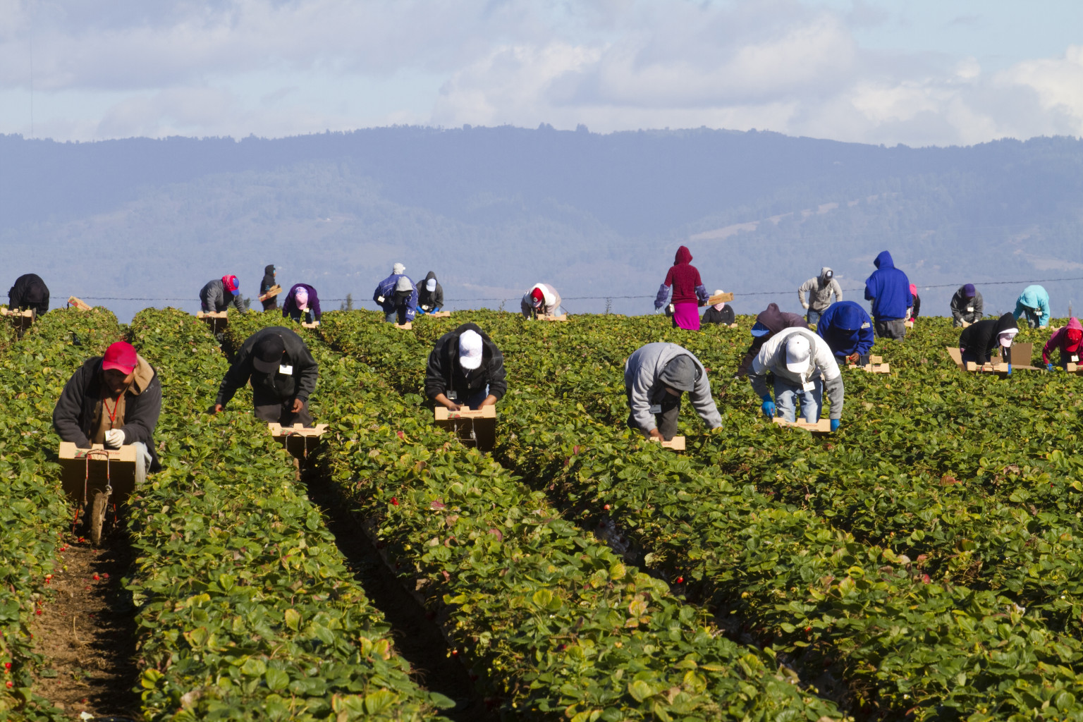

In 1994, the United States, Canada, and Mexico started the North American Free Trade Agreement (NAFTA). This allowed free trade (no taxes) on goods sold between the three countries. Cheaper corn and other crops from the United States hurt many Mexican farms. It also resulted in many U.S. factories moving to Mexico and Canada. Many Mexican farmers and their families moved to the United States for work. In 1980, there were 2.1 million Mexican immigrants living in the U.S. In 2000, there were 9.1 million Mexican immigrants living in the U.S. For the past 50 years, Mexicans have been one of the largest immigrant group coming to the United States.
WORKSHEET: 2-13.E

Source 4: Government Changes

In the 20th century, many governments were communist (countries where the government controls all stores) and they had dictators (leaders who are not elected). These countries did not allow their citizens to move to the United States. In the 1980s and 1990s, several countries ended communism. This included Poland (above), East Germany, Czechoslovakia, Romania, Bulgaria, and the Soviet Union (Russia). In the 1990s and 2000s, other communist countries began allowing their citizens to move to other places (which they did not allow before). This included China, Vietnam, Laos, and Cambodia. This allowed people from these countries to immigrate to the U.S. for the first time in many years.
ASSESSMENT: 2-13.F

Immigration in the 20th Century: Exit Ticket

Inquiry Question: In the 20th century, why did newer immigrants start coming from different countries (than before)?

After thinking about the different reasons, what was the most important reason why immigrants started coming from different countries in the 20th century? Include two pieces of evidence from the sources.

LESSON PLAN 2-14: What is a Refugee? A Case Study of Vietnam

MATERIALS

Vietnamese Refugees Video (Lesson2-14Video1) [Located in the UOW Video Library: www.christophercmartell.com/understandingourworld]
Source 1: Little Time to Prepare (WORKSHEET 2-14.A)
Source 2: Pirates (WORKSHEET 2-14.B)
Source 3: Broken Boats (WORKSHEET 2-14.C)
Source 4: Refugee Camps (WORKSHEET 2-14.D)
Vietnamese Refugees: Exit Ticket (ASSESSMENT 2-14.E)

STANDARDS

Massachusetts History and Social Science Framework

MA-HSS.2.7: On a map of the world, locate the continent, regions, or countries from which students, their parents, guardians, grandparents, or other relatives or ancestors came.

Common Core: Literacy

CCSS.ELA-Literacy.RI.2.9: Compare and contrast the most important points presented by two texts on the same topic.

CCSS.ELA-Literacy.RI.2.10: By the end of year, read and comprehend informational texts, including history/social studies, science, and technical texts, in the grades 2–3 text complexity band proficiently, with scaffolding as needed at the high end of the range.

CCSS.ELA-Literacy.W.2.8: Recall information from experiences or gather information from provided sources to answer a question.

PROCEDURES

Inquiry Question: If you were a refugee who came to the U.S. from Vietnam in the 1970s or 80s, what would have been the most difficult part of the journey?

PREPARATION

1. Post Definition of Refugee

Post the definition of refugee on the board or chart paper hidden from view. Refugee: A person who if forced to leave their home, often due to war or natural disaster.

A. OPENER (8 minutes)

2. Watch Video on Refugees
Tell students that they are going to watch a video that shows how some Vietnamese immigrants came to the United States because they were refugees. There was a war between North Vietnam and South Vietnam. At the end of that war, many people in South Vietnam needed to leave their country because of it. First, let’s discuss what a refugee is. Reveal the definition of refugee as “a person who if forced to leave their home, often due to war or natural disaster.” Tell the students that many of the immigrant groups that we have been studying came here because they wanted to. There were also immigrants who came here because they were forced to leave their homes and they are called refugees. We are going to watch a video about Van Nguyen (van win) who was a refugee from Vietnam when she was a little girl. She will tell us her story and all the difficult things she faced in her journey to the United States.

Have students watch a brief film Vietnamese Refugees Video (Lesson2-14Video1). Ask students about their reaction to this and questions like “Do you think Van, her mom, and dad were brave?” “Would it be really difficult for you to leave your home?” “Would it be scary getting on a boat and escaping in the middle of the night?” “Are you happy that Van and her mother were able to find their father and get their family back together in the United States?”

B. DEVELOPMENT (14 minutes)

3. Examine Sources As a Whole Class
Ask the students to read aloud (using choral, partner, or independent reading) the four documents in order on what refugees from Vietnam faced: Little Time to Prepare (WORKSHEET 2-14.A), Pirates (WORKSHEET 2-14.B), Broken Boats (WORKSHEET 2-14.C), Refugee Camps (WORKSHEET 2-14.D).

After reading each document, solicit from students what important facts should be underlined and highlighted about each source. Make sure to highlight examples of the great dangers that refugee face. Using the first worksheet, model looking for facts and taking notes for the students.

4. Discuss the Struggles that Refugees from Vietnam Faced
Ask students, after reading these sources, what do you think were the biggest problems that refugees from Vietnam faced? On the board or chart paper, take should take notes on what the students say. Anticipated responses may include: being forced to leave their homes, having to say goodbye to their relatives, getting on a boat, having things stolen by pirates, swimming to shore, living in a refugee camp, settling in a new country like the United States (different language, weather, etc.).

C. CLOSING (6 minutes)

5. Write Up Argument on Vietnamese Refugees
For the evaluation task, have the students complete the exit ticket (ASSESSMENT 2-14.E), where they write their own personal response to the lesson’s Inquiry Question: “If you were a refugee who came to the U.S. from Vietnam in the 1970s or 80s, what would have been the most difficult part of the journey?” Tell students to cite at least two pieces of evidence from the sources for this lesson.

Before using the exit ticket, consider using a graphic organizer or two column notes to prepare students for the writing task. Consider using sentence starters and modeling to help the students with their answer to the inquiry question.

D. EXTENSION

6. Learn About Present-Day Refugees and Write Local Officials
Use language arts time to have students to learn about present day refugees from places like Iraq, Syria, Haiti, and Central America (Newsela offers student-friendly current event articles). Write letters to political leaders (e.g. mayor, state representative, governor, congressperson, senator, president) about ways that we can help refugees to the United States settle here.

EVALUATION

ASSESSMENT 2-14.E

What to look for?

The students should take a stance on what would be the most difficult part about being a refugee. All arguments should cite at least 2 pieces of evidence from the sources.

Answers will vary based on guest speakers and students’ choice.

WORKSHEET: 2-14.A

Source 1: Little Time to Prepare

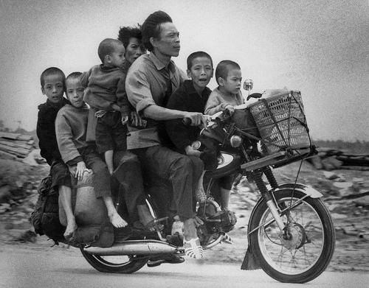
In the 1970s and 1980s, because of a war, many Vietnamese people fled their homes. They often left secretly in the middle of the night and could not tell their relatives good-bye. They thought that they might not see them ever again. They boarded small fishing boats or large passenger boats and sailed to nearby countries like Malaysia or Thailand. These people were called “boat people.” Some people would leave on roads to neighboring countries by using fake documents or bribing government workers. People would have to plan for months or even years and it would often cost them all their money.
WORKSHEET: 2-14.B

Source 2: Pirates

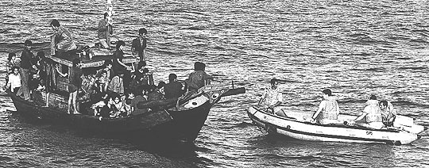

In 1980, there were more than 10,000 Vietnamese people each month fleeing their country on boats. Most of these boats were attacked by pirates or people who boarded the boats and demanded everyone’s money, jewelry, and food. This was scary for many of the people on the boat and they could get hurt or killed if they did not do what the pirates told them to do. One boat was even boarded by pirates over forty times.

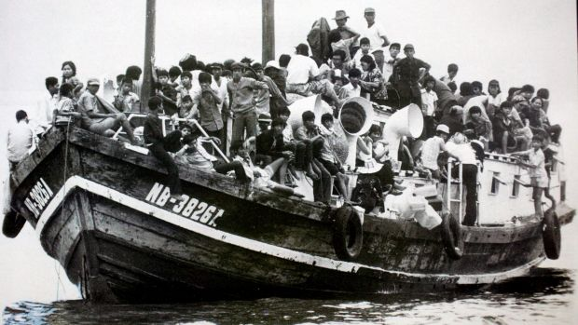
WORKSHEET: 2-14.C

Source 3: Broken Boats

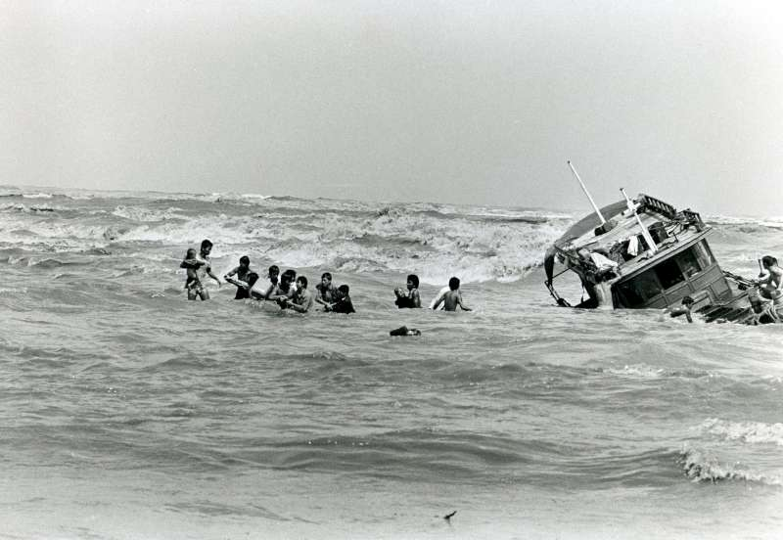

The boats that refugees had to travel on where not always in good shape and would break down. Sometimes the engines died or the boats got holes in their bottom. Other times storms would come and flood the boat. Many of these boats were not made for long distances and they would have to travel hundreds of miles to make it to Malaysia or Thailand. It took most boats 1-2 weeks to get to another country. Some lucky boats were rescued by fisherman, passenger ships, or large boats transporting goods across the ocean. Some unlucky boats took months to reach the shore.

WORKSHEET: 2-14.D

Source 4: Refugee Camps

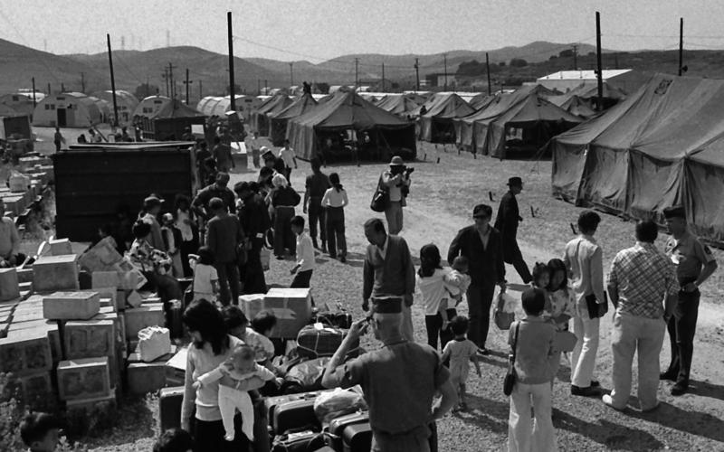

Many Vietnamese refugees immigrated to the United States, France, Canada, Australia, Britain, and Germany. They had to live in refugee camps. They stayed in tents and the military gave them food and clothes. Above is a picture from the refugee camp at Camp Pendleton in California. 1.6 million Vietnamese people went to the U.S. and other countries in the 1970s and 1980s. In Massachusetts, the Fields Corner section of Dorchester became one place for Vietnamese people to settle. It had cheaper housing and public transportation, which was very important for people who had to leave everything behind in their home country. Today, Dorchester has New England’s largest Vietnamese community with many Vietnamese stores, restaurants, and community organizations like Viet Aid.
ASSESSMENT: 2-14.E

Vietnamese Refugees: Exit Ticket

Inquiry Question: If you were a refugee who came to the U.S. from Vietnam in the 1970s or 80s, what would have been the most difficult part of the journey?

After thinking about the different struggles Vietnamese refugees faced, why do you think would be the hardest thing to face? Include two pieces of evidence from the sources.

LESSON PLAN 2-15: The Contributions of American Immigrants
[Albert Einstein, I.M. Pei, David Ortiz, Maria Hinojosa]

MATERIALS

American Immigrants Video (Lesson2-15Video1) [Located in the UOW Video Library: www.christophercmartell.com/understandingourworld]
Lined paper (not supplied)
Images (WORKSHEET 2-15.A)
Source 1: Science: Albert Einstein (WORKSHEET 2-15.B)
Source 2: Art and Music: I.M. Pei (WORKSHEET 2-15.C)
Source 3: Sports: David Ortiz (WORKSHEET 2-15.D)
Source 4: News and Media: Maria Hinojosa (WORKSHEET 2-15.E)
American Immigrants: Exit Ticket (ASSESSMENT 2-15.F)

STANDARDS

Massachusetts History and Social Science Framework

MA-HSS.2.10: After reading or listening to a variety of true stories about individuals recognized for their achievements, describe and compare different ways people have achieved great distinction (e.g. scientific, professional, political, religious, commercial, military, athletic, or artistic). (H)

MA-HSS.2.CS.7: Give examples of fictional characters or real people in the school or community who were good leaders and good citizens, and explain the qualities that made them admirable (e.g., honesty, dependability, modesty, trustworthiness, courage). (C)

Common Core: Literacy

CCSS.ELA-Literacy.RI.2.9: Compare and contrast the most important points presented by two texts on the same topic.

CCSS.ELA-Literacy.RI.2.10: By the end of year, read and comprehend informational texts, including history/social studies, science, and technical texts, in the grades 2–3 text complexity band proficiently, with scaffolding as needed at the high end of the range.

CCSS.ELA-Literacy.W.2.8: Recall information from experiences or gather information from provided sources to answer a question.

PROCEDURES

Inquiry Question: Which of the featured American immigrants do you think made the largest contribution to the United States?

A. OPENER (5 minutes)

1. Anticipation Images
Project the Images (WORKSHEET 2-15.A) for the class. Write on the board or chart paper, “What do you think these four people might have in common?” Do not give students help and write down their ideas on the board or chart paper. Anticipated responses may include: they are famous, they live in cities, they live in Boston, they are smart, they are happy, they are for other countries. After 1-2 minutes, ask students if they know any of their names and if they already know some things about them (Albert Einstein-scientist, I.M. Pei-architect, David Ortiz-baseball player, Maria Hinojosa-journalist/on television and radio). Reveal to the students that all four of these people are immigrants, who were born in other countries, and came to the United States. Today, we will learn about each of these different people and how they made the United States a better place.

2. Watch Video on American Immigrants
Tell students that they will now watch a video with a short clip from each of the immigrants who came to the United States and they will talk about their work and what is important to them. Have students watch a brief video American Immigrants Video (Lesson2-15Video1). Ask students about their reaction to this and questions like “What important things did each person tell us about their life or work?”

B. DEVELOPMENT (15 minutes)

3. Read About Different American Immigrants
Put students in small groups and assign them one of the sources: Science: Albert Einstein (WORKSHEET 2-15.B), Art and Music: I.M. Pei (WORKSHEET 2-15.C), Sports: David Ortiz (WORKSHEET 2-15.D), News and Media: Maria Hinojosa (WORKSHEET 2-15.E). Have one student from each group read their source. As the student reads, tell the other group members to underline or highlight any important information. Handout lined paper. Ask students to write down 3-4 important facts about their American immigrant.

4. Engage in a Jig Saw on American Immigrants
Have students participate in a jig saw activity. Make new groups where at least one student from each of the original groups is included. This will create several new groups of three students, one is an expert on 2-15.B, 2-15.C, 2-15.D, 2-15.E. Have each student describe their document to the other members of their group.
Ask students to use the sources to answer the following inquiry question: “Which of the featured American immigrants do you think made the largest contribution to the United States?” In answering this question, students should debate between the four different worksheets and consider which person did the most important things. After students have discussed the question, they should complete the exit ticket in the following step. Circulate the room, helping the students who may have difficulty choosing one person or finding evidence to support their choice.

D. CLOSING (10 minutes)

5. Write Up Argument on American Immigrants
For the evaluation task, have the students complete the exit ticket (ASSESSMENT 2-15.E), where they write their own personal response to the lesson’s Inquiry Question: “Which of the featured American immigrants do you think made the largest contribution to the United States?” Tell students to cite at least two pieces of evidence from the sources for this lesson.

Before using the exit ticket, consider using a graphic organizer or two column notes to prepare students for the writing task. Consider using sentence starters and modeling to help the students with their answer to the inquiry question.

EVALUATION

ASSESSMENT 2-15.E

What to look for?

The students should take a stance on which immigrant made the most important contribution to the United States. All arguments should cite at least 2 pieces of evidence from the sources.

Some information that students may include in their answer to the question:

Albert Einstein
- Discovered important scientific concepts, like the theory of relativity, which is about the speed of light
- His ideas would lead to the invention of atomic energy, a better design for solar panels, and a refrigerator that requires almost no energy
- He would win a Nobel Prize for Physics

I.M. Pei
- Designed many important buildings in Boston, like the new John Hancock Building, the Museum of Fine Arts West Wing, and the JFK Library
- Went to important universities
- He wants complex buildings to also be simple
- His buildings are some of the most well-known and important in the world, like the Louvre Museum in Paris

David Ortiz
- One of the greatest baseball players in history
- He says you should be a good person on and off the field
- Was fun to watch play baseball (was a Red Sox player)
- Attended 10 All-Star Games and won 3 World Series. He has the Red Sox record for most home runs in a season at 54
- Will probably be in the Baseball Hall of Fame one day

Maria Hinojosa
- Is an important journalist and reporter
- She supports immigrants
- Host an important show on Latinos on National Public Radio
- Host an important show interviewing people on the Public Broadcasting System
- Won four Emmy Awards

WORKSHEET: 2-15.A

Images

WORKSHEET: 2-15.B

Source 1: Science: Albert Einstein

Many important scientists were immigrants to the United States. Albert Einstein came to the U.S. from Germany in 1933. He was 54 years old. He was a famous scientist in Germany and he came to the United States because laws were being created against Jewish people. He would become one of the most well-known scientists in the world because his “theory of relativity” about the speed of light. He also had many other scientific theories. Einstein’s ideas would lead to the invention of atomic energy, a better design for solar panels, and a refrigerator that requires almost no energy. He would win a Nobel Prize for Physics.

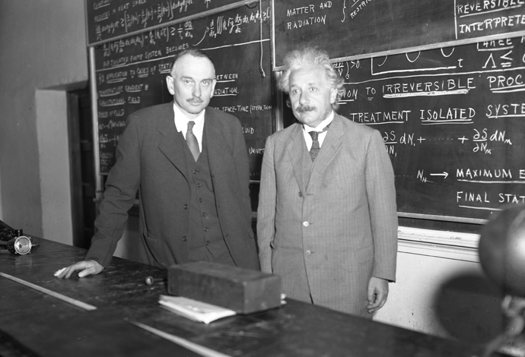
WORKSHEET: 2-15.C

Source 2: Art and Music: I.M. Pei

Many important artists, musicians, and architects were immigrants to the United States. I.M. Pei came to the U.S. from China in 1935. He was 18 years old. He came to attend college at the University of Pennsylvania and later the Massachusetts Institute of Technology. He then became an architect, who designed buildings. I.M. Pei designed some of the most famous buildings in the world, including the Louvre Art Museum in Paris (above). In Boston, he designed the John F. Kennedy Presidential Library in Dorchester and the new John Hancock Building in Copley Square and the Museum of Fine Arts West Wing in the Fenway (below).

WORKSHEET: 2-15.D

Source 3: Sports: David Ortiz

Many important athletes and coaches were immigrants to the United States. David Ortiz came to the U.S. from the Dominican Republic in 1992. He was 17 years old. He came to play first base on a minor league baseball team called the Wisconsin Timber Rattlers. As a kid, he was friends with fellow Dominican baseball player Pedro Martinez. They would eventually end up on the same team, the Boston Red Sox. He would also gain the nickname “Big Papi.” In his 20 years playing baseball, David Ortiz attended 10 All-Star Games and won 3 World Series. He has the Red Sox record for most home runs in a season at 54. He is considered one of the greatest designated hitters (a player who only bats) and will likely be in the Baseball Hall of Fame someday.
WORKSHEET: 2-15.E

Source 4: News and Media: Maria Hinojosa

Many important reporters and journalists were immigrants to the United States. Maria Hinojosa (hin-o-yo-sa) came to the U.S. from Mexico in the 1962. She was 1 year old. She came with her family, who moved to Chicago because of her father’s new job. She routinely visited her family in Mexico, which she says helped her always feel both American and Mexican. She wanted to be an actress, but in college decided instead to become a journalist, or someone who reports news stories. Today, Maria Hinojosa is a well-known journalist for National Public Radio (NPR) and the Public Broadcasting System (PBS). She often reports on stories related to the Latino community and she hosts two shows called Latino USA and One-on-One. She has won many awards for her reporting, including four Emmy Awards.

ASSESSMENT: 2-15.F

American Immigrants: Exit Ticket

Inquiry Question: Which of the featured American immigrants do you think made the largest contribution to the United States?

After thinking about the different ways that immigrants have contributed or added to the United States, explain which recent immigrant had the most important impact on the country.

LESSON PLAN 2-16: Immigration Today: How Do People Come to the U.S.?

MATERIALS

Banico Family Video (Lesson2-16Video1) [Located in the UOW Video Library: www.christophercmartell.com/understandingourworld]
Source 1: Taking a Flight from China (WORKSHEET 2-16.A)
Source 2: Riding the Bus from Canada (WORKSHEET 2-16.B)
Source 3: Driving from Mexico (WORKSHEET 2-16.C)
Source 4: Taking a Flight from Slovakia (WORKSHEET 2-16.D)
Immigration Today—Challenges: Exit Ticket (ASSESSMENT 2-16.E)

STANDARDS

Massachusetts History and Social Science Framework

MA-HSS.2.10: After reading or listening to a variety of true stories about individuals recognized for their achievements, describe and compare different ways people have achieved great distinction (e.g. scientific, professional, political, religious, commercial, military, athletic, or artistic). (H)

MA-HSS.2.CS.7: Give examples of fictional characters or real people in the school or community who were good leaders and good citizens, and explain the qualities that made them admirable (e.g., honesty, dependability, modesty, trustworthiness, courage). (C)

Common Core: Literacy

CCSS.ELA-Literacy.RI.2.9: Compare and contrast the most important points presented by two texts on the same topic.

CCSS.ELA-Literacy.RI.2.10: By the end of year, read and comprehend informational texts, including history/social studies, science, and technical texts, in the grades 2–3 text complexity band proficiently, with scaffolding as needed at the high end of the range.

CCSS.ELA-Literacy.W.2.8: Recall information from experiences or gather information from provided sources to answer a question.

PROCEDURES

Inquiry Question: What is the most difficult challenge immigrants face today?

A. OPENER (5 minutes)

1. Watch the Banico Family Video
Tell students that they are going to watch a video that tells a brief story about how the Banico (ba-nee-co) family immigrated from the Philippines to Canada. Have students watch the Banico Family Video (Lesson2-16Video1). Stop the video at important points to explain things to students, such as how the family’s mother immigrated first by herself, the family had never seen snow before coming to Canada, they had to sign up for school, they had to work hard jobs/had a hard time finding work, they struggled to learn a new language (English). Ask students about their reaction to this and questions like “What were some of the difficult challenges the Banico family faced?” Ask students if they, their family, or friends are immigrants and what challenges did they face? How is it similar or different to the Banico family? Write on the board or chart paper the list of challenges that immigrants face today.

A Note on the Topic:
This lesson discusses different ways that immigrants come to the United States. One of the sources (WORKSHEET 2-16.D) will discuss undocumented immigration. Be aware that you may have students who are undocumented. You may have students who have heard or use terms like “illegals” or “illegal immigrants.” This curriculum purposely does not use those terms and instead uses “undocumented immigrants.” “Illegal immigrants” or “illegals” are not formal terms and are not used in legislation or court cases, and are considered by many to be pejoratives and offensive. Teachers should help educate students on the correct academic language to use around immigration. It is important during this activity to emphasize that some people may choose to come here without permission from the government for many reasons and they have not committed a crime by living here without permission (as ruled by the Supreme Court in Arizona v. United States, 2012), but they can be deported (removed from the country). Here is a good explanation from the New York Times on their language use around immigration: https://www.nytimes.com/2017/03/10/insider/illegal-undocumented-unauthorized-the-terms-of-immigration-reporting.html

This lesson intentionally uses a same-sex couple to expose students to different types of families. Students may have questions about same-sex couples. We advise that you address any questions and emphasize that different families include different family members. For instance, some families include a mother and father, only a mother or a father, two mothers, two fathers, grandparents, or foster parents. The family depicted here has two fathers.

B. DEVELOPMENT (15 minutes)

2. Read About Different Ways to Immigrant Today
Pass out the sources: Taking a Flight from China (WORKSHEET 2-16.A), Riding the Bus from Canada (WORKSHEET 2-16.B), Driving from Mexico (WORKSHEET 2-16.C), Taking a Flight from Slovakia (WORKSHEET 2-16.D). Have students take turns reading aloud (using choral, partner, or independent reading) each source.

3. Write Diary Entry
Explain that a diary is a journal or writing that people do once a day to remember things about their day. They are going to write a diary entry pretending that they are a child today who is immigrating to the United States from another country. Tell them to choose a country that they would like to pretend to be an immigrant from and how they will get here (plane, bus, car). If students have a hard time thinking of a country, suggest possibly using the following (and write on the board or chart paper): China (plane), Haiti (plane), Nigeria (plane), Ireland (plane), Canada (bus, car), or Mexico (car). Tell them to include in their diary entries some of the information in the sources and the video of the Banico family that we watched at the beginning of class. Give students access to computer to watch the video again, if it is helpful for their writing.

The diary entries (ASSESSMENT 2-16.E) will serve as the evaluation task. Students’ diary entries will address the lesson’s Inquiry Question: “What is the most difficult challenge immigrants face today?” Tell students to cite at least two pieces of evidence from the sources or video for this lesson.

Before using the exit ticket, consider reading students some exemplar diary entries that you prepared. Consider using sentence starters and modeling to help the students with their answer to the inquiry question.

C. CLOSING (6 minutes)

5. Share Letters
Have students share their diary entries with the class. Draw comparisons between the different students’ stories and list them on the board or chart paper.

EVALUATION

ASSESSMENT 2-16.E

What to look for?

The students should write diary entries from the perspective of a new immigrant to the United States. All arguments should cite at least 2 pieces of evidence from the sources.

Some information that students may include in their journal entries:
- Being afraid of coming to a new country
- Having trouble speaking/learning the language
- Having to work difficult jobs/having trouble finding a job
- Being undocumented
- Having different weather from your home country
- Having to go to a new school

WORKSHEET: 2-16.A

Source 1: Taking a Flight from China

This is the Chin family. They immigrated from China to California. They flew on an airplane from Shanghai to San Francisco. The father of the family was accepted as a university student and he received a visa, which allowed him and his family to come to the country. When they entered the country at the airport, they needed to show their passports and visas, get fingerprinted, and be interviewed by an immigration officer. Although the parents spoke English, their children only spoke Mandarin Chinese. They had to learn English in school and it took a long time. After graduating, the father was able to find a job at a computer company. After 5 years, the family became citizens. The next year, they were allowed to bring his wife’s parents to the United States.

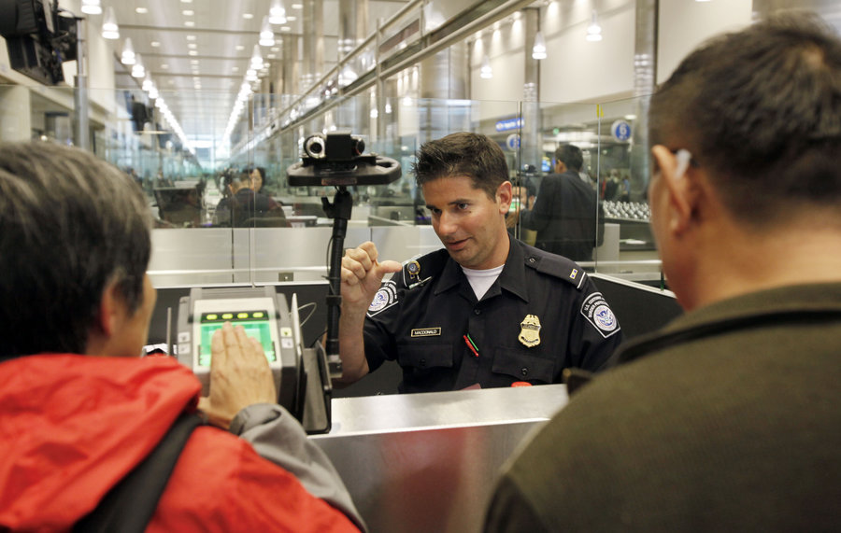

WORKSHEET: 2-16.B

Source 2: Riding the Bus from Canada

This is the MacDonald-Smith family. They immigrated from Canada to New York. They rode on a bus from Toronto to New York City. One of the fathers was born in the United States and he was an American citizen. This allowed him to bring his husband and children to the United States. When their bus crossed the border into the U.S., an immigration officer boarded the bus. They needed to show their passports and visas, get fingerprinted, and be interviewed. Everyone in the family speaks English, because it is one of the languages of Canada. When they arrived in the United States, the parents had to sign their children up for school and find jobs.
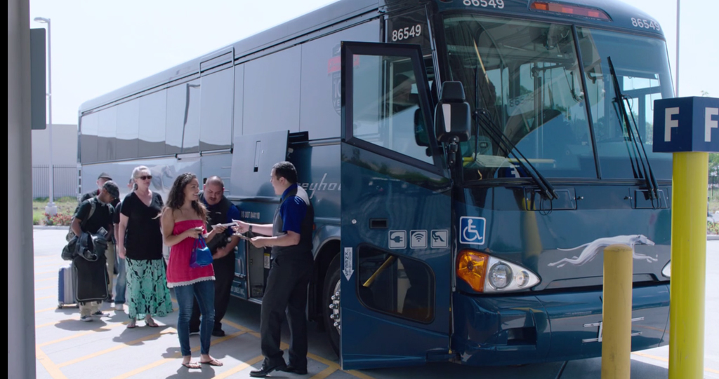

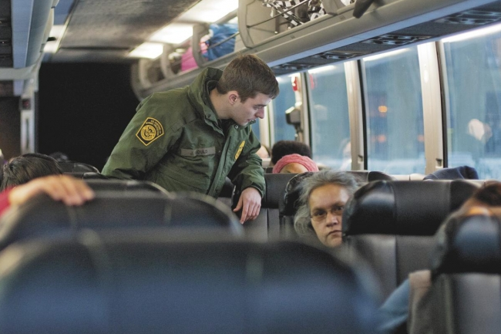
WORKSHEET: 2-16.C

Source 3: Driving from Mexico

This is the Hernandez family. They immigrated from Mexico to Texas. They drove their minivan from Mexico City to San Antonio. The mother was an engineer in Mexico and an American company brought her here on a work visa. The family had to wait 4 years to come to the United States. They had an uncle who lived in San Antonio. They arrived at his house and lived with his family for several months. Only the mother could speak English, so everyone else started taking English classes. The parents signed their children up for school. After 5 years, the family became citizens.

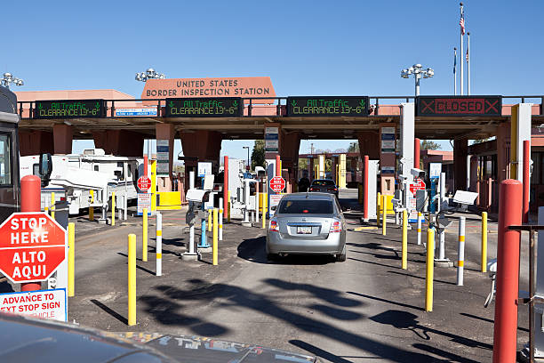

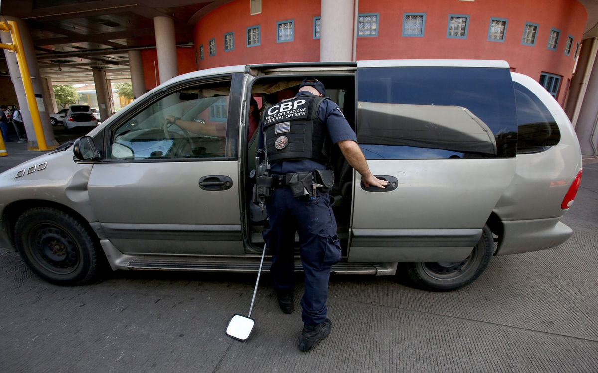
WORKSHEET: 2-16.D

Source 4: Taking a Flight from Slovakia

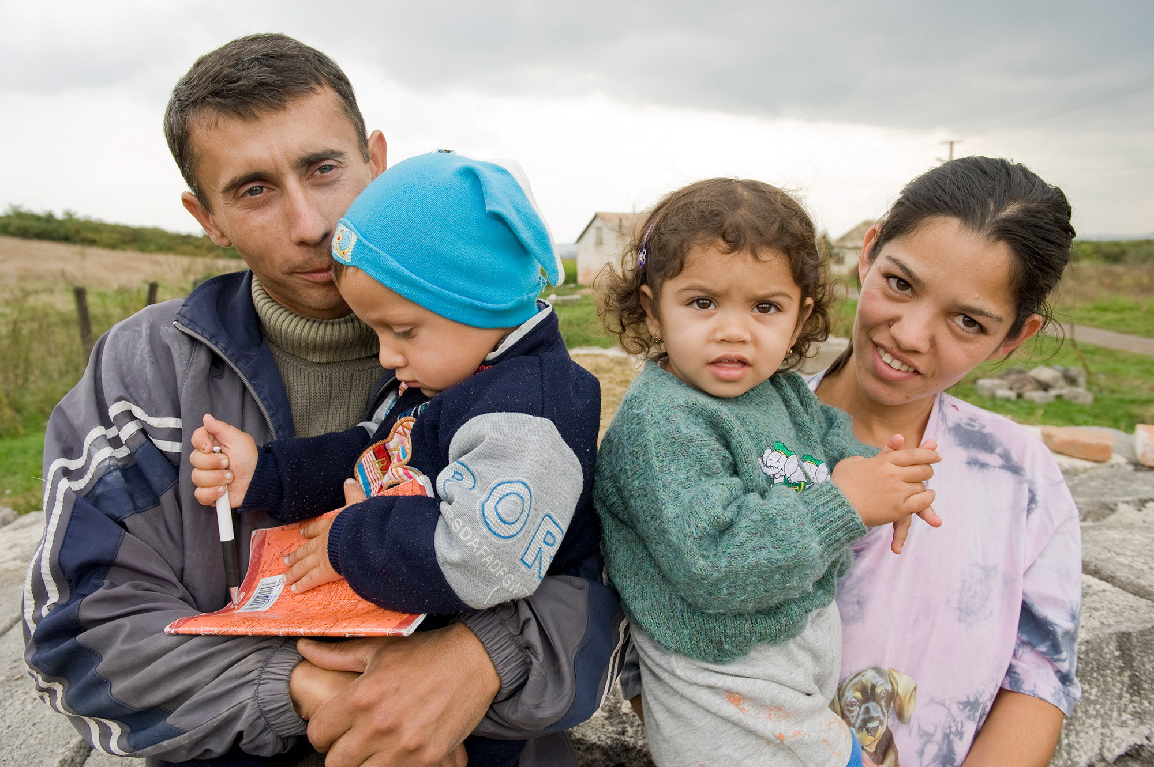

This is the Kováč family. They immigrated from Slovakia to Pennsylvania. They flew on an airplane from Bratislava to Pittsburgh. Both parents could not find work in Slovakia. Since many people from Slovakia want to come to the United States, they were told that they would have to wait many years to come here. The parents made a difficult decision to come to the United States without papers (undocumented). The U.S. let them visit as tourists and they stayed for longer. No one in the family could speak English, so they started taking English classes. The parents signed their children up for school and found jobs in a local restaurant. They worry that there is a chance that the U.S. government will find out that they do not have documents and they could be forced to return to Slovakia.

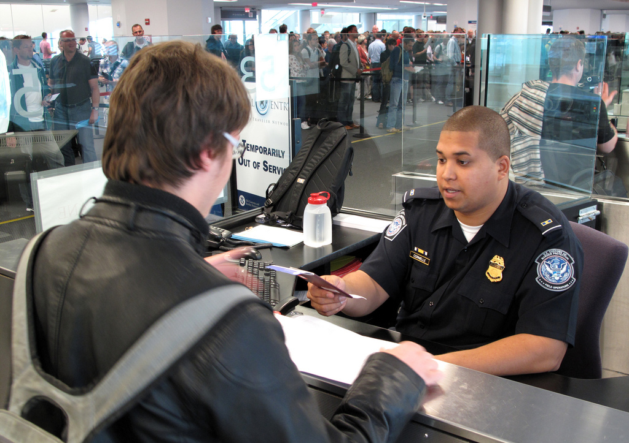
ASSESSMENT: 2-16.E

Immigration Today—Challenges: Exit Ticket

Inquiry Question: What is the most difficult challenge immigrants face today?

Imagine that you just emigrated to the United States. Pick a country, choose a transportation (plane, bus, car), and write a diary entry about your travels here. Be sure to discuss at least one important challenge you would face based on the sources.

LESSON PLAN 2-17: Boston: A City of Immigrants

MATERIALS

Images (WORKSHEET 2-17.A)
Letter to the Editor (WORKSHEET 2-17.B)
Source 1: History of Immigration (WORKSHEET 2-17.C)
Source 2: Many Cultures Living Together (WORKSHEET 2-17.D)
Source 3: Important Part of the Economy (WORKSHEET 2-17.E)
Source 4: Global Center for Art and Music (WORKSHEET 2-17.F)
Boston: A City of Immigrants: Exit Ticket (ASSESSMENT 2-17.G)

STANDARDS

Massachusetts History and Social Science Framework

MA-HSS.2.10: After reading or listening to a variety of true stories about individuals recognized for their achievements, describe and compare different ways people have achieved great distinction (e.g. scientific, professional, political, religious, commercial, military, athletic, or artistic). (H)

MA-HSS.2.CS.7: Give examples of fictional characters or real people in the school or community who were good leaders and good citizens, and explain the qualities that made them admirable (e.g., honesty, dependability, modesty, trustworthiness, courage). (C)

Common Core: Literacy

CCSS.ELA-Literacy.RI.2.9: Compare and contrast the most important points presented by two texts on the same topic.

CCSS.ELA-Literacy.RI.2.10: By the end of year, read and comprehend informational texts, including history/social studies, science, and technical texts, in the grades 2–3 text complexity band proficiently, with scaffolding as needed at the high end of the range.

CCSS.ELA-Literacy.W.2.8: Recall information from experiences or gather information from provided sources to answer a question.

PROCEDURES

Inquiry Question: How does being a city of immigrants make Boston better?

PREPARATION

This lesson uses a method called Visual Thinking Strategy (VTS). The key to VTS is that you as a teacher only do two things: (1) Ask the following questions and (2) repeat as precisely as possible exactly what the students say.

Visual Thinking Strategy Questions:
- Open with: “What’s going on in this picture?”
Summarize student responses using conditional language (“Raoul thinks this could be…”). This keeps the conversation open to other interpretations by other students.
- If appropriate: “What do you see that makes you say that?”
This encourages students to back up their statements with things they see in the work of art.
- Ask the group: “What more can we find?”
This continues the conversation.

If this is your first time using VTS, we recommend reading this description with a video example from Grade 1 produced by the Milwaukee Art Museum: http://teachers.mam.org/collection/teaching-with-art/visual-thinking-strategies-vts/

A. OPENER (8 minutes)

1. Engage in a Visual Thinking Strategy (VTS) on Tenement Images
Give students the Images (WORKSHEET 2-17.A). Do not reveal that this is an image of Boston’s Chinatown during the New Year’s Lion Dances. Project the first image (Lettered “A”) and tell the students to look at the image closely and quietly. Give them about one minute. Next, begin the VTS question about the image. Use the above questions, following VTS instructions. Have students inquire about the question using the above questions for about 2-3 minutes.

Project the second image (Lettered “B”). Do not reveal that this is an image of a girl marching in costume during Boston’s Caribbean Carnival. Tell the students to look at the image closely and quietly. Give them about one minute. Next, begin the VTS question about the image. Use the above questions, following VTS instructions. Have students inquire about the question using the above questions for about 2-3 minutes.

Tell students they had many good observations of the pictures. Today, we will be learning about how modern-day Boston is a city of immigrants. We were just looking at two events that happen every year in Boston that celebrate our immigrant roots. The first image was of the lion dances that happen in Chinatown every year during Chinese New Year’s. Different groups go around Chinatown performing dances in lion costumes and lighting firecrackers. They feed the lions lettuce and oranges for good luck and people dressed as Buddha walk alongside the lions. The second image was of Boston’s Caribbean Carnival that happens each summer. Different groups parade dancing in bright and sometimes very large costumes from the Caribbean islands, including Barbados, Trinidad and Tobago, Haiti, Jamaica, Antigua, and Dominica. Tell students that today we are going to learn about the ways that immigrants make Boston a better community. We will then write imaginary letters to the editors of our local paper to convince others that immigrants make Boston a great place to live.

B. DEVELOPMENT (15 minutes)

2. Read About Different Aspects of Boston Immigration
Pass out the sources: History of Immigration (WORKSHEET 2-17.C), Many Cultures Living Together (WORKSHEET 2-17.D), Important Part of the Economy (WORKSHEET 2-17.E), Global Center for Art and Music (WORKSHEET 2-17.F). Have students take turns reading aloud (using choral, partner, or independent reading) each source.

3. Write a Letter to the Editor
Tell students that we will now write letters to the editor of our local newspaper. Tell students that you will first show them an example of a letter to the editor. Read to them Letter to the Editor (WORKSHEET 2-17.B), which is an imaginary letter to the editor about why people should shovel their sidewalks after a snow storm. Ask the students to tell you what the purpose of this letter was. How did the writer try to convince you or change your mind on something?

Explain to students that people write letters to the editor, who is the person who runs the newspaper, when they want to convince other people of something. The editor may decide to put this letter in their newspaper. Tell the students that they are going to write a pretend letter to the editor explaining the reasons why immigrants make Boston better. They should look at the sources and choose one or more than one reasons why immigrants make Boston better.

The letters to editors (ASSESSMENT 2-17.G) will serve as the evaluation task. Students’ diary entries will address the lesson’s Inquiry Question: “How does being a city of immigrants make Boston better?” Tell students to cite at least two pieces of evidence from the sources.

Before using the exit ticket, consider reading students some exemplar letters to the editors that you prepared. Consider using sentence starters and modeling to help the students with their answer to the inquiry question.

C. CLOSING (6 minutes)

4. Share Letters to the Editor
Have students share their letters to the editor with the class. Draw comparisons between the different students’ stories and list them on the board or chart paper.

EVALUATION

ASSESSMENT 2-17.G

What to look for?

The students should write letters to the editor making an argument for why immigrants make Boston better. All arguments should cite at least 2 pieces of evidence from the sources.

Some information that students may include in their journal entries:
- Boston has been an immigrant city for hundreds of years
- Immigrants have come from all over the world, including England, Ireland, Poland, Russia, Italy, French Canada, Dominican Republic, Vietnam, Haiti, Cape Verde, and China, as well as migrants from the American South and Puerto Rico
- They make Boston a cosmopolitan city, where people from many countries come together
- They make Boston have many different cultures, languages, foods, festivals, and fashions
- Immigrants make up 28% (3 in 10) of Boston’s population
- Our economy could not work without immigrants
- Many own small businesses (5,500)
- They spend over $3 billion a year
- They contribute over $1 billion in taxes a year, which pay for schools, parks, fire, police, and roads
- 1 in 4 immigrants are managers or run businesses
- 1 in 4 immigrants work in sales or technology
- 1 in 10 immigrants work in construction
- They are important artists, musicians, poets, and writers
- Their art and music teaches Bostonians about different parts of the world and makes this a place known around the world

WORKSHEET: 2-17.A

Images (A)

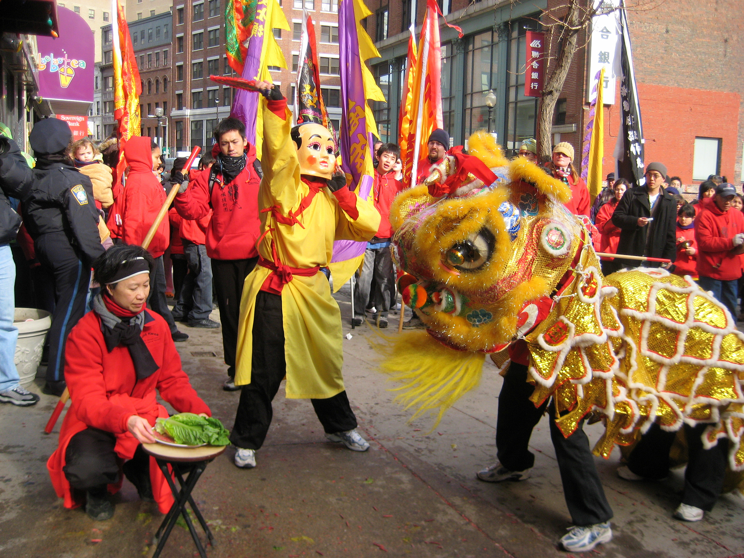
Images (B)

WORKSHEET: 2-17.B

Letter to the Editor

To the Editor,

It is important that everyone shovel their sidewalks when it snows. First, many people use the sidewalks to get to work and school. When they are not shoveled, it makes it difficult for many people to get to where they are going. Second, people will sometimes walk in the street, if the sidewalks are not shoveled. They could get hurt by a passing car. Third, many people need a wheelchair or use a cane. If the sidewalks are not shoveled, it is very hard for them to get around. I would ask that everyone in Boston make sure to shovel their sidewalks after snow storms.

Sincerely,
[Your name]

WORKSHEET: 2-17.C

Source 1: History of Immigration

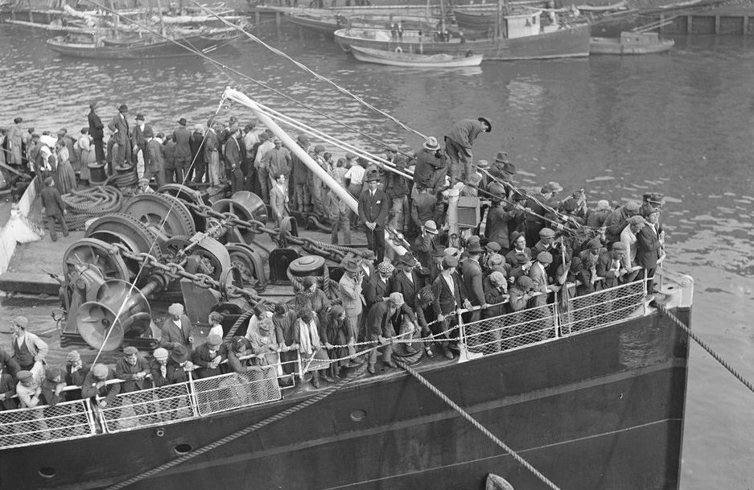

Boston has a long history of being a city of immigrants. For example, above is an image of immigrants from Ireland arriving in Boston in 1920. The first immigrants came to Boston in 1630. Since then, millions of immigrants over the years have made Boston their home. In the 1600s, 1700s, and 1800s, many immigrants to Boston came from England and later Ireland. In the early 1900s, many immigrants to Boston came from Ireland, Italy, Russia, Poland, and French Canada, and African American migrants from the southern United States. In the late 1900s, many immigrants came from the Dominican Republic, Vietnam, Haiti, Cape Verde, and China, and migrants from Puerto Rico. Boston has a long history of being a place for immigrants.

WORKSHEET: 2-17.D

Source 2: Many Cultures Living Together

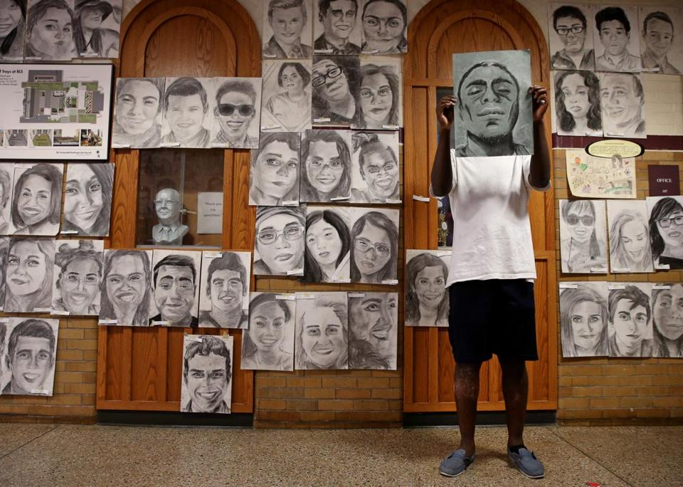

Boston is often described as “cosmopolitan,” which means a place where many different nations or countries come together. Today, 28% (3 in 10) of the people in Boston are immigrants from other countries. 1 in 3 people in Boston speak a language other than English. Over 100 languages are spoken here. Boston’s immigrants come from Asia, South America, Africa, and Europe. Phillip Sossou was a senior at Boston Latin Academy. He wanted to show how his school had so many different cultures, so he drew each of his classmates and posted their pictures on his school’s walls (above). In Boston, you can experience the world’s different cultures, languages, foods, festivals, and fashion, without ever leaving the city.
WORKSHEET: 2-17.E

Source 3: Important Part of the Economy

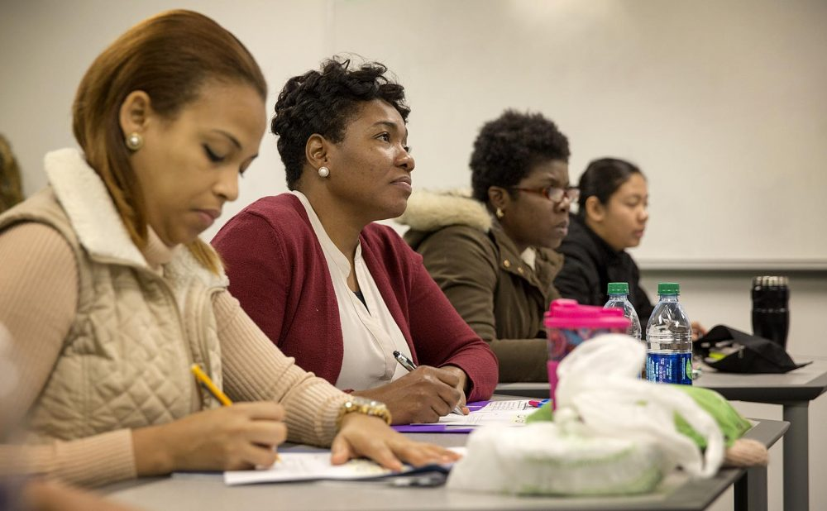

Immigrants are an important part of Boston’s economy. They spend over $3 billion dollars a year in the city. They pay $1 billion in taxes each year, which pay for schools, parks, fire, police, and roads. They run over 5,500 small businesses. Immigrants work in every type of job in the Boston. 1 in 4 immigrants are managers or run businesses. 1 in 4 immigrants work in sales or technology. 1 in 10 immigrants work in construction. If we did not have immigrants, it would be very difficult for our economy (how we buy and sell things) to run.

WORKSHEET: 2-17.F

Source 4: Global Center for Art and Music

Many artists, musicians, poets, writers, and actors are immigrants to Boston. This makes Boston a place known around the world for its art and music. Salvador Jiménez-Flores (above) immigrated to Chicago from Mexico. He later moved to Boston where he is an artist-in-residence at Harvard University. His sculptures and paintings often have images from Mexico. This helps people in Boston know more about the country where he came from. Since so many artists, musicians, poets, and writers come from other places, it makes Boston a place where you can experience art and music from around the world.

ASSESSMENT: 2-17.G

Boston: A City of Immigrants: Exit Ticket

Inquiry Question: How does being a city of immigrants make Boston better?

Imagine that you are writing a letter to the editor of a local newspaper. Explain why you think immigrants are an important part of the city of Boston. Use the sources to explain the ways that you think immigrants make Boston a better city. You can focus on one or more than one.

To the Editor,

LESSON PLAN 2-18: Immigration Today: Naturalization

MATERIALS

Citizenship Test (WORKSHEET 2-18.A)
Steps to Becoming a Citizen (Naturalization) (WORKSHEET 2-18.B)
Source 1: Citizenship Test Is Working (WORKSHEET 2-18.C)
Source 2: Citizenship Test Questions Need to Change (WORKSHEET 2-18.D)
Source 3: Passing a Test Does Not Mean Being a Good Citizen (WORKSHEET 2-18.E)
Immigration Today—Citizenship: Exit Ticket (ASSESSMENT 2-18.F)

STANDARDS

Massachusetts History and Social Science Framework

MA-HSS.2.10: After reading or listening to a variety of true stories about individuals recognized for their achievements, describe and compare different ways people have achieved great distinction (e.g. scientific, professional, political, religious, commercial, military, athletic, or artistic). (H)

MA-HSS.2.CS.7: Give examples of fictional characters or real people in the school or community who were good leaders and good citizens, and explain the qualities that made them admirable (e.g., honesty, dependability, modesty, trustworthiness, courage). (C)

Common Core: Literacy

CCSS.ELA-Literacy.RI.2.9: Compare and contrast the most important points presented by two texts on the same topic.

CCSS.ELA-Literacy.RI.2.10: By the end of year, read and comprehend informational texts, including history/social studies, science, and technical texts, in the grades 2–3 text complexity band proficiently, with scaffolding as needed at the high end of the range.

CCSS.ELA-Literacy.W.2.8: Recall information from experiences or gather information from provided sources to answer a question.

PROCEDURES

Inquiry Question: Is it fair how we choose who can become a citizen?

A. OPENER (8 minutes)

1. Engage Students in the “Citizenship Test”
Tell students that today we will be learning about how a person can become a U.S. citizen. One of the things that new citizens need to do is pass a citizenship test. Give students Citizenship Test (WORKSHEET 2-18.A). Do not give students the answer sheet. Tell students to use to answer the questions. Tell students that some questions may be hard, so you can take a wild guess or leave it blank if it is too hard. After all students are finished answering questions, reveal the answers found on the answer page. Have students put a check mark next to the questions that had correct answers. Ask students if they thought the questions were hard or easy and why. Next handout the Steps to Becoming a Citizen (WORKSHEET 2-18.B). Read the 5 steps to becoming a citizen to the students. Tell them that becoming a citizen is called “naturalization.” Ask students if they think any of the steps are fair or unfair. Anticipated responses may include: $725 is too much money/shouldn’t have to pay anything, shouldn’t have to pass the test/should have to pass the test, should be able to become a citizen sooner that/later than 5 years, you should/shouldn’t be fingerprinted.

B. DEVELOPMENT (12 minutes)

2. Read Arguments About the Citizenship Test
Put students in small groups. Pass out the sources: Citizenship Test Is Working (WORKSHEET 2-18.C), Citizenship Test Questions Need to Change (WORKSHEET 2-18.D), Passing a Test Does Not Mean Being a Good Citizen (WORKSHEET 2-18.E). Have students take turns reading aloud (using choral, partner, or independent reading) each source. As the student reads, tell the other group members to underline or highlight any important information.

3. Discuss the Citizenship Test: Keep or Change?
Ask students to use the sources to discuss the following inquiry question: “Is it fair how we choose who can become a citizen?” In answering this question, students should debate between the three different worksheets and consider if: (1) the current test is good, (2) the test can be better, or (3) should be community service instead. After students have discussed the question and the sources, they should complete the exit ticket in the following step. Tell them it is okay if they have a different argument than their group discussed. Circulate the room, helping the students who may have difficulty choosing coming to a decision and finding evidence to support it.

C. CLOSING (6 minutes)

4. Write Up Argument About the Citizenship Test
For the evaluation task, have the students complete the exit ticket (ASSESSMENT 2-18.F), where they write their own personal response to the lesson’s Inquiry Question: “Is it fair how we choose who can become a citizen?” Tell students to cite at least two pieces of evidence from the sources for this lesson.

Before using the exit ticket, consider using a graphic organizer or two column notes to prepare students for the writing task. Consider using sentence starters and modeling to help the students with their answer to the inquiry question.

EVALUATION

ASSESSMENT 2-18.F

What to look for?

The students should take a stance on how we should decide who becomes a citizen. All arguments should cite at least 2 pieces of evidence from the sources.

Some information that students may include in their answer to the question:

The current test is good
- It includes questions on U.S. history and government
- Every citizen needs to know about their government to be a good citizen
- Many people/students born in the U.S. cannot pass it

The test can be better
- People can study (CDs, flash cards, courses) and easily pass the current test
- The test should ask questions about being a good citizen
- Knowing about U.S. history or government does not mean a person will be a good citizen

Should be community service instead
- It should be showing that you helped your community or the United States
- Being a good member of the community before becoming a citizen shows you will be a good citizen later
- Knowing about U.S. history or government does not mean a person will be a good citizen

WORKSHEET: 2-18.A

Citizenship Test

The test for U.S. citizenship asks people 10 questions from a list of 100 questions. A person needs to get 6 out of the 10 questions correct to pass and become a citizen. Can you pass the test? Write your answers below the question.

1. What is the highest law in the United States?

2. What is one right in the First Amendment?

3. Name a branch of government?

4. Who is in charge of the Executive Branch (White House)?

5. How many senators does each state have?

6. How many years is a president in office for a term?

7. What is the highest court in the United States?

8. What is the capital of your state?

9. What year did the United States become a country?

10. Who was the first president?

Citizenship Test (ANSWERS)

Below are the answers to the citizenship test.

1. What document is the highest law in the United States?
The Constitution

2. What is one right in the First Amendment?
Speech
Press
Religion
Assembly
Petition

3. Name a branch of government?
Legislative (Congress, House and Senate)
Executive (President and Cabinet)
Judicial (Supreme Court)

4. Who is in charge of the Executive Branch (White House)?
The President
5. How many senators does each state have?
2

6. How many years is a president in office for a term?
4

7. What is the highest court in the United States?
The Supreme Court

8. What is the capital of your state?
Boston (if in Massachusetts)

9. What year did the United States become a country?
1776

10. Who was the first president?
George Washington

WORKSHEET: 2-18.B

Steps to Becoming a Citizen (Naturalization)

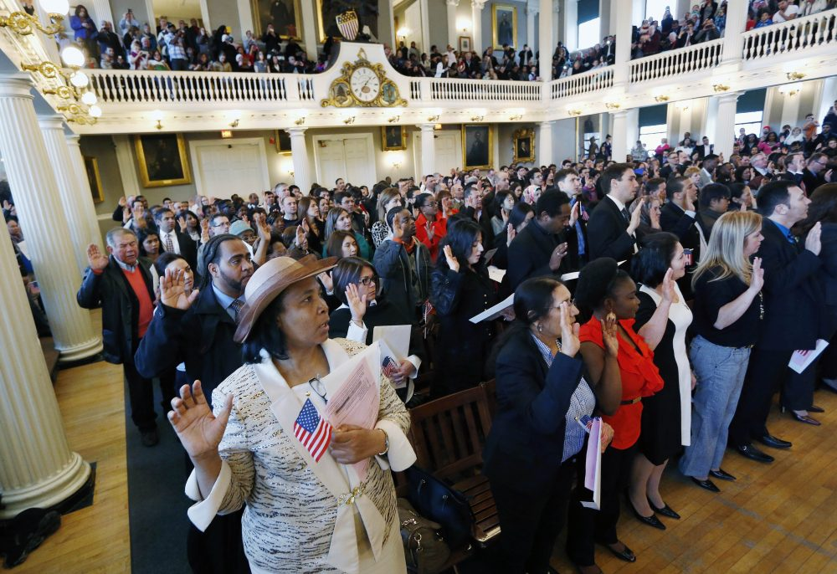

1. Live in the United States for 5 years with a Green Card

2. Complete a form and pay $725

3. Get fingerprinted

4. Pass the interview and citizenship test

5. Attend the oath ceremony (above at Faneuil Hall in Boston), where you swear to “support and defend the Constitution of the United States”

WORKSHEET: 2-18.C

Source 1: Citizenship Test Is Working

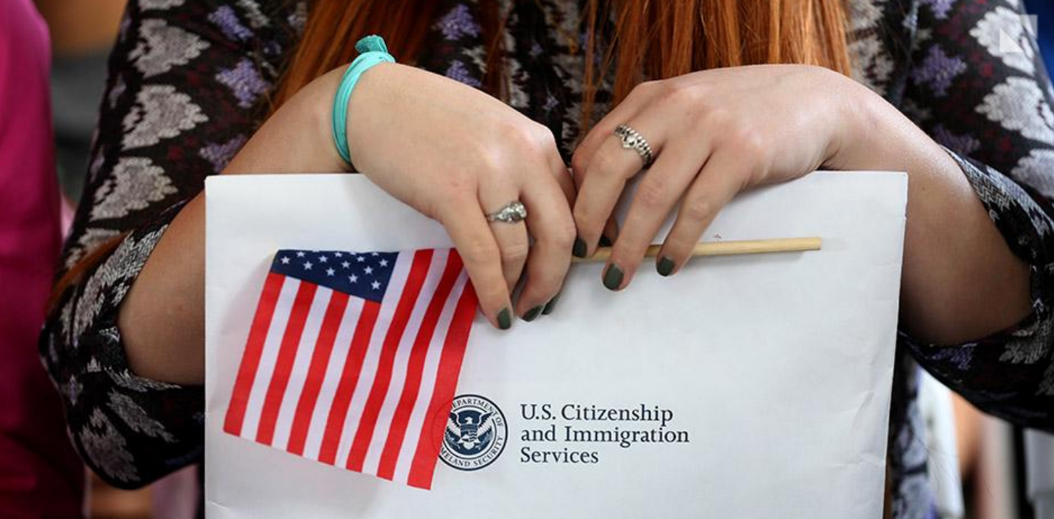

The current citizenship test works. The current citizenship test asks many questions about government and how it works. It is hard to be a good citizen, if you do not know about the government. This test helps the U.S. know if you will be a good citizen. In fact, many people born in the Unites States cannot answer the citizenship test questions. A recent poll found that only 1 in 3 people could name the three branches of government (Congress, President, Supreme Court). When students in Arizona were given the test, only 1 in 10 could answer the 6 of 10 questions correctly and would have become citizens. This test is something that every new citizen should be able to pass.

WORKSHEET: 2-18.D

Source 2: Citizenship Test Questions Need to Change

The questions on the citizenship test need to change. 9 out of 10 people who take the citizenship test pass it and become citizens. Many of the people who take it just memorize the answers by listening to CDs, using flash cards, or taking citizenship test courses. Just because someone can answer questions on U.S. history and government, does not mean they will be a good citizen. Instead, there should be new questions that ask about why a person wants to become an American. For example, a question might ask, “How will you be a good U.S. citizen?” “What ways will you help your community in the future?” “Do you want to vote or run for office in the future?” This test would be something that every new citizen should be able to pass.

WORKSHEET: 2-18.E

Source 3: Passing a Test Does Not Mean Being a Good Citizen

We should stop asking questions to new citizens. Those questions cannot tell us if the person will be a good citizen. Instead, the citizenship test should ask new citizens to describe how they have helped their community and made the United States a better place. It may be that they worked as a teacher, fire fighter, or police officer. They may have volunteered to help neighbors, worked at a food pantry, or participated in yearly clean-up of parks. We want citizens who will help their community. If a person has not done much for their community or the United States, they can be asked to make a plan for doing more and then take the test again in the future. This test would be something that every new citizen should be able to pass.
ASSESSMENT: 2-18.F

Immigration Today—Citizenship: Exit Ticket

Inquiry Question: Is it fair how we choose who can become a citizen?

Is the current citizenship test the best way to decide who can become a new citizen? Choose and explain your favorite options from the sources: (1) the current test is good, (2) the test can be better, or (3) should be community service instead. Include two pieces of evidence from the sources.

LESSON PLAN 2-19: Examples of Good Citizens

MATERIALS

Joshua and Stopping Hunger (Lesson2-19Video1) [Located in the UOW Video Library: www.christophercmartell.com/understandingourworld]
Lined paper (not supplied)
Source 1: Youth Way on the MBTA (WORKSHEET 2-19.A)
Source 2: The Martin Richard Foundation (WORKSHEET 2-19.B)
Source 3: Joseph Lee K-8 Students and Black Lives Matter (WORKSHEET 2-19.C)
Source 4: Girl Scouts and the Boston Plastic Bag Ban (WORKSHEET 2-19.D)
Good Citizens Thinking Questions (WORKSHEET 2-19.E)
Good Citizens (Part 1): Exit Ticket (ASSESSMENT 2-19.F)

STANDARDS

Massachusetts History and Social Science Framework

MA-HSS.2.CS.6: Define and give examples of some of the rights and responsibilities that students as citizens have in the school (e.g., students have the right to vote in a class election and have the responsibility to follow school rules). (C)

MA-HSS.2.CS.7: Give examples of fictional characters or real people in the school or community who were good leaders and good citizens, and explain the qualities that made them admirable (e.g., honesty, dependability, modesty, trustworthiness, courage). (C)

Common Core: Literacy

CCSS.ELA-Literacy.RI.2.9: Compare and contrast the most important points presented by two texts on the same topic.

CCSS.ELA-Literacy.RI.2.10: By the end of year, read and comprehend informational texts, including history/social studies, science, and technical texts, in the grades 2–3 text complexity band proficiently, with scaffolding as needed at the high end of the range.

CCSS.ELA-Literacy.W.2.8: Recall information from experiences or gather information from provided sources to answer a question.

PROCEDURES

Inquiry Question: Which group of people is the best example of good citizenship?

PREPARATION

1. Set Up Carousel Activity
Around the room, post the four sources: Youth Way on the MBTA (WORKSHEET 2-19.A), The Martin Richard Foundation (WORKSHEET 2-19.B), Joseph Lee K-8 Students and Black Lives Matter (WORKSHEET 2-19.C), Girl Scouts and the Boston Plastic Bag Ban (WORKSHEET 2-19.D).

A. OPENER (8 minutes)

2. Engage in a Brainstorm on Good Citizenship
Ask students, “What makes someone a good citizen for their community or country?” As students answer, write down their ideas on the board or chart paper. Anticipated responses may include: someone who cares about others, someone who follows the rules, someone who participates in protests, someone who votes, someone who helps people.

3. Watch Video on Good Citizenship
Tell students that they are going to watch a video that shows how one boy saw a problem and did something to help. Have students watch a brief video on Joshua and Stopping Hunger (Lesson2-19Video1), which shows how one boy, Joshua, got together many kids and adults to help reduce hunger. Ask students about their reaction to this and questions like “Do you think you could do something like Joshua to help your community or country? What was your favorite thing that Joshua did? What areas in our community do you think need someone to help make better?”

Tell students that today we will be studying good citizenship. We will look at four local groups of students who were good citizens for their communities or country. Like Joshua in the video, they saw a problem in their community or country and they did something to help people.

A Note on the Topic:
This lesson discusses the qualities of good citizenship. This curriculum defines a citizen and citizenship broadly as, “all members within local, national, and global communities with civic responsibilities.” This includes all citizens who participate in democracy, whether they are born in the United States, become citizens through naturalization, here on a Green Card, or are undocumented.

B. DEVELOPMENT (16 minutes)

4. Engage in a Carousel Activity on Good Citizenship
Give each student pencil and clipboard with the Good Citizens Thinking Questions (WORKSHEET 2-19.E) on it. Ask students to go to each of the four stations (2-19.A, 2-19.B, 2-19.C, 2-19.D). At each station, the students should take notes on the descriptions of what each group of citizens did to make their community or country better.

Once students have gone to each of the four stations, they should return to their seats.

C. CLOSING (6 minutes)

5. Write Up Argument on Good Citizenship
For the evaluation task, have the students complete the exit ticket (ASSESSMENT 2-19.F), where they write their own personal response to the lesson’s Inquiry Question: “Which group of people is the best example of good citizenship?” Tell students to cite at least two pieces of evidence from the sheets on the walls. Tell students that the evidence they use can be something that they wrote on the sheets. Encourage students to get up and look at the sheets on the wall, when they need evidence to write on their sheet.

Before using the exit ticket, consider using a graphic organizer or two column notes to prepare students for the writing task. Consider using sentence starters and modeling to help the students with their answer to the inquiry question.

EVALUATION

ASSESSMENT 2-19.F

What to look for?

The students should take a stance on which group was the best example of citizenship. All arguments should cite at least 2 pieces of evidence from the sources.

Some information that students may include in their answer to the question:

Youth Way on the MBTA
- They saw a problem that students could not use the T passes after school hours when they needed them
- They contacted the T about the problem
- They had protests about the problem
- They were able to get the T pass to work until 11 pm; they are still working on getting a $10 student T monthly pass

The Martin Richard Foundation
- They saw that many peace, justice, and service groups that helped the community needed money
- They thought it would be a great way to honor Martin Richard’s memory
- They wanted peace and for people to stop hurting others
- They help fund many sports groups and parks

Joseph Lee K-8 Students and Black Lives Matter
- They were upset at recent news events that showed a police officer hurting a Black people because of his race
- They held a protest with their school’s permission
- They told many people driving by about the recent news events
- They wanted everyone to be treated fairly and not to be hurt

Girl Scouts and the Boston Plastic Bag Ban
- They were upset that plastic bags often get stuck in trees, litter the streets, and are harmful to animals
- They made reusable grocery bags
- They invited a city councilor to their meeting
- They were able to get a plastic ban passed

WORKSHEET: 2-19.A

Source 1: Youth Way on the MBTA

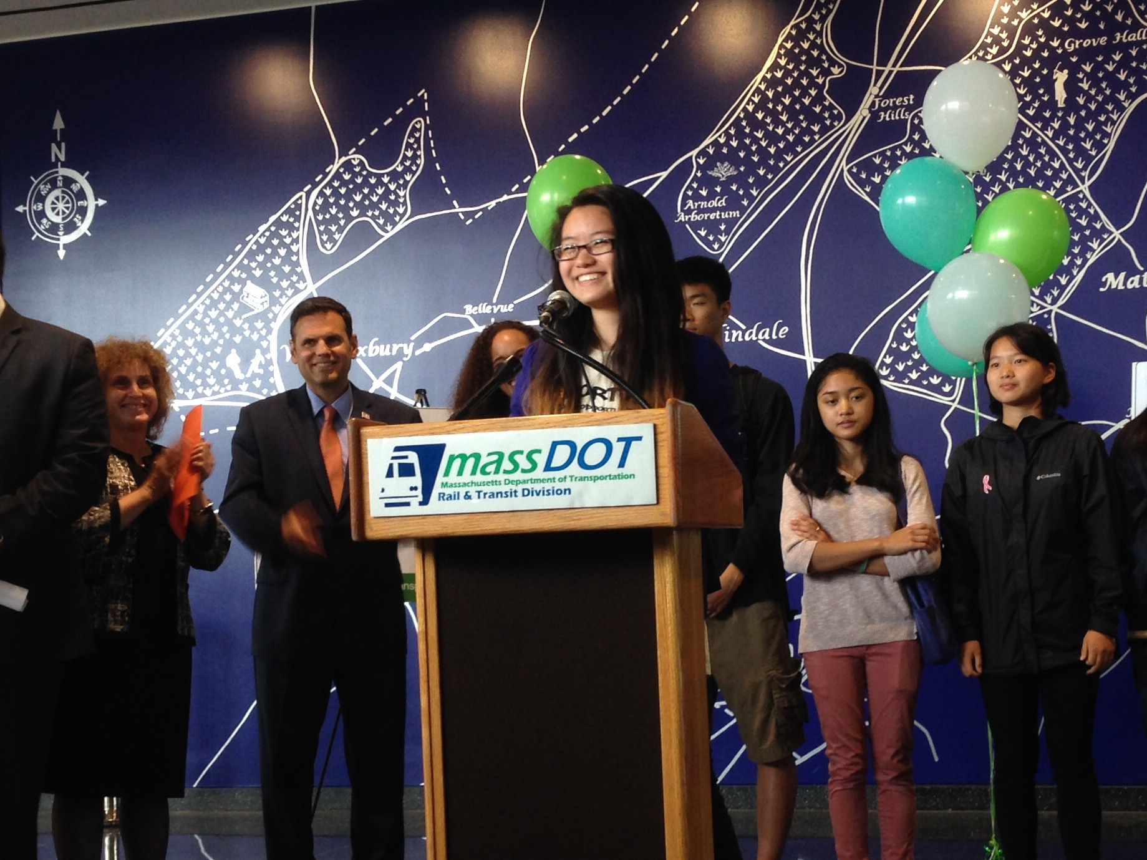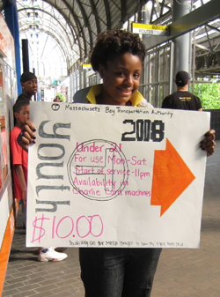

A local group of students was upset that their student T passes only worked during school hours. For many students in Boston, the T (subway, bus, commuter rail) is their only transportation (how they get from place to place). They got together as a group called “Youth Way on the MBTA” and wrote to the T about allowing student passes to always work. They said it would help them get home from school, if they stay after for sports or clubs, or have after school jobs. They lead rallies outside T stations and contacted the local newspapers, radio and television stations. The T would expand student passes to work on weekdays until 11 pm. The Youth Way on the MBTA is now working on letters and rallies to allow any student to buy a $10 monthly T pass.

WORKSHEET: 2-19.B

Source 2: The Martin Richard Foundation

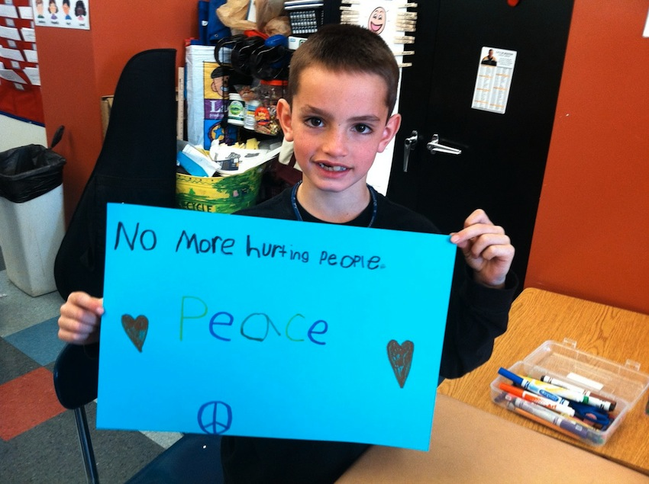

Martin Richard (above) was an eight-year-old boy who was killed during an explosion at the Boston Marathon. He believed in peace and did not want anyone to hurt others. In his memory, his family started the Martin Richard Foundation. The program gives money to community groups that focus on “peace, justice, and service.” The organization has given money to the Dorchester Boys and Girls Club, Dorchester sports leagues, and Challenger Sports, which helps kids with disabilities play sports. It also raises money to make more parks in Boston, include a new park named after Martin Richard next to the Children’s Museum.
WORKSHEET: 2-19.C

Source 3: Joseph Lee K-8 Students and Black Lives Matter

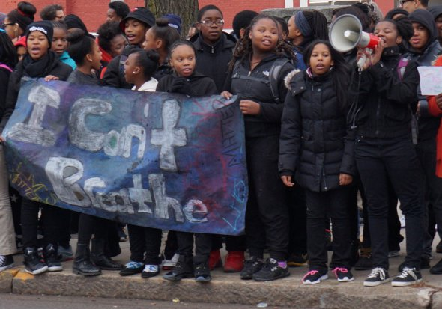

Students at the Joseph Lee K-8 School in Dorchester were upset at recent news events that showed a police officer hurting a Black person because of his race. They wanted to show everyone that it was not right. They asked their teachers if they could organize a protest. Their teachers talked to the principal and she approved them doing a protest in front of the school. Kids wrote up speeches and made posters and banners. They lead their protest, with teachers and police officers helping them, on December 15, 2014. As cars drove by, they chanted “black lives matter” and “What do we want? Justice! When do we want it? Now.” Many cars beeped in support as they drove by. Students felt that they told many people about their concerns that day.

WORKSHEET: 2-19.D

Source 4: Girl Scouts and the Boston Plastic Bag Ban

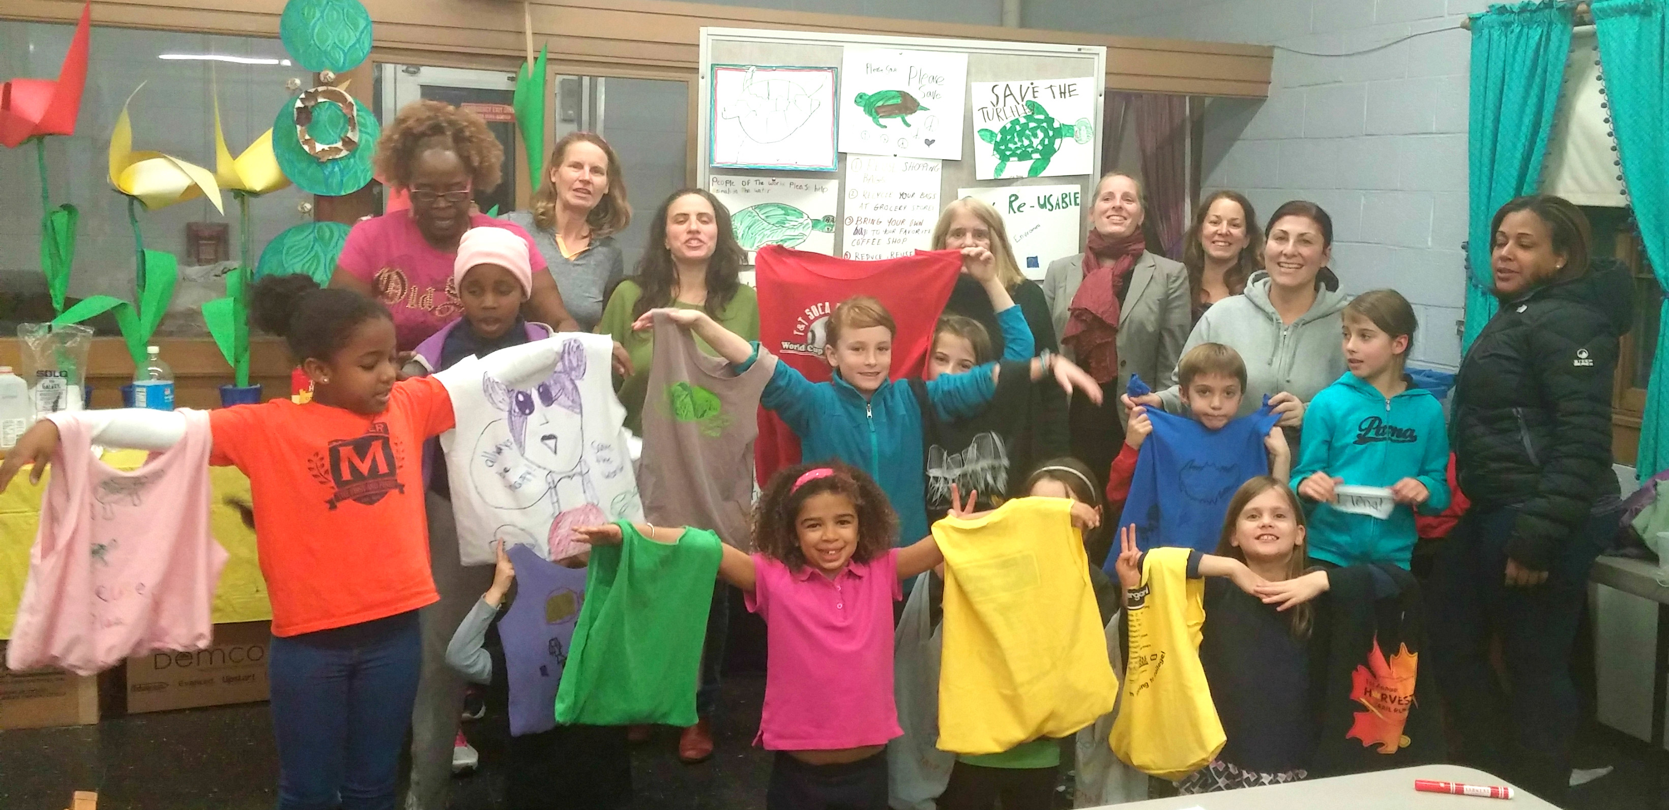

For years, the Boston City Council had debated banning bags. Plastic bags often get stuck in trees, litter the streets, and are harmful to animals. They City Council was never able to get enough councilors to support it. After learning about plastic bags, the Girl Scouts of Troop 68277 in Dorchester decided to take action. First, they had a sew-a-thon where they made reusable bags. Next, they invited City Councilor Matt O’Malley to come to their meeting. Then they started speaking with other councilors. In the end, the City Council voted unanimously (everyone voted yes) to end the use of plastic bags in Boston’s stores.

WORKSHEET: 2-19.E

Good Citizens Thinking Questions

Source 1: Youth Way on the MBTA
How did this group of citizens help their community or country?

Source 2: The Martin Richard Foundation
How did this group of citizens help their community or country?

Source 3: Joseph Lee K-8 Students and Black Lives Matter
How did this group of citizens help their community or country?

Source 4: Girl Scouts and the Boston Plastic Bag Ban
How did this group of citizens help their community or country?

ASSESSMENT: 2-19.F

Good Citizens (Part 1): Exit Ticket

Inquiry Question: Which group of people is the best example of good citizenship?

After thinking about the different groups in the sources, explain which one is the best example of being good citizens for their community or country. Include two pieces of evidence from the sources.

LESSON PLAN 2-20: How Will I Be a Good Citizen?

MATERIALS

Images (WORKSHEET 2-20.A)
Source 1: Speaking with Family, Friends, and Neighbors (WORKSHEET 2-20.B)
Source 2: Reading About Current Events (WORKSHEET 2-20.C)
Source 3: Voting (WORKSHEET 2-20.D)
Source 4: Protesting (WORKSHEET 2-20.E)
Source 5: Writing Letters (WORKSHEET 2-20.F)
Good Citizens (Part 2): Exit Ticket (ASSESSMENT 2-20.G)

STANDARDS

Massachusetts History and Social Science Framework

MA-HSS.2.CS.6: Define and give examples of some of the rights and responsibilities that students as citizens have in the school (e.g., students have the right to vote in a class election and have the responsibility to follow school rules). (C)

MA-HSS.2.CS.7: Give examples of fictional characters or real people in the school or community who were good leaders and good citizens, and explain the qualities that made them admirable (e.g., honesty, dependability, modesty, trustworthiness, courage). (C)

Common Core: Literacy

CCSS.ELA-Literacy.RI.2.9: Compare and contrast the most important points presented by two texts on the same topic.

CCSS.ELA-Literacy.RI.2.10: By the end of year, read and comprehend informational texts, including history/social studies, science, and technical texts, in the grades 2–3 text complexity band proficiently, with scaffolding as needed at the high end of the range.

CCSS.ELA-Literacy.W.2.8: Recall information from experiences or gather information from provided sources to answer a question.

PROCEDURES

Inquiry Question: What actions can I take to make my community and country a better place?

A. OPENER (8 minutes)

1. Anticipation Images
Project the Images (WORKSHEET 2-20.A) for the class. Write on the board or chart paper, “What do you think these four things have in common?” Do not give students help and write down their ideas on the board or chart paper. Anticipated responses may include: they are things you can do, they involve people, they are how we should tell our opinions, they are ways to change our communities, they are how we tell the government what we want. After 1-2 minutes, ask students if they know any what any of the pictures are of and if they already know some things about them (protest, talking to friends, a letter to the president, voting). Reveal to the students that all four of these are ways that they can influence or change our government. It is how they can tell the government their opinion or what they want the government to do. Today, we will learn about each of these different ways that you can make your community or the United States a better place.

2. Read About the Different Ways to Engage in Civics
Put students in small groups and assign them one of the five sources: Speaking with Family, Friends, and Neighbors (WORKSHEET 2-20.B), Reading About Current Events (WORKSHEET 2-20.C), Voting (WORKSHEET 2-20.D), Protesting (WORKSHEET 2-20.E), Writing Letters (WORKSHEET 2-20.F). Have one student from each group read their source. As the student reads, tell the other group members to underline or highlight any important information. Note: If your students have difficulty with jig saw activities, this lesson plan can be spread out over three days having all students focus on two of the documents on the first two days. Assign different students to be a leader for one of the four documents, responsible for explaining that document to their peers on the third day of the lessons when they use the exit ticket.

3. Engage in a Jig Saw About the Different Ways to Engage in Civics
Have students participate in a jig saw activity. Make new groups where at least one student from each of the original groups is included. This will create several new groups of three students, one is an expert on 2-20.B, 2-20.C, 2-20.D, 2-20.E. Have each student describe their document to the other members of their group.

Ask students to use the sources to answer the following inquiry question: “What actions can I take to make my community and country a better place?” In answering this question, students should debate between the four different worksheets and should two at least two actions they may take in the future. After students have discussed the question, they should complete the exit ticket in the following step. Circulate the room, helping the students who may have difficulty choosing at least to actions.

C. CLOSING (6 minutes)

4. Write Up Argument on Different Ways to Engage in Civics
For the evaluation task, have the students complete the exit ticket (ASSESSMENT 2-20.G), where they write their own personal response to the lesson’s Inquiry Question: “What actions can I take to make my community and country a better place?” Tell students to cite at least two pieces of evidence from the sources for this lesson.

Before using the exit ticket, consider using a graphic organizer or two column notes to prepare students for the writing task. Consider using sentence starters and modeling to help the students with their answer to the inquiry question.

EVALUATION

ASSESSMENT 2-20.G

What to look for?

The students should take a stance on which two actions they would take to make change in their community. All arguments should cite at least 2 pieces of evidence from the sources.

Some information that students may include in their answer to the question:

Speaking with Family, Friends, and Neighbors
- Share your opinions with others
- Hear others opinions
- Make better decisions
- Inform you on who or what to vote for

Reading About Current Events
- Stay updated on what is happening in community, country, or world
- Can know about issues
- Can try and stop something in your community, country, or world that you think is wrong

Voting
- Happens every year
- Choose who will be a politician (elected person) and make decisions for you
- Choose the answer to questions on issues

Protesting
- Tell politicians that you and others agree or disagree with something
- Often makes the news
- Shows that something should change or stay the same

Writing Letters
- Tells politicians how to vote or make a decision
- Is read by politicians or their staffs
- Often results in a response

WORKSHEET: 2-20.A

Images

WORKSHEET: 2-20.A

Source 1: Speaking with Family, Friends, and Neighbors

It is important that we talk to our family, friends, and neighbors about ways to make our communities and country better. To be a good citizen, you should ask others about their opinions and why they think that way. This allows you to make the best decision you can. You should to talk to people with different opinions that you to make sure you have heard the other sides of an issue. It is also always okay to change your mind on an issue, if you realize that someone has made some good points that you agree with. For example, Chris use to think that we spend too much money on schools. He was speaking one day with his neighbor, who is a parent. She explained how her child’s school does not have a nurse. Chris then realized that some schools need more money and decided to write a letter to politicians (elected people).

WORKSHEET: 2-20.B

Source 2: Reading About Current Events

It is important that we read about current events. To be a good citizen, you need to know what is going on in your city/town, state, country, and world. Sometimes people know what is going on in their community, but not in other countries. It is important that you learn about your community, country, and other countries. You should try your best to read many different newspapers, listen to different radio or television channels, and read different news stories on the Internet. Each news source may have different information or a different opinion of the issue. For example, Bìhn (bun) read that the city might close the library near her house in the newspaper. Her neighbors also heard about this on the television news. They met with politicians (elected people) and convinced them to keep the library open.
WORKSHEET: 2-20.C

Source 3: Voting

It is important that we vote in elections. Once a year (or sometimes more) there are elections where people vote or choose who they want to make decisions. To be a good citizen, you should vote on the politicians (elected people) or questions that are on the ballot (the paper that you vote with). This is how we choose who makes decisions for us, including the president, governor, Congressmen and women, mayors, city councilors, and selectmen and women. For example, José votes in every election. He knows that they can be very close sometimes. There was an election for city council. He supported one candidate, because she said that she would make more parks. The election was so close, only one vote decided the winner. It was the candidate he supported.

WORKSHEET: 2-20.D

Source 4: Protesting

It is important that we attend protests and rallies about issues that we care about. To be a good citizen, you should get together with others and show that many people are for or against something. When there is a large protest, the news will cover it and politicians will hear about how many people feel about an issue. For example, Aliyah was upset that the T (subway, buses, commuter rail) was going to raise its fare (the price to ride). She said that many people who use public transit may not have much money and this would be hard for them. Thousands of people showed up at the State House to protest. In the end, the T decided to not raise fares.

WORKSHEET: 2-20.E

Source 5: Writing Letters

It is important that we write to politicians (elected people) about issues that we care about. To be a good citizen, you should explain to politicians why you agree or disagree with a law or decision. This can be done by writing a paper letter, e-mailing, or calling the president, Congressmen and women, governors, mayors, city councilors, and others. Politicians and their staffs read letters and listen to phone calls and use that to make their decisions on how to vote or make decisions. For example, Caleb was upset that the United States government made a bill that would take away some people’s health care. He knows that it is hard for many people cannot afford to go to the hospital or see a doctor. He wrote a letter to his Congresswoman. She wrote back thanking him for his letter and said many people also wrote her with the same opinion. She voted no on the bill that Caleb did not like.
WORKSHEET: 2-19.E

Good Citizens (Part 2): Exit Ticket

Inquiry Question: What actions can I take to make my community and country a better place?

After reading about the different ways you can make your voice heard, explain which actions you will take in the future to make your community better. Choose at least two of the methods (speaking with others, reading about current events, voting, protesting, writing letters). Include two pieces of evidence from the sources.

If you would like, you can speak about a specific issue you care about (like homelessness, the environment, education, healthcare, immigrant rights).

ADDITIONAL RESOURCES

Below is a list of lesson plan and unit resources from other organizations, which in conjunction with Understanding Our World, may help teachers develop a content-rich elementary social studies curriculum.

Boston Public Schools: History and Social Studies Department

K-12 Curriculum Resources
https://sites.google.com/a/bostonpublicschools.org/history/curriculum-documents/

Massachusetts Department of Elementary and Secondary Education
Model Curriculum Units (Elementary-Level; Social Studies)
http://www.doe.mass.edu/candi/model/download_form.aspx

C3 Teachers

Inquiries
http://www.c3teachers.org/

New York State Education Department

New York State K-12 Social Studies Resource Toolkit
https://www.engageny.org/resource/new-york-state-k-12-social-studies-resource-toolkit

Teaching Tolerance

Elementary Resources
http://www.tolerance.org/activities

Facing History and Ourselves

Educator Resources
https://www.facinghistory.org/educator-resources

Primary Source

Online Curriculum
https://www.primarysource.org/for-teachers/online-curriculum

Share My Lesson (American Federation of Teachers)
Educator Resources
https://sharemylesson.com

Better Lesson (National Education Association)
Educator Resources
https://betterlesson.com

ABOUT THE DEVELOPERS

Christopher C. Martell, Ed.D.
Chris Martell is a Clinical Assistant Professor and Program Director of Social Studies Education at the Boston University School of Education. He teaches courses on elementary and secondary social studies methods. He was a social studies teacher for eleven years in urban and suburban contexts. For most of his teaching career, Chris taught in Framingham, Massachusetts, which is a racially and economically diverse urban school outside Boston with large immigrant populations from Brazil, Central America, and the Caribbean. His research and professional interests focus on social studies teachers in urban and multicultural contexts, critical race theory, culturally relevant pedagogy, and historical inquiry.

Jennifer R. Bryson, Ed.M.
Jenn Bryson is a former elementary classroom teacher in the Chelsea Public Schools and specializes in the professional preparation of elementary education teachers at the Boston University School of Education. Her responsibilities include coordination and supervision of student teachers in the elementary education program and the student-teaching abroad programs in London, England, Sydney, Australia, and Quito, Ecuador. She also facilitates the elementary pre-practicum placements for juniors and graduate students. In addition, Jenn teaches a course on urban education, leads field seminars on classroom management, and facilitates a book club entitled “Dads Read” at the William Monroe Trotter School in Dorchester, Massachusetts.

