Open Social Studies

An Inquiry-Based and Literacy-Focused K-6 Curriculum

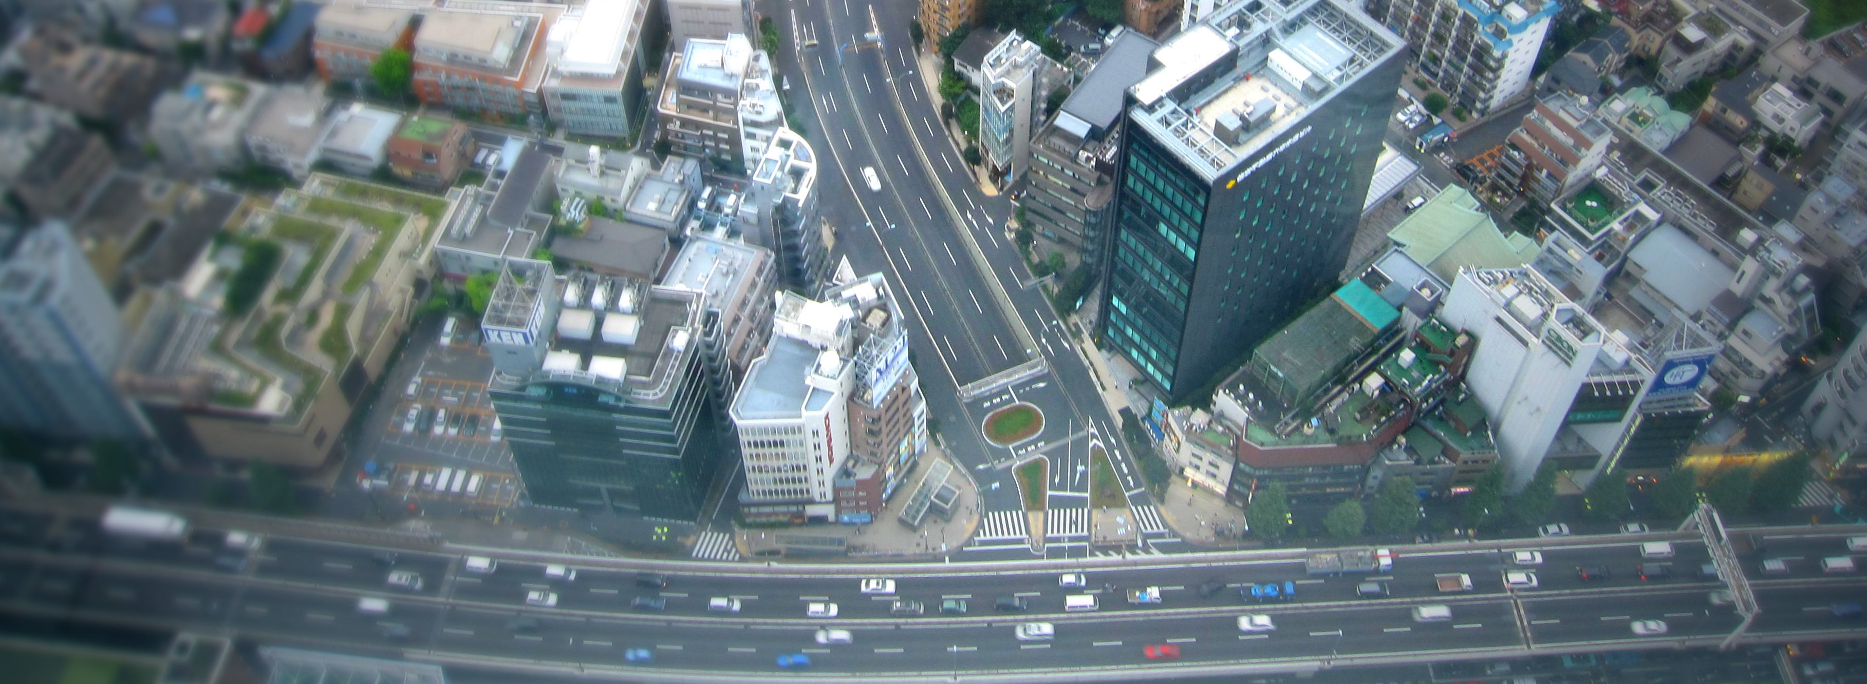

Curric

**STUDENT WORKBOOK**

**Level: Grade 5**

Exploring the United States

Developers:

 Christopher C. Martell

Jennifer R. Bryson

**GRADE 5 ROAD MAP**

**LESSON 5-1**

Lesson Title: The Indigenous People: Diverse Nations, Diverse People

*Inquiry Question: What were the most important parts of ancient Indigenous cultures?*

**LESSON 5-2**

Lesson Title: Who Were the Vikings?

*Inquiry Question: Were the Vikings the brutal raiders they are often depicted as?*

**LESSON 5-3**

Lesson Title: Spain, Portugal, France, England: Explorers or Invaders?

*Inquiry Question: Were the Europeans who came to the Americas explorers or invaders?*

**LESSON 5-4**

Lesson Title: History Detectives: Pocahontas and Jamestown

*Inquiry Question: What is the real story of Pocahontas?*

*NOTE: In chronological order, the relationship between the Pilgrims, Puritans, and the Indigenous people would appear here after Lesson 5-4. These lessons are currently included in the Grade 3 curriculum (i.e. 3-1. 3-2, 3-3, 3-4, 3-5, 3-6, 3-7, 3-8), which is Massachusetts history. Teachers are encouraged to use modified versions of those lessons again here.*

**LESSON 5-5**

Lesson Title: The Salem Witch Trials: What Really Happened?

*Inquiry Question: What really happened in Salem in 1692?*

**LESSON 5-6**

Lesson Title: British America: The Shared Histories of Canada, the American Colonies, and the British West Indies

*Inquiry Question: If you were a colonist coming to the American colonies at this time, what colony would you settle in and why?*

**LESSON 5-7**

Lesson Title: The Transatlantic Slave Trade

*Inquiry Question: Why did the Transatlantic Slave Trade happen?*

**LESSON 5-8**

Lesson Title: Mock Trial: The Boston Massacre

*Inquiry Question: Was Captain Thomas Preston guilty of murder during the Boston Massacre?*

**LESSON 5-9**

Lesson Title: Road to Revolution: French & Indian War, and Acts of Parliament

*Inquiry Question: Would you have supported the Crown?*

**LESSON 5-10**

Lesson Title: The Boston Tea Party

*Inquiry Question: Were the colonists justified in rebelling from Britain?*

**LESSON 5-11**

Lesson Title: Lexington and Concord

*Inquiry Question: Who fired the first shot on Lexington Green?*

**LESSON 5-12**

Lesson Title: Declaring Independence

*Inquiry Question: What was the most important point made in the Declaration of Independence?*

**LESSON 5-13**

Lesson Title: Revolutionary War Journals

*Inquiry Question: What was life like during the American Revolution?*

**LESSON 5-14**

Lesson Title: Winners and Losers: The Peace of Paris

*Inquiry Question: Was the Peace of Paris fair?*

**LESSON 5-15**

Lesson Title: Shays’ Rebellion

*Inquiry Question: Were the participants of Shays’ Rebellion justified in their revolt?*

**LESSON 5-16**

Lesson Title: Mock Convention: Writing the Constitution

*Inquiry Question: Did the delegates as the Constitutional Convention make the right decisions?*

**LESSON 5-17**

Lesson Title: Know Your Rights! An Introduction to the Bill of Rights

*Inquiry Question: What is the most important right guaranteed to you under the Bill of Rights?*

**LESSON 5-18**

Lesson Title: The Louisiana Purchase: Worth the Price?

*Inquiry Question: Should Thomas Jefferson have purchased Louisiana from France?*

**LESSON 5-19**

Lesson Title: Why the “Lewis and Clark Expedition” Should Really Be the “Lewis, Clark, Sacagawea, York, and Charbonneau Expedition”

*Inquiry Question: Who was the most important leader during the Lewis and Clark Expedition?*

**LESSON 5-20**

Lesson Title: Trail of Tears

*Inquiry Question: What was it like for someone who was forced out of their home by the U.S. government during the Trail of Tears?*

**LESSON 5-21**

Lesson Title: Racial Inequity and the California Gold Rush

*Inquiry Question: Should the California Gold Rush be remembered for its opportunity or its inequity?”*

**LESSON 5-22**

Lesson Title: Westward Expansion or Invasion from the East?

*Inquiry Question: Was the movement of White Americans a “westward expansion” or an “invasion from the east?”*

**LESSON 5-23**

Lesson Title: The Civil War

*Inquiry Question: Why was the Civil War fought?*

**LESSON 5-24**

Lesson Title: Reconstruction

*Inquiry Question: What was the worst decision made during the period of Reconstruction after the Civil War?*

**LESSON 5-25**

Lesson Title: The Great Migration

*Inquiry Question: If you were an African American in the South at the turn of the 20th Century, would you have moved north?*

**LESSON 5-26**

Lesson Title: Japanese American Incarceration: Civil Liberties and War

*Inquiry Question: What was it like for Japanese Americans who were forced by the U.S. government into prison camps during World War II?*

**LESSON 5-27**

Lesson Title: Martin Luther King and Malcolm X

*Inquiry Question: Who had the better strategy for reducing racism and improving the Black community?*

**LESSON 5-28**

Lesson Title: Sí Se Puede! César Chavéz, Dolores Huerta, and the National Farm Workers Association

*Inquiry Question: Which type of protest used by Chavéz and Huerta was most effective?*

**LESSON 5-29**

Lesson Title: The Other Civil Rights Movements: Women’s Rights, Indigenous Rights, Latino Rights, and Asian American Rights

*Inquiry Question: For your assigned group, what was their most important action?*

**LESSON 5-30**

Lesson Title: The Boston Busing Crisis

*Inquiry Question: What was the best plan for racially integrating Boston’s schools?*

**GRADE 5 PRE-TEST**

Answer the following questions.

**1. What was the American Revolution?**

**2. What are rights?**

**3. What is a movement?**

**4. Label each continent on the picture below: Antarctica, Africa, Asia, Australia, Europe, North America, South America.**

**5. Label as many states as you can on the picture below.**

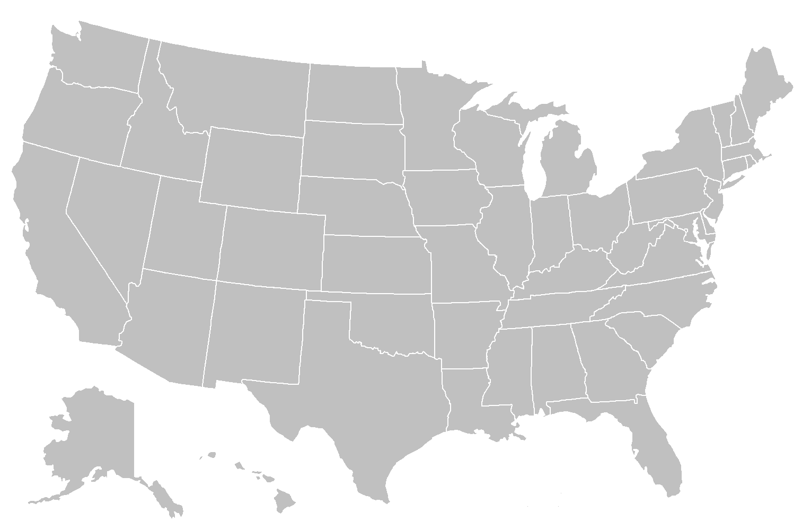

**6. What was the relationship between the European and Indigenous people like in the Americas?**

**7. Name as many rights found in the Bill of Rights as you can.**

**8. Name the three branches of government.**

**9. Name as many causes of the Civil War as you can.**

**10. What are civil rights?**

**WORKSHEET 5-1.A**

**Response to Dakota Access Pipeline Protest**

After watching the new story about the Dakota Access Pipeline Protests, “Would you have supported the pipeline protesters at Standing Rock? Why or why not?”

**ASSESSMENT 5-1.C**

**The Indigenous People: Exit Ticket**

Inquiry Question: *What were the most important parts of ancient Indigenous culture?*

Describe the most important parts of the ancient Indigenous (Native) groups that we studied (Puebloan, Mississippian, Plateau

Iroquois, Algonquin Culture). Include three pieces of evidence from the sources.

**ASSESSMENT 5-2.C**

**The Vikings: Exit Ticket**

Inquiry Question: *Were the Vikings the brutal raiders they are often depicted as?*

Take a stand on the following question: Were the Vikings brutal raiders or needed to invade others to save their people? Include three pieces of evidence from the sources.

**MATERIALS 5-3.A**

**Teacher’s Guide**

**(For Teachers Only)**

Today, we are going to pretend to be four different European nations that are sending people to the Americas. You will need to listen to the different things they encounter and based on your information sheet decide what to do. Let’s start!

It is 1492, Christopher Columbus has convinced the Spanish king and queen to give him money to sail west to Asia. Up until this point, Europeans had to travel across land to Asia. Like most sailors of his time, he knew the world was a globe and thought that it would be much quicker to sail east. [Show students on the world globe how he thought going west by boat would be faster than going east by land]. He underestimated how large the Earth was. Lucky for him, there was a bunch of land between Europe and Asia, now called the Americas. Otherwise, he and his men probably would have run out of food and died on their journey.

**Spain:** Columbus has just landed in what you are calling the New World. He interacts with the Indigenous people there. He thinks he is in Asia and calls them Indians. They are actually called the Arawak and Taíno people. Columbus and his sailors believe the Arawak and Taíno have large amounts of hidden gold. They do have bows and arrows, but not weapons like the Spanish. They have never heard of Christianity or your God. You must decide if you will take over the Arawak and Taíno to get their gold and convert them to Christianity or leave them alone and go somewhere else.

[If the students are following their card, they should choose to stay, get their gold and convert them to Christianity.]

**Spain:** While Columbus never found gold, you know it must be in the New World. You recruit sailors to go look for it. A man named Hernán Cortés will go to the Aztecs (today what is Mexico). There he meets their leader Montezuma. Another man named Francisco Pizarro will go to the Incas (today what is Peru). There he meets their leader Atahualpa. These nations are large empires with millions of people. They have many weapons, although not guns or canon like you have. They had gold, but did not think it was as valuable as the Europeans did. They have never heard of Christianity or your God. The Aztecs at first think you are gods, but soon realize you are not. You must decide if you will take over the Aztecs and Incas to get their gold and convert them to Christianity (and name it after yourself, New Spain) or leave them alone and go somewhere else.

[If the students are following their card, they should choose to stay, get their gold and convert them to Christianity.]

**Portugal:** Spain is the country next to you. You are known for making great sailors (Columbus actually learned to sail in Portugal). Four years before Columbus goes to the New World, one of your sailors is the first European to sail around the south of Africa and finds a new ocean route to Asia. One of your sailors Pedro Álvares Cabral has landed in what is today Brazil and he meets with the Amerindians. They believe the Amerindians have large amounts of hidden gold. They do not have weapons. They have never heard of Christianity or your God. You must decide if you will take over these people to get their gold and convert them to Christianity (and call this new place Brasil, after a type of wood there) or leave them alone and go somewhere else.

[If the students are following their card, they should choose to stay, get their gold and convert them to Christianity.]

**France:** You have been watching Spain and Portugal expand all over the Earth, in the Americas and Asia. It is 40 years after Columbus, and you decide to send Jacques Cartier to the New World. The Spanish and Portuguese have divided up South America, so you send him to North America. In 1534, he enters a large river (now called the St. Lawrence River) and settles near the bottom of it (now called Montréal in Québec). They interact with the Algonquin people. They do have bows and arrows, but not weapons like the French. They do not have gold, but many animal furs, which will be valuable back in Europe for clothing. They have never heard of Christianity or your God. You must decide if you will take over these people to get their furs and convert them to Christianity (and name it after yourself, New France) or leave them alone and go somewhere else.

[If the students are following their card, they should choose to stay, get their gold and convert them to Christianity.]

**England:** You are late to get into this game of traveling to faraway places and claiming it for your country. It is over 100 years after Columbus came to the New World. Unlike the Spanish, Portuguese, and French, your sailors are not quite as good. You hire an Italian named Giovanni Caboto (you call him John Cabot) and tell him to go to the New World. He lands in Newfoundland and Labrador (in what is now Canada). This allows other Englishmen to explore further south to what is now Massachusetts and Virginia. They begin fishing off of the coast in the Atlantic Ocean and interact with the Algonquin people. They do have bows and arrows, but not weapons like the English. You think they may have hidden gold. There are also many trees that can be used for making more ships. They have never heard of Christianity or your God. You must decide if you will take over these people to get their gold and wood and convert them to Christianity (and name it after yourself, New England) or leave them alone and go somewhere else.

[If the students are following their card, they should choose to stay, get their gold and convert them to Christianity.]

End of the simulation.

**ASSESSMENT 5-3.D**

**Explorers or Invaders?: Exit Ticket**

Inquiry Question: *Were the Europeans who came to the Americas explorers or invaders?*

Take a stand on the following question: Were the Europeans who came to the Americas explorers or invaders? Include three pieces of evidence from the sources.

**WORKSHEET 5-4.B**

**Preparation for the Corner Debate**

Think about the following sentences and decide if you think “strongly agree,” “agree,” “disagree,” or “strongly disagree.” Then explain why.

**The English should have been allowed to settle in Virginia, where the Powhatan had lived for thousands of years.**

Circle:

Strongly Agree Agree Disagree Strongly Disagree

**The Powhatan are as responsible for the war as the English.**

Circle:

Strongly Agree Agree Disagree Strongly Disagree

**Pocahontas saved John Smith.**

Circle:

Strongly Agree Agree Disagree Strongly Disagree

**Pocahontas was treated very poorly by the English.**

Circle:

Strongly Agree Agree Disagree Strongly Disagree

**MATERIALS 5-4.C**

**STRONGLY AGREE**

**AGREE**

**DISAGREE**

**STRONGLY DISAGREE**

**ASSESSMENT 5-4.D**

**Pocahontas: Exit Ticket**

Inquiry Question: *What is the real story of Pocahontas?*

Using the information from the sources, write the story of Pocahontas. Be sure to put the events in order from first to last. Consider these questions: What were some of the most difficult moments of her life? What were some of the happiest moments of her life? Include three pieces of evidence from the sources.

**WORKSHEET 5-5.A**

**Witch Hunting Sheet**

Today we are recreating the events of Salem in the early 1690s. You will interact with your Salem neighbors and get to know them, while trying to find out who is secretly a witch. Use your skills at looking for people that are unusual or different from the rest of the group.

Before this class I chose a person to be the witch (she or he knows who they are). There are specific answers to the following questions that prove she or he is a witch. You must go around to each person in class and ask them these questions.

Based on your evidence, try to guess who the witch is. You will then report back to the town constable (teacher) and we will make public who the witches are and put them on trial! Be careful to fill in the list so you can recall who you talked to and WHY you thought they were a witch.

Choose **1** of the following questions to ask your peers:

Do you have any pets/animals?

Do you cry when you are sad?

Can you swim?

Do you attend religious ceremonies?

Name Notes About Classmate’s Answers

|  |  |
| --- | --- |
|  |  |
|  |  |
|  |  |
|  |  |
|  |  |
|  |  |
|  |  |
|  |  |
|  |  |
|  |  |
|  |  |
|  |  |
|  |  |
|  |  |
|  |  |
|  |  |
|  |  |
|  |  |
|  |  |

**ASSESSMENT 5-5.D**

**Salem Witch Trial: Exit Ticket**

Inquiry Question: *What really happened in Salem in 1692?*

Take a stand on the following question (choosing on the of three theories or your own): *What really happened in Salem in 1692?* Include three pieces of evidence from the sources.

**ASSESSMENT 5-6.C**

**The British Colonies: Exit Ticket**

Inquiry Question: *If you were a colonist coming to the American colonies at this time, what colony would you settle in and why?*

Choose a part of the American colonies and explain why you would choose to settle there. Include three pieces of evidence from the posters or sources.

**ASSESSMENT 5-7.C**

**The Transatlantic Slave Trade: Exit Ticket**

Inquiry Question: *Why did the Transatlantic Slave Trade happen?*

Take a stand on the following question (choosing on the of three theories or your own): *Why did the Transatlantic Slave Trade happen?* Include three pieces of evidence from the sources.

**WORKSHEET 5-8.B**

**Boston Massacre: Trial Preparation and Note Sheet**

**My name:**

**My role (assigned by teacher):**

**Facts that I learned about myself (if the lawyers or jury, list questions you have about the witnesses after reading the sources):**

**Facts that I learned about others in the trial:**

**ASSESSMENT 5-8.C**

**Boston Massacre: Exit Ticket**

Inquiry Question: *Was Captain Thomas Preston guilty of murder during the Boston Massacre?*

Take a stand on the following question: Was Captain Thomas Preston guilty of murder during the Boston Massacre? This should be your own argument and you do not have to agree with the opinion of your role in the mock trial. Include three pieces of evidence from the sources and trial materials.

**ASSESSMENT 5-9.C**

**Road to Revolution: Exit Ticket**

Inquiry Question: *Would you have supported the Crown?*

If you were living in the colonies before 1776, would you have been a loyalist or a patriot? Why?Include three pieces of evidence from the sources.

**WORKSHEET 5-10.A**

**Boston Tea Party: Liberty Kids Video Reflection**

After watching the video “Liberty Kids: Boston Tea Party,” write down your thoughts about the Boston Tea Party? Was it a protest for something important? Was it a mob damaging property?

**ASSESSMENT 5-10.C**

**Boston Tea Party: Exit Ticket**

Inquiry Question: *Were the colonists justified in rebelling from Britain?*

Considering all of the evidence, do you think the Boston colonists should have thrown the tea in the harbor in protest?Include three pieces of evidence from the sources.

**ASSESSMENT 5-11.B**

**Lexington and Concord: Exit Ticket**

Inquiry Question: *Who fired the first shot on Lexington Green?*

Considering all of the evidence, who do you think fired first on Lexington Green, colonial militiamen or British soldiers? Include three pieces of evidence from the sources.

**WORKSHEET 5-12.A**

**School Grievances**

Grievances: A complaint or protest of unfairness.

If we are to break away from our school, what complaints or protests do we have about how students are treated or the rights they should have.

**ASSESSMENT 5-12.C**

**Declaration of Independence: Exit Ticket**

Inquiry Question: *What was the most important point made in the Declaration of Independence?*

Looking at the Declaration of Independence, what was the most important made? Include three pieces of evidence from the sources.

**ASSESSMENT 5-13.G**

**Revolutionary War Journals Checklist**

Inquiry Question: *What was life like during the American Revolution?*

Students will answer the above inquiry question by creating a journal that highlights their assigned figures contributions to the Revolutionary War. Your journal should have the following (check box when complete):

Threejournal entries from your person. Each should be a few sentences.

 List the dates and begin each entry with “Dear Diary”.

Day One Entry: August 1, 1774

Before the Revolutionary War starts on the problems in Boston. Do you consider yourself British? How do you feel about Britain? How do you view the events that happened in Boston (Boston Massacre, Boston Tea Party, Closing of Boston Harbor)

Day Two Entry: August 1, 1776

Should be during the Revolutionary War and after the colonies declare independence. How do you feel about Britain now? Do you support or oppose the war? Will you fight/are you involved in the Revolution? What are your hopes and worries? Discuss specific events like: Lexington and Concord, Bunker Hill, Declaration of Independence.

Day Three Entry: August 1, 1783

Should be after the end of the war, before the **Peace of Paris Treaty**, which officially ended the American Revolution. How do you feel about Britain now? Are you happy or sad that the American colonists have won? What are your hopes and worries (have they changed)? Discuss specific events like: Ticonderoga, Saratoga, British Capture of New York City, Yorktown.

If time: Draw a picture of your historical figure.

**WORKSHEET 5-14.A**

**Newburgh Troubles**

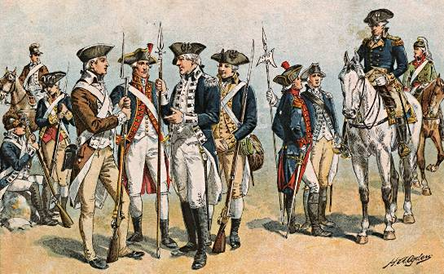

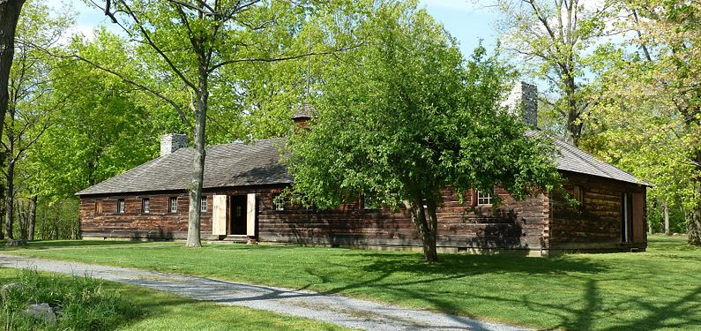

**Scenario:** It is March 10, 1783. The Continental Army had a major victory at Yorktown and British soldiers are returning to England. George Washington has moved his soldiers to New York (soldiers and headquarters pictured above). Many of the soldiers have not been paid. They do not think a new United States government will have money to pay them. Their families are struggling back home with a lack of food and clothes.

A petition (letter with people signing if they agree) is being sent around to all of the soldiers. It says: **“We will take our weapons to Philadelphia and refuse to leave the Continental Congress until they pay us for our service.”**

The Continental Army seems about to rebel and take over the country. Rumors are spreading that they will make George Washington the King of the United States!

**You are a solider in the Continental Army. What will you do?**

**Option 1:** I will sign the petition and I am willing to march to Philadelphia. The Continental Congress is treating the soldiers like the King of Britain treated the colonists. I will not stand for this. I am willing to fight against tyranny (cruel government).

**Option 2:** I will sign the petition, but I am not willing to march to Philadelphia. I want to show that I am upset with the Continental Congress and our lack of pay, but I am not willing to rebel or use violence against our new country.

**Option 3:** I will not sign the petition. I am unhappy with my lack of pay, but I trust the new government to find a way to pay us.

Circle an option above and explain why you chose it below:

**WORKSHEET 5-14.B**

**Washington’s Newburgh Speech**

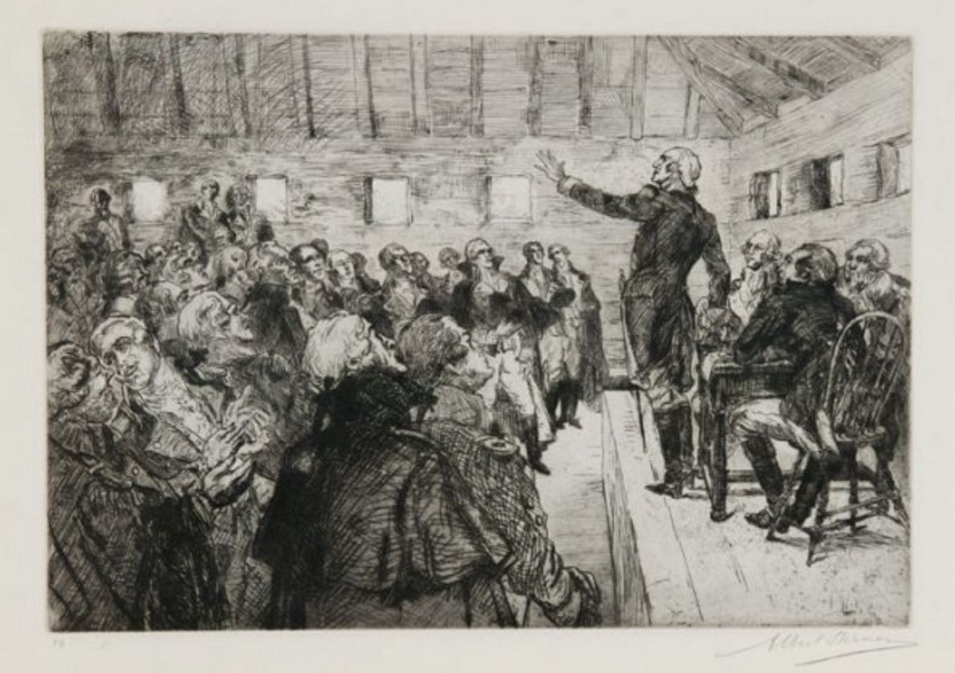

Washington says, “Gentlemen, I would like to address the soldiers who are sending around that petition. The idea of a war against our new nation is wrong. The person who wrote this, who will not share his name, is not a friend. I know times are tough. Congress has been slow. I give you my promise that I will bring this to Congress and will not stop until they give you what you deserve.”

After hearing Washington’s speech, will you change your decision (from the last sheet, 5-14.A) or keep it the same? Explain why.

**WORKSHEET 5-14.C**

**Problem 1: Loyalists**

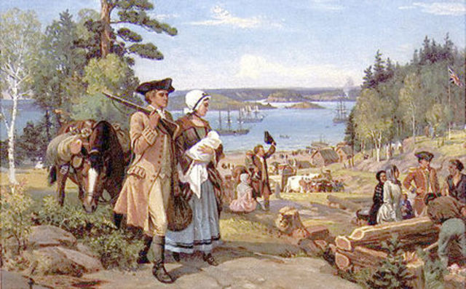

About 1 in 5 American colonists are **Loyalists**. They supported the King, Parliament, and did not want to leave Britain. Many of these Loyalists fought in the war for Britain. Many Loyalists were born and raised in the American colonies and have never been to Canada or England.

At the end of the war, the Loyalists are afraid that the Patriots might take their homes and land, put them in prison, or even hurt them. Many of these Loyalists are fleeing to Canada or taking boats to England. They might return to the new United States if they are promised their protection, freedom, and property.

In the peace treaty, what should we do? (See next page)

**Option 1:** Include in the peace treaty that Loyalists will be given full rights in the new United States. Anyone who threatens a Loyalists will be imprisoned and they should be allowed to live their life as they did before the war.

**Option 2:** Include in the peace treaty that Loyalists will have their homes and land protected, but not the same voting rights as Patriots (they did not support the new nation). If they choose to stay, no one will be able to force them out of their homes.

**Option 3:** Ask the Loyalists to leave the new United States. Provide them with free transportation to Canada or England. This is the only way to ensure their safety.

Circle the option above and explain why your group chose it:

**WORKSHEET 5-14.D**

**Problem 2: Enslaved Black People Who Supported the British**

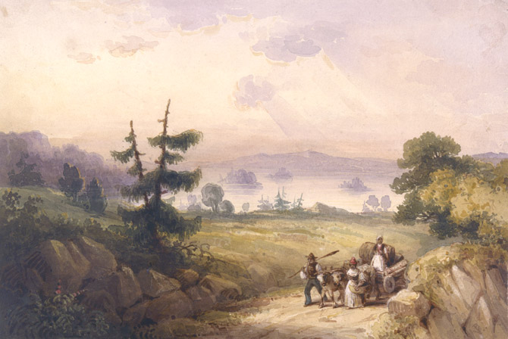

About 20,000 enslaved Black people joined the British Army (only 5,000 enslaved Black people joined the Patriots). Many of the enslaved people had escaped their plantations and were runaways. The British Army promised enslaved people their freedom at the end of the war.

At the end of the war, American slave owners are now demanding that their runaway slaves are returned to them. The British government is worried that runaway slaves may be hurt or killed.

In the peace treaty, what should we do? (See next page)

**Option 1:** Include in the peace treaty that the enslaved people will be returned to their owners. Ask the new United States government to ban slavery.

**Option 2:** Include in the peace treaty that enslaved people who fought for Britain should be considered free. The new freeman can stay in the United States. The British government will pay all slave owners for their freed slaves.

**Option 3:** Include in the peace treaty that enslaved people who fought for Britain should be freed. The new freeman must leave the new United States and move to another British territory in Canada, the Caribbean, or Africa. The slave owners will not be paid for their loss.

Circle the option above and explain why your group chose it:

**WORKSHEET 5-14.E**

**Problem 3: Britain in North America**

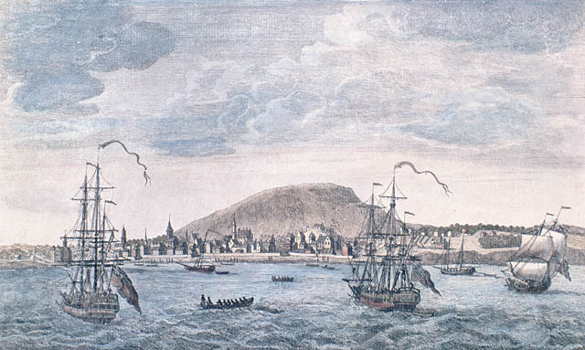

Although the Patriots will get to have their own country in what was the American colonies, Britain still has several territories in North America. This includes Canada to the north (Montréal, Canada is pictures above), Jamaica, and other Caribbean islands to the South. Britain had long fished off the coast of New England and used the Mississippi River to transport goods.

At the end of the war, Americans are worried that Britain will attack them again and force them back into the British empire. They are worried about letting Britain continue to have their navy and army in the Atlantic Ocean and Mississippi River.

In the peace treaty, what should we do? (See next page)

**Option 1:** Include in the peace treaty that Britain can continue to use the Mississippi River and Atlantic Ocean for fishing, trade, and their military.

**Option 2:** Include in the peace treaty that Britain can continue to use the Mississippi River and Atlantic Ocean for fishing and trade, but not for their military.

**Option 3:** Include in the peace treaty that Britain can no longer use the Mississippi River and Atlantic Ocean (south of Canada).

Circle the option above and explain why your group chose it:

**WORKSHEET 5-14.F**

**Peace of Paris (1783) Summary**

Below is a summary of the peace treaty ending the war.

Put a happy face next to anything you think is fair and a sad face next to anything you think is unfair.

____ 1. Britain gives the United States independence and they are no longer part of the British Crown.

____ 2. The boundaries of the United States will be at Canada (part of Britain) and Florida (part of Spain).

____ 3. Fisherman from the United States can fish in the Atlantic off the coast of Canada and fisherman from Britain (and Canada) can fish off the coast of New England.

____ 4. The Congress will ask all states to pay Loyalists for the land that they lost. They will stop their people from taking more land from Loyalists. *(Most Loyalists were not paid and about 100,000 would flee the United States with half going to Canada)*

____ 5. Prisoners from the war will be returned. This includes enslaved people who fought for the British. They will be returned to their owners. *(Britain did not do this and 3,000 former slaves were allowed to go to Canada and others went to the Caribbean or Africa)*

____ 6. Britain and the United States will forever be able to use the Mississippi River.

**ASSESSMENT 5-14.G**

**Exit Ticket: Peace of Paris**

Inquiry Question: *Was the Peace of Paris fair?*

Comparing your group’s views of each problem with the actual Peace of Paris, do you think the peace treaty was fair for everyone? Include three pieces of evidence from the sources.

**WORKSHEET 5-15.B**

**Preparation for the Corner Debate**

Think about the following sentences and decide if you think “strongly agree,” “agree,” “disagree,” or “strongly disagree.” Then explain why.

**It was unfair that farmers were losing their land and going to jail because of taxes.**

Circle:

Strongly Agree Agree Disagree Strongly Disagree

**Massachusetts needed to raise taxes to pay back its debts from the American Revolution.**

Circle:

Strongly Agree Agree Disagree Strongly Disagree

**A rebellion is good sometimes, because it keeps the government doing the right thing (Thomas Jefferson).**

Circle:

Strongly Agree Agree Disagree Strongly Disagree

**The Shays’ rebels were justified (right) in their protests.**

Circle:

Strongly Agree Agree Disagree Strongly Disagree

**MATERIALS 5-15.C**

**STRONGLY AGREE**

**AGREE**

**DISAGREE**

**STRONGLY DISAGREE**

**ASSESSMENT 5-15.D**

**Shays’ Rebellion: Exit Ticket**

Inquiry Question: *Were the participants of Shays’ Rebellion justified in their revolt?*

Using the information from the sources and the videos, explain if the Shays’ rebels were justified (right) in their revolt. Include three pieces of evidence from the sources.

**WORKSHEET 5-16.C**

**Mock Constitutional Convention: Items (Part 2)**

**Item 1: Slavery**

Proposal to ban the slave trade and allow Congress to vote to end slavery.

**Item 2: Taxes**

Proposal to have Congress tax imports (bought from other countries) and exports (sold to other countries).

**Item 3: Suffrage**

Proposal to allow each state to decide who can vote and who cannot vote. Most women, Black and Indigenous people, and men without property will probably not be able to vote.

**Item 4: Branches of government**

Proposal for three branches of government (below).

**Legislative (Congress)**

Proposal that larger states have more delegates.

Proposal to have two delegates per state.

**Executive (President and Cabinet)**

Proposal that the president serves for life.

**Judicial (Courts)**

Proposal that judges serve for life.

**Item 5: National government power**

There is a proposal that states (and their laws) are above national laws, so they have more power than the national government.

**Mock Constitutional Convention: How You Will Vote (Part 3)**

**Item 1: Slavery Proposal**

**Circle: Yes or No; Explain why below.**

**Item 2: Taxes Proposal**

**Circle: Yes or No; Explain why below.**

**Item 3: Suffrage (Voting) Proposal**

**Circle: Yes or No; Explain why below.**

**Item 4A: Branches: Legislative (Congress)**

**Circle: Population or Two Per State; Explain why below.**

**Item 4B: Branches: Executive (President and Cabinet)**

**Circle: Yes or No; Explain why below.**

**Item 4C: Branches: Judicial (Courts)**

**Circle: Yes or No; Explain why below.**

**Item 5: National government power**

**Circle: Yes or No; Explain why below.**

**Mock Constitutional Convention: What They Decided (Part 4)**

**Item 1: Slavery**

Slavery would be allowed. Congress could not end slavery until at least 1808.

**Item 2: Taxes**

Congress could have direct taxes on goods (things people own or buy) including imports (bought from other countries). Congress cannot tax exports (sold to other countries).

**Item 3: Suffrage**

Did not decide who could vote, so left up to each state.

**Item 4: Branches of government**

1. **Legislative (Congress)**

There are two bodies: House of Representatives (by population) and Senate (two per state).

1. **Executive (President and Cabinet)**

Would not serve a four-year term, but could be re-elected as many times as the voters wanted (this was changed in 1951 to only allow 2 elected terms).

1. **Judicial (Courts)**

Judges would serve life terms.

**Item 5: National government power**

The national government (and its laws) are above state laws, so they have more power than the states.

**ASSESSMENT 5-16.E**

**Constitutional Convention: Exit Ticket**

Inquiry Question: *Did the delegates as the Constitutional Convention make the right decisions?*

List at least 3 items found in the Constitution and explain if they were a good or bad idea to add. Include three pieces of evidence from the sources.

**WORKSHEET 5-17.B**

**Rank the Bill of Rights**

Below is a summary of each Amendment in the Bill of Rights. After discussing each with your group, put numbers next to the amendments you think are more important (1 being most important) and less important (10 being least important).

____ 1st Amendment. Freedom of religion, speech, press, assembly (protest), and petition.

____ 2nd Amendment. For the militia, people can keep and bear arms (guns/weapons).

____ 3rd Amendment. Soldiers cannot be forced to stay in homes.

____ 4th Amendment. The government cannot search (look for) or seize (take) property without a warrant (judge’s permission).

____ 5th Amendment. People do not need to testify (speak) in court, if you think it may incriminate (get you in trouble). They have a right to due process (a trial). They cannot be put on trial for the same crime twice. They cannot have their property taken away by the government without being paid money.

____ 6th Amendment. People must have a speedy trial and a jury (people who choose guilty or not guilty) of their peers. You have a right to a lawyer to defend you.

____ 7th Amendment. Civil cases (involving property crimes-like stealing or damages) will also have a jury.

____ 8th Amendment. The government cannot have bail (money to get out of jail) or fines that are too high or cruel and unusual punishments.

____ 9th Amendment. These are not all the rights and people still have rights not listed here.

____ 10th Amendment. Powers not given to the U.S. government in this Constitution are given either to the states or the people.

**ASSESSMENT 5-17.C**

**Bill of Rights: Exit Ticket**

Inquiry Question: *What is the most important right guaranteed to you under the Bill of Rights?*

Look at your ranking of the Amendments in the Bill of Rights. Of the top 3-4 you ranked, what do think you think is the most important right that you have? Explain why. Include three pieces of evidence from the sources or your own life.

**ASSESSMENT 5-18.F**

**Louisiana Purchase: Exit Ticket**

Inquiry Question: *Should Thomas Jefferson have purchased Louisiana from France?*

After considering the arguments for and against the Louisiana Purchase, decide if the cost (15 million francs) was worth it. Include three pieces of evidence from the sources.

**WORKSHEET 5-19.B**

**Lewis and Clark Expedition Video Reflection**

After watching the video “Lewis and Clark Expedition,” write down your thoughts about their journey. What were the most important events? Was the journey worth the risk of death?

**ASSESSMENT 5-19.H**

**Lewis and Clark Expedition: Exit Ticket**

Inquiry Question: *Who was the most important leader during the Lewis and Clark Expedition?”*

After learning about all the people involved in the Lewis and Clark Expedition, who do you think was most important. Include three pieces of evidence from the sources.

**WORKSHEET 5-20.A**



**ASSESSMENT 5-20.F**

**Trail of Tears: Exit Ticket**

Inquiry Question: *What was it like for someone who was forced out of their home by the U.S. government during the Trail of Tears?*

Using the information from the book Trail of Tears, your person’s biography, and the notes we took on the board, write four journal entries describing what it was like for a Cherokee person to be forced out of their homes and moved to the new Indian Territory (Oklahoma).

**Diary Entry 1**

**Date:**

**Diary Entry 2**

**Date:**

**Diary Entry 3**

**Date:**

**Diary Entry 4**

**Date:**

**MATERIALS 5-21.B**

**Gold Hunt** **Rules (For Teacher)**

Anglos or White Miners: The Anglos were often the first to show up to a mining site. As a result, they did not look very carefully, because the gold was plentiful. Whites ran the government of California and the laws favored them. If you are assigned to this group, you should simply look everywhere by wandering around the classroom. If the Latinos are more successful than you at finding gold, you can start spreading rumors that they are bandidos or roaming bandits who have only stolen their gold. If any Latino miners come within 10 feet of you, you should yell “bandidos” and you are allowed to take their gold.

Latino Miners: Latinos (primarily Californios, Mexicans, and Chileans) were the second group to arrive (or, if they were originally from California, already living there). They were often more skilled than the Anglos (especially the Chileans and Peruvians), because many of them were already miners back home. At the same time, they faced discrimination from the Whites who ran the government of California. You should stay at least 10 feet away from any of the Anglos. It is recommended that you focus in on a specific area of the room and only spend your time in that area scouring over every crevice. By doing this, your hard work is much more likely to help you find Gold.

Native Miners: The indigenous people of northern California had a long history of poor treatment by Europeans (first by the Spanish missionaries and later by the Anglo settlers). During the Gold Rush, as a result of the Indenture Act, many Miwok, Maidu, and Nissenan people had their land taken, or were enslaved and forced to do work in the gold fields. As a result, you will begin with the Anglos miners, but will have to give them any of the gold that you find. It is estimated that 100,000 native people died in the first two years of the Gold Rush as the result of violence and disease, while many others lost everything they had.

Chinese Miners: The distance of the Pacific Ocean meant that many Chinese miners did not arrive until later. Additionally, the Chinese miners were banned by the Whites from mining new land. So, for you, there will be a one-minute delayed start and you may only look for gold in places that the Whites have finished looking. However, you should be more careful than the Whites and Latinos. Search hard in places no one is looking and you may find more gold than the other groups.

African American Miners: While some African Americans were slaves brought by their masters to California, most were freeman who came to earn an income and escape their poor treatment back East. However, much like the Latino miners, African Americans faced discrimination. You will be freemen from northern states, who, like the Chinese miners, can only mine in places with permission of the Anglo miners.

**MATERIALS 5-21.C**

REPUBLIC OF MEXICO (LATINOS)

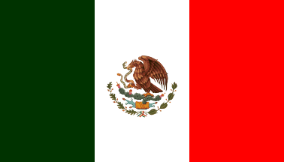

UNITED STATES OF AMERICA

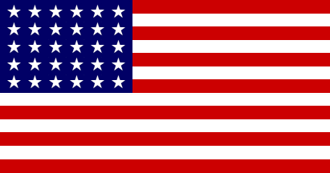

QING DYNASTY (CHINA)

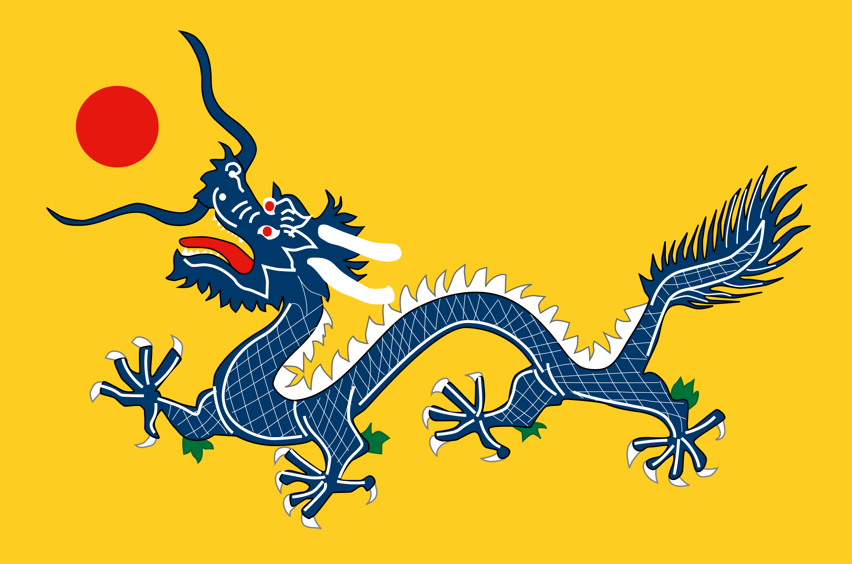

ANTI-SLAVERY FLAG (AFRICAN AMERICANS)

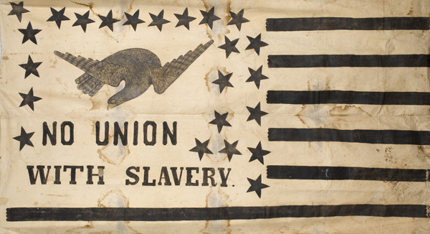

MIWOK (NATIVE PEOPLE)

**ASSESSMENT 5-21.E**

**California Gold Rush: Exit Ticket**

Inquiry Question: *Should the California Gold Rush be remembered for its opportunity or its inequity?”*

Based on what we learned today, describe if the Gold Rush was a time of opportunity or inequity. Include three pieces of evidence from the sources or Gold Rush hunt.

**ASSESSMENT 5-22.B**

**Westward Expansion or Invasion from the East?: Exit Ticket**

Inquiry Question: *Inquiry Question: Was the movement of White Americans a “westward expansion” or an “invasion from the east?”*

After considering the different sources related to White Americans movement west, should it be called a movement or an invasion? Include three pieces of evidence from the sources.

**WORKSHEET 5-23.D**

**Scribe Sheet**

Inquiry Question: *Why was the Civil War fought?*

We think the strongest cause of the Civil War was (circle):

Slavery Business The Union

Our reasons for this are:

**ASSESSMENT 5-23.E**

**The Civil War: Exit Ticket**

Inquiry Question: *Why was the Civil War fought?*

After consider all of the causes of the Civil War, which do you think was the strongest factor that led to war? While all of these factors were reasons why the war happened, why do you think this was the one that was strongest? Include three pieces of evidence from the sources.

**ASSESSMENT 5-24.F**

**Reconstruction: Exit Ticket**

Inquiry Question: *What was the worst decision made during the period of Reconstruction after the Civil War?*

After consider all of the bad decision made after the Civil War, decide which decision was the worst. Choose a decision that you think made it most difficult for former slaves to improve their lives and escape slavery. Include three pieces of evidence from the sources.

**ASSESSMENT 5-25.F**

**The Great Migration: Exit Ticket**

Inquiry Question: *If you were an African American in the South at the turn of the 20th Century, would you have moved north?*

After consider the pros and cons on moving North, decide if you would have risked everything to be a part of the Great Migration. Include three pieces of evidence from the sources.

**WORKSHEET 5-26.A**



**ASSESSMENT 5-26.G**

**Japanese American Incarceration: Exit Ticket**

Inquiry Question: *What was it like for Japanese Americans who were forced by the U.S. government into prison camps during World War II?*

Using the information from the book “The Bracelet,” your person’s biography, the timeline, and the notes we took on the board, write four journal entries describing what it was like for a Japanese American person to be forced out of their homes and into prison camps.

**Diary Entry 1**

**Date:**

**Diary Entry 2**

**Date:**

**Diary Entry 3**

**Date:**

**Diary Entry 4**

**Date:**

**WORKSHEET 5-27.E**

**Note Taking Sheet**

Source 1: Overview: The Civil Rights Movement

Source 2: Martin Luther King Sources

Source 3: Malcolm X Sources

**ASSESSMENT 5-27.F**

**The Civil Rights Movement: Exit Ticket**

Inquiry Question: *Who had the better strategy for reducing racism and improving the Black community?*

After reading about the positions of Martin Luther King and Malcolm X, decide which civil rights leader has the best ideas for reducing racism and improving the Black community. Include three pieces of evidence from the sources.

**ASSESSMENT 5-28.F**

**National Farm Workers Association: Exit Ticket**

Inquiry Question: *Which type of protest used by Chavéz and Huerta was most effective?*

After consider the different protest methods used by the National Farm Workers Association, choose the one that you think worked best or was most effective and explain why. Include three pieces of evidence from the sources.

**ASSESSMENT 5-29.G**

**The Other Civil Rights Movements: Exit Ticket**

Inquiry Question: *For your assigned civil rights movement, what was their most important action?*

For the civil rights group that you were assigned (Women’s Liberation Movement, American Indian Movement, Chicano Student Movement, Justice for Vincent Chin Movement), choose one or more actions they took and explain why they were important.

**ASSESSMENT 5-30.F**

**The Boston Busing Crisis: Exit Ticket**

Inquiry Question: *What was the best plan for racially integrating Boston’s schools?*

After consider the different possible ways to integrate the Boston Public Schools, choose the one that you think would work best and explain why. Include three pieces of evidence from the sources.

**GRADE 5 POST-TEST**

Answer the following questions.

**1. What was the American Revolution?**

**2. What are rights?**

**3. What is a movement?**

**4. Label each continent on the picture below: Antarctica, Africa, Asia, Australia, Europe, North America, South America.**

**5. Label as many states as you can on the picture below.**



**6. What was the relationship between the European and Indigenous people like in the Americas?**

**7. Name as many rights found in the Bill of Rights as you can.**

**8. Name the three branches of government.**

**9. Name as many causes of the Civil War as you can.**

**10. What are civil rights?**

**11. What was the most important point made or idea found in the Constitution or Bill of Rights?**

**12. Does the United States live up to this line in the Pledge of Allegiance: “one nation … with liberty and justice for all?”**