Open Social Studies

An Inquiry-Based and Literacy-Focused K-6 Curriculum

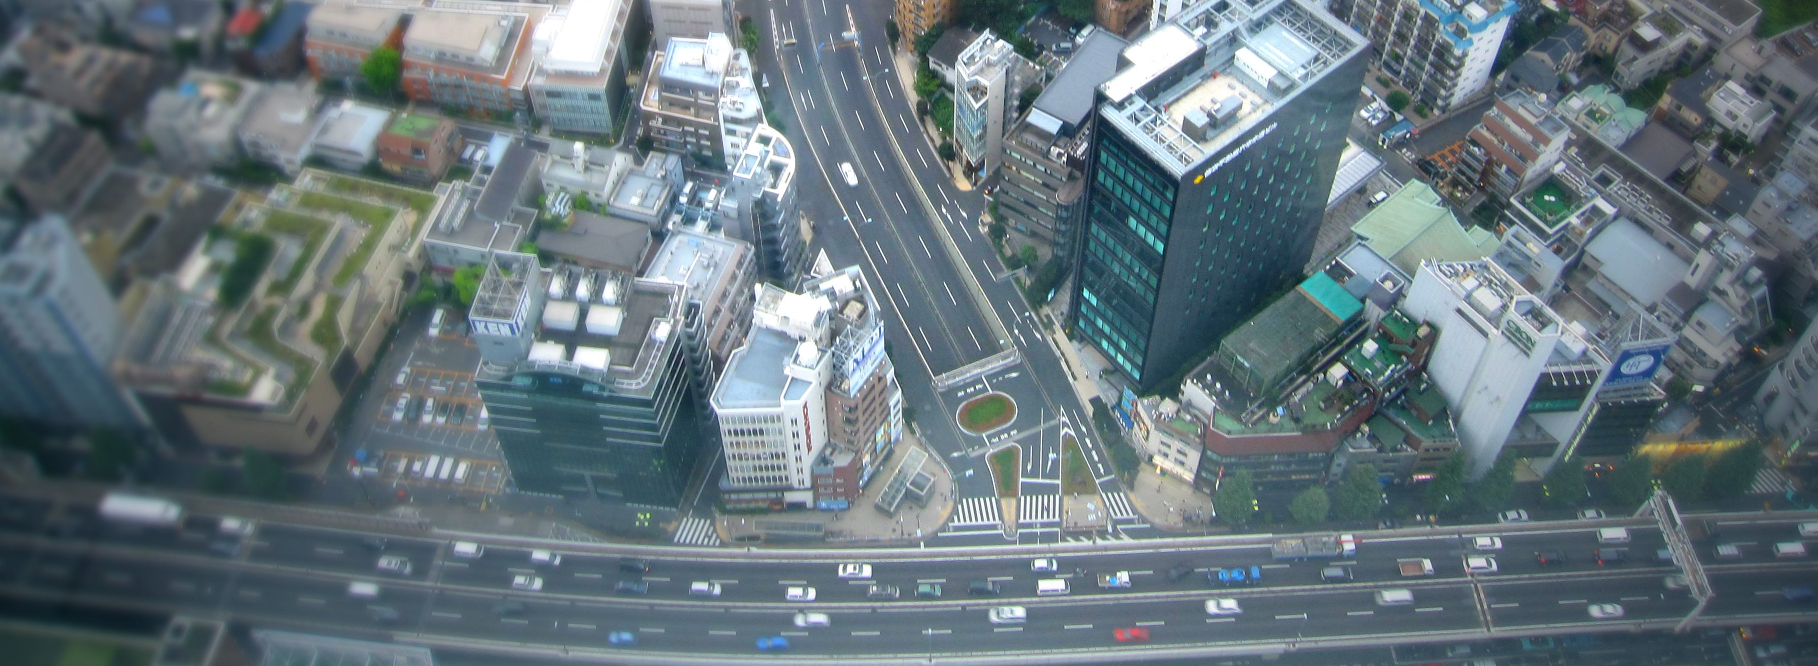

Curric

STUDENT WORKBOOK

Level: Grade 4

Exploring the World

Developers:

Christopher C. Martell

Jennifer R. Bryson

GRADE 4 ROAD MAP

LESSON 4-1

Lesson Title: Northeast (U.S. Regions Mini-Unit)

Inquiry Question: What is the most important city in the Northeast United States?

LESSON 4-2

Lesson Title: Southeast (U.S. Regions Mini-Unit)

Inquiry Question: What tourist destination in the Southeast United States would you most like to visit?

LESSON 4-3

Lesson Title: Midwest (U.S. Regions Mini-Unit)

Inquiry Question: If you were to start a business in the Midwest United States, what would it be?

LESSON 4-4

Lesson Title: Southwest (U.S. Regions Mini-Unit)

Inquiry Question: What natural area in the Southwest United States is most important to protect?

LESSON 4-5

Lesson Title: West (U.S. Regions Mini-Unit)

Inquiry Question: If you had to move to the West United States, which metropolitan area would you move to?

LESSON 4-6

Lesson Title: The History of Canada (North America Mini-Unit)

Inquiry Question: What was the most important event in Canadian history?

LESSON 4-7

Lesson Title: Road Trip: Canada (North America Mini-Unit)

Inquiry Question: If you were to visit Canada, what city would you travel to?

LESSON 4-8

Lesson Title: The History of Mexico (North America Mini-Unit)

Inquiry Question: What was the most important event in Mexican history?

LESSON 4-9

Lesson Title: Road Trip: Mexico (North America Mini-Unit)

Inquiry Question: If you were to visit Mexico, what part would you travel to?

LESSON 4-10

Lesson Title: How Many Continents and Oceans Are There?

Inquiry Question: How many continents and oceans are there?

LESSON 4-11

Lesson Title: Which Way Is Up? Seeing the World Through Different Maps

Inquiry Question: Which map is best?

LESSON 4-12

Lesson Title: Africa: Where Humans Began (Africa Mini-Unit)

Inquiry Question: What was the most important event of early human in Africa?

LESSON 4-13

Lesson Title: Ancient Egypt (Africa Mini-Unit)

Inquiry Question: If you could be in any ancient Egyptian social class, which would you choose and why?

LESSON 4-14

Lesson Title: The Great African Empires: Ghana, Kongo, Ethiopia, and Zimbabwe (Africa Mini-Unit)

Inquiry Question: If you could live in any African empire, which one would it be and why?

LESSON 4-15

Lesson Title: Timbuktu: How Trade Shaped a City (Africa Mini-Unit)

Inquiry Question: Why was Timbuktu so important?

LESSON 4-16

Lesson Title: Apartheid in South Africa: A Movement for Freedom (Africa Mini-Unit)

Inquiry Question: What can we learn from the Anti-Apartheid Movement in South Africa?

LESSON 4-17

Lesson Title: Africa Today: Diverse Nations, Diverse People (Africa Mini-Unit)

Inquiry Question: If you were to visit Africa today, what country would you choose and why?

LESSON 4-18

Lesson Title: The Great Asian Empires: China, Japan, India, and Persia (Asia Mini-Unit)

Inquiry Question: If you could live in any Asian empire, which one would it be and why?

LESSON 4-19

Lesson Title: The Silk Road: Connecting the Continents (Asia Mini-Unit)

Inquiry Question: What was life like on the Silk Road?

LESSON 4-20

Lesson Title: Việt Nam: A Country of Waterways (Asia Mini-Unit)

Inquiry Question: Are the human changes to the Mekong River more positive or negative?

LESSON 4-21

Lesson Title: Asian Megacities: Would You Want to Live There? (Asia Mini-Unit)

Inquiry Question: Would you like to live in an Asian megacity?

LESSON 4-22

Lesson Title: World Religions: Hinduism, Confucianism, Buddhism, Judaism, Christianity, and Islam (Asia Mini-Unit)

Inquiry Question: What is each religion’s greatest contribution to the world?

LESSON 4-23

Lesson Title: Asia Today: Diverse Nations, Diverse People (Asia Mini-Unit)

Inquiry Question: If you were to visit Asia today, what country would you choose and why?

LESSON 4-24

Lesson Title: The Great American Empires: Aztec, Maya, Inca, and Mississippi (Americas Mini-Unit)

Inquiry Question: If you could live in any American empire, which one would it be and why?

LESSON 4-25

Lesson Title: Columbus: Hero or Villain? (Americas Mini-Unit)

Inquiry Question: Did Columbus’s voyages have more of a positive or negative impact on the world?

LESSON 4-26

Lesson Title: Haiti: What Type of Revolution? (Americas Mini-Unit)

Inquiry Question: What type of revolution did Toussaint Louverture lead in Haiti?

LESSON 4-27

Latin America Today: Diverse Nations, Diverse People (Americas Mini-Unit)

Inquiry Question: If you were to visit Latin America today, what country would you choose and why?

LESSON 4-28

Lesson Title: The Great European Empires: Greece, Rome, Spain, France, and Britain (Europe Mini-Unit)

Inquiry Question: If you could live in any European empire, which one would it be and why?

LESSON 4-29

Lesson Title: Irish Independence: A New Country from an Ancient People (Europe Mini-Unit)

Inquiry Question: Why was Irish independence from England so important to its people?

LESSON 4-30

Lesson Title: Backpacking Across Europe: Diverse Nations, Diverse People (Europe Mini-Unit)

Inquiry Question: If you were to backpack across Europe today, what country would you most want to visit and why?
GRADE 4 PRE-TEST

Answer the following questions.

1. What does it mean to be an Indigenous person?

2. What is an immigrant?

3. What is slavery?

4. Name the oceans on Earth.

5. Label each continent on the picture below: Antarctica, Africa, Asia, Australia, Europe, North America, South America.

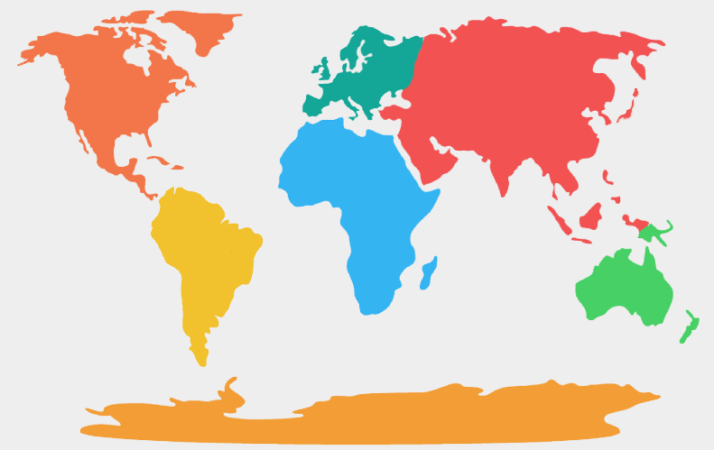

6. Label as many states as you can on the picture below.
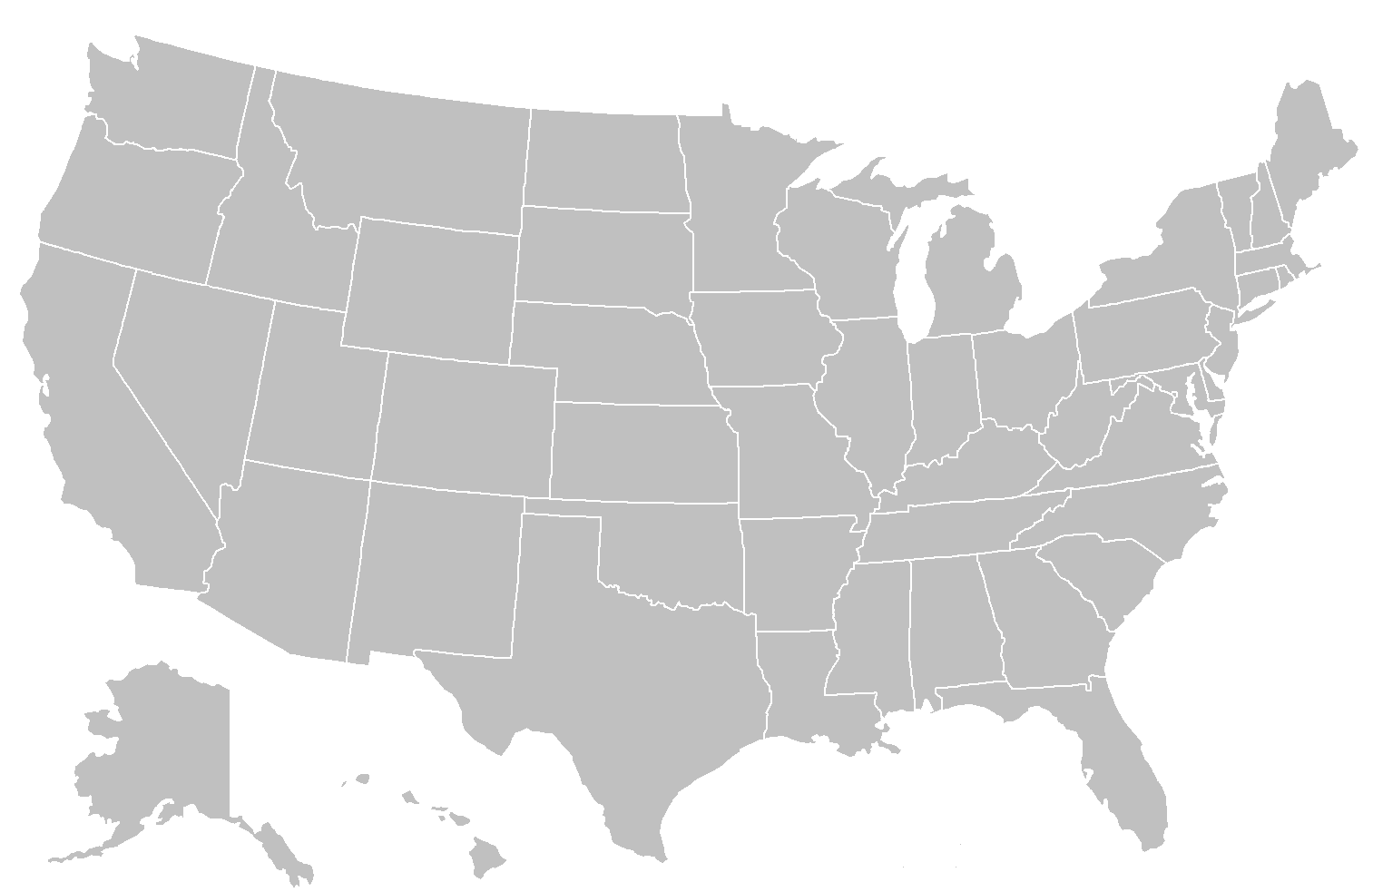
7. Explain where humans first began.

8. Name as many religions as you can.

9. What continent has the most people?

10. What countries border the United States?

WORKSHEET 4-1.A

Amazing Race Challenge 1: Northeast Map
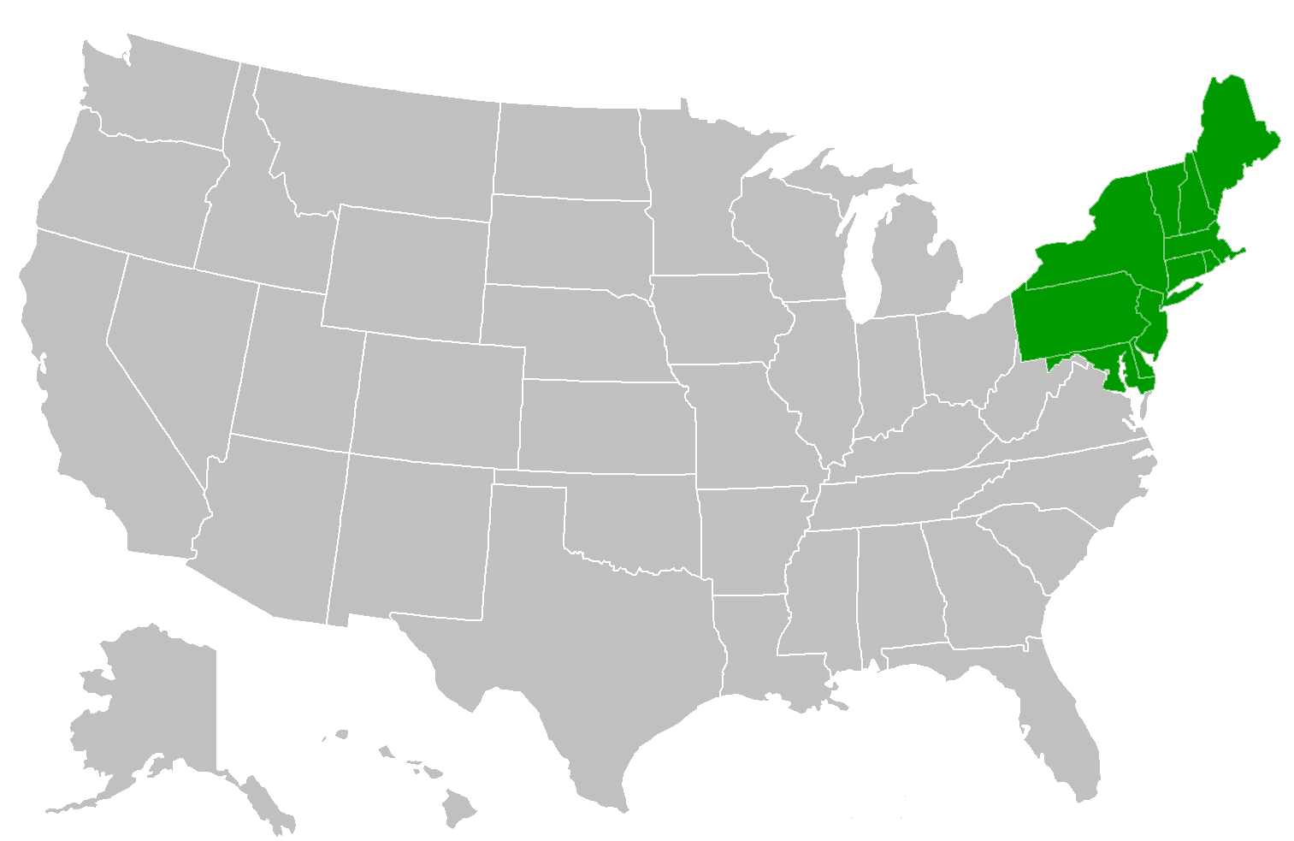
Answer Key
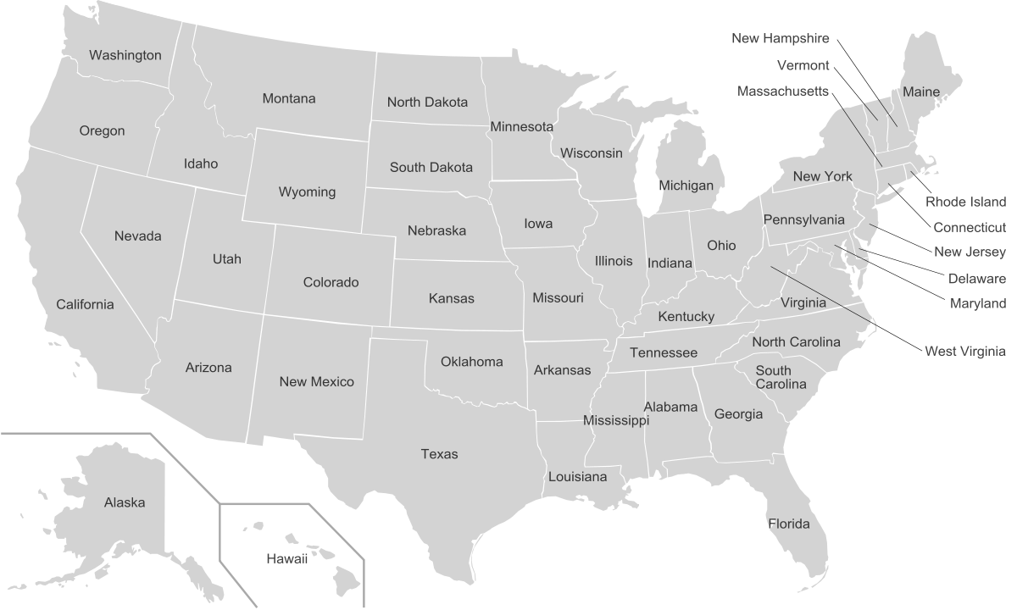

WORKSHEET 4-1.G

Amazing Race Challenge 2: Clues About Northeast Cities

Clue 1: This city is known for its steel factories.

Clue 2: This city has one of the largest shipping ports in the U.S.

Clue 3: This city has a famous bell with a crack in it.

Clue 4: This city has recently won a sports championship in every major U.S. sport (baseball, basketball, football, and hockey).

Clue 5: This is the largest city in the United States.

Answer Key

Clue 1: This city is known for its steel factories.

Pittsburgh

Clue 2: This city has one of the largest shipping ports in the U.S.

Baltimore

Clue 3: This city has a famous bell with a crack in it.

Philadelphia

Clue 4: This city has recently won a sports championship in every major U.S. sport (baseball, basketball, football, and hockey).

Boston

Clue 5: This is the largest city in the United States.

New York

ASSESSMENT 4-1.H

Northeast: Exit Ticket

Inquiry Question: What is the most important city in the Northeast United States?

After visiting each station on the cities of the Northeast, which city do you think is most important? Include three pieces of evidence from the sources.

WORKSHEET 4-2.A

Amazing Race Challenge 3: Southeast Map
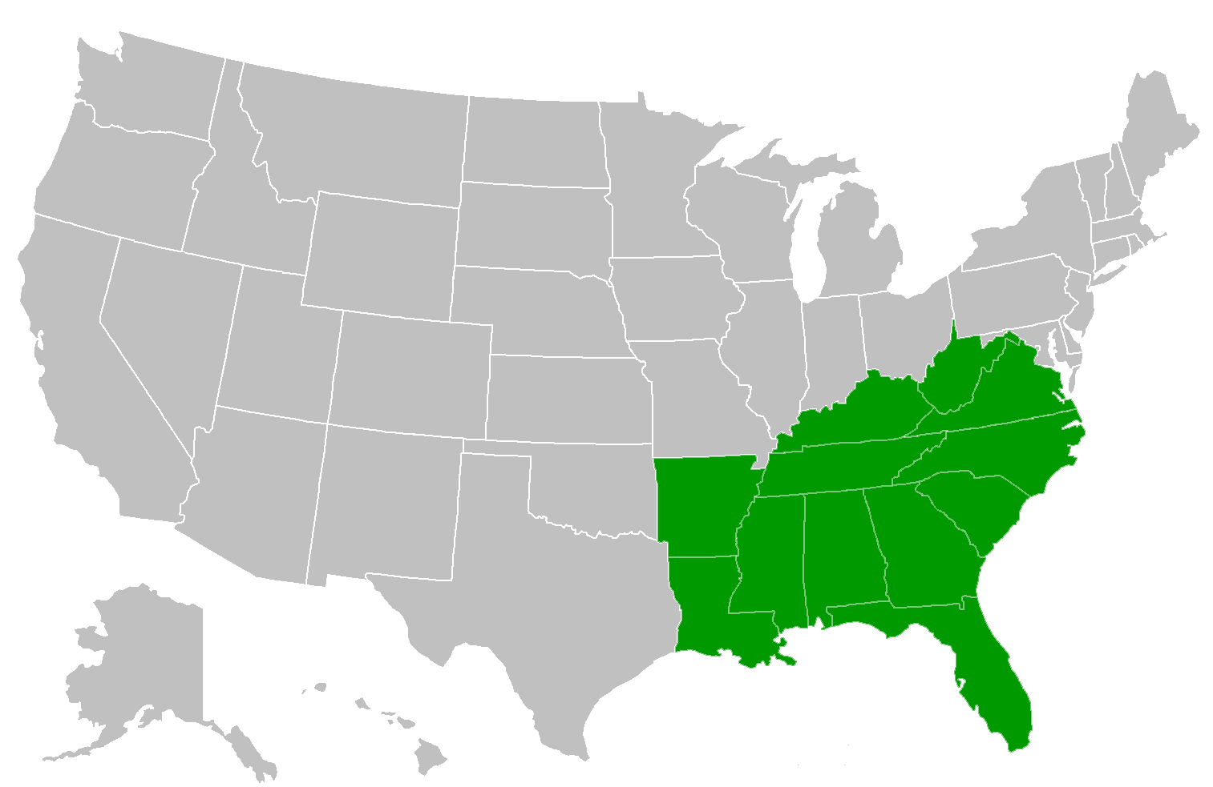
Answer Key

WORKSHEET 4-2.G

Amazing Race Challenge 5: Clues About Southeast Attractions

Clue 1: This place is where you can listen to country music.

Clue 2: This place is where you can learn about the history of the South.

Clue 3: This place is on the Mississippi River.

Clue 4: This place has white sand beaches.

Clue 5: This place is often covered in fog.

Answer Key

Clue 1: This place is where you can listen to country music.

Nashville

Clue 2: This place is where you can learn about the history of the South.

Charleston

Clue 3: This place is on the Mississippi River.

New Orleans

Clue 4: This place has white sand beaches.

Miami Beach

Clue 5: This place is often covered in fog.

The Smoky Mountains

ASSESSMENT 4-2.H

Southeast: Exit Ticket

Inquiry Question: What tourist destination in the Southeast United States would you most like to visit?

After visiting each station on the attractions of the Southeast, which tourist destination would you want to visit? Include three pieces of evidence from the sources.

WORKSHEET 4-3.A

Amazing Race Challenge 5: Midwest Map
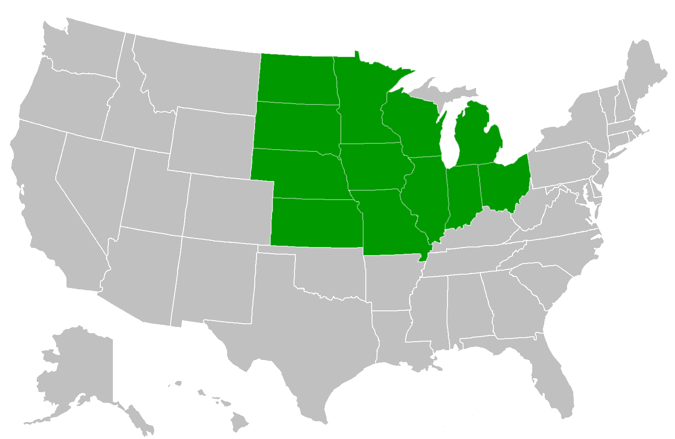
Answer Key
WORKSHEET 4-3.G

Amazing Race Challenge 6: Clues About Midwest Industries

Clue 1: This would be a good state to raise cattle and horses.

Clue 2: This would be a good state to make and sell cheese.

Clue 3: This would be a good state to trade stocks and futures.

Clue 4: This would be a good state to ship goods, like lumber, steel, and grain.

Clue 5: This would be a good state to grow corn.

Answer Key

Clue 1: This would be a good state to raise cattle and horses.

North Dakota

Clue 2: This would be a good state to make and sell cheese.

Wisconsin

Clue 3: This would be a good state to run a stocks and futures.

Illinois

Clue 4: This would be a good state to ship goods, like lumber, steel, and grain.

Ohio

Clue 5: This would be a good state to grow corn.

Iowa

ASSESSMENT 4-3.H

Midwest: Exit Ticket

Inquiry Question: If you were to start a business in the Midwest United States, what would it be?

After visiting each station on the businesses of the Midwest, which business would you start? Include three pieces of evidence from the sources.

WORKSHEET 4-4.A

Amazing Race Challenge 7: Southwest Map
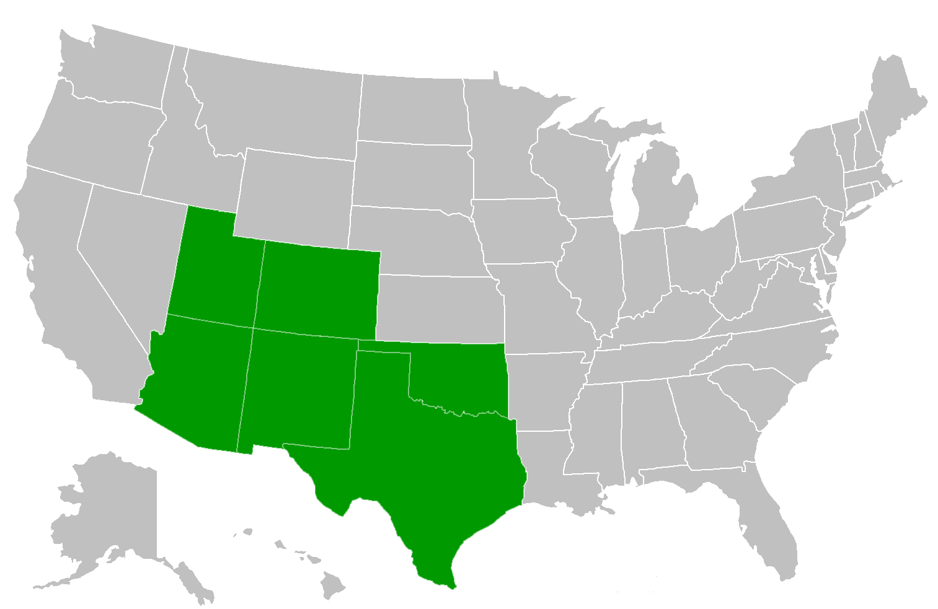

Answer Key

WORKSHEET 4-4.G

Amazing Race Challenge 8: Clues About Southwest Natural Areas

Clue 1: This would be a good state to find petrified wood.

Clue 2: This would be a good state to travel in a boat on the bayou.

Clue 3: This would be a good state to climb the highest peak in the southern Rocky Mountains.

Clue 4: This would be a good state to see rock forms that appear in many movies.

Clue 5: This would be a good state to go deep underground in caverns.

Answer Key

Clue 1: This would be a good state to find petrified wood.

Arizona

Clue 2: This would be a good state to travel in a boat on the bayou.

Texas

Clue 3: This would be a good state to climb the highest peak in the southern Rocky Mountains.

Colorado

Clue 4: This would be a good state to see rock forms that appear in many movies.

Utah

Clue 5: This would be a good state to go deep underground in caverns.

New Mexico

ASSESSMENT 4-4.H

Southwest: Exit Ticket

Inquiry Question: What natural area in the Southwest United States is most important to protect?

After visiting each station on the natural areas of the Southwest, which do you think is most important to protect? Include three pieces of evidence from the sources.

WORKSHEET 4-5.A

Amazing Race Challenge 9: West Map
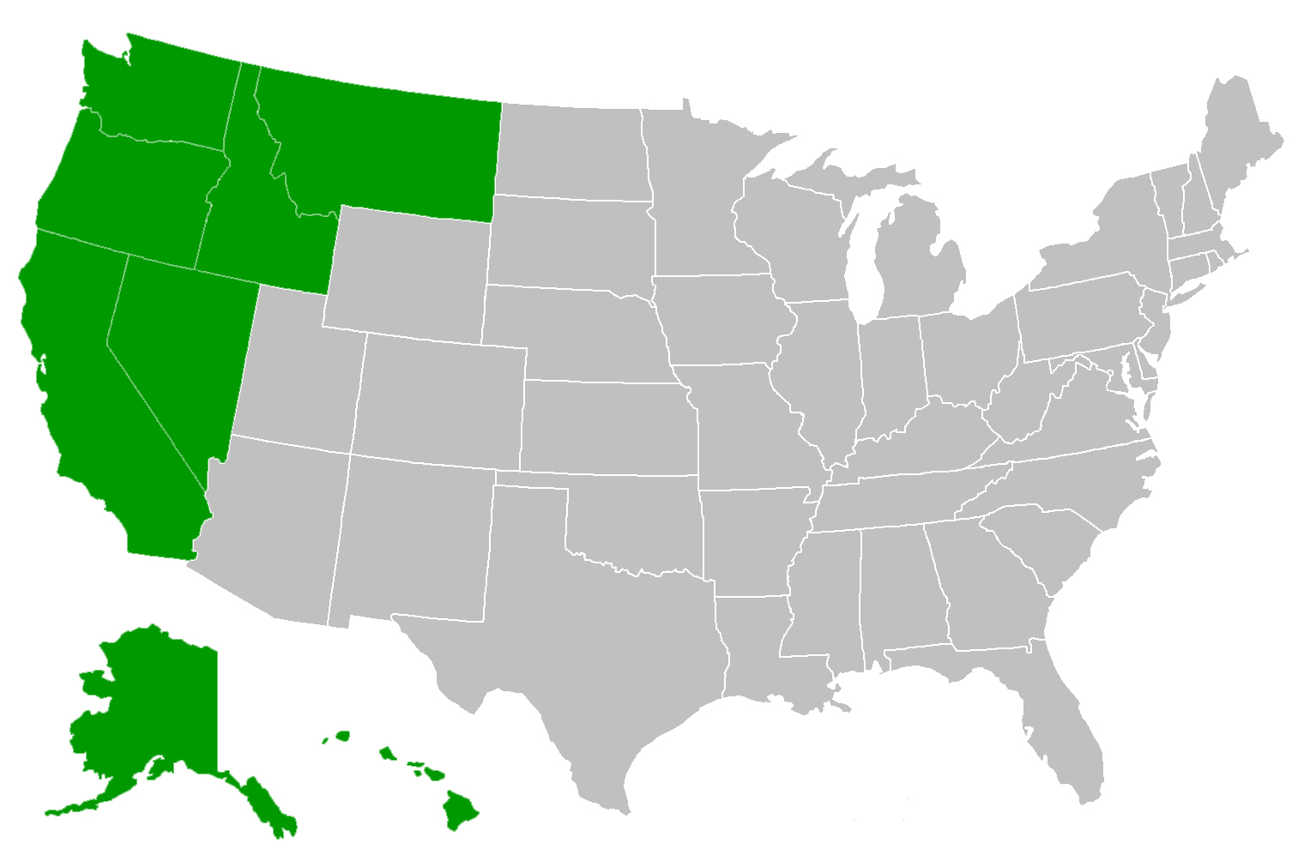

Answer Key
WORKSHEET 4-5.G

Amazing Race Challenge 10: Clues About Metropolitan Areas in the West

Clue 1: This would be a good area to move to if you wanted to grow grapes on a farm.

Clue 2: This would be a good area to move to if you wanted to work with computers.

Clue 3: This would be a good area to move to if you wanted to run boat tours to see orca whales.

Clue 4: This would be a good area to move to if you wanted to work as an actor or musician.

Clue 5: This would be a good area to move to if you wanted to run a hotel near the beach.

Answer Key

Clue 1: This would be a good area to move to if you wanted to grow grapes on a farm.

Willamette Valley (Oregon)

Clue 2: This would be a good area to move to if you wanted to work with computers.

San Francisco Bay Area (California)

Clue 3: This would be a good area to move to if you wanted to run boat tours to see orca whales.

Puget Sound (Washington)

Clue 4: This would be a good area to move to if you wanted to work as an actor or musician.

Greater Los Angeles (California)

Clue 5: This would be a good area to move to if you wanted to run a hotel near the beach.

Island of O’ahu (Hawaii)

ASSESSMENT 4-5.H

West: Exit Ticket

Inquiry Question: If you had to move to the West United States, which metropolitan area would you move to?

After visiting each station on the metropolitan areas of the West, where would you move? Include three pieces of evidence from the sources.

WORKSHEET 4-6.A

Canadian History Timeline

Below are some of the important events in Canadian history. We will specifically discuss the events that are highlighted in gray.

8000 BCE: Indigenous people create first communities in Canada.

3000 BCE: Indigenous people establish various animal management and farming techniques across Canada.

1000: Vikings arrive in Newfoundland (500 years before Columbus), briefly settled there and left after a short time to explore other places.

1541: Jacques Cartier explores the St. Lawrence River and makes contact with the St. Lawrence Iroquois people.

1608: Samuel de Champlain founds Québec and French people begin settling along the St. Lawrence River.

1763: France would fight Britain in Canada (1754-1763) during what was called the War of Conquest (by Canadians) or French and Indian War (by Americans). In the end, Britain would take control of Canada.

1775: During the American Revolution, the United States would invade Canada and try to take it over. Britain’s army would stop the invasion.

1812: During the War of 1812, the United States would invade Canada and try to take it over. Britain’s army would stop the invasion.

1837-38: French Canadians would rebel against the British government as part of the Patriote movement, which demanded equal rights to Anglo Canadians.

1867: The Canadian colonies unite under the Confederation of Canada, becoming one nation, and electing John Macdonald prime minister.

December 6, 1917: A ship ran into another ship carrying explosives for the war. 2,000 people died and 9,000 were injured during the Halifax Explosion. It was the largest man-made disaster in Canadian history. It was part of the First World War, where many Canadian soldiers fought and died in Europe.

1930s: During the Depression, 1 in 5 Canadians had no jobs and many people were hungry. The Canadian government would create relief programs to help the people.

1939: Canada sends soldiers to Europe (and later Asia) to fight in the Second World War. One million Canadians would serve.

1982: Canada Act: Canada gained its full independence from Britain by creating its own constitution. This included the Charter of Rights and Freedom, which guarantees all citizens the rights to democracy, speech, press, protest, and religion.

 | 1541 | 1763 | 1837-38 | 1867 | 1917 | 1982
Indigenous People
French Canadians
Anglo Canadians
Black Canadians
Asian Canadians
ASSESSMENT 4-6.G

Canadian History: Exit Ticket

Inquiry Question: What was the most important event in Canadian history?

After reading the sources, decide what event was most important in creating the nation of Canada. Include three pieces of evidence from the sources.

ASSESSMENT 4-7.E

Canada, Road Trip: Exit Ticket

Inquiry Question: If you were to visit Canada, what city would you travel to?

After looking at the places in Canada that we studied today on our road trip, which city would you most want to visit? Include three pieces of evidence from the sources.

MATERIALS 4-8.A
250

1325

1519

1810

1857

1910

1968

ASSESSMENT 4-8.C

Mexican History: Exit Ticket

Inquiry Question: What was the most important event in Mexican history?

After reading the sources, decide what event was most important in creating the nation of Mexico. Include three pieces of evidence from the sources.

WORKSHEET 4-9.A

Places in Mexico Notes

Source 1: Mexico City

Source 2: Baja California

Source 3: Yucatán Peninsula

Source 4: Chihuahua

ASSESSMENT 4-9.F

Mexico, Road Trip: Exit Ticket

Inquiry Question: If you were to visit Mexico, what part would you travel to?

After looking at the places in Mexico that we studied today on our road trip, which place would you most want to visit? Include three pieces of evidence from the sources.

WORKSHEET 4-10.A

Continents and Oceans Notes

Source 1: 8 Continents Argument

Source 2: 7 Continents Argument

Source 3: 5 Continents Argument

Source 4: 3 Continents Argument

Source 5: 5 Oceans Argument

Source 6: 4 Oceans Argument

Source 7: 3 Oceans Argument

Source 8: 1 Ocean Argument

MATERIALS 4-11.A

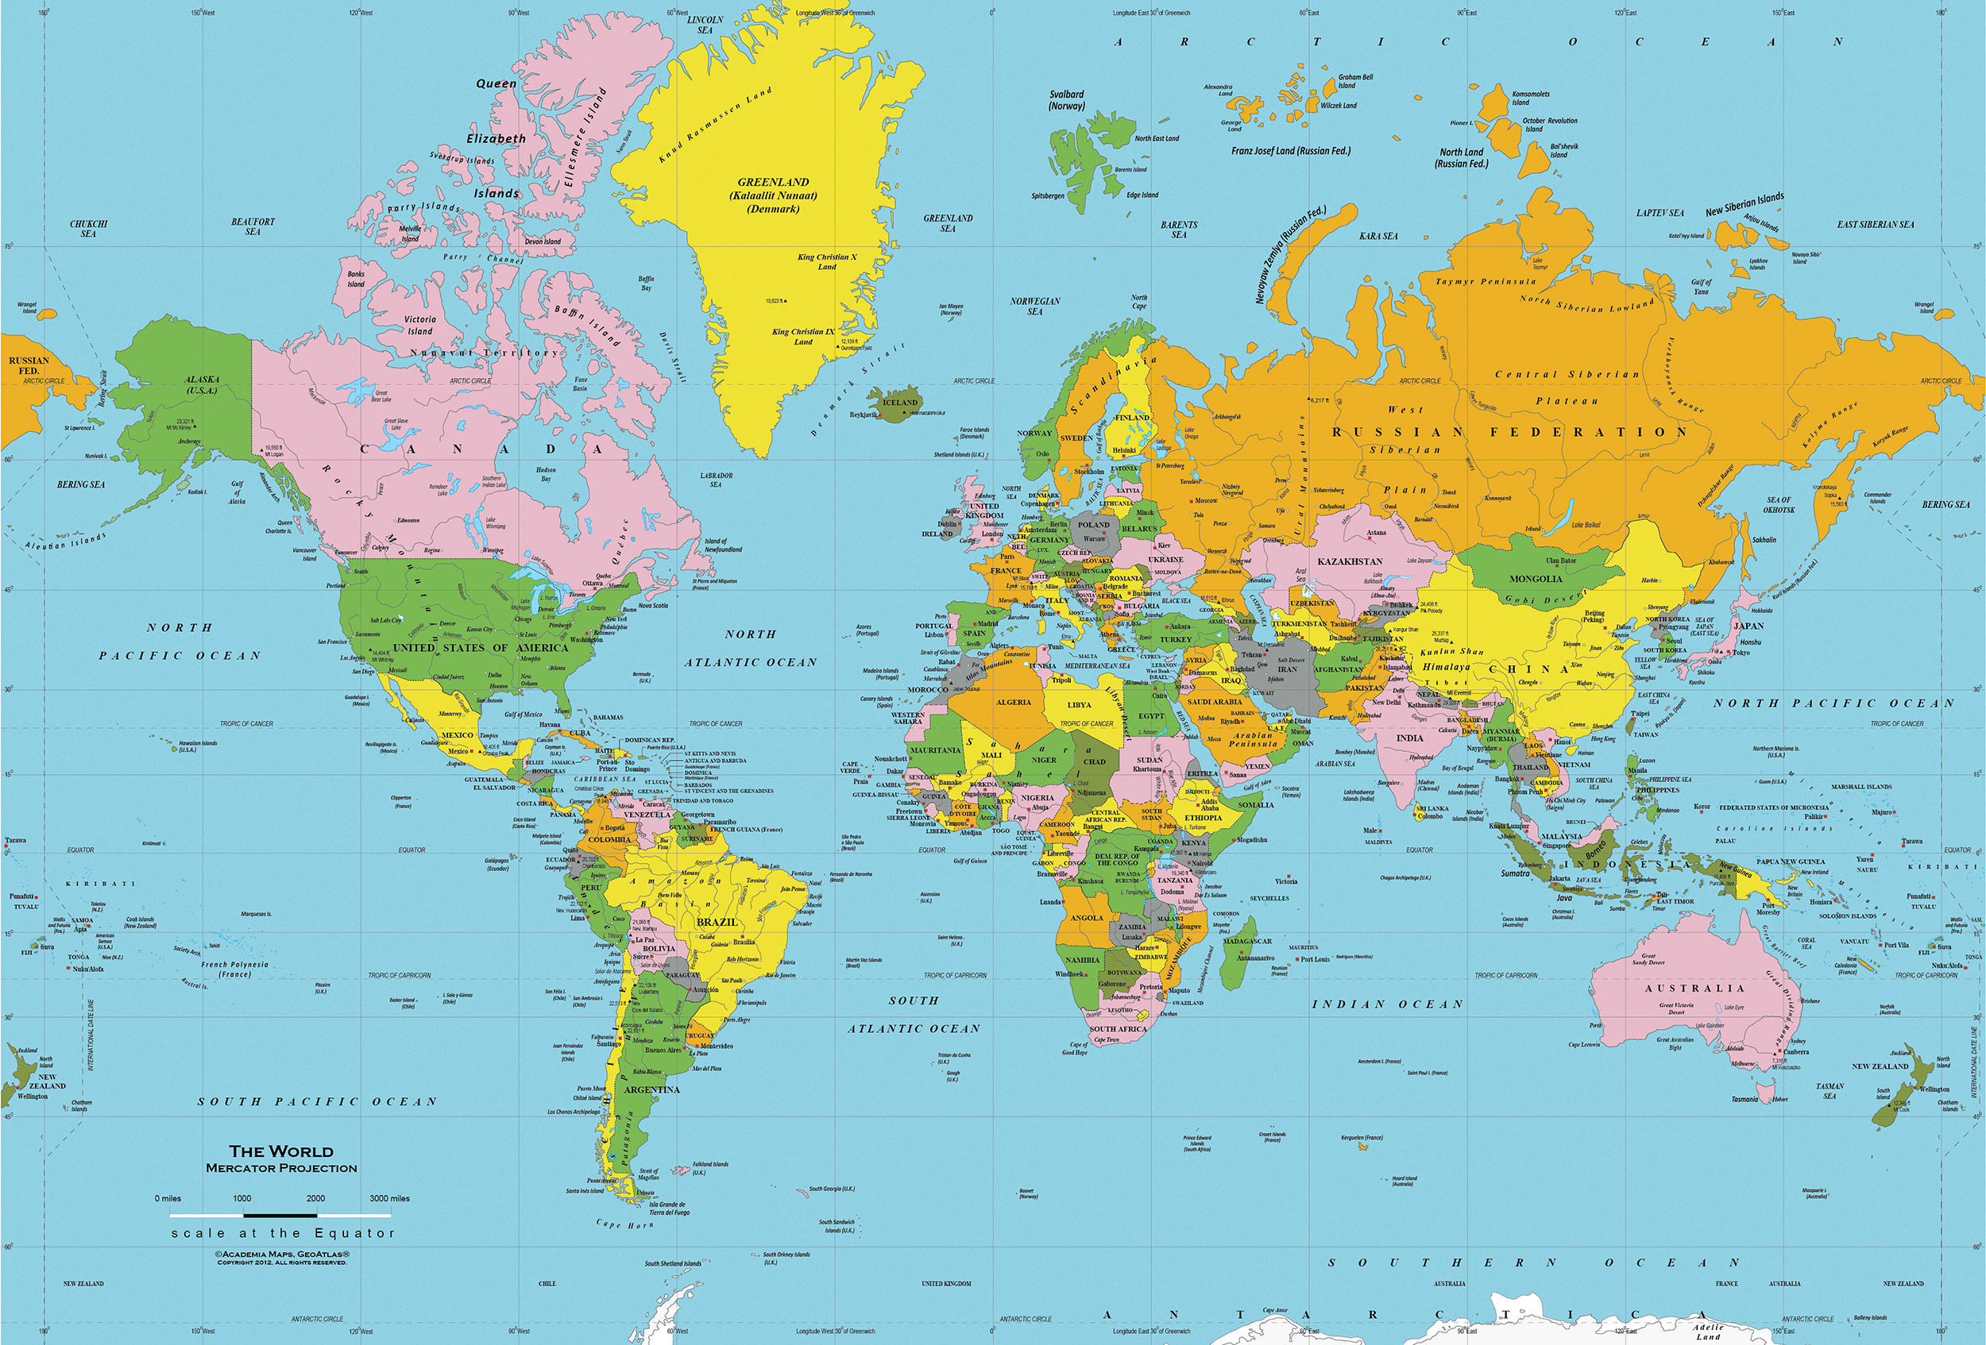
Mercator Projection
Mercator Projection

This type of map was invented by Gerardus Mercator in 1569. He was Flemish (from Belgium in Europe). It projects a globe on a cylinder (see below).

PROS
It is the most helpful for navigation, because it will show you the most direct angle from one point to the other. It is commonly used by Global Positioning Systems (GPS) maps, such as Google Maps.

CONS
It distorts the poles, so that land and water masses at the North and South Poles are stretched, making them look much larger than they actually are.

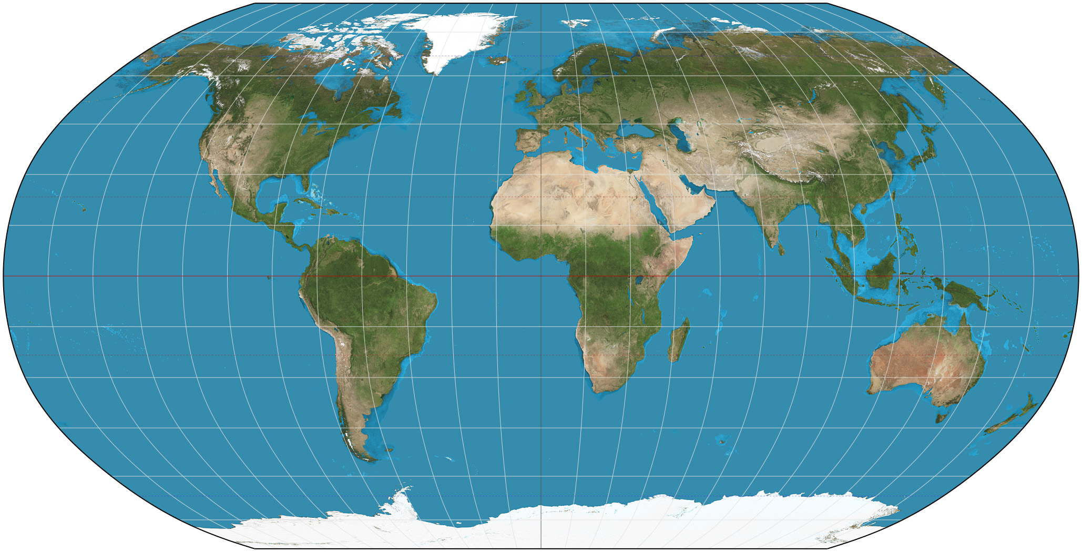
Robinson Projection
Topographical Map
Robinson Projection

This type of map was invented by Arthur H. Robinson in 1963. He was an American (born in Montréal, Québec, lived in Great Britain and later Wisconsin).

PROS
It projects a globe on a rounded flat surface. It attempts to show the actual relative sizes of the land on earth comparing north to south.

CONS
It distorts the corners of the map (northeast, southeast, southwest, northwest), making them look much larger than they actually are.

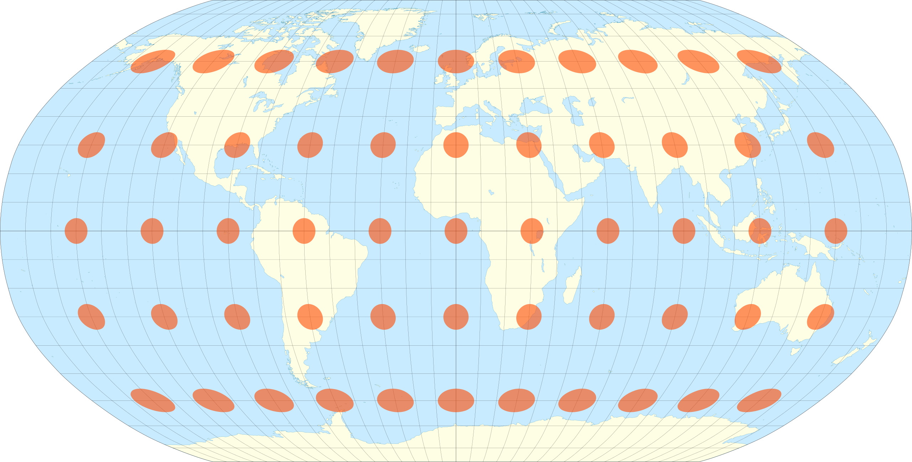

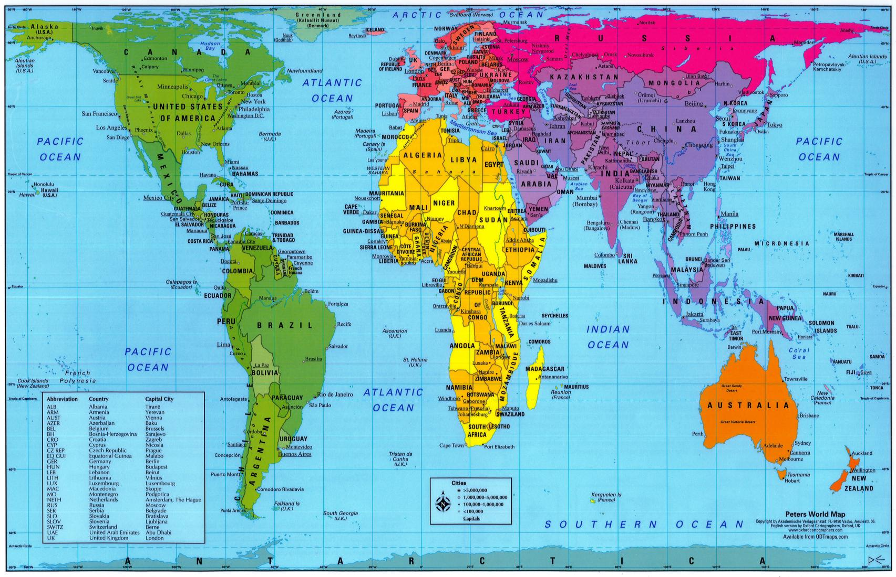
Gall-Peters Projection
Gall-Peters Projection

This type of map was invented by James Gall (from Scotland) in 1851 and later rediscovered by Arno Peters (from Germany) in 1967. In 2017, the Boston Public Schools began became the first school system in the United States to adopt this map in all classrooms.

PROS
It shows the correct ratios of land mass across the Earth. This means that it shows the exact size of one continent versus another.

CONS
It cannot be used for navigation, because it does not show the true shape of every country (as the Mercator Projection would).

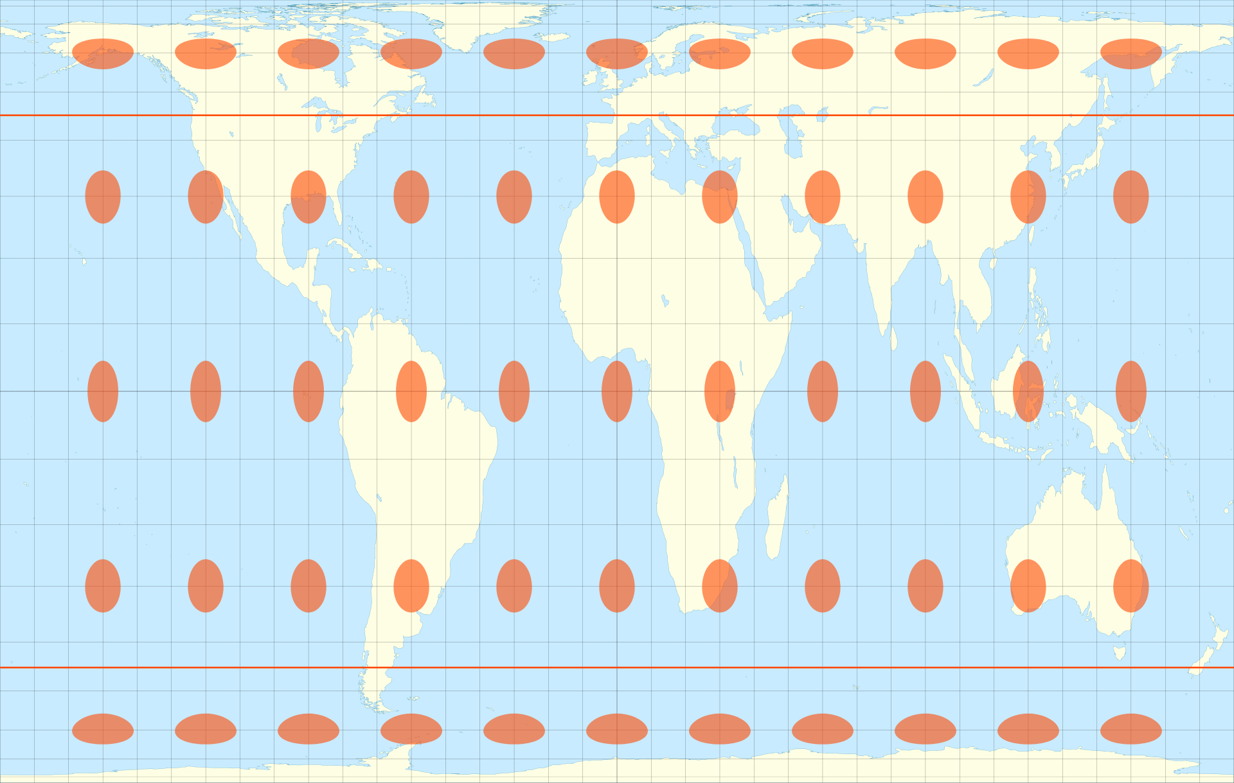
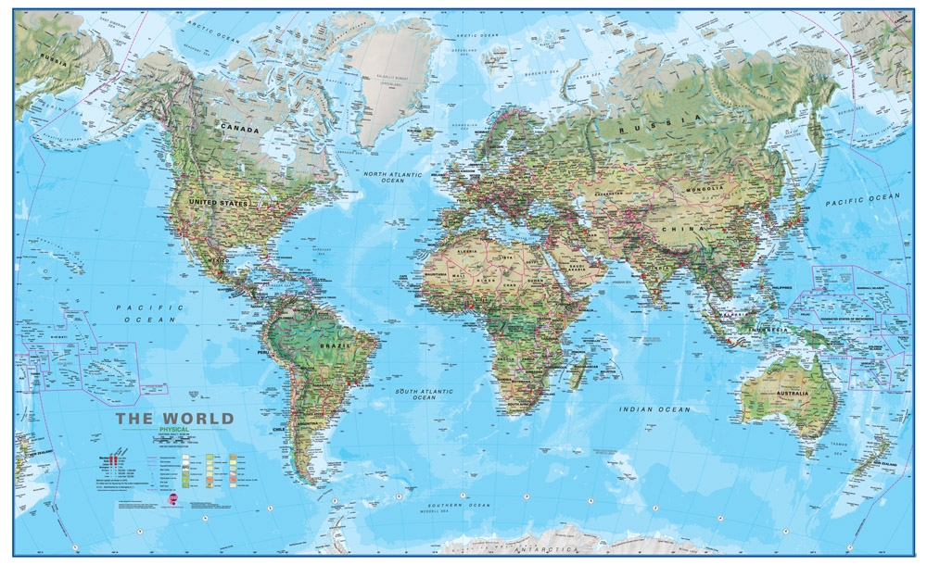
Atlantic-Centric Projection
Physical Map
Atlantic-Centric Projection
Physical Map

This type of map is an Atlantic-Centric physical map. This map places the Atlantic Ocean at the center of the world. It also shows terrain types (i.e. mountains, plains, rives, forests).

PROS
It is most commonly used by people in the Americas, Europe, and Africa. It shows the areas where they often trade goods over the ocean. It can show you the elevation (how high or low) the land and water are, as well as where you can find different terrain types.

CONS
Europe is at the center and top of the Earth, when there is no true center or top of the Earth. It cuts the Pacific Ocean in half.

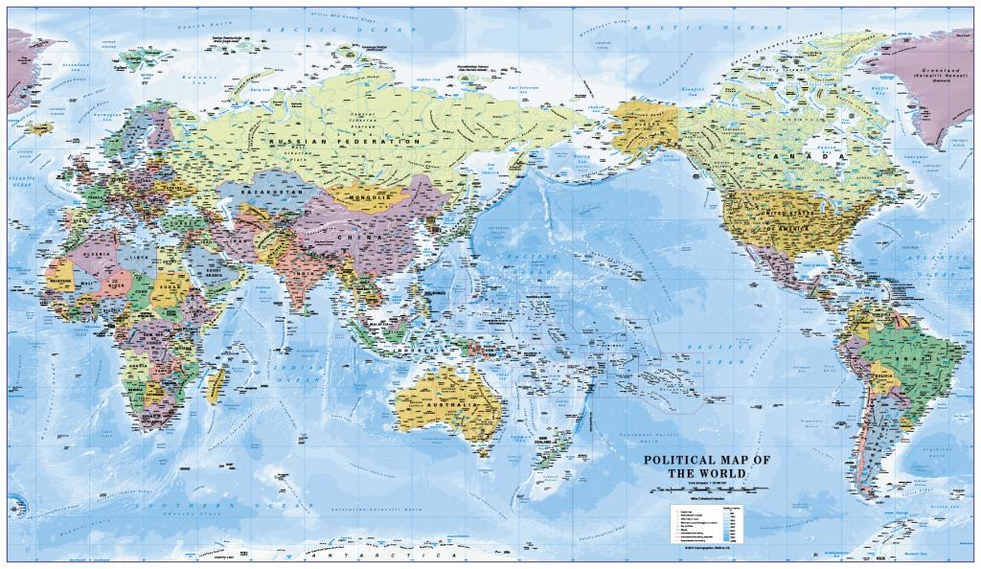
Pacific-Centric Projection
Political Map
Pacific-Centric Projection
Political Map

This type of map is a Pacific-Centric political map. This map places the Pacific Ocean at the center of the world. It also shows the boundaries of each country and makes them a separate color.

PROS
It is most commonly used by people in Asia. It shows the areas where they often trade goods over the ocean. It shows country’s boundaries, so you where they start and end.

CONS
Asia is at the center and top of the Earth, when there is no true center or top of the Earth. It cuts the Atlantic Ocean in half.

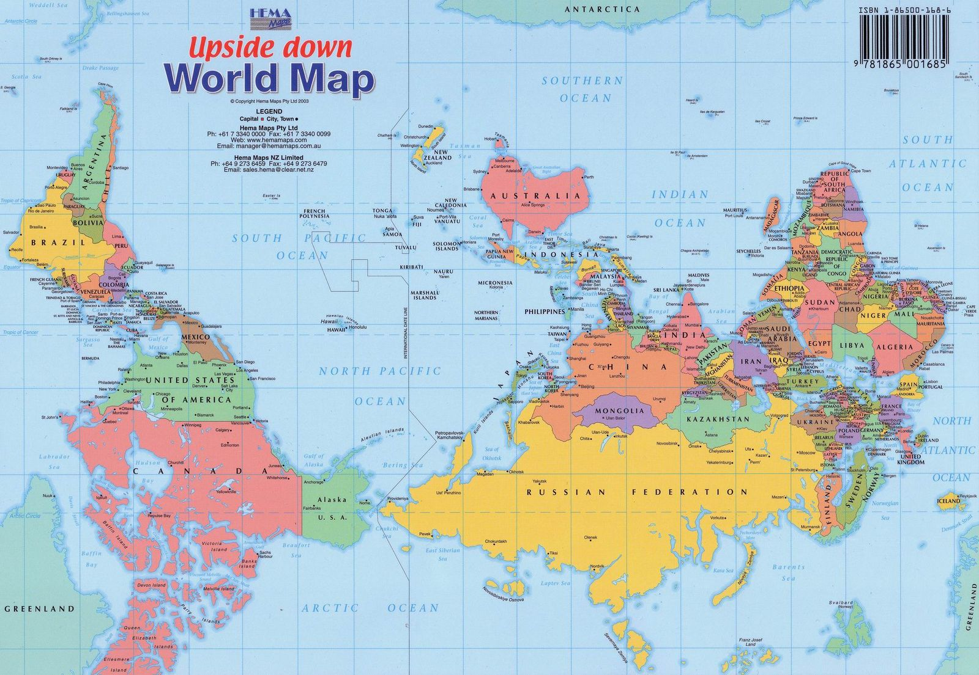
Southern Hemisphere-Top Projection
Southern Hemisphere-Top Projection
[South Up]

This type of map is a Southern Hemisphere-Centric Projection or South Up Map. This map places the Southern Hemisphere at the top of the world. Since most of the world’s land is in the Northern Hemisphere, most map makers have put that at the top.

PROS
This map makes you question what is up and what is down on a map. Since there is no true up or down in space, this map reminds us of that.

CONS
The Southern Hemisphere is at the top of the Earth, when there is no true top of the Earth.

WORKSHEET 4-11.B

Note Taking Sheet

Map 1: Mercator Projection

What locations are at the center and top of this map? How does this look the same or different than maps you are using to looking at? Which maps do you think are more or less helpful (and for who)?

Map 2: Robinson Projection

What locations are at the center and top of this map? How does this look the same or different than maps you are using to looking at? Which maps do you think are more or less helpful (and for who)?

Map 3: Gall-Peters Projection

What locations are at the center and top of this map? How does this look the same or different than maps you are using to looking at? Which maps do you think are more or less helpful (and for who)?

Map 4: Atlantic-Centric

What locations are at the center and top of this map? How does this look the same or different than maps you are using to looking at? Which maps do you think are more or less helpful (and for who)?

Map 5: Pacific-Centric

What locations are at the center and top of this map? How does this look the same or different than maps you are using to looking at? Which maps do you think are more or less helpful (and for who)?

Map 6: Southern Hemisphere-Centric

What locations are at the center and top of this map? How does this look the same or different than maps you are using to looking at? Which maps do you think are more or less helpful (and for who)?

ASSESSMENT 4-11.C

Map Perspectives: Exit Ticket

Inquiry Question: Which map is best?

Choose the one map from the carousel that you think best represents the Earth. You may consider qualities like most useful, fairness, accuracy, or other reasons. Include three pieces of evidence from the sources.

ASSESSMENT 4-12.E

Africa: Where Humans Began:
Exit Ticket

Inquiry Question: What was the most important event of early humans in Africa?

Choose one even in early human history and explain why you think it is the most important. Include three pieces of evidence from the sources.

ASSESSMENT 4-13.B

Ancient Egypt:
Exit Ticket

Inquiry Question: If you could be in any ancient Egyptian social class, which would you choose and why?

Choose one social class from Ancient Egypt (but you cannot choose the pharaoh) and explain why you would want to be in that social class. Include three pieces of evidence from the descriptions of each social class.

WORKSHEET 4-14.E

Note Taking Sheet

Source 1: Ghana

What are the most important points about this empire?

Source 2: Kongo

What are the most important points about this empire?

Source 3: Ethiopia

What are the most important points about this empire?

Source 4: Zimbabwe

What are the most important points about this empire?

ASSESSMENT 4-14.F

The Great African Empires: Exit Ticket

Inquiry Question: If you could live in any African empire, which one would it be and why?

Choose one Great African Empire and explain why you would choose to live there. Include three pieces of evidence from the sources.

ASSESSMENT 4-15.E

Timbuktu: Exit Ticket

Inquiry Question: Why was Timbuktu so important?

Choose one part of Timbuktu and explain why it is the most important part of the city. Include three pieces of evidence from the sources.

ASSESSMENT 4-16.E

Anti-Apartheid: Exit Ticket

Inquiry Question: What can we learn from the Anti-Apartheid Movement in South Africa?

Choose one method of protest and explain why it is the most important way that protesters worked to stop Apartheid. Include three pieces of evidence from the book or sources.

MATERIALS 4-17.A

Where in the World Is Carmen Sandiego?
Questions

1. How many countries are there in Africa?: 22, 54, 81
ANSWER: 54

2. What is the largest city in Nigeria?: Abuja, Lagos, Kano
ANSWER: Lagos

3. What is the capital of Egypt?: Cairo, Alexandria, Giza
ANSWER: Cairo

4. How many languages are spoken in Africa?: 100, 500, 3000
ANSWER: 3000

5. What country is at the southern tip of Africa?: South Africa, South Sudan, Zimbabwe
ANSWER: South Africa

6. Which animal lives in Africa?: Penguins, Polar Bears, Koala Bears
ANSWER: Penguins (on the islands off the coast of South Africa)

7. What is the highest mountain in Africa?: Mount Kenya, Mount Kilimanjaro, Mount Meru
ANSWER: Mount Kilimanjaro

8. How many people live on the continent of Africa: 1 million, 1 billion, 1 trillion
ANSWER: 1 billion

9. Which of these African countries is the newest in the world?: Senegal, Mali, South Sudan
ANSWER: South Sudan

10. This is the world’s largest hot desert?: Gobi, Sahara, Namib
ANSWER: Sahara

$10
Carmen Sandiego Bucks
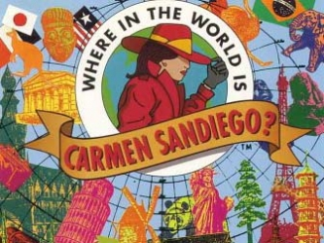
$10

$10
Carmen Sandiego Bucks
$10

ASSESSMENT 4-17.J

Africa Today: Exit Ticket

Inquiry Question: If you were to visit Africa today, what country would you choose and why?

Choose one country from those listed around the room and explain why you would like to visit it. Include three pieces of evidence from the sources.

ASSESSMENT 4-18.F

The Great Asian Empires: Exit Ticket

Inquiry Question: If you could live in any Asian empire, which one would it be and why?

Choose one Great Asian Empire and explain why you would choose to live there. Include three pieces of evidence from the sources.

ASSESSMENT 4-19.G

The Silk Road: Exit Ticket

Inquiry Question: What was life like on the Silk Road?

Imagine you are traveling the Silk Road and write a diary entry about each stop. Include three pieces of evidence from the sources. Use another sheet of paper if you need more space for each diary entry.

Stop 1— Guangzhou

Stop 2— Chang’an

Stop 3—Pataliputra

Stop 4—Persepolis

Stop 5— Constantinople

WORKSHEET 4-20.F

Preparation for the Corner Debate

Think about the following sentences and decide if you think “strongly agree,” “agree,” “disagree,” or “strongly disagree.” Then explain why.

More people should transport goods and people using the Mekong River.

Circle:
Strongly Agree Agree Disagree Strongly Disagree

More people should trade goods on the Mekong River.

Circle:
Strongly Agree Agree Disagree Strongly Disagree

People should go to jail for many years if they kill endangered animals near the Mekong River.

Circle:
Strongly Agree Agree Disagree Strongly Disagree

People should stop all pollution in the Mekong River.

Circle:
Strongly Agree Agree Disagree Strongly Disagree

MATERIALS 4-20.G

STRONGLY AGREE

AGREE

DISAGREE

STRONGLY DISAGREE

ASSESSMENT 4-20.H

Việt Nam: A Country of Waterways: Exit Ticket

Inquiry Question: Are the human changes to the Mekong River more positive or negative?

Choose that the changes to the Mekong River are positive or negative and explain why you think so. Include three pieces of evidence from the sources.

ASSESSMENT 4-21.F

Asian Megacities: Exit Ticket

Inquiry Question: Would you like to live in an Asian megacity?

Considering the good and bad parts of living in a megacity, would you want to live in an Asian megacity? Why or why not? Include three pieces of evidence from the sources.

ASSESSMENT 4-22.G

World Religions Newspaper Checklist

Inquiry Question: What is each religion’s greatest contribution to the world?

Students will answer the above inquiry question by creating a newspaper that highlights their assigned religions contribution to the world. Your group’s newspaper should have the following (check box when complete):

A title for your newspaper that includes religion’s name.

Article 1 on the basic facts about your assigned religion.

Article 2 on an interesting part of your assigned religion.

Picture 1 on the founder or supreme being of your religion

Picture 2 of a map showing where your religion started

Picture 3 on something interesting from your religion
WORKSHEET 4-23.A

8 Asian Countries Notes

Source 1: Taiwan

Source 2: Vietnam

Source 3: India

Source 4: Mongolia

Source 5: South Korea

Source 6: United Arab Emirates

Source 7: Japan

Source 8: Nepal

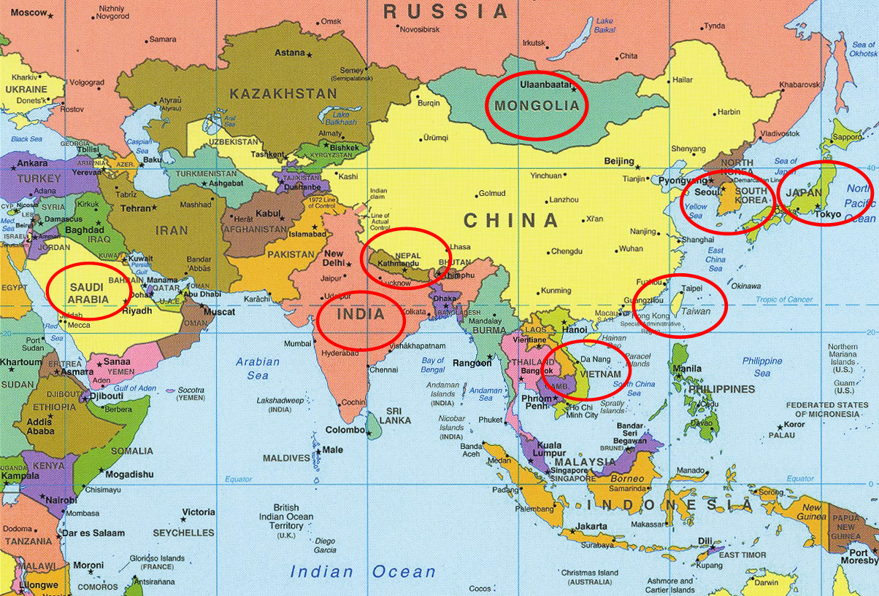
ASSESSMENT 4-23.J

Asia Today: Exit Ticket

Inquiry Question: If you were to visit Asia today, what country would you choose and why?

Out of the 8 Asian countries presented, which one would you most like to visit and why? Include three pieces of evidence from the sources.

WORKSHEET 4-24.F

American Empires: Poster Instructions

Today, we will be making poster advertisements for our assigned empires. You will need to answer the following questions on your poster. Since it is an advertisement, remember to convince others that your empire is the best.

Your poster should include at least 3 drawings:

These drawings should give us images related to the below sections, maps, or important symbols.

Your poster should include 3 sections:

Section 1: Way of Life

What was life like for people in your empire? Did the people do certain jobs? Were their certain classes (i.e. nobles, priests, peasants, farmers, commoners)? What types of houses did they live in?

Section 2: Climate

What was the climate, including weather, like in your empire? How did the climate effect the empire?

Section 3: Trade

What items did your empire trade? How wealthy did this make the empire?
ASSESSMENT 4-24.G

The Great American Empires: Exit Ticket

Inquiry Question: If you could live in any American empire, which one would it be and why?

After looking at all of the empire advertisements, choose one Great American Empire and explain why you would choose to live there. Include three pieces of evidence from the sources.

WORKSHEET 4-25.G

Positive-Negative Chart

Columbus is Positive

Columbus is Negative

ASSESSMENT 4-25.H

Columbus: Exit Ticket

Inquiry Question: Did Columbus’s voyages have more of a positive or negative impact on the world?

After looking at the sources and hearing the debate, do you think Columbus did more positive (good) or negative (bad). You do not need to agree with the side that you were on the debate team. Include three pieces of evidence from the sources.

ASSESSMENT 4-26.E

Haitian Revolution: Exit Ticket

Inquiry Question: What type of revolution did Toussaint Louverture lead in Haiti?

Revolution (1): An uprising or revolt against a government. Revolution (2): A major change in ideas.

After looking at the above definitions of “revolution,” do you think Toussaint Louverture led an uprising or a major change in ideas. Explain if it was definition 1 or 2, and include three pieces of evidence from the sources.

WORKSHEET 4-27.A

8 Latin American Countries Notes and Latin America Map

Source 1: Ecuador

Source 2: Peru

Source 3: Argentina

Source 4: Brazil

Source 5: Guatemala

Source 6: Haïti

Source 7: Dominican Republic

Source 8: Jamaica

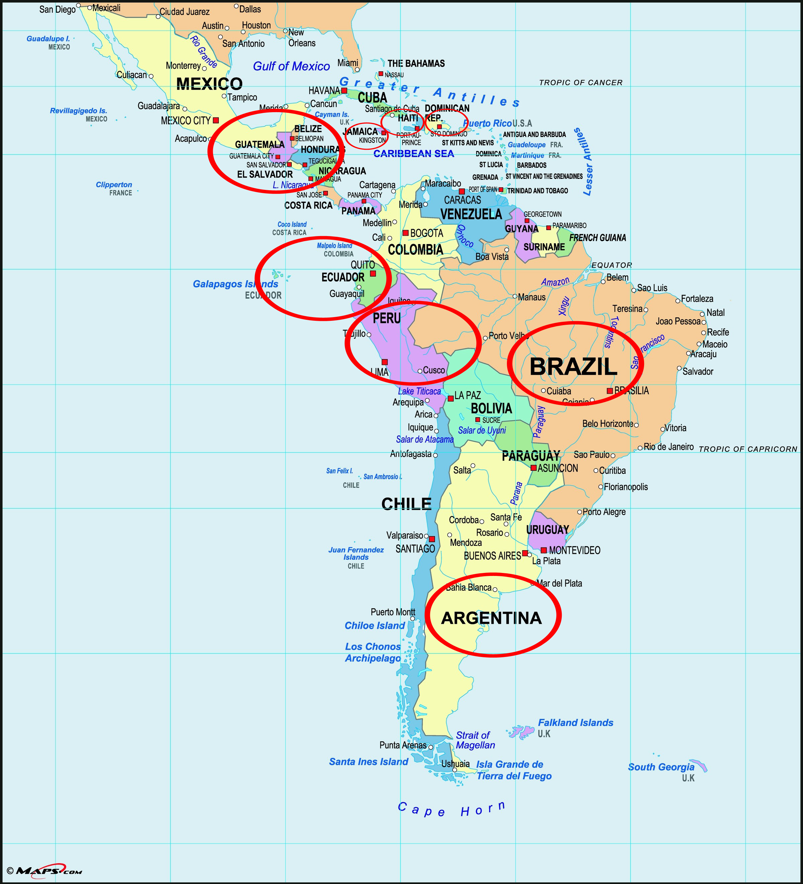

ASSESSMENT 4-27.J

Latin America Today: Exit Ticket

Inquiry Question: If you were to visit Latin America today, what country would you choose and why?

Out of the 8 South American, Central American, and Caribbean countries presented, which one would you most like to visit and why? Include three pieces of evidence from the sources.

WORKSHEET 4-28.G

European Empires: Digital Slideshow Instructions

Today, we will be making presentations for our assigned empires. You will need to answer the following questions using digital slideshows.

Your digital slideshow should include at least 3 images:

These images should be related to the below sections, maps, or important symbols.

Your slideshow should include 3 sections (with at least one slide per section):

Section 1: Way of Life

What was life like for people in your empire? Did the people do certain jobs? Were their certain classes (i.e. nobles, priests, peasants, farmers, commoners)? What types of houses did they live in?

Section 2: Climate

What was the climate, including weather, like in your empire? How did the climate effect the empire?

Section 3: Trade

What items did your empire trade? How wealthy did this make the empire?

ASSESSMENT 4-28.H

The Great European Empires: Exit Ticket

Inquiry Question: If you could live in any European empire, which one would it be and why?

After listening to peers give their presentations, choose one Great European Empire and explain why you would choose to live there. Include three pieces of evidence from the sources.

ASSESSMENT 4-29.D

Irish Independence: Exit Ticket

Inquiry Question: Why was Irish independence from England so important to its people?

Choose one issue related to Irish independence and explain why it is the most important reason for the Irish people to have their own country. Include three pieces of evidence from the sources.

WORKSHEET 4-30.I

Backpacking Europe: Travel Brochure Instructions

Today, we will be making travel brochures for our assigned countries. You will need to answer the following questions on your brochures. Since it is an advertisement, remember to really convince others that your country is the best.

Your brochure should include 6 panels and 2 drawings:

Your brochure should be made on one sheet of paper and can be folded into three parts (making 6 panels total). It should include at least a cover page, 3 text (writing) sections, and 2 drawings (maps or drawings of important places, events, or symbols).

Your brochure should include 3 sections:

Section 1: Attractions

What things can be done in your country? What are some important places, foods, or events people should enjoy?

Section 2: People and Culture

What are the people like in your country? What language do they speak? What traditions do they have? What makes their culture different from other countries?

Section 3: General Information

How many people live is your country? Where is it located in Europe? What is the capital and major cities? What are the major rivers, oceans, mountains, and other geographic features?
ASSESSMENT 4-30.J

Backpacking Europe: Exit Ticket

Inquiry Question: If you were to backpack across Europe today, what country would you most want to visit and why?

Which country would you most want to visit when backpacking across the European continent? Include three pieces of evidence from the sources.

GRADE 4 POST-TEST

Answer the following questions.

1. What does it mean to be an Indigenous person?

2. What is an immigrant?

3. What is slavery?

4. Name the oceans on Earth.

5. Label each continent on the picture below: Antarctica, Africa, Asia, Australia, Europe, North America, South America.

6. Label as many states as you can on the picture below.

7. Explain where humans first began.

8. Name as many religions as you can.

9. What continent has the most people?

10. What countries border the United States?

11. If you could move to any other country, which would it be and why?

12. If you could move to any other state in the United States, which would it be and why?

