Open Social Studies

An Inquiry-Based and Literacy-Focused K-6 Curriculum

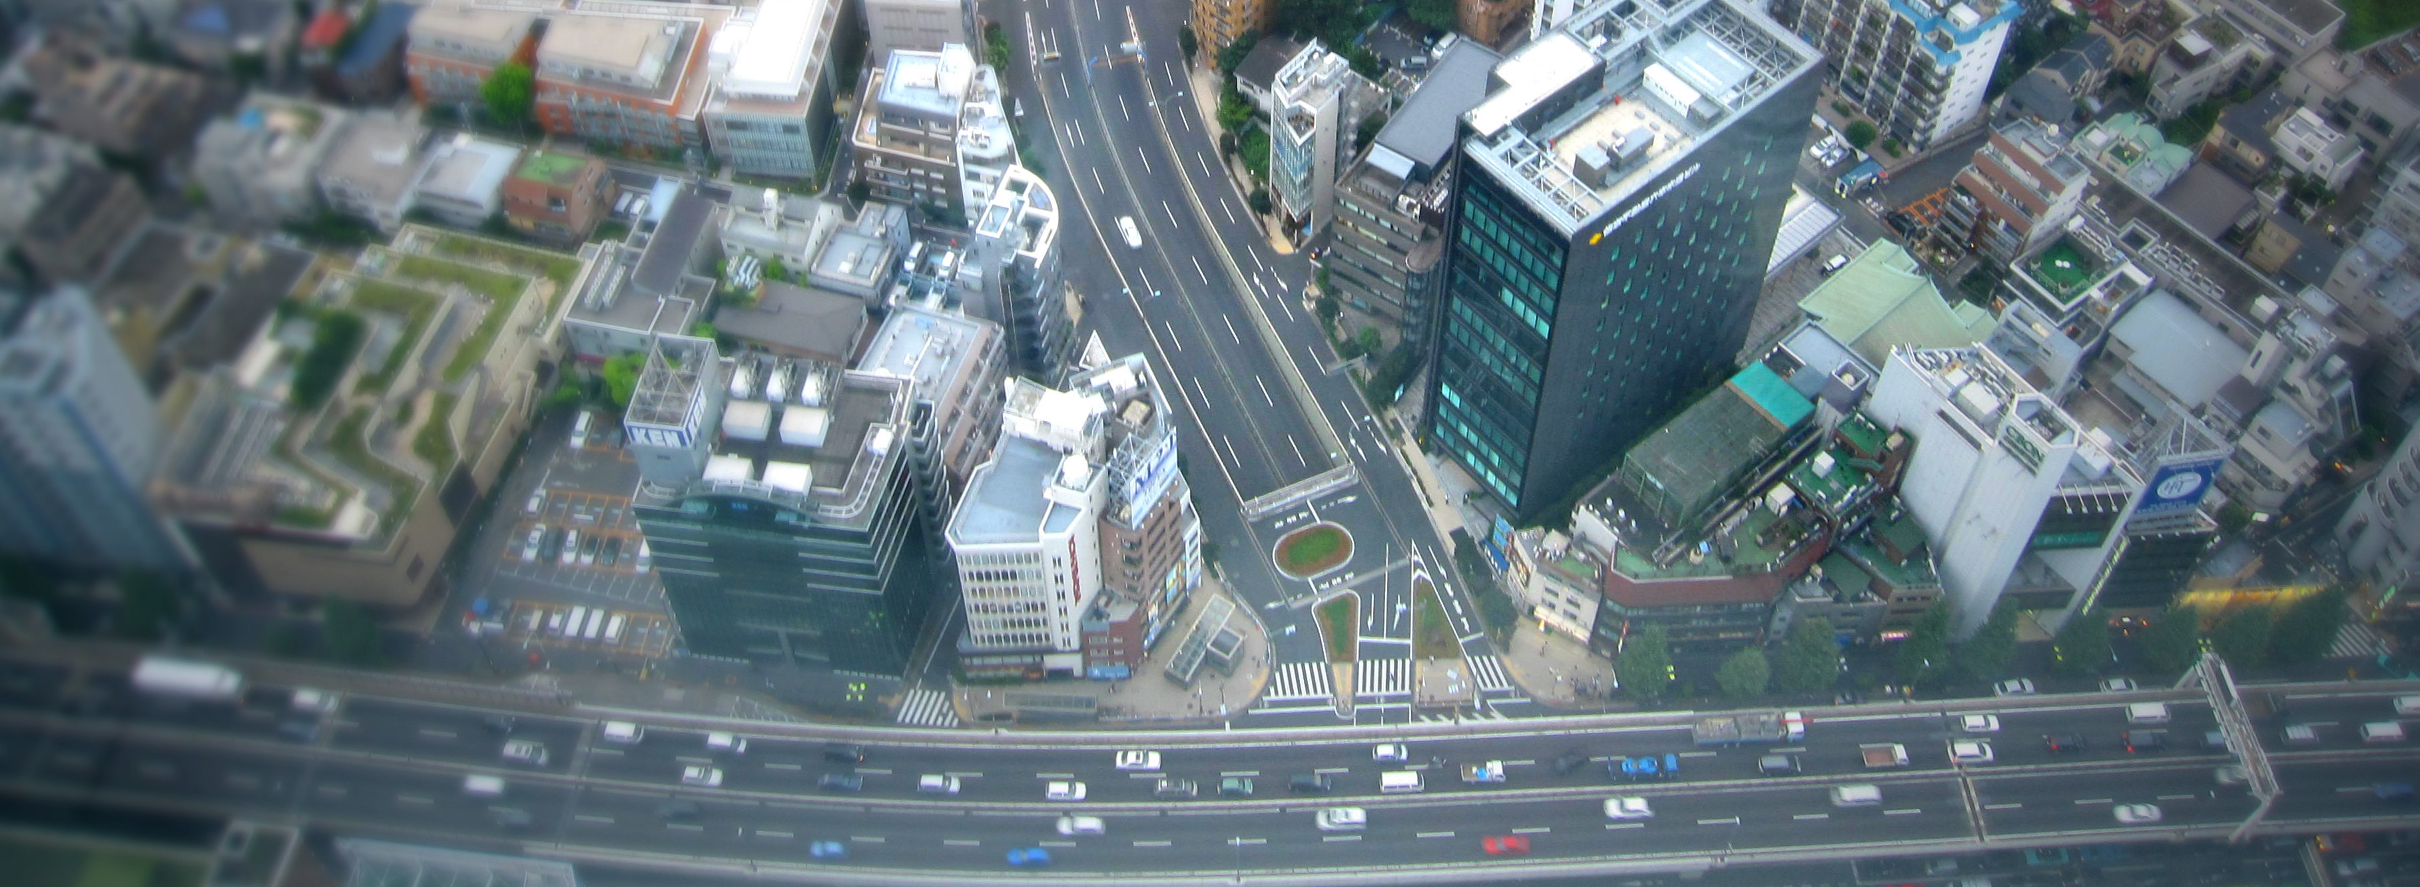

Curric

**STUDENT WORKBOOK**

**Level: Grade 3**

Exploring Boston: From Past to Present

***Developers:

Christopher C. Martell

Jennifer R. Bryson

**GRADE 3 ROAD MAP**

**LESSON 3-1**

Lesson Title: People of the First Light: The Wampanoag

*Inquiry Question: What was the most interesting part of the Wampanoag’s traditional way of life?*

**LESSON 3-2**

Lesson Title: Squanto’s Life: A Timeline Activity

*Inquiry Question: What was the most important event in Squanto’s life?*

**LESSON 3-3**

Lesson Title: The Mayflower Voyage and Settlement

*Inquiry Question: Did the Pilgrims make the right choice in coming to America?*

**LESSON 3-4**

Lesson Title: The First Thanksgiving?

*Inquiry Question: How should we remember the Pilgrim and Wampanoag Thanksgiving?*

**LESSON 3-5**

Lesson Title: Choose Your Own Adventure: The Puritans

*Inquiry Question: Did the Puritans make the right decisions?*

**LESSON 3-6**

Lesson Title: Roger Williams: Church and State

*Inquiry Question: What was Roger Williams’ most important achievement?*

**LESSON 3-7**

Lesson Title: Anne Hutchinson: Women Should Lead!

*Inquiry Question: What should Anne Hutchinson be remembered for?*

**LESSON 3-8**

Lesson Title: King Philip’s War

*Inquiry Question: What caused King Philip’s War?*

*NOTE: In chronological order, Massachusetts and the American Revolution would appear here after Lesson 3-8. These lessons are currently included in the Grade 5 curriculum (i.e. 5-8, 5-9, 5-10, 5-11, 5012), which is United States history. Teachers are encouraged to use modified versions of those lessons again here.*

**LESSON 3-9**

Lesson Title: Revolutionary Leaders: John Adams, Samuel Adams, John Hancock, and Paul Revere

*Inquiry Question: Which Boston leader had the best way to spread revolutionary ideas?*

**LESSON 3-10**

Lesson Title: Massachusetts, From Slavery to Anti-Slavery: Frederick Douglass, Sojourner Truth, and William Lloyd Garrison

*Inquiry Question: What was the best way that Massachusetts abolitionists convinced people to oppose slavery?*

**LESSON 3-11**

Lesson Title: Women’s Rights: Abigail Adams,Susan B. Anthony, the Grimké sisters, and Lucy Stone

*Inquiry Question: Which Massachusetts women’s rights leader had the best strategy for equality?*

**LESSON 3-12**

Lesson Title: New England Factory Life

*Inquiry Question: Did Massachusetts factory owners treat their workers well?*

**LESSON 3-13**

Lesson Title: Massachusetts: The Birthplace of Public Education

*Inquiry Question: What was Horace Mann’s most important achievement?*

**LESSON 3-14**

Lesson Title: Massachusetts: A State of Firsts

*Inquiry Question: Which Massachusetts invention was the most important?*

**LESSON 3-15**

Lesson Title: Massachusetts Town Meeting: How Does It Work?

*Inquiry Question: If you were a member of a town meeting, what would you want to pass and why?*

**LESSON 3-16**

Lesson Title: Running for Mayor

*Inquiry Question: What issues do you want the Mayor of Boston to address?*

**LESSON 3-17**

Lesson Title: Taxes: You Decide What Should Be Funded!

*Inquiry Question: What should our city/town use our tax money for?*

**LESSON 3-18**

Lesson Title: Preserving Boston: The Pierce House, The Strand Theater, The Ladder Blocks, The Little-Collins (Malcolm X) House

*Inquiry Question: Which historic building in Boston is the most important to preserve?*

**LESSON 3-19**

Lesson Title: Our Past: Dorchester’s History

*Inquiry Question: What was the most important event in our community’s history?*

**LESSON 3-20**

Lesson Title: Our Future: Making Boston Better

*Inquiry Question: What is the most important issue for our community to solve in the future?*

**GRADE 3 PRE-TEST**

Answer the following questions.

**1. What does it mean to be an Indigenous person?**

**2. What is an immigrant?**

**3. What is slavery?**

**4. Draw a circle in the place where you live (Boston) on the picture below.**

**5. Label each continent on the picture below: Antarctica, Africa, Asia, Australia, Europe, North America, South America.**

**6. What is a settler?**

**7. What is a colonist?**

**8. What was the American Revolution?**

**9. What are rights?**

**10. What is a movement?**

**ASSESSMENT 3-1.E**

**People of the First Light: The Wampanoag: Exit Ticket**

Inquiry Question: *What was the most interesting part of the Wampanoag’s traditional way of life?*

Choose one part of traditional Wampanoag life and explain why you think it is most interesting. Include three pieces of evidence from the sources.

**WORKSHEET 3-2.A**



**ASSESSMENT 3-2.B**

**Squanto’s Life: Exit Ticket**

Inquiry Question: *What was the most important event in Squanto’s life?*

Using the information that you put on our timeline and the other events from the story (listed on the board/chart paper), write the story of Squanto from his perspective. Be sure to put the events in order from first to last. Consider these questions: What were some of the most difficult moments of his life? What were some of the happiest moments of his life? Include three pieces of evidence from the sources.

**WORKSHEET 3-3.A**

**Pilgrim Quiz**

*Circle the answer that you think is correct. If you do not know, take a guess.*

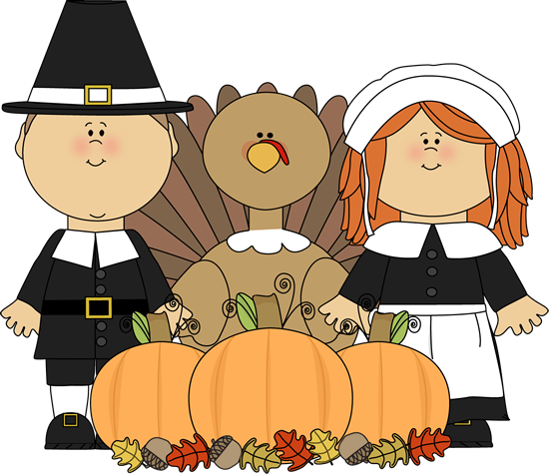

1. The Pilgrims wore black clothes, as well as black hats and shoes with buckles (see picture above).

True False

2. The Pilgrims celebrated the first Thanksgiving.

True False

3. The Pilgrims landed their ship on Plymouth Rock.

True False

4. The Pilgrims ate turkey on Thanksgiving.

True False

5. The Pilgrims were not allowed to do certain things like play music or dance.

True False

**Pilgrim Quiz**

**ANSWER SHEET**

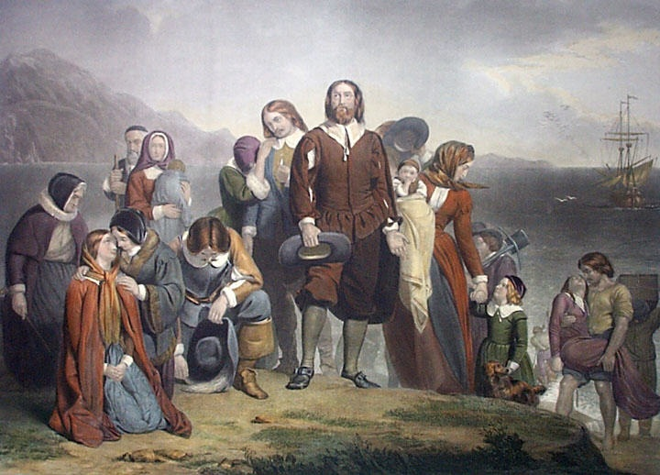

1. The Pilgrims wore black clothes, as well as black hats and shoes with buckles (see picture above). **FALSE.**

*Above is a more accurate picture of the Pilgrims. Black dye was very expensive and most people did not wear black. They also did not wear buckle hats or shoes. Most of our images of the Pilgrims were paintings from the 1860s, when Thanksgiving became a national holiday. The people of that time imagined those outfits, instead of finding out what they really wore.*

2. The Pilgrims celebrated the first Thanksgiving. **FALSE.**

*Europeans had been celebrating thanksgivings in fall for hundreds of years. In fact, the Spanish celebrated the first thanksgiving in the Americas in 1598 near El Paso, Texas.*

3. The Pilgrims landed their ship on Plymouth Rock. **FALSE.**

*You can visit Plymouth Rock today, but it is actually nowhere near where the Pilgrims landed. In fact, a man made the story up in the 1700s and the town would eventually “find” the rock to attract tourists and visitors.*

4. The Pilgrims ate turkey on Thanksgiving. **FALSE.**

*We do not know exactly what the Pilgrims ate on Thanksgiving. The only record we have of the event says it lasted 3 days and they ate deer that the Wampanoag hunted.*

5. The Pilgrims were not allowed to do certain things like play music or dance. **FALSE.**

*This is simply not true. They danced and played music like most people. This idea developed sometime in the 1800s, when people started to confuse the Pilgrims for another group that settled in Boston called the Puritans (they played music, but just not in church and they prohibited dancing in public).*

**WORKSHEET 3-3.B**

**Two Column Sheet**

Use this sheet to take notes on your book section.

My section title is:

**Should Come to America**

**Should Not Come to America**

**ASSESSMENT 3-3.C**

**The Mayflower Voyage and Settlement: Exit Ticket**

Inquiry Question: *Did the Pilgrims make the right choice in coming to America?*

Using the information that you put on your note taking sheet and the other events from the story (listed on the board/chart paper), write an argument as to whether the Pilgrims should have come to America. Include three pieces of evidence from the sources.

**WORKSHEET 3-4.E**

**Thanksgiving Thinking Questions**

Source 1: Edward Winslow’s First Thanksgiving Description

What facts does he list about thanksgiving?

Source 2: William Bradford’s First Thanksgiving Description

What facts does he list about thanksgiving?

Source 3: Thanksgiving Image #1

What do you notice about this painting? Do you think it is accurate?

Source 4: Thanksgiving Image #2

What do you notice about this painting? Do you think it is accurate?

**ASSESSMENT 3-4.F**

**The First Thanksgiving?: Exit Ticket**

Inquiry Question: *How should we remember the Pilgrim and Wampanoag Thanksgiving?*

Using the information that you put on your thinking questions sheet and the other events we discussed, write a description of how we should remember the first thanksgiving (and if we should even it call it that). Include three pieces of evidence from the sources.

**WORKSHEET 3-5.B**

**Two Column Sheet**

Use this sheet to take notes during your group time.

**The Puritans:**

**Made the Right Choices**

**Did Not Make the Right Choices**

**ASSESSMENT 3-5.C**

**The Puritans: Exit Ticket**

Inquiry Question: *Did the Puritans make the right decisions?*

Using the information from the Choose Your Own Adventure, answer the following question: *Did the Puritans make the right decisions?* Take one side and describe why you chose that side and include three pieces of evidence from the sources.

Circle one:

Yes, they did make the right choices.

No, they did not make the right choices.

**ASSESSMENT 3-6.F**

**Roger Williams: Exit Ticket**

Inquiry Question: *What was Roger Williams’ most important achievement?*

After hearing both sides of the debate, choose one achievement (founder, diplomat, or linguist) and describe why it is Roger Williams’ most important. Include three pieces of evidence from the sources.

**ASSESSMENT 3-7.E**

**Anne Hutchinson: Exit Ticket**

Inquiry Question: *What should Anne Hutchinson be remembered for?*

After looking at all of the sources and creating an outline on the lined paper, write your autobiography of Anne Hutchinson. Include three pieces of evidence from the sources.

**WORKSHEET 3-8.E**

**Note Taking Sheet**

Source 1: Metacom/King Philip

Source 2: “Too Many People” Perspective

Source 3: “Disrespect” Perspective

**ASSESSMENT 3-8.F**

**King Philip’s War: Exit Ticket**

Inquiry Question: *What caused King Philip’s War?*

After hearing both sides of the debate, choose a side (“Too Many People” or Disrespect”) and write an answer to the question “What causes King Philip’s War?” Include three pieces of evidence from the sources.

**WORKSHEET 3-9.E**

**Revolutionary Leaders Thinking Questions**

Source 1: John Adams

What were his main ideas and actions?

Source 2: Samuel Adams

What were his main ideas and actions?

Source 3: John Hancock

What were his main ideas and actions?

Source 4: Paul Revere

What were his main ideas and actions?

**ASSESSMENT 3-9.F**

**Revolutionary Leaders: Exit Ticket**

Inquiry Question: *“Which Boston leader had the best way to spread revolutionary ideas?”*

After looking at all of the sources in the carousel, state the name of write an answer to the question “Which Boston leader had the best way to spread revolutionary ideas?” Include three pieces of evidence from the sources.

The best revolutionary leader was:

**LETTER 3-10.A**

Dear parents and guardians,

We are sending this letter home to let you know that next week the students will be learning about the abolition of slavery during our social studies time. It is essential that students learn about difficult historical topics like these from the caring and supportive adults in their lives, including their teachers and parents/guardians.

In covering this topic, we will be guided by three important principles. First, we will approach this topic with respect for those who lived in slavery. You may have heard stories on the news of teachers around the country using lessons that have students participate in mock slave auctions or pretend to be slaves and masters. Those lessons are not only troubling, but harmful. Nothing like that will occur in our classrooms.

Second, we will carefully monitor students’ emotions during our lesson on slavery. Our lesson will not include graphic depictions of slavery’s violence. Despite this, we realize the topic could still be upsetting to some children. Our classroom will be a safe place to grapple with this difficult topic.

Third, we are aware of the developmental level of the students and will only approach the topic in a way that is appropriate for 3rd graders. One helpful way to approach difficult topics in the classroom is through the use of picture books. In 2nd grade, our students used the picture book “Henry’s Freedom Box” by Ellen Levine and Kadir Nelson to introduce the topic of slavery. You might consider reading this book at home and use it as a way to discuss slavery with your child before we learn about it in our class.

As a parent or guardian, you may have additional questions about the lesson and are welcome to contact me through e-mail, the phone, or in person. I would also be happy to send you the lesson plan in advance, if you would like to see how we will teach about slavery.

Sincerely,

TEACHER NAME

E-MAIL ADDRESS

PHONE NUMBER

**3-10.F**

**Mini-Play Script Example**

*Below is an example of what a mini-play script would look like.*

Frederick Douglass: I was born into slavery, so I know how terrible this is. I must spread the word to everyone I meet.

Sojourner Truth: Like you, I was also born into slavery. I had to leave my family behind when I ran away. I want no more families to be split up.

William Lloyd Garrison: This is why I am sending my anti-slavery newspapers “The Liberator” to every person who I can.

*Now draft your script below… Include three pieces of evidence from the sources in your script.*

**WORKSHEET 3-10.G**

**Abolitionist Leaders: Exit Ticket**

Inquiry Question: *“What was the best way that Massachusetts abolitionists convinced people to oppose slavery?”*

Write your group’s final script here. Put a star (*) next to your parts, so you know when to speak. This words on your scripts should be the same for all group members. At the end of your mini-play, someone in your group should say which abolitionist (Frederick Douglass, Sojourner Truth, William Lloyd Garrison) had the best way to oppose slavery (answer the above question). Include three pieces of evidence from the sources in your script.

**MATERIALS 3-11.C**

**STRONGLY AGREE**

**AGREE**

**DISAGREE**

**STRONGLY DISAGREE**

**WORKSHEET 3-11.E**

**Women’s Rights Leaders: Exit Ticket**

Inquiry Question: *“Which Massachusetts women’s rights leader had the best strategy for equality?”*

Look at the Corner Debate Information handout, choose one women’s rights leader, and answer which hadthe best strategy for equality*.* Include three pieces of evidence from the sources.

**WORKSHEET 3-12.A**

**Two Column Sheet**

Use this sheet to take notes on the Mill Times video, sources, and class discussion.

**Factories Treated Workers Well**

**Factories Did Not Treat Workers Well**

**WORKSHEET 3-11.C**

**Factory Life: Exit Ticket**

Inquiry Question: *“Did Massachusetts factory owners treat their workers well?”*

Look at the notes we took on the Mill Times film and the sources, and answer the question, *“Did Massachusetts factory owners treat their workers well?”* Include three pieces of evidence from the sources.

**WORKSHEET 3-4.G**

**Horace Mann Thinking Questions**

Source 1: Education Paid for by Taxes

Why did Horace Mann want everyone to pay for schools through taxes?

Source 2: Education for All

Why did Horace Mann want everyone to be able to attend school?

Source 3: More and Better Schools

Why did Horace Mann want children to attend school longer and have better school buildings?

Source 4: Schools for Teachers

Why did Horace Mann want teachers to go to school to learn about education?

**WORKSHEET 3-13.H**

**Public Education: Exit Ticket**

Inquiry Question: *“What was Horace Mann’s most important achievement?”*

Look at your notes on the Horace Mann Thinking Questions sheet and answer the question, *“What was Horace Mann’s most important achievement?”* Include three pieces of evidence from the sources.

**ASSESSMENT 3-14.E**

**Inventions: Exit Ticket**

Inquiry Question: *Which Massachusetts invention was the most important?*

After looking at all of the sources, describe what Massachusetts invention you think was most important and made the biggest change in people’s lives. Include three pieces of evidence from the sources.

The most important invention was:

**WORKSHEET 3-15.A**

**Mock Town Meeting Ordinance**

Step 1: Brainstorm Issues

*Use the below worksheet to help you think of problems, issues, or things you would like to see changed in your community.*

What are somethings in your community that could be better?

Step 2: Choose One Issue and Make a Proposed Ordinance

*Choose one issue from Step 1 and answer the questions below.*

What is the issue that you chose?

Our ordinance involves the issue of

What are the reasons for why you think this is something we need to change or make better?

The reasons why we should make this issue better include:

What do you propose we do about your issue?

We propose that the following things be done:

**ASSESSMENT 3-15.B**

**Mock Town Meeting: Exit Ticket**

Inquiry Question: *“If you were a member of a town meeting, what would you want to pass and why?”*

After hearing all of the ordinances suggested by your classmates, what ordinance do you think your community should pass? Include three pieces of evidence from the class discussion.

**ASSESSMENT 3-16.D**

**Running for Mayor: Exit Ticket**

Inquiry Question: *What issues do you want the Mayor of Boston to address?*

Thinking about the mayoral campaigns from today, which candidate did you choose to vote for and why. What issues were most important to you? Include three pieces of evidence from the platforms, posters, or things said about the issues.

**WORKSHEET 3-17.E**

**Note Taking Sheet**

**Source 1: Public Safety (Police and Fire)**

*Reasons why this is important…*

**Source 2: Education (Schools and Libraries)**

*Reasons why this is important…*

**Source 3: Parks (Playgrounds, Community Centers, and Natural Areas)**

*Reasons why this is important…*

**Source 4: Transportation (Roads, Trains, Subways, and Buses)**

*Reasons why this is important…*

**ASSESSMENT 3-17.E**

**Taxes: Exit Ticket**

Inquiry Question: *Inquiry Question: What should our city/town use our tax money for?*

After considering all of the different things that cities/towns spend money on, describe what is the most important. Include three pieces of evidence from the sources.

**WORKSHEET 3-18.E**

**Note Taking Sheet**

**Source 1: The Pierce House (Dorchester)**

*What makes this historic site important to protect or repair…*

**Source 2: The Strand Theater (Dorchester)**

*What makes this historic site important to protect or repair…*

**Source 3: The Ladder Blocks (Downtown Boston)**

*What makes this historic site important to protect or repair…*

**Source 4: The Little-Collins (Malcolm X) House (Roxbury)**

*What makes this historic site important to protect or repair…*

**ASSESSMENT 3-18.E**

**Historic Buildings: Exit Ticket**

Inquiry Question: *Which historic building in Boston is the most important to preserve?*

After looking at all of the historic buildings that need support in Boston, explain which one is most important to preserve or fix. Include three pieces of evidence from the sources.

**ASSESSMENT 3-19.G**

**Dorchester History: Exit Ticket**

Inquiry Question: *What was the most important event in our community’s history?*

After looking at the Dorchester history events, explain which one was the most important. Include three pieces of evidence from the sources.

**WORKSHEET 3-20.D**

**Boston’s Future: Notes Sheet**

Our future problem is: ________________________________

List below the good and the bad about each solution to your future problem. This will help you decide which solution to choose.

**Solution 1: _________________________________________**

Good Bad

_______________________ _______________________

_______________________ _______________________

_______________________ _______________________

_______________________ _______________________

_______________________ _______________________

_______________________ _______________________

**Solution 2: _________________________________________**

Good Bad

_______________________ _______________________

_______________________ _______________________

_______________________ _______________________

_______________________ _______________________

_______________________ _______________________

_______________________ _______________________

**Solution 3: _________________________________________**

Good Bad

_______________________ _______________________

_______________________ _______________________

_______________________ _______________________

_______________________ _______________________

_______________________ _______________________

_______________________ _______________________

**WORKSHEET 3-20.E**

**Boston’s Future: Decision Sheet**

The solutions we choose is:

The reasons for why we chose this solution are (or reasons why you did not choose other solutions):

**ASSESSMENT 3-20.F**

**Boston’s Future: Exit Ticket**

Inquiry Question: *What is the most important issue for our community to solve in the future?*

After hearing groups’ future problems and their suggested solutions, which problem do you think is the most important to fix first and how would you fix it? Include three pieces of evidence from the sources.

The future problem we should focus on is (circle below):

Global Warming Overcrowding Larger Elderly Population

**GRADE 3 POST-TEST**

Answer the following questions.

**1. What does it mean to be an Indigenous person?**

**2. What is an immigrant?**

**3. What is slavery?**

**4. Draw a circle in the place where you live (Boston) on the picture below.**

**5. Label each continent on the picture below: Antarctica, Africa, Asia, Australia, Europe, North America, South America.**

**6. What is a settler?**

**7. What is a colonist?**

**8. What was the American Revolution?**

**9. What are rights?**

**10. What is a movement?**

**11. What was the most important event in Massachusetts history?**

**12. What is the most important issue for our community to solve?**