Open Social Studies

An Inquiry-Based and Literacy-Focused K-6 Curriculum

Curric

STUDENT WORKBOOK

Level: Grade 2

Strangers from Different Shores:

Migration/Immigration

Developers:

Christopher C. Martell

Jennifer R. Bryson

GRADE 2 ROAD MAP

LESSON 2-1

Lesson Title: The Indigenous People: The First Migrants?

Inquiry Question: Which idea of how the Indigenous (Native) people first came to the Americas is the strongest?

LESSON 2-2

Lesson Title: The Indigenous People: Communities

Inquiry Question: What quality of Indigenous life do you think we should adopt today in our society?

LESSON 2-3

Lesson Title: Push/Pull: Why Do People Immigrate?

Inquiry Question: If you were an immigrant to the U.S. in the 1890s, what would be the biggest challenge you would face?

LESSON 2-4

Lesson Title: Forced Migration: Slavery and Confronting a Difficult Past

Inquiry Question: How did African Americans stand up to slavery?

LESSON 2-5

Lesson Title: Mapping Where Our Families Immigrated/Migrated From

Inquiry Question: What is the most important similarity between how our ancestors came to the United States?

LESSON 2-6

Lesson Title: The Early European Immigrants: English, Germans, and Irish

Inquiry Question: What is the most important impact that English, German, and Irish immigrants made to the United States?

LESSON 2-7

Lesson Title: The Early Asian Immigrants: Chinese

Inquiry Question: How have Chinese immigrants made the United States better?

LESSON 2-8

Lesson Title: Welcome to Ellis Island: Eastern and Southern Europe and the Caribbean

Inquiry Question: How would you describe the experiences of immigrants entering the United States through Ellis Island?

LESSON 2-9

Lesson Title: Life After Angel Island: China, Japan, and India

Inquiry Question: Imagine that you were an immigrant from China, Japan, or India to the United States, how would you describe your new country to the people back home?

LESSON 2-10

Lesson Title: Life in the Tenements

Inquiry Question: If you were to redesign the tenement to improve immigrant conditions, what would they include?

LESSON 2-11

Lesson Title: Immigration from Canada and México: A History

Inquiry Question: What was the Canadian and Mexican immigrant experience like?

LESSON 2-12

Lesson Title: The Immigration Act of 1924

Inquiry Question: Should we limit the number of people who can move to the United States?

LESSON 2-13

Lesson Title: Immigration in the 20th Century

Inquiry Question: In the 20th century, why did newer immigrants start coming from different countries?

LESSON 2-14

Lesson Title: What is a Refugee? A Case Study of Vietnam

Inquiry Question: If you were a refugee who came to the U.S. from Vietnam in the 1970s or 80s, what would have been the most difficult part of the journey?

LESSON 2-15

Lesson Title: The Contributions of American Immigrants
[Albert Einstein, David Ortiz, I.M. Pei, Maria Hinojosa]

Inquiry Question: Which of the featured American immigrants do you think made the largest contribution to the United States?

LESSON 2-16

Lesson Title: Immigration Today: How Do People Come to the U.S.?

Inquiry Question: What is the most difficult challenge immigrants face today?

LESSON 2-17

Lesson Title: Boston: A City of Immigrants

Inquiry Question: How does being a city of immigrants make Boston better?

LESSON 2-18

Lesson Title: Immigration Today: Naturalization

Inquiry Question: Is it fair how we choose who can become a citizen?

LESSON 2-19

Lesson Title: Examples of Good Citizens

Inquiry Question: Which group of people is the best example of good citizenship?

LESSON 2-20

Lesson Title: How Will I Be a Good Citizen?

Inquiry Question: What actions can I take to make my community and country a better place?

GRADE 2 PRE-TEST

Answer the following questions.

1. What does it mean to be an Indigenous person?

2. What is the difference between a city and a town?

3. What is a state?

4. What is a country?

5. Label each continent on the picture below: Antarctica, Africa, Asia, Australia, Europe, North America, South America.

6. What is a citizen?

7. If you were not born a citizen of the United States, how can you become a citizen?

8. What is an immigrant?

9. What is slavery?

10. What is a refugee?

WORKSHEET: 2-1.D

Two Column Note Sheet

Land Bridge Idea

Over Water Idea

ASSESSMENT: 2-1.E

The Indigenous People: First Migrants? Exit Ticket

Inquiry Question: Which idea of how the Indigenous (Native) people first came to the Americas is the strongest?

Explain why you think either the land bridge idea or the over water idea is strongest. Include two pieces of evidence from the sources.

WORKSHEET: 2-2.A

Quick Quiz

Take a guess on each of these questions. Choose either true or false.

1. The United States government copied some things from the Indigenous peoples’ governments.

True or False

2. Indigenous people were able to live completely from nature. They did not need to make anything in factories.

True or False

3. Before Europeans came to the Americas, Indigenous people had a city larger than any city in Europe.

True or False

Quick Quiz
ANSWERS

Take a guess on each of these questions. Choose either true or false.

1. The United States government copied some things from the Indigenous peoples’ governments.

True or False

2. Indigenous people were able to live completely from nature. They did not need to make anything in factories.

True or False

3. Before Europeans came to the Americas, Indigenous people had a city larger than any city in Europe.

True or False

ASSESSMENT: 2-2.E

The Indigenous People: Communities: Exit Ticket

Inquiry Question: What quality of Indigenous life do you think we should adopt today in our society?

Describe which Indigenous group (Iroquois, Lakota, Mississippian) you think we should adopt today in our society. Include two pieces of evidence from the sources.

MATERIALS: 2-3.A

Immigration Cards

Caitlin O’Sullivan: You are Catholic and from Ireland. You have eight children. Your husband died of illness a few years ago. You have no job skills. You are healthy. There was a famine in Ireland and your family was going hungry. You came here for a job.

Elisha Robinowitz: You are Jewish and from Poland. You have no children. You want to find a husband in the United States. and has no particular job skills. You have no job skills. You are healthy. You are treated poorly back home because of your religion and came here because there is freedom of religion.

Belinda Esposito: You are Catholic and from Italy. You have a husband and two children. You can mend clothes as a seamstress. You have a high fever. You were having a hard time finding working in your home country. You came here for a job.

Tan Ji: You are Buddhist and from China. You have a wife and two children. You are a farmer. You are healthy. There was a problem with the crops (plants) on your farm and you were no longer able to grow them there. You came here for a job.

Jakob Tenerowicz: You are Catholic and from Poland. You have five children. Your wife died of illness a few years ago. You were a farmer. You are healthy. There was a famine in your country and your family was going hungry. You came here for a job.

Eusebé Martell: You are Catholic and from French Canada (Québec). You have no children. You are a trained carpenter. You are healthy. You have been out of work for several months and cannot afford food. You came here for a job.

José Gonzalez: You are a Mexican immigrant. You have no children. You were a farmer. You are healthy. There was a problem with the crops (plants) on your farm and you were no longer able to grow them there. You came here for a job.

Vasya Mikolovich: You are Eastern Orthodox and from Russia. You have no children. You have no job skills. You have a high fever. You were having a hard time finding working in your home country. You came here for a job.

Asim Abboud: You are and from Egypt. You have no children. You were a farmer. You are healthy. There was a war in your country and you were told that you need to fight, so you left your home country. There is no war here.

Ryuzo Hashimoto: You are Buddhist and from Japan. You have a wife and four children. You were a farmer. There was a problem with the crops (plants) on your farm and you were no longer able to grow them there. You came here for a job.

Elizabeth Smith: You are Protestant and from England. You have no children. You worked in a factory. You are healthy. You lost your job when the factory closed. You came here for a job.

Dalip Singh Samra: You are Sikh and from India. You have a wife and four children. You were a farmer. You are healthy. You are treated poorly back home because of your religion and came here because there is freedom of religion.

Immigration Agent: Your job is to ask questions to immigrants and decide if they can enter the U.S. Ask the following questions:

1. What is your name? What country are you from? Why are you entering the United States?

If they answer these questions truthfully, let them into the U.S.

2. Have you ever committed a crime?

If they answer no to this question, then let them into the U.S.

Immigration Doctor:

1. You should ask each person if they are sick.

If they say they are sick, tell them they must wait to enter the U.S. At the end of this, they will be sent back home (because they are still sick).

If they say they are healthy, let them into the U.S.

WORKSHEET: 2-3.B

Push-Pull Factors

PUSH

PULL

ASSESSMENT: 2-3.D

Push/Pull: Why Do People Migrate/Immigrate?: Exit Ticket

Inquiry Question: If you were an immigrant to the U.S. in the 1890s, what would be the biggest challenge you would face?

Thinking about all of the immigrant stories we heard today, describe what you think is hardest for immigrants who come to the United States. Include two pieces of evidence from the sources.

LETTER: 2-4.A

Dear parents and guardians,

We are sending this letter home to let you know that next week the students will be learning about slavery during our social studies time. It is essential that students learn about difficult historical topics like these from the caring and supportive adults in their lives, including their teachers and parents/guardians.

In covering this topic, we will be guided by three important principles. First, we will approach this topic with respect for those who lived in slavery. You may have heard stories on the news of teachers around the country using lessons that have students participate in mock slave auctions or pretend to be slaves and masters. Those lessons are not only troubling, but harmful. Nothing like that will occur in our classrooms.

Second, we will carefully monitor students’ emotions during our lesson on slavery. Our lesson will not include graphic depictions of slavery’s violence. Despite this, we realize the topic could still be upsetting to some children. Our classroom will be a safe place to grapple with this difficult topic.

Third, we are aware of the developmental level of the students and will only approach the topic in a way that is appropriate for 2nd graders. One helpful way to approach difficult topics in the classroom is through the use of picture books. In our classroom, we will be using the picture book “Henry’s Freedom Box” by Ellen Levine and Kadir Nelson. You are also welcome to read this book at home and use it as a way to discuss slavery with your child before we learn about it in our class.

As a parent or guardian, you may have additional questions about the lesson and are welcome to contact me through e-mail, the phone, or in person. I would also be happy to send you the lesson plan in advance, if you would like to see how we will teach about slavery.

Sincerely,
TEACHER NAME
E-MAIL ADDRESS
PHONE NUMBER

ASSESSMENT: 2-4.F

Forced Migration: Slavery and Confronting a Difficult Past: Exit Ticket

Inquiry Question: How did African Americans stand up to slavery?

Thinking about all of information we learned about slavery, including the book “Henry’s Freedom Box,” and explain what you think is the most important way that African Americans stood up to slavery. Include two pieces of evidence from the sources or the book.

LETTER: 2-5.A

Dear parents and guardians,

In our social studies time, we are studying immigration/migration. As part of a lesson, we are looking for family members who are immigrants or migrants to come tell their immigration/migration stories to our class.

If you or a relative would be interested in visiting our class and telling your immigrant/migrant story, please return this sheet with your name and contact information.

Name:
E-mail:
Phone Number:
Place Where I Am Originally From:

Thank you in advance for volunteering.

Sincerely,
TEACHER NAME
E-MAIL ADDRESS
PHONE NUMBER

WORKSHEET: 2-5.B

Pre-Lesson Activity: Where Did My Family Come From?

Dear Students and Families,

We will be learning about the immigration/migration histories of our own families in social studies. To help us know more about your family we ask that parents/guardians and students complete this sheet together. We realize that you may not know certain information about your family members. It is all right to leave anything blank. As you fill this out, we also hope this is an opportunity for parents/guardians to tell family stories to their students about immigration and migration.

Below, please list any family members/relatives who lived in other countries and moved to the U.S. (immigrants) or lived in another part of the U.S. and moved to Boston (migrants). These family members can be alive today or ancestors from past generations. If your child is an immigrant or migrant, please include them in the list. If you do not have any relatives, you may also list family friends or community members whom you know. Use the back of the sheet to list additional family members or relatives.

Name:
Relation to Student:
Place They Moved From:
Place They Moved To:

Name:
Relation to Student:
Place They Moved From:
Place They Moved To:

Name:
Relation to Student:
Place They Moved From:
Place They Moved To:

WORKSHEET: 2-5.C

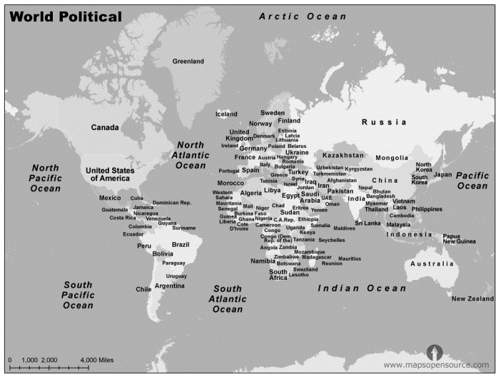
ASSESSMENT: 2-5.D

Mapping Where Our Families Immigrated/Migrated From:
Exit Ticket

Inquiry Question: What is the most important similarity between how our family members came to the United States?

Thinking about the ways that our family members came to the United States (or moved from one part of it to another), explain what you think is the most important similarity between how our family members came here. Include two pieces of evidence from then notes we took.

WORKSHEET: 2-5.E

Interview Questions

Below are some interview questions to start with. You should add more questions for our guest speakers.

1. When and where did you immigrate or migrate from?

2. How did you travel to the United States? What was that journey like?

3. What do you miss about your old home?

4. What do you like about living in the United States?

5.

6.

7.

8.

9.

10.

ASSESSMENT: 2-5.F

Guest Speakers: Exit Ticket

Thinking about our guest speakers, list the most important things you learned about immigrants who live in our community.

WORKSHEET: 2-6.A

Pop Quiz: English, German, or Irish?

Many things in American culture come from English, German, and Irish immigrants. Take a look at these items. If you think it came from England put an “E” above to it, Germany put a “G” above it, Ireland put an “I” above it.

1. Hot Dog: _____________

2. Hot Chocolate: ________

3. Soccer (Football): ______

4. Leprechaun: ___________
5. Holiday Tree: _________

6. Apple Pie: ____________

7. Kindergarten: _________

8. Hamburger: ___________

Answers

1. Hot Dog: Germany
Originally called the Frankfurter. It was a type of sausage first created in Frankfurt, Germany.

2. Hot Chocolate: Ireland
While the Mayans and Aztecs in México gave us chocolate, it was someone from Ireland who created the first modern hot chocolate by heating chocolate with milk.

3. Soccer (Football): England
Kicking a ball for sport probably started in China, but the first country to have organized rules for soccer (what is called football in most countries) was England.

4. Leprechaun: Ireland
The leprechaun comes from an Irish folk tale. The original story involved an Irish king being granted three wishes from this little imaginary man.

5. Holiday Tree: Germany
Germans were the first people to bring trees into their house and decorate them during Christmas.

6. Apple Pie: England
While many cultures have versions of the pie, it was the English who first decided to put apples in them.

7. Kindergarten: Germany
Germans invented the idea of preschool for young children, which they called Kindergarten or “children’s garden.”

8. Hamburger: Germany
The beef meat patty was invented in Hamburg, Germany. Although the idea of putting it on bread may actually be from the United States.

ASSESSMENT: 2-6.E

English, German, and Irish Immigrants: Exit Ticket

Inquiry Question: What is the most important impact that English, German, and Irish immigrants made to the United States?

Describe what you think is the most important thing that the English, Germans, and Irish brought with them to the United States. Some ideas to consider: language, government, food, music. Include two pieces of evidence from the sources.

WORKSHEET: 2-7.E

Chinese Immigrants Thinking Questions

Source 1: The Gold Rush
How did Chinese immigrants play an important part in this event?

Source 2: The Railroad
How did Chinese immigrants play an important part in this event?

Source 3: Feeding the United States
How did Chinese immigrants play an important part in this event?

Source 4: Making Chinatowns
How did Chinese immigrants play an important part in this event?

ASSESSMENT: 2-7.F

Chinese Immigrants: Exit Ticket

Inquiry Question: How have Chinese immigrants made the United States better?

Describe what you think is the most important thing that the Chinese did to help make the United States better. Include two pieces of evidence from then notes we took. You may also stand up and look at the information posted on the classroom walls.

ASSESSMENT: 2-8.E

Ellis Island: Exit Ticket

Inquiry Question: How would you describe the experiences of immigrants entering the United States through Ellis Island?

Pretend that you are an immigrant from Europe or the Caribbean and write back home to your family telling them what Ellis Island was like. You can say both good and bad things about Ellis Island. Include two pieces of evidence from the sources.

ASSESSMENT: 2-9.E

Life After Angel Island: Exit Ticket

Inquiry Question: Imagine that you were an immigrant from China, Japan, or India to the United States, how would you describe your new country to the people back home?

Imagine that you were an immigrant from China, Japan, or India. Write a letter back home describing life in your new country. Include two pieces of evidence from the sources.

WORKSHEET: 2-10.B

Original Tenement Description and Floor Plan
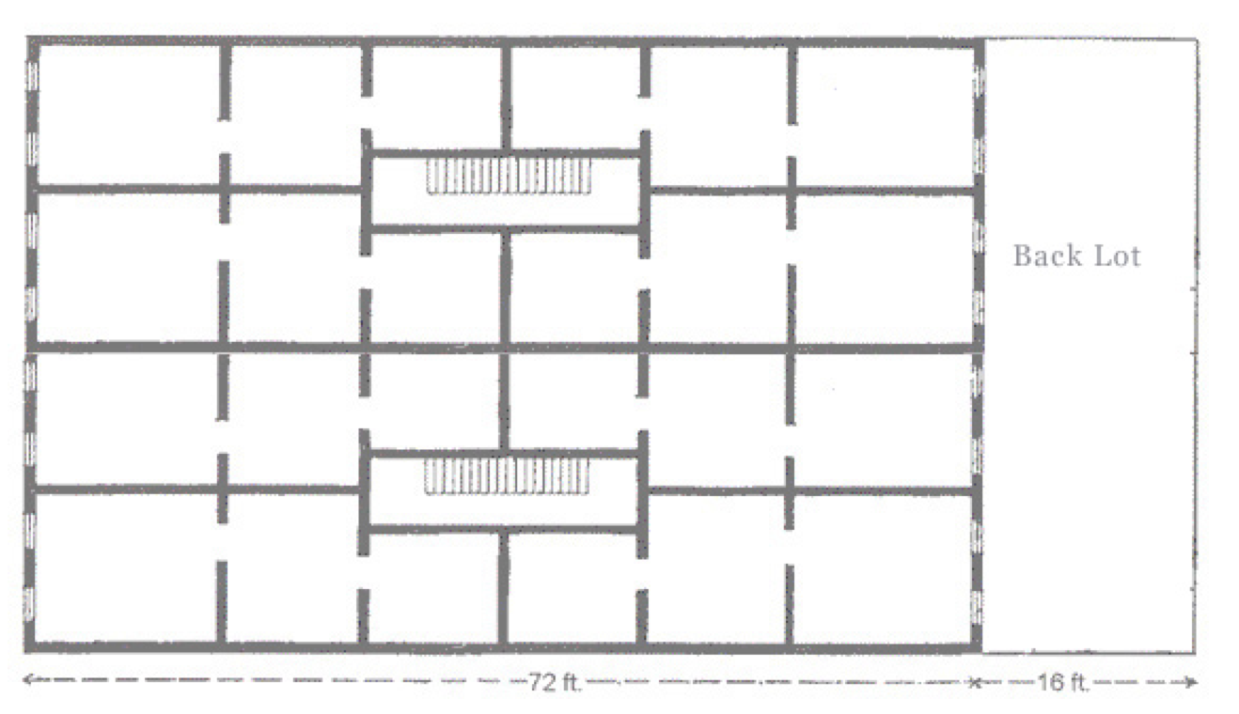

Tenement Description

- This is a tenement in the Little Poland section of Chicopee, Massachusetts. It has no indoor toilets or running water. People needed to go use outhouses and get water outside.

- If you are looking at the floor plan, each apartment has three rooms. They start at the stairs with the smallest, next is a larger room, and the largest room is on the end with windows. The windows went from almost the floor to almost the ceiling, just like most school classrooms.

- Sometimes more than one family lived in each apartment. It was very expensive and usually the whole family worked jobs, including the children. They may work in factories, selling things on the streets (like newspapers), or doing repair work (like sewing).

- Since there were few parks at this time, children had nowhere safe to play. They would often play on roofs or in back dirt lots (sometimes near the outhouses).

ASSESSMENT: 2-10.C

Explanation of Tenement Redesign: Exit Ticket

Inquiry Question: If you were to redesign the tenement to improve immigrant conditions, what would they include?

Scribe: List here all of the changes that were made to make the tenement better for the immigrants who live there.

WORKSHEET: 2-10.D

Dumbbell Tenement
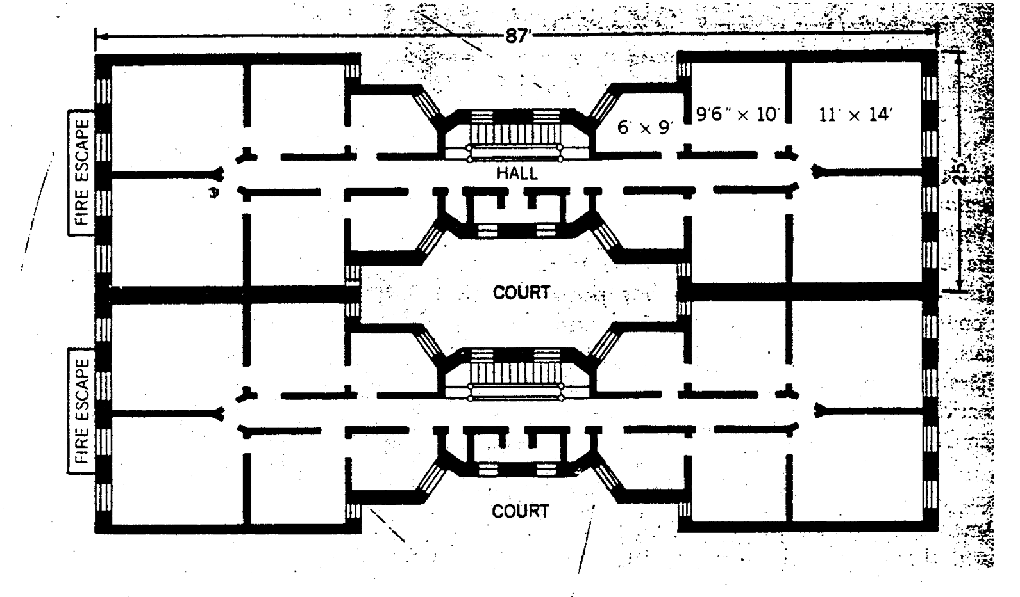
ASSESSMENT: 2-11.D

Immigration from Canada and México: Exit Ticket

Inquiry Question: What was the Canadian and Mexican immigrant experience like?

Imagine that you were a child who emigrated from México or Québec (French Canada). Write a diary entry about your time living in the United States. You can discuss the journey here and your new community. Include two pieces of evidence from the sources.

WORKSHEET: 2-12.B

Preparation for the Corner Debate

Think about the following sentences and decide if you think “yes” or “no.” Then explain why.

The United States should allow most immigrants to come here.

Circle: Yes or No

Immigrants who have families should be allowed to come to the United States before people who do not have families.

Circle: Yes or No

WORKSHEET: 2-12.C

YES

NO

ASSESSMENT: 2-12.D

1924 Immigration Act: Exit Ticket

Inquiry Question: Should we limit the number of people who can move to the United States?

Describe if you think that we should limit the number of immigrants (like they started doing in 1924) or that we should allow most immigrants to come here. Include two pieces of evidence from the sources.

ASSESSMENT: 2-13.F

Immigration in the 20th Century: Exit Ticket

Inquiry Question: In the 20th century, why did newer immigrants start coming from different countries (than before)?

After thinking about the different reasons, what was the most important reason why immigrants started coming from different countries in the 20th century? Include two pieces of evidence from the sources.

ASSESSMENT: 2-14.E

Vietnamese Refugees: Exit Ticket

Inquiry Question: If you were a refugee who came to the U.S. from Vietnam in the 1970s or 80s, what would have been the most difficult part of the journey?

After thinking about the different struggles Vietnamese refugees faced, why do you think would be the hardest thing to face? Include two pieces of evidence from the sources.

ASSESSMENT: 2-15.F

American Immigrants: Exit Ticket

Inquiry Question: Which of the featured American immigrants do you think made the largest contribution to the United States?

After thinking about the different ways that immigrants have contributed or added to the United States, explain which recent immigrant had the most important impact on the country.

ASSESSMENT: 2-16.E

Immigration Today—Challenges: Exit Ticket

Inquiry Question: What is the most difficult challenge immigrants face today?

Imagine that you just emigrated to the United States. Pick a country, choose a transportation (plane, bus, car), and write a diary entry about your travels here. Be sure to discuss at least one important challenge you would face based on the sources.

ASSESSMENT: 2-17.G

Boston: A City of Immigrants: Exit Ticket

Inquiry Question: How does being a city of immigrants make Boston better?

Imagine that you are writing a letter to the editor of a local newspaper. Explain why you think immigrants are an important part of the city of Boston. Use the sources to explain the ways that you think immigrants make Boston a better city. You can focus on one or more than one.

To the Editor,

WORKSHEET: 2-18.A

Citizenship Test

The test for U.S. citizenship asks people 10 questions from a list of 100 questions. A person needs to get 6 out of the 10 questions correct to pass and become a citizen. Can you pass the test? Write your answers below the question.

1. What is the highest law in the United States?

2. What is one right in the First Amendment?

3. Name a branch of government?

4. Who is in charge of the Executive Branch (White House)?

5. How many senators does each state have?

6. How many years is a president in office for a term?

7. What is the highest court in the United States?

8. What is the capital of your state?

9. What year did the United States become a country?

10. Who was the first president?

Citizenship Test (ANSWERS)

Below are the answers to the citizenship test.

1. What document is the highest law in the United States?
The Constitution

2. What is one right in the First Amendment?
Speech
Press
Religion
Assembly
Petition

3. Name a branch of government?
Legislative (Congress, House and Senate)
Executive (President and Cabinet)
Judicial (Supreme Court)

4. Who is in charge of the Executive Branch (White House)?
The President
5. How many senators does each state have?
2

6. How many years is a president in office for a term?
4

7. What is the highest court in the United States?
The Supreme Court

8. What is the capital of your state?
Boston (if in Massachusetts)

9. What year did the United States become a country?
1776

10. Who was the first president?
George Washington

ASSESSMENT: 2-18.F

Immigration Today—Citizenship: Exit Ticket

Inquiry Question: Is it fair how we choose who can become a citizen?

Is the current citizenship test the best way to decide who can become a new citizen? Choose and explain your favorite options from the sources: (1) the current test is good, (2) the test can be better, or (3) should be community service instead. Include two pieces of evidence from the sources.

WORKSHEET: 2-19.E

Good Citizens Thinking Questions

Source 1: Youth Way on the MBTA
How did this group of citizens help their community or country?

Source 2: The Martin Richard Foundation
How did this group of citizens help their community or country?

Source 3: Joseph Lee K-8 Students and Black Lives Matter
How did this group of citizens help their community or country?

Source 4: Girl Scouts and the Boston Plastic Bag Ban
How did this group of citizens help their community or country?

ASSESSMENT: 2-19.F

Good Citizens (Part 1): Exit Ticket

Inquiry Question: Which group of people is the best example of good citizenship?

After thinking about the different groups in the sources, explain which group is the best example of being good citizens for their community or country. Include two pieces of evidence from the sources.

WORKSHEET: 2-19.E

Good Citizens (Part 2): Exit Ticket

Inquiry Question: What actions can I take to make my community and country a better place?

After reading about the different ways you can make your voice heard, explain which actions you will take in the future to make your community better. Choose at least two of the methods (speaking with others, reading about current events, voting, protesting, writing letters). Include two pieces of evidence from the sources.

If you would like, you can speak about a specific issue you care about (like homelessness, the environment, education, healthcare, immigrant rights).

GRADE 2 POST-TEST

Answer the following questions.

1. What does it mean to be an Indigenous person?

2. What is the difference between a city and a town?

3. What is a state?

4. What is a country?

5. Label each continent on the picture below: Antarctica, Africa, Asia, Australia, Europe, North America, South America.

6. What is a citizen?

7. If you were not born a citizen of the United States, how can you become a citizen?

8. What is an immigrant?

9. What is slavery?

10. What is a refugee?

11. What are the most difficult things about being an immigrant to a new country?

12. What actions can I take to make my community a better place?

