Open Social Studies

An Inquiry-Based and Literacy-Focused K-6 Curriculum

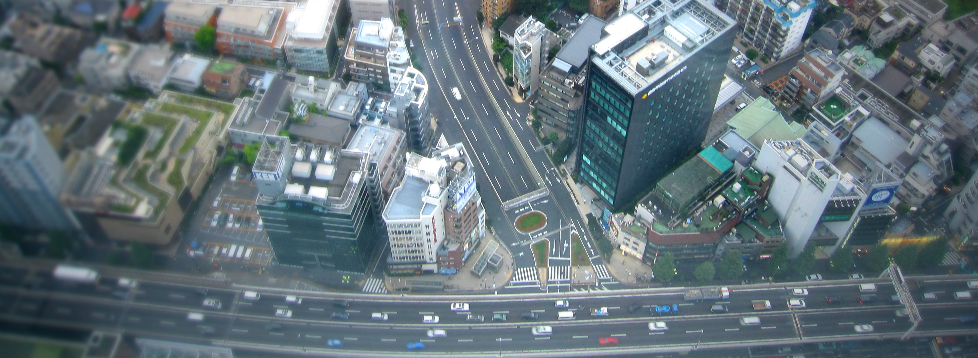

Curric

STUDENT SOURCEBOOK
Level: Grade K
Our Families and Communities

Developers:

Christopher C. Martell

Jennifer R. Bryson

GRADE K ROAD MAP

LESSON K-1

Lesson Title: My Caregivers

Inquiry Question: What important things do caregivers do?

LESSON K-2

Lesson Title: My Family

Inquiry Question: What is something that makes your family special?

LESSON K-3

Lesson Title: Different Types of Families

Inquiry Question: How are families different?

LESSON K-4

Lesson Title: A World of Workers

Inquiry Question: What job might I do when I grow up?

LESSON K-5

Lesson Title: How Much Is That?: Buying and Selling

Inquiry Question: How do we get the things that we need and want?

LESSON K-6

Lesson Title: From Farm to Table

Inquiry Question: How do we get our food?

LESSON K-7

Lesson Title: Building Cities

Inquiry Question: How do they build our cities?

LESSON K-8

Lesson Title: Past and Present: How Have People Changed?

Inquiry Question: How was life different 100 and 500 years ago?

LESSON K-9

Lesson Title: Traveling Around the World

Inquiry Question: Where in the world would you like to travel?

LESSON K-10

Lesson Title: Making a Difference in My Community

Inquiry Question: What problem in my community should we help make better (and how)?

SOURCEBOOK K-1.B

Station 1: Who Can Be a Caregiver?

Who Can Be a Caregiver?

Mother

Father
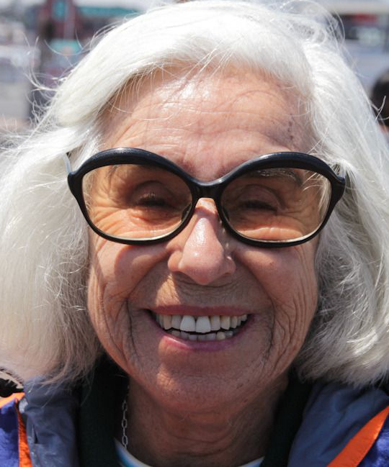
Grandparents

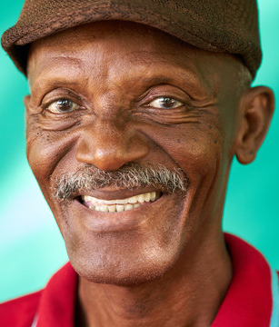
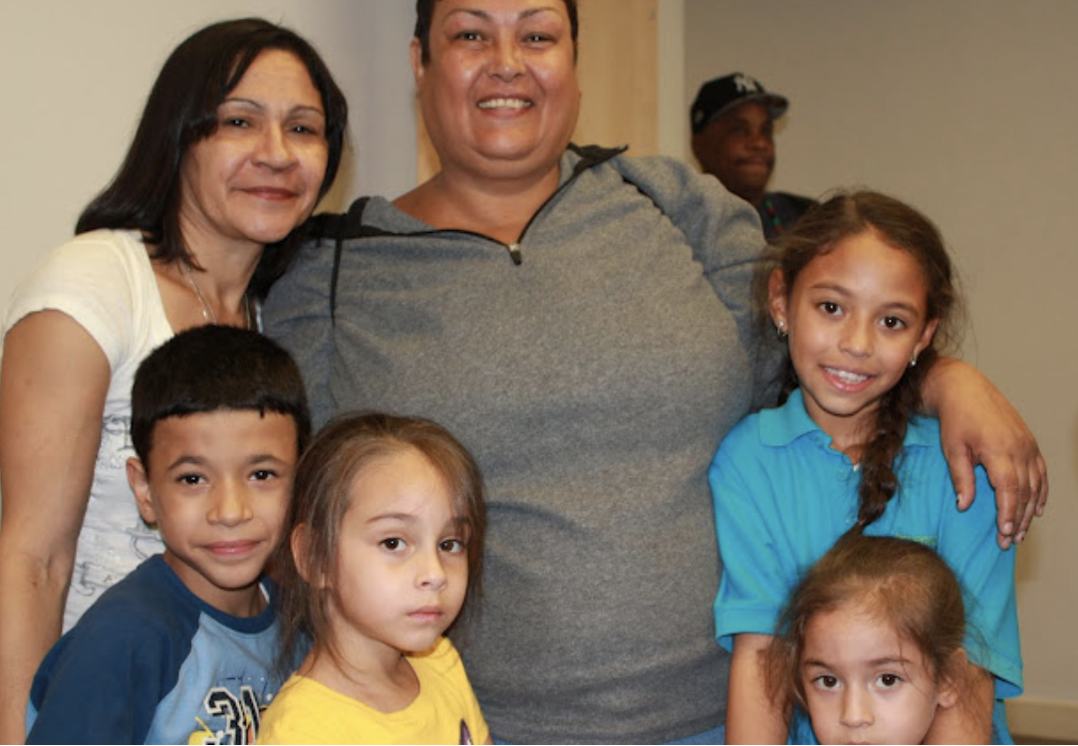
Foster Parents
Siblings

Uncles and Aunts

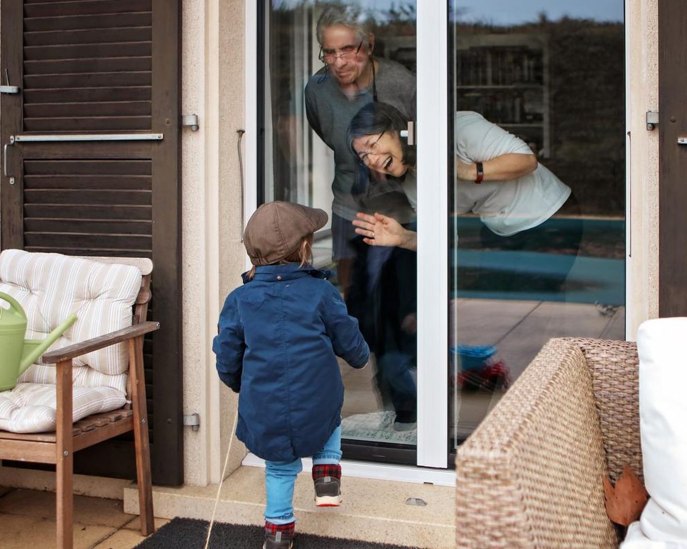
Neighbors
SOURCEBOOK K-1.B

Station 2: Help from Caregivers

What do caregivers do?

Cook
Clean
Read
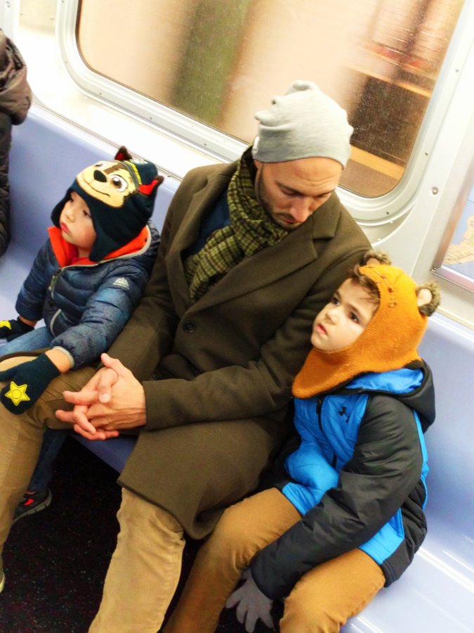
Transport
SOURCEBOOK K-1.C

Station 3: Who Is My Caregiver?

Draw a picture of your caregiver.

Use the space below to draw your caregivers. Try to show the ways that they help you.
SOURCEBOOK K-2.B

Station 1: Looking at a Picture of My Family

Find your family’s picture.

Who do you see in the picture? Tell your class friends about them.

SOURCEBOOK K-2.C

Station 2: Writing the Names of My Family Members

Who are the people in your family?

Practice writing their names or ask a teacher to help you.

Use the space below to write your family members names.

SOURCEBOOK K-2.D

Station 3: Drawing My Family

Draw a picture of your family.

Use the space below to draw your family.

SOURCEBOOK K-3.A

Station 1: Our Classroom’s Families

How are our families similar?

How are our families different?

SOURCEBOOK K-3.B

Station 3: Types of Families

What can you tell about these families?

Image 1
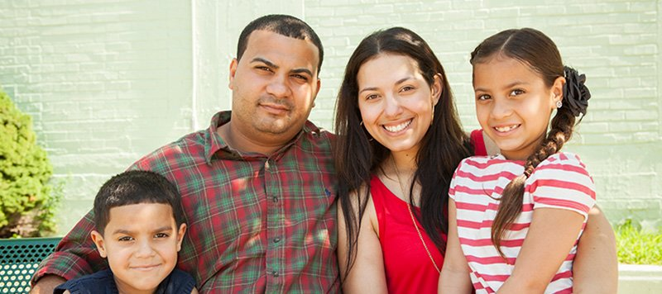

Image 2

Image 3
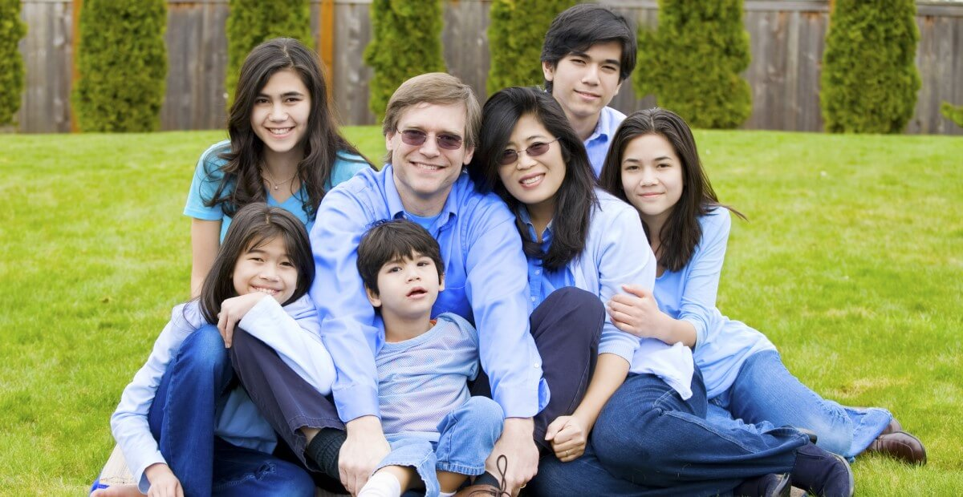

Image 4

Image 5

Image 6

Image 7
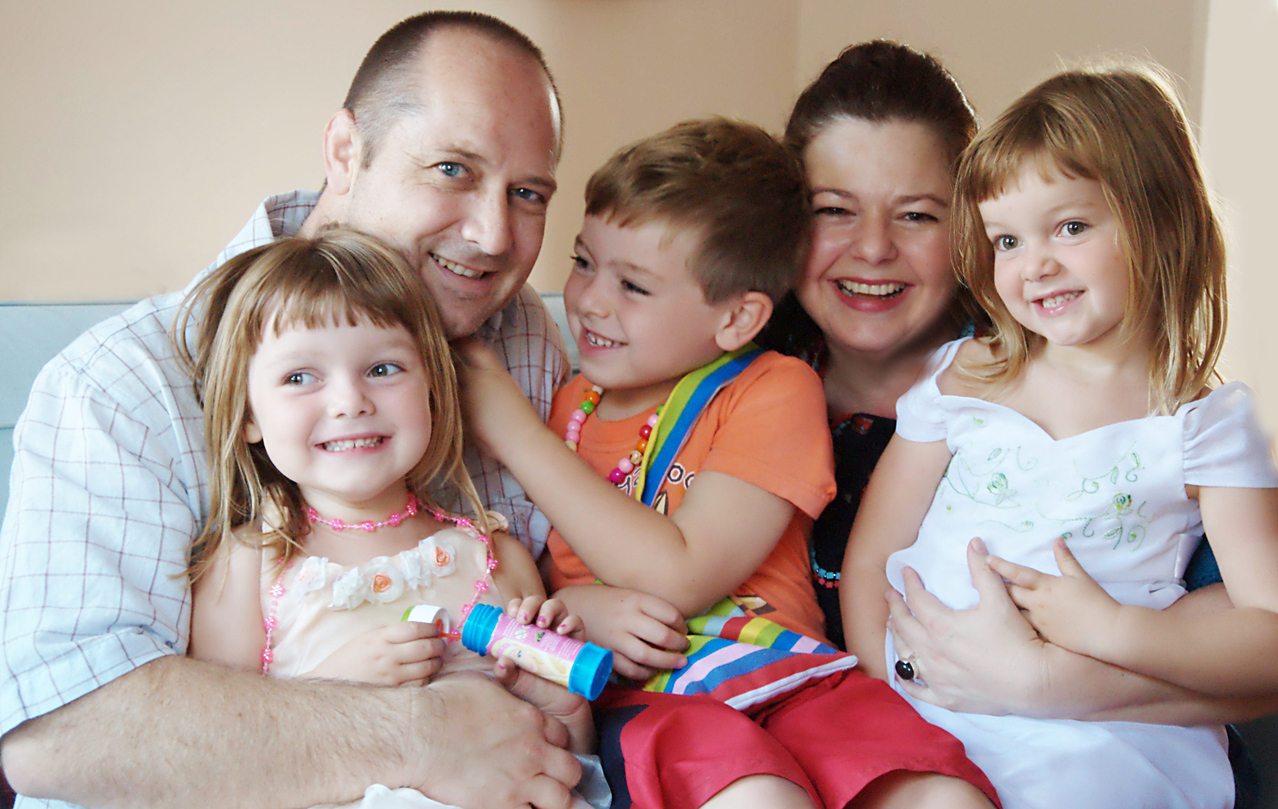

Image 8
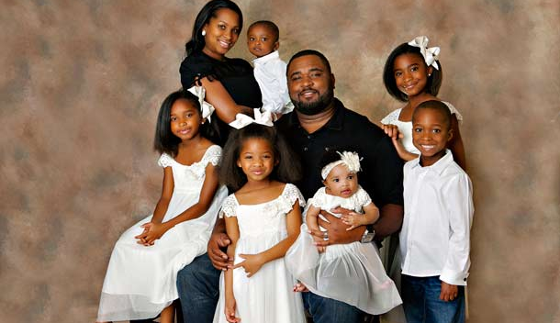
SOURCEBOOK K-3.C

Station 3: Look at Picture Books About Families

How are families similar and different?
SOURCEBOOK K-4.C

Station 1: Workers Who Visited Us

How do these workers help people?

What type of job do you think is most interesting?

SOURCEBOOK K-4.D

Station 2: Types of Jobs

How do these workers help people?

What type of job do you think is most interesting?

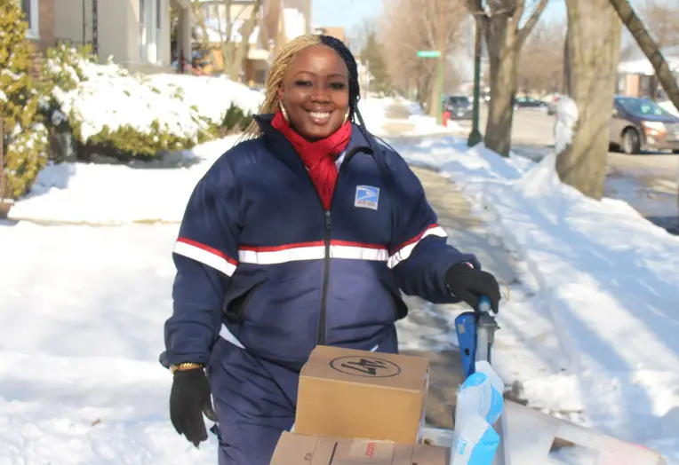
Postal Worker
Doctor

Doctor
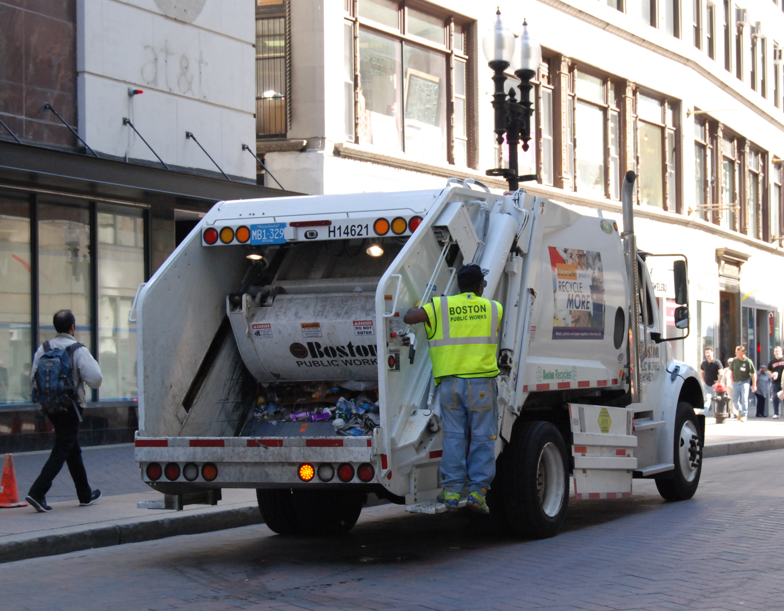
Sanitation Worker
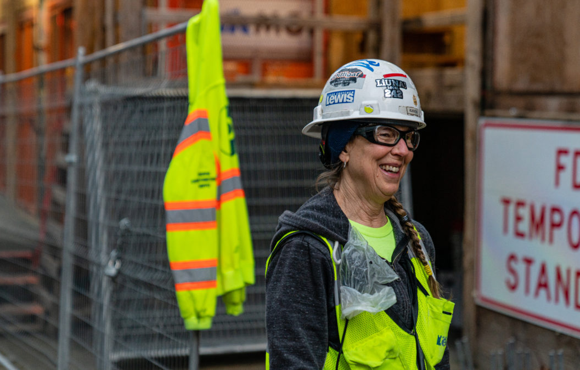
Construction Worker
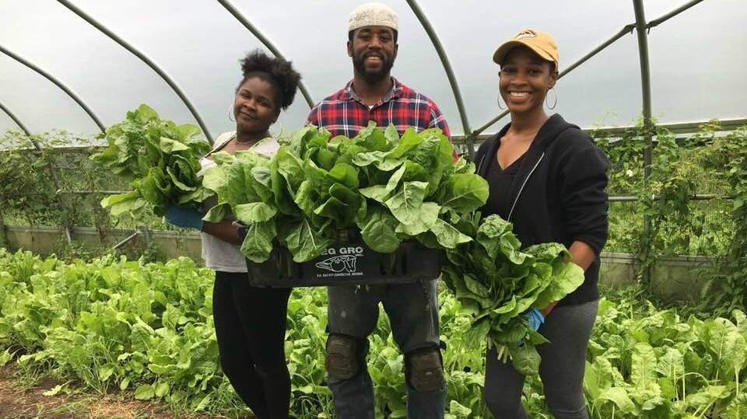
Farmer
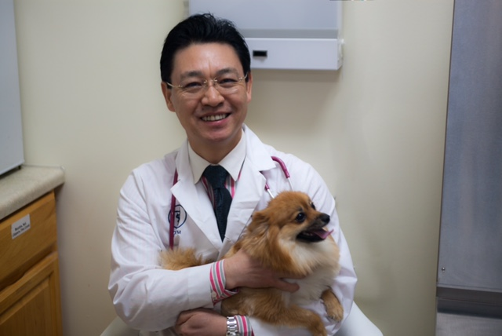
Veterinarian
Chef or Baker
Airplane Pilot
SOURCEBOOK K-4.E

Station 2: Look at Picture Books About Jobs

How do these workers help people?

What type of job do you think is most interesting?

SOURCEBOOK K-5.A

Station 1: Drawing:
How Something You Buy at the Store Is Made

Draw a picture of how something is made and then gets to a store.

Use the space below to draw a picture of how something is made and then gets to a store. You can use a cow and milk, or imagine something else.

SOURCEBOOK K-5.B

Station 2: Needs vs. Wants: Choices Activity
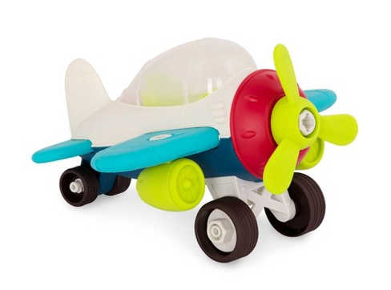
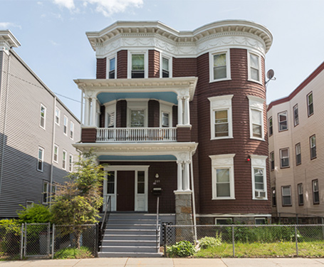
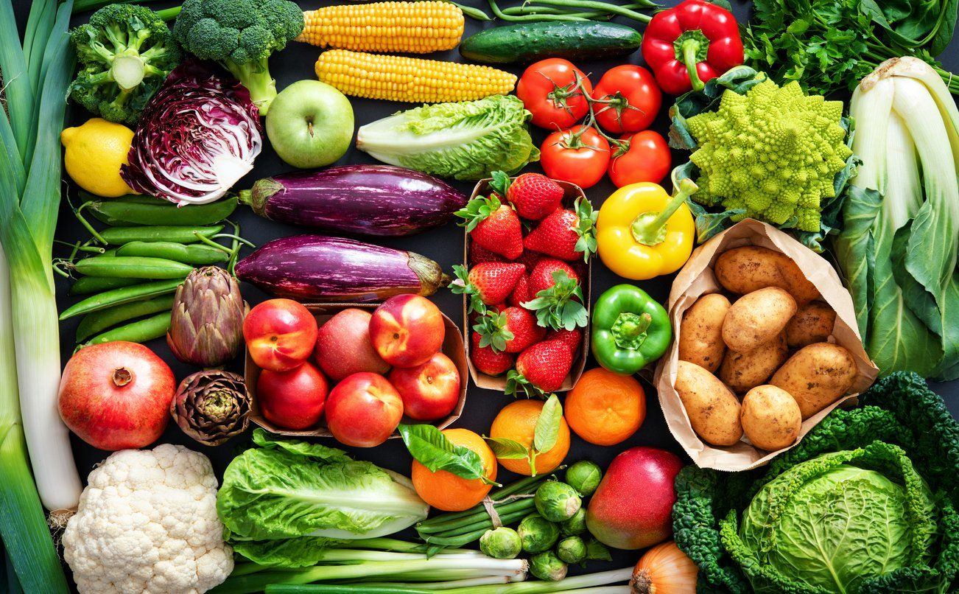
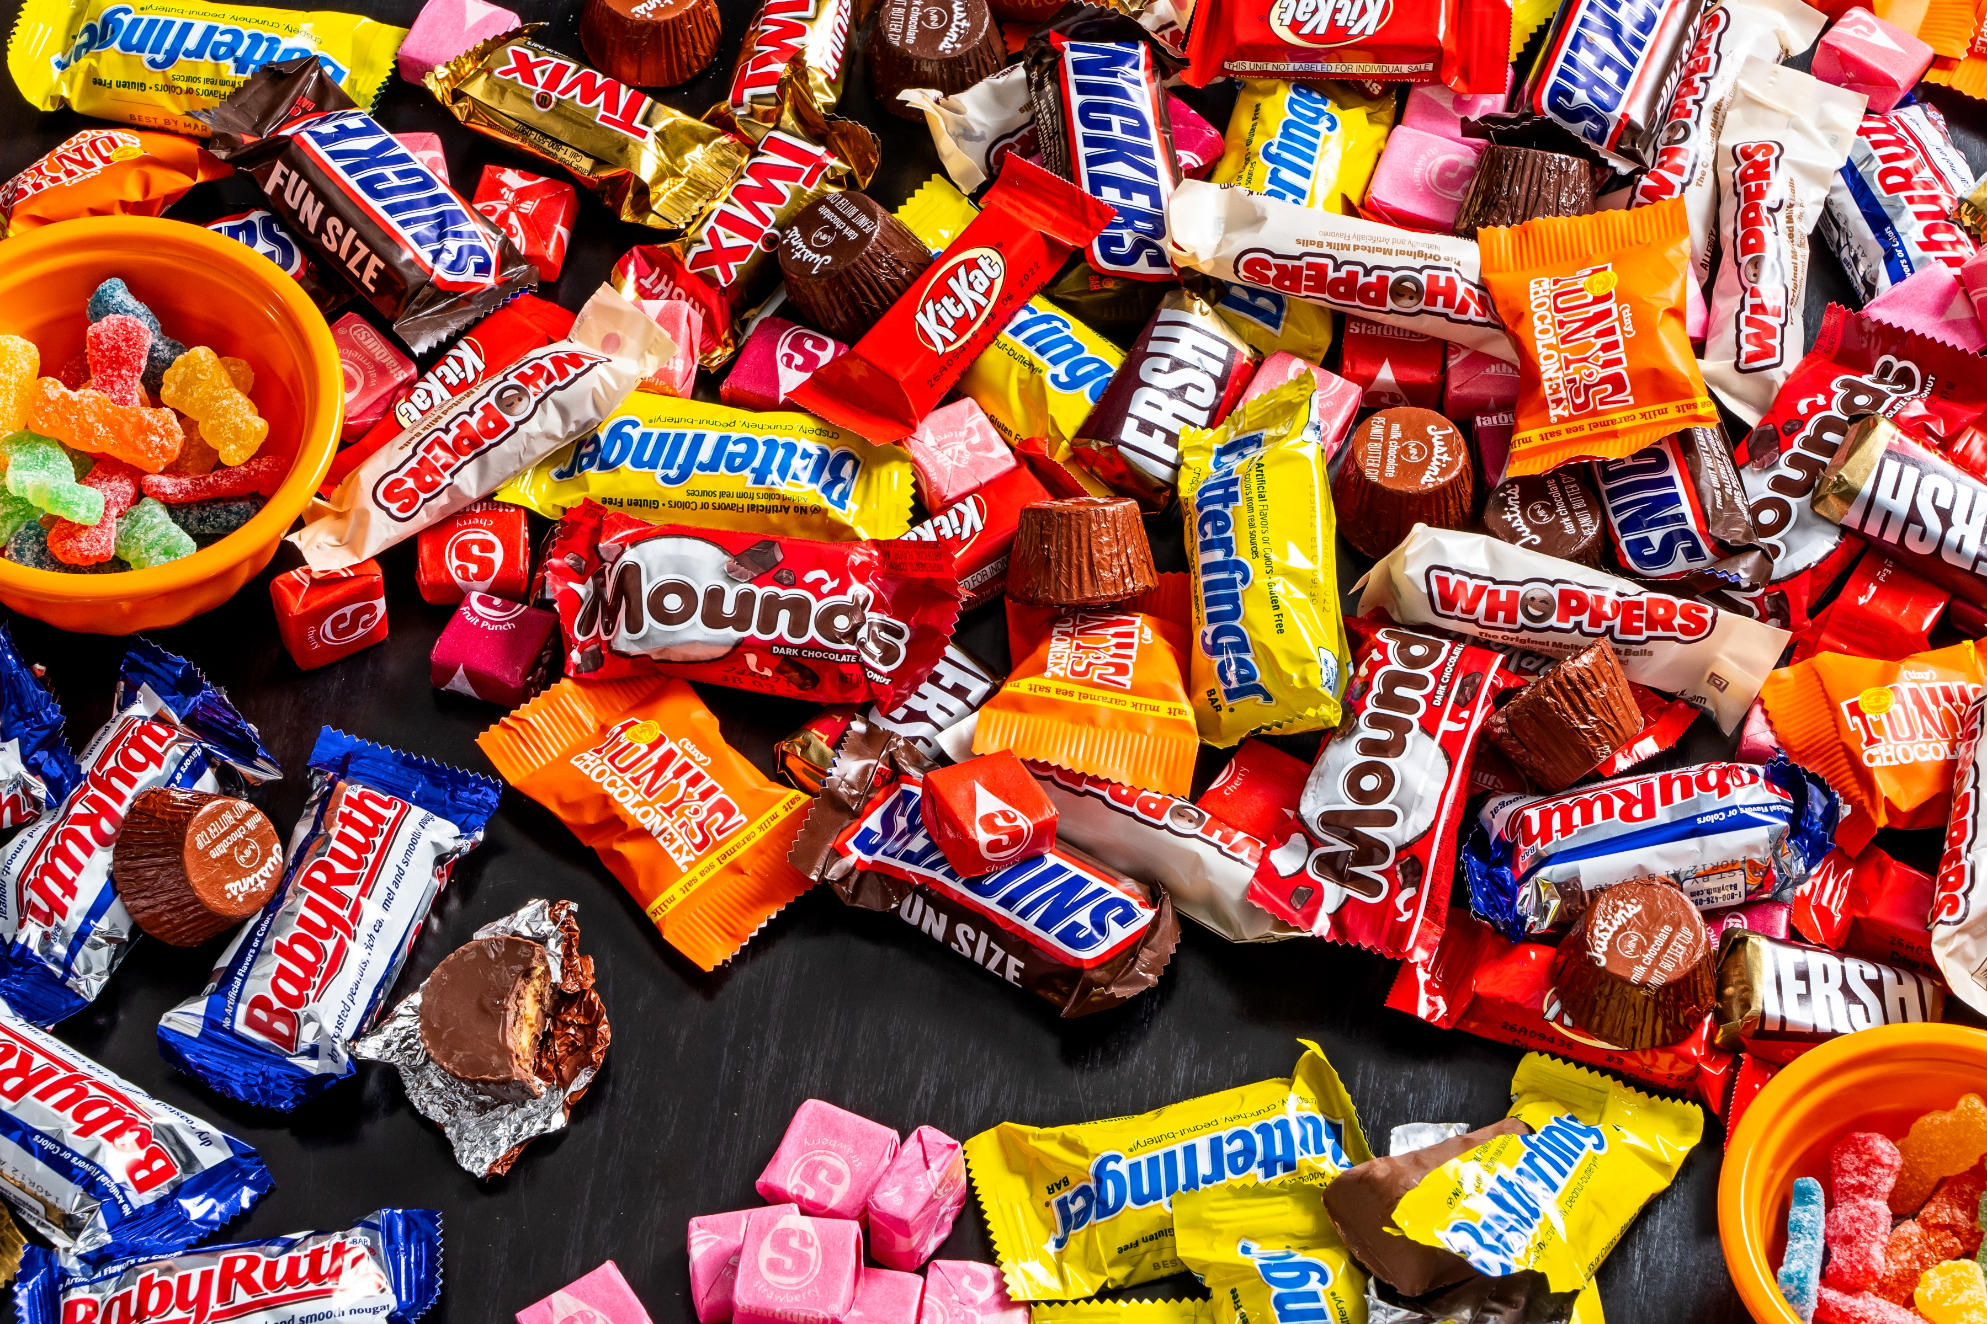
Home
Toy
Vegetables
Candy
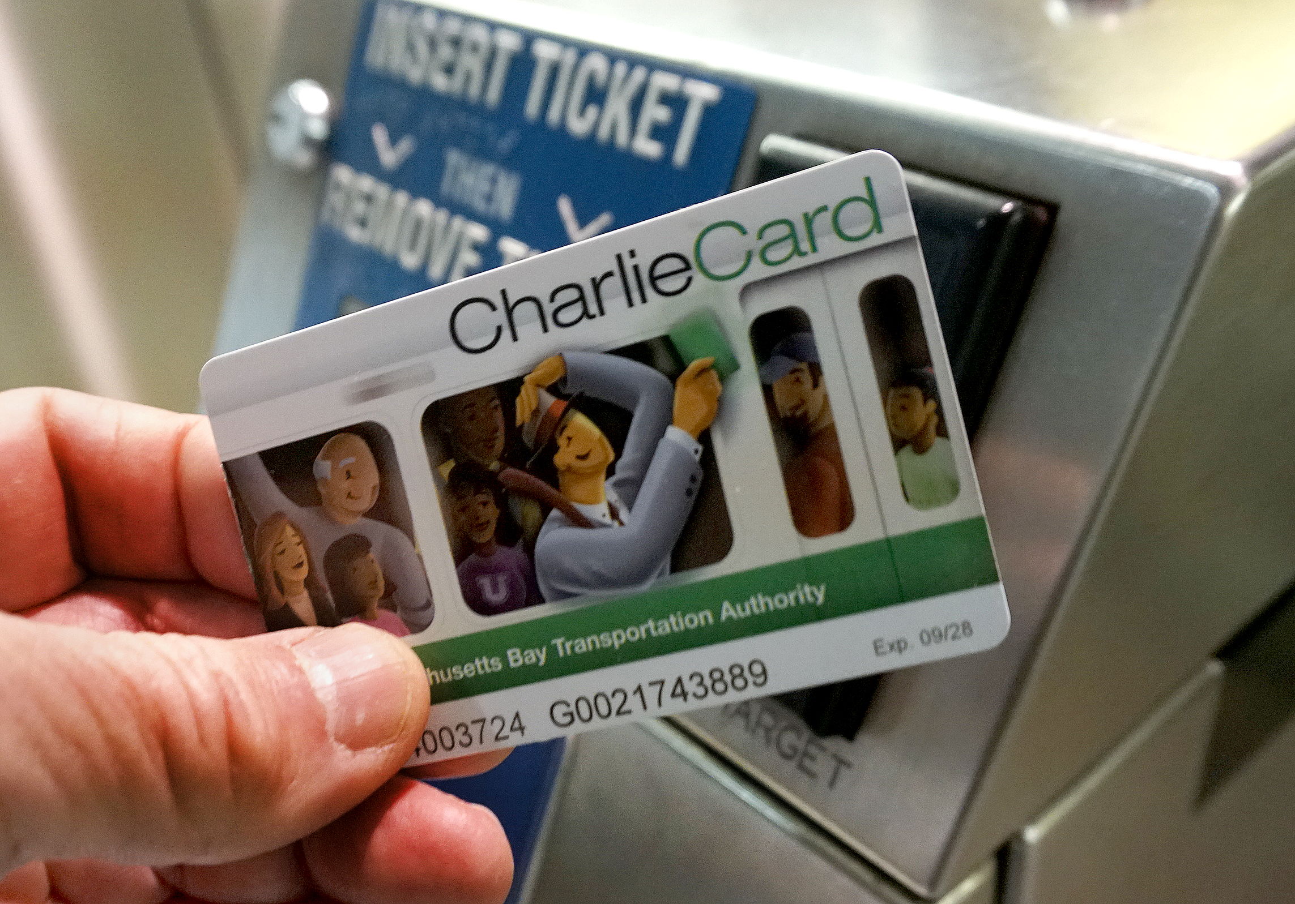
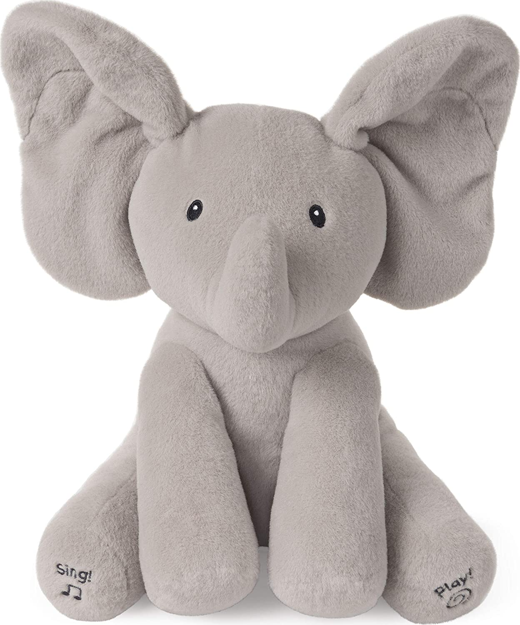
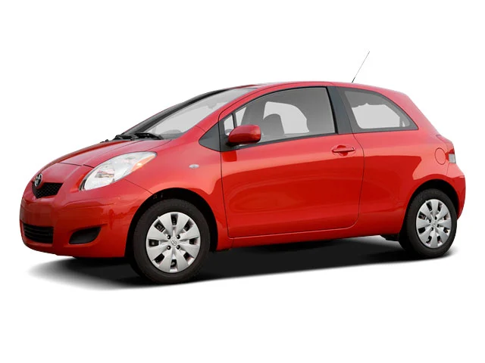
Subway Card
Plush Toy
Pizza
Car

SOURCEBOOK K-5.C

Play Money

Print 4 $5 dollar bills and cut out:

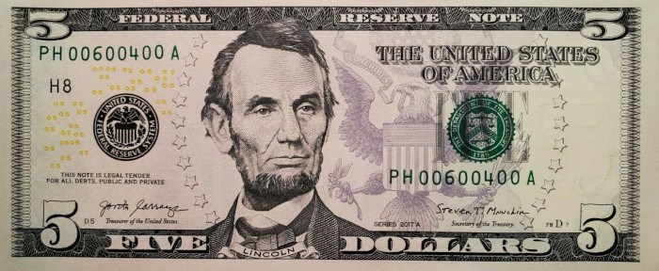

Print 30 $1 dollar bills and cut out:

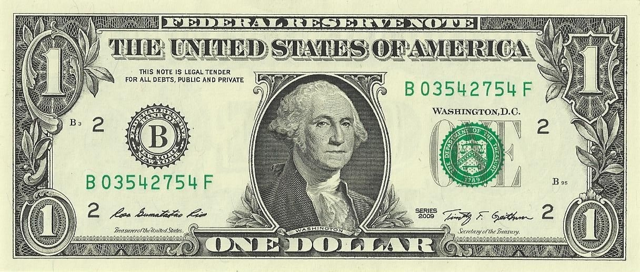

SOURCEBOOK K-5.D

Station 3: Using Money

Plush Toy: $10
Toy: $10
Pizza Slice: $5
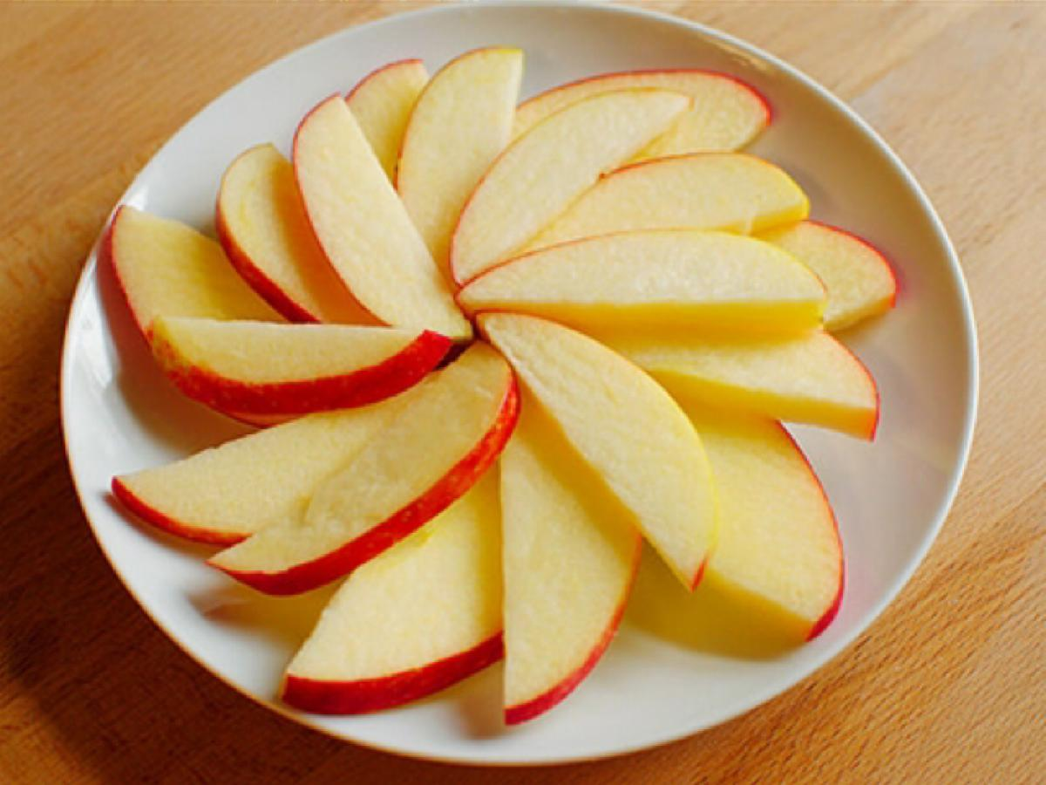
Apple Slices: $5
Music: $10
Book: $10
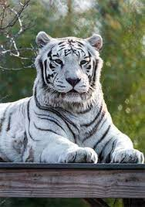
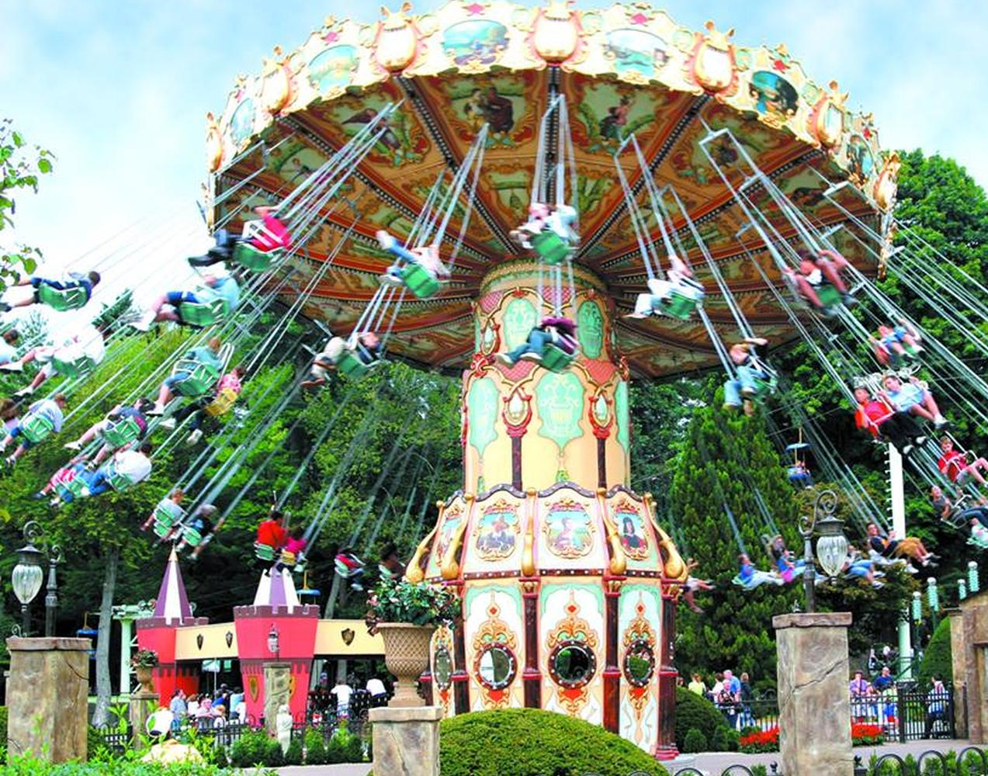
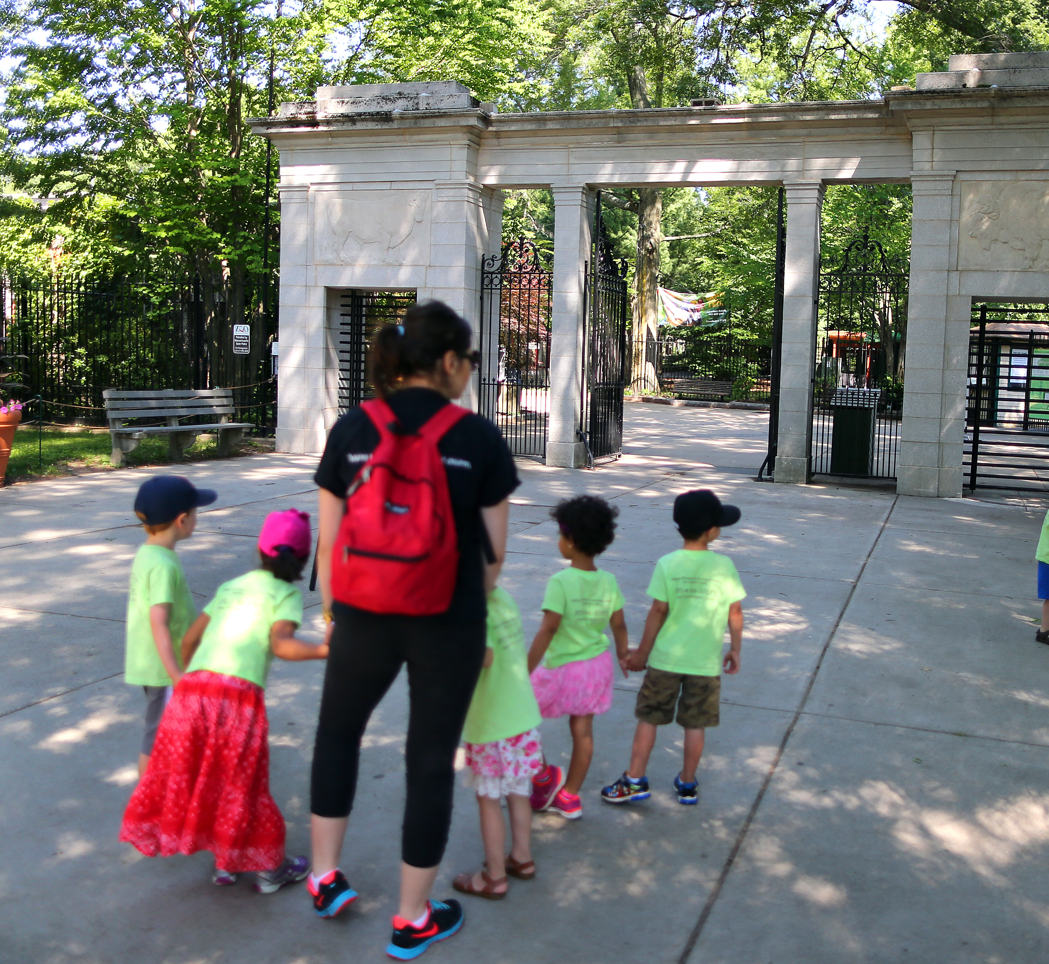
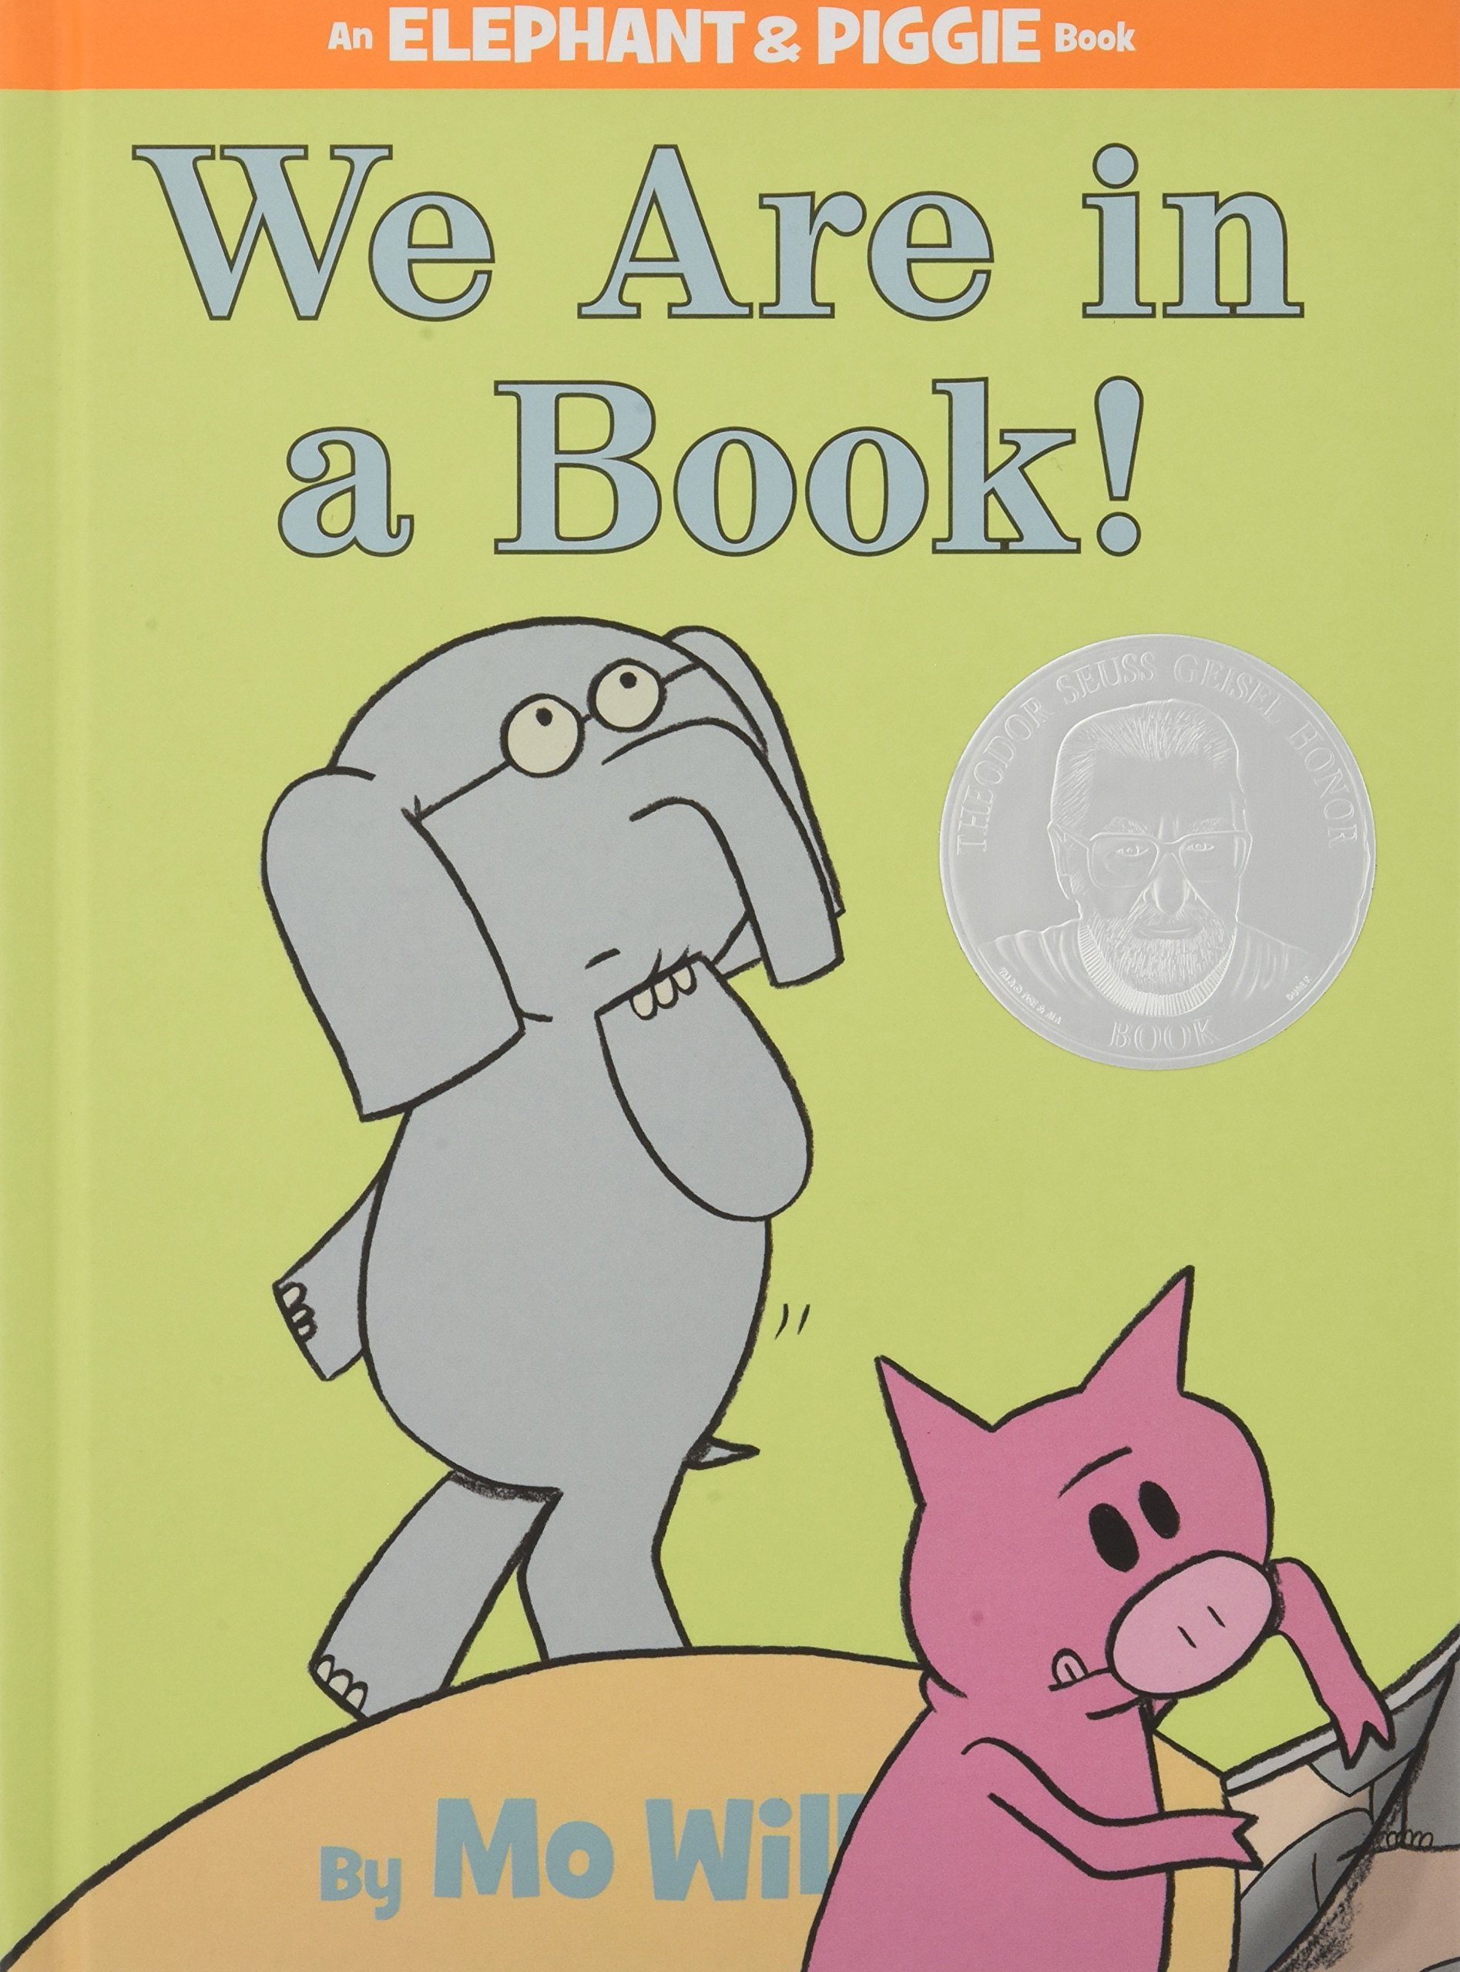
Visit Zoo: $30
Visit Amusement Park: $50

SOURCEBOOK K-6.A

Station 1: Pictures of Farm Workers

What do they do for work on farms?

How does food get from the farm to the grocery store?

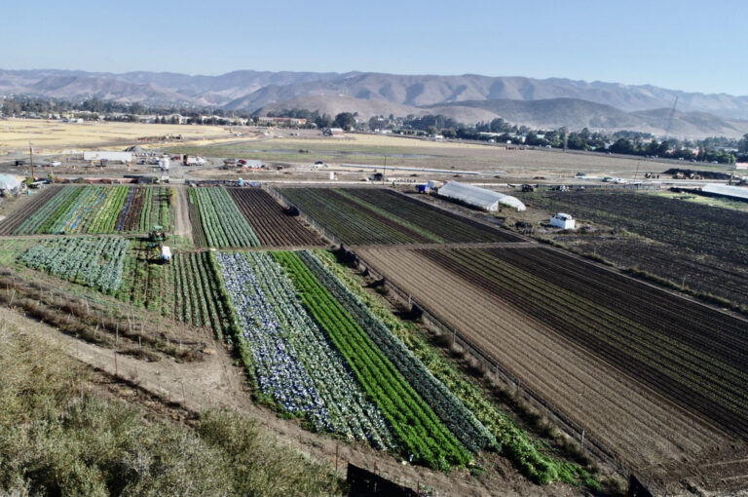
Some Farms Are Very Large

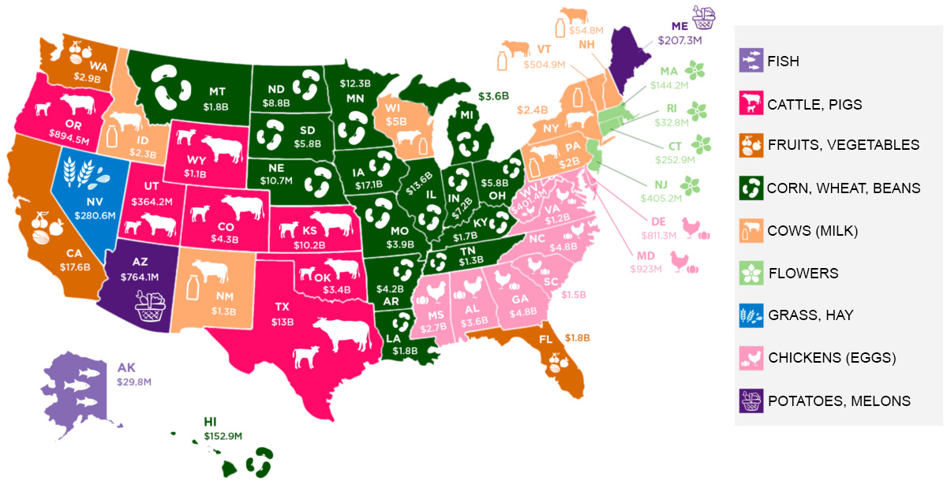
Where different crops (things grown to sell) are grown in the United States.

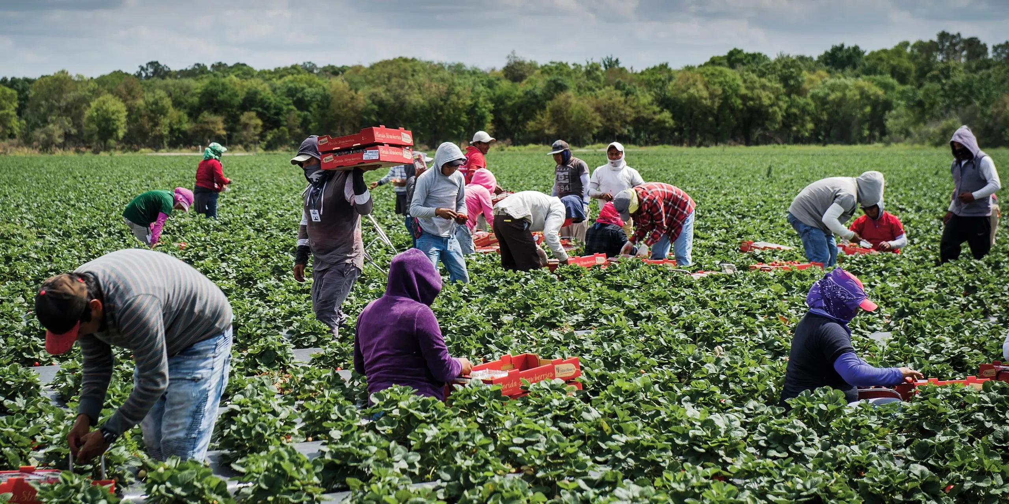
Picking Strawberries
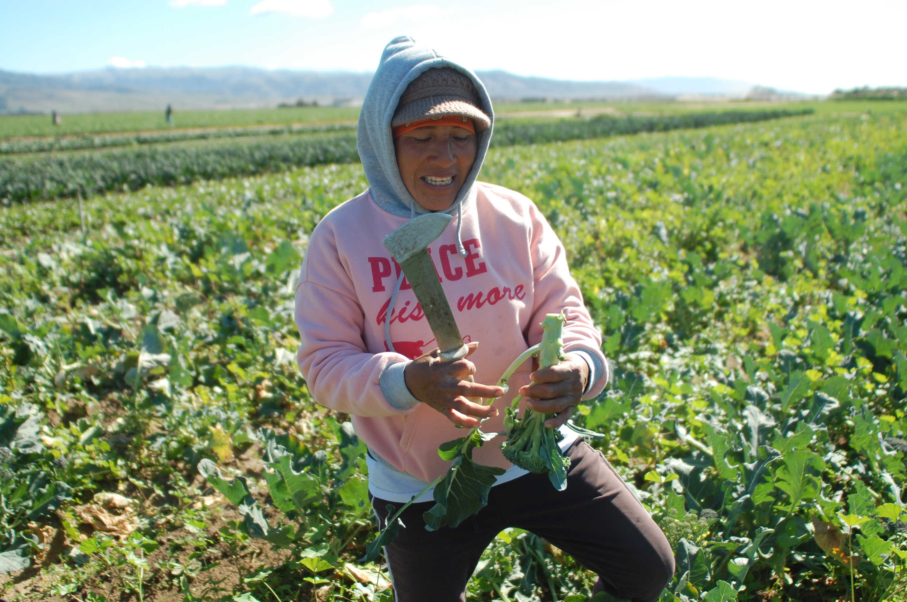
Picking Broccoli

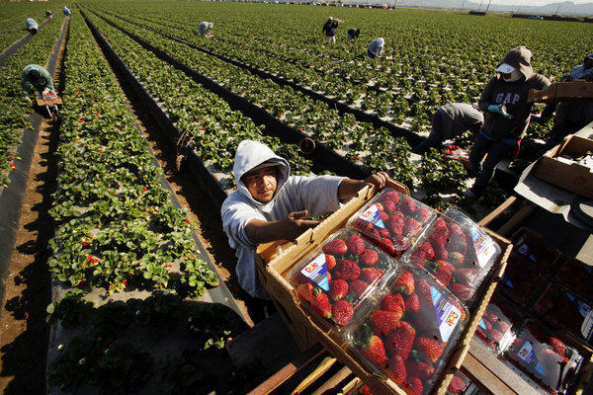
Loading the Strawberry Truck
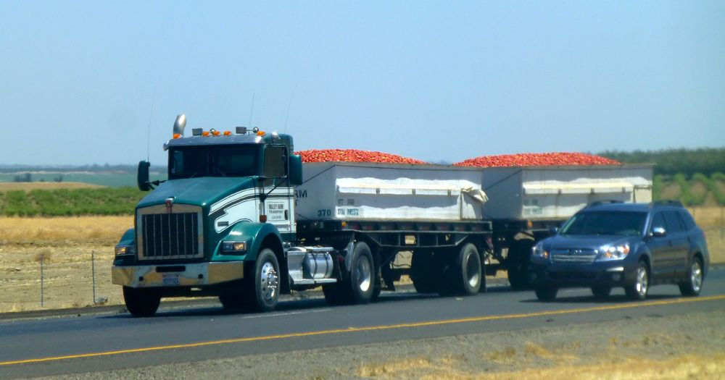
Tomato Truck on a Highway
SOURCEBOOK K-6.B

Station 2: A Day on the Farm [Video]

What do they do for work on farms?

How does food get from the farm to the grocery store?

SOURCEBOOK K-6.C

Station 3: Drawing a Farm

Draw a picture of a farm.

Use the space below to draw a farm. Try to show all the different people, animals, machines, and buildings on a farm.

SOURCEBOOK K-7.A

Station 1: Pictures of Construction Machines

What machines do they use at construction sites?

Excavator
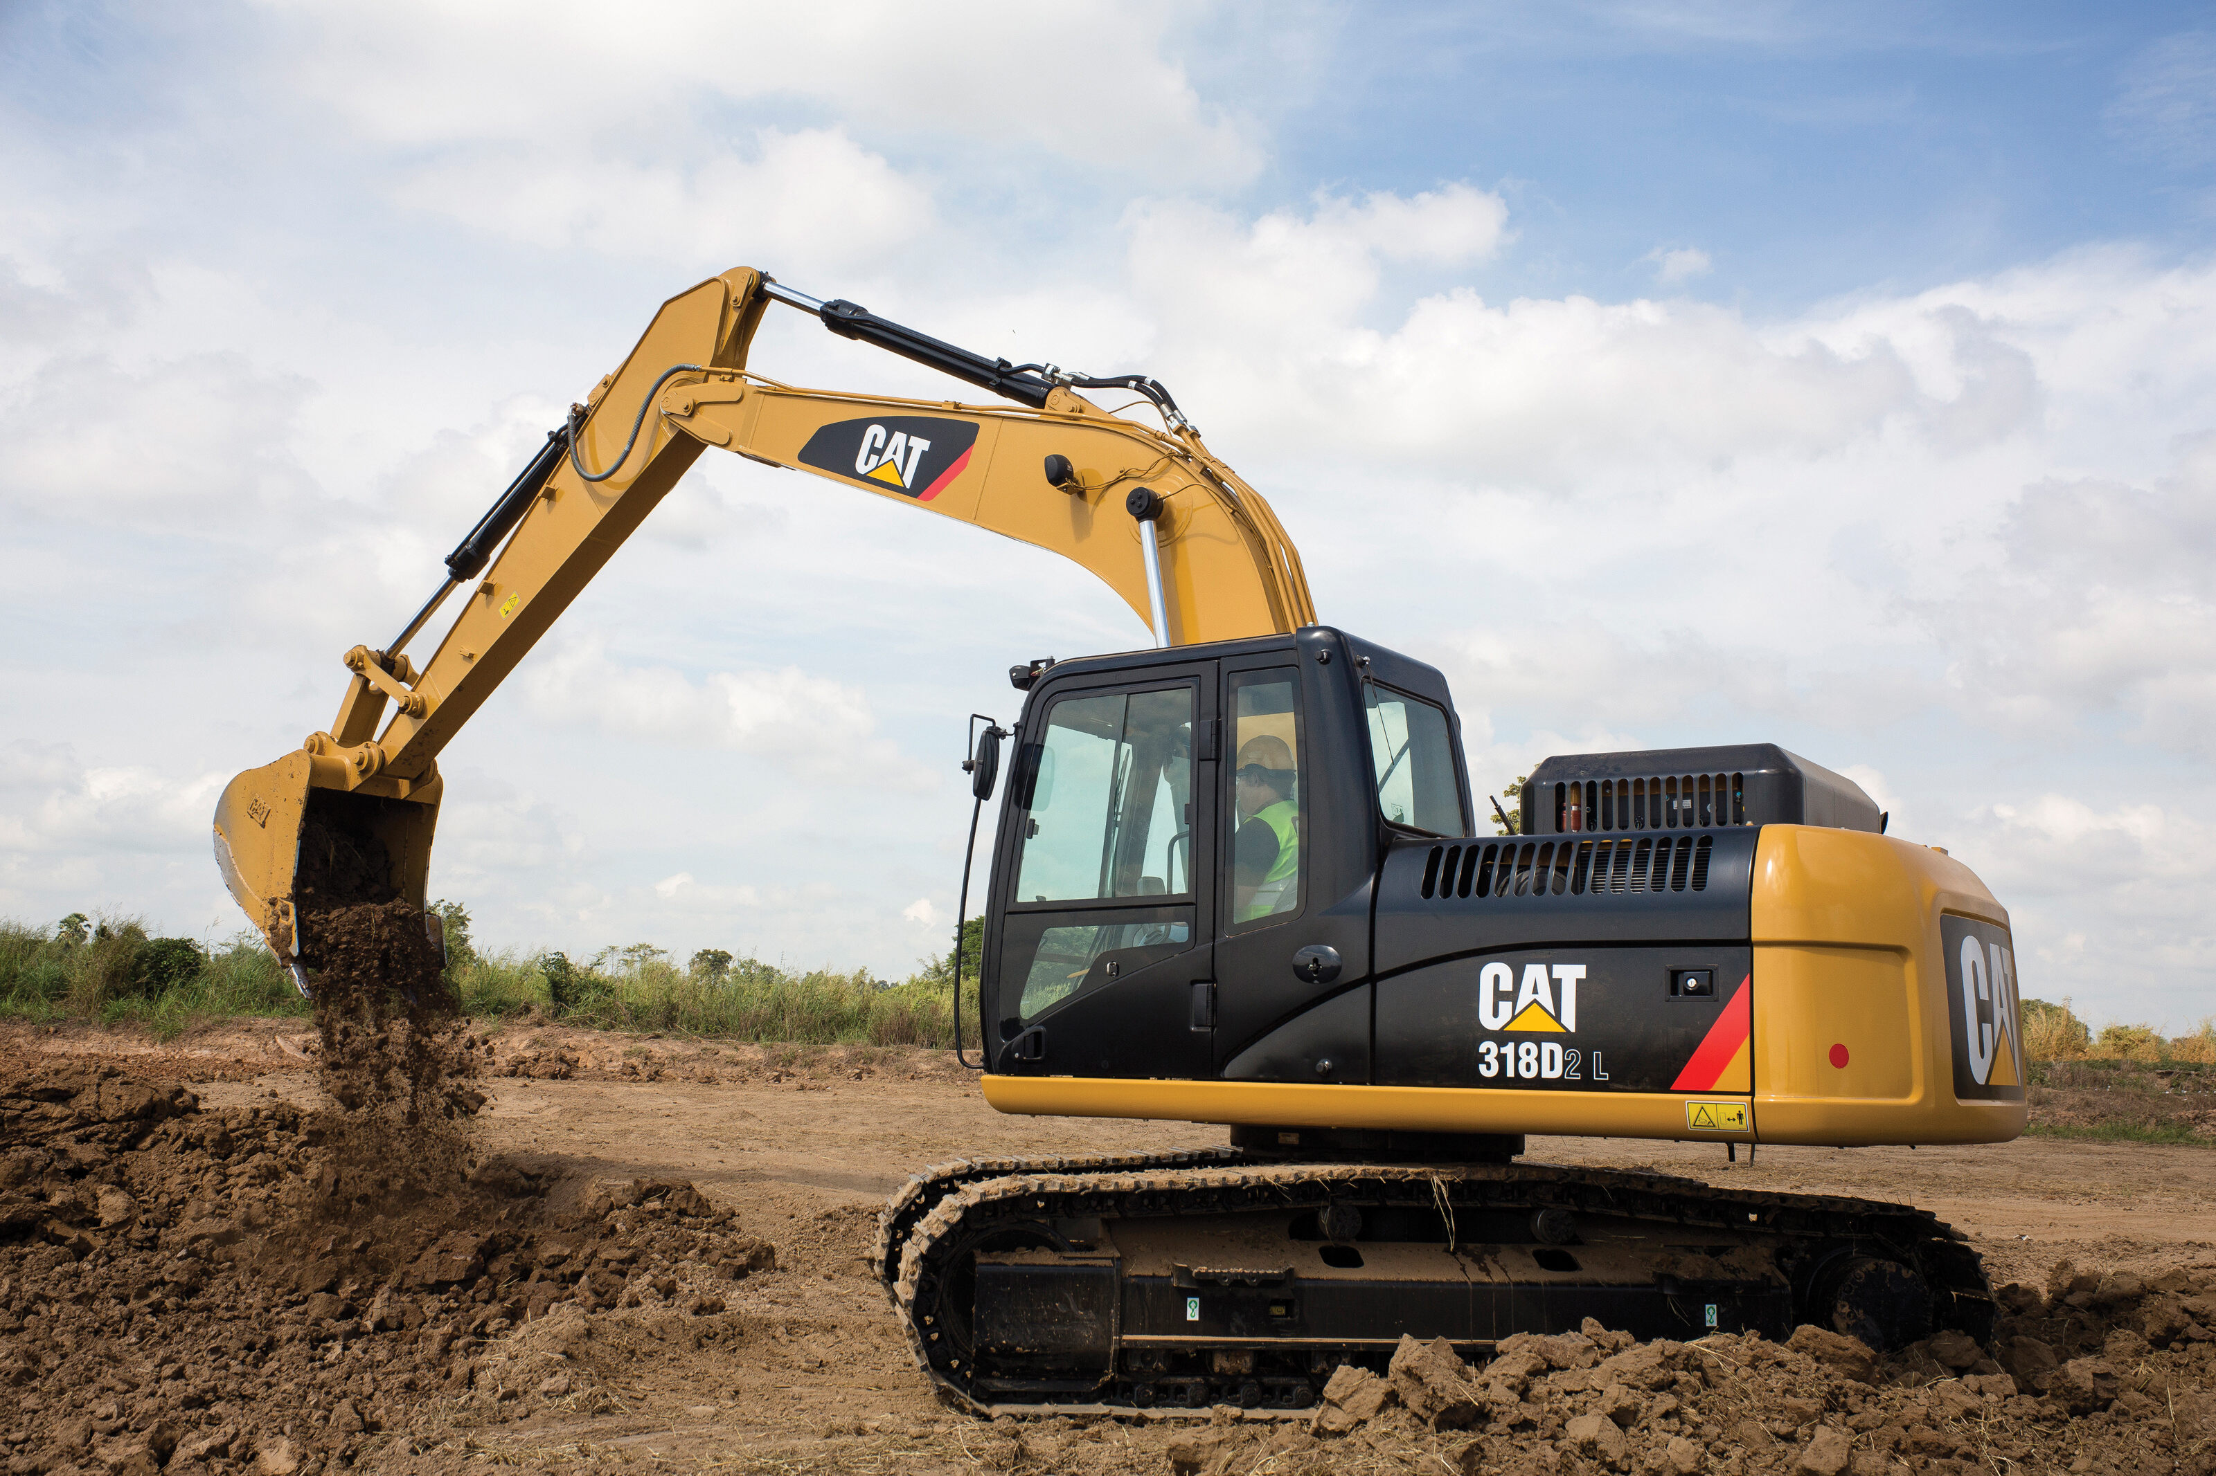
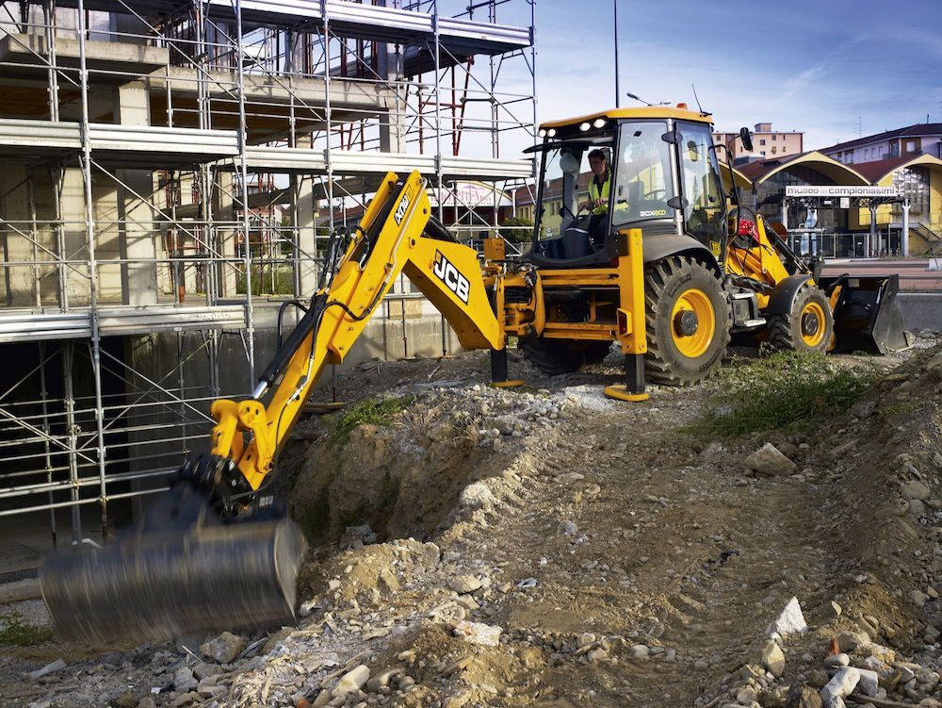
Backhoe
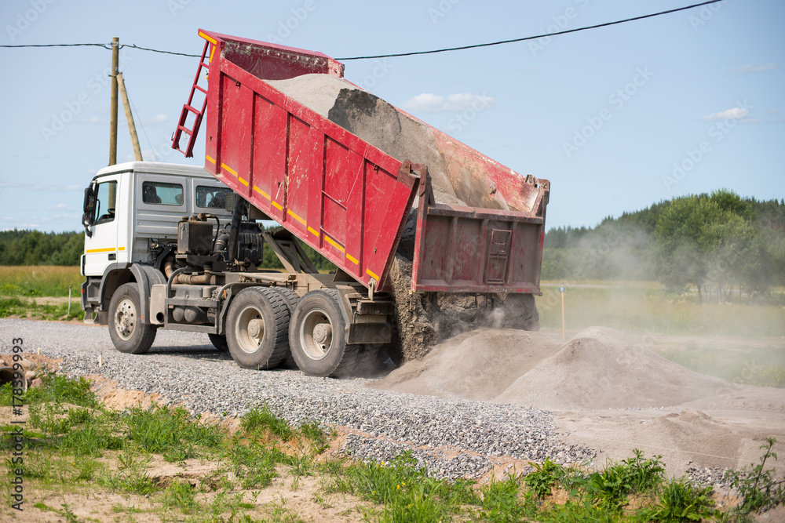
Dump Truck

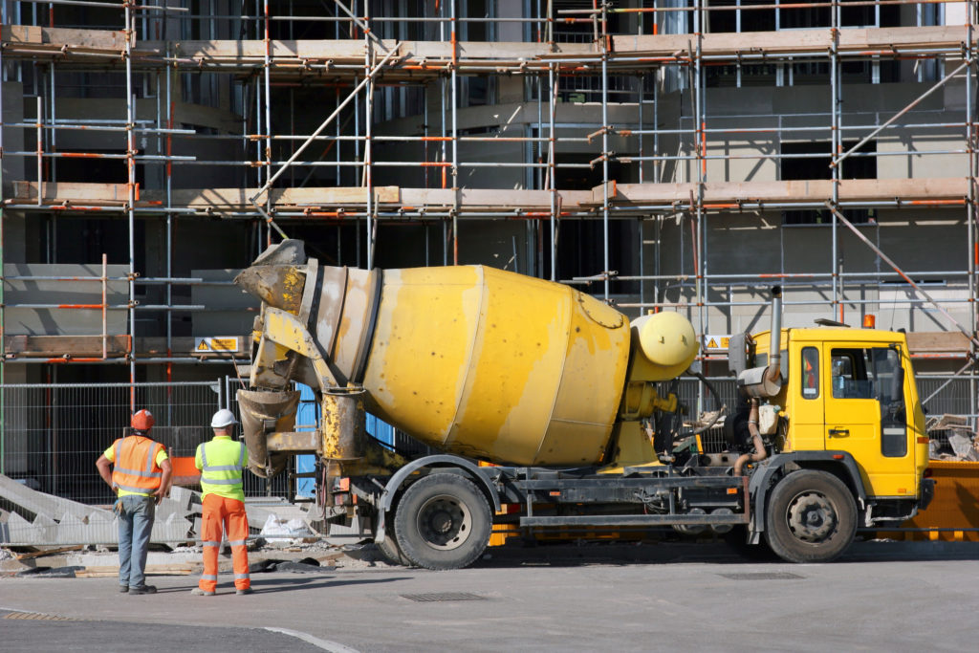
Cement Truck
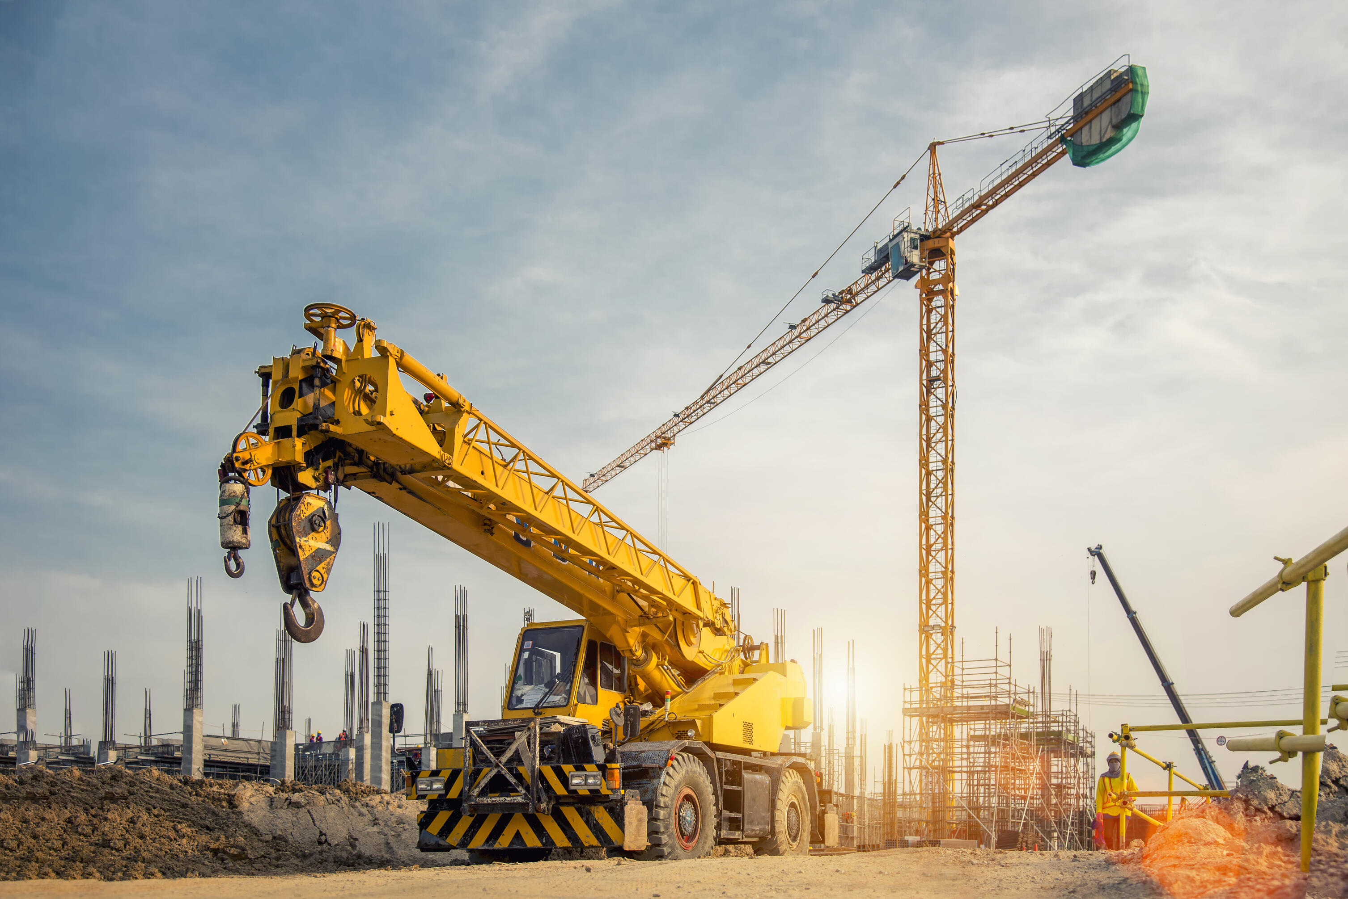
Crane

SOURCEBOOK K-7.B

Station 2: Building the New World Trade Center [Video]

How do they make buildings?

What work do they do at construction sites?

SOURCEBOOK K-7.C

Station 3: Drawing a Building

Draw a picture of a building.
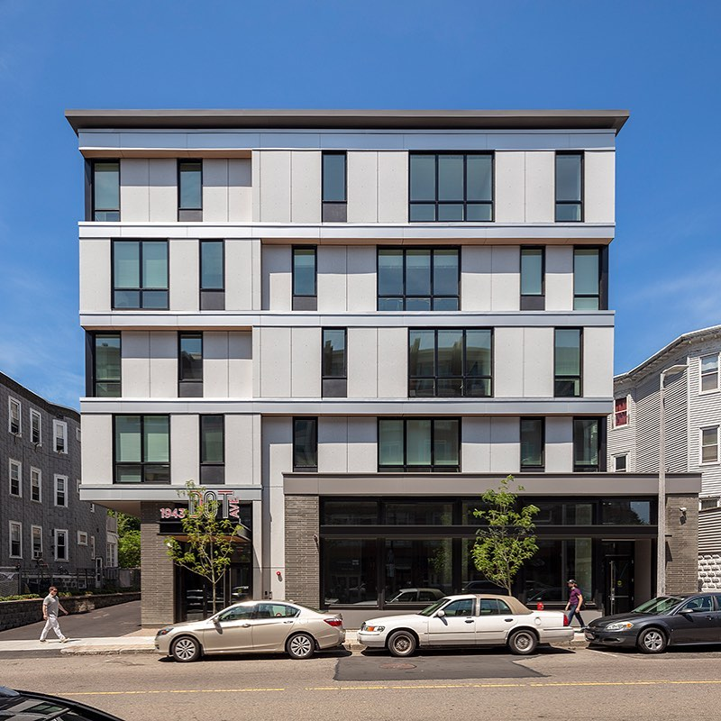

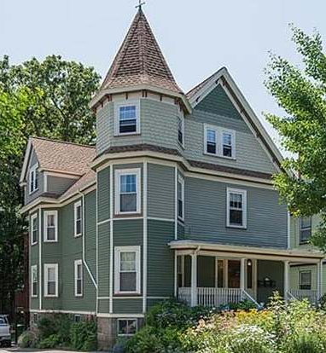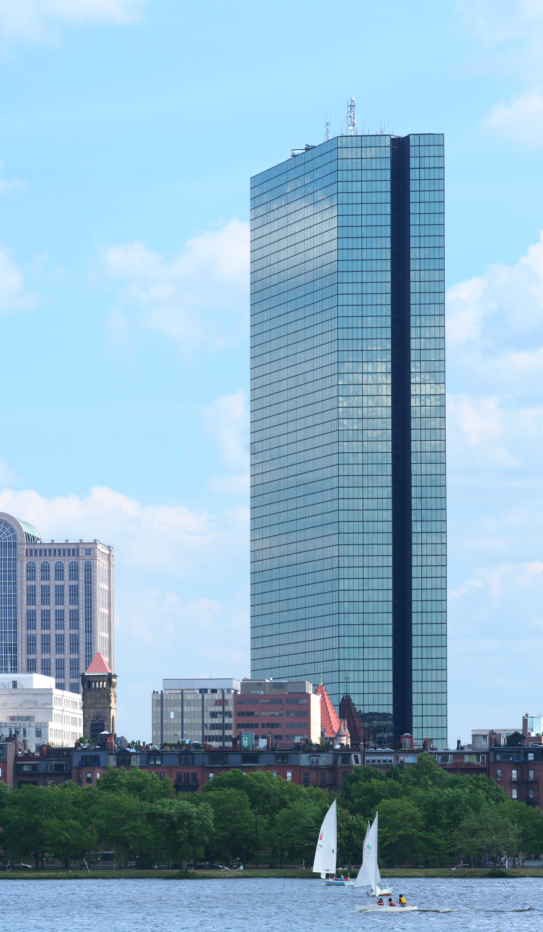

Use your imagination to draw a building. What will you make your building look like? What will your building include?

SOURCEBOOK K-8.A

Station 1: Life Today

What do we wear today?

How do we cook today?

How do we get to places today?

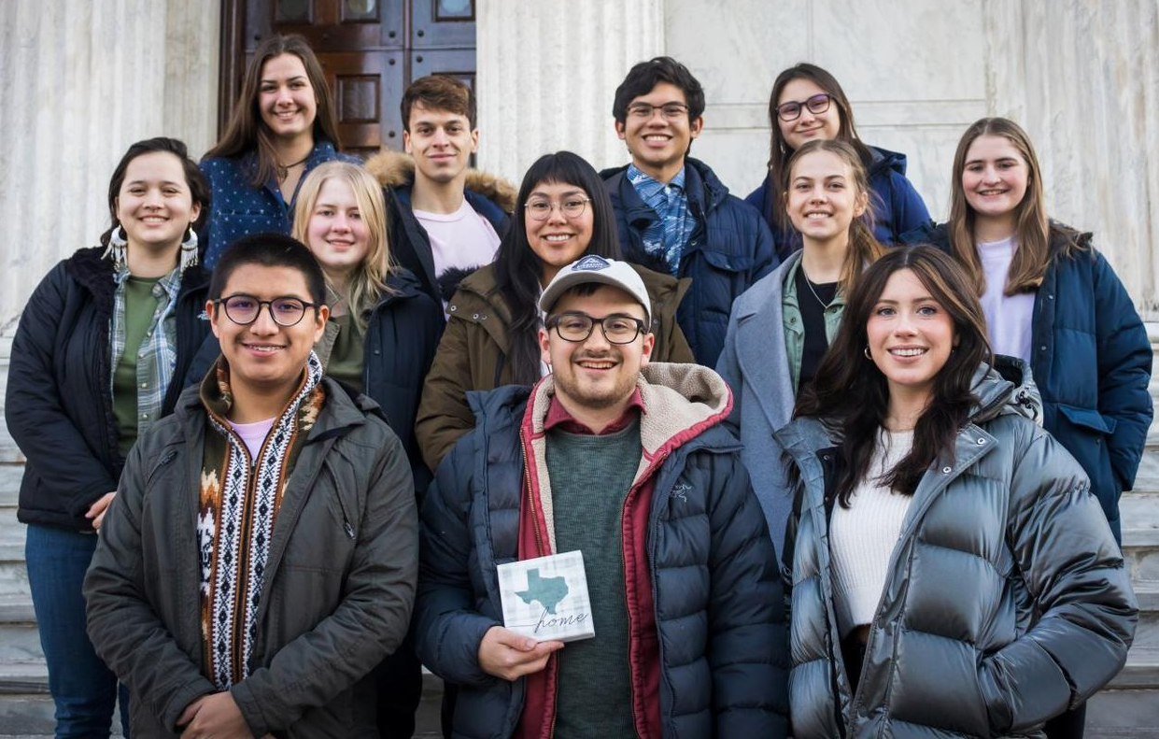
Clothes - Today

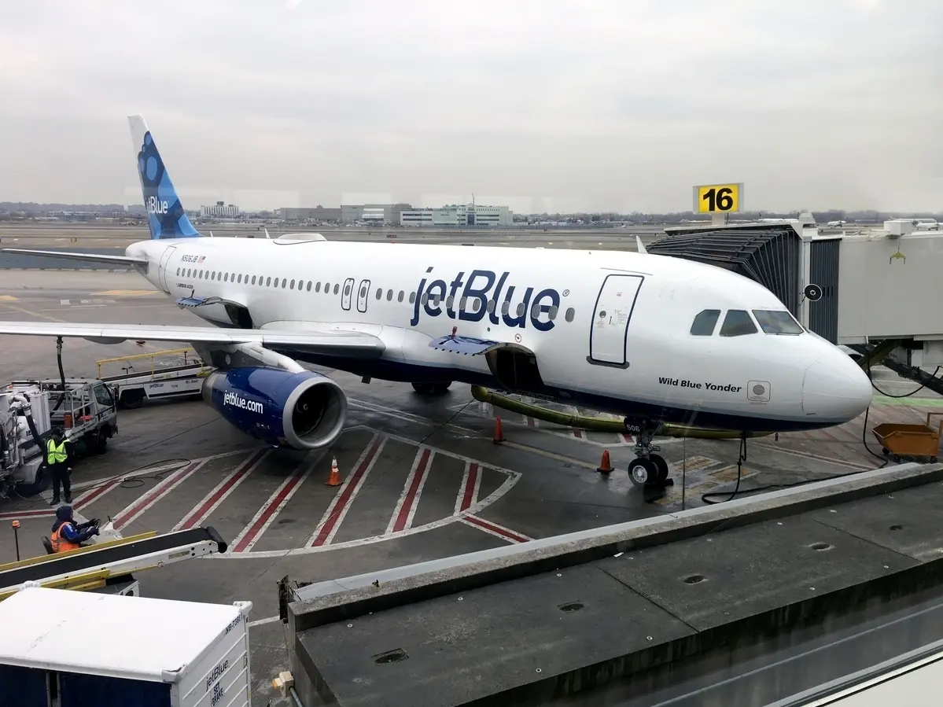
Transportation - Today

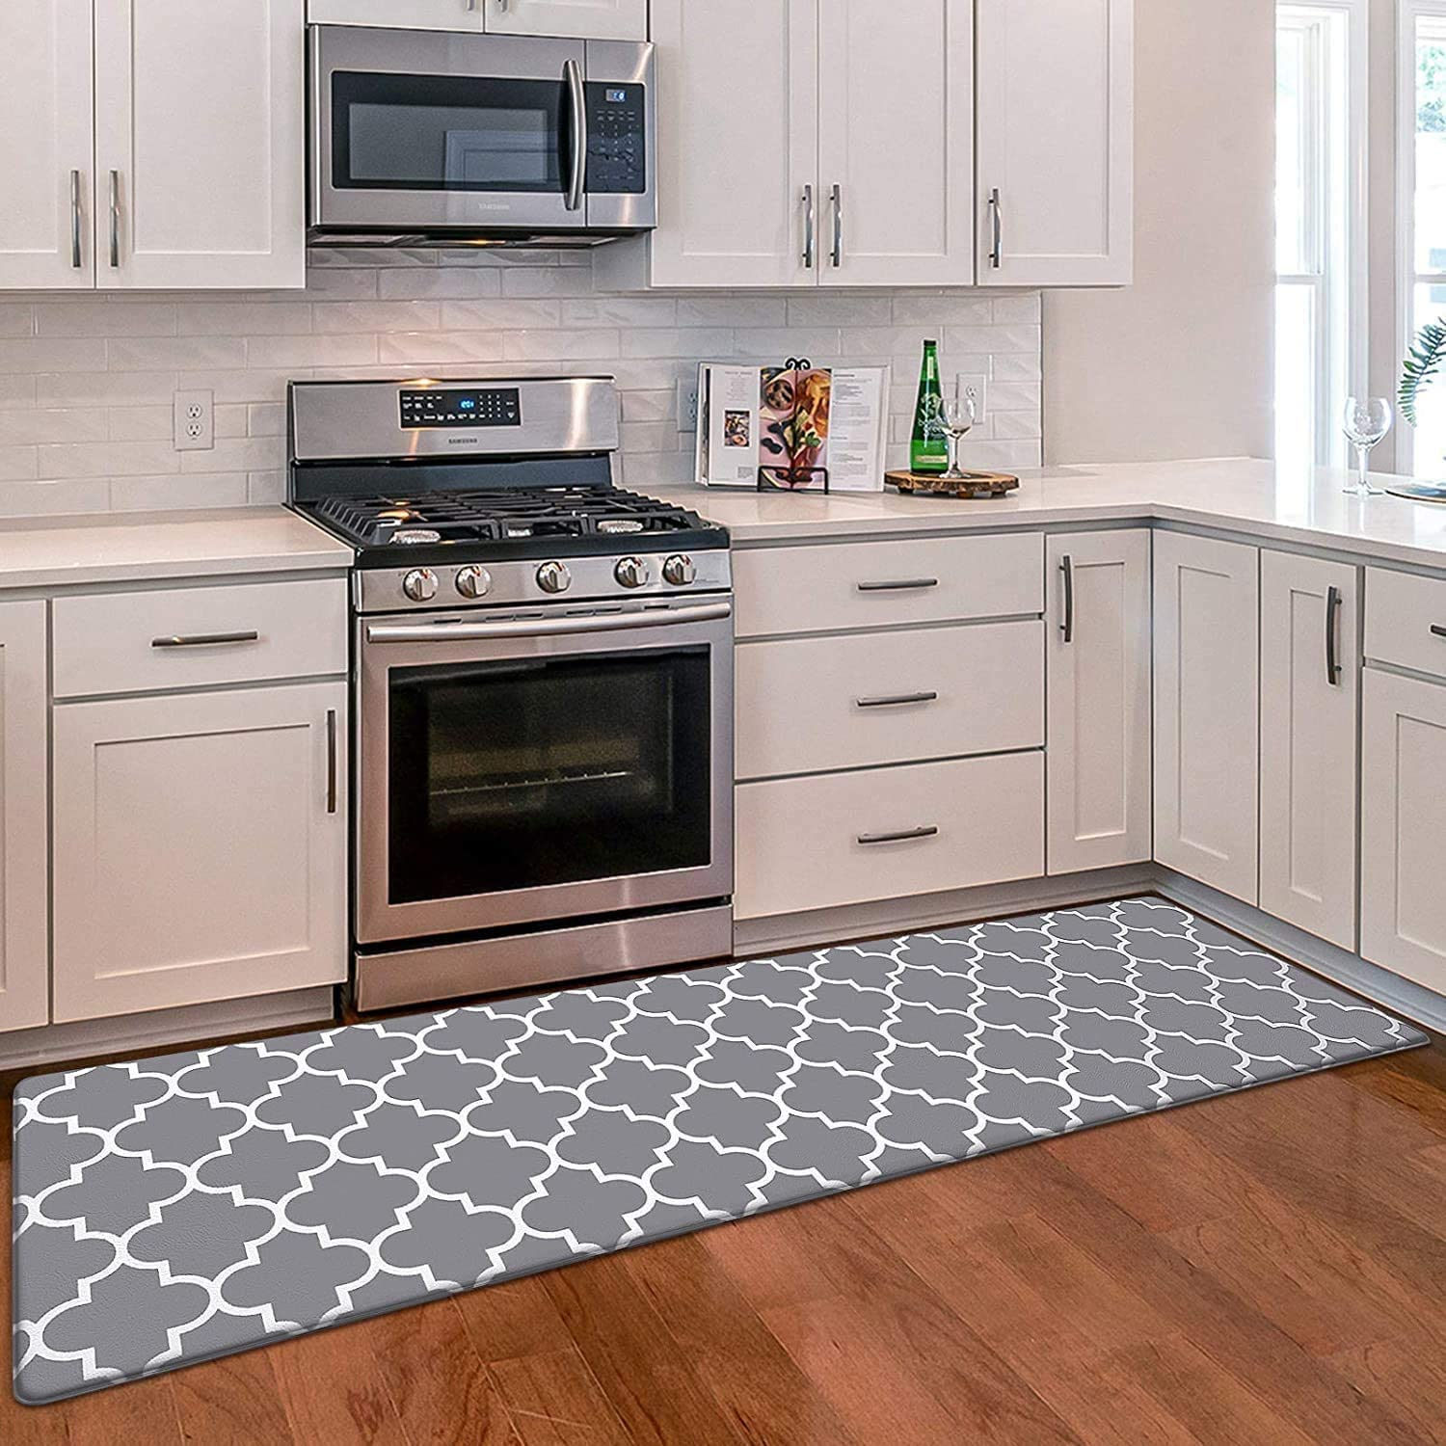
Cooking - Today
SOURCEBOOK K-8.B

Station 2: Life 100 Years Ago

What did they wear 100 years ago?

How did they cook 100 years ago?

How did they get to places 100 years ago?
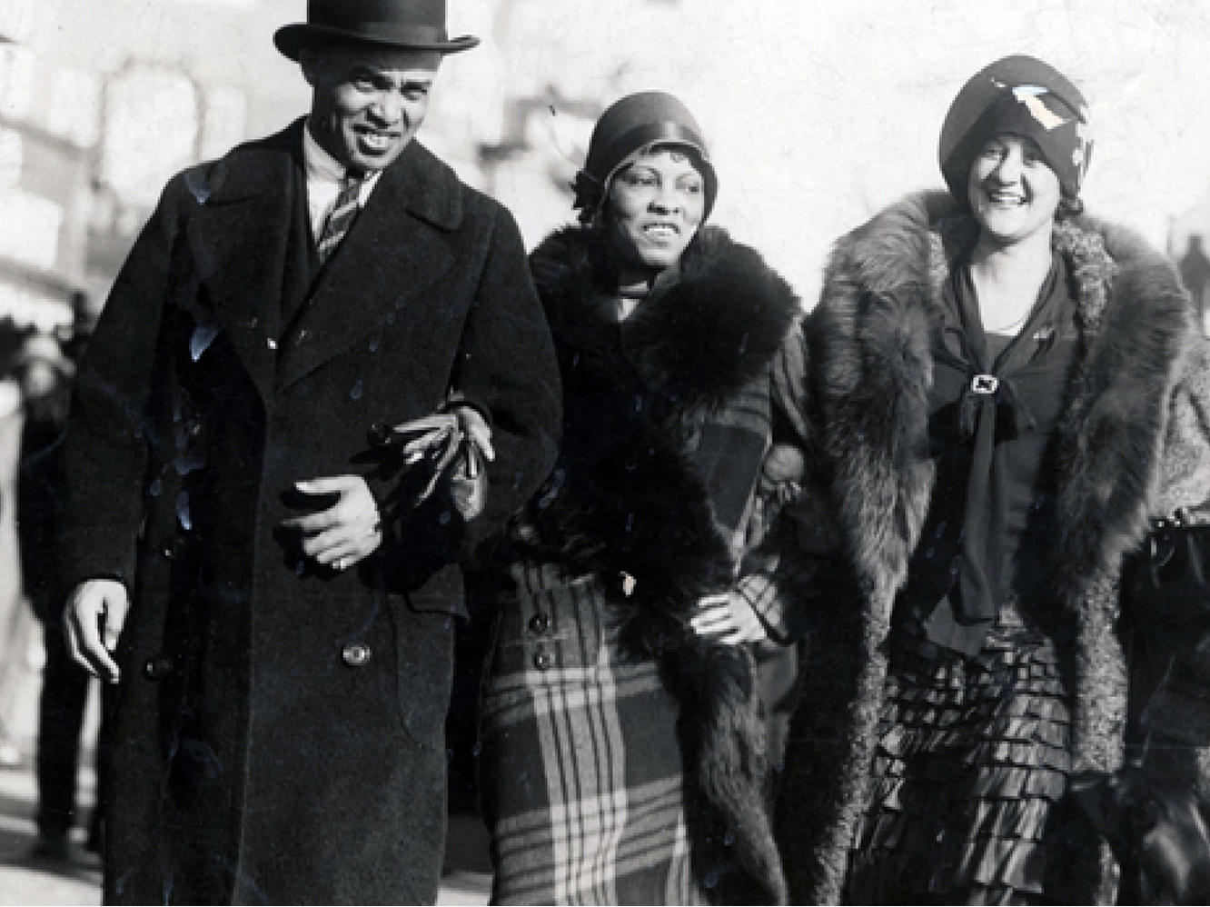
Clothes – 100 Years Ago

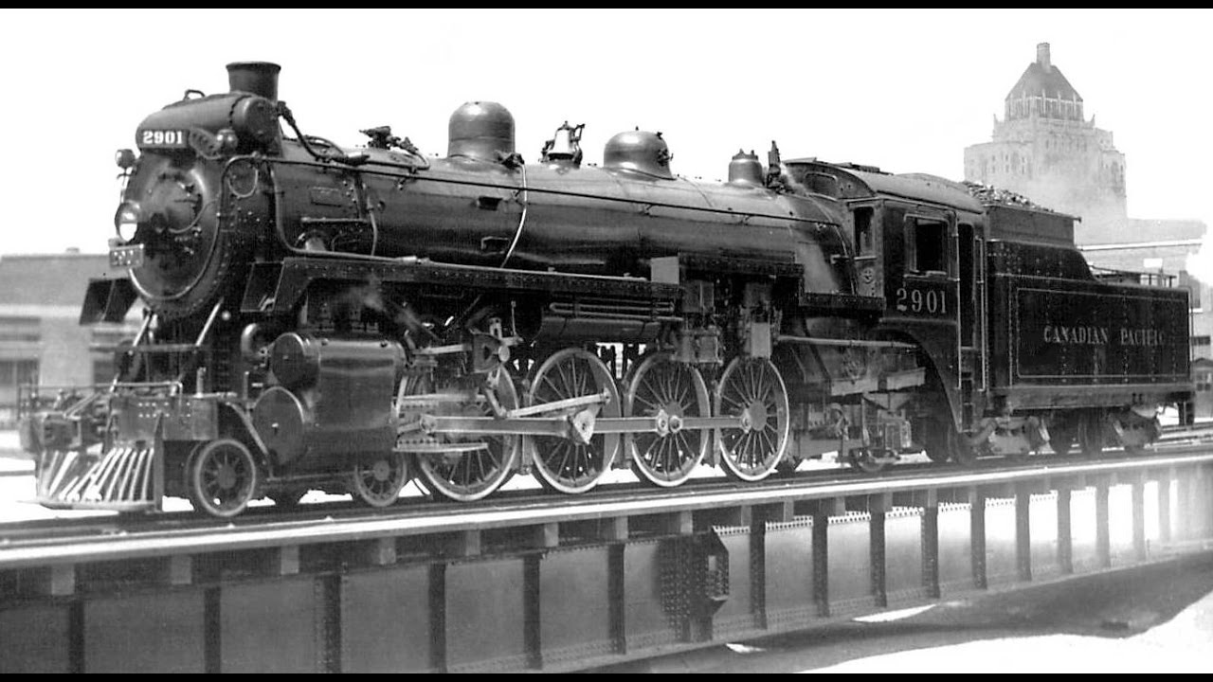
Transportation – 100 Years Ago

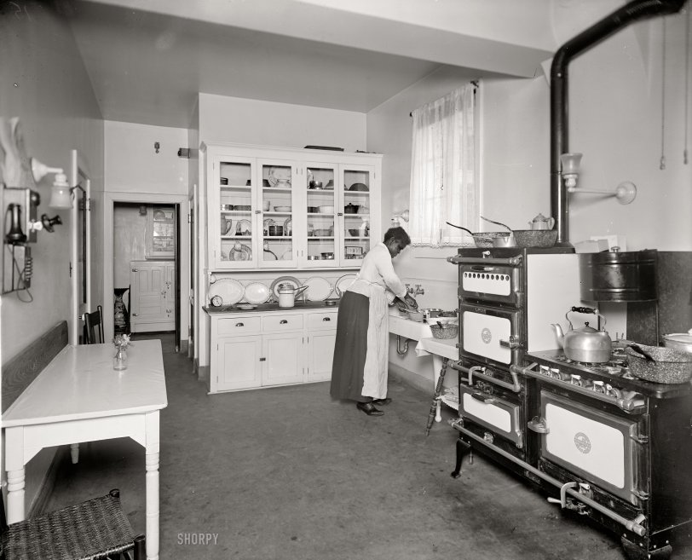
Cooking – 100 Years Ago

SOURCEBOOK K-8.C

Station 3: Life 500 Years Ago

What did they wear 500 years ago?

How did they cook 500 years ago?

How did they get to places 500 years ago?
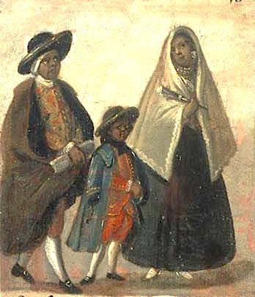
Clothes – 500 Years Ago

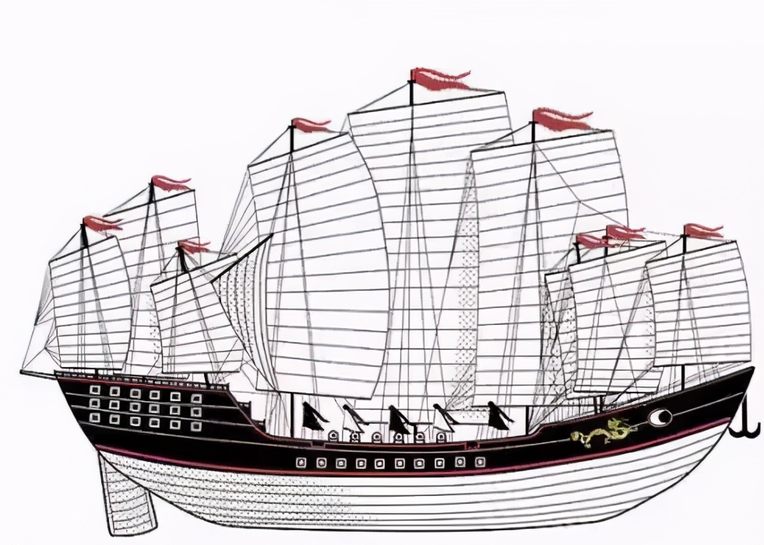
Transportation – 500 Years Ago

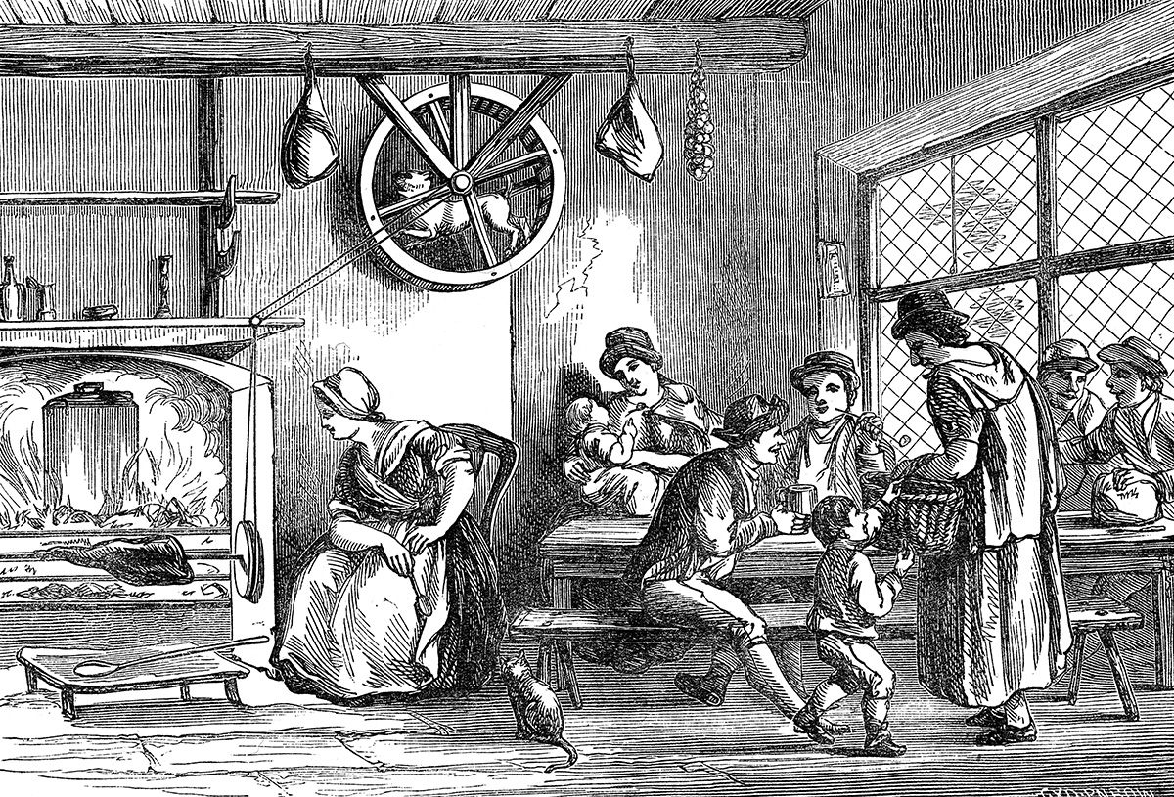
Cooking – 500 Years Ago
SOURCEBOOK K-9.A

Station 1: The Americas

Why would you visit this continent?

What interesting things would you see?

Map: The Americas

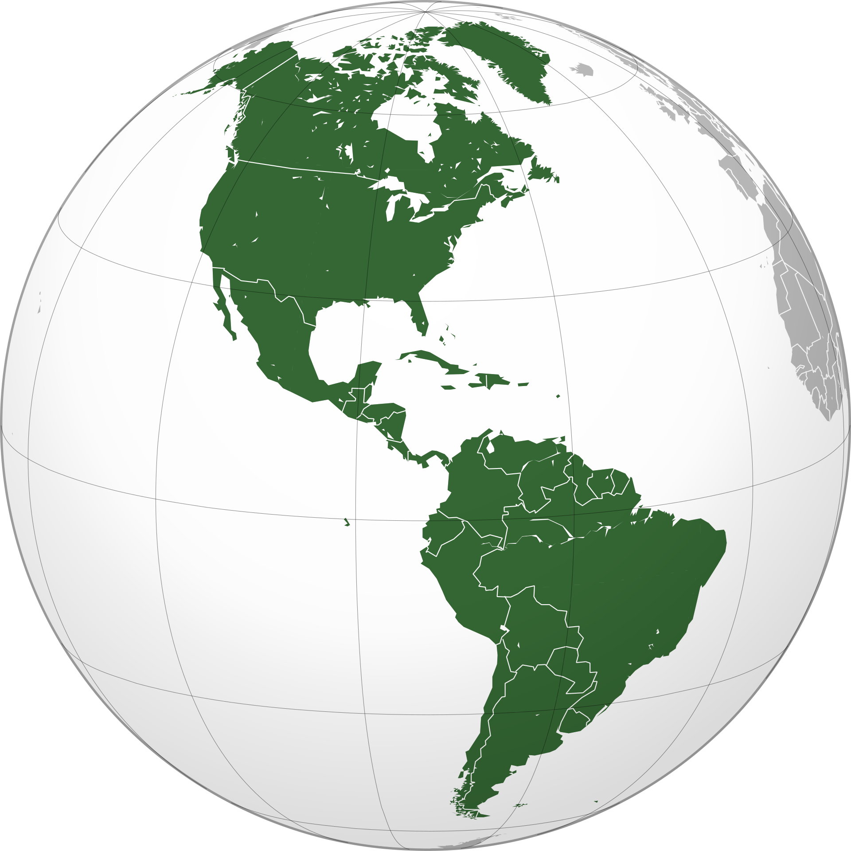

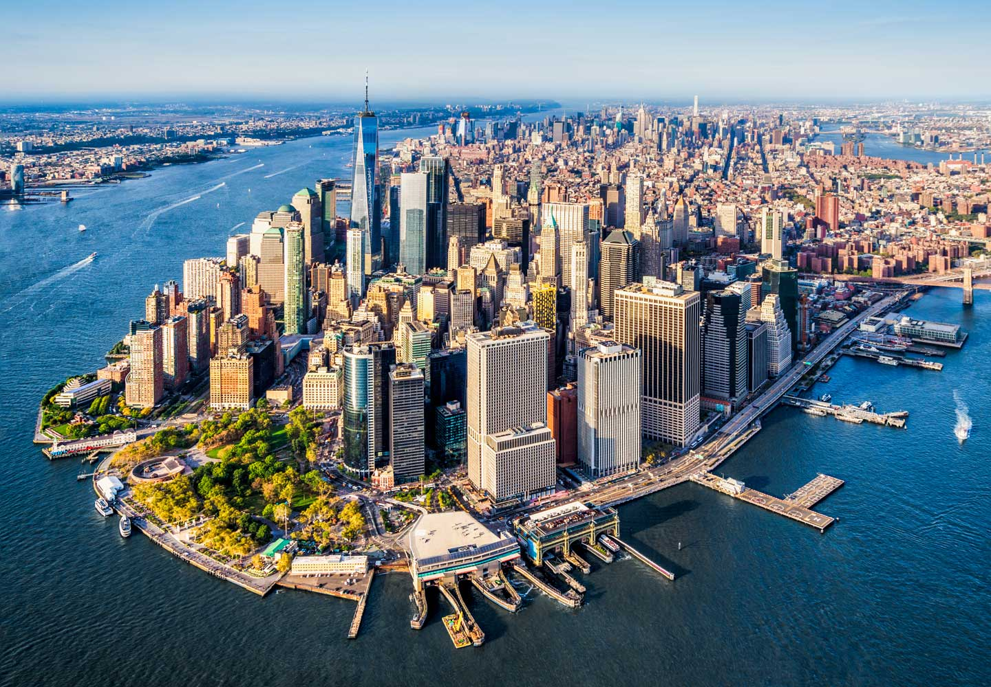
New York City, United States
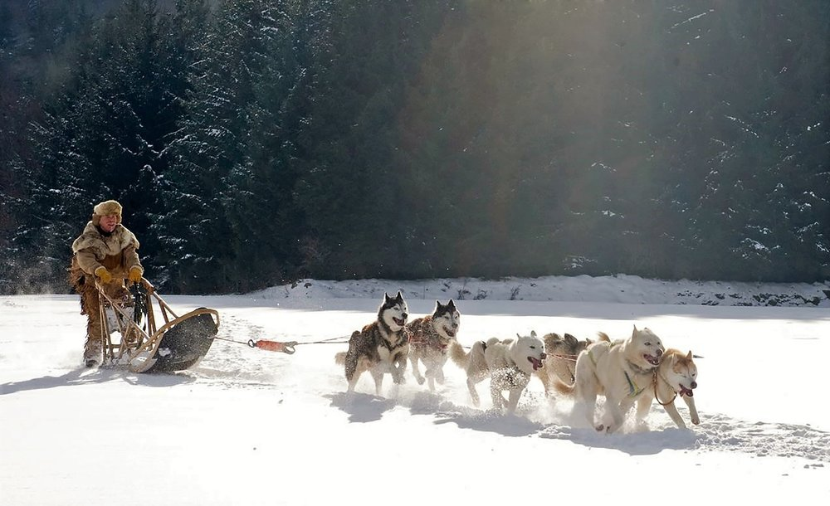
Inuit People, Canada
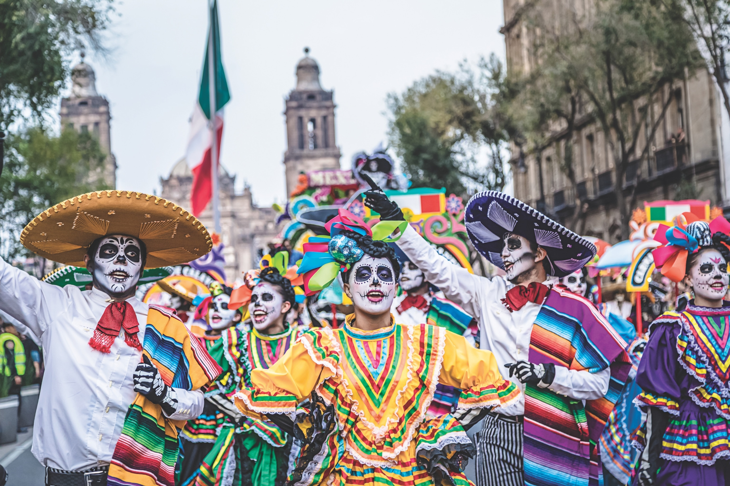
Día de Muertos Celebration, Mexico
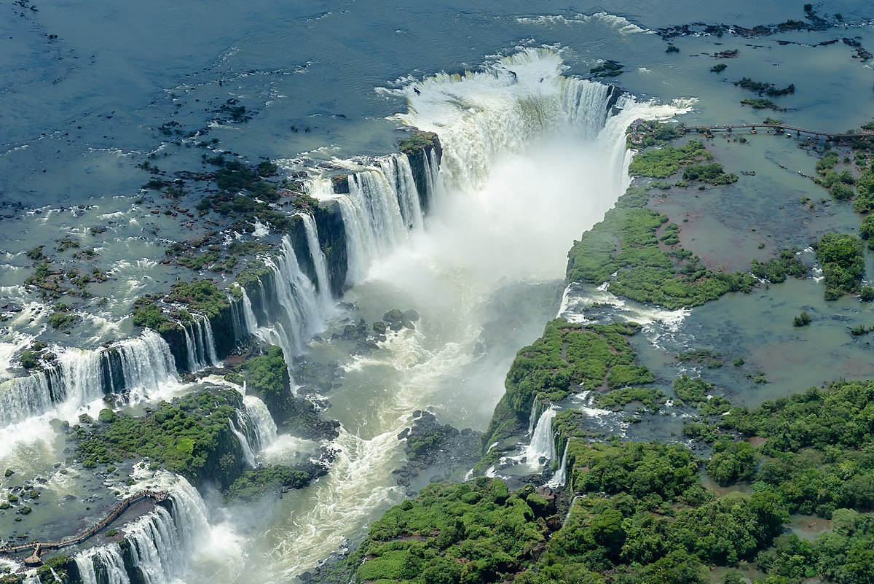
Iguazu Falls, Brazil

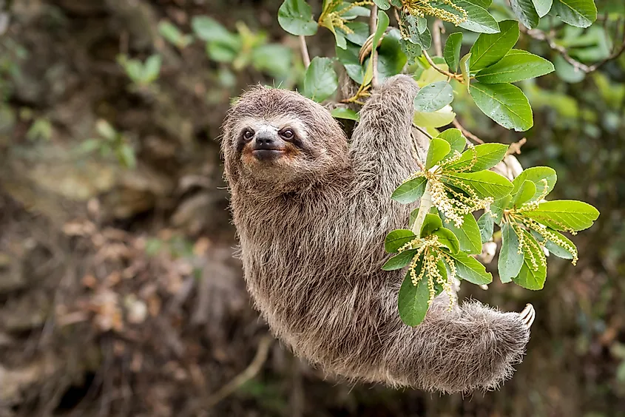
Sloth, Peru
SOURCEBOOK K-9.B

Station 2: Africa

Why would you visit this continent?

What interesting things would you see?

Map: Africa

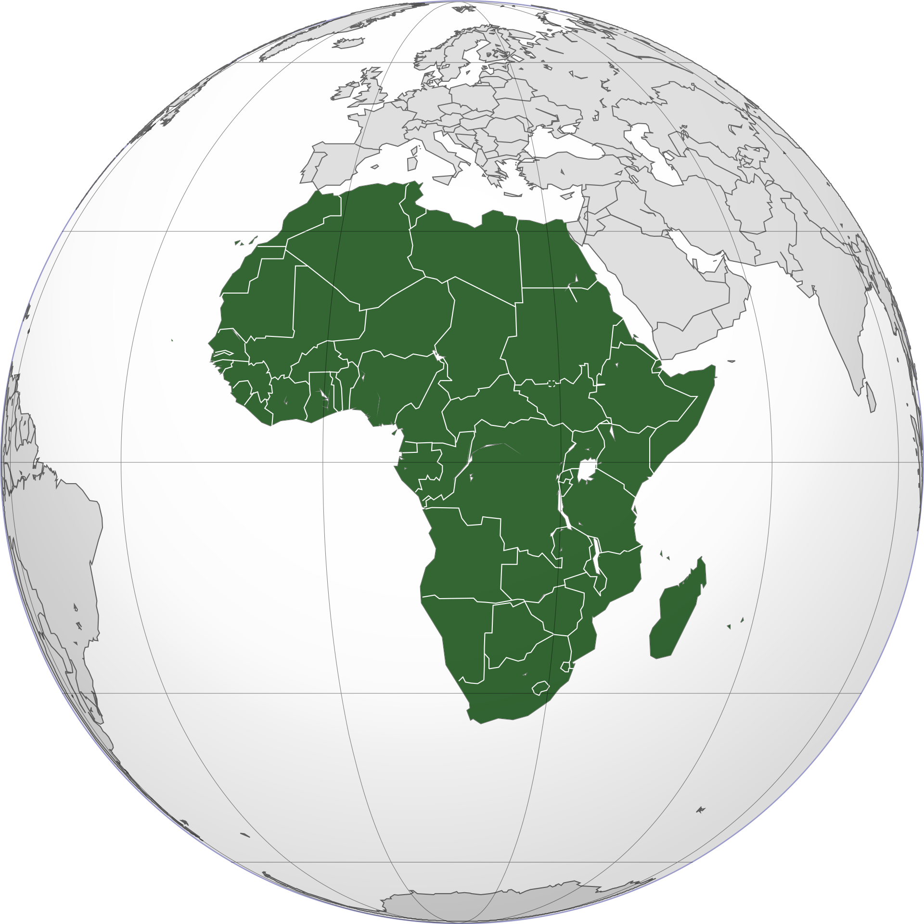

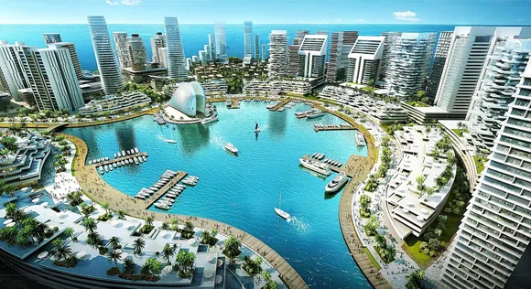
Lagos, Nigeria
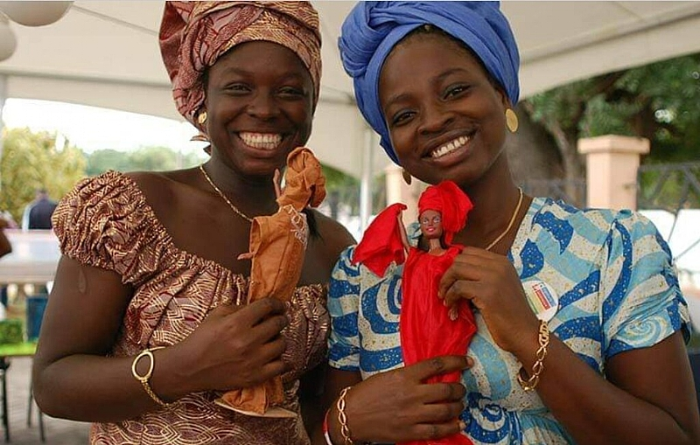
Kyode People, Ghana
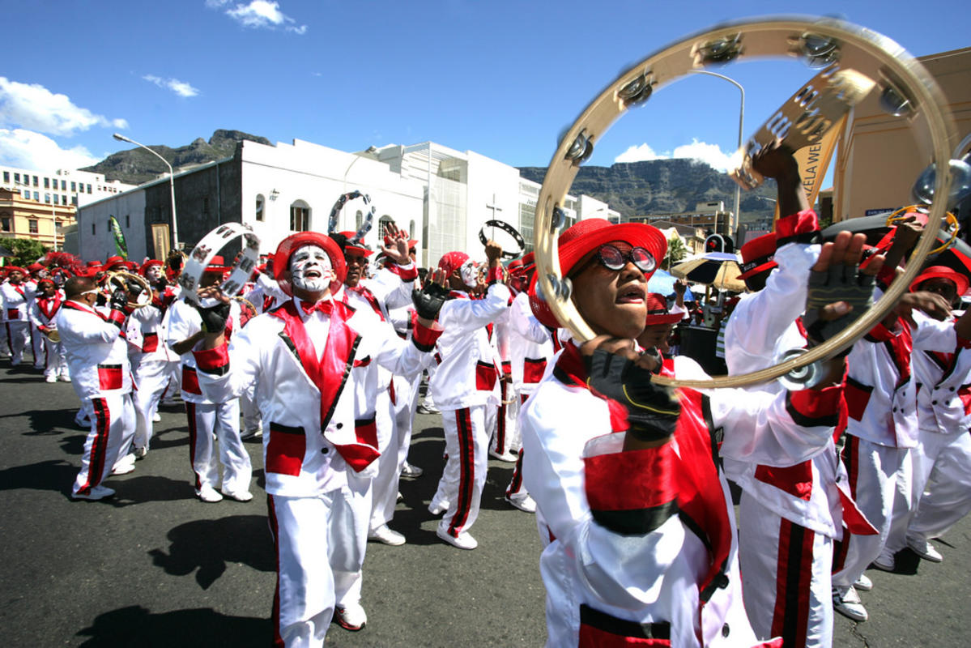
Cape Town Carnival, South Africa
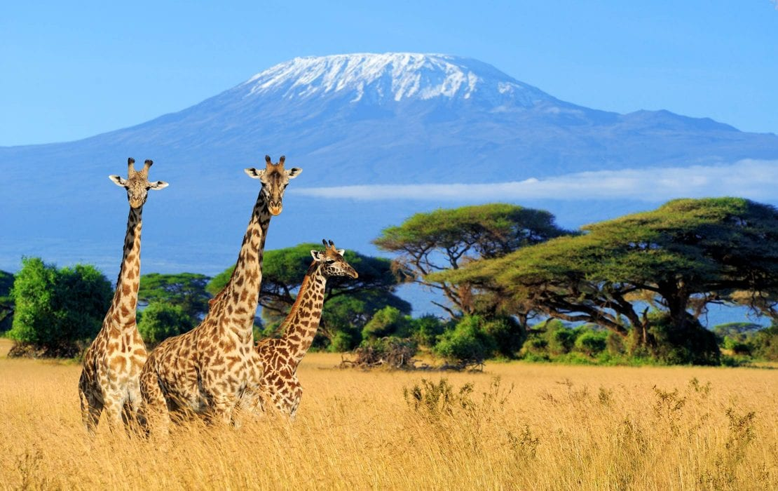
Mount Kilimanjaro, Tanzania
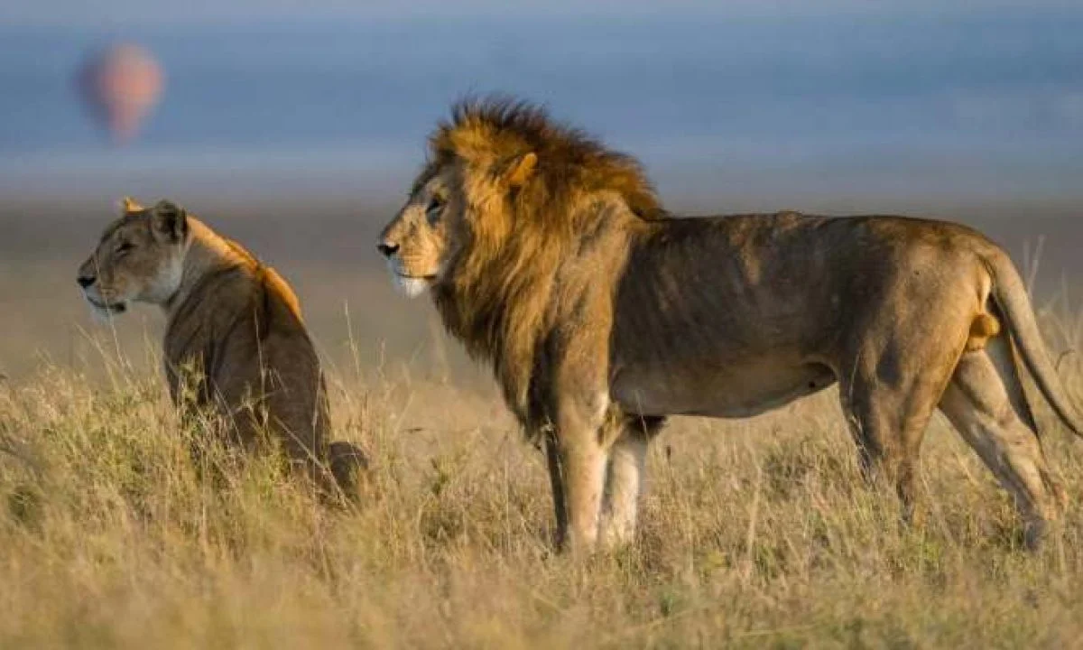
Lion, Kenya
SOURCEBOOK K-9.C

Station 3: Asia

Why would you visit this continent?

What interesting things would you see?

Map: Asia

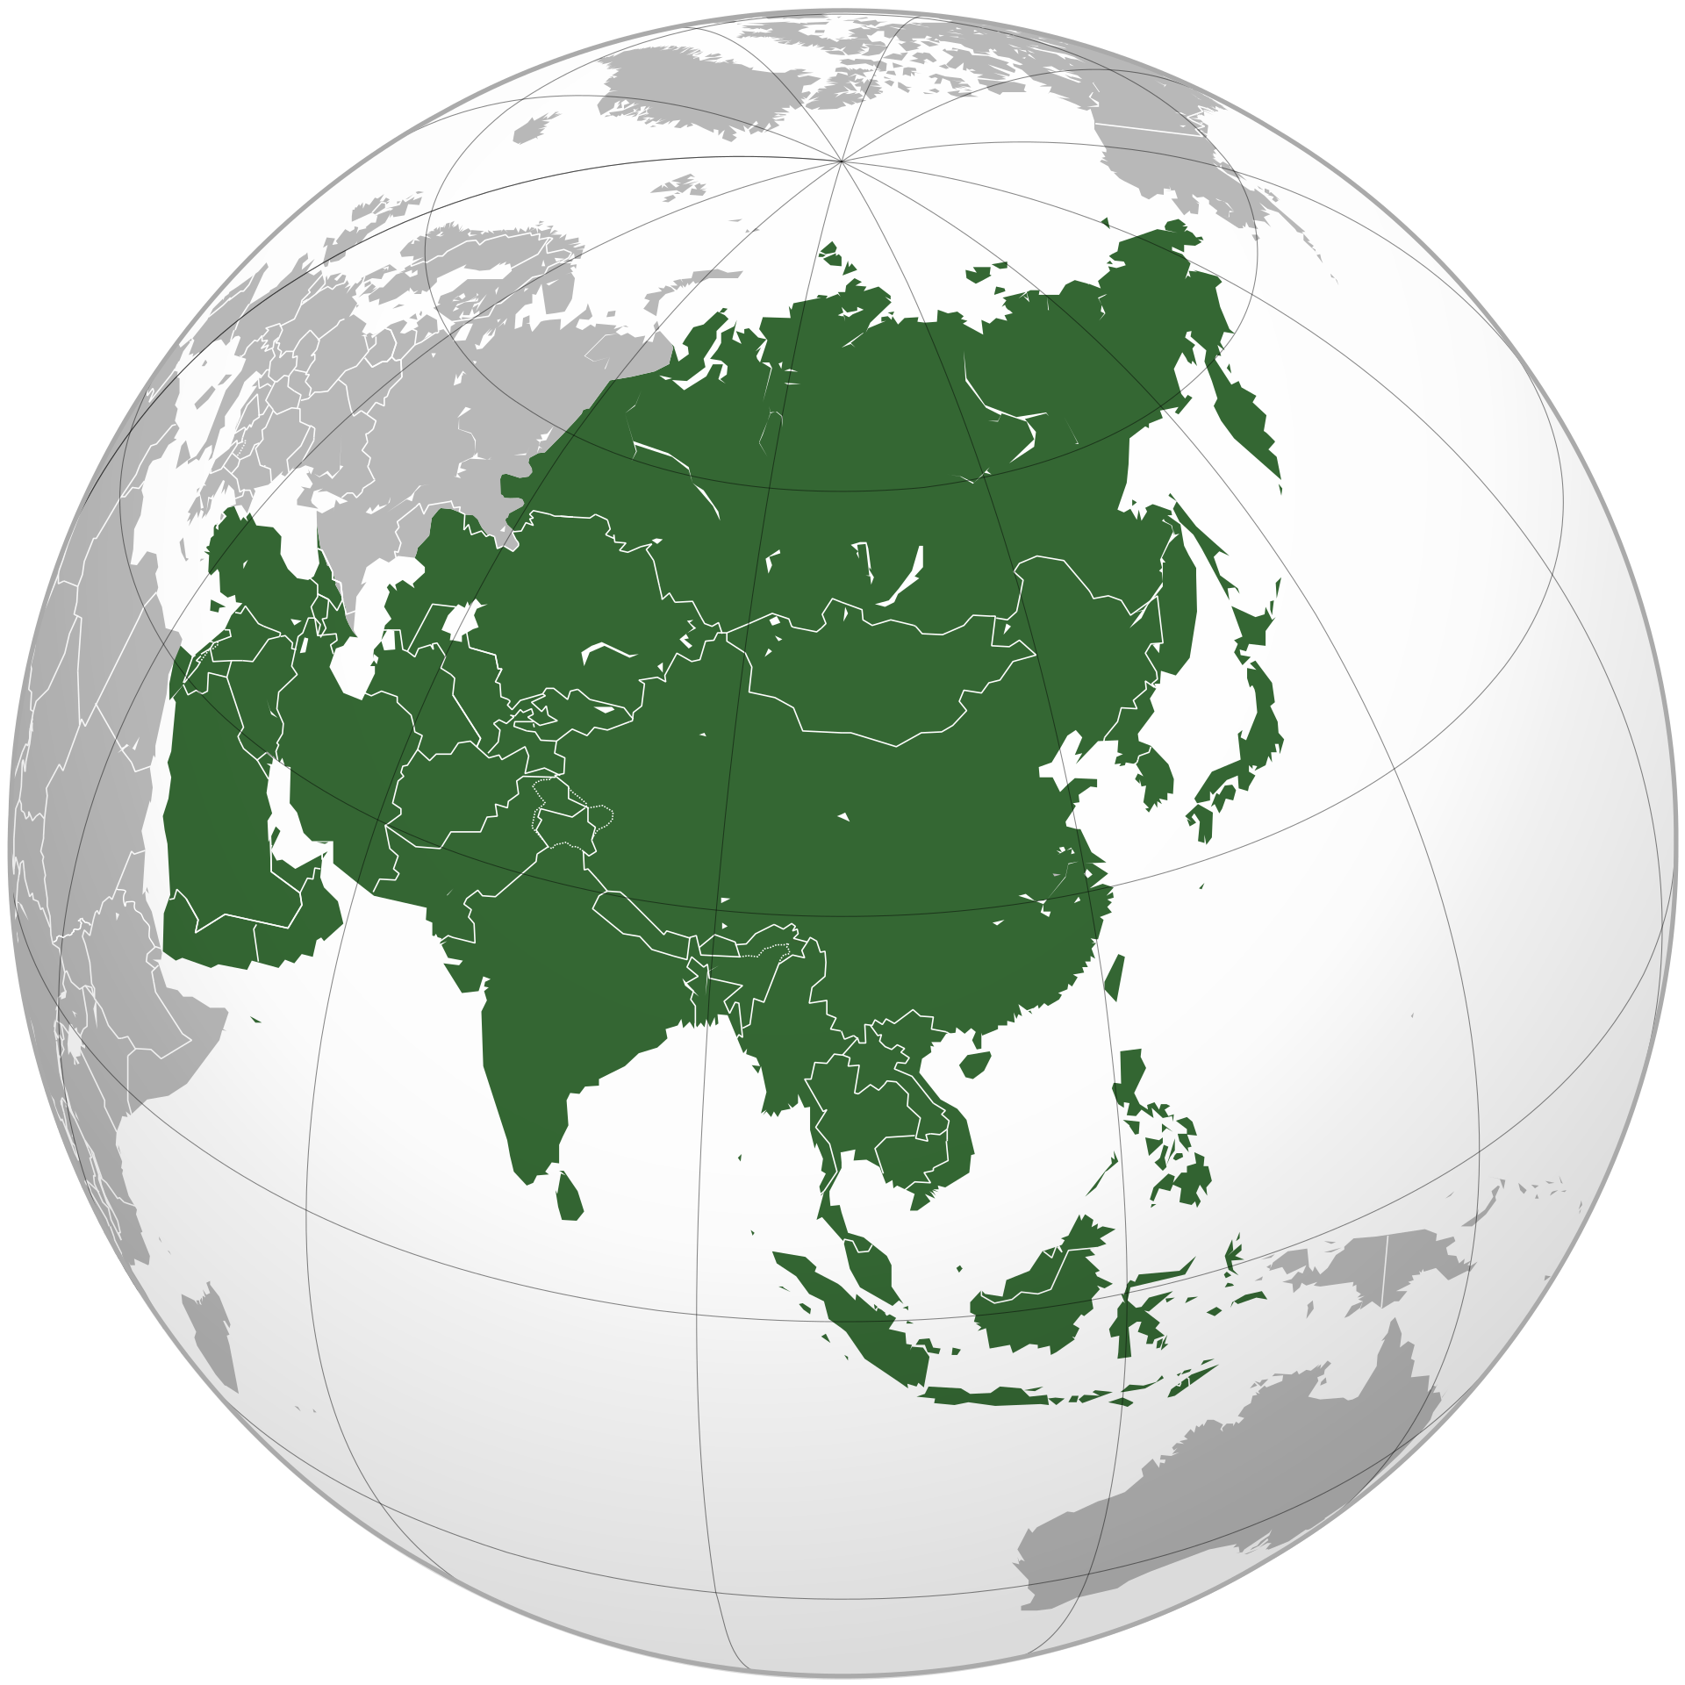

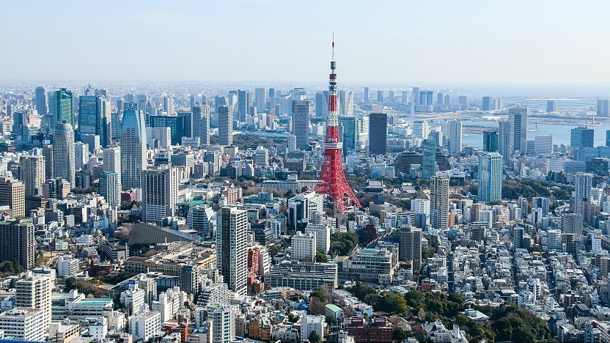
Tokyo, Japan
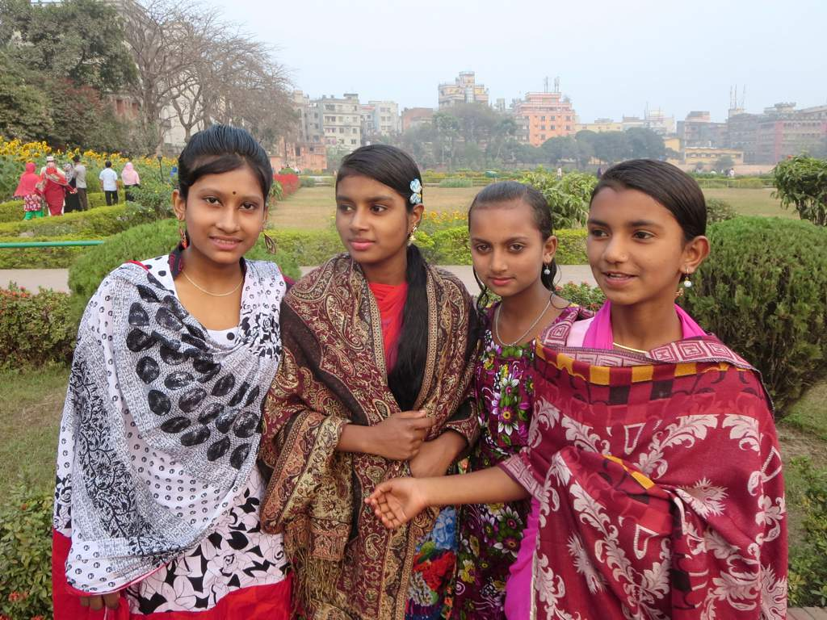
Bengali People, Bangladesh
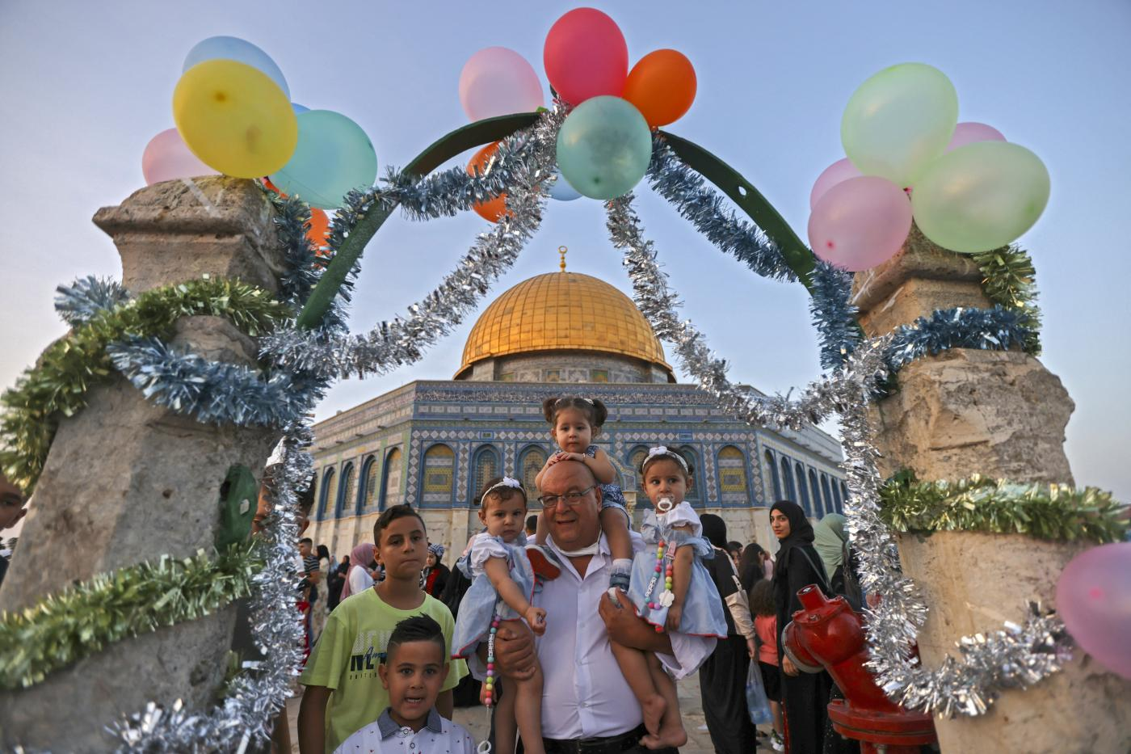
Eid al-Fitr Celebration, Jerusalem, Israel/Palestine
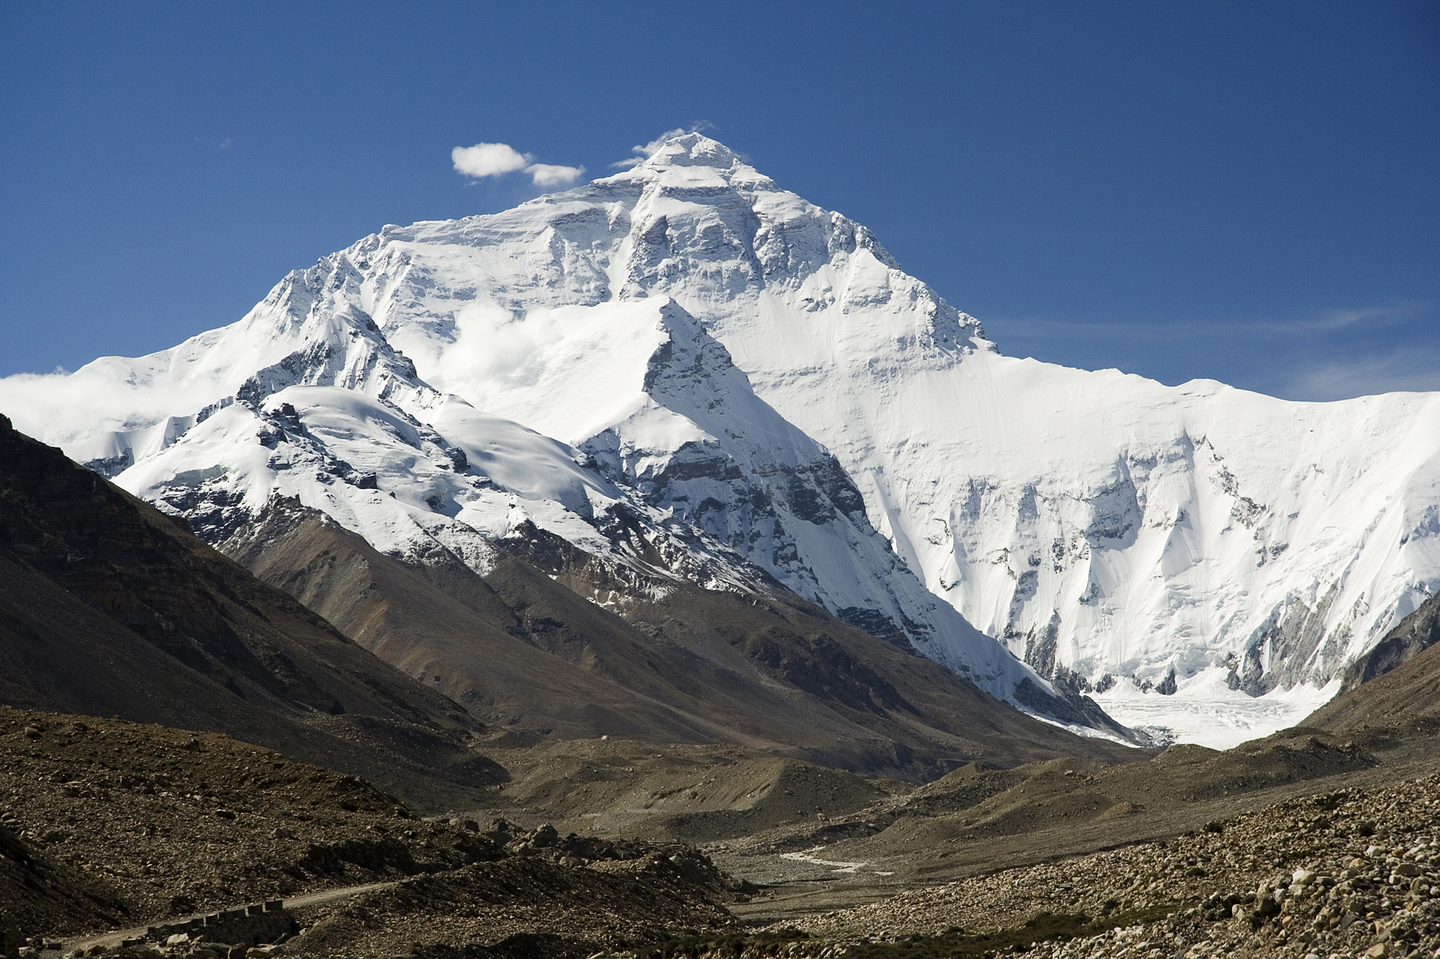
Mount Everest, Nepal/China
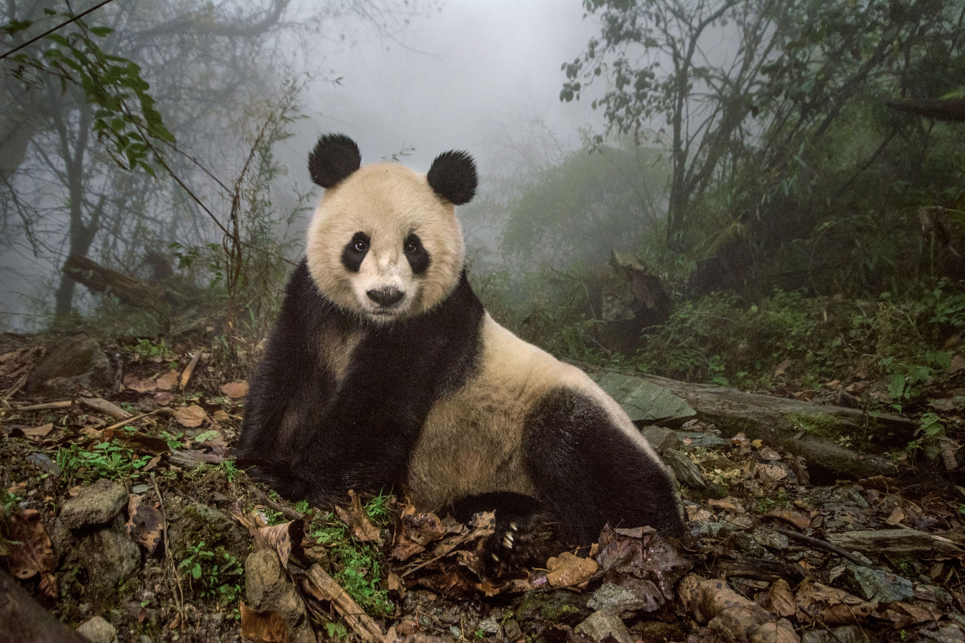
Panda, China
SOURCEBOOK K-9.D

Station 4: Europe

Why would you visit this continent?

What interesting things would you see?

Map: Europe

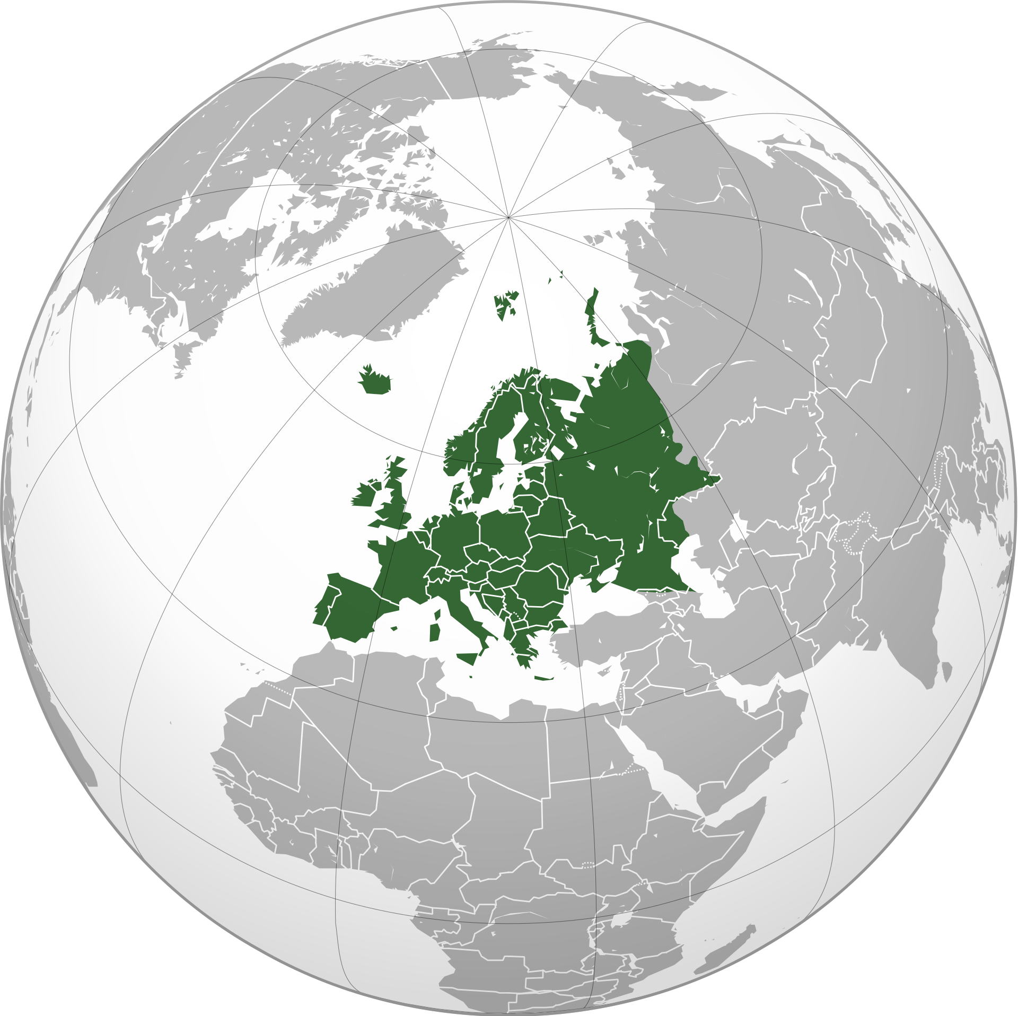

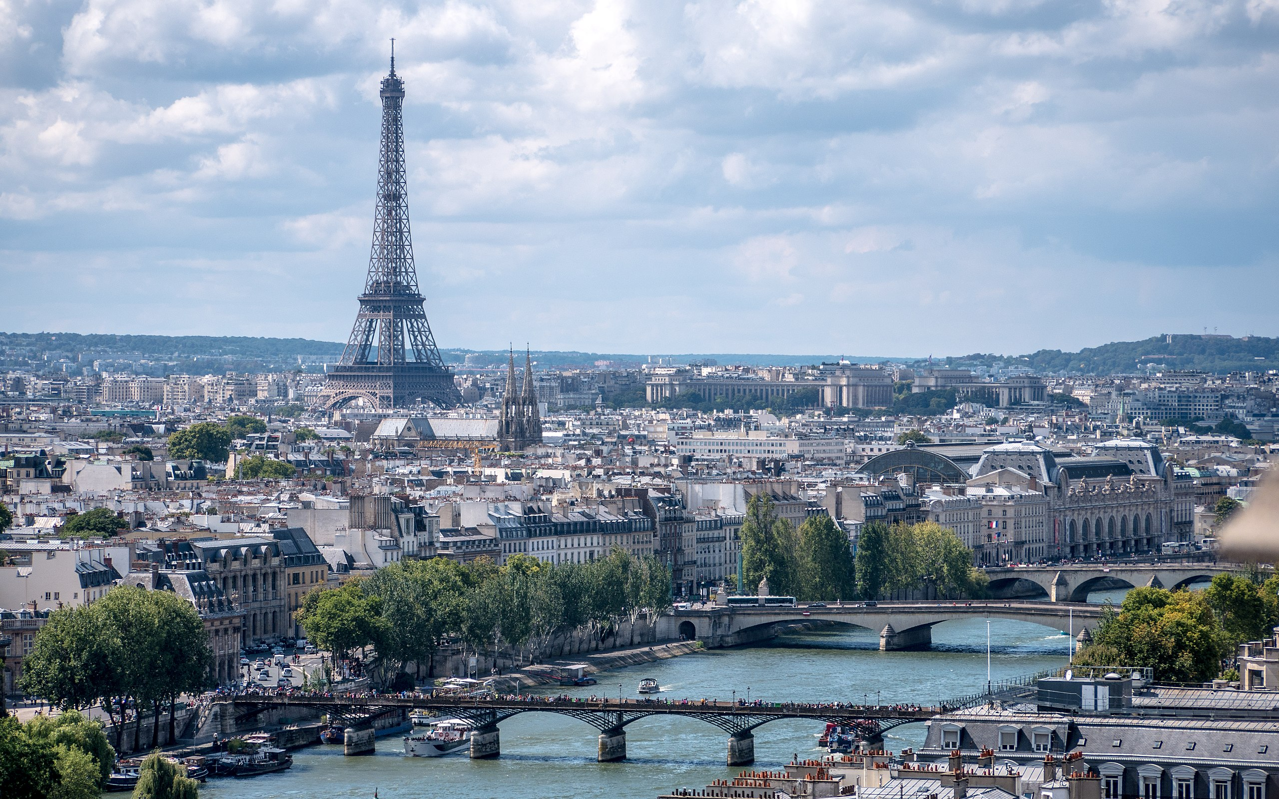
Paris, France
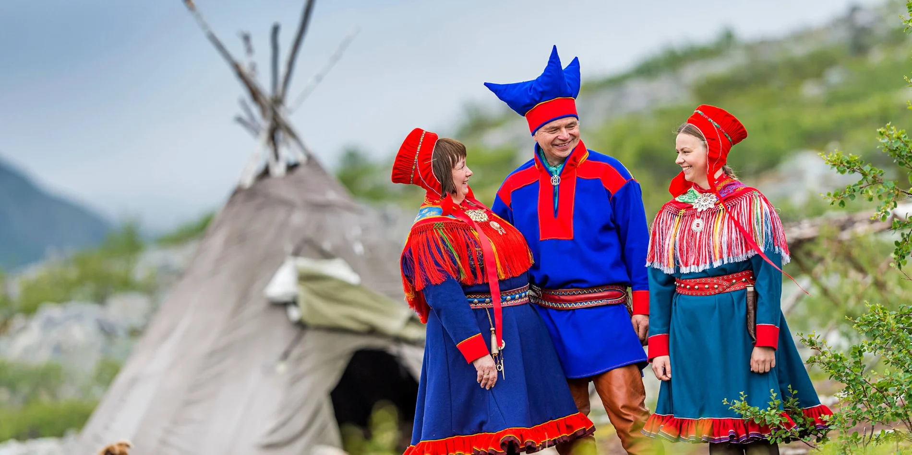
Sami People, Norway
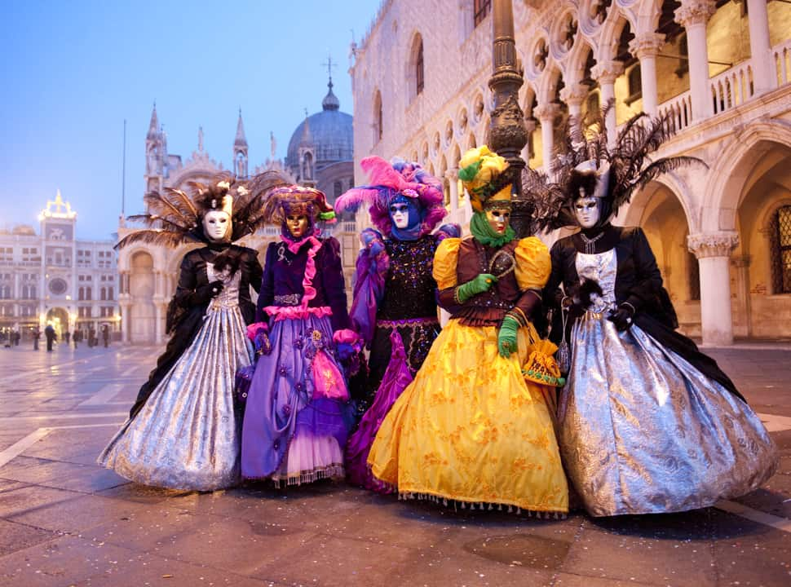
Carnival, Venice, Italy

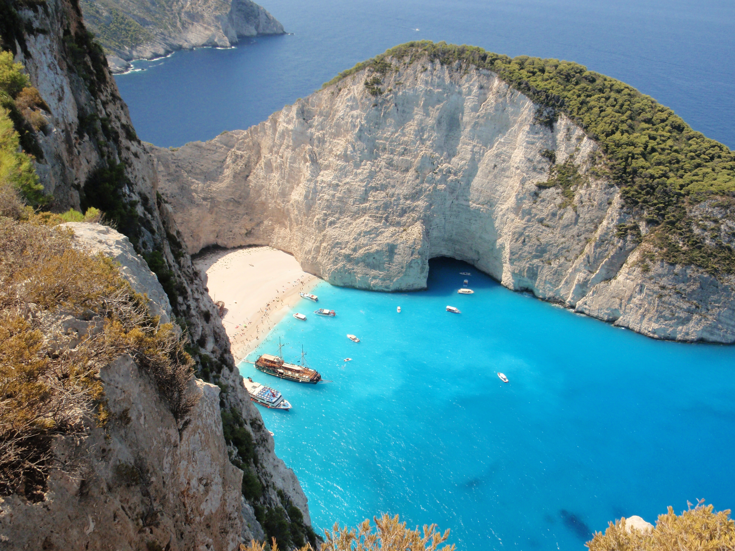
Coastline, Zakynthos, Greece
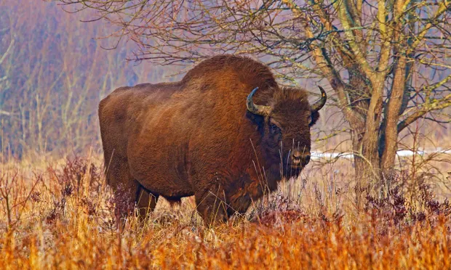
Bison, Poland
SOURCEBOOK K-9.E

Station 5: Australia and Antarctica

Why would you visit this continent?

What interesting things would you see?

Map: Australia and Antarctica

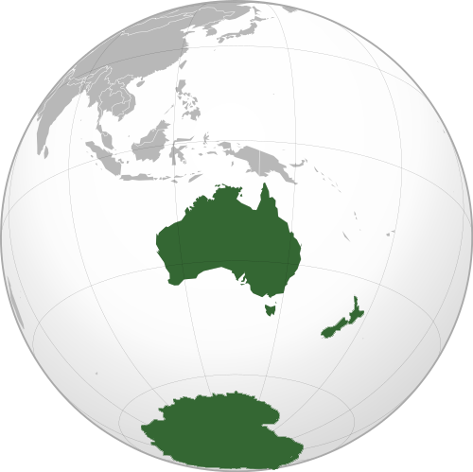

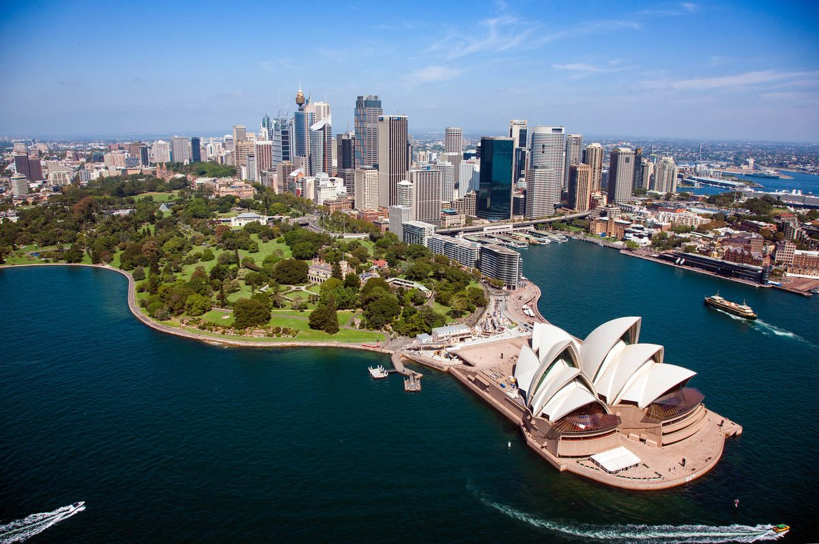
Sydney, Australia
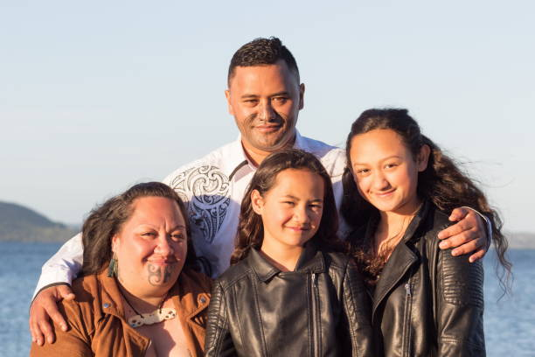
Māori People, New Zealand
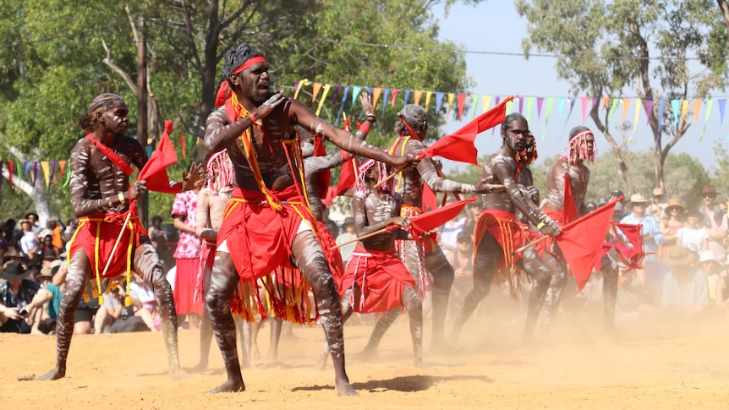
Barunga Festival, Australia
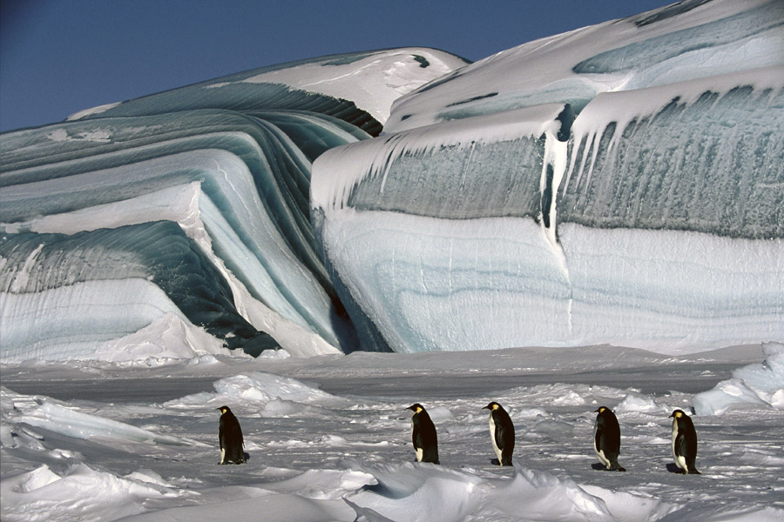
Glaciers, Antarctica
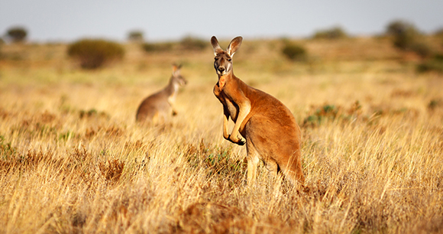
Kangaroo, Australia
SOURCEBOOK K-10.A

Station 1: Volunteer

How might this make change?

Should we do this to help our issue?

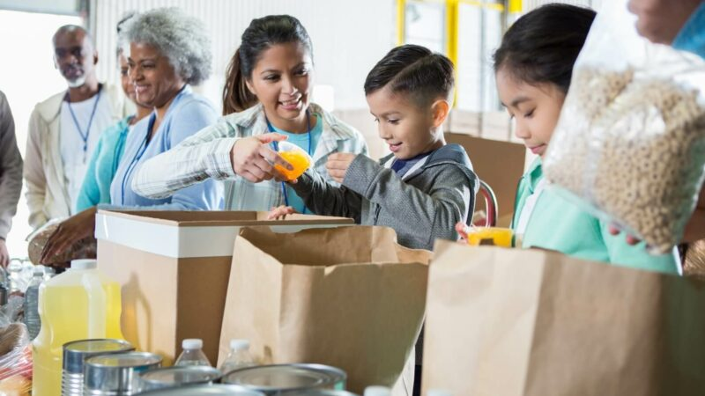

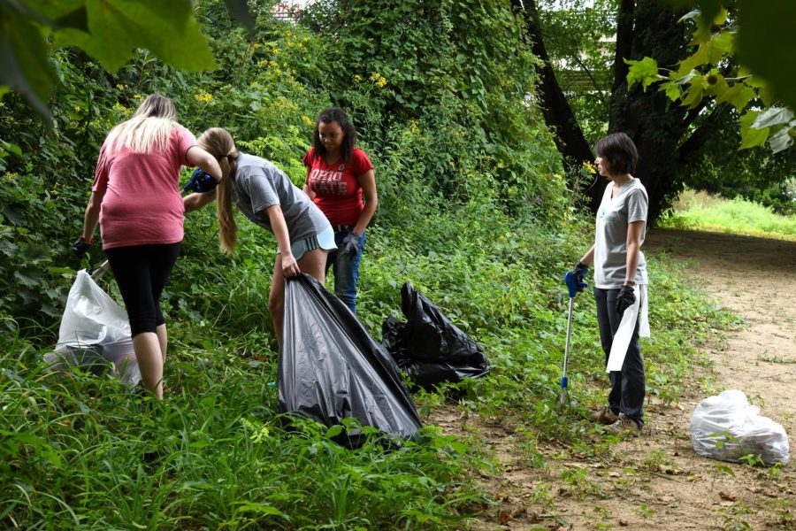
SOURCEBOOK K-10.B

Station 2: Raise Money

How might this make change?

Should we do this to help our issue?

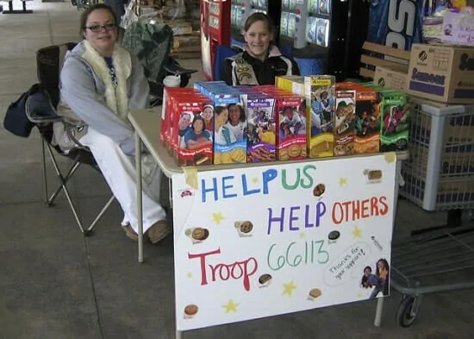

SOURCEBOOK K-10.C

Station 3: Contact Politicians

How might this make change?

Should we do this to help our issue?

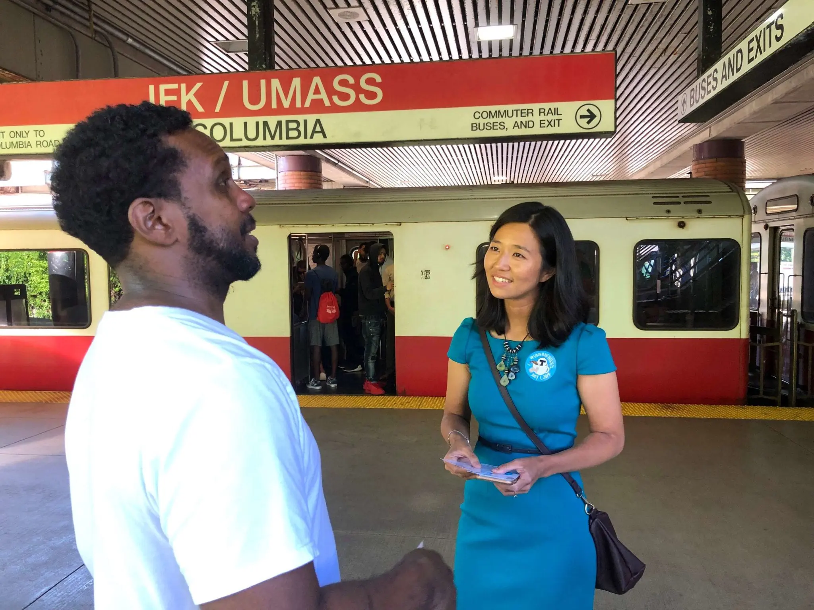

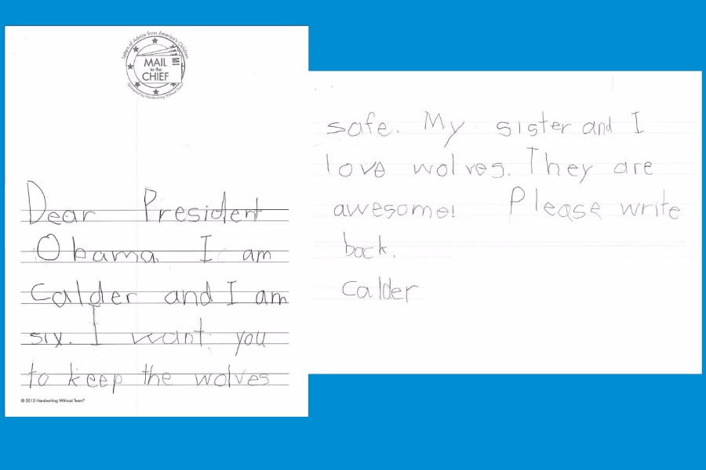
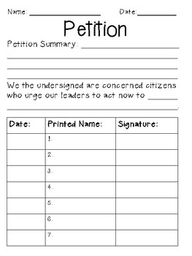
SOURCEBOOK K-10.D

Station 4: Protest or Rally

How might this make change?

Should we do this to help our issue?

