Open Social Studies

An Inquiry-Based and Literacy-Focused K-6 Curriculum

Curric

STUDENT SOURCEBOOK

Level: Grade 5

Exploring the United States

Developers:

Christopher C. Martell

Jennifer R. Bryson

GRADE 5 ROAD MAP

LESSON 5-1

Lesson Title: The Indigenous People: Diverse Nations, Diverse People

Inquiry Question: What were the most important parts of ancient Indigenous cultures?

LESSON 5-2

Lesson Title: Who Were the Vikings?

Inquiry Question: Were the Vikings the brutal raiders they are often depicted as?

LESSON 5-3

Lesson Title: Spain, Portugal, France, England: Explorers or Invaders?

Inquiry Question: Were the Europeans who came to the Americas explorers or invaders?

LESSON 5-4

Lesson Title: History Detectives: Pocahontas and Jamestown

Inquiry Question: What is the real story of Pocahontas?

NOTE: In chronological order, the relationship between the Pilgrims, Puritans, and the Indigenous people would appear here after Lesson 5-4. These lessons are currently included in the Grade 3 curriculum (i.e. 3-1. 3-2, 3-3, 3-4, 3-5, 3-6, 3-7, 3-8), which is Massachusetts history. Teachers are encouraged to use modified versions of those lessons again here.

LESSON 5-5

Lesson Title: The Salem Witch Trials: What Really Happened?

Inquiry Question: What really happened in Salem in 1692?

LESSON 5-6

Lesson Title: British America: The Shared Histories of Canada, the American Colonies, and the British West Indies

Inquiry Question: If you were a colonist coming to the American colonies at this time, what colony would you settle in and why?

LESSON 5-7

Lesson Title: The Transatlantic Slave Trade

Inquiry Question: Why did the Transatlantic Slave Trade happen?

LESSON 5-8

Lesson Title: Mock Trial: The Boston Massacre

Inquiry Question: Was Captain Thomas Preston guilty of murder during the Boston Massacre?

LESSON 5-9

Lesson Title: Road to Revolution: French & Indian War, and Acts of Parliament

Inquiry Question: Would you have supported the Crown?

LESSON 5-10

Lesson Title: The Boston Tea Party

Inquiry Question: Were the colonists justified in rebelling from Britain?

LESSON 5-11

Lesson Title: Lexington and Concord

Inquiry Question: Who fired the first shot on Lexington Green?

LESSON 5-12

Lesson Title: Declaring Independence

Inquiry Question: What was the most important point made in the Declaration of Independence?

LESSON 5-13

Lesson Title: Revolutionary War Journals

Inquiry Question: What was life like during the American Revolution?

LESSON 5-14

Lesson Title: Winners and Losers: The Peace of Paris

Inquiry Question: Was the Peace of Paris fair?

LESSON 5-15

Lesson Title: Shays’ Rebellion

Inquiry Question: Were the participants of Shays’ Rebellion justified in their revolt?

LESSON 5-16

Lesson Title: Mock Convention: Writing the Constitution

Inquiry Question: Did the delegates as the Constitutional Convention make the right decisions?

LESSON 5-17

Lesson Title: Know Your Rights! An Introduction to the Bill of Rights

Inquiry Question: What is the most important right guaranteed to you under the Bill of Rights?

LESSON 5-18

Lesson Title: The Louisiana Purchase: Worth the Price?

Inquiry Question: Should Thomas Jefferson have purchased Louisiana from France?

LESSON 5-19

Lesson Title: Why the “Lewis and Clark Expedition” Should Really Be the “Lewis, Clark, Sacagawea, York, and Charbonneau Expedition”

Inquiry Question: Who was the most important leader during the Lewis and Clark Expedition?

LESSON 5-20

Lesson Title: Trail of Tears

Inquiry Question: What was it like for someone who was forced out of their home by the U.S. government during the Trail of Tears?

LESSON 5-21

Lesson Title: Racial Inequity and the California Gold Rush

Inquiry Question: Should the California Gold Rush be remembered for its opportunity or its inequity?”

LESSON 5-22

Lesson Title: Westward Expansion or Invasion from the East?

Inquiry Question: Was the movement of White Americans a “westward expansion” or an “invasion from the east?”

LESSON 5-23

Lesson Title: The Civil War

Inquiry Question: Why was the Civil War fought?

LESSON 5-24

Lesson Title: Reconstruction

Inquiry Question: What was the worst decision made during the period of Reconstruction after the Civil War?

LESSON 5-25

Lesson Title: The Great Migration

Inquiry Question: If you were an African American in the South at the turn of the 20th Century, would you have moved north?

LESSON 5-26

Lesson Title: Japanese American Incarceration: Civil Liberties and War

Inquiry Question: What was it like for Japanese Americans who were forced by the U.S. government into prison camps during World War II?

LESSON 5-27

Lesson Title: Martin Luther King and Malcolm X

Inquiry Question: Who had the better strategy for reducing racism and improving the Black community?

LESSON 5-28

Lesson Title: Sí Se Puede! César Chavéz, Dolores Huerta, and the National Farm Workers Association

Inquiry Question: Which type of protest used by Chavéz and Huerta was most effective?

LESSON 5-29

Lesson Title: The Other Civil Rights Movements: Women’s Rights, Indigenous Rights, Latino Rights, and Asian American Rights

Inquiry Question: For your assigned group, what was their most important action?

LESSON 5-30

Lesson Title: The Boston Busing Crisis

Inquiry Question: What was the best plan for racially integrating Boston’s schools?

SOURCEBOOK 5-1.B

The Indigenous People: Sources

Source 1: Puebloan Culture

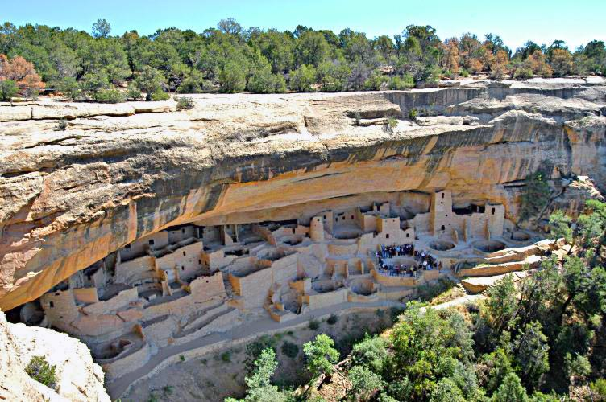

A group of ancient Indigenous people made their home in what is today Arizona, New Mexico, Colorado, and Utah. They carved their homes from the rock of hills (see above). Some of these homes were three stories high and had 50 rooms or more where the different families would live. In many ways, the Puebloan people made the first apartment buildings. They would grow beans, corn, and squash (known as the Three Sisters), and hunt deer, turkey, and other animals. Puebloan people were also known for their elaborate baskets, which were used for carrying water, storing food, and cooking.
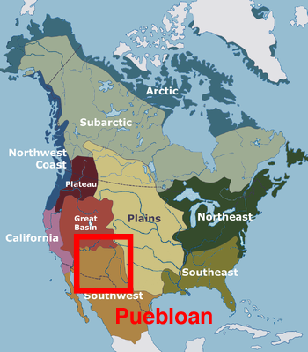

Source 2: Mississippian Culture

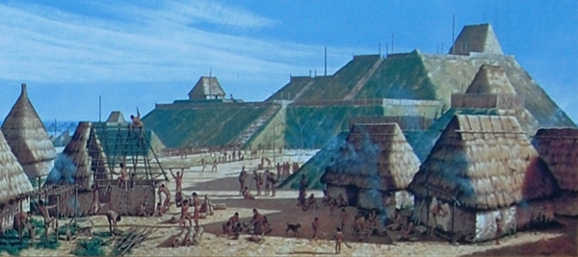

A group of ancient Indigenous people made their home in the Mississippi River Valley. They made houses on top of giant mounds (see above). Some of these mounds were as high as 10 stories. In many ways, the Mississippian people made the first skyscrapers. These mounds are found today all over the Southeastern United States. They would grow beans, corn, and squash (known as the Three Sisters), and hunt deer, turkey, and other animals. Puebloan people were also known for their elaborate craftwork making items from copper, shell, stone, wood, and clay.

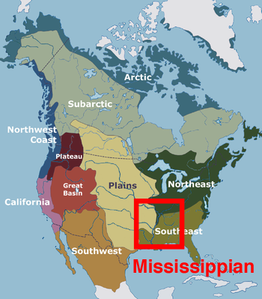

Source 3: Plateau Culture

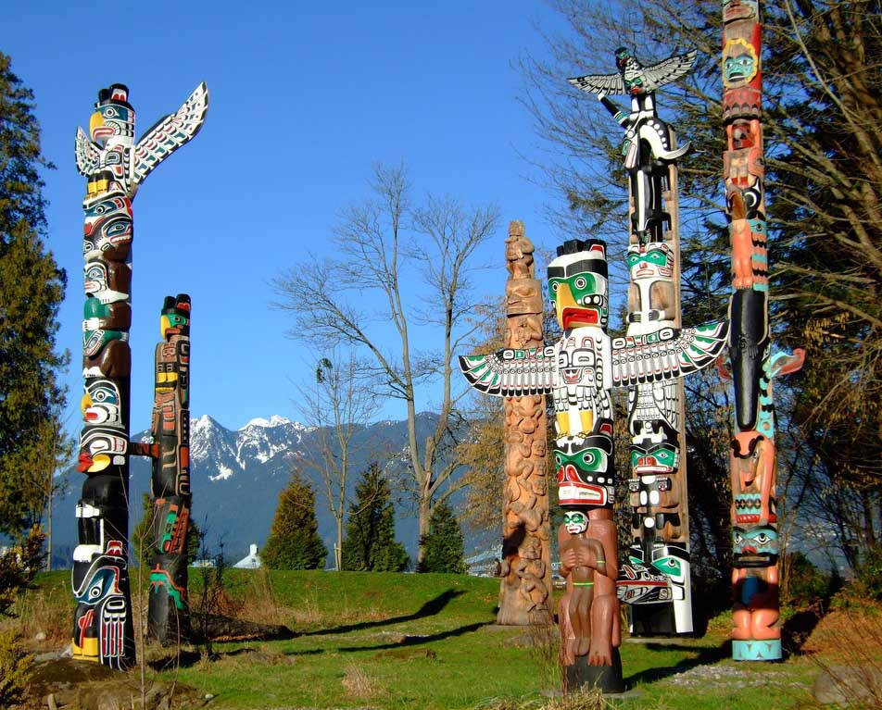

A group of ancient Indigenous people made their home in the Pacific Northwest Plateau. They were known for their boats and use of rivers and oceans. They would have one house for the summer and one house for the winter. They would fish, especially for salmon. They were known for their totem poles (see above), which featured animals (such as bears, birds, frogs, people, supernatural beings) and told the stories of families. To read the story, you start at the bottom and work your way to the top.
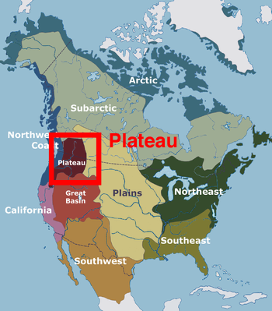

Source 4: Iroquois Culture

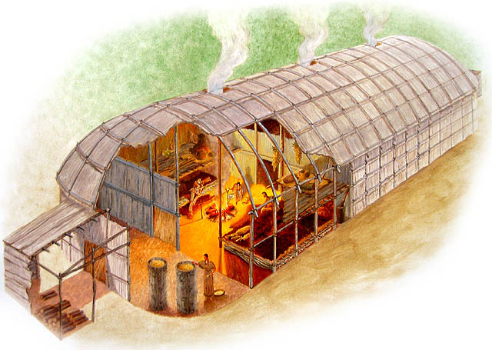

A group of ancient Indigenous people settled around the Great Lakes in what became the United States and Canada. They were known for their longhouses (see above), which would house up to 20 families. They had no windows, but had holes in the roofs to let out the smoke of fires for heat and cooking. They would grow beans, corn, and squash (known as the Three Sisters), and hunt deer, turkey, and other animals. They also invented the game of lacrosse, which involved using sticks to throw a ball within the opposing team’s net.

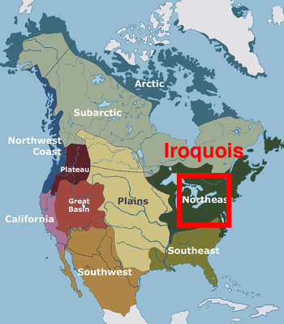

Source 5: Algonquin Culture
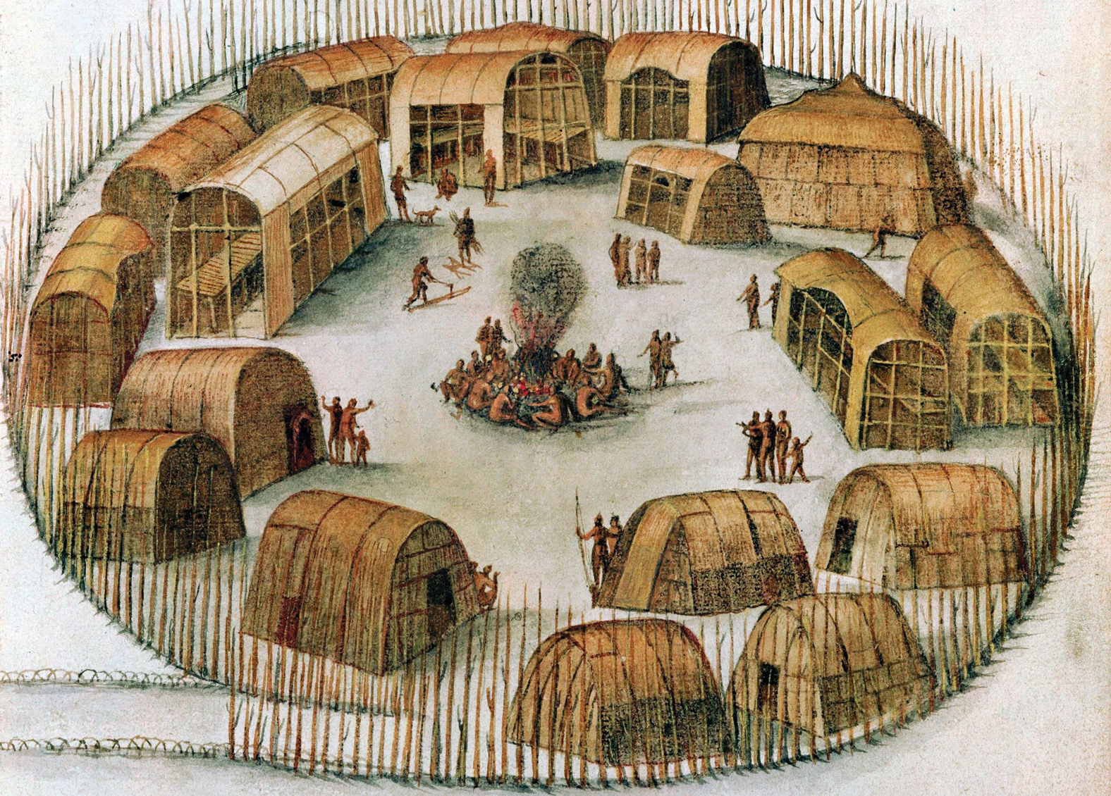

A group of ancient Indigenous people settled across the northern part of what became North America from the Atlantic Ocean to Hudson Bay. All of the Algonquin spoke similar languages and could understand other Algonquin people from very far away. They were known to live in small villages (see above). They would also have one house for the summer and one house for the winter. Clans, or families, were very important. They would grow beans, corn, and squash (known as the Three Sisters), and hunt deer, turkey, and other animals. Many Indigenous people, including the Algonquin, played a game similar to basketball long before Whites made their rules for it in 1891.
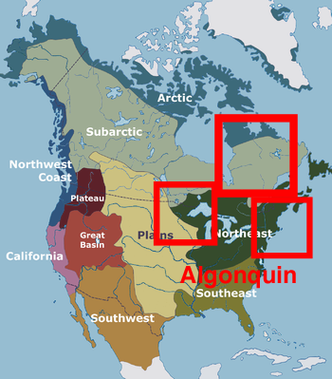

SOURCEBOOK 5-2.A

Images (A)

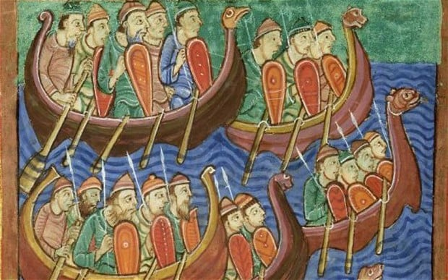

Images (B)

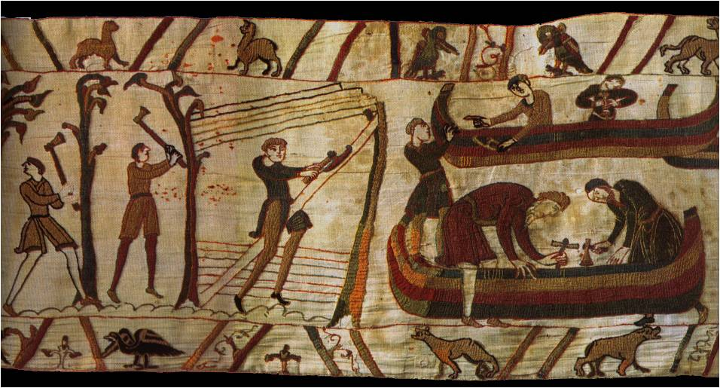

SOURCEBOOK 5-2.B

The Vikings: Sources

Source 1: Account of Lindisfarne Attack, 793 CE

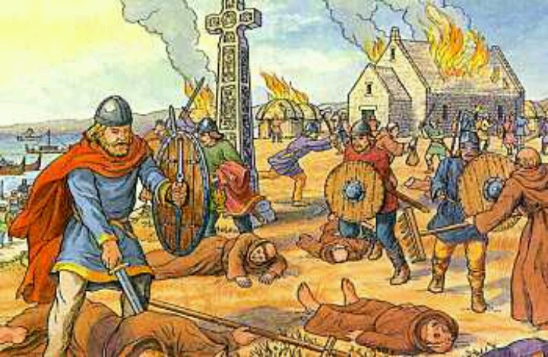

Above: Image of the Viking attack on Lindisfarne (English Island) and St. Cuthbert Church in 793 CE. Below is what the English wrote of the attack.

There came for the first time 3 ships; and then the leader rode there and wanted to make them to go to the king's town, because he did not know what they were; and they killed him. Those were the first ships of the Viking men which sought out the land of the English.

Source 2: The Rök Stone [Viking Stone Tablet]

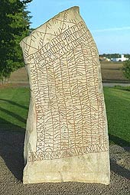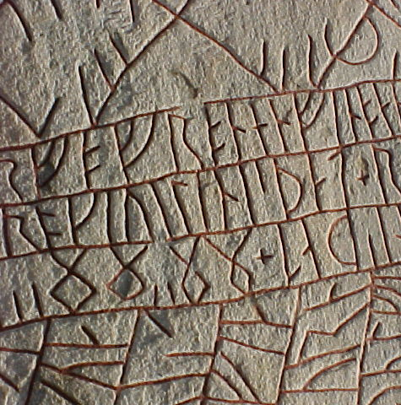

For most of their history, the Vikings were not literate (could not read and write). In the 1800s, a stone was discovered next to a church in Sweden. It is called the Rök Stone and may be the first recorded story in the Swedish language (many Vikings came from Sweden). Below is part of a story they wrote. It is important, because it is one of the few historical documents written by the Vikings about themselves.

Rök Stone Translation: You men go out to the sea and get a war booty (treasure). Many sea warriors have died. The people wait for them to return to help them. These young men are brave men. They are led by Vélinn. He could crush a giant.

Source 3: Leif Eriksson and Newfoundland

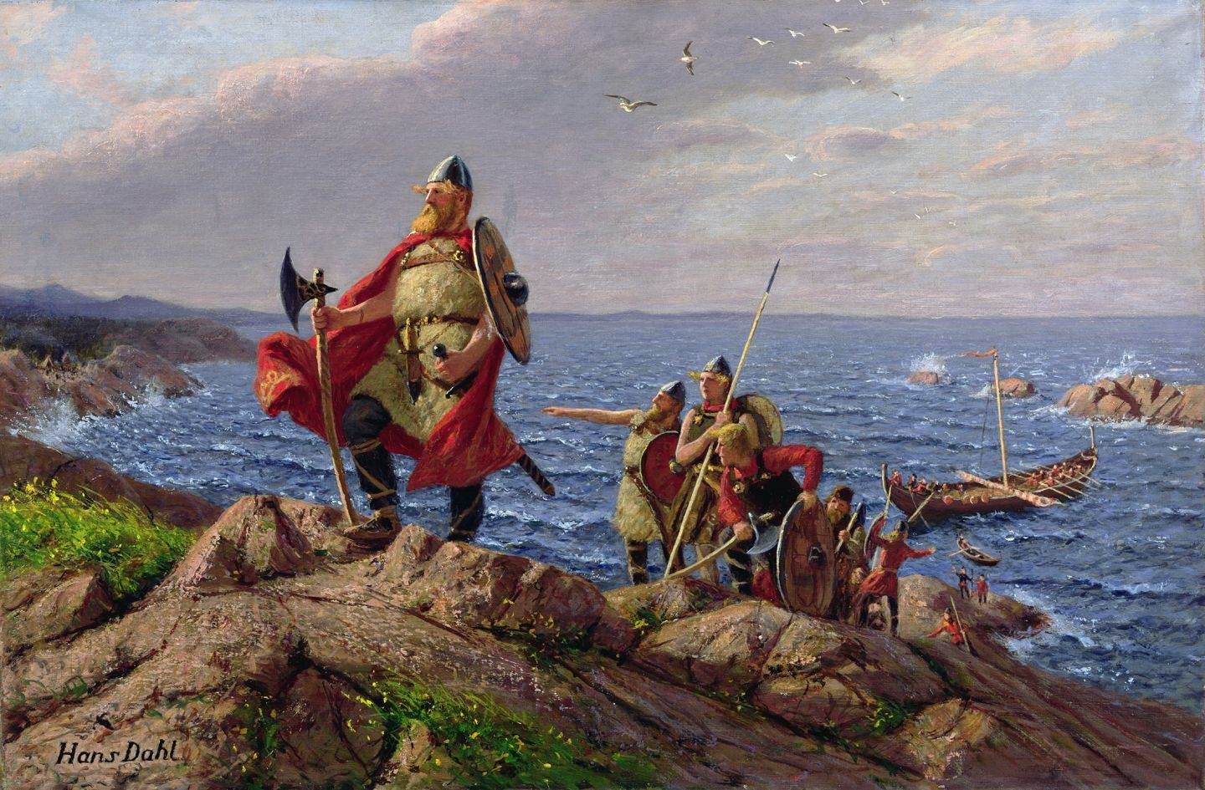

There is evidence that Vikings arrived in the Americans long before Columbus. There are many references to Vinland, which many historians argue is what they called North America. While it is possible other Vikings were there first, Leif Eriksson and his men were probably the European to come to North America. He most likely made landfall at a place called L'Anse aux Meadows in what is today Newfoundland, Canada (His father Erik the Red was the first European to settle in what is today Greenland). Although he described interactions with the Native people, it does not appear that they fought any of the people they came in contact with.

Source 4: “Were the Vikings Really So Bloodthirsty?” by Tom de Castella (British Broadcasting Company)

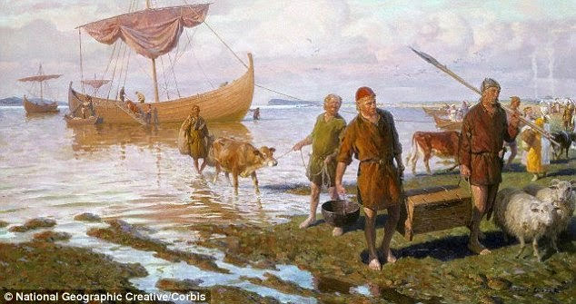

The Viking story has fascinated people for centuries. But have people got them all wrong? Let's start with those helmets with horns. The Vikings never wore them. They have only been included in pictures of them since the 1800s. They did raid villages and some churches (churches often had gold or other expensive materials), but the Vikings were more global traders than warriors. They were migrants who were trying to support their families back home. They did not just raid, pillage (steal), and leave. Over the 300-year Viking period, many stayed where they invaded. Many people today in England, Ireland, Normandy (France), Eastern Europe (Finland, Russia, Poland), and even the Middle East and Central Asia are ancestors of the Vikings. They also brought with them their art, literature, and language. Many English words have Viking roots, like dirt, steak, husband, bug, and even some days of the week (for instance, Thursday means Thor’s day).

SOURCEBOOK 5-3.B

Introduction: Spain

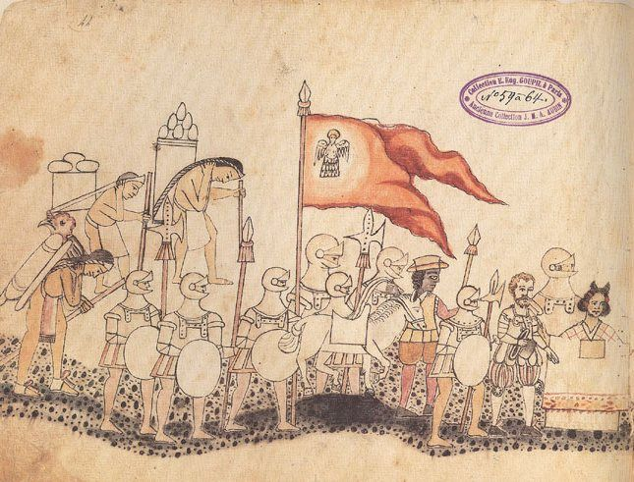

Many countries in Europe are at war with each other. You will use your army to protect your country and attack other countries (if you think they will attack first). To support your army, you need riches in the form of gold or items that you can trade.

You also believe anyone who is not Christian should become Christian. While you hope their become Christian on their own, you will force them and even use your army, if you have to.

Introduction: Portugal

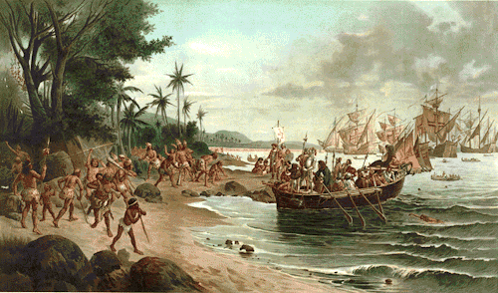

Many countries in Europe are at war with each other. You will use your army to protect your country and attack other countries (if you think they will attack first). To support your army, you need riches in the form of gold or items that you can trade.

You also believe anyone who is not Christian should become Christian. While you hope their become Christian on their own, you will force them and even use your army, if you have to.

Introduction: France

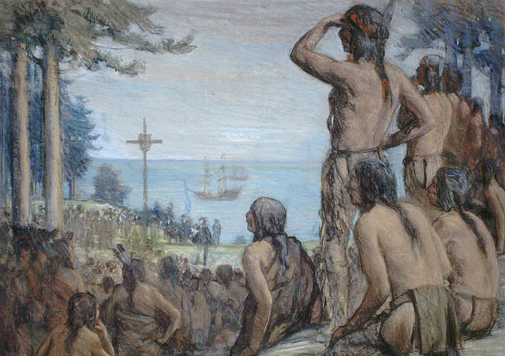

Many countries in Europe are at war with each other. You will use your army to protect your country and attack other countries (if you think they will attack first). To support your army, you need riches in the form of gold or items that you can trade.

You also believe anyone who is not Christian should become Christian. While you hope their become Christian on their own, you will force them and even use your army, if you have to.

Introduction: England

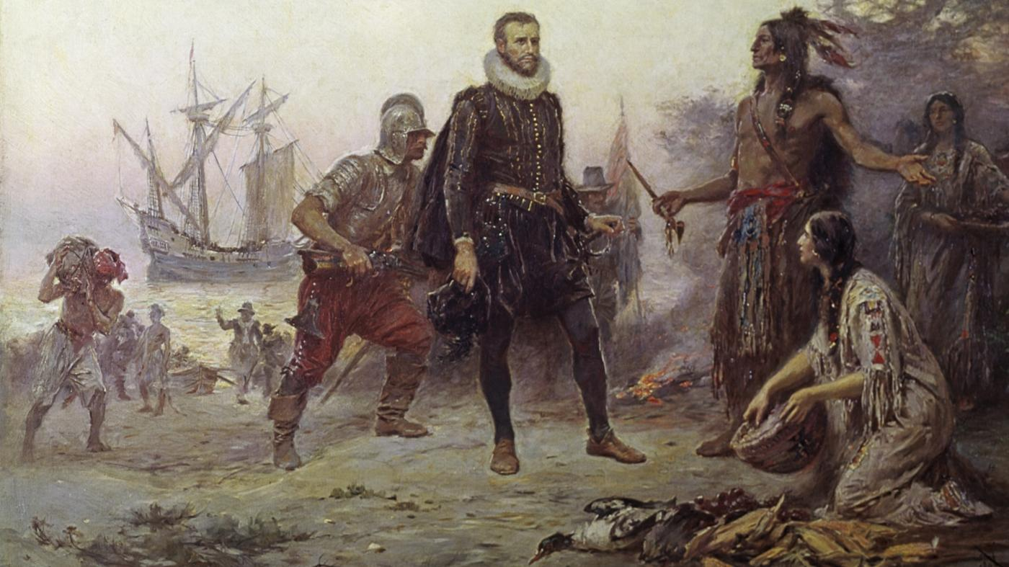

Many countries in Europe are at war with each other. You will use your army to protect your country and attack other countries (if you think they will attack first). To support your army, you need riches in the form of gold or items that you can trade.

You also believe anyone who is not Christian should become Christian. While you hope their become Christian on their own, you will force them and even use your army, if you have to.

SOURCEBOOK 5-3.C

Explorers or Invaders?: Sources

Source 1: Spain: “Broken Spears”

Above: An Aztec drawing of the arrival of the Spanish in Mexico.

The Spanish called the soldiers who went to the Americas “conquistadors” (conquerors). Christopher Columbus tried to sail to Asia, but was wrong about the size of the Earth and landed in the Americas. After Columbus, Hernán Cortés went to the Aztecs (Mexico) and met their leader Montezuma. Francisco Pizarro went to the Incas (Peru) and met their leader Atahualpa. They then went to war and took them over. This is one of the few recorded primary sources written by the Aztecs about Cortés arrival.

Translation: November 8, 1519: The Spanish said to us: Tell Montezuma that we are his friends. There is nothing to fear. Some months later, the Spanish entered the Sacred Patio to kill people. They came on foot, carrying swords and wooden and metal shields. They killed many and took many captives.

Source 2: Portugal: Treaty of Tordesillas

Above: A Portuguese painting of their first landing in Brazil.

Portugal did not want a war with Spain over the Americas, so they met them and proposed peace called the Treaty of Tordesillas. They would split the Americas in half, Portugal would get the east and Spain would get the west. Notice that there is no mention of the Indigenous people and they are not asked if they are all right with Spain and Portugal taking their land.

Translation: There is currently a controversy (disagreement) between those who explore the ocean. For the sake of peace, we will draw a line from the North Pole to the South Pole at seventy leagues west of Cape Verde. All lands and islands west will be Spain and all lands and islands east will be Portugal. (Signed June 7, 1494)

Source 3: France: Jacques Cartier Claims New France

Above: A Canadian painting of what the Indigenous people would have seen when Jacques Cartier landed in what is now Québec.

This is what Jacques Cartier wrote about their first interactions with the Indigenous people.

July 24, 1534: We had a cross made thirty feet high, which was put together in front of the Indians at the entrance of the harbor. We made a shield with the fleur-de-lys (a flower symbol used by the king of France). The chief came to our ship and said this land is his and we should not have set up the cross.

Source 4: England: Henry Hudson’s Diary

Above: A European painting of what they thought Henry Hudson’s landing in Canada looked like.

This is what Henry Hudson wrote in his diary.

September 9, 1609: Our men landed there and we saw many men women and children. … They are very polite and glad we came. They helped us pull our boats to shore and gave us food, tobacco, and other goods. We do not trust them. They will steal from us and carry away whatever they like.

SOURCEBOOK 5-4.A

Sources: Pocahontas

Source 1: Pocahontas: Disney Perspective

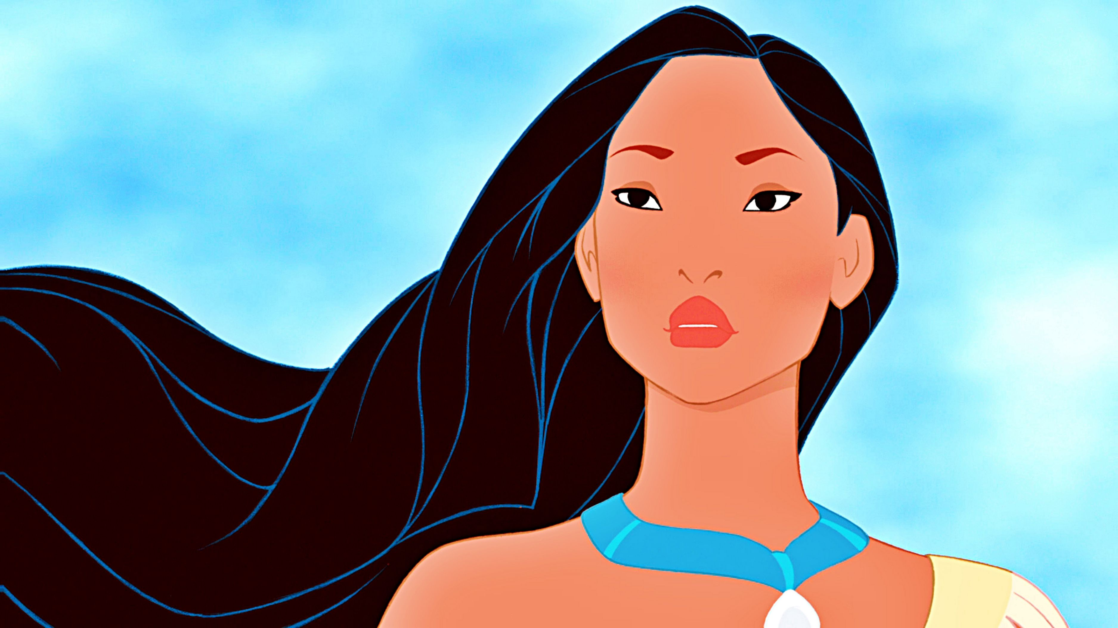

Above: Disney’s cartoon character Pocahontas.

The film “Pocahontas" is set in 1607, just as a new age of exploration has begun. A group of British adventurers led by the greedy governor of the Virginia Company, John Ratcliffe, and including a fearless soldier named John Smith, have set sail for the New World. Meanwhile, in Virginia, a beautiful young Native American woman named Pocahontas, the daughter of Chief Powhatan, ponders her path in life and dreams about what lies "just around the river bend." Should she marry Kocoum, the stern warrior her father has chosen for her, or does destiny have something else planned for her? She turns to her forest friends–Meeko, a mischievous raccoon, a feisty hummingbird named Flit and Grandmother Willow, a 400-year-old mystical spirit residing in an ancient tree–for friendship and advice.
Upon their arrival, the British settlers begin digging up the countryside in a quest for gold. Charged with protecting the colony, John Smith scouts the area and meets Pocahontas. They are attracted to one another and she introduces him to a world unlike any he has ever known. Pocahontas teaches him that every rock, tree and creature has a living spirit and explains how the Indians are able to "paint with all the colors of the wind." As their friendship blossoms, relations between the British and the Indians continue to deteriorate with fear and hatred mounting daily. When Smith is captured by Powhatan and set to be executed, Pocahontas bravely places her own life on the line by declaring that he must kill her first. Smith reciprocates the sacrifice by saving Powhatan's life from a British bullet, but is wounded in the process. In a powerful and moving finale, he and Pocahontas must part, knowing that their spirits will be forever joined on a path that never ends.

Source 2: Pocahontas: Powhatan Nation Perspective

Above: An actual painting of Matoaka (Pocahontas, Rebecca Rolfe) from her life.

The Disney company decided to release an animated movie about a Powhatan woman known as Pocahontas. We of the Powhatan Nation argue that the film lies about history. Pocahontas was a nickname, meaning “the naughty one” or “spoiled child.” Her real name was Matoaka (ma-toe-oh-ka). The legend is that she saved a heroic John Smith from being clubbed to death by her father in 1607. She would have been about 10 years old at the time. The truth is that Smith’s fellow colonists described him as a bad person. The truth is that the first time John Smith told the story about this rescue was 17 years after it happened. He had also told three other stories about being saved from death by different famous women. European Americans must ask themselves why Disney has made a movie based on a story that is probably not true.
The true Pocahontas story has a sad ending. In 1612, at the age of 17, Pocahontas was taken prisoner by the English. She was forced to marry European John Rolfe. Rolfe was famous for introducing tobacco (an addictive drug smoked in pipes) to Europeans. Shortly after, they had a son, whom they named Thomas Rolfe. Two years later, Rolfe took Pocahontas to England where the Virginia Company of London toured her around London to get support for their colony. It was recorded that when she encountered John Smith, she was so furious with him that she turned her back to him, hid her face, and went off by herself for several hours. Later, in a second encounter, she called him a liar. Pocahontas and her son set off on a ship to return to Virginia. She died during the journey. She was only 20 years old. It was only after her death that John Smith started telling everyone that she had rescued him.
SOURCEBOOK 5-5.B

Salem Witch Trials Theories

There are several theories (ideas) about the causes the Salem Witch Trials. Choose one of these theories or come up with one on your own:

Theory 1: Ergot/Food Poisoning
People who support this theory claim that wet conditions in Salem caused a fungus called ergot to spread throughout the rye, which is what they made their bread out of. It makes people hallucinate or see things that do not exist.

Theory 2: A Lie that Went Out of Control
People who support this theory claim that it was a case of rumors getting out of control. The girls started a rumor about with craft, because they wanted to get Tituba in trouble. This led to hysteria (a panic) that there were other witches.

Theory 3: Fear of Outsiders
People who support this theory claim that Tituba (an African or Indigenous slave from Barbados) and Rebecca Nurse (and elderly widow from Boston) were different than the other people in town, who were European and from Salem. This made the others in Salem afraid of them and allowed them to believe they were witches.

SOURCEBOOK 5-5.C

Salem Witch Trials: Sources

Source 1: Was the Salem Witch Scare Caused by Food Poisoning?

Before we look at the different documents, we will watch a short video about the ergot/food poisoning theory.
Source 2: Summary of the Salem Witch Trials by the University of Virginia

The Salem Witch Trials began in late February 1692 and lasted through April 1693. They were held in Salem Village in Massachusetts Bay Colony. The people of the town believed Betty Parris and Abigail Williams (who were cousins) were possessed by the Devil through witchcraft. Betty and Abigail accused the Parris’ slave Tituba of having taught the girls witchcraft. Tituba was African or Indigenous and from the Caribbean Island of Barbados. Betty and Abigail later accused Rebecca Nurse, an elderly widow, of spreading witchcraft. The girls, along with their neighbors the Putnums, then accused many in town of being witches. In the end 25 people were convicted: 19 were hanged, 1 was crushed to death under heavy stones, and 5 died in jail. Over 160 people across Massachusetts Bay Colony were accused of witchcraft and most were jailed.

Source 3: Testimony (words said at a trial) of Tituba, Samuel Parris’ slave from the Caribbean island of Barbados

John Hathorne (Judge): What familiarity have you with the Devil?

Tituba: The Devil, I am not sure. I saw a man in the night. I told him I would fear God. This man then came to me and said the Parris children was first hurt. He said he would kill the children if I would not serve him…

John Hathorne: Did you ever practice witchcraft in your own country (Barbados)?

Tituba: No. Never.

Source 4: Testimony (words said at a trial) of Rebecca Nurse (a 76 year-old woman charge with being a witch in Salem)

Rebecca Nurse: I can say that I am innocent and God will clear me… (Ann Putnum Jr. and other girls act as if they are being pinched by invisible people, crying out in pain.)

I have not hurt them. I am an innocent person.

John Hathorne (judge): Why do you make no face when you see the girls are in pain.

Rebecca Nurse: You do not know my heart. I am as clear as the child unborn.

John Hathorne: They accuse you of hurting them and they are not lying.

Rebecca Nurse: If so, I cannot help it, then the Devil may be in me.
Source 5: Testimony (words said at a trial) of Ann Putnum Sr. (a woman who claimed Rebecca Nurse was a witch and whose daughter claimed to be possessed by the witchcraft of Rebecca Nurse)

Ann Putnum, Sr.: My daughter told me that Rebecca Nurse and her sister were witches, and their mother was a witch. Because of her, six children in sheets (like a ghost) frightened me. They told me that Rebecca Nurse, an old woman at Boston had murdered them. They asked me to go and tell these things to the judges or they would tear me to pieces. Rebecca Nurse must be a witch.

Source 6: Drawing of the Rebecca Nurse Trial

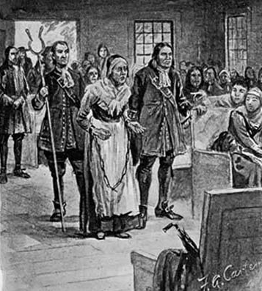
At the trial, Rebecca nurse was very old, was a widow (her husbands died), and not originally from Salem (she was from Boston). She had trouble hearing and often misunderstood what people were saying.

Source 7: A Drawing of Tituba

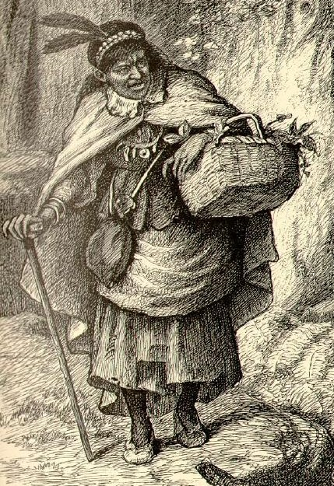
Tituba was African or Indigenous and from the Caribbean Island of Barbados. She was a slave owned by Samuel Parris (father of Betty Parris). She initially told everyone that she had never been a witch, but after being beaten by Samuel Parris she confessed to being a witch.

Source 8: Jurors’ Verdicts (Decision) for Rebecca Nurse

July 4, 1692. The jury came back with a verdict of “Not Guilty.” When this was announced there was a large outcry from the townspeople. The judges urged the jury to change their verdict to guilty. Chief Justice Stoughton asked the jury if they had considered what Rebecca Nurse had said of Abigail Hobbs, a 17 year-old girl, also accused of witchcraft.

Rebecca Nurse may have said, “She is one of us.” Nurse was old and almost deaf. When Nurse was asked by the judges to explain her words, she did not hear his question. The jury took her silence as guilt.

The jury met a second time and came back with a verdict of guilty. Rebecca Nurse was later sentenced to death for practicing witchcraft.

SOURCEBOOK 5-6.A

Zoom In Inquiry Activity

Zoom 1
Zoom 2
Zoom 3

SOURCEBOOK 5-6.B

The British Colonies: Sources

Source 1: Canada

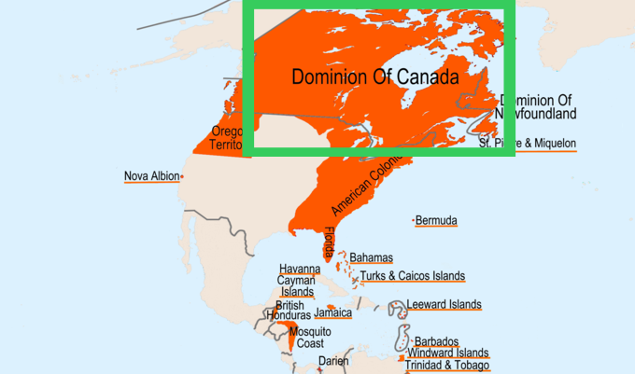

Canada was a French colony and part of the larger territory called New France. New France went from the Hudson Bay to the north, the Gulf of Mexico to the south, the Mississippi River to the west, and the British American Colonies to the east. In 1763, Britain defeated France in the Seven Years’ War. They would get France’s territory of Canada (green box above).

The first Europeans came to Canada to start business companies. The main purpose of Canada is to buy and sell animal furs. The Whites trade metal tools, cloth, and guns with the Indigenous people for beaver furs, which they would then sell to Europe. In Europe, these furs are made into hats and clothing. The growing season is very short, so farming was not as successful as other colonies.

The climate in Canada is temperate. It is usually below 0 Celsius (32 Fahrenheit) in the winter and rarely gets above 32 Celsius (90 Fahrenheit) in the summer. It usually rains in the summer and snows in the winter.

There are many Indigenous people in Canada. The largest group are the Algonquin. There is generally peace between the Whites and Indigenous people.

While slavery is allowed in Canada, there is only a very small number of enslaved Indigenous and Black people. Slavery is less common than in other colonies, because large amounts of workers are not needed.

Source 2: American Colonies: New England

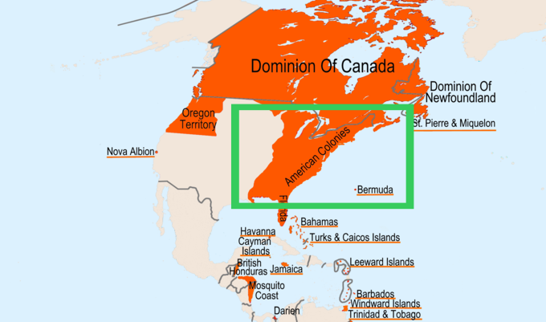

The first Europeans came to New England to start religious communities. There would be four colonies in New England: Massachusetts Bay, Rhode Island and Providence Plantations, Connecticut, and New Hampshire.

The main purpose of New England is to buy and sell (trade) fish and wood. It also became a place known for its shipbuilding. The soil there is rocky and the growing season is short, so farming was not as successful as other colonies.

The climate in New England is temperate. It is often below 0 Celsius (32 Fahrenheit) in the winter and rarely above 38 Celsius (100 Fahrenheit) in the summer. It usually rains in the summer and snows in the winter.

There are many Indigenous people in New England. The largest groups are the Wampanoag, Massachusett, Narragansett, and Nipmuc. The Whites are often at war with Indigenous people.

While slavery is allowed in New England, there is a small number of enslaved Indigenous and Black people. Slavery is less common than in other colonies, because large amounts of workers are not needed.

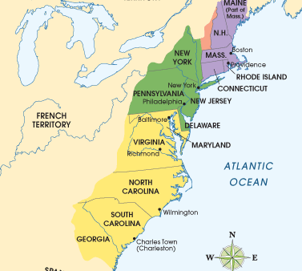

Source 3: American Colonies: Middle Colonies

The Middle Colonies were originally ruled by the Dutch (New Netherland, now New York) and Swedish (New Sweden, now Delaware). In 1674, Britain defeated the Netherlands in the Anglo-Dutch War. They would get France’s territory of the Middle Colonies.

The first Europeans came to the Middle Colonies to start business companies. There would be four colonies in the middle region: New York, New Jersey, Pennsylvania, and Delaware.

The main purpose of the Middle Colonies is to buy and sell fur, wood, and grains (like wheat and rye for bread). The soil there is rich and the growing season is longer, so farming is successful compared to the other colonies.
The climate in the Middle Colonies is temperate. It is sometimes below 0 Celsius (32 Fahrenheit) in the winter and sometimes above 38 Celsius (100 Fahrenheit) in the summer. It usually rains in the summer and snows in the winter.

There are many Indigenous people in the Middle Colonies. The largest groups are the Iroquois, Algonquin, and Lenape. The Whites are often at war with Indigenous people.

Slavery is allowed in the Middle Colonies. There are enslaved Black and Indigenous people, but fewer than the Southern Colonies and British West Indies. Slavery is less common than other colonies, because so many workers are not needed.

Source 4: American Colonies: Southern Colonies

Southern Colonies

The first Europeans came to the Southern Colonies to start business companies. There would be four colonies in the southern region: Virginia, Maryland, Carolina, Georgia.

The main purpose of the Middle Colonies is to buy and sell tobacco, which is smoked and is addictive (difficult for people to stop using). The soil there is rich and the growing season is very long, so farming was very successful compared to the other colonies. Due to the warm climate, there are also many outbreaks of diseases, such as yellow fever.

The climate in the Southern Colonies is subtropical. It is rarely below 0 Celsius (32 Fahrenheit) in the winter and often above 38 Celsius (100 Fahrenheit) in the summer. It usually rains in the summer and almost never snows in the winter.

There are many Indigenous people in the Southern Colonies. The largest groups are the Powhatan, Cherokee, and Creek. The Whites are often at war with Indigenous people.

Slavery is allowed in the Southern Colonies. Slavery is very common than in other colonies (although less than the West Indies), because large amounts of workers are needed to grow the crops.

Source 5: British West Indies

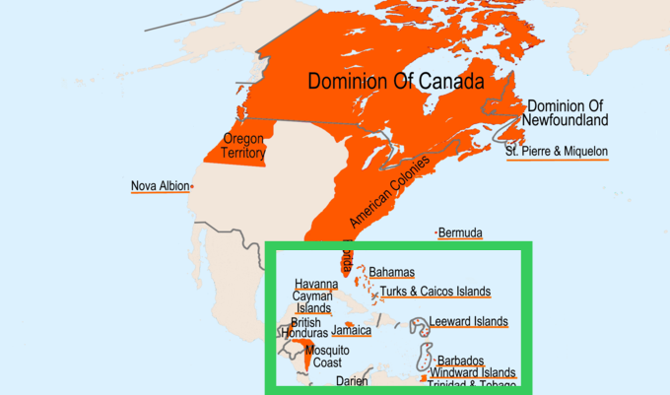

Jamaica, Bahamas, Barbados, Leeward Islands, Windward Islands

The first Europeans came to the British West Indies to start business companies. There would be five main colonies in the Caribbean: Jamaica, Bahamas, Barbados, Leeward Islands, Windward Islands.

The main purpose of the British West Indies is to buy and sell sugar, which can be used to make food sweeter and be turned into molasses or alcohol. The soil there is rich and the growing season is year-round, so farming was very successful compared to the other colonies. Due to the warm climate, there were also many outbreaks of diseases, such as yellow fever.

The climate in the British West Indies is tropical. It is usually between 21 Celsius (70 Fahrenheit) and 38 Celsius (100 Fahrenheit) year-round. It usually rains in the summer and winter. It never snows.

There are many Indigenous people in the British West Indies. The largest groups are the Arawak and Taínos. The Whites are often at war with Indigenous people.

Slavery is allowed in the British West Indies. Slavery is most common here compared to other British colonies, because large amounts of workers are needed to grow the crops. While slave’s work is often dangerous in the other colonies, it was incredibly dangerous is the Caribbean, as it was very difficult work cutting sugar cane and injuries or death were common due to accidents and disease.

SOURCEBOOK 5-7.A

Transatlantic Slave Trade: Theories

There are several theories (ideas) about the causes the Transatlantic Slave Trade. While all of these theories contributed to the slave trade becoming so large, which factor was the most important? Choose one of these theories:

Theory 1: Whites Viewed Blacks As Inferior
The cause of slavery was racism. Whites in Europe and later the Americas believed that Blacks were not as intelligent as Whites. This allowed them to dehumanize (think someone is less human) and treat them in such poor ways that they used violence and traded other human beings. This is why enslaved people became almost exclusively Black by the 1700s, as Whites stopped having White indentured servants.

Theory 2: It Made People Very Rich
From the beginning of the Transatlantic Slave Trade, human beings were very valuable and trading enslaved people was very lucrative (made a lot of money). Whites in Europe and later the Americas understood that Africans were fellow human beings, but they ignored this, because slavery made them so wealthy. This led to many wealthy slave owners not actually interacting with the enslaved people themselves, but hiring people to be “slave drivers” or overseers to control the enslaved people and run the plantations.

Theory 3: The Christian Religion Allowed It (At the Time)
For many centuries, many Christians believed that non-Christians could be forced into slavery and it was allowed under their religion. This is why some White people enslaved Indigenous and African people (because they practiced other religions). Some people even used verses in the Christian Bible to justify slavery. At the same time, other Christian groups started arguing that the Bible said slavery was wrong and they started to ban it in some states and countries.

SOURCEBOOK 5-7.B

Transatlantic Slave Trade: Sources

Source 1: Slave Ship Conditions

Below is a drawing of a slave ship. Enslaved people were often chained and forced to ride in cramped conditions in the bottom of the ship. They were only occasionally allowed to the top deck for fresh air. Enslaved people were often throw overboard if they were sick or being punished.

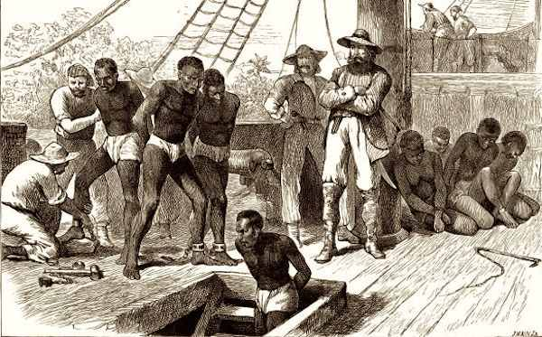

Source 2: Slave Ship Plan

Many books showed plans on how to store the most enslaved people on a ship (like this one below). Imagine what it would have been like to be forced on a ship like this for over two weeks, which is the time it took to travel from Africa to the Americas.

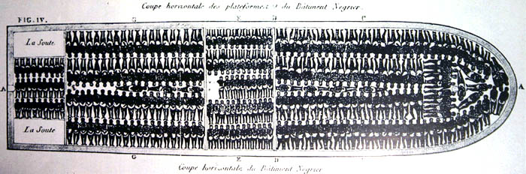

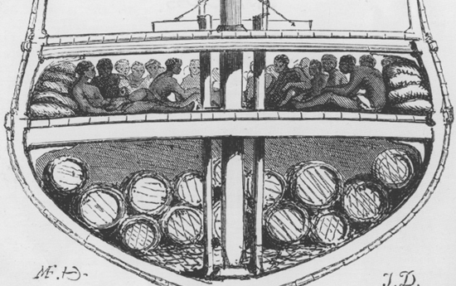

Source 3: Slave Auctions

Enslaved people were treated as property, much like a car or house today. They were auctioned off to the highest bidders. They could be bought and sold several times during their lives. Sometimes parents were sold away from their children and families were broken up. Enslaved people were also sometimes rented out to other plantations. When they were married, enslaved people would often say “until death or distance,” since they had no control of where they lived or who owned them.

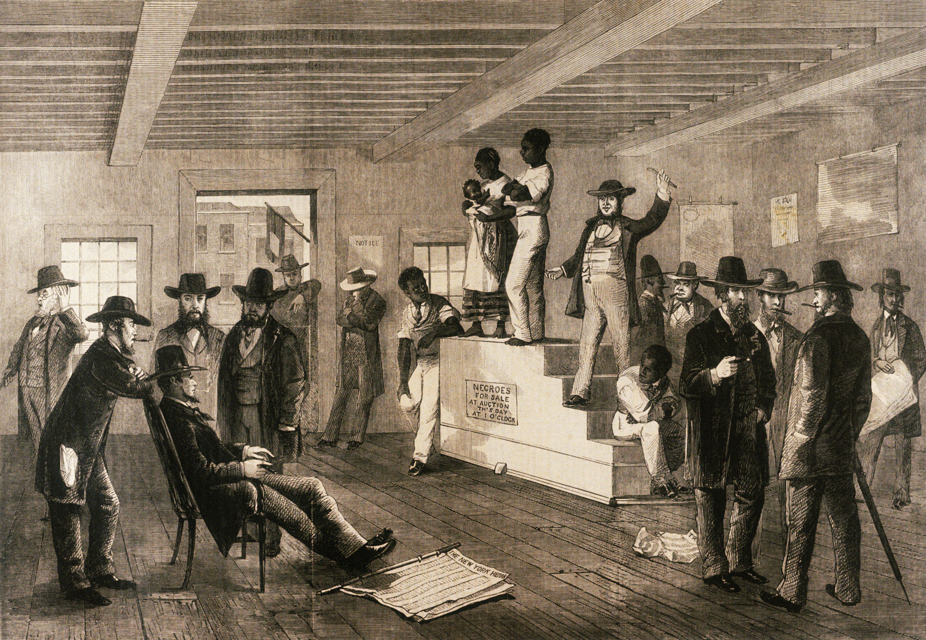

Source 4: Violence Used on Enslaved People

Slave masters and overseers often used violence on enslaved people to force them to work. This included the wearing of collars (especially for runaways), whipping, beating, and even killing.

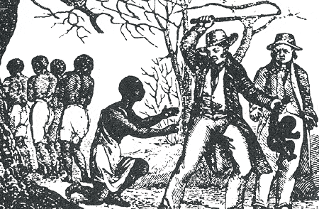

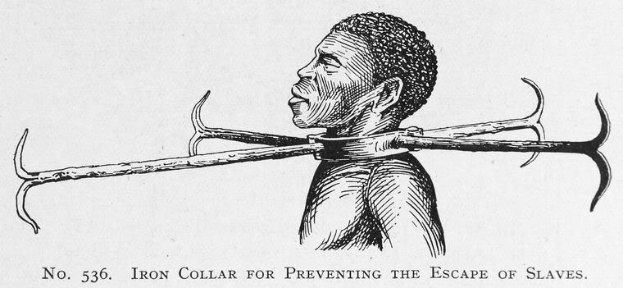

Source 5: Nat Turner’s Rebellion

In August 1831, Nat Turner, who was an enslaved Black man in Virginia, led a slave rebellion and wanted to end all slavery. This is a newspaper report from the Raleigh Register about the rebellion. In the end, 55 to 65 White people were killed. Nat Turner would be captured and put to death along with 55 other enslaved people accused of being involved.

Another slave rebellion! For the last 24 hours, this city has been in a state of excitement. Slaves have risen against Whites. We must put down these slave rebellions.

Source 6: The Amistad Case

In July 1839, a group of enslaved African people being transported to the United States rebelled against the crew of their slave ship. The enslaved people were put on trial. The U.S. Supreme Court ruled that they were illegally enslaved and they were freed.

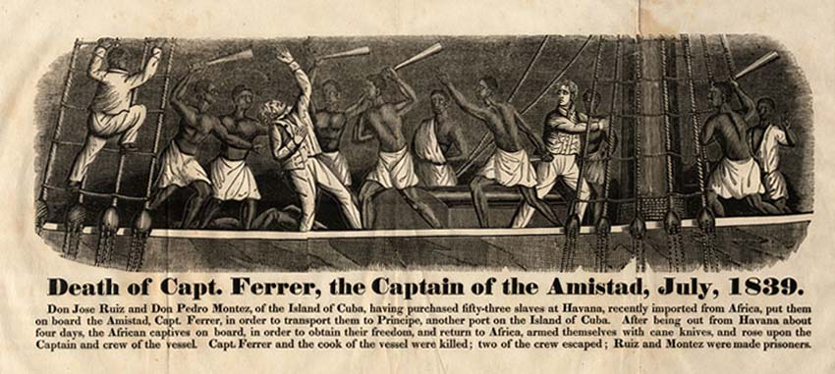
SOURCEBOOK 5-8.A

Images (A)
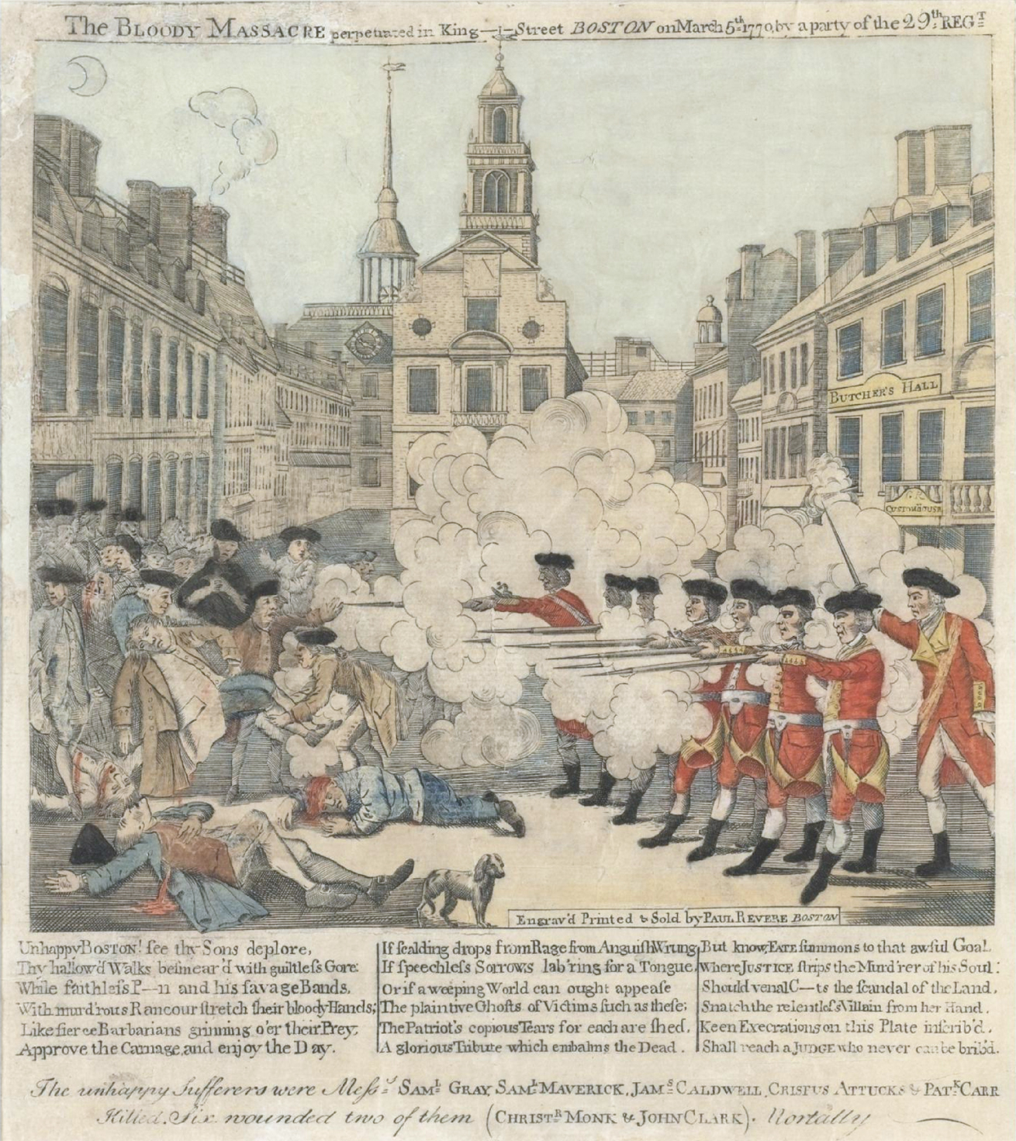

Images (B)
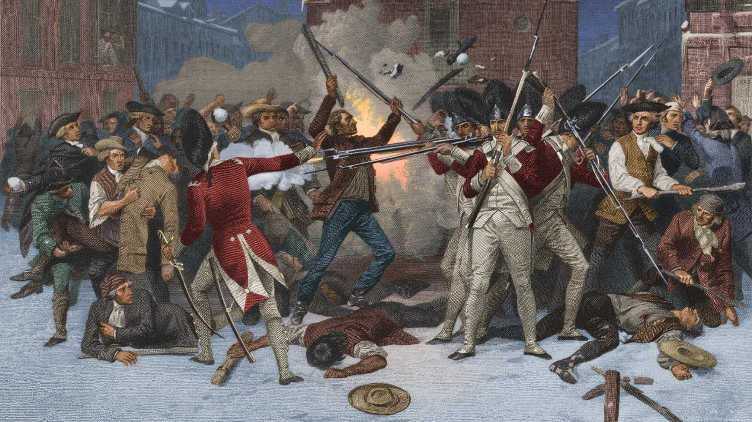

SOURCEBOOK 5-8.C

Boston Massacre: Sources

Lawyer’s Question

What do you know about the incident that happened on King Street last March?

Map of the Town House

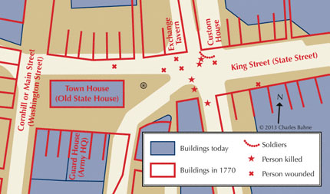

Witnesses for the Prosecution
(Against the Soldiers)

Source 1: Samuel Hemmingway Testimony

Questioned by: Samuel Quincy

I know many of the British soldiers. One evening I heard one solider say he would, if he had the chance, fire on the people of Boston. He said had wanted to ever since he landed here. That was about a week before this all happened.

Source 2: John Wilme Testimony

Questioned by: Robert Treat Paine

About ten days before the massacre a British solider named Christopher Rumbly of the 14th Regiment was at my house. He did talk very much against the town of Boston and said if there should be any problems, that the British Army was to march up King Street and stop them. He said he had been in many battles and that he thought he would soon be in a battle with colonists here. He would not miss with his musket and there will soon be blood in the streets of Boston.

Source 3: William Wyatt Testimony

Questioned by: Samuel Quincy

I heard the fire alarm bell ringing. I saw people running in several directions. I went the south side of the Town House, saw an officer leading out 8 or 10 men. Somebody met the officer and said “Captain Preston, look at this crowd. Take care of your men.” Preston told his men to turn around and they loaded their muskets. I saw about 100 people in Kings Street yelling, “Fire! Fire!” at the soldiers, trying to get them to shoot. In about 10 minutes, I heard a British troop say “Fire.” The soldiers took no notice. His back was to me, but I have no doubt the officer was Preston.

Source 4: John Cole Testimony

Questioned by: Robert Treat Paine

I saw Thomas Preston after the firing and spoke to the soldiers. I told them it was a cowardly action to kill men. They were pushing away people who were trying to come into the street and save those who were shot. A man in a red coat, which is what soldiers wear, came up and said, “Let them take the consequence of this.” I think he meant that this was the people’s own fault. I was within four feet of him. The soldiers were pushing and striking the people with their guns. I saw the people's arms moving but they had no sticks.

Source 5: Robert Goddard Testimony

Questioned by: Samuel Quincy

Captain Preston told the colonists to go home. The colonists were throwing snowballs. They did not leave, but threw more snowballs. The Captain was behind the soldiers. He told them to fire. One gun went off. A sailor or townsman struck the Captain. He said “Fire!” They all fired one after another about 7 or 8 in all. I was so near the officer when he gave the word fire that I could touch him.

Witnesses for the Defense
(For the Soldiers)

Source 6: Ebenezer Bridgham

Questioned by: Josiah Quincy II

There were angry sailors yelling at the British troops. The soldiers stood with their muskets before them to protect the Town House, where the governor’s chamber was. A group of colonists, about twelve in number, with sticks in their hands, stood in the middle of the street. They started yelling and immediately surrounded the soldiers. They hit the soldiers’ guns with their sticks. I saw the people near me on the left, strike the soldiers' guns, daring them to fire. He said “fire!” and called them cowardly rascals.

Source 7: Ebenezer Hinkley Testimony

Questioned by: John Adams

Just after 9 o'clock, I saw many soldiers come out of the Guard House. Someone, I don’t know who, cried out, “Fire upon them!" I followed them down before the Custom House door. The soldiers prepared their muskets. In 2 or 3 minutes, a boy threw a small stick. Then someone threw some pieces of snow as big as an egg. The group of people were about a foot away said, “They won’t fire! Don't be afraid.” I was a foot away from Captain Preston and I did not hear him give an order to fire.

Source 8: Theodore Bliss

Questioned by: Josiah Quincy II

I went to the Custom House. I saw Captain Preston there with the soldiers. I asked him if the muskets were loaded. He said yes. I saw the people throwing snow balls at the soldiers and saw a stick about 3 feet long strike a soldier upon his right cheek. He then fired. One or two snow balls then hit the soldier and another stick struck, before he fired. I did not hear any order given by the Captain to fire. I stood so near him, so I would have heard him.

Source 9: Newton Prince

Questioned by: John Adams

I heard the fire alarm bell ring. I ran out. I was told that there was no fire, but something better, there was going to be a fight. Some had buckets and bags and some had clubs. I saw some soldiers coming out of the Guard House with their guns and running down one after another to the Custom House. The people were calling them Lobsters, a mean name because of their red soldiers coats. The crowd dared them to fire. I saw Captain Preston speak to the people and try to calm them down. The people yelled “Fire!” I have heard no orders by the Captain to fire, only the people cried fire.

Source 10: Lieutenant Governor Thomas Hutchinson

Questioned by: Josiah Quincy II

After this happened, I asked Captain Preston, “How could you have told the soldiers to fire?” I thought he was offended at being asked, saying he did not tell the soldiers to fire. I do not know Captain Preston well, but his general character is extremely good.

Source 11: Captain Thomas Preston

Questioned by: John Adams

Everyone knows that the Majesty’s troops have not been welcome in Boston. The people here have been spreading lies about the British troops.

That night, about 9 soldiers came to me and said that the town’s people were gathering and we going to attack the soldiers. When we walked to the Town House, there was a large crowd there and they were saying the most horrible things. All of the King’s money is in the Custom House. I was told the people wanted to attack the soldier guarding it and take his money. I sent 12 soldiers there. The mob became larger. They had clubs. The mob yelled, “You rascals, you bloody backs, you lobster scoundrels, fire if you dare.”

Some well-behaved persons asked me if the guns were loaded. I replied yes. They then asked me if I would order the men to fire. I answered no. While I was speaking, one of the soldiers having received a severe blow by a stick and instantly fired his gun. After this, my men were hit with by a great number of heavy clubs and snowballs being thrown at them. All of our lives were in danger.

On my asking the soldiers why they fired without orders, they said they heard the word fire and supposed it came from me. This might be the case as many of the mob called out “Fire! Fire,” but I told the men that I gave no order; that my words were, don't fire, stop your firing.

SOURCEBOOK 5-9.A

Road to Revolution: Image Sort (A)

Try to put these images from 1754-1776 in chronological order, from the first (oldest) image to the last (newest) image.

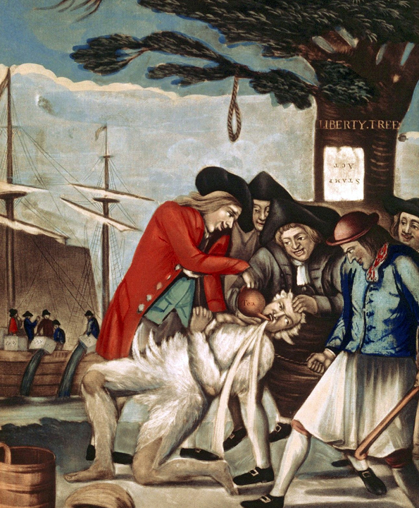
Road to Revolution: Image Sort (B)

Try to put these images from 1754-1776 in chronological order, from the first (oldest) image to the last (newest) image.

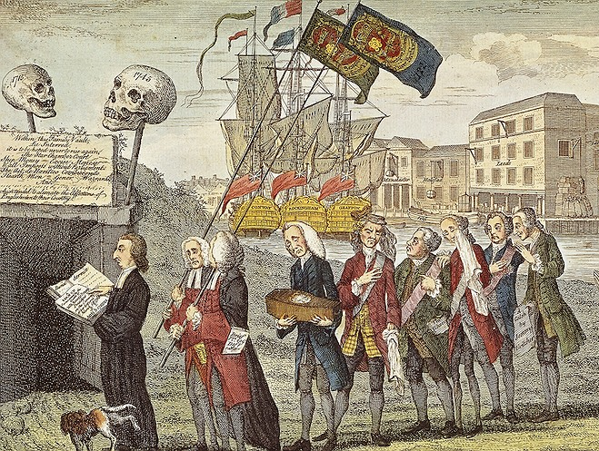

Road to Revolution: Image Sort (C)

Try to put these images from 1754-1776 in chronological order, from the first (oldest) image to the last (newest) image.

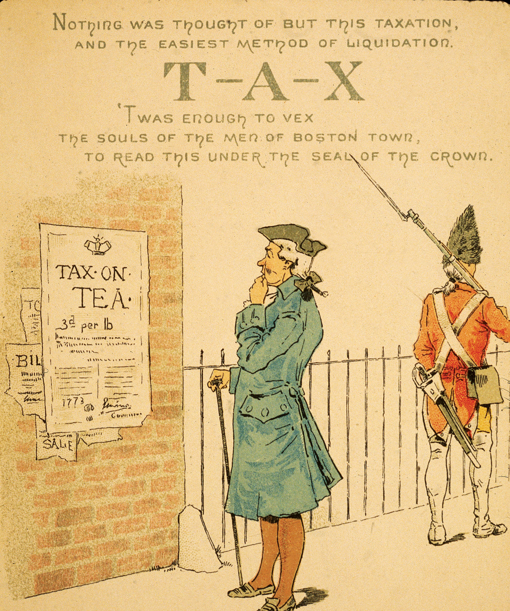

Road to Revolution: Image Sort (D)

Try to put these images from 1754-1776 in chronological order, from the first (oldest) image to the last (newest) image.

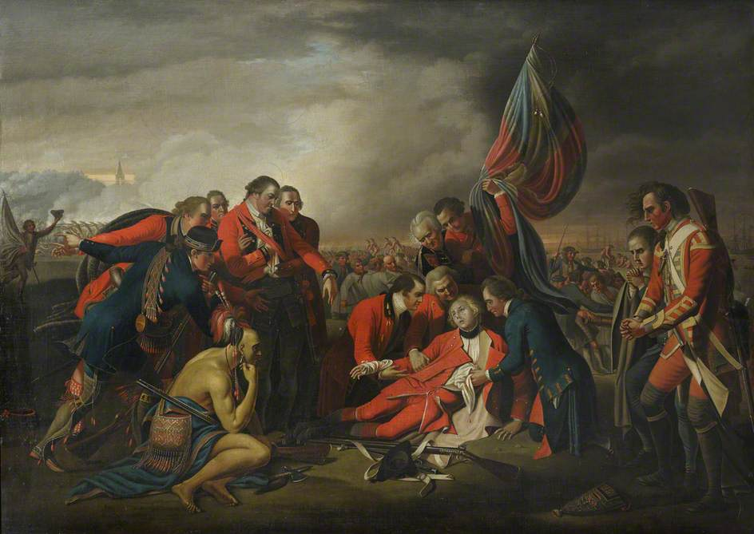

SOURCEBOOK 5-9.B

Road to Revolution: Sources

Source 1: French and Indian War or War of Conquest?

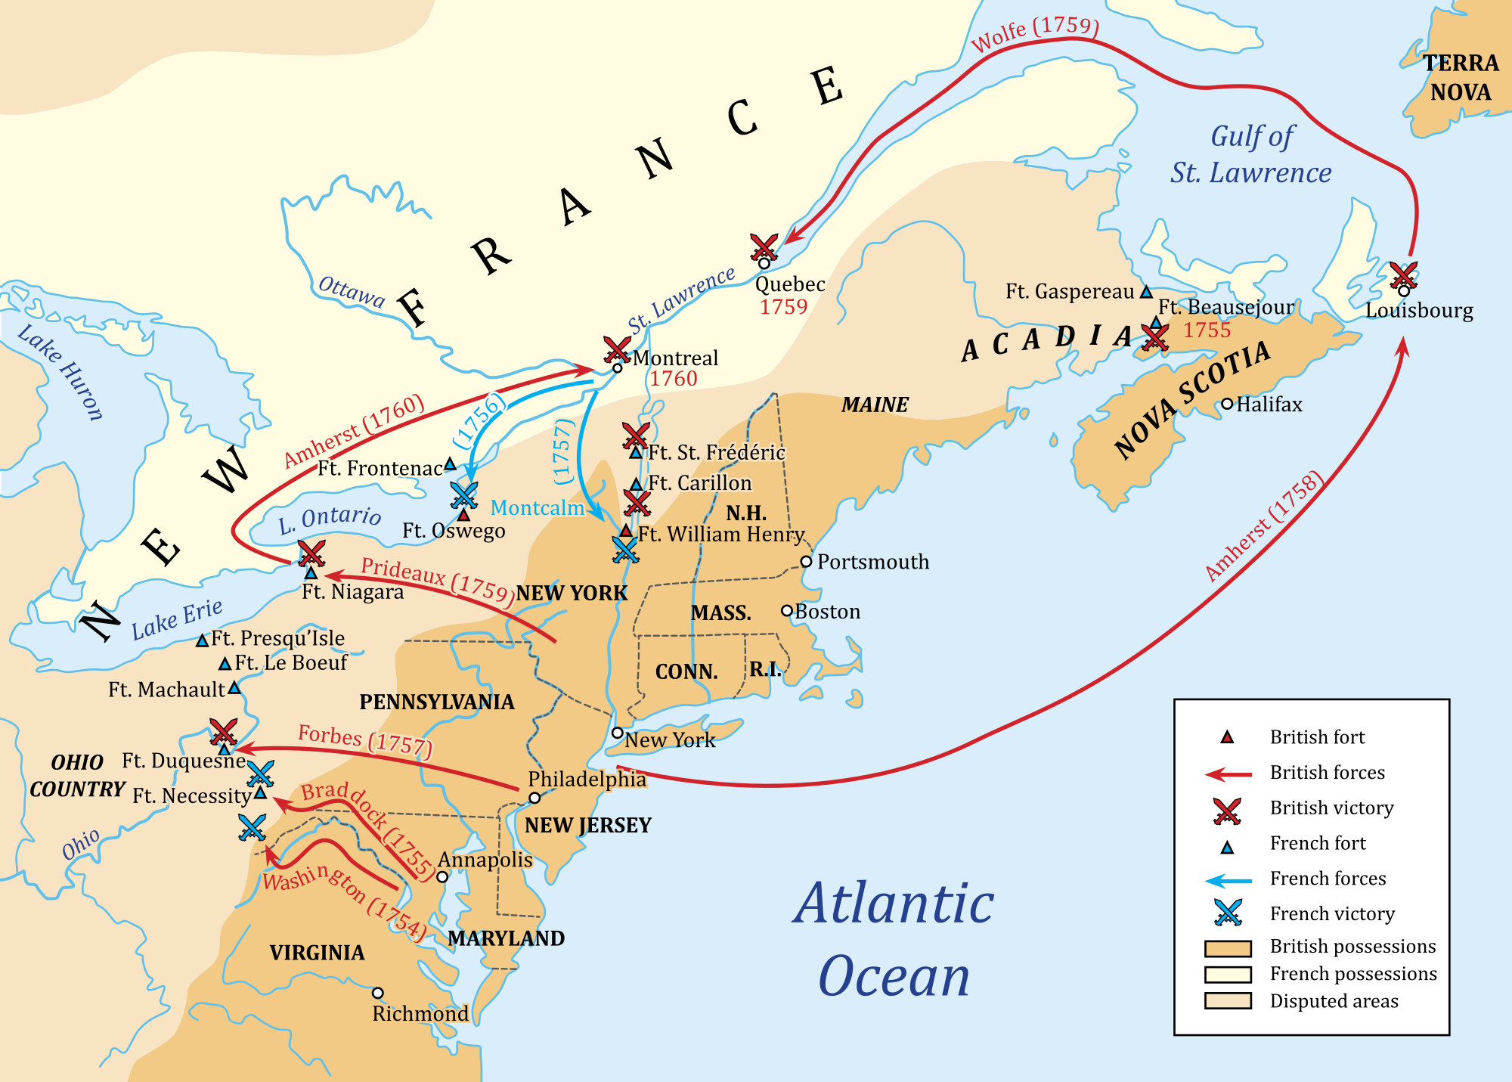

The British fought the French in a war from 1754-1763. The British colonists called this war “The French and Indian War,” because they, along with their Iroquois Indian allies were fighting the French and their Algonquin Indian allies. The French colonists called this “The War of Conquest,” because the British were fighting it to take their land in Canada. Above is a map of all the major battles of the war.

The French had a larger military in the Americas and did very well in the beginning of the war. The British would decide to spend a lot of money (£70 million, which would be about $80 billion today) and win the war. At the end of the war, Britain and France signed the Treaty of Paris, which gave all of Canada to Britain. Britain allowed the French people to stay in Québec, continue to speak French, and practice Catholicism, which angered many of the British colonists (who spoke English, were Protestant, and were afraid of the French). The French and Indian War debt (money owed) would lead to the British putting many taxes on the colonists to pay for it.

Support: The war was fought to protect us, the British colonists from France. Britain won and we are safe. We rule over Canada.

Against: The war was unnecessary and fought so that Britain could expand its empire. It made us, the British colonists, less safe by angering the French colonists and Indians.

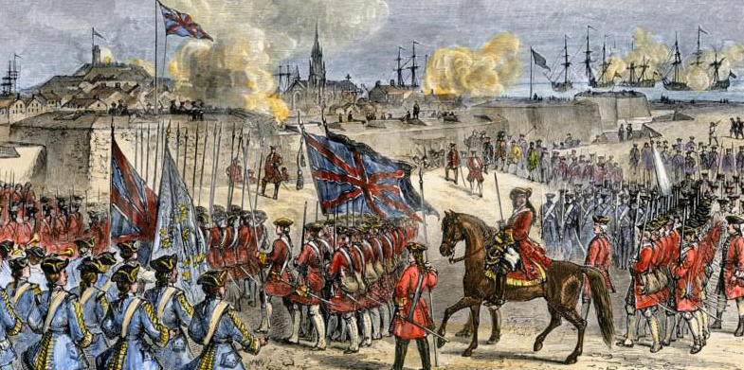
Above: The British victory that ended the French and Indian War.

Source 2: The Sugar Act (1764)
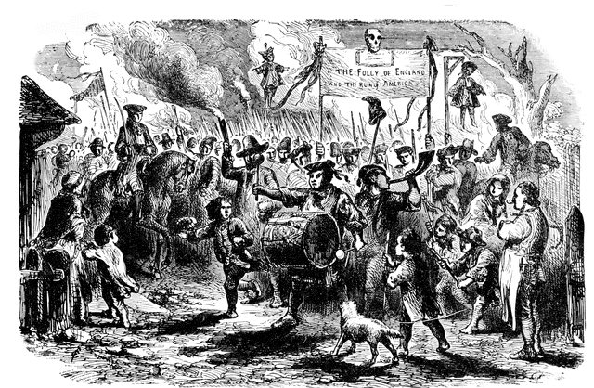

Text of the Sugar Act: Where there needs to be new money for the Kingdom to provide protection and peace in the colonies, … there will be a tax placed on syrups and molasses. … Colonists cannot buy sugar from other countries. All of the money collected will go to paying for the military protection of the American colonists.

In 1764, to help pay for the French and Indian War, the British Parliament forced colonists to pay a tax on sugar products, such syrup, molasses, and rum alcohol. Many colonists refused to pay the tax (boycotts), smuggled French or Spanish sugar, and marched in the streets against it (like the protest pictured above). The Parliament would eventually get rid of the law because it made so many colonists mad.
Support: We are loyal British people who support our King. The French and Indian War was justified and we should help pay for it.

Against: We have no representative in Parliament. We would be willing to pay needed taxes, as long as we get to have a say in what is taxed.

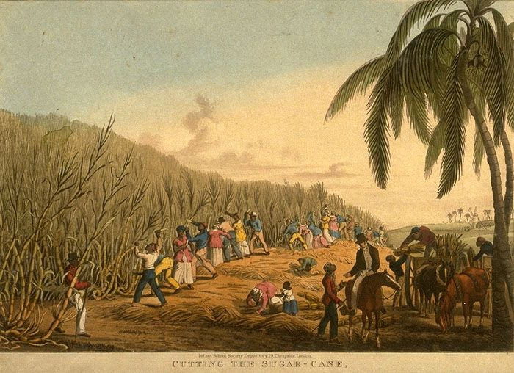
Above: A sugar cane plantation.

Source 3: The Stamp Act (1766)
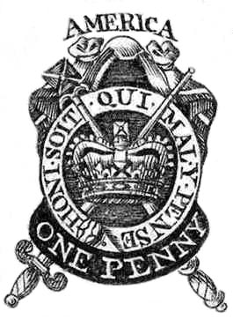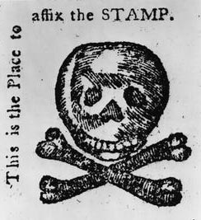
Above: (Left) What a stamp looked like. (Right) A fake protest stamp with skull and crossbones used to protest the Stamp Act.

Text of the Stamp Act: Where there needs to be money for the defending and protection of the colonies in America, … there will be a tax of 3 pence placed on sheet or piece of paper for legal reasons … 1 halfpenny placed on pamphlets and newspapers. … 10 shillings placed on playing cards

In 1765, to help pay for the French and Indian War, the British Parliament forced colonists to pay a tax on all printed materials, such as legal documents, magazines, newspapers, and even playing cards. Many colonists refused to pay the tax (boycotts) and marched in the streets against it. The Parliament would eventually get rid of the law because it made so many colonists mad.

Support: We are loyal British people who support our King. The French and Indian War was justified and we should help pay for it.

Against: We have no representative in Parliament. We would be willing to pay needed taxes, as long as we get to have a say in what is taxed.

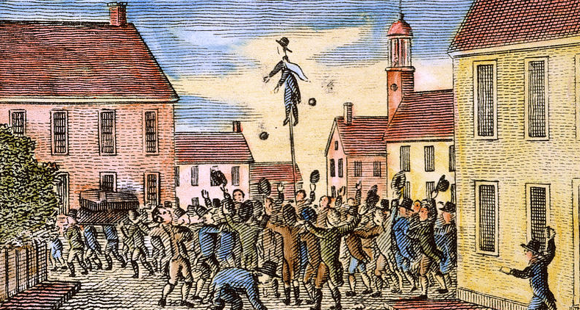
Above: Protesters in New Hampshire burning a tax collector doll in protest of the Stamp Act.

Source 4: The Townshend Acts (1767)

Text of the Townshend Act: Where the Majesty needs money to run the colonial governments, taxes will be put on … glass, … lead, … painting colors (paint), … tea, … atlases, … sugar, … paper, … pots, … dishes.

In 1767, to help pay for the French and Indian War, the British Parliament forced colonists to pay a tax on many items brought into the colonies from elsewhere, such as glass, lead, paint, tea, atlases, sugar, paper, pots, dishes. It was named after Charles Townshend, the Parliament member who came up with the tax. Many colonists refused to pay the tax (boycotts) and marched in the streets against it. The Parliament would eventually get rid of the law because it made so many colonists mad.

Support: We are loyal British people who support our King. The French and Indian War was justified and we should help pay for it.

Against: We have no representative in Parliament. We would be willing to pay needed taxes, as long as we get to have a say in what is taxed.

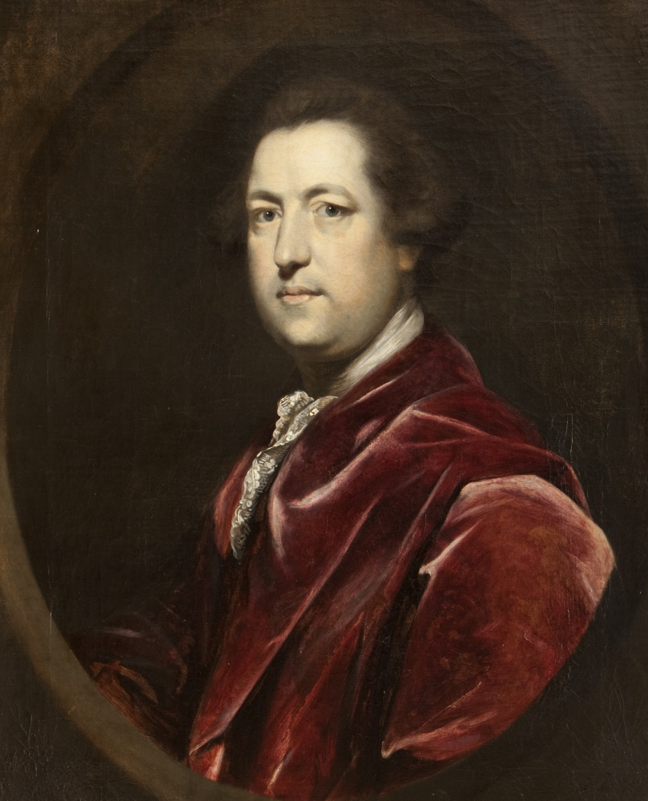
Above: A picture of Charles Townshend, who came up with the Townshend Acts.

Source 5: The Tea Act (1773)

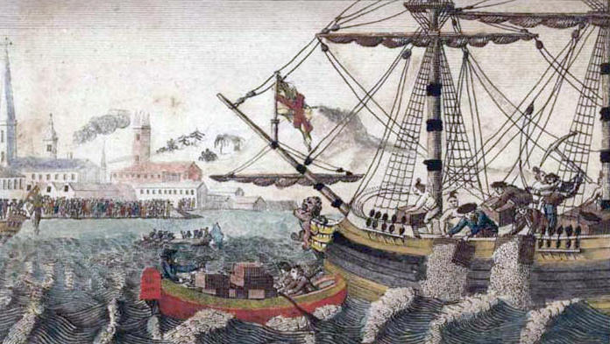

Text of the Tea Act: There shall be a tax on all public sales of East Indian Company Tea. Colonists shall only buy tea from the East Indian Company.

In 1773, to help pay for the French and Indian War, the British Parliament forced colonists to pay a tax on tea, which was one of their most popular drinks. It also required them to buy their tea from one British company (a monopoly) called the East India Company. Many colonists did not like that they had no person to represent them in Parliament, so no one to vote on what was taxed. Many colonists refused to pay the tax (boycotts) and protested in the streets.

In December 1773, a group of mostly men rant to an East Indian Company ship and threw tea into Boston Harbor in protest (Boston Tea Party). In January 1774, a tax collector named John Malcom had gotten in a fight with a patriot boy and man. A group of Bostonians found him, dragged him out into the streets, and tar and feathered him, which means to put hot tar on someone and then throw feathers on them.

The Parliament would be so upset at these protests, instead of getting rid of the law, they closed the Port of Boston to trade, prevented colonial government from meeting, and stationed more soldiers there to keep the peace.

Support: We are loyal British people who support our King. The French and Indian War was right and we should help pay for it. Those who want to rebel from the Crown are only thinking about themselves, rather than our country and King. Also, most of the laws the colonists did not like have been ended. There is no need for representation in Parliament, because they listen to us already.

Against: We have no representative in Parliament. We would be willing to pay needed taxes, but we have been given so many new taxes without any say. We should rebel from the Crown.

SOURCEBOOK 5-10.B

Boston Tea Party: Sources

Source 1: Boston Tea Party Image

Source 2: An Account of Dumping the Tea (Boston Gazette)

Last Tuesday, people from many towns, as far away as 20 miles, gathered at the Old South Meeting House to send the East India ship Dartmouth back to London. When they refused to send the ship back to London, a number of brave men went down to the boats and emptied every one of the 342 chests of tea on the three ships. There was no damage done to the ships or any other property. The people of Boston gathered on the shore and almost everyone was happy about this event.

Source 3: George Robert Twelve Hewes’s Account of the Tea Party

During the time, we were throwing the tea overboard, there were several attempts made by some of the citizens of Boston and its vicinity to carry off small amount of tea their family. … Being found, the group stopped them. With one man, they took his hat and wig from his head, threw him with the tea … into the water. Another man, since he was old, was allowed to escape. We wanted to make sure that everyone knew this was a protest for an injustice, not stealing.

Source 4: Join, or Die

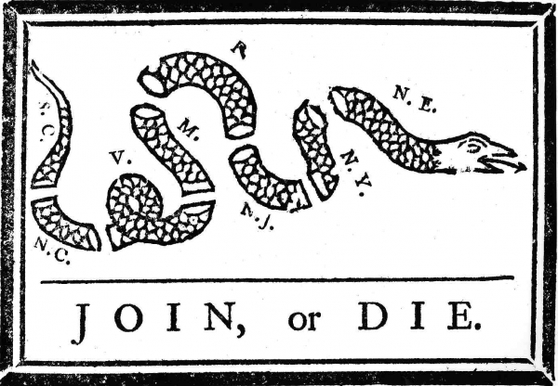

“Join, or Die” is a political cartoon, drawn by Benjamin Franklin during the French and Indian War to tell the British colonists to fight the French. The letters (S.C.=South Carolina, V.=Virginia, N.Y.=New York, N.E.=New England, etc.) represent the different colonies. After the Boston Tea Party, this image would be used to tell the colonists to join the patriots and unite against the British government.

Source 5: Connecticut Farmer Samuel Seabury’s Letter

Our peace is falling apart because our government is being taken over by rioting men. People are being denied liberty and their property is being destroyed. Men are saying a rebellion must occur because of a dispute with our Mother Country (Britain). That is crazy! Will you choose some group of rebels to lead us? … No, if I must be enslaved, let it be by a KING and not by a bunch of lawless men.

Source 6: Benjamin Franklin’s Letter to Boston Men

Benjamin Franklin, who was born in Boston and lived in Philadelphia, was a speaker for several American Colonies in London. After hearing about the Boston Tea Party, he wrote this letter to several Boston men, including Samuel Adams and John Hancock, who were the leaders of the Sons of Liberty (who lead the Tea Party protests). After, several members of Parliament accused him of starting the rebellion and forced him to return to the colonies.

I am very concerned. I know you are good men and you have no need to destroy private property. Most people here in England believe that Parliament has the right to tax. The East India Company are not our enemies. I wish and hope that you will repay them for any damage that you caused.

SOURCEBOOK 5-11.A

Lexington and Concord: Sources

Source 1: Diary of Lieutenant John Barker, British Army

A report from a British Army official who was at Lexington Green.

At 2 o’clock in the morning we marched through a very long stream. About 5 miles away from a town called Lexington, we heard there were hundreds of people there who were against us. At 5 o’clock we arrived there and saw many people, between 200 and 300. … As we came near them, they fired one or two shots, upon which our men without any orders, fired back. … We waited for some time there and continued to Concord.

Source 2: Statement by Colonial Militiamen

A statement signed by 32 of the colonial militiamen, who were at Lexington Green. The militiamen were often called “minutemen” because they were to always be ready within a minute.

We were 32 men present on Lexington Green on April 19, 1775. … At about five o’clock in the morning, we went towards the Green, and saw a large body of troops marching towards us. We started to walk away. While our backs were turned to the British troops, they fired on us, and a number of our men were
instantly killed and wounded. Not a gun was fired by any person in our company on the British soldiers before they fired on
us, and continued firing until we had all made our escape.

Source 3: An Account from Ann Hulton

Ann Hulton heard this from her brother, who was at Lexington Green. Her brother was a custom’s commissioner, who collected taxes for the King.

The people in the country had given guns to the minutemen companies in every town. … About daybreak a number of the people appeared before the troops near Lexington. They were called to leave. They fired on the troops and
ran off. The soldiers then shot about fifteen of
them. The troops went on to Concord.

Source 4: Statement by Lieutenant William Sutherland, British Army

A report from a British Army official who was at Lexington Green.

On coming near to the Village of Lexington a fellow from the corner of the road on the right pointed his loaded his gun at me ... I told Major Pitcairn of it right away. We still went on further when three shots were fired at us, which we did not fire back. They came from the corner of a large house [Buckman Tavern] to the right of the Church.

This is possibly evidence that it was neither the British soldiers or the colonial militiamen, but someone else at the corner of the Buckman Tavern.

Source 5: Account from Sylvanus Wood, colonial militiaman

The British officer swung his sword, and said, “Lay down your arms, you rebels, or you are all dead men. Fire!” Some guns were fired by the British at us. No person was killed or hurt. Captain Parker (leader of the colonial militia) ordered every man to take care of himself. The company immediately ran away. While leaping over the wall, the British fired and killed some of our men.

Source 6: After Lexington Green

The incident on Lexington Green resulted in eight colonial militiamen were dead and nine were wounded. No British soldiers were dead and one was injured.

The British Army continued on to Concord to find the barn full of illegal guns. They burned some gun carriages that they found, which spread to the Lexington Town Meetinghouse.

After searching for the guns for four hours without finding them, the British Army was getting ready to go back to Boston. At this time, over 2,000 militiamen had gathered near the North Bridge. Guns went off again. The militiamen were firing at the British soldiers from behind trees, stone walls, and houses. The British troops started running back to Boston. Many dropped their weapons and clothing in order to run faster.

SOURCEBOOK 5-12.B

Declaration of Independence: Sources

Source 1: Declaration of Independence (Modified and Abridged)

The unanimous declaration of the thirteen united States of America. When in the Course of human events, it becomes necessary for one people to stop being connected with another, it requires that they should say the reasons why they are separating (break apart).

We hold these truths to be self-evident, that all men are created equal, that they are endowed by their Creator with certain unalienable Rights, that among these are Life, Liberty and the pursuit of Happiness. That Governments are made by Men, and get their powers from the people who are being governed. Whenever any Government becomes hurtful, it is the Right of the People to change or to abolish (get rid of) it, and to make a new Government. … The history of the present King of Great Britain is a history of repeated injuries (hurting) and usurpations (doing things wrong), he has an absolute Tyranny (dictatorship, cruel ruler) over these States. To prove this, let Facts be submitted to the world.

He has refused to follow his own Laws, which are necessary for the public good.

He has stopped his Governors from passing laws until he approves them.

He has called legislative bodies at unusual, uncomfortable, and distance places.

He has refused the right to the people to rule themselves, by ending their Representative Houses (legislatures and assemblies).

He has stopped foreigners from becoming citizens and refused to allow people to migrate here.

He has stopped the judges and courts, so justice cannot be done. When judges do rule, they must do only what the King says.

He has sent new royal officials to harass (bother) our people.

He has kept armies among our people during a time of peace without our permission. They are quartered (staying in our houses and barns) among us.

He has cut off our Trade with the rest of the world.

He has pit Taxes on us without our Consent (permission; asking us).

He has stopped trials with juries of our fellow citizens.

He has declared that he is protecting us, but really waging war against us.

He has plundered our seas, ravaged our Coasts, burnt our towns, and destroyed the lives of our people.
He has sent foreign soldiers here to fight against us.

He has encouraged fellow citizens to riot and encouraged Indians to attached the people living in the frontier.

A Prince whose character is a Tyrant (dictatorship, cruel ruler), is unfit to be the ruler of a free people. We have wanted the attention of our British brothers. We have warned them of how we have been treated. They have not listed to us. We must then have a Separation (break apart).

We, therefore, the Representatives of the united States of America, in General Congress, Assembled, appealing to the Supreme Judge of the world, do, solemnly publish and declare, That these United Colonies are, and of Right ought to be Free and Independent States; that they are Absolved (free) from all Allegiance (to follow) to the British Crown, and that all political connection between them and the State of Great Britain.

We pledge to each other our Lives, our Fortunes and our sacred Honor.

Georgia
Button Gwinnett
Lyman Hall
George Walton

North Carolina
William Hooper
Joseph Hewes
John Penn
South Carolina
Edward Rutledge
Thomas Heyward
Thomas Lynch
Arthur Middleton

Massachusetts
John Hancock
Samuel Adams
John Adams
Robert Treat Paine
Elbridge Gerry

Maryland
Samuel Chase
William Paca
Thomas Stone
Charles Carroll

Virginia
George Wythe
Richard Lee
Thomas Jefferson
Benjamin Harrison
Thomas Nelson
Francis Lee
Carter Braxton

Pennsylvania
Robert Morris
Benjamin Rush
Benjamin Franklin
John Morton
George Clymer
James Smith
George Taylor
James Wilson
George Ross

Delaware
Caesar Rodney
George Read
Thomas McKean

New York
William Floyd
Philip Livingston
Francis Lewis
Lewis Morris

New Jersey
Richard Stockton
John Witherspoon
Fran. Hopkinson
John Hart
Abraham Clark

New Hampshire
Josiah Bartlett
William Whipple

Rhode Island
Stephen Hopkins
William Ellery

Connecticut
Roger Sherman
Sam Huntington
William Williams
Oliver Wolcott

New Hampshire
Matthew Thornton

SOURCEBOOK 5-13.A

Prince Hall

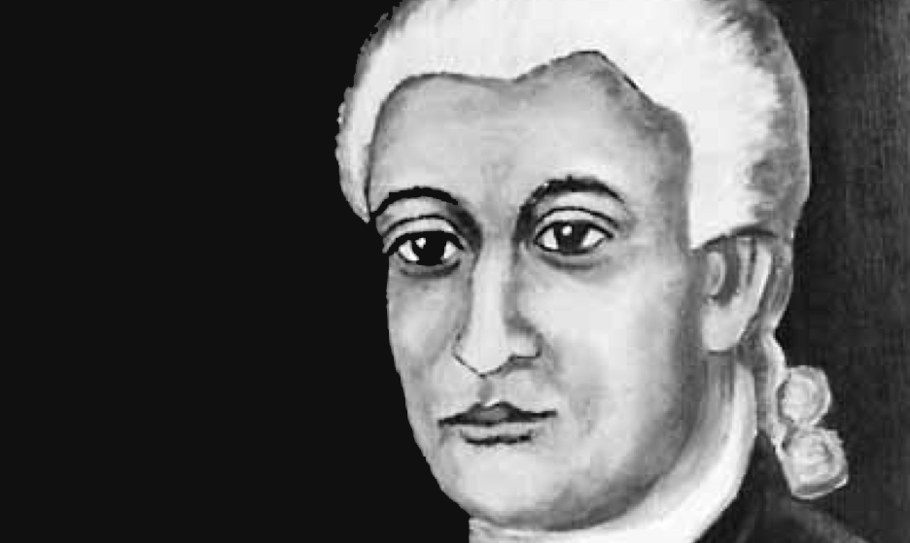

Prince Hall was an African American from Massachusetts. He was born a slave, but gained his freedom by age 11. He became an abolitionist (against slavery). He also convinced Massachusetts to allow Blacks to attend public school (which was only for Whites). At the beginning of the war, he was a leather seller and made drum heads for the Patriot army. Black people were not allowed to join the Continental Army (Patriots), but he started a group to change that. He compared the colonists’ treatment by Britain to that of enslaved people. He thought if African Americans fought in the war, the White Americans would free enslaved people after the war. Prince Hall would fight in the war. He was sad about Patriot losses (New York City), but celebrated victories (Ticonderoga, Saratoga, Yorktown). Sadly, slavery would not be ended at the end of the war.

SOURCEBOOK 5-13.B

Thayendanegea/Joseph Brant

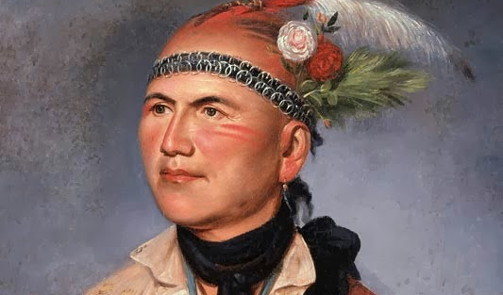

Thayendanegea (thay-en-day-nee-gee-ah) was a Mohawk Indian from New York. He lived in an area with many different groups and could speak Mohawk, several other Native languages, English, and German. He went to a school to learn to write English and there he took the English name Joseph Brant. At the beginning of the war, he was angry that the American colonists were trying to take his people’s land. Thayendanegea joined the British army. He became the leader of Indian soldiers in the British army. In 1779, the Continental Army (Patriots) marched through Pennsylvania and New York burning many Indian villages. Brant stood up to this. He was happy about Patriot losses (New York City), but sad about their victories (Ticonderoga, Saratoga, Yorktown). In the end, the Patriots would win and Brant and other Mohawks fled to Canada.

SOURCEBOOK 5-13.C

Deborah Sampson

Deborah Sampson was an English American from Massachusetts. As a young girl, her father left the family and her mother died, which was very difficult for her. Deborah would become a teacher. At the beginning of the war, she was upset that women were not allowed to be soldiers. She cut her hair, changed her clothes, made up a fake name of Robert Shirtliff, and joined the Continental Army (Patriots). She would fight in the war for a year and a half. She was sad about Patriot losses (New York City), but celebrated victories (Ticonderoga, Saratoga, Yorktown). During one battle, she was shot. To avoid doctors finding out her gender, she took the bullet out herself. Since then, we have learned that several other women also pretended to be men and joined the army. Women would not officially be able to join the U.S. military until the 1900s.

SOURCEBOOK 5-13.D

Titus Cornelius/Colonel Tye

Titus Cornelius, also known as Colonel Tye, was an African American from New Jersey. He was born a slave. Near the beginning of the war, a British military leader Lord Dunmore promised that any slave who fought for Britain would be freed at the end of the war. Titus Cornelius ran away. He took on the name Tye, so his master would not find him. He joined the British “Black Brigade,” which was for African American soldiers. He would eventually become a leader and was known for being a very good soldier. They would often attack plantations and free other enslaved people. They felt fighting for the British was the only way that slavery would be ended, because many White Americans supported slavery. He was happy about Patriot losses (New York City), but sad about victories (Ticonderoga, Saratoga, Yorktown). Colonel Tye (Titus Cornelius) would die near the end of the war after being wounded in battle.

SOURCEBOOK 5-13.E

George Washington

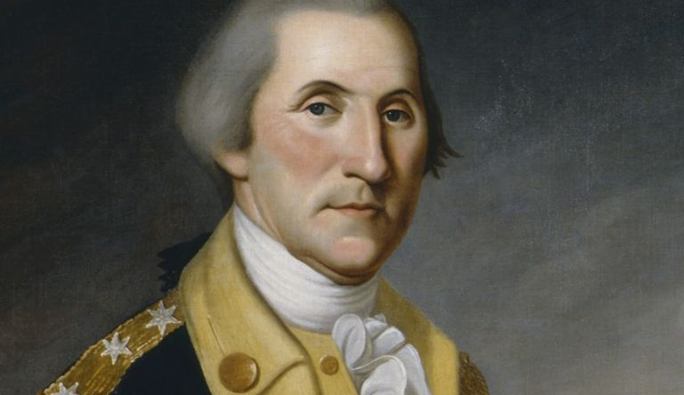

George Washington was an English American from Virginia. He was born into a very wealthy family. During the French and Indian War, George Washington became an important leader of the colonial militia. At the beginning of the war, he is recruited to be the leader of the Continental Army (Patriots). His biggest struggle was at Valley Force, where his men spent the winter in extreme cold and had little food and clothes supplies. Thousands of soldiers would die or run away. After that winter, things were better and George Washington would lead soldiers in many victories. In the Battle of Yorktown, George Washington’s victory would be the end of the war. He was sad about Patriot losses (New York City), but celebrated victories (Ticonderoga, Saratoga, Yorktown). Over time he proved to be a smart military leader and would eventually lead the American forces to victory.

SOURCEBOOK 5-13.F

Benedict Arnold

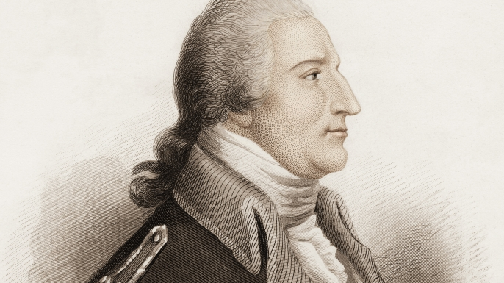

Benedict Arnold was an English American from Connecticut. He was born into a very wealthy family and sold medicine and books. At the beginning of the war, angry at the British taxes, he joined the Continental Army (Patriots). He became a military leader and led victories at Fort Ticonderoga and Fort Saratoga in New York. He then invaded Québec, Canada, which failed. This made many leaders in the Continental Army angry with him. He would then be sent to Philadelphia, Pennsylvania to protect the city. He became angry at the Patriot leaders and started to secretly speak with British military leaders about joining their side. He would switch to the British side in 1780. He was happy about victories that he led (Ticonderoga, Saratoga), but after he switched sides, he was sad with Yorktown (since Britain lost). When the British lost the war, he fled to London and lived there for the rest of his life.

SOURCEBOOK 5-15.A

Sources: Shays’ Rebellion

Source 1: Captain Daniel Shays’ Letter to General Benjamin Lincoln (1786)
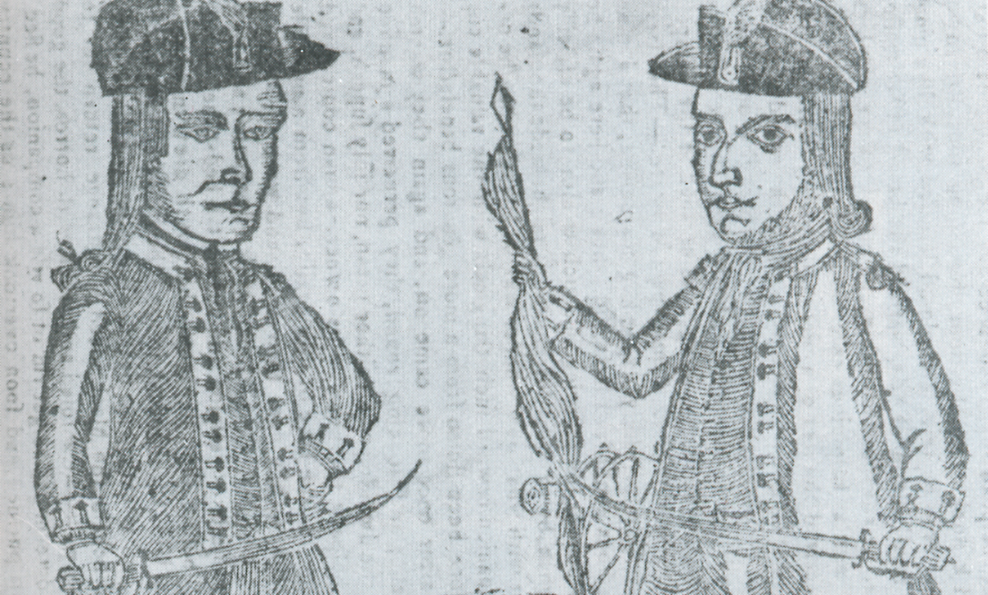

Above: The only known drawing of Daniel Shays (left).

The people assembled (getting together) in Western Massachusetts are furious (angry) and have decided to take up arms (guns). We do this for our families, because we are losing the land that we own. We have no other choice. We are willing to lay down our arms (put down our guns) if you pardon (forgive) us and let us return to our homes.

Source 2: Thomas Jefferson’s Letter to a Friend (1787)
Above: A picture of Thomas Jefferson (1791), who helped write the Declaration of Independence.

What country has never had a rebellion? What country from time-to-time does not warn its rulers that they will resist (fight back) to keep their spirit? Let the Shay’s rebels take arms (guns). This can be fixed by facts and pardon (forgiving).

The tree of liberty must be refreshed (made healthy) from time to time, with the blood of patriots and tyrants (dictators). Our convention has been too much concerned by the rebellion of Massachusetts. They are setting up an eagle to keep the hen yard in order (meaning they are giving us a warning to make things better).

Source 3: Address to the People of the Commonwealth by the General Court (1786)
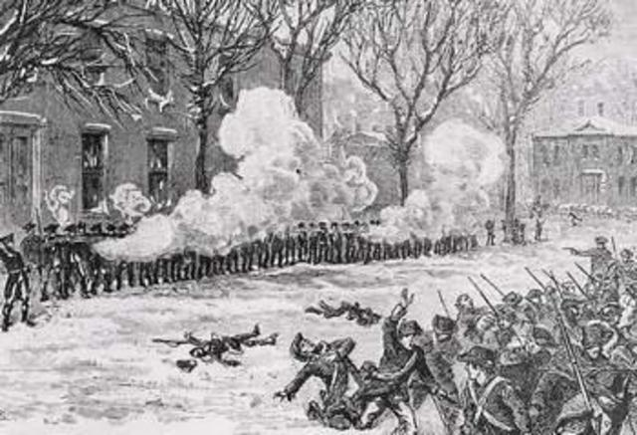
Above: A picture of the Springfield Armory and the fight between Shays’ men and the Massachusetts militia.

Massachusetts has a large debt (money owed) from the Revolutionary War and we think the people of the Commonwealth will be happy if we pay that debt. The reasons for this debt is the citizens. The Legislature (General Court) raised these taxes to bring money again to our Treasury (money saved like a bank). We have used this money to hire men and buy supplies for our army. Our citizens must be more frugal (save their money) and pay their debt. Otherwise this will ruin our Commonwealth.

SOURCEBOOK 5-16.A

Image
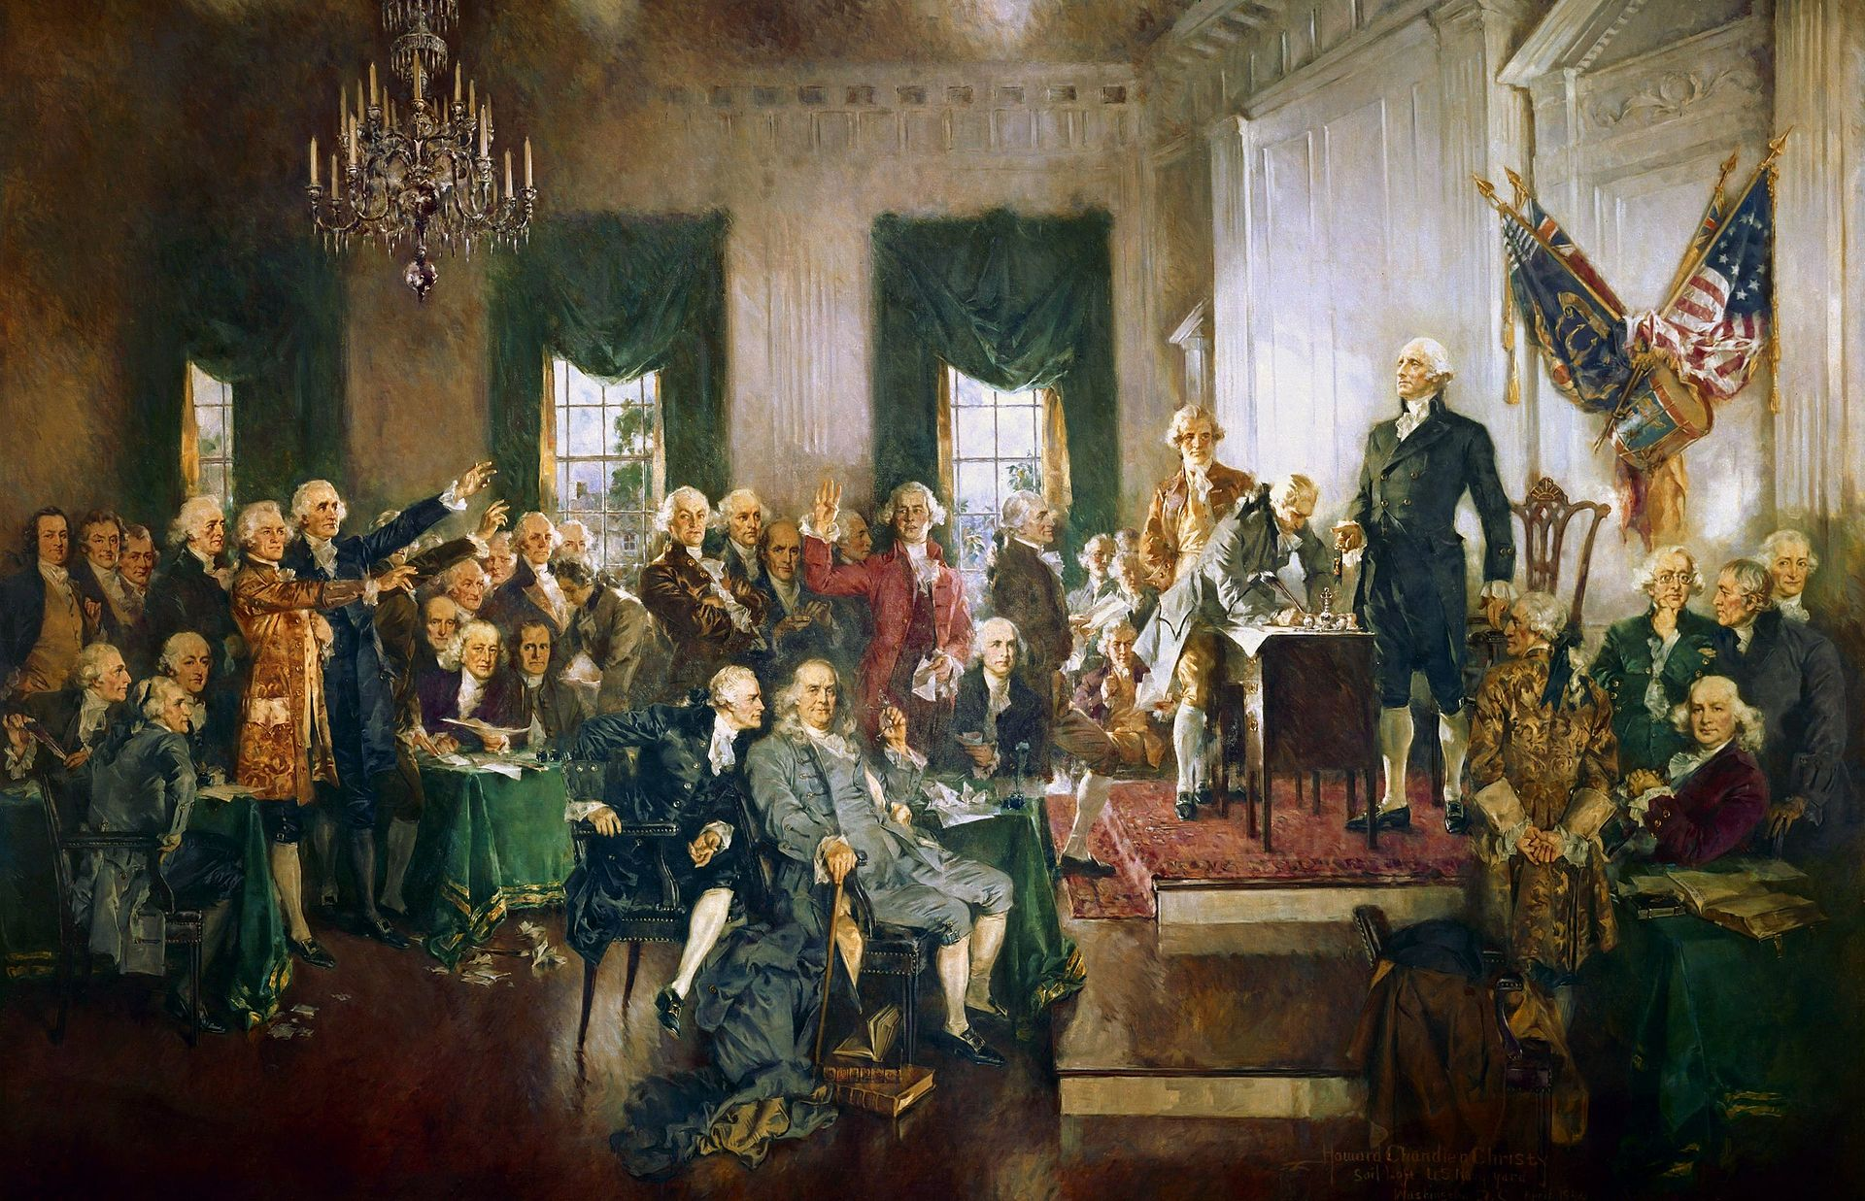

SOURCEBOOK 5-16.B

Mock Constitutional Convention: Roles (Part 1)

Group 1: White Slave Owners

Above: James Madison, a Virginia slave owner and lawyer. He was invited to the Constitutional Convention.

Overview: You have become very wealthy growing and selling tobacco, indigo, and rice in the South. The typical wealthy slave owner has about 25 slaves. The enslaved people do all of the hard work on their plantations. They plant, harvest (cut down), and dry the crops. The enslaved people sometimes run away and a slave catcher can be hired to find and return them. Slave owners see the slaves as their property (own them) and they are very expensive (cost a lot).

Slavery: You are against any attempts to end slavery. Your plantation would not be able to find enough workers without slaves.
Taxes: You want taxes to be low, because they will take away your profit (the money you make from your crops). You make a lot of money selling you crops to other countries. You do not support any taxes on goods sold to other countries through trade (export taxes).

Suffrage (Voting): You believe that people who own land or businesses (property) are better. You believe that women, Black, or Indigenous people are not equal to White men. You only want White men who own property to vote.

Branches of government: You are from a southern state will less population. You are worried the states with more people may get more say in Congress. You want every state to have an equal number of delegates in Congress (equal representation). You support a president who will serve for life and enforce the laws. You support judges to rule on court cases and serve for 10 years, which would allow judges to change more often.

National government power: You are worried that the new U.S. government will have too much power. You supported the American Revolution, because you thought the King had too much power. You want the most power to be given to the states.

Group 2: White Merchants

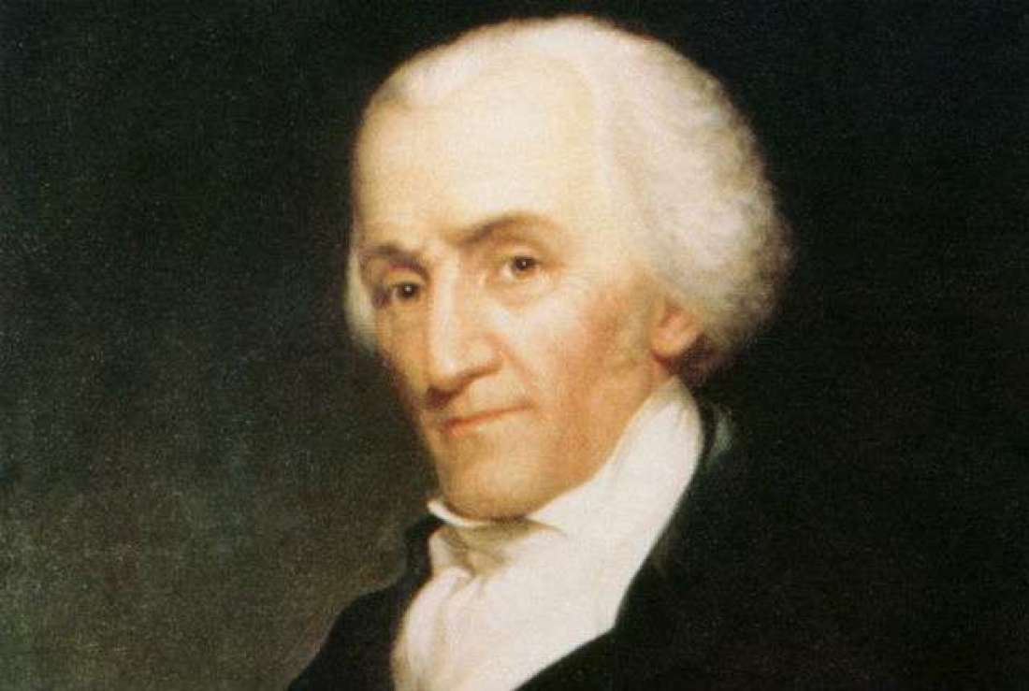
Above: Rufus King, a Massachusetts merchant and lawyer. He was invited to the Constitutional Convention.

Overview: You have become very wealthy as a merchant or businessman in the North. Your business trades molasses, sugar, tea, wine, and other products with people from Europe and across the world. You use to be able to only trade with England, but you can now trade with France, Portugal, Spain, Holland, and other countries. Although you do not own slaves (your state of Massachusetts banned slavery a few years ago), you do get tobacco, rice, indigo, and other items cheap because of slavery in the South.

Slavery: You are against slavery, but are willing to allow it. You think it is immoral, but also know you get cheaper raw materials (things that you turn into other things) from the South.
Taxes: You want taxes to be low, because they will take away your profit (the money you make from trading goods). You do not support any taxes on goods brought in from other countries through trade (import taxes).

Suffrage (Voting): You believe that people who own land or businesses (property) are better than people who do not. You believe that women, Black, or Indigenous people are not equal to White men. You only want White men who own property to vote.

Branches of government: You are from a northern state will more population. You are worried the states with less people may get more say in Congress. You want states with more people to have more delegates in Congress (proportional representation). You support a president who will serve for four years and enforce the laws. You support judges to rule on court cases and serve for life (so no one can change the judges to get a different ruling).

National government power: You are worried that the new U.S. government will be too weak (your state recently had a farmer uprising called Shays’ Rebellion). You want the most power to be given to the national government.

Group 3: White Farmers

Above: An image of a typical farming family. They were not invited to the Constitutional Convention.

Overview: You have been struggling to make money as a farmer in the Mid-Atlantic states. You and your family do all the hard work on your farm. You plant, harvest (cut down), and dry the crops. You need all of your children to stay on the farm and work, so you cannot send them to school. You do not own your land and have to rent it (pay someone else to use it). You fought in the American Revolution, but was never paid your wages. You owe people money. You are worried about your ability to feed your family.

Slavery: You are against slavery. You think it is immoral, but also unfair that some plantations can get very rich from the work of enslaved people.
Taxes: You want taxes to be higher, because it can be used to pay your soldier wages and improve the roads that you take your crops to market on.

Suffrage (Voting): You believe that women, Black, or Indigenous people are not equal to White men. You only want White men to vote. You think it is unfair to not allow a White man to vote if they do not own land or businesses.

Branches of government: You are from a northern state will more population. You are worried the states with less people may get more say in Congress. You want states with more people to have more delegates in Congress (proportional representation). You support a president who will serve for four years and enforce the laws. You support judges to rule on court cases and serve for life (so no one can change the judges to get a different ruling).

National government power: You are worried that the new U.S. government will have too much power. You supported the American Revolution, because you thought the King had too much power. You want the most power to be given to the states.

Group 4: Women

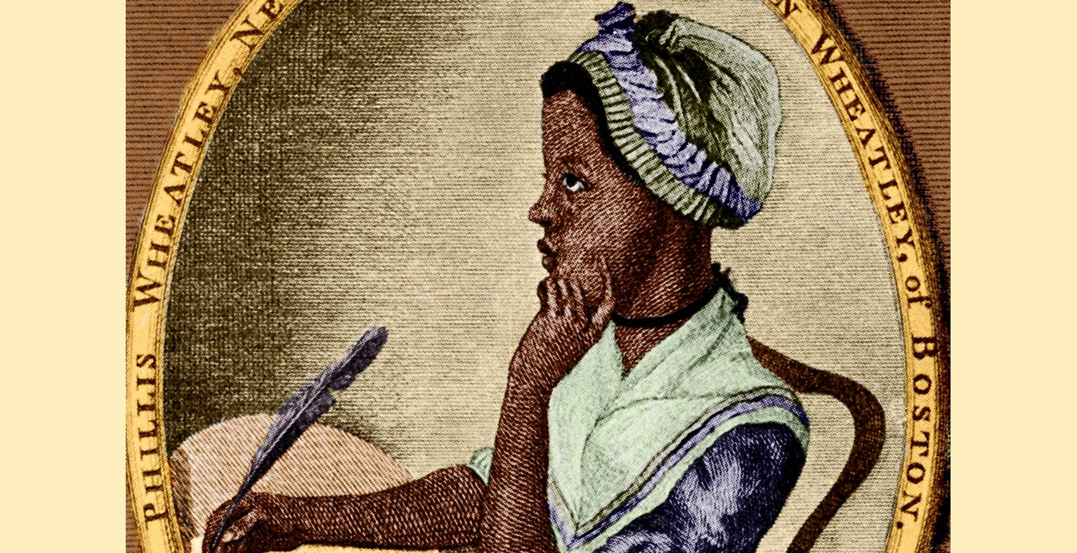
Above: Phillis Wheatley, a Boston freewoman, poet, and supporter of the American Revolution. She was not invited to the Constitutional Convention.

Overview: You are a woman. You are married and the head of a family. During the American Revolution, you took care of your children and farm when your husband and sons were fighting. As a woman, you are often treated poorly by men and given no say in government (this was even worse for Black and Indigenous women). In many states, you do not have the right to own a house or business, vote or run for office, go to college, or speak in public.

Slavery: You are against slavery. You think it is immoral, but also see women and enslaved people as both being treated poorly by the men in power.
Taxes: You want taxes to be higher, because it can be used to pay your husband and son’s soldier wages and improve the roads that you use to travel places.

Suffrage (Voting): You believe that all citizens are equal. You think it is unfair to not allow a person to vote because they are a woman, Black or Indigenous person, or do not own land or businesses (property).

Branches of government: You are from a northern state will more population. You are worried the states with less people may get more say in Congress. You want states with more people to have more delegates in Congress (proportional representation). You support a president to enforce the laws and courts to rule on cases. You support a president who will serve for four years and enforce the laws. You support judges to rule on court cases and serve for 10 years, which would allow judges to change more often. This may lead to a president and judges more likely to give women equal rights.

National government power: You want women to be treated as equals to men. You worry if it is left up to the states, women will never be equal. You want the most power to be given to the national government.

Group 5: Black Freeman

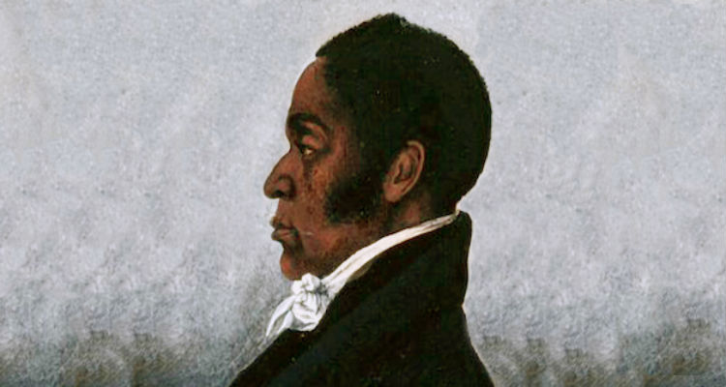
Above: James Forten, a Black freeman and abolitionist (anti-slavery). He was not invited to the Constitutional Convention.

Overview: You are a Black freeman. During the American Revolution, you were a sailor for the Patriots. As a Black man, you are often treated poorly by White men and given no say in government. Many Black people in the United States are enslaved. Sometimes slave catchers come to the North looking for runways and accuse free Black men and women of being runaway slaves. In many states, you do not have the right to own a house or business, vote or run for office, go to school, or speak in public.

Slavery: You are against slavery. You think it is immoral. You will do anything to have it abolished (ended).

Taxes: You want taxes to be higher, because it can be used to pay your sailor wages and improve the roads that you use to travel places.

Suffrage (Voting): You believe that all citizens are equal. You think it is unfair to not allow a person to vote because they are a Black or Indigenous person, woman, or do not own land or businesses (property).

Branches of government: You are from a northern state will more population. You are worried the southern states with less people may get more say in Congress (and will not end slavery). You want states with more people to have more delegates in Congress (proportional representation). You support a president who will serve for four years and enforce the laws. You support judges to rule on court cases and serve for 10 years, which would allow judges to change more often. This may lead to a president and judges more likely to give Black people equal rights.

National government power: You want Black people to be treated as equals to White people. All states in the South and some states in the North allow slavery. You worry if it is left up to the states, African Americans will never be equal. You want the most power to be given to the national government.

Group 6: Enslaved Black People

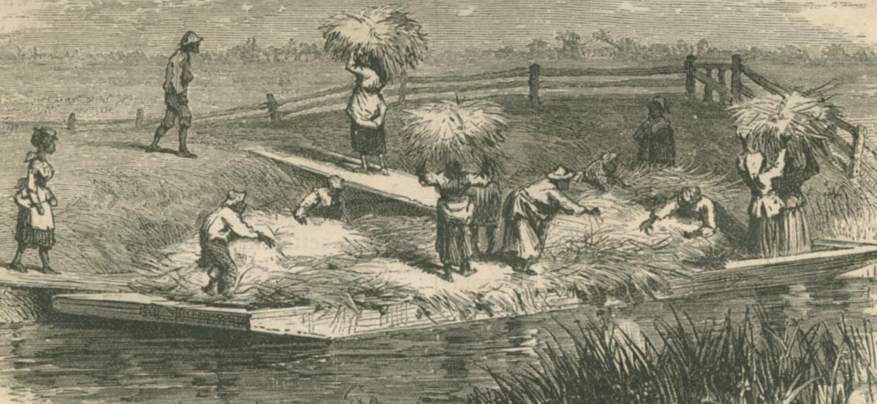
Above: Enslaved people on a South Carolina rice plantation. They were not invited to the Constitutional Convention.

Overview: You are a Black slave. You are considered property (owned by a master) and have no rights. You cannot accuse someone of committing a crime against you or have any say in the government. You have tried to run away from your plantation, but a slave catcher caught you. You cannot understand how the United States fought Britain because they were being tyrannical (no rights), but then White Americans treat Black Americans this way.

Slavery: You are against slavery. You think it is immoral. You will do anything to have it abolished (ended).

Taxes: You have no position on taxes, unless there is a way that they could help end slavery.

Suffrage (Voting): You believe that all citizens are equal. You think it is unfair to not allow a person to vote because they are a Black or Indigenous person, woman, or do not own land or businesses (property).

Branches of government: You are from a southern state will less population. You know that several of the northern states have banned slavery. You are worried the southern states with less people may get more say in Congress (and will not end slavery). You want states with more people to have more delegates in Congress (proportional representation). You support a president who will serve for four years and enforce the laws. You support judges to rule on court cases and serve for 10 years, which would allow judges to change more often. This may lead to a president and judges more likely to give Black people equal rights.

National government power: You want Black people to be treated as equals to White people. All states in the South and some states in the North allow slavery. You worry if it is left up to the states, African Americans will never be equal. You want the most power to be given to the national government.

Group 7: Indigenous (Native) People

Above: Six Nations Leader Ahyouwaighs (or John Brant). He was not invited to the Constitutional Convention.

Overview: You are an Indigenous (Native) person. Your people were the first people to live in the land now called the United States. You have been treated as a foreigner in your own country without the right to vote or run for office. You have had your land taken by Whites. You cannot understand how the United States fought Britain because they were being tyrannical (few rights), but then White Americans treat the Indigenous people this way.

Slavery: You are against slavery. Some of your ancestors were forced into slavery. You think it is immoral. You think it should be abolished (ended).

Taxes: You have no position on taxes, unless there is a way that they could help the Indigenous people.
Suffrage (Voting): You believe that all citizens are equal. You think it is unfair to not allow a person to vote because they are an Indigenous or Black person, woman, or do not own land or businesses (property).

Branches of government: You are from a northern state will more population. You are worried the states with less people may get more say in Congress. You want states with more people to have more delegates in Congress (proportional representation). You support a president who will serve for four years and enforce the laws. You support judges to rule on court cases and serve for 10 years, which would allow judges to change more often. This may lead to a president and judges more likely to give Indigenous people equal rights.

National government power: You want Indigenous people to be treated as equals to White people. Most states have treaties (agreements) with the Indigenous people. You worry if it is left up to the national government, many of those agreements will be broken. You want the most power to be given to the states.

SOURCEBOOK 5-16.D

Summary of the Constitution

The Articles (September 17, 1787)

The Constitution is based on the separation of powers. It divides power between the three separate branches of the government: legislative, judicial, and executive branches. Parts of the Constitution related to our convention are underlined.

Article I: Legislative (Congress)
The legislative branch includes the House of Representatives and the Senate. Together they are called Congress. They make the laws of the country, which may include taxes, borrowing, business, post offices, roads, promote science, inventions, and writings, punish pirates, declare war, and create all laws “necessary and proper.” Each state has different numbers of representatives in the House based on their number of people and they serve for 2 years. Each state has two senators in the Senate and they serve for 6 years. You must be 25 years old to be in the House and 30 years old to be in the Senate. A census (count of people) will be held every 10 years to decide the number of representatives from each state. Most Indians will not be counted as people. All other people (slaves) will be counted as 3/5th of a person. The House may charge the president and judges through impeachment, but the Senate will decide if they will be removed from office. Congress cannot ban slavery or the slave trade until at least 1808. Congress has the power to collect direct taxes (on things people own or sell). No tax may be put on goods sent outside the country (exports).

Article II: Executive (President and Cabinet)
The President and the Vice President have responsibilities and powers over the executive branch. They enforce the laws of Congress. They serve for four year terms (no limit on how many terms they can have). The president must be 35 years old, born in the United States, and have lived her for the last 14 years. He or she is chosen by the Electoral College. He or she is also the commander-in-chief of the military. He or she can pardon people who have committed crimes. He or she makes treaties with foreign countries working with the Senate.

Article III: Judicial (Courts)
The judicial branch includes the Supreme Court and lower courts. They make rulings on any case related to the national government. The Judges, including the Supreme Court justices, can hold office for life, unless they are removed, impeached, or go to jail. Anyone accused of committing a national crime has the right to a trial by jury.

Article IV: State Powers
Article IV discusses the relationship between states and the federal government. All states must respect other states laws – this is called the “Full Faith and Credit Clause.” When a territory has enough people, Congress can decide to make it a new state. All states must have a government that allows people to be representatives (a republic). (Nowhere in the document did it say who could vote or suffrage. This section means that each state will decide who can vote.)

Article V: Amendments (Change Constitution)
The government might need to make changes to this Constitution, which are called amendments. Both houses of Congress (2/3rd) must agree to propose an amendment. It takes a positive vote (3/4th) of the states to make an amendment law.

Article VI: National Law Over State Law
The Constitution is the highest law of the land. Federal and state officers and judges must uphold the Constitution.

Article VII: Ratification (Vote by States on This Constitution)
This Constitution must be ratified by nine of the thirteen states.

SOURCEBOOK 5-17.A

Bill of Rights

1st Amendment
Freedom of religion, speech, press, assembly (protest), and petition (a list of names of people who are for/against something).

2nd Amendment
For the militia (army), people can keep and bear arms (guns/weapons).

3rd Amendment
Soldiers cannot be forced to stay in homes.

4th Amendment
The government cannot search (look for) or seize (take) property without a warrant (judge’s permission).

5th Amendment
People do not need to testify (speak) in court, if you think it may incriminate (get you in trouble). They have a right to due process (a trial). They cannot be put on trial for the same crime twice. They cannot have their property taken away by the government without being paid money.

6th Amendment
People must have a speedy trial and a jury (people who choose guilty or not guilty) of their peers. You have a right to a lawyer to defend you.

7th Amendment
Civil cases (involving property crimes-like stealing) will also have a jury.

8th Amendment
The government cannot have bail (money to get out of jail) or fines that are too high or cruel and unusual punishments.

9th Amendment
These are not all the rights and people still have rights not listed here.

10th Amendment
Powers not given to the U.S. government in this Constitution are given either to the states or the people.

SOURCEBOOK 5-18.A

Louisiana Purchase Perspectives

Overview
In 1803, President Thomas Jefferson sent men to Paris with the hope of buying the port of New Orleans on the Mississippi River. France needed money to pay for its war with Britain and Haiti.

During the meeting, France asked the U.S. if they wanted to buy all of Louisiana (828 million acres). It went from New Orleans in the south to Canada in the north and the Rocky Mountains in the west (see map below). It would double the U.S.’s land and cost $15 million dollars ($50 million francs) or 4 cents per acre.

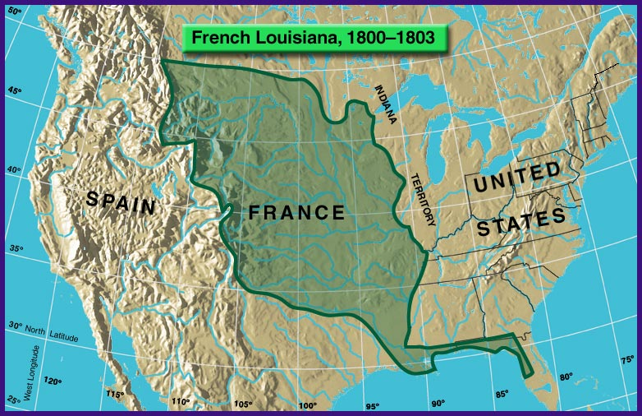

Group 1: Will Help U.S. Trade and Business (Support)
You support the U.S. government’s purchase of Louisiana. The country would double its size for very cheap. It would allow the United States to control the entire Mississippi River, which would allow it to make a lot of money. It would also open up millions of acres to farmers to grow more crops.

Group 2: Will Help U.S. Avoid War (Support)
You support the U.S. government’s purchase of Louisiana. The country would double its size for very cheap. It would allow the United States to control the entire Mississippi River, which could stop Britain and other nations from using the river. It would also make more space between Spain’s colonies in the Americas (such as Mexico) and the United States. This will prevent a war with Spain, Britain, or France.

Group 3: Constitution Does Not Allow (Oppose)
You do not support the U.S. government’s purchase of Louisiana. The Constitution limits the power of the government and purchasing millions of acres from France is one of those things it cannot do. If Jefferson makes this purchase, he would be acting like a king. Also, adding more land of the United States will mean that the states may fight each other over the new land.

Group 4: Indigenous People’s Land/More Slavery (Oppose)
You do not support the U.S. government’s purchase of Louisiana. This land belongs to the first people to live there, the Indigenous (Native) people. If the United States buys this land, it will continue a long history of taking land from the Indigenous people. Also, because Louisiana has slavery, it could increase the amount of slave states. France should return the land to the Native people.

SOURCEBOOK 5-18.B

Source 1: Constitution (Excerpt)

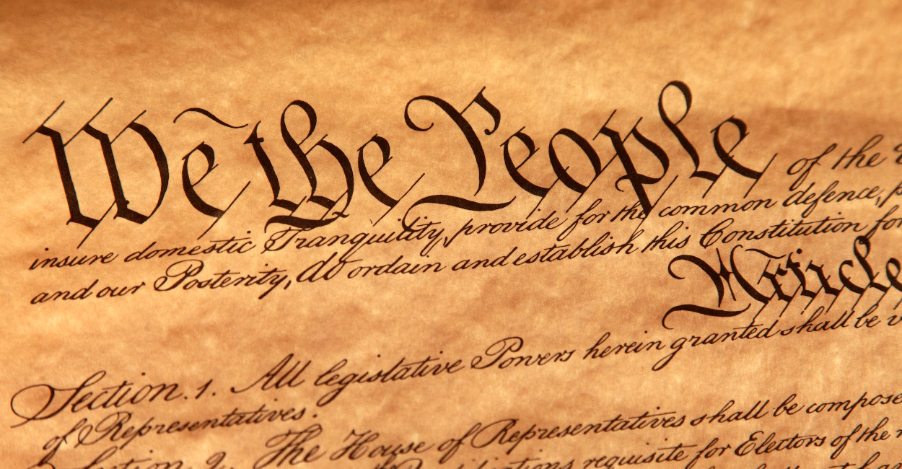

[This section does not state that the United States can purchase more land. Some people argued that if it was not written in the Constitution, it should not be allowed.]

Article IV Section 3

New states may become part of the United States with the permission of Congress.

Congress has the power to make all rules for territories or other property belonging to the United States.

SOURCEBOOK 5-18.C

Source 2: Rufus King on the Louisiana Purchase

[Rufus King was a delegate to the Constitutional Convention]

Rufus King of Massachusetts wrote:

According to the Constitution, Congress may add new states. But can the President sign treaties forcing Congress to add more land? Probably not.

Since slavery is legal and exists in Louisiana, won’t we be forced to admit the new slave states? Doing so will worsen the problems of slavery.

SOURCEBOOK 5-18.D

Source 3: Alexander Hamilton on the Louisiana Purchase

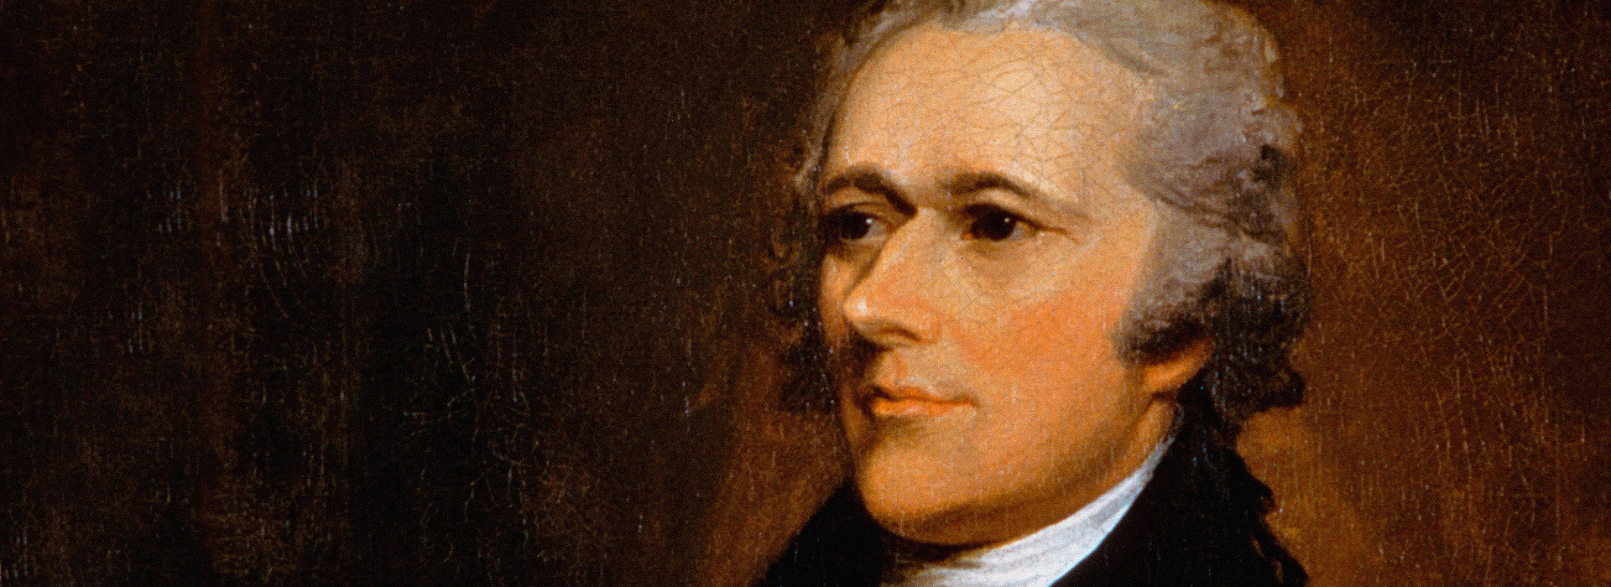

[Alexander Hamilton was a delegate to the Constitutional Convention and one of its main writers]

Alexander Hamilton of New York wrote:

As to the vast region west of the Mississippi, it is a wilderness with numerous tribes of Indians (Indigenous people). Currently only 1/16th of the current United States is occupied by (living there) Indians. The possibility that this new purchase will be a place of settlement seems unlikely. If our own citizens do settle this new land, it would weaken our country. On the whole, we can honestly say that this purchase is a bad idea.

SOURCEBOOK 5-18.E

Source 4: James Madison on the Louisiana Purchase

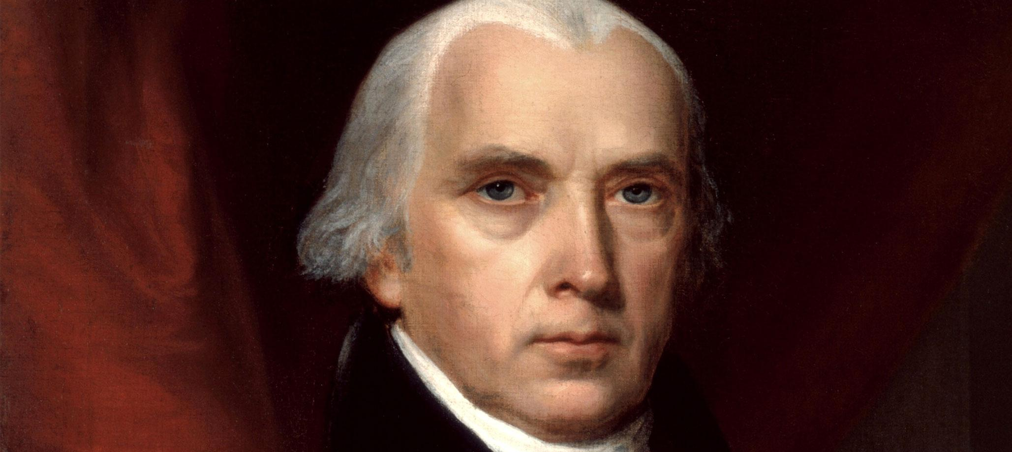

[James Madison was a delegate to the Constitutional Convention and one of its main writers]

James Madison of Virginia wrote:

The purchase of Louisiana should be approved by everyone. The uses of this land will lead to much good (for business and trade) and prevent much evil (prevent invasion from foreign armies).

SOURCEBOOK 5-19.A

Image
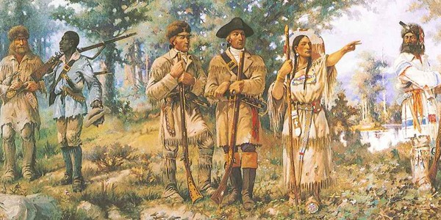

SOURCEBOOK 5-19.C

Source 1: Lewis Diary

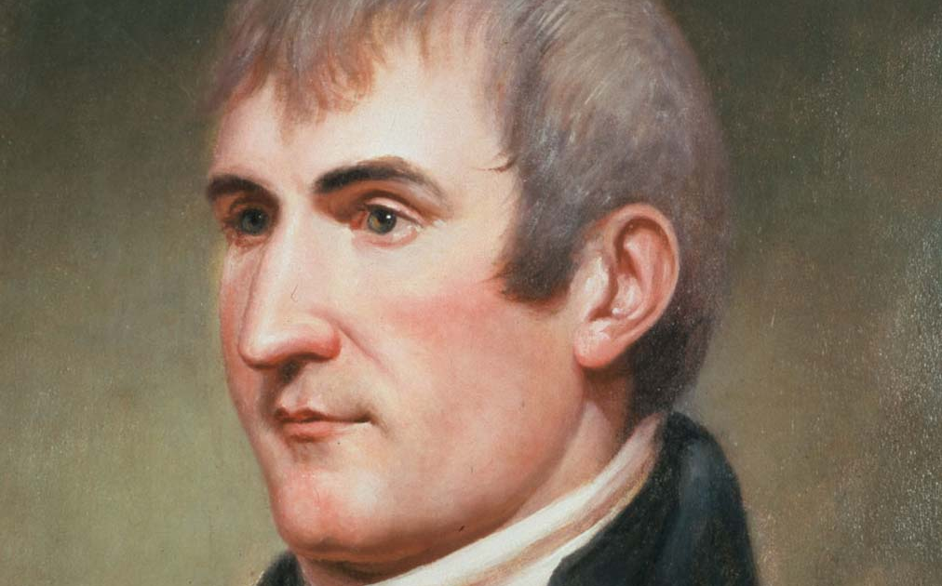

April 7, 1805
We are about to go across a country at least two thousand miles wide. We will soon know if this was a good or bad idea. We think we have everything that we will need. This may be the happiest moment of my life.

June 13, 1805
I heard in the distance the sound of a waterfall. I saw the spray rise above the plain like smoke which soon began to make a roaring sound too loud to be mistaken for anything other than the great falls of the Missouri River.
August 16, 1805
I told the chief several times that we had with us a woman of his nation who had been taken prisoner by the French and she was our guide. She recognized the chief as her brother. He agreed to help us.

September 14, 1805
We had to kill one of our horses, so we could eat it. The mountain snow and cold was much worse than yesterday. There are many fallen trees. It is steep with many stones. Our men and horses are very tired.

November 7, 1805
None.

SOURCEBOOK 5-19.D

Source 2: Clark Diary

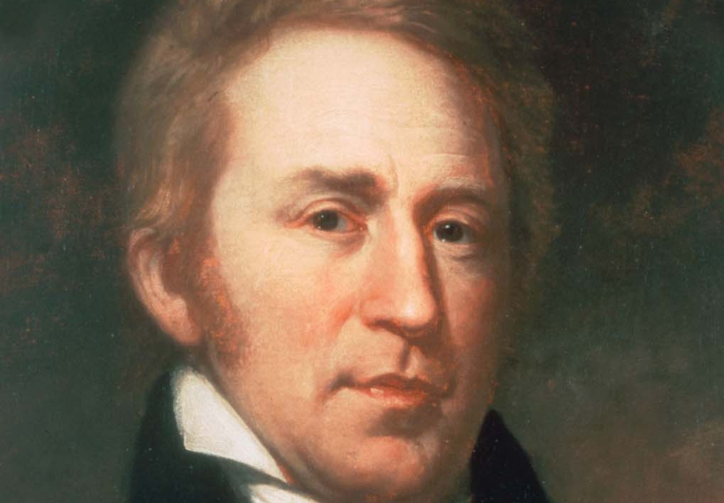

April 7, 1805
At 4 o’clock pm, we took the boat down river. There were 6 Soldiers, 2 Frenchmen, and Indian. With us there are also 2 small boats and 6 canoes.

June 13, 1805
A fair morning. The Indian woman (Sacagawea) is sick. I gave her salts. The mountains are covered with snow. Killed a goat and two buffalo to eat.

August 16, 1805
I have seen a great number of berries and they are ripe. I could see several small trees growing up the mountain and on the side there are willows.

September 14, 1805
We took the wrong road. Many miles in the wind and snow through rugged mountains. From these mountains, we could see higher mountains in all directions.

November 7, 1805
Great joy in camp. We are in view of the great Pacific Ocean which we been so long anxious (worried) to see. And the roaring loud noise made by the waves breaking on the rocky shores may be heard.

SOURCEBOOK 5-19.E

Source 3: Sacagawea Diary

[We do not have a diary from Sacagawea. This is based on what she may have written.]

April 7, 1805
We are beginning our journey with the group of White men. They seem very nervous. I have made this journey before, as I am from the mountains. I hope to see my family there again.

June 13, 1805
This morning I was very sick. My health has not been very good since I had my baby. My baby has traveled with us all the way from Fort Mandan. He has been wonderful and rarely cries.
August 16, 1805
When we came to this place, we saw a group of people. Pretty quickly I realized that their chief was my brother. I have not seen him for many years and I really miss him. It was so nice speaking with him and showing him my new son.

September 14, 1805
I told Lewis and Clark to wait until the weather was better to cross the mountains. I said I know this land well and that they should trust me. They went anyway and took the wrong road. We have been stuck in bad winds and snows. The White men are tired and cold. They decided to eat their horse.

November 7, 1805
We have made it to the Ocean. A whale had washed up on the shore. I had never seen such a monstrous fish. This was an amazing journey.

SOURCEBOOK 5-19.F

Source 4: York Diary

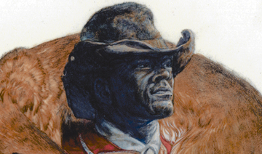

[We do not have a diary from York. This is based on what he may have written.]

April 7, 1805
I have traveled for several months with my master, William Clark. We have been waiting here at Fort Mandan for months. Today, we got on the boat and headed up the Missouri River.

June 13, 1805
We received word that Lewis has found the great waterfalls of the Missouri River. Sacagawea is very sick. I am worried.

August 16, 1805
Today I was sent by Clark to meet with the local Indians. This was an important mission. I had to make sure this group would not attack us. Since I am a slave, I am rarely allowed to go off by myself. This was a nice taste of freedom. I hope that someday I will be free.

September 14, 1805
I am worried that Lewis and Clark may not be good leaders. They have led us into the mountains in the middle of a snow storm. We are tired and cold. We had to eat our horse.

November 7, 1805
I am amazed to see the Pacific Ocean. It is so beautiful. We voted on where to stay and Lewis and Clark allowed both Sacagawea and I to vote. I was honored to make my voice heard.

SOURCEBOOK 5-19.G

Source 5: Charbonneau Diary

[We do not have a diary from Charbonneau. This is based on what he may have written.]

April 7, 1805
I am French and grew up near Montréal, Canada. I am a trapper who hunts animals for their furs. Here in the wilderness, I have learned many Native languages. I have been hired to lead Lewis and Clark to the Pacific. Along with me is my wife Sacagawea and newborn son Jean Baptiste. We start our voyage up the Missouri River today.

June 13, 1805
My wife is sick. Clark gave her medicine. She is very tough. I am hoping that she will be okay. A few months ago, I quit the exposition, because Lewis and Clark did not know what they were doing. I could not let them hurt all of the people in the expedition, so I rejoined them. They have mainly used me as a cook and a translator of Indian languages.

August 16, 1805
Today I met my wife’s brother.

September 14, 1805
Sacagawea told Lewis and Clark to wait until the weather was better to cross the mountains. They went anyway and took the wrong road. My wife, baby, and I will be fine. We are use to weather like this. I hope the White Americans will survive.

November 7, 1805
We have made it to the ocean. I have never seen this before. It is an amazing sight.

SOURCEBOOK 5-20.B

Person 1: Guwisguwi or John Ross

Guwisguwi (gu-wis-gu-wi), who was also known as John Ross, was born in Turkeytown, Alabama. As a child, his family moved to Tennessee. As an adult, he became a wealthy businessman. When the Cherokee were told that they would have to give up their homes and land and go to Indian Territory, John Ross wrote a letter to President Andrew Jackson. The letter said,

By your order, we are having our homes and property taken from us. We are sickened. We do not agree to this. Please reconsider this, or we will do all in our power to stop this injustice.

He would next bring a lawsuit in court saying the U.S. government went against the treaties (agreements) they signed with the Cherokees. He would win. He then become a leader of the Cherokee nation.
Guwisguwi/John Ross saw how other Indigenous (Native) nations were treated when they were forced to move to Indian Territory/Oklahoma. He asked the government if they could be in charge of their own move west. On the forced journey, he saw many of his people become sick or die (including his wife Quatie, who died of pneumonia during the Trail of Tears).

Guwisguwi/John Ross would arrive with his people in Indian Territory and forced to follow a new treaty with U.S. government called the Treaty of New Echota.

SOURCEBOOK 5-20.C

Person 2: Sallie Parsons Waterkiller

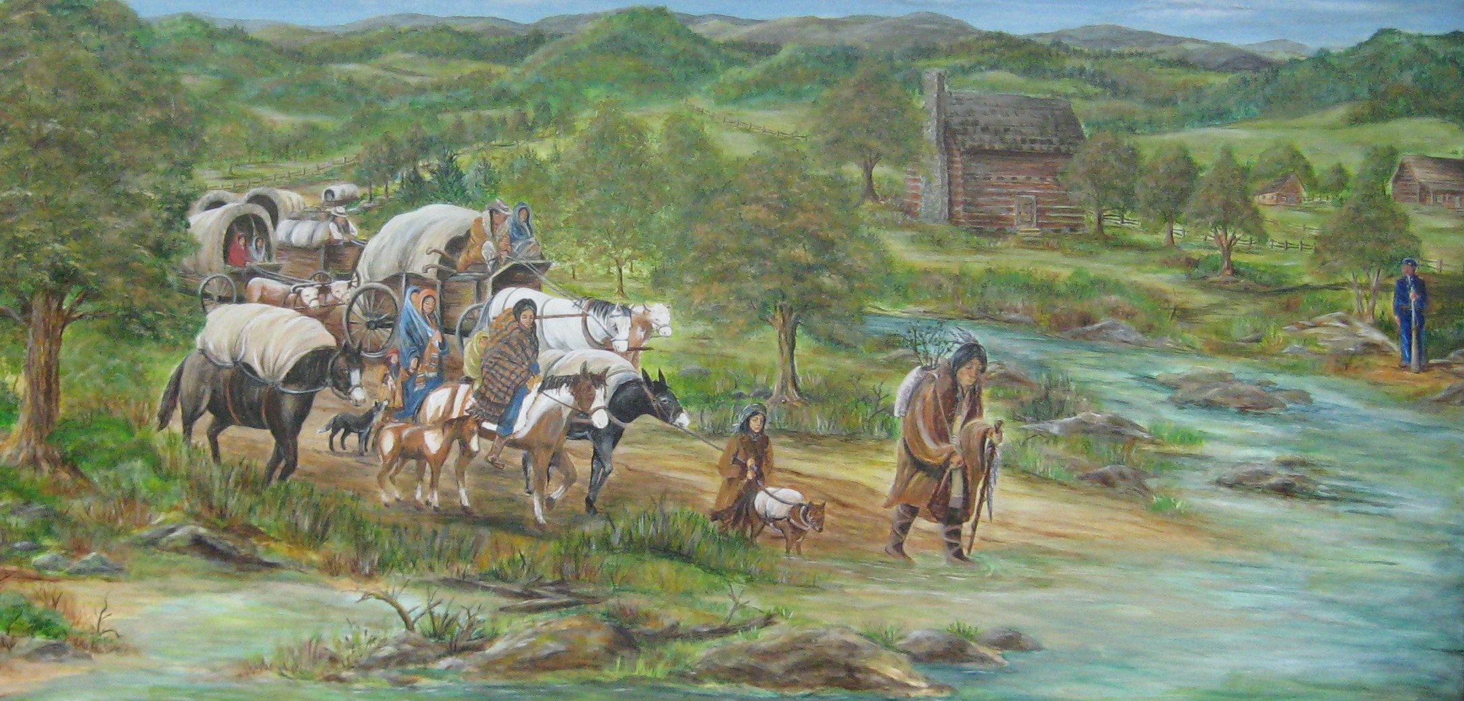
There are no known pictures of Sallie Parsons Waterkiller. Above is an image of the Trail of Tears.

Sallie Parsons Waterkiller was born in North Carolina. She moved with her husband to Georgia. In 1837, U.S. soldiers came to her house. They told her and her family to leave. She and her husband said that they did not want to go. The soldiers said that they need to go or they would be stick a bayonet (sword) in them. That night they got their skillet, pot, dishes, clothes, bedclothes, and pottery and packed them up.

They started their forced walk the next morning. It was an easy first day. Every day after it was worse. They felt like they were being treated like cattle. They had to walk through mud and rivers up to their chin. They were only feed once or twice a day by the soldiers.

Along the journey, Sallie saw many people die of sickness. Their clothes became very dirty. They had lost everything, including their home and land.

When Sallie arrived in Indian Territory, she saw that it was very different from Georgia. Unlike Georgia, it was very dry and hard to grow crops. Her family were farmers, but they could grow nothing here. They could not find work and became very poor.

SOURCEBOOK 5-20.D

Person 3: Mary Hicks

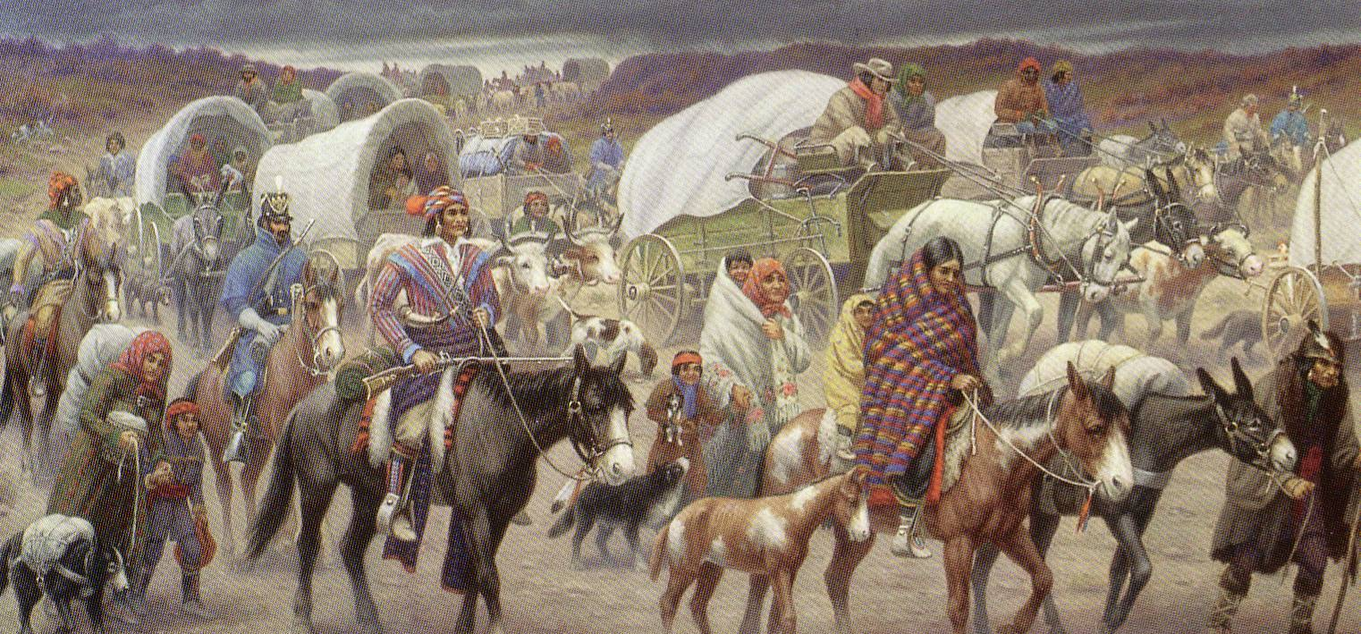
There are no known pictures of Mary Hicks. Above is an image of the Trail of Tears.

Mary Hicks was born in Alabama. She was a child in 1837. Her father, Joseph McCoy, was a rancher. Soldiers came to his house one day and said that everyone needed to move. They were allowed to take what they could carry and would be forced to leave the next morning. Along their forced march, Mary’s family came across two children whose parents had died along the march. They adopted them into her family.

The journey was long and hard. Unlike others, most of their family members survived. They did see many people die of sickness. As a child, Mary was very scared. She did not know why the U.S. government was making her family leave their home. She did not like the soldiers, who scared her.
When Mary and her family arrived in Indian Territory, they saw that it was very different from Alabama. Unlike Alabama, it was very dry and hard to raise animals. Her family were ranchers, but they had no animals to raise here. They could not find work and became very poor.

SOURCEBOOK 5-20.E

Person 4: Washington Lee

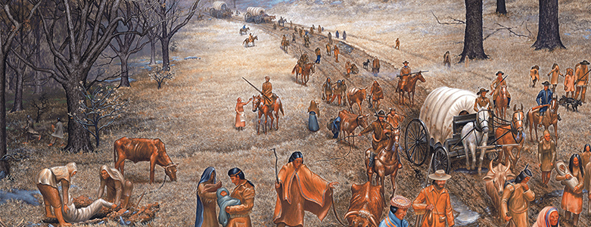
There are no known pictures of Washington Lee. Above is an image of the Trail of Tears.

Washington Lee was born in Alabama. He was a teenager in 1838. He was named after President Washington, who was the first president of the United States. His family was proud of being Cherokee, but also loved the United States.

One night in 1838, soldiers came to their house and demanded that they leave immediately. The next morning, they started their forced journey to Indian Territory. Along the march, his father, mother, and sister died. Older people who were weak were carried in government wagons. In the wagons, they also carried food and blankets. They were only fed cornbread or green corn. Sometimes a soldier would kill a buffalo and let the Cherokee take some of the meat and cook it. This was rare. Often the Cherokee became sick from the food that the government gave them. There was not much water around. They sometimes went 2 or 3 days until they found a river or creek to drink from.
The journey was long and hard. They did see many people die of sickness, including several parents, siblings, and cousins. He did not know why the U.S. government was making his family leave their home.

When Washington Lee and his family arrived in Indian Territory, they saw that it was very different from Alabama. Unlike Alabama, it was very dry and hard to farm. His family were farmers, but they were unable to grow crops here. They could not find work and became very poor.

SOURCEBOOK 5-21.A

Introduction to the Gold Hunt

Many gold miners arrived by sea, most from the East Coast through the Isthmus of Panama or, if arriving from Asia or Latin America, by the Pacific Ocean (would be helpful to show students on a map). In fact, there was such a mad rush, many ships were simply abandoned once they reached San Francisco. Others traveled overland on trails across the continental United States. The gold-seekers, called “49ers,” a reference to 1849, which was the year that many arrived in California to find gold, often faced hardships on their trip.

While most of the newly arrived were Anglos, or English-speaking White Americans, the Gold Rush attracted thousands of people from Latin America, China, Europe, and African Americans from the East Coast. At first, the 49ers found gold in streams and riverbeds using simple techniques, such as panning, where they would wash gravel in a pan to separate out the gold. Later, other methods of gold mining were used that made it easier to mine the gold, such as digging with picks or using water cannons. While a small group of gold miners became very wealthy, especially in the early days, the real money was to be made by selling gold mining equipment, such as pans, picks, camp supplies, and work clothes. In fact, this is when Levi Strauss first started selling his now well-known blue jeans.

SOURCEBOOK 5-21.D

California Gold Rush: Sources

Source 1: Lease agreement between John A. Sutter & James Wilson Marshall and the Yalesummi Tribe. February 4, 1848.

On January 18, 1848, John Sutter discovered gold in Coloma, California. Sutter convinced the Yalesummi Indians to give him the land for about $100 in clothing and other assorted items. Signing an X instead of a name probably means that those signers were unable to read and write English and may be agreeing to something they cannot understand.

The Yalesummi tribe will rent and lease unto Sutter and Marshall the following track of land for the term of twenty years and grant them the right to cut lumber and open mines.

Pupuli chief X (his mark)
Gesu chief X (his mark)
Colule alcalde X (his mark)
Lole alcalde X (his mark)

J.A. Sutter

James Marshall

NOTE: This document was later rejected by Colonel R. B. Mason, the military governor of California, who decided that since Indians are not citizens, they cannot sell or lease their land and the land can just be taken from them.

Source 2: Sutter’s Mill in Coloma, California

Before gold was discovered, Coloma, California was mostly peaceful wilderness. Gold mining changed this, as the gold miners stripped the land of its minerals and hurt animal habitats. It polluted rivers and destroyed mountainsides. Today, there is still mercury pollution in San Francisco Bay and the Sacremento-San Joaquin Rivers. While only a small number of people found gold, everyone else was left with a damanged environment.

Source 3: San Francisco after the Gold Rush (circa 1851)

This image shows the crowded port of San Francisco. Thousands of people arrived each year to mine gold. Many ships were simply abandoned by their crews on arrival. Few people became rich from mining gold. Many of the people who became wealthy did so by instead selling supplies to the gold miners (include Levi Strauss, who started his now-famous work pants company).

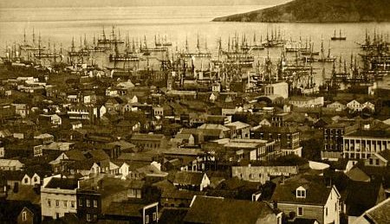
Source 4: Gum Shan Meets El Dorado; Head of Auburn Ravine. Circa 1852

This photograph shows three White men and four Chinese men working together at a sluicing job (using moving water to remove gold). The image is one of the earliest photographs to show Chinese miners. By the end of 1848, there were only seven known Chinese men in California. By the mid 1850s, over 20,000 Chinese people made a living in the gold country, which they called Gum Shan (gold mountain). They were not allowed to own land or mine without permission of Whites. Due to their hard work, a small number of Chinese miners did still become rich.

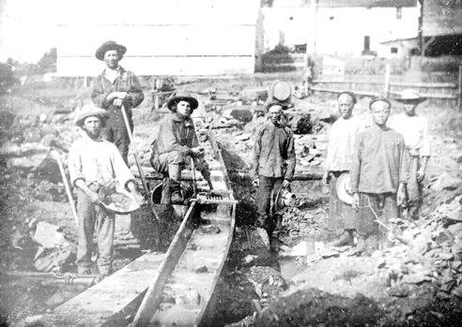

Source 5: J. B. Gilman [master] and Thomas Gilman [slave]. Signed bill of sale. August 17, 1852

This document records Thomas Gilman, a slave, buying his freedom from J. B. Gilman of Tennessee for $1,000. Slave owners brought approximately 200 to 300 slaves to work the mines, but California banned slavery in 1850. Many of those slaves were then forced to purchase their freedom with the profit they made from the mines.

I, J. B. Gillman, liberated and released Thomas, the said slave, from further servitude or bondage…. The 17th day of August 1852.
Source 6: Account of the Whites’ Raid on Little Chile Mining Camp. July 15, 1849.

On July 15th, many White men invaded the Little Chile Mining Camp yelling, “Down with the Chileans!” Bullets went flying. Many people were wounded and almost all robbed of all their possessions. The place was sacked, the tents destroyed and fires set to everything that would burn. Many of the residents ran up [to the] hills and some … aboard the ships anchored in the bay.

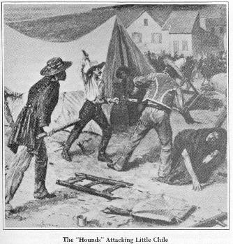

SOURCEBOOK 5-22.A

Zoom In Inquiry Activity

Zoom 1
Zoom 2
Zoom 3

SOURCEBOOK 5-23.A

Cause of the Civil War: Slavery

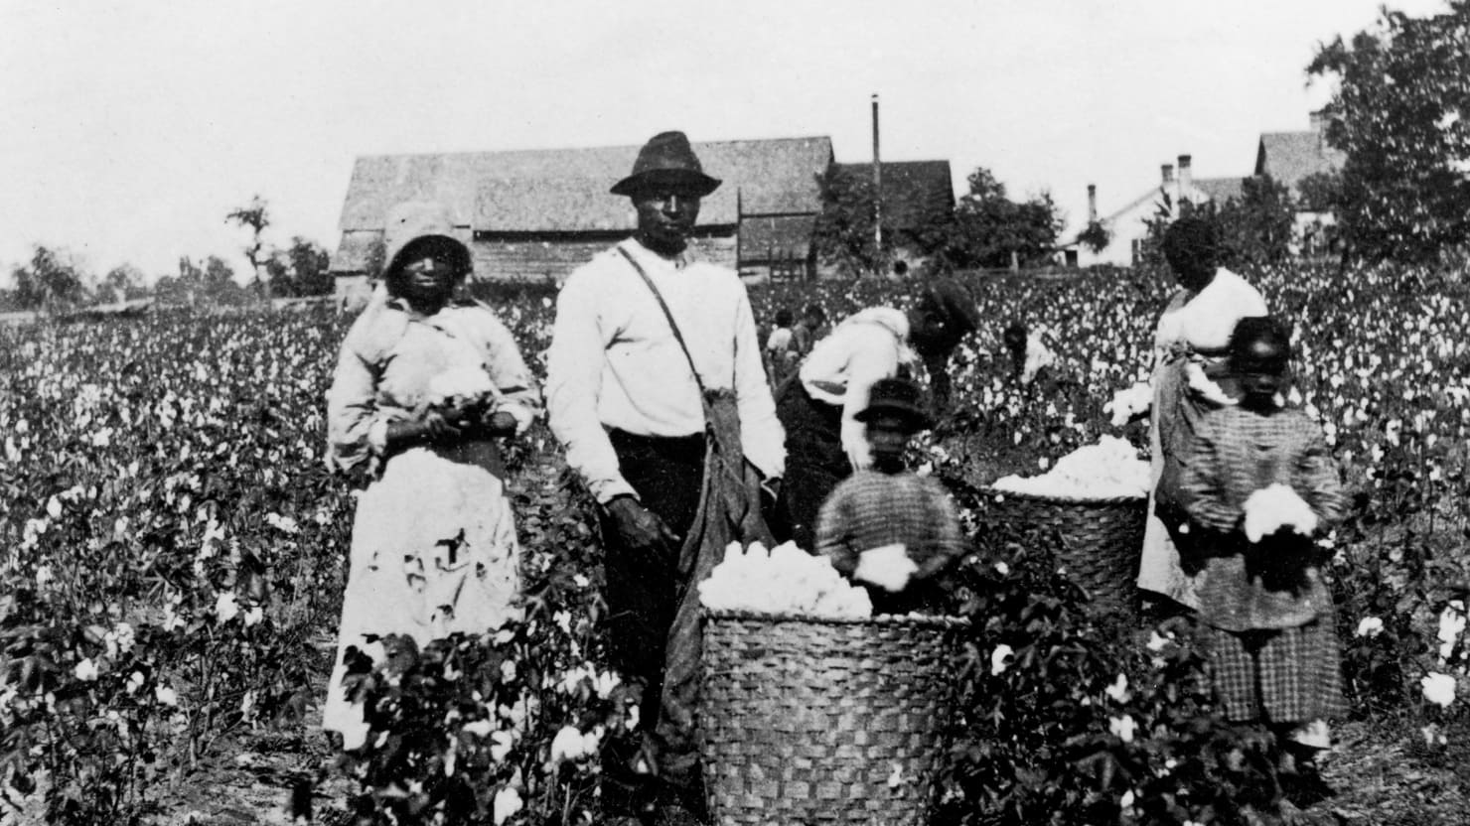
Slavery was the main cause of the Civil War. By the 1700s, most enslaved people were African Americans. The United States put laws about slavery in its new Constitution, which made it harder to abolish (end). At the same time, three states (Massachusetts, Pennsylvania, and Vermont) banned slavery in their new states. The number of enslaved people only grew in the United States as cotton (above) became a major product that was sold around the world (see chart on next page). In fact, Senator James Hammond from South Carolina declared in 1859 that “Cotton is King!”, reminding everyone that it controlled the country. When Southern states left the Union in 1860-61 (secession), the first states to leave were from the Cotton Belt or the area where the most cotton was grown. Their new country, the Confederate States of America, protected the right of people to own enslaved people in their new Constitution.
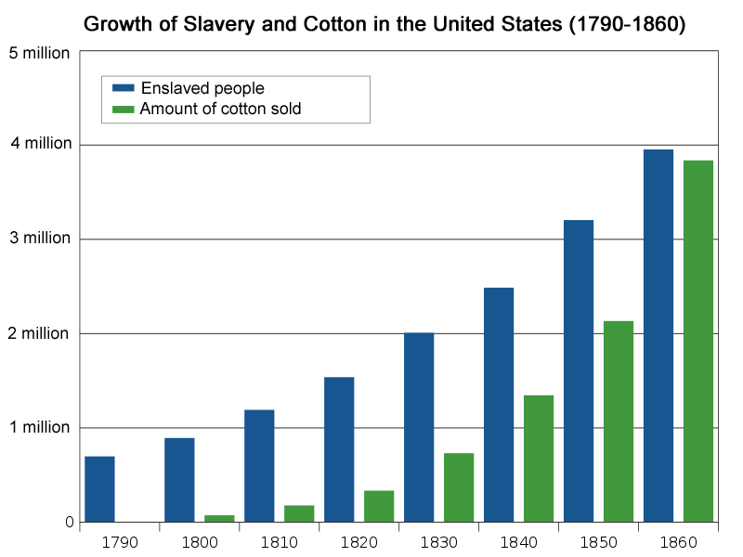

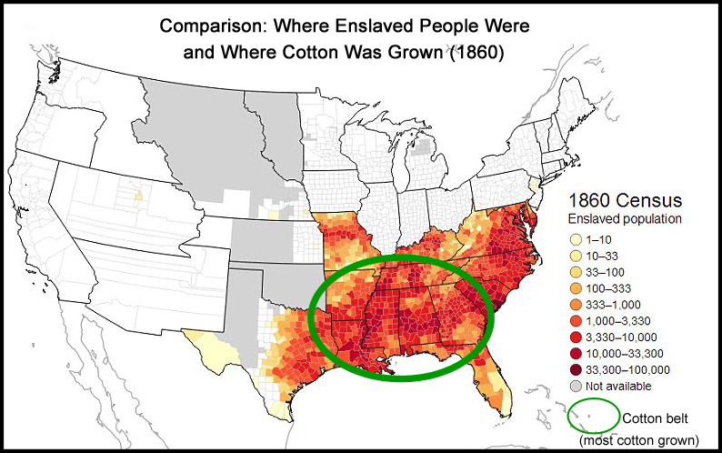

SOURCEBOOK 5-23.A

Cause of the Civil War: Business

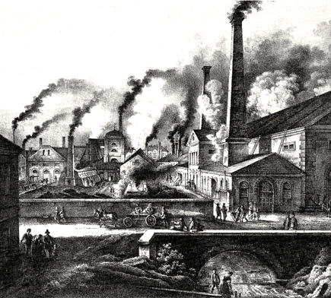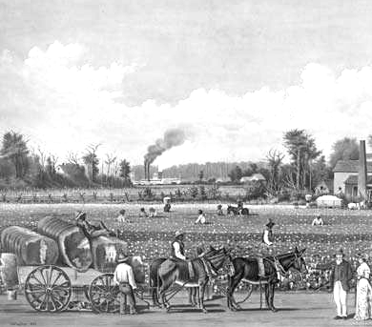
Business was the main cause of the Civil War. The North had a factory system, where raw materials (like cotton) were turned into items to be sold (like clothes). They had long winters and growing crops was difficult. They made their money from manufacturing or making goods instead. The South had an agrarian (farm) system, where raw materials or “cash crops” were grown and sold to Northern factories. The South had long warm summers and growing crops was easier. Their cash crops included tobacco, indigo, rice, but especially cotton. Growing cotton involved many workers. The cotton gin (next page-top) was invented by Eli Whitney in Connecticut and it helped the South produce even more cotton (see the image of a boat filled with cotton; next page-bottom). The South did not have enough workers and they used enslaved people to grow the crops (cotton). If slavery were to be ended, White plantation owners thought it would put them out of business, so they supported war. Many abolitionists (anti-slavery people) argued that plantation owners would just need to allow the enslaved people freedom and pay them for their work.
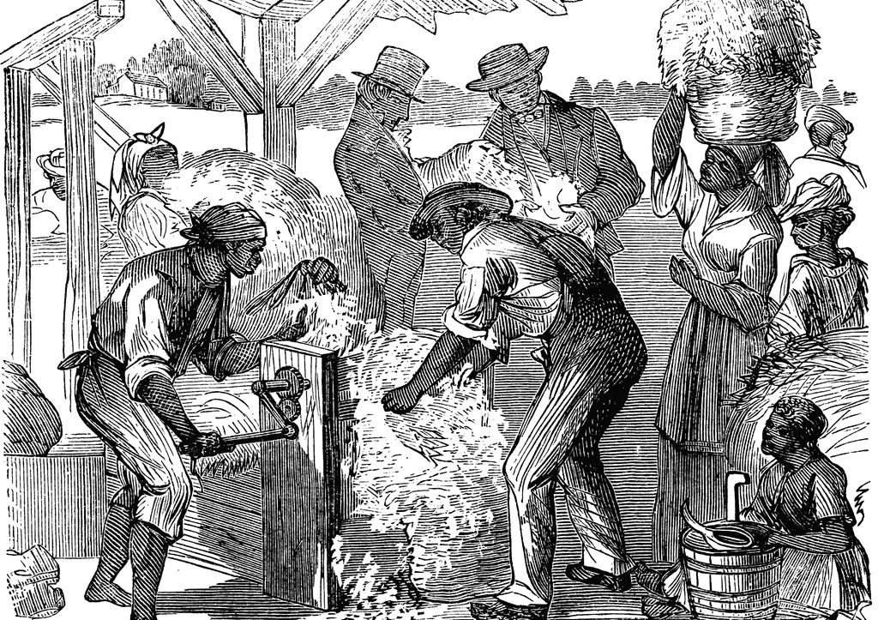

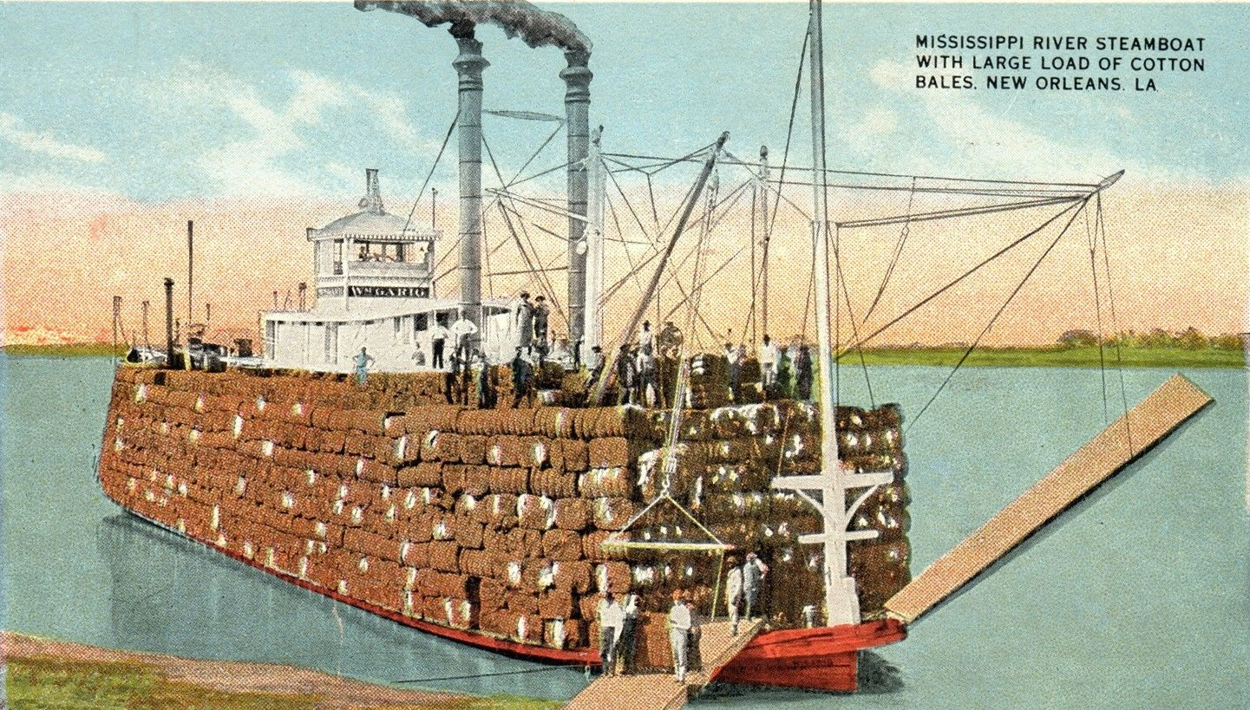

SOURCEBOOK 5-23.C

Cause of the Civil War: The Union

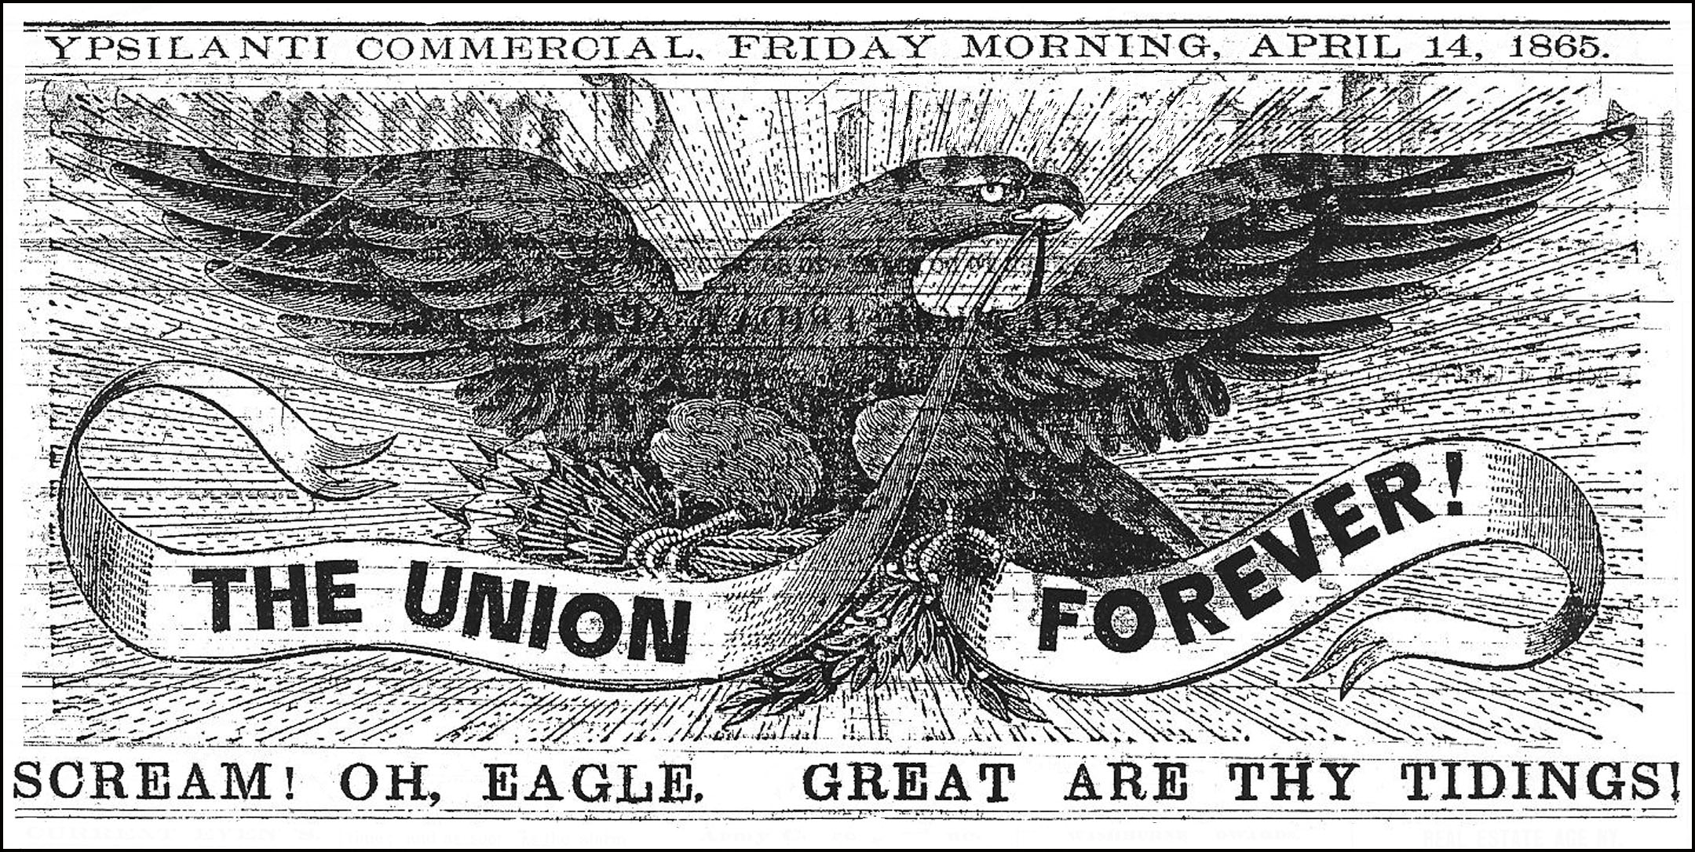
The Union, or keeping the country together, was the main cause of the Civil War. Slavery existed for over 200 years in the colonies and later U.S., but when states left the Union that finally caused war. Many northerners said they were fighting the war to keep the United States as one country. Many southerners said they were fighting the war to have their own country with their own rules and laws (and slavery). In 1862, Lincoln wrote his friend, “My [plan] is to save the Union, and is not either to save or to destroy slavery. If I could save the Union without freeing any slave I would do it, and if I could save it by freeing all the slaves I would do it.” Lincoln argued the reason for the war was to keep the country together. By 1863, Lincoln did start speaking about ending slavery and he passed the Emancipation Proclamation (next page-top), which freed all the slaves in rebelling states. After his death, Congress would force southern states to return to the Union and they ended slavery with the 13th Amendment (next page-bottom).
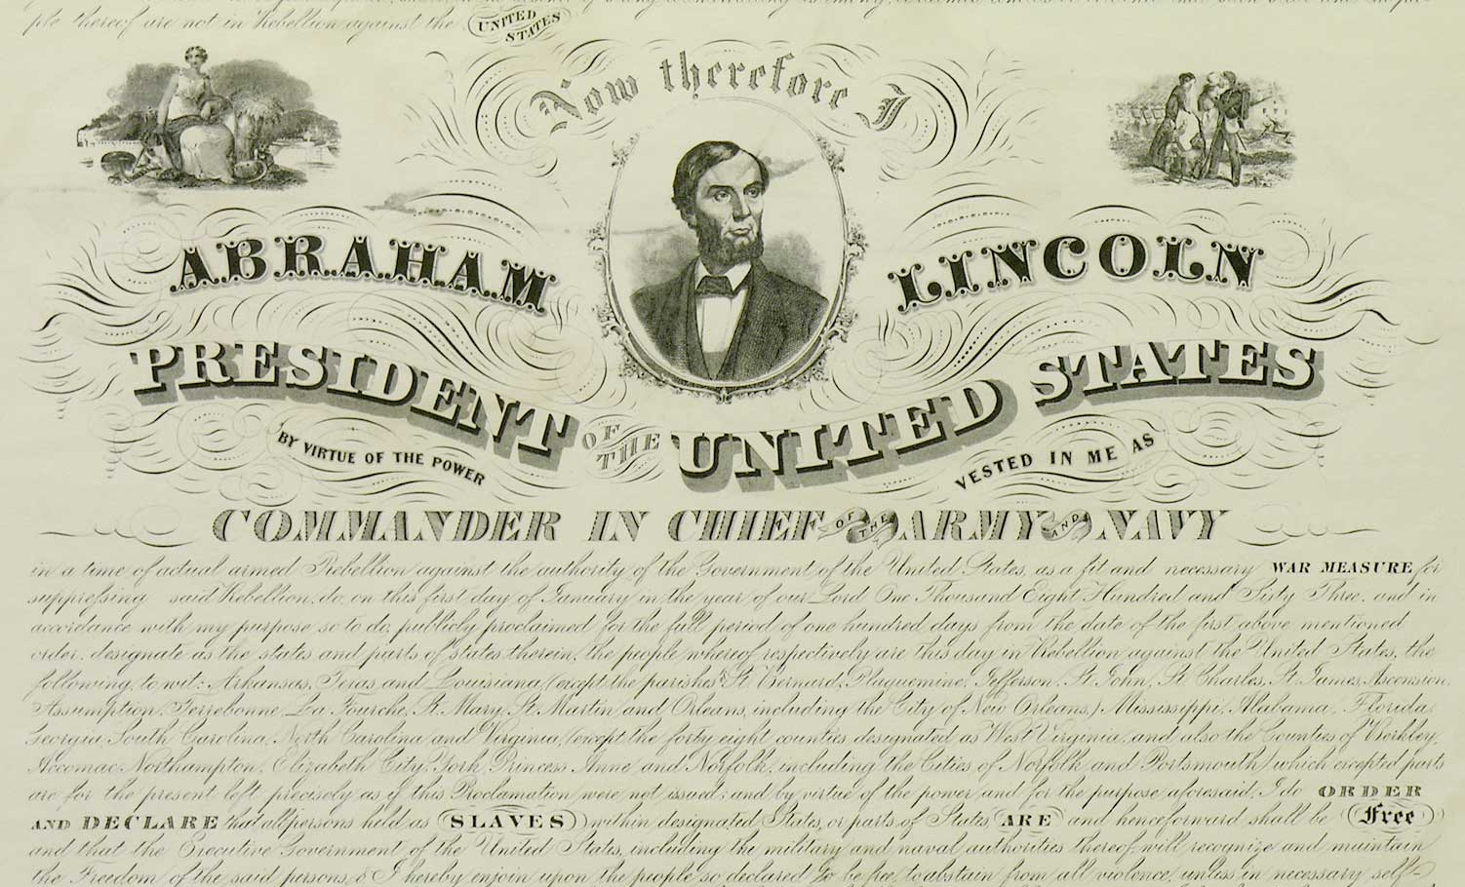

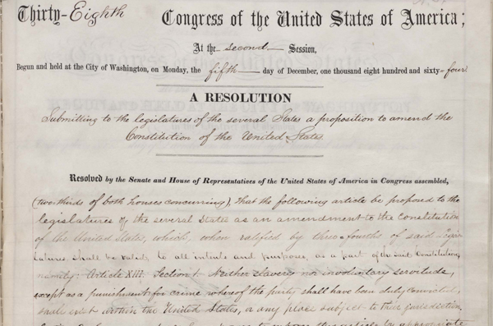

SOURCEBOOK 5-24.A

Worst Decision: Sharecropping

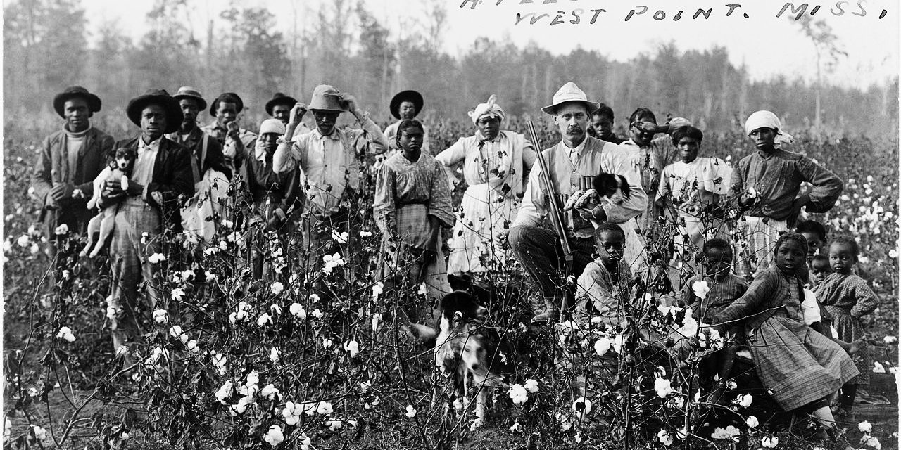
After slavery ended, people who were enslaved had no money and it was very difficult for them to leave the plantation where they lived. They often continued to work for the former slave master, (now called a landowner), but this time for pay. The landowners would pay the former slaves by giving them a “share” of what they grew or “sharecropping.” Many landowners charged their sharecroppers unfair amounts that put them into debt. Since they owed money, if they tried to leave the plantation, they could be arrested and jailed. Above is a picture of a landowner (the White man holding a gun) and his sharecroppers (who were his former slaves) picking cotton in West Point, Mississippi. For many sharecroppers, it seemed like they were still enslaved. The government did not stop sharecropping from happening and it did not make laws to protect the sharecroppers was unfair landowners.

SOURCEBOOK 5-24.B

Worst Decision: Ended the Freedman’s Bureau

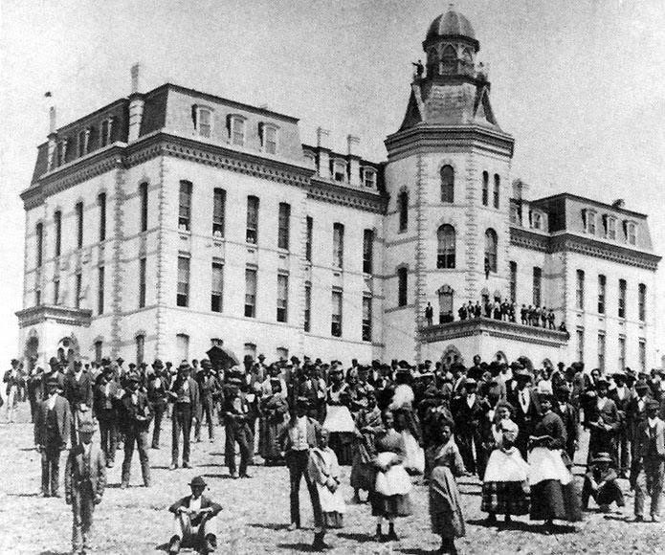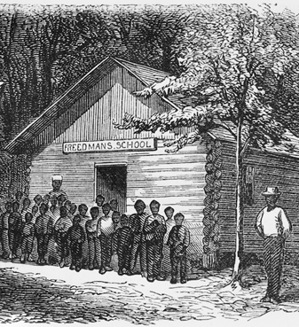
At the end of the Civil War, the United States Congress created the Freedman’s Bureau to help millions of freed slaves and poor Whites. It gave them aid through food, water, housing, doctors, lawyers, and education. One of the most successful parts of the Freedman’s Bureau was the creation of colleges and universities for Black students, such as Howard University (above left) in Washington, D.C. and Fisk University in Nashville, Tennessee (They still exist today and are called Historically Black Colleges and Universities). The Freedman’s Bureau also made free public schools for children and adults who were enslaved (above right). In 1872, Congress ended the program. Millions of people were left without help. This made life very hard for them and for many former slaves, it meant that they had to return to the plantations for work where they were once slaves.

SOURCEBOOK 5-24.C

Worst Decision: Not Stopping the Ku Klux Klan

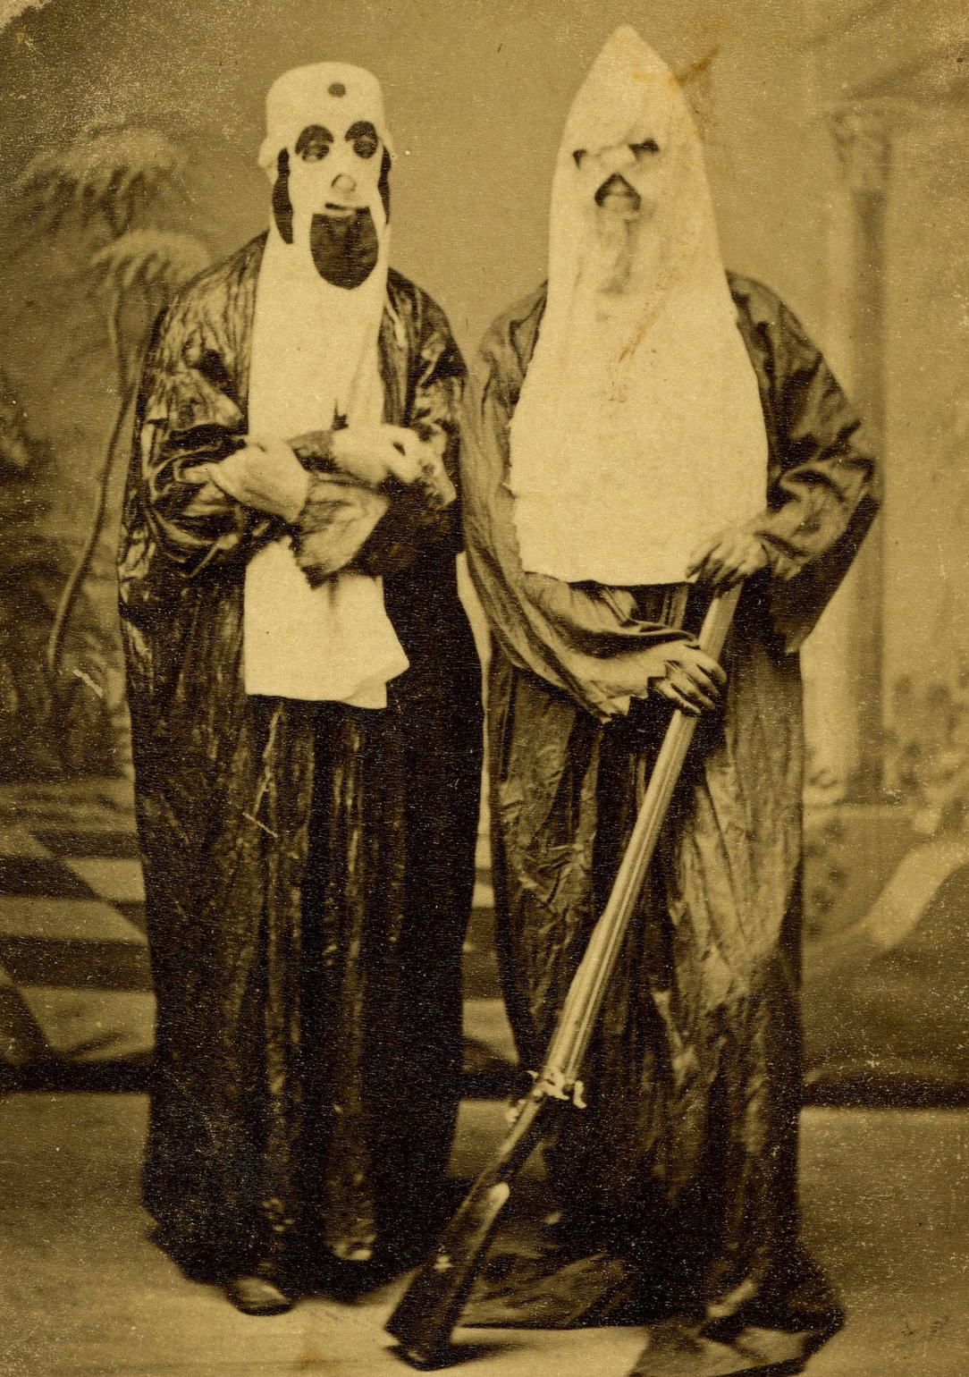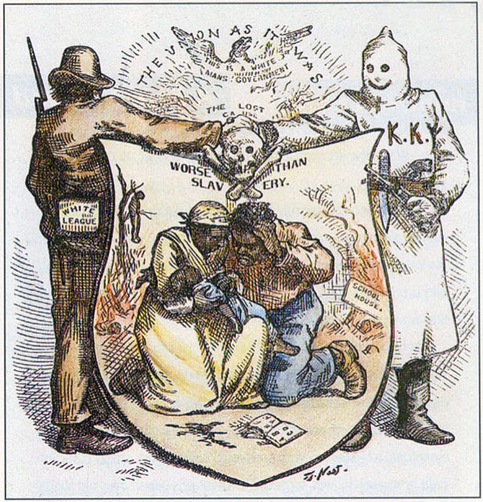
In 1866, a group of White Confederate soldiers in Pulaski, Tennessee formed a group called the Ku Klux Klan or KKK (above). Its members would often wear white hoods so no one would know who they are. The Ku Klux Klan waged a war of terror on free Black men and women. They used violence (above left) including shooting guns at African Americans and burning their houses and churches. By 1870, the Ku Klux Klan existed in all states in the South and many in the North. “Puck,” a magazine from New York City, ran a political cartoon by Thomas Nast called “Worse than Slavery” (above right), which showed how the Ku Klux Klan terrorized Black people and made them afraid. In 1871, the Congress passed a law making the Ku Klux Klan illegal, but KKK members ignored it. The Supreme Court then ruled against the Ku Klux Klan law and the KKK could continue.

SOURCEBOOK 5-24.D

Worst Decision: Did Not Protect Black People’s Right to Vote

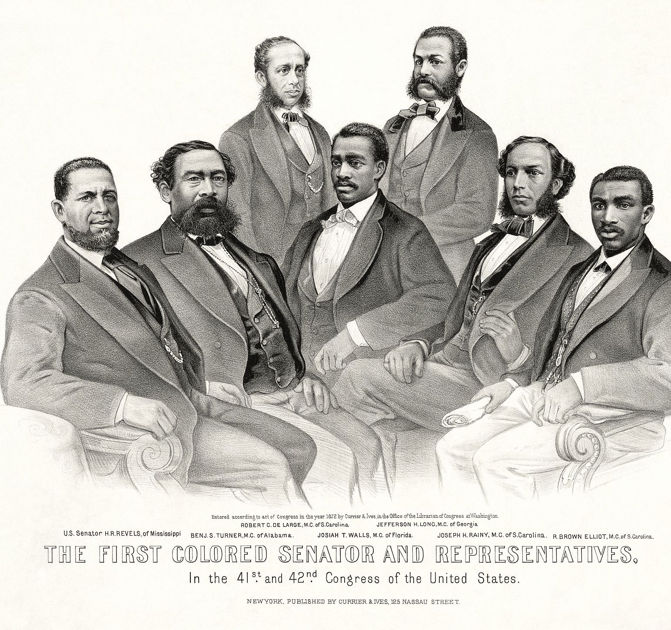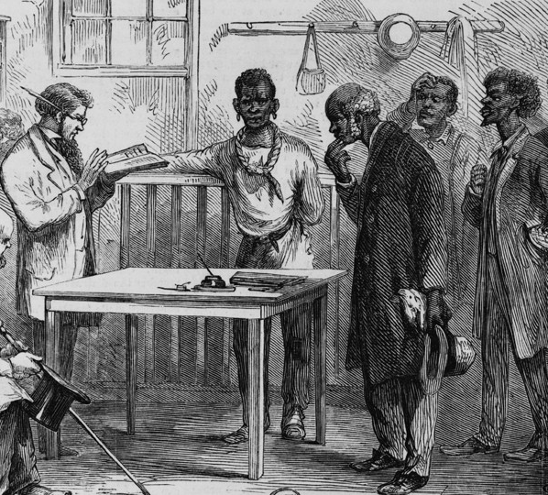
After the Civil War, the 15th Amendment allowed free Black men to vote (women could not vote at this time). Over 2,000 Black men were elected local, state, and national offices. In 1869, one Black man, Hiram Revels, was elected to the U.S. Senate and six Black men were elected to the U.S. House of Representatives (above left). Soon, Whites found ways to prevent Black people from voting. At first, they created poll taxes (tax paid to vote) and poll tests (a test you have to pass to vote, often making someone prove they could read or answer questions about government). Above right is a picture of a Black man being asked a poll test. This stopped many Black people from voting. Often, White people were not asked to pay poll taxes or do poll tests. By 1880, cities in the South were not allowing any Black people to register to vote. By preventing Black people from voting, it stopped Black people from being in government. By 1900, there were zero Black members in the House of Representatives and the Senate. The U.S. Congress did nothing to make sure Black people could vote.

SOURCEBOOK 5-24.E

Worst Decision: Did Not Stop Black Codes

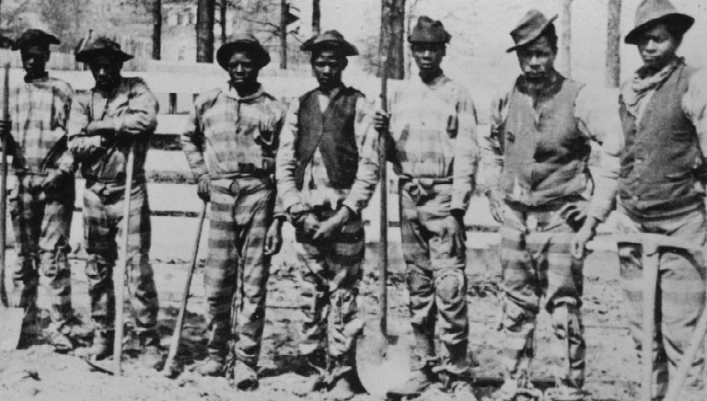
In the years after the Civil War, White Confederate leaders became the leaders of the southern states again. They passed laws called Black Codes that only applied to Black people. They banned Black people from traveling through White towns, traveling at night, and jailed Black people for vagrancy (not having a job-hard for many former slaves to find). Above is an image of a “chain gang” of prisoners who had to do hard labor for free. It is likely that these men were jailed for not having a job. The Black Codes were similar to the Slave Codes that enslaved people faced before the Civil War. White politicians often took the old slave laws and just replaced the word “slave” with the word “Black” or “Negro.” They also forced Black people to sign work contracts with landowners, which forcing them back onto their former slave plantations. The U.S. Congress did nothing to stop these laws.

SOURCEBOOK 5-25.A

Images (A)
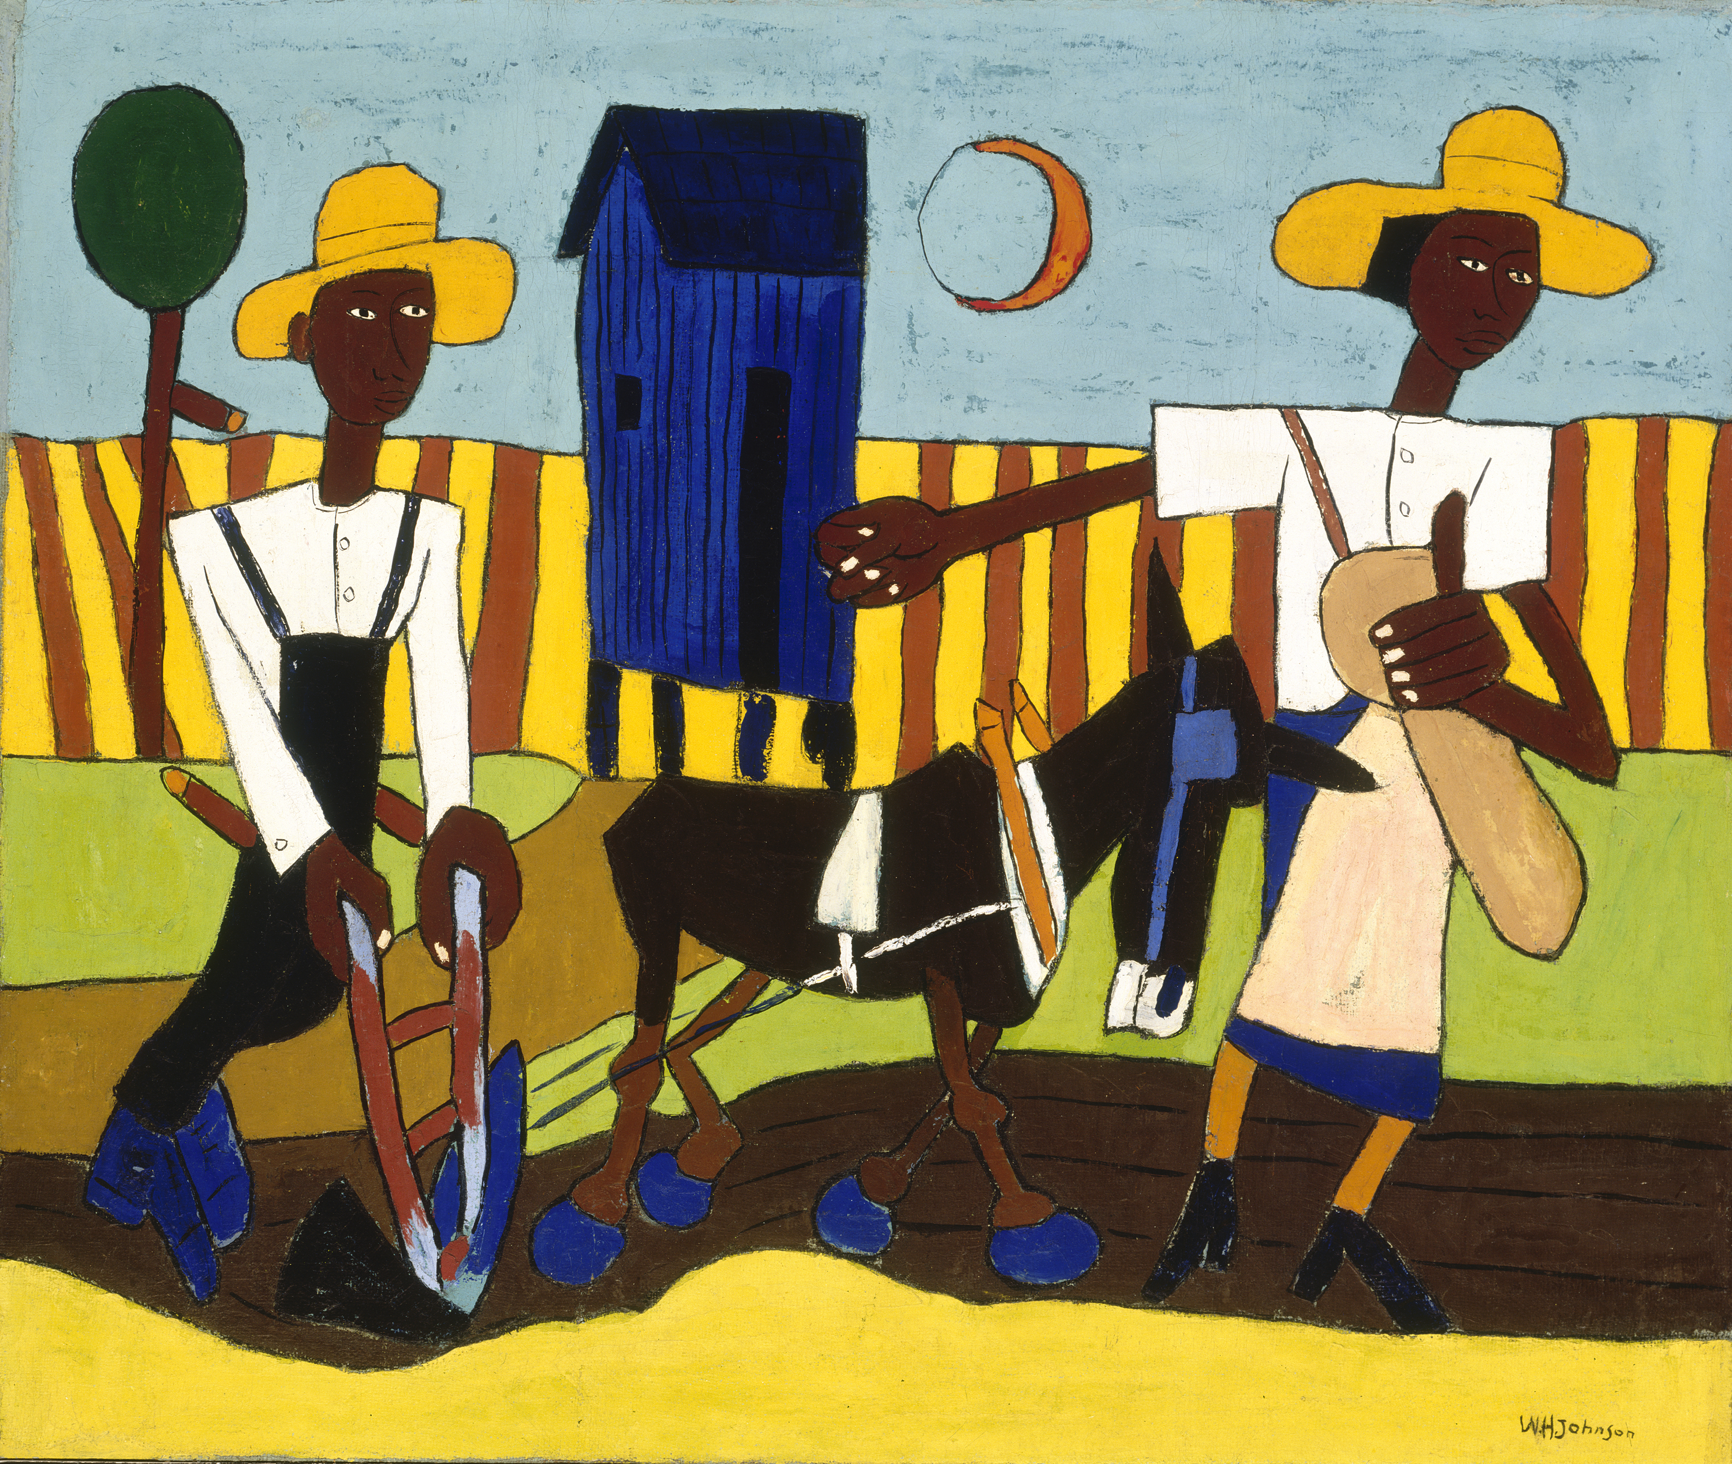

Images (B)
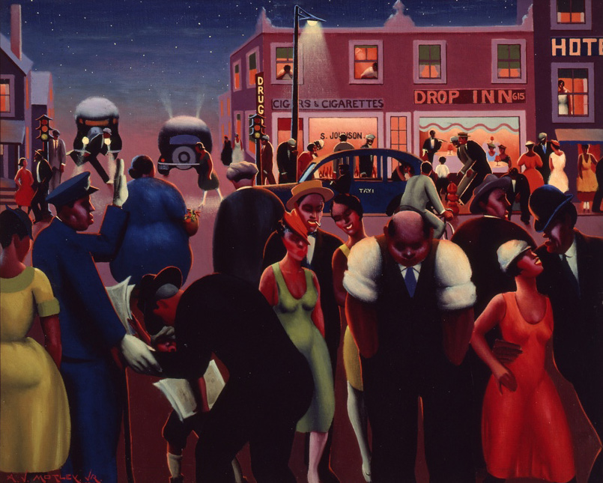

SOURCEBOOK 5-25.B

Source 1: Higher Pay in Northern Factories (Pro)

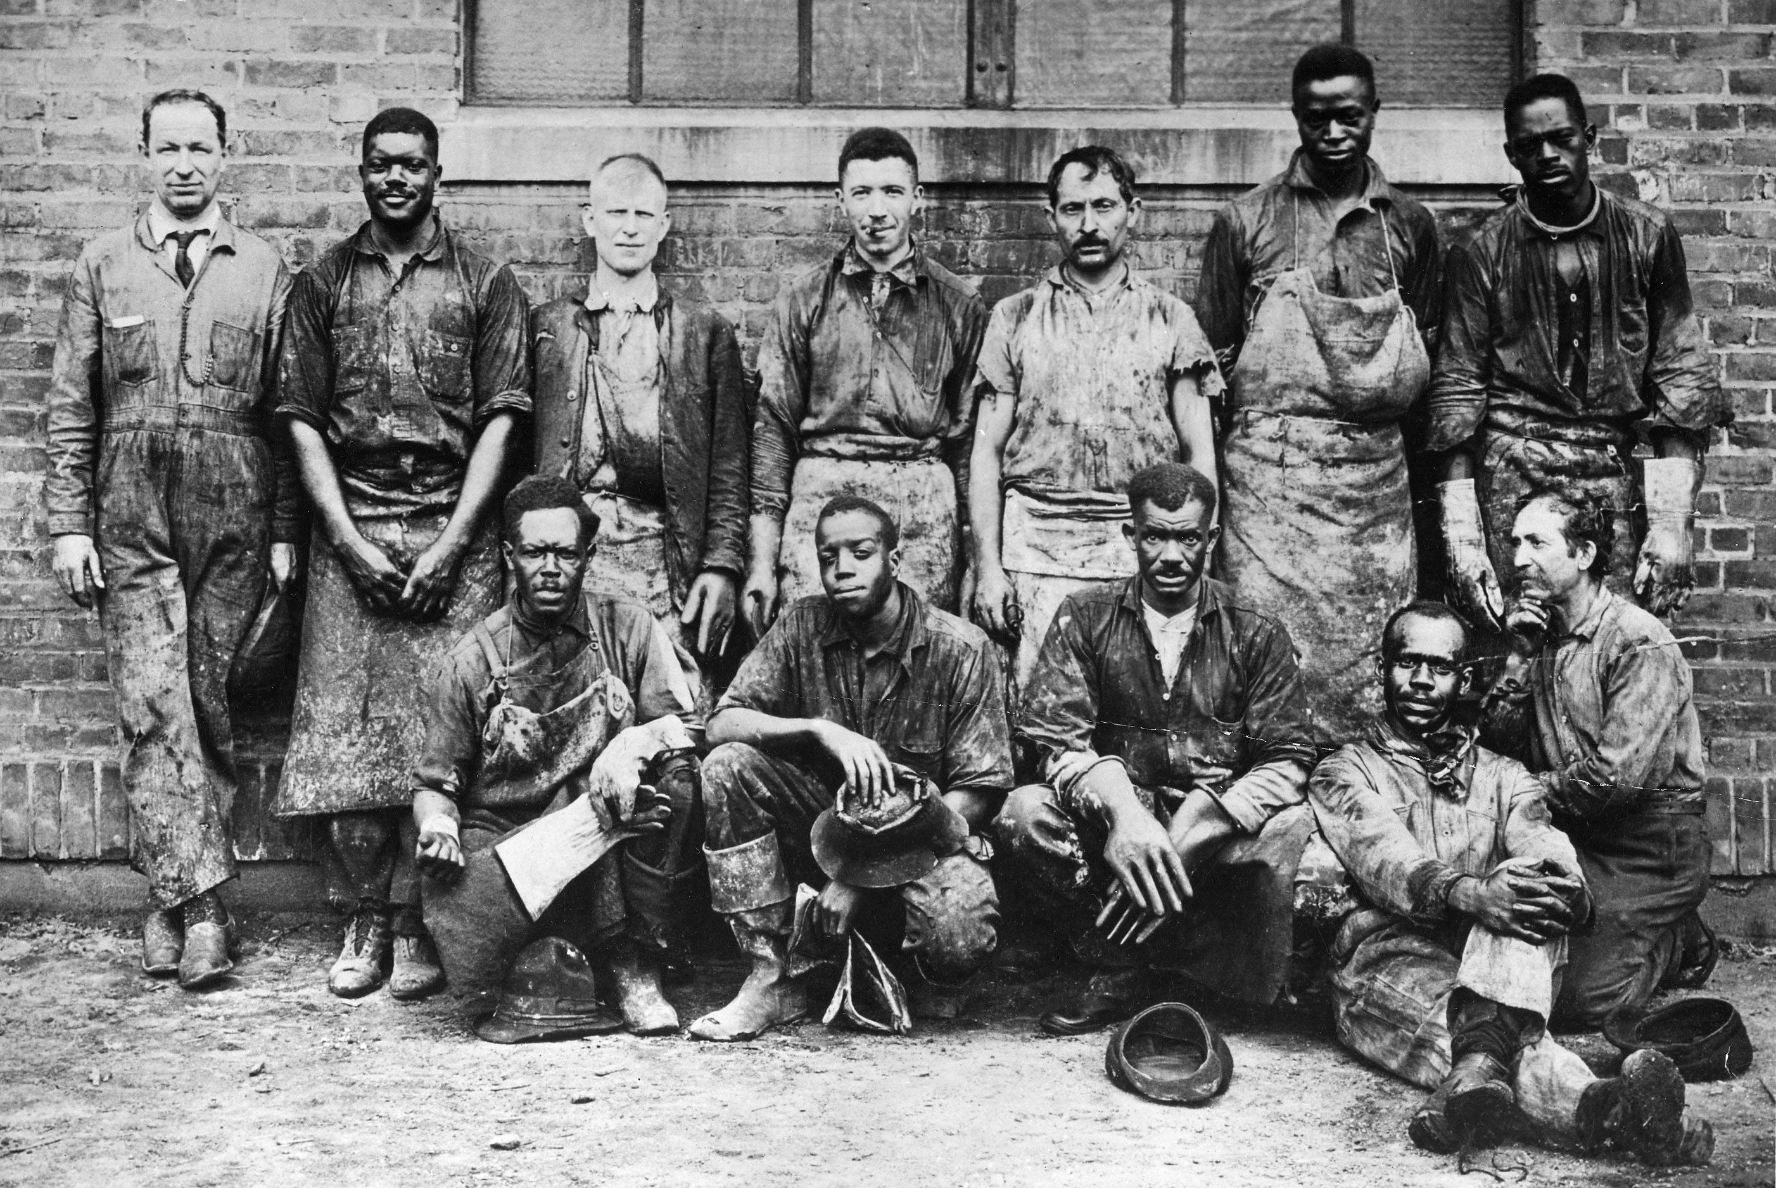
Above: Black and White factory workers at a dye plant in Bayonne, New Jersey.

Many African Americans moved to the North during the Great Migration to work in factories. While Black factory workers often were paid less than White factory workers, their pay was much better than being a sharecropper in the South. This would help many African Americans escape the debt that they had gained as sharecroppers in the South. While there was racial segregation in many factories, Black people were more likely to work alongside White people in the North. In the North, Black people were often prevented from buying houses in White neighborhoods. Unlike sharecropping in the South, African American factory workers could earn enough money to buy a house and land.

SOURCEBOOK 5-25.C

Source 2: Less Legal Segregation in North (Pro)

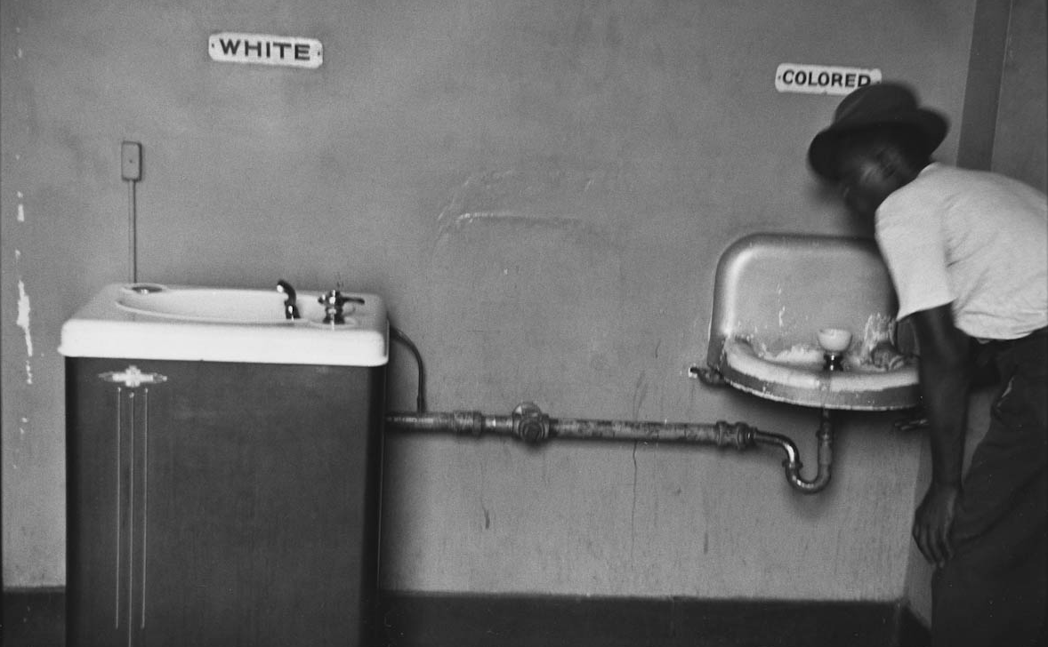
Above: A Black man drinks from the “colored” water fountain in North Carolina. The White fountain was cooled, where the Black fountain was not.

African Americans faced fewer segregation laws in the North. After the Civil War, many states in the South made laws that segregated (separated) Black people from White people. These laws were called “Jim Crow laws.” Jim Crow laws prevented Black people from using the same entrances, restrooms, drinking fountains, bus seats, train cars, seating areas, schools, and cemeteries as White people. While we no longer use these terms, Black people (and often Latino and Asian people) could only use things labeled “colored” or “Negro.” These laws generally did not exist in the North.

SOURCEBOOK 5-25.D

Source 3: Leave Family Members Behind (Con)

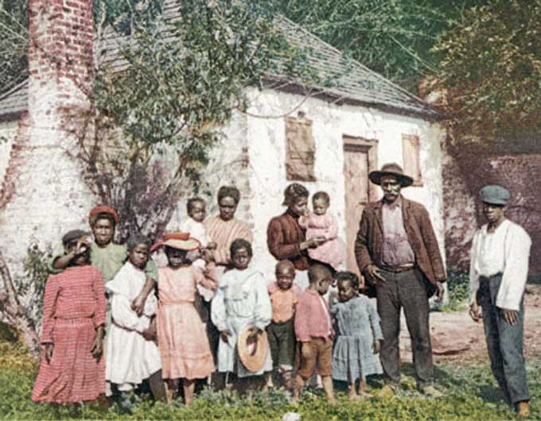
Above: A Black family in Georgia who are sharecroppers.

African Americans would have to leave their families to move to the North. It was very expensive to move to the North and African Americans often had to spend all of their money to get there. This mean only a few people in a family might be able to go. People would have to leave their parents, siblings, cousins, and other relatives. It is possible that they may never see each other again. It is very possible that you are only able to keep in touch by sending letters and maybe photographs. Many African Americans during the Great Migration also became homesick for the people, food, music, and weather. The North is also much colder.

SOURCEBOOK 5-25.E

Source 4: Distance to the North (Con)

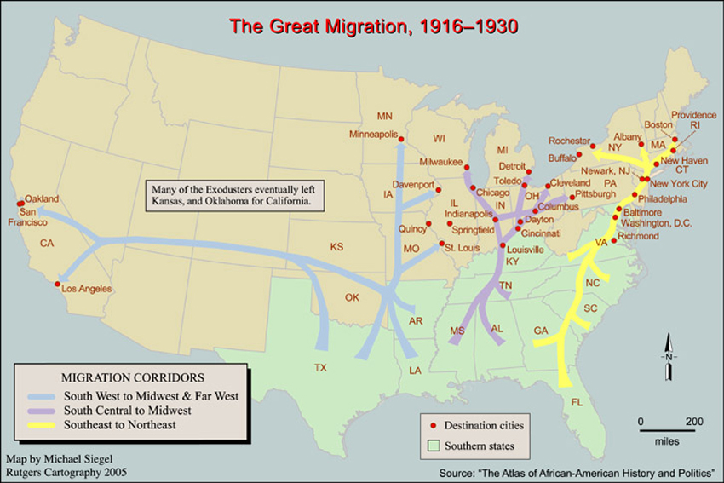
Above: A map showing how far Black people needed to travel to settle in the North from the South.

African Americans had to travel far distances to make it to the North. While many were able to save up and buy a train ticket, others walked, hitchhiked, or took horse and carts (before there were cars and buses). Even the train was not very fast; to go from New Orleans to Chicago could take over 20 hours. Often Black people settled in places that were connected by train to their home towns. For instance, many of the African Americans in the Boston area came from the coastal states in the South, because there were railways linking places like Atlanta, Charleston, and Richmond with the Northeast cities.

SOURCEBOOK 5-26.B

Overview: Japanese American Incarceration

1890s: Japanese immigrants arrived in large numbers in the United States to work in farming and fishing. The Alien Land Law prevented Japanese immigrants from owning their own land.

December 7-8, 1941: The country of Japan bombed the Pearl Harbor military base in Hawaii. On the next day, the U.S. Congress declared war on Japan. The FBI searched Japanese Americans’ homes and arrests many Japanese American men.

February 19, 1942: President Franklin Roosevelt signed Executive Order 9066, which allowed the military to imprison Japanese Americans.

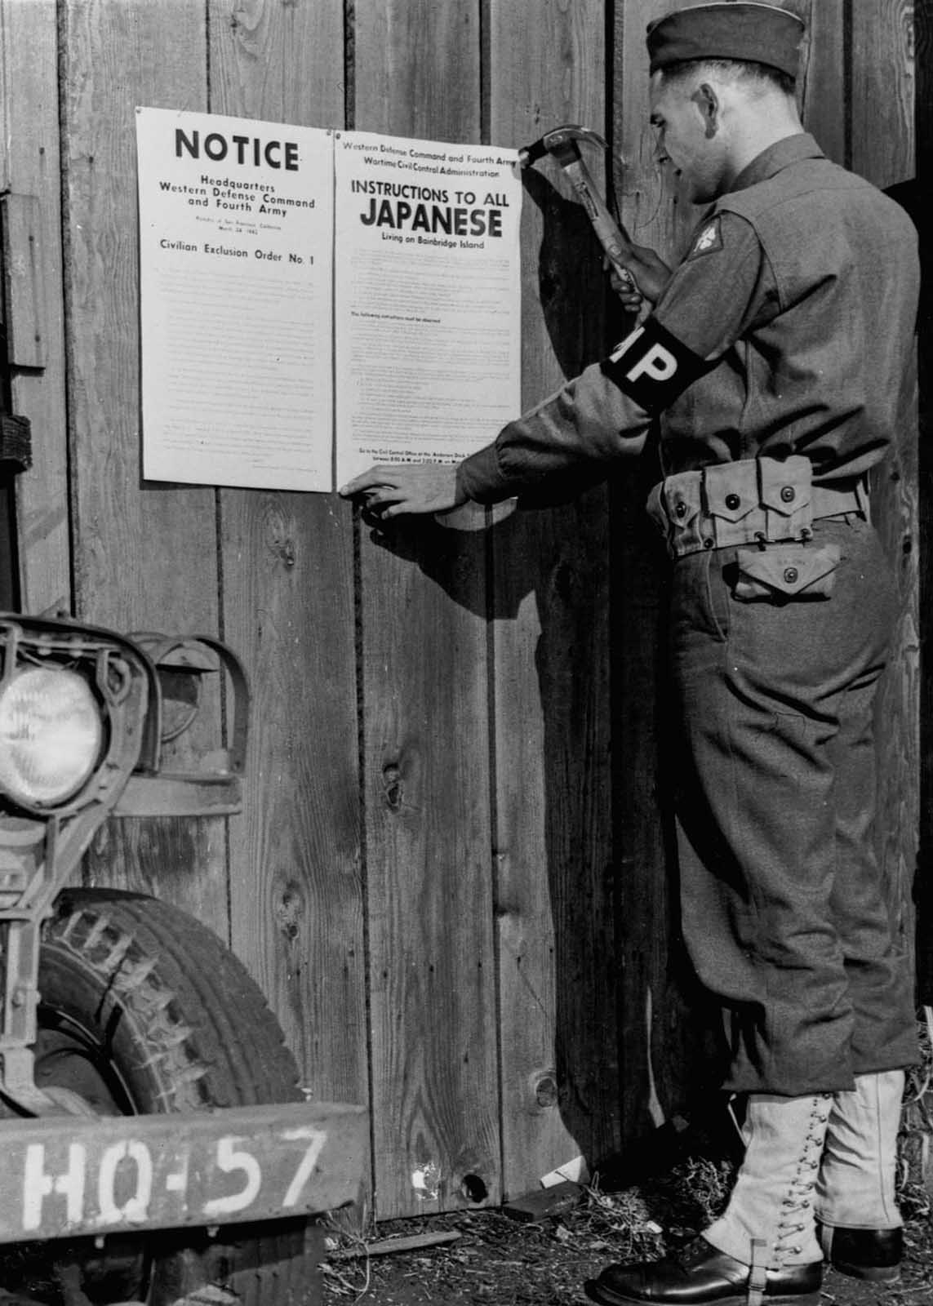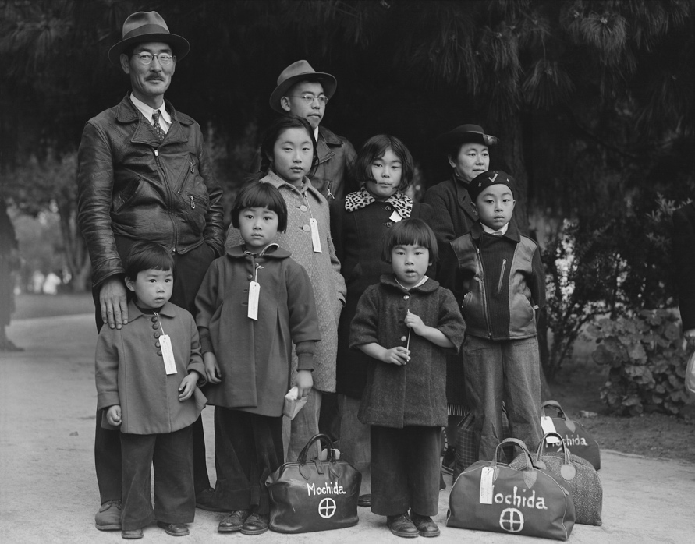
March 1942: The military put up posters in the streets and announced over the radio that all Japanese Americans in California, Washington, Oregon, and Arizona must report to “Assembly Centers.” They can only carry two bags each (above).
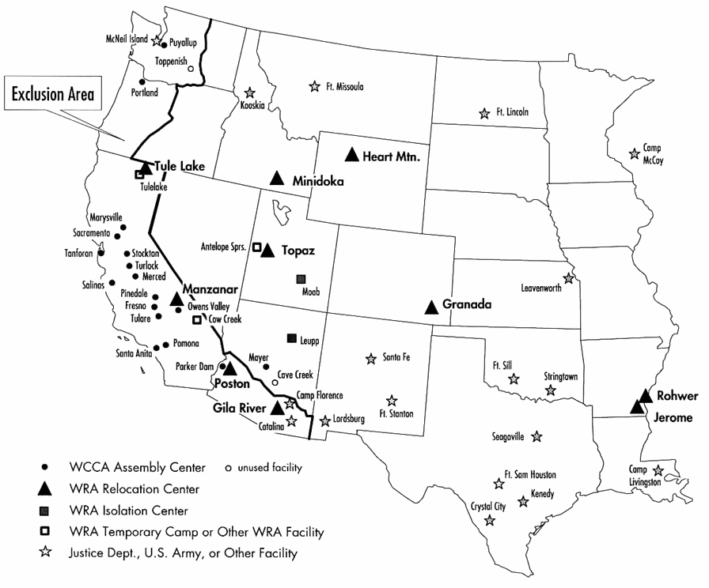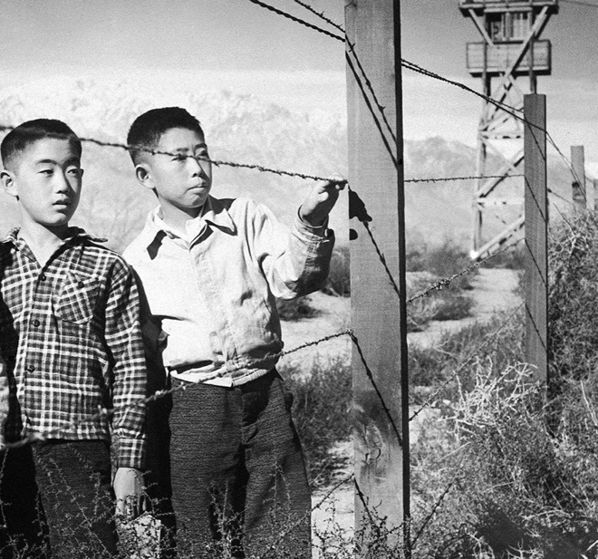

May 1942: The military moved Japanese Americans on trains to the 10 camps that they built (map; above left). Many were afraid that the government might kill them. The camps were: Manzanar (above right) and Tule Lake in California, Poston and Gila River in Arizona, Topaz in Utah (where Emi in “The Bracelet” was sent), Granada in Colorado, Heart Mountain in Wyoming, Minidoka in Idaho, and Jerome and Rohwer in Arkansas. Most of these prison camps were built in the desert, which gets very cold at night and there is snow in the winter. They were guarded by soldiers with guns (and some people were killed who tried to run away or misunderstood soldiers’ orders). People were forced to eat all their meals in “mess halls” and the food was chosen by the military (and did not taste very good). Japanese Americans did their best to survive. They created their own schools, art and music groups, sports leagues (like baseball, football, karate, and sumo wrestling). Many people signed up for work in the prison camp and some people were allowed to work in nearby farms (with soldiers guarding them). There were also jails, where anyone who protested might find themselves.
August 1942: The people in the Tule Lake prison camp had a major strike to protest their treatment by the government.

March 1943: 10,000 Japanese Americans in the prison camps volunteered to join the U.S. military. The 442nd Infantry Regiment of Japanese Americans would become one of the most decorated in the war (get the most awards for bravery).

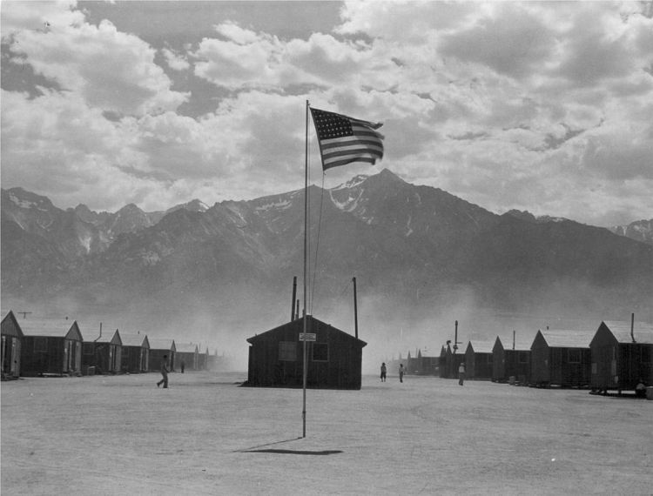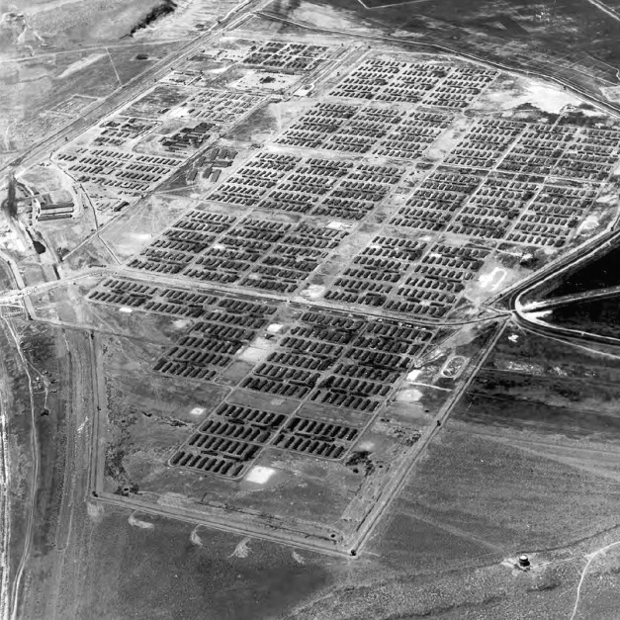
Above: Manazar (left) and Tule Lake (left) were two of the largest camps.

September 1943: Japanese Americans in the prison camps are told to answer a questionnaire about their loyalty to the United States. They are asked if they would fight for the United States in war and if they will swear allegiance to the United States and against the Japanese emperor or any other nation. Many people answered “no,” because they did not want to fight against their family members in Japan, were against war, and did not have an allegiance to the Emperor or Japan. People who answered “no” were sent to a “Segregation Center” camp called Tule Lake in California.

May 10, 1944: People at the Heart Mountain prison camp had a major protest of their treatment and being drafted into the military.

December 1944: The Supreme Court ruled that the government could imprison Japanese Americans during wartime.

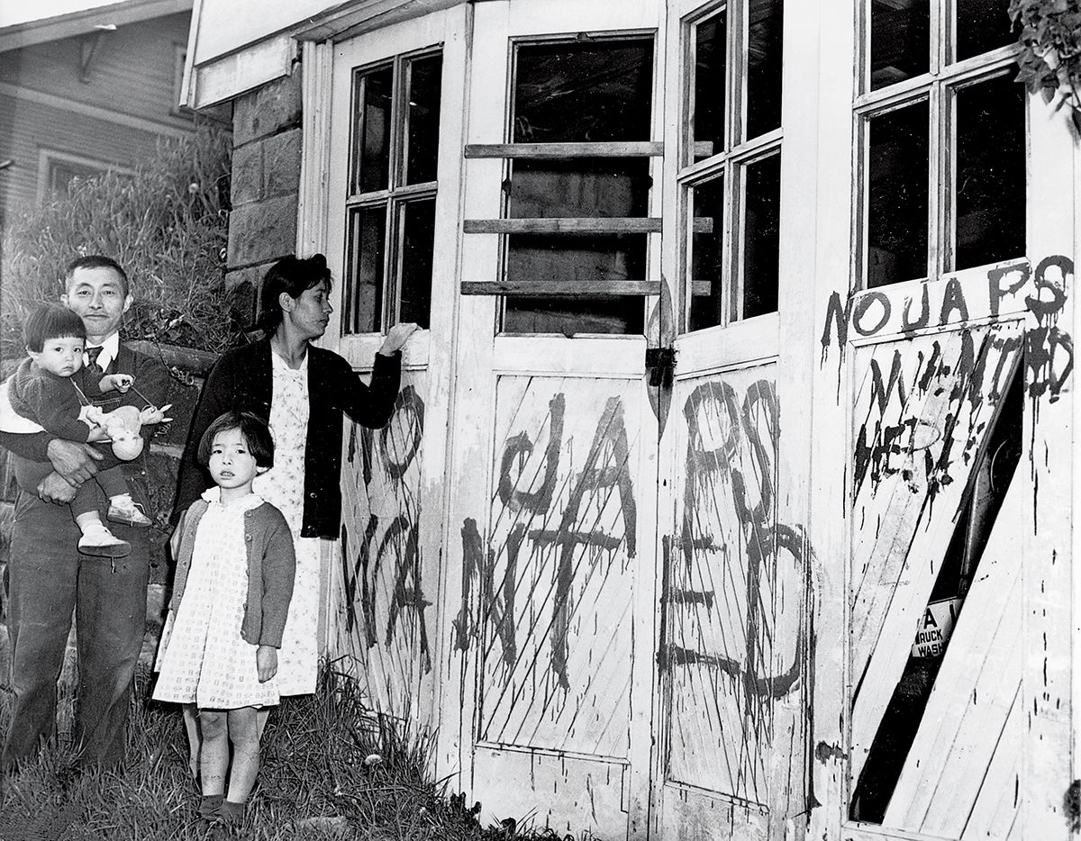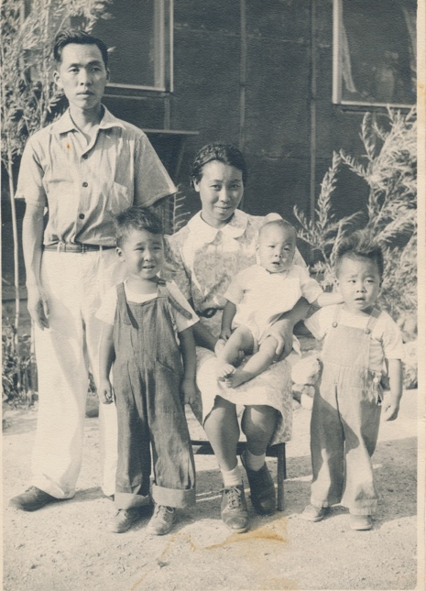
January 2, 1945: The Supreme Court ruled that “loyal” Japanese American citizens can be released from prison camps. Many people return to their homes on the West Coast to find them damaged, graffitied with hate words (above left), their things stolen, or other people living there. It was also hard to find work or return to school, because many White people blamed Japanese Americans for the war (even if they were born in the U.S.). Above (right) is a picture of the Hashimoto family at Tule Lake, who were not let out of their prison camp.

March 20, 1946: Tule Lake “Segregation Center” closes. This is the last prison camp to close. Some remaining Japanese Americans are sent to a prison in Crystal City, Texas.

SOURCEBOOK 5-26.C

Person 1: Gordon Kiyoshi Hirabayashi

Gordon Kiyoshi (ki-oo-she) Hirabayashi (he-ra-bi-ah-she) was born in Seattle, Washington. He was a Quaker and a pacifist, which meant his religion and beliefs would not allow him to fight in a war. He was 24 years old and a college student when Pearl Harbor was bombed. When Japanese Americans were told to go to Assembly Centers, he refused. Instead, he continued studying at his college, the University of Washington. He was arrested and sent to prison. He missed his family, who were sent to the Minidoka prison camp. He got a lawyer and sued the government. The case went all the way up to the Supreme Court and on June 21, 1943, they ruled that the government could imprison Gordon for violating the military orders.

SOURCEBOOK 5-26.D

Person 2: Shigeno Nakamura

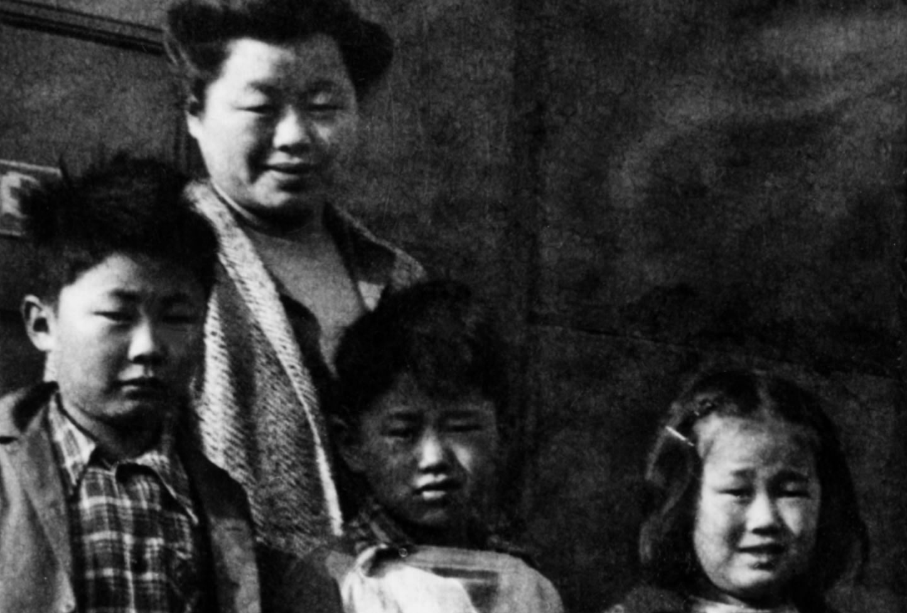

Shigeno (she-gee-no) Nakamura (na-ka-mur-ah) was born in Japan and immigrated to Sacramento, California when she was a young woman. She had five children. The whole family eventually moved to Los Angeles. In L.A., she had three grandchildren. Shigeno did not speak very much English and she was very afraid when the soldiers came and told her and her family to go to an Assembly Center. They lost everything, including their house. They were sent to Rohwer in Arkansas. Afraid that her children might be drafted to fight in the war, Shigeno answered “no” on the loyalty oath questions and they were sent to Tule Lake in California. Their time in the prison camp was very hard.

SOURCEBOOK 5-26.E

Person 3: Jimmy Tsutomu Mirikitani

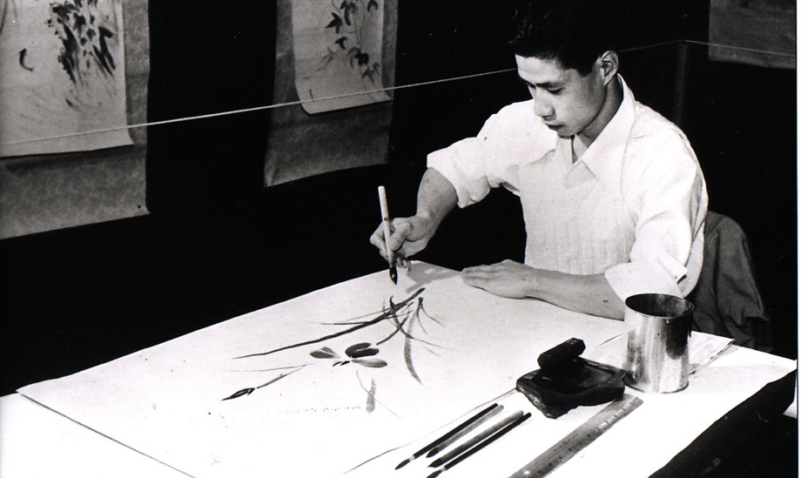

Jimmy Tsutomu (su-toe-moo) Mirikitani (mi-di-ki-ta-ne) was born in Sacramento, California. As a young boy, his parents sent him to Japan when he was little to live with relatives in Hiroshima, go to school, and learn Japanese (they called this being a “kibei”). In Japan, he became an artist known for his paintings (above). When he finished school in Japan, he returned to the United States, because he did not like war and did not want to be in the Japanese Army. He was 22 years old when Pearl Harbor was bombed. He was very afraid when the soldiers came and told him to go to an Assembly Center. He was sent to Tule Lake in California. He was against war and answered “no” on the loyalty oath questions. He sent a letter to the President asking to be released, since he was an artist and against war. He was later sent to a prison in Crystal City, Texas.

SOURCEBOOK 5-26.F

Person 4: Daphne Masumi Nakai

Daphne Masumi (ma-su-mi) Nakai (na-kai) was born at the Tule Lake Prison Camp in California (she is pictured above with her brother Ron). Her parents, who were born in the United States, lived in Oakland, California. They were very afraid when the soldiers came and told them to go to an Assembly Center. They heard that if you had family that lived far away from the ocean you would not be imprisoned. They moved to Lodi, where there were many farms. A few months later, they were told to report to an Assembly Center. They lost everything. They were sent to Rohwer in Arkansas. Daphne’s parents had family who lived in Japan and they did not want to fight in the war, so they answered “no” on the loyalty oath questions. They were sent to Tule Lake in California. In 1943, Daphne was born. She spent her first few years there. Her family missed their home and their friends.

SOURCEBOOK 5-27.A

Overview: The Civil Rights Movement

After the Civil War, there was an important Supreme Court case about racial segregation called Plessy v. Ferguson. Homer Plessy, an African American, had boarded a train in New Orleans and sat in a “whites-only” car. The Supreme Court ruled against Homer Plessy, allowing states to separate races (White, Black, Asian, Latino, Indigenous people) as long as it was “separate but equal.” This meant people could be separated as long as they are given the same things.

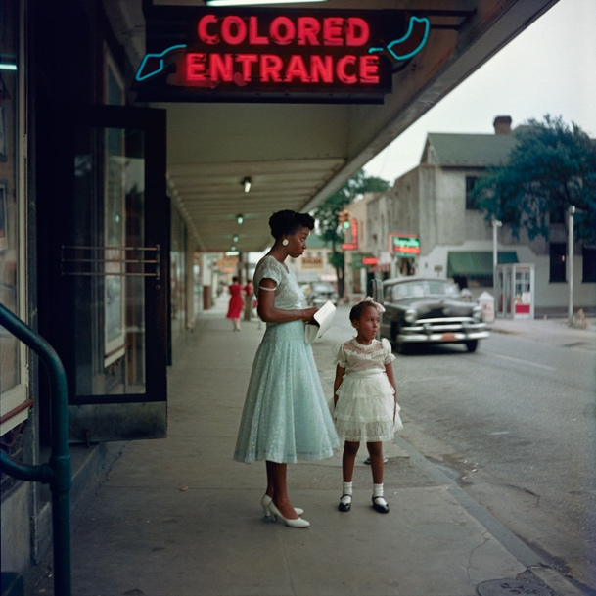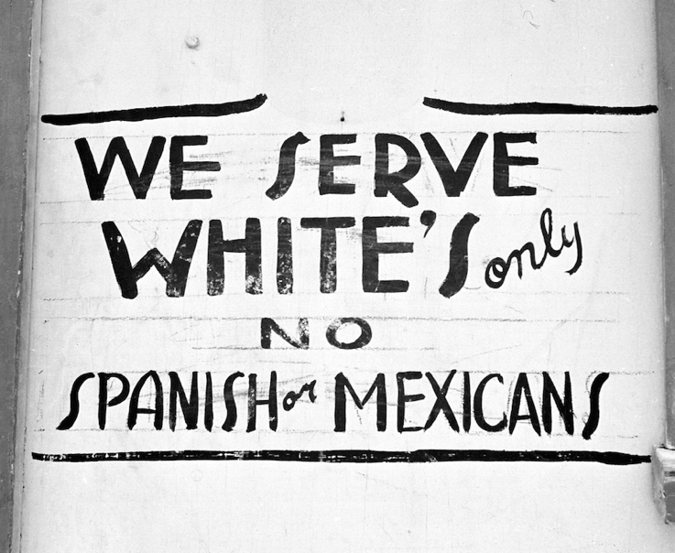

In many cities and towns, African Americans (and some places also Asians and Latinos) were not allowed to share a taxi with Whites or enter a building through the same entrance. They had to drink from separate water fountains, use separate restrooms, attend separate schools, and even be buried in separate cemeteries. They were excluded from certain restaurants, parks, swimming pools, and libraries. It was common to see signs that said, “Whites only” or even “Negroes and dogs not allowed.”
Black people were expected to step aside to let a White people pass. Black men could get in serious trouble for looking any White woman in the eye. Black men and women were rarely addressed as “Mister” or “Miss.” Black men were referred to as “boy” and Black women as “girl,” even if they were adults, and often called hate words.

Although the Constitution protected the right to vote for all races (15th Amendment), Black people were generally not allowed to vote. Many African Americans were required to pass literacy tests and to explain state constitutions to White clerks. These tests were not applied to Whites. In many places, groups like the Ku Klux Klan, burned schools and churches where voter education classes were held.

After Civil War, many organizations were formed to fight for racial justice and equality, but change was very slow. Groups such as the National Association for the Advancement of Colored People (NAACP), Congress of Racial Equality (CORE), and Dr. Martin Luther King's Southern Christian Leadership Conference (SCLC), believed change could only happen by peaceful means (no violence). Other groups, such as the Nation of Islam and the Black Panthers, argued for using violence in self-defense and creating Black communities separate from White communities. They believed the only way they could protect themselves was to be separate from Whites. During this time, many people were involved in marches, rallies, strikes, riots, and violent confrontations with the police in an attempt to stop racism and gain equality for African Americans.
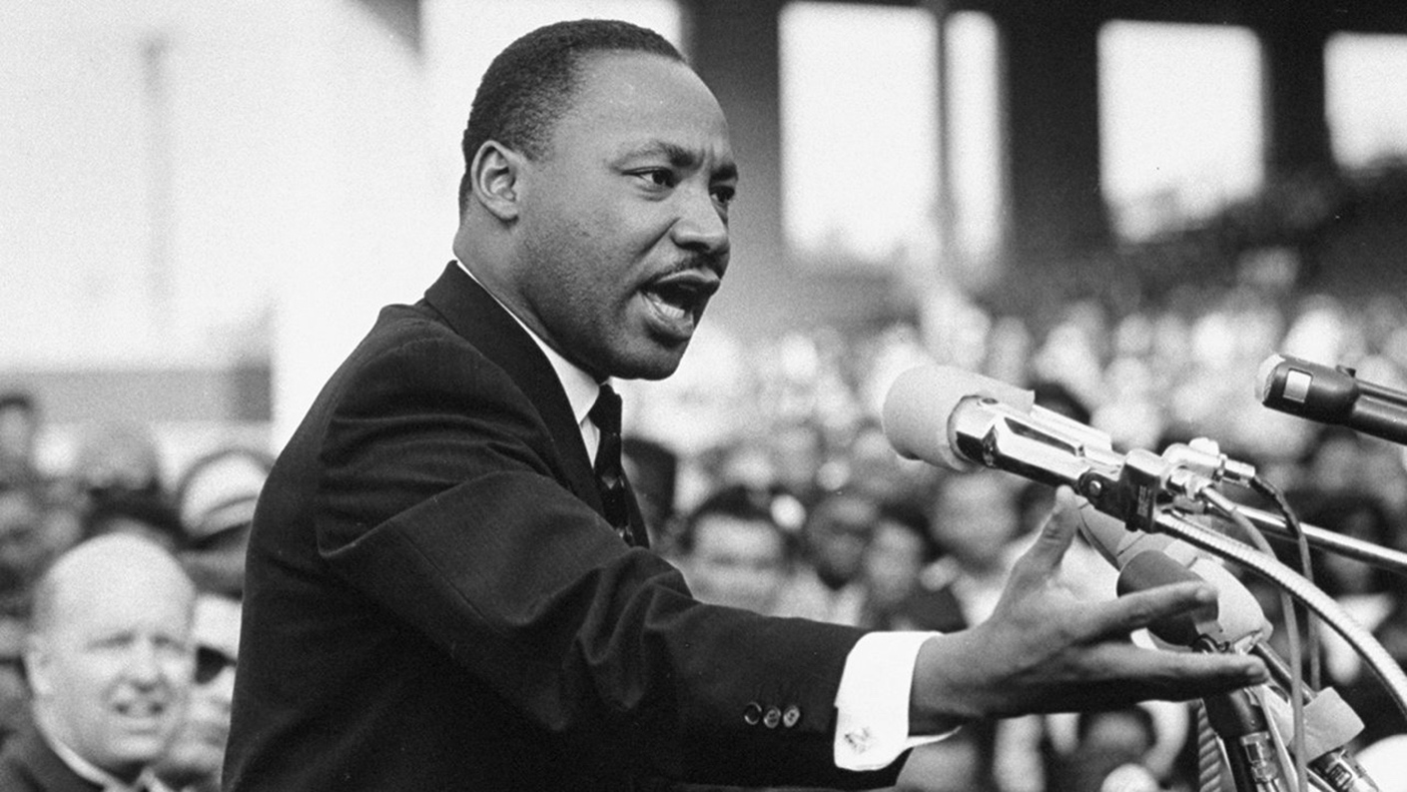

Martin Luther King
Martin Luther King was born and raised in Atlanta and lived in Grove Hall section of Dorchester/Roxbury and the South End while earning his Ph.D. at Boston University. He would become president of the Southern Christian Leadership Conference (SCLC). The SCLC organized numerous marches, rallies, and strikes to call attention to the systematic discrimination against Black people. King believed in nonviolent resistance, which meant you should never use force and the only way to make change is to stop “evil by the power of love.” His work would push Congress to pass laws protecting civil and voting rights. He also spoke out against the Vietnam War and poverty. On April 4, 1968, King was assassinated (killed) in Memphis while helping garbage workers who were on strike for better pay.

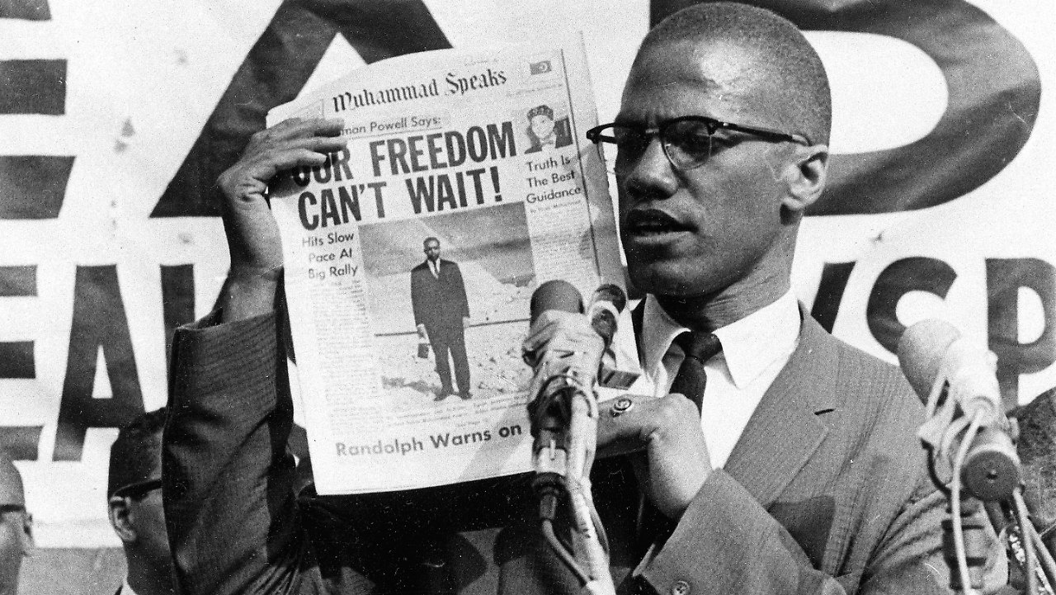

Malcolm X
Malcolm X was born Malcolm Little in Nebraska. As a boy, his father was killed by White supremacists. As a teenager, he moved in with his sister on Dale Street in Roxbury. He was serving time for robbery when he started reading many books. In jail, he joined the Nation of Islam (NOI). The NOI argued that Black people should create separate communities from Whites. This was the only way that they will stop being treated poorly by Whites. Malcolm X was known for his street corner speeches and tireless work in the Harlem section of New York City. In 1964, Malcolm X left the Nation of Islam out of concern about its leader Elijah Muhammad. After a trip to Africa and a pilgrimage to Mecca, Malcolm X started the Organization of Afro-American Unity, which wanted harmony among all races. On February 22, 1965, three men (possibly from NOI) assassinated Malcolm X as he gave a speech in the Harlem Ballroom.

SOURCEBOOK 5-27.B

Martin Luther King Sources

“The Power of Nonviolence” (1957)
From the very beginning there was a philosophy … of nonviolent resistance. There was always the problem of getting most people to understand it. We had to make it clear that nonviolent resistance is not a method of cowardice (for those with fear). It does resist (fight). The nonviolent resister is just as opposed to the evil that he is standing against as the violent resister but he resists without violence (without fighting). … The nonviolent resister does not seek to humiliate or defeat the opponent but to win his friendship and understanding.

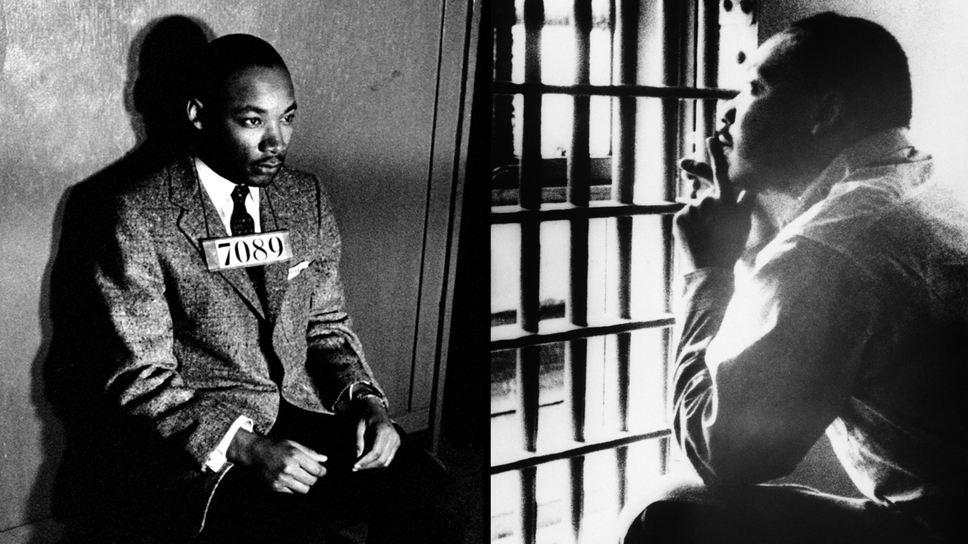
Above: Martin Luther King being arrested for protesting. He wrote the below letter while sitting in a jail.

Letter from a Birmingham Jail (1963)
We know that freedom is never voluntarily given by the oppressor (person controlling others); it must be demanded by the oppressed (people being controlled by others)… For years now I have heard the word “Wait!” It rings in the ear of every Negro with a piercing familiarity. This “wait” has almost always meant “never.” We must come to see with the distinguished jurist of yesterday that “justice too long delayed is justice denied” (if you are not treated fairly for long enough, it means you will never be treated fairly). We have waited for more than 340 years for our constitutional and God-given rights. The nations of Asia and Africa are moving with jet-like speed toward the goal of political independence, and we still creep at horse and buggy pace toward the gaining of a cup of coffee at a lunch counter.

I guess it is easy for those who have never felt the stinging darts of segregation to say wait. But when you have seen vicious mobs lynch (killed by a group) your mothers and fathers at will and drown your sisters and brothers at whim; when you have seen hate-filled policemen curse, kick, brutalize, and even kill your black brothers and sisters with impunity; when you see the vast majority of your 20 million Negro brothers smothering in an airtight cage of poverty in the midst of an affluent society;

When you suddenly find your tongue twisted and your speech stammering as you seek to explain to your six-year-old daughter why she can’t go to the public amusement park that has just been advertised on television, and see the tears welling up in her little eyes when she is told that Funtown (an amusement park) is closed to colored children, and see the depressing clouds of inferiority begin to form in her little mental sky, and see her begin to distort her little personality by unconsciously developing a bitterness toward white people; when you have to concoct an answer for a five-year-old son who is asking in agonizing pathos: "Daddy, why do white people treat colored people so mean?"

When you take a cross country drive and find it necessary to sleep night after night in the uncomfortable corners of your automobile because no motel will accept you; when you are humiliated day in and day out by nagging signs reading “white” men and “colored” when your first name becomes “nigger” and your middle name becomes “boy” (however old you are) … I hope, sirs, you can understand why we can no longer wait.

SOURCEBOOK 5-27.C

Malcolm X Sources

Louis Lomax Interviews Malcolm X (1963)
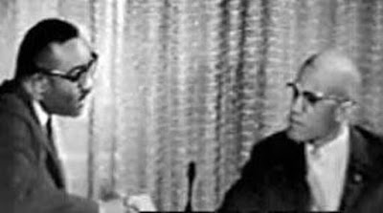
Above: An image of Louis Lomax interviewing Malcolm X.

Lomax: Wouldn’t you say the Negro has a nation—America?

Malcolm X: Sir, how can a Negro say America is his nation? He was brought here in chains; he was put in slavery and worked like a mule for three hundred years; he was separated from his land, his culture, his God, his language! The Negro was taught to speak the white man’s tongue, worship the white God, and accept the white man as his superior. This is a white man’s country. And the Negro is nothing but and ex-slave who is now trying to get himself integrated into the slave master’s house.

Lomax: It is suggested also that your movement preaches violence.

Malcolm X: No, sir. The black people of this country have been victims of violence at the hands of the white men for four hundred years. Today, we are showing black people in this country that, just as the white man and every other person on this earth has God-given rights, natural rights, civil rights, any kind of rights that you can think of, when it comes to defending himself, black people—we should have the right to defend ourselves also.

Lomax: Then your movement does not share the integration (live together) goals of the NAACP, CORE, Martin Luther King’s movement, and the Student Nonviolent movement.

Malcolm X: You don’t integrate with a sinking ship. You don’t do anything to further your stay aboard a ship that you see is going to go down to the bottom of the ocean. … If [Blacks] were treated like citizens, you wouldn’t have a race problem. If the 13th (ended slavery), 14th (everyone born in the U.S. a citizen) and 15th (right to vote) Amendments to the Constitution were followed, you wouldn’t have a race problem. If the Supreme Court desegregation decision was followed, you wouldn’t have a race problem. Right now, complete separation from whites is the only thing that will save us.

Malcolm X’s Speech at the Founding Rally of the Organization of Afro-American Unity (1964)
Recently, when I was blessed to make a religious pilgrimage to the holy city of Mecca where I met many people from all over the world, plus spent many weeks in Africa trying to broaden my own scope and get more of an open mind to look at the problem as it actually is, one of the things that I realized … was that our African brothers have gained their independence faster than you and I here in America have.

So, we have formed an organization known as the Organization of Afro American Unity. Our motto: We want freedom by any means necessary. We want justice by any means necessary. We want equality by any means necessary. We don't feel that in 1964, living in a country that is supposedly based upon freedom, and supposedly the leader of the free world, we don't think that we should have to sit around and wait for some segregationist congressmen and senators and a President from Texas in Washington, D.C., to make up their minds that our people are due some civil rights. What do we want:

1. We are trying to unite our people. We must unite together in order to go forward together.
2. We assert the Afro American's right to self-defense.
3. Education is an important element in the struggle for human rights. It is the means to help our children and our people rediscover their identity and self-respect.
4. Basically, there are two kinds of power that count in America: economic (money) power and political (government) power. In order for the Afro-Americans to control their destiny, they must be able to control their future through having power.
5. This organization is responsible only to the Afro-American people and the Afro-American community to form an organization that will help us improve our society.

SOURCEBOOK 5-28.A

Images

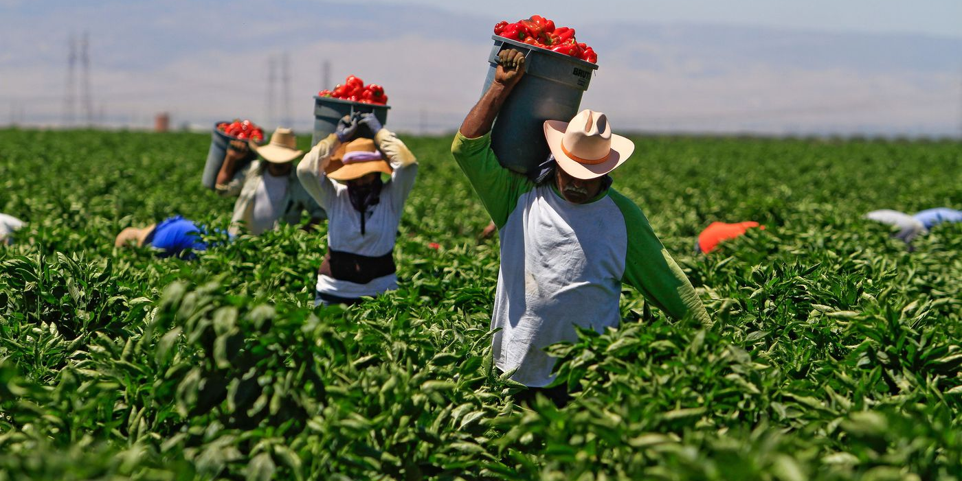

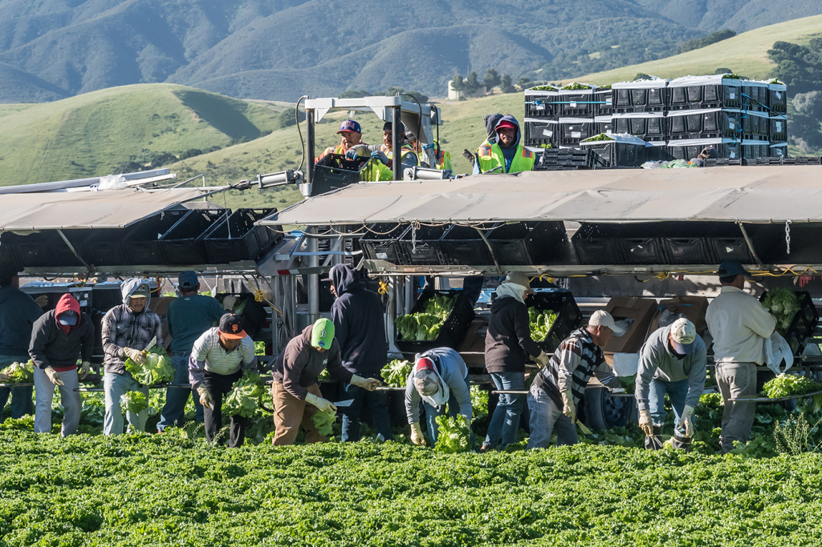

SOURCEBOOK 5-28.B

Source 1: Work Strikes and Picket Lines

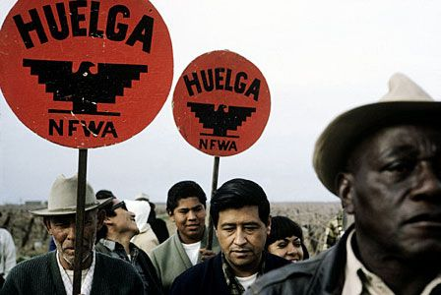

One of the protest methods that the National Farm Workers Association used were picket lines and work strikes, known as “huelga” (wel-ga) in Spanish. Work strikes are when worker refuse to do their job until their issues are improved or corrected. Striking workers would also form picket lines outside of the farms and ask other farmworkers to not cross them and go to work. This would often shut down farms, because they did not have enough work. Farm owners could not make money without workers (their crops will rot on the vines) and may fix the issues so that they can keep their farm workers harvesting (picking crops). Sometimes striking workers were fired and they no longer made money. This would make it really difficult for their families.

SOURCEBOOK 5-28.C

Source 2: Marches and Rallies

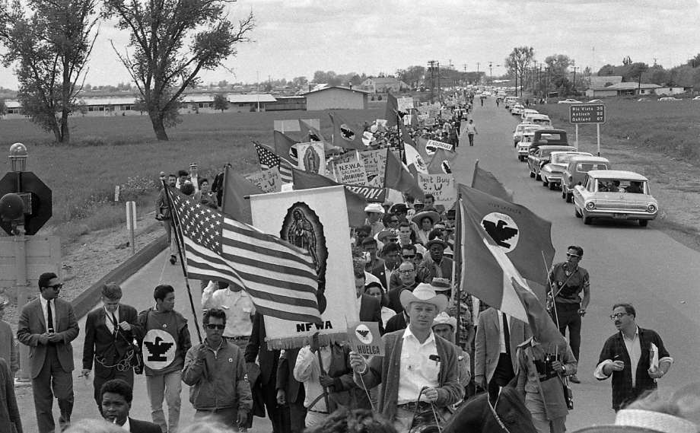

One of the protest methods that the National Farm Workers Association used were marches and rallies. These are actions to get the attention of passing by people and the media (like newspapers, radio, and television). In marches, they would gather hundreds and sometimes thousands of people to walk long distances. Their longest march was 300 miles from Delano to Sacramento (about the distance of Boston to Philadelphia). In rallies, they would gather hundred and sometimes thousands of people to listen to speeches and songs. They would often chant "Sí, se puede" (Spanish for “Yes, we can”). They would invite famous people, like Senator Robert F. Kennedy (President John F. Kennedy’s brother). The media would cover these events and people from around the country and world would hear about them. It showed that many people supported them.

SOURCEBOOK 5-28.D

Source 3: Hunger Strikes

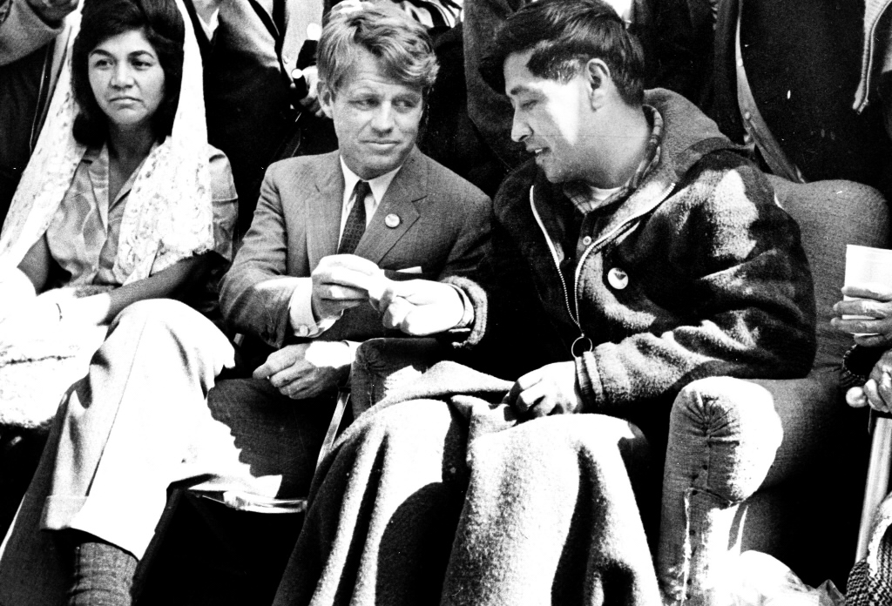

One of the protest methods that the National Farm Workers Association used were hunger strikes. A hunger strike is when a person refuses to eat. It can be very dangerous because you need to each regularly or you could become very sick or die. César Chavéz respected the famous Indian independence leader Mahatma Gandhi, who went on 17 hunger strikes (the longest one was 21 days). Alice Paul, wanted women to have the right to vote, was jailed and did a hunger strike in prison until they forced her to eat. So, César Chavéz decided to do a hunger strike too and it lasted for 25 days. He lost 35 pounds. He could barely walk. It convinced several important politicians to come to California and meet with him about the farmworker’s conditions.

SOURCEBOOK 5-28.E

Source 4: Boycotts

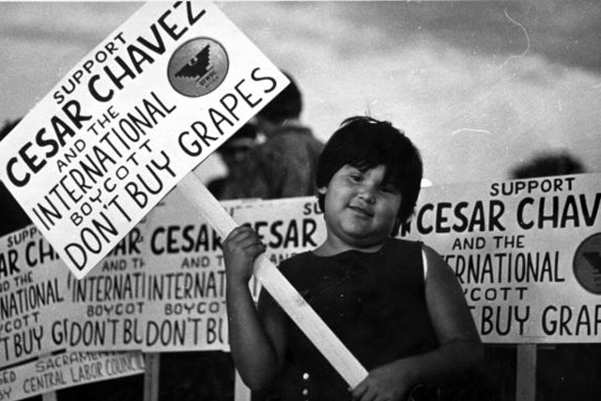

One of the protest methods that the National Farm Workers Association used were boycotts. A boycott is when you get people to not buy a product until they change something related to it. In 1965, the farmworkers started a boycott of grapes that lasted off and on for over several years. At first, it was a local boycott in places like San Francisco and Los Angeles. Later, they traveled around the country, to places like New York, Boston, Philadelphia, Chicago, New Orleans, asking people to not buy California grapes or shop at stores that carry California grapes. In the end, about 17 million people stopped buying grapes and it cost farm owners over $25 million. This caused one farm owner to change its policies and they sold many grapes. Many say the boycott made the owners want to speak with César Chavéz about the workers.

SOURCEBOOK 5-29.A

Zoom In Inquiry Activity
Zoom 1
Zoom 2
Zoom 3

SOURCEBOOK 5-29.B

Source 1: Women’s Liberation Movement

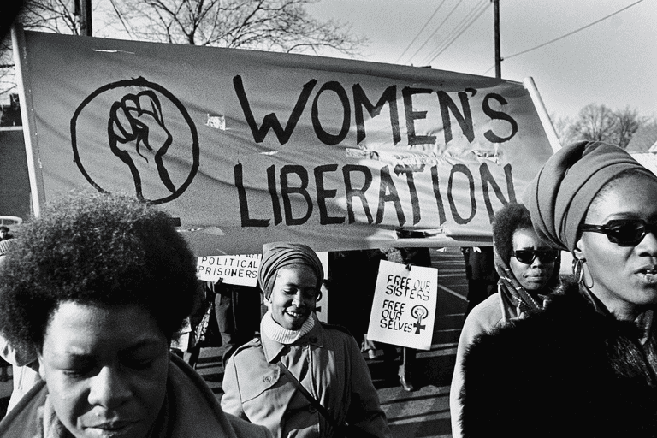

Inequalities:
In the 1960s, women did not have the same rights as men. Women were paid only 61 cents to every dollar that men made (today, they still only make 78 cents to every dollar that men make). They often were fired from their jobs if they became pregnant or were married. Men would often not help with raising kids at home and women did most of the cooking and cleaning for their families. Women could not attend the best colleges, like Harvard University, or serve on a jury in court. Men would often comment on women’s looks and could fire them if they thought they were getting too old. The law essentially allowed men to make decisions and be seen as owning their wives.
Protest Methods:
Using many of the ideas from the Civil Rights Movement, the Women’s Liberation Movement did protests, sit-ins, and marches to raise awareness of how women were being treated. They wrote books that spread the word that it is wrong how women were not treated as equals. Some of their most important leaders included Betty Friedan and Gloria Steinem. One of the most famous protests was at the Miss American Pageant in 1968. The Women’s Liberation Movement held signs outside saying “Do Not Judge Women by Their Looks, but By Their Brains” and “All Women Are Beautiful, No Need for a Contest!” They even dressed a sheep up with a Miss America pageant banner.

SOURCEBOOK 5-29.C

Source 2: American Indian Movement

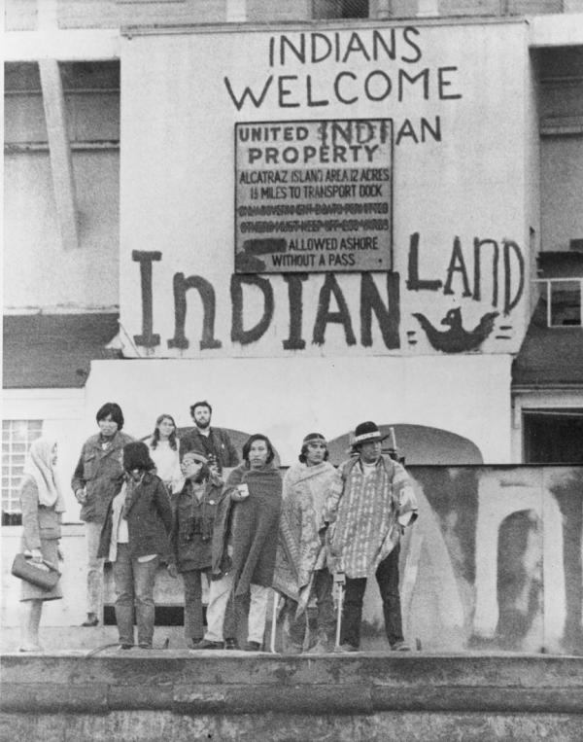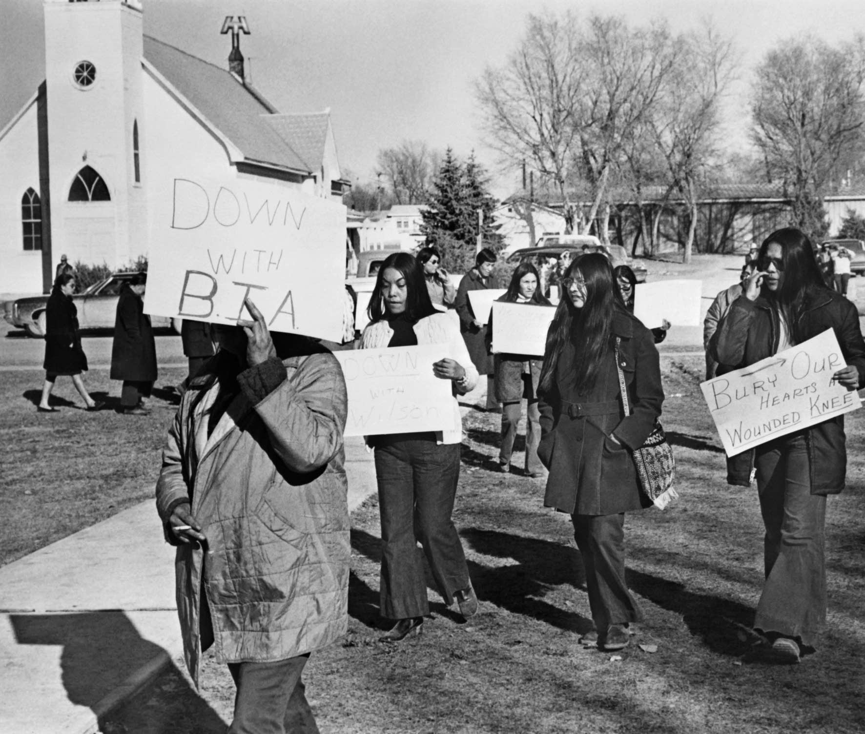

Inequalities:
In the 1960s, Indigenous people did not have the same rights as White people. Many Indigenous people were forced by the government to live on Indian Reservations in the 1800s and they did not have the same chances to have good work, schools, colleges, or other resources. The government chose who would run the Indian Reservations and they were often corrupt, giving jobs and money to their friends. The U.S. government made many treaties or agreements with the Indigenous people over the years and they were no longer following them.

Protest Methods:
Using many of the ideas from the Civil Rights Movement, the American Indian Movement did protests and marches to raise awareness of how Indigenous people were being treated. Some of their most important leaders included Dennis Banks and Russell Means. Two of their most famous protests were occupations (take over) of Alcatraz (last page, left) and Wounded Knee, South Dakota (last page, right). Alcatraz was a closed prison in San Francisco. In 1969, a group of 89 Indigenous protesters took a boat to it and occupied it for 19 months until they were arrested. In 1973, a group of about 200 Indigenous protesters took over the small town of Wounded Knee, South Dakota. It was the location of a massacre (killing) by the U.S. government of Native people in 1890. It lasted 71 days until the U.S. government arrested the protesters. In 1978, a group of thousands of Indigenous protesters and others participated in the Longest Walk, which was a 3,200-mile march from Alcatraz in San Francisco to Washington, D.C. to rally for laws to change the Indian Reservations and give Indian Nations more rights (below).

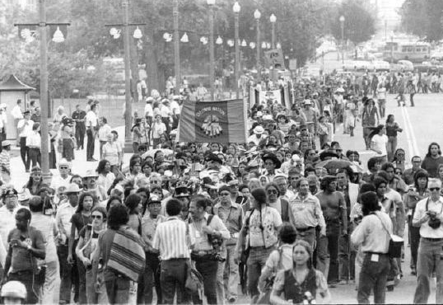

SOURCEBOOK 5-29.D

Source 3: Chicano Student Movement

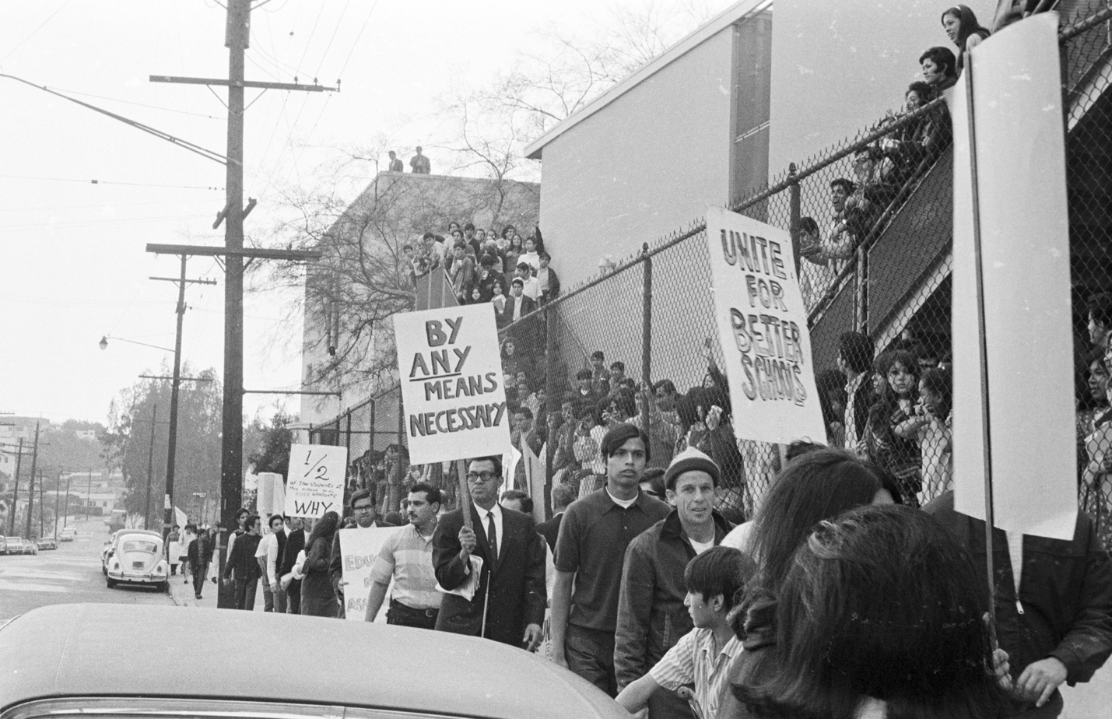

Inequalities:
In the 1960s, Mexican American people, also called Chicanos (a word once used to meanly refer to Mexican Americans, but then used to mean pride), did not have the same rights as White people. Mexican Americans were often paid less for the same amount of work, were being drafted into the military at a higher rate than Whites and were not allowed to attend the same schools and colleges or go to the same restaurants and businesses as Whites. Chicano students did not learn about their people’s history in school.

Protest Methods:
Using many of the ideas from the Civil Rights Movement, the Chicano Student Movement did protests and marches to raise awareness of how Mexican American people were being treated. Some of their most important leaders included Rosalio Muñoz and Rodolfo “Corky” Gonzales. Their most famous protests were the Los Angeles Student Walk Outs (picture last page). They started on March 5, 1968 and lasted several weeks. Over that time over 22,000 students walked out of their schools to protest not learning about Mexican American history, little support from teachers, classes with too many students, poor treatment of teenage Latinos by police, and wanting to stop the Vietnam War. They also gave speeches and attended school committee and city council meetings in large numbers.

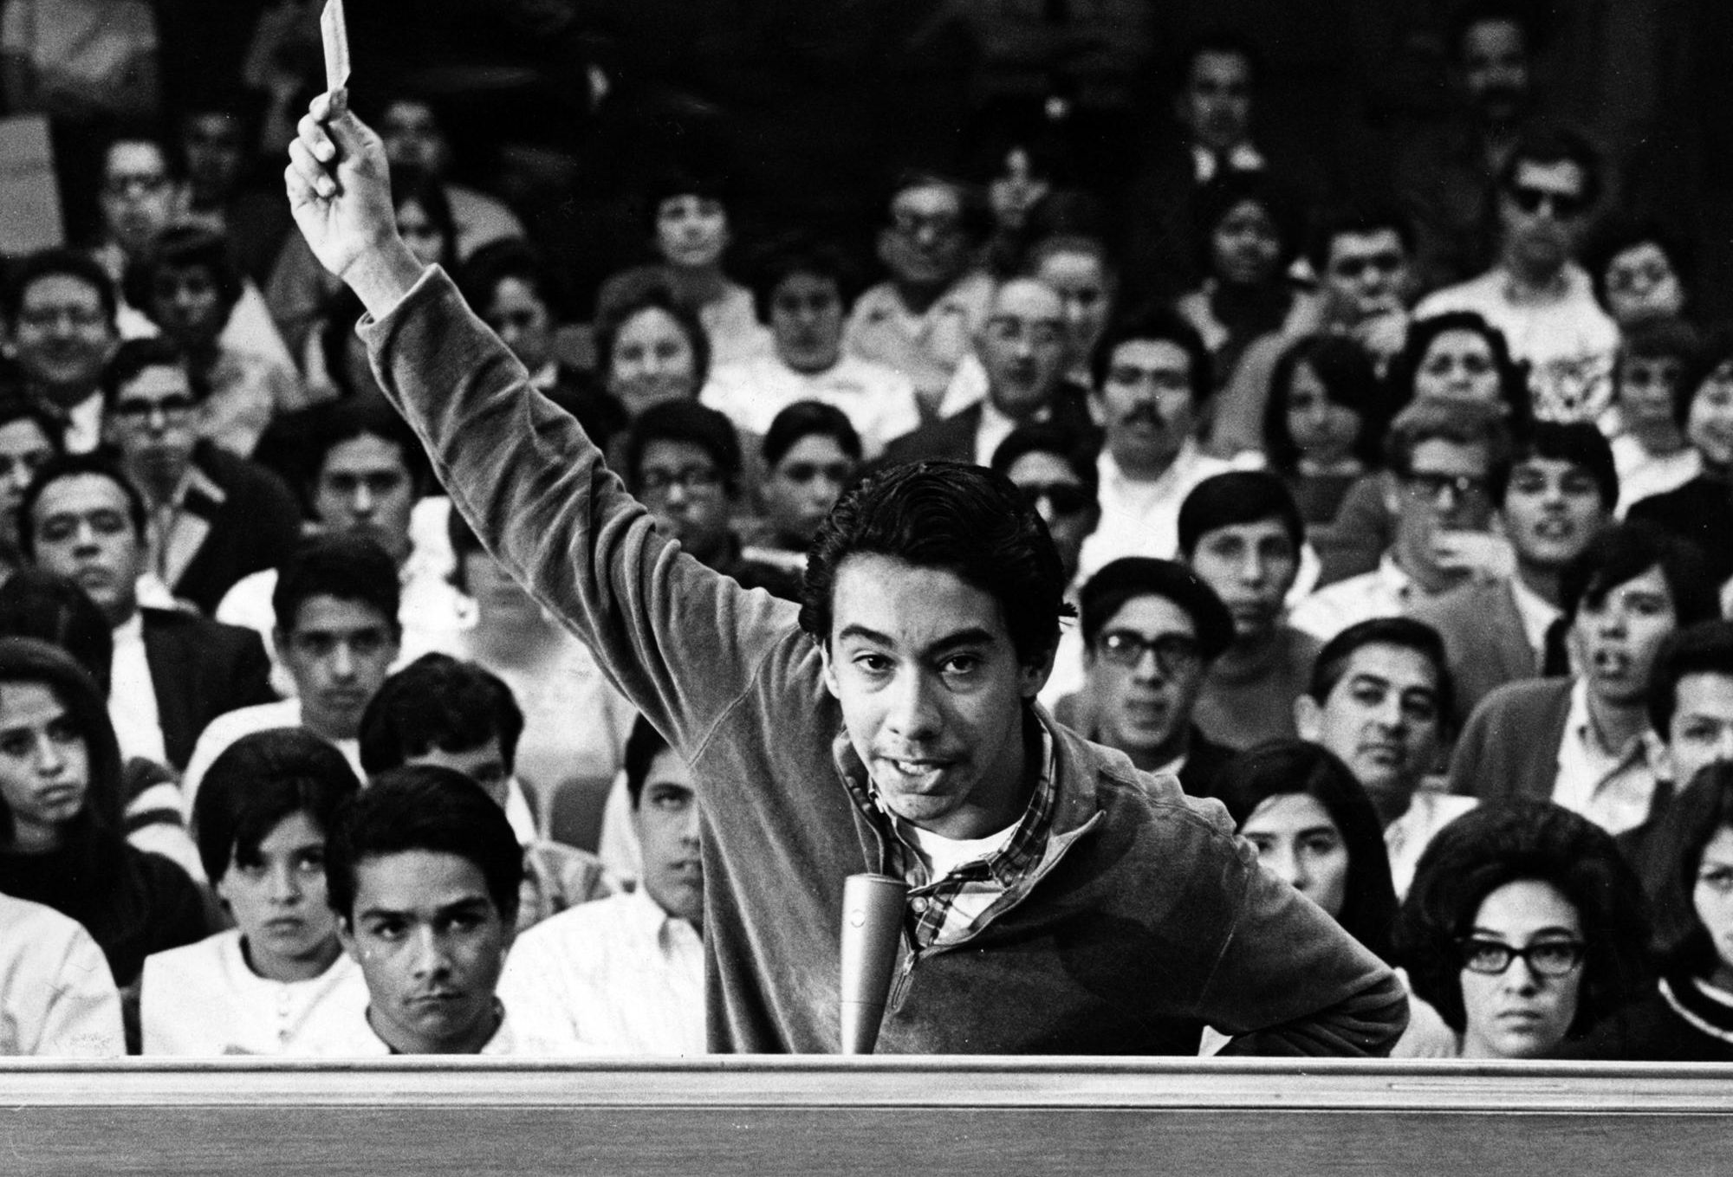

SOURCEBOOK 5-29.E

Source 4: Justice for Vincent Chin Movement

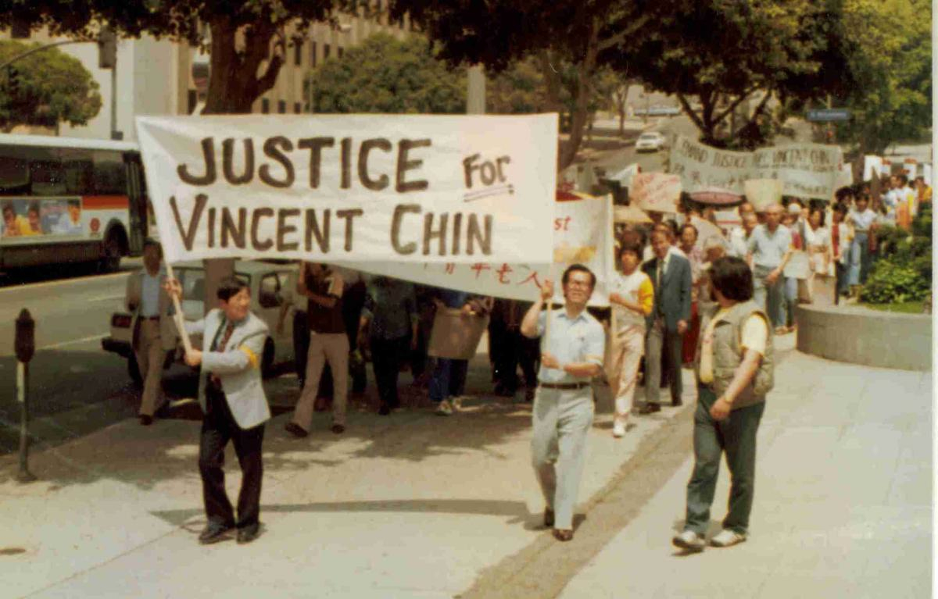

Inequalities:
In the 1960s, Asian American people did not have the same rights as White people. Asian Americans were often paid less for the same amount of work and were not allowed to attend the same schools and colleges or go to the same restaurants and businesses as Whites. A group of Asian American college students in Berkeley, California united with African American, Latino, and Indigenous students into a group called the Third World Liberation Front (a reference to not being from Europe). A decade later, Japanese cars were becoming more popular in the United States and many auto companies, workers, and politicians were blaming Japan for fewer U.S. cars being bought and less jobs. On June 19, 1982, Vincent Chin, a Chinese American living in the Detroit, Michigan area, was celebrating before his wedding with friends. Two unemployed auto workers, mistaking Vincent for being Japanese and blaming Japan for their lack of work, started yelling at him, “It’s because of you that we are out of work!” Later that evening would find Vincent Chin and kill him. In their trials, they received no jail time and only fines.

Protest Methods:
Using many of the ideas from the Civil Rights Movement, the Justice for Vincent Chin Movement did protests and marches to raise awareness of how Asian American people were being treated. They held memorials to remember Vincent Chin. Some of their most important leaders included Lily Chin (Vincent’s mother) and lawyer Liza Chan. Justice for Vincent Chin marches attracted thousands of people in San Francisco, Los Angeles, and elsewhere. Many people wrote to politicians asking them to change laws related to hate crimes. This led to Asian Americans forming organizations to fight for Asian American rights.

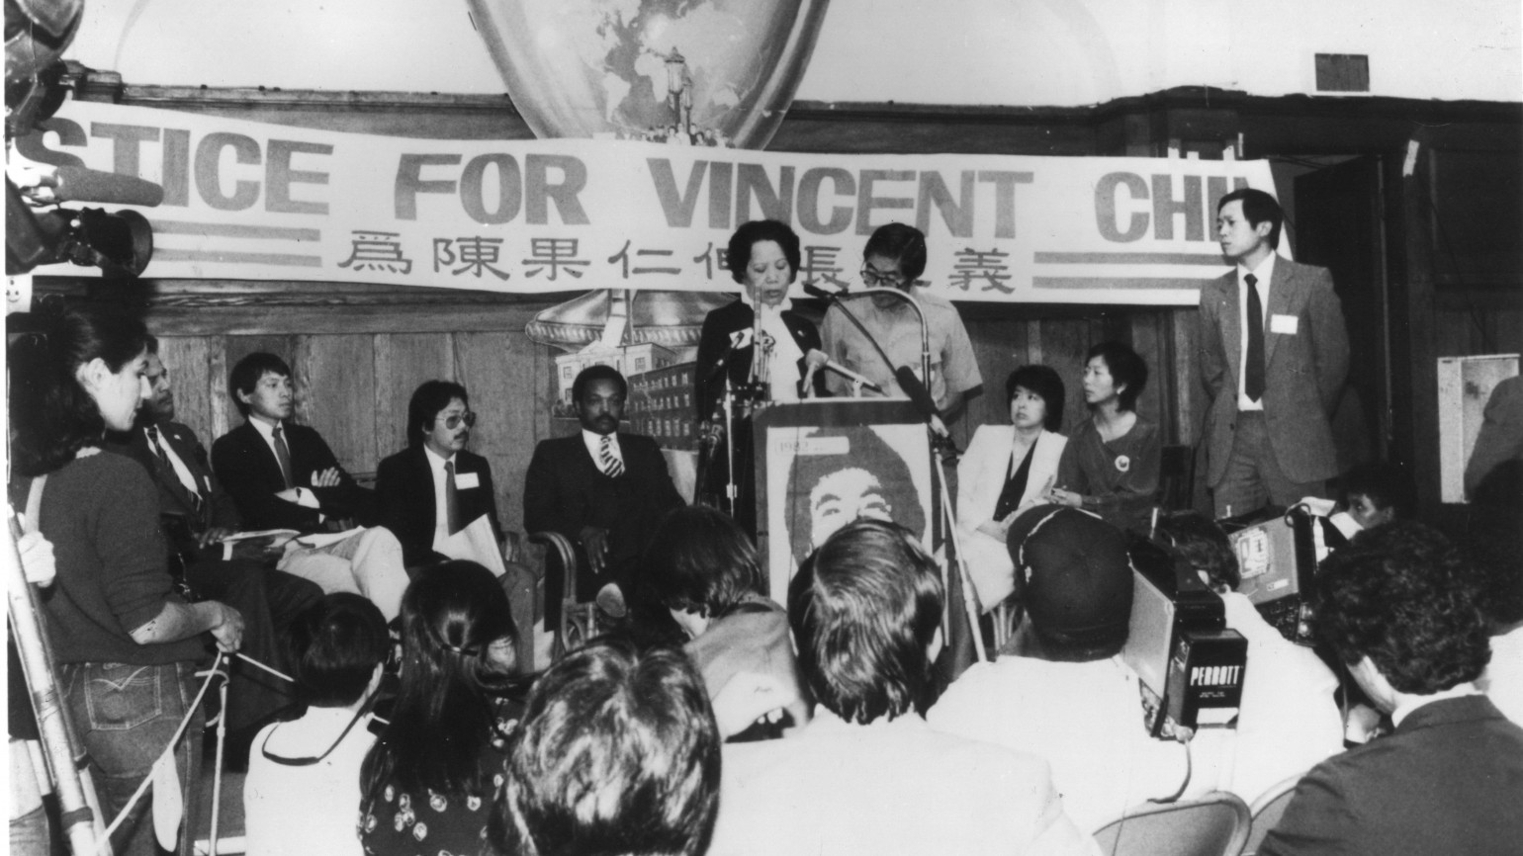

SOURCEBOOK 5-29.F

The Other Civil Rights Movements: Digital Slideshow Instructions

Today, we will be making presentations for our assigned civil rights movements. You will need to answer the following questions using digital slideshows.

Your digital slideshow should include at least 3 images:

These images should be related to the below sections.

Your slideshow should include 3 sections (with at least one slide per section):

Section 1: Inequalities

How was your group not treated the same as other Americans? What specific rights did they want that other Americans had (equality)?

Section 2: Protest Methods

What types of protests did they use to let other groups know they were not treated equality and solutions to their problems?

Section 3: Main Leaders

While all these movements were made up of many people working together, who were some of the main leaders?

SOURCEBOOK 5-30.A

Timeline: Boston Busing Crisis

1850: Benjamin Roberts, who was African American, tried to enroll his daughter Sarah in an all-White school in Boston and was not allowed. He sued the schools. The case went to the Massachusetts Supreme Judicial Court and they ruled against him and his daughter. This case pushed the Massachusetts legislature to pass a law banning segregated schools. It was the first anti-school segregation law in the United States.

1954: Oliver Brown, who was African American, tried to enroll his daughter Linda in an all-White school in Topeka, Kansas and was not allowed. He sued the schools. The case went to the U.S. Supreme Court and they ruled for him and his daughter. This made it illegal for a school to segregate (separate) students based on their race.

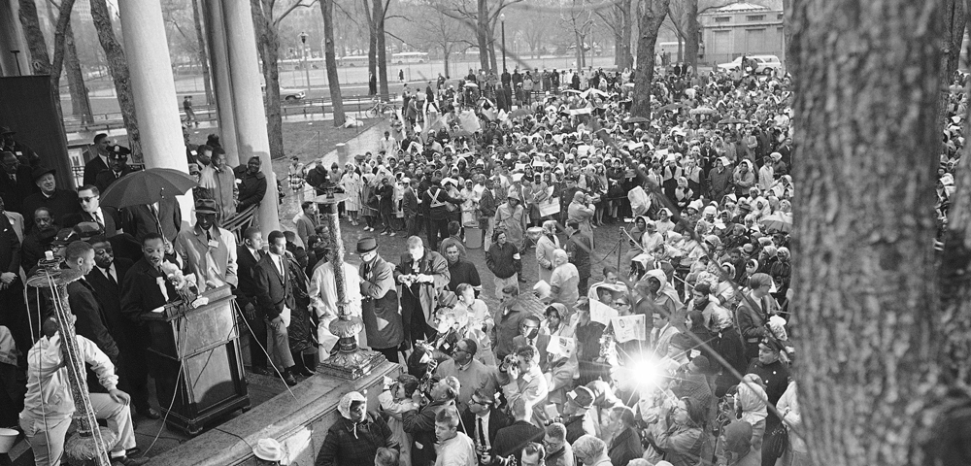

1965: Martin Luther King leads a march from Roxbury to Boston Common and rally of 22,000 people to integrate the schools in Boston (above). There is little change in the city.
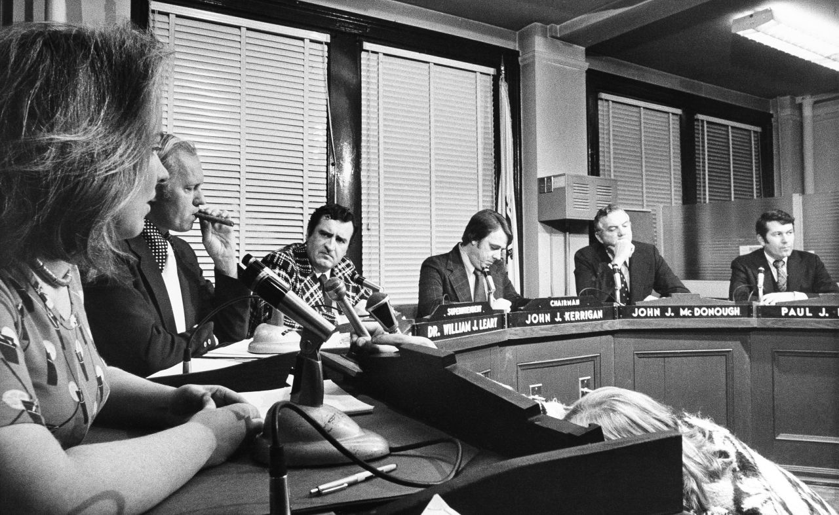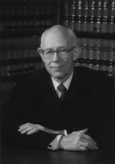

1972: The Boston NAACP helped 14 parents and 44 children sue the Boston School Committee (above left) for violating Black students’ civil rights by purposely allowing segregation.

June 21, 1974: U.S. Judge W. Arthur Garrity (above right) ruled that the parents and students’ civil rights have been violated. He orders that Boston schools with more than 50% White students must have more Black students go to school there.

Summer 1974: The Massachusetts Board of Education develops a desegregation plan that would bus Black students to White neighborhoods and White students to Black neighborhoods. This included 18,000 students in mostly Black neighborhoods like Roxbury, the South End, and Mattapan, and mostly White neighborhoods like South Boston, Charlestown, and West Roxbury. Some schools in Dorchester, which was racially diverse, but segregated, were also involved in busing.

July 1974: Restore Our Alienated Rights (ROAR) is formed by anti-busing leaders and City Councilwoman Louise Day Hicks.
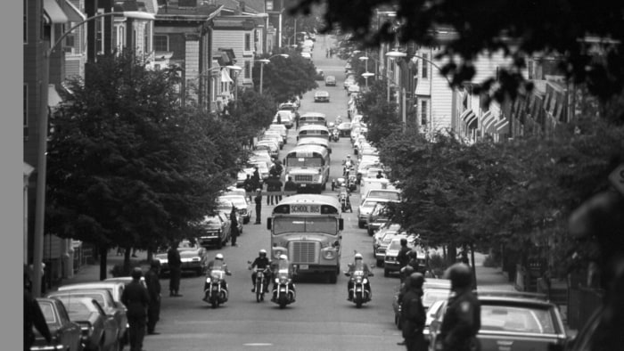

September 12, 1974: The first day of school. The majority of White students stayed home that day. Only 100 of the 1,300 South Boston High students came to school. 300 South Boston residents protested out in front of the high school that day and for many days afterward. Protesters throw rocks as buses leaving South Boston High and elsewhere in the city.

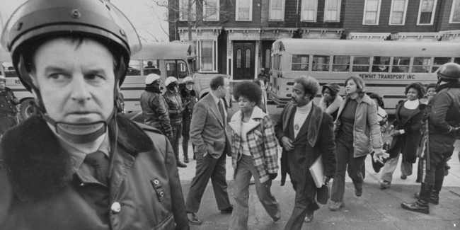

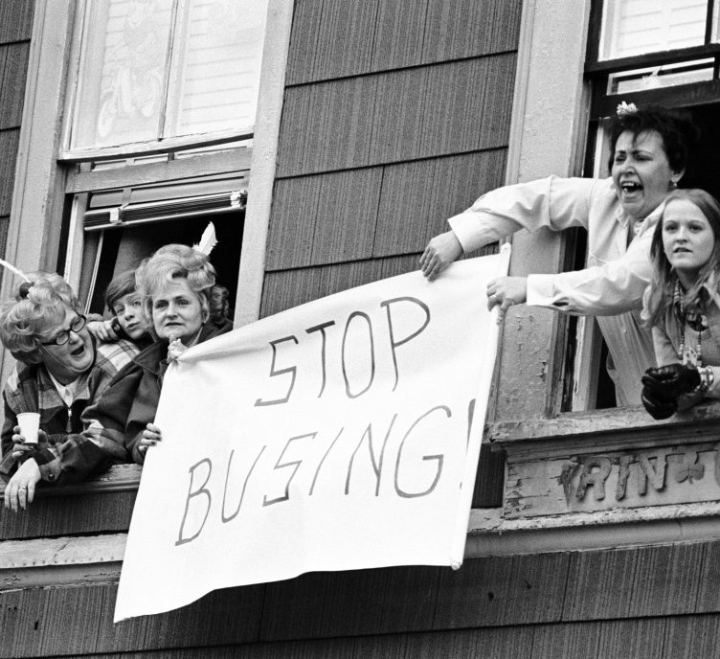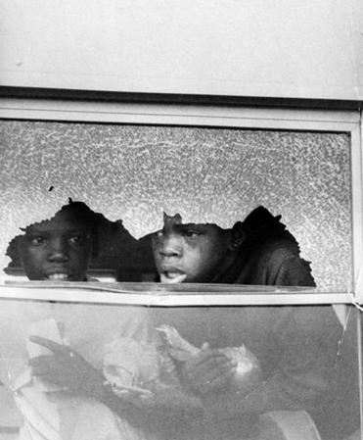

September-October, 1974: Violence breaks out across the city. There were 148 arrests and 129 injuries related to the busing issue.

October 9, 1974: A White mob attacks Jean-Louis Andre Yvon, a Haitian American, who was driving his car through South Boston to pick up his wife. Later that day, U.S. President Gerald Ford says that he is against forced busing in a speech on television.

December 11, 1974: After six days of continuous student fighting at South Boston High, Michael Faith, a White student, is stabbed by James White, a Black student. This causes a mob to form outside South Boston High and 125 Black students are trapped inside. The police sneak the students out the back door while decoy buses a driven to the front door.

May 1975: Many White parents take their students out of the Boston Public Schools and enroll them in private schools and move them to mostly White schools in the suburbs.
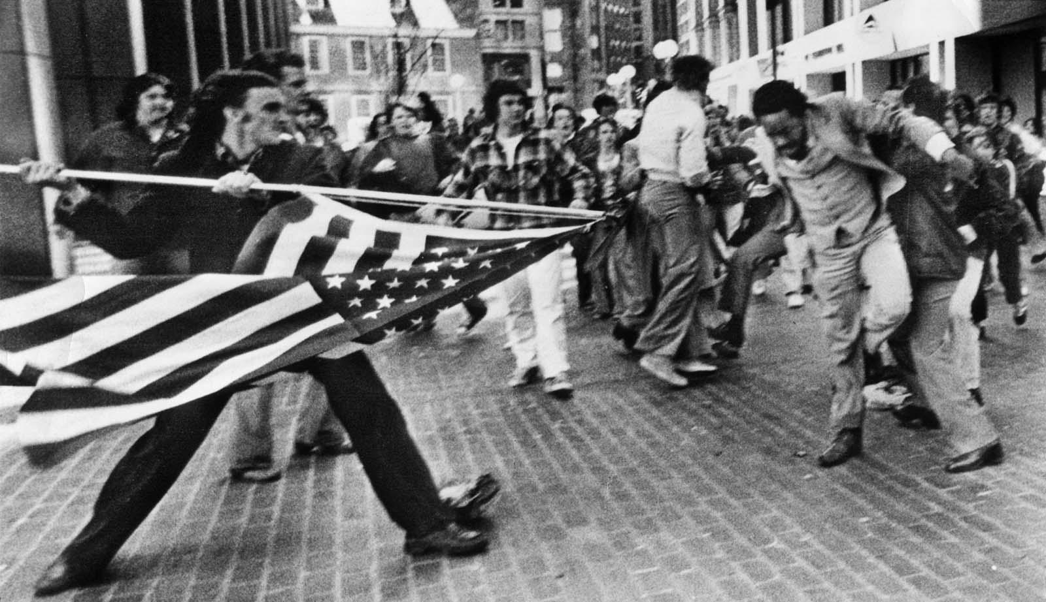

April 5, 1976: Black lawyer Theodore Landsmark is attacked on the steps of City Hall by a White mob protesting busing (above). The man holding Landsmark's arms is anti-busing activist Jim Kelly, who is actually trying to help Landsmark to his feet.

April 23, 1976: There is a march of about 50,000 people against racial violence from Boston City Hall to the Massachusetts State House.

November 1977: John O’Bryant is elected to the Boston School Committee. O’Bryant is the first Black Boston School Committee member since 1895.

Here is a link to a complete timeline of the events: http://learninglab.legacy.wbur.org/2014/09/05/boston-school-desegregation-and-busing-a-timeline-of-events/

SOURCEBOOK 5-30.B

Solution 1: Neighborhood Busing Plan

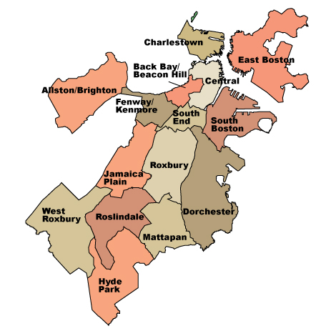

Overview: This plan would bus Black students to schools in mostly White neighborhoods and White students to schools in mostly Black neighborhoods. This plan was chosen by Judge Garrity.

Pros: This is the fastest way to desegregate the Boston schools. It would take one summer change schools that are racially segregated. It is also one of the cheapest solutions. It only requires that bus routes are changed and made longer.

Cons: It is very unpopular with most White and Black parents. They worry about their children being sent to other neighborhoods where people will not welcome them or there could be violence.

SOURCEBOOK 5-28.C

Solution 2: Regional Busing Plan
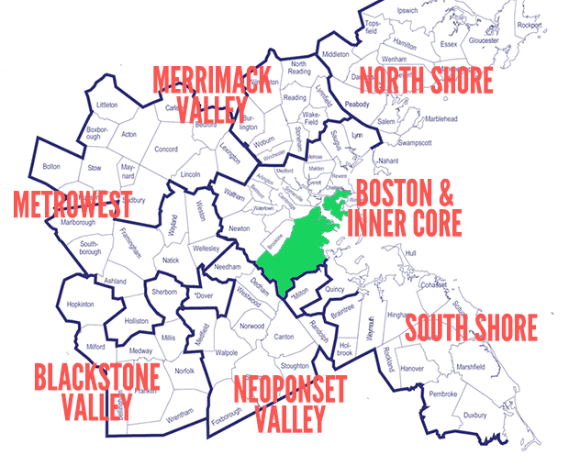

Overview: This plan would reserve seats for Black students from Boston (in green) in mostly White suburban towns’ schools. It would require these mostly White school districts to educate Boston’s students. This was a plan chosen to desegregate schools in Charlotte, North Carolina.

Pros: This plan does not force students to attend certain schools and Black students can attend better schools.

Cons: It would not desegregate mostly White schools in Boston. Children would be on long bus rides (sometimes for hours) every day, which is not good for them. It is hard to be one of only a few Black students in a school. It is unpopular with people in these suburban communities.

SOURCEBOOK 5-28.D

Solution 3: School Choice

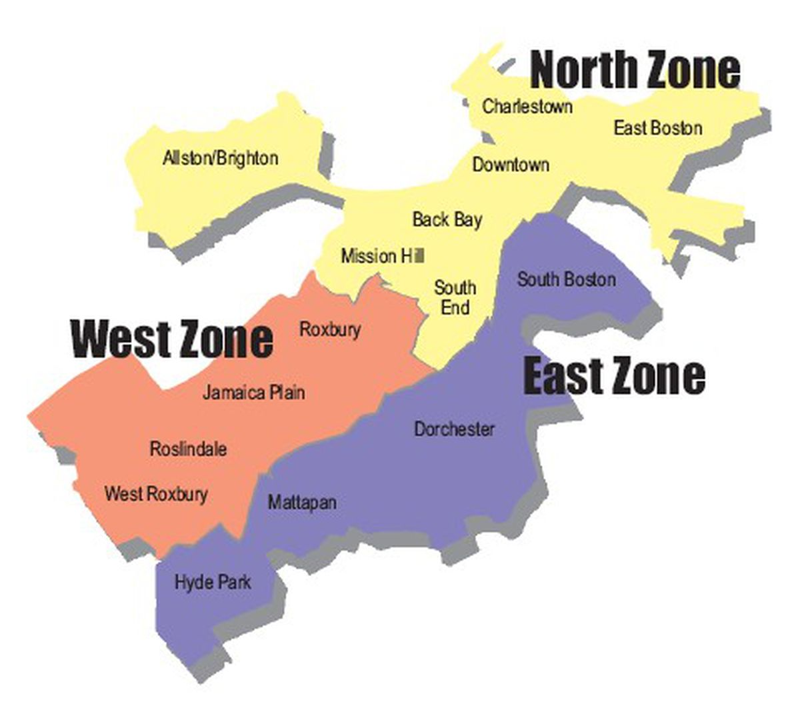
Overview: This plan would allow students to choose schools from three large zones that include mostly White and Black neighborhoods. It would make sure there is racial balance at each school. It would make magnet schools (like a school where you learn Spanish or where you take many courses in art and music) to encourage students to choose certain schools. This was a plan chosen to desegregate schools in Boston in the 1990s.

Pros: It allows complete choice (no forced busing). People voluntary choose to desegregate.

Cons: It relies on people choosing schools in an area where most people are from a different race and many people may still choose schools near their homes where people look like them.

SOURCEBOOK 5-28.E

Solution 4: Changes in Housing

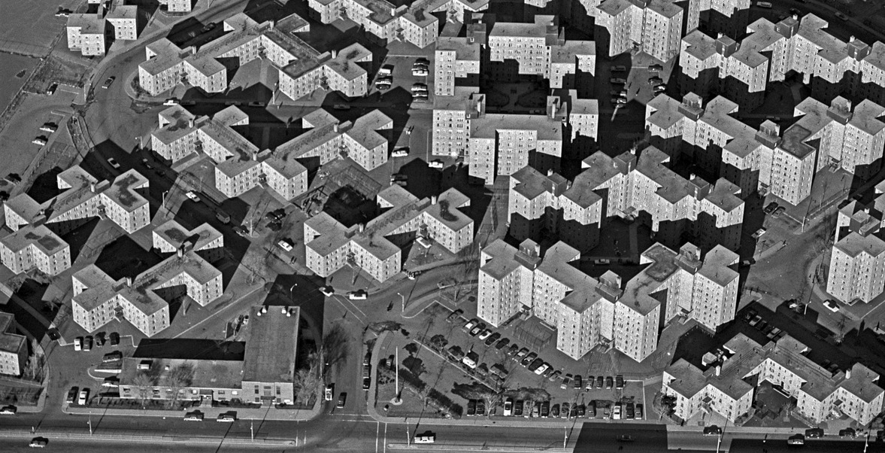

Overview: This plan would not do anything to the schools, but instead make sure that new renters and buyers of houses in the neighborhoods were racially diverse. The reason Boston’s neighborhoods are segregated is because for a long time Black people were not sold houses or given apartments in certain neighborhoods. For instance, apartments in Dorchester’s Columbia Point Housing Project (above) were given to mostly Black residents. Other housing projects had mostly White residents.

Pros: It would be the only way to ensure not only the schools, but also the city, became racially integrated for the long term.

Cons: It would take years, if not decades, to work. It would be very expensive. People may not welcome their new neighbors from different races.

