Open Social Studies

An Inquiry-Based and Literacy-Focused K-6 Curriculum

Curric

STUDENT SOURCEBOOK

Level: Grade 2

Strangers from Different Shores:

Migration/Immigration

Developers:

Christopher C. Martell

Jennifer R. Bryson

GRADE 2 ROAD MAP

LESSON 2-1

Lesson Title: The Indigenous People: The First Migrants?

Inquiry Question: Which idea of how the Indigenous (Native) people first came to the Americas is the strongest?

LESSON 2-2

Lesson Title: The Indigenous People: Communities

Inquiry Question: What quality of Indigenous life do you think we should adopt today in our society?

LESSON 2-3

Lesson Title: Push/Pull: Why Do People Immigrate?

Inquiry Question: If you were an immigrant to the U.S. in the 1890s, what would be the biggest challenge you would face?

LESSON 2-4

Lesson Title: Forced Migration: Slavery and Confronting a Difficult Past

Inquiry Question: How did African Americans stand up to slavery?

LESSON 2-5

Lesson Title: Mapping Where Our Families Immigrated/Migrated From

Inquiry Question: What is the most important similarity between how our ancestors came to the United States?

LESSON 2-6

Lesson Title: The Early European Immigrants: English, Germans, and Irish

Inquiry Question: What is the most important impact that English, German, and Irish immigrants made to the United States?

LESSON 2-7

Lesson Title: The Early Asian Immigrants: Chinese

Inquiry Question: How have Chinese immigrants made the United States better?

LESSON 2-8

Lesson Title: Welcome to Ellis Island: Eastern and Southern Europe and the Caribbean

Inquiry Question: How would you describe the experiences of immigrants entering the United States through Ellis Island?

LESSON 2-9

Lesson Title: Life After Angel Island: China, Japan, and India

Inquiry Question: Imagine that you were an immigrant from China, Japan, or India to the United States, how would you describe your new country to the people back home?

LESSON 2-10

Lesson Title: Life in the Tenements

Inquiry Question: If you were to redesign the tenement to improve immigrant conditions, what would they include?

LESSON 2-11

Lesson Title: Immigration from Canada and México: A History

Inquiry Question: What was the Canadian and Mexican immigrant experience like?

LESSON 2-12

Lesson Title: The Immigration Act of 1924

Inquiry Question: Should we limit the number of people who can move to the United States?

LESSON 2-13

Lesson Title: Immigration in the 20th Century

Inquiry Question: In the 20th century, why did newer immigrants start coming from different countries?

LESSON 2-14

Lesson Title: What is a Refugee? A Case Study of Vietnam

Inquiry Question: If you were a refugee who came to the U.S. from Vietnam in the 1970s or 80s, what would have been the most difficult part of the journey?

LESSON 2-15

Lesson Title: The Contributions of American Immigrants
[Albert Einstein, David Ortiz, I.M. Pei, Maria Hinojosa]

Inquiry Question: Which of the featured American immigrants do you think made the largest contribution to the United States?

LESSON 2-16

Lesson Title: Immigration Today: How Do People Come to the U.S.?

Inquiry Question: What is the most difficult challenge immigrants face today?

LESSON 2-17

Lesson Title: Boston: A City of Immigrants

Inquiry Question: How does being a city of immigrants make Boston better?

LESSON 2-18

Lesson Title: Immigration Today: Naturalization

Inquiry Question: Is it fair how we choose who can become a citizen?

LESSON 2-19

Lesson Title: Examples of Good Citizens

Inquiry Question: Which group of people is the best example of good citizenship?

LESSON 2-20

Lesson Title: How Will I Be a Good Citizen?

Inquiry Question: What actions can I take to make my community and country a better place?

SOURCEBOOK: 2-1.A

Possible Routes Map

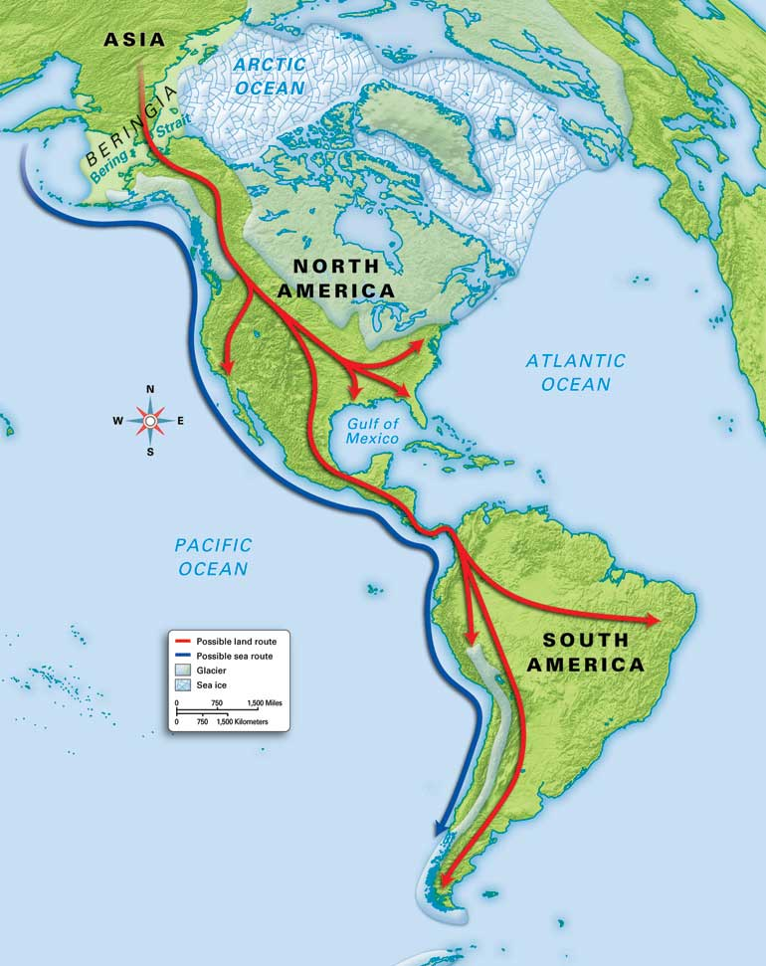

SOURCEBOOK: 2-1.B

Source 1: Land Bridge Idea

Some scientists argue that the Indigenous people came to the Americas by walking across a land bridge. About 20,000 years ago, the world was in an ice age, where much of the land was covered in ice. They argue this would have lowered the sea and created a “bridge” of land for people to walk from Asia to the Americas. They also argue that taking boats would be far more dangerous than walking.

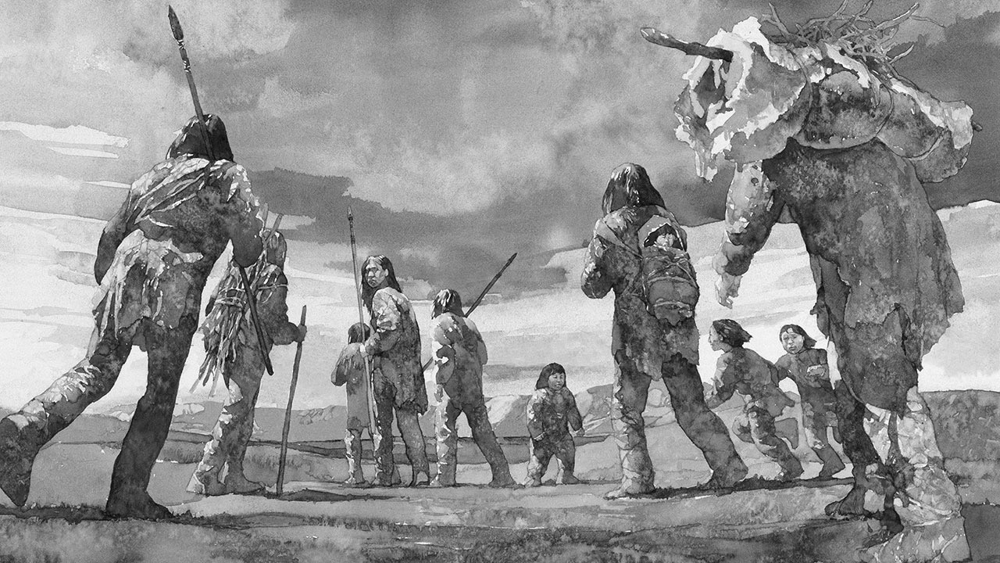

SOURCEBOOK: 2-1.C

Source 2: Over Water Idea

Some scientists argue that the Indigenous people came to the Americas in boats over the water. They say there is evidence that people were here before 20,000 years ago, when there would not have been a “land bridge.” They argue that the people took small boats along the coast. Boats would have been much faster than walking. It would have not been too hard to walk across very cold ice.

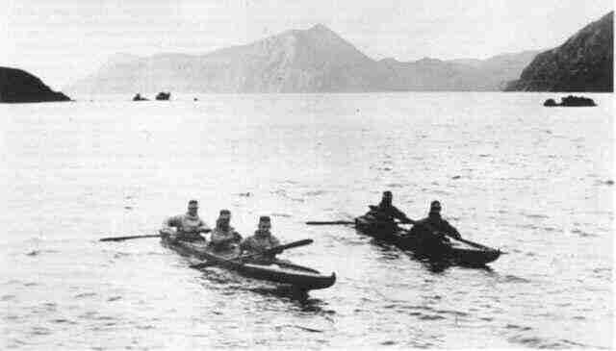

SOURCEBOOK: 2-2.B

Source 1: Iroquois Confederacy and Government

The Iroquois Confederacy was five different groups (Seneca, Cayuga, Onondaga, Oneida, and Mohawk) who agreed to not fight each other. Together they created a meeting where all the groups could talk through their problems and work together. This civic group stopped the groups from fighting and the current U.S. government used some of their ideas.

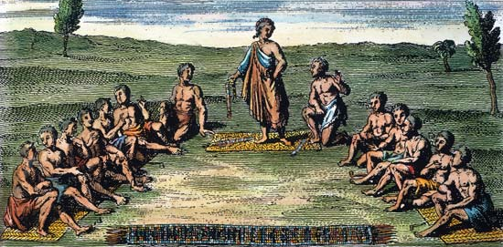

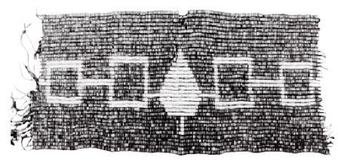
SOURCEBOOK: 2-2.C

Source 2: Lakota and Buffalo

The buffalo was incredibly important to the Lakota people. Almost everything the Lakota people needed came from the buffalo, including their homes called tipis (tee-pees), their clothes, and their food. Their life was spent following the buffalo and killing them only when they needed to. The Lakota would not waste any part of the buffalo

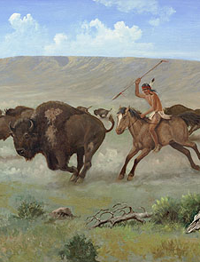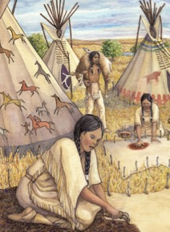

SOURCEBOOK: 2-2.D

Source 3: Mississippian and Buildings

Before any European ever came to the Americas, the Mississippian people made one of the largest cities in the world. It was called Cahokia. It was made of over 120 mounds with thousands of buildings. The Mississippian had an amazing ability to make buildings, which allowed over 20,000 people make their home there. It was larger than most cities in Europe.

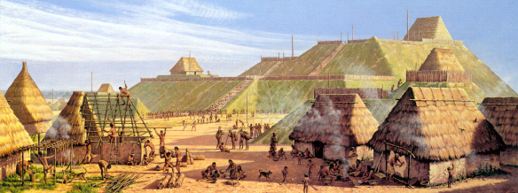

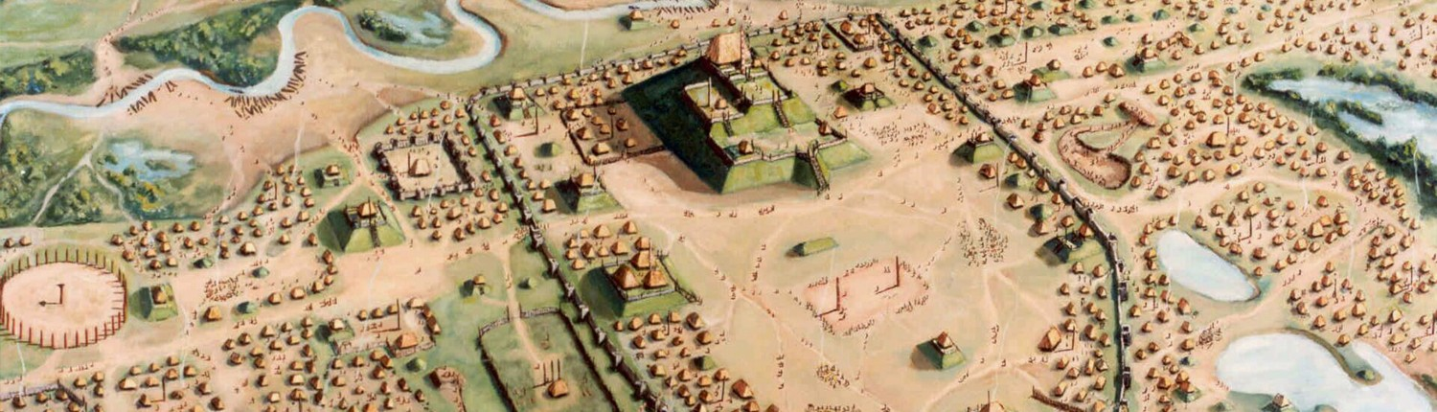

SOURCEBOOK: 2-3.C

Source 1: Dagoberto Olvera’s Immigration Story

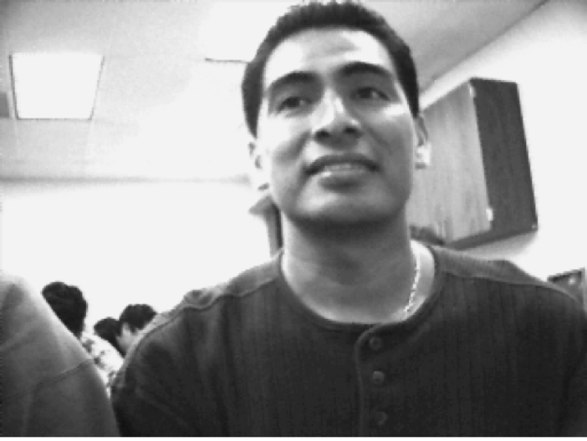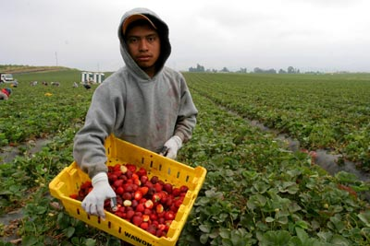

I am Dagoberto Olvera. I was born in México City, one of the biggest cities in the world. I did not finish high school and it was hard to find a job. I heard that they needed farm workers in the United States and I applied to work for a company. They helped me come to California. I only spoke Spanish, so it was very difficult. I worked long hours on that farm in the hot sun.

I started to slowly learn English. It was hard. I saved enough money to attend college. I then went to school for computers. I learned all about how to make the computers work and today I work for a computer company. I love my job and living in California, but I miss my family. It is hard being an immigrant, because you cannot sometimes see your family, because they are so far away.

SOURCEBOOK: 2-4.B

Source 1: Life in Africa

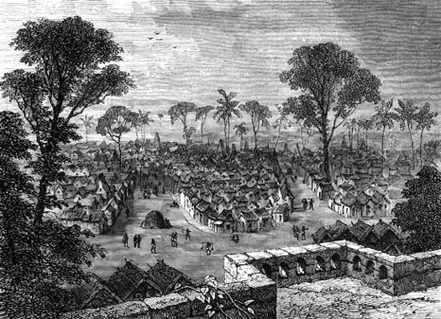

West Africa had many wealthy empires from their mining of gold, salt, and metals. Some West African people lived in large cities, such as Asante (above), while others lived in small villages (below). Many West African people were farmers or miners. There were also many different groups of West African people, who spoke different languages and had different religions. These West African groups also had their own music, art, and stories. Much of our American music, art, and stories traces its roots to West Africa.

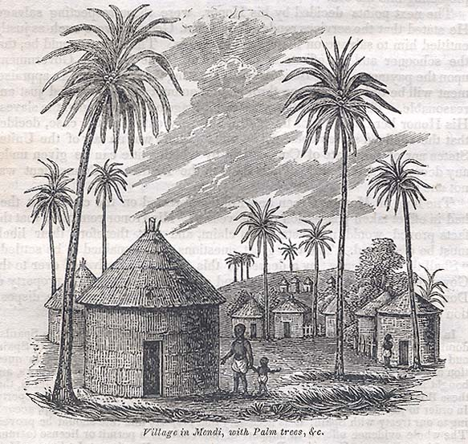
SOURCEBOOK: 2-4.C

Source 2: The Slave Trade

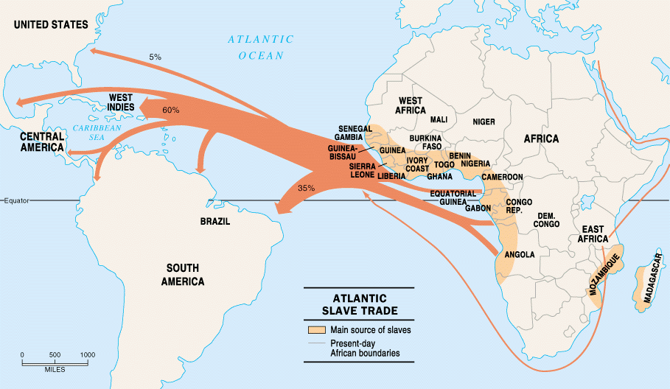

Slavery is the owning of a person and making them work for you without pay. In the 1600s, Europeans started taking Africans on ships to be sold as enslaved people in the Americas. Unlike immigrants, they were forced migrants and did not chose to come here. Most enslaved people were sent to the Caribbean and Brazil, but about 400,000 enslaved people were sent to the U.S.

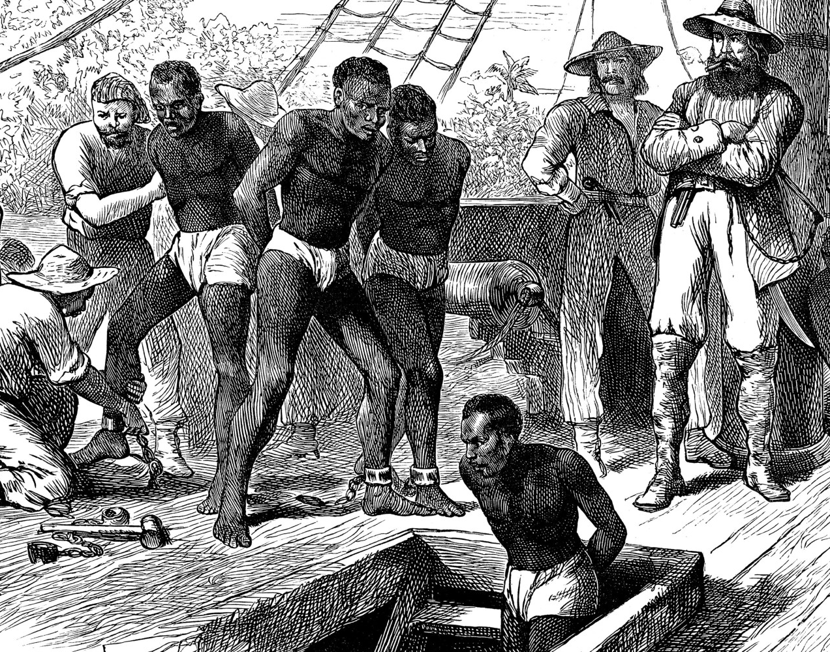

SOURCEBOOK: 2-4.D

Source 3: Plantations

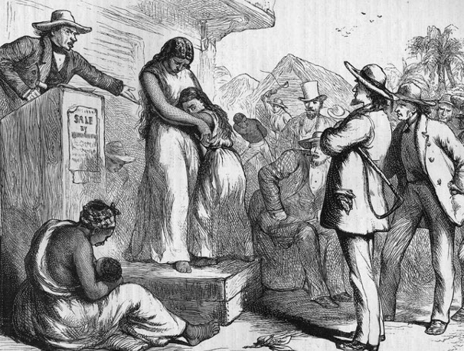

In the United States, Africans were sold to European American slave owners, often called masters, who then made the Africans work on their plantations (large farms) for no pay. This happened in both the North and South. The Africans were often treated badly. Sometimes people (like Henry in the book) were sold and had to move away from their families. Enslaved people could not leave, so many tried to ran away. Slave masters hired slave catchers to find runaway slaves.

SOURCEBOOK: 2-4.E

Source 3: Abolition

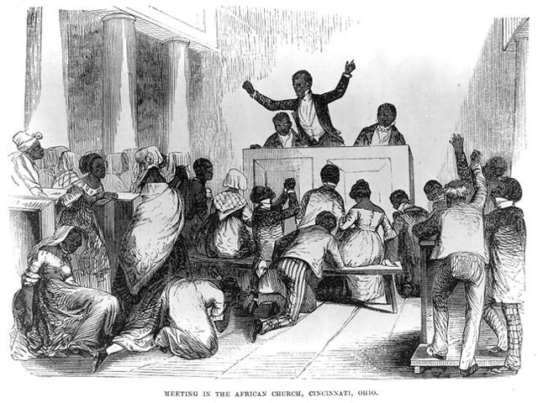

Many African Americans tried to stop slavery, especially free Black people in the North. Someone who wanted to end slavery is called an abolitionist. They would help enslaved people run away from their plantations (like Henry). They gave speeches and made newspapers. In some places, they were able to pass laws against slavery. After the Civil War, slavery was banned in the United States. While many African Americans have ancestors who were enslaved, others have ancestors were born free or came to the U.S. after slavery.

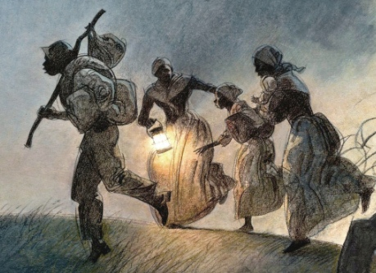

SOURCEBOOK: 2-6.B

Source 1: English Immigrants

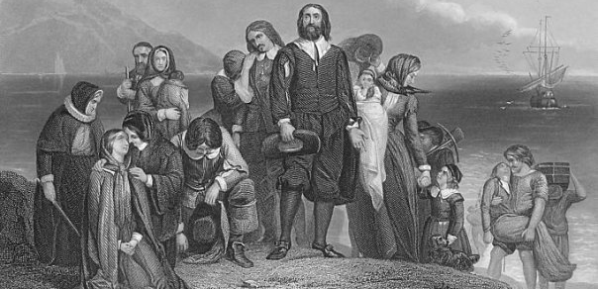

The first Europeans to immigrate to what is now the United States were the English. This is why the most common language in the United States is English. The Colonial Assemblies and later the U.S. Congress were created by mostly English Americans and based on their English Parliament. They also brought with them their food and many American recipes are actually from England, including some stews, pies, meats, breads, and cheeses.

SOURCEBOOK: 2-6.C

Source 2: German Immigrants

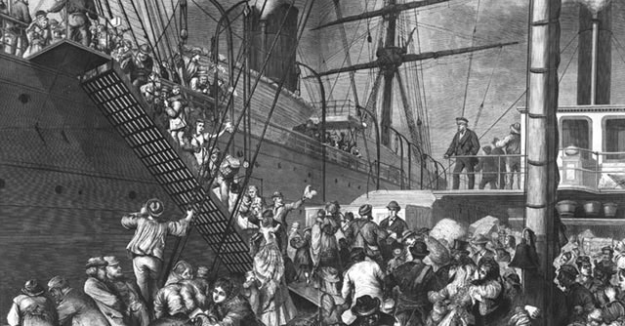

The second major wave of European immigrants to the United States was the Germans. While they spoke German, it is a language that is similar to English, so many learned English. Many Germans came to the United States to seek religious freedom or leave wars. Many Germans were Protestants and brought their Christian holiday traditions (such as Christmas trees and Easter eggs) that many Americans celebrate today. They also brought many foods here, such as hamburgers and frankfurters. Germans also brought with them their music. It often used clarinets, fiddles, accordions, and drums.

SOURCEBOOK: 2-6.B

Source 3: Irish Immigrants

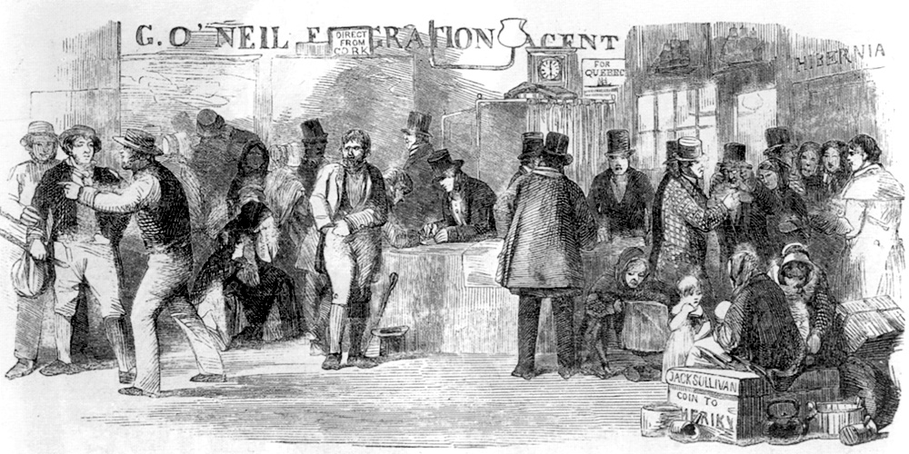

The third major wave of European immigrants to the United States was the Irish. While they spoke the Irish language (also sometimes called Gaelic), their country was ruled by the English and many Irish people were forced to speak English. A large number of the Irish people came to the United States because of something called the Potato Famine. A disease (called a blight) killed most of the potatoes in Ireland. Potatoes were the main part of their meals, because they needed to sell wheat and other crops to the English. While corn beef and cabbage is rarely eaten in Ireland, Irish Americans made it a popular dish in the U.S. Irish music often uses fiddles, flutes, harps, and bagpipes. American folk music borrowed a lot from it.

SOURCEBOOK: 2-7.A

Source 1: The Gold Rush

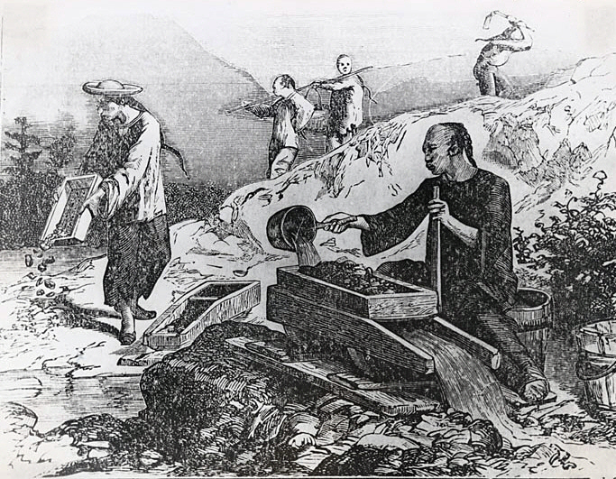

The first Chinese immigrants came in small numbers to the U.S. in 1810s. When gold was discovered in California in 1848, thousands of Chinese men decided to go to San Francisco in hopes of making money for their families. In the gold fields and mines, the Chinese were paid and treated very poorly. Despite this, they were responsible for mining much of the gold found at this time.
SOURCEBOOK: 2-7.B

Source 2: The Railroad

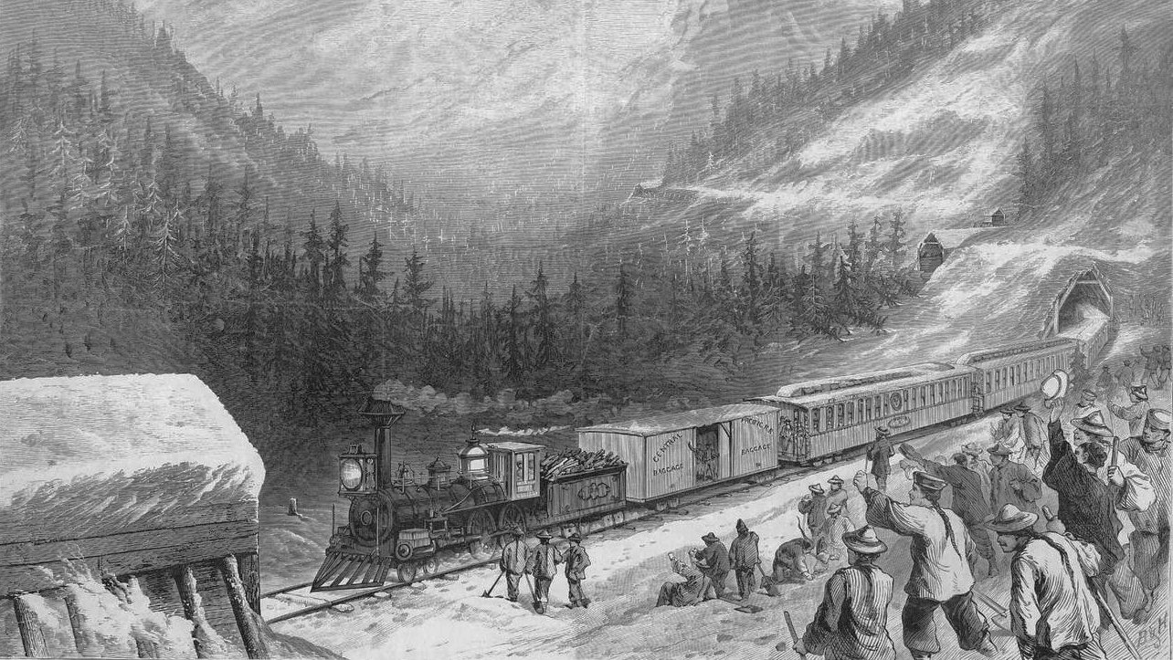

After the Gold Rush, the U.S. started building its first railroad across the country, called the Transcontinental Railroad. Since there was a lack of White workers on the West Coast, the railroad companies recruited Chinese immigrants to do these difficult and dangerous jobs. During this time, the Chinese were paid and treated very poorly. Despite this, without the Chinese workers, the railroad may have not been made.

SOURCEBOOK: 2-7.C

Source 3: Feeding the United States

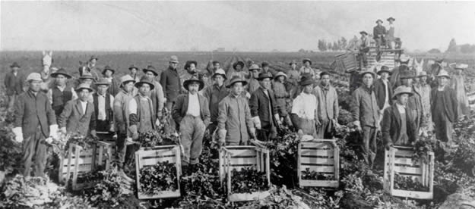

In the late 1800s, California began producing much of the food for the United States. With the railroad connecting California to the East Coast, it allowed food to be transported in days rather than weeks. Many Chinese immigrants started to work in their fields (alongside Japanese and Indian immigrants). During this time, the Chinese and other Asians were not allowed to buy land. Despite this, they would be responsible for helping grow much of the United States’ food.

SOURCEBOOK: 2-7.D

Source 4: Making Chinatowns

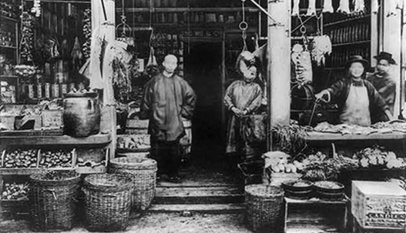

During the Gold Rush, Chinese immigrants started creating homes and businesses in the same area of San Francisco, which became known as Chinatown (not long after other Chinese immigrants would also make a Chinatown in Boston). In Chinatowns, Chinese people could sell all of the products that they needed, such as tea, rice, herbs, and Chinese style clothing. Chinatowns also became places for other Americans to learn about Chinese culture.

SOURCEBOOK: 2-8.A

Images of Ellis Island

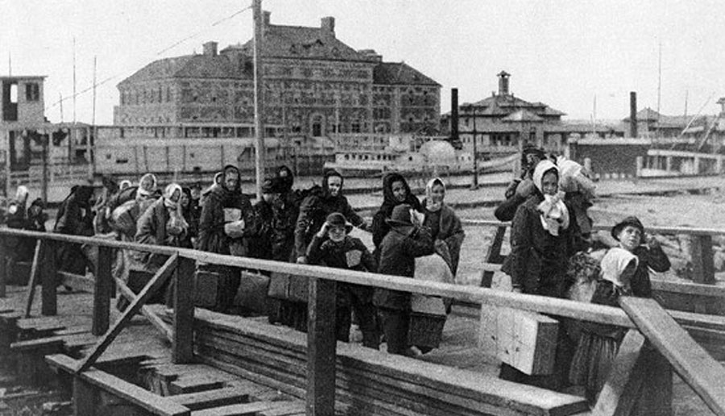

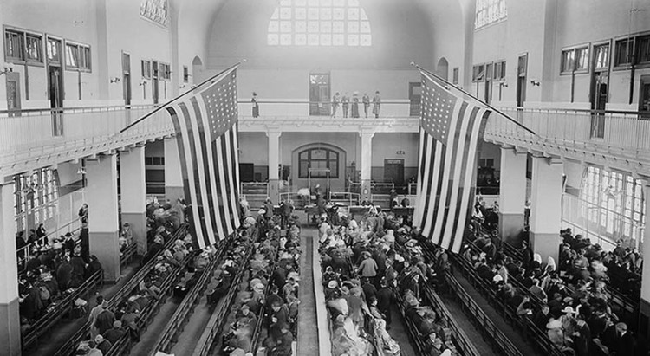
SOURCEBOOK: 2-8.B

Source 1: The Voyage

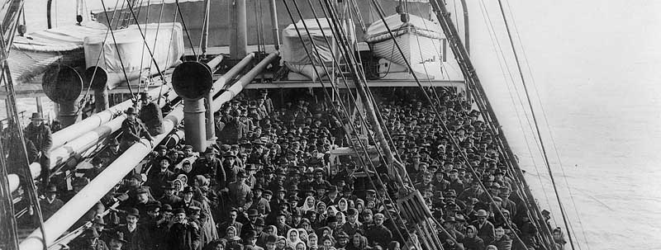

Immigrants to Ellis Island came from many countries, mostly in Eastern Europe (Poland, Russia), Southern Europe (Italy, Greece), and the Caribbean (Jamaica, Cuba, Puerto Rico). They were forced to travel in steerage, or the bottom of the boat. Many people had to fit in a small area. They slept on bunk beds and the food did not taste good. Many were seasick and some people got diseases. The voyage took about seven to ten days. Once they arrived in the United States, they saw the Statue of Liberty.

SOURCEBOOK: 2-8.C

Source 2: Arriving at Ellis Island

Once the immigrants arrived at Ellis Island, they walked off the boat and waited in line. They were only allowed to bring with them a few things that they could carry. Each immigrant was given a label with their name and home country. Men were separated from women and children. Millions of immigrants would enter the United States through Ellis Island.

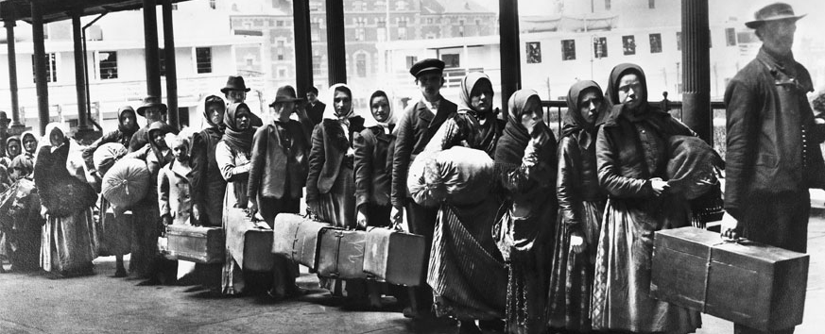
SOURCEBOOK: 2-8.D

Source 3: The Inspection

Immigrants would then enter the Great Hall (above). Before entering, they would get a health inspection. If they were sick, the would have to go to special rooms. If they did not get better, they would be sent back home. The immigrants would wait for hours in line. Then they would be asked 32 questions and their answers were written down. After the questions, they would find their bags and relatives at something called the Kissing Post. From there, they took a ferry to the land.

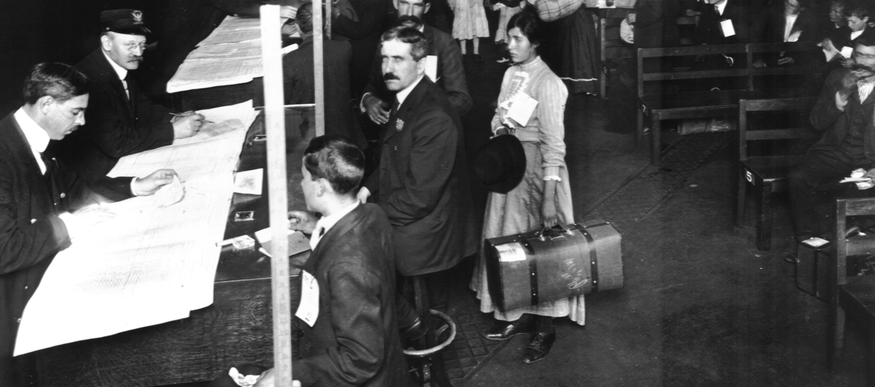
SOURCEBOOK: 2-9.A

Images of Angel Island

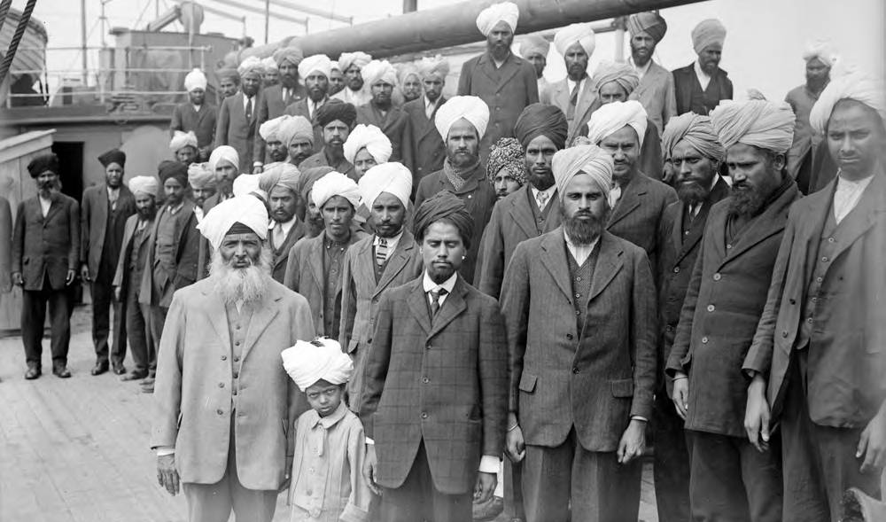

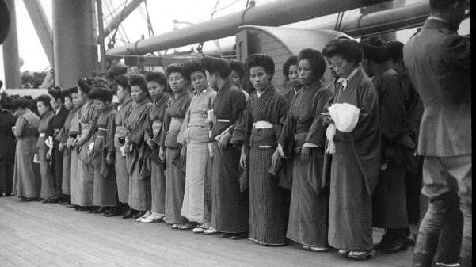

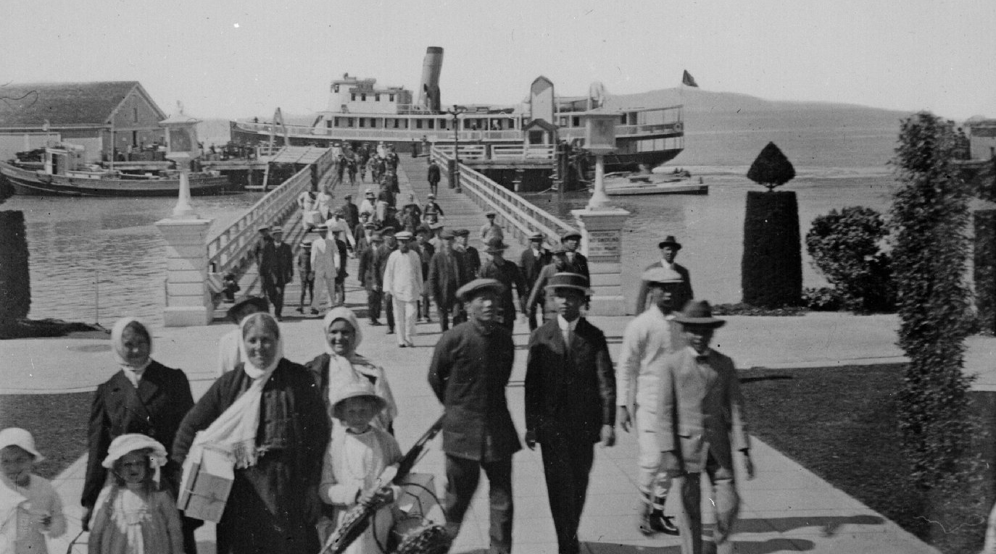

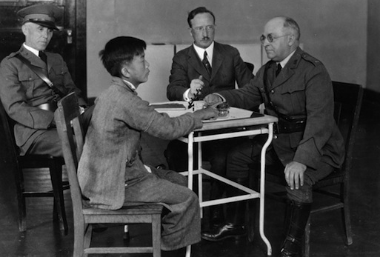
SOURCEBOOK: 2-9.B

Source 1: Arriving in San Francisco

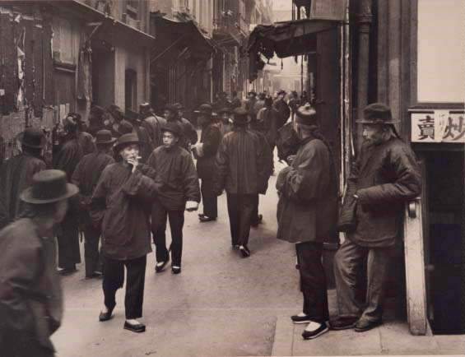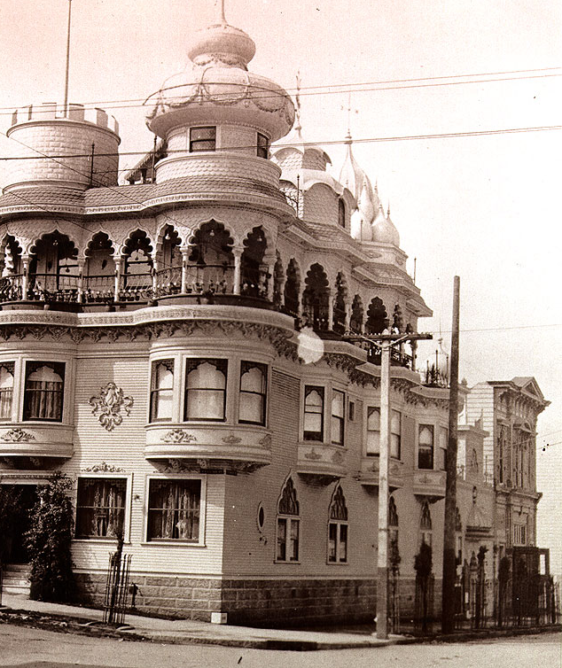

After taking a ferry to San Francisco from Angel Island, Chinese people would usually go to Chinatown. Japanese people would go to Japantown. Indian people would go to a place called Cow Hollow. These were places to find other people would speak their languages and could help them find a place to stay and work. If you had relatives in San Francisco, they may be waiting here for you. Sometimes family members had not seen each other in years. There were also laws in California that said Asians could not be citizens, so they could not vote or own land. This made life very hard.

SOURCEBOOK: 2-9.C

Source 2: Finding a Home

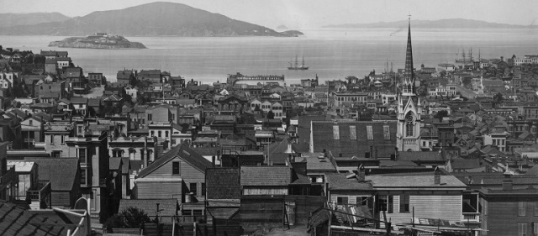

In the early 1900s, San Francisco was a very crowded city. New immigrants from China, Japan, and India usually lived in small apartments. Since immigrants were new to the city, they may stay with a relative first. Apartments were expensive, so people would often share their apartments with other people.

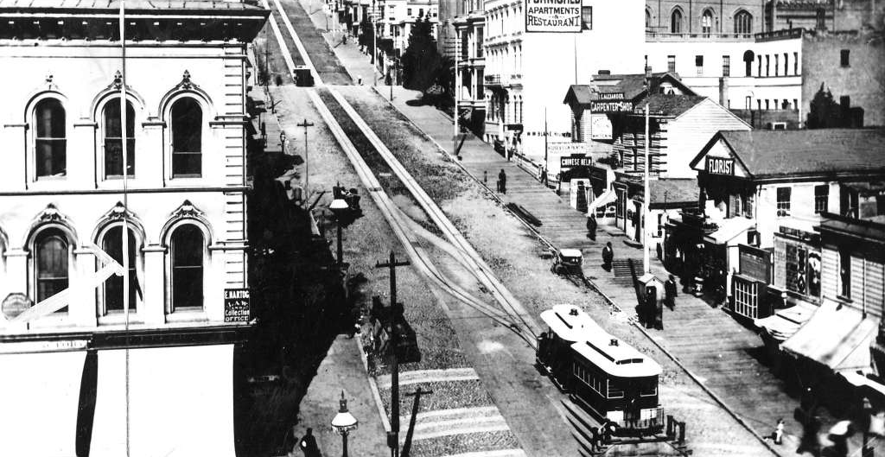
SOURCEBOOK: 2-9.D

Source 3: Finding Work

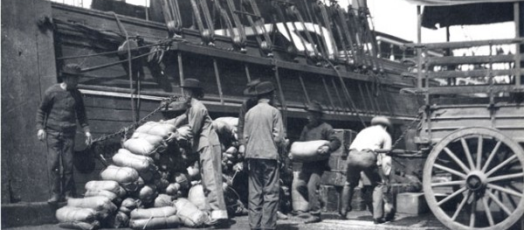

Since so many people were looking for work, companies often paid poorly and made people work for long hours. Many Chinese, Japanese, and Indian immigrants worked in the dockyards (above) and factories (below). Others moved out of San Francisco and worked on farms. Most bosses did not speak their language.

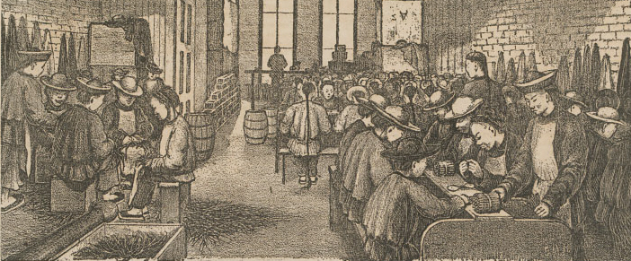
SOURCEBOOK: 2-10.A

Images (A)

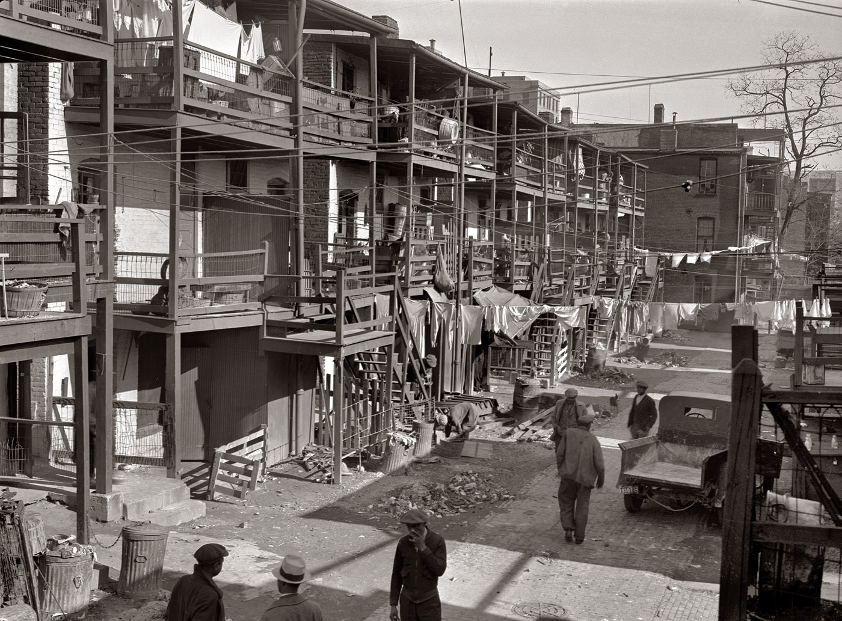
Images (B)

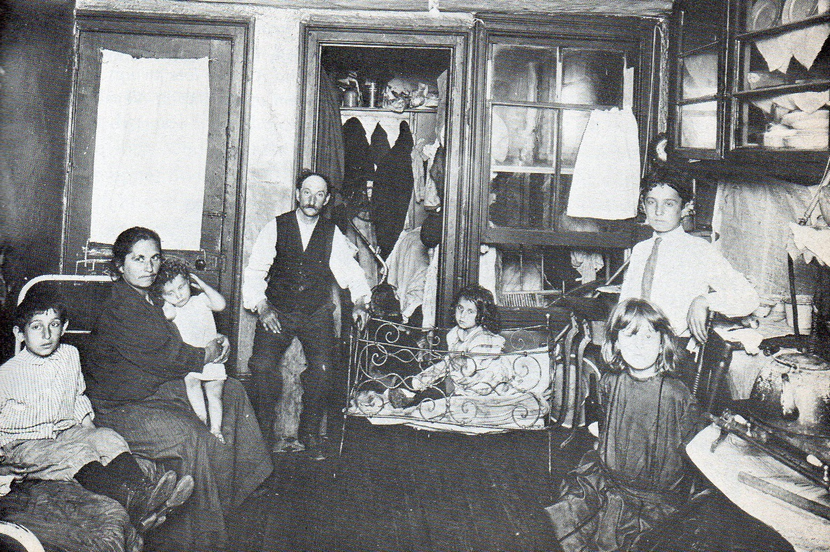
SOURCEBOOK: 2-11.A

Mexican Family

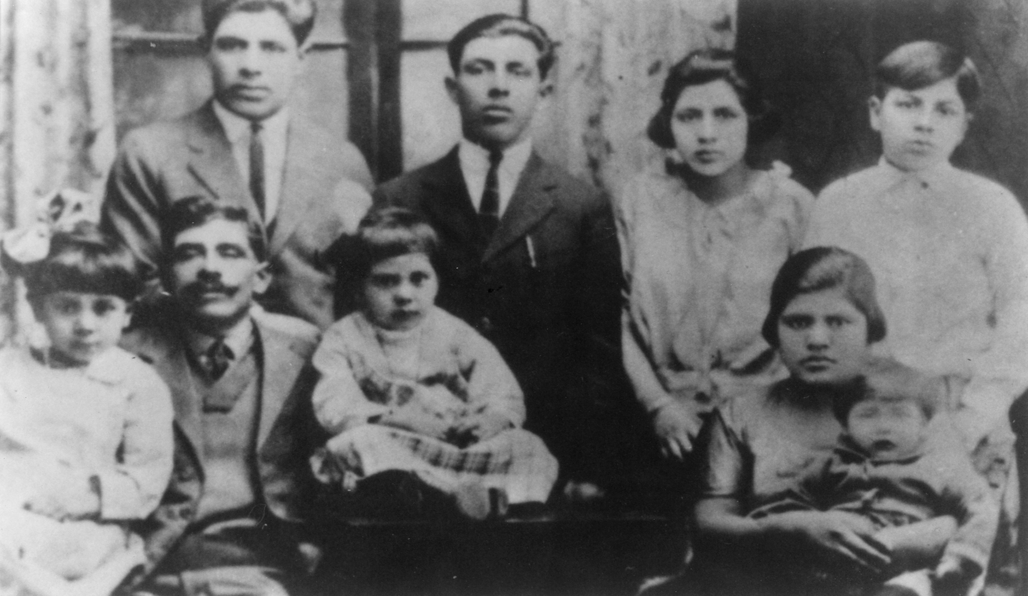
French Canadian Family

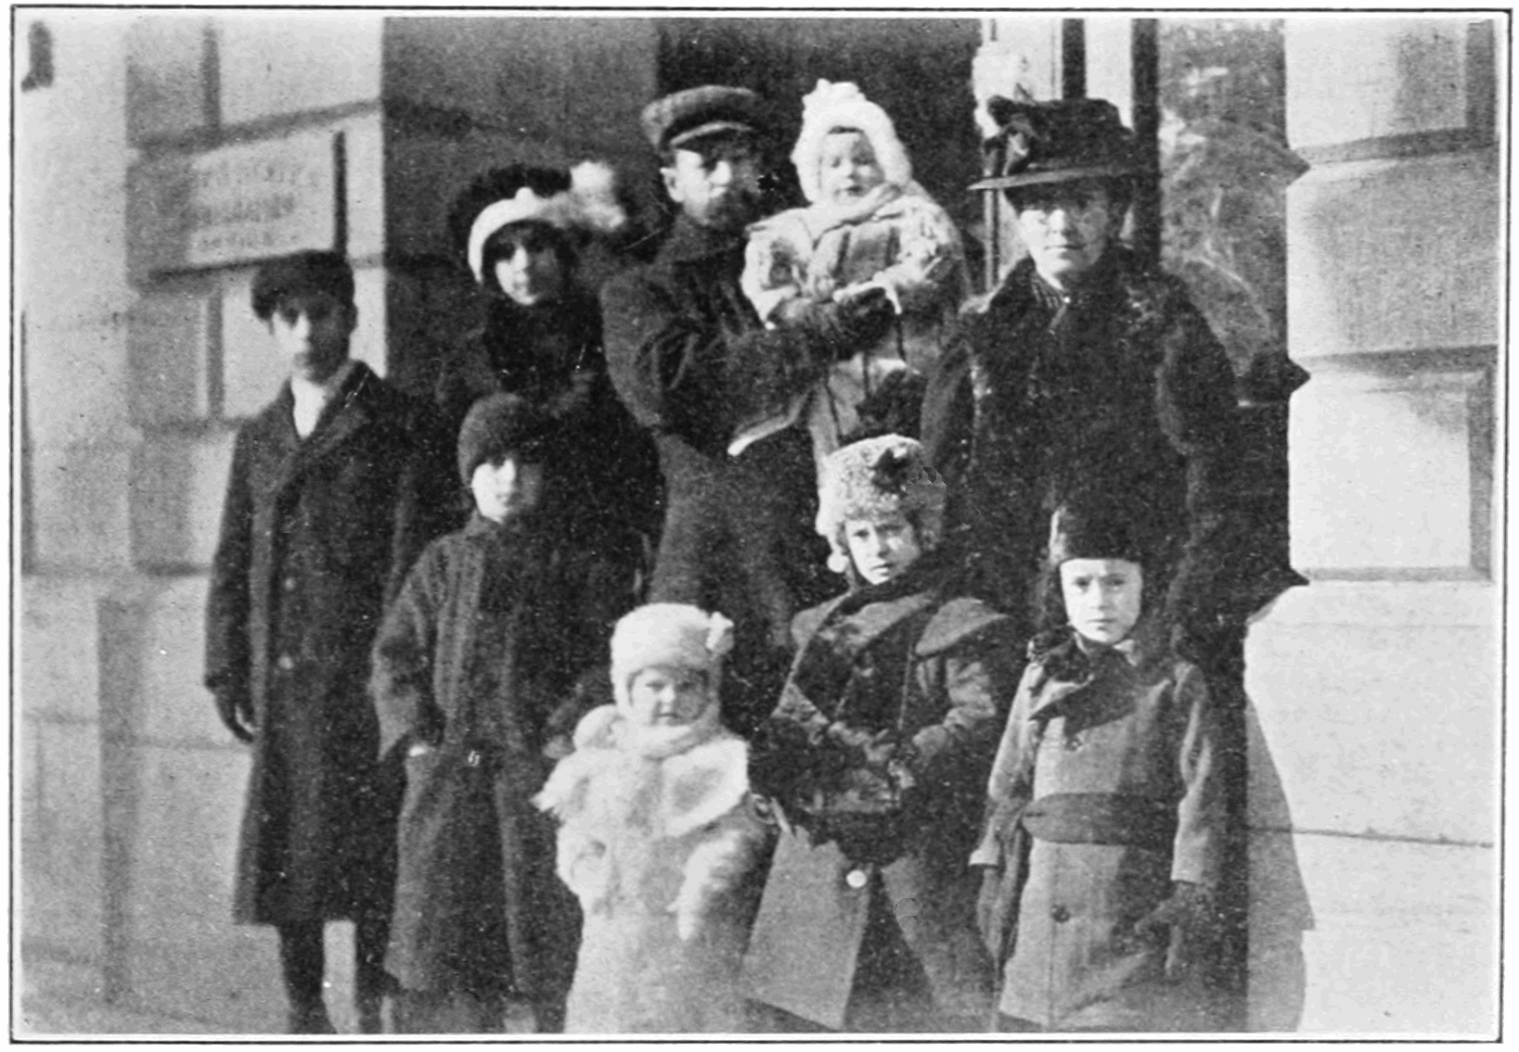
SOURCEBOOK: 2-11.C

Source 1: Mexican Immigrants

This is the Montoya family. They emigrated from Zacatecas,
México and came to Kansas City in 1907. The father was named Juan and he brought his family to Kansas City because he got a job working for the railroad. The family only spoke Spanish when they first arrived. They experienced all sorts of new American food, but cooked Mexican food like tamales (below). They liked to listen to traditional Mexican music, which was played at family parties. They helped start the first Spanish speaking Catholic church in Kansas City, called Our Lady of Guadalupe.

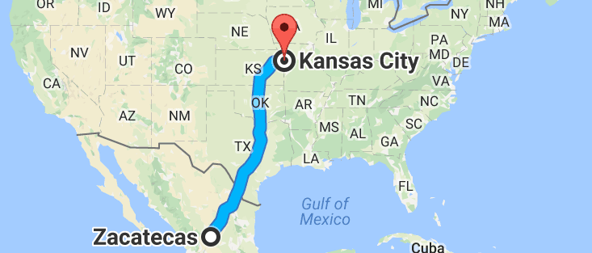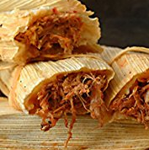
SOURCEBOOK: 2-11.D

Source 2: French Canadian Immigrants

This is the Lapointe family. They emigrated from Montréal, Québec (French Canada) and came to Holyoke, Massachusetts in 1907. The father was named Theophile and he brought his family to Holyoke because he got a job working in a paper factory. The family only spoke French when they first arrived. They experienced all sorts of new American food, but cooked French food like tourtière (below). They liked to listen to traditional Québec music, which was played at family parties. They went to the French-speaking Precious Blood Catholic Church.

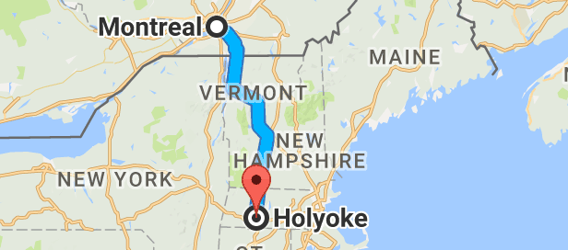
SOURCEBOOK: 2-12.A

1924 Immigration Law

Section 1A: If you have family members in the United States or marry an American, you can become a citizen.

Section 1B: There is a quota for the current immigrants. No more than a certain number of people can come to the United States from any country in a year.

…

Section 11: For the number of immigrants allowed to come to the U.S., we will base it on the number of immigrants from each country in 1890.

Question:
After 1890, there was a change in where immigrants came from. There were many more immigrants from Eastern Europe (like Poland and Russia), Southern Europe (like Italy and Greece), and Asia (like China and Japan).

Why do you think they chose that year instead of 1920?

SOURCEBOOK: 2-13.A

Zoom 1

Zoom 2
Zoom 3
SOURCEBOOK: 2-13.B

Source 1: 1965 Immigration Act

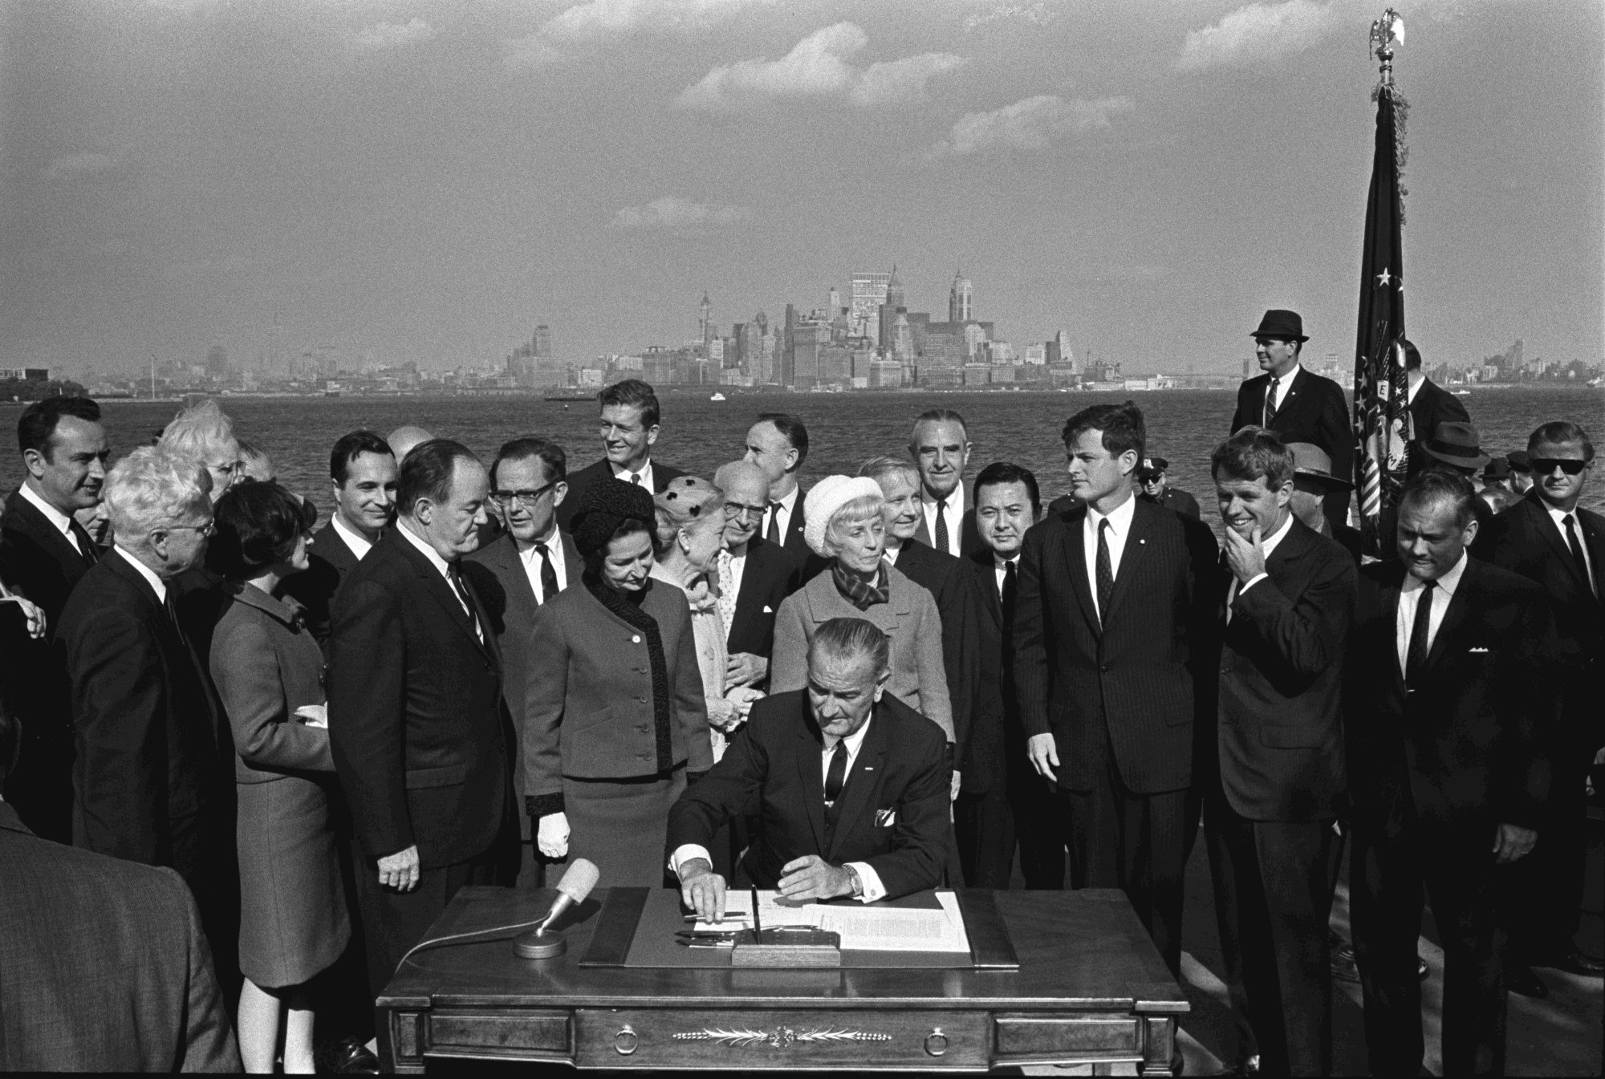

In 1965, President Lyndon Johnson signed a new immigration law while sitting in front of the Statue of Liberty (see New York City in the background). This new law ended quotas or limits (meaning only a certain number of people could enter from any one country). These quotas allowed many more immigrants from Europe compared to other continents. This law allowed more immigrants from countries in Asia (like China, Vietnam, and India) and South America and the Caribbean (like Colombia, Dominican Republic, Haiti, Brazil).

SOURCEBOOK: 2-13.C

Source 2: Transportation Changes

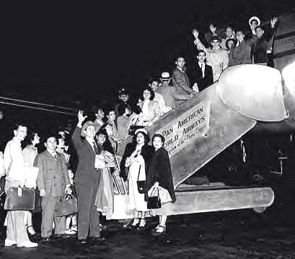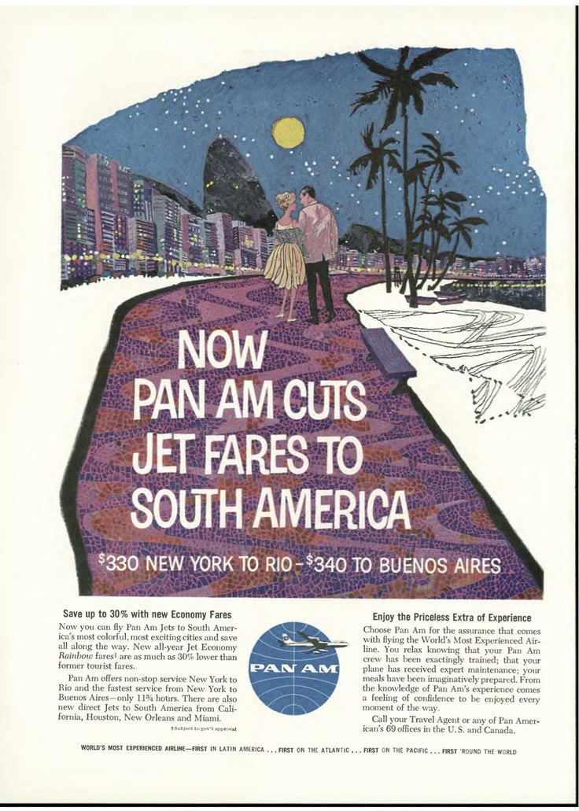

In the 1930s, trains became faster and transported many immigrants from México and Canada. These trains from México and Canada carried people until the 1970s when they ended due to lack of passengers. In 1960s, with the new jet airplane, flights became much faster and cheaper. Different American airlines began flying to further away places, like South America, the Caribbean, Asia, and Africa. This allowed more immigrants to take airplanes, instead of ships to the United States. It would only take a few hours by plane, instead of several days by ship. These two new transportation types, ships and planes, allowed more people from faraway places to immigrate to the United States.

SOURCEBOOK: 2-13.D

Source 3: Work Changes

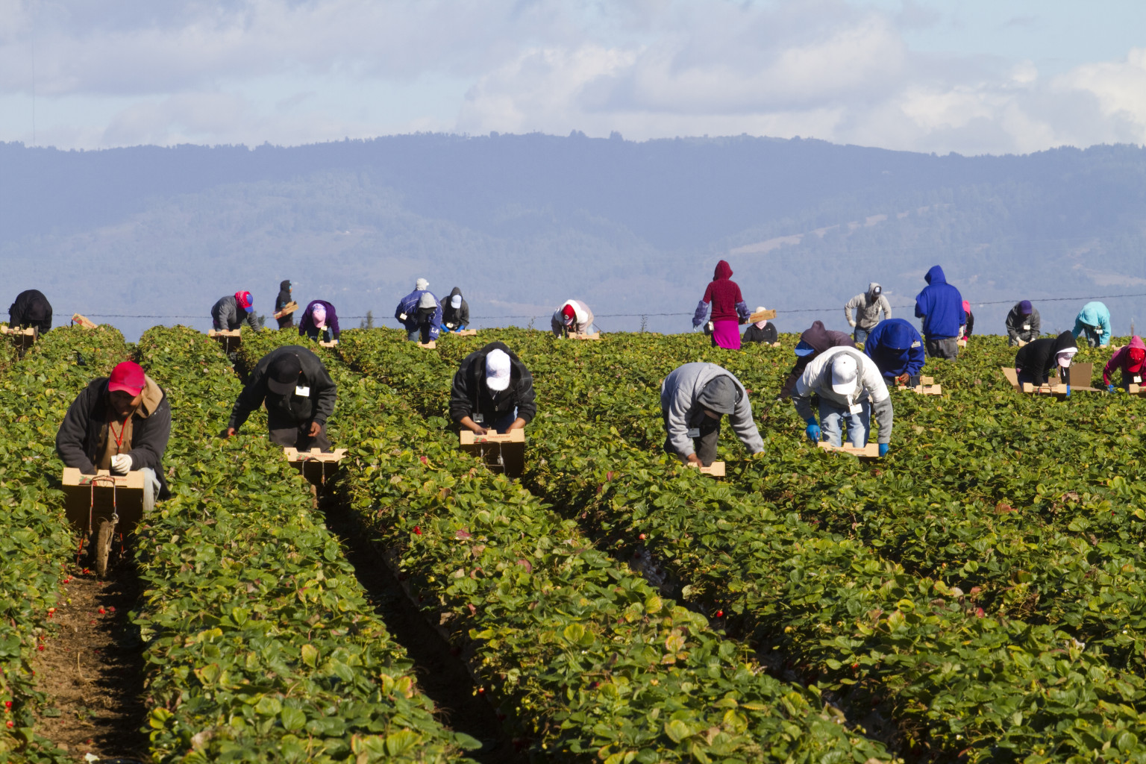

In 1994, the United States, Canada, and México started the North American Free Trade Agreement (NAFTA). This allowed free trade (no taxes) on goods sold between the three countries. Cheaper corn and other crops from the United States hurt many Mexican farms. It also resulted in many U.S. factories moving to México and Canada. Many Mexican farmers and their families moved to the United States for work. In 1980, there were 2.1 million Mexican immigrants living in the U.S. In 2000, there were 9.1 million Mexican immigrants living in the U.S. For the past 50 years, Mexicans have been one of the largest immigrant group coming to the United States.

SOURCEBOOK: 2-13.E

Source 4: Government Changes

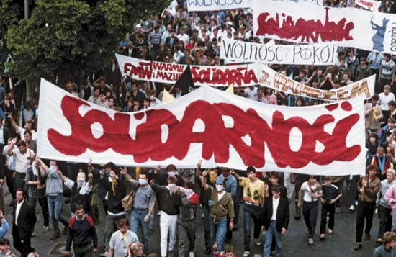

In the 20th century, many governments were communist (countries where the government controls all stores) and they had dictators (leaders who are not elected). These countries did not allow their citizens to move to the United States. In the 1980s and 1990s, several countries ended communism. This included Poland (above), East Germany, Czechoslovakia, Romania, Bulgaria, and the Soviet Union (Russia). In the 1990s and 2000s, other communist countries began allowing their citizens to move to other places (which they did not allow before). This included China, Vietnam, Laos, and Cambodia. This allowed people from these countries to immigrate to the U.S. for the first time in many years.

SOURCEBOOK: 2-14.A

Source 1: Little Time to Prepare

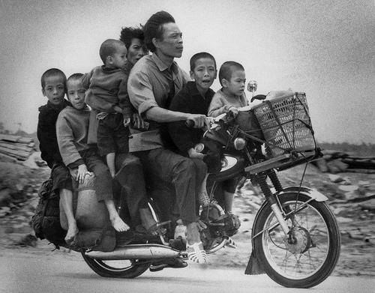
In the 1970s and 1980s, because of a war, many Vietnamese people fled their homes. They often left secretly in the middle of the night and could not tell their relatives good-bye. They thought that they might not see them ever again. They boarded small fishing boats or large passenger boats and sailed to nearby countries like Malaysia or Thailand. These people were called “boat people.” Some people would leave on roads to neighboring countries by using fake documents or bribing government workers. People would have to plan for months or even years and it would often cost them all their money.
SOURCEBOOK: 2-14.B

Source 2: Pirates

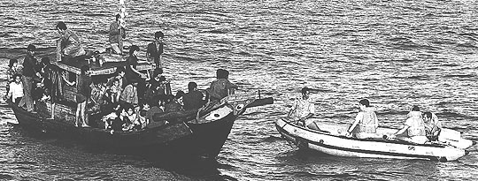

In 1980, there were more than 10,000 Vietnamese people each month fleeing their country on boats. Most of these boats were attacked by pirates or people who boarded the boats and demanded everyone’s money, jewelry, and food. This was scary for many of the people on the boat and they could get hurt or killed if they did not do what the pirates told them to do. One boat was even boarded by pirates over forty times.

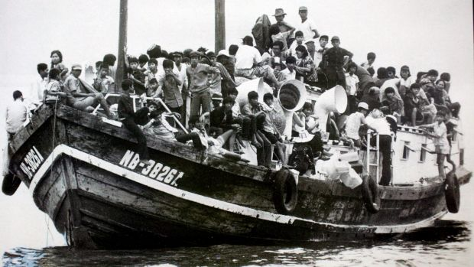
SOURCEBOOK: 2-14.C

Source 3: Broken Boats

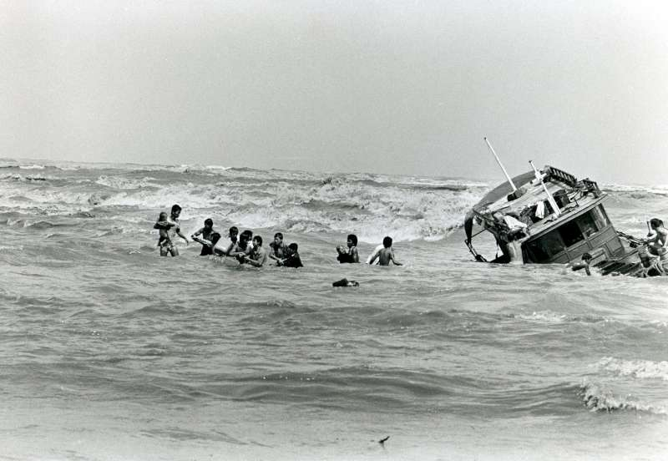

The boats that refugees had to travel on where not always in good shape and would break down. Sometimes the engines died or the boats got holes in their bottom. Other times storms would come and flood the boat. Many of these boats were not made for long distances and they would have to travel hundreds of miles to make it to Malaysia or Thailand. It took most boats 1-2 weeks to get to another country. Some lucky boats were rescued by fisherman, passenger ships, or large boats transporting goods across the ocean. Some unlucky boats took months to reach the shore.

SOURCEBOOK: 2-14.D

Source 4: Refugee Camps

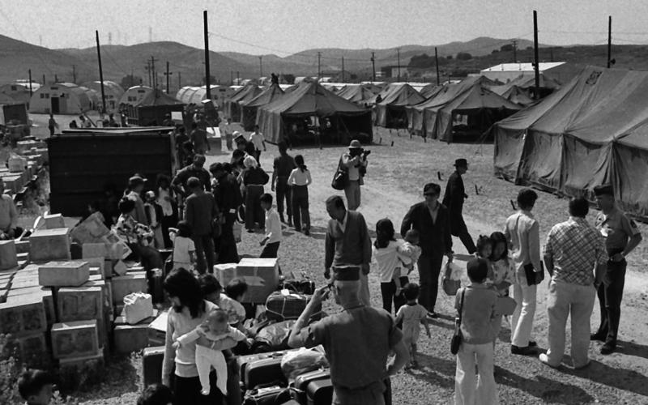

Many Vietnamese refugees immigrated to the United States, France, Canada, Australia, Britain, and Germany. They had to live in refugee camps. They stayed in tents and the military gave them food and clothes. Above is a picture from the refugee camp at Camp Pendleton in California. 1.6 million Vietnamese people went to the U.S. and other countries in the 1970s and 1980s. In Massachusetts, the Fields Corner section of Dorchester became one place for Vietnamese people to settle. It had cheaper housing and public transportation, which was very important for people who had to leave everything behind in their home country. Today, Dorchester has New England’s largest Vietnamese community with many Vietnamese stores, restaurants, and community organizations like Viet Aid.
SOURCEBOOK: 2-15.A

Images

SOURCEBOOK: 2-15.B

Source 1: Science: Albert Einstein

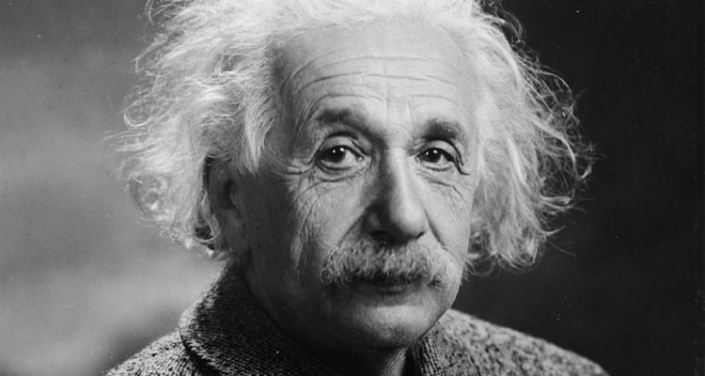

Many important scientists were immigrants to the United States. Albert Einstein came to the U.S. from Germany in 1933. He was 54 years old. He was a famous scientist in Germany and he came to the United States because laws were being created against Jewish people. He would become one of the most well-known scientists in the world because his “theory of relativity” about the speed of light. He also had many other scientific theories. Einstein’s ideas would lead to the invention of atomic energy, a better design for solar panels, and a refrigerator that requires almost no energy. He would win a Nobel Prize for Physics.

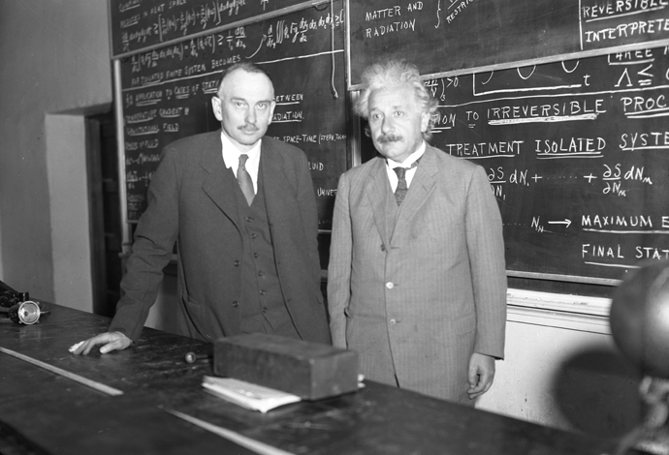
SOURCEBOOK: 2-15.C

Source 2: Art and Music: I.M. Pei

Many important artists, musicians, and architects were immigrants to the United States. I.M. Pei came to the U.S. from China in 1935. He was 18 years old. He came to attend college at the University of Pennsylvania and later the Massachusetts Institute of Technology. He then became an architect, who designed buildings. I.M. Pei designed some of the most famous buildings in the world, including the Louvre Art Museum in Paris (above). In Boston, he designed the John F. Kennedy Presidential Library in Dorchester and the new John Hancock Building in Copley Square and the Museum of Fine Arts West Wing in the Fenway (below).

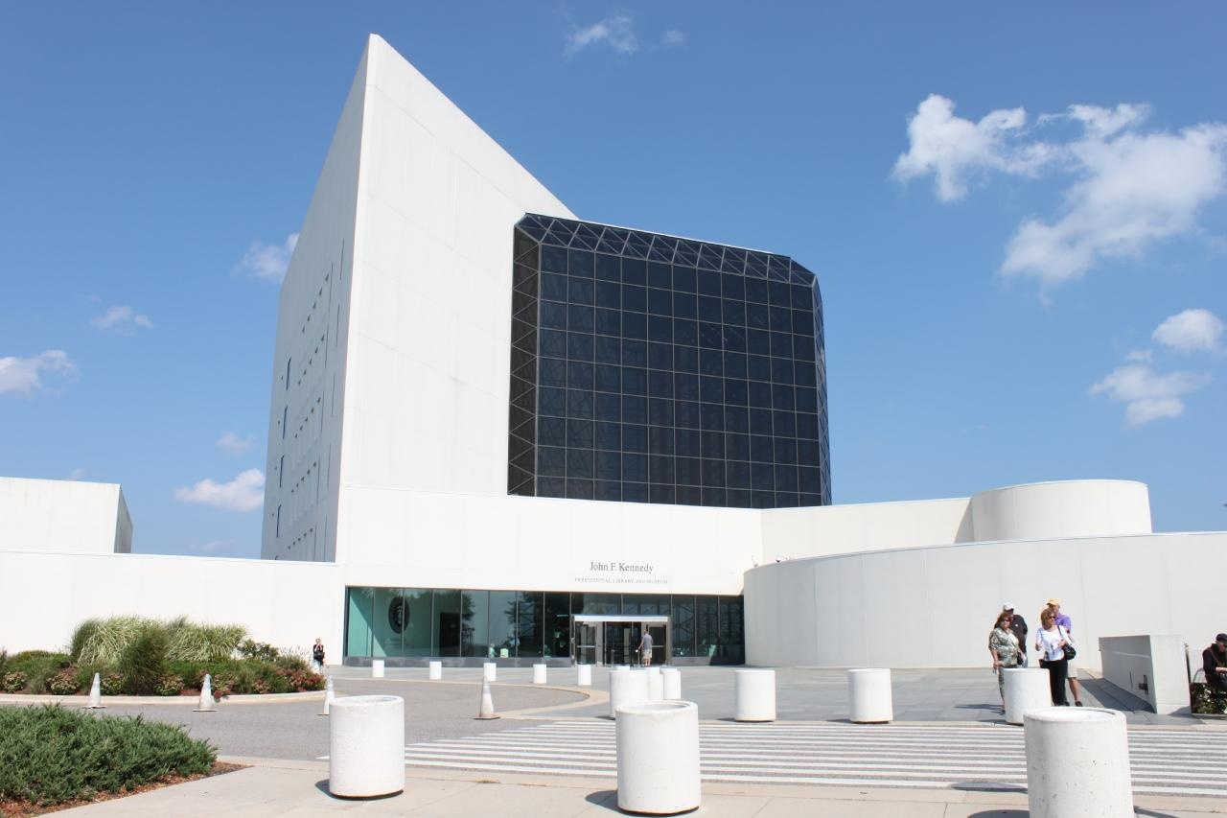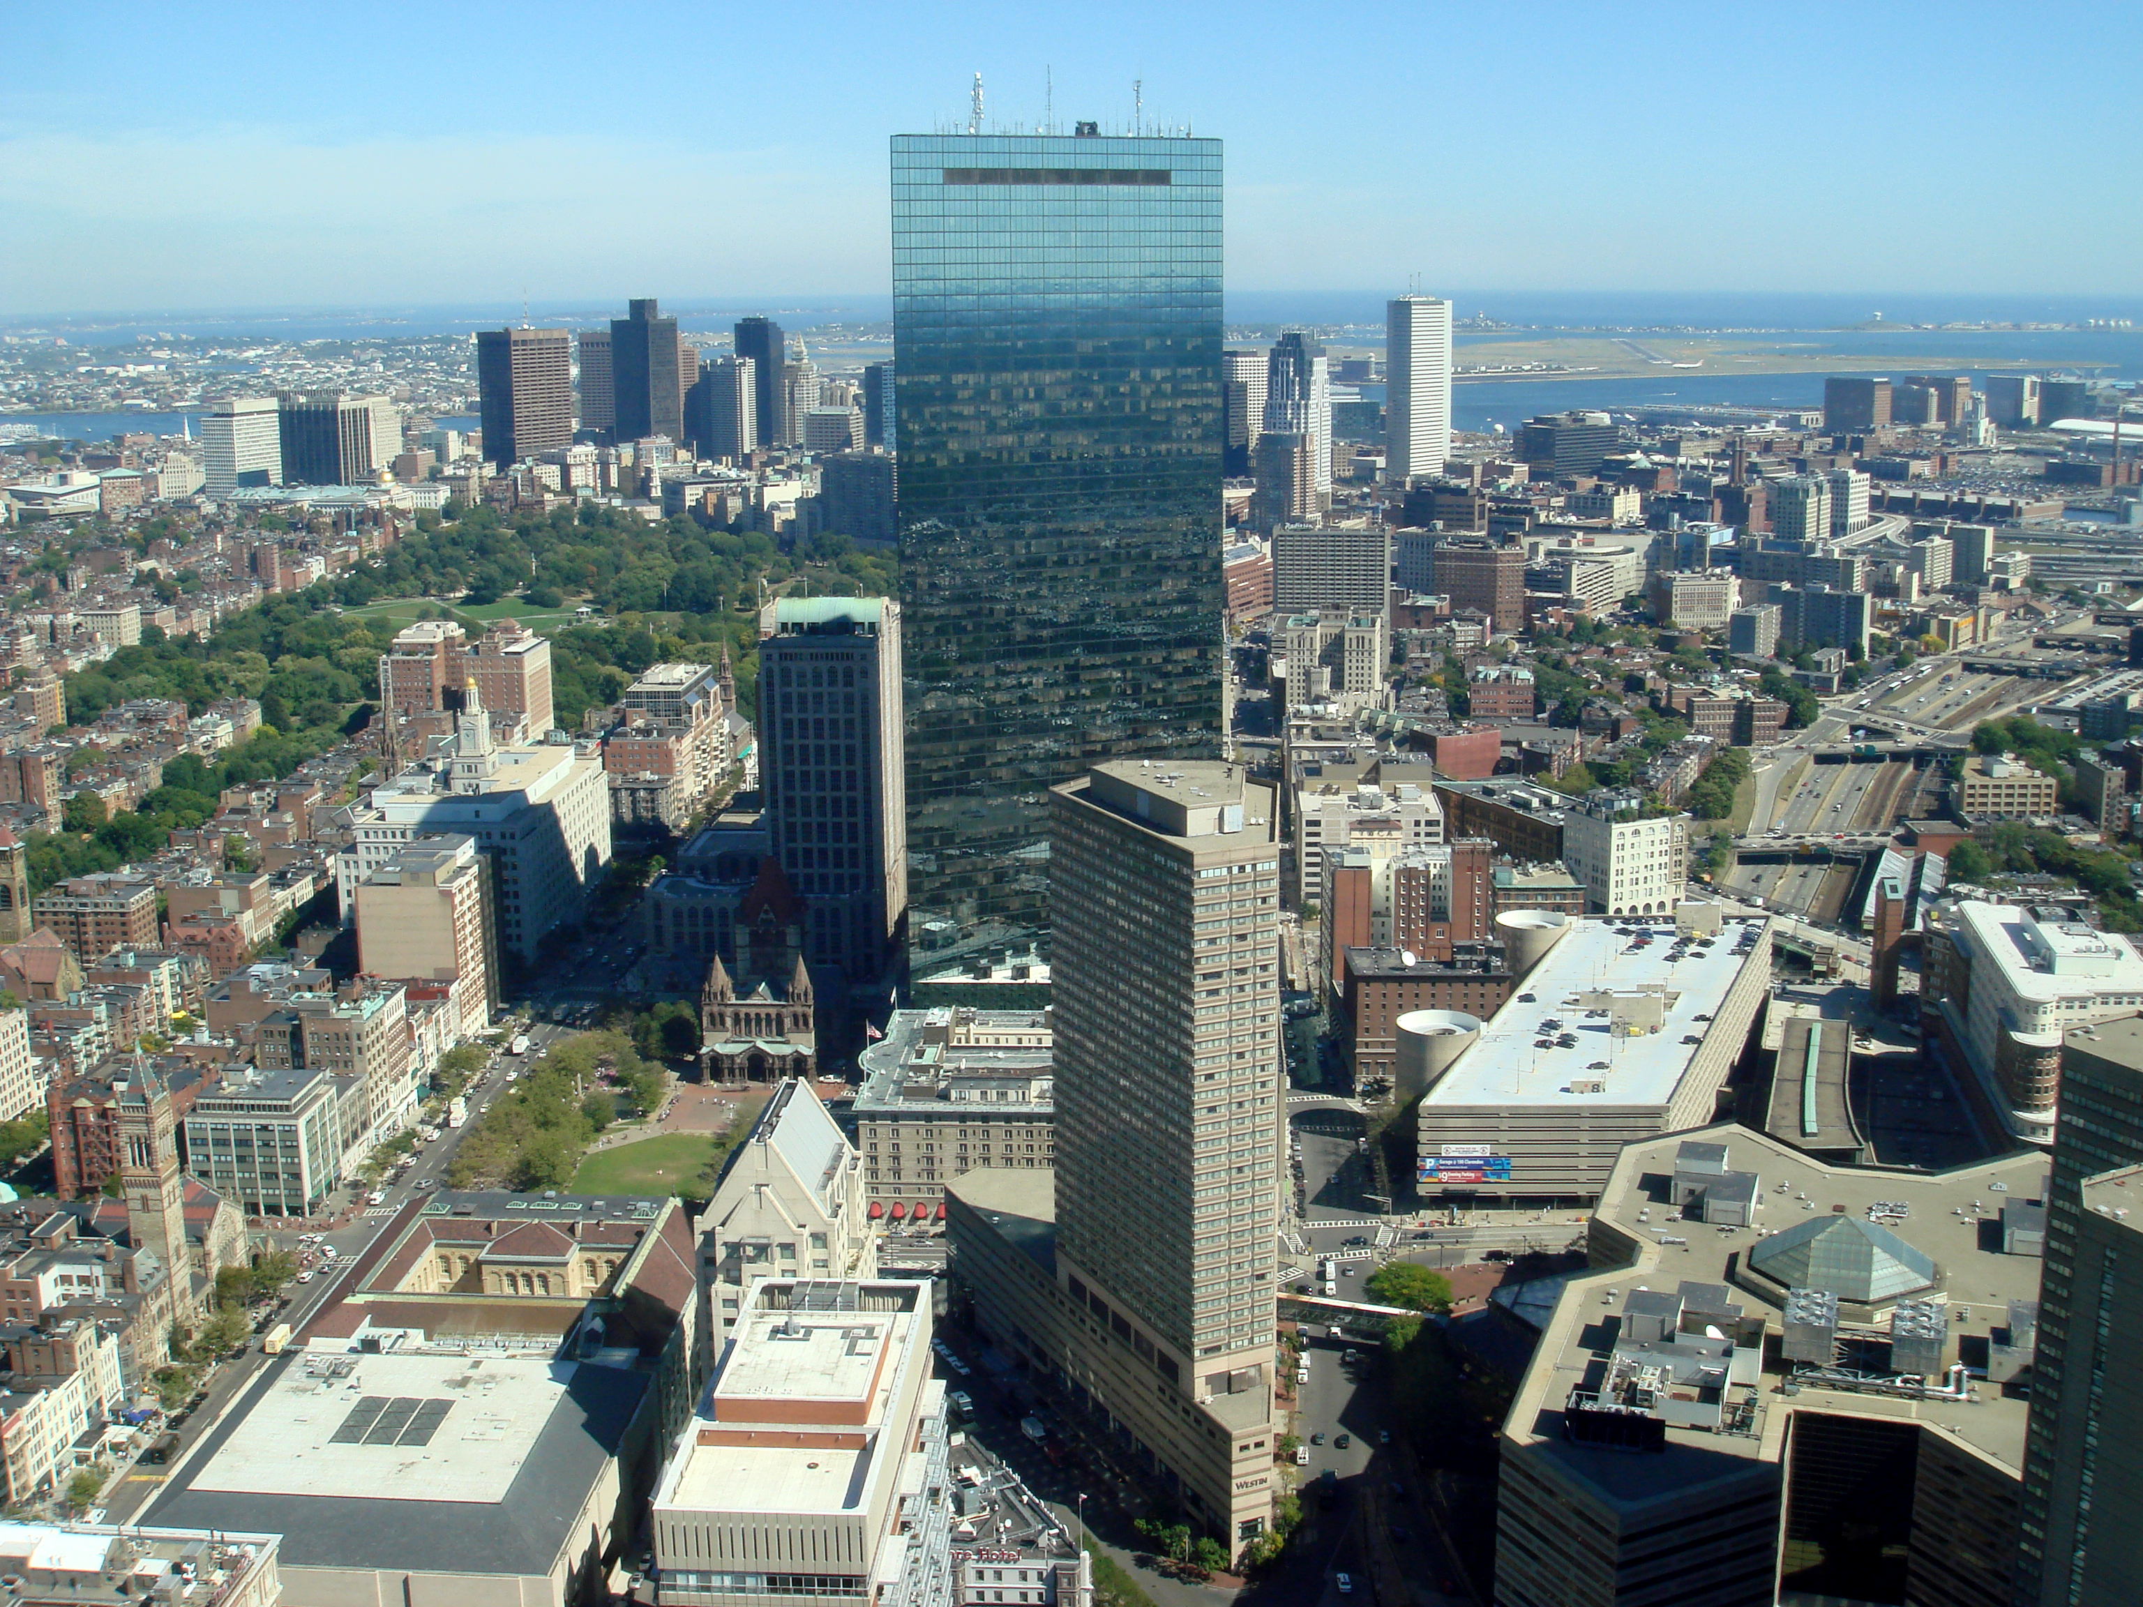
SOURCEBOOK: 2-15.D

Source 3: Sports: David Ortiz

Many important athletes and coaches were immigrants to the United States. David Ortiz came to the U.S. from the Dominican Republic in 1992. He was 17 years old. He came to play first base on a minor league baseball team called the Wisconsin Timber Rattlers. As a kid, he was friends with fellow Dominican baseball player Pedro Martinez. They would eventually end up on the same team, the Boston Red Sox. He would also gain the nickname “Big Papi.” In his 20 years playing baseball, David Ortiz attended 10 All-Star Games and won 3 World Series. He has the Red Sox record for most home runs in a season at 54. He is considered one of the greatest designated hitters (a player who only bats) and will likely be in the Baseball Hall of Fame someday.
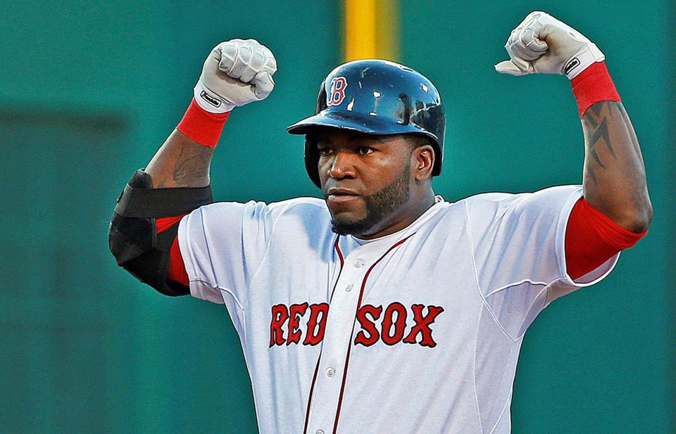
SOURCEBOOK: 2-15.E

Source 4: News and Media: Maria Hinojosa

Many important reporters and journalists were immigrants to the United States. Maria Hinojosa (hin-o-yo-sa) came to the U.S. from México in the 1962. She was 1 year old. She came with her family, who moved to Chicago because of her father’s new job. She routinely visited her family in México, which she says helped her always feel both American and Mexican. She wanted to be an actress, but in college decided instead to become a journalist, or someone who reports news stories. Today, Maria Hinojosa is a well-known journalist for National Public Radio (NPR) and the Public Broadcasting System (PBS). She often reports on stories related to the Latino community and she hosts two shows called Latino USA and One-on-One. She has won many awards for her reporting, including four Emmy Awards.

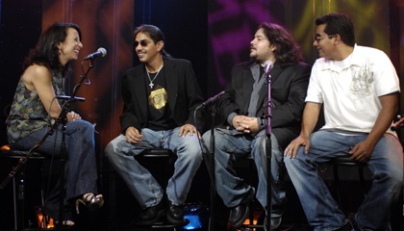
SOURCEBOOK: 2-16.A

Source 1: Taking a Flight from China

This is the Chin family. They immigrated from China to California. They flew on an airplane from Shanghai to San Francisco. The father of the family was accepted as a university student and he received a visa, which allowed him and his family to come to the country. When they entered the country at the airport, they needed to show their passports and visas, get fingerprinted, and be interviewed by an immigration officer. Although the parents spoke English, their children only spoke Mandarin Chinese. They had to learn English in school and it took a long time. After graduating, the father was able to find a job at a computer company. After 5 years, the family became citizens. The next year, they were allowed to bring his wife’s parents to the United States.

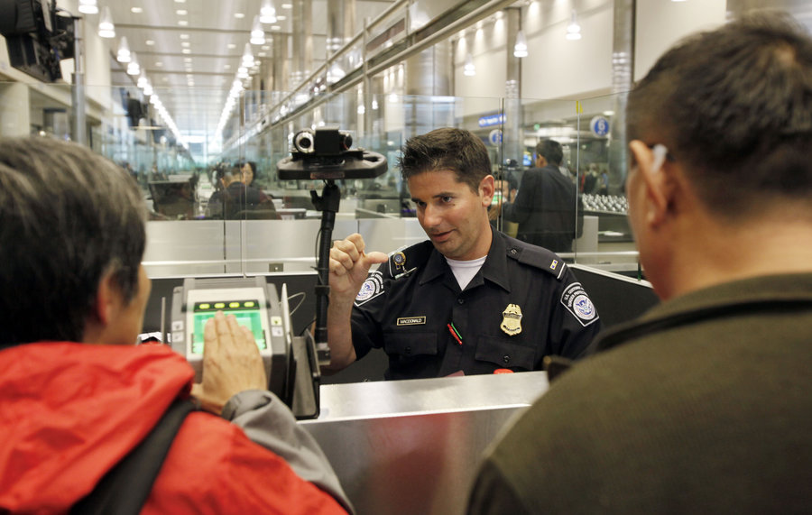

SOURCEBOOK: 2-16.B

Source 2: Riding the Bus from Canada

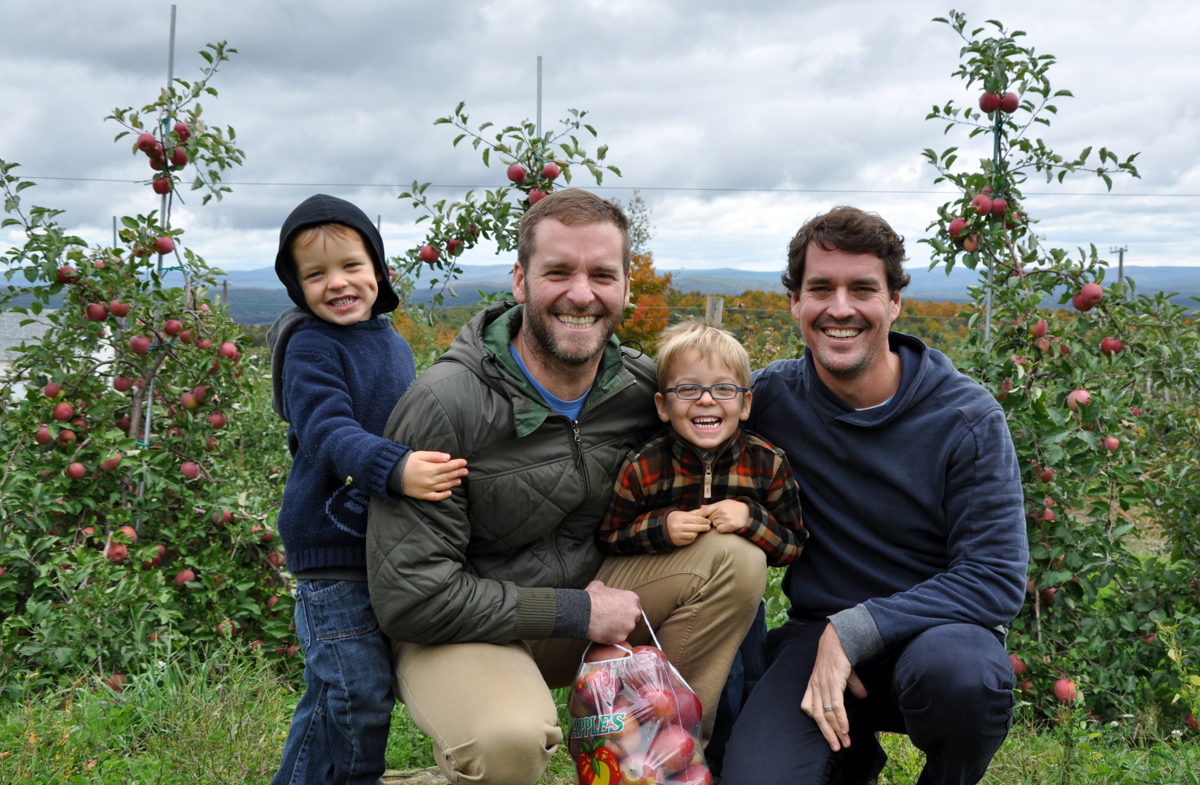

This is the MacDonald-Smith family. They immigrated from Canada to New York. They rode on a bus from Toronto to New York City. One of the fathers was born in the United States and he was an American citizen. This allowed him to bring his husband and children to the United States. When their bus crossed the border into the U.S., an immigration officer boarded the bus. They needed to show their passports and visas, get fingerprinted, and be interviewed. Everyone in the family speaks English, because it is one of the languages of Canada. When they arrived in the United States, the parents had to sign their children up for school and find jobs.
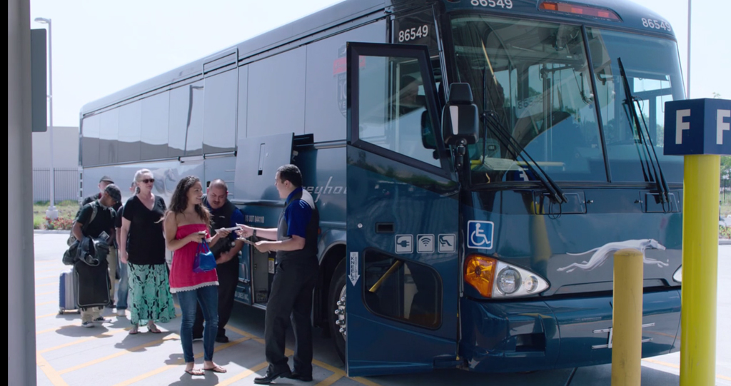

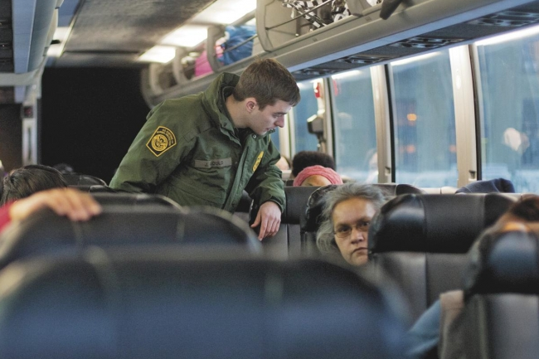
SOURCEBOOK: 2-16.C

Source 3: Driving from México

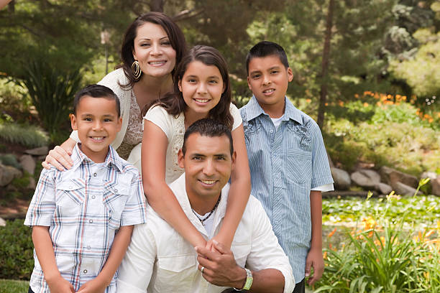

This is the Hernandez family. They immigrated from México to Texas. They drove their minivan from México City to San Antonio. The mother was an engineer in México and an American company brought her here on a work visa. The family had to wait 4 years to come to the United States. They had an uncle who lived in San Antonio. They arrived at his house and lived with his family for several months. Only the mother could speak English, so everyone else started taking English classes. The parents signed their children up for school. After 5 years, the family became citizens.

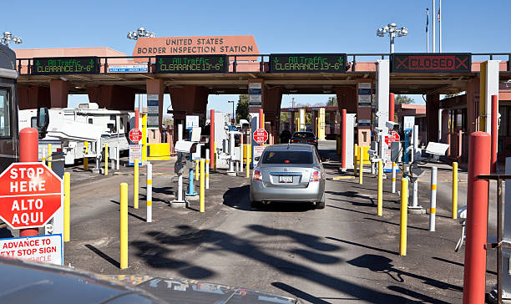

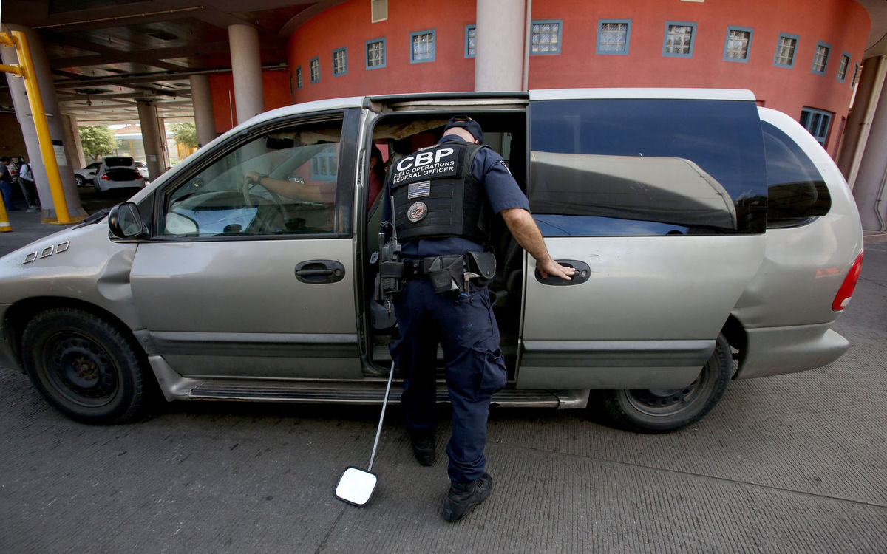
SOURCEBOOK: 2-16.D

Source 4: Taking a Flight from Slovakia

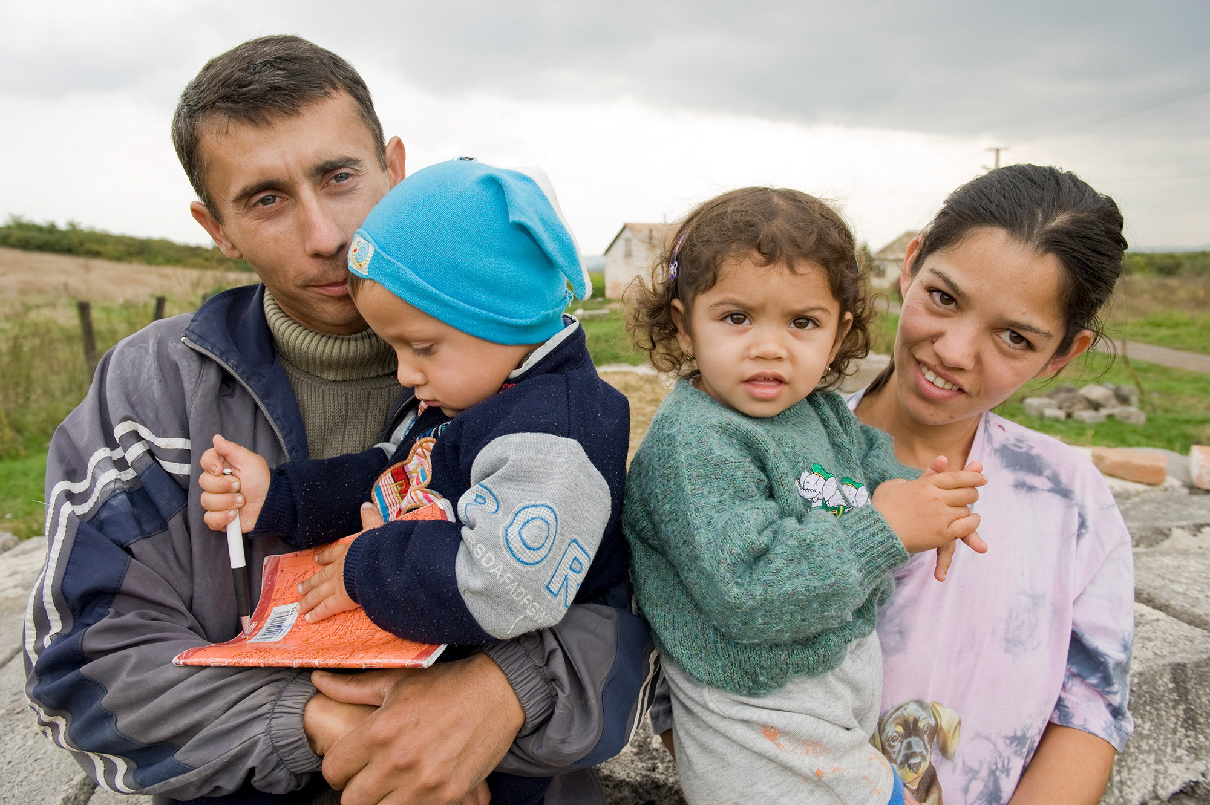

This is the Kováč family. They immigrated from Slovakia to Pennsylvania. They flew on an airplane from Bratislava to Pittsburgh. Both parents could not find work in Slovakia. Since many people from Slovakia want to come to the United States, they were told that they would have to wait many years to come here. The parents made a difficult decision to come to the United States without papers (undocumented). The U.S. let them visit as tourists and they stayed for longer. No one in the family could speak English, so they started taking English classes. The parents signed their children up for school and found jobs in a local restaurant. They worry that there is a chance that the U.S. government will find out that they do not have documents and they could be forced to return to Slovakia.

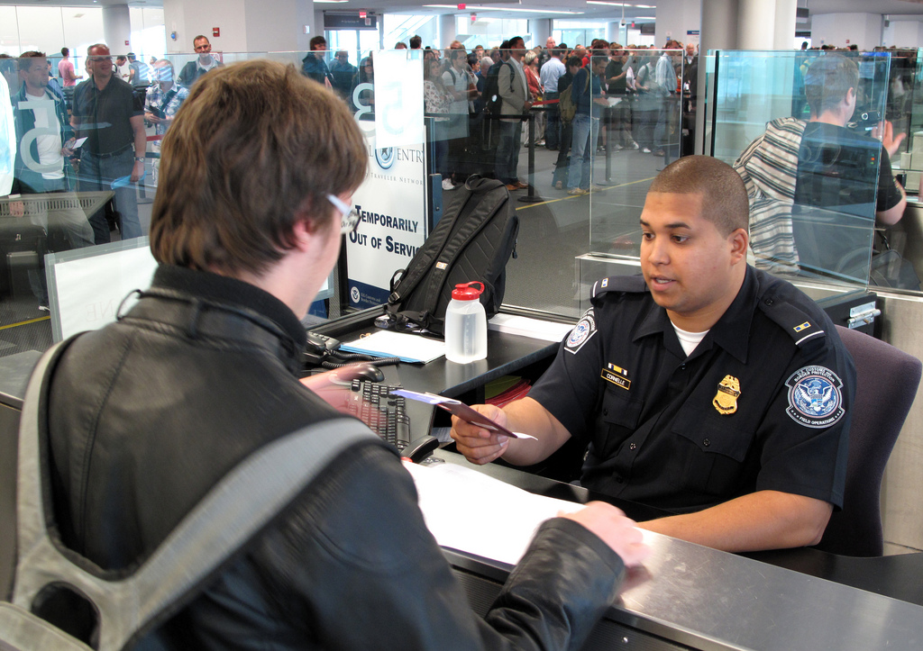
SOURCEBOOK: 2-17.A

Images (A)
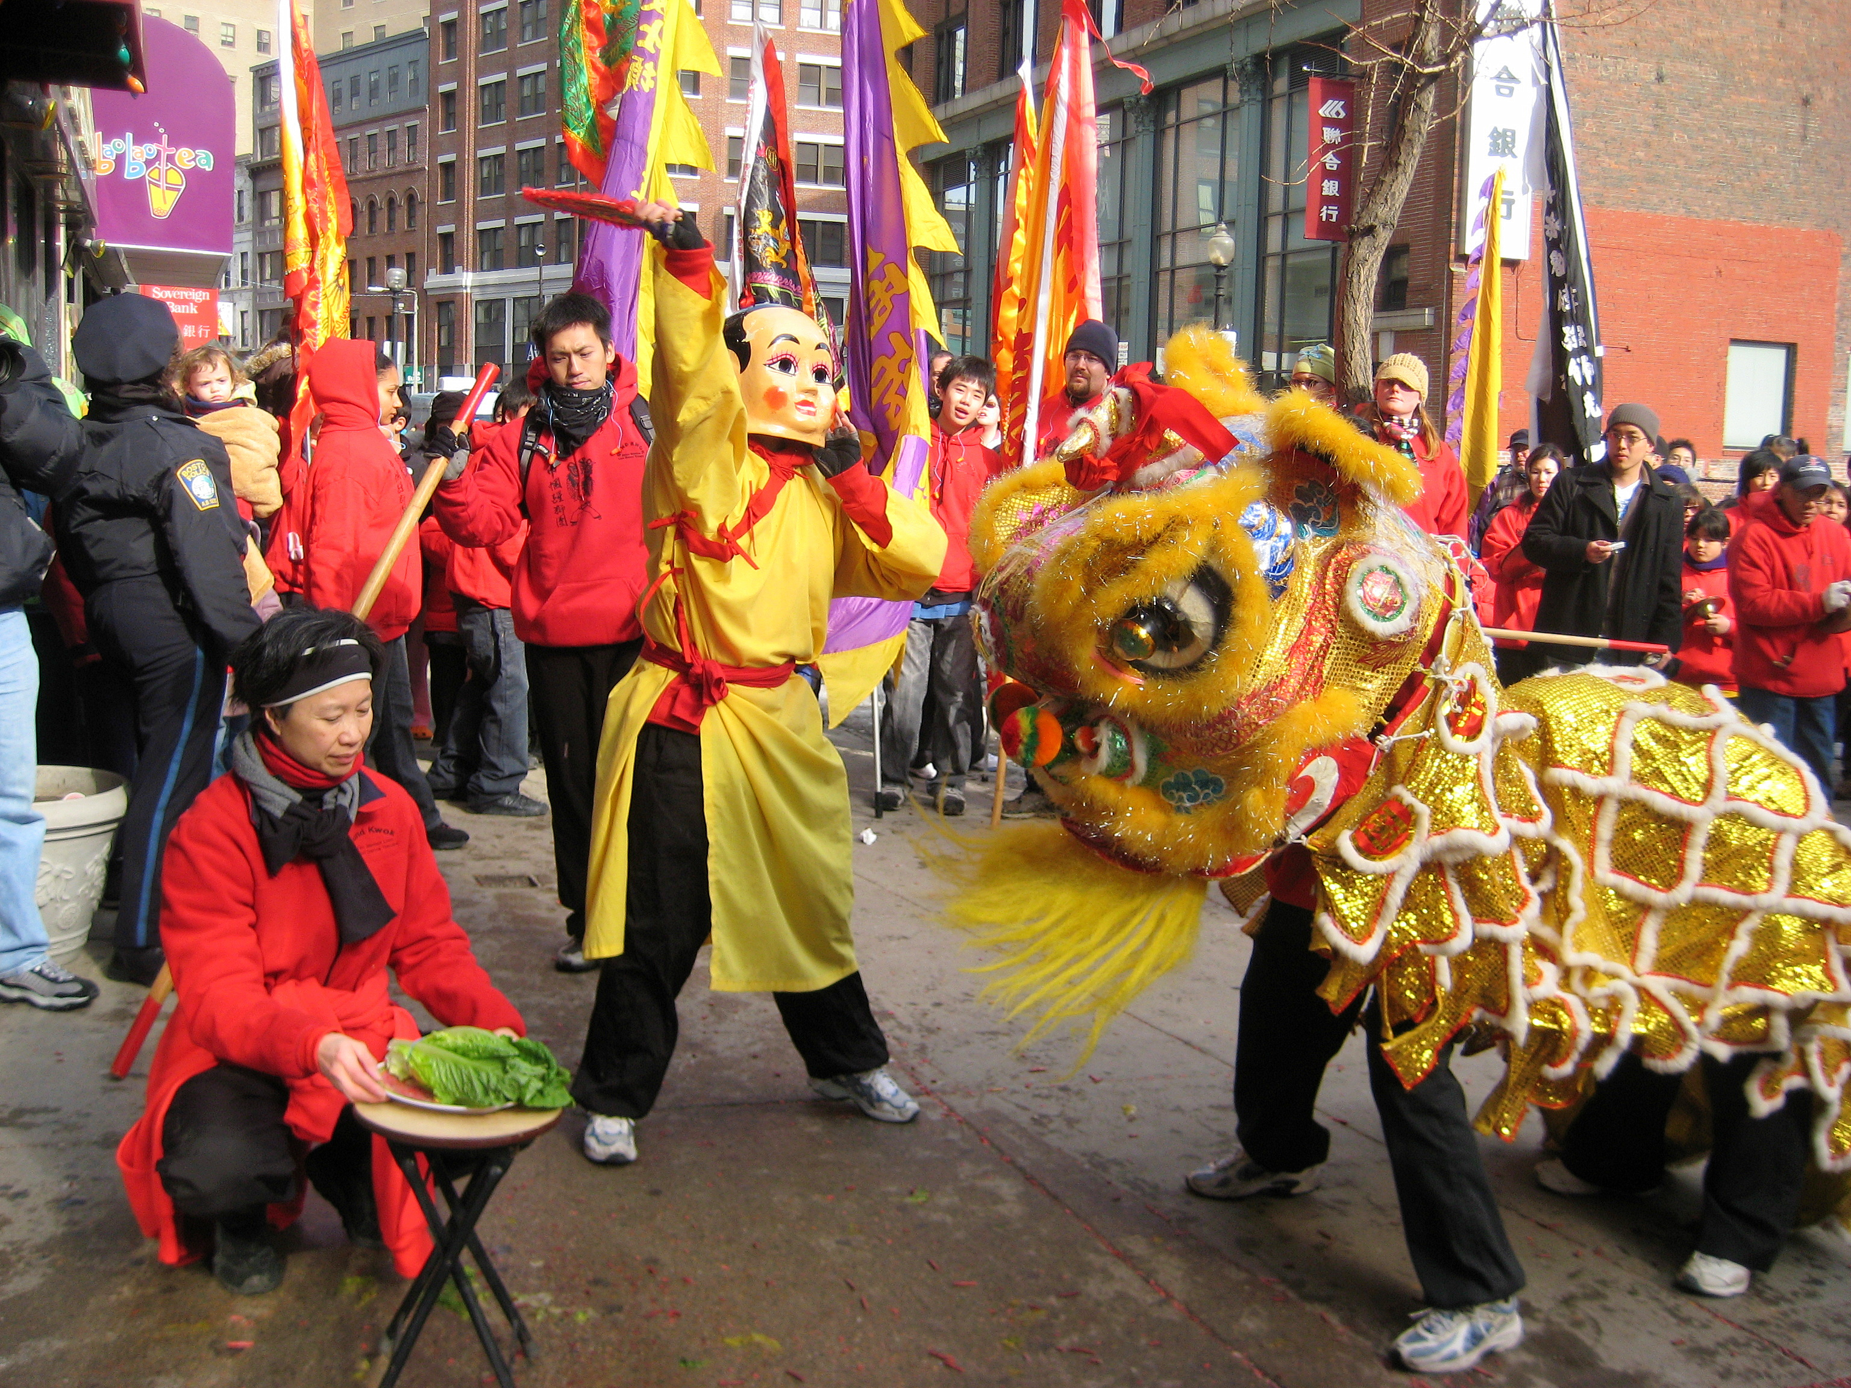
Images (B)
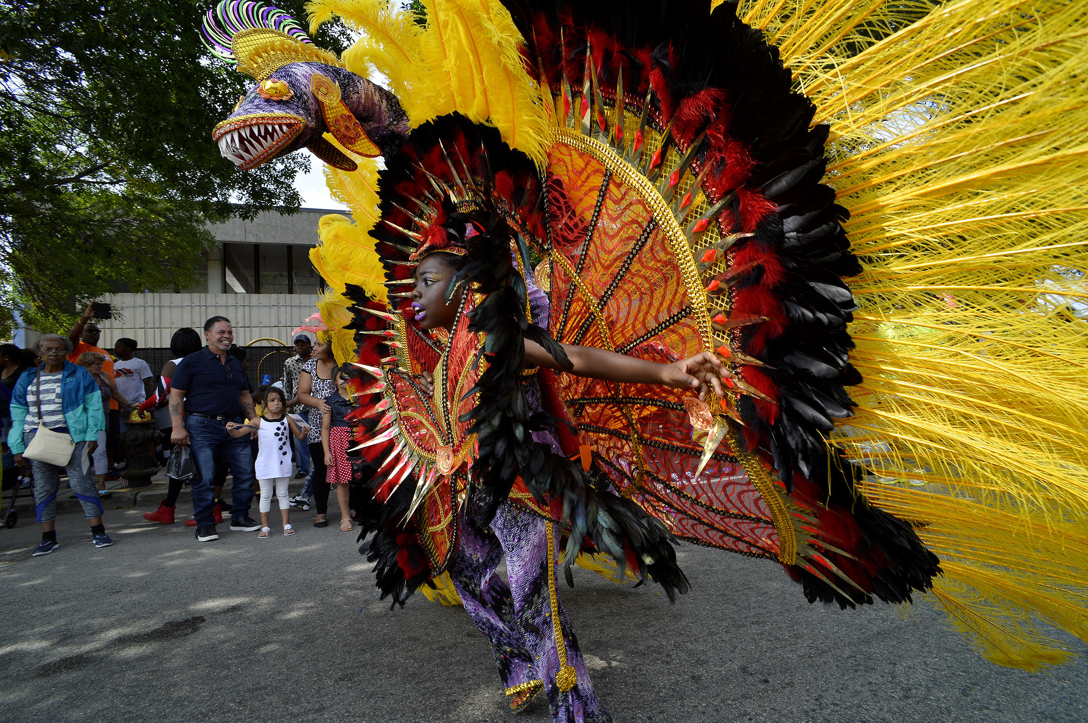
SOURCEBOOK: 2-17.B

Letter to the Editor

To the Editor,

It is important that everyone shovel their sidewalks when it snows. First, many people use the sidewalks to get to work and school. When they are not shoveled, it makes it difficult for many people to get to where they are going. Second, people will sometimes walk in the street, if the sidewalks are not shoveled. They could get hurt by a passing car. Third, many people need a wheelchair or use a cane. If the sidewalks are not shoveled, it is very hard for them to get around. I would ask that everyone in Boston make sure to shovel their sidewalks after snow storms.

Sincerely,
Bill Sullivan

SOURCEBOOK: 2-17.C

Source 1: History of Immigration

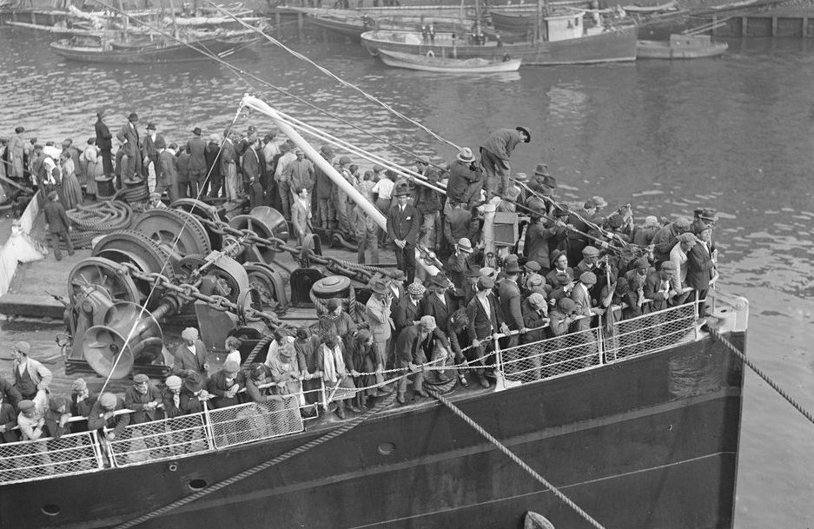

Boston has a long history of being a city of immigrants. For example, above is an image of immigrants from Ireland arriving in Boston in 1920. The first immigrants came to Boston in 1630. Since then, millions of immigrants over the years have made Boston their home. In the 1600s, 1700s, and 1800s, many immigrants to Boston came from England and later Ireland. In the early 1900s, many immigrants to Boston came from Ireland, Italy, Russia, Poland, and French Canada, and African American migrants from the southern United States. In the late 1900s, many immigrants came from the Dominican Republic, Vietnam, Haiti, Cape Verde, and China, and migrants from Puerto Rico. Boston has a long history of being a place for immigrants.

SOURCEBOOK: 2-17.D

Source 2: Many Cultures Living Together

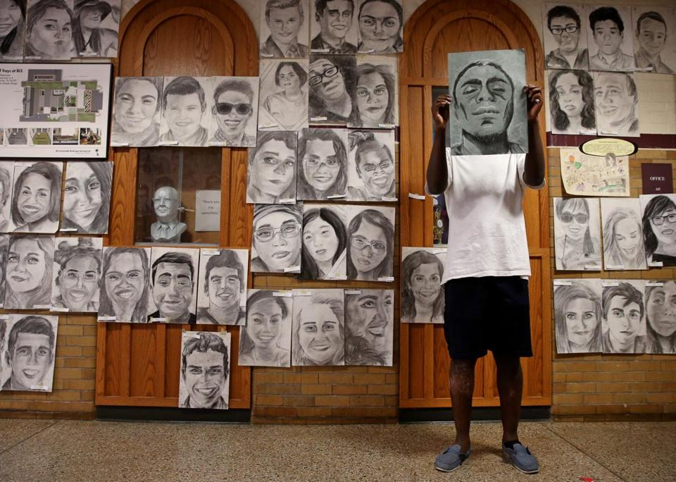

Boston is often described as “cosmopolitan,” which means a place where many different nations or countries come together. Today, 28% (3 in 10) of the people in Boston are immigrants from other countries. 1 in 3 people in Boston speak a language other than English. Over 100 languages are spoken here. Boston’s immigrants come from Asia, South America, Africa, and Europe. Phillip Sossou was a senior at Boston Latin Academy. He wanted to show how his school had so many different cultures, so he drew each of his classmates and posted their pictures on his school’s walls (above). In Boston, you can experience the world’s different cultures, languages, foods, festivals, and fashion, without ever leaving the city.

SOURCEBOOK: 2-17.E

Source 3: Important Part of the Economy

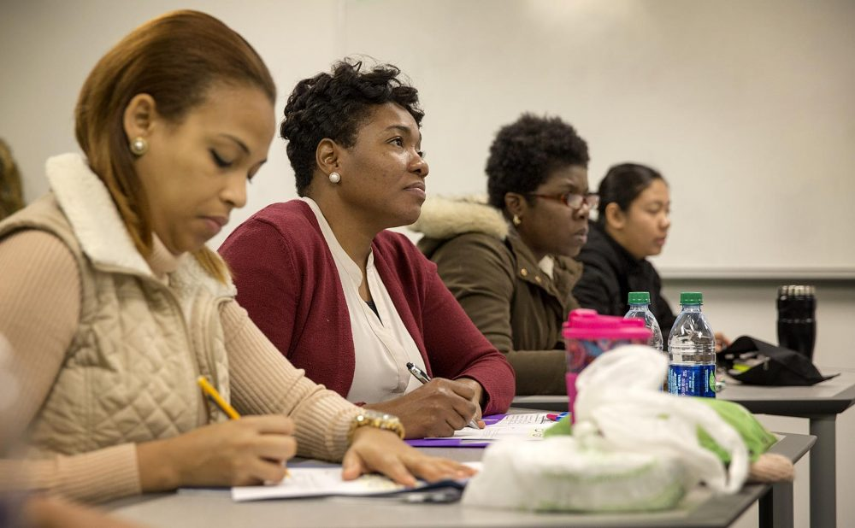

Immigrants are an important part of Boston’s economy. They spend over $3 billion dollars a year in the city. They pay $1 billion in taxes each year, which pay for schools, parks, fire, police, and roads. They run over 5,500 small businesses. Immigrants work in every type of job in the Boston. 1 in 4 immigrants are managers or run businesses. 1 in 4 immigrants work in sales or technology. 1 in 10 immigrants work in construction. If we did not have immigrants, it would be very difficult for our economy (how we buy and sell things) to run.

SOURCEBOOK: 2-17.F

Source 4: Global Center for Art and Music

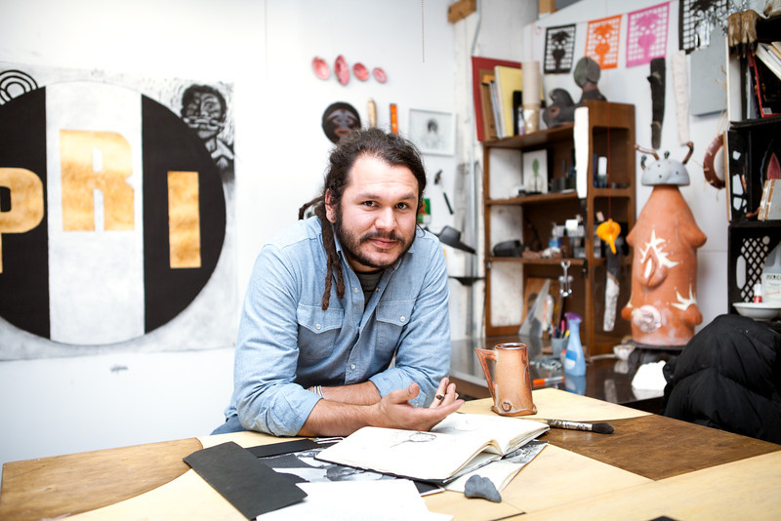

Many artists, musicians, poets, writers, and actors are immigrants to Boston. This makes Boston a place known around the world for its art and music. Salvador Jiménez-Flores (above) immigrated to Chicago from México. He later moved to Boston where he is an artist-in-residence at Harvard University. His sculptures and paintings often have images from México. This helps people in Boston know more about the country where he came from. Since so many artists, musicians, poets, and writers come from other places, it makes Boston a place where you can experience art and music from around the world.

SOURCEBOOK: 2-18.B

Steps to Becoming a Citizen (Naturalization)

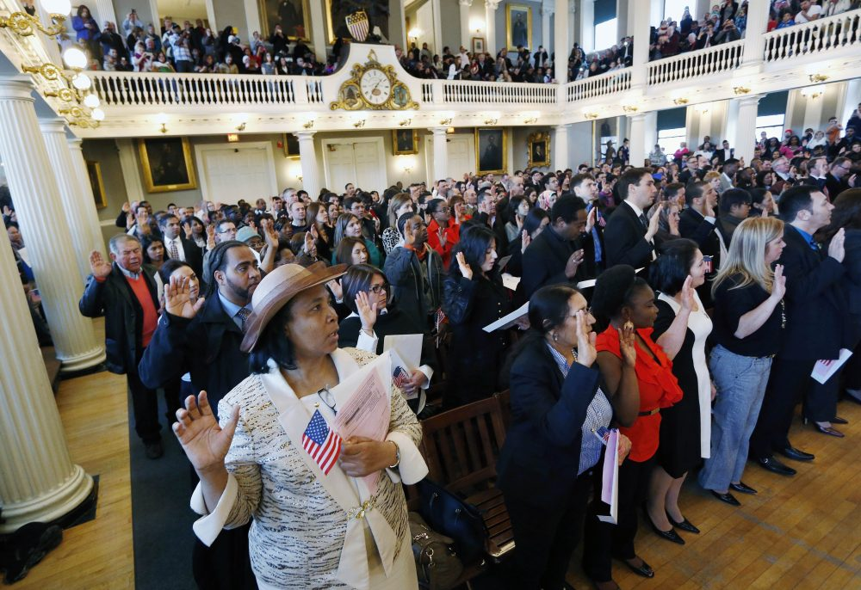

1. Live in the United States for 5 years with a Green Card

2. Complete a form and pay $725

3. Get fingerprinted

4. Pass the interview and citizenship test

5. Attend the oath ceremony (above at Faneuil Hall in Boston), where you swear to “support and defend the Constitution of the United States”

SOURCEBOOK: 2-18.C

Source 1: Citizenship Test Is Working

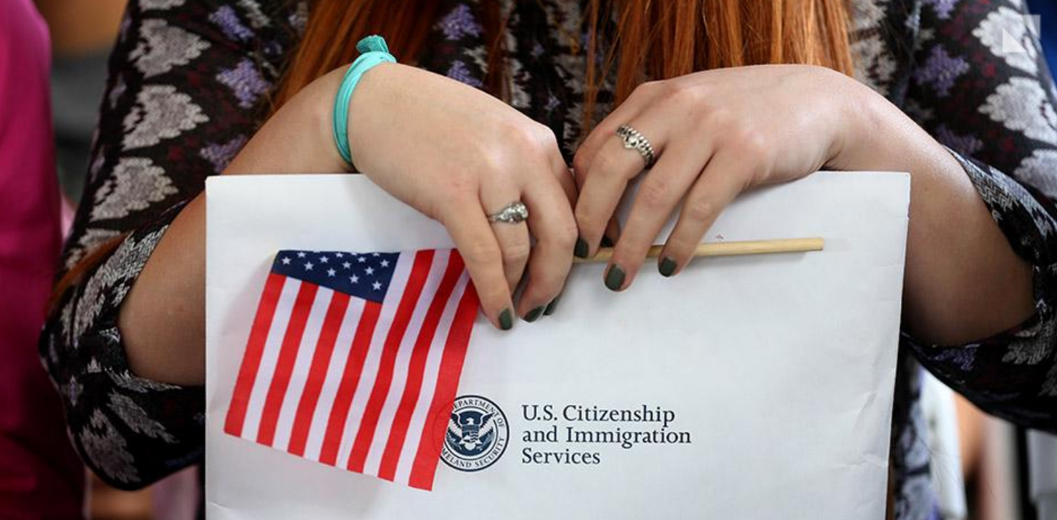

The current citizenship test works. The current citizenship test asks many questions about government and how it works. It is hard to be a good citizen, if you do not know about the government. This test helps the U.S. know if you will be a good citizen. In fact, many people born in the Unites States cannot answer the citizenship test questions. A recent poll found that only 1 in 3 people could name the three branches of government (Congress, President, Supreme Court). When students in Arizona were given the test, only 1 in 10 could answer the 6 of 10 questions correctly and would have become citizens. This test is something that every new citizen should be able to pass.

SOURCEBOOK: 2-18.D

Source 2: Citizenship Test Questions Need to Change

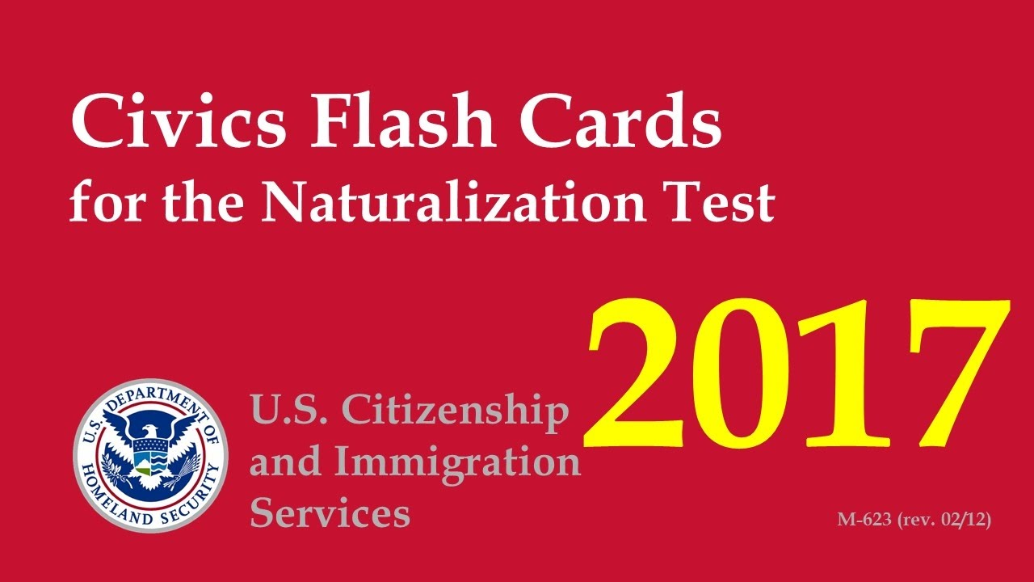

The questions on the citizenship test need to change. 9 out of 10 people who take the citizenship test pass it and become citizens. Many of the people who take it just memorize the answers by listening to CDs, using flash cards, or taking citizenship test courses. Just because someone can answer questions on U.S. history and government, does not mean they will be a good citizen. Instead, there should be new questions that ask about why a person wants to become an American. For example, a question might ask, “How will you be a good U.S. citizen?” “What ways will you help your community in the future?” “Do you want to vote or run for office in the future?” This test would be something that every new citizen should be able to pass.

SOURCEBOOK: 2-18.E

Source 3: Passing a Test Does Not Mean Being a Good Citizen

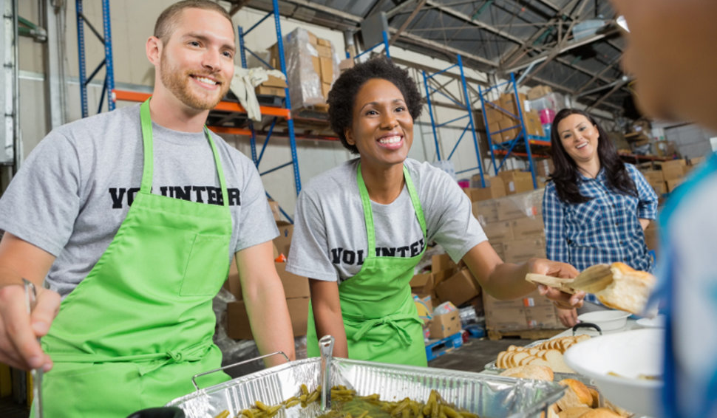

We should stop asking questions to new citizens. Those questions cannot tell us if the person will be a good citizen. Instead, the citizenship test should ask new citizens to describe how they have helped their community and made the United States a better place. It may be that they worked as a teacher, fire fighter, or police officer. They may have volunteered to help neighbors, worked at a food pantry, or participated in yearly clean-up of parks. We want citizens who will help their community. If a person has not done much for their community or the United States, they can be asked to make a plan for doing more and then take the test again in the future. This test would be something that every new citizen should be able to pass.
SOURCEBOOK: 2-19.A

Source 1: Youth Way on the MBTA

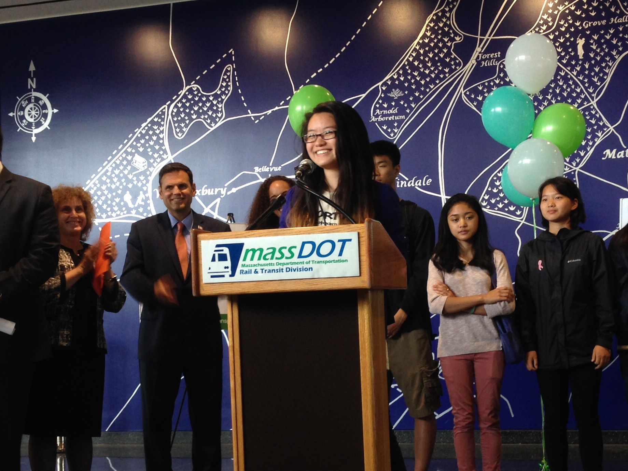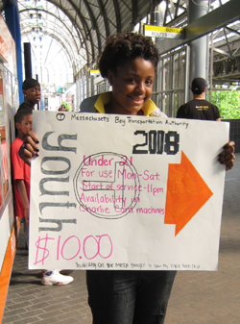

A local group of students was upset that their student T passes only worked during school hours. For many students in Boston, the T (subway, bus, commuter rail) is their only transportation (how they get from place to place). They got together as a group called “Youth Way on the MBTA” and wrote to the T about allowing student passes to always work. They said it would help them get home from school, if they stay after for sports or clubs, or have after school jobs. They led rallies outside T stations and contacted the local newspapers, radio and television stations. The T would expand student passes to work on weekdays until 11 pm. The Youth Way on the MBTA is now working on letters and rallies to allow any student to buy a $10 monthly T pass.

SOURCEBOOK: 2-19.B

Source 2: The Martin Richard Foundation

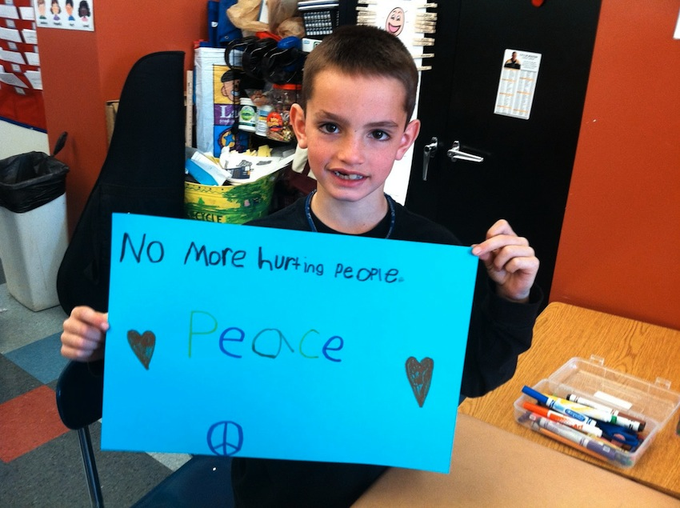

Martin Richard (above) was an eight-year-old boy who was killed during an explosion at the Boston Marathon. He believed in peace and did not want anyone to hurt others. In his memory, his family started the Martin Richard Foundation. The program gives money to community groups that focus on “peace, justice, and service.” The organization has given money to the Dorchester Boys and Girls Club, Dorchester sports leagues, and Challenger Sports, which helps kids with disabilities play sports. It also raises money to make more parks in Boston, include a new park named after Martin Richard next to the Children’s Museum.
SOURCEBOOK: 2-19.C

Source 3: Joseph Lee K-8 Students and Black Lives Matter

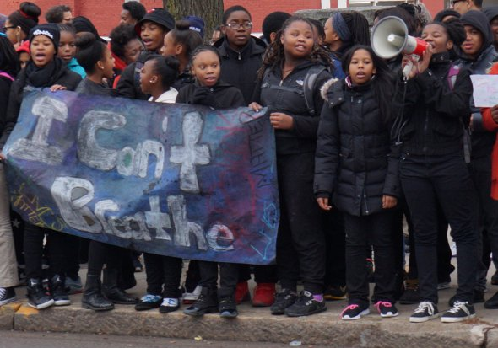

Students at the Joseph Lee K-8 School in Dorchester were upset at recent news events that showed a police officer hurting a Black person because of his race. They wanted to show everyone that it was not right. They asked their teachers if they could organize a protest. Their teachers talked to the principal and she approved them doing a protest in front of the school. Kids wrote up speeches and made posters and banners. They lead their protest, with teachers and police officers helping them, on December 15, 2014. As cars drove by, they chanted “black lives matter” and “What do we want? Justice! When do we want it? Now.” Many cars beeped in support as they drove by. Students felt that they told many people about their concerns that day.

SOURCEBOOK: 2-19.D

Source 4: Girl Scouts and the Boston Plastic Bag Ban

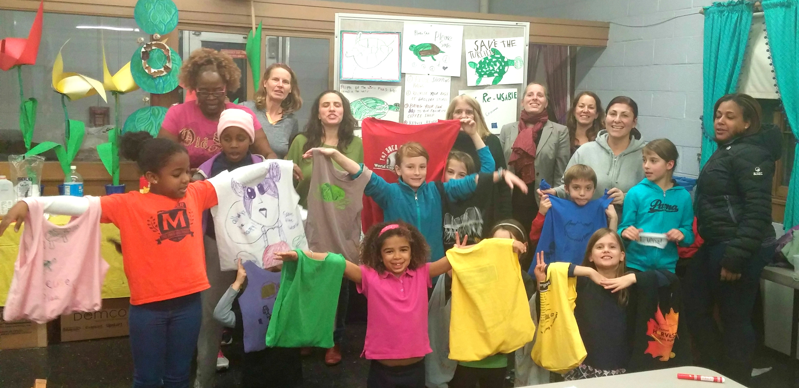

For years, the Boston City Council had debated banning bags. Plastic bags often get stuck in trees, litter the streets, and are harmful to animals. They City Council was never able to get enough councilors to support it. After learning about plastic bags, the Girl Scouts of Troop 68277 in Dorchester decided to take action. First, they had a sew-a-thon where they made reusable bags. Next, they invited City Councilor Matt O’Malley to come to their meeting. Then they started speaking with other councilors. In the end, the City Council voted unanimously (everyone voted yes) to end the use of plastic bags in Boston’s stores.

SOURCEBOOK: 2-20.A

Images

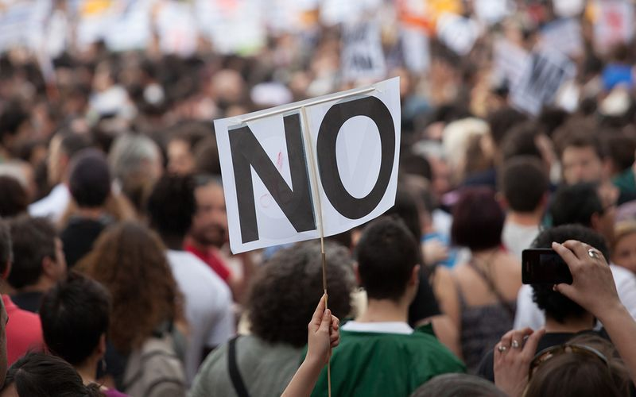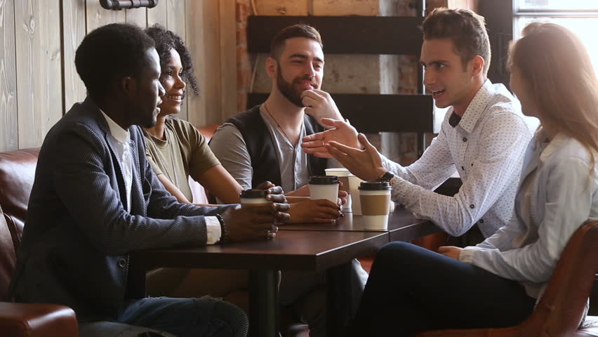

SOURCEBOOK: 2-20.A

Source 1: Speaking with Family, Friends, and Neighbors

It is important that we talk to our family, friends, and neighbors about ways to make our communities and country better. To be a good citizen, you should ask others about their opinions and why they think that way. This allows you to make the best decision you can. You should to talk to people with different opinions that you to make sure you have heard the other sides of an issue. It is also always okay to change your mind on an issue, if you realize that someone has made some good points that you agree with. For example, Chris use to think that we spend too much money on schools. He was speaking one day with his neighbor, who is a parent. She explained how her child’s school does not have a nurse. Chris then realized that some schools need more money and decided to write a letter to politicians (elected people).

SOURCEBOOK: 2-20.B

Source 2: Reading About Current Events

It is important that we read about current events. To be a good citizen, you need to know what is going on in your city/town, state, country, and world. Sometimes people know what is going on in their community, but not in other countries. It is important that you learn about your community, country, and other countries. You should try your best to read many different newspapers. You should listen to different radio or television channels. You should read different news stories on the Internet. Each news source may have different information. For example, Bìhn (bun) read in a newspaper that the library near her house might be closed. Her neighbors also heard about this on the television news. They met with politicians (elected people) and convinced them to keep the library open.
SOURCEBOOK: 2-20.C

Source 3: Voting

It is important that we vote in elections. Once a year (or sometimes more) there are elections where people vote or choose who they want to make decisions. To be a good citizen, you should vote on the politicians (elected people) or questions that are on the ballot (the paper that you vote with). This is how we choose who makes decisions for us, including the president, governor, Congressmen and women, mayors, city councilors, and selectmen and women. For example, José votes in every election. He knows that they can be very close sometimes. There was an election for city council. He supported one candidate, because she said that she would make more parks. The election was so close, only one vote decided the winner. It was the candidate he supported.

SOURCEBOOK: 2-20.D

Source 4: Protesting

It is important that we attend protests and rallies about issues that we care about. To be a good citizen, you should get together with others and show that many people are for or against something. When there is a large protest, the news will cover it and politicians will hear about how many people feel about an issue. For example, Aliyah was upset that the T (subway, buses, commuter rail) was going to raise its fare (the price to ride). She said that many people who use public transit may not have much money and this would be hard for them. Thousands of people showed up at the State House to protest. In the end, the T decided to not raise fares.

SOURCEBOOK: 2-20.E

Source 5: Writing Letters

It is important that we write to politicians (elected people) about issues that we care about. To be a good citizen, you should explain to politicians why you agree or disagree with a law or decision. This can be done by writing a paper letter, e-mailing, or calling the president, Congressmen and women, governors, mayors, city councilors, and others. Politicians and their staffs read letters and listen to phone calls and use that to make their decisions on how to vote or make decisions. For example, Caleb was upset that the United States government made a bill that would take away some people’s health care. He knows that many people cannot afford to go to the hospital or see a doctor. He wrote a letter to his Congresswoman. She wrote back thanking him for his letter and said many people also wrote her with the same opinion. She voted no on the bill that Caleb did not like.

