Open Social Studies

An Inquiry-Based and Literacy-Focused K-6 Curriculum

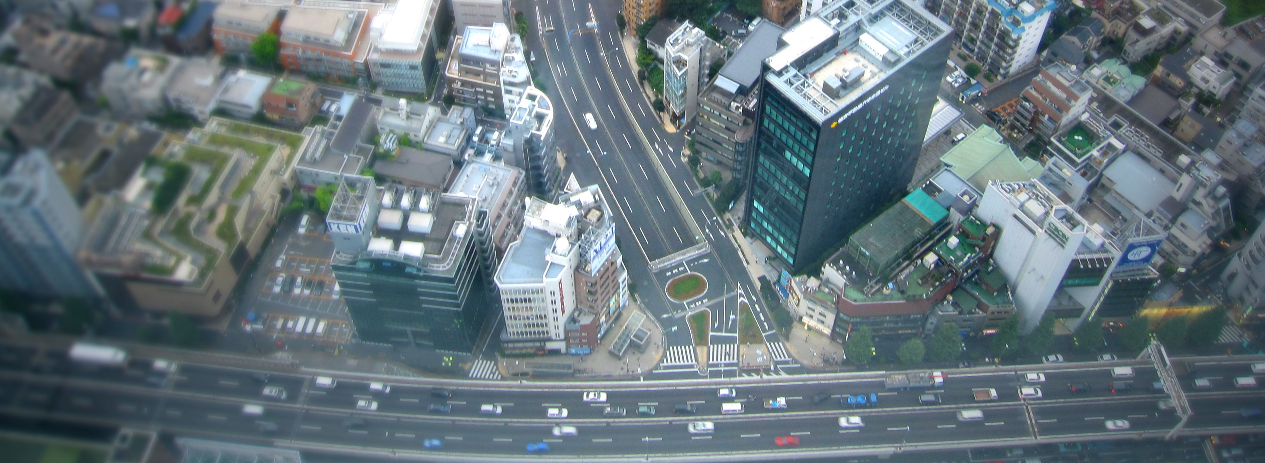

Curric

STUDENT SOURCEBOOK
Level: Grade 1
Our Communities: Local, State, Nation, World

Developers:

Christopher C. Martell

Jennifer R. Bryson

GRADE 1 ROAD MAP

LESSON 1-1

Lesson Title: Time and Calendars

Inquiry Question: Which calendar is most useful for its people?

LESSON 1-2

Lesson Title: My Family and Our History (Family Chronology)

Inquiry Question: What is my family’s story?

LESSON 1-3

Lesson Title: Mapping Our Ancestors

Inquiry Question: How were our ancestors (or our own) journeys to (or within) the U.S. similar and different?

[This lesson uses a timeline for the Boston neighborhood of Dorchester, but it can be altered for other communities where this curriculum may be used]

LESSON 1-4

Lesson Title: An Introduction to Our Communities (Local, State, National, Global)

Inquiry Question: Which community is most important in your life?

LESSON 1-5

Lesson Title: Our Neighborhood (Dorchester)

Inquiry Question: What makes our neighborhood a great place to live?

[This lesson will be on one neighborhood in the City of Boston (specifically Dorchester), but can be altered for other communities where this curriculum may be used]

LESSON 1-6

Lesson Title: Our Boston

Inquiry Question: Should Boston be considered a world-class city? Why or why not?

[This lesson will be on the City of Boston, but can be altered for other communities where this curriculum may be used]

LESSON 1-7

Lesson Title: Our Nation

Inquiry Question: Why do you like living in the United States?

LESSON 1-8

Lesson Title: Important Americans (Part 1: Workers for Justice): Harriet Tubman, Alice Paul, Fred Korematsu, César Chávez

Inquiry Question: Which civil rights leader had the best way to make change?

LESSON 1-9

Lesson Title: Important Americans (Part 2: Breaking Barriers): Amelia Earhart, Jackie Robinson, Lin-Manuel Miranda, Yo-Yo Ma

Inquiry Question: What are the most important ways that these pioneers have broken barriers?

LESSON 1-10

Lesson Title: Important Americans (Part 3: Inventors): The Wright Brothers, George Washington Carver, Rachel Carson, Eugene Trinh

Inquiry Question: Which inventor contributed the most to our nation?

LESSON 1-11

Lesson Title: National Symbols: The Many Meanings of the American Flag

Inquiry Question: Is our flag a good symbol for our nation?

LESSON 1-12

Lesson Title: National Symbols: The Bald Eagle

Inquiry Question: Is the bald eagle the best choice for a national bird?

LESSON 1-13

Lesson Title: National Symbols: Monuments

Inquiry Question: Which group of national monuments are most important?

LESSON 1-14

Lesson Title: Our Holidays: Independence Day, Labor Day, Patriots’ Day, and Juneteenth

Inquiry Question: What national holiday should we create?

LESSON 1-15

Lesson Title: The Pledge of Allegiance

Inquiry Question: Should everyone say the Pledge of Allegiance?

LESSON 1-16

Lesson Title: Our Customs and Traditions

Inquiry Question: What customs or traditions are most important to you?

LESSON 1-17

Lesson Title: Our World

Inquiry Question: If you could move anywhere in the world, where would it be?

LESSON 1-18

Lesson Title: Important Global Citizens: Mahatma Gandhi, Desmond Tutu, Malala Yousafzai, Mary Robinson

Inquiry Question: Which leader made the most important change to the world?

LESSON 1-19

Lesson Title: Making Our World Better (Part 1)

Inquiry Question: What are the most important current global problems?

LESSON 1-20

Lesson Title: Making Our World Better (Part 2)

Inquiry Question: Taking a global issue that you think is very important, what should we do to make it better?

SOURCEBOOK 1-1.A

Gregorian Calendar
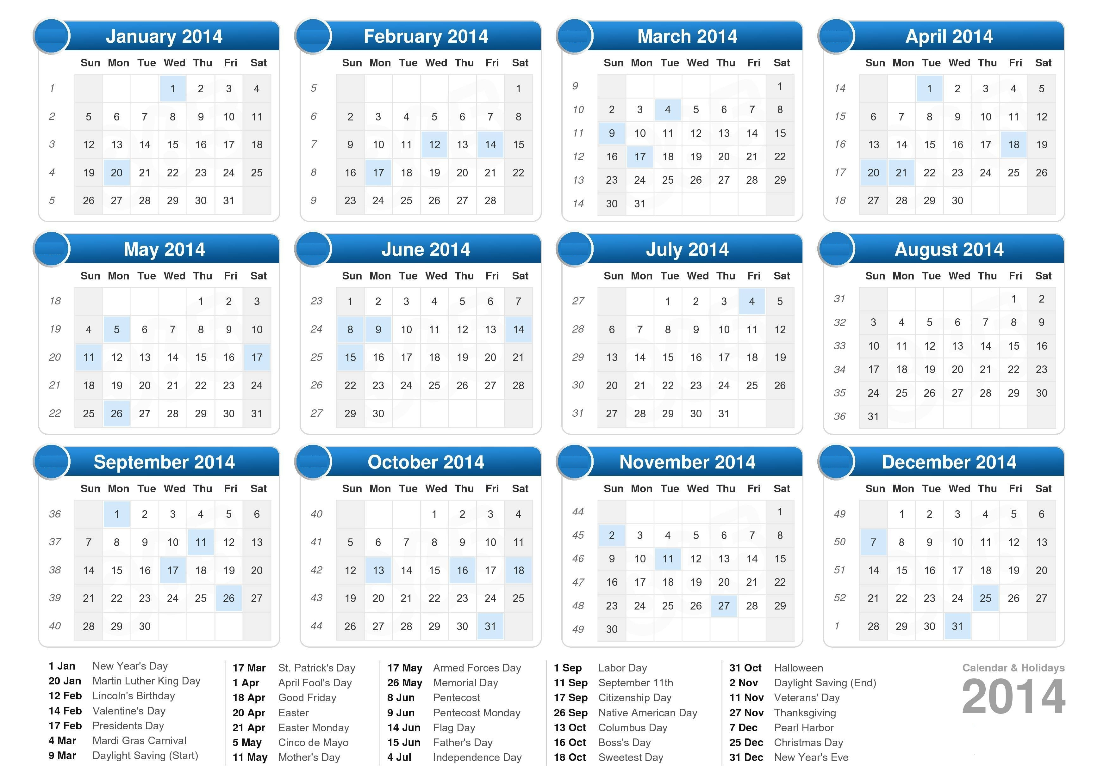

Source 1: Gregorian (Christian) Calendar

The Gregorian calendar is used by most people in the United States. It comes from Europe. It is based on Christianity. It reminds people of important Christian holidays, like Christmas and Easter.

This calendar is based on the sun. It has one year with 12 months (large squares) and 365 days (smaller squares). The first month of the year is January and last month is December. The start of the calendar is at the birth of Jesus Christ.

SOURCEBOOK 1-1.B

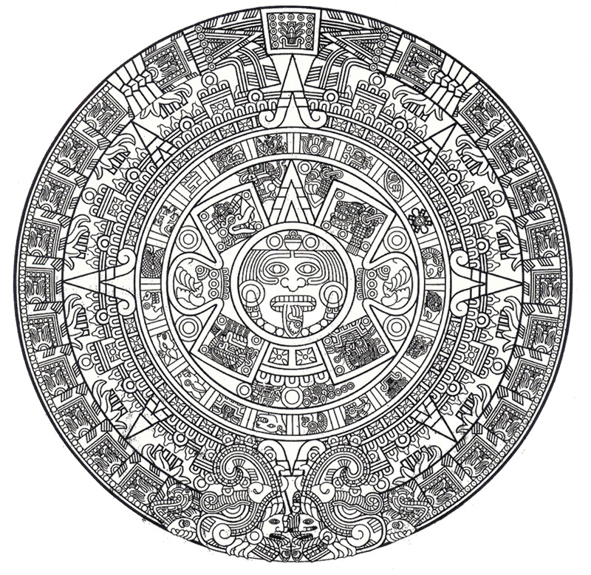
Source 2: Mayan Calendar

The Mayan calendar is used by the Maya people. They live today in southern Mexico. You do not need to read to use their calendars. Instead of words, it uses pictures. Above is a chart to show you how to use it. Can you find these pictures on the other side?

This calendar is based on the stars, sun, and moon. It keeps track of days, but also the moon and star locations, so they can use it for directions at night. This calendar keeps track of thousands of years on only one page.

SOURCEBOOK 1-1.C

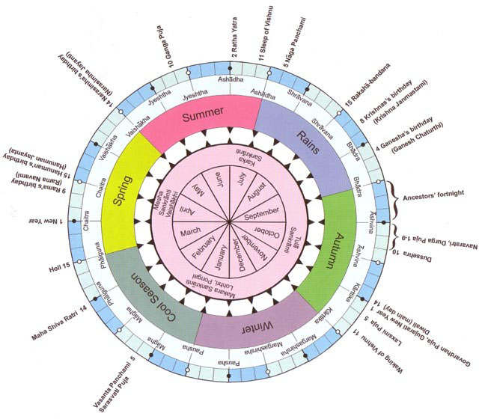
Source 3: Saka (Indian) Calendar

The Saka calendar is used by people in India. The beginning of the year is marked with “1 New Year” and then the months count up from there. Can you find the beginning of the calendar?

This calendar is based on the sun and moon. It lists when it is usually rainy or dry. It helps with planting crops. This calendar keeps track of Hindu holidays like Diwali. Hinduism is the largest religion in India. It is also one of the oldest religions in the world.

SOURCEBOOK 1-1.D

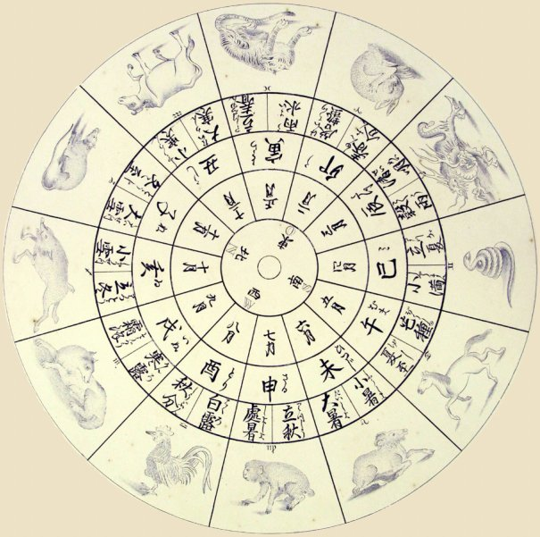
Source 4: Chinese Calendar
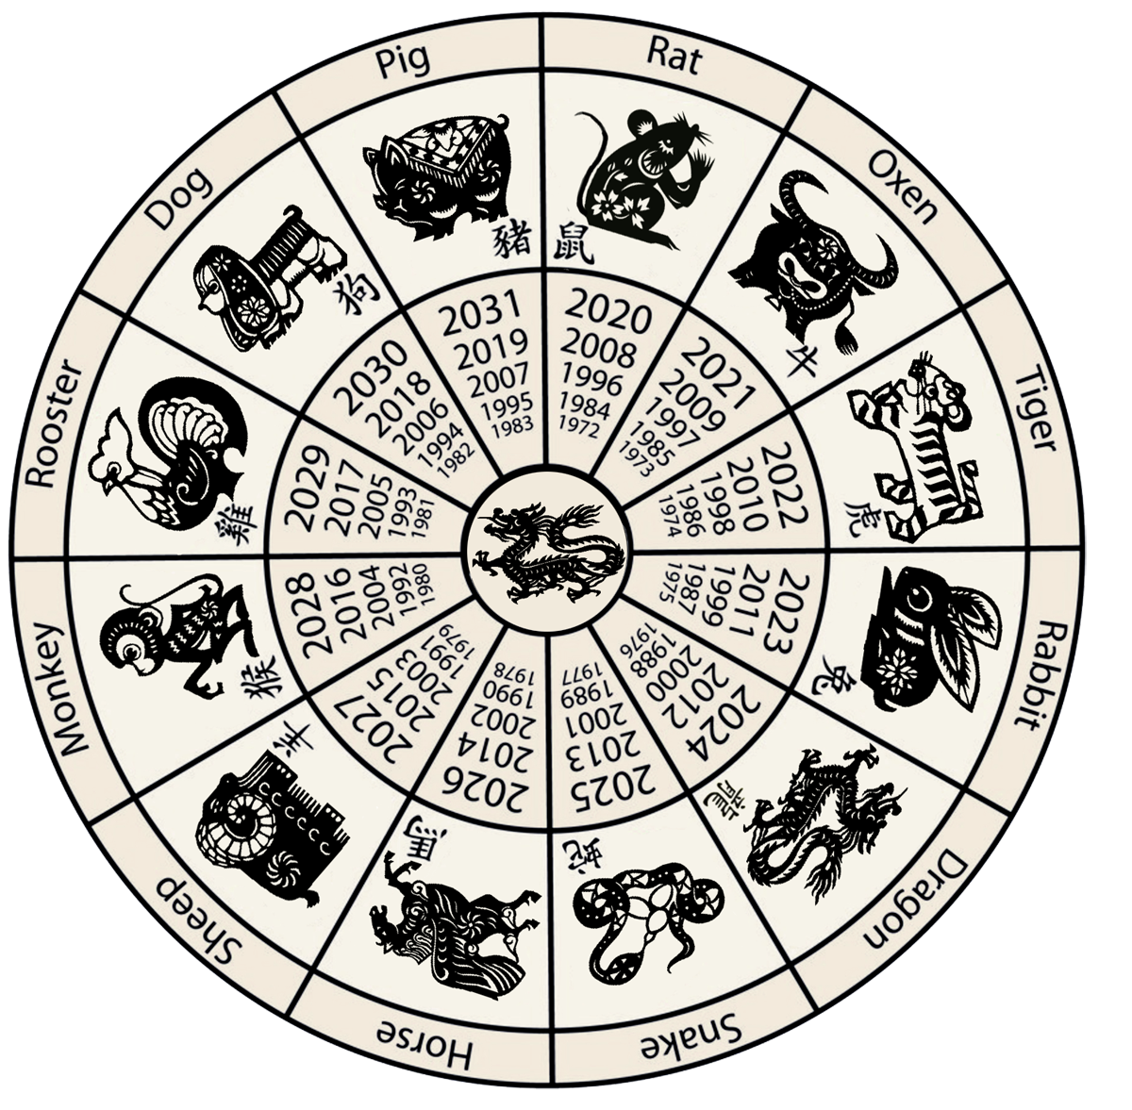
The Chinese calendar is used by people in China and other countries in Asia. The calendar tells the story of a race. The following animals finished in this order: rat, ox, tiger, rabbit, dragon, snake, horse, sheep, monkey, rooster, dog and pig. Each year has a different animal. Can you find the animal of your birth year?

The calendar is based on the sun and moon. The new year starts on the new moon (cannot see it at night) in January or February. This calendar is used by many people to choose good dates for important events. This includes dates for weddings, funerals, or when to start a business. It also tells the date of holidays like Chinese New Year or Vietnamese Tết.

SOURCEBOOK 1-5.A

Source 1: Dorchester’s Parks

Dorchester is home to many of the city’s parks. This includes Dorchester Park (below), Franklin Park and Zoo (below), the Neponset River Trail, and Ronan Park. It also has many beaches. This includes Savin Hill Beach (below), Malibu Beach, and Tenean Beach. They are great places for families to spend time outside. You can picnic, bike, hike, canoe, and play.

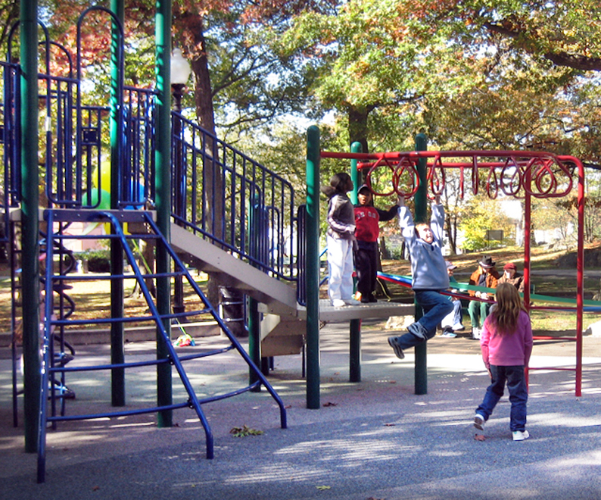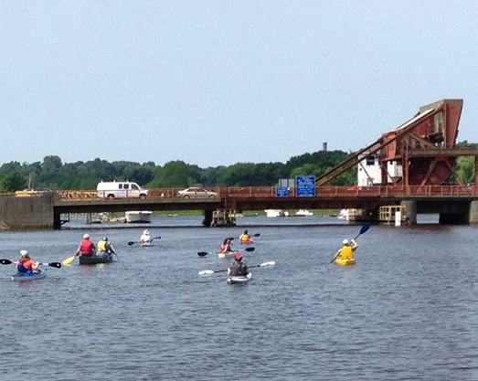

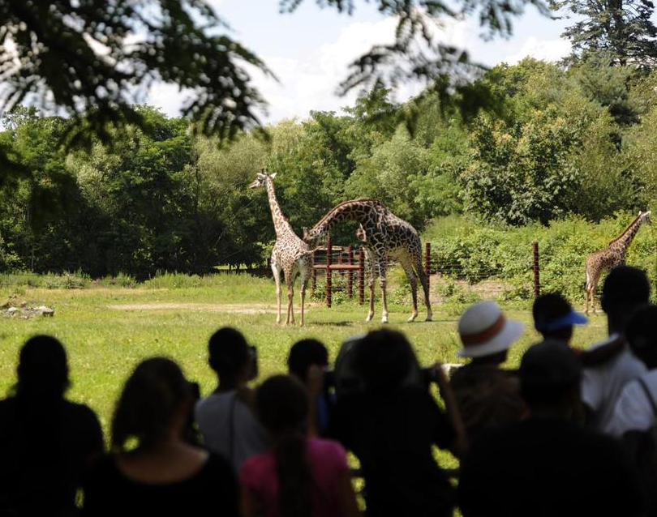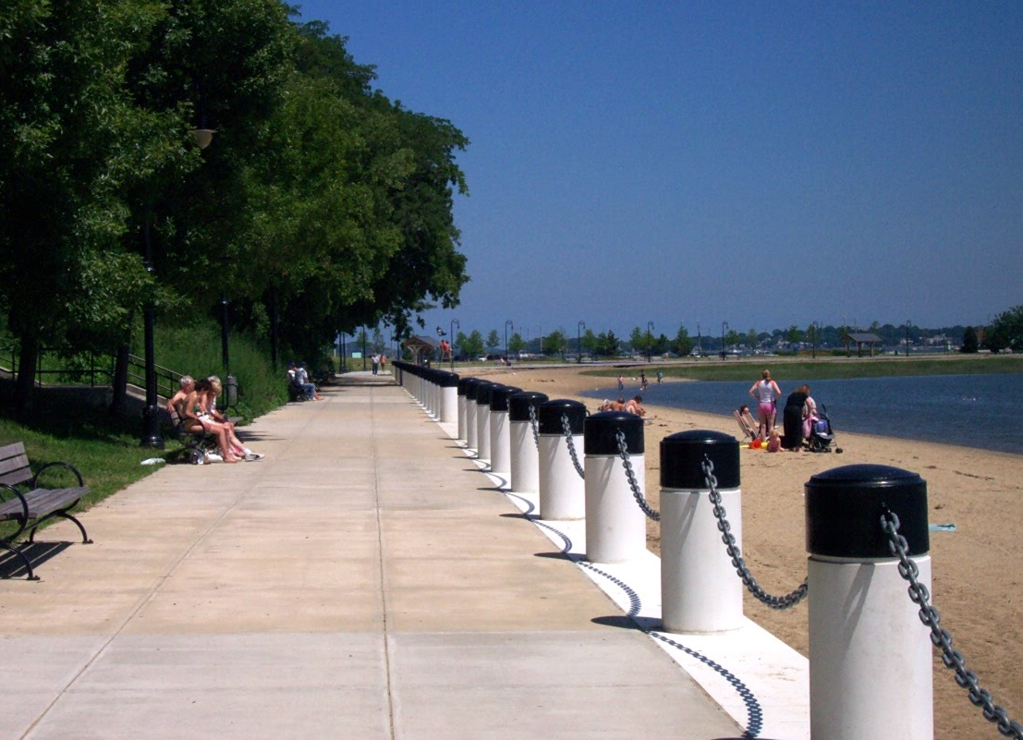

SOURCEBOOK 1-5.B

Source 2: Dorchester’s Businesses

Dorchester is home to many businesses. It has restaurants (below), bakeries, and grocery stores (below). It has hair salons, barbershops, auto repair shops, and hardware stores. You can buy everything you need without leaving the neighborhood.

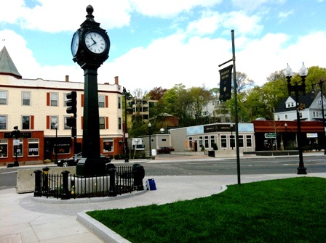

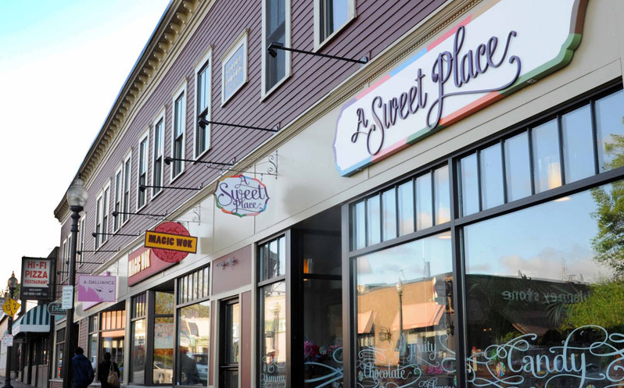

SOURCEBOOK 1-5.C

Source 3: Dorchester’s Music and Art

Dorchester is home to many musicians and artists. There are also some famous musicians from here, including the Kenny School Marching Band (below), Donna Summer (below) and the New Kids on the Block. There is also famous artwork on display. This includes the “Rainbow Swoosh” by Corita Kent (below) and Joe Wheelwright’s “Sleeping Moon” (below).

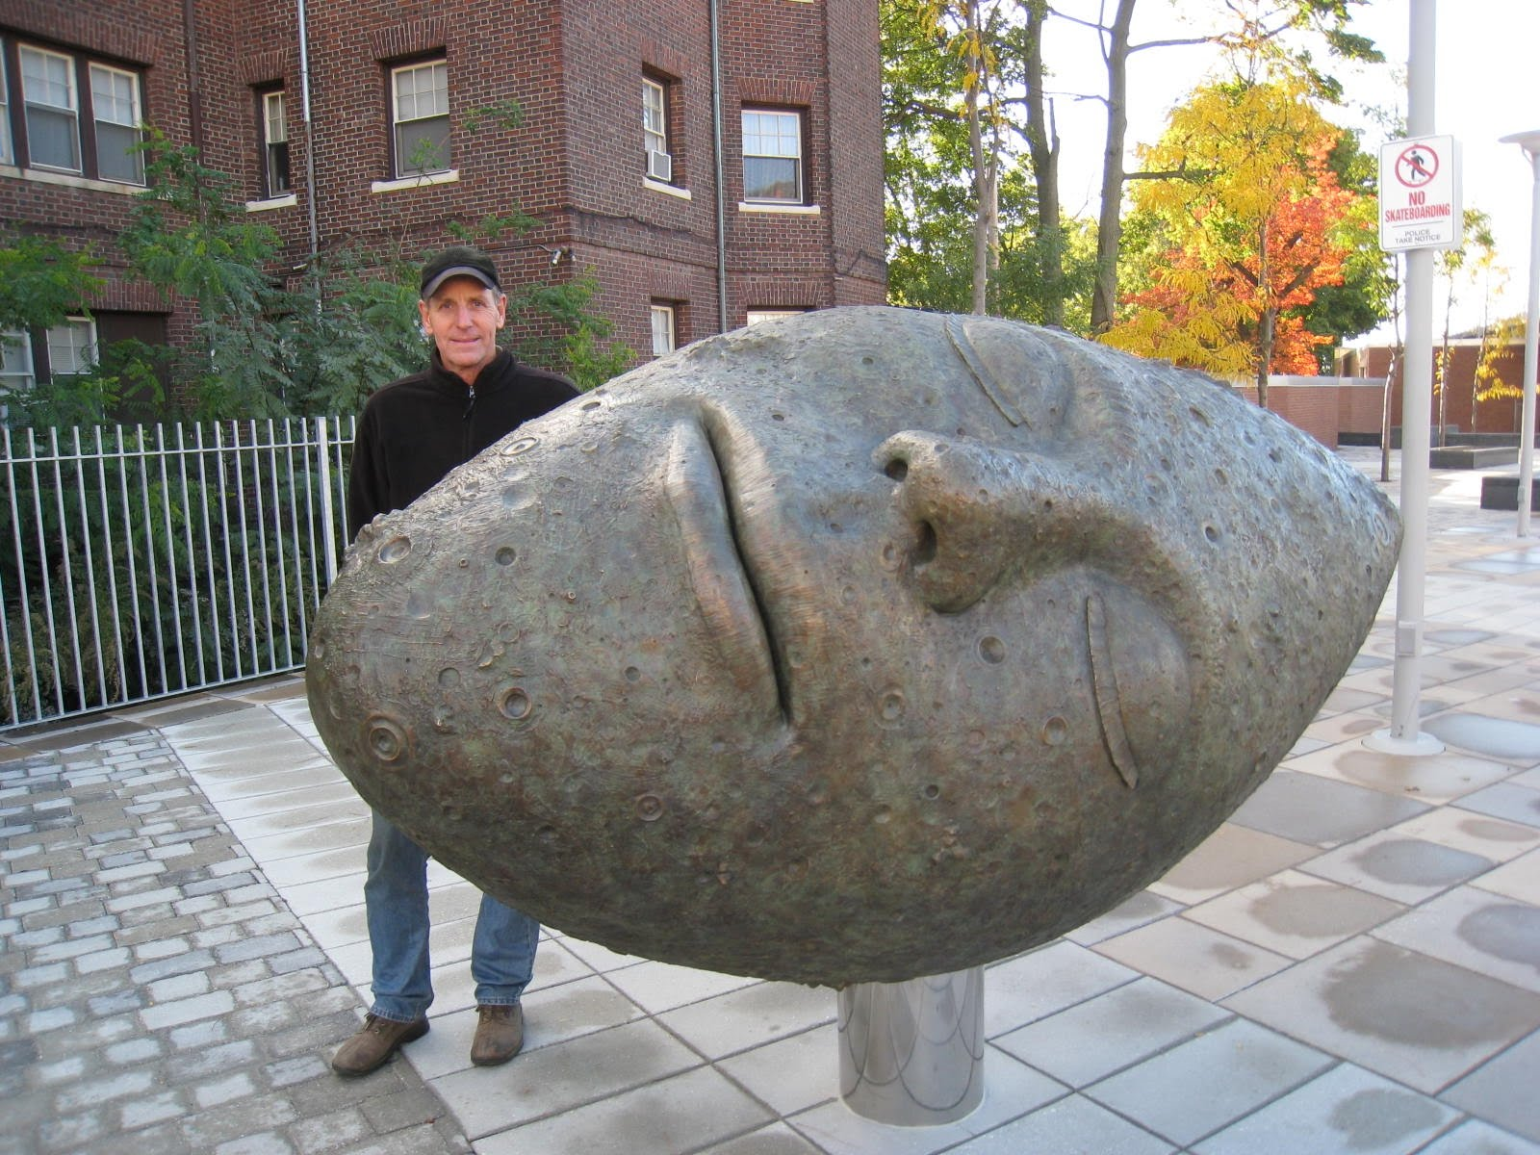

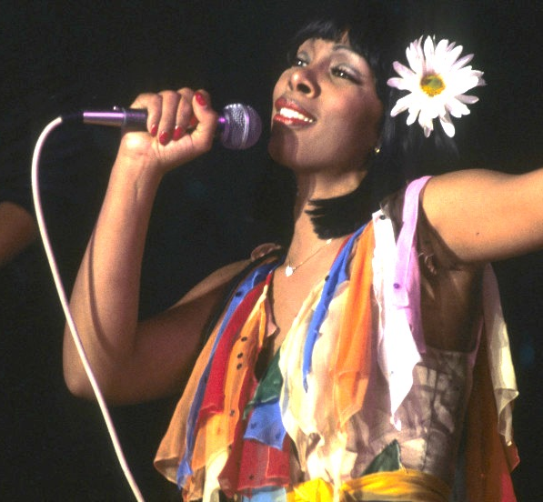

SOURCEBOOK 1-5.D

Source 4: Dorchester’s Schools, Libraries, and Hospitals

Dorchester is home to many of the city’s schools, libraries, and hospitals. These are places where people learn or help people become healthy. This includes the Thomas J. Kenny School (below) and UMass Boston (below). There is also the John F. Kennedy Presidential Library, the Adams Street Library (below), and the Codman Square Library. There is also the Carney Hospital (below) and the Dorchester House.

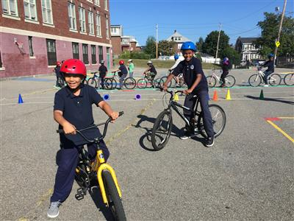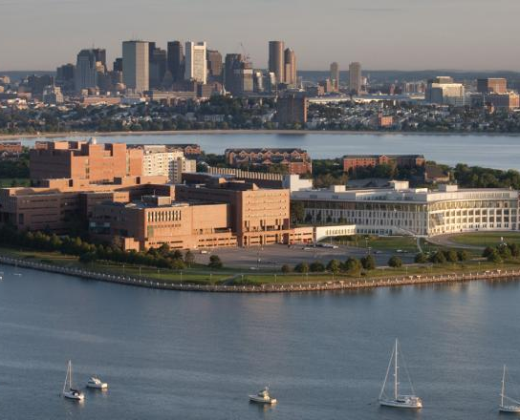

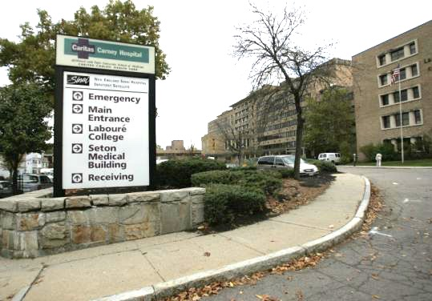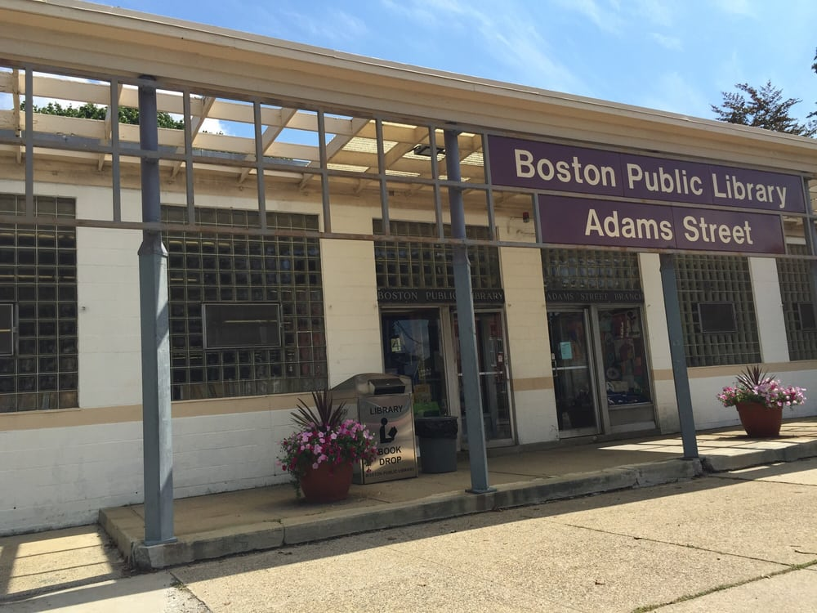

SOURCEBOOK 1-6.A

Article:
Boston is a World Class City
By Kristin Toussaint
May 31, 2016
The Boston Globe

Boston is one of the best cities in the world says a new report. The Global Cities 2016 ranked Boston as 24th in the world. The city was ranked high because it has some of the world’s top schools. It is one of the smartest cities. Its people are also heathier than other cities. Bostonians get sick less and live longer. Boston also has diverse people. Its residents come from countries all over the world. It has a good transportation system. Many people do not need cars. It also has many important places. This includes historical sites, museums, sports teams, and places for music.

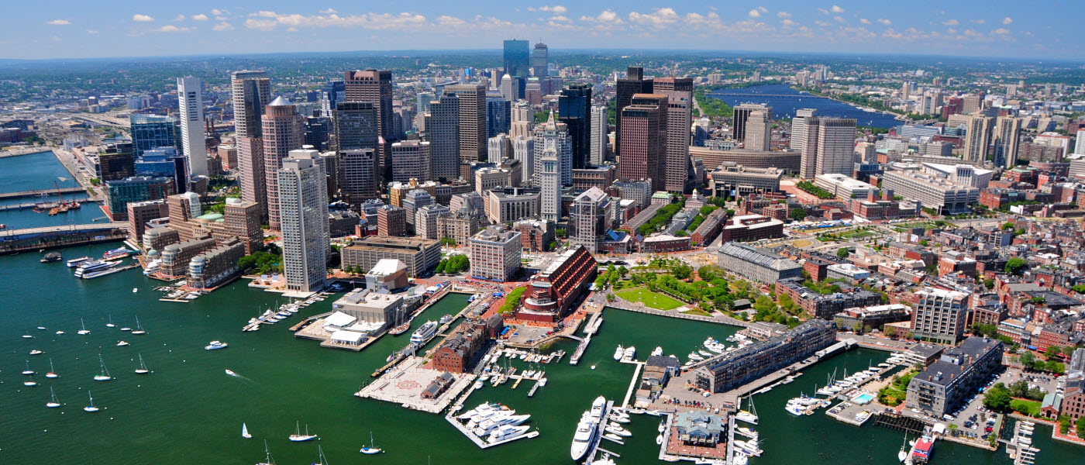
SOURCEBOOK 1-6.B

Source 1: Boston’s Places

Boston is known for its world class places that are visited by tourists. About 1.4 million people visit Boston each year. They come here to see historical sites, such as the Freedom Trail (below). They come for the food, including all of the lobster they can eat. They also like to visit the schools, museums, sports teams (at places like Fenway Park), and beaches.

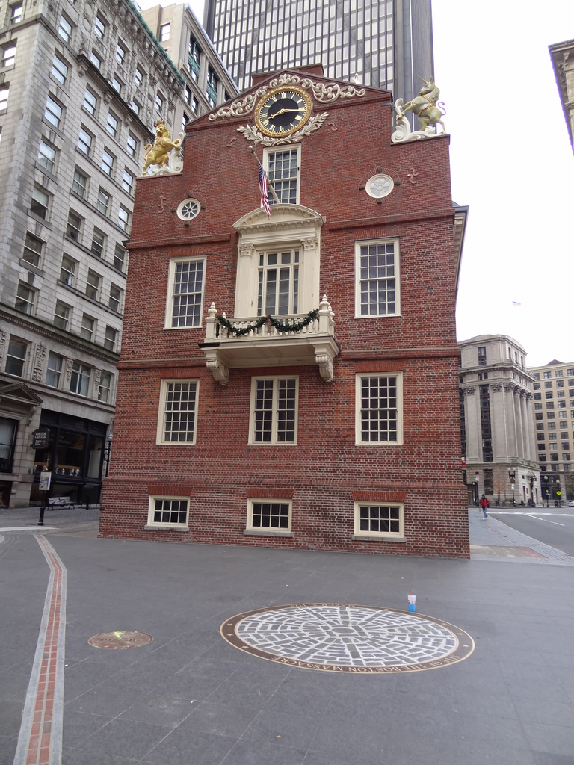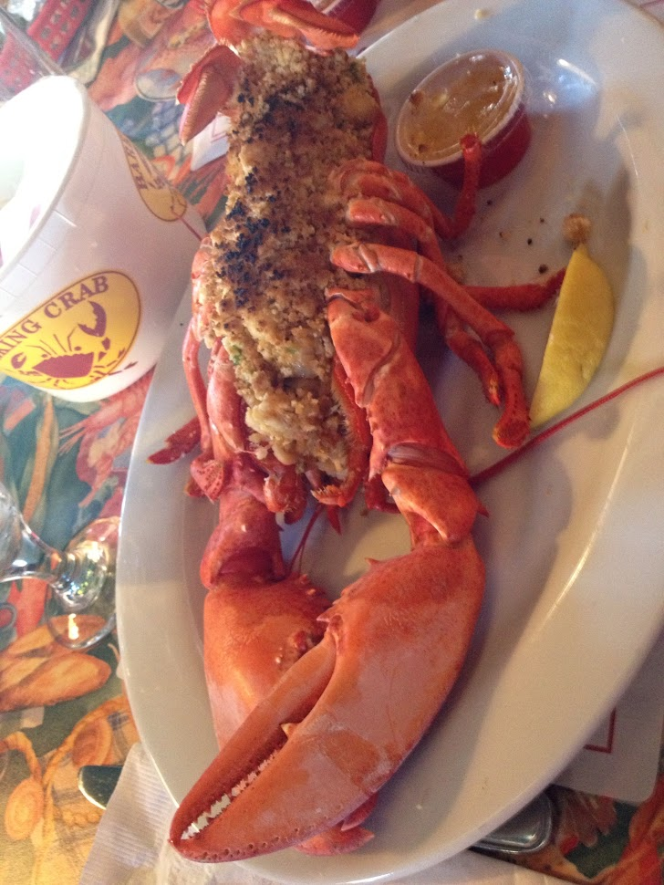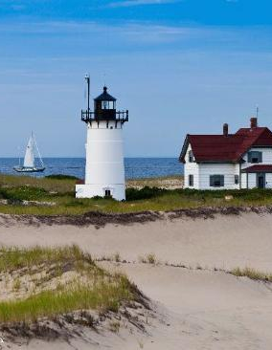

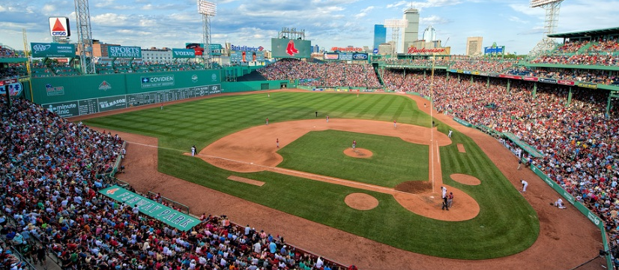
SOURCEBOOK 1-6.C

Source 2: Boston’s People

Boston is known for its world class people. Some of its people were born here. Others were born in other states or countries. Boston is one of the most diverse cities in the United States. It has people from many different races, cultures, and religions. Half of the people in Boston are White. The other half are Latino, Black, and Asian. 1 out of 4 Bostonians were born in another country. Over 200 languages are spoken here. Below are several community events. This includes the Walk for Peace, New Year’s Celebration in Chinatown, the Irish Festival in Adam’s Corner, and Boston’s Carnival.

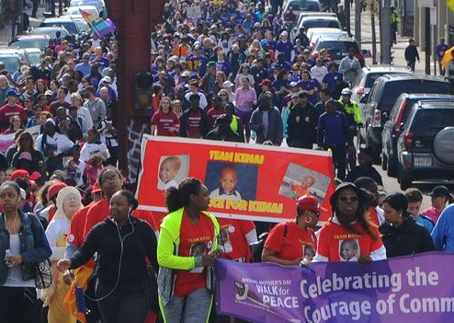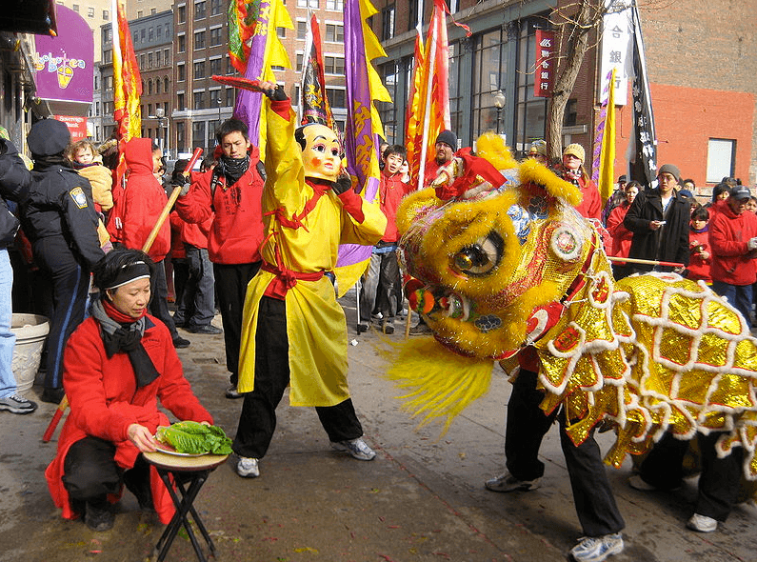

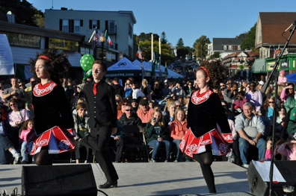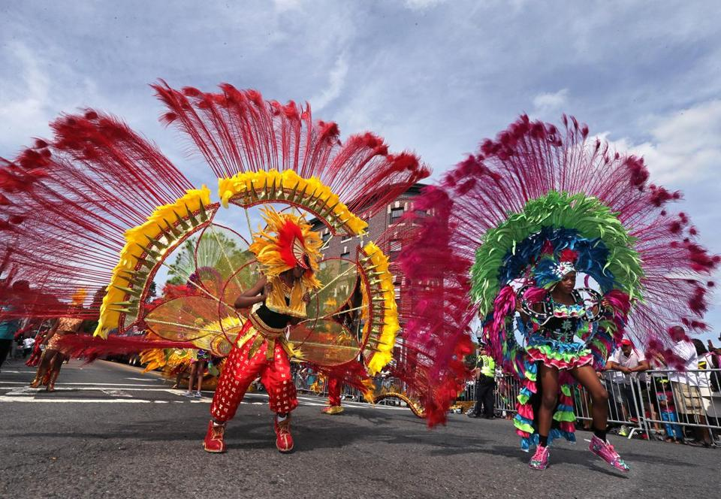

SOURCEBOOK 1-6.D

Source 3: Boston’s Inventions

Boston is known for its world class inventions. This is where the first public park was created (Boston Common). It is where the first subway in the U.S. was created (The T). It is where the telephone was invented (by Alexander Graham Bell). It is where the personal computer and Internet started (at MIT).

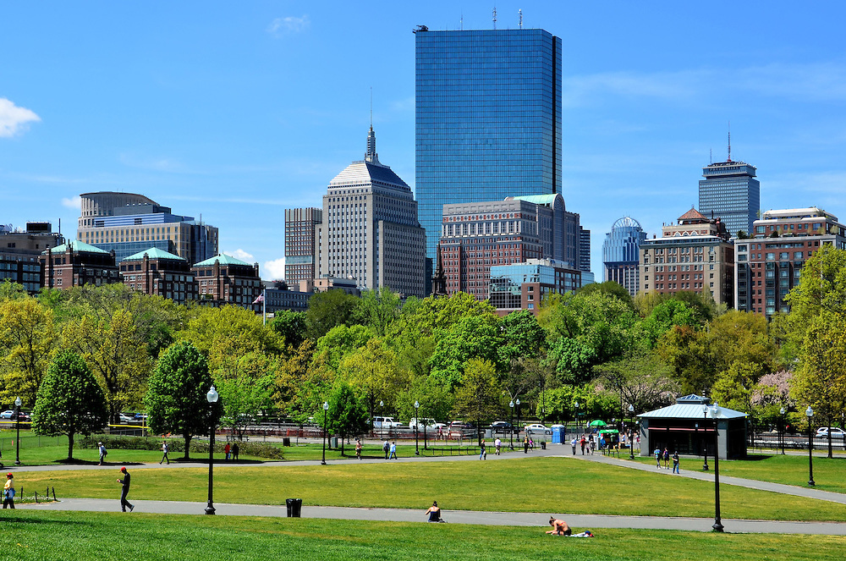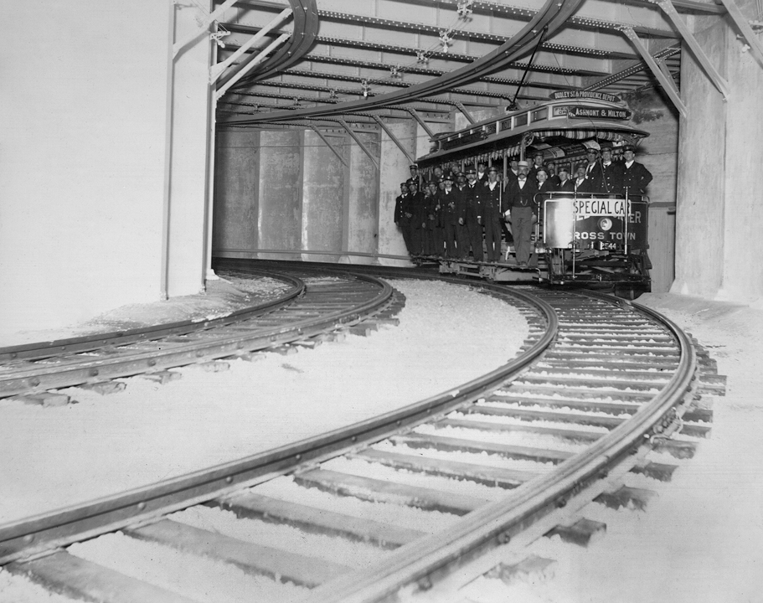

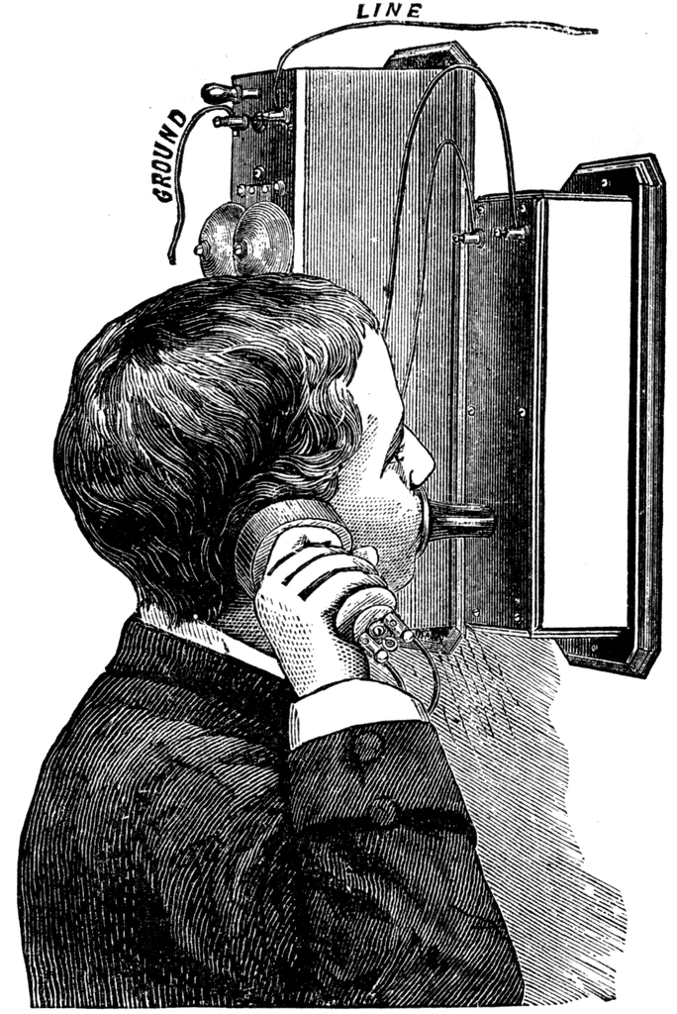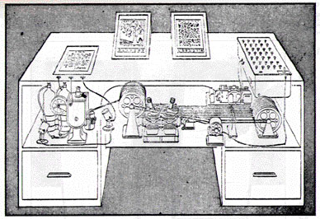

SOURCEBOOK 1-7.A

Marisela’s Story

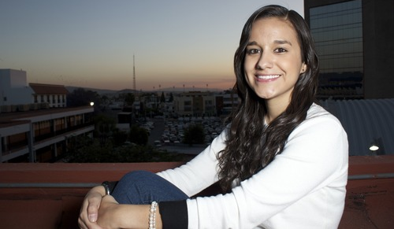

I am Mexican American. I was born in Mexico. I came to the United States with my family when I was little. When we arrived in the United States, we met people in our neighborhood who were very welcoming. They helped us move into our new home. They helped my dad find a job. I like living in the United States, because it is a place where neighbors care about each other.
Marisela
Los Angeles, California

SOURCEBOOK 1-7.B

Amy’s Story

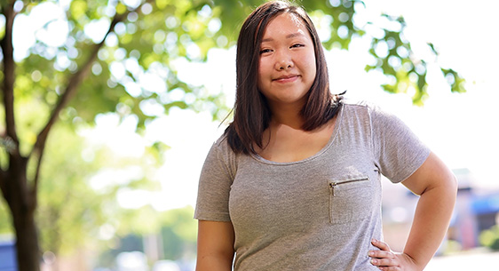

I am Hmong (mung) American. I was born in St. Paul, Minnesota. My parents are from Laos (laohse). They moved to the United States in the 1980s. I can practice my religion and eat Hmong food. I can also celebrate 4th of July. I like being an American because I can have my family's traditions, but I can also have America’s traditions.

Amy
St. Paul, Minnesota

SOURCEBOOK 1-7.C

Chris’s Story

I am Polish American. I was born in Springfield, Massachusetts. I moved to Boston when I was little. There are many reasons to love being an American. I think the most important reason is that we are given freedoms that some people in other countries do not have. I get to choose my leaders, like the president. I have the right to say what is on my mind to others. I get to choose where to live. I like living in the U.S. because of its freedoms.

Chris
Boston, Massachusetts

SOURCEBOOK 1-7.D

Christina’s Story

I am Vietnamese American. I was born in Nashville, Tennessee. I have friends who came here from all around the world. One friend is from Lithuania. One friend is from Nigeria. One friend is from Israel. There are some people who are unkind to people from other countries. My friends say that most people are nice to them. We have many laws that say it is wrong to treat people differently because of who they are. I like being an American, because everyone has the same rights.

Christina
Nashville, Tennesee

SOURCEBOOK 1-8.A

Source 1: Harriet Tubman

Harriet Tubman was born into slavery in 1820. She owned by someone else. She had to work for free for them. She ran away in 1849. She came to the North. There was no slavery there. She would sneak back into the South and help people run away. People called this the “underground railroad.” It was not really a railroad. It was a secret code word so no one would know what they were doing. In her life, she helped hundreds of slaves run away to freedom in Canada. Slavery was ended in 1865. She spent her life taking care of the former slaves as they became old.

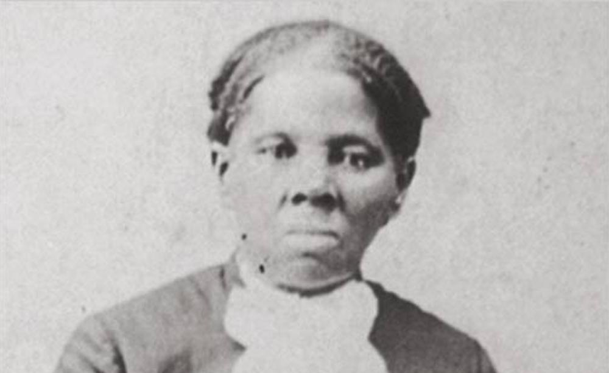

SOURCEBOOK 1-8.B

Source 2: Alice Paul

Alice Paul grew up in the United States when women could not vote. They did not have the same rights as men. In 1910, she became a leader for women to have the right to vote. She led several protests. She and other protesters stood outside the White House every day for two months. In another protest, she would be put in jail. She refused to eat. Each of these protests were covered in the newspapers. Finally, women gained the right to vote in 1920.

SOURCEBOOK 1-8.C

Source 3: Fred Korematsu

Fred Korematsu was Japanese American. In World War II, the government put all Japanese people in prison camps. Most were born here and citizens. Fred believed that it was wrong for the government to put him in prison. He did nothing wrong. Fred protested by not going into the prison camp. He was arrested. His court case went to the Supreme Court. He would lose and be sent to the prison camp. After the war, the government apologized to him and other Japanese Americans.

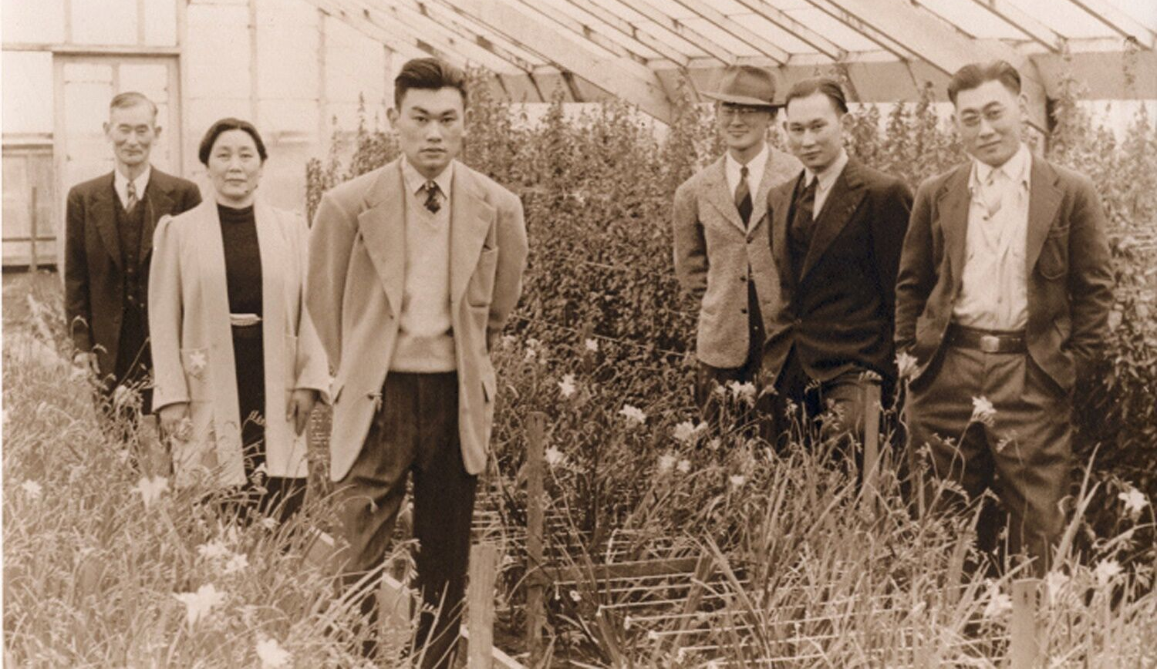
(Fred Korematsu with his family; Fred is in the middle front)

SOURCEBOOK 1-8.D

Source 4: César Chávez

César Chávez saw that farm workers in California were treated very poorly. They had to work long hours under a hot sun. They were paid very little. Chávez and Dolores Huerta founded the National Farm Workers Association in 1962. They held strikes. Farm workers refused to work. They had grape boycotts. They asked people to not buy grapes. They even marched for 300 miles from the farm fields to the state capital. Many people learned about the fram workers. They stopped buying grapes. Many laws were passed helping the famers.

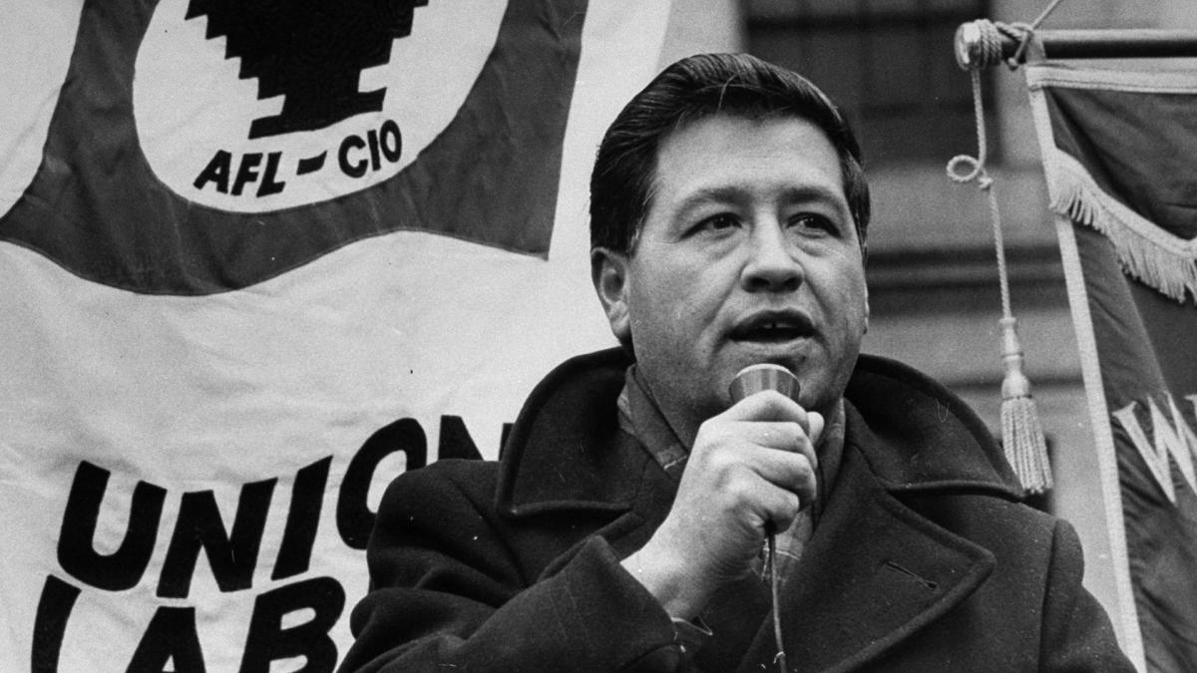

SOURCEBOOK 1-9.A

Source 1: Amelia Earhart

Amelia Earhart was born in Kansas. Many people said girls could not do the same things boys could. She ignored them and often climbed trees, hunted animals, and went sledding. One day she visited an air field. She went on a plane ride. She decided that she would become a pilot. She learned to fly. She wanted to be the first woman to fly across the Atlantic Ocean. She did this in 1928 when she flew from Canada to Britain.

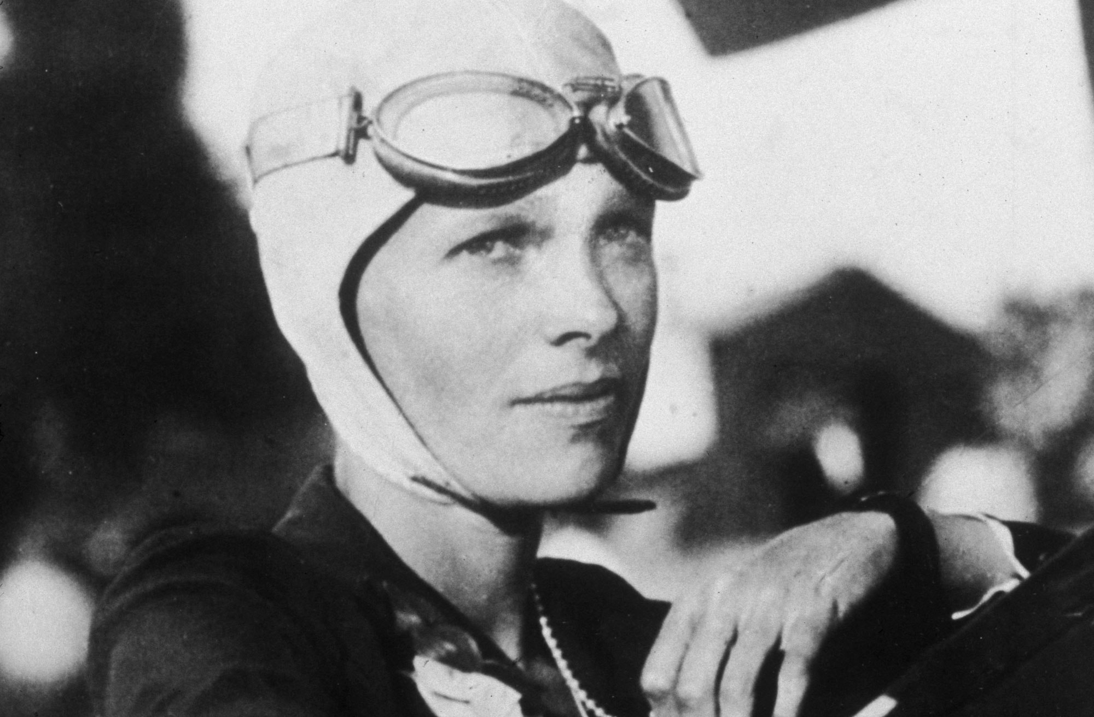

SOURCEBOOK 1-9.B

Source 2: Jackie Robinson

Jackie Robinson was born in Georgia. Black kids were not allowed to play sports with White kids. He went to an all-Black high school. He became a sports star. He started playing baseball for the Kansas City Monarchs in 1945. There was one baseball league for White people. There was another baseball league for Black people. He was so good that the Brooklyn Dodgers signed him. It was a team for Whites only. Many White people not wanting him to play for the Dodgers. Jackie Robinson became the first Black major league player in 1947.

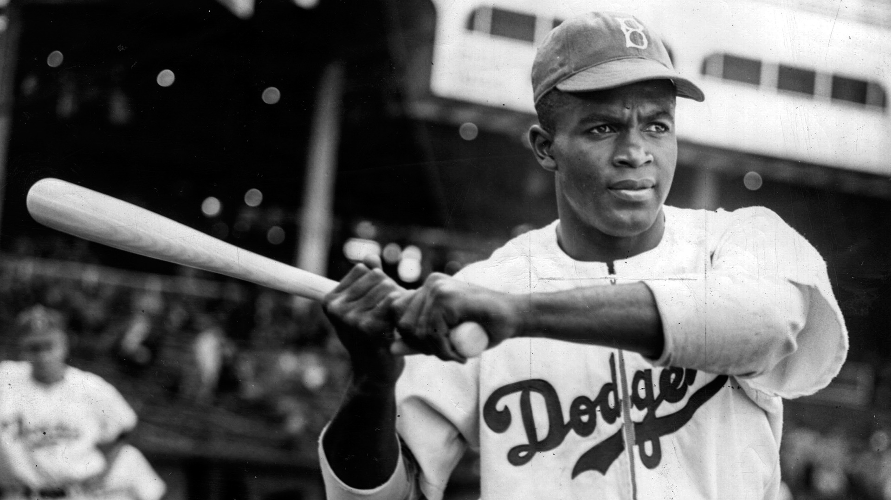

SOURCEBOOK 1-9.C

Source 3: Lin-Manuel Miranda

Lin-Manuel Miranda was born in New York. He loved dancing and music. He formed a hip-hop comedy group. Lin-Manuel Miranda dreamed of writing musicals on Broadway. He was Puerto Rican. He was told that people would not let him write musicals. He worked hard. In 2015, he wrote a musical called “Hamilton.” It is one of the top selling musicals of all time.

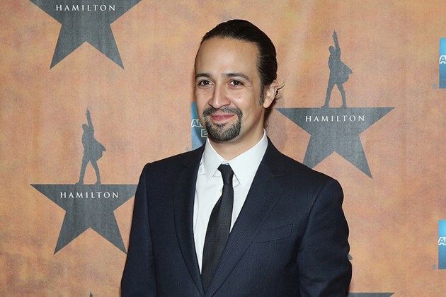

SOURCEBOOK 1-9.D

Source 4: Yo-Yo Ma

Yo-Yo Ma was born in Paris. His parents were from China. He learned to play violin, piano, and cello when he was 4 years old. Very few classical musicians were Asian. It did not stop Yo-Yo Ma from practicing very hard. Today, he is considered one of the most famous classical musicians.

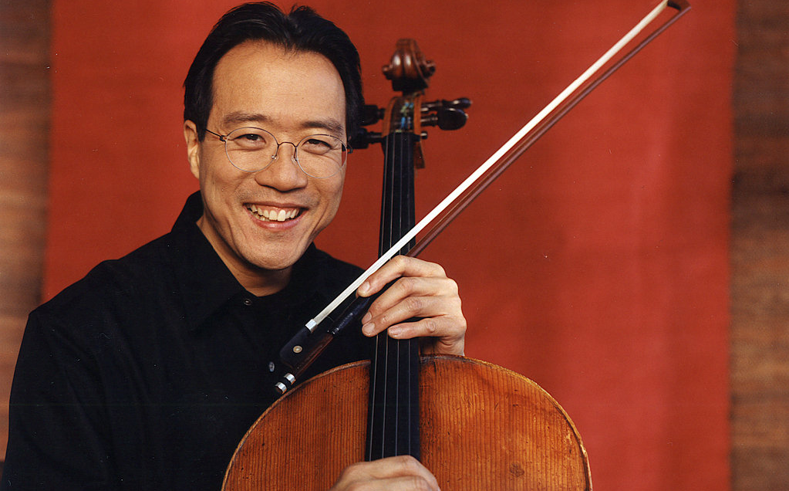

SOURCEBOOK 1-10.A

Source 1: The Wright Brothers

Wilbur and Orville Wright were brothers from Ohio. They were interested in science. They designed a new type of bicycle. They started a company called the Wright Cycle Company. Next, they decided that they wanted to make the first airplane. Their plane had many crashes. They finally made the first plane fly in 1903 at Kitty Hawk, North Carolina.

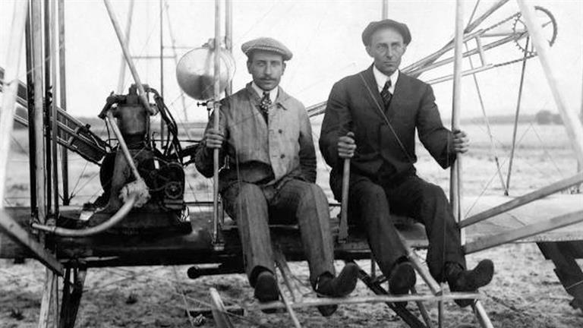

SOURCEBOOK 1-10.B

Source 2: George Washington Carver

George Washington Carver was born in Missouri. He was interested in science. He was very smart. He was accepted to college. The college did not allow Black people. They told him to not come. He started doing his own experiments. He eventually went to college. He became a professor. He discovered new ways to use peanuts, sweet potatoes, soybeans and pecans. These inventions helped many poor farmers make a better living.
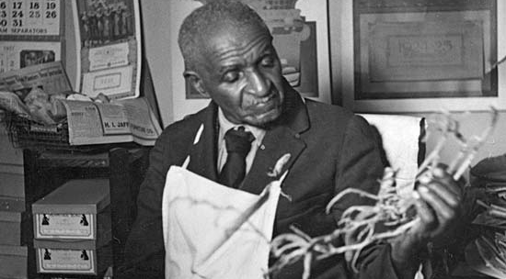

SOURCEBOOK 1-10.C

Source 3: Rachel Carson

Rachel Carson was born in Pennsylvania. She grew up on a farm. She learned a lot as a child about plants and animals. Few women went to college. She went to college. She became a scientist who studied the ocean. In 1962, she discovered that chemicals were polluting the rivers and oceans. This was hurting many plants and animals, including humans. She published an important book called “Silent Spring” that told everyone about this.
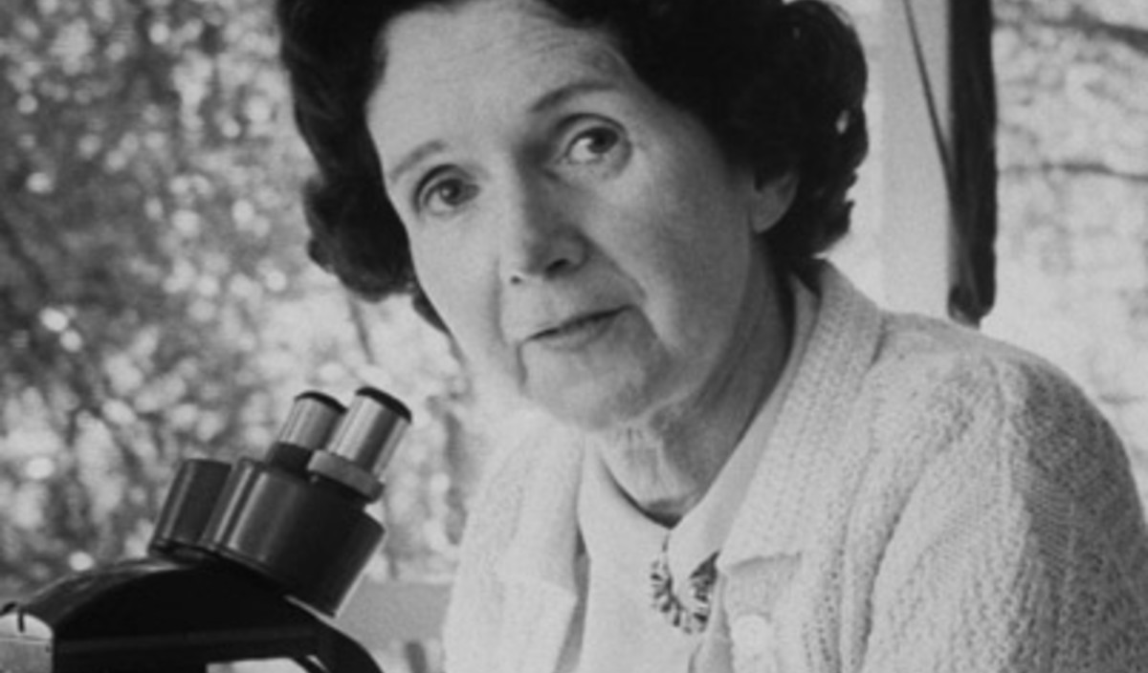
SOURCEBOOK 1-10.D

Source 4: Eugene Trịnh

Eugene Trịnh was born in Saigon, Vietnam. He moved to France when he was 2. He later moved to the United States. He wanted to become a pilot. He never learned to fly. He became a scientist who studied jet airplanes. He published over 40 papers about his experiments. In 1992, he became the first Vietnamese American in space.

SOURCEBOOK 1-11.B

U.S. Flag

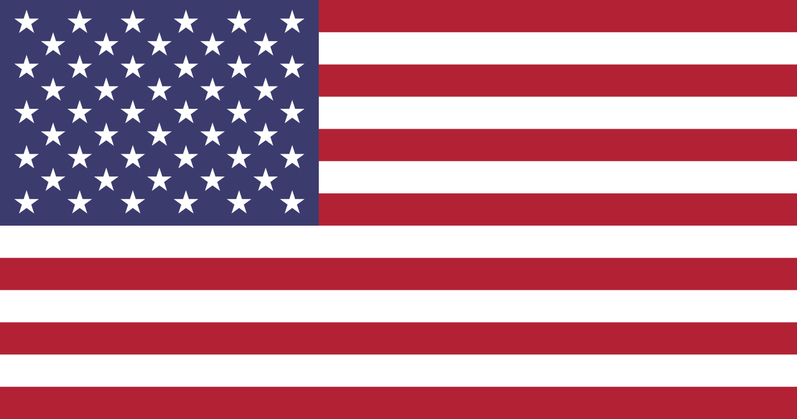

The Flag of Britain (1770s)

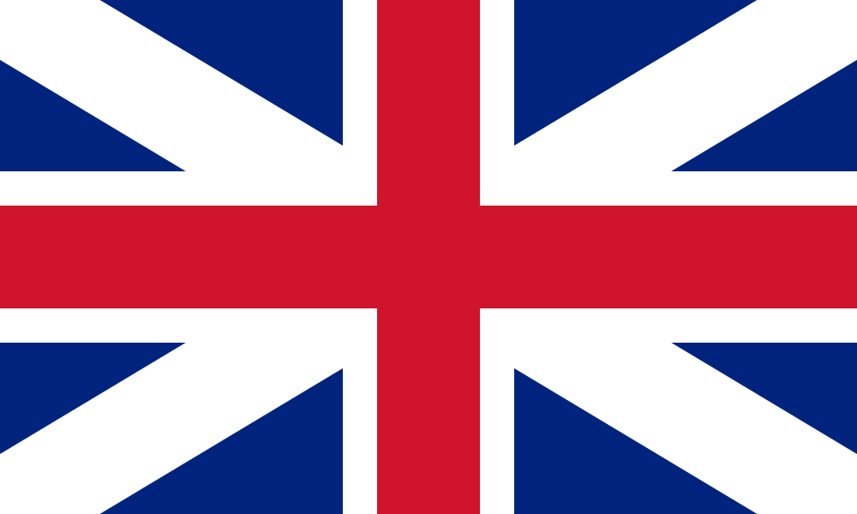

SOURCEBOOK 1-11.C

History of the U.S. Flag

1775
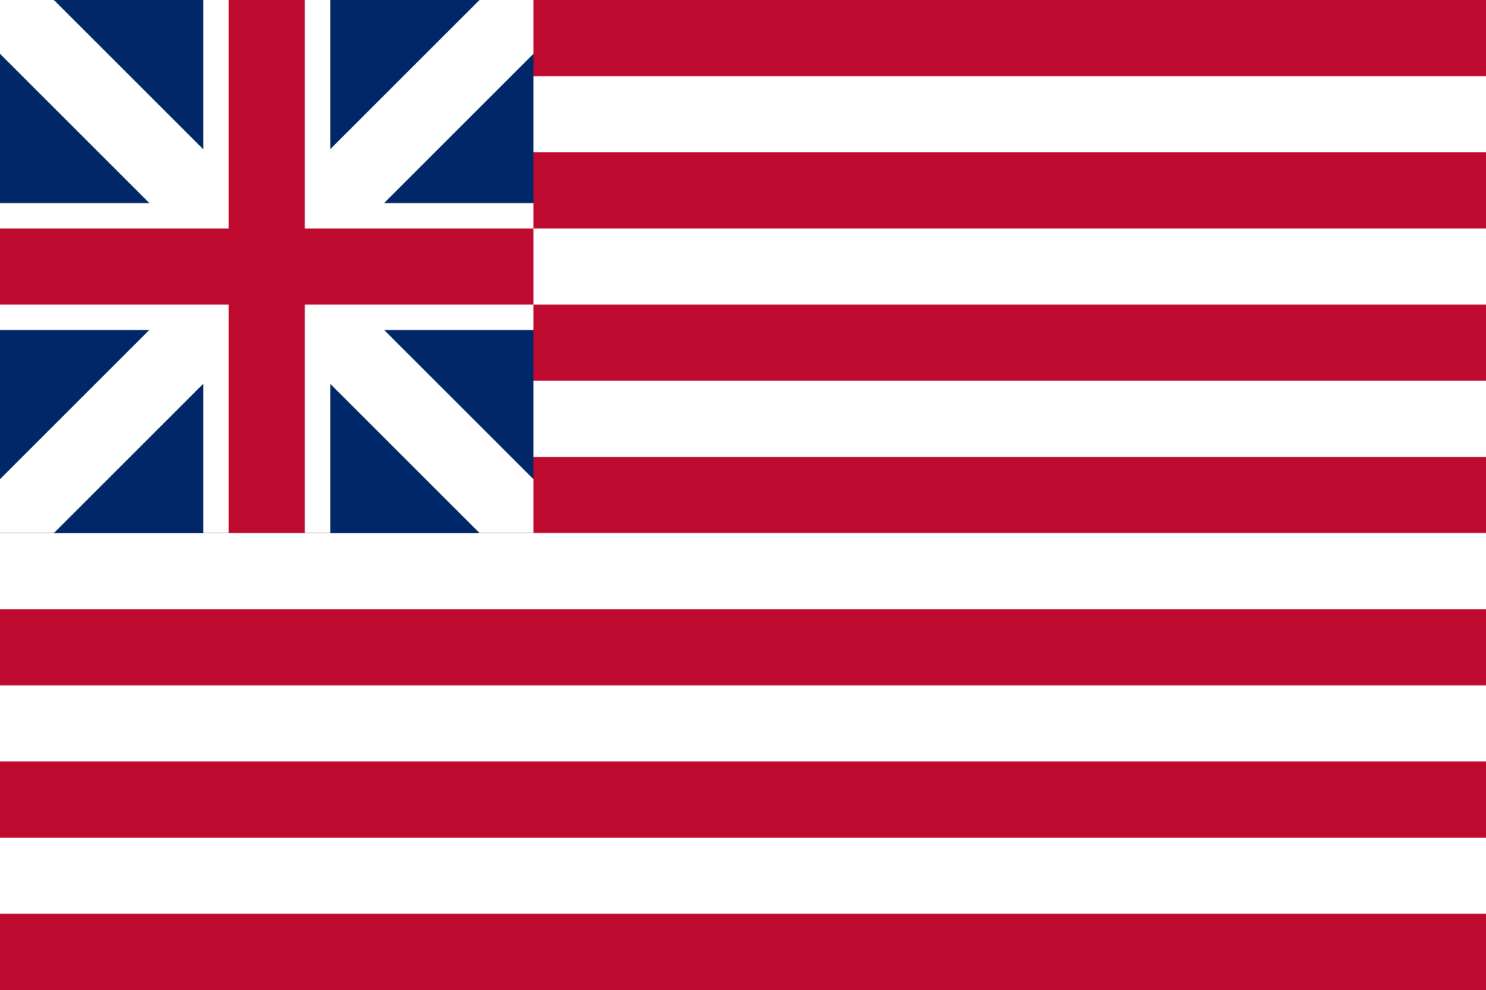

1776
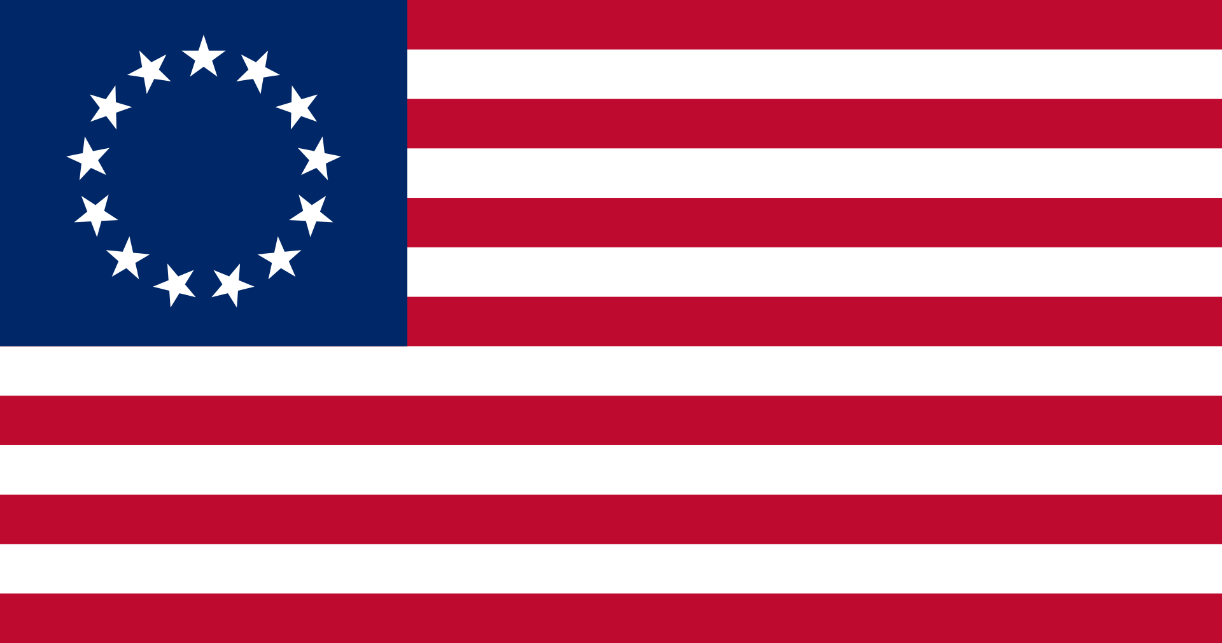

1861
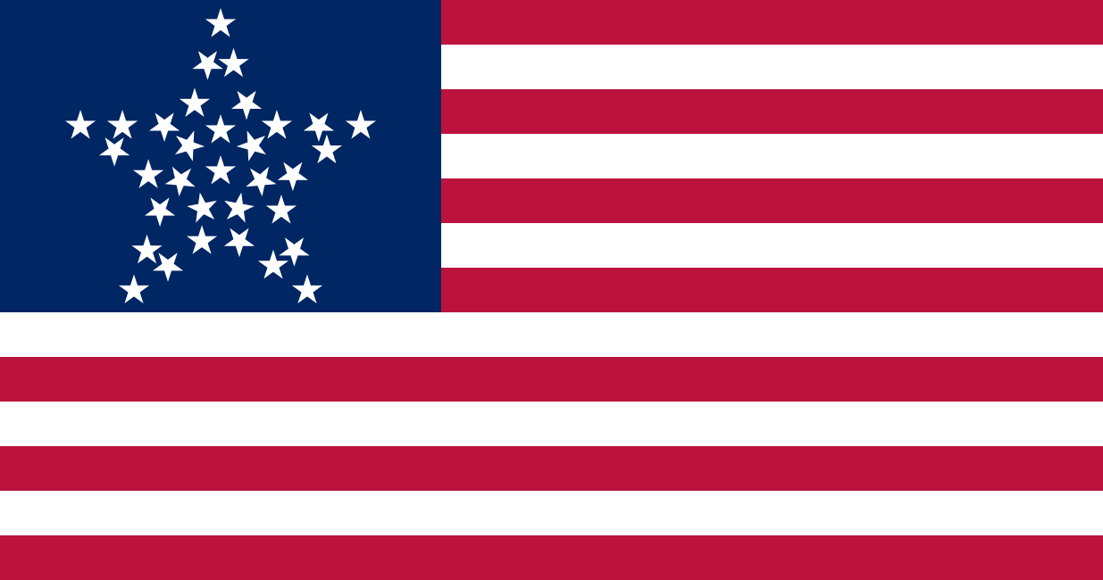

Today

The U.S. flag was first created in 1775. It looked similar to today’s flag without stars. Above you can see four different U.S. flags. Today, the flag has 50 stars. Every time the U.S. gets a new state, it adds another star. Puerto Rico voted to become a state. If that happens, the U.S. will have to add one more star.

SOURCEBOOK 1-11.D

Source 1: Holiday Celebrations

The U.S. flag is often used during national celebrations. You often see it on Independence Day (4th of July), Memorial Day, Veterans Day, and Flag Day. People fly it on houses. People use it in parades. It can be used to celebrate a person’s love for the United States. It also expresses pride in their country.

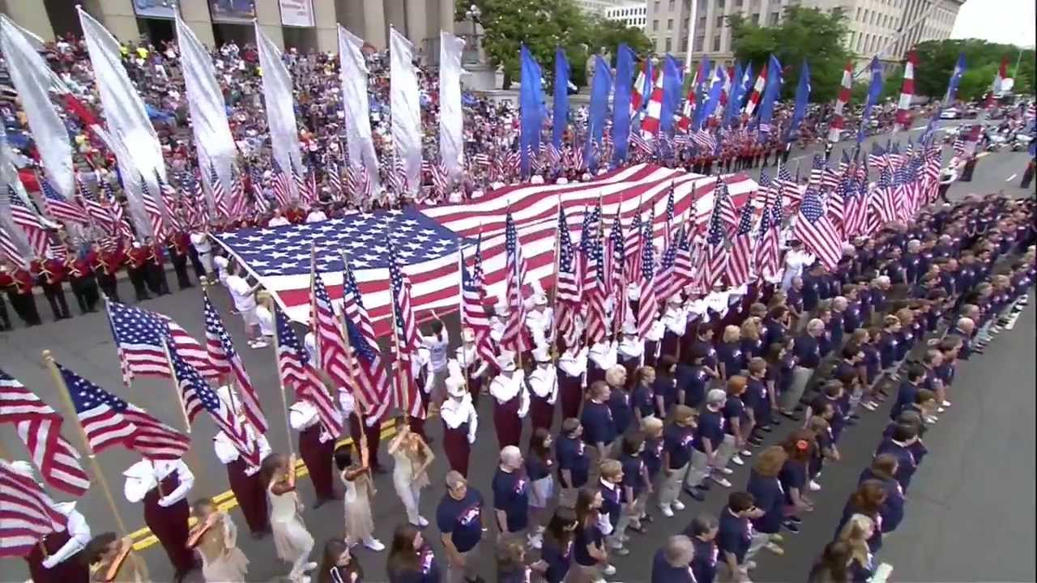

SOURCEBOOK 1-11.E

Source 2: Protests

The U.S. flag is often used during political protests. Protesting is a right that all Americans have. Martin Luther King walk in front of many U.S. flags. He was protesting how African Americans were treated. His marches led to new laws to treat everyone fairly.

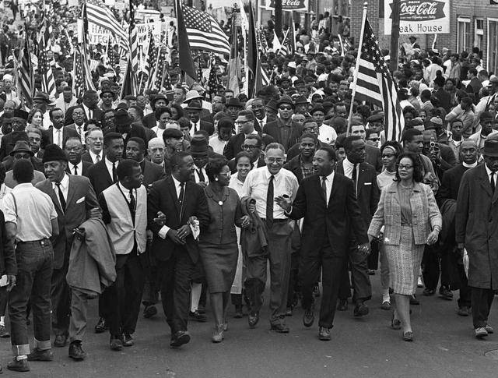

SOURCEBOOK 1-11.F

Source 3: Sporting Events

The U.S. flag is often used by sports teams to celebrate. This is the U.S. Relay Team. They won a gold medal at the London Olympic Games in 2012. They had flags and sang the national anthem.

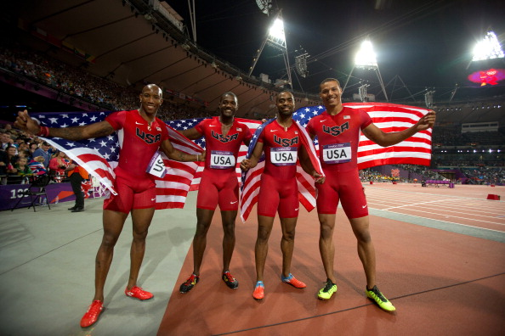

SOURCEBOOK 1-11.G

Source 4: War

Flags were first made for wars. Some people say that their country’s flag shows respect for soldiers. It reminds us to support them during war. Other people say it reminds us why we should not go to war. They say that we should not fight other countries.

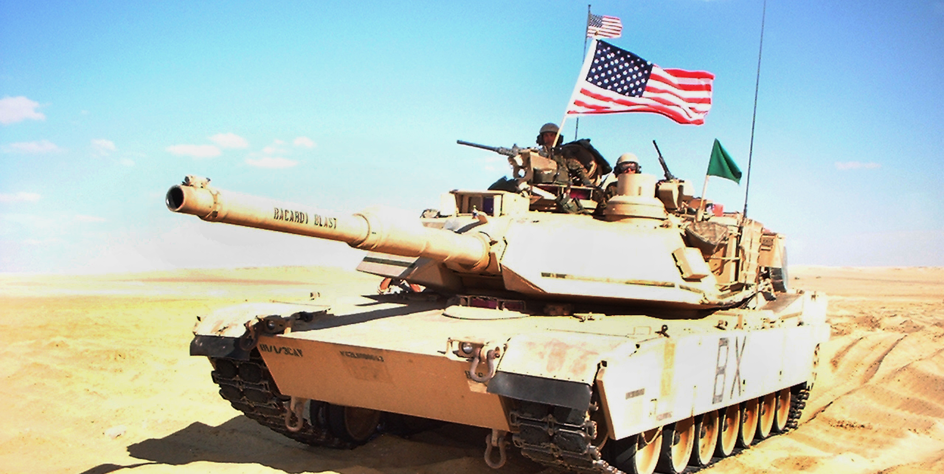

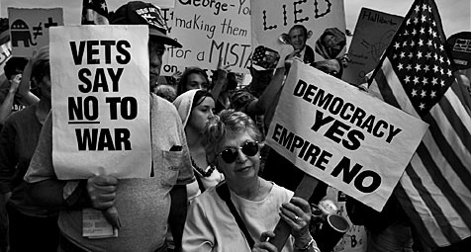

SOURCEBOOK 1-12.A

National Bird Choices

Bald Eagle
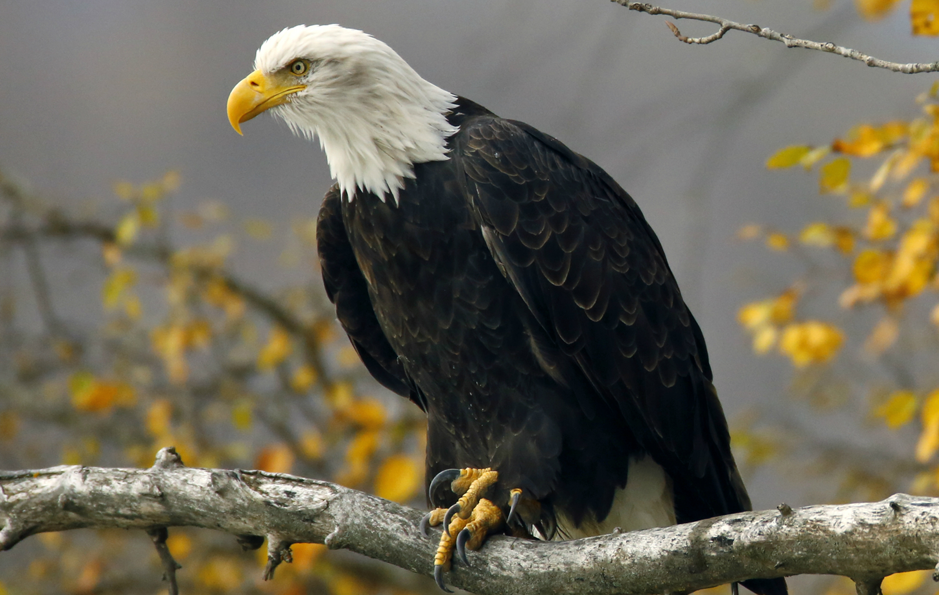

American Turkey
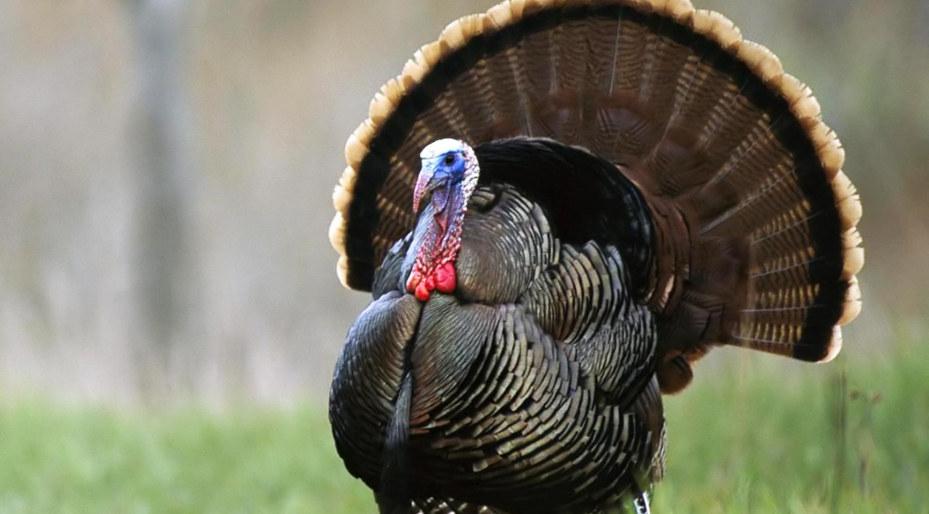

Black Crow
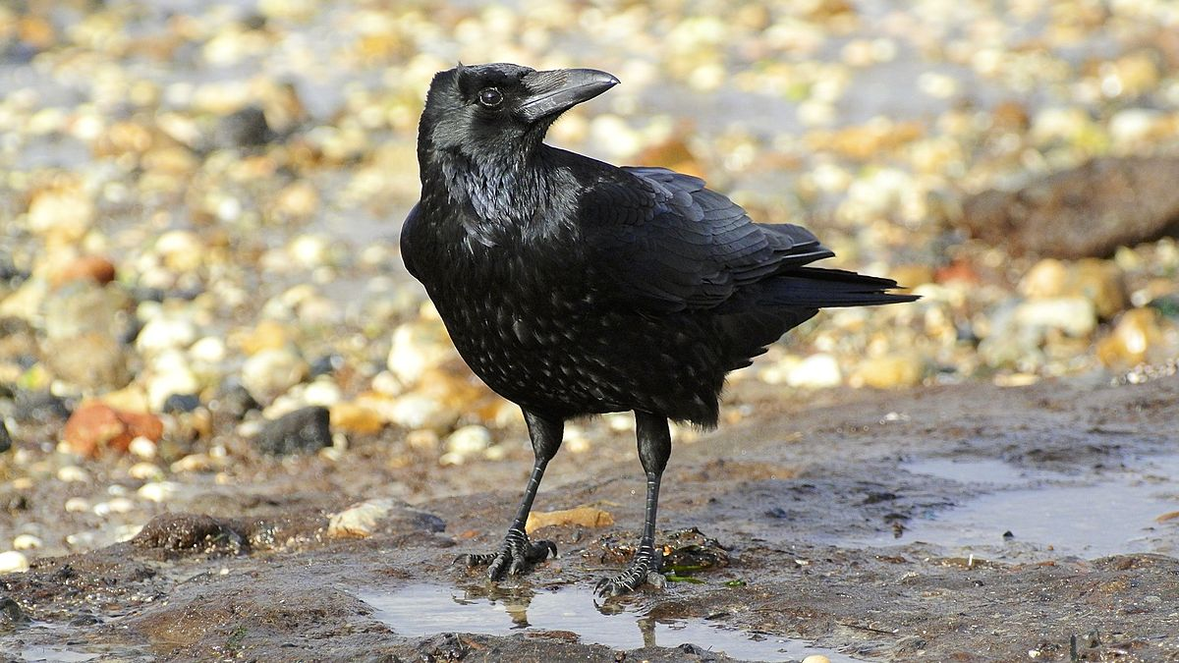

Hummingbird
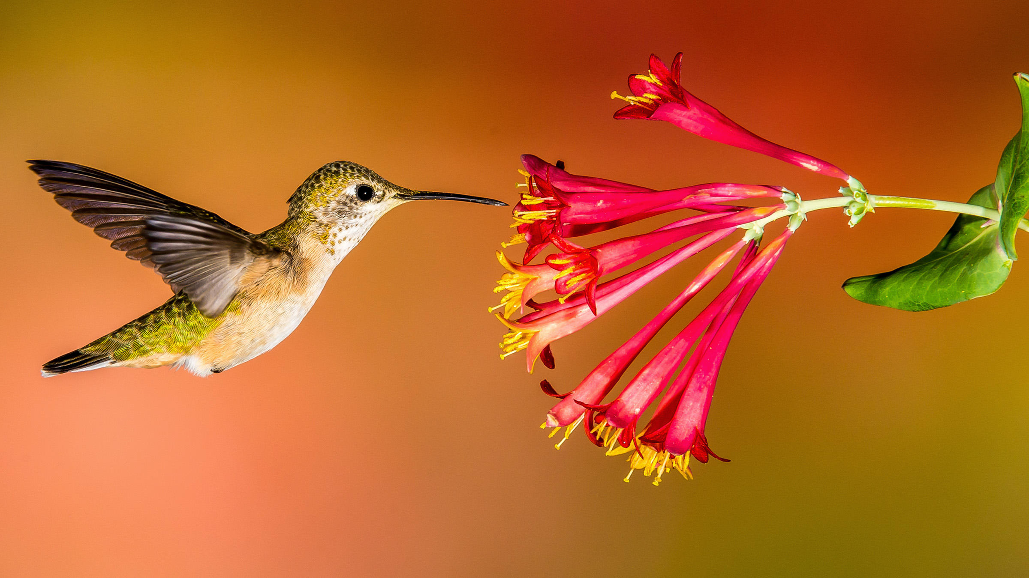

SOURCEBOOK 1-13.A

Images (A)

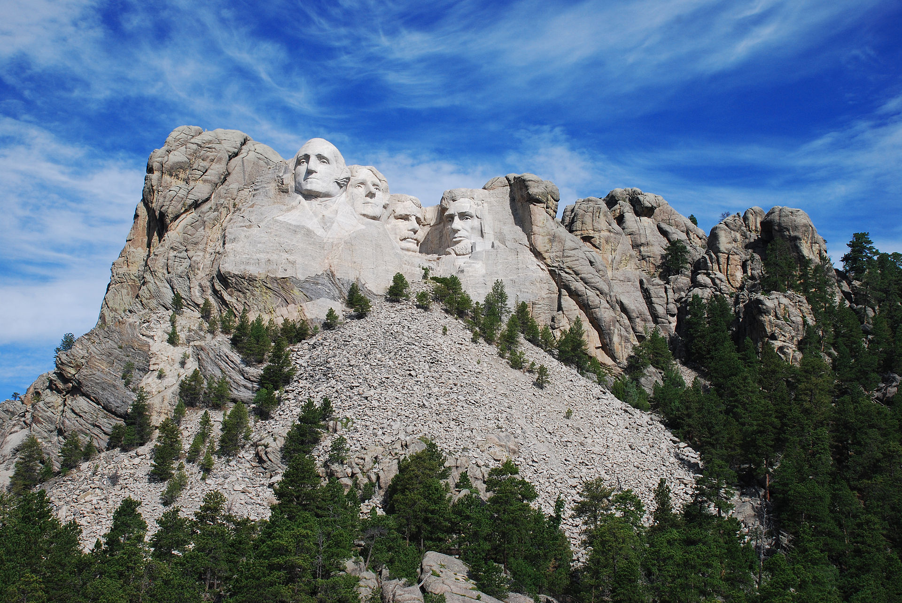
Images (B)

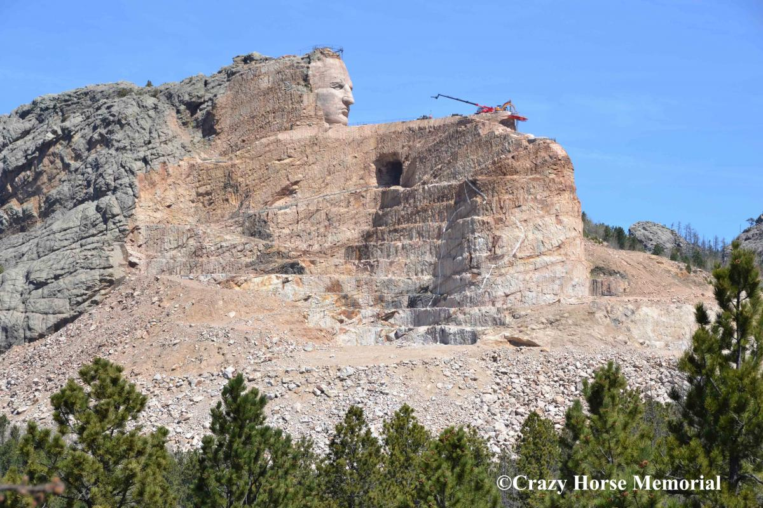

SOURCEBOOK 1-13.B

Source 1: Government Monuments:
National Mall (Capitol, White House, Washington and Lincoln Memorials)

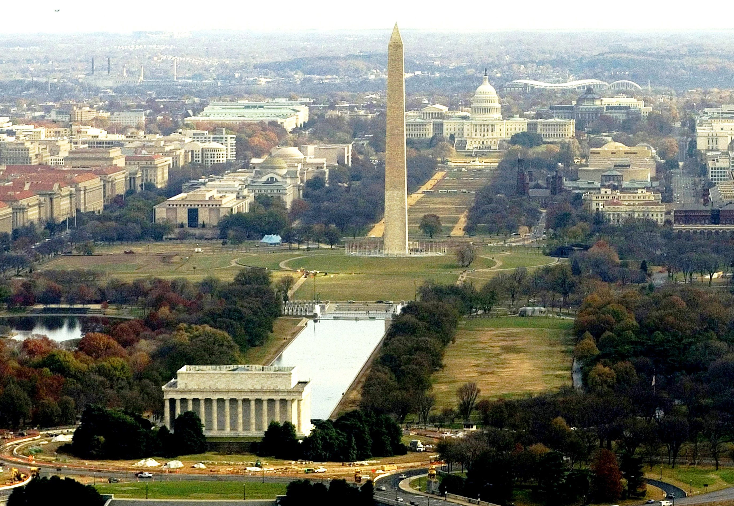

The National Mall includes four monuments that are about the U.S. government. The Washington Monument is the tall pointed structure (above). The Lincoln Memorial is the smaller rectangle building (above). These monuments were made to help remember George Washington and Abraham Lincoln (next page-bottom). They were important presidents.

The Capitol (top) is where the people in Congress make laws (rules) for the country. The White House (middle) is where the president makes sure people follow the nation’s laws (rules).

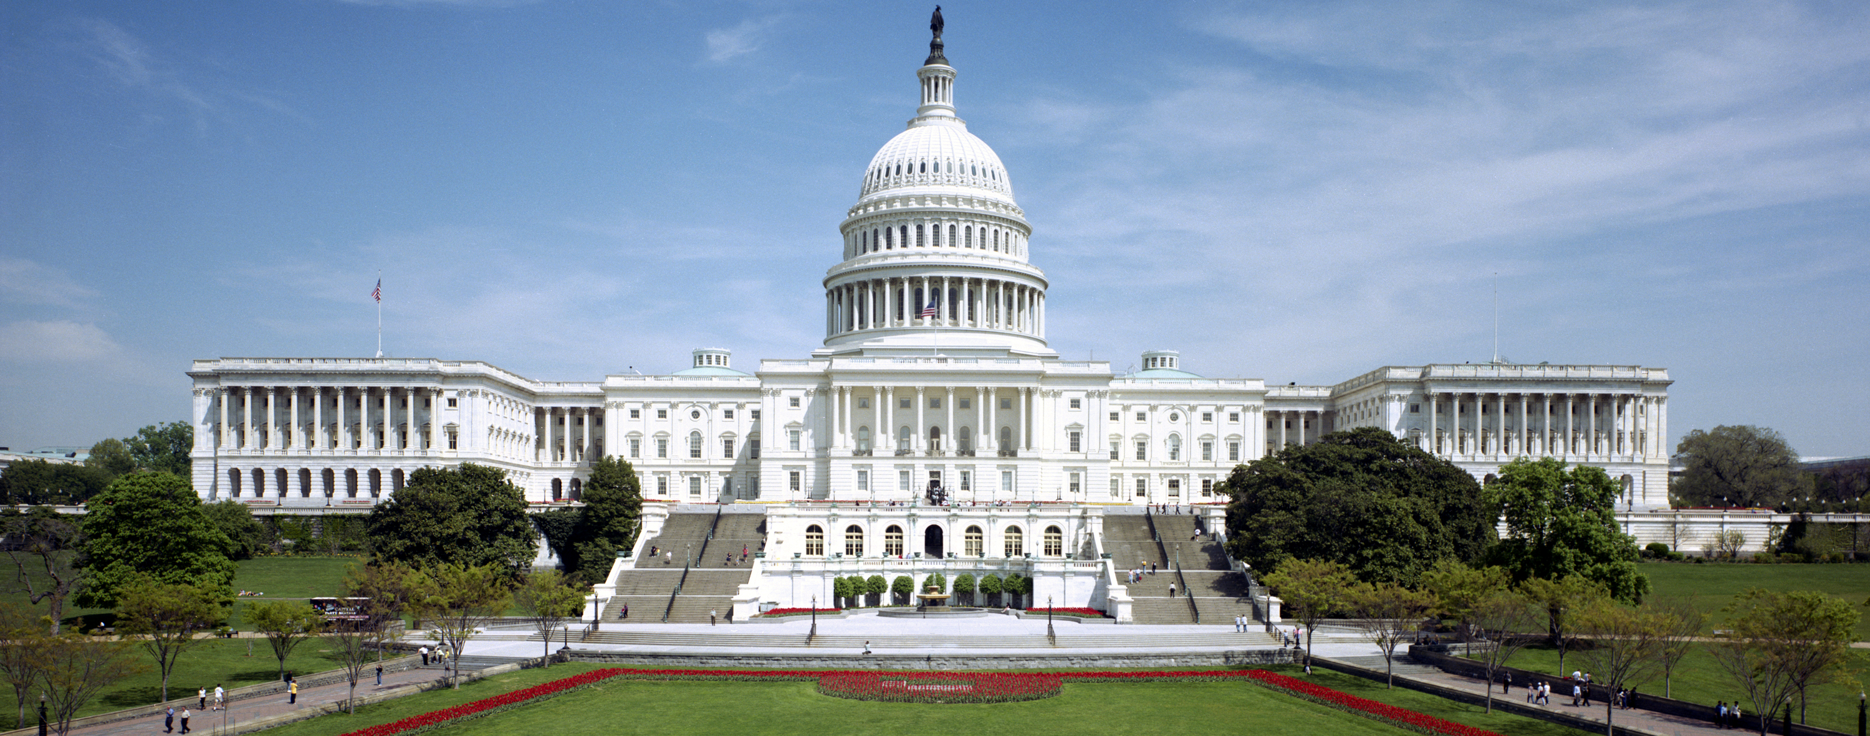

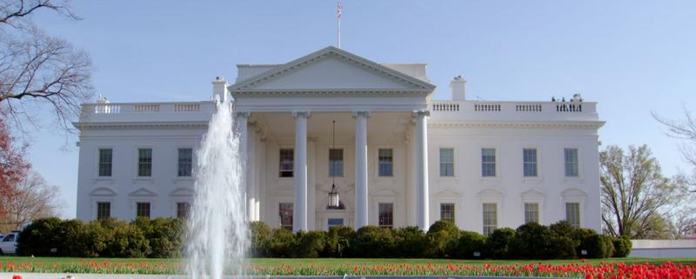

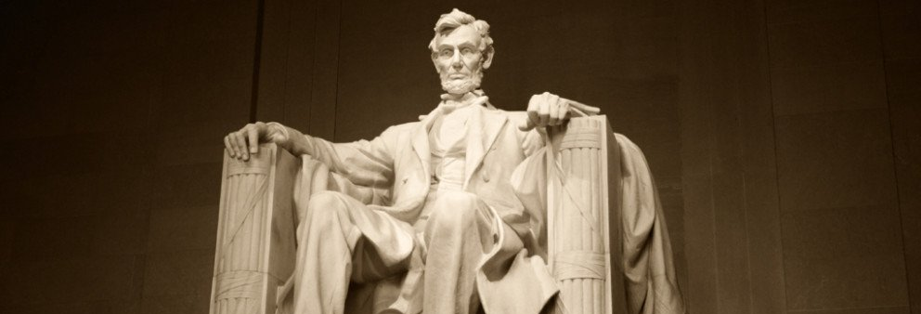
SOURCEBOOK 1-13.E

Source 2: Independence Monuments: Freedom Trail

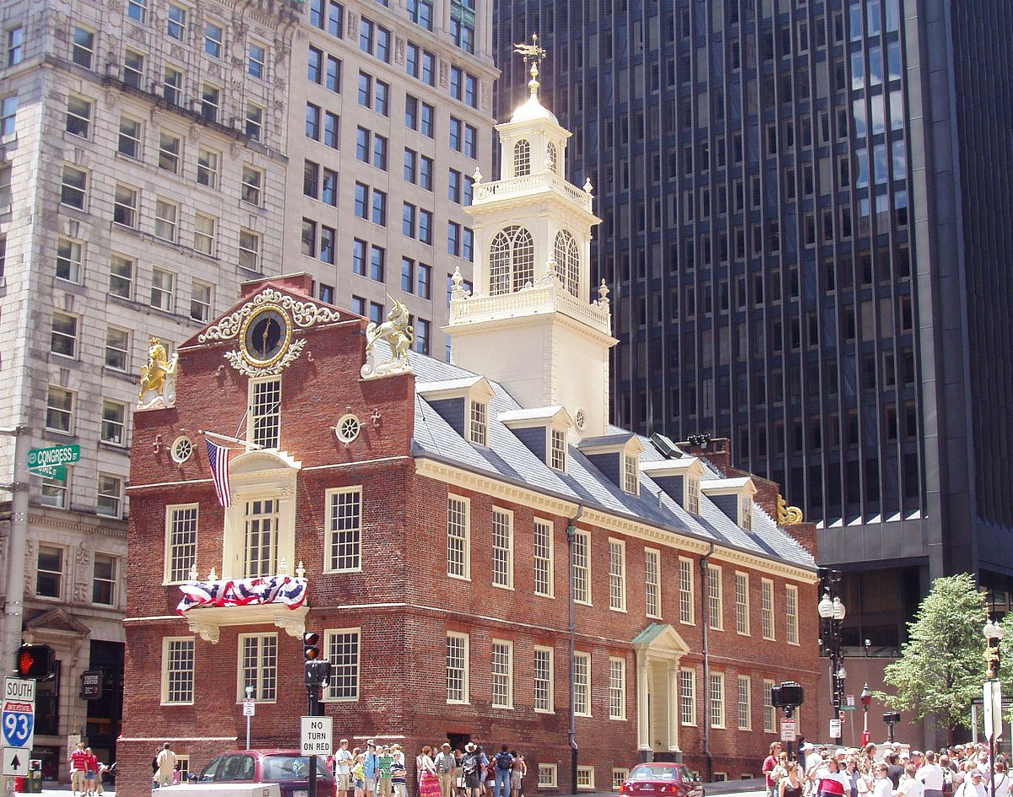

The Freedom Trail is monument in Boston. It is to remember how the United States became a country. It is a 2.5 mile (4 km) long brick trail. The people of Boston began to rebel against their government about 250 years ago. They told other colonies to join them. They declared independence (have their own country) from England. The Freedom Trail includes the Old State House (above), Paul Revere Statue, and the Old North Church (next page).
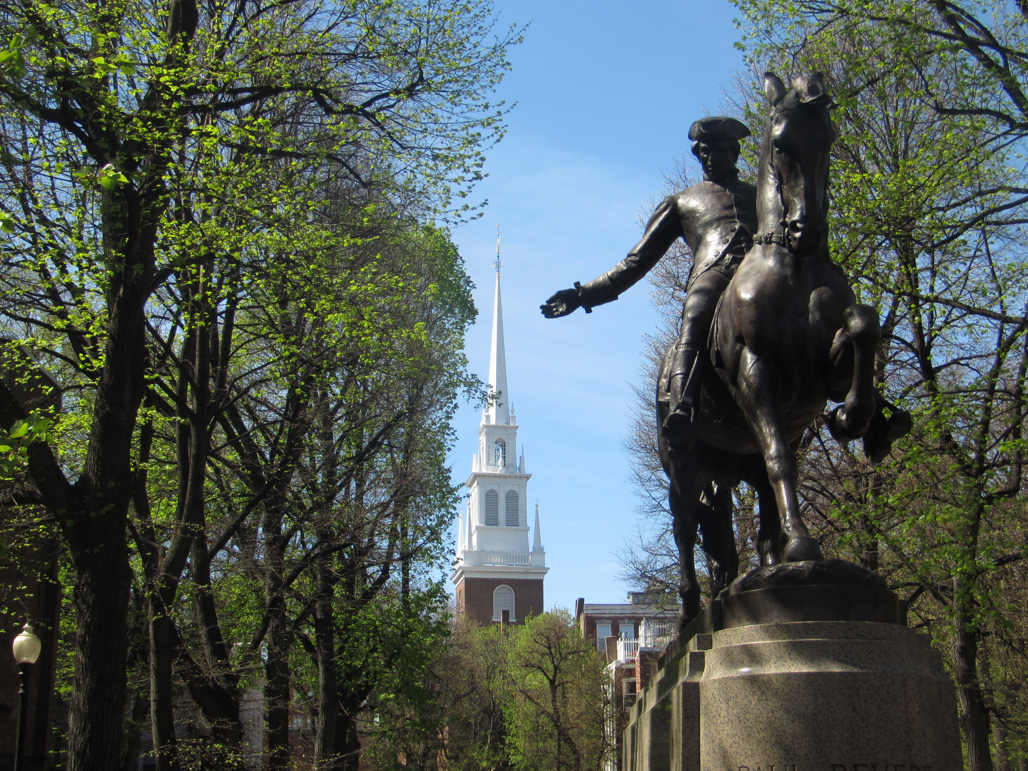

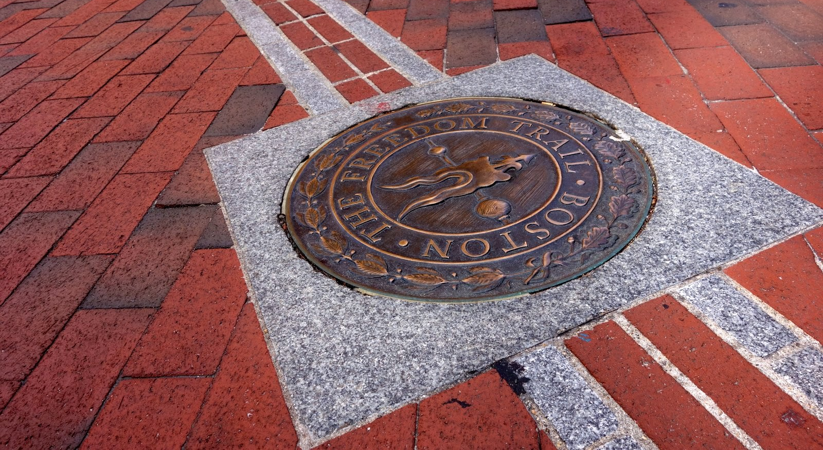
SOURCEBOOK 1-13.D

Source 3: Constitution Monuments: Independence Hall and the Liberty Bell

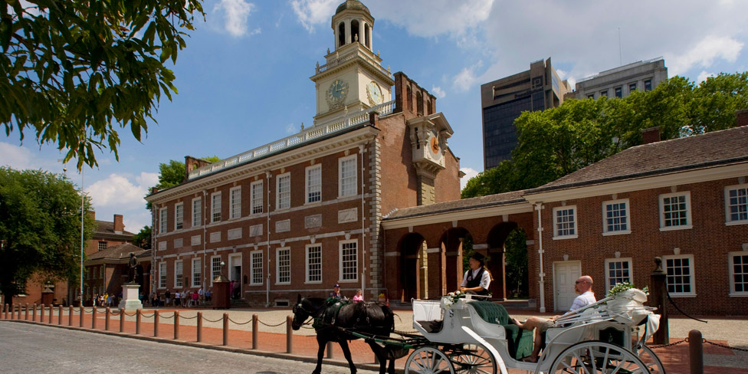

Independence Hall (above) and Liberty Bell (next page) are monuments to remember the Constitution. Philadelphia was the first capital of the U.S. The Americans wrote their new Constitution there. It said there would be a Congress, a President, and a Supreme Court. They also wrote down important rules in the Bill of Rights. This includes freedom of speech and freedom of religion.

There is a tale (untrue story) that the Liberty Bell (next page-top) rang on the first Independence Day (July 4, 1776). It also has a famous crack, which happened years later when it was ringing.

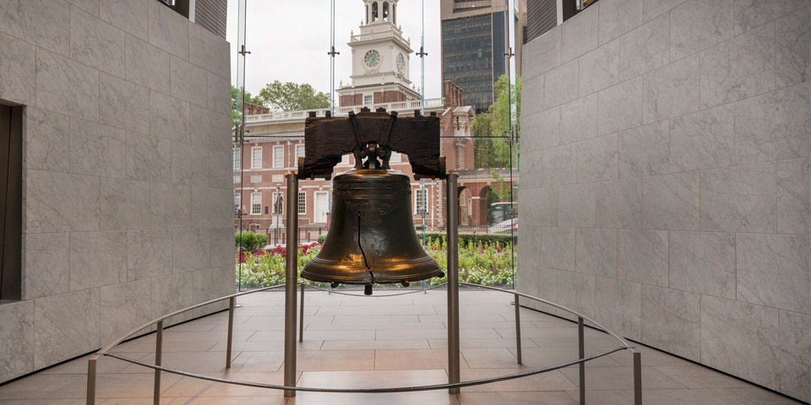

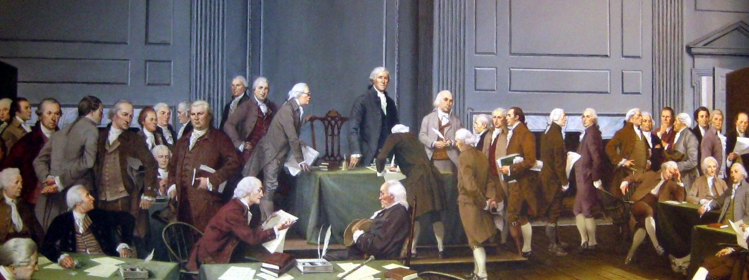
SOURCEBOOK 1-13.C

Source 4: Immigration Monuments:
Statue of Liberty and Ellis Island

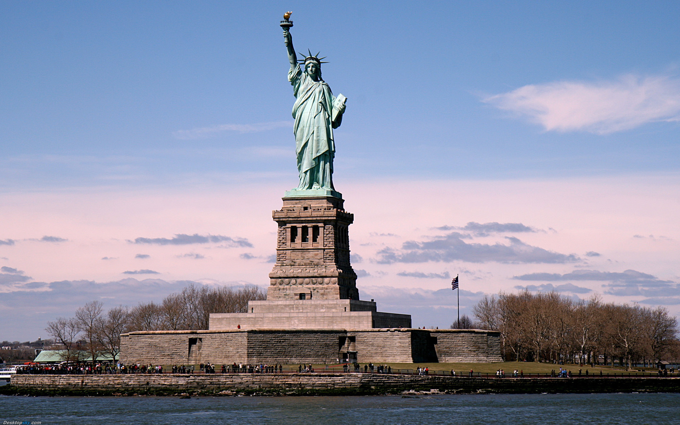

The Statue of Liberty and Ellis Island are monuments about immigrants. Immigrants are people who move to the United States from other countries. Many immigrants entered the U.S. through New York City. France gave the U.S. the Statue of Liberty in 1886. Immigrants who came on boats would see that statue. It became a symbol for the U.S. The bottom of the statue says, “Give me your tired, your poor, who want to breathe free.” New immigrants would go through Ellis Island (next page-top and bottom). These monuments remind us that our country has many immigrants.
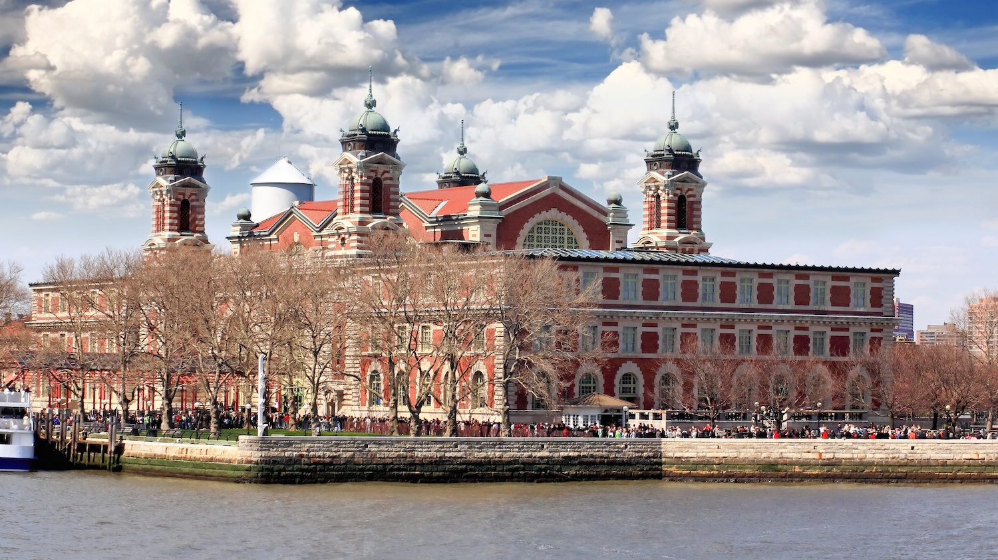

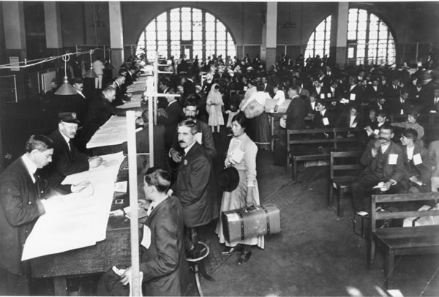
SOURCEBOOK 1-13.F

Source 5: Natural Monuments:
Grand Canyon and Niagara Falls

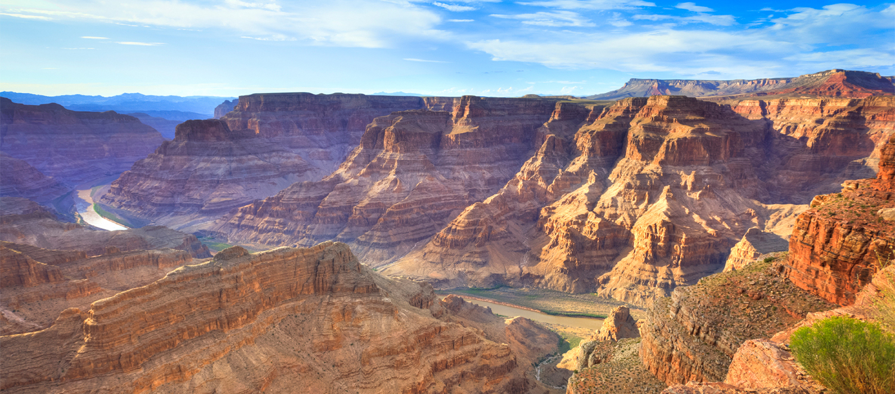

The Grand Canyon in Arizona and Niagara Falls in New York are monuments about nature. Both were here before people were. The Grand Canyon (above) is one of the world’s largest canyons. A canyon is deep cut in the ground. It is usually caused by a river over time. It was discovered by the Pueblo people. Almost 5 million people visit it each year.

Niagara Falls (next page-top) is a name for three giant waterfalls. It is on the U.S. (New York) and Canada (Ontario) border. The Mohawk people were the first to see it. Fourteen daredevils (people that do stunts) have gone over the falls in metal barrels (next page-bottom). 8 million people visit Niagara Falls each year. Some people say the Grand Canyon and Niagara Falls are the most beautiful natural monuments in the world.
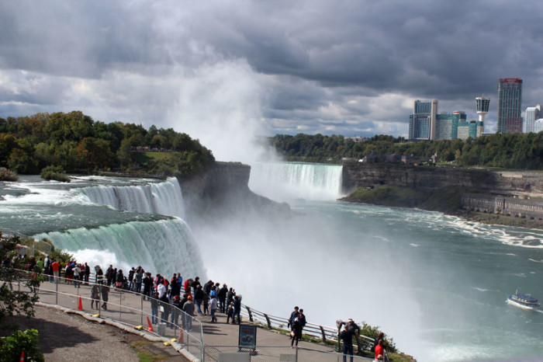

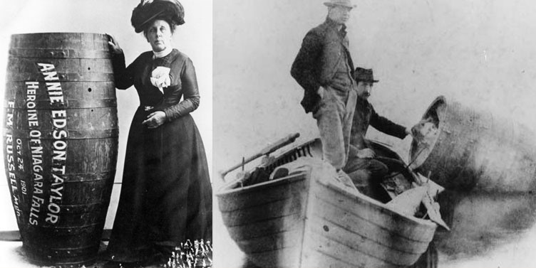
SOURCEBOOK 1-13.G

Source 6: Man-Made Monuments:
Golden Gate Bridge and Gateway Arch

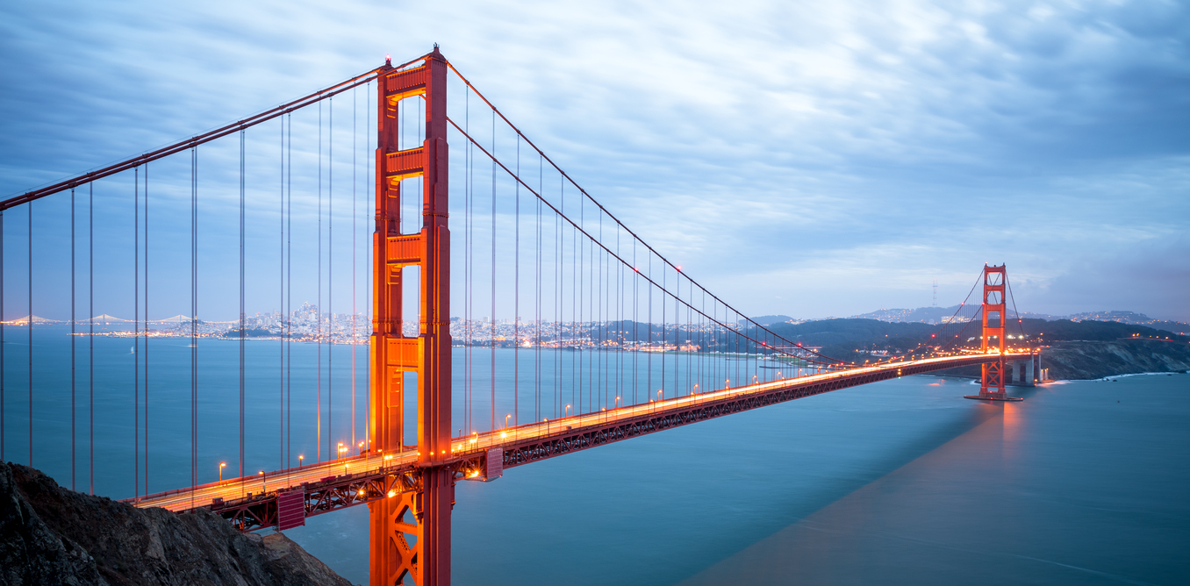

The Golden Gate Bridge in California and the Gateway Arch in Missouri are monuments about building. The Golden Gate Bridge (above and next page-top) was built from 1933-1937 in San Francisco, California. It is the most famous bridge in the world. It is 1970 meters (1.7 miles) and takes about 45 minutes to walk across.

The Gateway Arch (next page-middle and bottom) was built from 1963-1965 in St. Louis, Missouri. It is on the Mississippi River. It is the world’s tallest arch at 630 feet tall. It greets people to the western half of the United States. You can take an elevator to the top of it. It has amazing views of St. Louis and the Mississippi River. The Mississippi River is the longest in the U.S.

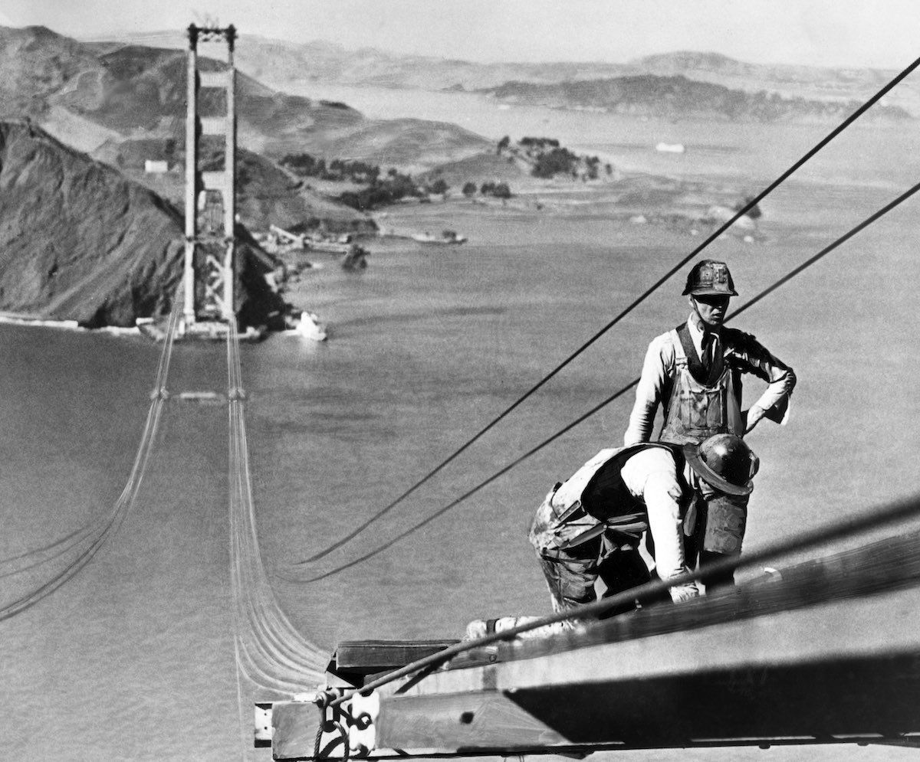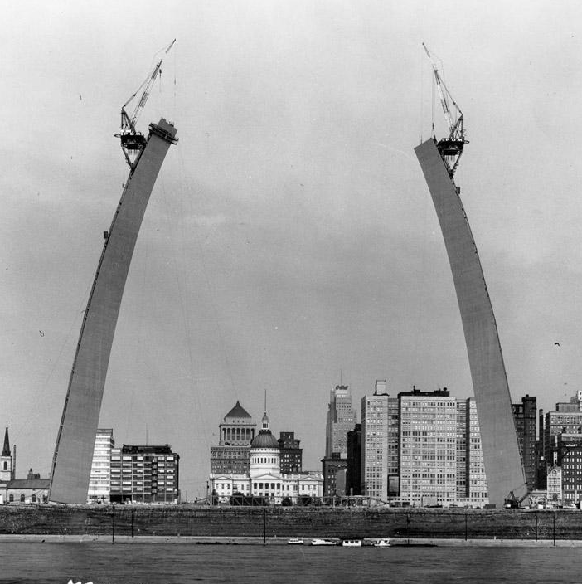

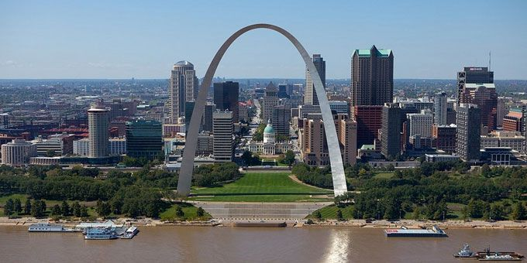

SOURCEBOOK 1-14.A

Source 1: Independence Day

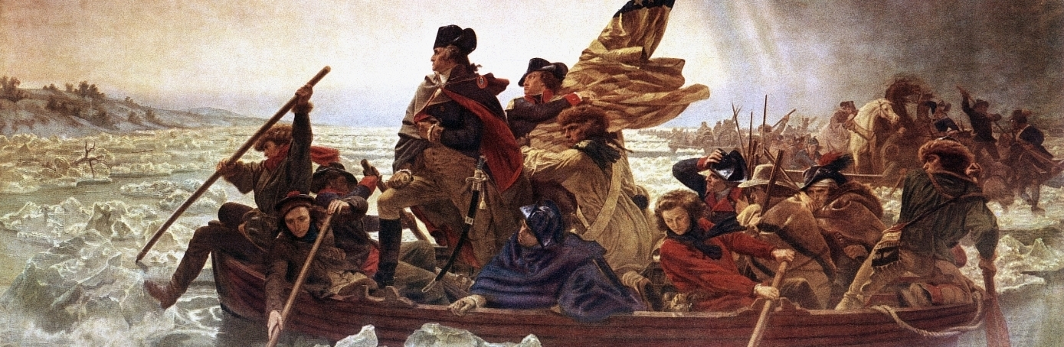Independence Day is a holiday celebrated across the United States. It is also called 4th of July. It honors the day that the American colonies declared independence. It happened on July 4, 1776. The American colonists won the Revolutionary War. Britain allowed them to be their own country. In their new country, Americans could vote for their leaders. They would create a list of rights that everyone would have. This included freedom of speech, press, protest, and religion.
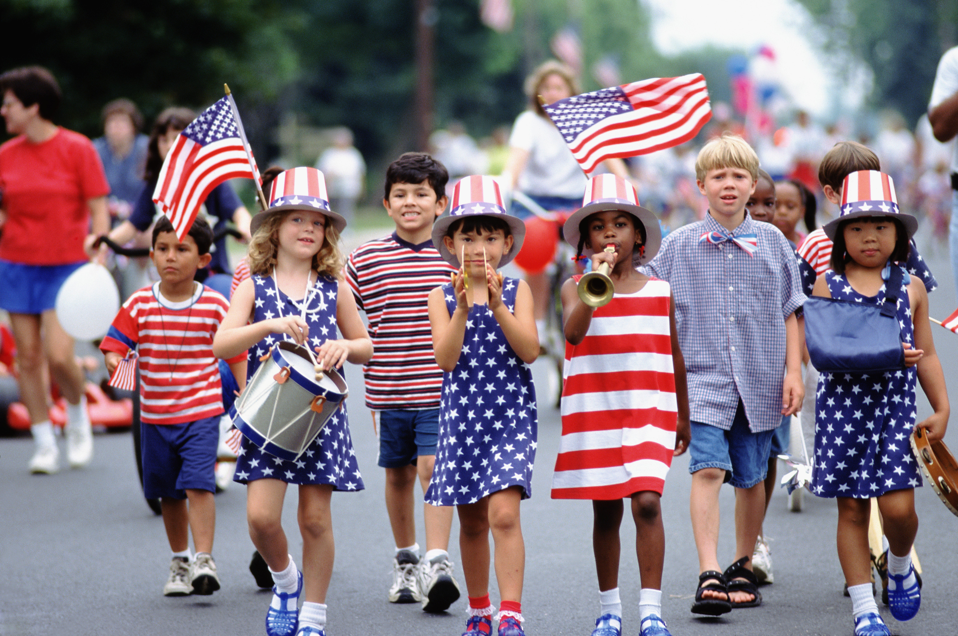
Above: Kids marching in an Independence Day parade. Below: The annual 4th of July Boston Pops concert and Charles River fireworks.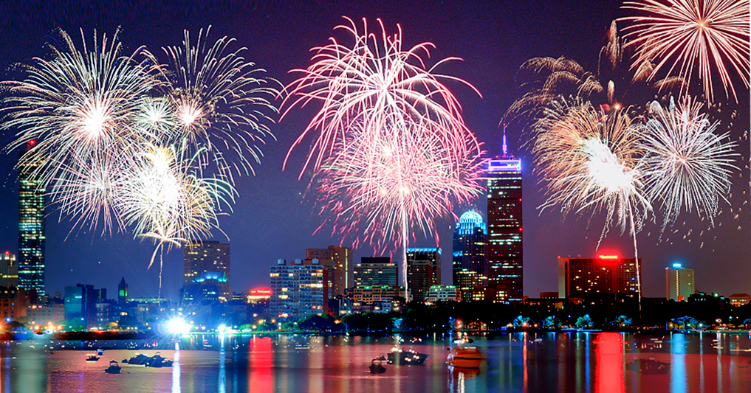
SOURCEBOOK 1-14.B

Source 2: Labor Day

Labor Day is a holiday celebrated across the United States. It honors workers and their labor (work). Workers help their communities and country. Labor Day was started in 1882 by labor unions (groups of workers). The holiday was started because workers were not always treated fairly. Workers sometime give speeches. They also march in labor parades. Today, it allows workers a day off from work at the end of the summer to celebrate all that they do.
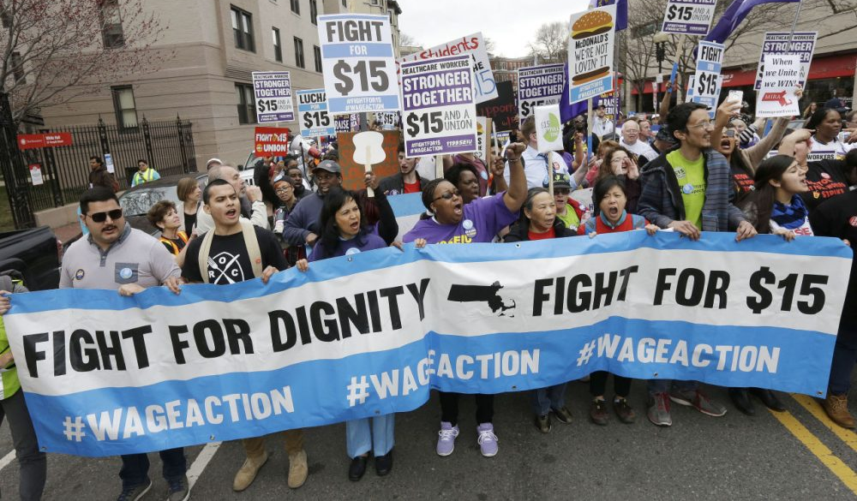Above: Workers marching in Boston to raise the minimum wage. Below: The first Labor Day Parade in New York (1882).
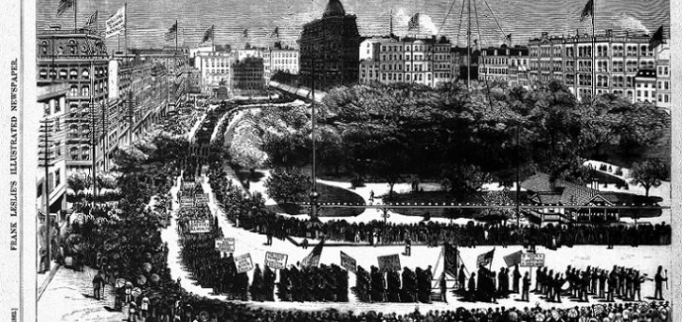
SOURCEBOOK 1-14.C

Source 3: Patriots’ Day

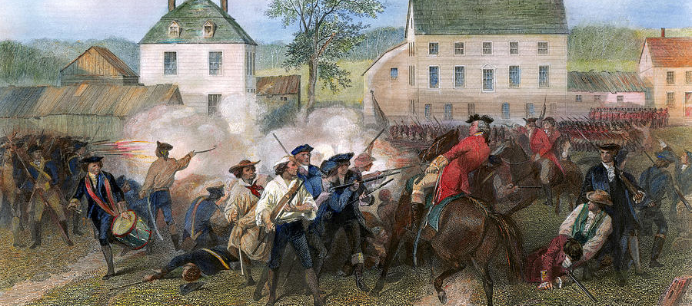
Patriots’ Day is a holiday celebrated in Massachusetts and Maine. It honors the Battle of Lexington and Concord on April 19, 1775. That was the start of the Revolutionary War. People dress up like soldiers and militiamen and act out the battle. It reminds people that a small group can make a big change. It is also the day of the Boston Marathon. It was first run on April 19, 1897. It is the oldest marathon in the United States. Some people call the holiday “Marathon Monday.”
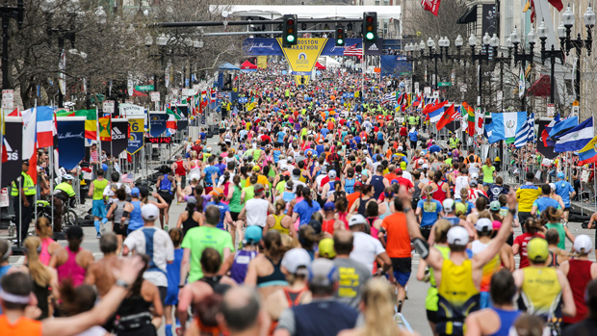
Above: The running of the Boston Marathon on Patriots’ Day. Below: People dressed up as soldiers and militiamen in Concord.
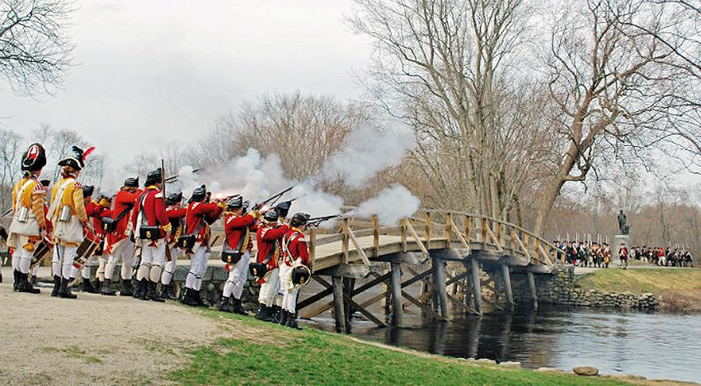
SOURCEBOOK 1-14.D

Source 4: Juneteenth

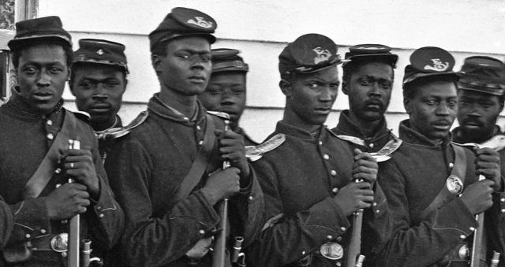
Juneteenth or Freedom Day is a holiday in 45 states, including Massachusetts. It honors the day that the last enslaved people were freed. It took place in Texas on June 19, 1865. The name comes from combining the words June and nineteenth. It is an especially important holiday in the African American community. People celebrate with speeches, meals, and parades related to freedom and civil rights.
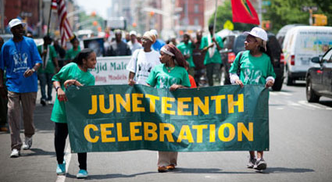
Above: A Juneteenth Parade in Harlem, New York City. Below: An early Emancipation Day parade in Richmond, Virginia (1905).
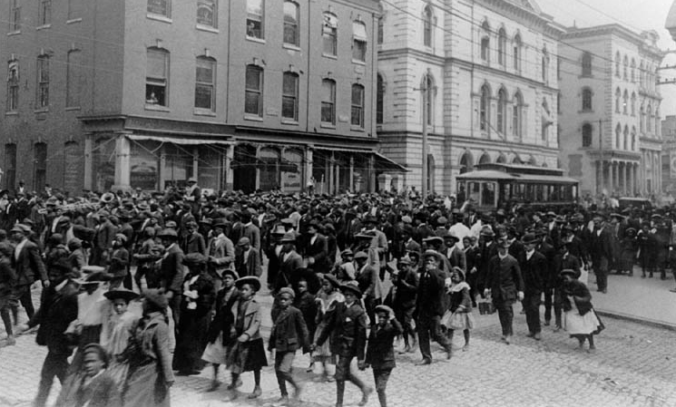

SOURCEBOOK 1-15.A

Source 1: Pledge of Allegiance History

Below are the words to the United States’ Pledge of Allegiance.

“I pledge allegiance to the flag of the United States of America, and to the republic for which it stands, one nation under God, indivisible, with liberty and justice for all.”

It did not always have these same words. Francis Bellamy wrote this first pledge in 1892 when visiting Massachusetts:

“I pledge allegiance to my Flag and the Republic for which it stands, one nation, indivisible, with liberty and justice for all.”

What words were changed or added in 1923 and 1954 (underlined above)?

Which version do you like better? Why?
SOURCEBOOK 1-15.B

Source 2: Children Saying the Pledge in School

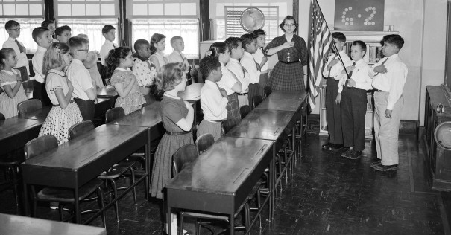

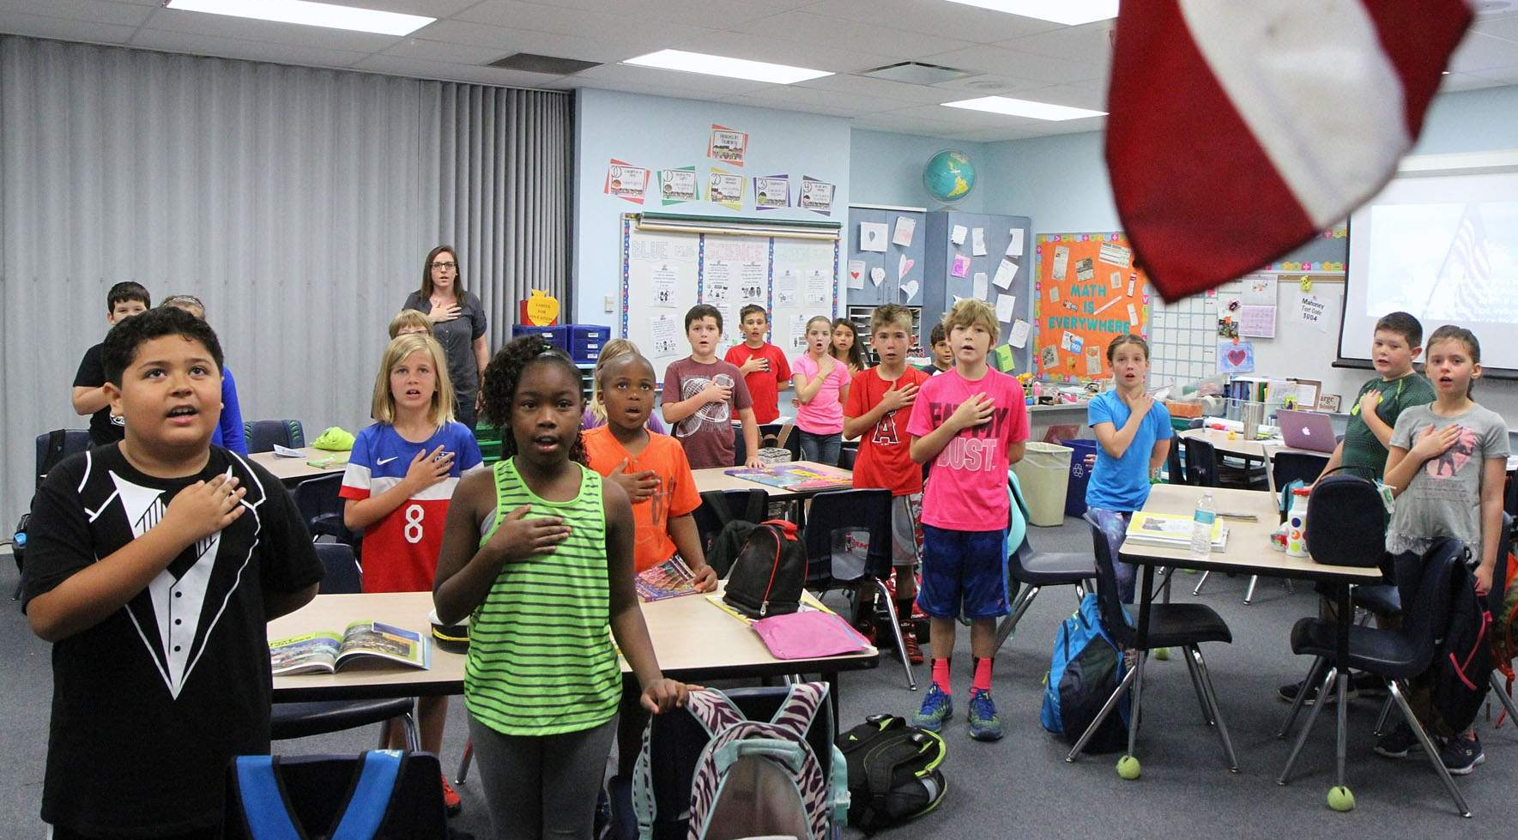

SOURCEBOOK 1-15.C

Source 3: West Virginia v. Barnette Case

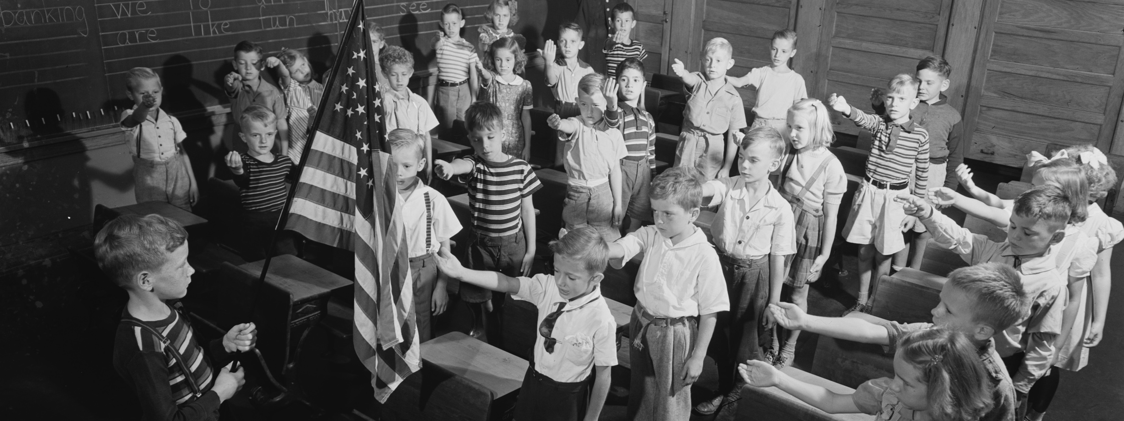

In the 1940s in West Virginia, there was a law that said that all students must stand, salute a United States flag, and say the Pledge. Marie and Gathie Barnett were Jehovah's Witnesses. Their religion did not allow them to salute flags or say pledges. Their father told them to not salute the flag. The students were sent home. Supreme Court judges heard the case. They said the students were right. It went against their religion. You do not have to say the Pledge. You do not need to salute a flag.

SOURCEBOOK 1-15.D

Source 4: Jane Doe v. Acton-Boxborough

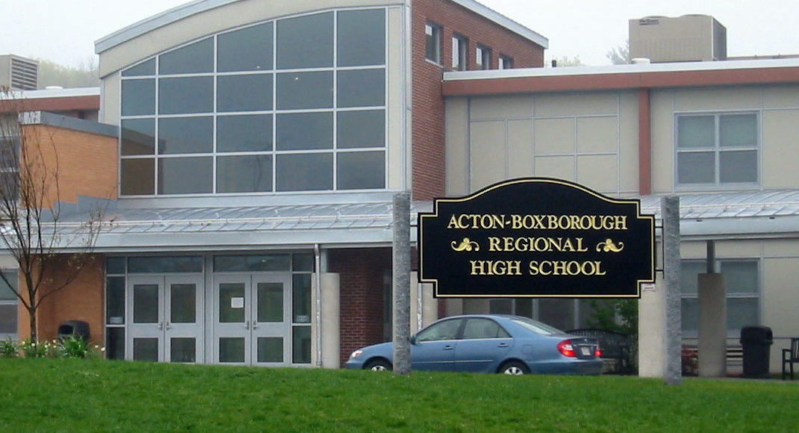

Students at Action-Boxborough High School said that the school should stop saying the Pledge of Allegiance in 2014. They said the words “under God” should not be in it. Some people do not believe in God. The Massachusetts Supreme Court said the pledge should be allowed in schools. It is not religious just because it says “under God.” They also said that no one can be forced to say the pledge.

SOURCEBOOK 1-16.C
A
SOURCEBOOK 1-16.D
B
SOURCEBOOK 1-16.E
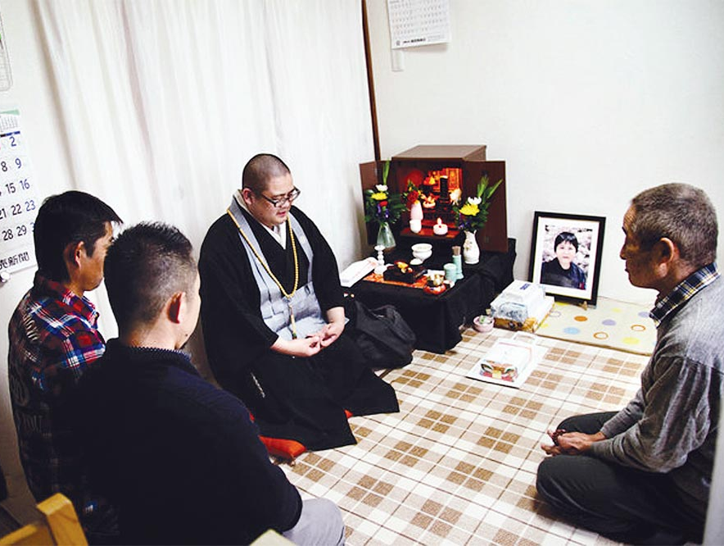
C
SOURCEBOOK 1-16.F
D

SOURCEBOOK 1-16.G
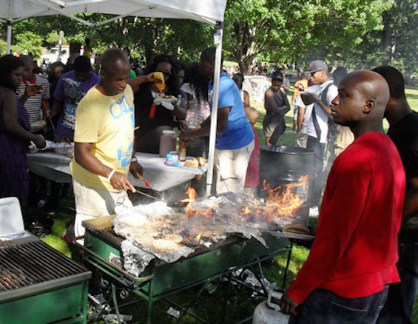
E
SOURCEBOOK 1-16.H
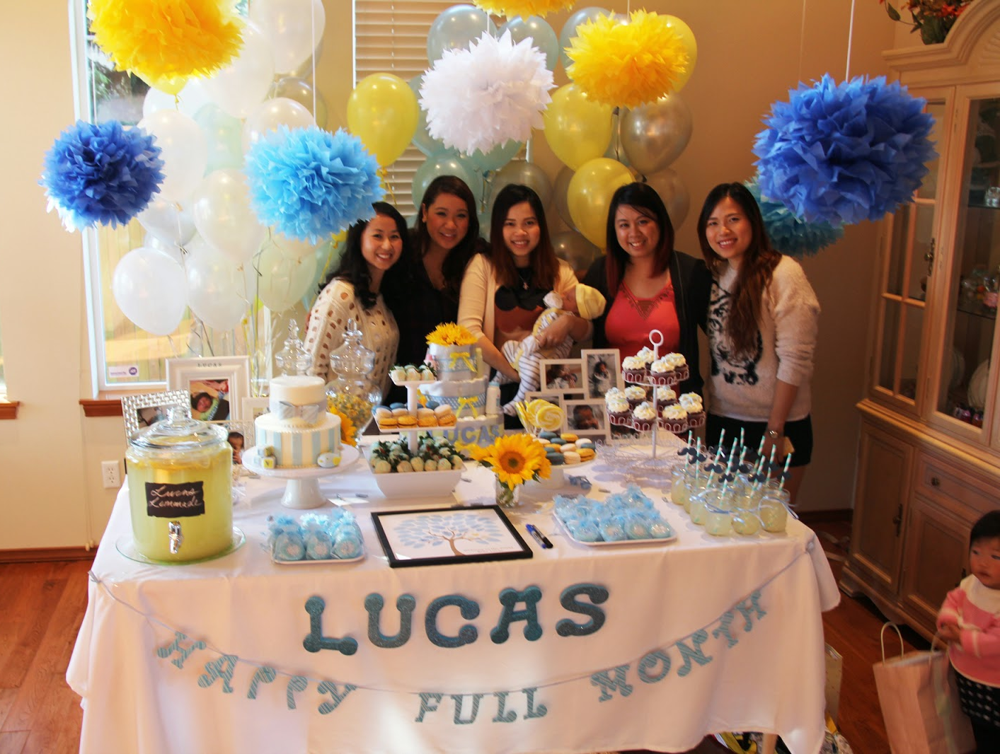
F
SOURCEBOOK 1-17.A
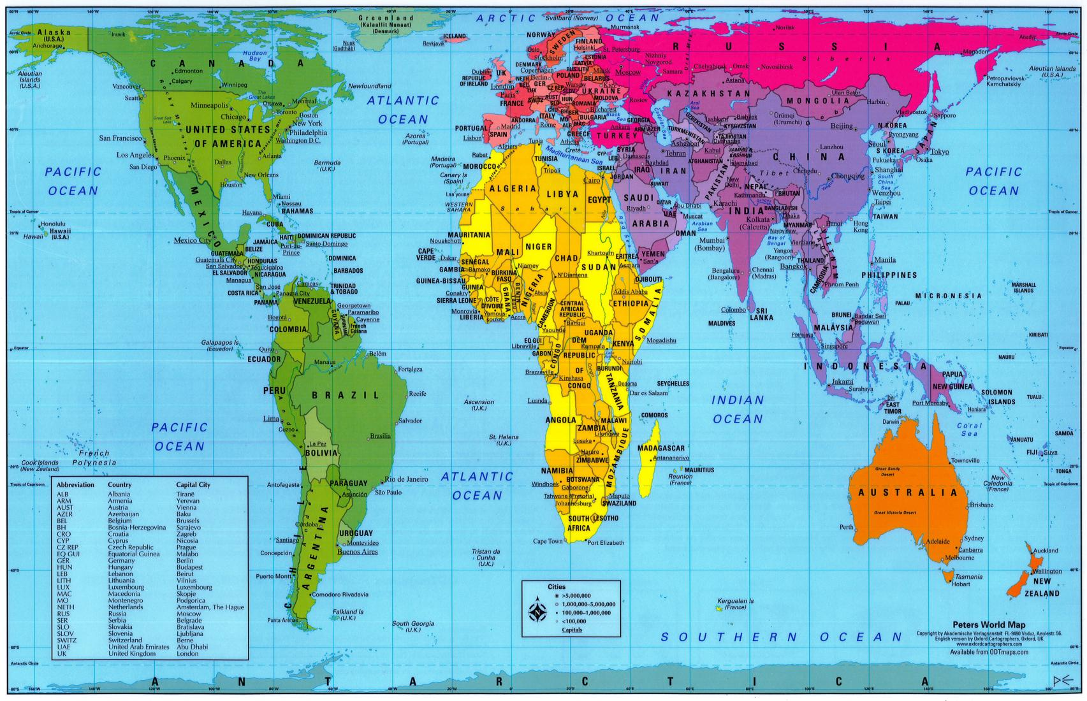
SOURCEBOOK 1-17.B

Source 1: Africa

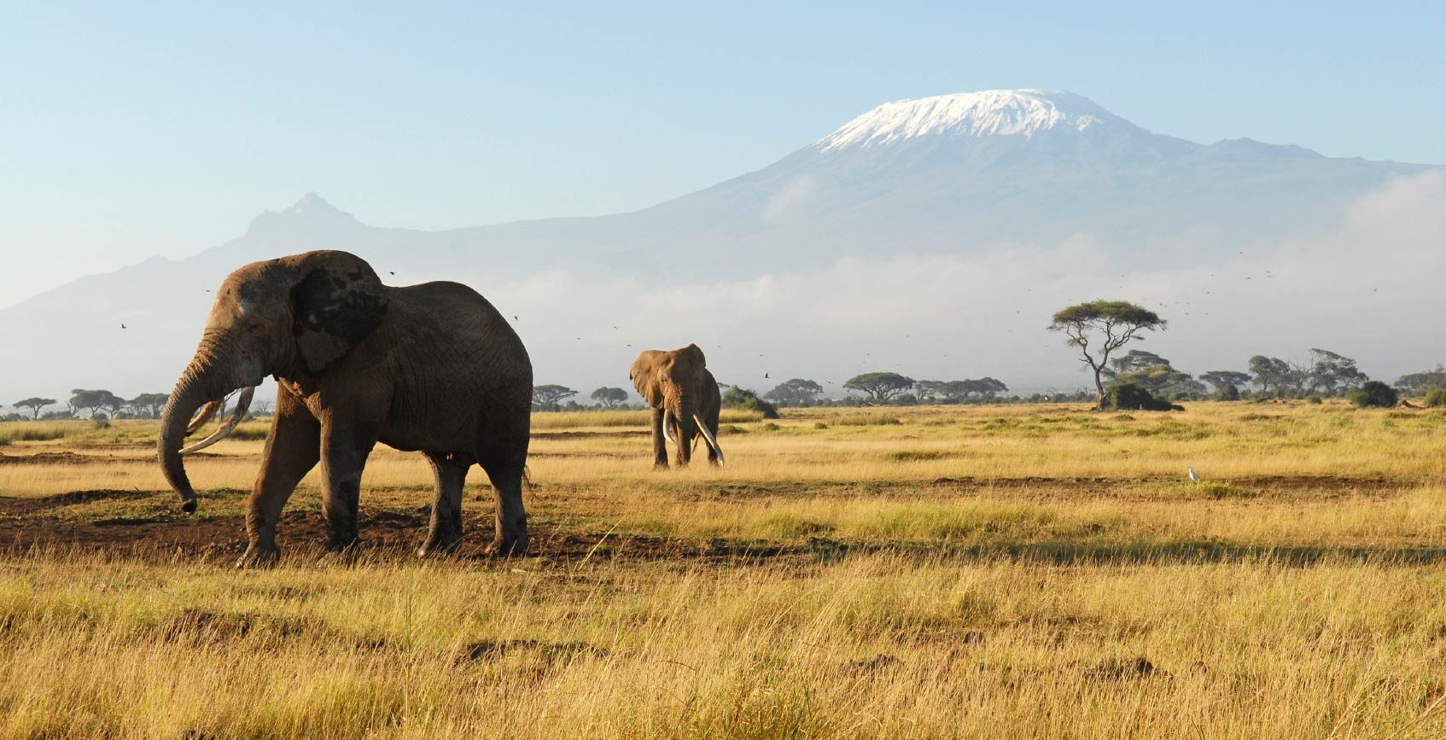

Africa is a continent with natural beauty and large cities. Above is an image of elephants in Kenya’s Ambiseli National Park. It is Mount Kilimanjaro behind them. Africa has many deserts, savannahs, jungles, and rivers.

Although some people live in rural areas (countryside), 4 in 10 Africans live in cities or towns. One important city is Cape Town, South Africa (next page). There are 797 million people living in 54 countries in Africa. There are over 1,000 different languages there. Africa is the place were humans began and then eventually moved to other continents.
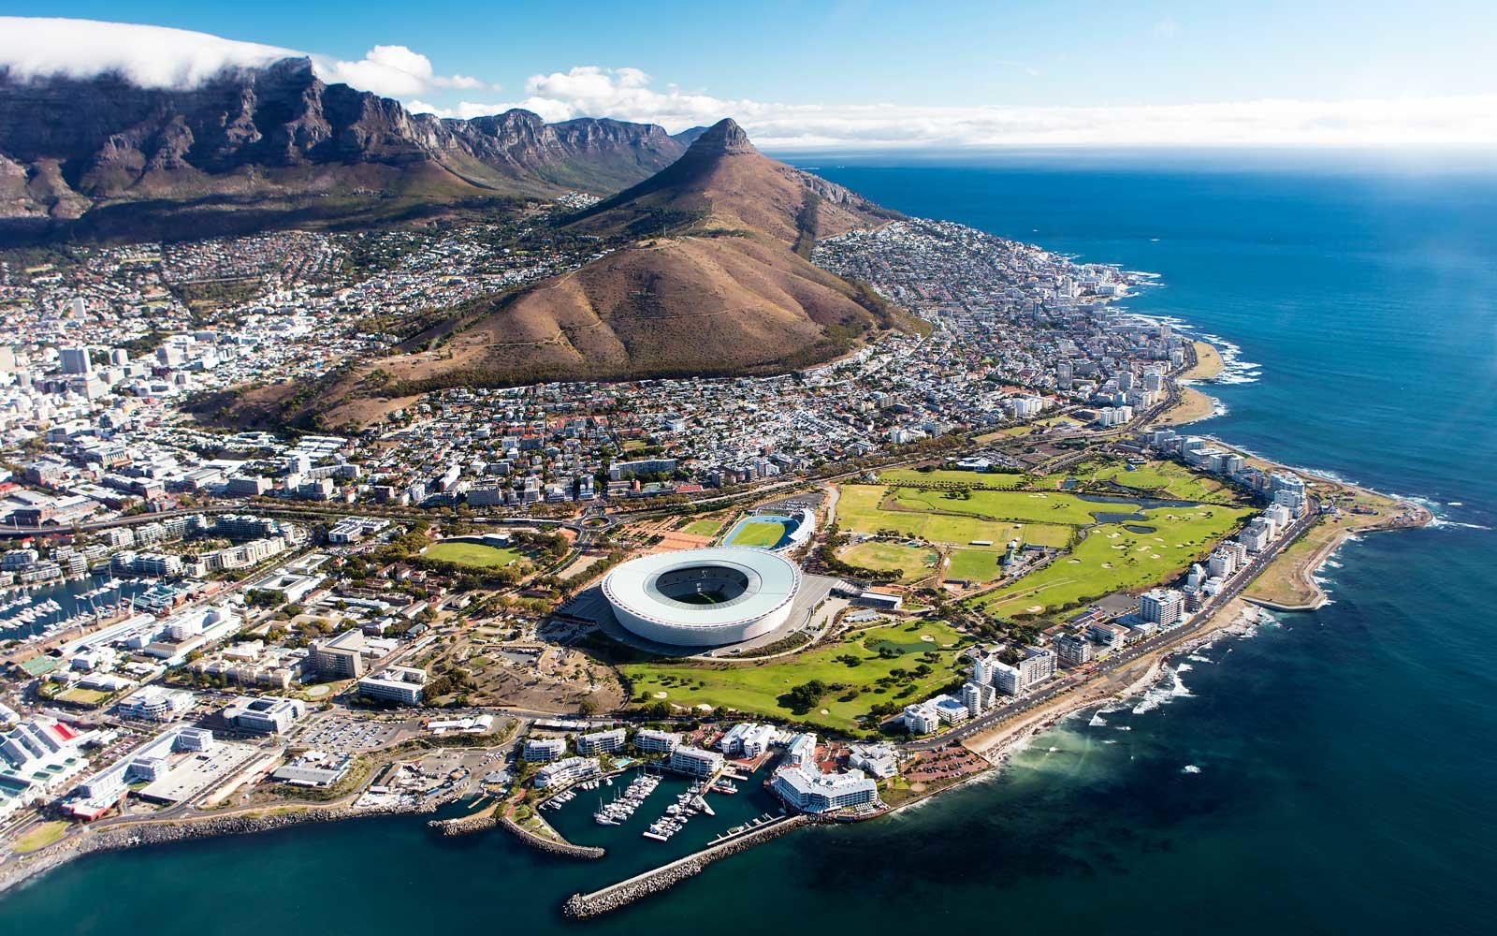

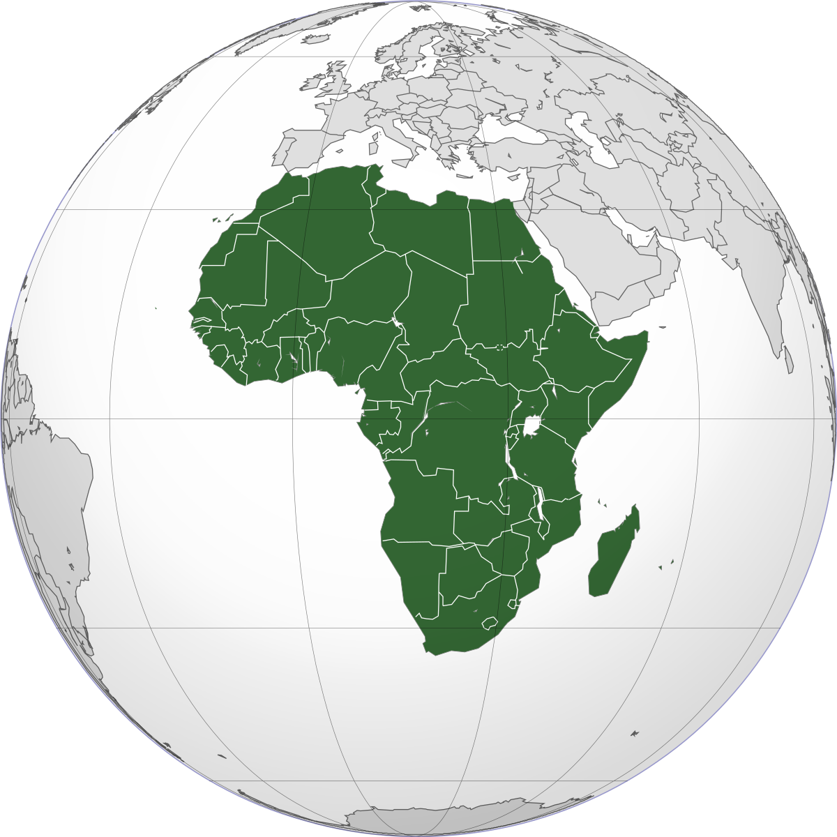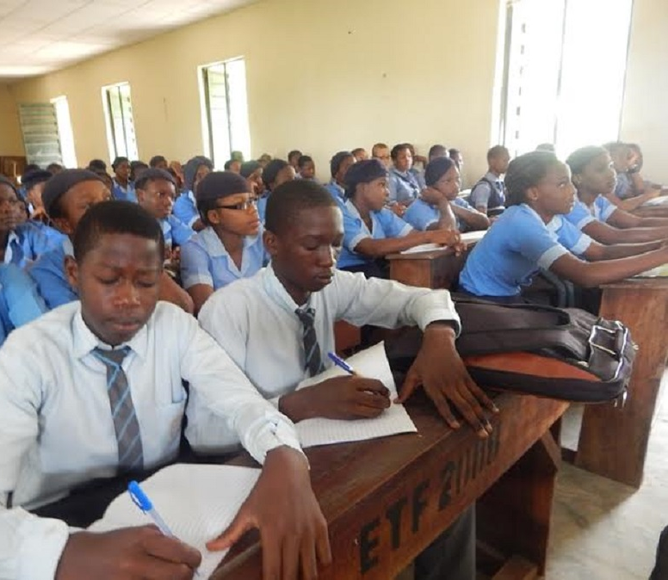

SOURCEBOOK 1-17.C

Source 2: Asia

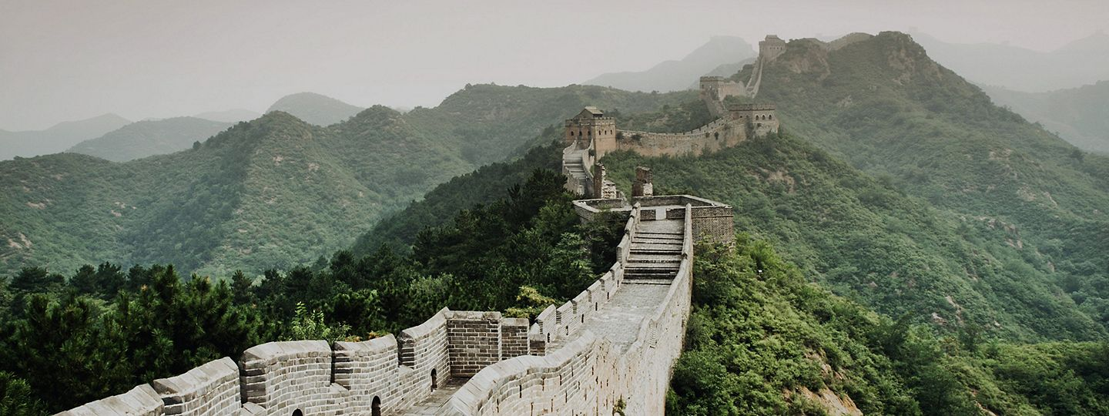

Asia is the largest continent. It includes 60% of the world’s people. Above is an image of the Great Wall in China. It is over 5,000 miles long. It is one of the most well-known places in the world. Asia has many deserts, plains, jungles, mountains, and rivers.

Although some people live in rural areas (countryside), 5 in 10 Asians live in cities or towns. One important city is Dubai in the United Arab Emirates (next page). There are 4.4 billion people living in 48 countries in Asia. There are over 2,000 different languages there. Mount Everest is the highest point on land. The Dead Sea is the lowest point on land. Both are in Asia.

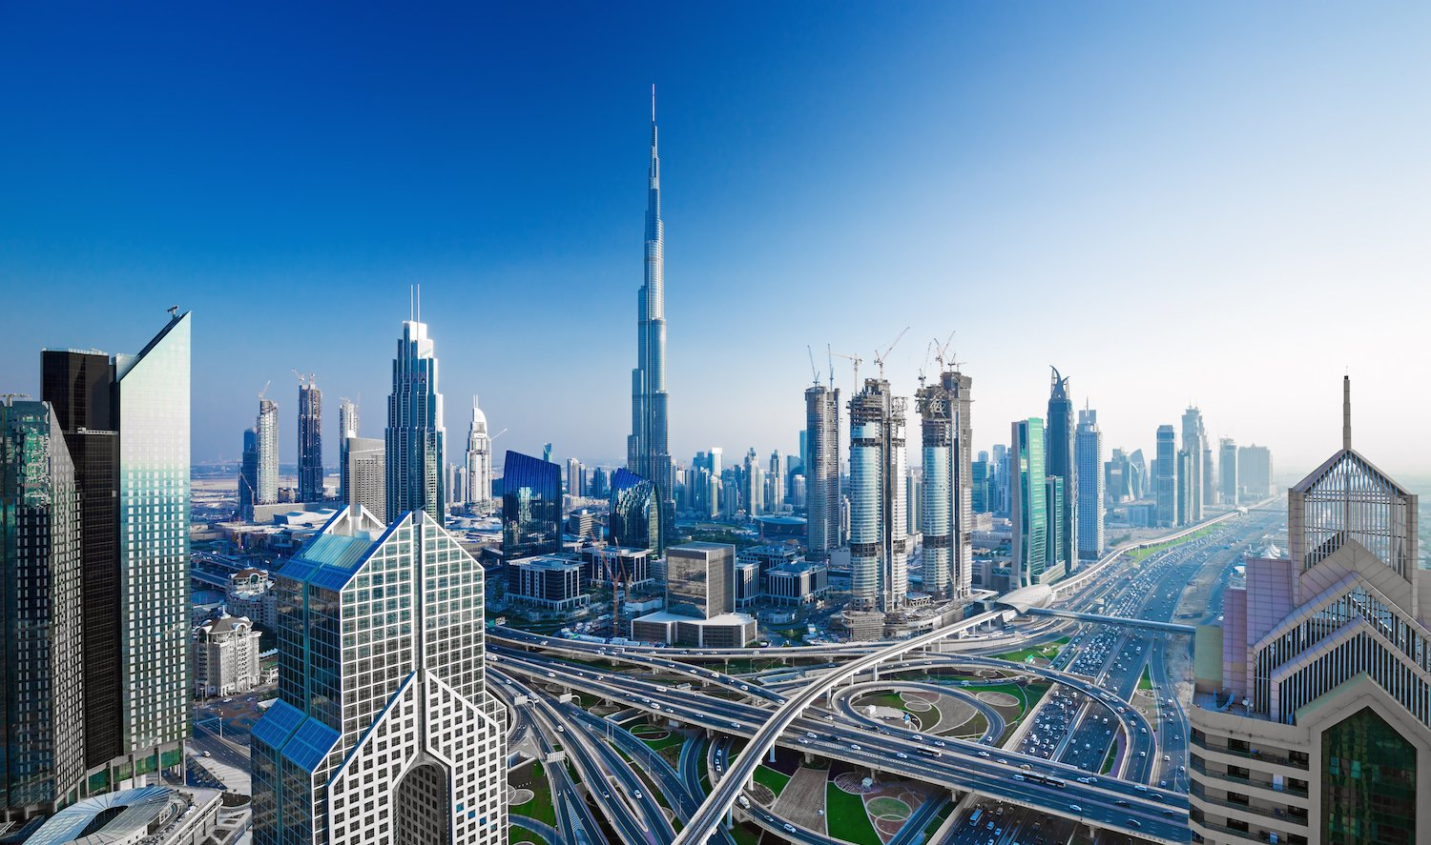

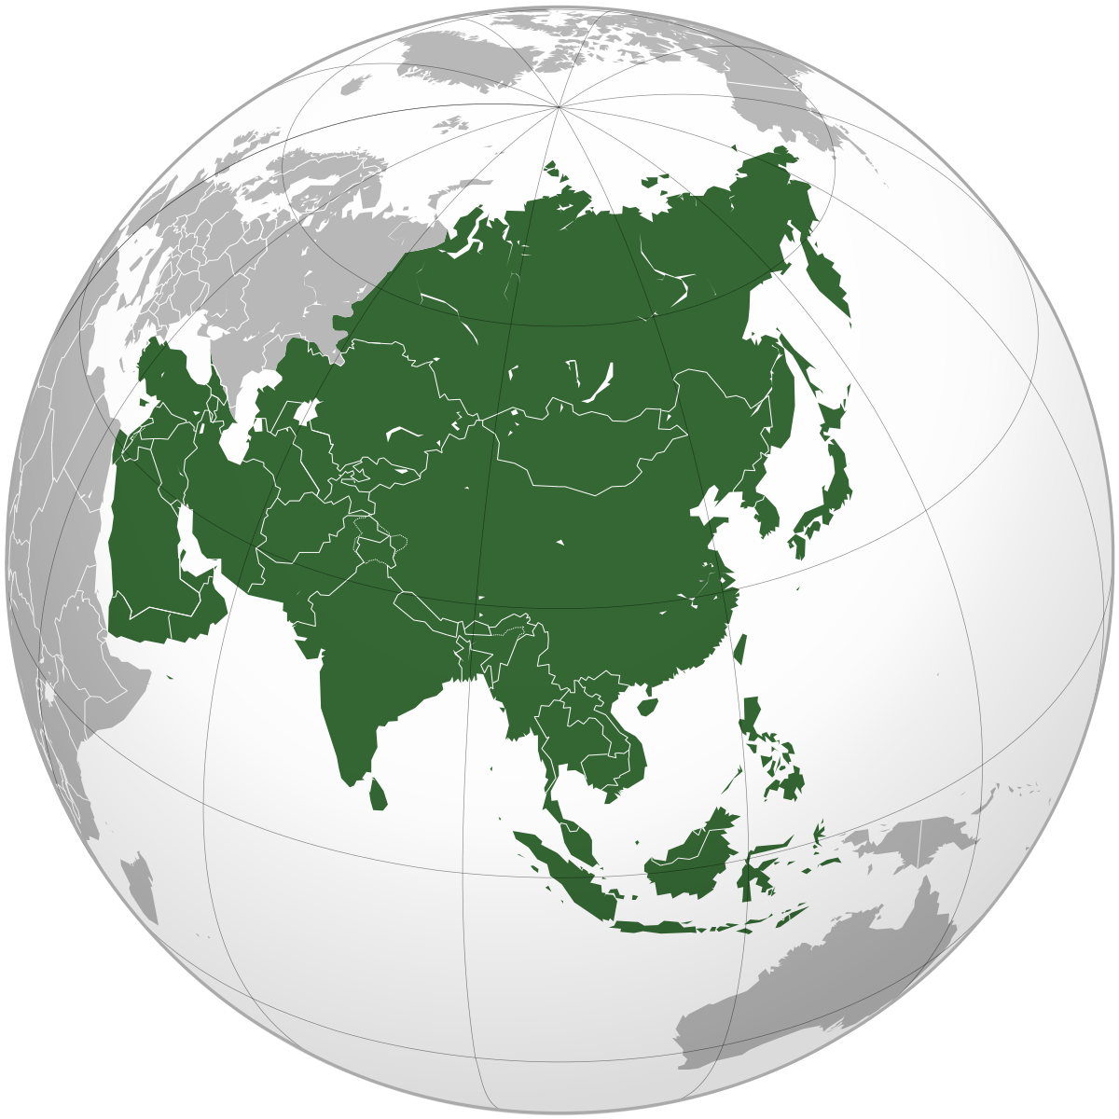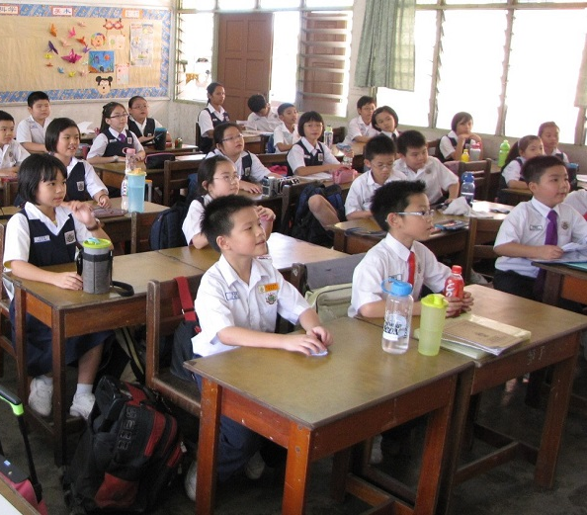
SOURCEBOOK 1-17.D

Source 3: Europe

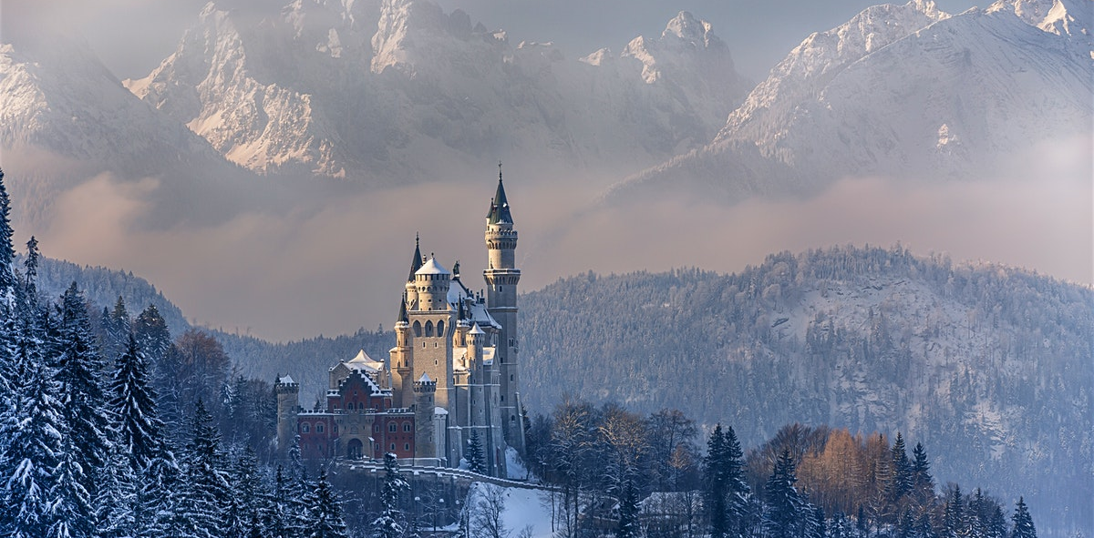

Europe is a continent with many small countries. Europe has many plains, forests, mountains, rivers, and glaciers. It is known for its castles. One famous castle is Neuschwanstein in Germany (above). Snow White’s castle is based on it.

Although some people live in rural areas (countryside), 8 in 10 Europeans live in cities or towns like Paris (next page). There are 743 million people living in 44 countries in Europe. There are over 100 different languages there. The most northern town in the world is Ny-Ålesund in Norway. Only 35 people live there all year round.
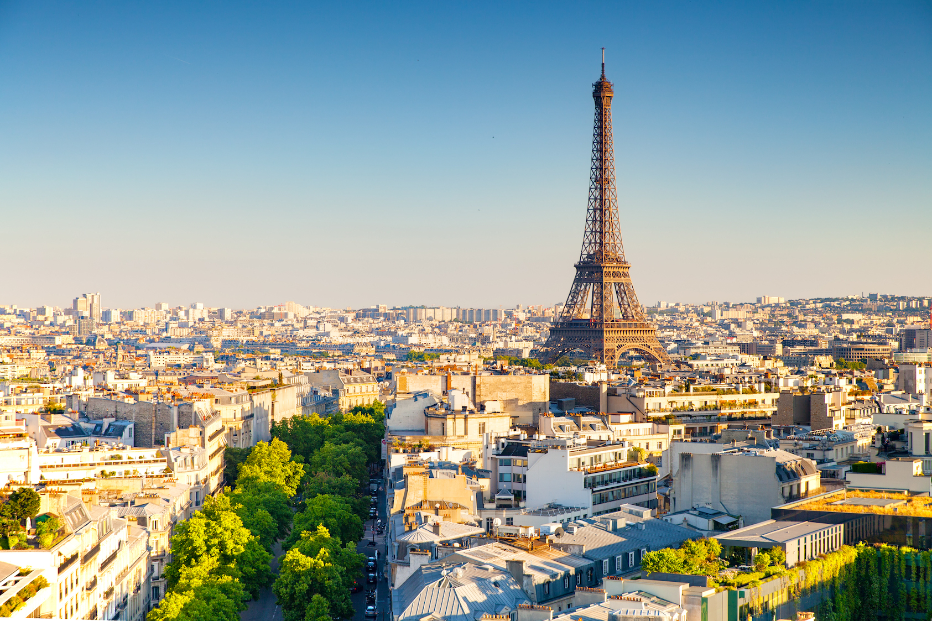

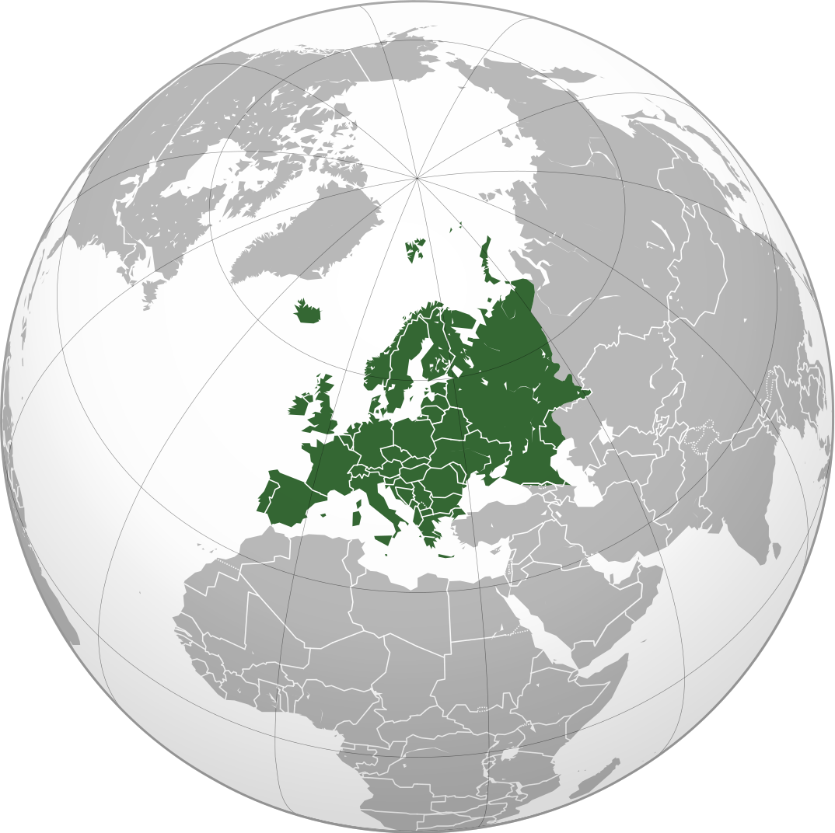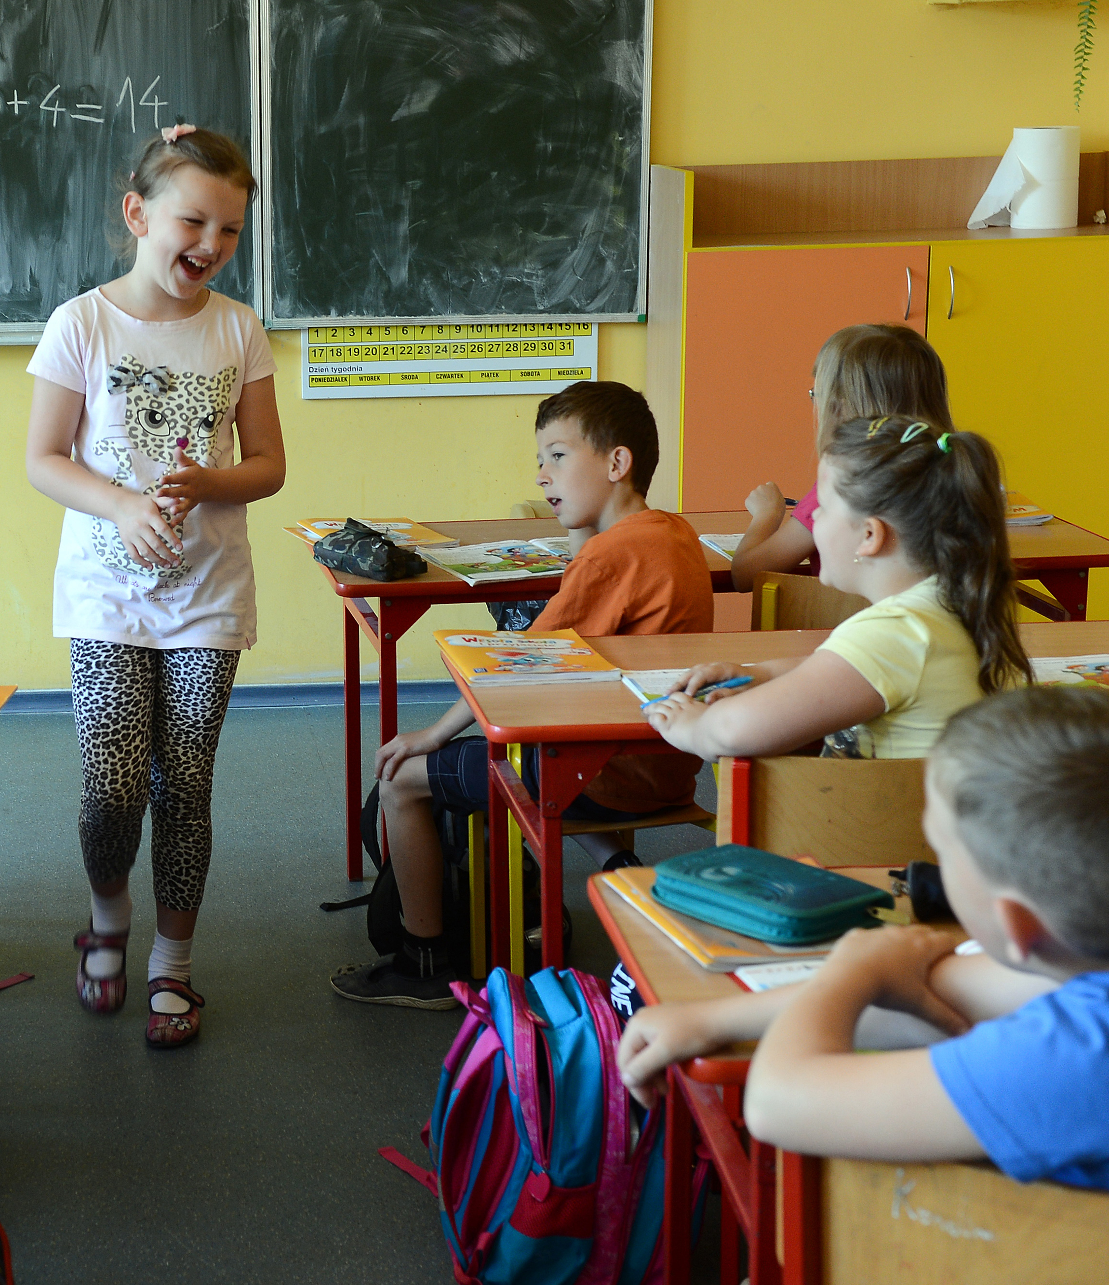

SOURCEBOOK 1-17.E

Source 4: Australia

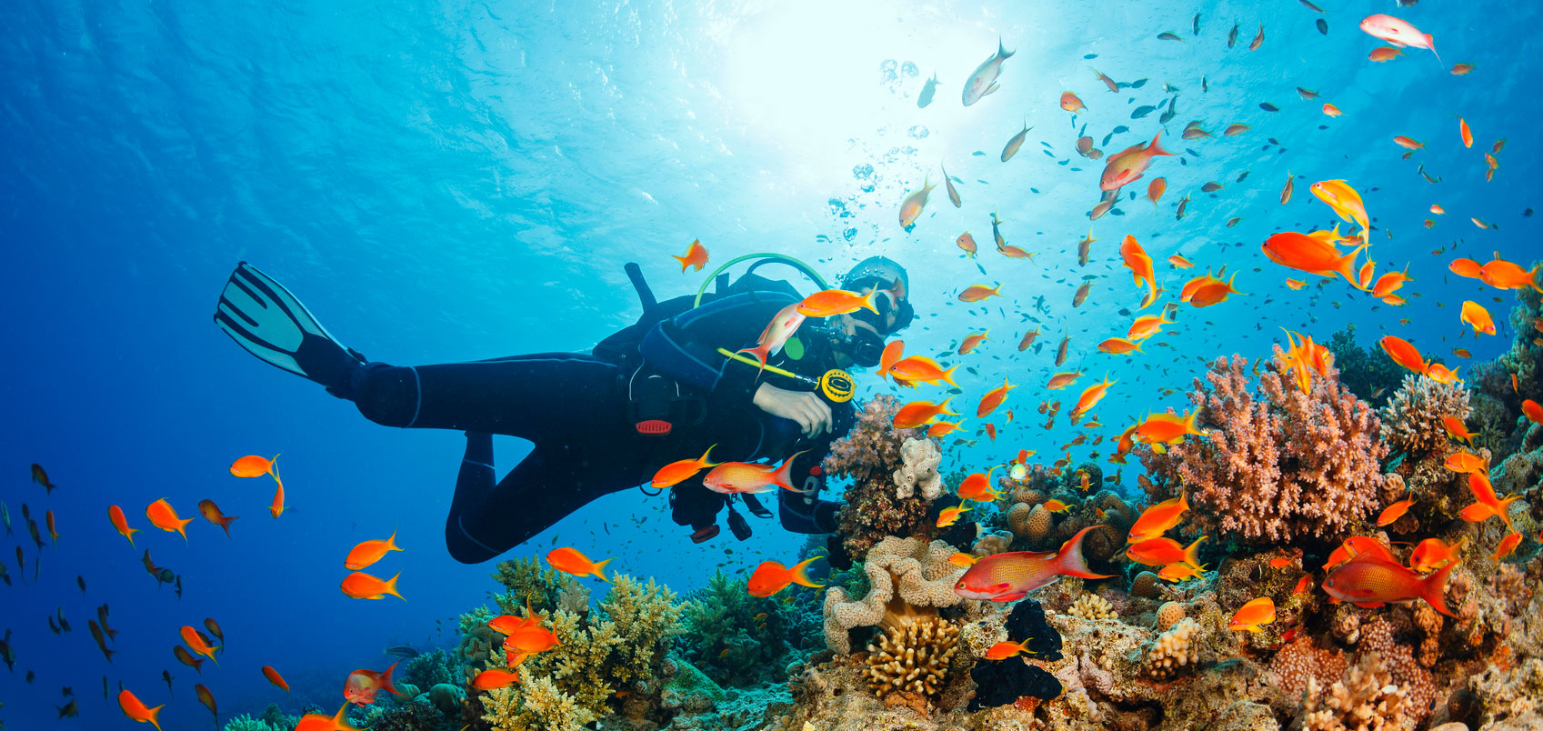

Australia is the smallest continent. Australia has many deserts, plains, and jungles. It is known for its Great Barrier Reef (above). It is home to many types of sea life. There is also the Outback. Many kangaroos (next page) and dingoes live there.

Although some people live in rural areas (countryside), 9 in 10 Australians live in cities or towns. There are 31 million people living in two countries (Australia and Papua New Guinea). There are over 20 different languages there. The Aborigines are the native people (Indigenous) of Australia. They have lived on the continent for over 60,000 years.
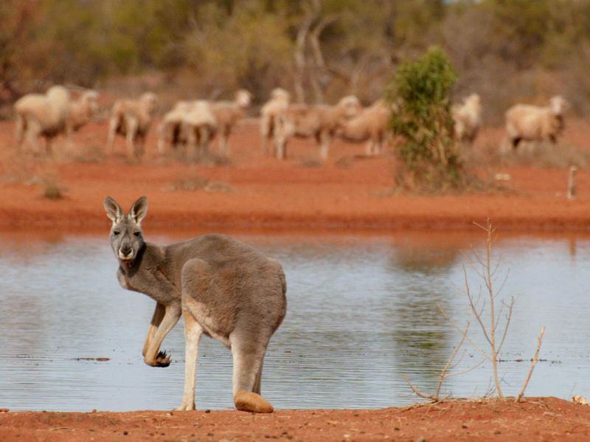

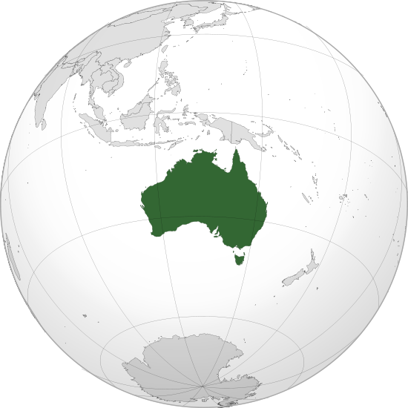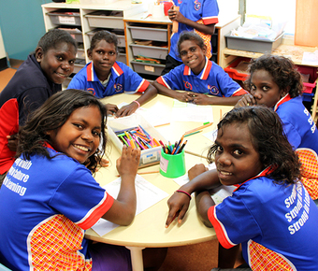

SOURCEBOOK 1-17.F

Source 5: North America

North America is a continent of large cities and natural beauty. It has the Grand Canyon (above). It also has Barbados (next page-top). North America has many deserts, plains, mountains, jungles, rivers, and glaciers.

Although some people live in rural areas (countryside), 8 in 10 North Americans live in cities or towns. One important city is Toronto in Canada (next page-middle). There are 579 million people living in 23 countries. There are over 300 different languages there. The Indigenous people (also called First Nations, American Indians, Native Americans) are the native people of North America. They have lived on the continent for over 15,000 years.
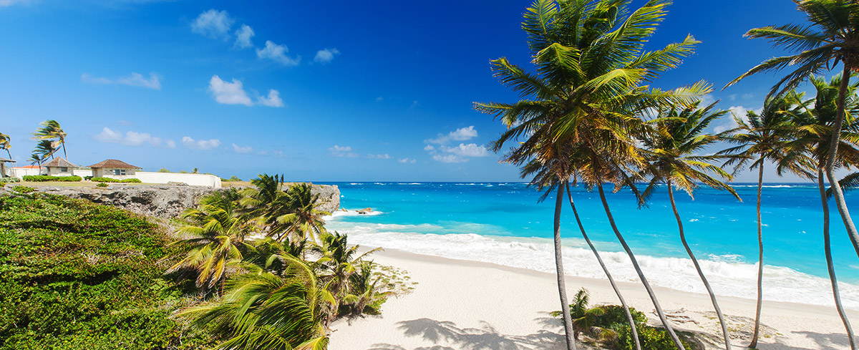

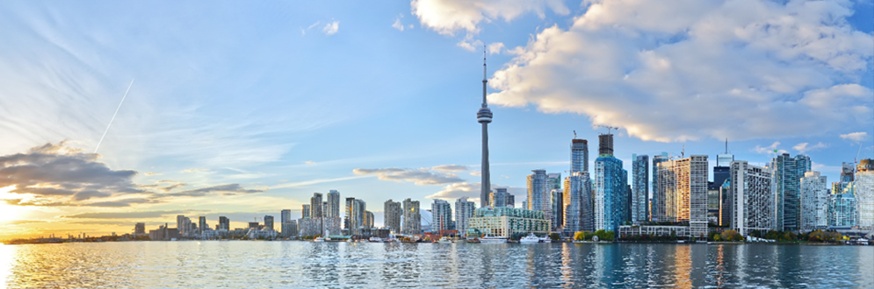

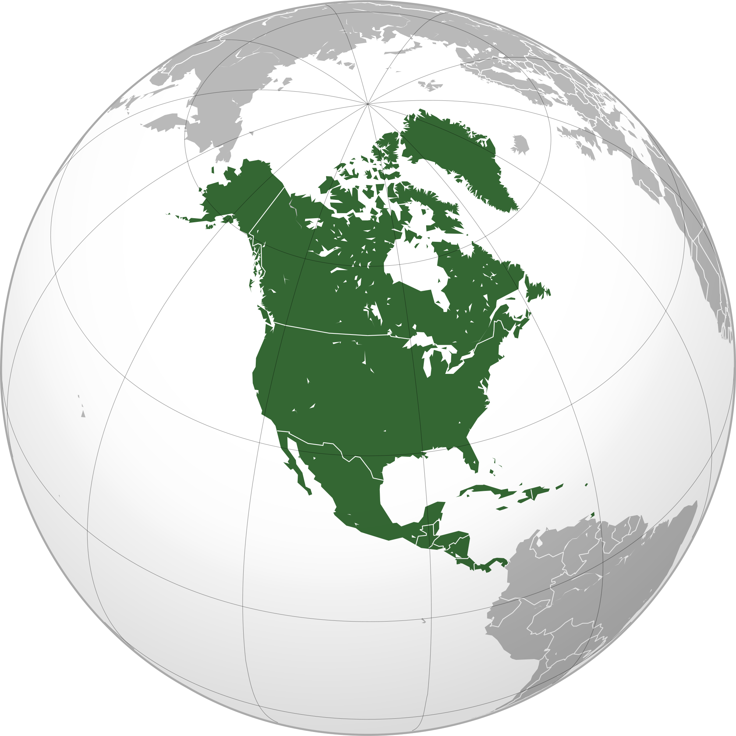
SOURCEBOOK 1-17.G

Source 6: South America

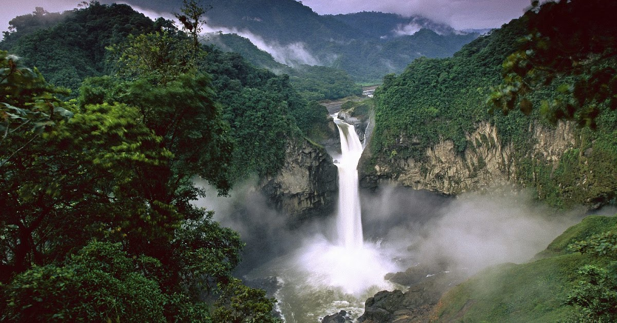

South America is a continent of large cities and natural beauty. It has the famous Amazon Rain Forest in Brazil (above). It also has Machu Picchu in Peru (next page-top). South America has many mountains, plains, deserts, jungles, and rivers.

Although some people live in rural areas (countryside), 8 in 10 South Americans live in cities or towns. One important city is Buenos Aires in Argentina (next page-middle). There are 522 million people living in 12 countries. There are over 400 different languages there. There are only two countries in South America that are not on the ocean. They are Paraguay and Bolivia.
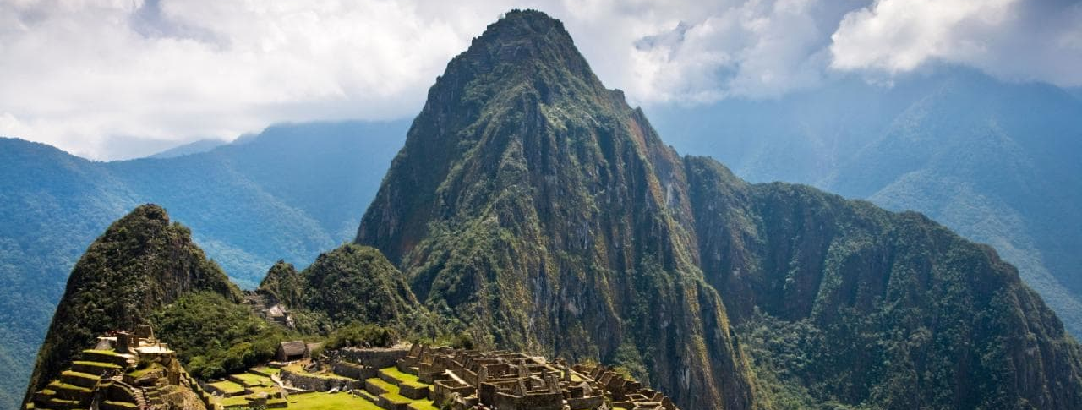

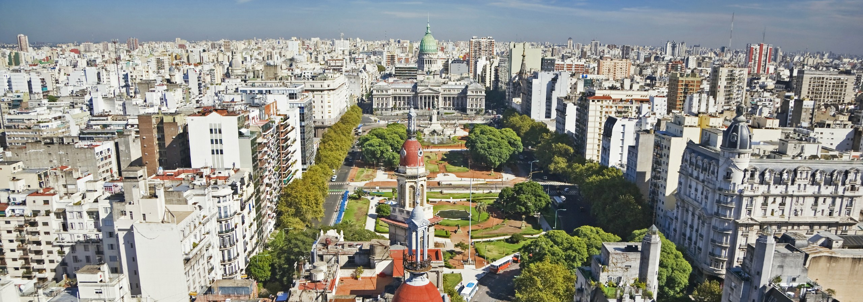

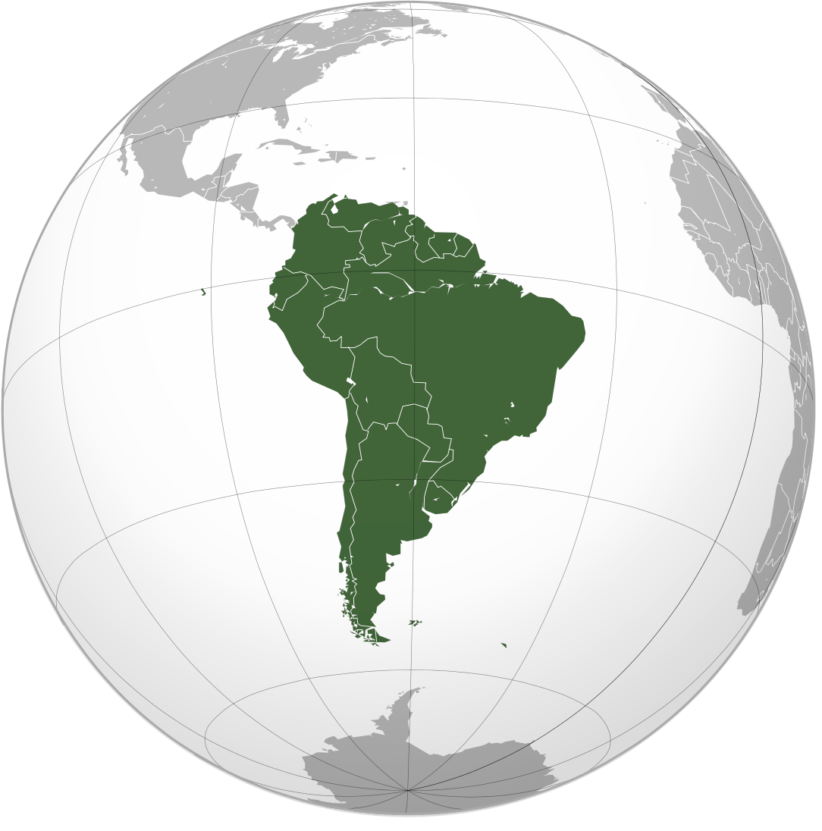

SOURCEBOOK 1-17.H

Source 7: Antarctica

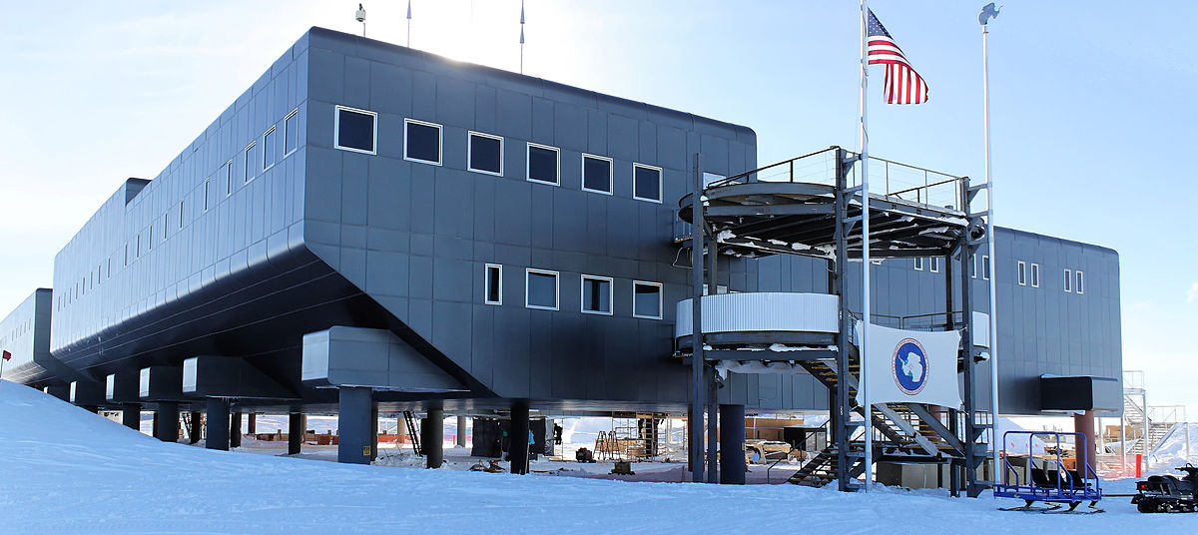

Antarctica is the only continent without people who live there. Only scientists live there (above is a U.S. science station). Tourists can visit Antarctica on cruises. They are very expensive.

Humans did not even know Antarctica existed until the 1700s. Humans did not go to Antarctica until 1820. There are no countries there. It is the coldest continent. It is covered with ice. Antarctica is known for its wildlife. It has penguins (next page-top), whales (next page-middle), and seals.
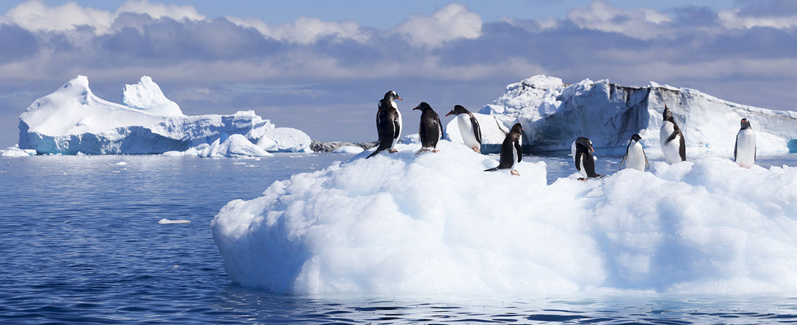

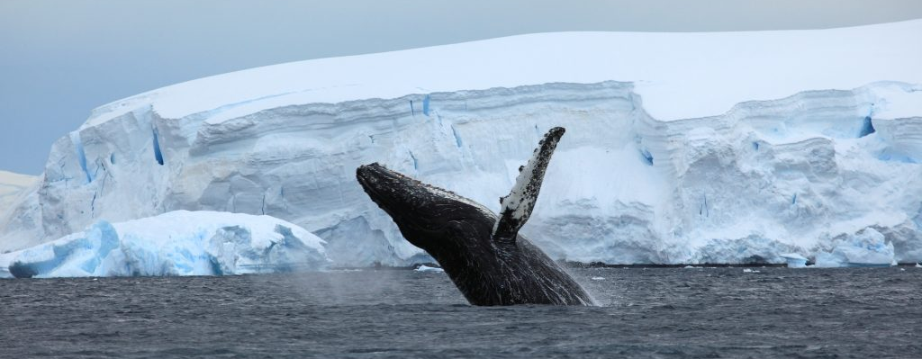

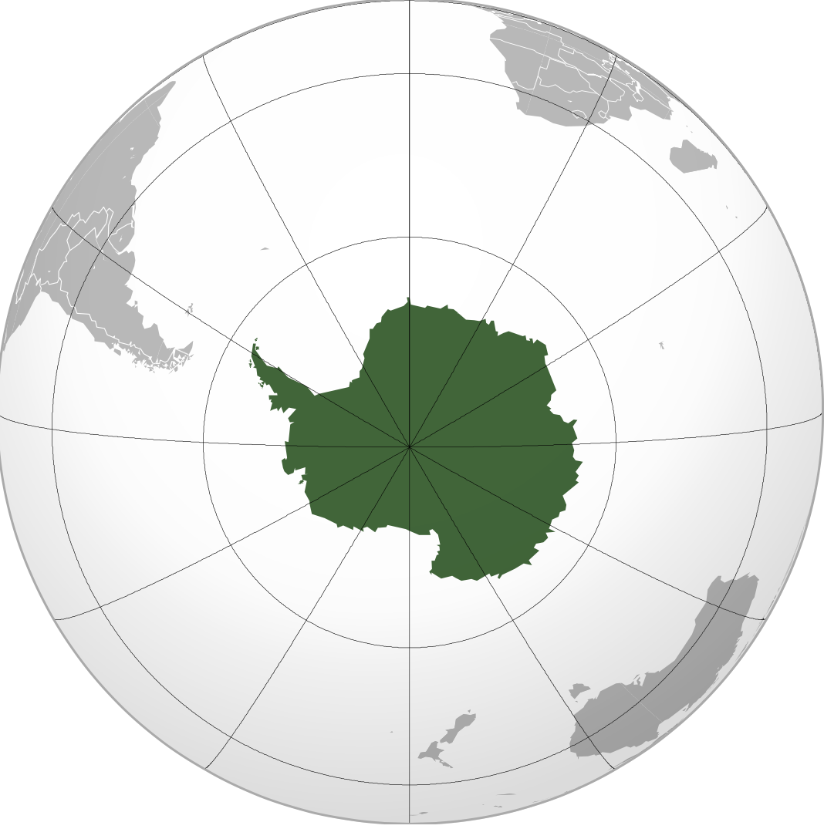
SOURCEBOOK 1-18.A

Source 1: Mahatma Gandhi

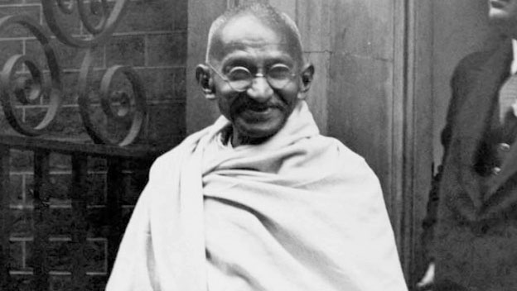

Mahatma Gandhi was born in India. He went to law school in England when he was 19. He moved to South Africa to be a lawyer. South Africa had Apartheid. African and Indian people did not have the same rights as European people. He thought this was wrong. He returned home to India. He realized that the British government treated Indian people unfairly there too. Indians could not live in European areas. They could not hold certain jobs. They could not vote for their leaders. Mahatma Gandhi wanted India to be independent from Britain. It should rule itself. He did not believe in violence (hurting people). He held many protests where people were peaceful. He and his followers marched for 240 miles to the ocean to collect salt. Indians were not allowed to take salt from the Ocean. The British government arrested 60,000 Indians. In another protest, he fasted (did not eat) for 21 days. He was sent to prison for breaking British laws. He started spinning cotton to make his own clothes (below). He then told all Indians to do the same. They should not buy British clothes. In 1948, the British government allowed India to become its own country. It had its own leaders. Mahatma Gandhi would travel around the world speaking about peace and the need for all people to rule themselves.

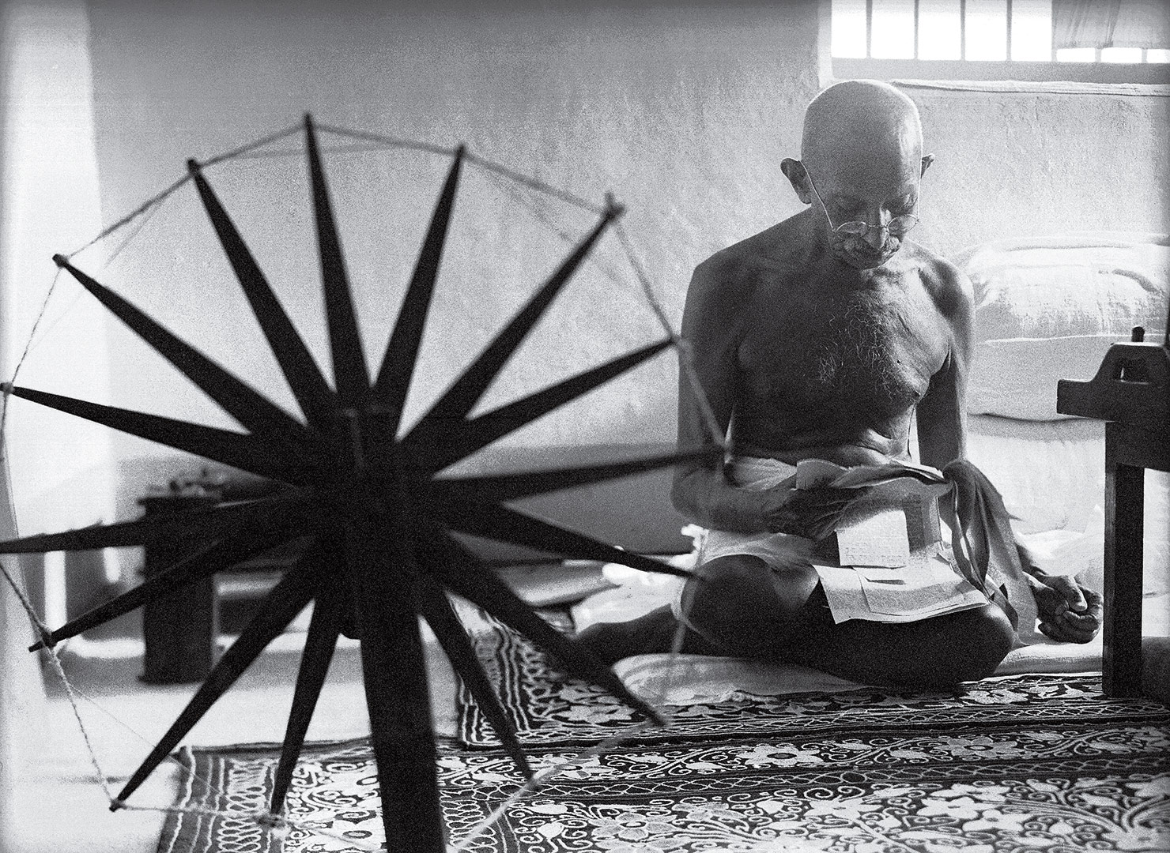
SOURCEBOOK 1-18.B

Source 2: Desmond Tutu

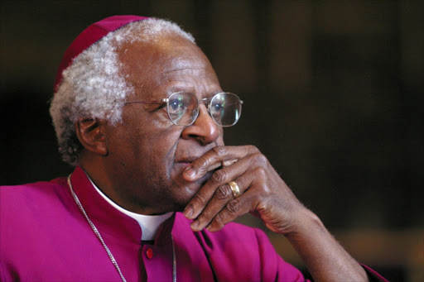

Desmond Tutu was born in South Africa. When he was little his family moved around often. He became a minister. In South Africa they had Apartheid. African and Indian people did not have the same rights as European people. He thought this was wrong. He started preaching about how Apartheid was wrong. He led protests against it. He would become the Archbishop of Cape Town. They never had a Black archbishop. He was given the Nobel Peace Prize. It is an award for making the world better and more peaceful. His protests would lead to South Africa ending Apartheid. He continues to travel the world trying to stop poverty, HIV/AIDS, and tuberculosis. He protests against discrimination (treating people different because of who they are). He would help another protester named Nelson Mandela (below) be released from prison. Nelson Mandela later became the first Black president of South Africa.

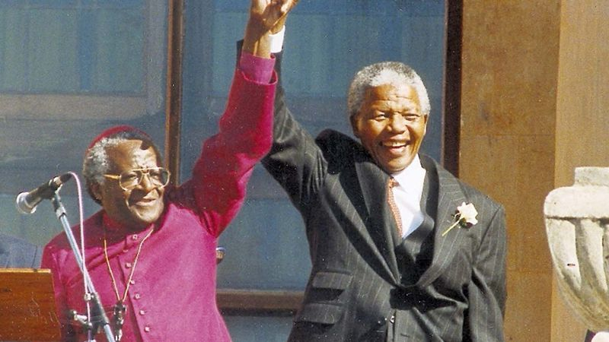
SOURCEBOOK 1-18.C

Source 3: Malala Yousafzai

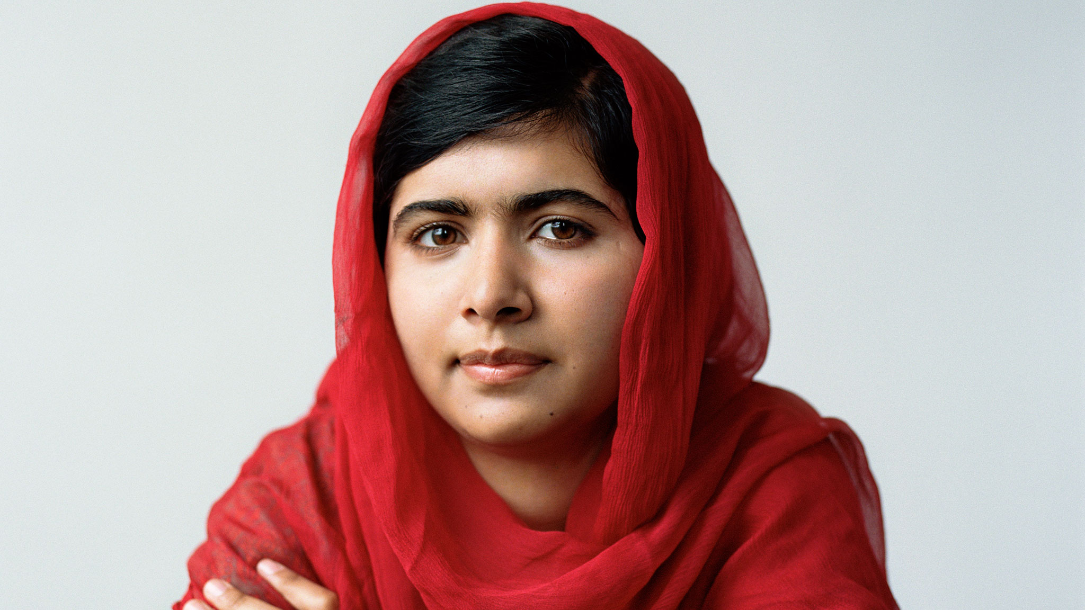

Malala Yousafzai (ma-la-la you-shaf-zai) was born in Pakistan. A group called the Taliban decided to close all schools for girls. She began blogging (posting on the Internet) when she was 11 years old about her life. She told everyone about not going to school. She did not use her real name. She was afraid someone would find out and maybe hurt her family. Many people read her blog posts. Different governments started to work with Pakistan to reopen the schools. Eventually her school would reopen. He family would leave their hometown. They were afraid for their safety. She was given the Nobel Peace Prize. It is an award for making the world better and more peaceful. She continues to travel around the world giving speeches about the importance of educating all girls and women.

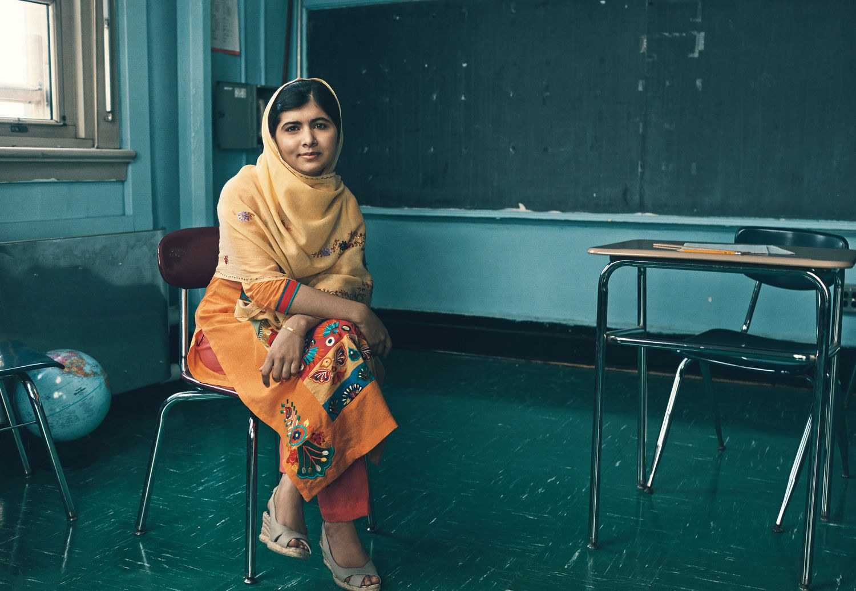

SOURCEBOOK 1-18.D

Source 4: Mary Robinson

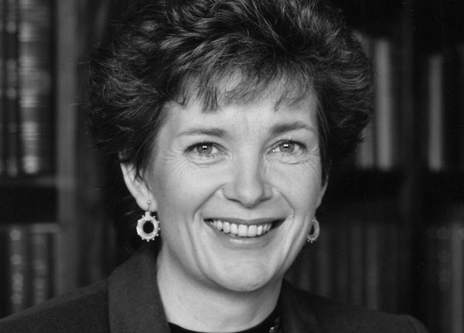

Mary Robinson was born in Ireland. She worked hard in school. She eventually became a lawyer. She realized that women were not being treated the same as men in Ireland. She saw that there were few women in government. She ran for City Council in Dublin (Ireland’s capital city). She later won election for the Seanad Éireann (she-an-ed er-in). It is the Irish Senate. There she helped pass many laws to make women equal. This included allowing women to serve on juries (people who say guilty or not guilty in court). They also allow women to stay working after they were married. She decided to run for Ireland’s president in 1990. No woman had ever run for president. Some people made fun of her for being a woman. Other people were really excited that she was running. She won the election. She became a very popular president (see her signing a law below). She then became a leader at the United Nations. She helped refugees. Refugees are people who have to leave their country due to war, hunger, or jobs. She travels around the world giving speeches about the importance of women leaders. She helps more women run for office.

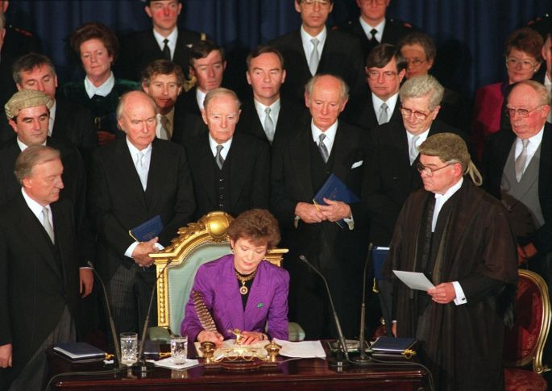
SOURCEBOOK 1-19.C

Source 1: Global Warming/Climate Change
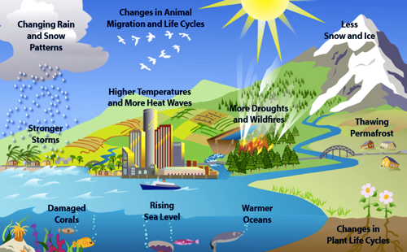

The planet is warming up fast—faster than at any time in history. This is called global warming. Global warming is causing climate change (above). There is less or more rain, wind, or snow than in the past. This is hurting people’s way of life. Some farmers cannot grow their crops due to droughts or too much rain. Some cities are experiencing heat waves. This hurts people’s health. Hurricanes and blizzards are getting stronger. Glaciers (large ice) in the mountains and north pole are melting. This causes the sea to rise. Coral reefs are dying because the ocean is too warm. Climate changes also hurt animals and plants.

What is causing this? Most scientists agree that humans are causing global warming. When people burn carbon fuels (like oil, gasoline, natural gas, or coal), it sends carbon dioxide into the atmosphere (air). This creates a greenhouse effect. It is like a greenhouse where plants grow. These gases prevent heat from escaping the Earth.

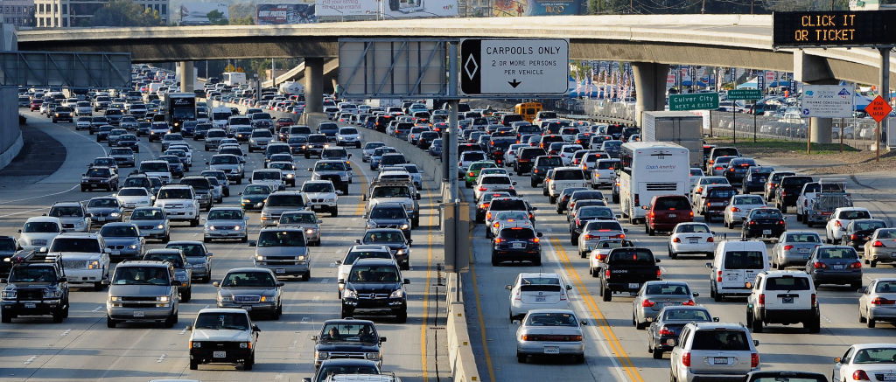

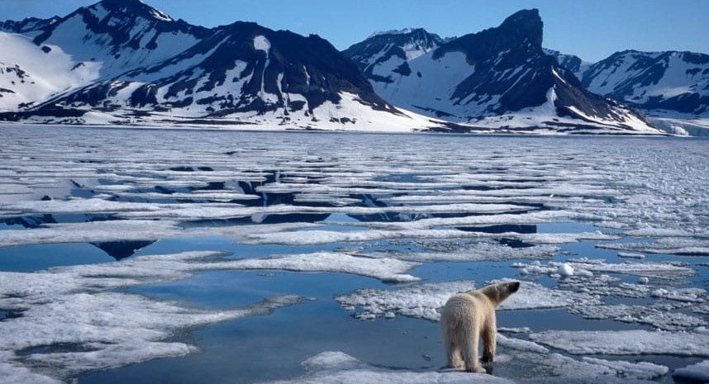
SOURCEBOOK 1-19.D

Source 2: Poverty
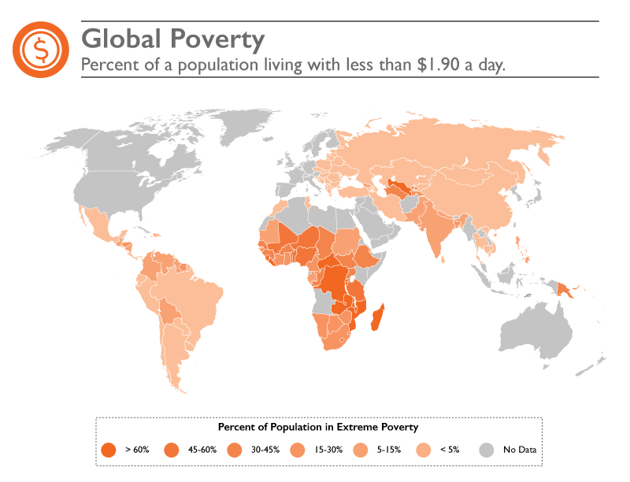

Poverty is when a person or family does not have enough money to pay for the home, food, or clothes. Some countries around the world have more money than others. Most countries have people who live in poverty (including the United States). In the above map, it shows that more than half of the world’s countries have high poverty. Any country in orange has many people who live on less than $1 a day.

What is causing this? Poverty is caused by many things. Not having work can lead to poverty. People cannot earn money. Problems with weather can cause poverty. People cannot grow food. In some countries leaders are unfair and they only let some people get food, clothes, and other things they need.

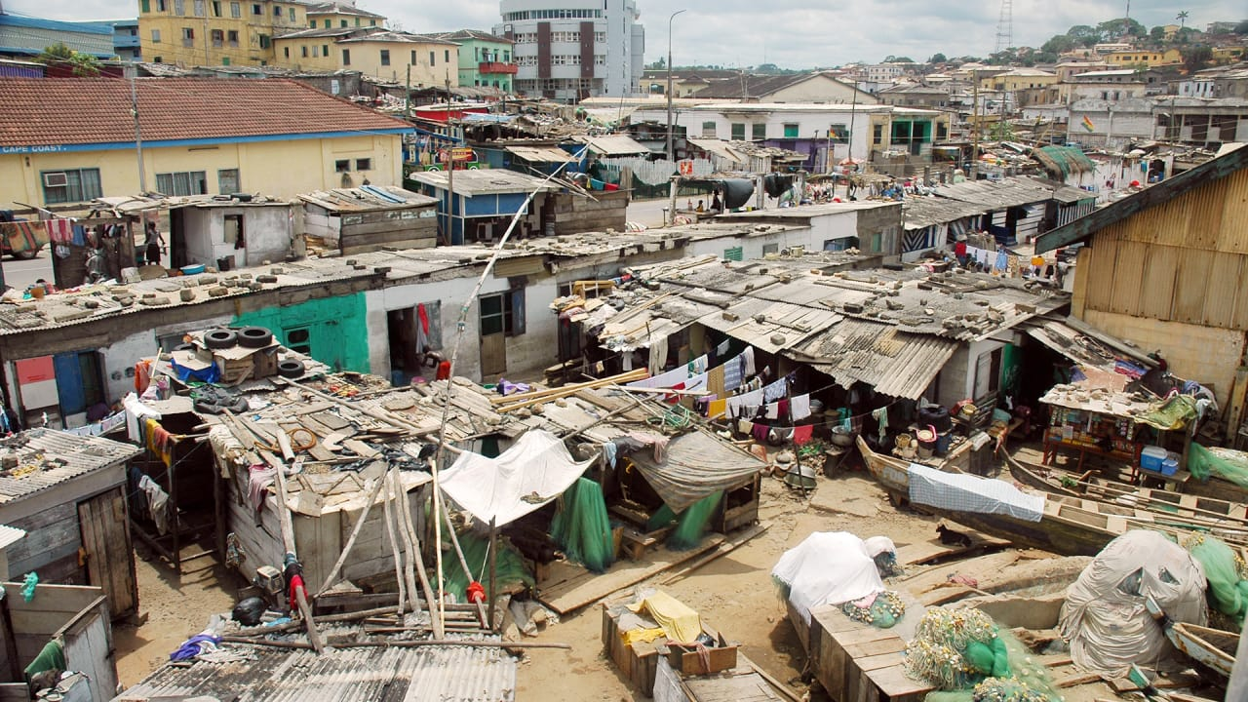

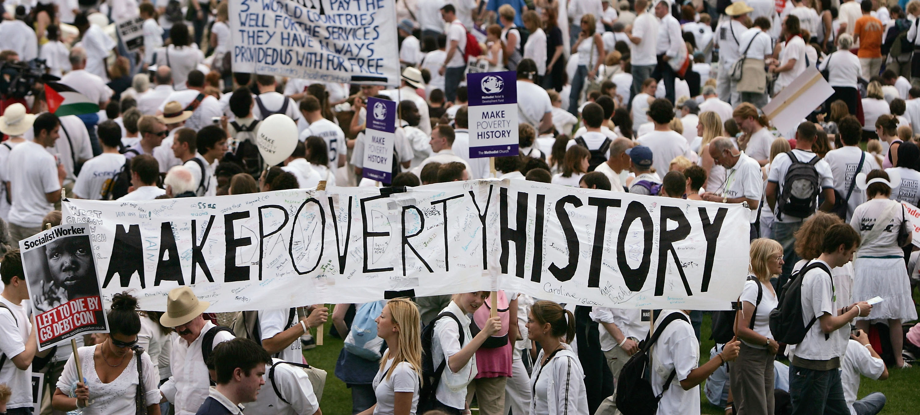
SOURCEBOOK 1-19.E

Source 3: Disease
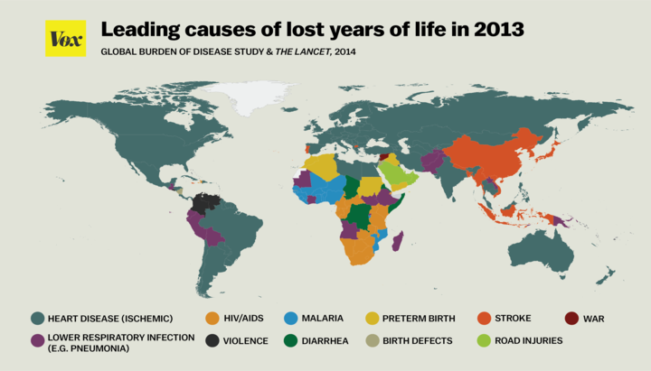

Diseases often end people’s lives early. Heart disease causes heart attacks. Malaria is spread by mosquitos. HIV/AIDS is spread through blood or other body fluids. Cancer is caused by many things. Many diseases have cures. Some people cannot afford the medicine. Other diseases do not have cures. Scientists do experiments to find new medicines. Diseases can spread and make many people sick or die. The Zika virus spread in 2015 and 2016. Many people in South America and the Caribbean became sick. They killed many of the mosquitos that carried Zika. This stopped it.

What is causing this? Finding medicines to cure disease is very expensive. People do not have enough money to stop diseases. Sometimes countries also do not have enough money. Scientists may not have the money to do their research. That can lead to cures. The World Health Organization is part of the United Nations. It tries to help stop diseases worldwide. Its budget is only $3 billion (the state of Massachusetts has a budget of $60 billion).

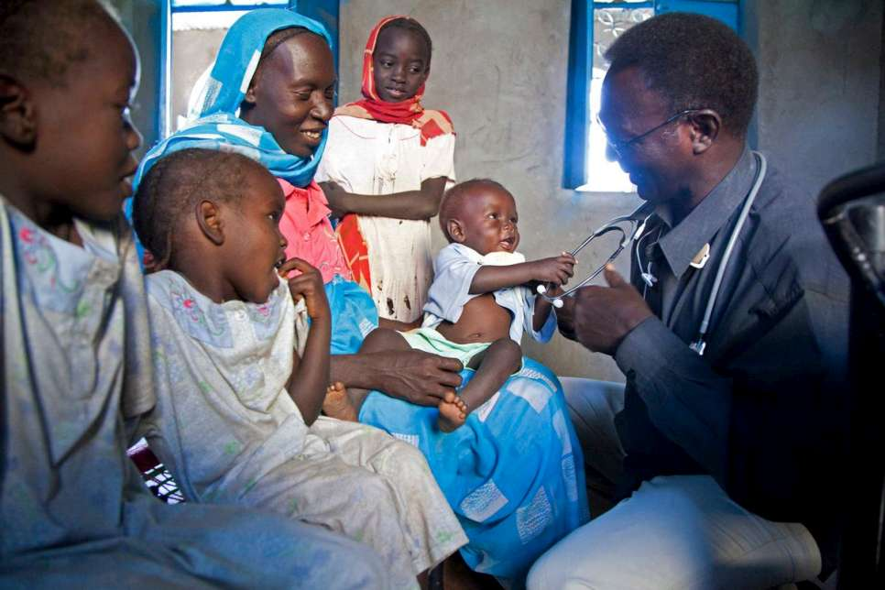

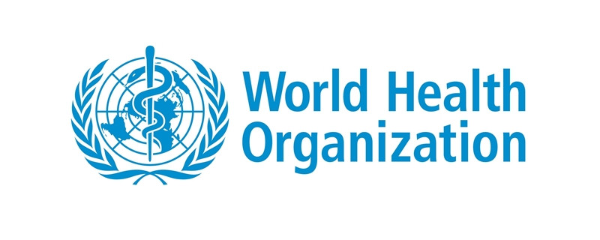
SOURCEBOOK 1-19.F

Source 4: Lack of Democracy
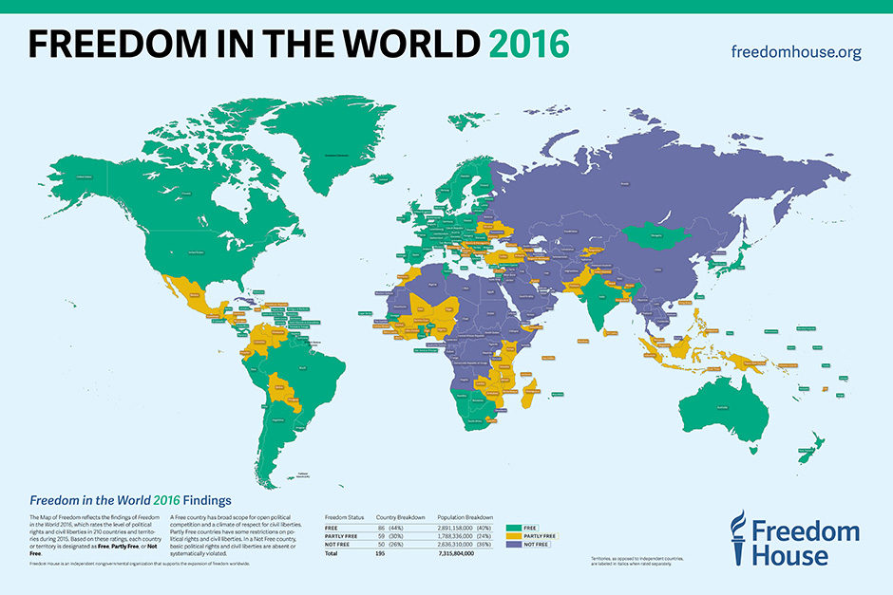

Democracy is when people have a say in their government. The United States has a democracy. Other countries have instead have kings or queens. They may also have only one person (dictator). They may have military rulers. These leaders are not elected. People in those countries do not have as much freedom. They have no say over what rules they have in their country. They must do whatever their rulers tell them. The map above shows countries without democracy in purple.

What is causing this? Not all people believe democracy is best. Some countries may have always had a king, queen, or dictator. Some countries may have had a democracy. Due to war or a bad economy, their leaders were replaced by dictators or other rulers. Hong Kong had a democracy. It was taken over by China in 1997. Many of their freedoms were taken away. There have been many recent protests. They use umbrellas as a symbol of democracy (see below). They hope to get all of their freedoms back. Below is a similar protest for democracy in Sri Lanka.

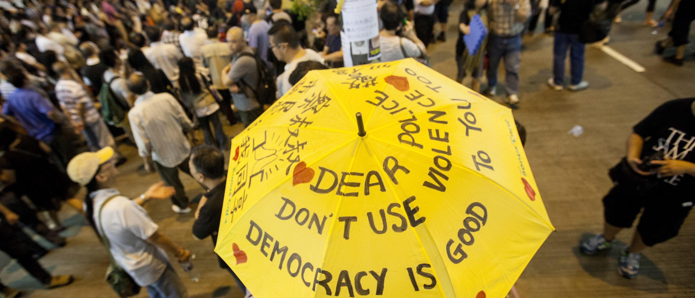

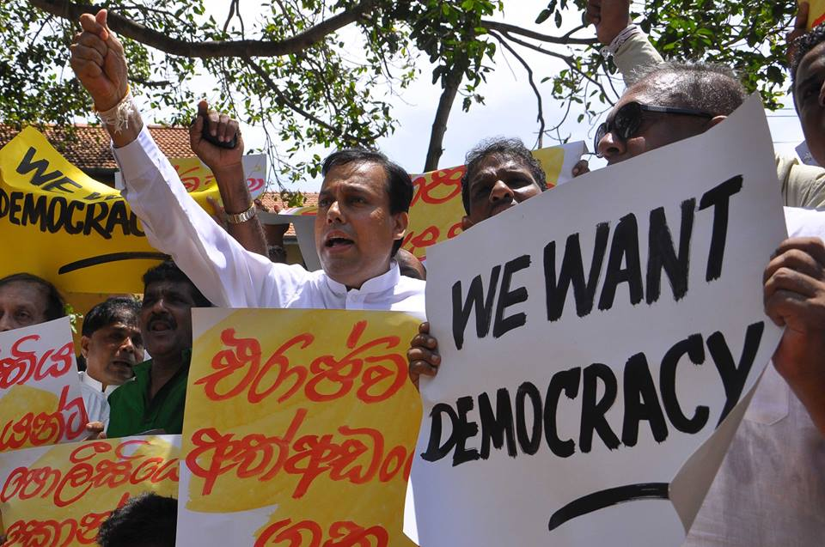
SOURCEBOOK 1-20.A

Zoom 1

Zoom 2

Zoom 3
SOURCEBOOK 1-20.C

Source 1: Possible Solutions: Global Warming/Climate Change

Overview: Global warming is making the planet warm up fast. It is causing climate change. There is less or more rain, wind, or snow than in the past. This is hurting animals (including people) and plants. See SOURCEBOOK 1-19.C for more information (from last class).

Solution 1: Ban the Use of Most Fossil Fuels. Scientists know that burning fossil fuels (i.e. oil, gasoline, coal, natural gas) is causing global warming. We should pass a UN resolution to ban most fossil fuels. We should make almost all of our energy be through the wind, water, or the sun.

Solution 2: Reduce the Use of Most Fossil Fuels. Scientists know that burning fossil fuels (i.e. oil, gasoline, coal, natural gas) is causing global warming. We should pass a UN resolution that would reduce fossil fuels in all countries. It would make more energy through the wind, water, or the sun. It would not start right now. Over time governments would allow fewer and fewer fossil fuels.

Solution 3: Ask People to the Use Less Fossil Fuels. Scientists know that burning fossil fuels (i.e. oil, gasoline, coal, natural gas) is causing global warming. We should not ban any fossil fuels. We should ask people to use less. Everyone should do their share. This is a problem that should be fixed by individual people. Not by governments or the UN.

SOURCEBOOK 1-20.D

Source 2: Possible Solutions: Poverty

Overview: Many people around the world live in extreme poverty or less than $1 a day. This leads to many problems, including lack of food, clothing, or homes. See SOURCEBOOK 1-19.D for more information (from last class).

Solution 1: Have Richer Countries Give Money to People in Poorer Countries. There are many causes of poverty. It includes weather, unfair governments, or no jobs. The richer countries will give money to the poorer countries. They can help their people stop being in poverty.

Solution 2: Have More Programs to Help People in Poorer Countries Make Money. There are many causes of poverty. It includes weather, unfair governments, or no jobs. The United Nations will make a program to help poorer people make money. It will train them for jobs that will not be effected by weather. It will give them supplies to start their own businesses.

Solution 3: Ask People to Donate to Poorer Countries. There are many causes of poverty. It includes weather, unfair governments, or no jobs. People should donate money to help people in poor countries. This is a problem that should be fixed by individual people. Not by governments or the UN.

SOURCEBOOK 1-20.E

Source 3: Possible Solutions: Disease

Overview: There are many diseases effected people across the Earth. Some diseases are curable. Some people cannot afford the medicines. Other disease need more research to find a cure. See SOURCEBOOK 1-19.E for more information (from last class).

Solution 1: Have Richer Countries Pay to End Diseases. We can help researchers find new cures. We can help people afford medicines that work. The richer countries should give money to researchers to find cures. They should also give money to poorer countries. That will help treat their people’s diseases.

Solution 2: Have More Programs to Help End Disease. We can help researchers find new cures. We can help people afford medicines that work. Governments should give the United Nations’ World Health Organization more money. They can make a program to help find new cures to diseases. They can treat people who cannot afford medicines.

Solution 3: Ask People to Donate Money to Help End Diseases. We can help researchers find new cures. We can help people afford medicines that work. People should donate money to help researchers find cures. They can also donate money to groups that help poor people around the world get medicines. This is a problem that should be fixed by individual people. Not by governments or the UN.

SOURCEBOOK 1-20.F

Source 4: Possible Solutions: Lack of Democracy

Overview: There are many people on Earth who live in countries that are not democracies. They have no say in their laws. People in those countries do not have freedom. See SOURCEBOOK 1-19.F for more information (from last class).

Solution 1: Have Democratic Countries Stop Trading with Non-Democratic Countries. Countries where people have a say in their laws should help non-democratic countries. The democratic countries will stop trading goods with non-democratic countries. This will make it hard for those countries. They will let their people vote. They will let their people have a say in government.

Solution 2: Have Programs to Help People Learn About Democracy. The United Nations should educate the people in non-democratic countries about democracy. They should help them see how voting is important. Then people in non-democratic countries will want to have a democracy. They will tell their government to change through protests.

Solution 3: Ask People to Give Money to Groups that Support Democracy. People should donate money to groups that are trying to bring democracy to non-democratic countries. These groups can help governments hold elections. They can allow people to have a say in their governments. This is a problem that should be fixed by individual people. Not by governments or the UN.

