Open Social Studies

An Inquiry-Based and Literacy-Focused K-6 Curriculum

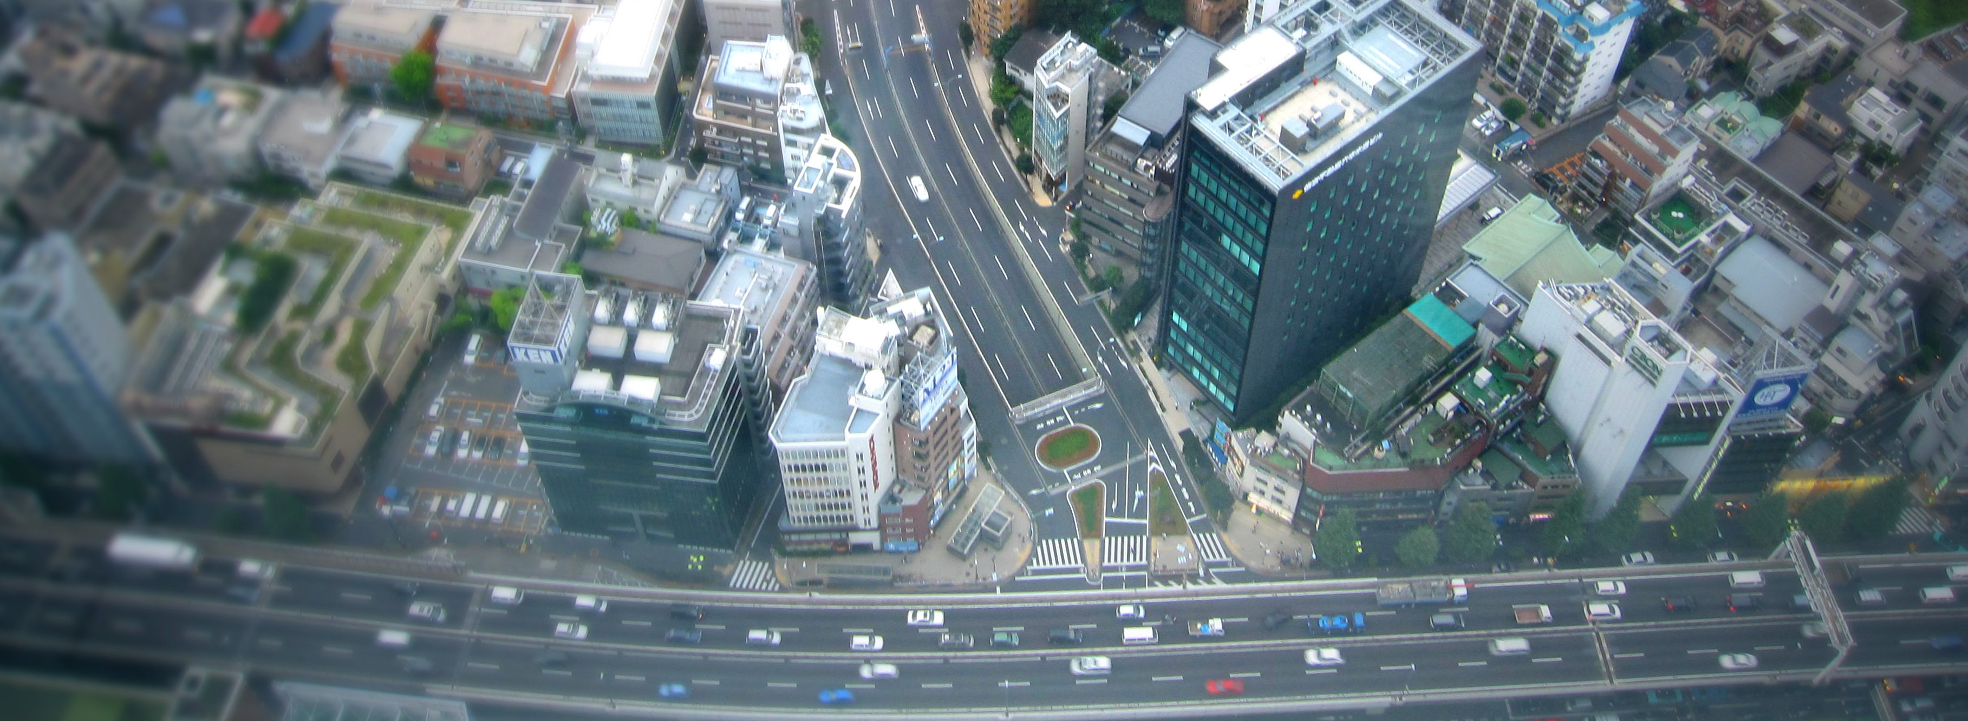

Curric

STUDENT WORKBOOK

Level: Grade 6

Connecting the Ancient World to the Present

Developers:

Christopher C. Martell

Jennifer R. Bryson

GRADE 6 ROAD MAP

PART I. AFRICA

LESSON 6-1

Lesson Title: Human Eras: Paleolithic, Neolithic, Ancient, Medieval, and Modern

Inquiry Question: Are we living in a new era of human development (or are we still in the Modern Era or Post-Modern Era)? If we are living in a new era, what would you call it and why?

NOTE: The Massachusetts History and Social Science Framework for Grade 6 includes Topic 2 that includes the origins of humans and Topic 3 that includes Ancient Egypt, Timbuktu, and Ghana. In this curriculum, this was included in the Grade 4 curriculum (i.e. 4-12, 4-13. 4-14), which is the introduction to world history and geography. This level of the curriculum will begin with ancient East Africa and does not cover human origins or ancient Egypt, Timbuktu, and Ghana. Teachers are encouraged to use modified versions of those lessons again here to refresh students’ understanding of the topics.

LESSON 6-2

Lesson Title: Anthropology of Ancient Africa (Domestication of Cattle and Goats, Iron Working, and Cave Paintings)

Inquiry Question: What is the most important early African achievement?

LESSON 6-4

Lesson Title: The Nok People: An Art Study

Inquiry Question: What was life like for the Nok people? How are people today trying to preserve the record of their world?

LESSON 6-4

Lesson Title: Ancient Nubia (Kush): How Can You Live in a Desert?

Inquiry Question: What was the ancient Nubians’ most important adaption to their environment?

LESSON 6-5

Lesson Title: Ancient Swahili Coast: The Center of the World?

Inquiry Question: What was the most important factor in making the Swahili Coast wealthy trading ports?

LESSON 6-6

Lesson Title: Medieval Mali: A User’s Guide to Building an Empire

Inquiry Question: What was the most important factor that led to the Mali Empire?

LESSON 6-7

Lesson Title: Landforms of Africa

Inquiry Question: What is Africa’s most important landmark?

LESSON 6-8

Lesson Title: Africa in Our Century

Inquiry Question: What event has had the largest impact on Africa in the 21st Century?

LESSON 6-9

Lesson Title: African Nations Today (Multi-Day Mini-Unit)

Inquiry Question: What are the most important cultural, governmental, economic, and natural aspects of your nation?

PART II. ASIA

LESSON 6-10

Lesson Title: Life in Ancient Mesopotamia

Inquiry Question: How should we remember ancient Mesopotamia?

LESSON 6-11

Lesson Title: Life in the Ancient Indus Valley

Inquiry Question: How should we remember ancient Indus Valley?

LESSON 6-12

Lesson Title: Native Peoples of Oceania: Indigenous Australians, Māori, and Samoans

Inquiry Question: How would you depict on of the Native peoples of Oceania in a graphic novel?

LESSON 6-13

Lesson Title: Phoenicia: The Ancient Mediterranean World

Inquiry Question: If you were an ancient historian, how would you write the history of the Phoenicians?

LESSON 6-14

Lesson Title: Israel–Palestine Conflict: Making a Plan for Peace

Inquiry Question: What is the best solution for creating peace in Palestine and Israel?

LESSON 6-15

Lesson Title: Ancient Empires of the Central Asia: Persia/Sasanian, Gandhara, and Mauryan

Inquiry Question: If you could live in any Central Asian empire, which one would it be and why?

LESSON 6-16

Lesson Title: Ancient Chinese Inventions

Inquiry Question: What was the most important invention of ancient China?

LESSON 6-17

Lesson Title: Ancient Chinese Dynasties: Zhou, Qin, Han, Tang

Inquiry Question: Which dynasty of China was strongest?

LESSON 6-18

Lesson Title: Ancient Peoples of Eastern Asia: Japan, Korea, Mongolia, and Việt

Inquiry Question: What is each ancient people’s greatest contribution to the world?

LESSON 6-19

Lesson Title: History Detectives: How Did a Giraffe End Up in the Chinese Imperial Court?

Inquiry Question: How did a giraffe end up in the Chinese imperial court?

LESSON 6-20

Lesson Title: Comparing Global Trade Routes: Ancient and Modern Silk Roads

Inquiry Question: What has changed the world more, the Silk Road (100s BCE–1450s CE) or the Belt and Road Initiative (2013 CE-present)?

LESSON 6-21

Lesson Title: The Crusades: Islamic Resistance to Invaders

Inquiry Question: What was the most important act of resistance to the European Crusades in the Middle East?

LESSON 6-22

Lesson Title: Climate and Terrain of Asia

Inquiry Question: Which of Asia’s regions would you like to visit most?

LESSON 6-23

Lesson Title: Asia in Our Century

Inquiry Question: What event has had the largest impact on Asia in the 21st Century?

LESSON 6-24

Lesson Title: Asian and Oceania Nations Today (Multi-Day Mini-Unit)

Inquiry Question: What are the most important cultural, governmental, economic, and natural aspects of your nation?

PART III. THE AMERICAS

LESSON 6-25

Lesson Title: The Salish People: Examining the c̓əsnaʔəm (Marpole Midden) Site

Inquiry Question: What is the best way to protect ancient Indigenous cultural sites?

NOTE: The Massachusetts History and Social Science Framework for Grade 6 includes Topic 2 that includes the origins of humans and Topic 5 that includes Ancient Aztec and Maya. In this curriculum, this was included in the Grade 4 curriculum (i.e. 4-24), which is the introduction to world history and geography. This level of the curriculum will begin with other Indigenous peoples of the Americas and does not include Aztec, Incas, or Maya. Teachers are encouraged to use modified versions of those lessons again here to refresh students’ understanding of the topics.

LESSON 6-26

Lesson Title: Native People of the Caribbean: The Taíno

Inquiry Question: What was life like in the Caribbean before the invasion of Europeans?

LESSON 6-27

Lesson Title: Indigenous People of the Amazon

Inquiry Question: How can we protect the Indigenous people of the Amazon?

LESSON 6-28

Lesson Title: Places of Latin America

Inquiry Question: What Latin America place would you like to visit and why?

LESSON 6-29

Lesson Title: Latin America in Our Century

Inquiry Question: What event has had the largest impact on Latin America in the 21st Century?

LESSON 6-30

Lesson Title: Nations of the Americas Today (Multi-Day Mini-Unit)

Inquiry Question: What are the most important cultural, governmental, economic, and natural aspects of your nation?

GRADE 6 PRE-TEST

Answer the following questions.

1. Name the oceans on Earth.

2. Label each continent on the picture below: Antarctica, Africa, Asia, Australia, Europe, North America, South America.

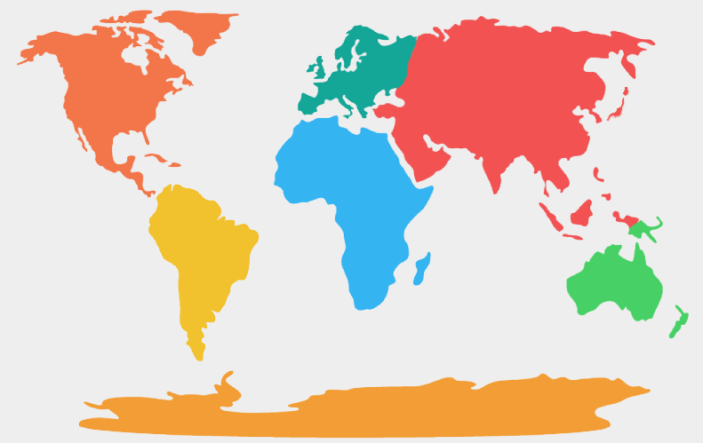

3. Explain where humans first began.

4. Explain what ancient Egypt was like.

5. Explain what ancient Maya (Mayans) were like.

6. Explain what ancient Mesopotamia like.

7. Explain what ancient Axum like.

8. Explain what ancient China like.

9. Explain what ancient India like.

10. Explain what ancient people of the Caribbean (Taínos, Arawak, Carib) were like.

WORKSHEET 6-1.C

Notetaking Sheet: Human Eras

Source 1: Paleolithic Era

Source 2: Neolithic Era

Source 3: Ancient Era

Source 4: Medieval Era

Source 5: Modern Era

ASSESSMENT 6-1.D

Human Eras: Exit Ticket

Inquiry Question: Are we living in a new era of human development (or are we still in the Modern Era or Post-Modern Era)? If we are living in a new era, what would you call it and why?

ASSESSMENT 6-2.C

Archeology of Ancient Africa: Exit Ticket

Inquiry Question: What is the most important early African achievement?

WORKSHEET 6-3.A

Slideshow Notes
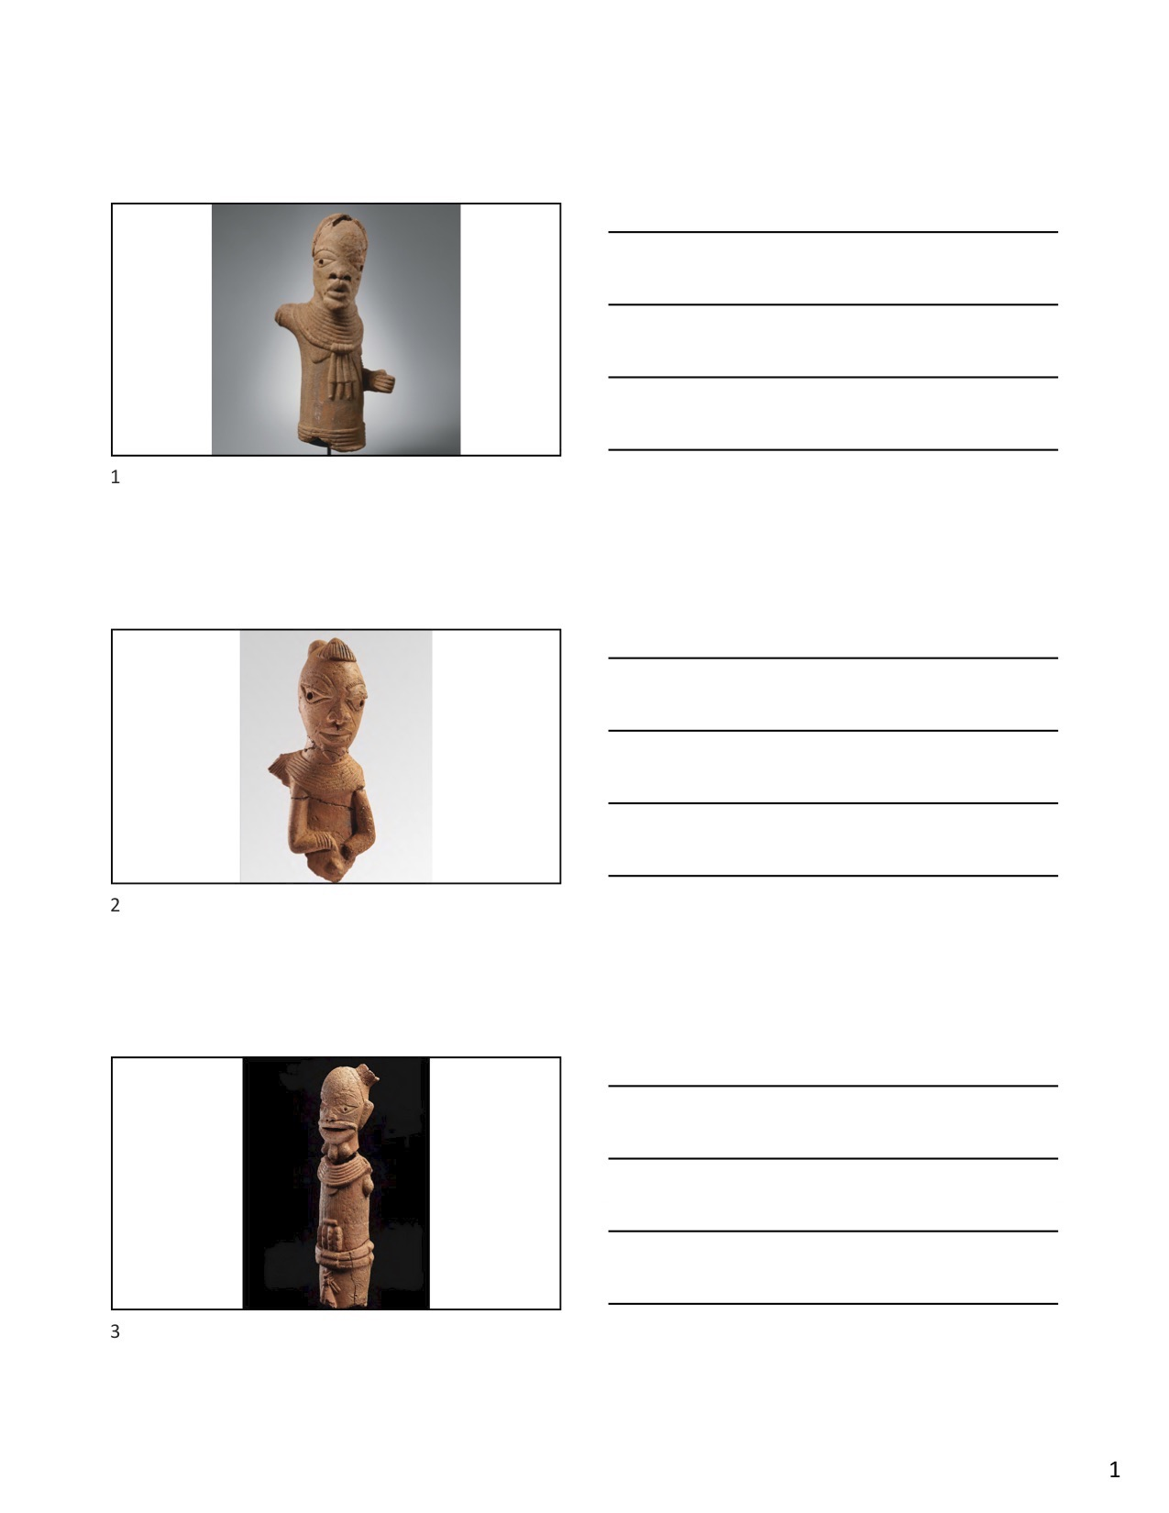

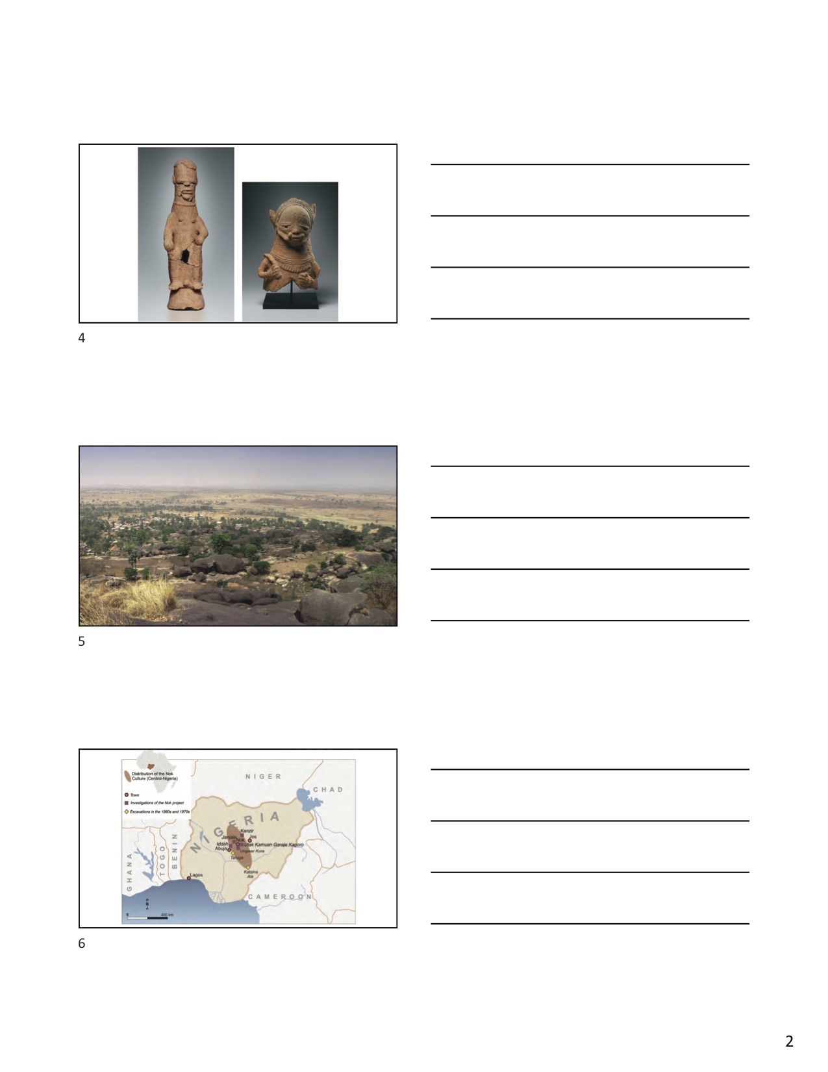

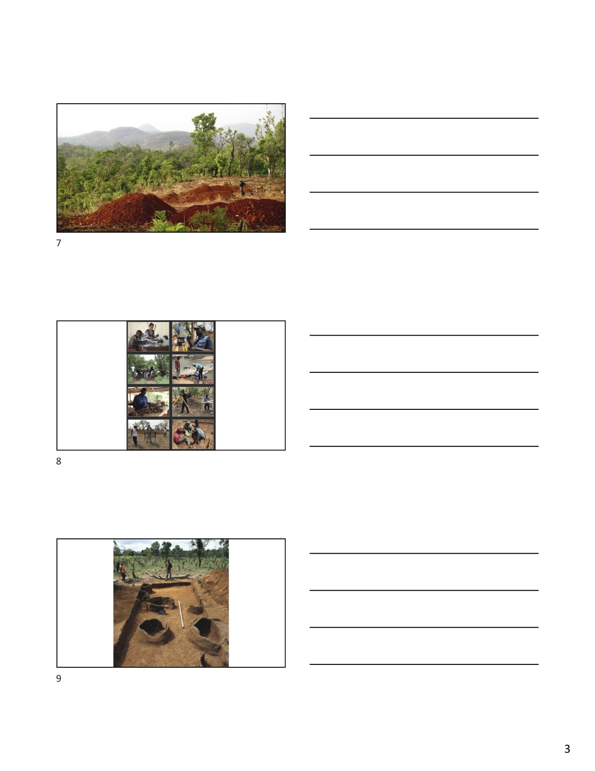

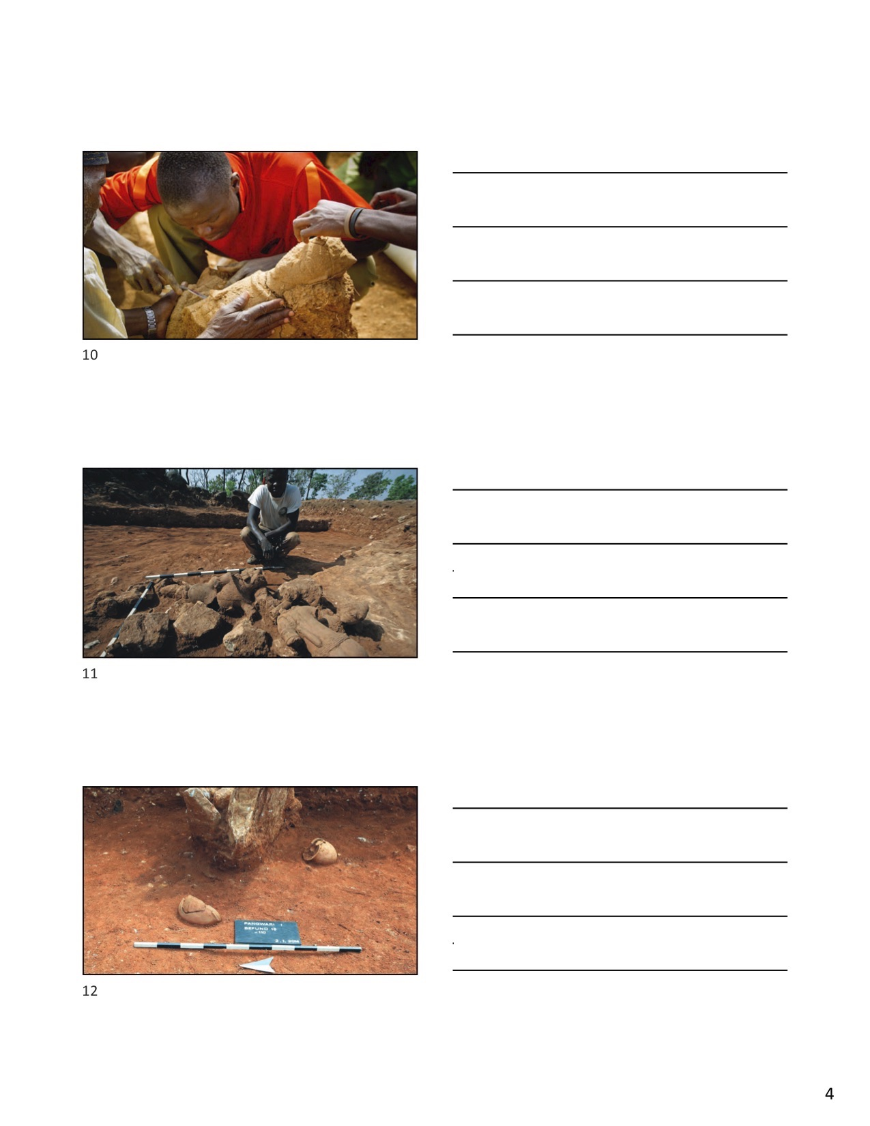

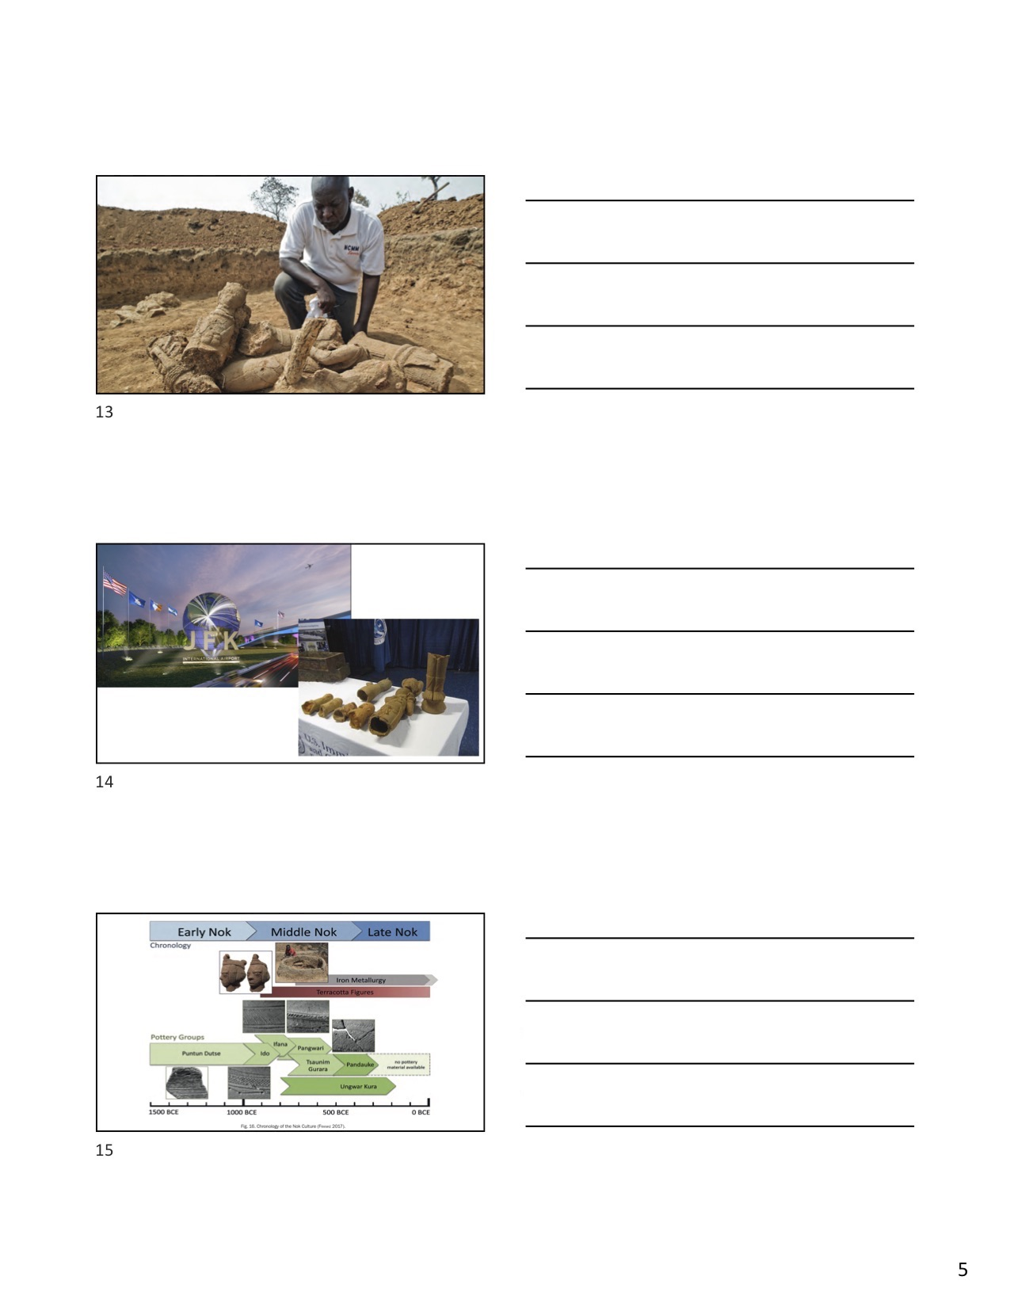

ASSESSMENT 6-3.C

News Report on the Nok Artwork: Exit Ticket

Inquiry Question: What was life like for the Nok people?

Use your slideshow notes and answer the above question in the form of a news report. Do not forget to include information about the history of the Nok terracotta, the process of archeologist excavation, and the threats to the terracotta artifacts today (such as smugglers).

ASSESSMENT 6-4.D

Ancient Nubia: Exit Ticket

Inquiry Question: What was the ancient Nubians’ most important adaption to their environment?

WORKSHEET 6-5.C

Notetaking Sheet: Ancient Swahili Coast

Source 1: Ancient Indian Ocean Map

Source 2: Painting of the Dhow Boat

Source 3: Painting of the Coastal City of Kilwa

Source 4: Architecture of the Great Mosque of Kilwa

Source 5: Gold Coins Used in the Swahili Coast

ASSESSMENT 6-5.D

Ancient Swahili Coast: Exit Ticket

Inquiry Question: What was the most important factor in making the Swahili Coast wealthy trading ports?

ASSESSMENT 6-6.C

Medieval Mali: Exit Ticket

Inquiry Question: What was the most important factor that led to the Mali Empire?

WORKSHEET 6-7.A

Notetaking Sheet: Landforms of Africa

Source 1: Mount Kilimanjaro

Source 2: Nile River

Source 3: Sahara Desert

Source 4: Mosi-oa-Tunya/Victoria Falls

Source 5: Congo Basin Rainforest

ASSESSMENT 6-7.G

Landforms of Africa: Exit Ticket

Inquiry Question: What is Africa’s most important landmark?

ASSESSMENT 6-8.F

Africa in Our Century: Exit Ticket

Inquiry Question: What event has had the largest impact on Africa in the 21st Century?

WORKSHEET 6-9.A

African Nations Project: Assignment Instructions

Inquiry Question: What are the most important cultural, governmental, economic, and natural aspects of your nation?

For the next 1-2 weeks, students will work in teams to research and write books on the various nations of Africa. These books will be published, bound, and stored in the classroom/school library to teach our classmates about each country’s past and present.

STEP 1: CHOOSE A COUNTRY
Each group will choose a different country to research from the below list of African nations.

Algeria
Angola
Benin
Botswana
Burkina Faso
Burundi
Cabo Verde (Cape Verde)
Cameroon
Central African Republic
Chad
Comoros
Congo-Brazzaville
Congo-Kinshasa (Zaire)
Cote d'Ivoire
Djibouti
Egypt
Equatorial Guinea
Eritrea
Eswatini (Swaziland)
Ethiopia
Gabon
Gambia
Ghana
Guinea
Guinea-Bissau
Kenya
Lesotho
Liberia
Libya
Madagascar
Malawi
Mali
Mauritania
Mauritius
Morocco
Mozambique
Namibia
Niger
Nigeria
Rwanda
Sao Tome and Principe
Senegal
Seychelles
Sierra Leone
Somalia
South Africa
South Sudan
Sudan
Tanzania
Togo
Tunisia
Uganda
Zambia
Zimbabwe

NOTE: Congo-Brazzaville is officially called the Republic of Congo; Congo-Kinshasa is officially called the Democratic Republic of the Congo (formerly Zaire); Eswatini was formerly Swaziland)

STEP 2: RESEARCH
Your group should borrow books from the library related to your country and visit trustworthy websites.

Here are some good websites to start with:
www.cia.gov/library/publications/the-world-factbook/
www.britannica.com/
www.un.org/en/member-states/
www.kids.nationalgeographic.com/explore/countries/
www.nationalgeographic.com/travel/destinations/
news.bbc.co.uk/2/hi/country_profiles/default.stm
www.google.com/earth/

How to know a website or book is trustworthy?

+ Authority: Is it a valid source? Who published the article or book? Does it have a website ending in .edu, .gov, or .org (which tend to be education, government, or other organizations)?

+ Authorship: What is the background of the author (search the author’s name on the internet)? Are they an expert on the topic? Where did they go to school? Have they published other books or articles on the topic?

+ Accuracy: Does it include credible information? Does the author tell us where they got their information (called citations)? Can you find the same information on multiple websites or sources?

STEP 3: TAKE NOTES
Your group should read the books and website articles while taking notes in a notebook. Be sure to cite (list what book) you get your information from by listing the author and page number (if no page numbers, write n.p. for “no page”).

Like this:

“The Bantu people are one of the largest groups living on the African continent” (Martell, p. 5).

STEP 4: CREATE AN OUTLINE
Use a word processing program (such as Microsoft Word, OpenOffice, or Google Documents) to begin creating your book. You should start with making an outline of your book. Your book should include the following sections: 1. Introduction and History, 2. Geography, 3. People, Language, and Culture, 4. Government, 5. Economics. In each section, you should organize the important facts or stories from your research.

STEP 5: DRAFT SECTIONS
Make sure there is a cover page with the title of your book, your group members’ names, and an image that may make people interested in reading your book.

Each section should start on a new page. For each section, write 1-2 paragraphs describing your country and include at least 2 images. Below are some questions to help guide you. You teach will also give you a template that might be helpful.

1. Introduction and History

When did people first settle in your country? Where did it get its name? What are the most important events that occurred there?

2. Geography

Where is your country located on Earth (show a map, describe its longitude and latitude)? What is the climate (weather) like there? What is the terrain (the land) like and does it have any major bodies of water?

3. People, Language, and Culture

What people live in your country? What languages do they speak? What is special about their culture (holidays, traditions, ways of life, traditional clothing, art, or music)?

4. Government

How does your country govern itself? Who are the leaders and how are they chosen? Have they had any other systems of government?

5. Economics

What is your country’s economy like? What resources exist? What types of items do they produce? Who do they trade with?

STEP 6: REVISE SECTIONS

Continue to look at your sources (books, websites) and find more information. Change your sections based on what you find. Check for grammar or spelling mistakes (make sure others can understand it).

STEP 7: PUBLISH AND SHARE YOUR BOOK

When you book is complete and free of mistakes, you should e-mail it to your teacher, so it can be printed. After it is printed, you will read your book to the class.

WORKSHEET 6-9.B

African Nations Project: Template

Book Title

IMAGE HERE

By
Name Here
Name Here

Section Title

IMAGE HERE

Text here.

Text here.

ASSESSMENT 6-9.C

African Nations Project: Rubric

 | Exemplary | Satisfactory | Emerging
Argument | Students have a clear and logical argument in most sections | Students have a clear and logical argument in some sections | Students do not have arguments in most sections
Sources | Students cite multiple sources in each section | Students cite at least one source in each section | Students cite no sources in some or all sections
Accuracy | Students have facts to support all or most statements | Students have facts to support some statements | Students do not have facts to support most statements
Presentation | Book is organized and includes engaging graphics; few grammar and spelling errors | Book is organized and includes engaging graphics; several grammar and spelling errors | Book is not organized; does not include engaging graphics; many grammar and spelling errors

ASSESSMENT 6-10.F

Life in Ancient Mesopotamia: Exit Ticket

Inquiry Question: How should we remember ancient Mesopotamia?

Imagine that you are a historian and write an article on the history of Mesopotamia. What is your perspective on Mesopotamia? Decide what events are most important and use evidence to support your conclusions.

ASSESSMENT 6-11.C

Ancient Indus Valley Children’s Book: Exit Ticket

The exit ticket for this lesson is to create a children’s book that will be shared with younger students. Follow these steps in creating your book.

STEP 1: CREATE AN OUTLINE
Choose the type of book that you would like to create. Here are a few types that you may consider using:

- Historical fiction: Authors imagine the story of person living during a particular period.

- Illustrated history: Authors primarily use pictures to tell a story, but include bubbles explaining to each part of drawings.

- Non-fiction: Authors describe the facts and features of the historical event or place (like an encyclopedia).

- Historical graphic novel/comic book: Authors use images and dialogue in panels to tell a historical story.

After your group reads all of the sources, begin outlining each page of your book. Remember that your audience will be younger students. The book should include at least 10 pages with an image and a few sentences on each page. Look at the rubric on the following page, which explains how you will be assessed.

STEP 2: DRAFT YOUR IMAGES AND WORDS

Using pencil and drawing paper, follow your outline and draft your images and words on each page.

STEP 3: COLOR YOUR IMAGES AND PROOFREAD YOUR TEXT

Once your group is happy with the drafted images and text, proofread the words to ensure they have proper spelling and grammar. Use markers/crayons to trace the words and color the images.

STEP 4: SHARING YOUR CHILDREN’S BOOKS

Students will share their books with classmates and/or younger students.

Children’s Book Rubric

 | Exemplary | Satisfactory | Emerging
Accuracy | Students have historically accurate sentence on each page | Students have historically accurate sentence on most pages | Students have historically inaccurate sentence on most pages
Images | Students have historically accurate images on each page | Students have historically accurate images on most pages | Students have historically inaccurate images on most pages
Perspectives | Students show many perspectives that existed at the time | Students show some perspectives that existed at the time | Students show few perspectives that existed at the time

ASSESSMENT 6-12.D

Native Peoples of Oceania: Exit Ticket

The exit ticket for this lesson is to create a children’s book that will be shared with younger students. Follow these steps in creating your book.

STEP 1: BEGIN RESEARCH
Below are websites about the Native people of Oceania, created by the Native people of Oceania. You should read through the sources for your assigned group and take notes on key events.

Aboriginal Australians
- http://www.workingwithindigenousaustralians.info/content/History_2_60,000_years.html
- https://www.aboriginalart.com.au/aboriginal_australia.html
- https://www.aboriginalheritage.org/

Māori
- https://www.govt.nz/browse/history-culture-and-heritage/nz-history/maori-history/
- https://teara.govt.nz/en/maori
- https://www.otago.ac.nz/christchurch/departments/mihi/i-hikoi/index.html

Samoans
- http://www.ashpo.org/index.php/history.html
- http://nzetc.victoria.ac.nz/tm/scholarly/tei-TuvAcco.html
- https://www.touramericansamoa.com/about-samoa

If these sources do not provide enough information, you can search other websites. Be sure to seek the voices of the Native people themselves and check with your teacher to see if they are valid and accurate. In the past, Europeans wrote most of the histories of the Indigenous Australians, Māori, or Samoan people. In doing so, they presented the European narrative (their view of history), which often presented the Native people of Oceania in a negative way. You should avoid these types of sources when created your graphic novel, as your graphic novel should try to portray Indigenous perspectives of the past.

STEP 2: CREATE AN OUTLINE

After your group reads all of the sources, begin outlining each page of your graphic novel (see two examples of graphic novel pages from the books “Boxer” and “A Game for Swallows”). Remember that your audience will be students your age. You should map out the 3-9 “comic” boxes for each page, including images and text bubbles. There should be a minimum of six pages. Look at the rubric on the following page, which explains how you will be assessed.

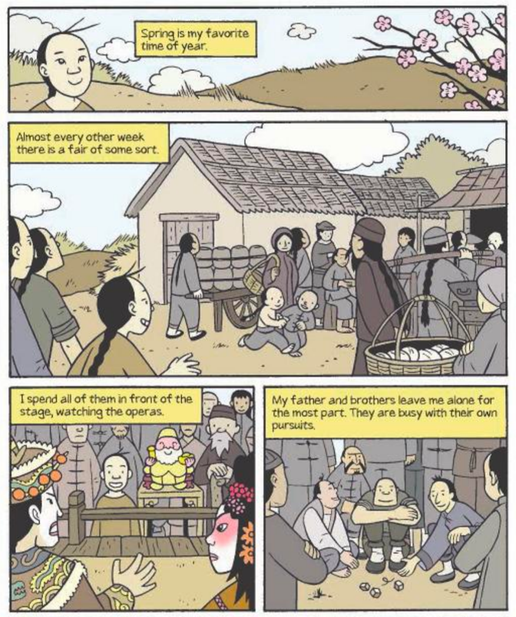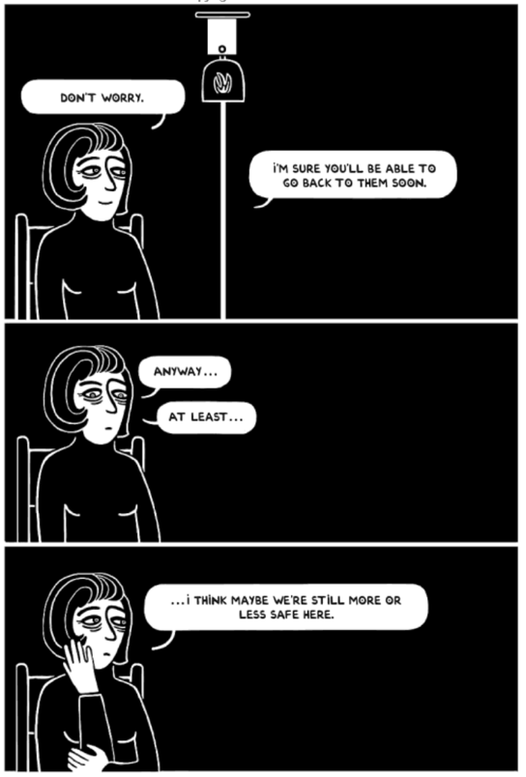

STEP 3: FINALIZE YOUR IMAGES AND WORDS

Next, make your draft pages into finished pages. Using pencil and drawing paper, finalize your comic boxes, including images and text bubbles. You may choose for your graphic novel to be in color or black-and-white. Be sure to proofread the words to ensure they have proper spelling and grammar. Use markers/crayons to trace the words and color the images.

STEP 4: SHARING YOUR GRAPHIC NOVELS

Students will share their books with classmates. Students will later receive a class book that compiles all of the different graphic novels created by your peers.

Graphic Novel Rubric

 | Exemplary | Satisfactory | Emerging
Accurate and Diverse Perspectives | Students show accurate and diverse perspectives of the Native people presented in their graphic novel (show different views within their group) | Students show accurate perspectives of the Native people presented in their graphic novel | Students show some inaccurate perspectives of the Native people presented in their graphic novel
Images | Students have culture-related images on each page | Students have culture-related images on most pages | Students do not have culture-related images on most pages

ASSESSMENT 6-13.F

Phoenicia: Exit Ticket

Inquiry Question: If you were an ancient historian, how would you write the history of the Phoenicians?

Use the space below to plan your relief sculpture or papyrus scroll telling the history of the Phoenician people.

WORKSHEET 6-14.E

Note Taking Sheet

Source 1: One-State Solution

Source 2: Two-State Solution

Source 3: Federation Solution

ASSESSMENT 6-14.F

Israel–Palestine Conflict: Exit Ticket

Inquiry Question: What is the best solution for creating peace in Palestine and Israel?

ASSESSMENT 6-15.E

Ancient Empires of the Central Asia: Exit Ticket

Inquiry Question: If you could live in any Central Asian empire, which one would it be and why?

WORKSHEET 6-16.F

Notetaking Sheet: Ancient Chinese Inventions

Source 1: Character-Based Language (Logograph Systems)

Source 2: Paper/Moveable Print

Source 3: Gun Powder/Rockets

Source 4: Compass

Source 5: Mechanical Clock

ASSESSMENT 6-16.G

Ancient Chinese Inventions: Exit Ticket

Inquiry Question: What was the most important invention of ancient China?

WORKBOOK 6-17.A

Ancient Chinese Dynasties Scavenger Hunt

Zhou Clue 1  c. 500 BCE: Sun Tzu wrote the “Art of War,” which is as much about war, as it is about keeping peace. “The supreme art of war is to subdue the enemy without fighting.” -Sun Tzu  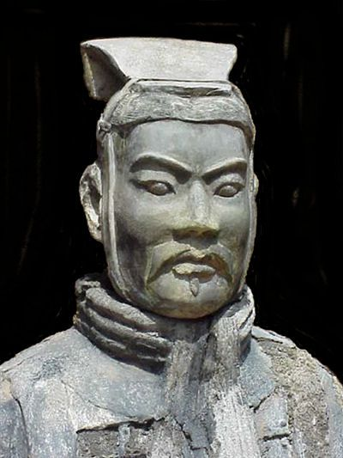 | Zhou Clue 2  1046 BCE: Beginning of the Zhou Dynasty, which would last over 800 years and be the longest in Chinese history. Emperor Ji Chang was the first Zhou emperor.  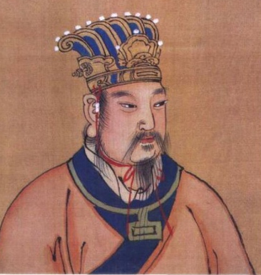
Zhou Clue 3  475 BCE–479 BCE: Confucius teaches his principles that are later written by his followers in the “Analects.” They are a philosophy called legalism that guides some aspects of Chinese culture even today.  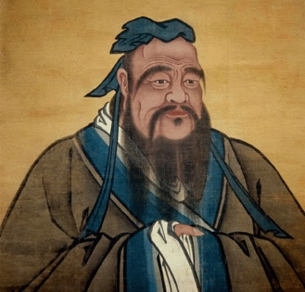 | Zhou Clue 4  c. 772-476 BCE: Spring and Autumn Period. It is named after the Spring and Autumn Annals, which was the first written history of China. It was also a time of art, music, poetry, and philosophy. Below is artwork from the period.  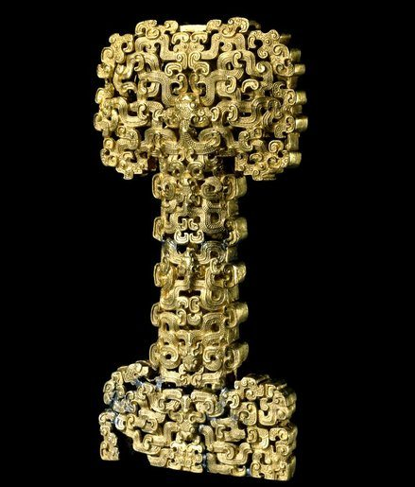
Qin Clue 1  210 BCE: The terracotta warrior sculptures were created for the burial tomb of Qin Shi Huang. They included statues of 8,000 soldiers, 130 chariots with 520 horses, and 150 cavalry horses.  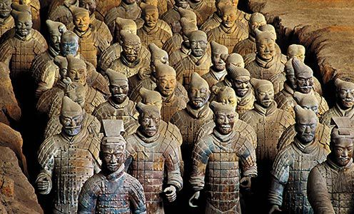 | Qin Clue 2  202 BCE: Emperor Qin Shi Huang drank an elixir of mercury, which he believed would let him live forever, but killed him. This would be one of the shortest dynasties.  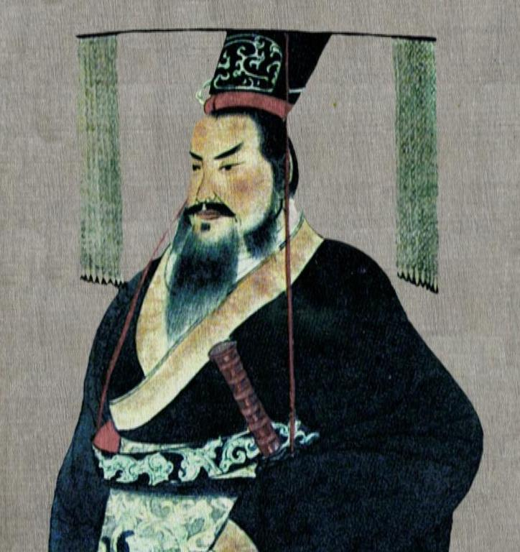
Qin Clue 3  213 BCE: Emperor Qin Shi Huang built a powerful government that tried to control the people. He removed power from nobles and enslaved people. He ended free speech and had a massive book burning to stop ideas that might oppose Confucianism and his rule.  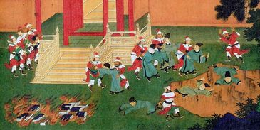 | Qin Clue 4  221 BCE: Completion of the first part of the Great Wall. Many thousands of people died building a wall to stop invasions of armies from the north.  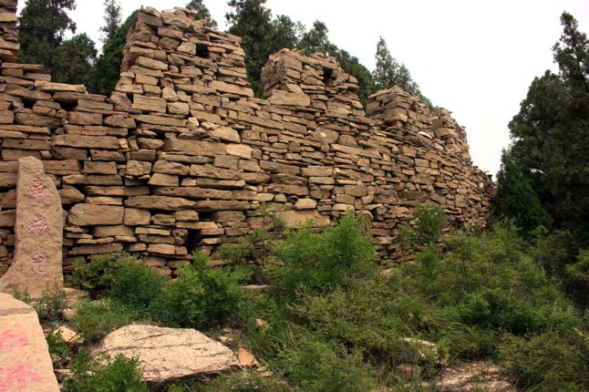
Han Clue 1  195 BCE: Empress Lu Zhi becomes the first women emperor of China. She was a powerful ruler who had some of her enemies killed. She made many of her family members rulers over parts of the country. | Han Clue 2  130 BCE: The Silk Road begins. China began to create trade routes with the peoples to their west. This increased the wealth of China.  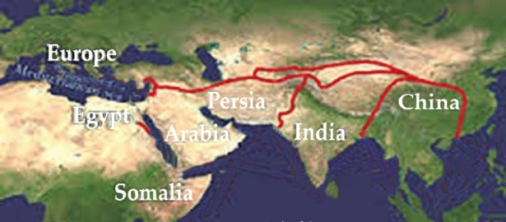
Han Clue 3  100 BCE: Paper invented. During the Han Dynasty, paper was invented, which allowed for the rapid communication of ideas.  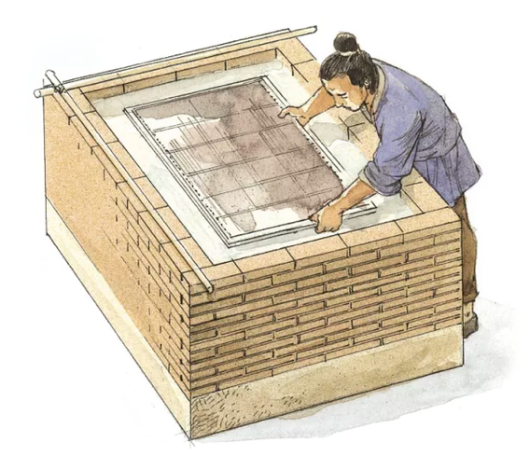 | Han Clue 4  202 BCE: As a former commoner, Emperor Gaozu understood the life of the peasants. He lowered taxes and opened up bureaucratic positions (government jobs) positions to all classes.  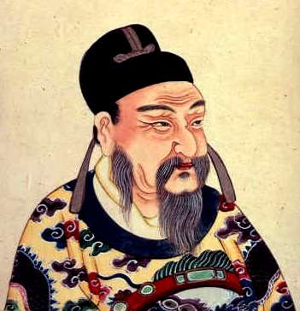
Tang Clue 1  683-704 CE: Empress Wu Zetian improved education, agriculture, and reformed the government. Her reforms made the country more stable and generally improved the lives of the people.  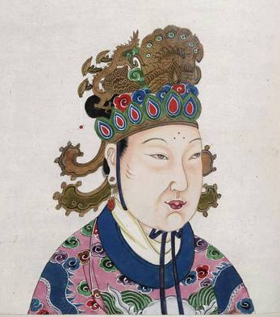 | Tang Clue 2  725 CE: Yi Xing invents the first mechanical clock powered by water.  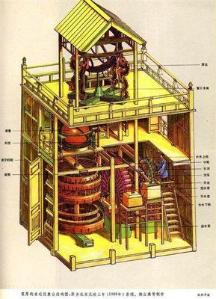
Tang Clue 3  712-756 CE: Emperor Xuanzong built public libraries to collect all the books and calendars in print.  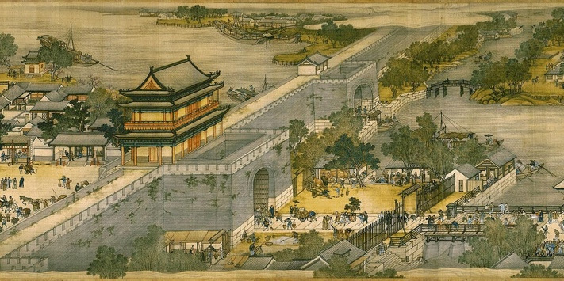 | Tang Clue 4  874-884 CE: Huang-Chao Rebellion was an uprising against the emperor led by soldiers and peasants who were unhappy with their lack of wealth and opportunity. It was so strong that it ended the Tang Dynasty.  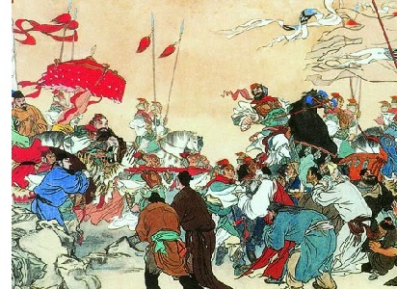

ASSESSMENT 6-17.F

Ancient Chinese Dynasties: Exit Ticket

Inquiry Question: Which dynasty of China was strongest?

ASSESSMENT 6-17.F

Ancient Peoples of Eastern Asia: Exit Ticket

Inquiry Question: What is each ancient people’s greatest contribution to the world?

ASSESSMENT 6-17.C

The Giraffe and the Chinese Court: Exit Ticket

Inquiry Question: How did a giraffe end up in the Chinese imperial court?

ASSESSMENT 6-20.F

Silk Road and Belt and Road Initiative: Exit Ticket

Inquiry Question: What has changed the world more, the Silk Road (100s BCE–1450s CE) or the Belt and Road Initiative (2013 CE-present)?

ASSESSMENT 6-21.F

The Crusades: Resistance to Invaders: Exit Ticket

Inquiry Question: What was the most important act of resistance to the European Crusades in the Middle East?

WORKSHEET 6-22.C

Notetaking Sheet: Climate and Terrain of Asia

Source 1: Asian Steppe

Source 2: The Himalayas

Source 3: Monsoon Region

Source 4: Arabian Desert

Source 5: Ring of Fire

ASSESSMENT 6-22.I

Climate and Terrain of Asia: Exit Ticket

Inquiry Question: Which of Asia’s regions would you like to visit most?

ASSESSMENT 6-23.G

Asia in Our Century: Exit Ticket

Inquiry Question: What event has had the largest impact on Asia in the 21st Century?

WORKSHEET 6-24.A

Asian and Oceania Nations Project: Assignment Instructions

Inquiry Question: What are the most important cultural, governmental, economic, and natural aspects of your nation?

For the next 1-2 weeks, students will work in teams to research and write books on the various nations of Asia and Oceania. These books will be published, bound, and stored in the classroom/school library to teach our classmates about each country’s past and present.

STEP 1: CHOOSE A COUNTRY
Each group will choose a different country to research from the below list of Asian and Oceania nations.

Australia
Afghanistan
Armenia
Azerbaijan
Bahrain
Bangladesh
Bhutan
Brunei
Cambodia
China
Fiji
Georgia
India
Indonesia
Iran
Iraq
Israel
Japan
Jordan
Kazakhstan
Kiribati
Kuwait
Kyrgyzstan
Laos
Lebanon
Malaysia
Maldives
Marshall Islands
Micronesia
Mongolia
Myanmar (formerly Burma)
Nauru
Nepal
New Zealand
North Korea
Oman
Pakistan
Palau
Palestine
Papua New Guinea
Philippines
Qatar
Samoa
Saudi Arabia
Singapore
Solomon Islands
South Korea
Sri Lanka
Syria
Taiwan
Tajikistan
Thailand
Timor-Leste
Tonga
Tuvalu
Turkey
Turkmenistan
United Arab Emirates
Uzbekistan
Vanuatu
Vietnam
Yemen

STEP 2: RESEARCH
Your group should borrow books from the library related to your country and visit trustworthy websites.

Here are some good websites to start with:
www.cia.gov/library/publications/the-world-factbook/
www.britannica.com/
www.un.org/en/member-states/
www.kids.nationalgeographic.com/explore/countries/
www.nationalgeographic.com/travel/destinations/
news.bbc.co.uk/2/hi/country_profiles/default.stm
www.google.com/earth/

How to know a website or book is trustworthy?

+ Authority: Is it a valid source? Who published the article or book? Does it have a website ending in .edu, .gov, or .org (which tend to be education, government, or other organizations)?

+ Authorship: What is the background of the author (search the author’s name on the internet)? Are they an expert on the topic? Where did they go to school? Have they published other books or articles on the topic?

+ Accuracy: Does it include credible information? Does the author tell us where they got their information (called citations)? Can you find the same information on multiple websites or sources?

STEP 3: TAKE NOTES
Your group should read the books and website articles while taking notes in a notebook. Be sure to cite (list what book) you get your information from by listing the author and page number (if no page numbers, write n.p. for “no page”).

Like this:

“China has the largest national population in the world” (Martell, p. 5).

STEP 4: CREATE AN OUTLINE
Use a word processing program (such as Microsoft Word, OpenOffice, or Google Documents) to begin creating your book. You should start with making an outline of your book. Your book should include the following sections: 1. Introduction and History, 2. Geography, 3. People, Language, and Culture, 4. Government, 5. Economics. In each section, you should organize the important facts or stories from your research.

STEP 5: DRAFT SECTIONS
Make sure there is a cover page with the title of your book, your group members’ names, and an image that may make people interested in reading your book.

Each section should start on a new page. For each section, write 1-2 paragraphs describing your country and include at least 2 images. Below are some questions to help guide you. You teach will also give you a template that might be helpful.

1. Introduction and History

When did people first settle in your country? Where did it get its name? What are the most important events that occurred there?

2. Geography

Where is your country located on Earth (show a map, describe its longitude and latitude)? What is the climate (weather) like there? What is the terrain (the land) like and does it have any major bodies of water?

3. People, Language, and Culture

What people live in your country? What languages do they speak? What is special about their culture (holidays, traditions, ways of life, traditional clothing, art, or music)?

4. Government

How does your country govern itself? Who are the leaders and how are they chosen? Have they had any other systems of government?

5. Economics

What is your country’s economy like? What resources exist? What types of items do they produce? Who do they trade with?

STEP 6: REVISE SECTIONS

Continue to look at your sources (books, websites) and find more information. Change your sections based on what you find. Check for grammar or spelling mistakes (make sure others can understand it).

STEP 7: PUBLISH AND SHARE YOUR BOOK

When you book is complete and free of mistakes, you should e-mail it to your teacher, so it can be printed. After it is printed, you will read your book to the class.

WORKSHEET 6-24.B

Asian and Oceania Nations Project: Template

Book Title

IMAGE HERE

By
Name Here
Name Here

Section Title

IMAGE HERE

Text here.

Text here.

ASSESSMENT 6-24.C

Asian and Oceania Nations Project: Rubric

 | Exemplary | Satisfactory | Emerging
Argument | Students have a clear and logical argument in most sections | Students have a clear and logical argument in some sections | Students do not have arguments in most sections
Sources | Students cite multiple sources in each section | Students cite at least one source in each section | Students cite no sources in some or all sections
Accuracy | Students have facts to support all or most statements | Students have facts to support some statements | Students do not have facts to support most statements
Presentation | Book is organized and includes engaging graphics; few grammar and spelling errors | Book is organized and includes engaging graphics; several grammar and spelling errors | Book is not organized; does not include engaging graphics; many grammar and spelling errors

ASSESSMENT 6-25.G

The Salish People: Exit Ticket

Inquiry Question: What is the best way to protect ancient Indigenous cultural sites?

ASSESSMENT 6-26.B

The Taíno: Exit Ticket

Inquiry Question: What was life like in the Caribbean before the invasion of Europeans?

WORKSHEET 6-27.B

Notetaking Sheet: Indigenous People of the Amazon

Source 1: Protect Indigenous Land

Source 2: Support Indigenous Cultures and Languages

Source 3: Help Increase Indigenous People’s Access to Technology in Remote Areas

Source 4: Prevent Contact with Isolated Indigenous People

ASSESSMENT 6-27.G

Indigenous People of the Amazon: Exit Ticket

Inquiry Question: How can we protect the Indigenous people of the Amazon?

WORKSHEET 6-28.B

Notetaking Sheet: Indigenous People of the Amazon

Source 1: Mexico City

Source 2: Rio de Janiero

Source 3: Lima

Source 4: Havana

ASSESSMENT 6-28.G

Places of Latin America: Exit Ticket

Inquiry Question: What Latin America place would you like to visit and why?

ASSESSMENT 6-29.G

Latin America in Our Century: Exit Ticket

Inquiry Question: What event has had the largest impact on Latin America in the 21st Century?

WORKSHEET 6-30.A

The Americas Nations Project: Assignment Instructions

Inquiry Question: What are the most important cultural, governmental, economic, and natural aspects of your nation?

For the next 1-2 weeks, students will work in teams to research and write books on the various nations of the Americas. These books will be published, bound, and stored in the classroom/school library to teach our classmates about each country’s past and present.

STEP 1: CHOOSE A COUNTRY
Each group will choose a different country to research from the below list of American nations.

Antigua and Barbuda
Argentina
Aruba
Bahamas
Barbados
Bolivia
Brazil
Canada
Cayman Islands
Chile
Colombia
Cuba
Dominica
Dominican Republic
Ecuador
Grenada
Guyana
Haïti
Jamaica
México
Paraguay
Peru
St. Kitts and Nevis
St. Lucia
St. Vincent and the
Grenadines
Suriname
Trinidad and Tobago
United States
Uruguay
Venezuela

STEP 2: RESEARCH
Your group should borrow books from the library related to your country and visit trustworthy websites.

Here are some good websites to start with:
www.cia.gov/library/publications/the-world-factbook/
www.britannica.com/
www.un.org/en/member-states/
www.kids.nationalgeographic.com/explore/countries/
www.nationalgeographic.com/travel/destinations/
news.bbc.co.uk/2/hi/country_profiles/default.stm
www.google.com/earth/

How to know a website or book is trustworthy?

+ Authority: Is it a valid source? Who published the article or book? Does it have a website ending in .edu, .gov, or .org (which tend to be education, government, or other organizations)?

+ Authorship: What is the background of the author (search the author’s name on the internet)? Are they an expert on the topic? Where did they go to school? Have they published other books or articles on the topic?

+ Accuracy: Does it include credible information? Does the author tell us where they got their information (called citations)? Can you find the same information on multiple websites or sources?

STEP 3: TAKE NOTES
Your group should read the books and website articles while taking notes in a notebook. Be sure to cite (list what book) you get your information from by listing the author and page number (if no page numbers, write n.p. for “no page”).

Like this:

“Brazil is the fifth largest national land area in the world” (Martell, p. 5).

STEP 4: CREATE AN OUTLINE
Use a word processing program (such as Microsoft Word, OpenOffice, or Google Documents) to begin creating your book. You should start with making an outline of your book. Your book should include the following sections: 1. Introduction and History, 2. Geography, 3. People, Language, and Culture, 4. Government, 5. Economics. In each section, you should organize the important facts or stories from your research.

STEP 5: DRAFT SECTIONS
Make sure there is a cover page with the title of your book, your group members’ names, and an image that may make people interested in reading your book.

Each section should start on a new page. For each section, write 1-2 paragraphs describing your country and include at least 2 images. Below are some questions to help guide you. You teach will also give you a template that might be helpful.

1. Introduction and History

When did people first settle in your country? Where did it get its name? What are the most important events that occurred there?

2. Geography

Where is your country located on Earth (show a map, describe its longitude and latitude)? What is the climate (weather) like there? What is the terrain (the land) like and does it have any major bodies of water?

3. People, Language, and Culture

What people live in your country? What languages do they speak? What is special about their culture (holidays, traditions, ways of life, traditional clothing, art, or music)?

4. Government

How does your country govern itself? Who are the leaders and how are they chosen? Have they had any other systems of government?

5. Economics

What is your country’s economy like? What resources exist? What types of items do they produce? Who do they trade with?

STEP 6: REVISE SECTIONS

Continue to look at your sources (books, websites) and find more information. Change your sections based on what you find. Check for grammar or spelling mistakes (make sure others can understand it).

STEP 7: PUBLISH AND SHARE YOUR BOOK

When you book is complete and free of mistakes, you should e-mail it to your teacher, so it can be printed. After it is printed, you will read your book to the class.

WORKSHEET 6-24.B

The Americas Nations Project: Template

Book Title

IMAGE HERE

By
Name Here
Name Here

Section Title

IMAGE HERE

Text here.

Text here.

ASSESSMENT 6-30.C

The Americas Nations Project: Rubric

 | Exemplary | Satisfactory | Emerging
Argument | Students have a clear and logical argument in most sections | Students have a clear and logical argument in some sections | Students do not have arguments in most sections
Sources | Students cite multiple sources in each section | Students cite at least one source in each section | Students cite no sources in some or all sections
Accuracy | Students have facts to support all or most statements | Students have facts to support some statements | Students do not have facts to support most statements
Presentation | Book is organized and includes engaging graphics; few grammar and spelling errors | Book is organized and includes engaging graphics; several grammar and spelling errors | Book is not organized; does not include engaging graphics; many grammar and spelling errors

GRADE 6 POST-TEST

Answer the following questions.

1. Name the oceans on Earth.

2. Label each continent on the picture below: Antarctica, Africa, Asia, Australia, Europe, North America, South America.

3. Explain where humans first began.

4. Explain what ancient Egypt was like.

5. Explain what ancient Maya (Mayans) were like.

6. Explain what ancient Mesopotamia like.

7. Explain what ancient Axum like.

8. Explain what ancient China like.

9. Explain what ancient India like.

10. Explain what ancient people of the Caribbean (Taínos, Arawak, Carib) were like.

11. Choose one group of ancient people that you studied this year, and describe how they worked for fairness or justice.

12. Choose one group of modern-day people that you studied this year, and describe how they worked for fairness or justice.

